**Twenty-Third Sunday**

**after Pentecost**

**“Jesus Lives!”**

1 Thessalonians 4:13–18

**November 8, 2020**

**Messiah Lutheran Church**

**Lutheran Church-Missouri Synod**

4102 Trinity River Dr., Corpus Christi, Texas 78410

**Pastor:**  **Rev. Scott E. Herbert**

Church Phone: 361-387-7748 Email: mlc@stx.rr.com

Church Fax: 361-767-1768 Website: [www.messiahlcms-cc.org](http://www.messiahlcms-cc.org)

Pastor Phone: 469-693-9683 Pastor Email: chirev59@gmail.com

**WELCOME TO MESSIAH!**

We are glad you are here to receive what God is doing for you during Divine Service. Please sign our Guest Book located near the front door. Feel free to converse quietly until the organ prelude begins. If you are looking for a church home, please talk to the Pastor at the door. We would love to have you join us.

**Preparing for Service**

***The Gospel Prepares Us for Our Heavenly Bridegroom’s Coming***

The Day of the Lord is *“darkness, and not light”* (Amos 5:18, 20) for all who trust in their own righteousness and piety. The Lord will not accept their *“burnt offerings and grain offerings,”* nor will He look upon their *“peace offerings”* (Amos 5:22). Instead, He desires a heart of faith that trusts in Him, which lets *“justice roll down like waters, and righteousness like an ever-flowing stream”* (Amos 5:24) in love for the neighbor. In order for the “lamps” of our lives to burn brightly with such love, we must be filled with the “oil” of forgiveness through faith in our Bridegroom, Jesus Christ (Matt. 25:1–4). Therefore, as we await His coming, wisdom directs us *“to the dealers”* (Matt. 25:9), that is, to the ministers of His Gospel. Thus, we wait upon the Lord, and we *“encourage one another with these words”* (1 Thess. 4:18). Waking or sleeping, we are prepared to meet Him when He comes *“with a cry of command, with the voice of an archangel, and with the sound of the trumpet of God,”* and *“we will always be with the Lord”* (1 Thess. 4:16, 17).

# Confession and Absolution

814 O Bless the Lord, My Soul

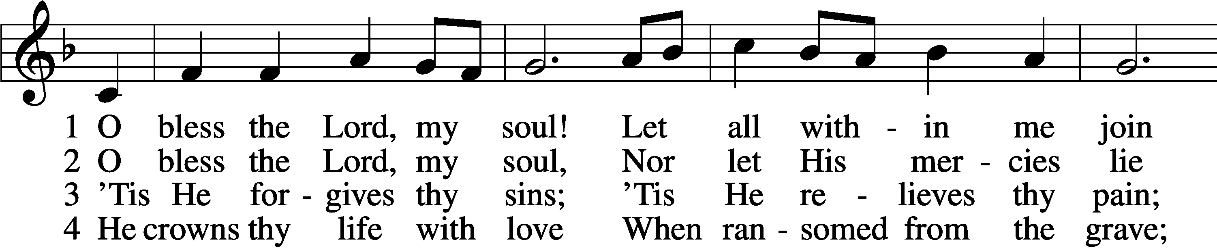

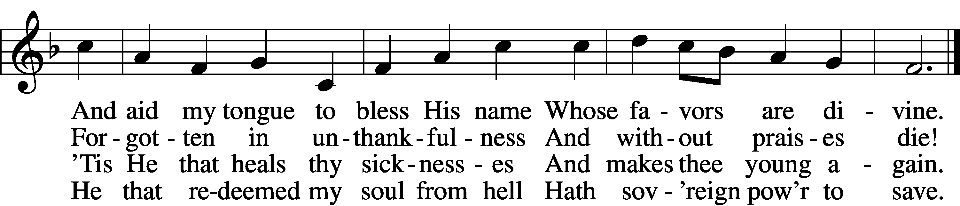

5 He fills the poor with good;  
 He gives the suff’rers rest.  
The Lord hath judgments for the proud  
 And justice for th’oppressed.

6 His wondrous works and ways  
 He made by Moses known,  
But sent the world His truth and grace  
 By His belovèd Son.

Text and tune: Public domain

P In the name of the Father and of the T Son and of the Holy Spirit.

C **Amen.**

P Beloved in the Lord! Let us draw near with a true heart and confess our sins unto God our Father, beseeching Him in the name of our Lord Jesus Christ to grant us forgiveness.

P Our help is in the name of the Lord,

C **who made heaven and earth.**

P I said, I will confess my transgressions unto the Lord,

C **and You forgave the iniquity of my sin.**

P O almighty God, merciful Father,

C **I, a poor, miserable sinner, confess unto You all my sins and iniquities with which I have ever offended You and justly deserved Your temporal and eternal punishment. But I am heartily sorry for them and sincerely repent of them, and I pray You of Your boundless mercy and for the sake of the holy, innocent, bitter sufferings and death of Your beloved Son, Jesus Christ, to be gracious and merciful to me, a poor, sinful being.**

P Upon this your confession, I, by virtue of my office, as a called and ordained servant of the Word, announce the grace of God unto all of you, and in the stead and by the command of my Lord Jesus Christ I forgive you all your sins in the name of the Father and of the T Son and of the Holy Spirit.

C **Amen.**

# Service of the Word

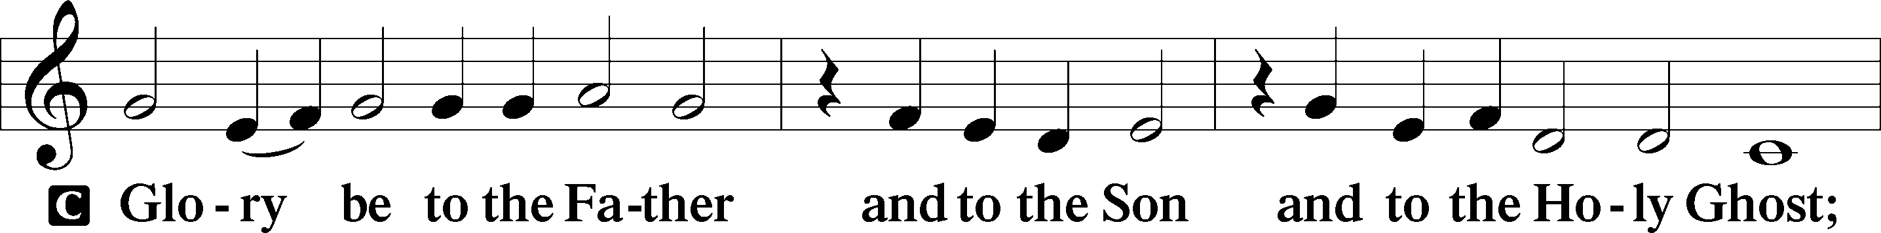

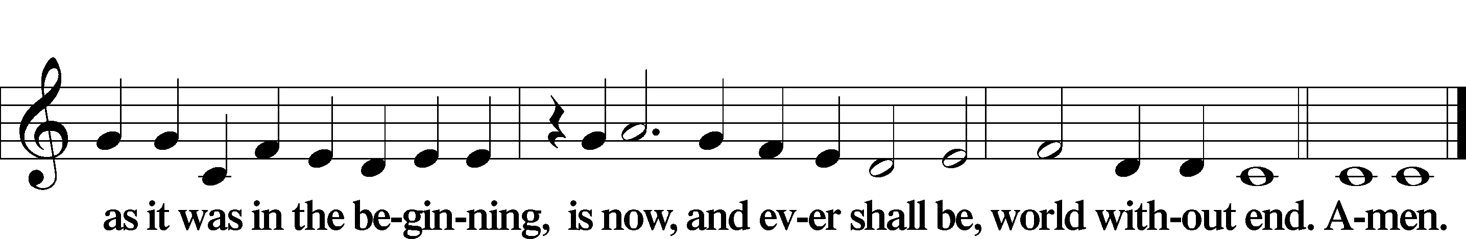

Kyrie LSB 186

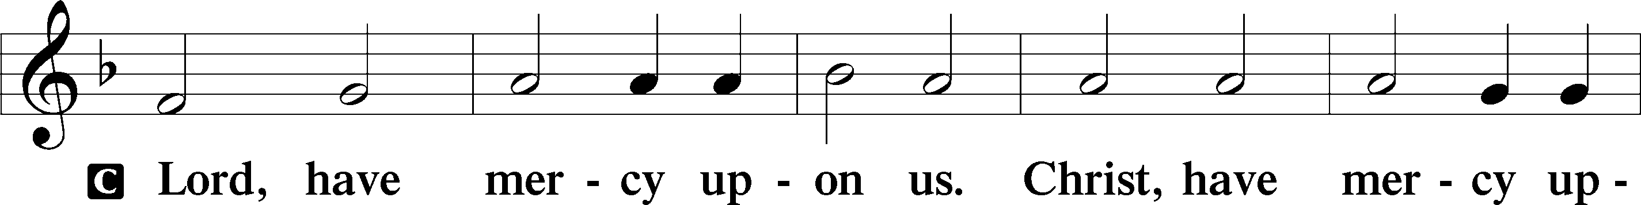

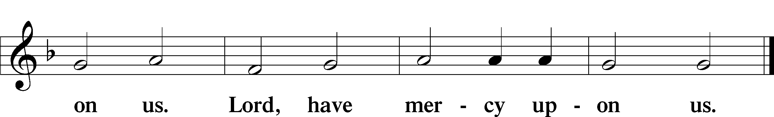

Gloria in Excelsis LSB 187

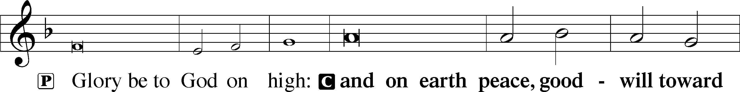

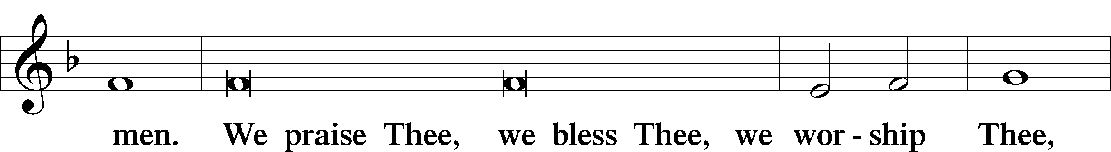

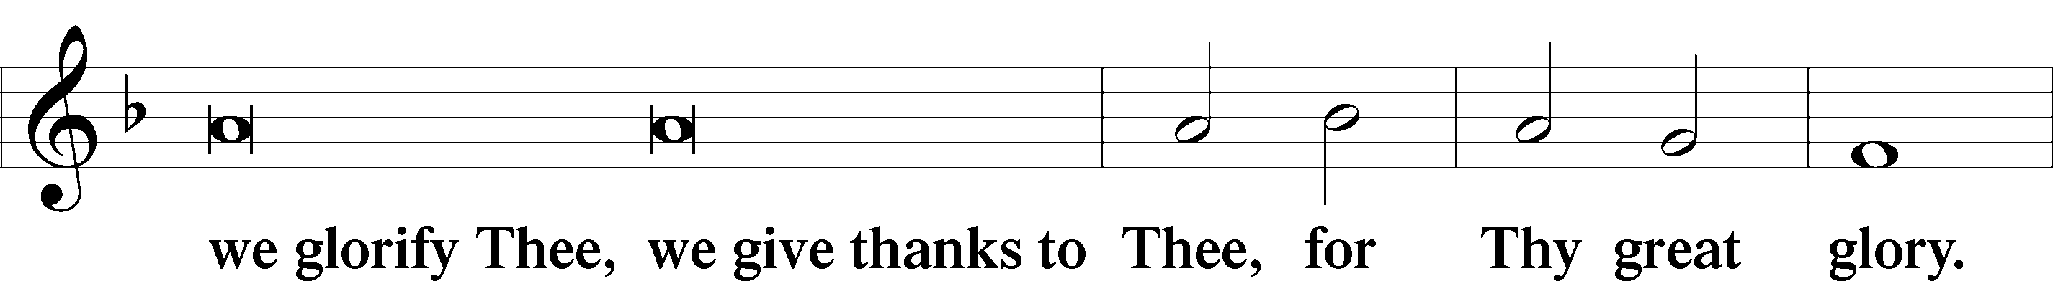

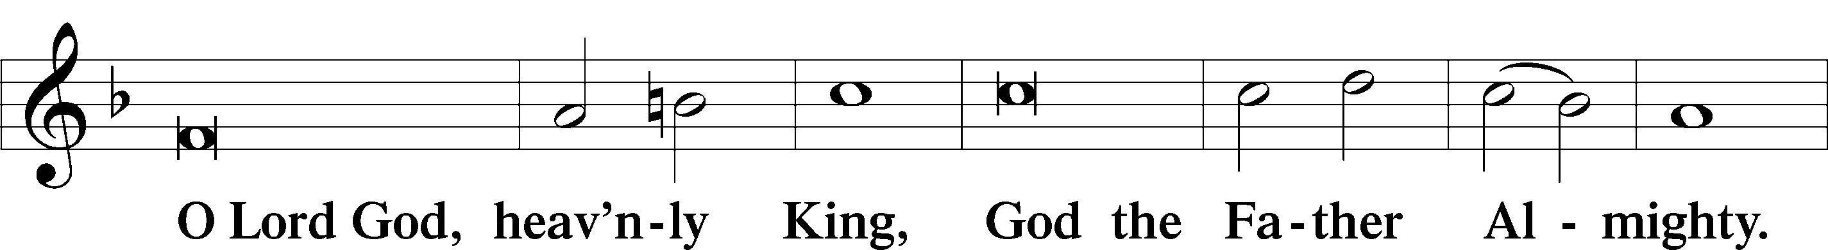

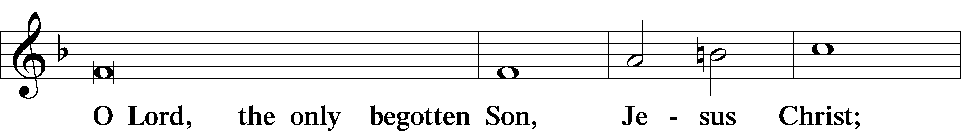

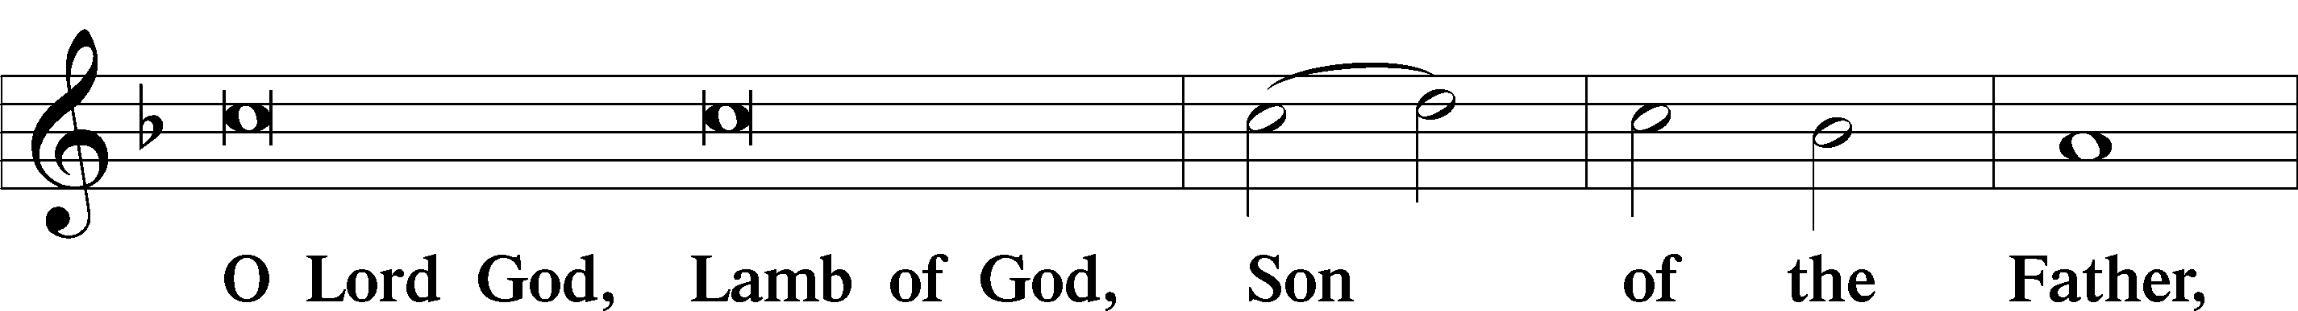

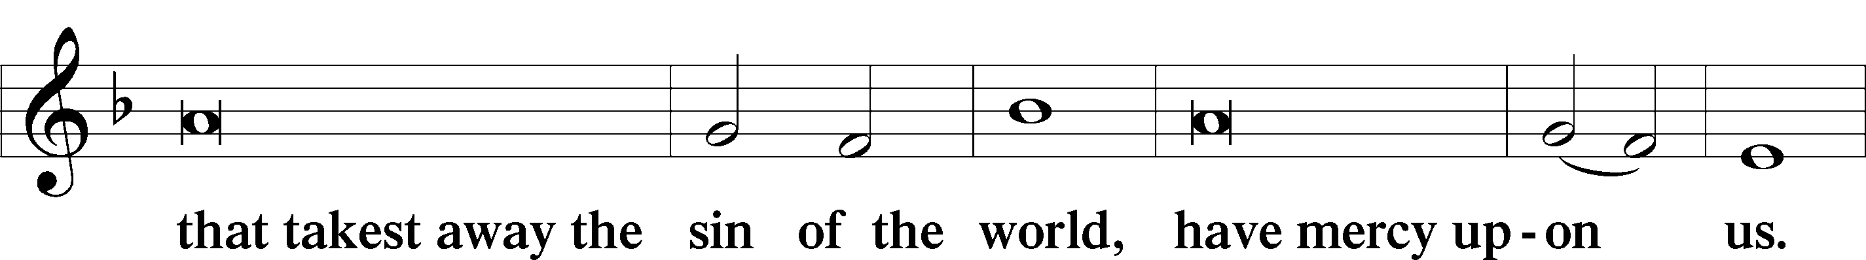

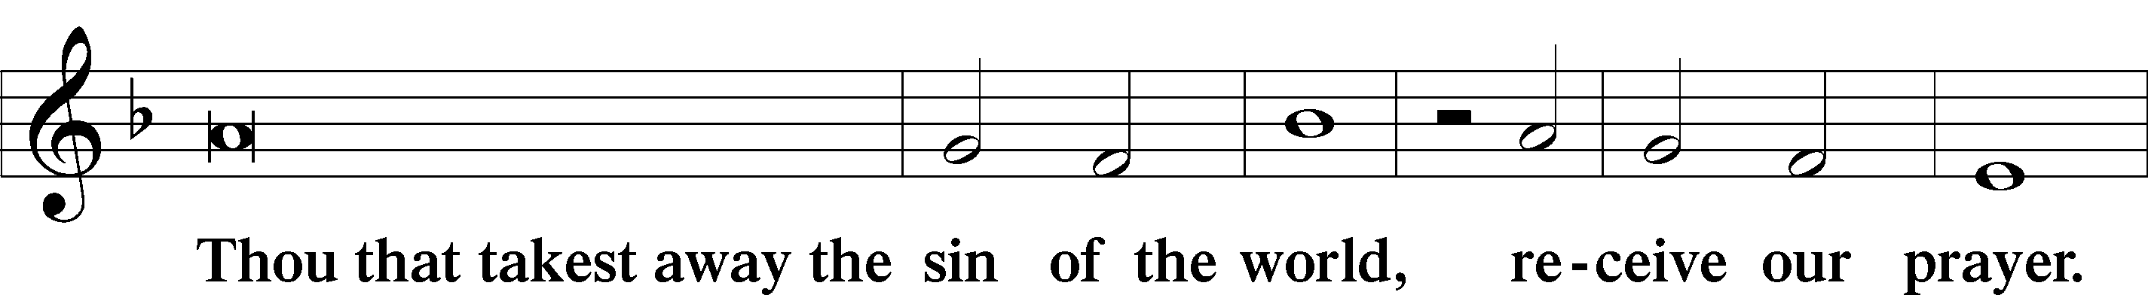

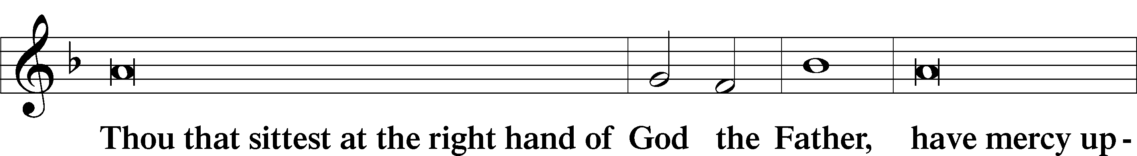

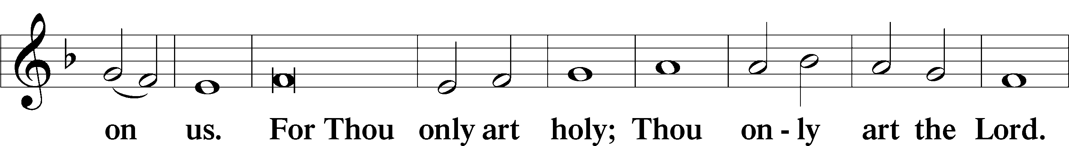

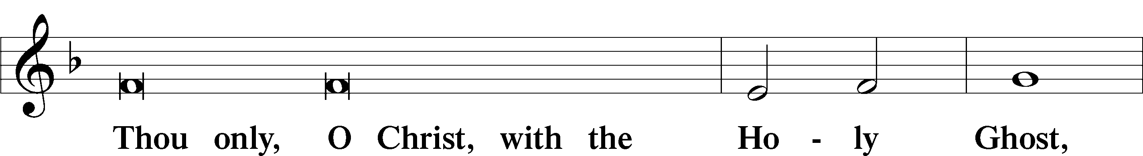

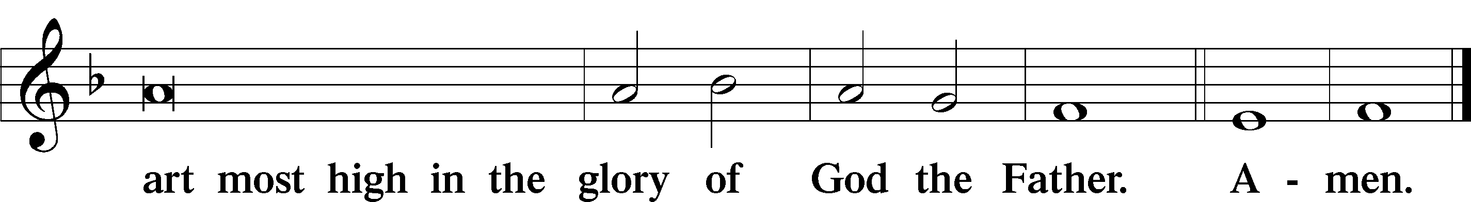

Salutation and Collect of the Day

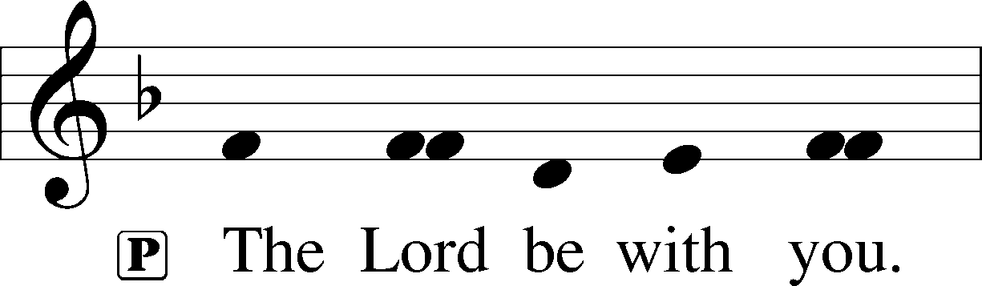

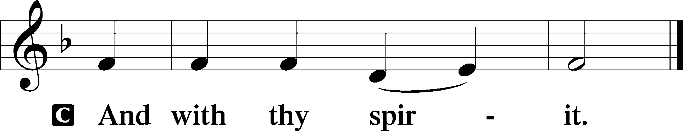

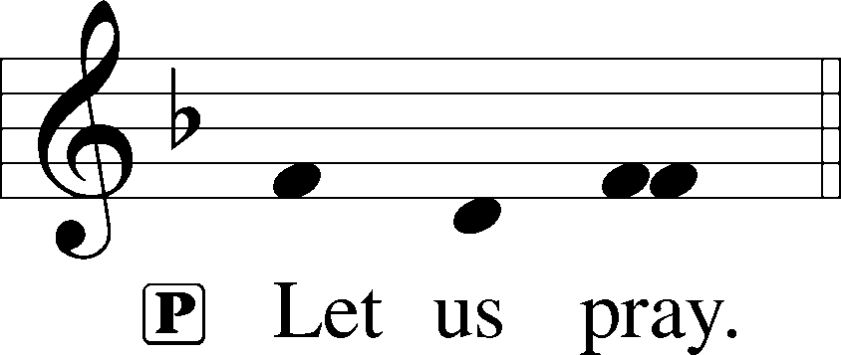

P Lord God, heavenly Father, send forth Your Son to lead home His bride, the Church, that with all the company of the redeemed we may finally enter into His eternal wedding feast; through the same Jesus Christ, our Lord, who lives and reigns with You and the Holy Spirit, one God, now and forever.

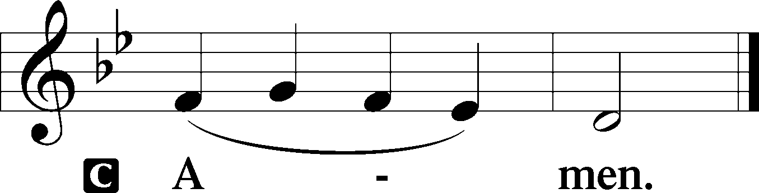

Old Testament Reading Amos 5:18–24

18Woe to you who desire the day of the Lord!  
 Why would you have the day of the Lord?  
It is darkness, and not light, 19as if a man fled from a lion,  
 and a bear met him, or went into the house and leaned his hand against the wall, and a serpent bit him.  
20Is not the day of the Lord darkness, and not light,  
 and gloom with no brightness in it?  
21“I hate, I despise your feasts,  
 and I take no delight in your solemn assemblies.  
22Even though you offer me your burnt offerings and grain offerings, I will not accept them; and the peace offerings of your fattened animals, I will not look upon them.  
23Take away from me the noise of your songs;  
 to the melody of your harps I will not listen.  
24But let justice roll down like waters,  
 and righteousness like an ever-flowing stream.”

A This is the Word of the Lord.

C **Thanks be to God.**

Psalm Psalm 70

1Make haste, O God, to deliver me!  
 **O Lord, make haste to help me!**2Let them be put to shame and confusion  
 **who seek my life!**Let them be turned back and brought to dishonor  
 **who desire my hurt!**3Let them turn back because of their shame  
 **who say, “Aha, Aha!”**

4May all who seek you  
 **rejoice and be glad in you!**May those who love your salvation  
 **say evermore, “God is great!”**5But I am poor and needy;  
 **hasten to me, O God!**You are my help and my deliverer;  
 **O Lord, do not delay!**

Epistle 1 Thessalonians 4:13–18

13But we do not want you to be uninformed, brothers, about those who are asleep, that you may not grieve as others do who have no hope. 14For since we believe that Jesus died and rose again, even so, through Jesus, God will bring with him those who have fallen asleep. 15For this we declare to you by a word from the Lord, that we who are alive, who are left until the coming of the Lord, will not precede those who have fallen asleep. 16For the Lord himself will descend from heaven with a cry of command, with the voice of an archangel, and with the sound of the trumpet of God. And the dead in Christ will rise first. 17Then we who are alive, who are left, will be caught up together with them in the clouds to meet the Lord in the air, and so we will always be with the Lord. 18Therefore encourage one another with these words.

A This is the Word of the Lord.

C **Thanks be to God.**

Alleluia LSB 190

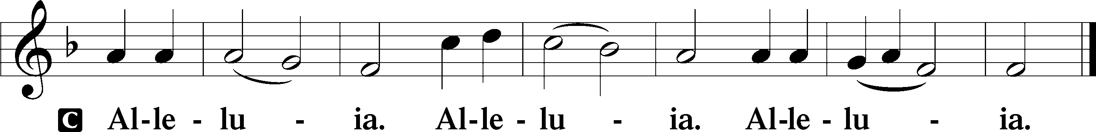

Holy Gospel Matthew 25:1–13

P The Holy Gospel according to St. Matthew, the twenty-fifth chapter.

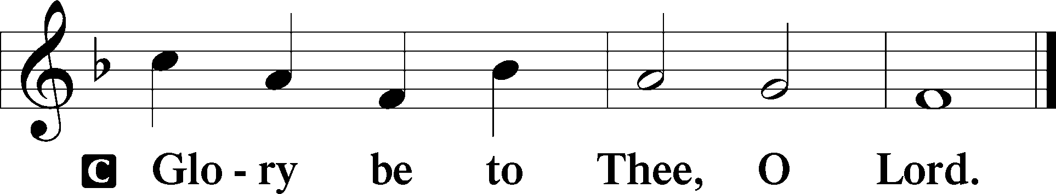

1[Jesus said:] “The kingdom of heaven will be like ten virgins who took their lamps and went to meet the bridegroom. 2Five of them were foolish, and five were wise. 3For when the foolish took their lamps, they took no oil with them, 4but the wise took flasks of oil with their lamps. 5As the bridegroom was delayed, they all became drowsy and slept. 6But at midnight there was a cry, ‘Here is the bridegroom! Come out to meet him.’ 7Then all those virgins rose and trimmed their lamps. 8And the foolish said to the wise, ‘Give us some of your oil, for our lamps are going out.’ 9But the wise answered, saying, ‘Since there will not be enough for us and for you, go rather to the dealers and buy for yourselves.’ 10And while they were going to buy, the bridegroom came, and those who were ready went in with him to the marriage feast, and the door was shut. 11Afterward the other virgins came also, saying, ‘Lord, lord, open to us.’ 12But he answered, ‘Truly, I say to you, I do not know you.’ 13Watch therefore, for you know neither the day nor the hour.”

P This is the Gospel of the Lord.

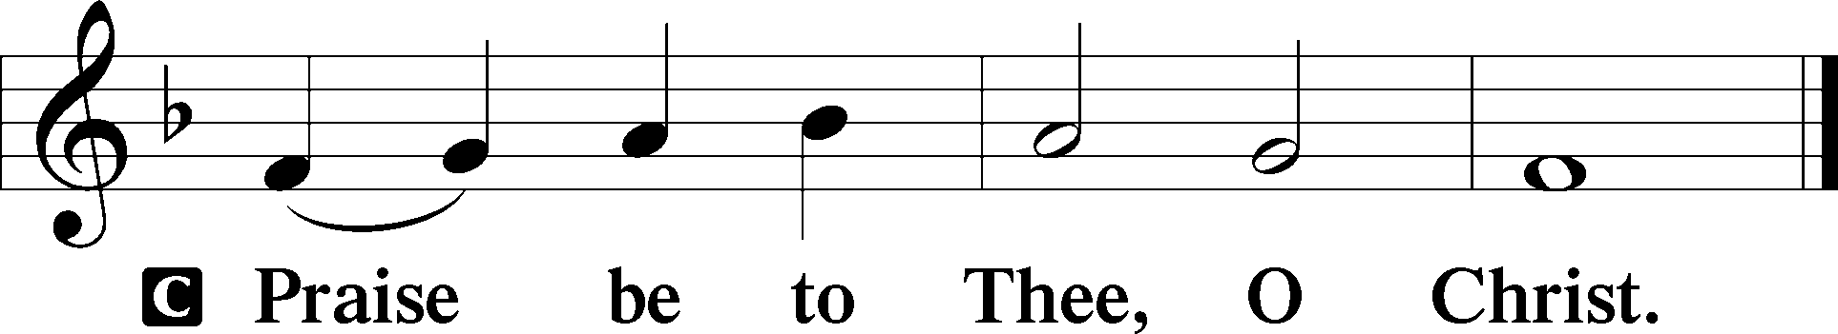

Nicene Creed

C **I believe in one God,**

**the Father Almighty,**

**maker of heaven and earth**

**and of all things visible and invisible.**

**And in one Lord Jesus Christ,**

**the only-begotten Son of God,**

**begotten of His Father before all worlds,**

**God of God, Light of Light,**

**very God of very God,**

**begotten, not made,**

**being of one substance with the Father,**

**by whom all things were made;**

**who for us men and for our salvation came down from heaven**

**and was incarnate by the Holy Spirit of the virgin Mary**

**and was made man;**

**and was crucified also for us under Pontius Pilate.**

**He suffered and was buried.**

**And the third day He rose again according to the Scriptures**

**and ascended into heaven**

**and sits at the right hand of the Father.**

**And He will come again with glory to judge both the living and the dead,**

**whose kingdom will have no end.**

**And I believe in the Holy Spirit,**

**the Lord and giver of life,**

**who proceeds from the Father and the Son,**

**who with the Father and the Son together is worshiped and glorified,**

**who spoke by the prophets.**

**And I believe in one holy Christian and apostolic Church,**

**I acknowledge one Baptism for the remission of sins,**

**and I look for the resurrection of the dead**

**and the life** T **of the world to come. Amen.**

Children’s Message Oil in My Lamp

490 Jesus Lives! The Victory’s Won

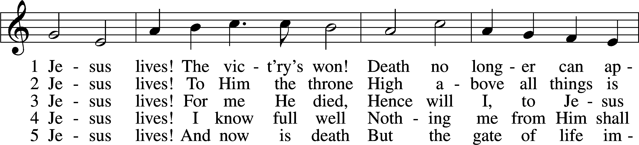

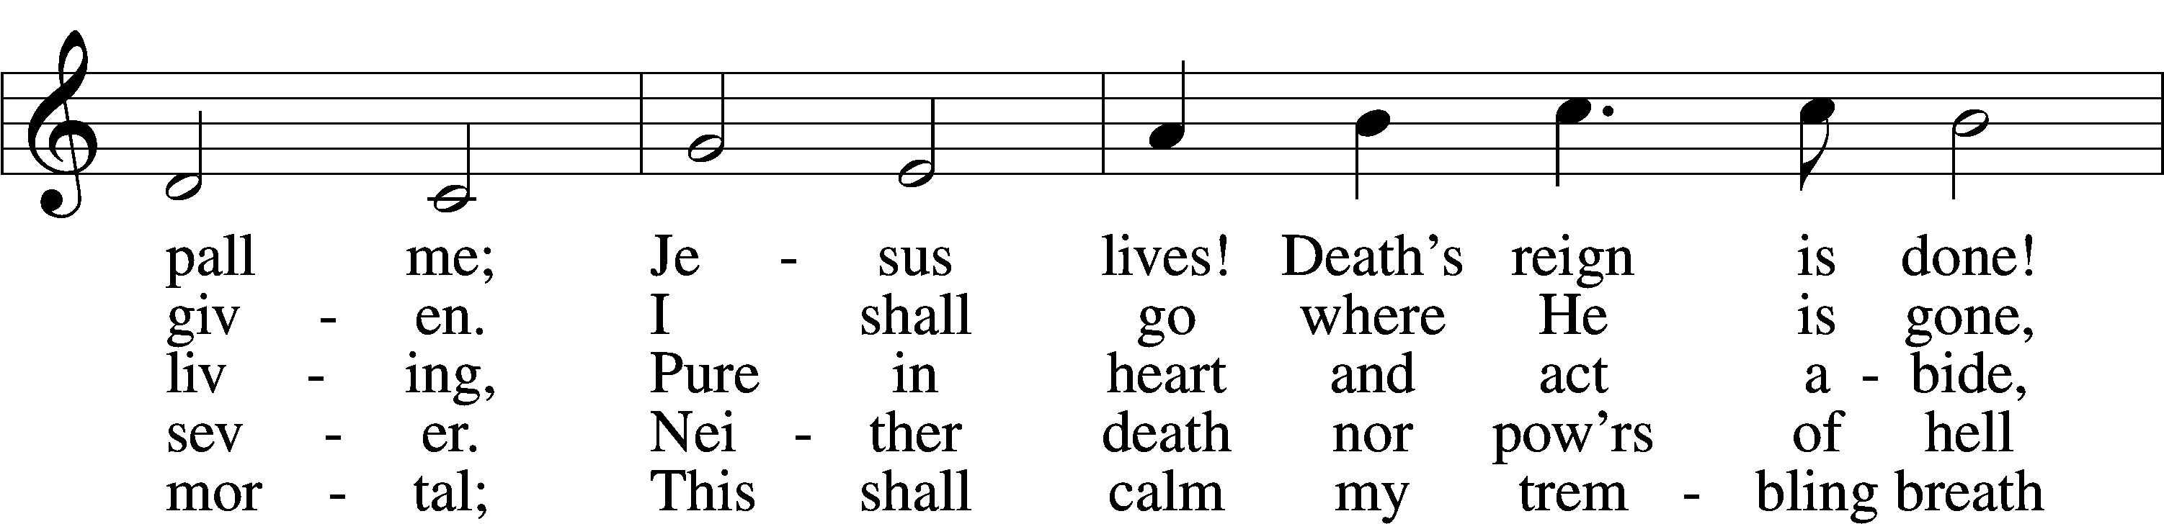

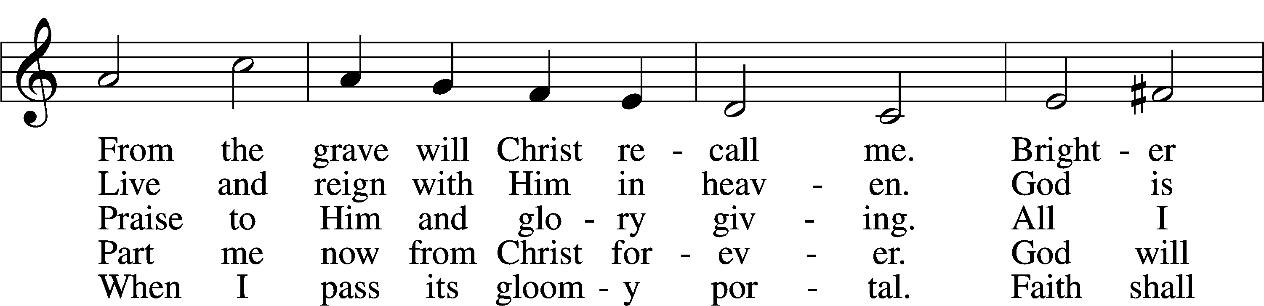

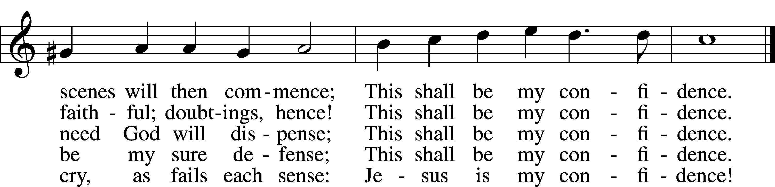

Text and tune: Public domain

Sermon Jesus Lives!

Installation of New Congregational Officers

Jon Larson – Board of Elders

Justin Perkins – Board of Elders

Cassey Bluntzer-Utley – Youth Leader

Offertory LSB 192

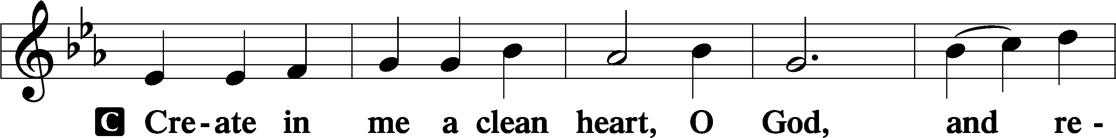

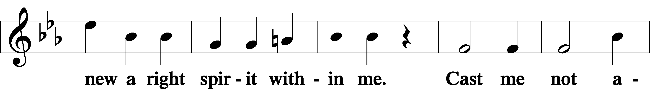

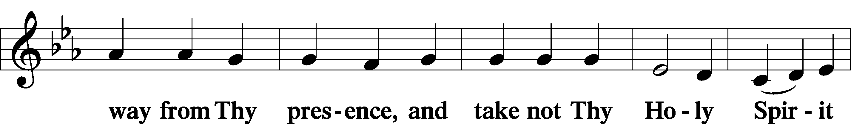

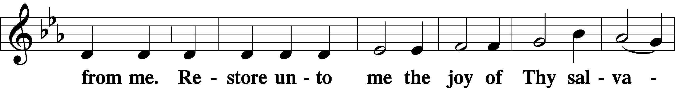

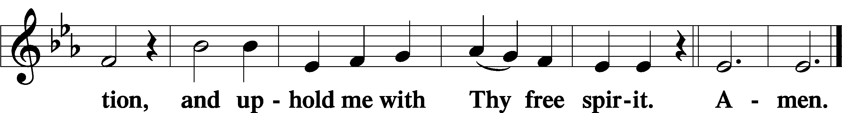

Prayer of the Church

# Service of the Sacrament

Preface LSB 194







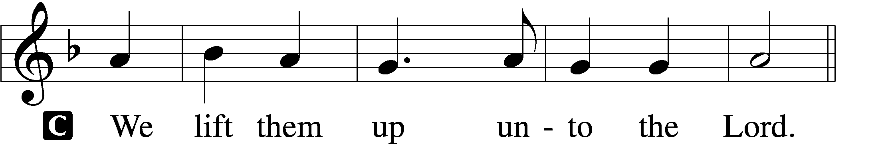

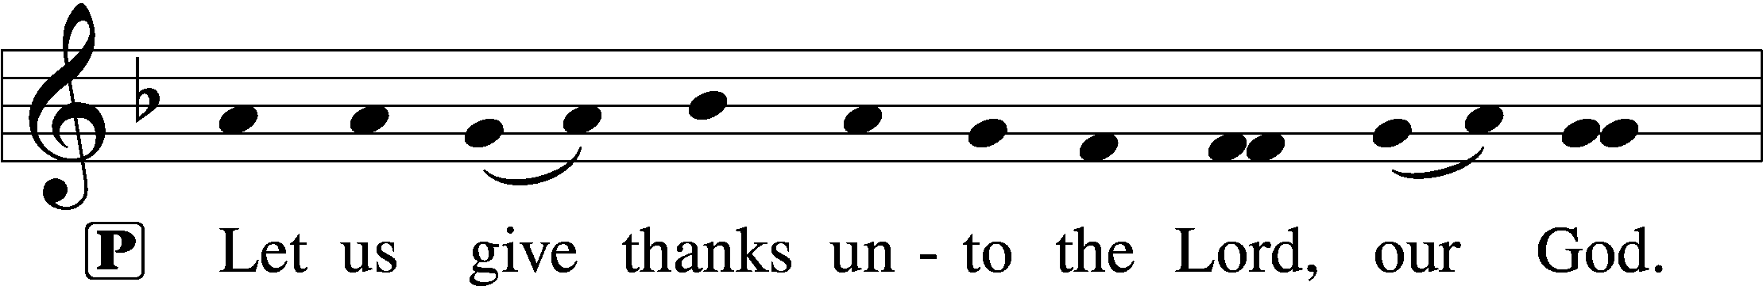

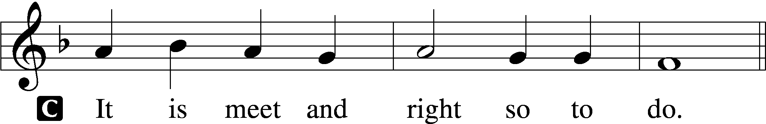

P It is truly meet, right, and salutary that we should at all times and in all places give thanks to You, holy Lord, almighty Father, everlasting God, through Jesus Christ, our Lord. Therefore with angels and archangels and with all the company of heaven we laud and magnify Your glorious name, evermore praising You and saying:

Sanctus LSB 195

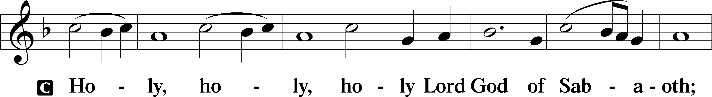

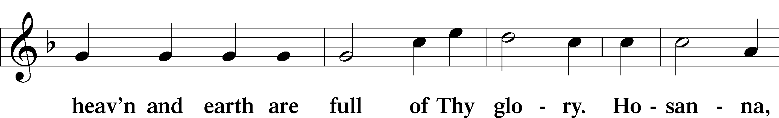

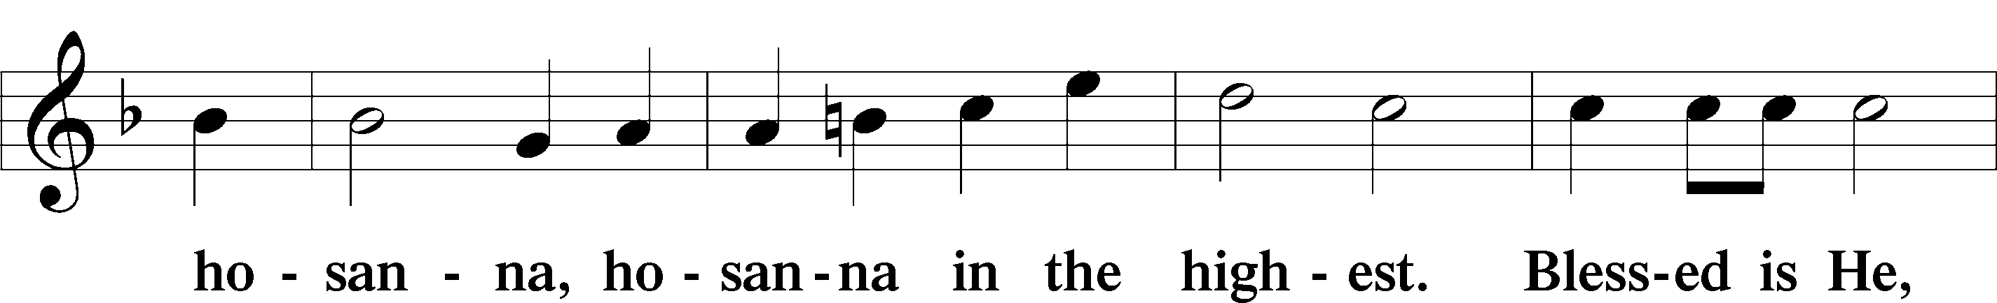

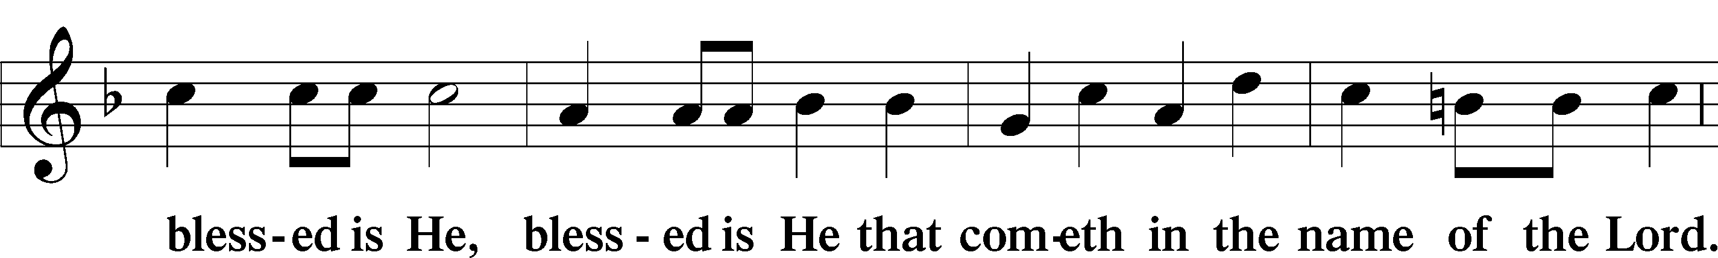

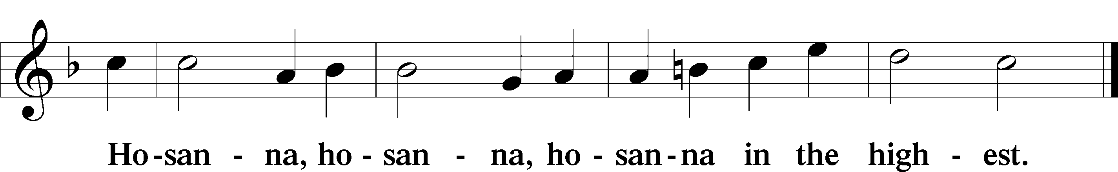

Lord’s Prayer LSB 196

P Our Father who art in heaven,

hallowed be Thy name,

Thy kingdom come,

Thy will be done on earth as it is in heaven;

give us this day our daily bread;

and forgive us our trespasses as we forgive those who trespass against us;

and lead us not into temptation,

but deliver us from evil.

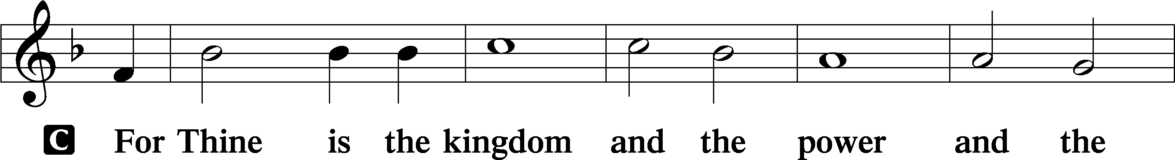

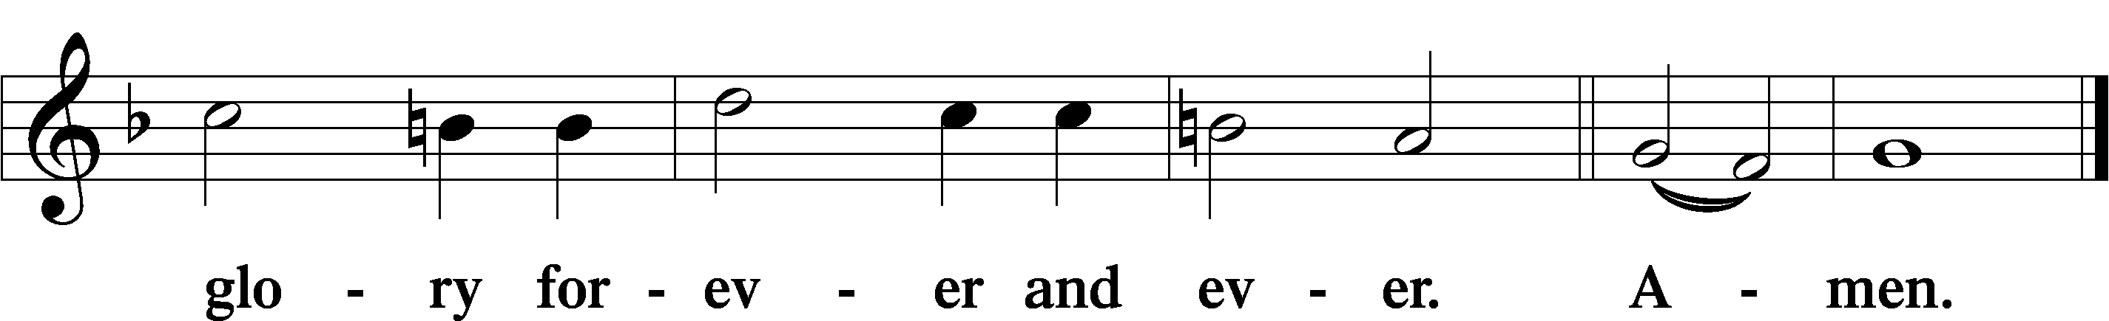

The Words of Our Lord LSB 197

P Our Lord Jesus Christ, on the night when He was betrayed, took bread, and when He had given thanks, He broke it and gave it to the disciples and said: “Take, eat; this is My T body, which is given for you. This do in remembrance of Me.”

In the same way also He took the cup after supper, and when He had given thanks, He gave it to them, saying: “Drink of it, all of you; this cup is the new testament in My T blood, which is shed for you for the forgiveness of sins. This do, as often as you drink it, in remembrance of Me.”

Pax Domini LSB 197

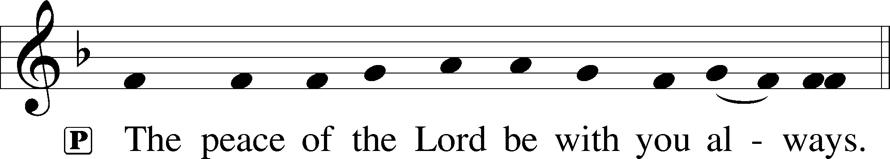

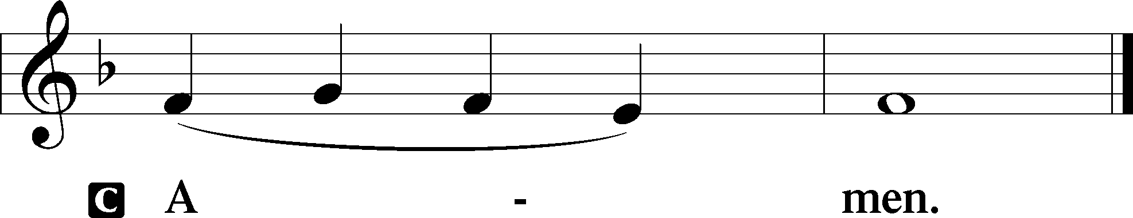

Agnus Dei LSB 198

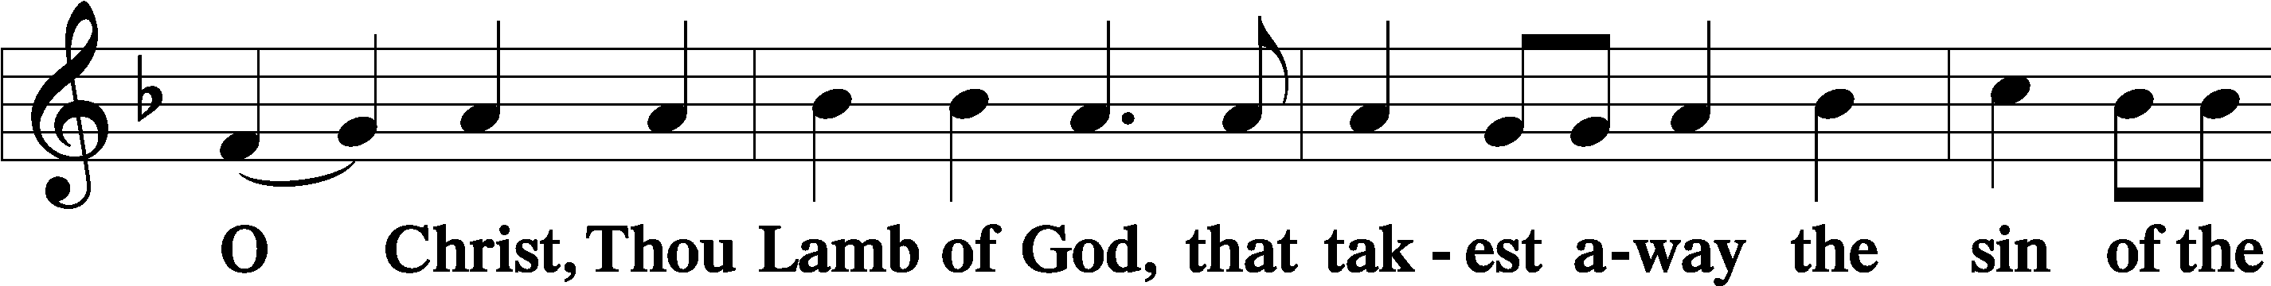

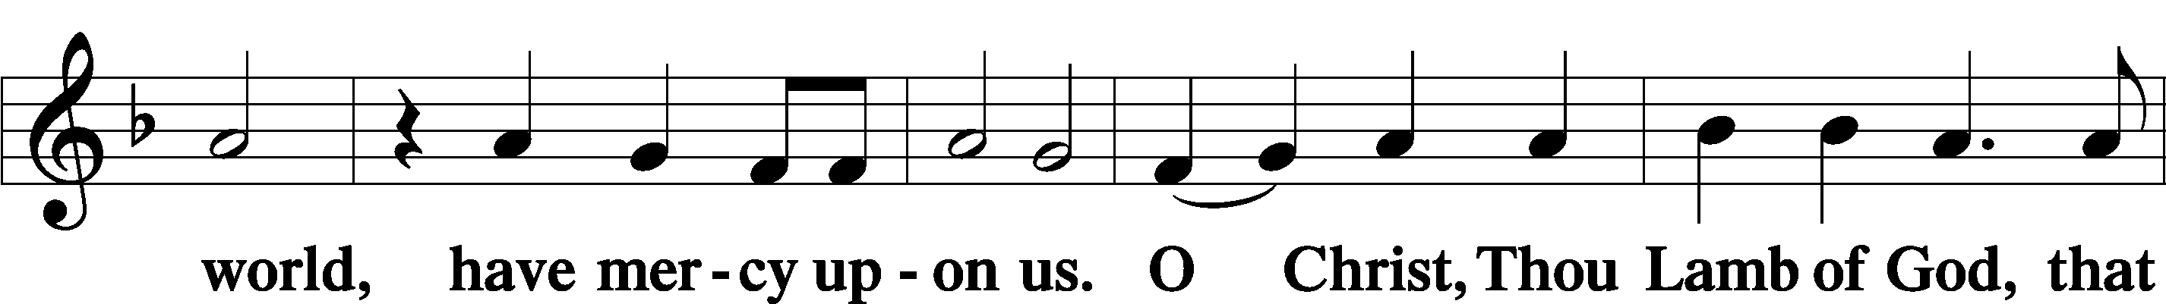

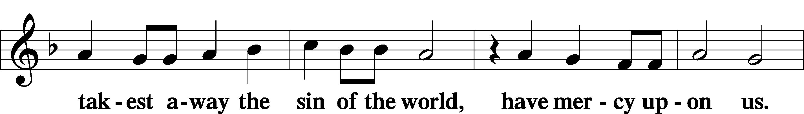

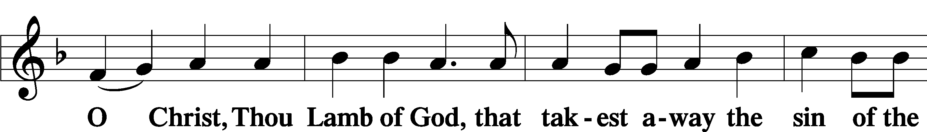

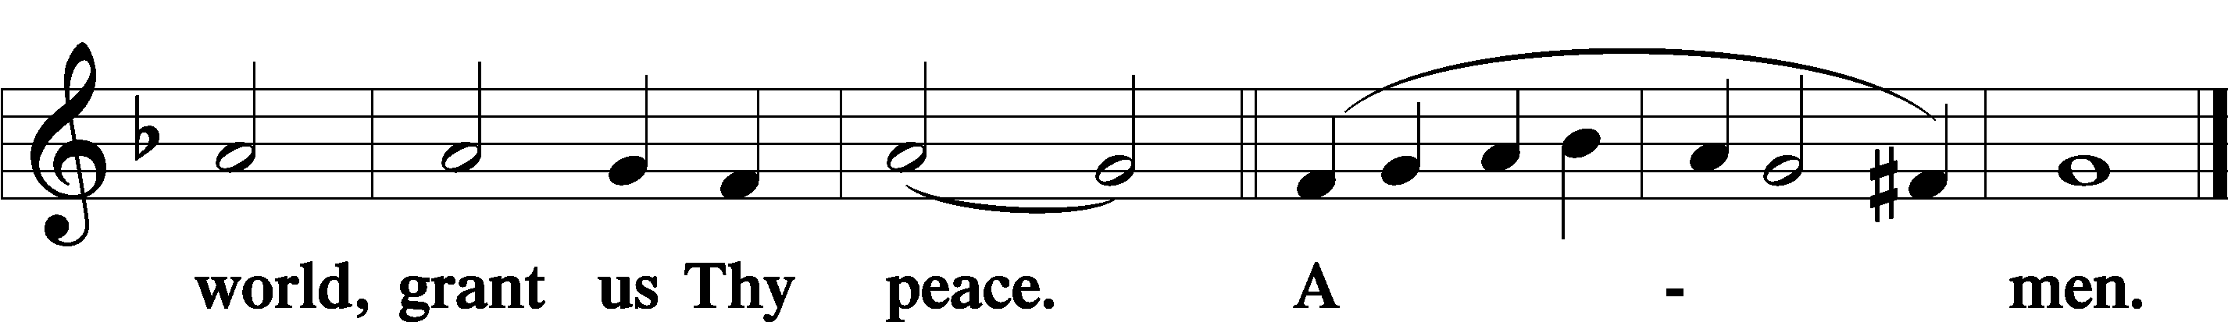

Distribution

636 Soul, Adorn Yourself with Gladness

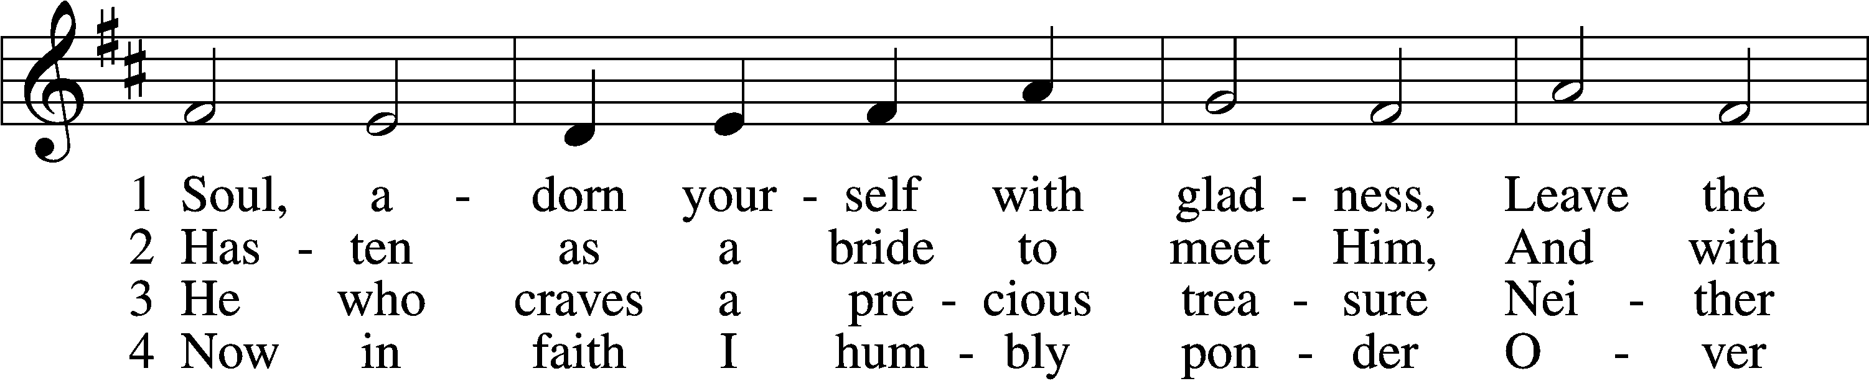

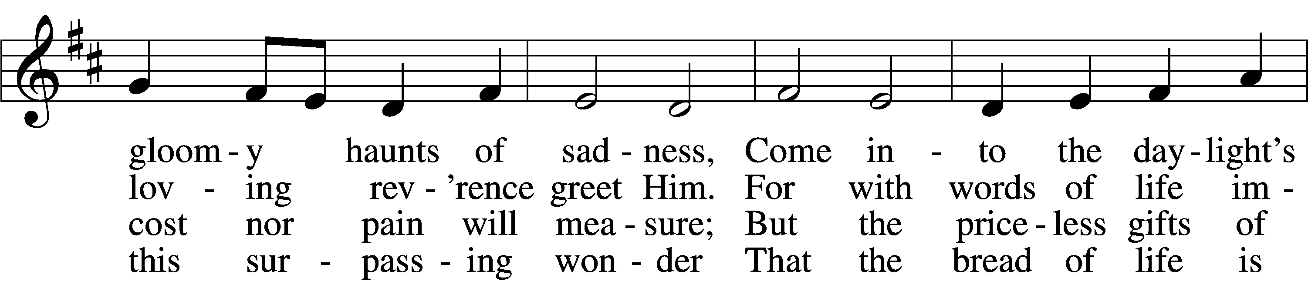

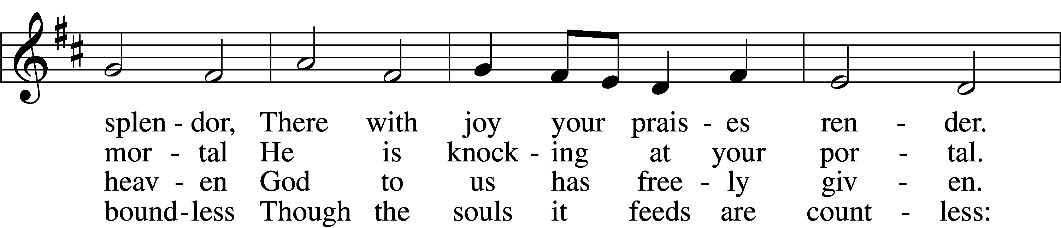

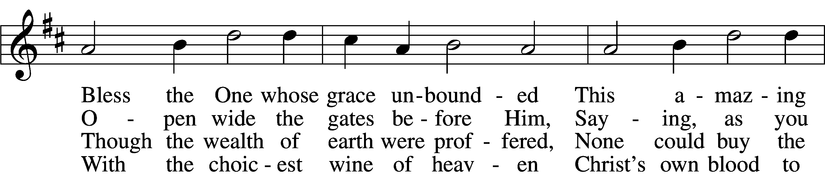

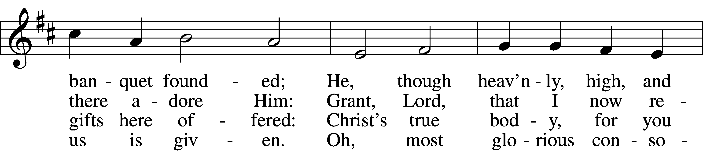

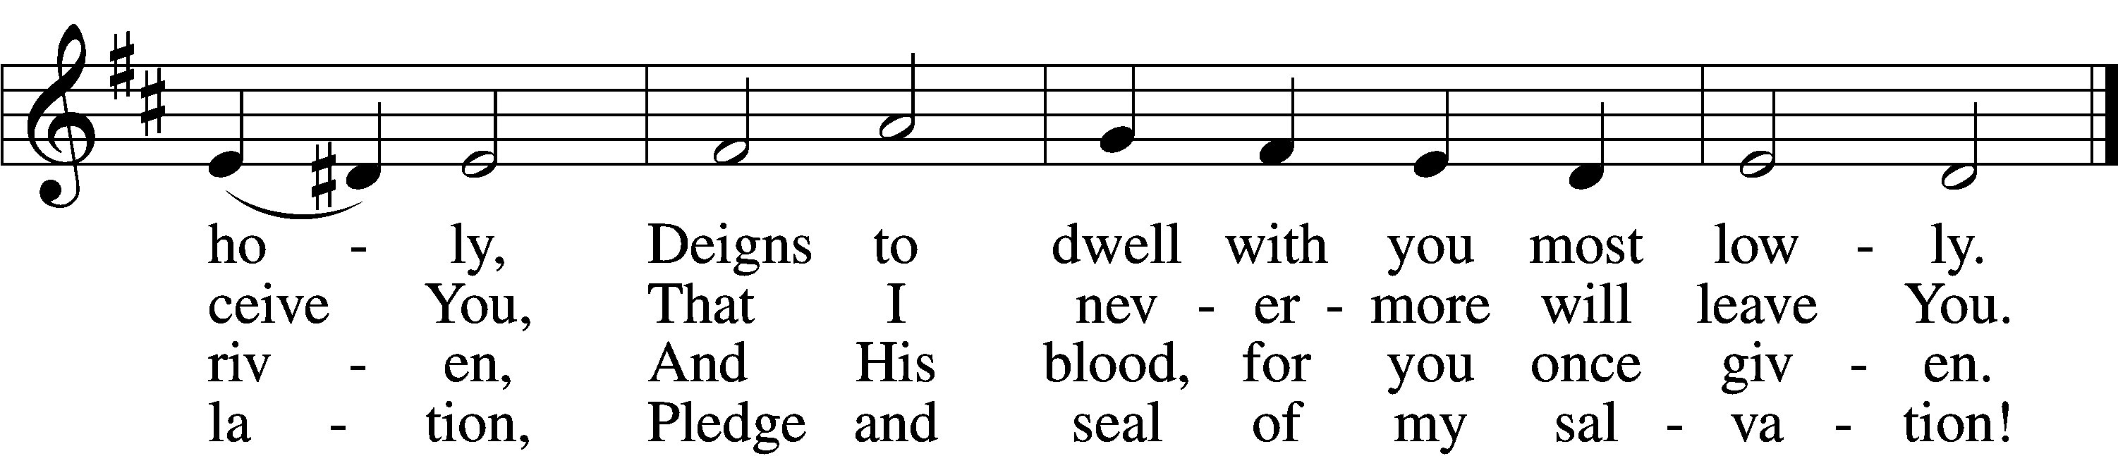

5 Jesus, source of lasting pleasure,  
Truest friend, and dearest treasure,  
 Peace beyond all understanding,  
 Joy into all life expanding:  
Humbly now, I bow before You;  
Love incarnate, I adore You;  
 Worthily let me receive You  
 And, so favored, never leave You.

6 Jesus, sun of life, my splendor,  
Jesus, friend of friends, most tender,  
 Jesus, joy of my desiring,  
 Fount of life, my soul inspiring:  
At Your feet I cry, my maker,  
Let me be a fit partaker  
 Of this blessèd food from heaven,  
 For our good, Your glory, given.

7 Lord, by love and mercy driven,  
You once left Your throne in heaven  
 On the cross for me to languish  
 And to die in bitter anguish,  
To forego all joy and gladness  
And to shed Your blood in sadness.  
 By this blood redeemed and living,  
 Lord, I praise You with thanksgiving.

Tune and text: Public domain

Text (sts. 1, 4–5): © 1978 Lutheran Book of Worship. Used by permission: LSB Hymn License no. 110005047

Nunc Dimittis LSB 199

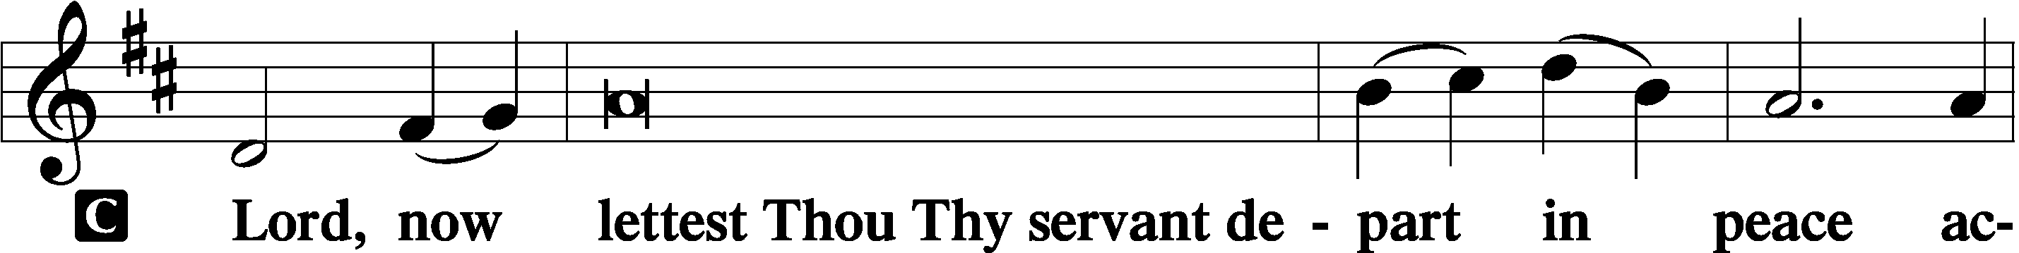

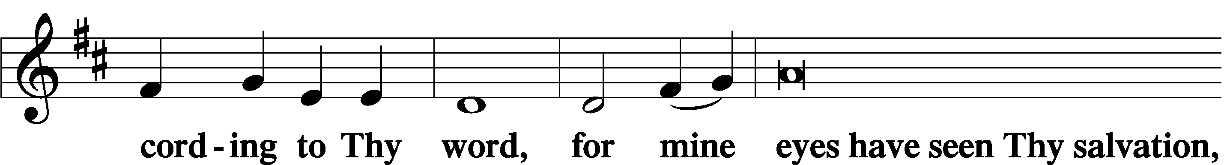

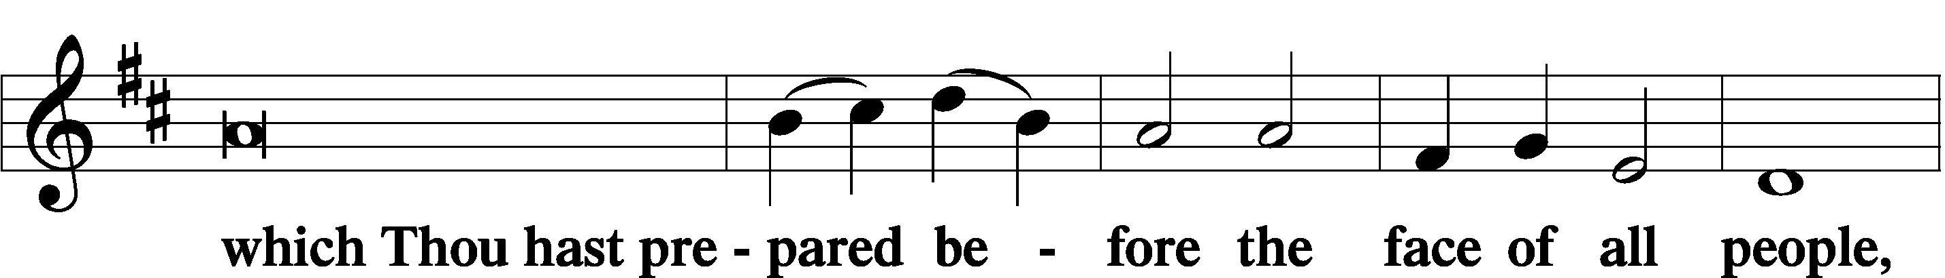

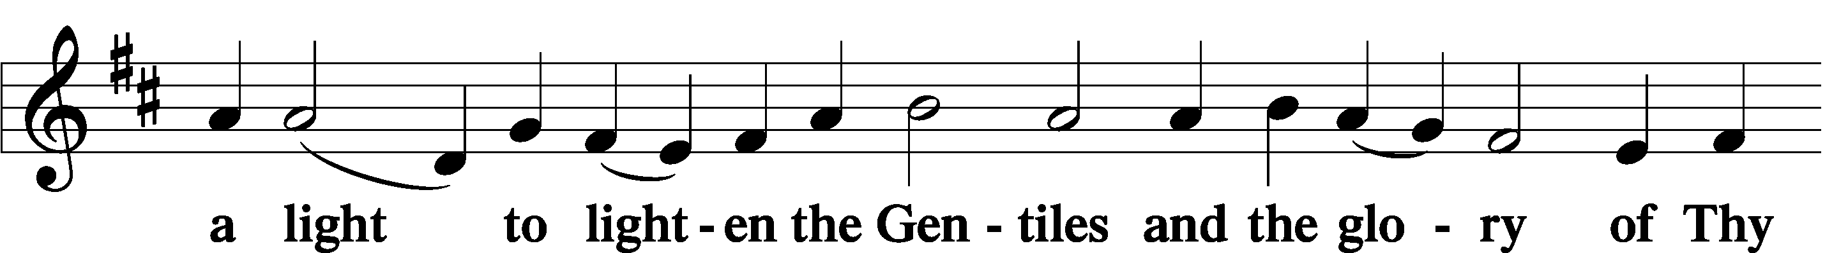

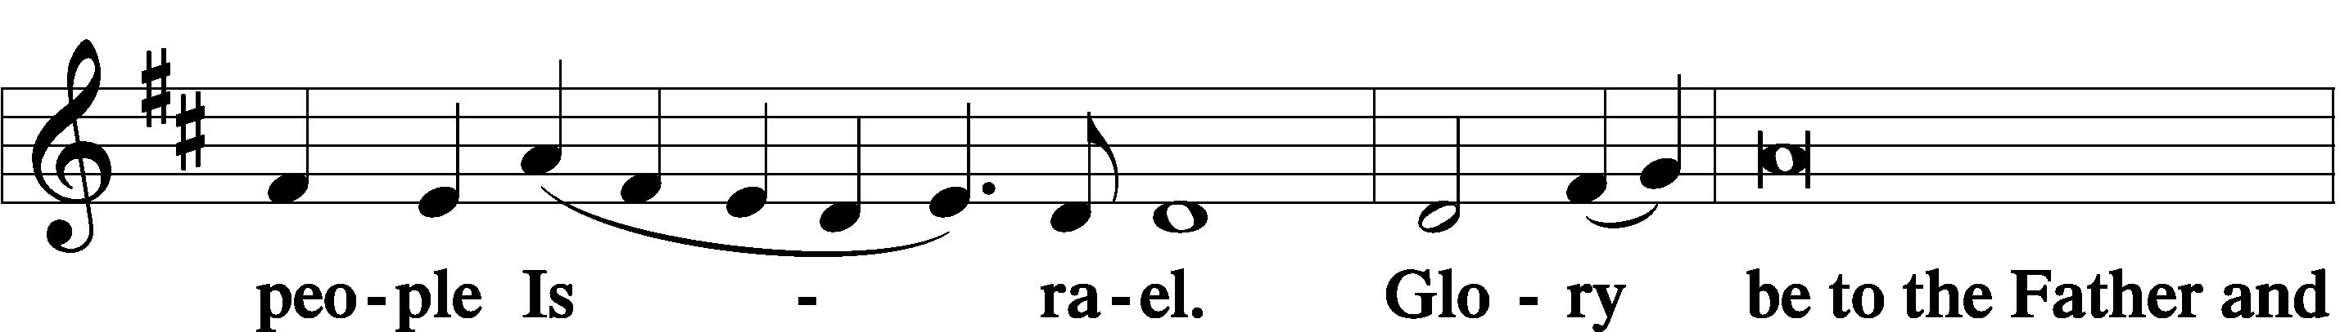

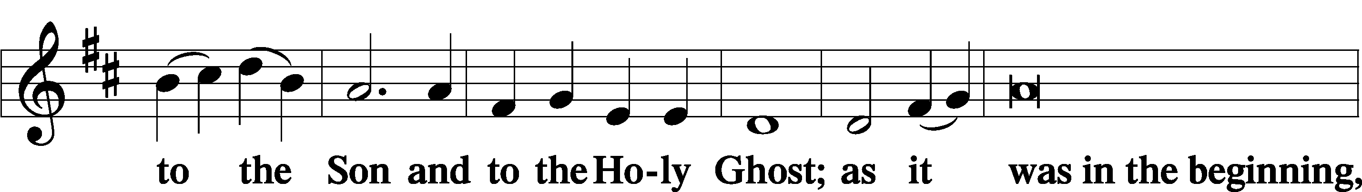

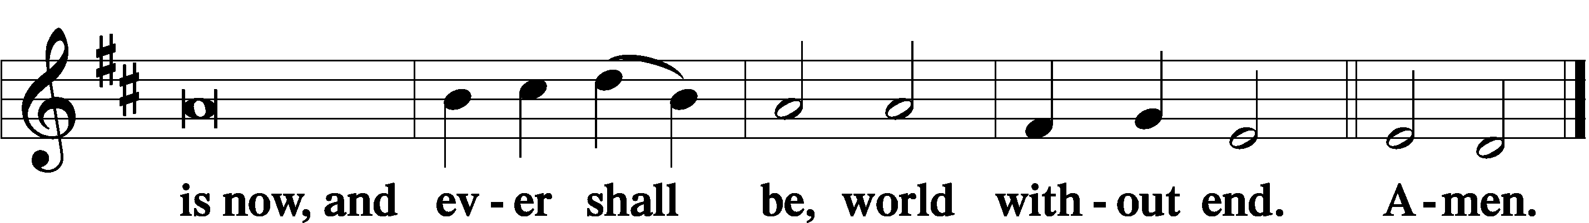

Thanksgiving LSB 200

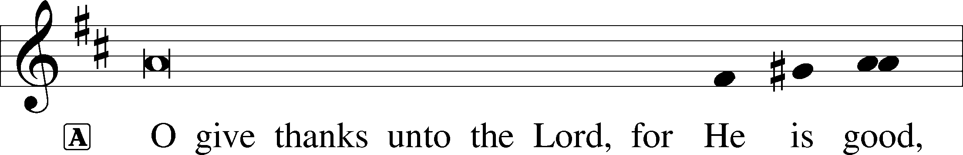

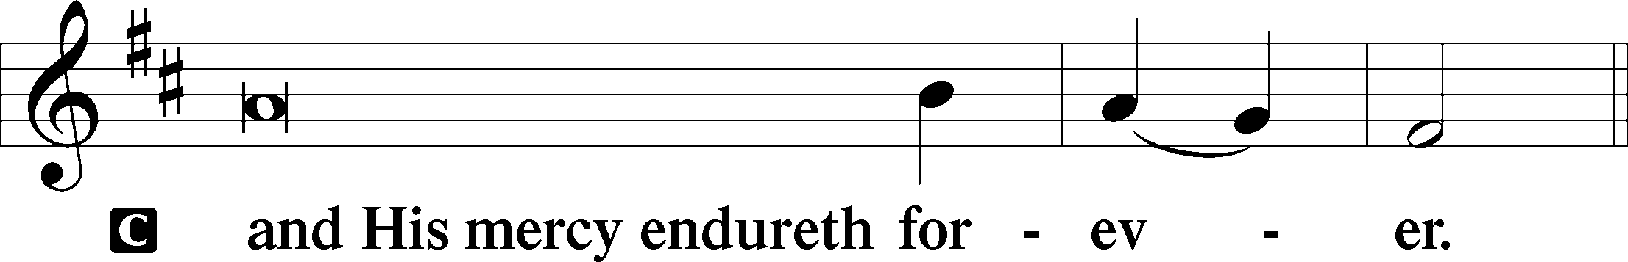

A Let us pray.

O God the Father, the fountain and source of all goodness, who in loving-kindness sent Your only-begotten Son into the flesh, we thank You that for His sake You have given us pardon and peace in this Sacrament, and we ask You not to forsake Your children but always to rule our hearts and minds by Your Holy Spirit that we may be enabled constantly to serve You; through Jesus Christ, Your Son, our Lord, who lives and reigns with You and the Holy Spirit, one God, now and forever.

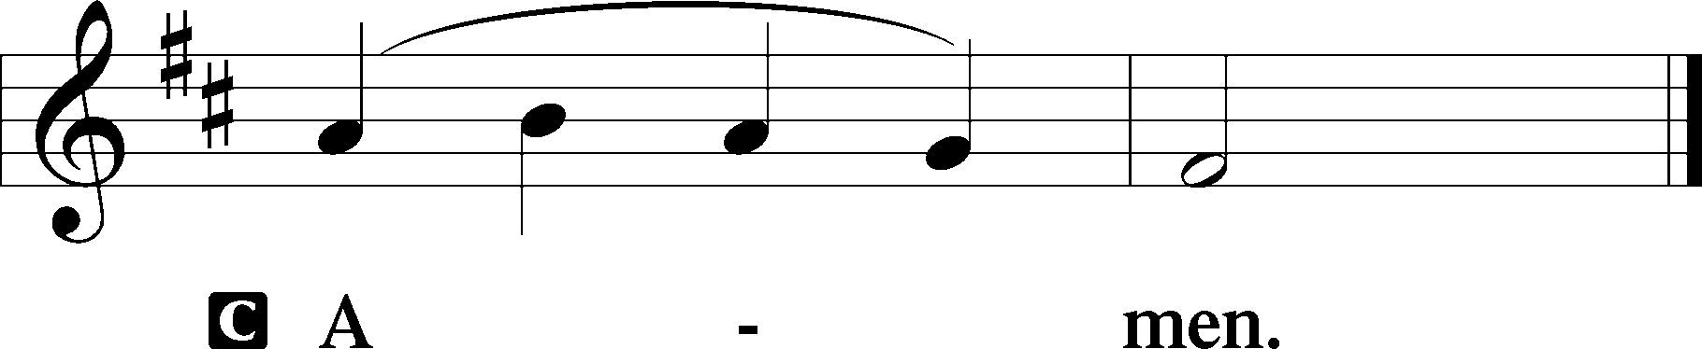

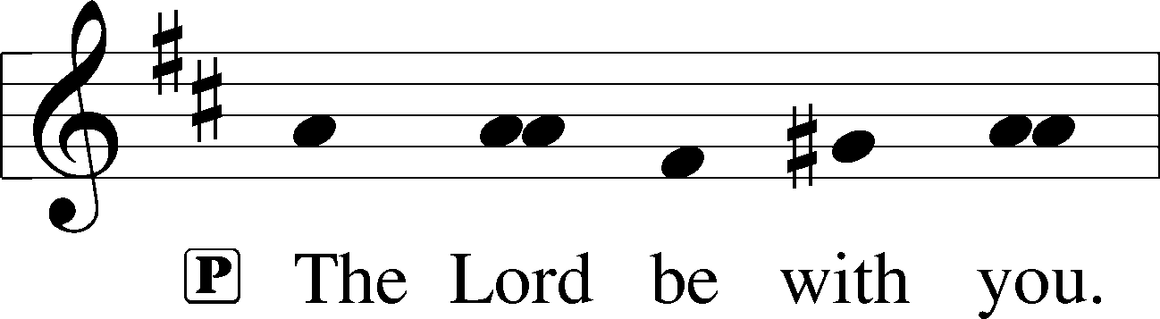

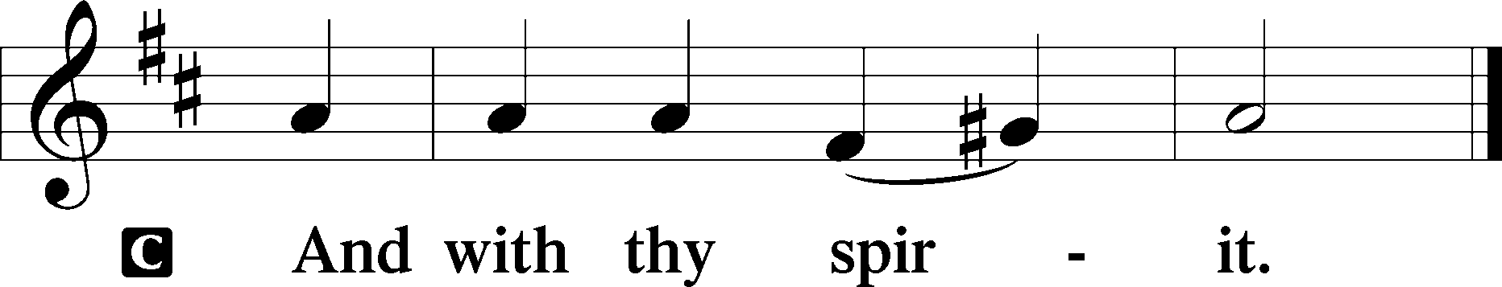

Benedicamus LSB 202

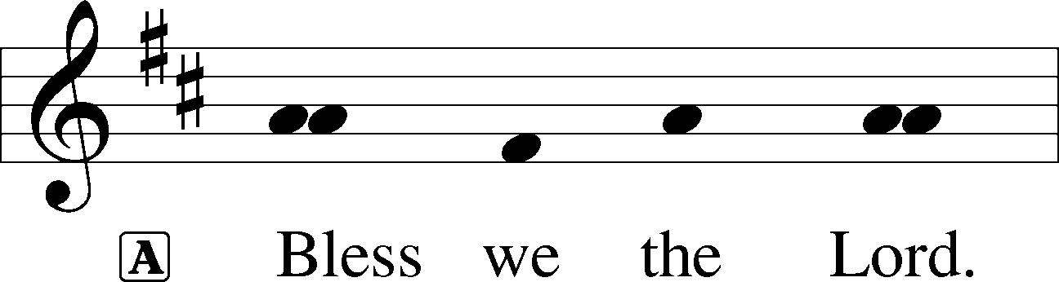

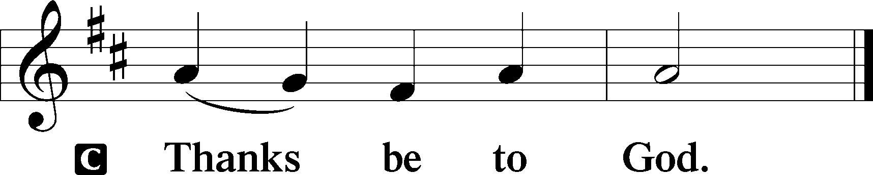

Benediction LSB 202

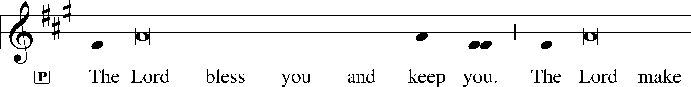

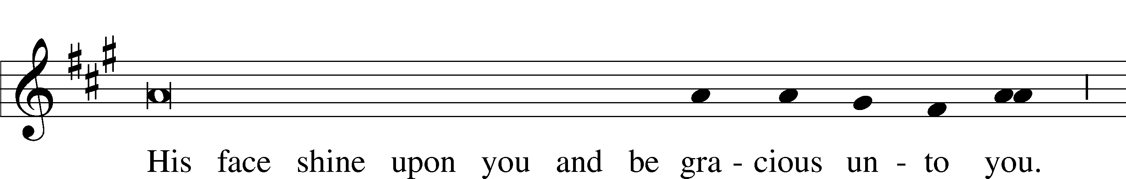

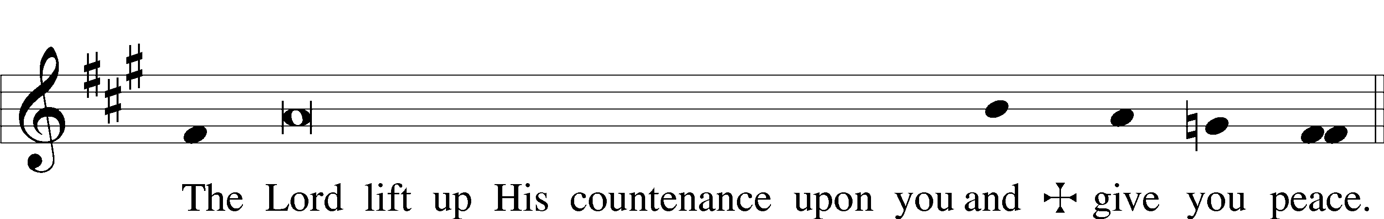

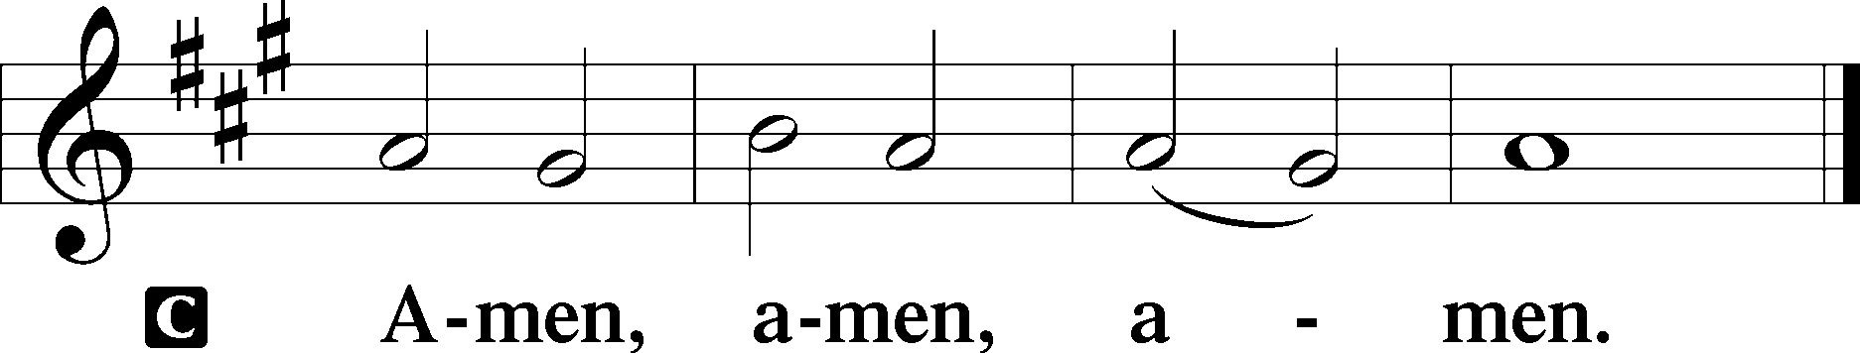

763 When Peace, like a River

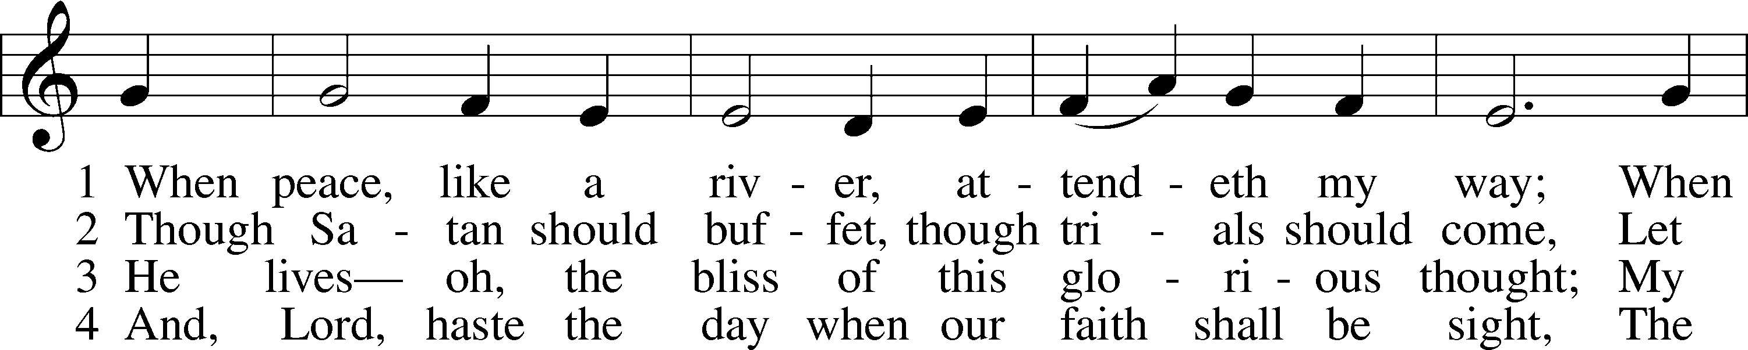

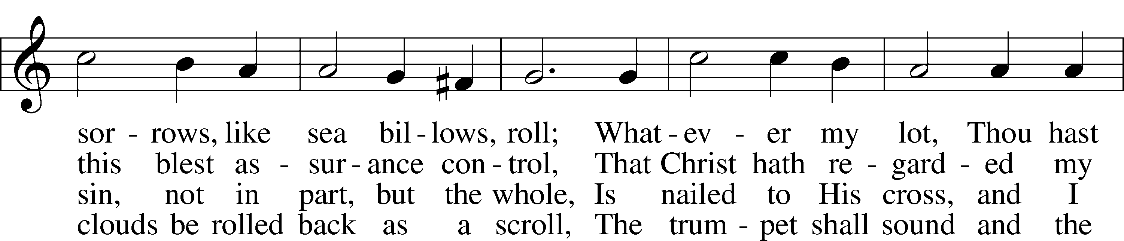

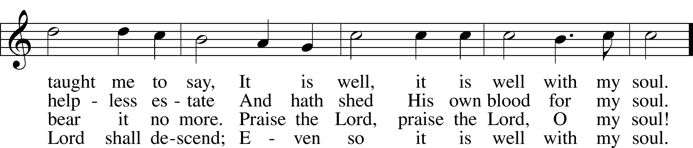

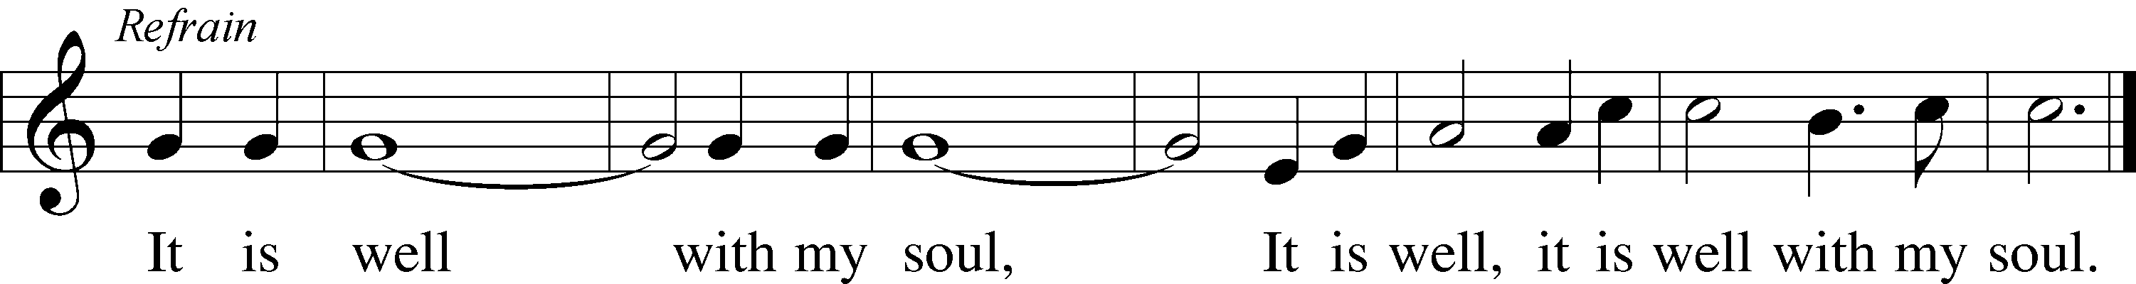

Text and tune: Public domain

Acknowledgments

Divine Service, Setting Three from Lutheran Service Book

Unless otherwise indicated, Scripture quotations are from the ESV® Bible (The Holy Bible, English Standard Version®), copyright © 2001 by Crossway, a publishing ministry of Good News Publishers. Used by permission. All rights reserved.

Created by Lutheran Service Builder © 2018 Concordia Publishing House.

**Life Quote for Sunday, November 8:** “Maybe you enjoy showing hospitality to others, whether at home or as part of a joint effort at church. Perhaps you invite people who are lonely or people who are hungry or homeless or far away from home. Perhaps you are reaching out to refugees or to international students. Perhaps you take a casserole to a family with a new baby or buy toothpaste and toilet paper for the local homeless shelter. If so, you are showing hospitality to Jesus. What an honor to be able to do so!” *Dr. Kari Vo, Lutheran Hour Ministries*

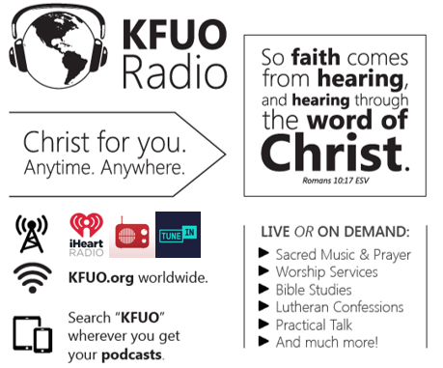

**This week on KFUO.org,**begin studying 2 Timothy on Sharper Iron’s “The Word is Trustworthy” series (weekdays at 8:00 a.m. CT), continue in 2 Samuel on Thy Strong Word (weekdays at 11:00 a.m. CT), consider a curious theological topic on Cross Defense (11/9 at 2:00 p.m. CT), and study the practicality of our Lutheran Confessions on Concord Matters (11/10 at 2:00 p.m. CT). Find these programs on demand at kfuo.org or wherever you get your podcasts!

**Gifts of Time and Treasure**

***“Whatever you do, work heartily for the Lord…”***

***Matthew 6:21***

**LAST WEEK’S OFFERINGS**  **LAST WEEK’S ATTENDANCE**

General Fund $ 1,705.23 Service 34

Needed Weekly $ 3,963.38 Communed 31

Adult Bible Study $ 5.00

Children’s SS/Mission $ 25.00

**The Lord’s Week**

Today 8:45 am – Bible Studies for all ages

**(Nov. 8th)** 10:00 am – Divine Service

11:30 am – Confirmation

Tuesday 9:00 am – MDO

Wednesday 10:00 am – Women’s Bible Study

Thursday 9:00 am – MDO

Next Sunday 8:45 am –Bible Studies for all ages

**(Nov. 15th)** 10:00 am – Divine Service

11:15 am – Voter’s Meeting

11:30 am – Confirmation

**In His Service**

Elder: John Polen

Organist: Sharon Schrader

Acolytes: Parker Bluntzer, Cody Wilson

Alter: Devereaux Brewer

Flowers: Laura & Ed Lopez- Judy Kunkel