Our Mission is Developing young Kings and Queens to be responsible, disciplined & proficient in life and with firearms!  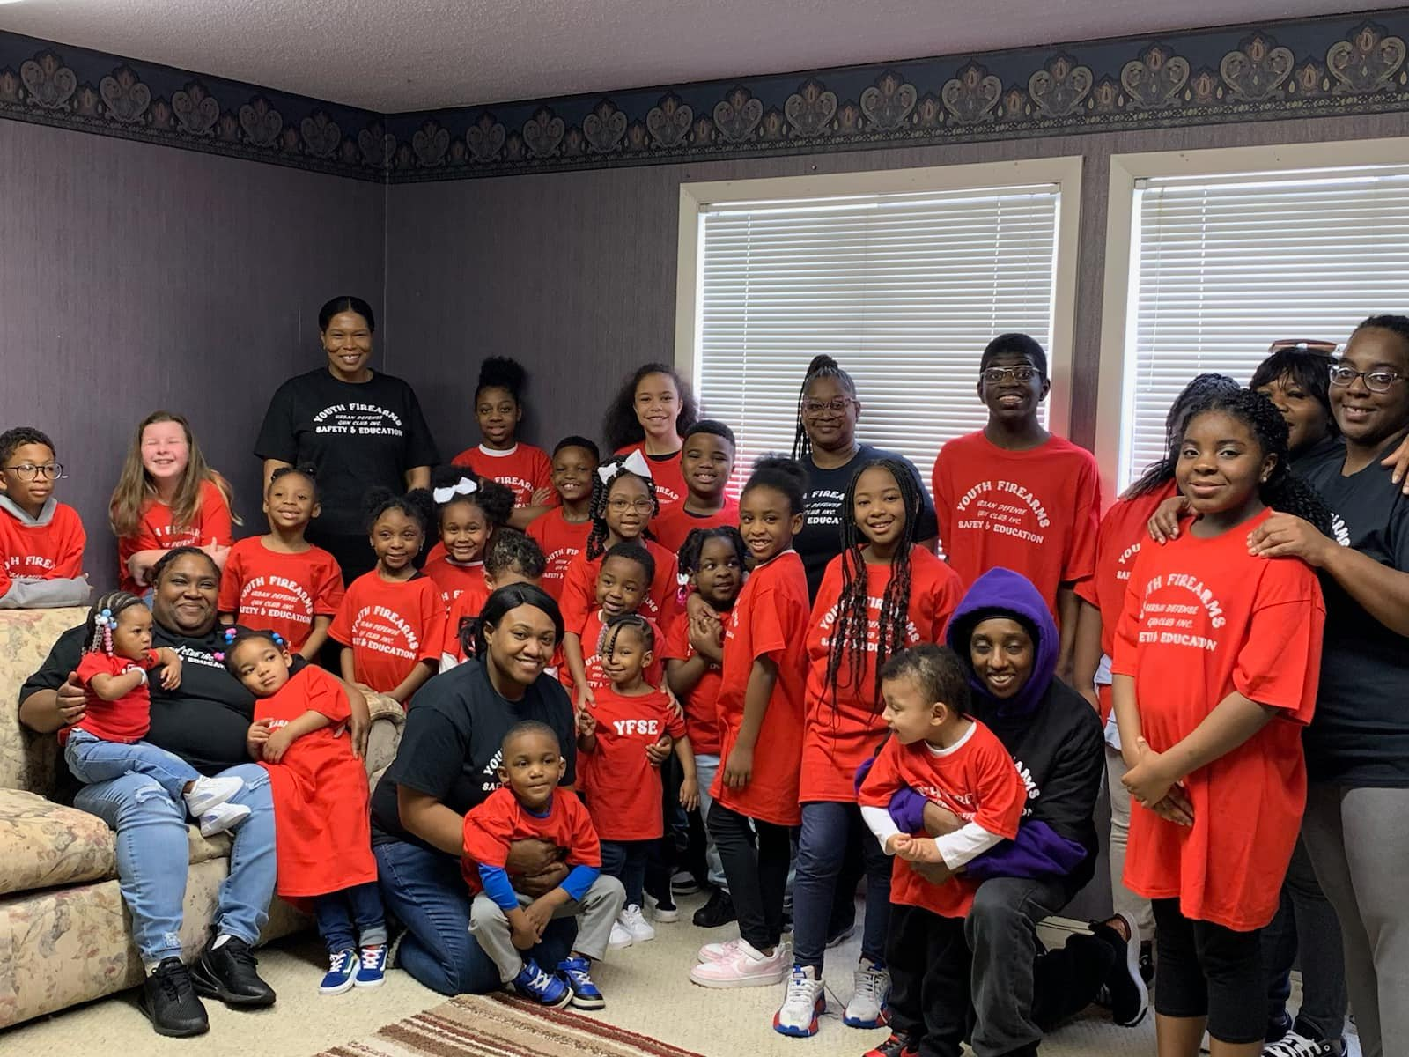 |  | URBAN DEFENSE GUN CLUB INC.  1029 CAMPBELL SUITE 203  JACKSON, TN.38301 |  |  | Urban Defense Gun Club  YOUTH FIREARM SAFETY & EDUCATION PROGRAM  - Proverbs 22:6  - Train up a child in the way they should go: and when there older, they will not depart from it.  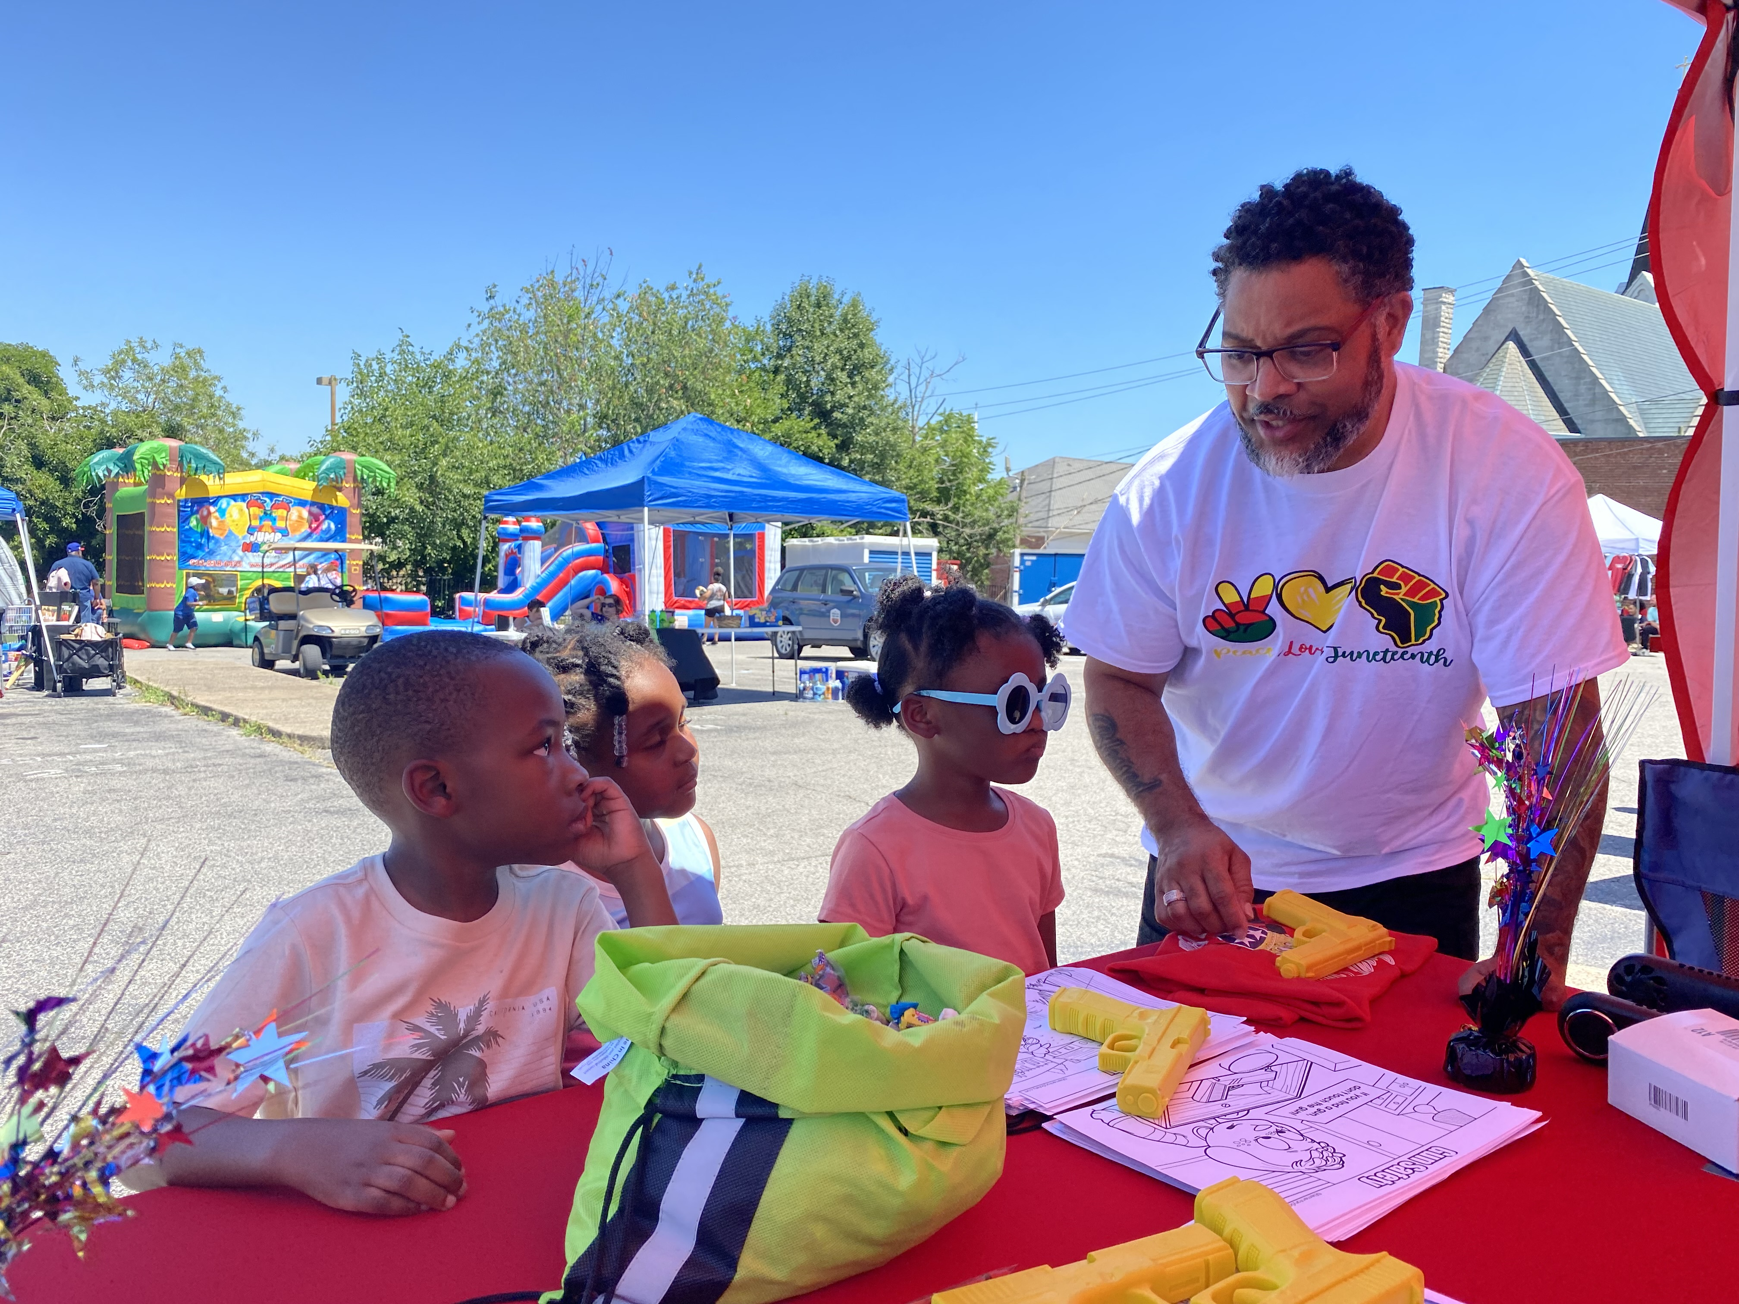  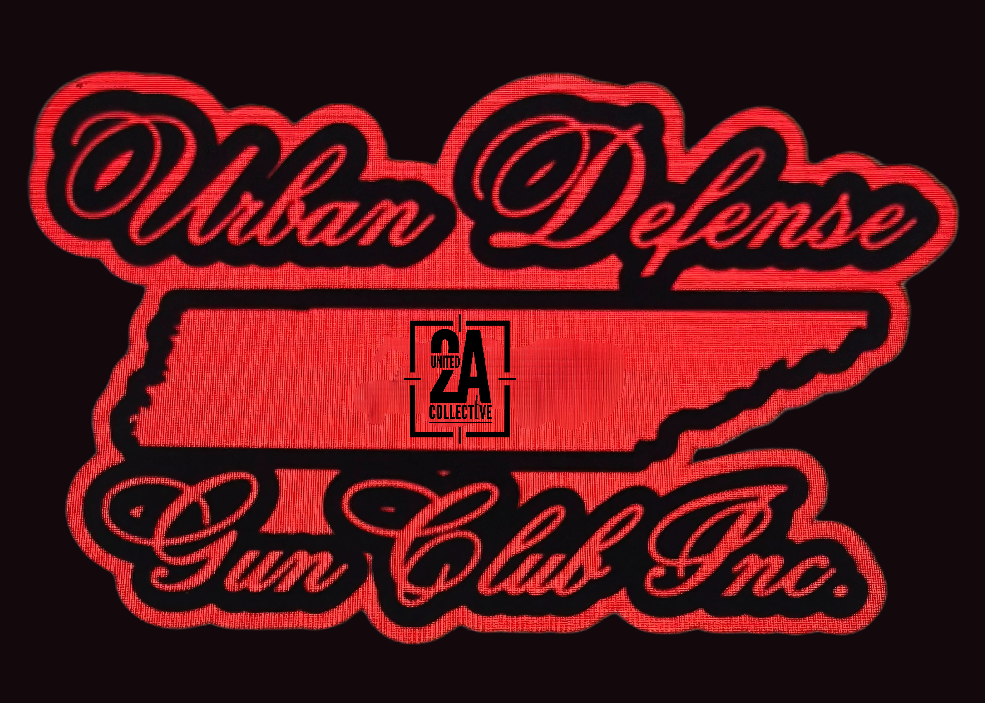  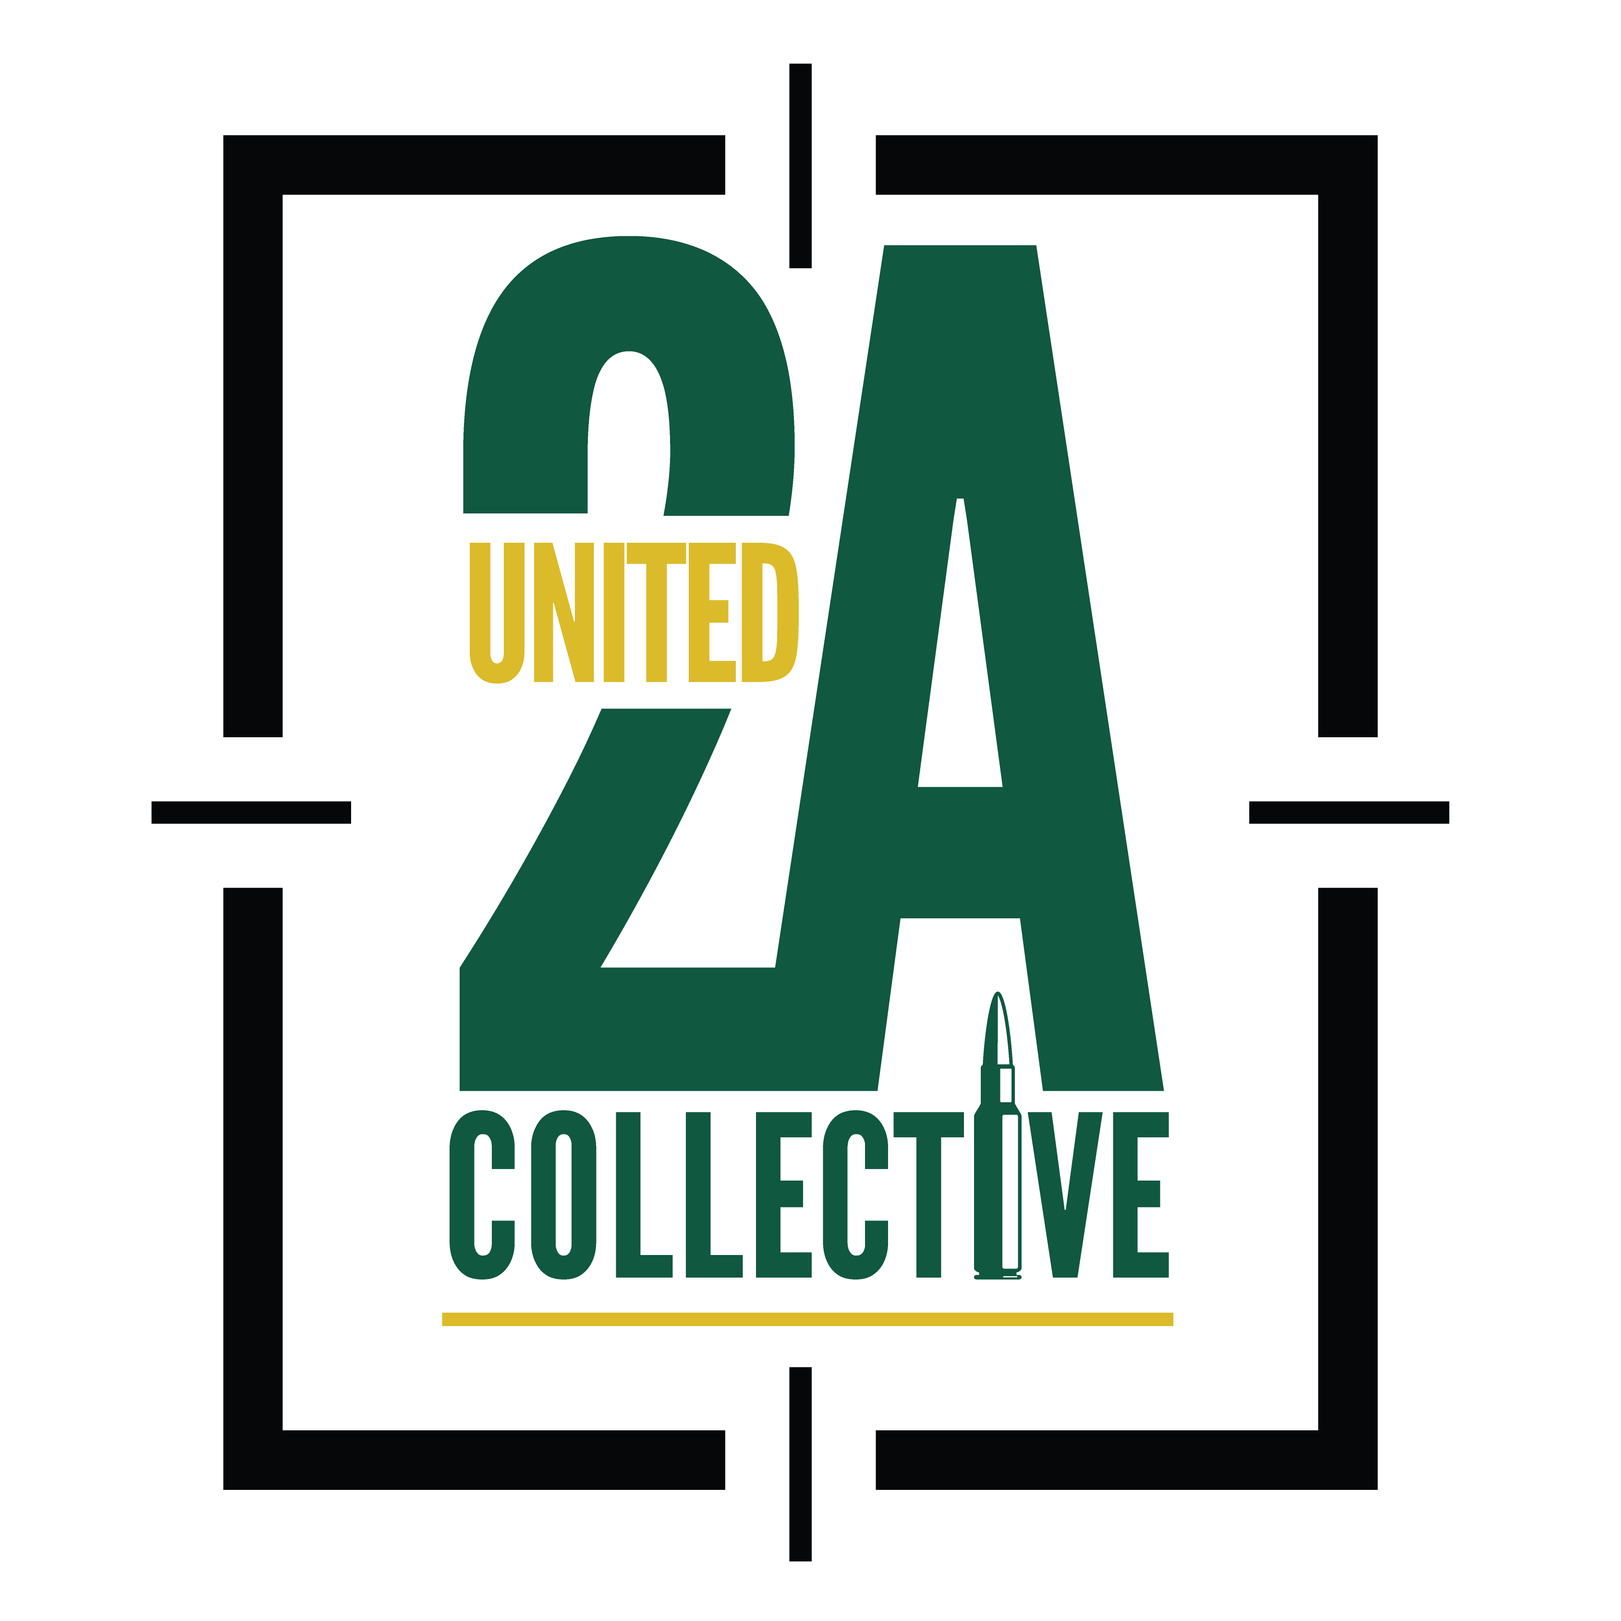

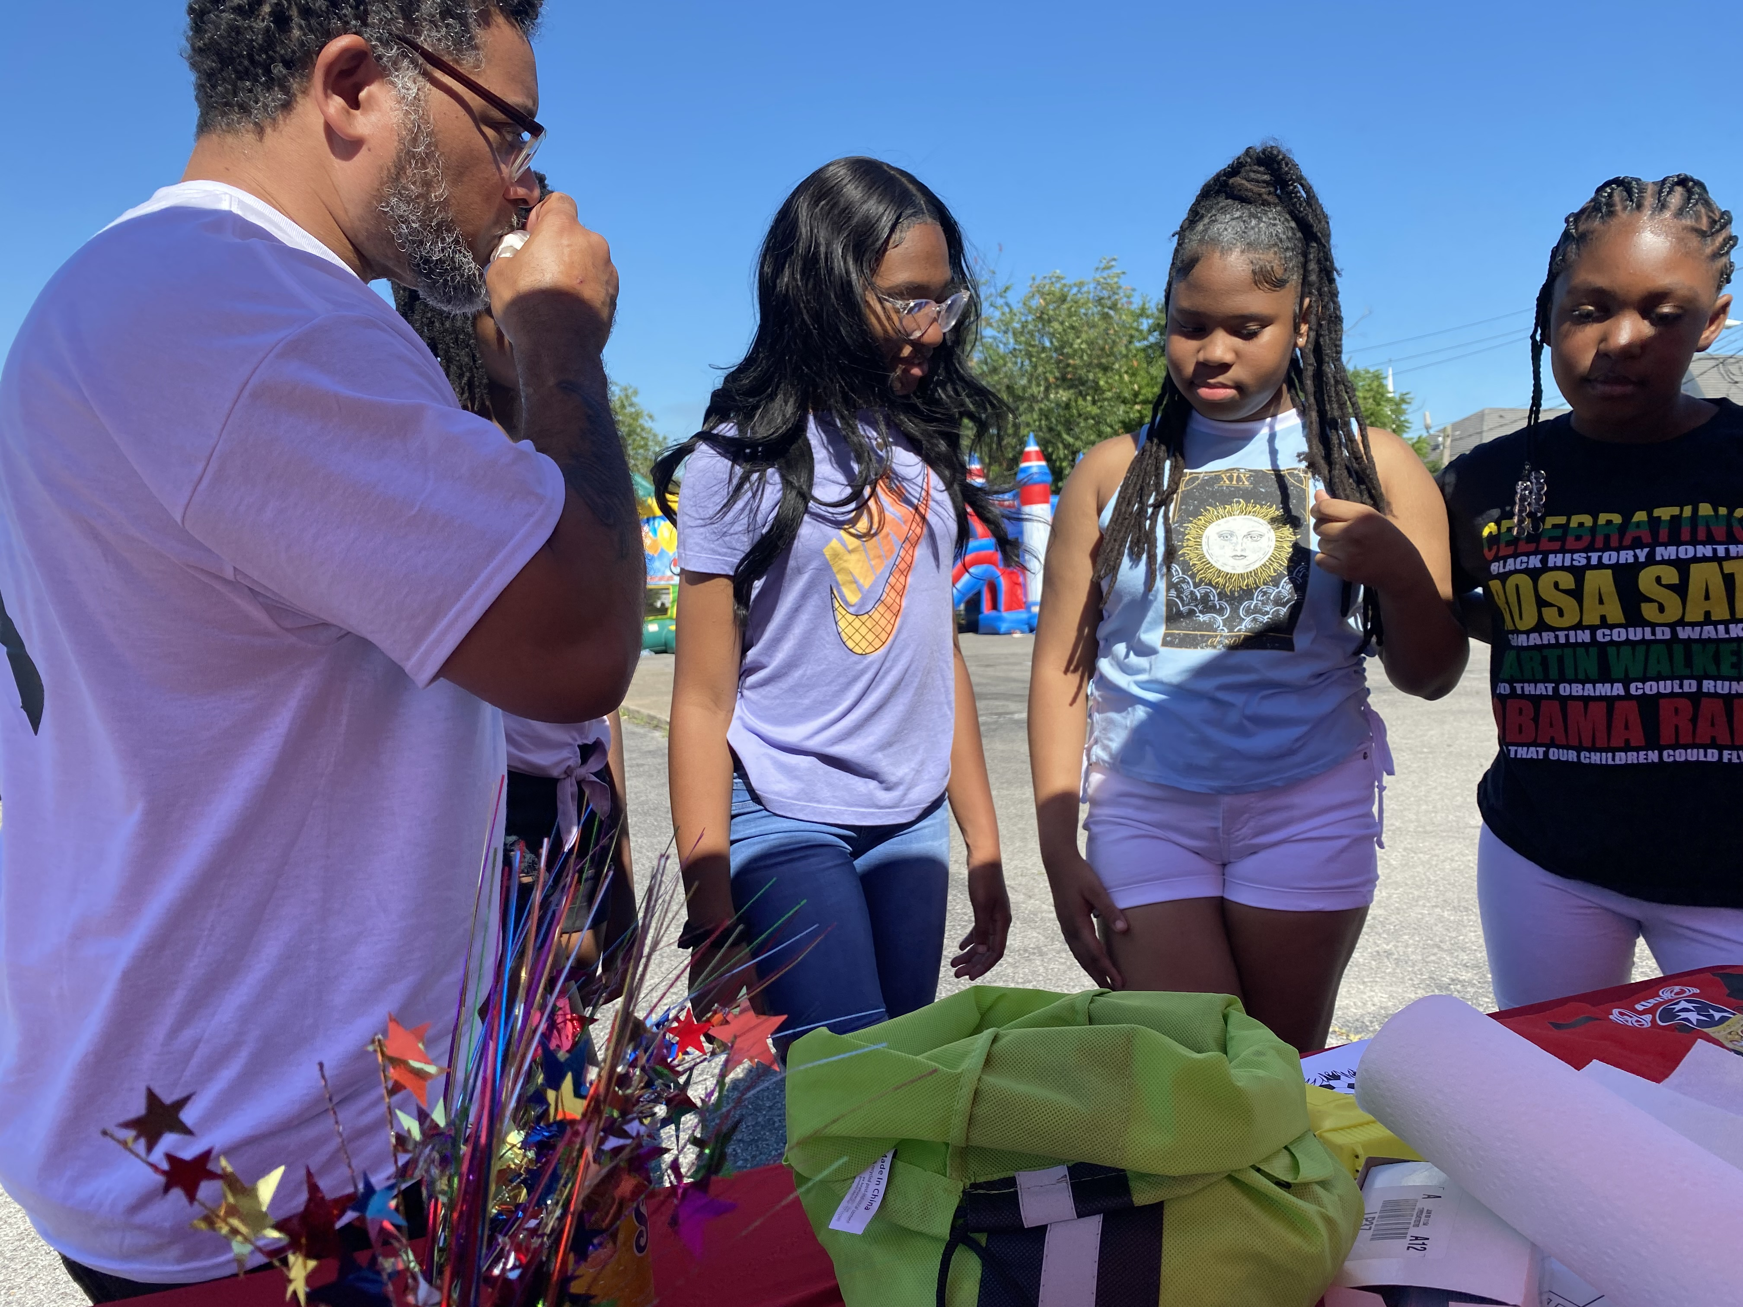  The Youth Firearms Safety & Education program was established in 2019, An addition of our mentorship program for youth and young adults. Established June 6, 2009 We recognized a need in our community for education around the safe storage and handling of firearms. We are seeing far too many incidents of ignorant and negligent behavior, by both our youth and adults, leading to unintended injuries and or deaths by firearms in our community!  We do not feel, that the answer is more laws and regulations! We understand and stand by the idea of Education over Legislation. Our mentorship and YFSE program focuses on educating youth and young adults 3yr - 21yrs of age and their parents or guardians on the positive uses of firearms, historical figures in our community. As well as the Black Tradition of Arms, situational awareness, and fundamentals of firearm safety, safe storage, and most importantly mental health awareness. A one-on-one practical learning experience is also offered, on the gun range, demonstrating safe gun handling and marksmanship skills learned in the class. | 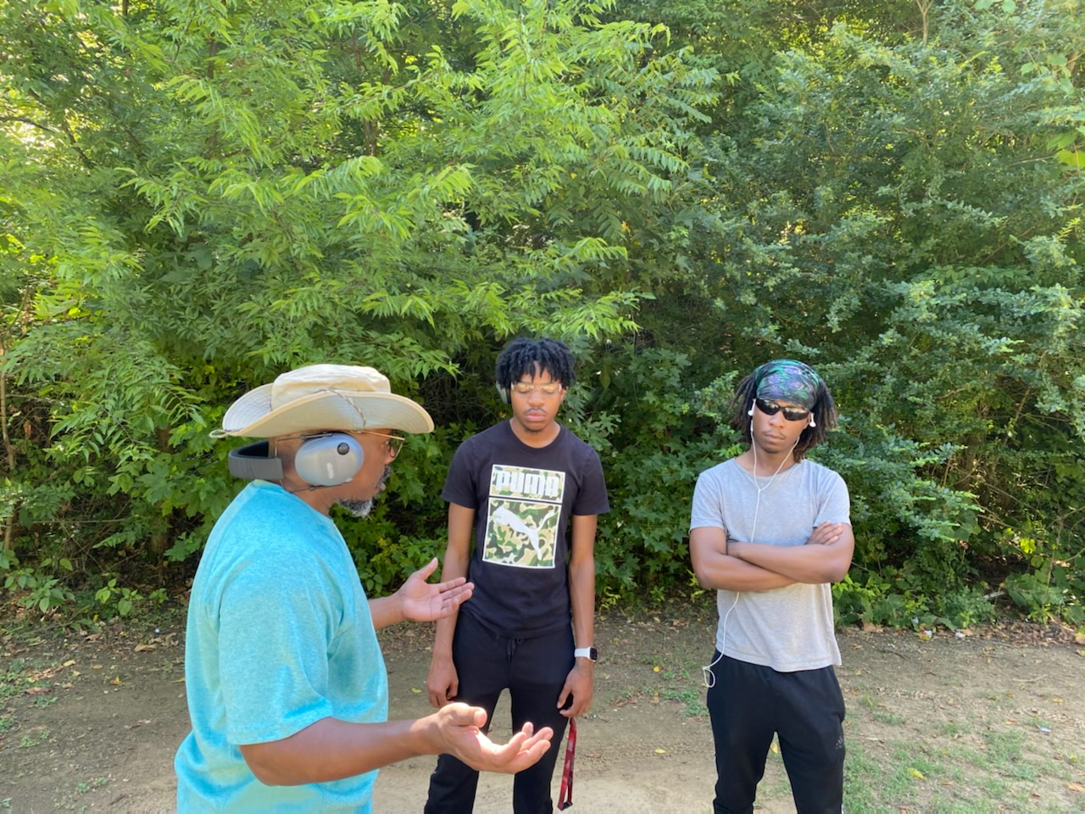  Our goal is to create positive perspectives, build respect and discipline, and promote responsible firearms ownership. By leading our youth and young adults with education, we can increase positive experiences and decrease the number of negligent incidents occurring in our community!  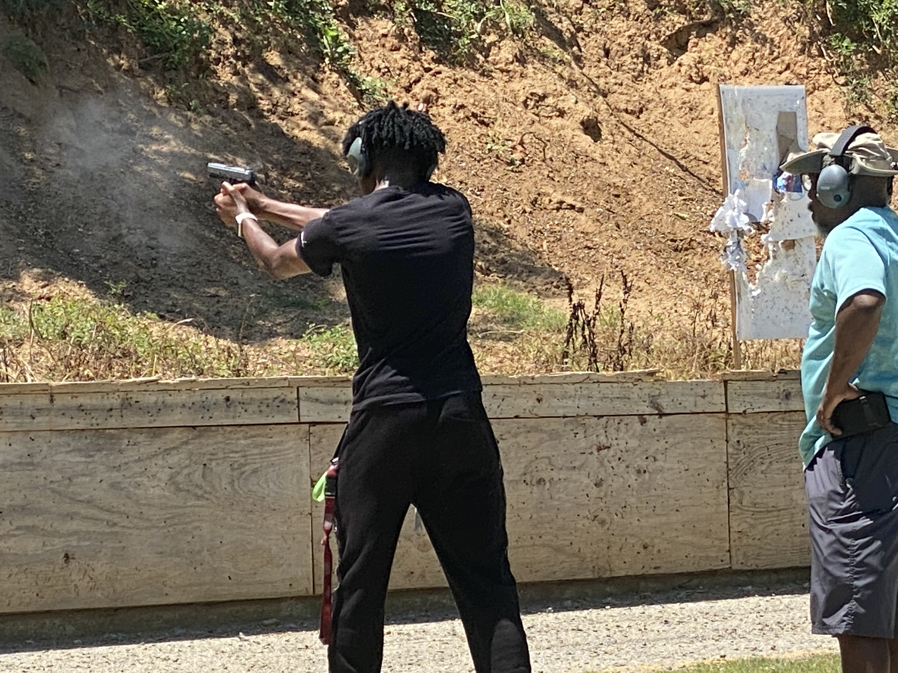 | Our Youth Firearms Safety & Education Program was established in 2019 by Beverly Jones, Toyorah Willoughby, Terrill Perry & Allen Bragg Jr. In addition of our mentorship program. Established June 6, 2009 by Beverly Jones, Toyorah Taylor-Willoughby & Terrill Perry  - Train up a child in the way they should go: and when there older, they will not depart from it.  - Developing young Kings and Queens to be responsible, disciplined & proficient in life and with firearms!  Contact Us  URBAN DEFENSE GUN CLUB INC.  1029 CAMPBELL SUITE 203  JACKSON, TN.38301  1029 Campbell  Jackson, TN. 38301  (731)574-1095  info@urbandefense.club  www.urbandefense.club

