Cedar Ridge Outfitters
PO Box 147
Mills, WY 82644
Phone: 307 251-3309
Fax: 307 234-6795

Cedarridgehunting.com
info@cedarridgehunting.com

Cedar Ridge Outfitters

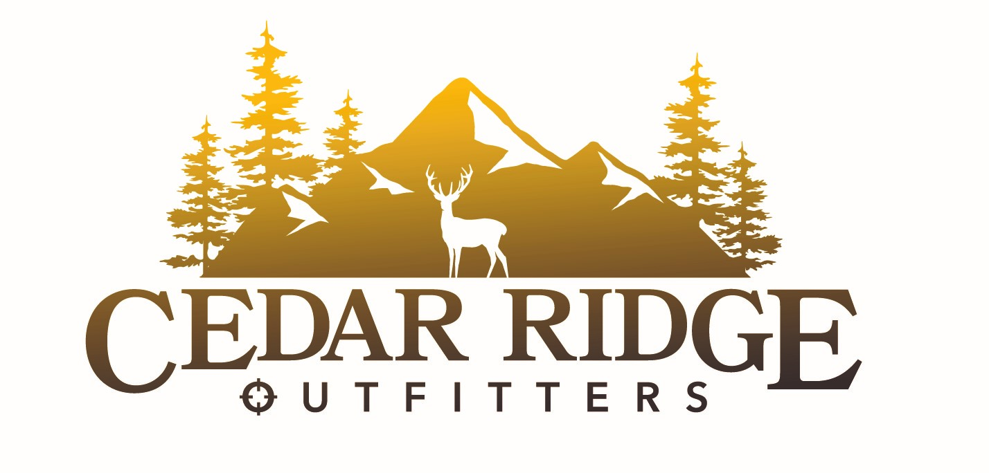

Quick Overview
- Offer elk, deer, antelope rifle hunts
- Exclusive rights to private property for Deer hunts
- Access to over 150,000 acres of public and private land
- Cabin with modern amenities
- Located in secluded valley
- Home cooked meals
- UTV & Pickups to get to hunt areas
- Close to a pheasant farm and fishing access for after hunt activities
- Short drive from town

Please call with any questions on any of our hunts or offerings.

Lodging and Meals
Our cabin started out as a homestead on the ranch that is now over 100 years old. There has been a kitchen, dining area, bunk room and shower added to give our guests modern amenities without the motel feel. We have a large porch that allows our guests and staff to sit relax and relive the days adventures with each other.
We offer fresh home cooked sit-down meals twice a day during your stay and field luncheon items while out hunting. We will try and reasonably accommodate any special dietary needs we are made aware of prior to client’s hunt date.

We offer a complete hunt package
We are a quick 1 ½ hour drive from Casper, WY. Our cabin is situated near the center of most of our hunt areas, so morning trips to hunt areas are easily done in UTV’s. But we are in a private valley which feels like you are worlds apart. We offer modern amenities in our cabin without taking away the feeling of being in the back country.

Hunt areas
We have exclusive rights for deer hunting on 50,000 acres of private property we lease. We also have access to over 120,000 acres of BLM, State and private for our antelope, deer and elk hunts. We offer hunts for Antelope in areas 67,72,73,74,75; Deer areas 34,36,89,90; Elk areas 23,48,120,128. Call us and we will do our best to help you apply for the area that is right for you.

Hunts
We offer a variety of hunts all based from our Cabin – call for this year’s pricing
- Antelope Rifle – 3-day hunt
- Deer Rifle – 4-day hunt
- Bull Elk Rifle – 5-day hunt
- Cow/Calf Rifle Hunt – 4-day hunt
- Ant/Deer Combo Hunt – 6-day hunt
- Deer/Elk Combo Hunt – 7-day hunt
- Ant/Elk Combo Hunt – 6-day hunt
- We also offer a non-hunter day rate so friends and family can accompany you.

All Hunts include
- Transport to/from Casper, WY airport
- 3 meals per day – two sit-down meals and one field lunch
- Lodging in our Cabin
- Modern amenities – hot shower, bunk room, tv
- Transportation of meat to processor

Perfect place to unplug
- Semi off grid
- No traffic from county or hunt area access roads
- Lots of wildlife in our private valley

Items to bring on your trip
- Sleeping bag, towel, toiletries
- Personal comfort items
- Weapon and Ammo
- Personal Hunting Gear
- Special Dietary need items

Personal Service
We strive to have all of hunts be 1:1 with a guide. We do encourage our family hunts to stay together with one guide so all the memories and fun can be shared.

