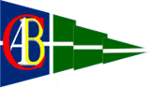
ABCrosby & Company, Inc.
Work Surface Products

ABCrosby Workbench Tops and Shelves
ABCrosby offers a complete line of work bench tops and shelves tailored specifically for your unique application. ABCrosby workbench products offer high impact resistance and durability and are used in commercial, healthcare, educational, industrial, military and government facilities around the world.
Standard Dimensions  Work Shelf Dimensions  Standard Thickness: 3/4", 1-1/4  Standard Widths: 12, 15, 18, 24  Standard Lengths: 24, 30, 36, 40, 48. 60, 72,  96, 120, 144  Work Top Dimensions  Standard Thickness: 1-1/4”, 1-1/2”  Standard Widths: 24, 30, 36, 48, 60  Standard Lengths: 24, 30, 36, 40, 48, 60, 72, 96,  120, 144  Metal Wrapped Top Cores  Standard Thickness: 1-1/2”, 1-3/4”  Standard Widths: 12, 15, 18, 24, 30, 36, 48, 60  Standard Lengths: 24, 30, 36, 40, 48, 60, 72, 96,  120, 144  Call us to discuss your Custom Dimensions  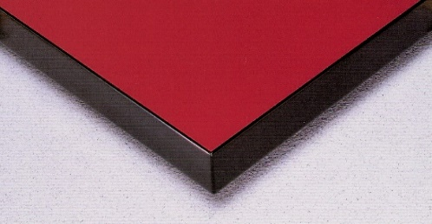  Tops with 3mm Black PVC Edge | 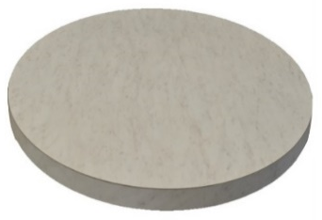  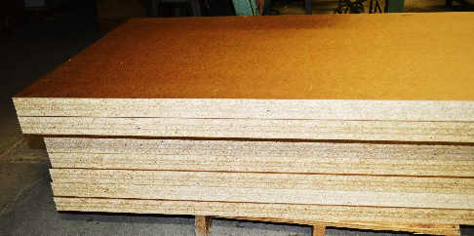  Self-Edge Round Laminate Top  Particle Board Core for Metal-Wrapped Tops  as  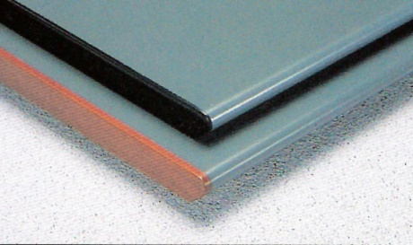  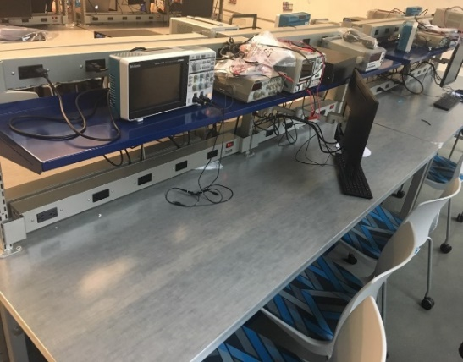  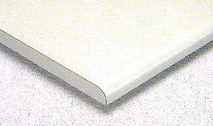  Bullnose Front & PVC or Wood Edges  Custom Laboratory Tops  Brushed Chrome T-Mold Edge & Wilsonart Silver Alchemy Laminate  Laminate Top with Ash ½” Wide F Edge  Work Surface with a Waterfall Edge
Flexible Manufacturing Capabilities to Deliver Product Built to Your Unique Specifications

Laminate Options  - Wilsonart Dove Grey 92-60  - Wilsonart Frosty White 1753-60  - Wilsonart Black 1595-60  - Nevamar ESD Laminates  - Wilsonart Chemsurf Laminates  - Your Custom Laminate Choice  We work with any laminate. | Core Options  - Particle Board  - MDF  - Plywood  - Solid Wood  - Your Custom Core Choice | Backer Options  - Polybak Backer  - Phenolic Backer  - Laminate Backer  - Your Custom Backer Choice | Custom Features  - Cut-outs, Borings  - Round, Other Shapes  - Grounding terminals,  - Tight Joint Fasteners  - Backsplashes  - Double Bullnose Edges  - Your Custom Features
s

Work Benches - Built to Your Design
Industrial Grade Manufacturer  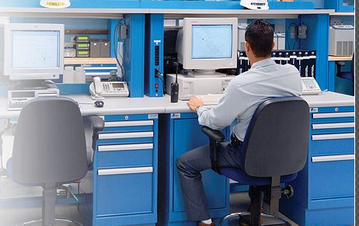  When a Fortune 500 manufacturer was looking for a vendor to supply the laminated tops and shelves for their work bench product line, they turned to ABCrosby.  The customer needed high quality work benches and shelves built to meet their customers’ specifications with a one-week turnaround. ABCrosby stepped up and made it happen. ABCrosby is now this customer’s sole source for laminated tops and shelves as well as particle board cores for their metal wrap bench tops.  The Easy Choice for Tough Jobs  A manufacturer of rugged test and measurement equipment needed a laminated top for their equipment. Their test equipment is designed to work in the most demanding environments.  The manufacturer needed a work top, which would survive as well as their equipment. After reviewing their options, The manufacturer chose ABCrosby to supply their tops. | Standard Work Top Edge Styles  Edge Picture Type Description  A Laminate Edge (Self Edge)  ABN Laminate Bullnose Edge (Self Edge)  AWF Laminate Waterfall Edge (Self Edge)  APV PVC Edgeband .018. .020. & 1, 2, 3mm thickness  B Wood Edge under Laminate  C 1 ¾” Drop Edge under Laminate (Self Edge)  E PVC T-Mold Edge (Radius Corners)  F ½” Wide Wood Frame Edge (Picture Frame)  M Metal T-Mold Edge (Radius Corners)  Contact us to discuss your Custom Edge Style

Additional Capabilities

Solid Wood Tops & Shelves  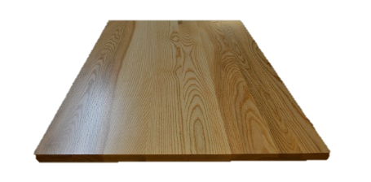 | Solid Surface Work Surfaces | 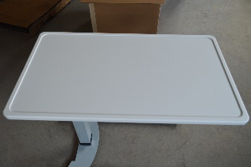  Thermofoil Panels
Ph: 978.827.6064 │ www.abcrosby.com │ sales@abcrosby.com

