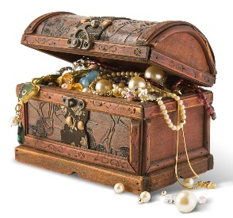
Neighborhood Play it Forward
Sharing stories & enriching our Community
A game of Community engagement because connection is the cure!
The impact of coronavirus goes well beyond physical health. It has tremendous impact on mental health and social connection.
We know that communities recovering from natural disasters and other wide scale disruptions have shown that social connection is a key to being resilient and to bouncing back. Socially connected communities simply respond better to crisis and disaster, and they rebound better afterwards.
This is all to say we need each other more than ever as we live through this unprecedented time and the link between social connection and recovery cannot be underestimated in the wake of the COVID-19 pandemic.
So please join, your (neighborhood) play it forward!
A community game where all families can join in on the fun and inspire a sense of group connection through discovery.
The intention of this "get to know your neighbors" activity is to celebrate our commonalities and differences within our very own community by sharing our histories, likes, dislikes, talents, quirks and more!
Build personal relationships, business networks and have some fun!
So while the vaccine is still rolling out slowly - we have the medicine to combat social isolation - and that medicine is community fun!
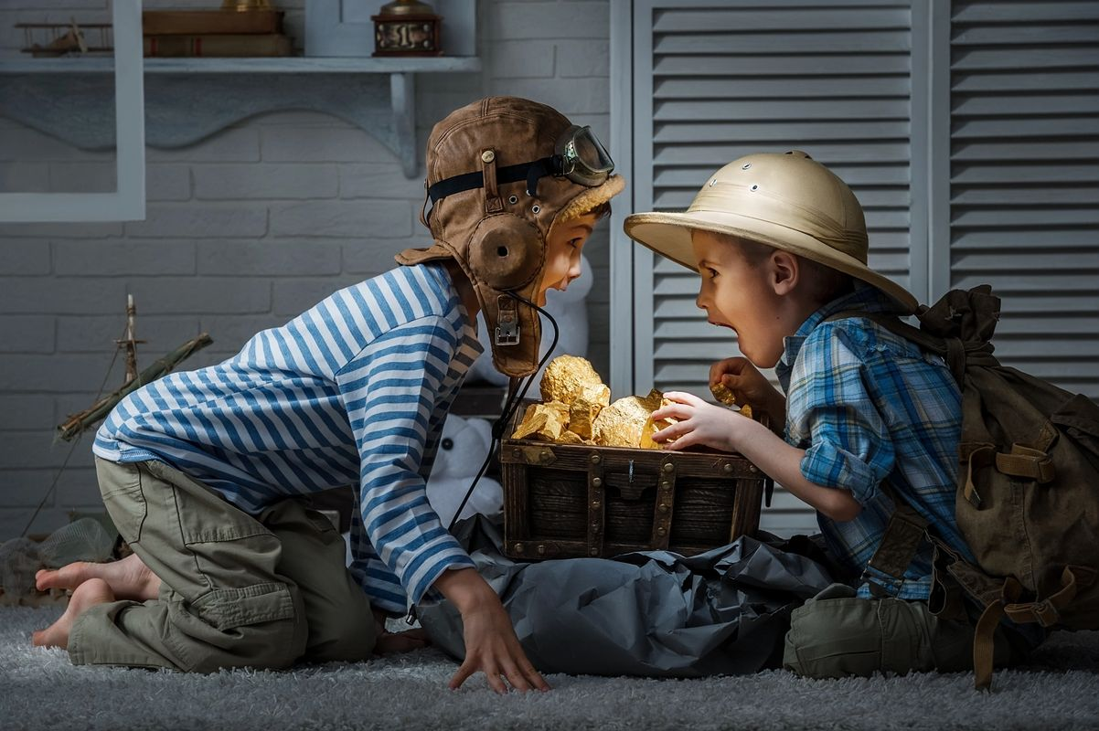

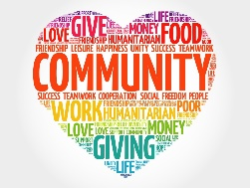
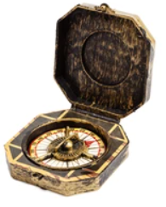
How to Play?
Step 1 - Take a Profile Picture of yourself or family – OR use a picture that you already have and glue it in the designated spot.
Fill in your full family name(s) and the profile questions.

Step 2 - Fill in one area only in the Fun Facts section.

Step 3 – Once you’ve picked a gift from the treasure chest, please replace it with something else (ideas listed below)

Step 4 - You have 48 hours to Play it over to the next Neighbor of your choice
Keep it in this Neighborhood of ___________ (Your Neighborhood Name)
If you do not want to play please give it back to the sender which can be found at the front of the book.
Write who it's from on the Blank Card with the Erasable Marker and in your Profile write what Gift you chose and gave to which family.
Include your address or contact information so the player knows who to give it back to.

Step 5
Leave it on the Neighbors doorstep or give it to them directly - Make it fun

Step 6
Have a lot of fun and let’s make this go Viral

The Rules?

Bonus Area
Please indicate in this area if you are interested in activities with others in the community, similar hobbies, activities, walking, and anything else in order to connect. EG. Social Distance Walks, etc.…

Service for Service - If you're interested in exchanging services with neighbors please put your business card or make a custom card with the available blank cards and write what service that would be - take a picture of the card for your records and then put it back in for others to share in the services, This section is found in the profile of the family or person on the bottom right hand side.

A gift can be:
A service eg. A painting or a trade profession exchange – a painting, etc.
Any gift you wish to give
Something Sentimental – Something near and dear?
A voucher of some sort - eg. Night at our Cabin – Snow Shoveling – Community Walk

Sharing is Caring - Let's Spread some Joy and have a lot of fun learning about each other!

Please inspire others to share in this idea and initiate this in their own local communities
Want to make your own Play it Forward for your community?
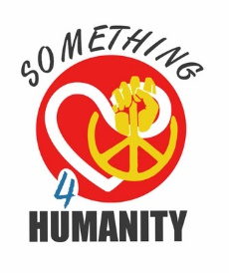
Templates & Rules can be found on www.something4humanity.com/play-it-forward

