PURPOSE:

None

RESPONSIBILITY:

All providers, pharmacy, and nursing staff in the OR and affected patient care areas.

PROCEDURE:

Use of bupivacaine liposome injection and all medications will be appropriately labeled and verified prior to use in any procedure or case performed in an operating room, procedure room or any other area that transfers medications/solutions out of the original container. All inpatients that receive bupivacaine liposome injection will receive education by floor nursing staff prior to discharge. Same day admission patients will receive patient safety sheet and education by ACU nursing prior to discharge. All inpatients that receive bupivacaine liposome injection will have a Caution/Information sheet posted above their bed.

Pharmacy Procedure
- Bupivacaine liposome injection will be stored in the pharmacy department and dispensed per specific case
- A single dose medication order will be entered through the pharmacy Siemens system with a 96 hour duration so clinical interaction check may be performed by the pharmacist.
- Bupivacaine liposome injection will be dispensed in a clear bag with “Precautionary Labels” and administration checklist.
- Prior to dispensing, vial will be labeled with patient name and medical record number, medication name ,dose

OR Procedure
- Verify all medications prior to usage using the five ‘rights’ as applicable:
  - The right patient
  - The right medication
  - The right dose concentration
  - The right time, and
  - The right route.

- In all cases where medication is used, preprinted labels or a sterile marking pen with sterile labels is to remain available on the sterile field.

- All medication cups/containers/syringes on the back table must be labeled.

- All medications must be concurrently verbally and visually verified by the scrub person and the RN circulator, including the medication, strength, dosage concentration, and expiration date, before it is dispensed into a labeled container.

- Bupivacaine liposome injection is to be delivered to the sterile field in an aseptic manner. The medication should be inverted multiple times to re-suspend the particles immediately prior to dispensing and withdrawing from the vial. When dispensing, the circulator may draw it up in a labeled syringe. The scrub person will then add designated amount of bupivacaine to saline, as designated by surgeon (see surgeon specific dosing)

- Verify each medication individually and complete it’s preparation for administration, mix and stir, designated amount of bupivacaine and saline, prior to handing off syringe to surgeon.

- In all cases where injections are given by the surgeon, the RN circulator drawing up the medication must visually and verbally verify the medication and dose with the surgeon and label the syringe. In cases where the surgeon draws up the medication, it must be verified with the RN circulator.

- Before bupivacaine liposome injection is administered, the anesthesia team must be notified and a time-out procedure should be done to verify when the last dose of local anesthetic was administered. Anesthesia will determine the dose of the one time peripheral nerve block prior to administration of bupivacaine liposome injection.

- Medications injected must be documented in the intraoperative record and Netaccess as to total amount given and the time of the injection.

- If a patient has received lidocaine, either administered by the surgeon or anesthesia, you must wait at least 20 minutes after lidocaine injection, before bupivacaine liposome injection can be given.

- At shift change or break relief, the entering and exiting personnel are to verify all medications and labels on the sterile field and times of administration of all local anesthetics.

- Any medication or solution found in the OR without a label is to be immediately discarded.

- All medication bottles, ampules, vials, etc., must be saved until the completion of the case.

- Medication errors and near misses should be reported to the Safety Reporting System (SRS).

Informing Staff of Bupivacaine Liposome Injection Administration:

For all inpatients receiving bupivacaine liposome injection, a sign will be placed above patient’s bed stating:
a. Bupivacaine (any formulation, including Ropivacaine) CANNOT be administered at any site or route within 96 hours
b. Lidocaine CANNOT be administered LOCALLY at the same surgical site of bupivacaine liposome injection within 96 hours

Patient Education:
- For all patients receiving bupivacaine liposome injection, a patient education sheet will be given to the patient informing them that they have received medication during surgery and to notify/show any treating physician the education sheet; which will state:
  - Bupivacaine (any formulation, including Ropivacaine) CANNOT be administered at any site or route within 96 hours
  - Lidocaine CANNOT be administered LOCALLY at the same surgical site of bupivacaine liposome injection within 96 hours
- Contact the patient’s surgeon for any questions

ADDENDUM A:

Surgeon Specific Information Sheet

At the present time, bupivacaine liposome injection is being utilized for certain surgeons and for certain procedures ONLY.

ADDENDUM B:

EXPAREL PATIENT INFORMATION SHEET

Your surgeon has administered a long-acting local anesthetic during your procedure to help with your pain control after the procedure. This medication is called Exparel and it is a long-acting form of bupivacaine.

You should call 911 or go to the nearest emergency room, if you experience
- numbness around your lips,
- ringing in your ears,
- chest pain, shortness of breath,
- seizures,
- loss of consciousness.

If you have any questions about Exparel, please contact your surgeon’s office.

Please notify any health care providers that you received Exparel, by giving them this sheet. This medication will remain in your system for up to 96 hours. Your other doctors will need to know this information in order to better take care of your and prevent any potential adverse reactions.

FOR ANY TREATING PHYSICIAN:

  - Your patient has received Exparel (liposomal bupivacaine), during their recent surgery.
  - Bupivacaine (any formulation, including Ropivacaine) CANNOT be administered within 96 hours of Exparel
  - Lidocaine CANNOT be administered LOCALLY at the same surgical site of Exparel within 96 hours
  - Contact the patient’s surgeon for any questions

DATE OF SURGERY:____________________________________________________

ADDENDUMC: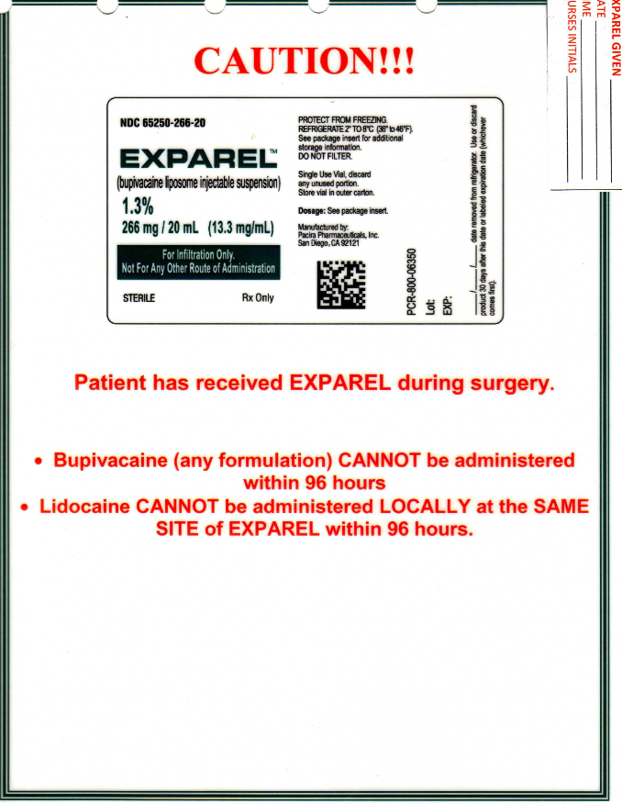

Surgeon Specific Information Sheet

At the present time, bupivacaine liposome injection is being utilized for certain surgeons and for certain procedures ONLY.

Surgeons, Procedures and Dilutions

- Colorectal surgery: Surgeons who have undergone certification process will be using bupivacaine liposome injection for colorectal surgery. 266 mg of Exparel will be diluted with 20 mL of 0.9% NaCl for a total volume of 40 mL. Surgeons may choose to inject all or some of the 40 mL volume. Any remaining Exparel not administered will be discarded. Please verify with anesthesia regarding any lidocaine or any other local anesthetic administration and the time of administration.

- Adult Ankle arthroplasty: Surgeons who have undergone certification process will be using bupivacaine liposome injection 20 mg of Exparel will be used undiluted. Surgeons may choose to inject all or some of the 20 mL volume. Any remaining Exparel not administered will be discarded. Please verify with anesthesia regarding any lidocaine or any other local anesthetic administration and the time of administration.

- Bariatric surgery: Surgeons who have undergone certification process will be using bupivacaine liposome injection. 266 of Exparel will be diluted with 100 mL of sterile 0.9% NaCl for a total volume of 120 mL. Surgeons may choose to inject all or some of the 120 mL volume. Any remaining Exparel not administered will be discarded. Please verify with anesthesia regarding any lidocaine or any other local anesthetic administration and the time of administration.

- Inguinal Hernia repair: Surgeons who have undergone certification process will be using bupivacaine liposome injection. 266 mg of Exparel will be diluted with 60 mL of sterile 0.9% NaCl for a total volume of 80 mL. Surgeons may choose to inject all or some of the 80 mL volume. Any remaining Exparel not administered will be discarded. Please verify with anesthesia regarding any lidocaine or any other local anesthetic administration and the time of administration.

