# *In the Bis League Information*

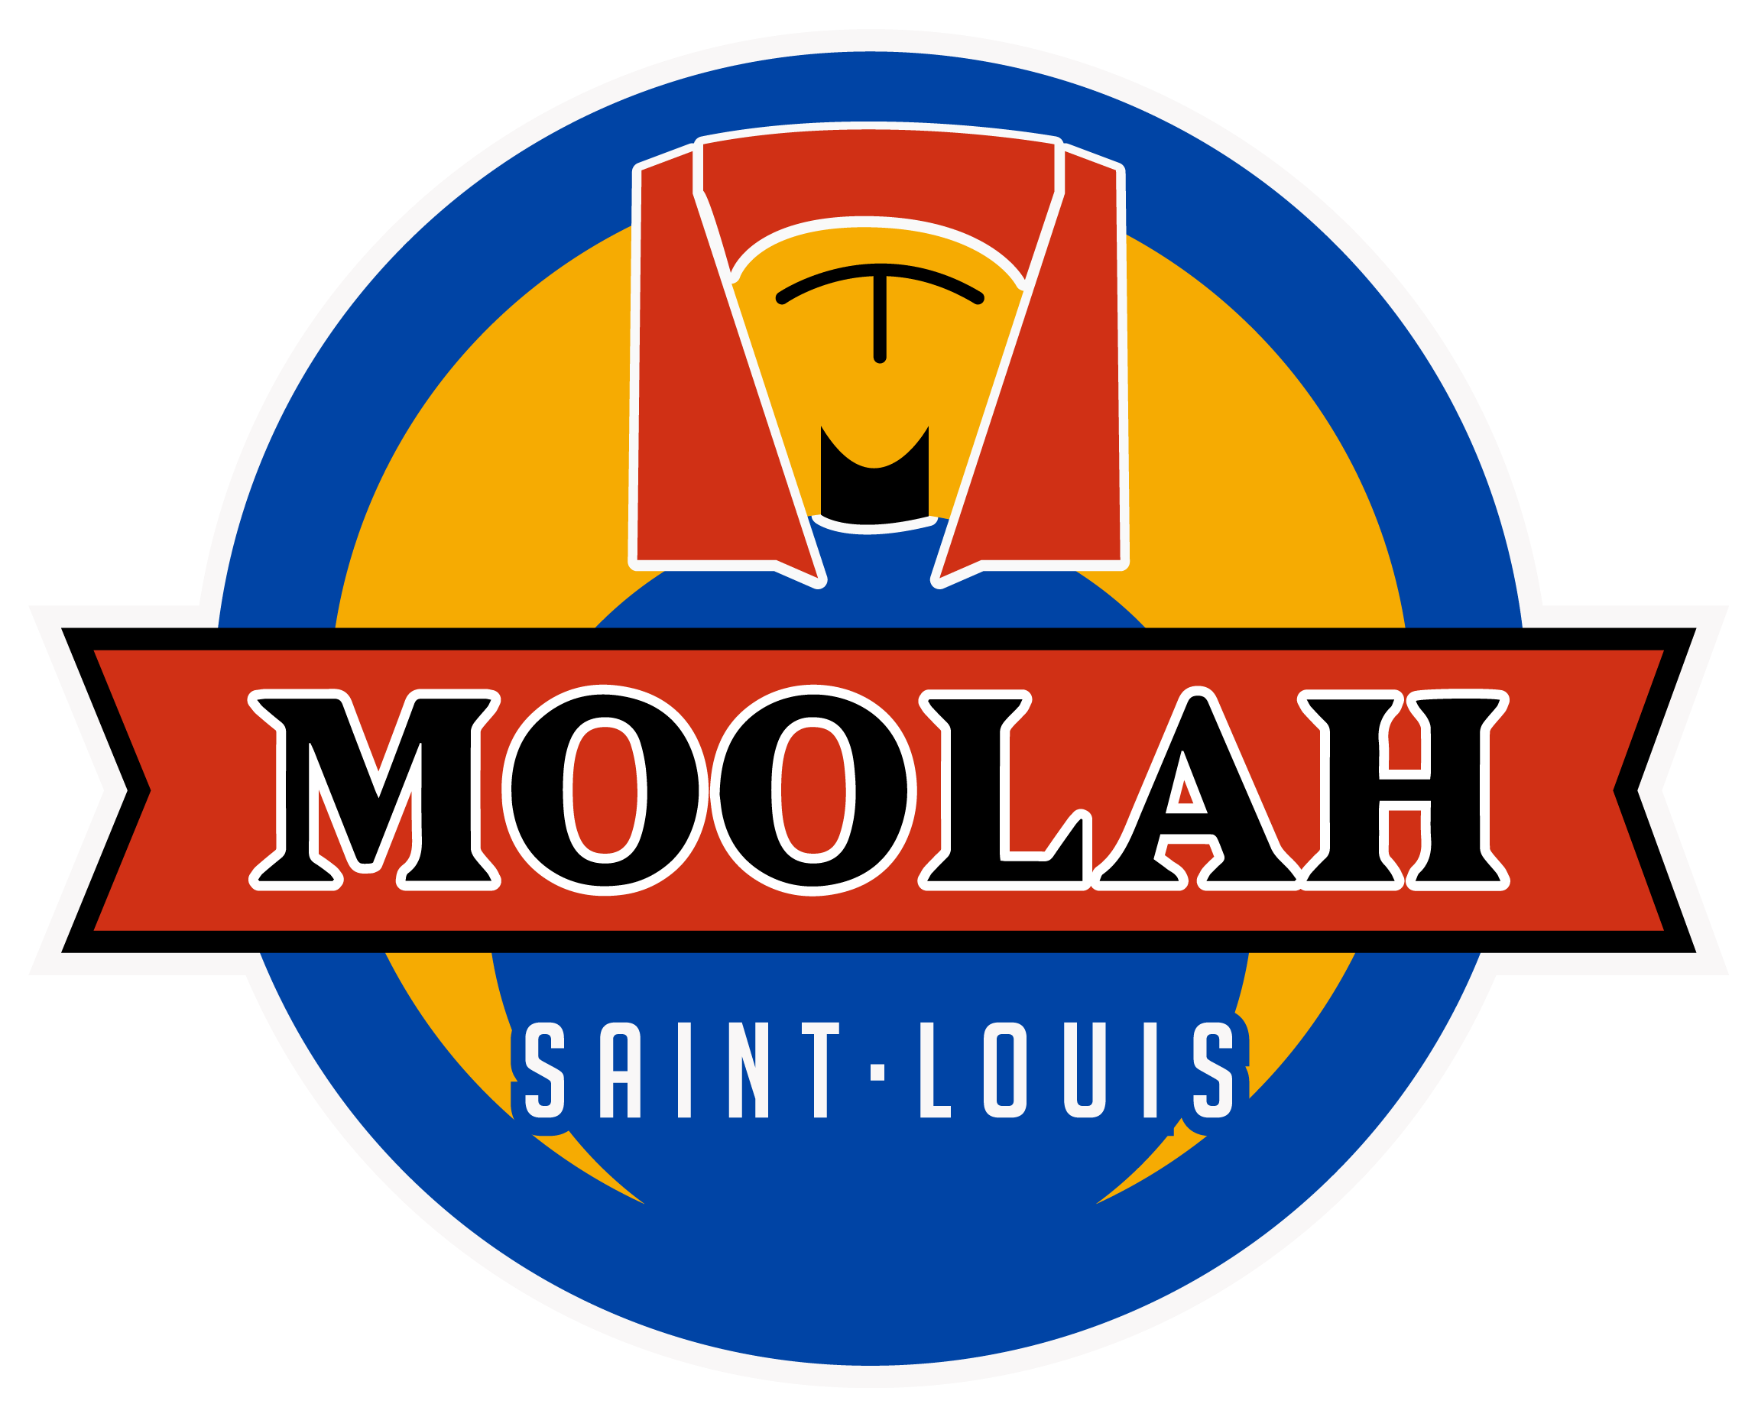

(Industry Employees only)

***Price:*** $12 Per Night

***Duration:***  Sunday Nights 7pm-10pm (Tentative- April 28 start date + 12 weeks)

***Team Information:*** 5 bowlers on each team. Each team will bowl 2 games per week. President of each team will be responsible for getting subs if a teammate cannot make it that week.

Restaurant or bar employees only********

***League Scoring:*** TBD (based on league size)

* Head to Head Matchups win or lose. Standings based of wins and losses.

***League Rules:*** TBD (based on league size)

* Head to Head matchups. Wins and losses based on win or loss that night. Standings will be off wins and losses.

***League Winner:***

* Winner of league will receive a free 3 hour (only certain dates available) private event for his/her bar or restaurant.

***Champion Night***

* Week 12 is champion night
* 8 teams in the league will play in a bracket play
* With 3 total games played that night
* Winner of league receive cash prizes and more!