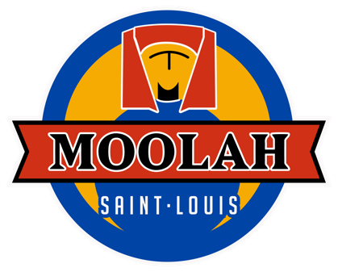

RETURN THIS COMPLETED BY 4/20/19 and you will also receive

$25 GIFT CARD!

(1 per team. Feel free to copy for multiple teams)

**Industry League Team**

**Sign Up**

|  |  |
| --- | --- |
| **Team Name:** | |
| **Name** | **Phone#** |
| 1. Caption |  |
|  |  |
|  |  |
|  |  |
|  |  |
| 1. Alternate* |  |
| ***\*alternates not required but recommended*** | |

Return this filled out to Moolah Lanes or email to [jbarton@moolahlanes.com](mailto:jbarton@moolahlanes.com) to join the league!

Industry Employees ONLY

