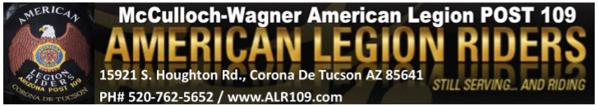
October 9th, 2022
E Board
Start Time: 11:04 am
End Time: 11:26 am

Roll Call of Officers:
Director: Steve Lemmon - Present
Vice Director: Chas Bird - Present
Secretary: Jessica Bird– Present
Sergeant at Arms: Rick Curry –Excused
Treasurer: Cathy Graham- Excused
Road Captain: Kenny Knapp – Present
Membership: April Moss - Excused
Chaplain: Michelle Chapman – Present

Membership:
- N/A

Items Discussed/Old Business:
- Will move our December meeting to December 4th so it doesn’t conflict with the Sun Rider’s Toy Parade.
-Slingo will still be held on December 11th for the Riders. Will ask another entity if they want to pick up our slingo as most of us will at the Sun Rider’s Toy Parade
-November 14th meeting will be canceled as almost all of the ALR E board will be out of town
-Next ALR dinner on November 25th will be canceled

New Business:
-Steve Lemmon brought up the idea of donating funds to the Legion of the Silver Rose. May ask all entities for $500 and also to create a ride to generate more funds to donate. Perhaps collaborate with other posts.
-One of our 109 bartenders is in need.

-Made a motion to donate $500 to the bartender in need: Kenny
-Seconded: Michelle
-Discussion: No
-Motion Passes: Yes

