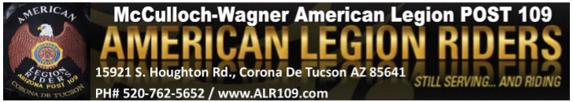
December 4th, 2022
E Board
Start Time: 11: 07
End Time: 11: 31

Roll Call of Officers:
Director: Steve Lemmon -Present
Vice Director: Chas Bird -Present
Secretary: Jessica Bird– Present
Sergeant at Arms: Rick Curry –Present
Treasurer: Cathy Graham- Present
Road Captain: Kenny Knapp – Present
Membership: April Moss - Present
Chaplain: Michelle Chapman – Present

Membership:- N/A

Items Discussed/Old Business:
- On November 11th, April Moss made a motion to donate $300 to Youth on Their Own
-Seconded: Chas Bird
-Discussion: No
-Motion Passes: Yes

New Business:
-Bob Carfagno is running for District 2, and Kirk Affolder is running for Area A for ALR. At state conference next year, they will share a hospitality room along with Chas Bird and Ace Tounsel.

-Made a motion for $500 to go towards the combined hospitality room ($250 each for Bob and Kirk): Chas Bird
-Seconded: Steve Lemmon
-Discussion: Cathy Graham suggested this should be brought up in the general membership meeting for a vote
-Motion Passes: No. Will be brought up in the general membership meeting

-Donation to be made for $250 to go towards the Sun Rider’s Toy Run – Will bring up in general membership meeting for a vote.
-Will need volunteers to run ALR slingo next Sunday, December 11th - Will bring up in general membership meeting
-Discussed issue of kitchen dues (if the $75 still applies and if so, who are we writing the checks to)
-Jennifer Williams is interested in being a new supporter for ALR 109. She has already completed enough volunteer events. She will fill out an application and will be eligible to be voted in at today’s general membership meeting. “Canteens” is her rider’s name.
-ALR 109 won an award for best motorcycle group at the 2022 Veteran’s day parade. Kirk Affolder will present the award to Steve Lemmon in the general membership meeting.

Good of the Riders: - N/A

-Next ALR 109 meeting: January 8th
-Next ALR 109 slingo: January 22nd
-Next ALR 109 dinner: January 27th

