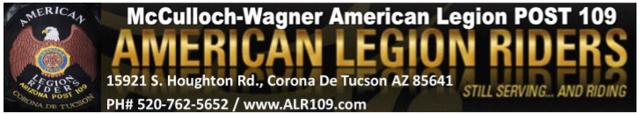

August 14th , 2022
E Board

Start Time: 11:10 am
End Time: 11:40 am

Roll Call of Officers:
President: Steve Lemmon - Present
Vice President: Chas Bird - Present
Secretary: Jessica Bird– Present
Sergeant at Arms: Rick Curry – Present
Treasurer: Cathy Graham- Excused
Road Captain: Kenny Knapp – Present
Membership: April Moss - Present
Chaplain: Michelle Chapman - Present

Membership:
- N/A

Items Discussed/Old Business:
- Thunder Mountain Moose (Cause for Paws): September 24th – asking for $150 donation. They are using us for their 4th stop. Will bring it to the general membership for a vote
-Tabathia wants to charge riders $100 per month as we don’t do a breakfast. Will bring it up to the legion to see if they authorize it. We are already paying $50 (expenditures, electricity, utensils, dry goods, etc.)
-We will try out the new dinner for a couple of months to see if we sell more meals. If not, then we may cancel rider’s dinners altogether.
-Bingo drink chips were discussed
-E board has decided to enforce the bylaws for new members (motorcycle endorsement, and verified insurance). April will add those 2 requirements to the new member applications.
-Ace Tounsel was given his patches and wants to be a supporting membership

-April Moss makes motion to accept Ace as supporting member of the riders
-Seconded: Michelle Chapman
-Discussion: No
-Motion Passes: Yes

-Reviewed general membership meeting agenda for August 14th 2022.
-Florence post hosted last trophy steal (August 10th). Safford post won the trophy
-Next trophy steal will be on September 18th at the Safford post (Burgers and macaroni salad for $8)
-Rescue rider trailer is still in final completion
-Last meeting, the riders donated $300 to Listen Linda’s granddaughter’s softball team

New Business:
-Run For The Hills will be on Saturday, August 20th. We will need volunteers for the 50/50 and raffle (before and after the ride)
-DJ ace will be the “band”

-April Moss made a motion to donate $100 to supplement the cost for Ace to DJ the for Run for the Hills event
-Seconded: Chas Bird
-Discussion: No
-Motion Passes: Yes

-Reminder to pay entity membership
-Reminder to participate in 3 events per year to keep your membership active

Good of the Riders:
-Rider’s slingo today (8/14). We need volunteers.
-Next Rider’s slingo: September 25th
-Next ALR meeting: Sunday, September 11th
-Combat Vets will be holding a ride that will start at 109 and end at 109
-TAMS run has been moved to April 22nd
-Next Rider’s dinner: August 26th. We will need volunteers (dining room will be finished by then)
-Postal has 3 Rider name patches to present at today’s general membership meeting.

