WINTER SPIRIT WEAR ORDER FORM STUDENTS
Order forms and payment due to the office by Tuesday, October 29th. Please make checks payable to Braelinn PTO.
Please circle sizes and indicate quantity. If you are ordering multiple sizes in same style, please note that. Questions? Email us! Heather Kinsinger Kinsingerh@gmail.com or Tracy Florczak Tracy.Florczak@gmail.
****When in doubt order up in size****
Child’s Name _________________________________________ Parent Name _________________________________
Teacher Name ________________________________________ Grade __________ Phone ____________________
Email : _____________________________________ Total $ & Check # ______________ Total Qty ___________
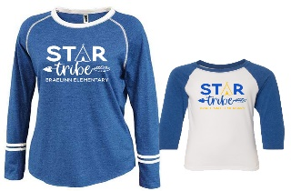  **Adult and Youth designs are different (Adult is the Blue and Youth is the White) | YOUTH STAR TRIBE (WHITE) $18 QTY____  SIZE: SMALL (6-8) MEDIUM (10-12) LARGE (14-16) XLarge (16-18)  ADULT STAR TRIBE (BLUE) $18 QTY____  SIZE: SMALL MEDIUM LARGE XLarge
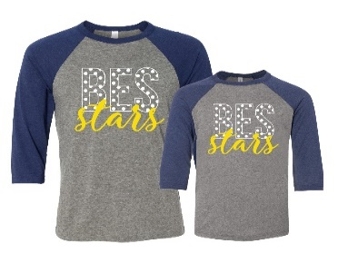  Back by Popular Demand! | YOUTH BASEBALL TEE $18 QTY____  SIZE: SMALL (6-8) MEDIUM (10-12) LARGE (14-16) XLarge (16-18)  ADULT BASEBALL TEE $20 QTY____  SIZE: SMALL MEDIUM LARGE XLarge
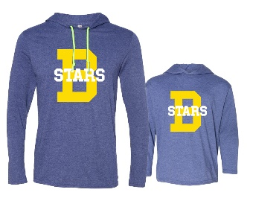  **note – the YELLOW B is available in GLITTER – if you do not want GLITTER – order BOYS version | YOUTH STARS LIGHT HOODIE (no Glitter) $20 QTY BOYS____  YOUTH STARS LIGHT HOODIE (Glitter) $20 QTY GIRLS___  BOYS FLAT YELLOW SIZE: SMALL (6-8) MEDIUM (10-12) LARGE (14-16) XLarge (16-18)  GIRLS GLITTER YELLOW SIZE: SMALL (6-8) Medium (10-12) Large (14-16) XL (16-18)  ADULT STARS LIGHT HOODIE (Glitter) $22 QTY _____  ADULT STARS LIGHTHOODIE (No Glitter) $22 QTY _____  SIZE: SMALL MEDIUM LARGE XLarge
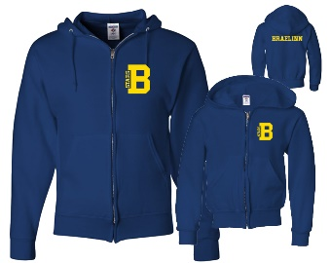  **note – BRAELINN on back of hoodie | YOUTH ZIP HOODIE $20 QTY____  SMALL (6-8) MEDIUM (10-12) LARGE (14-16) XLarge (16-18)  ADULT ZIP HOODIE $22 QTY____  SIZE: SMALL MEDIUM LARGE XLarge
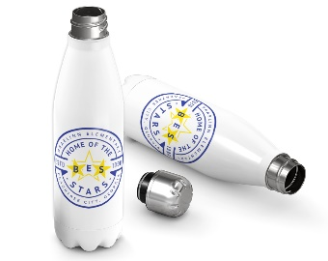 | Water Bottle (with lid) with Lid 17 ounce $15 QTY____
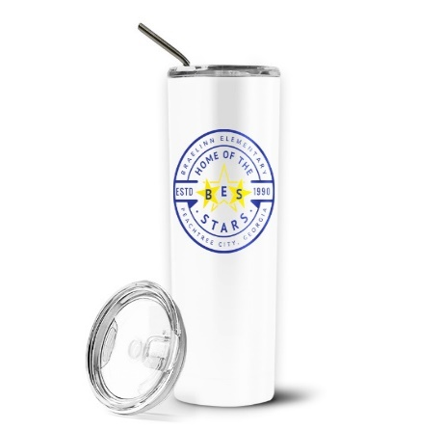 | Water Tumbler with stainless straw 20 0z $18 QTY____
 |  | ORDER TOTAL QTY#______ TOTAL $$______

NOTES: ___________________________________________________________________________________________
-------------------------------------------------------------------------------------------------------------------------------------------------------------------------------------------------------------------------------------------------------------------------------------------------------------------------------

****When in doubt order up in size****

