www.marcusharrisfoundation.org
info@marcusharrisfoundation.org
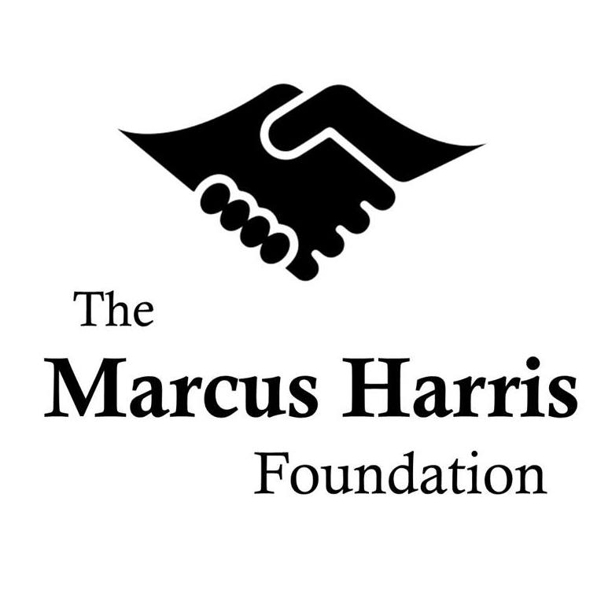
P.O. Box 11490
Durham, NC 27703

Robert B. Harris Memorial Scholarship Program

Academic Recommendation Form

We appreciate your willingness to support the applicant’s efforts to join our Robert B. Harris Memorial Scholarship Program. Through the program, we offer financial and career assistance to matriculated college students who have demonstrated a strong commitment to community service and are leaders for positive change in the lives of those around them.

If you are or have been the applicant’s teacher, professor, TA, guidance counselor, or advisor, please answer the questions below to give us your assessment of his/her academic experience and abilities. This completed form can be emailed to us at info@marcusharrisfoundation.org.

If you have any questions or concerns, please feel free to contact us at info@marcusharrisofundation.org.

Applicant’s Name:

Your Name:

Your Title:

Your Telephone Number:

Your Email Address:

How do you know the applicant? (e.g. teacher, counselor, advisor, etc.)

How long have you known the applicant?

To the extent to which you’re familiar, please expound on the applicant’s academic performance, including his/her focus, determination, and overall commitment to obtaining a higher education.

If you believe the applicant has overcome any special circumstances or unusual challenges over the course of his/her academic career, please describe them below. Please include any applicable examples of how s/he has demonstrated resiliency in the face of unexpected difficulty.

In what ways, if any, have you witnessed the applicant display strong leadership among his/her academic peers?

If there’s any additional information you’d like us to know about the applicant, please share it below.

Your Signature:

Date:

