www.marcusharrisfoundation.org
info@marcusharrisfoundation.org
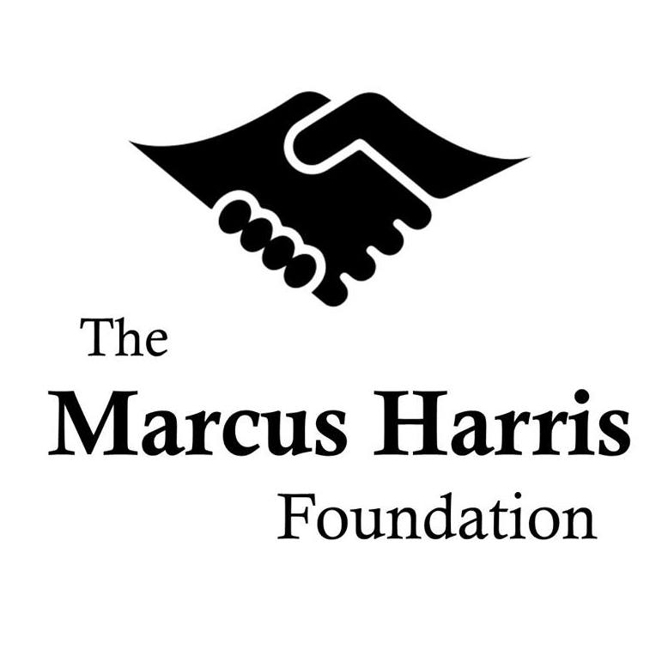
P.O. Box 11490
Durham, NC 27703

Robert B. Harris Memorial Scholarship Program

Personal Recommendation Form

We appreciate your willingness to support the applicant’s efforts to join our Robert B. Harris Memorial Scholarship Program. Through the program, we offer financial and career assistance to matriculated college students who have demonstrated a strong commitment to community service and are leaders for positive change in the lives of those around them.

If you are or have been the applicant’s mentor, coach, religious leader, or employer, please answer the questions below to give us your assessment of his/her personal traits and commitment to community service. This completed form can be emailed to us at info@marcusharrisfoundation.org.

If you have any questions or concerns, please feel free to contact us at info@marcusharrisofundation.org.

Applicant’s Name:

Your Name:

Your Title:

Your Telephone Number:

Your Email Address:

How do you know the applicant? (e.g. mentor, coach, employer, etc.)

How long have you known the applicant?

Please describe any specific activities, deeds, and/or involvements that demonstrate the applicant’s leadership and other strong characteristics. Please include any examples that help highlight his/her overall character.

Please describe the specific ways, if any, through which the applicant has demonstrated genuine concern for the welfare of others (e.g. community, church, family, etc.).

If you believe the applicant has overcome any unusual personal challenges over the course of his/her life, please describe them below. Please include any applicable examples of how s/he has demonstrated resiliency in the face of unexpected difficulty.

If there’s any additional information you’d like us to know about the applicant, please share it below.

Your Signature:

Date:

