Biodiversity Scientist Rescue Guide:
Boreal Forest
Hint:
Spoiler Tag: Delete to see what’s underneath!

Think about what characteristics the boreal forest has. What is its temperature and terrain, and what might be some species that don’t fit that description? Also make sure to read the description for each species, they might give you some helpful clues.
Solution:
Spoiler Tag: Delete to see what’s underneath!

The Polar Bear does not belong since it lives in the Arctic, the Orca does not belong since it lives in the ocean, the Western Whiptail Lizard does not belong since it prefers hot, dry climates, the Eastern Dwarf Tree Frog does not belong since it lives in freshwater habitats, the, and the Rhinoceros does not belong since it lives in grasslands, savannas, and shrublands. Now, unscramble the letters!
Answer:
The only word that uses these 5 letters is POWER.
Spoiler Tag: Delete to see what’s underneath!
Spoiler Tag: Delete to see what’s underneath!

Parkland
Hint:
Remember, you only need to identify the invasive species, not the native ones.
Spoiler Tag: Delete to see what’s underneath!
Spoiler Tag: Delete to see what’s underneath!

Solution:
Spoiler Tag: Delete to see what’s underneath!

Using the field notes, use the photos to identify which plants are invasive or not. Most photos will look very similar or the same.
Answer:
Spoiler Tag: Delete to see what’s underneath!

Refer to the picture below for the order of the invasive plants, question by question.
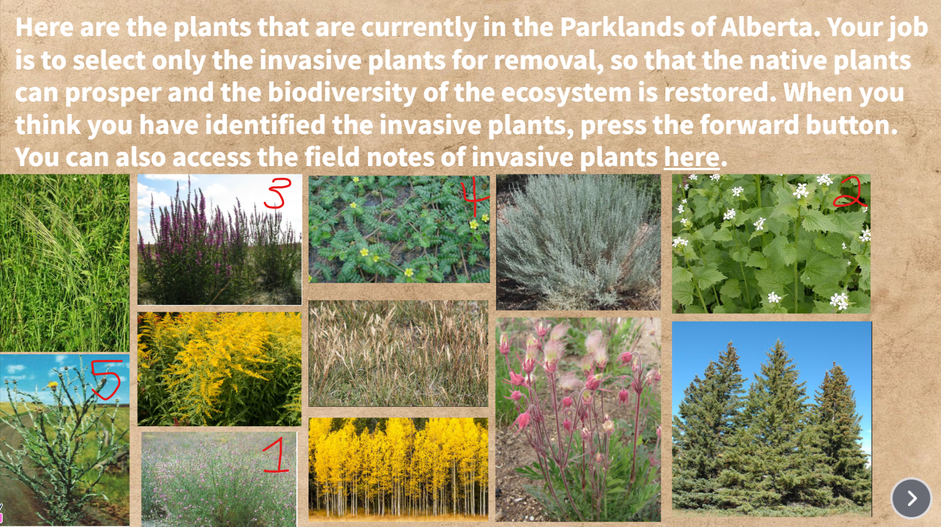
Foothills
Hint:
Use the field notes to identify what each type of fish is. Is there anything in there that tells you what fishes can or cannot be caught, and if there are any size limitations?
Spoiler Tag: Delete to see what’s underneath!

Solution:
Spoiler Tag: Delete to see what’s underneath!

Although there are many fish in the picture, some are eliminated for various reasons. From the field notes, any Walleye that are under 50cm cannot be caught, any Northern Pike that are under 63cm cannot be caught, any Mountain Whitefish under 30cm cannot be caught, and any Arctic Grayling, Bull Trout, and Rainbow Trout cannot be caught at all, regardless of size.
Answer:
Spoiler Tag: Delete to see what’s underneath!

Refer to the photo below. Only the fish that are not crossed out can be hunted, and that number is 9. For the species that were not allowed to be hunted at all, the only correct listing was the Bull Trout and Rainbow Trout.
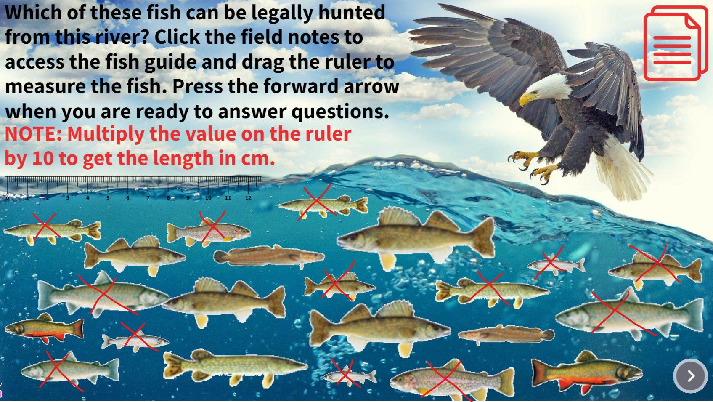

Grassland
Hint:
If you don’t understand what the question is asking, make sure you read the field notes!
Spoiler Tag: Delete to see what’s underneath!
Spoiler Tag: Delete to see what’s underneath!

Solution:
Spoiler Tag: Delete to see what’s underneath!

The species richness is 10 since there are 10 different species in the picture and the species abundance of bison is 5 since there are 5 bison in the picture. The species intactness of bison is calculated to be 25%, since for the year of 2020, there are expected to be 20 bison in the habitat, and since we have 5 currently in the picture, 5 divided by 20 is 0.25, or 25%.
Answer:
10, 5, 25
Spoiler Tag: Delete to see what’s underneath!
Spoiler Tag: Delete to see what’s underneath!

Rocky Mountains
Hint:
Spoiler Tag: Delete to see what’s underneath!

Using the dichotomous keys, try and eliminate some of the beetles. For example, if the colour of the beetle is bright, the dichotomous key shows that it is not a pine beetle. You should be able to eliminate all but one of the beetles this way.
Solution:
Spoiler Tag: Delete to see what’s underneath!

Using the clues related to colour, exoskeleton, antenna, and legs alongside the other characteristics of the beetles, you can find the mountain pine beetle as the red and black one on the bottom right of the screen.
Answer:
Refer to the picture below for the location of the mountain pine beetle, circled in red.
Spoiler Tag: Delete to see what’s underneath!

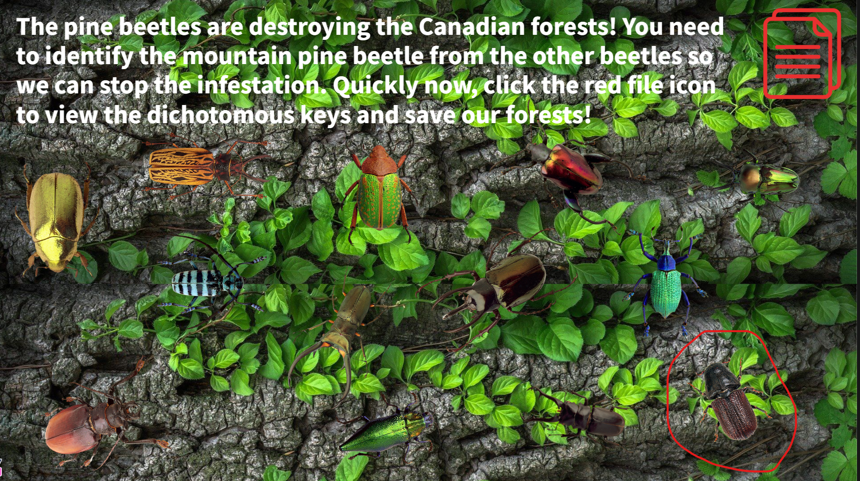
Canadian Shield
Hint:
Do you remember Dr. Cyber’s hidden note? You might want to read that again if you don’t.
Spoiler Tag: Delete to see what’s underneath!
Spoiler Tag: Delete to see what’s underneath!

Solution:
Spoiler Tag: Delete to see what’s underneath!

Putting all the notes together, you will find the coordinates to Dr. Cyber’s location.
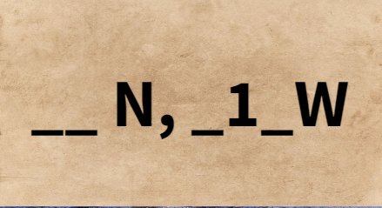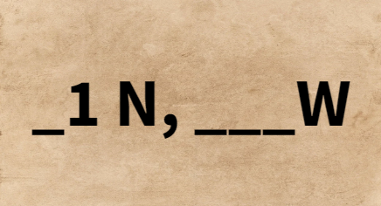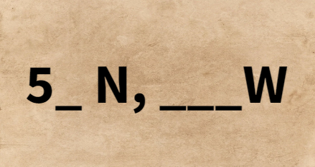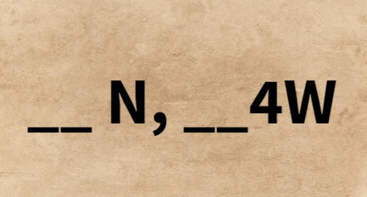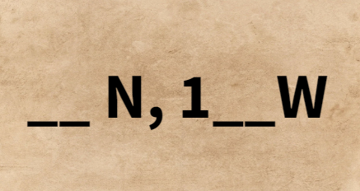
Putting the clues together, it reads 51N, 114W.
Answer:
Spoiler Tag: Delete to see what’s underneath!

Using the coordinates on the map by reading the axes, Dr. Cyber’s location is the black dot where Calgary is (where the blue arrow is pointing to).
