**Escape the Pokemon World Walkthrough**

**Made by Game Creator, Brennan O’Yeung**

This document is intended to show you how to complete the various puzzles found in Escape the Pokemon World. It is not comprehensive (does not contain solutions for every part of every puzzle in the game) but provides a detailed overview of what you need to know and what you might expect so that you are able to successfully complete the game. If you have further questions, please email escapewithstem@gmail.com.

**Berry Fields (Science Puzzle)**

If you are having difficulties with this puzzle, make sure you’ve taken a look at the Helpful Signpost (pictured right) first to learn the explanations for how the puzzle works and have tried to grow the berries a few times. If you are still having trouble, then you can read this walkthrough for a more in-depth explanation.

Fertilizers:

Nitrogen – use in the sprouting and growing stages unless potassium fertilizer is needed.

Phosphorous – use in the seed and ripening stages unless potassium fertilizer is needed.

Potassium – use in harsh weather conditions unless stated otherwise.

Weather Conditions:

Normal, Rainy, Snowy (harsh), and Sunny (harsh)

I will do the **Aspear** Berry Plant as an example.

Seed Stage: As a seed, it is important to give them some sun as they will not be exposed to much light as they grow.

* A pixel art of a game

  Description automatically generatedHere, since the signpost mentions that sun and light is needed, the correct weather will be the **sunny** condition. In addition, we know that sunny weather is considered harsh, and since there is no mention of protection or other fertilizers being needed, we should go ahead and use **potassium** fertilizer. Make sure to put fertilizer first before changing the weather.

If done correctly, you should see a sprout form in the soil plot.

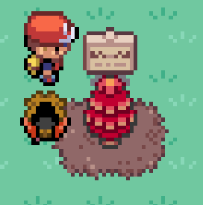Sprouting Stage: During sprouting, ease back on the weather to a normal setting and give it some potassium fertilizer to protect it in the future.

* Here, once again the weather is clearly stated for us, change it to **normal**. However, this signpost specifically mentions potassium fertilizer is required, so even though we would normally use nitrogen fertilizer for the sprouting stage in non-harsh weather, we make an exception here and follow the instructions by adding **potassium** fertilizer.

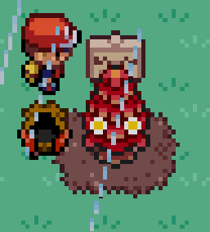If done correctly, you should start to see more growth in the plant.

Growing Stage: A torrential downpour of water really helps it grow quickly!

* Here, from the description we know we are dealing with **rainy** weather. We also know that in non-harsh weather in the growing stage, we require the use of **nitrogen** fertilizer.

If done correctly, you should see berries start to appear on the plant.

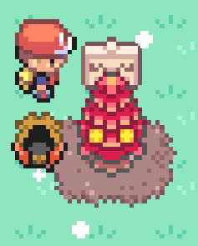Ripening Stage: Aspear berries are cold to the taste – let them grow in their natural environment where they are protected from the harsh weather!x

* Here, we can infer that since Aspear berries are cold to the taste, they must grow in a cold weather condition, and the only cold condition we have is **snowy** weather. For the type of fertilizer we need, we can see that the instruction state that the berries are already protected in this weather environment, so even though the weather is considered harsh, based on the information we should use **phosphorus** fertilizer since it is the ripening stage.

If done correctly, you should see the final state of the plant and can pick berries afterwards.

If you read through all the instructions carefully, you should be able to solve the other berries. Remember that once you pick at least 4 different berries that you can go talk to Jigglypuff to finish the puzzle!

**Stony Plains (Mathematics Puzzle)**

If you are having difficulties with this puzzle, make sure you’ve talked to Nidorino (pictured right) to make sure you know the rules and have tried to follow the steps a few times first. If you are still having trouble, then you can read this walkthrough for a more in-depth explanation.

I will do the third puzzle (Hourglass) as an example.

Step 1: The boulder on the origin does not move in this puzzle but is part of the final solution.

* Here, we know that the boulder on the dark square (the origin) will not move, but will be included in the final shape of the number. No need to do anything here right now, just keep it in mind for future steps.

Step 2: The boulders in the corners are not needed, hit them to the side.

* Here, we know that the boulders in the four corners of the hourglass shape are not needed. However, in Step 1 we learned that the origin is part of the final solution, so we only need to remove the other three boulders.

Step 3: Any other boulders left should be pushed one space in the negative x direction if allowed.

* Here, all the boulders should be pushed one space left, except for the boulder at the origin due to Step 1. Start from the left side first, as if you hit from the right you may block the other boulders from going left.

Step 4: The boulders with the highest y coordinates should be pushed in the negative y direction until they sit on the line with slope 1 passing through the origin.

* A video game screen with two people in a red hat

  Description automatically generatedHere, the boulders with the highest y coordinates are the two at the top of the picture after Step 3. They need to be hit until they are on the line with slope 1 passing through the origin. A line with slope 1 means that for every increase of one in the x direction, there is an increase of one in the y direction as well. So, if the line passes through the origin (0,0), then this means that the x and y values on the line need to be the same. Push the left top boulder down to coordinate (1,1) and the right top boulder down to coordinate (3,3).

Step 5: All boulders with an odd y coordinate should be pushed one space in the negative x direction if allowed.

* Here, the only boulders with an odd y coordinate are the ones we just pushed in Step 4, the boulders at (1,1) and (3,3). Push them each once to the left.

Step 6: All boulders with an even y coordinate should be pushed in the negative x direction starting from the left until they can't go further or lie on the y axis.

* Here, all the other remaining boulders need to pushed as far left as possible, either until they collide with another boulder or they lie on the y axis (where x = 0). If you start from the left and follow these instructions, you will see that the number is a 2.

If you read through all the instructions carefully, you should be able to solve the other boulder puzzles. Remember that you need to follow the instructions exactly and if you make a mistake and need to reset the puzzle, talk to Celebi!

**Rustling Forest (Technology and Engineering Puzzle)**

If you are having difficulties with this puzzle, make sure you’ve talked to Machoke to learn about the different types of equipment and what materials might be needed, and also have explored the forest interacting with things that might look out of place. If you are still having trouble, then you can read this walkthrough for a more in-depth explanation.

I will show the first step of the puzzle, right after Machoke gives you the **Shear**.

You may choose to first learn about the different equipment and materials or go explore the forest. Either way is fine, you will need to do the other at some point.

If we choose to look through all the equipment, we see that there are 4 different types: Climbing Gear, Pickaxe, Raft, and Strength Gauntlet. If we click on each one, we get a small description of the equipment along with what it looks like.

Out of all the equipment, only the raft requires one material, the rest require two. It appears that the raft is made from wood. These pieces of information are important to keep in mind as we search for various materials we can use.

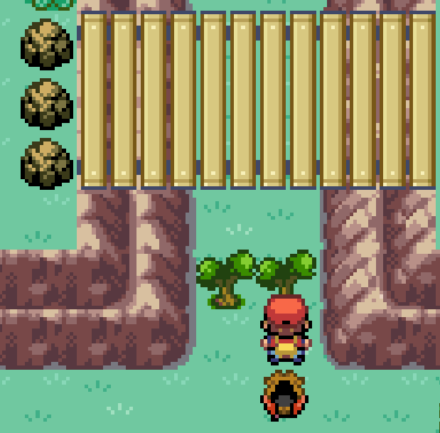

To start exploring the forest, we first need to cut down these small trees using the shear Machoke gave us.

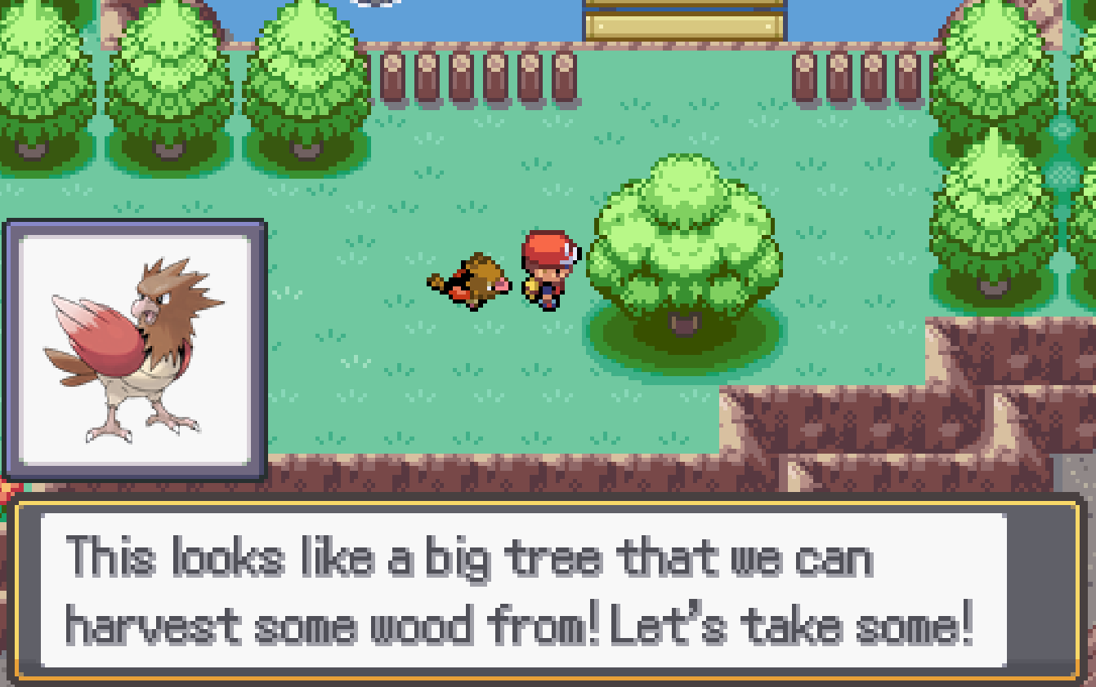After we make it past the small trees, we will cross and bridge and eventually come to a different looking tree near another bridge that crosses some water. If we interact with the tree (press the use key which is defaulted to **C**), we will be able to take some wood from it.

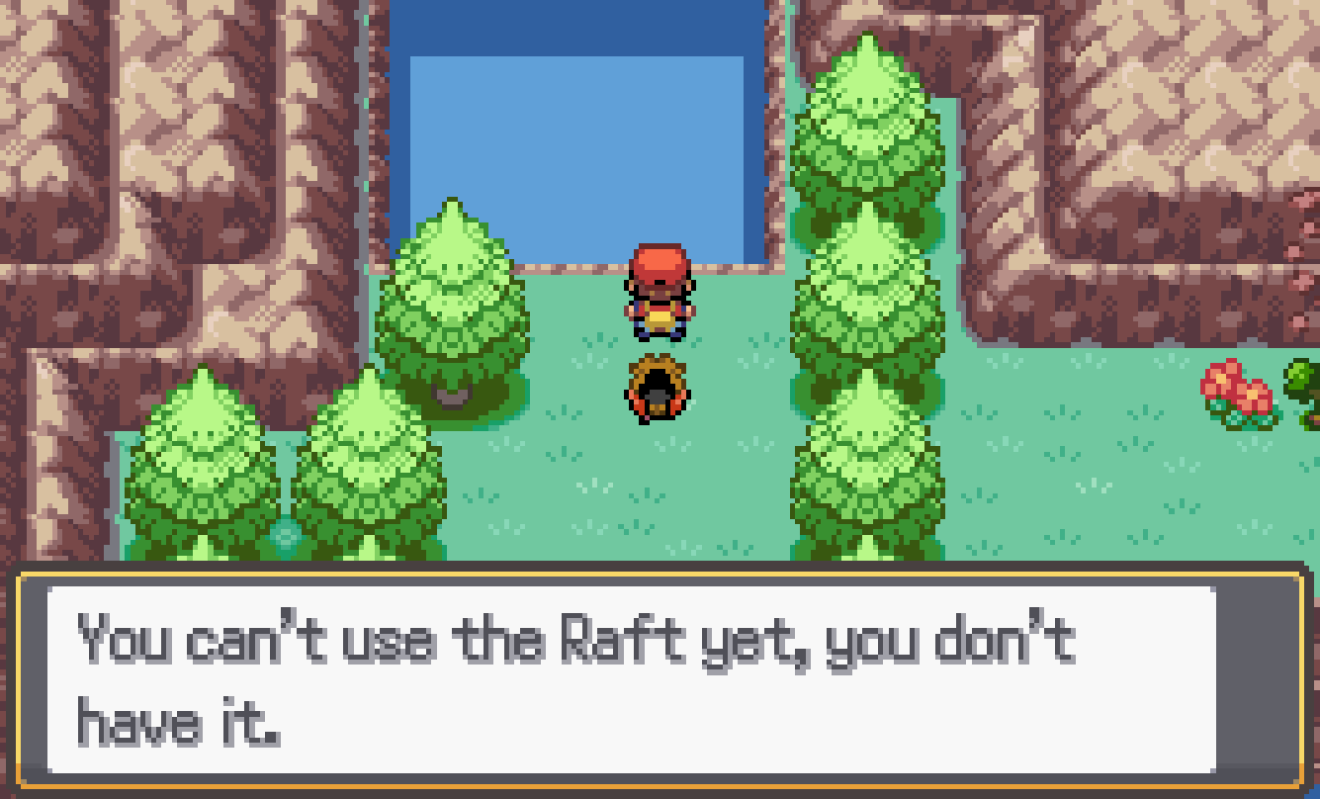If we keep exploring, we will need to cut down some more small trees, and then we will eventually reach some water. We currently cannot cross since we do not have the Raft. However, since we did some research beforehand, we know that we have the right material and can make the raft when we go back to Machoke. Then, we can progress on and continue looking for Machop!

If you read through all the instructions and search from the forest carefully, you should be able to craft all the necessary equipment and find Machop. Remember to check anything that might look out of place and learn about the equipment so you know what you can do!

**Once you are done all the puzzles**, **talk to Spearow and enjoy the rest of the game!**