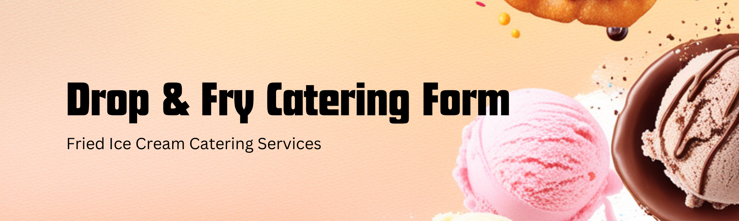
Customer Information
Name:  Address:  City, State, Zip: | Email:  Phone:
Event Information
Event Type:  Date: | Time:  Location:
Estimated Number of Guests:
Ice Cream Selection
Please select your desired ice cream flavors (Maximum 3). We offer a wide variety of flavors to suit every taste! Contact us for a full ice cream list available.
(Note: Availability of specific flavors may vary. We will confirm your choices.)
Flavors:
- Vanilla
- Oreo
- Strawberry
- Cookie Dough
- Other: ______________
Quantity (Servings per flavor):
(Please specify the number of servings for each flavor selected.)
Special Requests & Add-ons
Do you have any special requests or require additional items?
(e.g., toppings, cones, cups, napkins, spoons, dietary restrictions, etc.)
Contact Information
For any questions or clarifications regarding your order, please contact us at:
203-561-5403
Dropandfry@gmail.com
Dropandfry.com
Thank you for choosing us! We look forward to making your event a sweet success.



