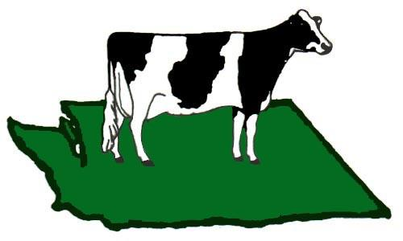
Washington State Holstein Show and All Breeds
Stalling Request Form
Jodi McKay 425-343-3552

The stalling request form must be completed for all animals on the grounds.

A string is defined as: By consent of all owners, animal that are interspersed within a row that must share tack, feed, clipping space and crew.
The superintendent may not be able to honor all stalling requests

Name of Farm or String:_____________________________________________________________________
Name of Show String Manager:___________________________________Cell#______________________
Total animals in String:_______________________
Estimated date and time of arrival:___________________________________________________
Do you have your own Night Hawk: Yes _________ No___________
Do you have others tying in your string: Yes__________ No___________

Exhibitors name/Farm # of Heifers #of Cows Breed
List yourself and other exhibitors that are tying within your string.
______________________________________________________________________________________________________________________________________________________________________________________________________________________________________________________________________________________________________________________________________________________________________________________________________________________________________________________________________________________________________________________________________________________________________________
Special requests will be considered but not guaranteed:
_______________________________________________________________________________________________________________________________________________________________________________________________________________________________________________________________________________________

