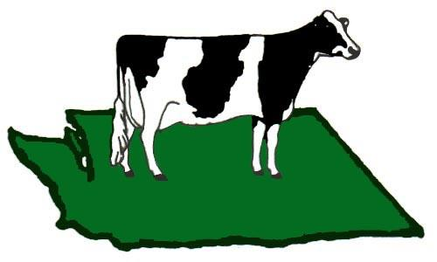
Washington State Holstein Association is
Proud to announce the
2026 State Holstein,
Western National Guernsey, and All Other Breeds Show
Judge: Kelly Reynolds
July 12-17, 2026 @ Evergreen State Fairgrounds, Monroe WA
Entries Open June 1, 2026 -July 1, 2026
Cost: Juniors $5.00 membership fee Adults $30.00 membership fee.
Livestock: $30 Entry fee per head $60 Late fee after July 1st $120 fee for entries at the show
Tack and Feed space will be allocated with stalling, if you want to utilize a 10x10 tent a fee of $50 will be added. (space available)
Enter online:WWW.assistexpo.ca/Washington-state-holstein-association
Visit the WA State Holstein Website for Links to: Show rules, Assist Expo, Sponsorship and donation forms.
Entries open to in state and out of state exhibitors. Out of state exhibitors will be required to follow Health requirements to travel into Washington, Health papers will be checked on arrival by a veterinarian.
Sunday 7-12-26
12:00 PM Animal early entry and set up no other early entry
Monday 7-13-26
6am-7pm Arrival of animals and registration paper check in.
Animals must be in place by 7:00 pm
8:00 pm Exhibitor Meeting
Tuesday 7-14-26
10 AM State 4-H And FFA Judging Contest All animals need to be made available
12:00 pm Lunch provided by Simplot
1:00 pm Pick up backtag, Jr T-shirts, pay outstanding fees
5:00 pm Junior Exhibitor Showmanship Grade animals welcome for showmanship only
Wednesday 7-15-26
9:00 Heifer Show Ayrshire, Brown Swiss, Guernsey, Jersey, Milking Shorthorn, Holstein
6:00 pm Exhibitor Dinner
Thursday 7-16-26
9:00 am Cow Show Ayrshire, Brown Swiss, Guernsey, Jersey, Milking Shorthorn, Holstein
Friday 7-17-26
All animals moved out by 12:00 pm
Things to Know:
Live Show Coverage by Cowsmo
Cow Pictures by Sarah Damrow
Bedding: Shavings will be provided, if straw is preferred you can bring your own or purchase locally
Feed: Exhibitors are responsible for their own feed
Parlor: Will be available Hours will be posted, or you can use portable on your pack
RV Spaces: Just outside the dairy barn Hook ups $40 a night request space and pay on Assist Expo
Lodging: Best Western Sky Valley Inn Monroe
Evergreen Inn & Suites, Monroe
Feed Stores: Monroe Co-op and Tractor Supply
Questions: Jackie Rupard 509-289-0313

