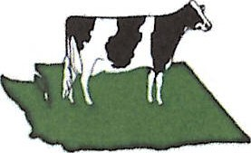
WASHINGTON STATE HOLSTEIN ASSOCIATION

2026 SPONSORSHIP CONFIRMATION
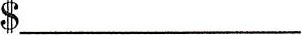Donation amount
Contact Name:__________________________________________________________________________
Business Name:__________________________________________________________________________
Mailing Address:_________________________________________________________________________
Phone:_______________________Email:_____________________________________________________
Notes:__________________________________________________________________________________
All sponsorship donors will be recognized on our website and Facebook page. Please email (see below) or attach your company logo, so it can be displayed on a banner ringside. All Sponsors will be announced by Cowsmo livestream and ringside during the show. Your ad or logo will also be in the show catalog

Contact Jackie Rupard (509-289-0313) with any specific requests for how you or your company can be part of this event! Kindly return this form by July 1, 2026, to guarantee inclusion on signage!

Please make checks payable to WA State Holstein Association, PayPal or Venmo, also accepted.
Please put State Show donation in comment line.
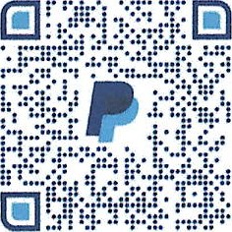  PayPal |   Venmo

Mailing Address: Washington State Holstein Association
C/O Duane Davidson Secretary
2005 W 24th Ave
Kennewick, WA 99337
509-366-3646
wastateholstein@gmail.com

Thank You for your Support!

