|  |
| --- |
|  |
| May Newsletter 2018 |
|  |

Bridgepoint CA

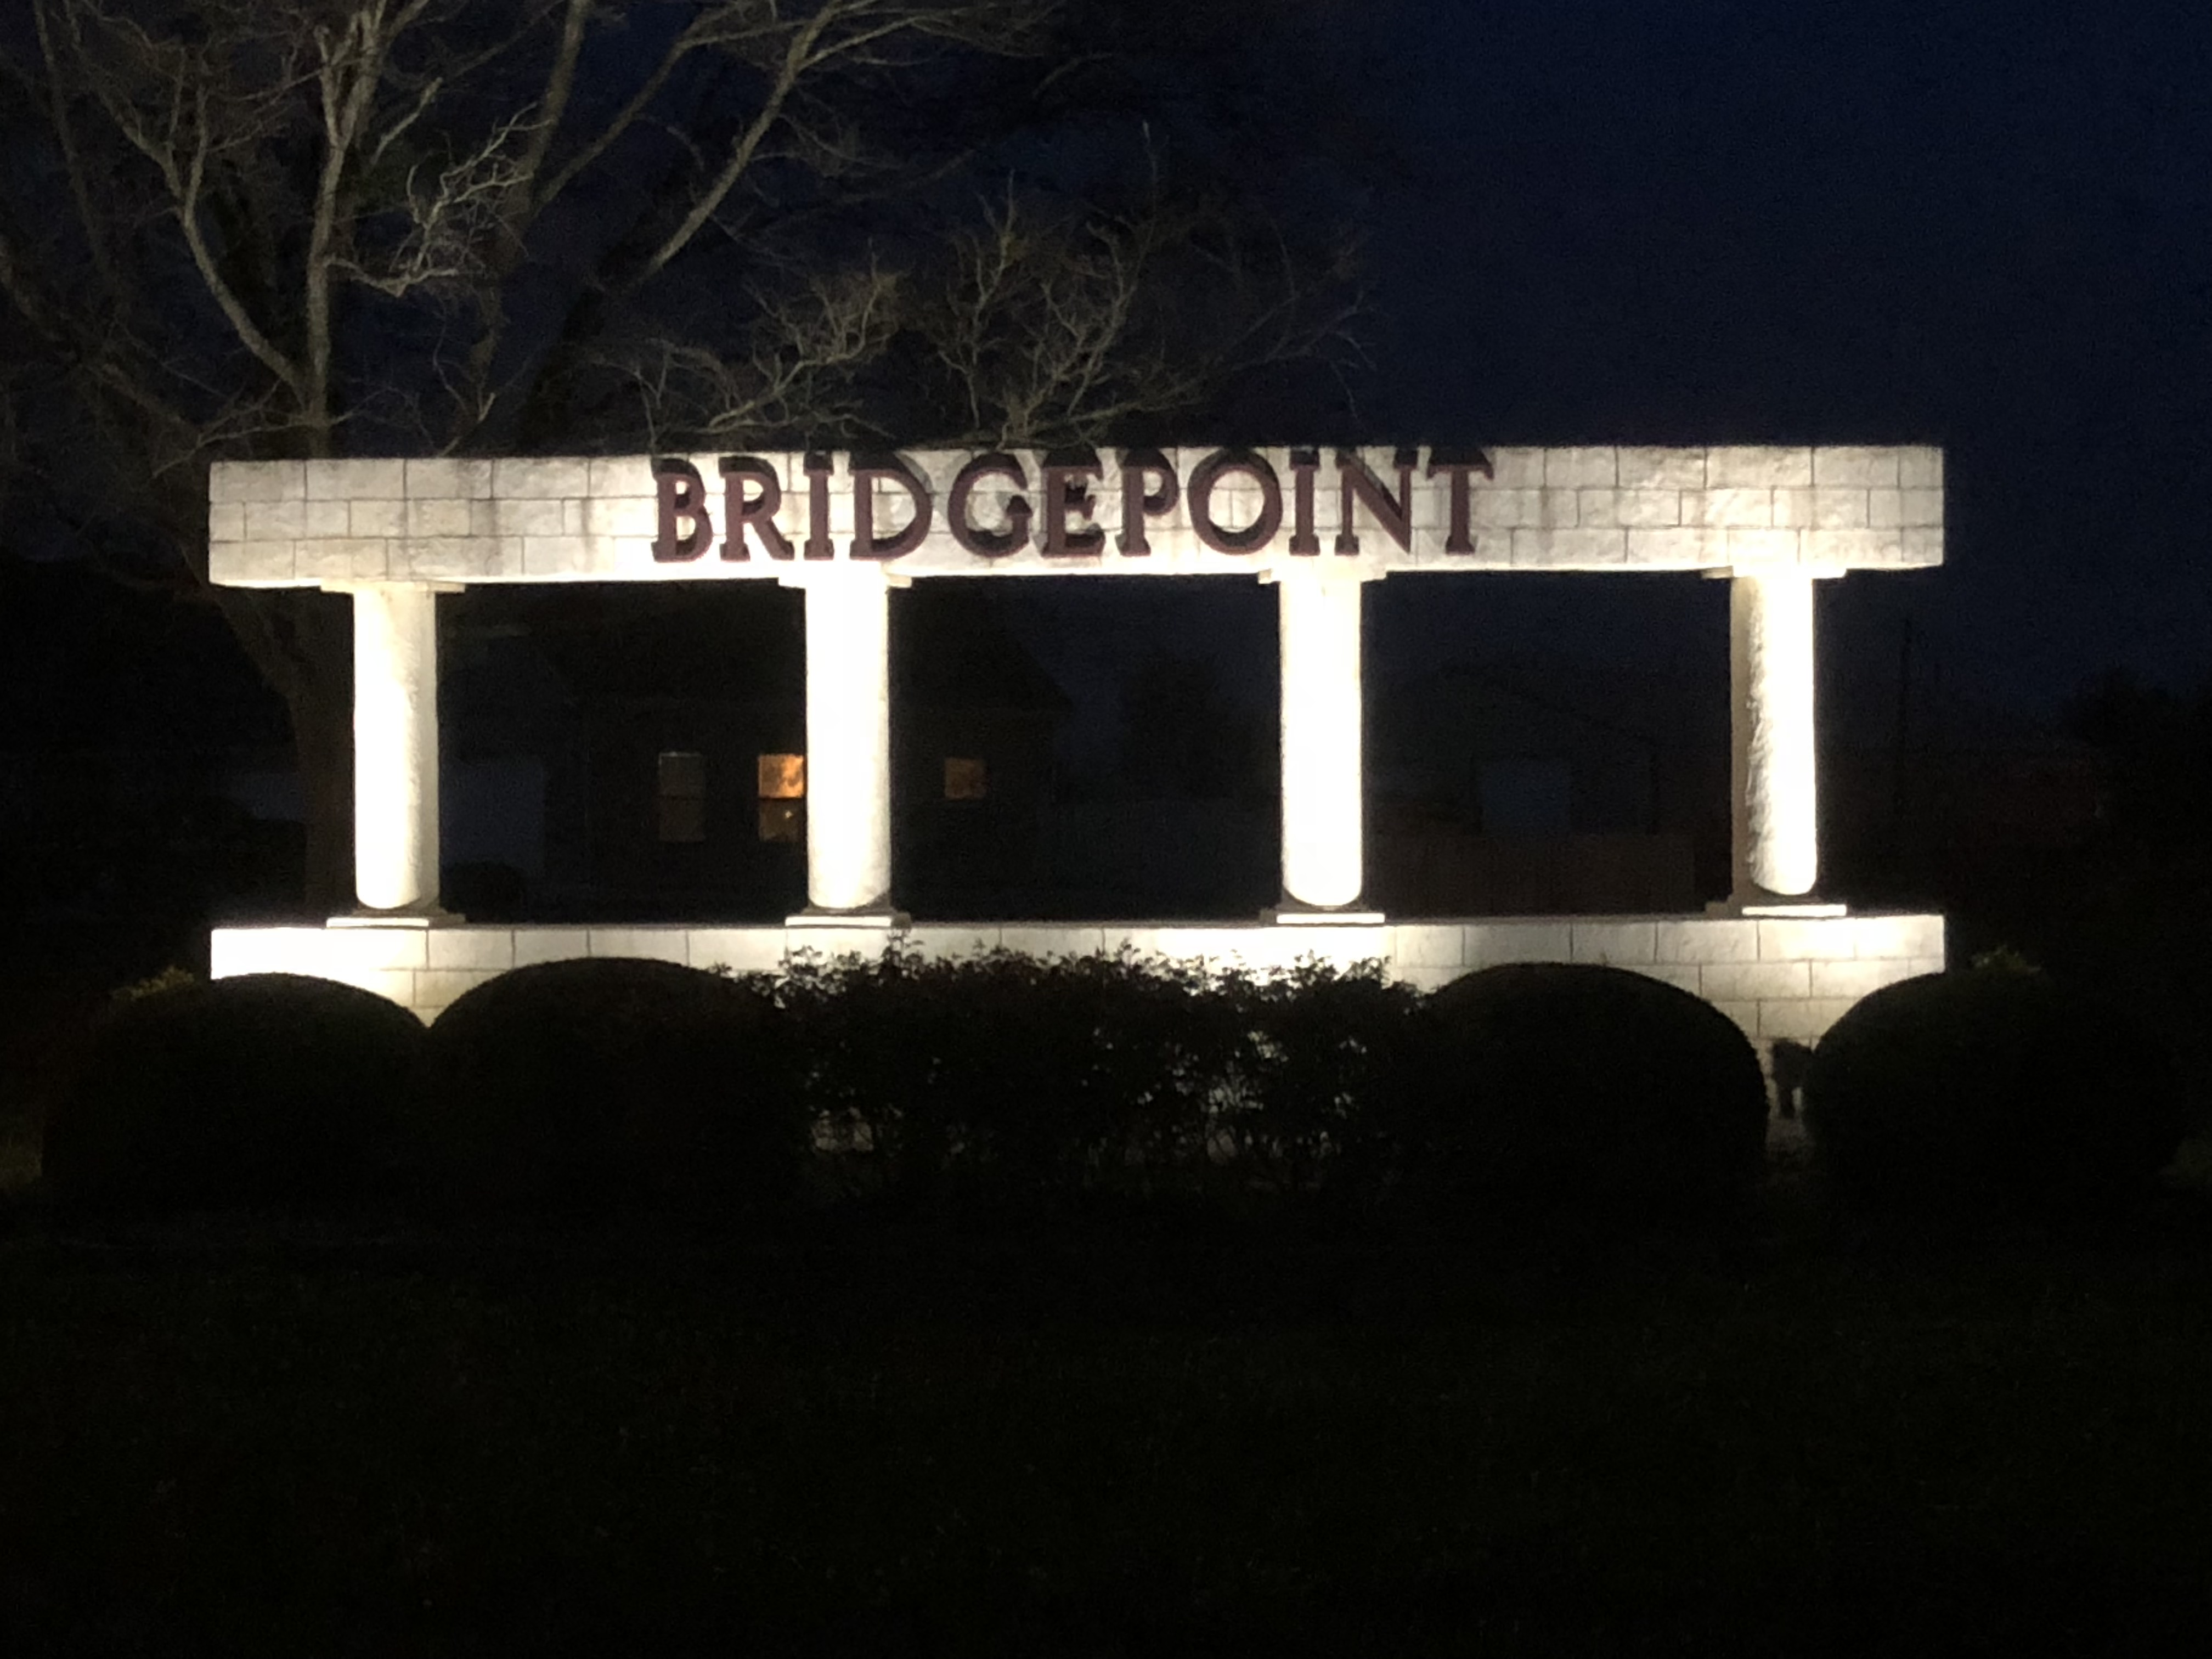

# Upcoming Events

## May 14

Bridgepoint BOD Meeting

## May 19

Bridgepoint Neighborhood Garage Sale

|  |
| --- |
|  |
| Image result for garage sale signs  Gather all your stuff that has been sitting around your house collecting dust, and let’s make some money off of it. The Bridgepoint neighbors are having a Garage Sale on May 19th. Invite all your friends to join you and let’s make it successful for everyone. Good luck! |
|  |

P.O. Box 1709, Willis, TX 77378

http://bridgepointca.org/ T: 713-598-0856

|  |
| --- |
|  |
| Happy Spring Neighbors,  The grass is getting green, the trees are all budded out and the flowers are in beautiful bloom. I want to say that everyone in the neighborhood is doing a great job of making their yards look beautiful and enjoyable to look at. The BOD of Bridgepoint wants to wish each and every one of you a happy summer. Enjoy the wonderful weather that we having while it last. Please be safe if you are boating or traveling this summer and we look forward to seeing you in September. |
|  |

## BOD Meeting

The meeting at the boat dock last month was as great success. We had a great turnout and look forward to the May 14th meeting being just at successful. It’s very easy to grab a chair, get in your buggy and head down to the boat dock and participate with your community. It is a great opportunity to get out and enjoy the evening weather and made a difference with your opinions and additions to the meeting. It will be your last chance until September. There is only a 10% chance of rain in the forecast. But keep tuned into your email if anything changes, the meeting will be moved to Mink Street.

**Big Shout out**

The whole BOD and the rest of the neighborhood wants to give a BIG THANK YOU to ***Lynelle Soltys*** for the amazing job she does with the entry way into the subdivision. Thank you for all the time that you volunteer on this. It is greatly appreciated.