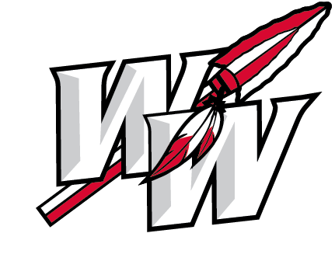

WASHINGTON WARRIOR FOOTBALL BOOSTER CLUB
MEMBERSHIP FORM
2021
The Washington Football Booster Club is excited to support the 2021 WARRIOR FOOTBALL Team! Parents, Grandparents, Alumni, Local Businesses, and Friends all participate to help the team financially and logistically. The Booster Club is always ready to help! Thank you to all of our past supporters and Corporate Sponsors. The generosity and commitment of businesses and individuals has played a big part in our Football program’s success!
Funds raised this year will help provide the team with game day meals, practice gear, paying towards an Athletic Trainer on staff, 2021 Football Banquet, and various other team expenses. The Booster Club pays for a large portion of our summer speed, strength, and agility program: “Performance Course” which gives our kids the best opportunities to EARN their SUCCESS.
Our club could not do all that we do without your generous support!
In order to have your donations listed in the program for the first home game, we need to receive them by August 20th, 2021.
Thank you in advance for your generous support of our Washington Warriors!

With Gratitude,
Washington Football Booster Club

MEMBERSHIP LEVELS | BENEFITS
Booster Club $25 | Name recognition in Team Program
Bronze Warrior $100 | Name recognition in Team Program PLUS:  Warrior CAP
Silver Warrior $250 | All Bronze Warrior benefits PLUS:  2 x 2020 Season Football Passes
Gold Warrior $500 | All Silver Warrior benefits PLUS:  Custom Banner/Advertisement at Football Field
Platinum Warrior $1000 | All Gold Warrior benefits PLUS:  Signed Souvenir Football  ½ Page Ad in Team Program
Diamond Warrior $1500 | All Platinum Warrior benefits PLUS:  Full Page Ad in Team Program
Ultimate Warrior $2000 | All Diamond Warrior benefits PLUS:  Immediate Family All-Sports Pass

***Name or Company Name: _______________________________________________
Address: _______________________ City: ______________ State: ___ Zip: _______
Phone: ______________________ Email: ___________________________________

__ Booster __ Bronze __Silver __Gold __ Platinum __ Diamond __ Ultimate
Checks are payable to: Washington Football Booster Club, PO Box 714 Washington, OK 73093
For information contact: Kevin Cantrell (580-399-8299) or Sonya Coles (405-473-1022),
*** Please print your name exactly how you want it to read in the Team Program

