How to use this Service Agreement
 | Nurturing Hands Allied Health P/L wrote this agreement. When you see the words “We” or “Us” it means Nurturing Hands Allied Health P/L.
 | We have written this Service Agreement in an easy-to-read way.  We use pictures to explain some ideas.
 | You can ask for help to read this Service Agreement. A friend, family member or support person may be able to help you.
 | This Service Agreement is between:
 | You (write your name)
 | Who lives at (write your address)
and
 | Us, Nurturing Hands Allied Health P/L, your NDIS Service Provider.
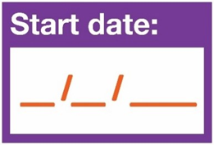 | This agreement STARTS on  __/__/____
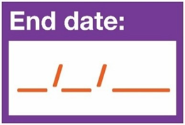 | This agreement ENDS on  __/__/____

What’s in this document?
Table of Contents
What is a Service Agreement 4
Responsibilities 5
What you need to do 6
What we need to do 7
What both of us need to do together 7
Paying for your support 9
Changing this agreement 11
Ending this agreement 12
Cancelling services 12
Tell us what you think 13
Making this agreement 14
Contact us 16
Your Schedule of Supports 16

What is a Service Agreement
 | This Service Agreement is about the services and supports you will get from us.
 | It explains the supports that we will give you.
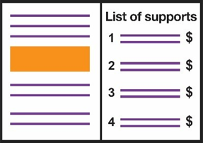 | At the end of this document, there is a list of:  - Your Supports  - Their Prices
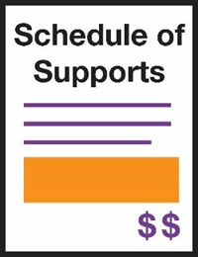 | We call this your “Schedule of Supports”
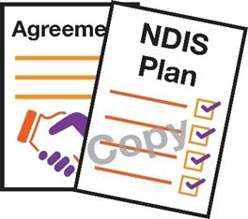 | There is also a copy of your NDIS plan at the end of this document.

This agreement also explains:
 | - What you can expect from US
 | - What we expect from YOU

Responsibilities
Responsibilities are things that:
 | - YOU need to do
 | - WE need to do
 | - Both of us need to do TOGETHER

What you need to do
You need to:
 | - Tell us how you want to get your support
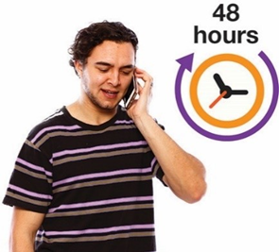 | - Tell us 48 HOURS BEFORE if you want to cancel an appointment
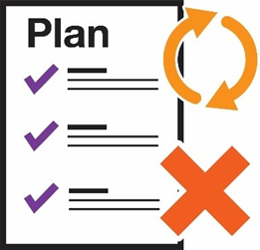 | - Tell us as soon as possible if your plan changes of ends

What we need to do
We will give you:
 | - Supports that meet your needs
 | - Supports when you want them
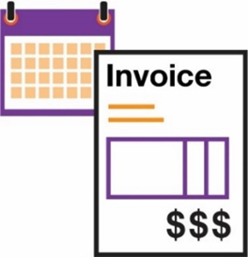 | - An invoice for your supports after each session, if you self-manage.

What both of us need to do together
We both need to:
 | - Treat each other KINDLY and with RESPECT
 | - Work out a PLAN for your support
 | - Check out how your supports are going at least once per year
 | - Talk to each other about your supports and funding
 | - Follow NDIS laws – the National Disability Insurance Scheme Act 2013
 | - Keep the paperwork for your supports
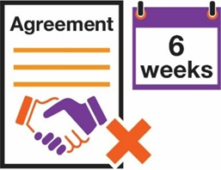 | - Give 6 WEEK’S NOTICE if this agreement needs to end
 | - Listen to feedback
 | - Fix problems quickly

Paying for your support
 | Funding is the money to pay for your supports
Tick the box to show where your funding comes from:
 | ☐  The National Disability Insurance Scheme (NDIS) (Agency-Managed)
☐
You (Self-Managed)
 | ☐  Your Plan Manager (Plan-Managed)
 | If you have a Plan Manager, they will pay us for your supports
If you manage your own funding you need to:
 | - Have enough funding to pay for our services
 | - Pay for travel costs if you manage your own transport funding
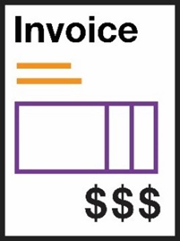 | We will send your invoices that tell you how much you need to pay.
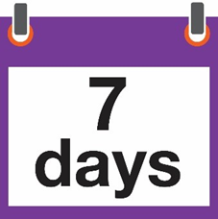 | You will need to pay those invoices within 7 days
 | If you don’t, we may not be able to provide you with support
 | We will connect third party services to assist us in ensuring you are safe, and your supports are maintained during an emergency or disaster.

Changing this agreement
 | This agreement may need to change
 | You might want to change it.  We might want to change it.
 | We will talk to you about any changes.

Ending this agreement
 | You can end your Service Agreement if we cannot give you the supports you need.
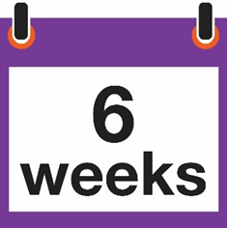 | You need to tell us 6 weeks before you want the agreement to end.
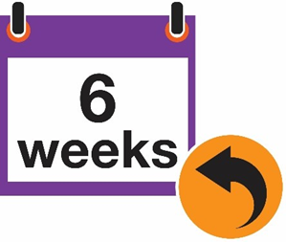 | If we need to end the agreement, we will tell you 6 weeks before the date.

Cancelling services
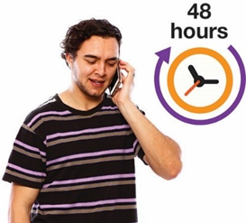 | You must tell us if you need to cancel an appointment, at least 48 hours before.
 | We will have to charge you a fee if you don’t tell us
 | If we have to charge you these fees more than 8 times in 1 year, we have to tell the NDIA.

Tell us what you think
 | It’s important that we know how you feel about our service
You can:
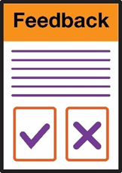 | Give us feedback – tell us how things are going. All feedback or complaints will be kept private
 | Make a complaint – tell us if something is wrong. If you want to do this anonymously, you can mail the complaint form to:  Nurturing Hands Allied Health P/L  15 Caromar Street  Croydon Vic 3136
 | You can contact the NDIS Commission via phone on 1800 035 544 (free call from landlines) Monday to Friday 9am to 5pm (4.30pm in NT)
 | Or via their website https://www.ndiscommission.gov.au

Making this agreement
 | Please read and sign this page
 | I understand and agree to everything in this agreement.
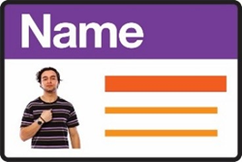 | Your name
 | Your signature
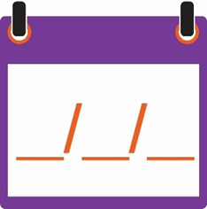 | Date  __/__/____
 | Your Parent’s, Nominee’s or Guardian’s name
 | Your Parent’s, Nominee’s or Guardian’s signature
Date

__/__/____
Your Coordinator or Contact reads and signs this page
 | I accept this agreement for
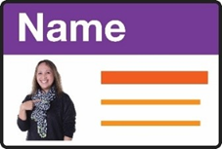 | Staff Member’s name
 | Signature
Date

__/__/____
This agreement needs to be checked on or before:

__/__/____

Contact us
 | 0419 54 59 51
 | deb@nurturing-hands.com.au
 | 15 Caromar Street  Croydon Vic 3136
 | www.nurturing-hands.com.au

Your Schedule of Supports
Name of Support   | About this Support   | How much this Support Costs  

