June 22, 2022
Thirteenth Sunday in Ordinary Time
June 26, 2022

Jesus said to him, “No one who puts
his hand to the plow and looks back
is fit for the kingdom of God.”

-Luke 9.51-62

Online Broadcast of the Daily / Sunday Masses:
- Sacred Heart Cathedral, PG Facebook
- Annunciation Parish Prince Rupert Facebook
- St. Joseph’s Parish, Smithers Facebook
- Notre Dame Parish, Dawson Creek, Facebook

For those with cable or optic TV, please check with your provider for the following or go directly to:
- Salt & Light
- Vision TV
- EWTN TV

Attachments
- Charity 50/50 Appeal

Shepherd’s Corner Needs Volunteers
Shepherd’s Corner is a ministry and outreach of the Diocese. Our purpose is to be a Christ-like presence in the downtown amongst homeless and street people. On account of the onslaught of Covid 19, we have been unable to invite people inside. This situation continues due to ongoing uncertainty, even though many restrictions in respect of Covid 19 have been relaxed. However, we are still able to provide (at our front door) services of drinks, snacks, clothing (when available) along with the warmth and presence of Jesus. We are open Monday to Friday from 10:00 A.M. to 1:00 P.M.

We are very thinly staffed and are in dire need of volunteers.

As Catholics, Shepherd’s Corner allows us an opportunity to do as Jesus asked us in Matthew 25: 35 - 40. One does not need to be an expert in matters of homeless people. What is important is that volunteers try to see that those people who come to our door are children of God. From a safety perspective, as noted above, we do not let people in, but serve them at the door, and we have strict procedures in place to ensure cleanliness and high standards of hygiene. Thus, volunteers can feel safe. If you feel called to serve in any way, please contact: Sister Marife Macalam at mmacalam@pgdiocese.ca or (778) 675-6547 or Peter Ranson at p-ranson@shaw.ca or (250) 552-8980. Please also call us if you are uncertain about volunteering, or if you just wish to learn more about Shepherd’s Corner.

In 2021, Aid to the Church in Need (ACN) raised a record amount for persecuted and suffering Christians
In 2021, Aid to the Church in Need, an international Catholic and pontifical charity dedicated to supporting persecuted and suffering Christians, raised over 197.4 million dollars in donations. In Canada alone, just over 2.2 million was raised.

Funds raised by ACN go towards funding for projects and initiatives in countries around the world, including the formation of priests, religious and seminarians, as well as projects meant to help Christians stay in their homelands in the face of various adversities and crises.

For greater details on ACN’s work and the distribution of its funds, please read the article in full here: https://acn-canada.org/in-2021-aid-to-the-church-in-need-acn-raised-a-record-amount-for-persecuted-and-suffering-christians/

CNEWA Canada Raises $4 Million to Support Ukraine
In the early weeks of February after the invasion of Ukraine by Russia, CNEWA Canada launched a campaign to raise money for relief efforts in Ukraine. In the 100 days since then, people across Canada have donated a historic $4 million.

Msgr. Peter Vaccari, president of CNEWA, said “We’re working quickly to direct this aid to those who need it most through our partners on the ground in Ukraine as transparently and securely as possible.”

The full news release can be read here: https://cnewa.org/ca/cnewa-canadas-ukraine-campaign-tops-4-million/

Donations can continue to be made online, by phone, and through cheques in the mail as detailed below.

Support Ukraine through CNEWA
The Catholic Near East Welfare Association (CNEWA) is a papal agency dedicated to addressing the needs of near-eastern countries and implementing solutions with and through the Church in those countries.

Donations for Ukraine can be sent to CNEWA the following ways:
- Visit https://cnewa.org/ca/campaigns/ukraine/
- Call 1-866-322-4441
- Send cheques to CNEWA Canada, 223 Main Street, Box 80, Ottawa ON K1S 1C4

PG4Ukraine – Share Hope Refugee Sponsorship
The Share Hope Refugee Sponsorship Committee has been very active since the invasion of Ukraine began. To date we are helping numerous families make their way to Prince George and our northern region of BC to seek refuge and resettle either temporarily or permanently. This support is carried out by our committee members who help with all manner of logistics from travel, housing, language, job searchers, education and health, wellness and more. We also support the families and individuals through a supportive network of socializing and making them feel both welcome and at home in our region. If you would like to get involved, please reach out to Eva Gillis at Immaculate Conception or Dick Mynen at St Mary's with our new email address pg.sharehope@gmail.com.

Share Hope is also raising funds to help resettle and financially support those arriving to our region. We have already received requests from multiple families and have begun to distribute funds. If you would like to help with our fundraising efforts, you can donate directly to your Parish and mark it “in support of the Share Hope Refugee Sponsorship Committee.” You can also donate through CanadaHelps using the “Ukraine” option on the page for the Diocese of Prince George located here: https://www.canadahelps.org/en/dn/70838. If you have a fundraising idea or initiative you would like to promote, contact pg.sharehope@gmail.com

Knights of Columbus Summer 50/50 Charity Appeal
Tickets are now on sale for this year’s Summer 50/50 Charity appeal. Funds raised from this Charity Appeal are given back to the dioceses in BC to help fund education and social programs.

For more details, please see the attached poster.

Family Love: Vocation and Path to Holiness – A CCCB Video for the 10th World Meeting of Families
The 10th World Meeting of Families will take place from 22-26 June 2022 this year. It has been organized by the Diocese of Rome and the Dicastery for the Laity, Family and Life. This year, the event itself will be celebrated in all dioceses and eparchies across the world and not just in Rome.

To help bring the theme to life for dioceses and eparchies in Canada, the CCCB Standing Committee on Family and Life has produced and released “Family Love: Vocation and Path to Holiness,” a short promotional video.

View the full press release and access the video on the CCCB’s website: https://www.cccb.ca/media-release/press-release-world-meeting-of-families/

Prince George Pro-Life Society
These past two years, the Prince George Pro Life Society has kept a low profile, waiting for the end of COVID and restrictions, never expecting the pandemic to last this long. It is now time to take steps towards becoming more active, in whatever way possible. Our goal is to return to some, or all, of the events of past years, such as: Life Chain, Day of Infamy, 40 Days for Life, and our booth at the exhibition. Eventually, we hope to add on new events such as a pro-life movie and dessert evening.

To accomplish this, one of our first goals is to rebuild our membership to pre-pandemic levels. For those who are interested in joining us in our work for the respect and protection of all human life, please consider becoming a member of the Pro-Life Society. Membership is $24 (adult/family) and $12 (student/senior) per year. Our mailing address is P.O. Box 2333 Stn A, Prince George, BC, V2N 2J8. If you have any questions, please contact Laura at 250-563-3874 or at jafowlie@telus.net.

The Young Adults of the Diocese of Prince George Telegram Group Chat!
For all young adults in the Diocese of Prince George! Scan the QR code to join our Telegram group chat! Keep up to date on all the events and gatherings for young adults!

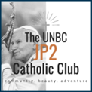
JP2 Catholic Club Instagram
For all young adults, students at CNC or UNBC, young professionals, or young families – follow us on our Insta: @jp2catholicclub! We post everything from inspirational content for your prayer life, to events that are happening in the area! Our Instagram is the place to go for updates and changes made on our week-to-week events and gatherings.

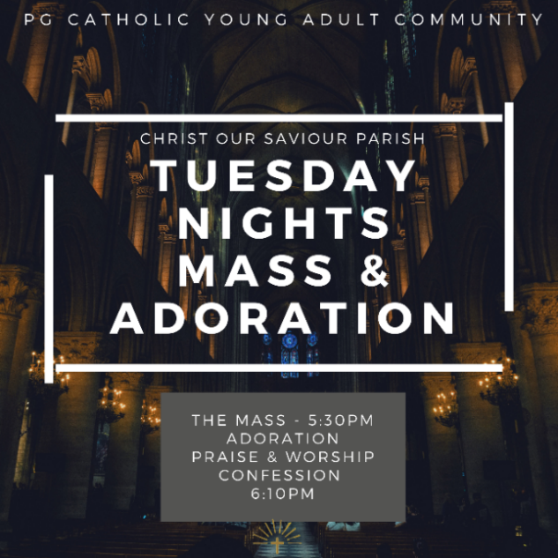
Tuesday Nights at Christ Our Saviour
All youth and young adults are invited to Christ our Saviour Parish, each Tuesday night, to spend an evening with Jesus, alongside a community of other young people! Fr. Michael celebrates Mass at 5:30PM, followed by leading us through Eucharistic Adoration. Throughout Adoration, we have praise and worship led by some of the young adult community, have time for silence, and there’s the opportunity to go to the Sacrament of Reconciliation. All are welcome to make this night a consistent part of their week.

Employment Opportunities

Catholic Independent Schools Diocese of Prince George (CISPG):

- Teachers: Catholic Independent Schools Diocese of Prince George (CISPG) is hiring for September 2022, full-time teaching positions in Prince George, Terrace, Kitimat, Smithers and Dawson Creek. Please help spread the word! Postings found at http://cispg.ca/careers/

CNEWA Canada National Director:

- CNEWA Canada, a papal agency that helps provide humanitarian and pastoral support to peoples and churches in the East, is currently looking for a dedicated, hardworking and passionate National Director to lead the Canadian bureau. The job posting can be found at https://cnewa.org/ca/national-director-cnewa-canada-job/ and more information about the CNEWA can be found on their website: https://cnewa.org/ca/

Catholic Independent Schools of the Diocese of Victoria (CISDV):

- The Catholic Independent Schools of the Diocese of Victoria are looking for a principal for St. Andrew’s Regional High School in Victoria, BC. Please see the job posting for further details: 2022-04-04-Principal-SARHS.pdf (cisdv.bc.ca)

Want to share news in the Wednesday Weekly?
Email reception@pgdiocese.bc.ca by NOON on Tuesday.
Late entries will be published in the following week’s edition. Please send in Word format.

To receive all diocesan news directly in your inbox or on your phone email reception@pgdiocese.bc.ca or text “pgd” to 514-900-0130 to join Flocknote. This is an email and text messaging tool created for churches, ministries, teams and other community organizations. It helps to communicate with the people by sending a simple text message. Please join us in keeping up with all the diocesan news.

