
November 30, 2022

The Second Sunday of Advent
December 4, 2022

“Repent, for the kingdom of heaven
has come near.”

-Matthew 3.1-12

Online Broadcast of the Daily / Sunday Masses:
- Sacred Heart Cathedral, PG Facebook
- Annunciation Parish Prince Rupert Facebook
- St. Joseph’s Parish, Smithers Facebook

For those with cable or optic TV, please check with your provider for the following or go directly to:
- Salt & Light
- Vision TV
- EWTN TV

Attachments
- Research and Resources Development Assistant Job Description
- St. Therese Institute – Co-Director
- St. Therese Institute – Executive Director
- Advent Mission Poster
- Advent Coffeehouse Poster

Fake Email Messages from the Bishop and Clergy of the Diocese
There have been reports from people receiving emails and text messages pretending to be sent by priests or the bishop and requesting assistance of some kind. Please DO NOT respond. Emails from the bishop would come from pgdiocese.bc.ca or pgdiocese.ca. While most fake messages have been from gmail.com accounts, there have been rare reports of some fake emails imitating legitimate email accounts.

Our advisors have told us that there are no steps we can take to prevent these messages from being sent. All we can do is advise everyone of the problem. If you receive an unexpected email claiming to be from the Bishop, Clergy, or any religious in the diocese and are not certain if it is legitimate, please call the Diocesan Pastoral Centre at 250-964-4424 or forward the email to the Pastoral Centre at reception@pgdiocese.bc.ca.

For more information on the many types of phishing messages and how to identify them, please visit this government website: https://www.getcybersafe.gc.ca/en/phishing

Advent Mission with Guest Speaker Jean-Paul de Fleuriot
From December 2nd to 4th, Christ Our Saviour Parish will be hosting an Advent Mission with guest speaker Jean-Paul de Fleuriot. Please see the attached poster for the schedule.

Monthly Day of Eucharistic Exposition and Adoration of the Blessed Sacrament
Emmanuel Hermitage invites you to a Personal Date with Jesus on Tuesday, December 13, 2022 at the Domano Chapel, 6500 Southridge Ave. Mass will be celebrated at 7:30 AM and the Blessed Sacrament will be exposed from 8:00 AM to 8:00 PM for a day of silent prayer and adoration. We will pray for the universal Church and the world, and for the people and needs of our Diocese. In particular we will pray for the protection of all human life, for all the sick, for vocations, for Peace in our world, and for the intentions of those participating in the day. Please mark your calendar on the second Tuesday of each month for Personal Dates with Jesus days.

Hope for Women Christmas Hampers – Sponsor a Family this Christmas
Hope for Women Pregnancy Services has handpicked several clients and their families to be recipients of a Christmas Hamper to help with the holidays. If you would like to sponsor a family in Prince George this year, here’s how you can help:

- The first thing you need to do is let Hope for Women know that you're on board by contacting chelsea@hopeforwomen.ca
- You will then be paired with a family that fits with your budget. Depending on the size of the family, hampers will cost between $200-600 to create.
- Behind the scenes, Hope for Women will gather a wish list from the family to make this process as easy and fun for you as possible. Then they will send you a shopping list that includes gift ideas for the family members and other optional items such as gas or grocery cards.
- Shop for the items to add to your hamper.
- Drop off your hamper. Instructions will be given by the site manager in your area with the date and time for drop off.

Feel free to round up your extended family and make this a new holiday tradition or make it a project for your church group or staff team. We definitely can't do this without you!

Advent Coffeehouse Fundraiser for St. Vincent de Paul

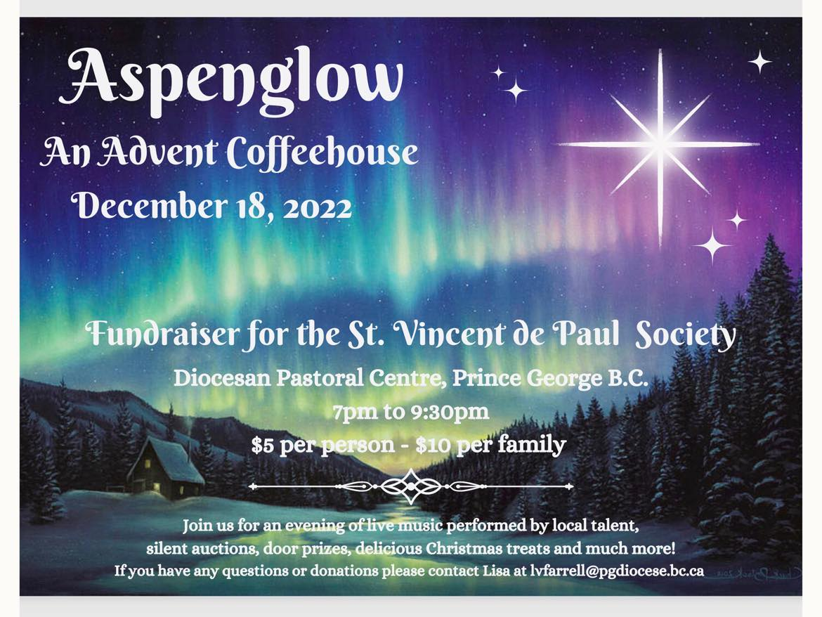
There will be printed posters given to each of the Prince George parishes. Throughout this week and next, one of our young adult organizers will drop off posters at each parish.

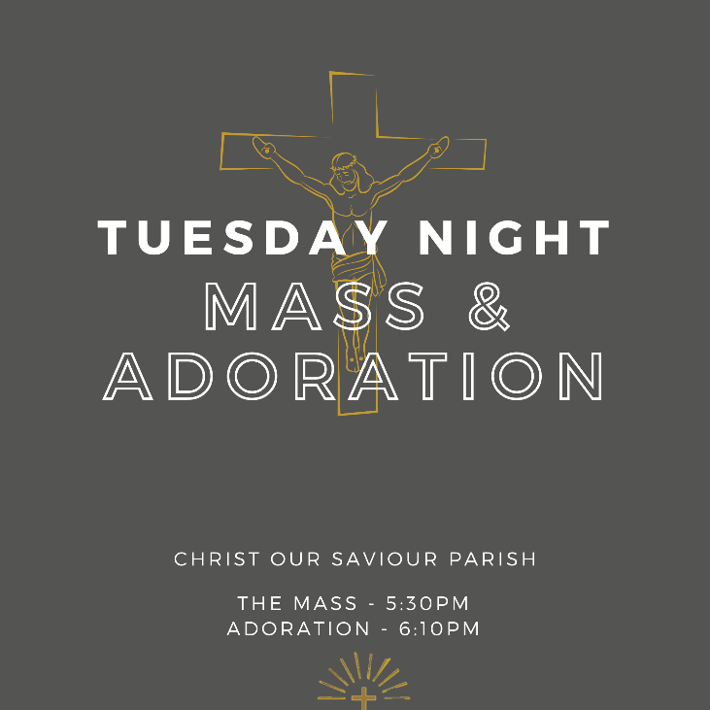
Tuesday Nights – Mass and Adoration at Christ Our Saviour
All youth and young adults are invited to Christ our Saviour Parish, each Tuesday night, to spend an evening with Jesus, alongside a community of parishioners from across the city. Fr. Michael celebrates Mass at 5:30PM, followed by Eucharistic Adoration which begins at about 6pm and ends at 7pm. There’s also the opportunity to go to the Sacrament of Reconciliation during Adoration. All are welcome to make this night a consistent part of their week.

Employment Opportunities

Canadian Conference of Catholic Bishops
- Research and Resource Development Assistant – Office for Family and Life: The CCCB is looking for a full-time research and resource development assistant to work under the supervision of the Director of the Office for Family and Life for the English sector. Please see the attached job description for more details

St. Therese Institute, Bruno, SK
- Executive Director: The Executive Director provides managerial and administrative leadership to develop and implement the necessary plans to accomplish the organizational goals as directed by the Board. This role is responsible for overseeing administration, fund-raising, programs and the execution and further development of the organization’s strategic plan. Please see the attached job posting for further details.
- Co-Director of Formation: The Co-Director works collaboratively with the Director and Assistant Director of Formation to ensure the quality of the pastoral ministry, academics, way of life and faith formation of all the students, with a special emphasis on journeying with the female student community. Please see the attached job posting for further details.

Want to share news in the Wednesday Weekly?
Email reception@pgdiocese.bc.ca by NOON on Tuesday.
Late entries will be published in the following week’s edition. Please send in Word format.

To receive all diocesan news directly in your inbox or on your phone email reception@pgdiocese.bc.ca or text “pgd” to 514-900-0130 to join Flocknote. This is an email and text messaging tool created for churches, ministries, teams and other community organizations. It helps to communicate with the people by sending a simple text message. Please join us in keeping up with all the diocesan news.

