March 15, 2023
The Fourth Sunday of Lent
March 19, 2023

Then the man who was blind went and
washed, and came back able to see.

-John 9.1-41

Online Broadcast of the Daily / Sunday Masses:
- Sacred Heart Cathedral, PG Facebook
- St. Joseph’s Parish, Smithers Facebook

For those with cable or optic TV, please check with your provider for the following or go directly to:
- Salt & Light
- Vision TV
- EWTN TV

Attachments
- Appeal Update as of March 14, 2023
- RCEC Financial Report 2021-22
- Catechists Formation Level One Course
- Diocese of Whitehorse – Principal Job Posting

Chrism Mass – March 28, 2023
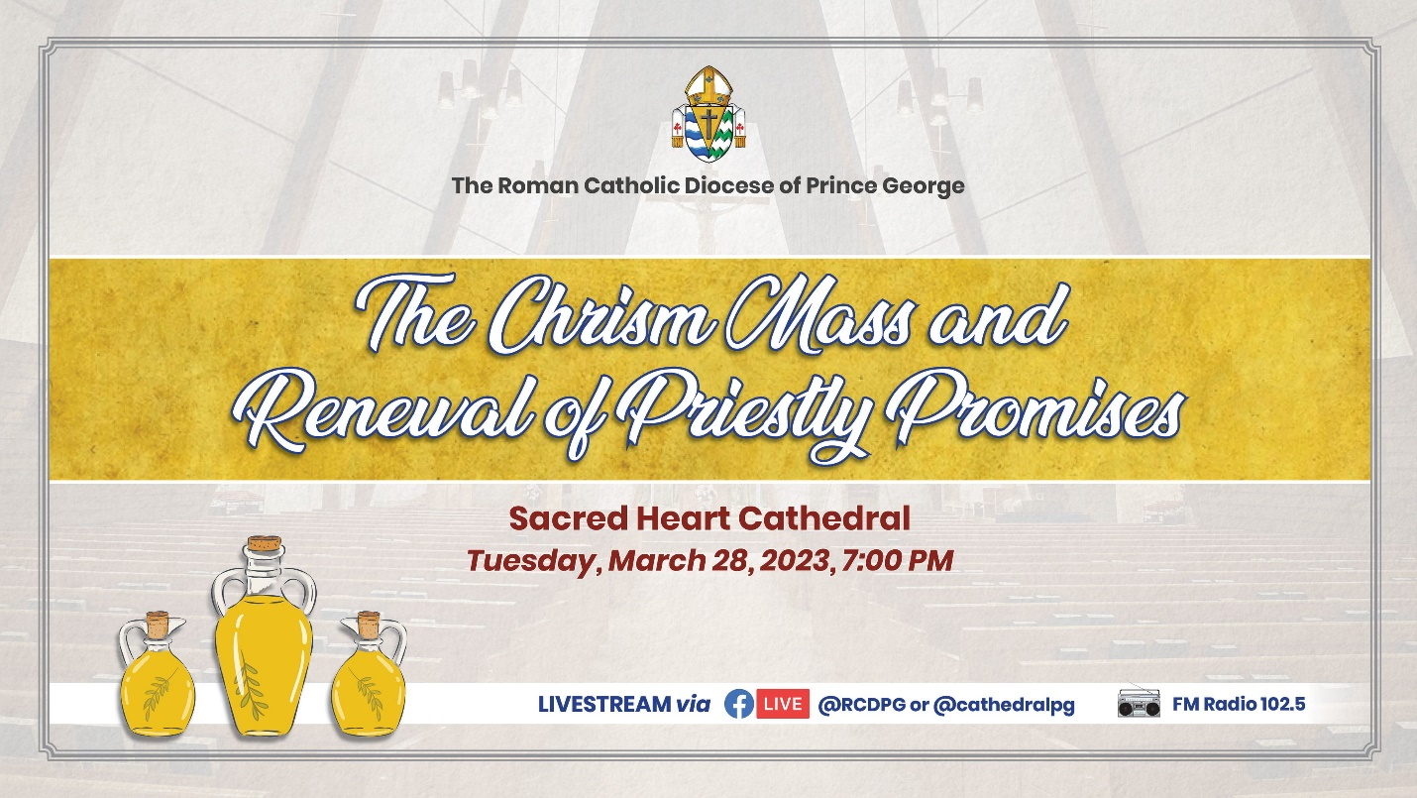

A reception will follow. Those attending are invited to bring a plate of snacks to share and are asked to put the snack on the designated table in the lower hall before Mass. Thank you.

Called Together and Healing and Reconciliation Appeal Update
I am happy to provide an update to our Called Together Diocesan Appeal as well as our Healing and Reconciliation Appeal.

We have seen a significant slowing of contributions to these appeals, with only $3,500 in additional donations being received for the diocesan appeal and less than $100 more added to the Healing and Reconciliation total. This puts us at a little over 86% of our diocesan goal.

We are pleased to announce that Notre Dame has reached 100% in pledges toward its parish goal and further contributions will be returned to the parish.

I wish to express our profound thanks to all who have been participating in these appeals. Your continued support both financially and in prayer is appreciated. If you have not contributed this year, please consider donating to help us reach our diocesan goal.

All of the tax receipts for 2022 have been sent out. If you have not received your tax receipt, or if you have any questions about your receipt, please contact us at appeal@pgdiocese.bc.ca or call us at 250-964-4424.

- James Fowlie, Business Manager

Diocese of Prince George Financial Report 2021-22
Attached to the Wednesday Weekly is a summary financial report for the Diocese of Prince George for the fiscal year 2021-22. There is a written section that explains much of the report.

If you have questions about the report, please feel free to email jfowlie@pgdiocese.bc.ca.

CALL TO ACTION
Euthanasia legislation in Canada has been on an ever-expanding journey since the introduction of MAiD (June 2016) in Bill C-14 An Act to amend the Criminal Code and to make related amendments to other Acts (medical assistance in dying). The premise at the time was that persons facing terminal illness should have a choice in how they die, while recognizing the need to protect Canadians who may be vulnerable to coercion to end their lives. However, pressure to further expand MAiD into more vulnerable populations resulted in Bill C-7 An Act to amend the Criminal Code (medical assistance in dying), receiving royal assent in March 2021. Those living with disabilities or mental illness are all now considered candidates for euthanasia, even without a terminal illness. On February 15th, 2023, a report tabled in the House of Commons by the Special Joint Committee on Medical Assistance in Dying (AMAD) made the recommendation to expand MAiD even further to include minors.

Bill C-7 has introduced two tracks to death: new criteria allowing euthanasia for individuals whose natural death is not reasonably foreseeable and another that has shortened the time from consent to the actual killing of those facing terminal illness. It is now possible in this circumstance for a person to ask for MAiD and be put to death on the same day.

Concerns regarding safeguards for mental illness resulted in eligibility being withheld for two years for those whose sole underlying medical condition is mental illness. Though extended until March 17, 2024, to allow time to put resources in place, this delay does not mean a change to eligibility—it is just delayed. And the slope continues downward. Bill S-248 An Act to Amend the Criminal Code (medical assistance in dying), is at its second reading in the Senate and aims to remove the need for final consent before being put to death.

Disability advocates have spoken out against this devaluing of the dignity of persons, but we need to add our voices. Now is the time for us to communicate to our Members of Parliament our opposition to this relentless assault on life. The diocesan website has information that can assist you in this vital task.

https://www.pgdiocese.bc.ca/

*Euthanasia Prevention Coalition: Where can we go from here?
In a recent video, the president of the Euthanasia Prevention Coalition (EPC), Gordon Friesen, discusses the expanding Euthanasia situation in Canada, highlighting the differences in practice and attitude towards Euthanasia and Physician Assisted Suicide (PAS) between Canada and California. Both have similar sized populations and legalized state sanctioned death in 2016, but despite these similarities, the statistics regarding the number of deaths is vastly different. In the past 7 years, California has had only 486 deaths while Canada has had over 10,000.

To listen to the discussion, view the video here: https://www.youtube.com/watch?v=ITpluGF7Utg

*No Options No Choice – Access to Alternatives to MAiD Campaign
The No Options No Choice campaign:

The expansion of euthanasia is threatening the lives of Canadians who don’t have access to sufficient services to live. Your fellow Canadians need your help. Tell your elected officials that Canadians with life-threatening conditions, disabilities, and mental illness deserve real government investment in services and supports so they can live.

Write to your provincial representative today at www.nooptionsnochoice.com

With your help, we can get Canadians the support they need to LIVE.

Campaign resources for parishes:
https://drive.google.com/drive/folders/1XuurQHPZFkfgzUa9UDLqSJpmfr5vUim7?usp=share_link

Journey Through Lent
The CCCB video series Journey through Lent is available on the CCCB website. This year’s Lenten reflections are delivered by His Eminence Gérald Cyprien Cardinal Lacroix, Archbishop of Quebec and Primate of Canada, and the Most Reverend Brian Joseph Dunn, Archbishop of Halifax-Yarmouth.

Every Monday throughout Lent, a video reflection will be posted on the CCCB website in English and in French for the following Sunday up to and including Easter Sunday.

View the video series here: https://www.cccb.ca/evangelization-catechesis-catholic-education/video-resources/journey-through-lent-2023/

Walk for Life
Walk For Life is an in-person, family friendly, outdoor event that gives walkers/runners the opportunity to participate in peer-to-peer fundraising! Through peer-to-peer fundraising, you have the amazing opportunity to invite your friends and family to sponsor your walk and tell them about Advokate's life saving work. Additionally, you get the opportunity to share with them why it's so important to continue advocating for vulnerable women and their unborn children, and why you are passionate about this work!

PRINCE GEORGE: 4th Annual
Date: Saturday, May 27, 2023
Location: Lheidli T’enneh Memorial Park 17th Ave. Prince George, BC V2L 3X9 (Picnic Pavillion)
Time: 12:30pm-4:00pm

How to sign up:
- Register. Head to our website at walkforlife.ca and register to walk!
- Create a fundraising page based on your location, Prince George or Fraser Valley.
- Start Fundraising! Share your fundraising page link online and ask your friends & family to make a donation and sponsor your walk! You can collect donations through your online fundraising link, or on your pledge sheet.
- Email us at bethany@advokate.ca for your FREE t-shirt to wear on event day!
- Join us on event day to walk the 5k or run the 10k together! Enjoy fun, food, games and prizes!

Baby Bottle Campaign
The Baby Bottle Campaign by Advokate Life & Education Services is an annual fundraiser that will run from Mother’s Day (May 14th, 2023) to Father’s Day (June 18th, 2023). Their mission is to “bring hope in action to vulnerable women and low-income families facing unplanned pregnancy while promoting the inherent worth and dignity of every human being.”

During the campaign, parishes which sign up will be provided with real baby bottles to distribute to their church family to fill with cash, cheques and/or completed donation forms. Virtual bottles can also be filled online at babybottles.ca. All funds raised from the campaign go towards supporting free and confidential support to the women, children, and families Advokate serves at its Hope for Women Pregnancy Services Centres.

Parishes that would like to join the Baby Bottle Campaign can reach out to Bethany Somerville at bethany@advokate.ca and let her know how many bottles your parish will need.

Campaign promotional materials are also available to parishes here: https://drive.google.com/drive/folders/1zMB2qqQxm8ac5GuwyviceO8Fyt2dZD6A

Rachel’s Vineyard Spring Retreats
ABORTION HEALING SPRING RETREATS

Rachel's Vineyard Retreats offers you a supportive, confidential, and non-judgmental environment where women and men can express, release and reconcile painful post-abortive emotions to begin the process of restoration, renewal & healing.

Registering now. Confidentiality assured.

Merritt retreat April 25 - 27
- Call 250-267-5081 or email rvkamloops@yahoo.ca

If you or someone you know is suffering from an abortion experience, there is no need to suffer in silence. Rachel's Vineyard is here to help.

Grief to Grace Retreat
Through a retreat program facilitated by mental health professionals and centered on Jesus Christ, Grief to Grace helps those who have endured physical, emotional, sexual, and/or spiritual abuse find healing. The next retreat is May 23 – 27, 2023 in Kelowna. For more information please email grieftogracekelowna@gmail.com or make a confidential call to 250-808-6403.

Family Grief Support Program
The Prince George Hospice Palliative Care Society will be starting their Family Grief Support Program on April 4th.

The Family Grief Support Program supports children, teens, and their parents who have lost a loved one. The parent, teen, and children groups run simultaneously, with the same theme for all. Families will learn to grieve together.

This is an 8-week program held at their Solace Centre. This is a FREE program; there is no fee for all Hospice programs. If you know a family that would benefit from this program or would like to learn more, please give them the contact information for the Hospice society: 250-563-2551 or info@pghpcs.ca.

The Hospice Society also has a drop-in weekly for children grieving the loss of someone every Tuesday from 3:00-4:30 pm.

Catechist Formation Level One Course

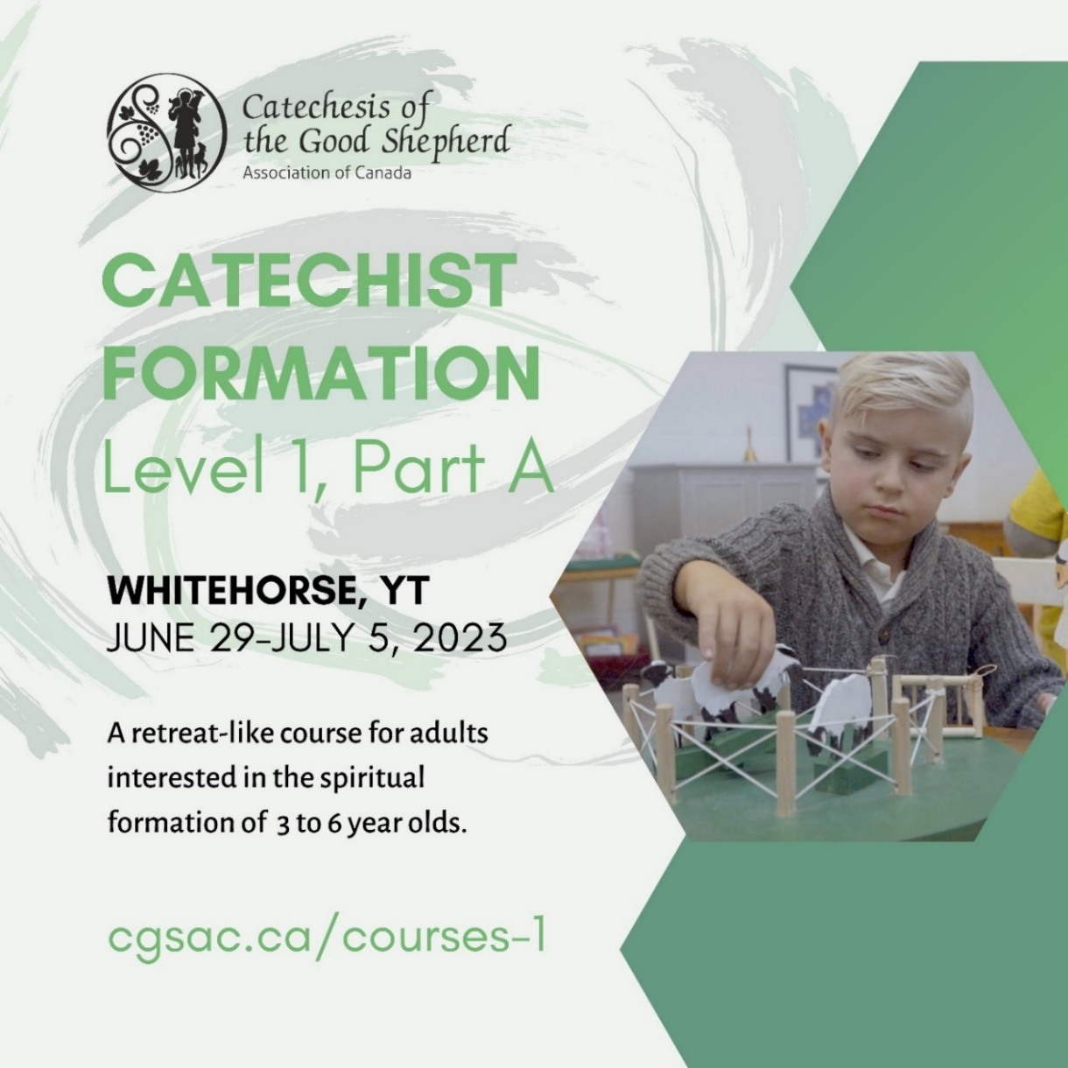

Catechesis of the Good Shepherd – Level 2 Formation
This 90+ hour course concretely prepares adults to develop and facilitate an atrium for children ages 6-9 at your parish.
Dates for the training are:
• Part A: March 20 - Mar. 25, 2023
• Part B: July 24 - Jul. 29, 2023
• Part C: November 10 - Nov. 12, 2023
From 9:00 a.m. to 5:00 p.m. at St. Patrick's Parish, Maple Ridge. Learn more and register at beholdvancouver.org/events.

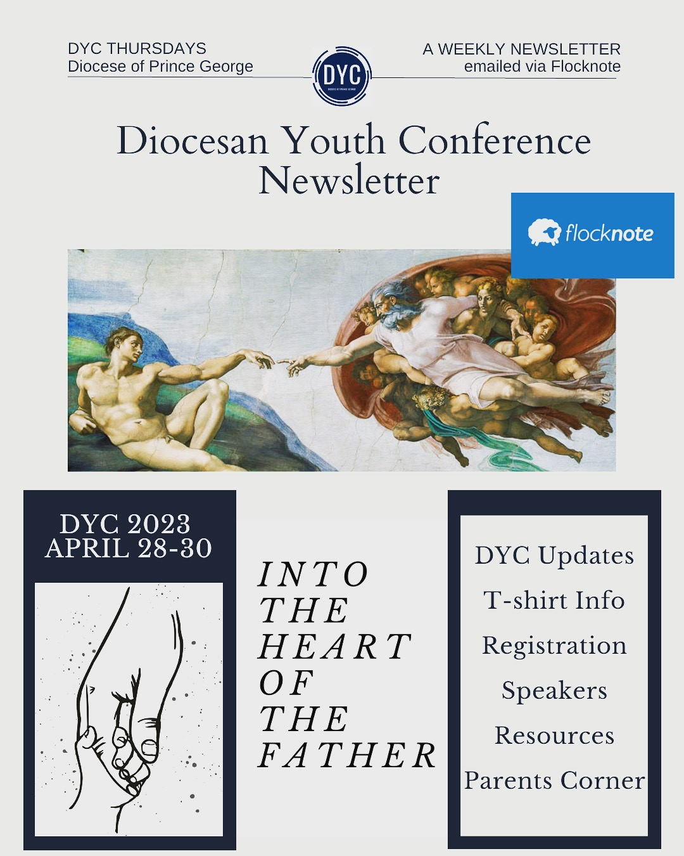

Diocesan Youth Conference Newsletter
Stay up to date with all the news, updates, registration info, DYC t-shirts, and even resources for teens and parents with “DYC Thursdays” our weekly Flocknote newsletter, which arrives straight to your inbox at around 5pm every Thursday! Email Lisa at lvfarrell@pgdiocese.bc.ca to subscribe!

Save the Date – 2023 Young Adult and Family Camp
2023 Young Adult and Family Camp - mark your calendars and invite your friends.

Where: Camp Morice, located on Stewart Lake
When: June 29th - July 3rd, 2023 (beginning in the early evening on the 29th, and ending at midday on the 3rd)

Registration will open soon.

Employment Opportunities

Catholic Independent Schools Diocese of Prince George (CISPG):

- Catholic Independent Schools Diocese of Prince George (CISPG) is hiring for September 2023 including the Principalship of St. Joseph’s School in Smithers and full-time teaching positions in Prince George, Smithers, Prince Rupert, Kitimat and Dawson Creek. Please help spread the word! Postings found at http://cispg.ca/careers

The Catholic Diocese of Whitehorse

- The Catholic Diocese of Whitehorse is looking for a principal for St Francis of Assisi Catholic Secondary. Please see the attached job ad on how to apply.

Life Restoration Ministries

- Communications Specialist: The successful applicant will be responsible for managing the various digital communication platforms for Life Restoration Ministries (LRM). They will work with a dedicated team of internal and external collaborators and draw on their experience in writing/editing for diverse audience segments. They will use modern communication technology and apply skillful planning and execution, responding to our participants with sensitivity and integrity. For more information on the position or to apply, please see the job posting on their website: https://www.liferestoration.ca/apply-communications
- Event Project Manager: The successful applicant will be responsible for propelling forward multiple, simultaneous projects and events with a dedicated team of diverse collaborators. They will draw on their experience in project planning, event management, and logistical execution, supporting impactful, life-changing experiences for participants. For more information or to apply, please see the job posting on their website: https://www.liferestoration.ca/apply-projectmanager

Want to share news in the Wednesday Weekly?
Email reception@pgdiocese.bc.ca by NOON on Tuesday.
Late entries will be published in the following week’s edition. Please send in Word format.

To receive all diocesan news directly in your inbox or on your phone email reception@pgdiocese.bc.ca or text “pgd” to 514-900-0130 to join Flocknote. This is an email and text messaging tool created for churches, ministries, teams and other community organizations. It helps to communicate with the people by sending a simple text message. Please join us in keeping up with all the diocesan news.

