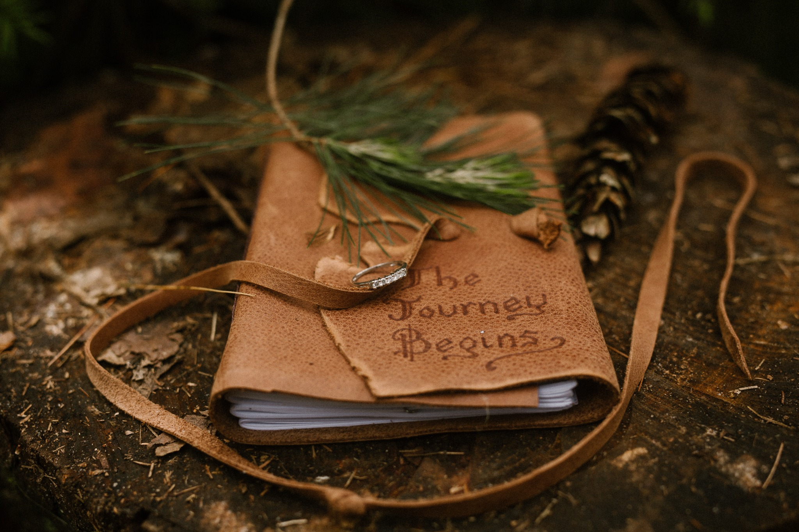

**Weekly Reflection Journal**

**Created by Dr. Mark A. Mitchell  
Founder, Pay Attention Coaching**[*www.payattentioncoaching.com*](http://www.payattentioncoaching.com)

# Welcome to your Weekly Reflection Journal.

This is your space to pause, reflect, and reconnect with the goals and values that matter most to you.

**Every step you take toward greater clarity and purpose is powerful. Take your time, be honest with yourself, and trust the journey.**

— *Dr. Mark A. Mitchell, Pay Attention Coaching*

**This document is intended for your personal growth. Please create your own copy to begin your reflection journey.**

**If you'd like, you can share selective reflections with me before our sessions to help guide our coaching conversations.**

Date: __________________________________________

Week Number: ___________________________________

# How to Use This Journal

Take 10–15 minutes at the end of each week to slow down, reflect, and refocus. This simple exercise will help you stay connected to your goals, values, and growth journey.

# Weekly Reflection Questions

1. What went well this week? (Celebrate your wins, no matter how small.)

________________________________________________________________________

________________________________________________________________________

________________________________________________________________________

________________________________________________________________________

1. What challenges did I face? How did I respond? (Recognize obstacles and patterns without judgment.)

________________________________________________________________________

________________________________________________________________________

________________________________________________________________________

________________________________________________________________________

1. What am I most proud of this week? (Acknowledge moments of strength, resilience, or progress.)

________________________________________________________________________

________________________________________________________________________

________________________________________________________________________

________________________________________________________________________

1. Where did I feel most aligned with my values? (Identify the moments where you felt true to yourself.)

________________________________________________________________________

________________________________________________________________________

________________________________________________________________________

________________________________________________________________________

1. Where did I feel stuck or disconnected? (Reflection creates awareness for growth.)

________________________________________________________________________

________________________________________________________________________

________________________________________________________________________

________________________________________________________________________

1. What is one thing I will focus on improving next week? (Set a small, specific intention to guide your actions.)

________________________________________________________________________

________________________________________________________________________

________________________________________________________________________

________________________________________________________________________

1. What is one thing I am grateful for today? (Gratitude grounds and strengthens your mindset.)

________________________________________________________________________

________________________________________________________________________

________________________________________________________________________

________________________________________________________________________

# Notes, Insights, or Ideas

Use this space for free journaling, new realizations, or creative ideas that surface during your reflection.

________________________________________________________________________

________________________________________________________________________

________________________________________________________________________

________________________________________________________________________

________________________________________________________________________

________________________________________________________________________

________________________________________________________________________

________________________________________________________________________

# Quick Weekly Action Step

Based on your reflections, what is one small, meaningful action you’ll commit to next week?

________________________________________________________________________

________________________________________________________________________

________________________________________________________________________

________________________________________________________________________

# Closing Reminder

"The answers you seek often come when you slow down and truly pay attention."

— Dr. Mark A. Mitchell

# Suggested Usage

* Print a copy each week
* Keep a digital journal
* Review monthly to celebrate growth and patterns

Thank You and Next Steps

Thank you for taking the time to reflect and invest in your personal growth.

If you're ready to take the next step, I invite you to book a free Discovery Call.

[**Schedule Your Free Discovery Call**](https://www.payattentioncoaching.com)

Let's work together to unlock the life you're meant to live.

— *Dr. Mark A. Mitchell, Pay Attention Coaching*