**First Washington United Methodist Church**

**Event and Building Use Form**

**Date of request:**       **Event Name:**

**Type of event:  Church Service  Ministry/team meeting  Class  Church sponsored social event**

**Non-church event or meeting  Includes serving food and drinks**

**One Time Event Start Date:**       **End Date:**

|  |  |
| --- | --- |
| **Event start time:** | **Event end time:** |
| **Set up start time:** | **Teardown start time:** |
| **Set up end time:** | **Teardown end time:** |

**Repeating Event Start Date:**       **End Date:**

**Weekly (specify day of the week and times):**

**Alternate weeks** **(describe interval and times):**

*Important Note* if doing “alternating weeks,” please state if the meeting is truly alternating weeks OR if it’s 1st/3rd or 2nd/4th weeks. Months with 5 occurrences of a particular day can throw off alternating weeks meaning the calendar will not accurately reflect your meeting days and the room may be double booked as a result.

**Monthly (describe interval and times):**

**Exceptions (such as holidays):**

**Total expected number of participants:**      

**On-site room requested (see attached floorplan):  Sanctuary  Narthex (lobby)  Pavilion**

**1st floor classroom**;specify desired classroom**:**

**Basement classroom**;specify desired classroom**:**

**Special room set up required**, please provide details:

**Off-site facility:** provide location name and address

Note: Unless otherwise specified, the address shown above will be included in the marketing of the event. If the event is at a private residence and you do not want your full address shared, you MUST fill in the box below with the exact wording you would like shared:

**Tech equipment needed:  Sound  Projectors for video  Recording media  TV/DVD cart**

Please describe the intended use of the tech needed:

**Outdoor equipment needed:  BBQ Grill  Awnings/Shade  Fire Pit**

**Support services needed:  Heat/Air Conditioning  Security  Childcare**

**Kitchen,** please describe the intended use of the kitchen:

**Extra janitorial cleaning** (additional cost, please specify which budget is to be used      )

**Marketing support needed:**

**Website listing**

Full event description

**Website and app calendar** (should only be checked for events that the congregation is invited to join)

Short event summary

**Social Media**

Short event summary

**Weekly e-mail announcements**

Short event summary

What time frame should the announcement be included in the e-mail?

**Announcement loop**

Will the graphics be supplied by the organizer?  **Yes  No**

If no, what information is needed on the announcement slide?

What time frame should the graphic be included in the announcement loop?

**Postcard/Poster** (additional cost, please specify which budget is to be used)

**Planning Center support**:

**Event Registration** (for signups)

What time frame should event registration be open?

Is there a cost for the event?  **Yes  No**;if yes, please provide cost:

Please provide additional information such as t-shirt add-ons, questionnaires for participants, etc. as needed

**Event check-in** (for attendance)

It is understood that not all information may be available when this form is initially turned it. Information may be provided at a later date as it is available. It is the responsibility of the event organizer to provide all information before the event is included in the e-mail announcements, announcement loop, social media, or Planning Center. Efforts will be made to reminder event organizer to provide the information. But ultimately it is the event organizer who is responsible for providing all information.

Please allow 2 weeks for completion of bulletin, screen loop or website requests. Any materials to be produced commercially require prior cost or expense request approval by the appropriate mission team leader.

**Requested by:**       **Phone:**       **Email:**

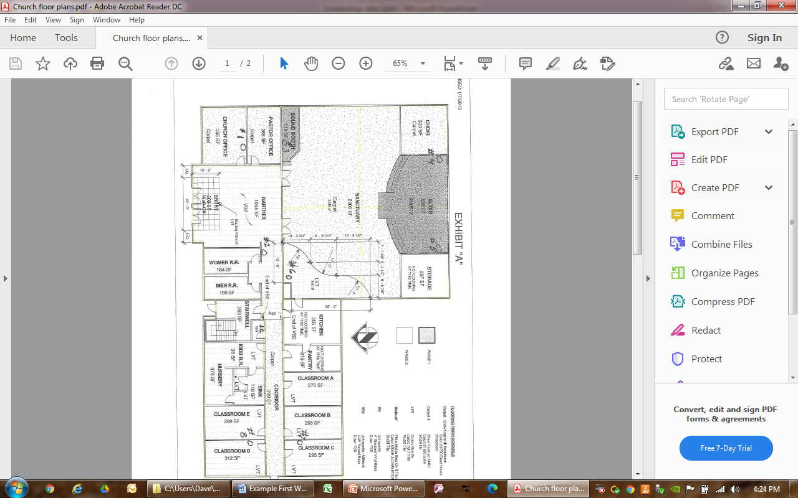

W

M

F

P

HVAC B 1

F

HVAC Z 2

HVAC Z 8

Main Floor

HVAC Z 1

HVAC B 2

HVAC Z 7

HVAC Z 6

HVAC Z 5

HVAC Z 3

HVAC Z 4

HVAC Z4

Common Grounds

Youth Room

Basement