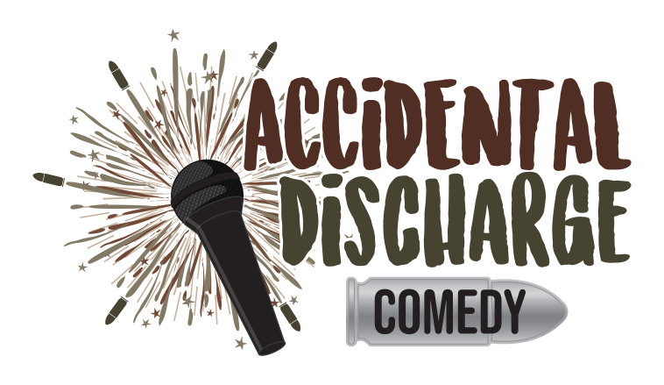

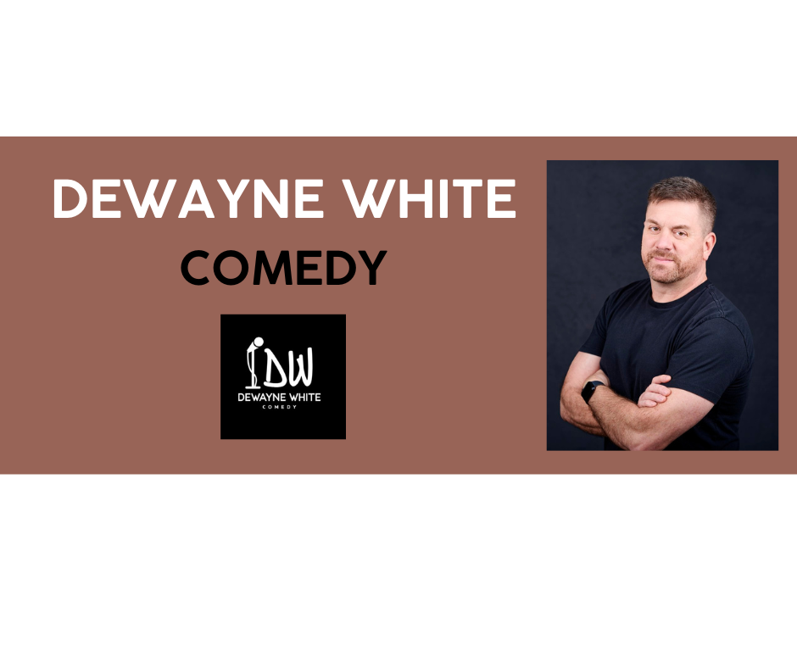

Dewayne White is quickly becoming one of the most sought-after comics on the scene. Hailing from Washington, D.C., his no-nonsense, East Coast demeanor seamlessly transforms into hilarity on stage. He draws on his experiences as a combat wounded Army vet, husband and father with a no holds barred attitude.

With irreverent observations and an infectious energy, Dewayne always delivers an unforgettable evening of laughter. He’s shared the stage with comedy heavyweights like Josh Blue, Mark Normad, and Jo Firestone, Now he’s headlining comedy clubs across the country and touring internationally with the USO or Armed Forces Entertainment.

**COMEDY CLUBS AND TOURS**

* L.A. Comedy Club, Las Vegas
* Caroline’s on Broadway
* The Funny Bone, nationally
* USO Talent Corps
* Armed Forces Entertainment Tours
* Don’t Tell Comedy
* DC Improv
* DC Comedy Loft
* Flappers Comedy Club
* The “Almost” Red, White, and Blue Comedy tour with Josh Blue
* Tacoma Comedy Club

**COMEDY SHORTS**

* Clean Comedy Connection: <https://www.youtube.com/watch?v=iM60FA7jH7Y>
* House of Comedy 2023: <https://www.youtube.com/watch?v=bwFONpTDBlk>
* Aug 23 Syracuse Funny Bone: <https://www.youtube.com/watch?v=PbZi60ud9ko>
* Crowd Work at DC Improv: <https://www.youtube.com/watch?v=m0Np41C9JBw>

**FESTIVALS AND CONTESTS**

* WTKR TV-Coast Comedy Live-Season 2 Winner
* World Series of Comedy (Top 101-2023)
* Plano Comedy Festival 2020/2022 (Best of Fest 2022)
* North Carolina Comedy Festival
* Last DC Comic Standing (Finalist)
* Magooby’s Joke House (Finalist-2021 Comedian of the Year)
* Last Comix Standing (Semi-Finalist)
* Baltimore Comedy Festival

**SOCIAL MEDIA**

* **TikTok:** 1K Followers, 23K Likes
* **Facebook:** 1.1K Followers
* **Instagram:** 13,000 Followers
* **YouTube:** 495 Subscribers

**CONTACT**: Jamie Henline, Manager/Agent

[info@bobbyhenlinecomedy.com](mailto:info@bobbyhenlinecomedy.com)

Cell: 606-875-5808