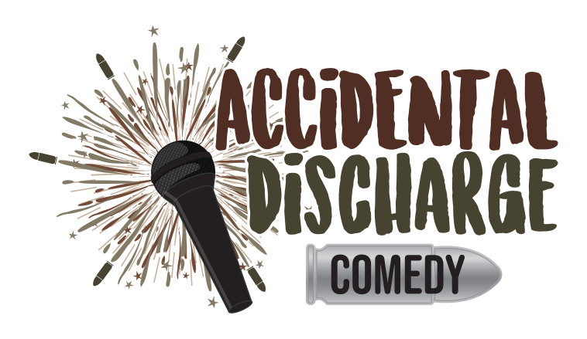

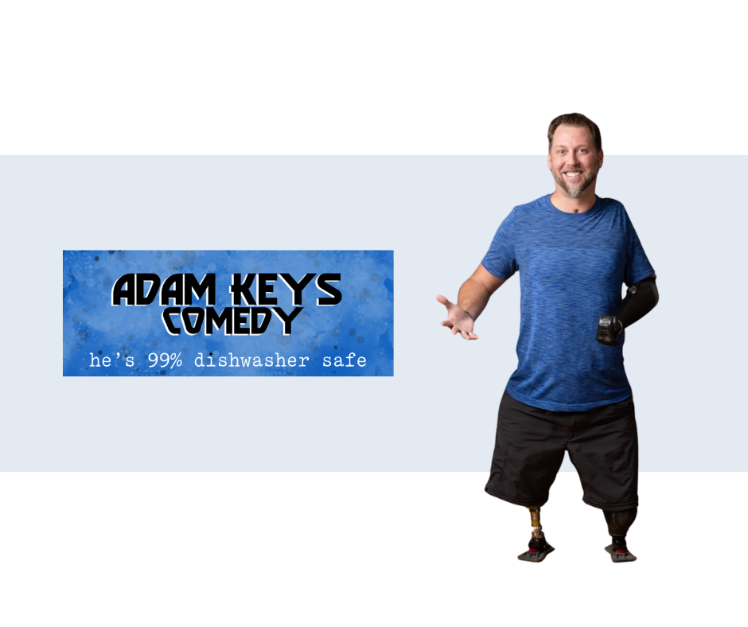

Adam got his start in comedy with Armed Services Arts Partnership back in 2018 and has been hittin’ in person and virtual stages across the country ever since.

He’s been North American his whole life- born in Canada and relocated to the U.S. as a teen. He then went on to serve in the U.S. Army after a little event called 9/11.

He tried to make it as a foot model but got denied for ugly toes. So, he stepped on an I.E.D to open himself to a world of possibilities, like insane phantom limb pain, awkward first dates, and endless jokes about his crazy new life.

Now he has…#comedylegs. He’s 99% dishwasher safe, so if you’re looking for a clean show just request that his jokes come out sparkling.

**COMEDY CLUBS AND TOURS**

* The “Almost” Red, White, & Blue Comedy Tour with Josh Blue and Dewayne White
* Mic Drop Comedy
* Punchline Sacramento
* Curious Comedy Theater
* STAB! Comedy Theater

**OTHER COMEDY VENUES**

* Rebellion Brewing Company, Auburn, CA
* The Center for the Arts, Grass Valley, CA
* By All Means Stand-Up Competition 2024
* Private Events
* World Series of Comedy Competition 2024
* Pat Pending Productions, Pittsburg, CA
* Bambino's Restaurant & Bar
* Trax Taproom & Kitchen
* True Symmetry Brewing Company, Suisun City, CA
* PenFed Gala, Phoenix, AZ
* Armed Services Art Partnership

**COMEDY SHORTS**

* Laughs Unlimited: <https://www.youtube.com/watch?v=DvwpVjhDFFw>
* DC Set Short: <https://www.youtube.com/watch?v=VS11Ie10fbg>
* Adam Keys Comedy Compilation: <https://www.youtube.com/watch?v=8yeA6FizVDQ&list=TLPQMDQwMzIwMjQ5INppckzTbQ&index=4>

**FESTIVALS AND CONTESTS**

* World Series of Comedy 2024
* By All Means Stand Up Competition 2023
* American Laughiti Comedy Competition 2023

**CONTACT**:

Jamie Henline, Manager/Agent

[info@bobbyhenlinecomedy.com](mailto:info@bobbyhenlinecomedy.com)

Cell: 606-875-5808