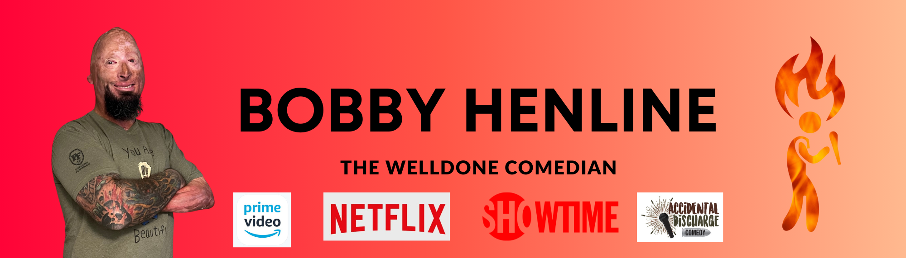

***COMEDIAN - ACTOR - SPEAKER - SONGWRITER***

***Smokin’ hot and full of flame, Henline’s comedic style is focused on making fun of not only himself, but others who may or may not unwittingly enter his circle of everyday living. Known as “The WellDone Comedian” by audiences and “Burnt Pa” by his grandkids, he keeps audiences rolling on the floor with his raw approach to his injuries as a burn survivor and living in a world that views him as “disabled.” His performance starts as a campfire, warming the audience up to laugh with him, and erupts into a bonfire, sparks flying!***

Henline is a retired Army Staff Sergeant, last serving with the 82nd Airborne Division. He spent 13 years in the Army, completing four tours. While on his fourth tour in Iraq, three weeks after his arrival, an IED exploded under his Humvee – April 7, 2007, is a day he will never forget.

The four soldiers with him did not survive. As Henline stumbled out of the wreck, a human torch, he was extinguished by the soldier he had replaced in the Humvee. With burns covering 40% of medically induced coma for two weeks and flown back to the States.

During his initial six-month hospital stay, Bobby remained upbeat, positive, and relied on humor to get him through each day. Putting nurses in headlocks, trying to keep other wounded soldiers’ spirits up by telling them jokes, and singing a ditty over and over garnered the attention of his occupational therapist. She challenged him to go to an open mic night and try his hand at comedy, making him promise with a pinky swear. He kept his promise, and that experience started a new chapter in his life in 2010. He has been doing comedy whenever and wherever he can ever since.

A few of the most notable clubs Henline has performed in include **Brad Garrett’s Comedy Club**, Las Vegas; **L.A. Comedy Club**, Las Vegas; **Laugh Factory**, Chicago; and **Hollywood Improv**, Los Angeles.

Henline’s story and lived experiences have been featured in film, print, and electronic media, including the documentaries *Comedy Warriors: Healing Through Humor,* *Healing Bobby*, and *Weight of Honor*; on CNN, PBS KET, NPR, Today.com, and Time.com; Time Magazine, People Magazine, The Huffington Post, Guideposts, and Readers Digest; as well as television, radio, and podcasts from around the world.

Henline is also a motivational speaker and travels the world sharing his inspiring story and comedy.

**COMEDY SHORTS**

* Brad Garrett Comedy Club: <https://www.youtube.com/watch?v=3ITZB7CsE8I>
* Huckabee Show: <https://www.youtube.com/watch?v=yOxDKt6kzy0>
* Krackpots Comedy Club: <https://www.youtube.com/watch?v=vbtxrWUQj8E>

**FILMS, DOCUMENTARIES, SERIES**

* **Comedy Warriors: Healing Through Humor** with Bob Saget, Lewis Black, Zach Galifianakis, B.J. Novak (Amazon Prime Video)
* **MBF: Man’s Best Friend** (Amazon Prime Video)
* **Sophie and the Rising Sun** (Amazon Prime Video)
* **Showtime series “Shameless”** as Pyro Paulie
* **Healing Bobby** by Red Border Films (Time Magazine – YouTube)

**NOTABLE COMEDY CLUB PERFORMANCES**

* Brad Garrett Comedy Club, MGM, Las Vegas
* L.A. Comedy Club, The Strat, Las Vegas
* Krackpots Comedy Club, Massillon, OH
* Stardome, Birmingham, AL
* Laugh Factory, Chicago
* Hollywood Improv, LA
* Stand Up Live, Huntsville, AL
* Laugh Out Loud, San Antonio, TX
* Joke Joint Comedy Showcase, Houston, TX
* Snappers, Fort Myers, FL
* Zanies Nashville, Nashville, TN
* Cozzy’s Comedy Club, Newport News, VA

**OTHER COMEDY PERFORMANCES**

* Fort Bragg, Iron Mike Conference Center, NC
* McConnell Air Force Base, Kansas
* Fort Huachuca, Arizona
* Fort Rucker, Alabama
* Stardome, Alabama
* USO Fort Bragg, NC
* USO Cherry Point, NC
* LT Michael P Murphy Gala, NY
* Alabama Veteran, AL
* Corporate, Non-Profits
* Southeastern Homicide Investigators Association
* Combat Veterans Motorcycle Associations
* Military Veteran Fundraisers
* Fundraisers
* High Schools (Clean Comedy only)
* Universities and Colleges
* VFW and American Legion Posts

**BOBBY HENLINE COMEDY – STRAIGHT TO THE EPK:** <https://bobbyhenlinecomedy.com/epk>

**BOBBY HENLINE COMEDY WEBSITE:**

<https://bobbyhenlinecomedy.com>

**ACCIDENTAL DISCHARGE COMEDY TOUR WEBSITE:**

<https://bobbyhenlinecomedy.com/adc-comedians>

Bobby Henline and his wife, Jamie, produce the Accidental Discharge Comedy shows.

**MANAGER/AGENT**:

Jamie Henline

Cell: 606-875-5808

Email: [info@bobbyhenlinecomedy.com](mailto:info@bobbyhenlinecomedy.com)