CYBER TROOPERS: DIGITAL WARRIORS
A Novel by Claude
The Three Gates Protocol: Biometric, Device, and Knowledge Authentication
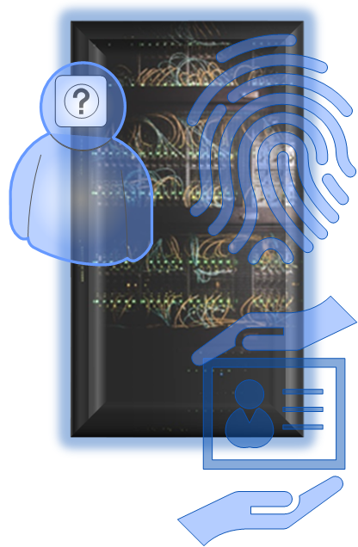
Chapter 1: The Three Gates Protocol
The authentication chamber hummed with biometric scanners as Maya Chen approached the entrance to the Cyber Defense Academy. At seventeen, she had already memorized the Three Gates Protocol that protected every secure facility in 2048: something you are, something you have, and something you know.
First gate: her palm pressed against the biometric scanner, reading the unique geometry of her hand while a retinal scanner mapped the blood vessels in her eyes. The blue light confirmed her biological identity.
Second gate: she pulled out her authentication fob, a device that generated new security codes every thirty seconds, synchronized with the academy's quantum encryption servers. The device had never left her side since receiving her acceptance letter.
Third gate: the knowledge phrase. Not her pet's name, not her hometown, not her school—all information that could be scraped from social media archives in the global holo-sphere. Instead, she spoke a complex passphrase that combined random words, numbers, and symbols, changed every sixty days as required by Academy protocol.
"Crimson-Elephant-9-Nexus-&-Thunder-42-Cascade"
The massive doors slid open with a satisfying hiss.
"Welcome to your new reality, Cadet Chen," said Drill Instructor Rodriguez as Maya stepped into the main hall. "Everything you think you know about cybersecurity is about to change. In here, we don't just teach you to fight digital enemies—we teach you to think like the infrastructure itself."
Around her, forty-nine other recruits stood at attention. Maya noticed something immediately: no visible email addresses on their uniforms, no phone numbers, no social media handles. In this world, direct contact was a luxury that created vulnerability.
"Your first lesson," DI Rodriguez continued, "is that every connection is a potential breach point. Look around you. See any email addresses? Phone numbers? Social media tags?"
The recruits shook their heads.
"Good. Because public-facing contact information is like leaving your front door open with a sign that says 'Rob Me.' Seventy percent of all successful cyberattacks begin with phishing emails, spam, holograph image capture, or chat messages sent to public addresses. In this academy, if you want to communicate with someone, you use secure, embedded messaging systems that never expose personal identifiers."
Maya felt a chill of excitement. This wasn't just military training, this was preparation for a war fought entirely in information space.
Chapter 2: The Segmented Fortress
Honeycomb Network Architecture: Multiple Walls, Gates, and Checkpoints
The academy's network architecture was unlike anything Maya had encountered. As she logged into her first tactical systems class, Instructor Park drew a complex diagram on the holographic display.
"Traditional networks are like medieval cities," Park explained. "One wall around everything. Breach the wall, and you own the entire city. But look at our academy network."
The display showed a honeycomb structure of interconnected but isolated segments. Financial systems sat in one protected zone, student records in another, tactical simulations in a third, each with its own defensive barriers.
"Network segmentation," Park continued, "is like building a city with multiple walls, gates, and checkpoints. If malware gets into the cafeteria's ordering system, it can't automatically jump to our weapons research databases. Each segment has its own authentication requirements, its own monitoring systems, its own backup protocols."
Maya raised her hand. "But doesn't that make communication slower and more complex?"
"Excellent question, Chen. Yes, it does. And that friction is intentional. Speed without security is how civilizations fall. Every connection between segments requires authentication, authorization, and accounting. Triple-A protocol. Nothing moves through our network without being verified, logged, and monitored."
The instructor's eyes grew serious. "During the Great Breach of 2039, when your brother died defending the financial networks, the enemy succeeded because everything was connected to everything else. One breach became universal access. We learned from that catastrophe. Now, breaching one system gets you access to exactly one system."
Chapter 3: The Backup Doctrine
Seven-Layer Backup Architecture: The First Line of Defense Against Ransomware
Maya's favorite class was Disaster Recovery, taught by Professor Williams, a former combat engineer who had survived three major ransomware campaigns. The woman's cybernetic arm was a reminder that digital warfare could have very physical consequences.
"Raise your hands if you think cybersecurity is about preventing attacks," Williams said.
Most of the class raised their hands. Williams smiled grimly.
"Wrong. Cybersecurity is about surviving attacks. Prevention is important, but survival is essential. And survival means backup systems so robust that getting hit by ransomware is merely inconvenient rather than catastrophic."
She gestured to a massive display showing the academy's backup architecture. "We maintain seven different backup systems. Real-time mirrors, daily snapshots, weekly archives, monthly deep storage, quarterly offline backups, yearly historical preserves, and emergency rollback states. Each system uses different encryption, different storage media, different geographic locations."
Maya studied the complexity. "Professor, doesn't this seem like overkill?"
"Tell that to the City of Atlanta in 2018, Chen. Tell that to the Colonial Pipeline in 2021. Tell that to Costa Rica's entire government in 2022. Tell that to the Great Cyber Wall of China in 2027 and the children that starved to death. Each of those entities thought their backup systems were adequate right up until they weren't."
Williams pulled up case studies of organizations that had recovered from major attacks. "Look at this company—hit by ransomware that encrypted everything. Recovery time: four hours. Know why? Because they could roll back to a backup from three hours before the attack. Compare that to this organization—same attack, but inadequate backups. Recovery time: six months, and they lost two years of data."
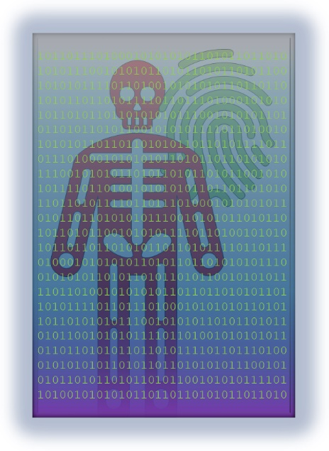
The lesson was clear: in the digital age, backup systems weren't just storage—they were weapons of defense.
Chapter 4: The Human Factor
Continuous Training: The Most Important Cybersecurity Technology is the Human Mind
The most intense training wasn't technical, it was psychological. Dr. Sarah Kim, the academy's head of human factors training, ran what she called "Social Engineering Bootcamp."
"Every sixty seconds of every day," Dr. Kim announced to Maya's class, "someone, somewhere, is trying to trick you into giving them access to something they shouldn't have. Your training will never stop, because their attacks never stop."
The training was relentless and creative. Fake phishing emails appeared in their inboxes daily, designed to look like messages from friends, family, professors, or official academy sources. Students who clicked malicious links found themselves in remedial training sessions.
Maya learned to recognize the subtle signs: urgent language designed to bypass rational thinking, requests for information that legitimate sources wouldn't ask for, links that didn't quite match their displayed text, request for funds, attachments from unexpected sources.
But the psychological training went deeper. They learned about pretexting—how attackers would research their targets through social media, building elaborate fictional scenarios to gain trust. They practiced what Dr. Kim called "healthy paranoia"—the ability to verify everything without becoming paralyzed by suspicion.
"The human brain is designed to trust," Dr. Kim explained. "That's what makes us effective social creatures. But in cybersecurity, trust must be earned and verified, never assumed. Your instinctive desire to be helpful, to be trusting, to avoid conflict—these are all attack vectors."
The most challenging exercises were the covert tests. Without warning, students would receive seemingly legitimate requests from "academy officials" asking them to temporarily share login credentials for "system maintenance." Those who complied found themselves in intensive remedial training.
Maya failed her first three tests before learning to question everything. The breakthrough came when she received an urgent email from "DI Rodriguez" asking for her backup authentication codes due to a "system emergency." Instead of responding, she walked to his office and asked him directly.
"Outstanding, Chen," Rodriguez had said. "You just passed your first real test. The email was fake, sent by Dr. Kim's team. Always verify through independent channels."
Chapter 5: The Culture Wars
Building Security Culture: Where Every Person is Part of the Cybersecurity Team
Six months into training, Maya began to understand that cybersecurity wasn't just a technical discipline—it was a way of thinking that had to permeate every aspect of an organization's culture.
"Culture eats strategy for breakfast," Professor Martinez explained in their Organizational Security class. "You can have the best technology, the best policies, the best training in the world. But if your culture doesn't support security-conscious behavior, none of it matters."
He showed case studies of organizations with identical security technologies but vastly different outcomes. "Company A had state-of-the-art firewalls, intrusion detection, and encryption. Company B had the same systems. Company A was breached within six months. Company B has never been successfully attacked. The difference? Culture."
In Company A, security was seen as IT's responsibility. Employees routinely shared passwords, clicked suspicious links, and bypassed security protocols because they were "inconvenient." The management talked about security but didn't model secure behavior.
Company B had built what Martinez called "collective security consciousness." Every employee, from the CEO to the janitor, understood that they were part of the cybersecurity team. Security wasn't something imposed by the IT department—it was something everyone embraced because they understood the stakes.
"In this academy," Martinez continued, "we're not just training individual cyber warriors. We're creating a culture where security awareness is as natural as breathing. Where questioning suspicious requests is seen as professional diligence, not paranoia. Where following authentication protocols is a matter of pride, not burden."
Maya saw this culture in action every day. Students didn't share login credentials because it would be like sharing their weapon with an unknown person. Instructors modeled perfect security hygiene in every interaction. Even the cafeteria staff understood that they were part of the cybersecurity ecosystem—their ordering systems were segmented and protected because everyone recognized that any breach point could become a highway for attackers.
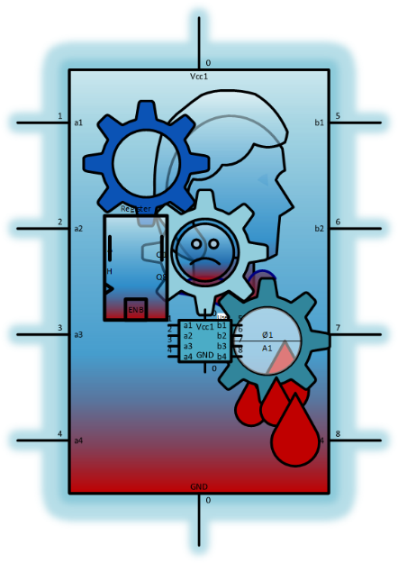
Chapter 6: First Blood
Maya's first real combat deployment came during her second year, when a sophisticated attack targeted the academy's partner institutions. Unlike the training scenarios, this was a coordinated assault by human adversaries supported by advanced AI systems.
The attack began with social engineering. Carefully crafted messages, sent through compromised but legitimate-looking communication channels, targeted faculty and staff at seventeen different institutions. The messages appeared to come from trusted colleagues and requested temporary access to research databases for "urgent collaborative projects."
Maya's squad, now veterans of hundreds of training scenarios, deployed to defend the Regional Educational Network. But this time, their Three Gates Authentication saved them. When the first wave of attacks attempted to use stolen passwords, the attackers were stopped by the biometric requirements they couldn't fake, and the authentication fobs they didn't possess.
"First barrier holding," reported Tommy Martinez from his station. "They've got passwords but can't get past multifactor authentication."
But the attackers adapted. Instead of trying to breach the authentication systems, they began targeting the human elements. Faculty members received phone calls from people claiming to be IT support, asking them to "verify" their authentication by reading their fob codes over the phone.
"Social engineering attack in progress," Maya announced. "They're trying to bypass technology with psychology."
This was where their training paid off. Instead of panic, Maya felt the calm focus that came from years of preparation. Faculty members who had been trained to verify all requests through independent channels began calling their actual IT departments to confirm the requests. The carefully crafted deception unraveled quickly.
But the most impressive defense came from the network segmentation. When the attackers finally did gain access to one system—a compromised food service database—they found themselves trapped in a single, isolated segment with no pathway to the valuable research and student data they sought.
"Containment successful," Sarah Kim reported from the network monitoring station. "Breach isolated to Segment 7-Delta. Initiating backup restoration protocols."
Within hours, the compromised segment was restored from backup, the attack vectors were analyzed and patched, and the academy's network was stronger than before.
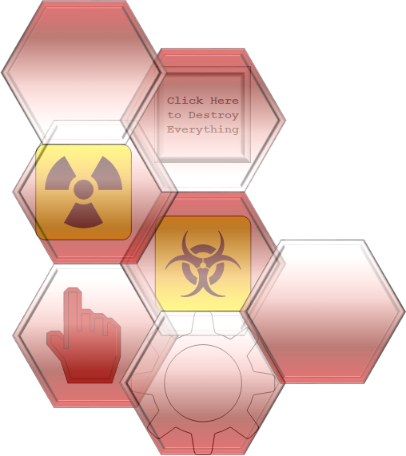
Chapter 7: The Advanced Threat
Maya's final year brought her face-to-face with the most sophisticated attack yet seen: a coordinated assault that combined human psychology, artificial intelligence, and advanced persistent threat tactics.
The attack began months before anyone detected it. Adversaries had spent extensive time researching their targets through social media, professional networks, and public records. They built detailed psychological profiles of key personnel, identifying their relationships, interests, communication patterns, and potential vulnerabilities.
The first phase wasn't technical at all—it was social. Fake personas, supported by elaborate backstories and AI-generated content, began building relationships with academy personnel through professional networking sites and academic conferences. These relationships developed slowly, naturally, building trust over time.
Maya first noticed something wrong during what seemed like routine network maintenance. Traffic patterns showed subtle anomalies—not the obvious spikes that would indicate a traditional attack, but barely perceptible changes in data flow that suggested someone was already inside the network, moving very carefully.
"This isn't amateur hour," she reported to Colonel Torres, who had replaced DI Rodriguez as senior instructor. "Someone's been in our systems for weeks, maybe months. They're not smashing and grabbing—they're studying us."
The investigation revealed a sophisticated campaign. The attackers had used their carefully cultivated relationships to introduce malware through seemingly innocent file sharing. But network segmentation had limited their access, forcing them to spend months mapping the network topology and trying to find pathways between segments.
Their backup systems had detected and preserved evidence of the intrusion without the attackers realizing it. Every move they had made was recorded, even when they thought they had deleted their tracks.
"This is why we maintain parallel monitoring systems," Colonel Torres explained as they reviewed the attack timeline. "They compromised our primary logging, but they didn't know about the secondary and tertiary systems."
But the most revealing aspect was how their security culture had limited the damage. Personnel who had been approached by the fake personas had reported the interactions as "unusual but not necessarily suspicious." This early warning system, built on cultural awareness rather than technology, had provided crucial intelligence about the attack's social engineering component.
Chapter 8: Graduation Day
The Next Generation: Digital Warriors Ready to Defend Civilization's Digital Infrastructure
Maya stood before the assembled class of 2049, now wearing the insignia of a full Cyber Trooper. Her graduation speech focused not on technology, but on the human elements that made cybersecurity possible.
"When I arrived here three years ago," she began, "I thought cybersecurity was about firewalls and encryption and antivirus software. I thought it was about building walls high enough and strong enough to keep the bad guys out."
She gestured to the academy's architecture, with its segmented design and multiple authentication checkpoints visible even in the graduation ceremony setup.
"I learned that cybersecurity isn't about building perfect walls—it's about building perfect habits. It's not about trusting technology to protect us—it's about creating a culture where protection becomes second nature."
She looked at her fellow graduates, each of whom had survived three years of intensive training in both technical skills and human factors.
"You've learned that every email might be a trap, but you've also learned to verify without becoming paralyzed by suspicion. You've learned that every network connection is a potential breach point, but you've also learned to segment and isolate without breaking functionality. You've learned that every backup system is a lifeline, but you've also learned to maintain them without becoming complacent."
Colonel Torres joined her at the podium. "Class of 2049, you are graduating into a world where the threats evolve daily. The attack methods you've trained against will be obsolete within months. The technology you've mastered will be replaced within years. But the principles you've internalized—authentication, segmentation, backup, training, and culture—these will serve you throughout your careers."
Maya looked out at the audience, which included families, faculty, and representatives from organizations around the world seeking cybersecurity expertise.
"The enemy isn't just malicious code or rogue AI," she continued. "The enemy is complacency. The enemy is the assumption that yesterday's security is good enough for tomorrow's threats. The enemy is the belief that cybersecurity is someone else's job."
She paused, thinking of her brother and all the digital warriors who had fallen defending humanity's information infrastructure.
"Your mission, should you choose to accept it, is to make cybersecurity everyone's job. To build organizations where security culture is as natural as breathing. To create systems where authentication is automatic, segmentation is invisible, and backup is so robust that attacks become mere inconveniences rather than catastrophes."

Chapter 9: The Next Battlefield
Global Defense: Academy Principles Scaled to Protect Entire Nations
Five years later, Commander Maya Chen stood in the command center of the Global Cybersecurity Coordination Hub, watching her team respond to a coordinated international incident. The lessons learned at the academy had scaled up to protect entire nations' digital infrastructure.
The attack was unprecedented in its scope and sophistication. Adversaries had spent years building legitimate-seeming businesses and organizations, establishing trust relationships with critical infrastructure operators across multiple countries. They had used these relationships to introduce seemingly beneficial software that contained dormant malicious capabilities.
But the defense was equally sophisticated. The global network of Cyber Troopers had implemented academy principles on a planetary scale. Critical infrastructure operated in segmented networks that prevented cascading failures. Backup systems maintained multiple generations of clean data and software. Personnel training programs included regular social engineering tests and continuous cultural reinforcement.
Most importantly, the security culture that had started in the academy had spread throughout society. Citizens understood that cybersecurity was a shared responsibility. Organizations competed to demonstrate their security hygiene. Governments invested in security education as heavily as they invested in security technology.
"Commander," reported Lieutenant Thompson from the monitoring station, "we've successfully isolated the attack to Sectors 7 through 12. Backup restoration is in progress. Estimated recovery time: forty-seven minutes."
Maya smiled. An attack that would have crippled entire nations just decades earlier was now a manageable incident that would be resolved before most people even knew it had occurred.
"Outstanding work, team. Begin the after-action analysis. I want to understand how they got as far as they did and how we can prevent similar approaches in the future."
As she watched her teamwork, Maya reflected on how far cybersecurity had evolved. Technology was important, but it was the human elements—the culture, the training, the habits, the collective commitment to security—that had transformed vulnerability into resilience.
Chapter 10: Legacy
Honoring the Fallen: Names of Digital Warriors Who Gave Their Lives for Cybersecurity
Years later, as Maya prepared to retire from active duty, she was invited back to the academy to speak to the newest class of recruits. Technology had advanced beyond recognition, but the fundamental principles remained unchanged.
"The threats you'll face," she told the young cadets, “Will be different from the ones I fought. The technology you'll use will be more powerful than anything we had. But the principles that will keep you alive, and keep civilization secure, are the same ones we learned decades ago."
She walked them through the memorial wall, where the names of fallen cyber warriors were etched in quantum-encrypted light that would never fade.
"Multi-factor authentication," she said, pointing to the first principle. "Something you are, something you have, something you know. This isn't just about logging into systems about verifying reality itself in a world where everything can be faked."
"Network segmentation. Don't put all your eggs in one basket, and don't make every basket accessible from every other basket. Isolation saves civilizations."
"Backup systems. Hope for the best, prepare for the worst, and always have a way back to a known good state. Your backups aren't just files—they're time machines that let you undo disasters."
"Continuous training. The enemy learns every day, so you must learn every day. Training isn't something you complete—it's something you live."
"Security culture. Technology serves culture, not the other way around. Build organizations where doing the secure thing is the natural thing, and you'll have built something that can survive any attack."
She paused at her brother's name on the memorial wall.
"These principles cost lives to learn. Honor those sacrifices by making them the foundation of everything you do. Make cybersecurity so natural, so automatic, so deeply embedded in how you think and work and live, that future generations won't even understand how we once lived without them."
The young cadets stood at attention, their faces reflecting the same mixture of determination and uncertainty that Maya remembered from her own first day.
"The digital frontier is vast, complex, and absolutely essential to defend. It's not just networks and systems—it's the nervous system of human civilization. You are its guardians. Train hard, think clearly, trust carefully, and never forget that in cybersecurity, the most important technology is the human mind committed to collective security."
As Maya left the academy for the final time, she smiled at the sight of new recruits going through their authentication protocols, their network segmentation exercises, their backup drills, their social engineering training. The culture of cybersecurity had become self-sustaining, passed from generation to generation like the most important knowledge humanity possessed.
The digital future was secure not because of any single technology, but because people had learned to make security a way of life.
THE END

Author's Note: This story explores the foundational principles of cybersecurity through the lens of military science fiction. While the future depicted is fictional, the seven principles woven throughout—multifactor authentication, password management, elimination of public-facing contact information, network segmentation, robust backup systems, continuous training, and security culture—represent real-world best practices that organizations can implement today to protect themselves against evolving cyber threats.

