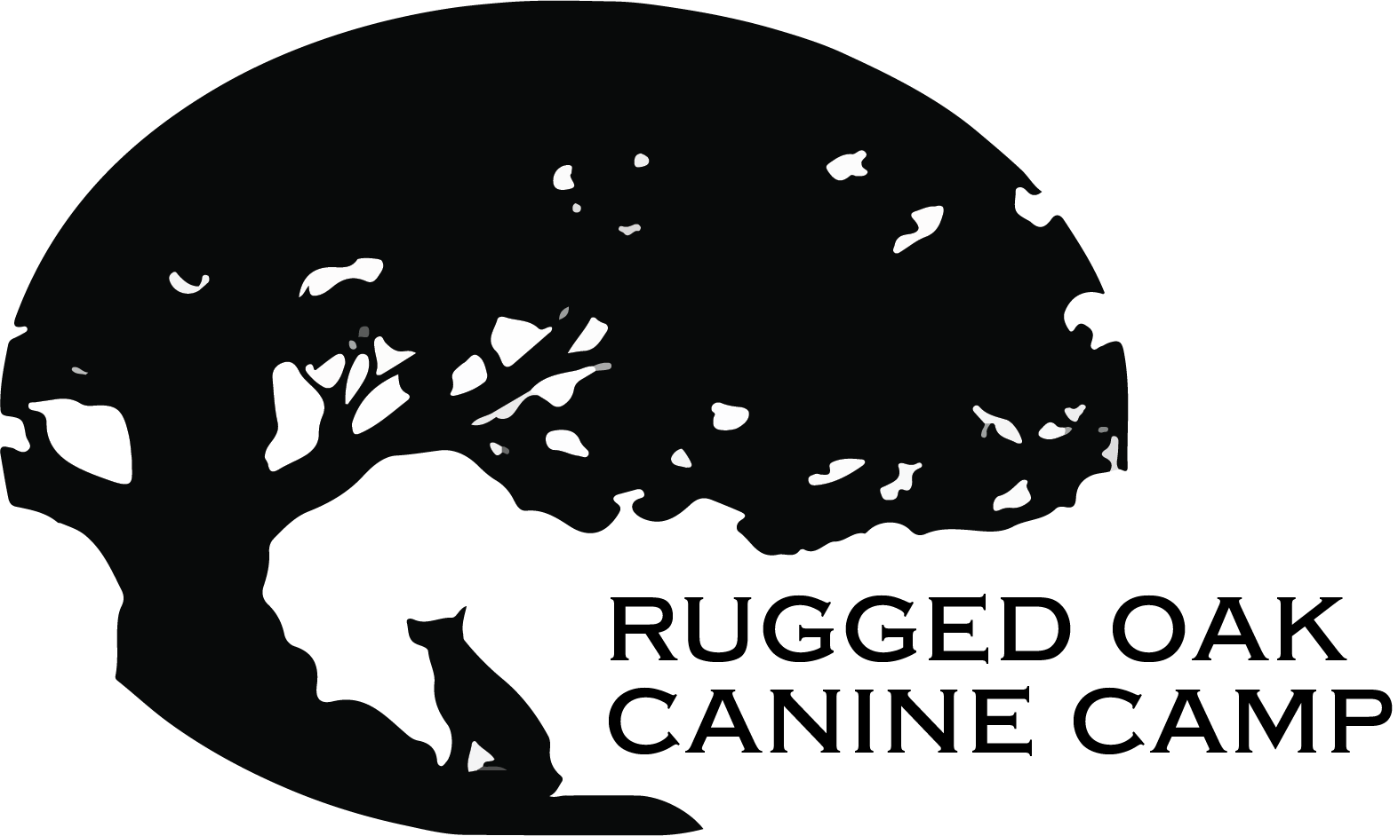**Day Camp Agreement and Liability Release**

**Vaccination and Health Requirements**

1. All dogs must be current on the following vaccinations:  
   * Rabies (certificate required)
   * Bordetella (kennel cough)
   * Distemper
2. All dogs must be on flea and tick prevention.
3. All dogs must be licensed as required by Pennsylvania law.
4. All dogs must be at least 16 weeks old and have completed all required vaccinations listed above.
5. Dogs aged 7 months and older must be spayed or neutered.
6. All dogs must be in good health and should be free of any communicable conditions within the past 30 days.
7. Absolutely no aggressive dogs are permitted- aggressive behavior towards other dogs, people, food, toys, etc., is not tolerated.
8. Drop-off hours are from 7:30 AM to 10:00 AM, and pick-up hours are from 3:00 PM to 5:30 PM. A late pick-up will incur a fee of $10.
9. Unarranged late pick-ups beyond 30 minutes past closing will result in an overnight boarding charge at the applicable rate.
10. A 24-hour notice is required for all cancellations. Failure to provide notice will result in a fee equal to the daily rate.
11. (For membership only) Monthly membership fees are due on the first of each month. Late payments will incur a fee of $25. No refunds, make-ups, or substitutions of days are permitted. Additional or alternate days may be purchased individually at the daily rate.
12. Owners must provide a list of individuals authorized to pick up their dog(s). Please include names and phone numbers below:

**Liability Release**

I, the owner, acknowledge that Rugged Oak Canine Camp reserves the right to refuse service to any dog at check-in for any reason, including but not limited to signs of illness, injury, pain, or behavior that may jeopardize the health or safety of other dogs or our staff.

I understand that I am responsible for any medical expenses and damages resulting from injuries caused by my dog(s).

I expressly waive and relinquish any and all claims against Rugged Oak Canine Camp, its employees, and representatives.

I have disclosed all known risks associated with my dog(s) to Rugged Oak Canine Camp.

I understand and agree that Rugged Oak Canine Camp shall not be held liable for any damage to my property or that of others caused by my dog(s) while in their care.

In the event of a medical issue while my dog(s) is in the care of Rugged Oak Canine Camp, I authorize the camp to take necessary actions for the safety, health, and well-being of my dog(s). I agree to assume full financial responsibility for any expenses incurred.

I understand that Rugged Oak Canine Camp allows dogs to engage in free play. I accept the associated risks and agree that Rugged Oak Canine Camp is not liable for any injuries or illnesses that may arise during my dog’s attendance.

I hereby declare that I am the legal owner of my dog; that my dog has not been exposed to distemper, rabies, or parvo within the last 30 days; that my dog(s) has been vaccinated as indicated by the presented records; that my dog(s) is currently and properly licensed; and that I have read this agreement in its entirety.

**Owner Signature:** ________________________________________ **Date:** _______________

**Printed Name:** ________________________________

**Dog’s Name: _________________________________**

**Dog’s Description: ____________________________**