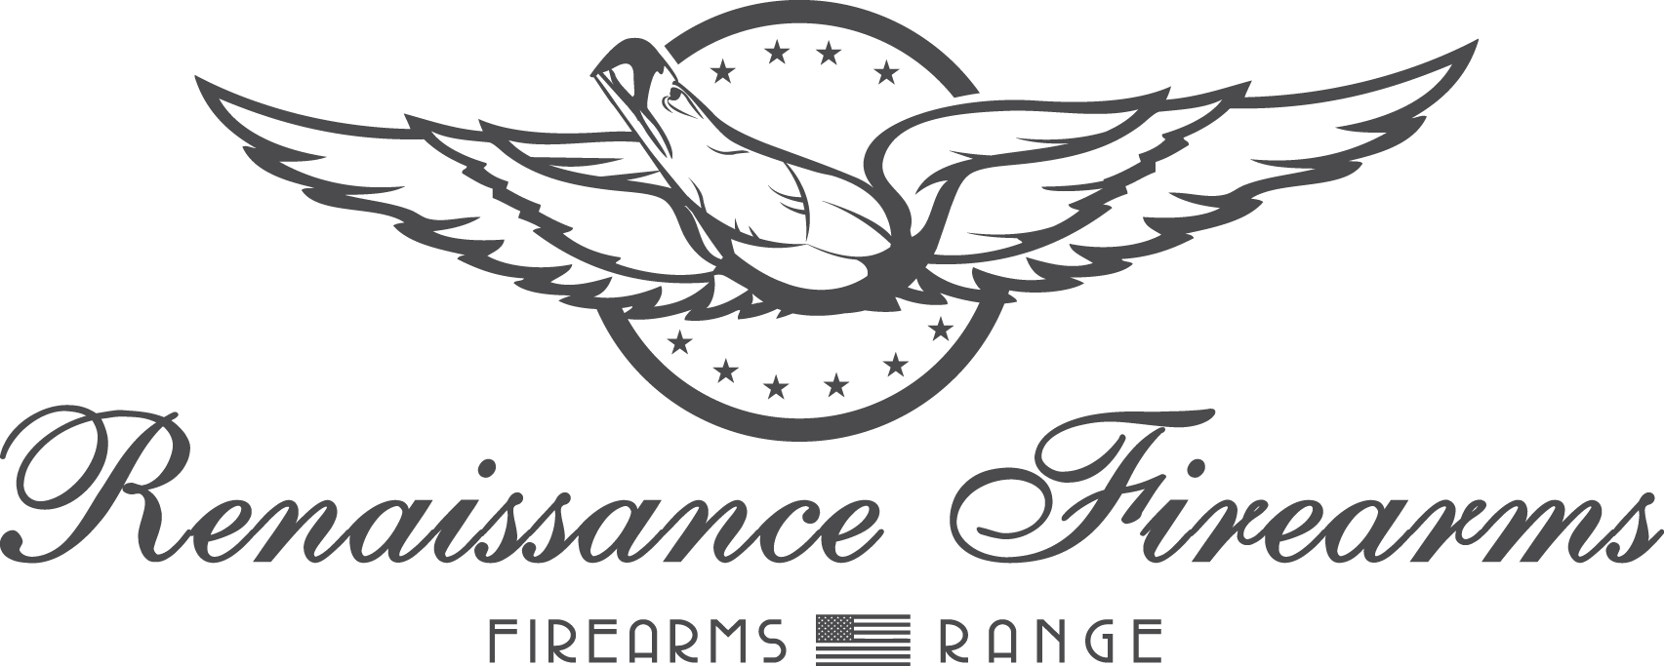

Range Safety Test

Must be completed with no more than 5 incorrect answers to pass
(Failing can only happen if you tell us you are going to hurt yourself or someone else. We will help answer any and all questions to include giving you the answers. Our goal is to make sure you are aware of the ways we all stay safe and to make sure we interact with you and show you we care about you, no joke! Good luck!)

NAME: ___________________________
DATE: ___________________________

- RENARMS reserves the right to deny service to anyone, at any time, for any reason.
a) True
b) False
.
- If you observe a violation of the range rules, what should you do?
a) Ignore it
  - Confront the violator
  - Notify the RSO
  - Leave immediately
..
- Which of these ammunition types are allowed for use on our range? (more than one)
  - Reloads/Hand Loads
  - Muzzle Loaded
  - Shotgun Slugs and 00 Buckshot
  - Tracer
  - Incendiary Bullets
.
- All Federal, State, and Local firearm laws must be obeyed, including transportation to and from the range.
  - True
  - False

- Which of these are allowed in the range area?
  - Food
  - Beverages
  - Chewing Tobacco
  - Snuff
  - Cigarettes
  - Cigars
  - None of these are allowed
.
- Being under the influence of alcohol or any other intoxicating substance is prohibited.
Customers can and will be required to leave the facility if they smell of alcohol or appear intoxicated to the staff.
  - True
  - False
.
- RENARMS staff have the right to inspect all firearms, ammunition, and equipment.
a) True
b) False
.
- All firearms entering or leaving the range must be unloaded and in a _________.
- At what point may magazines be loaded?
a) The waiting room outside the range
b) Once inside the store
c) Once you are at the firing line

- What do you do when “CEASE FIRE” is commanded on the range?
  - Finish your current magazine and ask what is wrong
  - Stop shooting, clear your firearm, and make it safe
  - Pack up your firearms and leave the range area
  - Drop your firearm
- In the case of emergency or power outage, you should:
  - Continue shooting until the ammunition in your firearm is depleted
  - Move your firearm to the tables behind you and leave the range area
  - Act as though a cease fire command was given
  - None of the above
..
- What is the first thing to do if you sustain an injury on the range?
  - Go to the first aid kit and treat your injury immediately and/or then alert the range staff
  - Tell no one, suffer in silence
  - All of the above
.
- Handling of firearms is allowed
  - In the classroom area
  - On the firing line, or directly accompanied by RENARMS staff
  - The Parking Lot
.
- When do eye and ear protection need to be applied?
  - While browsing on the sales floor
  - Before entering the first door to the firing range
  - Once inside the range area
  - Only when an RSO calls "eyes and ears"
.
- Proper dress is required while using the range. Which of the following are not allowed? (more than one)
a) Tee shirt
  - Open-toed sandals
  - Low cut shirts
  - Steel-toed boots
.
- Which of these are allowed?
  - Drawing and firing from your holster (without a certification from RenArms)
  - Shooting at objects on the floor
  - High and Ready (muzzle at the ceiling)
  - None of the above

- Which targets are you allowed to fire at while on the range?
  - Approved targets in my own lane only
  - Approved targets in my lane or one lane over, as long as it’s OK with the other shooter
  - Whichever targets I see as long as they’re downrange
- Unless otherwise directly permitted by a RSO, how fast are you allowed to fire on the range?
a) In a controlled manner where all rounds are landing on target
  - Two shots per second
  - One shot per second
  - None of the above
.
- Dry firing your firearm is permitted
  - Only at the firing line or accompanied by RENARMS Staff
  - Anywhere, so long as you are sure your firearm is cleared of ammunition
  - In the social area
.
- How many people are allowed per lane?
  - Two (One person firing at a time)
  - Two (Two people firing at a time)
  - Three (One person firing at a time)
  - Unlimited
.
- Firearms may be exchanged between booths.
  - True
  - False
- What should you do if your firearm malfunctions?
  - Bring it over to a RSO to have it looked at
  - Take it out of the range immediately to have our sales staff repair it
  - Lay the firearm on the bench with the muzzle pointed downrange and call a RSO
- If you do not want to pick up and keep your empty shell casings after firing, where should they go?
  - Pushed forward of the firing line
  - Pushed behind you
  - In the garbage can

- How many loaded firearms are allowed in your booth at once?
  - Two
  - Three
  - One
  - Unlimited
- Firearms not being used while in your booth need :
  - To be unloaded
  - To have their muzzle pointed downrange
  - All of the above
.
- What is the closest a target is allowed to be when firing a rifle in the range?
a) No limit
  - 5 Yards
  - 10 Yards
  - 15 Yards
.
- What is the closest a target is allowed to be when firing a pistol in the range?
  - No Limit
  - 3 Yards
  - 7 Yards
  - 10 Yards
- How old must a minor be to enter the range with their guardian?
  - 13 Years
  - 15 Years
  - 10 Years
- Who is responsible for your firearm, personal equipment, and personal items?
  - Me!
  - RSO
  - RENARMS Instructors

- Where are you allowed to handle your firearm(s)? (Including removing from, and placing into its case)
a) Anywhere, as long as it is in a safe direction
b) In the room between the firing range and the sales floor only
c) While in your assigned shooting lane

The Following Questions do not have an incorrect answer. They are for the staff to help inform you of potentials hazards you may encounter on the range.
42) A Squib Load is when ______________________________________________________________________________________________________________________ happens.

43) What is a Hang Fire?
____________________________________________________________________________

44) A misfire is when ________________________________________________________________________ happens.

Fill in the blanks for the four basic rules of firearm safety:
- __________________________________________________________________
- __________________________________________________________________
- __________________________________________________________________
- __________________________________________________________________

