**Combined Test Entry** 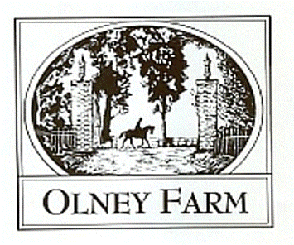

Saturday March 27, 2021

Closing Date: Monday March 22, 2021

Mail Entries to Olney Farm Att. Kelsea

1001 Old Joppa Road Joppa, Maryland 21085

Email: [Olneyfarm@gmail.com](mailto:Olneyfarm@gmail.com)

Dress: Casual riding attire e.g. polo’s, jodhpurs. Required: ASTM/SEI approved helmet, shoes or boots with a heel. Tests may be read. May carry whip. Dressage: sand and rubber outdoor ring. Warm-up Indoor small arena, sand and rubber footing, lighted. $50 per class ($40 for leadline/poles division) $25 dressage/jump only, $15 extra tests or jump round.

**Class ​​Dressage Test-​​Obstacles**

1.Leadline- Leadline Test B-Poles 2. Tadpole- USDF Intro Test B-2’

3. Advanced Elementary- USDF Intro Test C- 2’3” 4. Beginner Novice- USEA BN Test A-​​2 7” 5. N​​​ovice- USEA N Test A- 2’11”​ 6. Training- USEA T​​​ Test A-​​​3’3”​

7. Modified- USEA M Test A-3’5” 8. Preliminary- USEA P Test A-3’7”

9. Dressage Only TOC- USEA BN-Prelim including YEH, USDF Intro-2nd Level

10.Jump Only 11. Extra Jump round (limited availability to add on day off) 2’-3’7”

Please fill in the following in print and submit with signed release and negative coggins.

RIDER NAME:__________________________________________

HORSE’S NAME: ________________________________________

EMAIL: ________________________________________________TELEPHONE NUMBER: _____________________

Circle CLASSES you want to ride:

State WHICH TEST you want to ride in class 8 and height for 9/10

1 Leadline ​ 2 Tadpole 3 Advanced Elementary 4 Novice 5 Training

6 Modified 7 Preliminary

8 Dressage Only, USEA/USDF Test ($25/$15 additional tests) __________________

9 Jump only ($25) Height ______ ​​​Extra Jump Round: $15___________

TOTAL _______

Questions please call/text Kelsea Blazek 443-286-1706 kelsea218@comcast.net

Releases and leadline test available at olneyfarm.com

Mail: 1001 Old Joppa Rd, Joppa 21085 Email: olneyfarm@gmail.com. .