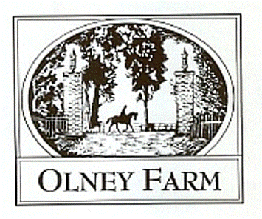
Derby and Dressage Dress Rehearsal Entry

Saturday May 15, 2021
Closing Date Monday May 10, 2021
Send Entries to Kelsea Blazek 2 Vaughn Avenue Bel Air, Maryland 21014 email Kelsea218@comcast.net

The derby will be run with a shortened show jump course first followed immediately by the cross country course. (Same format as YEH for anyone looking for a chance to practice) Prizes given based on closest to optimum time without going over. We will start smallest to biggest and you may enter more than one height division with the same horse and rider combination. Each height will have a set number of ride slots and will run within their time frame, no extensions, pre-entry is preferred but day of permitted if slots available.
Dressage is dress rehearsal style, tests will be scored and returned but no placings or ribbons. Have your test read or even a coach talk you through your moves. If riding a dressage test and the derby course, dressage will be scheduled before the entered division has started.

Derby Divisions: $5o per round $35 for additional rounds
Advanced Elementary 2’-2’3” (pairs well with USDF Intro Test C)
Beginner Novice 2’7” (pairs well with USEA BN tests as well as USDF Training 1)
Novice 2’11” (pairs well with USEA N, USDF Training 2, Training 3 if looking at a move up soon)
Training 3’3” (pairs well with USEA T, USDF First 1)
Modified 3’5” (pairs well with USEA M, USDF First 2 & 3)

Dressage TOC available: $2o per test
USEA YEH 4&5, BN-Preliminary,
USDF Intro- Second Level (note that First level and higher will be ridden in a standard arena and will go at the end of the dressage portion)

Rider Name: ___________________________________________

Horse Name:___________________________________________

Phone Number:_________________ Email Address:____________________________________

Derby Division:______________________Additonal Round Division:_________________________

Dressage TOC (Please list each test you wish to do):_____________________________________________

Releases can be found at Olneyfarm.com under the events tab and should be filled out and included along with your coggins and entry. All checks made payable to Olney Farm, paypal available Olneyfarm@gmail.com $3 fee for payments up to $50, $5 fee payments up to $150. Please contact Kelsea Blazek 443-286-1706 or Lia McGuirk 443-617-1617 with any questions or concerns.

