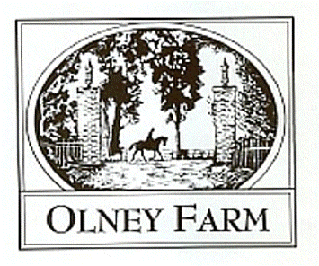
Trail Obstacle Competition Entry Form

A course of between 12-18 trail related obstacles will be set out on our cross country course. Once each obstacle has been completed a playing card can be taken from that obstacle. Each card is worth its numerical value, face cards worth 10, aces 15. Tally your points at the end and select a prize associated with that level of points, arcade style.

Rider Name_____________________________________________________________

Email Address___________________________________________________________

Phone Number__________________________________________________________

Horse Name_____________________________________________________________

Preferred Time Slot 5:00-6:00 6:00-7:00 7:00-8:00

Rules and Details:
- Open to any discipline and breed of horse.
- All riders must sign a release form. Available at Olneyfarm.com please fill out and return via email prior to the event if possible. Riders 17 years or age and under must have parent/guardian signature on release form. Competitors and parents/legal guardians of youth assume all responsibility when on the grounds and participating in the event.
- Helmets and proper footwear required.
- Equines must be serviceably sound and in good condition.
- It is expected that each horse shall be treated humanely with kindness and respect at all times.
- No whining, moaning, or complaining. The object is to have fun and to better our horsemanship. Suggestions are welcome.
- If you choose to lead your horse through an obstacle you must remount before moving toward the next obstacle.
- If you happen to fall off your horse and you can regain control without assistance and remount you may do so.
- Course can be done alone, with a ground person, as a pair, or group. Each horse and rider must complete each obstacle in order to each take a card, if only one member of your group completes the obstacle only one card can be taken.
- Show management has the right to add additional rules if necessary. Rule additions will be posted at registration table.
- Entry Fee $40 entries and payment received prior to 11/13 $50 day of $20 extra round (same horse and rider)
Entries and Coggins can be returned via email to Kelsea218@comcast.net or mailed to 1001 Old Joppa Road Joppa, Maryland 21085 att. Kelsea/Kate questions to above email or 443-286-1706 (Kelsea) 443-910-2759 (Kate)
Electronic payments can be made via paypal to Olneyfarm@gmail.com +$5 E-payment fee checks should be made payable to Olney Farm.

