

***WATER 4 MERCY'S PROVEN, SUSTAINABLE SOLUTION***

*to transform our world*

To ensure a permanent solution to eliminate thirst, hunger and poverty in Africa, our 'Boots on the Ground" partners, Israeli NGO's innovation:Africa (iA) and CultivAid integrate four (4) critical components in our proven, sustainable approach that is 100% successful:

💦**Community Involvement**

From the beginning, iA's 'team of experts' set up a 'Village Solar/Water Committee" to involve the villagers in the project so that they understand how the systems work and what to do when there is a problem.

💦**Boots on the Ground**

iA staff are locals who speak the language and understand the village life and culture.

IA staff oversee the "Village Solar/Water Committee" and are quickly regarded as 'family' by many of the villagers.

Our permanent “boots on the ground” are the critical communication link between villagers, iA technicians, local governments and donors.

💦**Real-time System Monitoring**

Production at every installation is continuously monitored electronically via satellite so that iA technicians are immediately aware of a system failure.

Within hours of a problem occurring, local agents and villagers who are responsible for maintenance of the system address and resolve any issues.

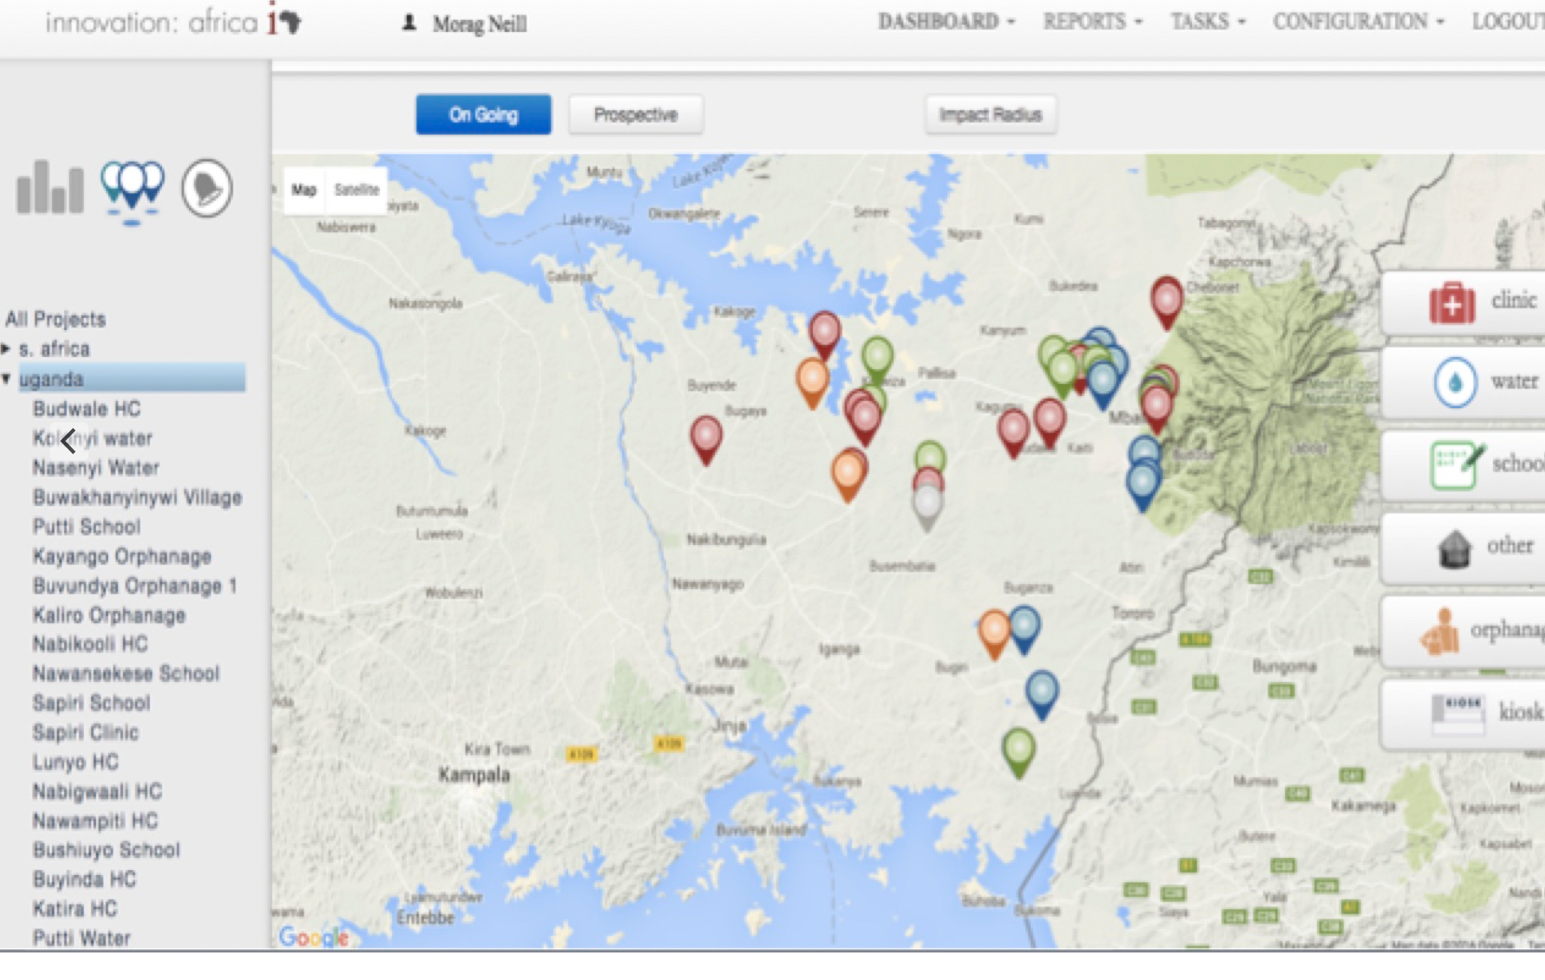

💦**Drip Irrigation for Optimal Farming**

CultivAid's agricultural 'team of experts' oversee the drip irrigation implementation with iA staff and the villagers.

CultivAid staff transfer knowledge and train the villagers on optimal agricultural practices.

Villagers learn about farming practices to optimize crop production for a healthy food source and also to gain financial independence.