03/11/2022 NEWS -Don’t Miss Shorashim Insights: link- https://madmimi.com/p/a2f0a31?pact=107300-166918432-1683292940-e27757e44eabb02592f082e04f5df5dcc6343da2

God Will Work It Out (feat. Naomi Raine & Israel Houghton)
https://www.youtube.com/watch?v=URuIldVKk9U
"Kings had always been involving and impoverishing their people in wars,
pretending generally, if not always, that the good of the people was the object."
-- Abraham Lincoln (1809-1865) 16th US President
Read the Prophets & PRAY WITHOUT CEASING!
That is the only hope for this nation!
Please  Remember  These  Folks  In  Prayer-  Check often  They  Change! | Pray that the world would WAKE UP! Time for a worldwide repentance!  ALL US soldiers fighting for our freedom around the world  Pray for those in our government to repent of their wicked corrupt ways.  Pray for BB – Severe sciatic needing procedure.  Pray for EL – Had clot embolized to brain – successful ‘clot buster’ but long road to go.  Pray for BB – Severe West Nile Fever –still not mobile- improving!  Pray for RBH – cancer recurrence  Pray for Ella – Child with serious problems  Pray that The Holy One will lead you in Your preparations for handling the world problems. – Have YOU made any preparations?
Exodus 10:¹⁶Then Pharaoh called for Moses and Aaron in haste; and he said: 'I have sinned against the LORD your God, and against you. ¹⁷Now therefore forgive, I pray thee, my sin only this once, and entreat the LORD your God, that He may take away from me this death only.' (18) And he went out from Pharaoh, and entreated the LORD. ¹⁹And the LORD turned an exceeding strong west wind, which took up the locusts, and drove them into the Red Sea; there remained not one locust in all the border of Egypt. ²⁰But the LORD hardened Pharaoh's heart, and he did not let the children of Israel go.

Anonymous hacks Russian federal agency, releases 360,000 documents
Documents released by the hacking group show that Russia is censoring the narrative regarding its role in its war with Ukraine.
By ARIELLA MARSDEN Published: MARCH 10, 2022 18:24 Updated: MARCH 10, 2022 20:45
The Ukrainian Anonymous hacker group has hacked into Roskomnadzor, the Russian federal agency responsible for monitoring and censoring media, and released 360,000 files, the group announced on Twitter on Thursday.
JUST IN: #Anonymous has successfully breached and leaked the database of Roskomnadzor, the Russian federal executive agency responsible for monitoring, controlling and censoring #Russian mass media, releasing to the public over 360K files. #OpRussia https://t.co/m5wvoDGNPh
— Anonymous TV (@YourAnonTV) March 10, 2022
Among the censored documents released by Anonymous, some of which are dated as late as March 5, are ones that show Moscow censored anything that referred to the war as a Russian invasion of Ukraine.
Roskomnadzor blocked Russian use of Facebook after it flagged Russian articles as factually inaccurate. They are also threatening to block Russian Wikipedia for including an article on the Russian invasion.
A few days ago, Anonymous hacked several Russian broadcasts, interrupting their content and leaving messages saying that normal Russians don't support the war.
Anonymous has been waging a cyberwar against Russia since February 24 when the invasion began. The group has taken credit for hacking multiple Russian government websites. They also opened a website where users could send emails to random Russians whose email addresses were stored in the database, and they encouraged users to "spread the truth about war in Ukraine."
On Wednesday, Anonymous denied a report that its website was hacked by pro-Russian hackers. https://www.jpost.com/breaking-news/article-700940 [When you see the media reports from the West are lies and then you see this which documents Russian lies you can assure yourself that there is no real way to know what is actually happening in this war. There is a wonderful little verse: Psalm 146:3 “Put not confidence in nobles, in a son of man, in whom there is no salvation.” rdb

Half of Kyiv's population left the capital, mayor says
Mayor Vitali Klitschko says city heavily fortified as forces prepare for encroaching Russian forces; British MOD says miles-long Russian convoy making its way to capital continues to suffer losses
Ynet | Updated: 03.10.22, 19:14
Half of the population of Kyiv has left the city since the Russian invasion of Ukraine started 14 days ago, the mayor of the besieged capital stated Thursday.
Speaking on state television amid reports of encroaching Russian forces, Vitali Klitschko added that “slightly less than two million people remain in the city. Kyiv is now a fortress. Every street, every building - is now fortified.”
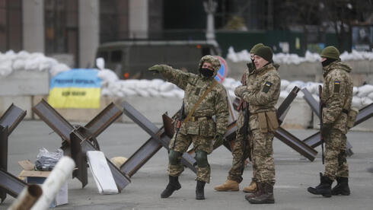  A Ukrainain military checkpoint in Kyiv (Photo: EPA) | 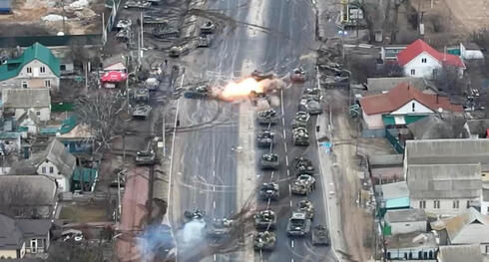  Russian tanks destroyed near Brovary
The British Ministry of Defense, meanwhile, reported that the huge Russian convoy making its way to the capital from the northwest "has made little progress in the last week" - and that it has suffered “continuous losses” at the hands of Ukrainian forces.
Kyiv's Mayor, Vitali Klitschko (Photo: AP )
Drone footage released Thursday shows Ukrainian forces ambushing a Russian tank convoy near the city of Brovary, some 35 km from the center of Kyiv.
According to independent investigative agency Bellingcat, the video was captured on the E95 - a main road which leads directly to the center of Kyiv.
The Ukrainian Defense Ministry verified the video’s authenticity, stating that “the force’s commander, Colonel Zakharov, has been killed. The force has suffered heavy casualties, both in manpower and equipment," a statement said.
Both the video and Klitschko’s statement come in the wake of yet another round of negotiation, which saw the foreign ministers of Russia and Ukraine meet Thursday in Turkey - the highest-level contact between the two countries since the war started.
Ukraine's Dmytro Kuleba said he had secured no promise from Russia's Sergei Lavrov to halt Russian bombardment so aid could reach civilians in several besieged cities, including Kyiv's main humanitarian priority — evacuating hundreds of thousands of people trapped in the port city of Mariupol.
Ukraine's Deputy Prime Minister Iryna Vereshchuk said Thursday that not a single civilian was able to leave the encircled Mariupol as Russian forces failed to respect a temporary ceasefire to allow evacuations. https://www.ynetnews.com/article/hjex79d115#autoplay

After rebuff, Zelensky to address Knesset members in coming days, says speaker
Date for speech via Zoom to be finalized; Ukrainian leader reportedly also asks to address Yad Vashem, museum says it will look into the matter
By TOI staff Today, 6:26 pm
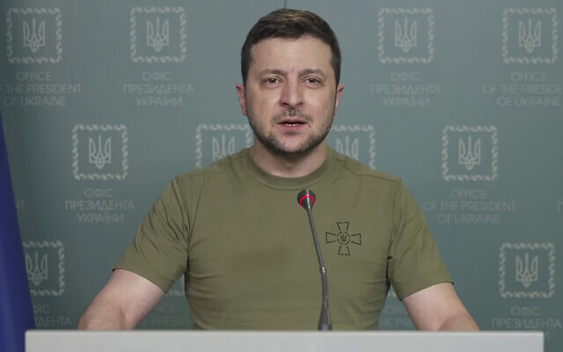
In this image from video provided by the Ukrainian Presidential Press Office and posted on Facebook, Ukrainian President Volodymyr Zelenskyy speaks in Kyiv, Ukraine, on Wednesday, March 9, 2022. (Ukrainian Presidential Press Office via AP)
Ukrainian President Volodymyr Zelensky is slated to address the Israeli parliament via Zoom in the coming days, according to Knesset Speaker Mickey Levy.
Levy said on Thursday that he spoke with Ukrainian Ambassador to Israel Yevgen Korniychuk to reiterate his invitation to Zelensky to address members of the Knesset.
Korniychuk and Levy have agreed to schedule a date for Zelensky’s address in the coming days, the statement said.
Zelensky had first asked to address the full Knesset plenum, but Levy responded that the Knesset would be going on recess after its closing session on Thursday, and the building was then scheduled for renovations, according to reports.
“The ambassador thanked Speaker Levy for his welcoming response to his letter and for publicly clarifying and refuting the false information published in the press, that allegedly argued that the speaker refused President Zelensky’s request to address members of the Knesset,” the statement said.
Zelensky has given similar speeches to officials and lawmakers in the United Kingdom, European Union, and Canada.
Separately, Reuters reported on Thursday that Zelensky asked to address the Yad Vashem Holocaust Memorial Museum to discuss Russia’s invasion of his country.
According to the report, Yad Vashem said in a statement that it will discuss the proposal with Ukraine’s ambassador to Israel.
There was no immediate comment from the Ukrainian embassy on the matter.
Relations between Israel and Ukraine have been tense since Russia launched its invasion, as Jerusalem attempts to walk a tightrope between Kyiv and Moscow, and Ukraine has sought more support.
Israel has avoided harshly criticizing Russia, or supporting Ukraine too strongly, because of Russia’s presence in Syria. Israel carries out airstrikes against Iran-linked targets in Syria, with Russia’s understanding, to prevent Iran-backed forces from gaining a foothold on Israel’s northern border. https://www.timesofisrael.com/zelensky-slated-to-address-knesset-members-in-coming-days-says-speaker/

Blankets won’t save us from bombs: Ukraine’s Jewish ex-PM pleads for Israel’s help
Volodymyr Groysman, who lost family in Holocaust, calls Russia’s invasion ‘a continuation of Nazi policy on a national basis,’ notes ‘Hitler was not stopped by economic sanctions’
By Gareth Browne Today, 5:00 pm
AFP — Former Ukrainian premier Volodymyr Groysman, who lost much of his family in the Holocaust, compared Russia’s invasion of his country to Nazism and said the West and Israel needed to do more in response.
Groysman, who was Ukraine’s first openly Jewish prime minister, was in office from 2016 to 2019.
For the brief period in 2019 when he served under President Volodymyr Zelensky, Ukraine was the only country in the world besides Israel to have a Jewish head of state and head of government.
“Part of my family survived the Holocaust… the other part did not,” Groysman, 44, told AFP in Jerusalem from his hometown of Vinnytsia, southwest of Kyiv.
“What’s happening now, I’m not exaggerating, is a continuation of the Nazi policy on a national basis” rather than a religious one, he said.
“Hitler was not stopped by economic sanctions… We need more weapons, we need to close the sky,” he added, echoing calls from the Kyiv government to enforce a no-fly zone over Ukraine, something NATO has so far ruled out for fear of starting a World War III.
‘Blankets’ not enough
Ukrainian officials, including Zelensky, have made direct appeals to the international Jewish community to take action in response to the Russian invasion, especially after last week’s Russian strike beside Kyiv’s Babyn Yar Holocaust memorial site.
Then prime minister Benjamin Netanyahu meets his Ukrainian counterpart, Volodymyr Groysman, in Kyiv, Ukraine, August 20, 2019. (Amos Ben Gershom/GPO)
But Zelensky and his envoys have been more pointed in addressing the Israeli response to the crisis.
Prime Minister Naftali Bennett has so far avoided forceful condemnation of the Russian invasion, seeking to maintain delicate security ties with Moscow, especially in relation to neighboring Syria.
Bennett has also attempted to play a mediation role, speaking repeatedly to Zelensky and Russian President Vladimir Putin by phone, and to Putin in a three-hour meeting at the Kremlin on Saturday.
Last week, Zelensky voiced gratitude at images of Jews praying at Jerusalem’s Western Wall wrapped in the Ukrainian flag, but told reporters he did not feel “that the Israeli government had wrapped itself with the Ukrainian flag.”
Speaking to journalists this week, Ukraine’s envoy to Israel, Yevgen Korniychuk, thanked Bennett for his mediation efforts but grew emotional when expressing frustration that Israel had not yet approved the export of defensive equipment — specifically helmets and flak jackets — to Ukraine.
“I don’t know what these people (Israeli officials) are afraid of, to provide personal security to Ukrainians,” Korniychuk said, as he put on the type of helmet he said Ukrainians were seeking to acquire.
Groysman, who drew plaudits while in office for talking openly about his Judaism in a country with a history of antisemitism, also voiced gratitude at Bennett’s mediation efforts but said Israel needed to approve non-humanitarian forms of assistance.
“Your blankets will not protect Ukrainians from missile and bomb attacks,” he told AFP.
According to Israeli media, Bennett has repeatedly rebuffed requests by Zelensky for military assistance.
Groysman said the war offered a “historic chance” for the West to defeat Putin and “cleanse Russia from this total evil.”
Rejecting notions that Putin could be “stopped from within” by internal rivals, he said military defeat of Russia was essential to safeguard “a sustainable peace.”
“Russia is a potential threat for Israel, and for Europe, and for other democratic countries,” he said.
“It’s time to end this — this is the perfect chance.” https://www.timesofisrael.com/blankets-wont-save-us-from-bombs-ukraines-jewish-ex-pm-pleads-for-israels-help/

Foreign Ministry says nearly 11,000 Israelis fled Ukraine, some 1,500 remain
Officials believe most still remaining don’t want to leave or can’t due to current military conscription laws
By TOI staff Today, 7:03 pm
Israelis board a bus outside Israel’s honorary consulate in Lviv, to take them to the Polish border, on March 2, 2022. (Lazar Berman/The Times of Israel)
The Foreign Ministry said on Thursday that nearly 11,000 Israelis have fled Ukraine in the past four weeks.
Some 1,500 still remain in the country amid Russia’s invasion. According to the ministry, most of them are not interested in leaving at the moment or are not allowed to due to current military conscription laws.
All Ukrainian men aged 18-60 have been ordered to remain in the country to serve as a potential fighting force.
The ministry noted that there is still heavy traffic towards the border and recommended that Israelis still wishing to leave Ukraine do so through the Zahony border crossing with Hungary and the Palanca border crossing with Moldova.
Last week, the Foreign Ministry warned Israelis currently in Belarus not to approach the country’s southern border with Ukraine, due to the ongoing Russian invasion and continued deployment of military forces in the area.
The ministry also asked Israelis remaining in the Russia-aligned dictatorship — officially a republic — to register with the embassy in Minsk as a precaution.
Ongoing updates for Israelis currently in Ukraine, at the MFA website 24/7 ⬇️https://t.co/SfsFZoMss5 pic.twitter.com/nRZIdoBRcg
— Israel Foreign Ministry (@IsraelMFA) February 26, 2022
The warning comes amid growing fears of Moscow targeting civilians in Ukraine and Belarus who are seeking to join the war from the north.
Ukraine has voiced concern about Belarusian troops joining the battle over Kyiv — located just over 167 kilometers (103.7 miles) from the Belarus-Ukraine border crossing — where a Russian advance has stalled in the face of strong resistance. https://www.timesofisrael.com/foreign-ministry-says-nearly-11000-israelis-fled-ukraine-some-1500-remain/

Lapid meets King Abdullah, bids to lower tensions with Palestinians as holidays near
2nd meeting between FM and Jordan king takes place in Amman amid uptick in Jerusalem, West Bank violence, which US fears could spill over like it did last May
By Jacob Magid Today, 7:28 pm
Foreign Minister Yair Lapid meets with Jordan's King Abdullah in Amman, on March 10, 2022. (Courtesy)
Foreign Minister Yair Lapid met with Jordan’s King Abdullah II in Amman on Thursday, with the two agreeing to cooperate in an effort to lower tensions between Israelis and Palestinians as the Ramadan and Passover holidays approach.
It marked the second meeting between the two since the new Israeli government was formed last June, but the first time that the meeting was publicized by Jordan in a further sign of improved ties with Jerusalem since former prime minister Benjamin Netanyahu left office.
“We agreed that we must work together to calm tensions and promote understanding, particularly in the lead-up to the month of Ramadan and Passover,” Lapid said in a statement after the meeting at the Al Husseiniya Palace.
Recent weeks have seen an uptick in violence in both East Jerusalem and the West Bank, including several stabbing attacks by Palestinians targeting Israeli security forces, as well as several Palestinians shot dead by Israeli troops, some during violent clashes.
Lapid met on Wednesday with senior Palestinian Authority official Hussein al-Sheikh in the second such public meeting in less than two months.
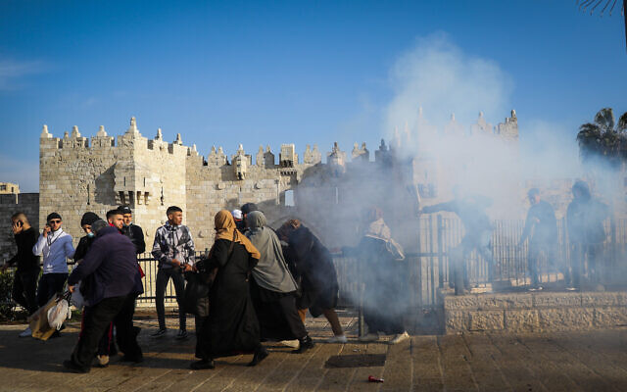
The confluence of Ramadan, Passover, and Easter in April has been a point of concern for the Biden administration as well, with US and Israeli officials telling The Times of Israel last month that Washington has asked Jerusalem to take steps to lower tensions and prevent an outbreak of violence similar to what occurred last May when Israel fought an 11-day war with Hamas in Gaza.

Police fire sound grenades at Palestinians at Damascus Gate in Jerusalem Old City, on February 28, 2022. (Flash90)
Lapid in his post-meeting statement added: “Our special relationship with the Kingdom of Jordan ensures a better future for our children, and the peace between us isn’t just good neighborliness, but is also our moral responsibility to both our peoples.”
The readout from the Royal Hashemite Court reiterated Jordan’s regular talking points on the conflict, saying the king “reaffirm[ed] the need to step up efforts to achieve just and comprehensive peace on the basis of the two-state solution that guarantees the establishment of an independent, sovereign, and viable Palestinian state, on the 4 June 1967 lines, with East Jerusalem as its capital.”
Abdullah also called for the preservation of the status quo at the Temple Mount/al-Aqsa Mosque compound where Jordan serves as custodian. He also called on Israel to cease “unilateral action that undermines the two-state solution,” ostensibly referring to settlement building.
Also participating in the meeting was Foreign Minister Ayman Safadi who met with Lapid privately before they stepped into the king’s office.
Abdullah has met twice with Defense Minister Benny Gantz and once with Prime Minister Naftali Bennett as well. https://www.timesofisrael.com/lapid-meets-abdullah-in-effort-to-lower-tensions-with-palestinians-as-holidays-near/

Herzog: Erdogan open to true dialogue, tie-building advancing ‘under no illusions’
President hopes trip to Turkey laid groundwork for better ties between two countries; visits Neve Shalom Synagogue, scene of deadly 1986 terror attack, before returning to Israel
By Tal Schneider Today, 2:01 pm
President Isaac Herzog talks during a ceremony at Neve Shalom synagogue, in Istanbul, Turkey, March 10, 2022. (Emrah Gurel/AP)
ISTANBUL, Turkey — In Turkey on an official visit, President Isaac Herzog said Thursday his Turkish counterpart Recep Tayyip Erdogan showed a willingness to address a range of issues and that though there are challenges to repairing relations between the countries, there is a mutual interest in doing so.
Erdogan, he said in a briefing to Israeli reporters a day after his meetings with the Turkish president, has been “open to true dialogue on numerous and varied issues, and we got down to details on matters of importance for both sides.”
He said the process of rekindling ties with Ankara was being carried out “under no illusions, but reflects bilateral interests.”
Expressing hope that he had laid the groundwork for redeveloping bilateral ties, Herzog said that he engaged with Erdogan with his “eyes open and in full coordination with all cabinet ministries and other parties.”
Herzog noted that discussions with Erdogan about establishing a mechanism to prevent any future crises that could arise between the two countries were a measure that “reflects a correlation of bilateral interests.”
He also pointed out that there are a lot of matters of interest to both countries that are not politically charged, such as mutual trade, energy agreements and the Ukraine-Russia issue, “in which Israel and Turkey are both trying to help and mediate between the parties.”
Herzog later visited the Neve Shalom synagogue in the heart of Istanbul, which has been targeted three times in terror attacks, including a deadly 1986 shooting in which 22 people were killed and bombings in 1992 and in 2003.
The president was greeted by synagogue officials and the community with joyful clapping and blasts of the shofar, a ram’s horn.
Addressing the gathering, Herzog asked those assembled to pray for “our Jewish brothers and sisters of the Jewish community in Ukraine.”
He said Turkish Jews “have had a huge role in writing the history of the Jewish people,” with “a long line of rabbis, poets, wise men, traders, entrepreneurs and leaders” coming from the country. [They also played a huge rule in the early development of the Church as well. When you read Church history much of it occurred in turkey. – rdb]
“You are a symbol of solidarity, of tradition, of community that faces up to all the challenges,” he said. “I know that the Jewish community here in Turkey and also this synagogue, Neve Shalom, has experienced severe terrorist attacks. To my great regret, around the world Jewish schools, synagogues, supermarkets and Jewish businesses were and still are the target of haters.”
The president told the gathering that during their meeting the day before, Erdogan had told him he believes in “the need to strengthen that which binds us, all nations and religions.” [Strange words from Erdogan who is a relatively fundamental Islamic and their doctrine really doesn’t have much of a place for other religions. -rdb]
“Even more so in such days of war and terrible tragedy in Ukraine, we must walk in the path of the sons of Abraham, a legacy of respect, acceptance and friendship,” Herzog said.
Later in the day, the president and his wife, First Lady Michael Herzog, boarded a plane back to Israel.
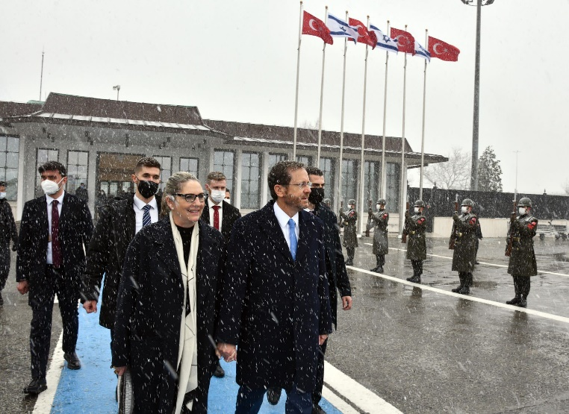
President Isaac Herzog and his wife Michal board a plane to Israel after concluding a state visit to Turkey on March 10, 2022 (GPO)
Hamas, Islamic Jihad slam meeting
The Hamas terror group condemned Erdogan’s meeting with Herzog, but without naming names.
“We express our sorrow over these visits to our brothers in Arab and Islamic countries, which we consider the strategic depth of our Palestinian people and their just national cause,” the terror group said Thursday.
The Islamic Jihad terror group — whose main regional patron is Iran — issued a more full-throated denunciation of Herzog’s Turkey trip.
“This trip sidesteps the blood of Turkish martyrs who died for Gaza,” Islamic Jihad said, a reference to the 10 Turkish citizens who died during the 2010 Mavi Marmara incident.
As part of rapprochement efforts, Israel has reportedly asked Turkey to expel Hamas officials.
Speaking anonymously, a source in the president’s entourage said that issues such as Hamas activity in Turkey, relations with the Palestinians and other political matters were discussed in Herzog and Erdogan’s meeting on Wednesday. MORE - https://www.timesofisrael.com/herzog-erdogan-open-to-true-dialogue-tie-building-advancing-under-no-illusions/

Citizenship Law likely to pass tonight, as Ra’am threatens to vote no confidence
After weeks of extensive negotiations, controversial legislation expected to pass with help from opposition; Ra’am to vote against, even if bill becomes a confidence vote
By Carrie Keller-Lynn Today, 7:15 pm
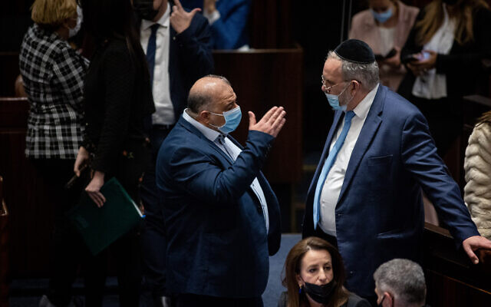
Ra'am party leader Mansour Abbas, left, and United Torah Judaism MK Yaakov Asher during a vote on the ultra-Orthodox draft bill at the Knesset in Jerusalem, on January 31, 2022. (Flash90)
In its last legislative gasp before breaking for Passover recess, the Knesset is expected to cross coalition-opposition lines to pass a new version of the so-called “Citizenship Law,” which largely prevents Palestinians who marry Israelis from obtaining permanent residency.
The 2003 Citizenship and Entry Law was renewed on an annual basis until it expired last June, when the coalition failed to pass it. The ban is one of Israel’s most controversial policies — proponents call it necessary to ensure Israeli security and a Jewish majority, while opponents say it immiserates the lives of Palestinians and Arab Israelis.
Opposition parties Likud, Religious Zionism, United Torah Judaism and Shas are set to contribute up to 53 votes in support of the measure, according to a spokeswoman for Religious Zionism MK Simcha Rothman. The conservative lawmaker has been a key force in the deal-making that brought the right-wing opposition members behind the push to renew the ban.
Opposition backing is necessary to pass the law, as coalition members Meretz and Ra’am have harshly condemned it.
But the votes are likely to come piecemeal. While the Religious Zionism party has decided to support the measure, Likud has given its members freedom to decide.
The Islamist Ra’am party has long opposed the policy. Arab Israelis have attacked Ra’am for sitting in a coalition that legislates a ban on Palestinian family unification.
In the plenum earlier on Thursday, Ra’am MK Walid Taha said: “This law fires a gunshot at the future of our children and will annihilate any chance of quality of life and hope.”
While the measure likely has the votes to pass, its opponents may turn the bill into a no-confidence vote in the government. The parliamentary maneuver would force opposition parties to vote against the bill they ideologically support rather than express confidence in the government.
Ra’am has pledged to vote against the bill, even if lawmakers amend the process to become a vote against the coalition in which the party itself sits.
“We said that we’d vote against the bill, even if it turns into a vote against confidence in the government. The decision [on a vote of no-confidence] rests with the opposition,” Taha told The Times of Israel. “We will vote against the bill in either situation,” and won’t leave the plenum to abstain, even if it requires casting votes of no-confidence against the government.
The opposition Joint List party is expected to put forward a motion to turn the vote into a vote of no confidence in the government, which is an obstacle that might stop the bill from passing its third reading. Voting for the bill would express confidence in the government, and against it would be a vote of no-confidence. Opposition parties need 61 votes to topple the government, however, which is not expected.
The government is not likely in danger with such a vote, but rather the Joint List party — which is pushing to attach a no-confidence measure — is making it difficult for right-wing opposition parties to vote in favor of the Citizenship Law.
Should this happen, it’s expected that opposition parties will abstain or leave the plenum, rather than casting a vote against the bill.
A source inside United Torah Judaism confirmed that “we won’t support” the bill on its third reading if it is combined with a vote of no-confidence, so as not to support the coalition.
Likud MKs received a directive to either abstain from voting or leave the plenum during the vote’s third and final reading, in order to avoid the awkward issue of explicitly supporting the government they have pledged to topple. MORE - https://www.timesofisrael.com/citizenship-law-likely-to-pass-tonight-as-raam-threatens-to-vote-no-confidence/ Israel is fundamentally a Jewish land. Using the loophole of marrying an Israeli (arab) in order to get citizenship in Israel by a “PA” person is much like the anchor babies we have in the US. This dilutes the Jewish population. – rdb]

Israeli settlement growth proceeds despite hostile U.S. policy
Growth of West Bank's Jewish population far outpacing Israel’s overall annual growth rate as territory's Jewry tends to be younger and more religious, with a higher average birth rate
Associated Press | Published: 03.10.22, 15:31
The growth of Israel’s West Bank Jewish population accelerated last year, according to figures released by a pro-settler group on Thursday, despite renewed American pressure to rein in construction on territory that the Palestinians want for a future state.
The figures show that a settlement surge initiated when U.S. President Donald Trump was in office shows no sign of slowing down. Trump provided unprecedented support for Israel’s claims to land seized in war, reversing decades of U.S. policy.
President Joe Biden’s administration has returned to the previous approach, criticizing settlement expansion as an obstacle to resolving the conflict. But Israel has continued to build and expand settlements, and major road projects are expected to bring even more Jews into the territory.
The statistics, compiled by WestBankJewishPopulationStats.com and based on official figures, show the Jewish population grew to 490,493 as of Jan. 30, a nearly 3.2% rise over 13 months. The population has risen by 16.5% since the group began compiling statistics in 2017, it says.
Israel’s overall annual growth rate, by comparison, is around 1.7%. In 2020, the last year of the Trump administration, which also saw repeated coronavirus lockdowns, the Jewish population in the West Bank grew by 2.6%, according to the group.
“There’s a tremendous amount of construction going on,” said its CEO, Baruch Gordon, including in his community of Beit El, just outside the West Bank city of Ramallah, where the Palestinian Authority is headquartered.
“Right now there are 350 units going up that will probably be finished within a year, year and a half. So when that hits, that’s going to increase the size of our town by about 25%,” he said.
The Jewish population in the West Bank tends to be younger and more religious, with a higher average birth rate. Many Israelis are drawn to state-subsidized settlements for the quality of life. They resemble suburbs or small towns and offer lower housing prices than Israel’s crowded and increasingly unaffordable cities. The pandemic might have made the settlements even more attractive.
“Just like in America, people moved out of Manhattan and went to suburbs and found that they could live in more open spaces, and the same is happening in Israel,” Gordon said.
Settlement construction (Photo: EPA) | Israeli settlement construction (Photo: EPA)
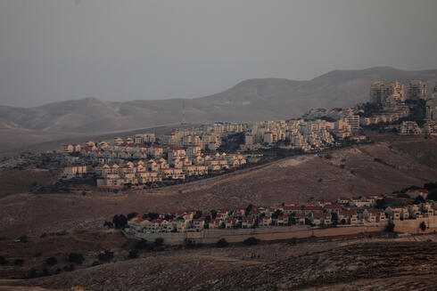
[Do you really think these look like “settlements” – rdb] His figures do not include East Jerusalem, which Israel annexed in a move not recognized internationally, and which is now home to more than 200,000 Jews. The West Bank and East Jerusalem are together home to some 3 million Palestinians. Israel captured both territories from Jordan, along with Gaza, in the 1967 Six-Day War. The Palestinians view the growth of settlements as the main obstacle to peace because they cut off Palestinian communities from their land and from one another, and make it nearly impossible to create a viable state. Settlements have expanded under every Israeli government, even at the height of the peace process in the 1990s.
There have been no serious peace negotiations in over a decade, and Israel’s current prime minister, Naftali Bennett, is a former West Bank settlement leader opposed to Palestinian statehood. Israel’s political system is dominated by pro-settler parties that view the West Bank as the biblical and historical heartland of the Jewish people.
The international community still considers a two-state solution to be the only realistic way of resolving the century-old conflict, but it has provided no incentive for Israel to end its presence in the territory — now well into its sixth decade.
Hagit Ofran, an expert at the anti-settlement monitor Peace Now, says the population figures are an imprecise measure of growth, as they reflect the higher birth rate and people moving into homes built after years of planning and approvals.
Ma'ale Adumim settlement (Photo: Reuters)
She says that while U.S. pressure appears to have succeeded in pausing some of the most controversial settlement projects, the overall enterprise is proceeding in the same way it always has, with several projects gradually advancing and new homes and roads being built.
“The Americans, as far as I know, are trying to stop it and have had very limited success,” she said.
The seemingly permanent military presence has led three well-known human rights groups to conclude that Israel is committing the international crime of apartheid by systematically denying Palestinians equal rights. Israel rejects those accusations as an attack on its very existence as a Jewish-majority state.
The increasingly authoritarian and unpopular Palestinian Authority, established through agreements with Israel in the 1990s, administers parts of the West Bank, while the Islamic militant group Hamas controls Gaza, from which Israel withdrew troops and Jewish civilians in 2005.

Settlement construction (Photo: AP)
Israel’s current government, which relies on the support of parties from across the political spectrum, has vowed to preserve the status quo, with neither a settlement freeze nor any formal annexation. It has also taken some steps to improve economic conditions for Palestinians.
But Ofran says that in practice, pro-settler ministers and other officials do as they please, and the government does damage control when it is called out.
“The foreign minister gets phone calls from the Americans, or whatever, and suddenly the government needs to do something about it,” she said. https://www.ynetnews.com/article/rj3qavww5

Israelis will need another COVID shot in future, senior health official says
Health Ministry DG Prof. Nachman Ash tells Ynet that while he hopes the Omicron outbreak was the last of its kind, coronavirus hasn't disappeared, and Israelis may need additional jab in preparation for another wave
Attila Somfalvi, Alexandra Lokash | Published: 03.10.22, 16:35
A senior health official said Thursday that Israelis may need another COVID vaccine dose to protect them from possible new coronavirus strains.
Health Ministry Director General Prof. Nachman Ash told Ynet it's still to soon to say that the pandemic is behind us. "The [Omicron] wave is behind us, but the confirmed cases are still not low. I really hope that this is the last wave. I don't know that there won't be another variant that will bring on another wave. We're preparing for such an option, but I hope it doesn't happen."
Professor Nachman Ash (Photo: GPO)
Prof. Ash added, however, that he is encouraged by the significant decline in virus patients who require hospitalization. "We're practically, almost, living normally," he said.
"One thing that's staying with us is the vaccine. We still need to continue making sure the population gets vaccinated and I assume we'll need to supervise this in a more intense way before next winter." [It is amazing that these so called experts are continuing to cling to something that has been demonstrated to be ineffective by many studies. – rdb]
Prof. Ash claims crowded events, including upcoming Purim celebrations, don't invoke fears in him of a potential mass outbreak. "I'm not worried at all, I don't expect there to be an influx of cases because of Purim. But personally, everyone needs to avoid getting infected... Elderly people with compromised immune system need to protect themselves much more, and I would advise them to avoid these parties."
The WHO came out with a statement this week, claiming that vaccine boosters are indeed effective, however, Prof. Ash said the fourth jab is not recommended for everyone. [HUMMM? The WHO has lied from the very onset of this event. Why are people still listening to them? Perhaps you might want to watch a little video from this person who is trying to educate people as to the overall program that all of this JABBING is actually leading to. Is Klaus Schwab the Most Dangerous Man in the World?
https://youtu.be/6G3nWyoQ5CQ Not only does this mess with your genetics but it grossly messes with your immune system – rdb]
"I'm calling on all those who are immunocompromised, chronically ill, etc. to get the fourth dose. But at this point, with numbers going down, I don't think everyone needs to get the fourth dose. Nonetheless, at a certain point we'll need to receive another vaccine that will strengthen our immune system against possibilities of another wave.
"We're going through a process of learning as we go along, this month we have a full day dedicated to examining what happened [in the last wave] and extracting lessons for the next wave, there are certainly things we need to learn from," he said.
Prof. Yehuda Adler (Photo: Ynet)
Professor Yehuda Adler, cardiologist and advisor to local authorities on COVID issues, reiterated Prof. Ash's sentiments that it's too early to say the pandemic is behind us.
He said that despite the declining number of new cases, each Israeli now knows at least one person who has had the virus, and the BA.2, which is Omicron's offshoot, variant is becoming more prevalent - making up 30% of current active cases.
"There will be many unclear things in the management of the next wave," Adler said. https://www.ynetnews.com/health_science/article/bkp4lddb5

US House approves $1 billion for Israel’s Iron Dome after months-long delay
Bennett welcomes replenishment of ‘life-saving’ system; Defense Minister Gantz hails ‘critical security and missile defense’ for citizens
By Jacob Magid, TOI staff and JTA Today, 9:33 am
After months of delay due to internal political disputes, the US House of Representatives on Wednesday approved an additional $1 billion in funding for Israel’s Iron Dome missile defense system.
The money will fund interceptor missiles for the system, many of which were used to defend the country during last year’s conflict with Hamas in the Gaza Strip. The Palestinian terror group fired over 4,300 rockets at Israel in the space of 11 days, and Iron Dome reportedly intercepted 90 percent of those heading to populated areas. It was also used in previous rounds of fighting with Gaza.
The supplemental Iron Dome funding was folded into the $1.5 trillion omnibus spending package needed to keep the government running for the full fiscal year. Also included in the bill is the $3.8 billion in defense aid for Israel in line with the Memorandum of Understanding signed by former president Barack Obama in 2015.
The Senate will vote on the Omnibus Appropriations Agreement in the coming days, and it will need to pass by the weekend in order to prevent a government shutdown.
Prime Minister Naftali Bennett expressed his gratitude to Congress for its “overwhelming commitment to Israel’s security and for passing the critical security package — including the replenishment of the life-saving Iron Dome.”
Defense Minister Benny Gantz hailed the approval and thanked US President Joe Biden for his “unwavering support for the security of the State of Israel.”
“Thank you to the US House of Representatives for passing critical security and missile defense funding for Israel in the spending package,” Gantz wrote. “Iron Dome replenishment and missile defense will ensure Israel’s military edge, secure our citizens, and bolster US-Israel cooperation”
Gantz also thanked US Secretary of Defense Lloyd Austin “for his steadfast commitment to the extraordinary US-Israel ties and defense cooperation.”
In expressing his gratitude, Foreign Minister Yair Lapid singled out House Speaker Nancy Pelosi and Majority Leader Stenny Hoyer for praise.
“The support that Israel received tonight in the American House of Representative is testimony to the strategic relationship between Israel and the US,” Lapid tweeted. “Thank you for the $1 billion of aid for the Iron Dome system and for the commitment to Israel’s security over the years.”
Also included in the omnibus is substantially increased funding for nonprofit security, a key request by major Jewish groups over the last year.
The House vote on the bill Wednesday came as stopgap funding for the government ends Friday.
The massive 2,741-page bill makes clear that the $1 billion is in addition to a separate $500 million in the bill for Israel’s missile defense. The $500 million in funding, brokered in the last months of then-US president Barack Obama’s administration, is part of a $3.8 billion annual defense assistance package for Israel that has been written into law.
It comes after progressive Democrats in the House last year insisted on considering the funding separately from another massive spending bill, a signal that defense assistance for Israel would come under much stricter scrutiny going forward.
Despite that fraugHouse overwhelmingly approved the standalone $1 billion for additional Iron Dome spending in September. The Senate wht debate, the as also set to push it through, when a single senator — a Republican this time, Rand Paul of Kentucky — used his prerogative to hold up the bill.
The bill increases funding for nonprofit security from $180 million to $250 million, a hike that Jewish groups have been pressing for, especially after the hostage-taking in a Texas synagogue in January. At least two proposed laws are seeking further increases: Reps. Benny Thompson, a Democrat from Mississippi and the chairman of the Homeland Security Committee, along with John Katko, a Republican from New York, last week got the committee to approve a bill that would increase funding for the security grants portion of the security increase to $500 million.
The Jewish Federations of North America said in a statement Wednesday that it was “grateful for the increase in funding for nonprofit security in last night’s omnibus bill. This accomplishment is the culmination of months long advocacy efforts that we led.”
In the Senate on Tuesday, speaking to Charlie Cytron-Walker, the rabbi who saw his congregants through the hostage crisis, Republican Sen. Ted Cruz said he would introduce a bill to increase the funding to $540 million.
The Orthodox Union, the Jewish Federations of North America, and Agudath Israel of America are all longtime backers of the program.
“We will work with bipartisan champions of this program to ensure that it continues to grow until there is enough funding to secure every synagogue, church, mosque, and vulnerable nonprofit facility,” Eric Fingerhut, CEO of the JFNA, said in a statement. MORE - https://www.timesofisrael.com/us-house-approves-1-billion-for-israels-iron-dome-after-months-long-delay/

Iran offers mixed signals, blames US as nuclear talks deadline looms
Raisi appears to defend Vienna negotiations while country’s top diplomat and a security official point finger at US for deadlock, saying Washington making unreasonable proposals
By Jon Gambrell Today, 8:02 pm
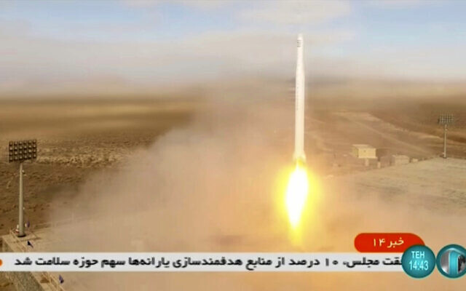
This image taken from video footage aired by Iranian state television on Tuesday, March 8, 2022, shows the launch of a rocket by Iran's Revolutionary Guard carrying a Noor-2 satellite in northeastern Shahroud Desert, Iran. (Iranian state television via AP)
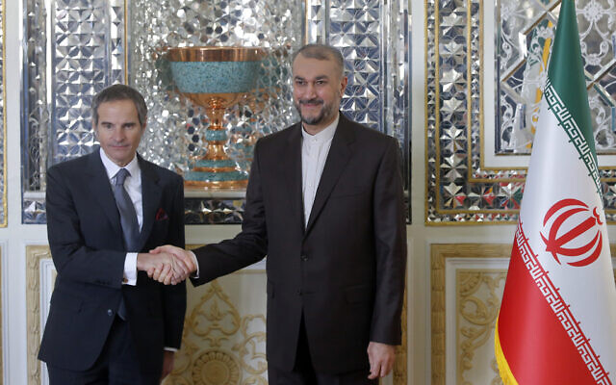
DUBAI, United Arab Emirates (AP) — Iran offered mixed signals on Thursday as a deadline loomed in talks over Tehran’s tattered nuclear deal with world powers. The Iranian president defended the negotiations while the country’s top diplomat and a security official blamed America for the deadlock.
The months-long, indirect talks in Vienna have sought to both get the United States to return to the accord that Washington unilaterally withdrew from in 2018, and have Iran restore limits on its rapidly advancing nuclear program.
Western diplomats have in recent days signaled the talks had reached their conclusion, laying the final decision with Iran. Ali Shamkhani, the secretary of the country’s powerful Supreme National Security Council, wrote on Twitter early Thursday, trying instead to blame America for the deadlock.
The “US approach to Iran’s principled demands, coupled with its unreasonable offers and unjustified pressure to hastily reach an agreement, show that US isn’t interested in a strong deal that would satisfy both parties,” Shamkhani wrote in multiple languages. “Absent US political decision, the talks get knottier by the hour.”
International Atomic Energy Agency director-general Rafael Mariano Grossi, left, and Iran’s Foreign Minister Hossein Amirabdollahian shake hands prior to their meeting in Tehran, on March 5, 2022. (AP)
Shamkhani and other Iranian officials have repeatedly projected Western complaints about the Islamic Republic’s behavior throughout the negotiations back to the West.
Later on Thursday, Iran’s Foreign Minister Hossein Amir-Abdollahian spoke with European Union foreign policy chief Josep Borrell — and also criticized America for what he described as conveying “a new and different message to us every day through a coordinator.”
“If the American side has a public opinion problem, I must say that we also have a public opinion problem in Iran,” Amir-Abdollahian said, according to a Foreign Ministry statement. “They monitor developments with great sensitivity and precision and demand that the government respond to and effectively lift sanctions and maintain a peaceful nuclear capability.”
However, Amir-Abdollahian added: “If realism governs the behavior of all parties, we are still close to reaching a good and strong agreement.”
Earlier, hardline Iranian President Ebrahim Raisi’s Twitter account appeared to offer Iran’s theocracy cover for potentially supporting a possible deal in Vienna.
“The government is doing negotiations in the way of the supreme leader’s framework and has not and will not retreat from any red lines which were announced,” he wrote.
Iran’s civilian government operates on a narrow bandwidth under Supreme Leader Ayatollah Ali Khamenei, who has final say on all matters of state. However, divisions exist within even the hardline camp of Iran’s theocracy — particularly on the nuclear deal and any interactions with the West. MORE - https://www.timesofisrael.com/iran-offers-mixed-signals-blames-us-as-nuclear-talks-deadline-looms/ The still play footsie with a group who 3 days sends off a rocket that could carry a bomb and destroy multiple players and they expect these people will abide by anything? Stupid,Evil or insane? – rdb]

While more companies join Russian boycott, some are hesitant to halt operations
McDonald’s and Starbucks branches remain open in Moscow despite announcements, video footage shows; tobacco giant BAT says it has a ‘duty of care’ to all its employees
By Tobias Siegal Today, 10:29 am
Women walk in front of a McDonald's restaurant in central Moscow on March 9, 2022 (Photo by AFP)
As more and more major Western brands have taken a stand against Russia and halted their operations in the country over the ongoing war in Ukraine, some seemed to be trying to play both sides.
McDonald’s, Starbucks, Pepsi and Coca-Cola all announced over the past couple of days that they would temporarily halt all activity in Russia due to its ongoing invasion of Ukraine.
“The conflict in Ukraine and the humanitarian crisis in Europe has caused unspeakable suffering to innocent people. As a System, we join the world in condemning aggression and violence and praying for peace,” a statement issued by McDonald’s on Tuesday read.
The company said that while it employs 62,000 people in Russia “who have poured their heart and soul into our McDonald’s brand,” it “cannot ignore the needless human suffering unfolding in Ukraine” and that it would temporarily shut down all of its restaurants in the country.

A McDonald’s branch in Moscow open on March 9, 2022. (Screen capture/Channel 12)
Starbucks said it would shut down 100 cafes it operates in Russia.
However, footage captured by Israelis in Moscow and aired by Channel 12 on Wednesday showed McDonald’s and Starbucks branches in Russia’s capital remain open.
The footage also showed a supermarket full of produce, apparently not impacted by the sanctions announced against the country.
Other companies have expressed reluctance to halt all operations in the country, citing the large Russian market and concern for their employees.
British American Tobacco, one of the so-called Big Four tobacco producers, has suspended all planned capital investment in Russia but continues to operate there.
The company said it had a “duty of care” to all its 2,500 employees in the country.
“Furthermore, we are scaling our business activities appropriate to the current situation, including rationalizing our marketing activities,” the company said, adding that it’s complying with all international sanctions related to the conflict.
In contrast, another major tobacco producer, Imperial Brands, said Wednesday it would halt all operations in Russia, including production at its factory in Volgograd and cease all sales and marketing activity.
Danish brewer Carlsberg on Wednesday said it would begin a strategic review of its business in the country, according to a report by Reuters.
“The future is highly unpredictable and we are reviewing a full range of strategic options for our Russian business,” chief executive Cees ‘t Hart said in a statement.
According to the report, the company will keep its eight breweries in Russia operational but will halt all advertising and selling of its flagship beer brand, as well as suspend all exports to the country.
Meanwhile, other companies have taken a more active role in the conflict.
E-commerce giant Amazon announced Wednesday that it has suspended all shipments to Russian customers as well as access to online content.
“We are also suspending access to Prime Video for customers based in Russia, and we will no longer be taking orders for New World, which is the only video game we sell directly in Russia,” the company said in a statement.
The announcement comes after chief executive Andy Jassy said last week that the company would use its expertise in cybersecurity and logistics to assist Ukraine.
“We’re supporting humanitarian relief NGOs on the ground with cash donations from Amazon and our employees, logistics to get supplies to people needing them, and cyber security assistance to companies and governments,” Jassy tweeted.
Twitter went as far as launching a privacy-protected version of its site that can bypass surveillance and censorship after Russia restricted access to its service in the country.
Facebook has said it was looking for a similar solution.
Russia has blocked access to Facebook and has put limits on Twitter in an attempt to restrict the flow of information about its war in Ukraine. https://www.timesofisrael.com/as-more-companies-join-russian-boycott-others-hesitant-to-halt-operations/

New York Times reporter: Trump 'pee tape' does not exist
Describes on hidden camera internal ideological war at 'paper of record'
By Art Moore Published March 10, 2022 at 11:55am
The New York Times reporter who reveals on hidden camera his belief that that media is falsely portraying the Capitol riot also discloses that there's an internal ideological war at the paper with a far-left but influential minority.
And he acknowledges that the "pee tape" in the infamous anti-Trump Steele dossier "doesn't exist," saying it "involved" CIA and National Security Agency sources.
Matthew Rosenberg, in part 2 of Project Veritas' series on the Times national security correspondent, also says he believes the paper may lose the defamation lawsuit that Project Veritas and founder James O'Keefe filed against the paper.
When interviewed later by O'Keefe, Rosenberg said he "absolutely" stands by the comments made in the undercover footage.
See the Project Veritas video:
In part 1, Project Veritas released undercover video of Rosenberg admitting the media’s coverage of Jan. 6 is "over-the-top." And he contradicts his own Jan. 6 reporting, confirming the reporting of alternative media that the FBI was involved.
"There were a ton of FBI informants amongst the people who attacked the Capitol,” Rosenberg says. "It was like, me and two other colleagues who were there outside and we were just having fun!"
Rosenberg says establishment media were "making this an organized thing that it wasn't."
In part 2, Rosenberg speaks about his confidential sources, including the source of the "ridiculous … pee tape." His reference is to the Steele dossier’s claim that a tape existed of Trump engaging in lewd acts in a Moscow hotel room.
The tape, he says, "doesn’t exist."
Rosenberg says that in the New York Times newsroom there is "a real internal tug of war between, like the reasonable people and some of the crazier leftist sh*t that's worked its way in there."
"They're not the majority, but they're very vocal, loud minority that dominate social media and, therefore, has just hugely outsized influence," he says.
That ideological slant, the reporter discloses, is "alienating" the paper's subscribers who he describes as "prosperous."
Rosenberg describes colleagues at the Times as "bullies" and "not the clearest thinkers, some of them." And some are "very neurotic people."
He talks about Times reporter Adam Goldman, describing him as a "terrible writer."
"He's just not good at conceptualizing things. He's not good with words. It’s a skill. It's a hard one.” Rosenberg added that “editors do all his writing for him."
Rosenberg also comments on the Project Veritas defamation suit against the Times.
"James O'Keefe, that was a f*ck up. We may well lose that one," said Rosenberg. https://www.wnd.com/2022/03/times-reporter-trump-pee-tape-not-exist/

Investigation: Ukraine worked with Democrats to fight Trump in 2016
But bet 'backfired badly'
By WND News Services Published March 10, 2022 at 11:50am By Paul Sperry Real Clear Investigations
[Editor's note: This story originally was published by Real Clear Investigations.]
Six years ago, before Russia’s full-scale invasion of their country, the Ukrainians bet that a Hillary Clinton presidency would offer better protection from Russian President Vladimir Putin, even though he had invaded Crimea during the Obama-Biden administration, whose Russian policies Clinton vowed to continue.
Working with both the Obama administration and the Clinton campaign, Ukrainian government officials intervened in the 2016 race to help Clinton and hurt Trump in a sweeping and systematic foreign influence operation that's been largely ignored by the press. The improper, if not illegal, operation was run chiefly out of the Ukrainian Embassy in Washington, where officials worked hand-in-glove with a Ukrainian-American activist and Clinton campaign operative to attack the Trump campaign. The Obama White House was also deeply involved in an effort to groom their own favored leader in Ukraine and then work with his government to dig up dirt on – and even investigate -- their political rival.
Ukrainian and Democratic operatives also huddled with American journalists to spread damaging information on Trump and his advisers – including allegations of illicit Russian-tied payments that, though later proved false, forced the resignation of his campaign manager Paul Manafort. The embassy actually weighed a plan to get Congress to investigate Manafort and Trump and stage hearings in the run-up to the election.
As it worked behind the scenes to undermine Trump, Ukraine also tried to kneecap him publicly. Ukraine's ambassador took the extraordinary step of attacking Trump in an Op-Ed article published in The Hill, an influential U.S. Capitol newspaper, while other top Ukrainian officials slammed the GOP candidate on social media.
At first glance, it was a bad bet as Trump upset Clinton. But by the end of his first year in office, Trump had supplied Ukrainians what the Obama administration refused to give them: tank-busting Javelin missiles and other lethal weapons to defend themselves against Russian incursions. Putin never invaded on Trump's watch. Instead, he launched an all-out invasion during another Democratic administration – one now led by President Biden, Barack Obama's former Vice President, whose Secretary of State last year alarmed Putin by testifying, “We support Ukraine's membership in NATO.” Biden boasted he’d go “toe to toe” with Putin, but that didn't happen as the autocrat amassed tanks along Ukraine’s border in response to the NATO overtures.
The Ukrainian mischief is part of Special Counsel John Durham’s broader inquiry – now a full-blown criminal investigation with grand jury indictments – into efforts to falsely target Trump as a Kremlin conspirator in 2016 and beyond.
Sources say Durham has interviewed several Ukrainians, but it’s not likely the public will find out exactly what he's learned about the extent of Ukraine’s meddling in the election until he releases his final report, which sources say could be several months away.
In the meantime, a comprehensive account of documented Ukrainian collusion – including efforts to assist the FBI in its 2016 probe of Manafort – is pieced together here for the first time. It draws from an archive of previously unreported records generated from a secret Federal Election Commission investigation of the Democratic National Committee that includes never-before-reviewed sworn affidavits, depositions, contracts, emails, text messages, legal findings and other documents from the case. RealClearInvestigations also examined diplomatic call transcripts, White House visitor logs, lobbying disclosure forms, congressional reports and closed-door congressional testimony, as well as information revealed by Ukrainian and Democratic officials in social media postings, podcasts and books.
2014:
Prelude to Collusion
The coordination between Ukrainian and Democratic officials can be traced back at least to January 2014. It was then when top Obama diplomats – many of whom now hold top posts in the Biden administration – began engineering regime change in Kiev, eventually installing a Ukrainian leader they could control.
On Jan. 27, U.S. Ambassador to Ukraine Geoffrey Pyatt phoned Assistant Secretary of State Victoria Nuland at her home in Washington to discuss picking opposition leaders to check the power of Ukrainian President Viktor Yanukovych, whom they believed was too cozy with Putin. “We’ve got to do something to make it stick together,” Pyatt said of a planned coalition government, adding that they needed “somebody with an international personality to come out here and help to midwife this thing.”
Nuland responded that Biden’s security adviser Jake Sullivan had just told her that the vice president – who was acting as Obama’s point man in Ukraine – would give his blessing to the deal. “Biden’s willing,” she said. But they agreed they had to “move fast” and bypass the European Union. “F--- the EU,” Nuland told the ambassador, according to a leaked transcript of their call.
Nuland’s role in the political maneuvering was not limited to phone calls. She traveled to Kiev and helped organize street demonstrations against Yanukovych, even handing out sandwiches to protesters. In effect, Obama officials greased a revolution. Within months, Yanukovych was exiled and replaced by Petro Poroshenko, who would later do Biden’s bidding – including firing a prosecutor investigating his son Hunter. Poroshenko would also later support Clinton's White House bid after Biden decided not to run, citing the death of his older son Beau.
The U.S. meddling resulted in the installation of an anti-Putin government next door to Russia. A furious Putin viewed the interference as an attempted coup and soon marched into Crimea.
Nuland is now Biden’s undersecretary of state and Sullivan serves as his national security adviser.
Whispering in their ear at the time was a fiery pro-Ukraine activist and old Clinton hand, Alexandra “Ali” Chalupa. A daughter of Ukrainian immigrants, Chalupa informally advised the State Department and White House in early 2014. She organized multiple meetings between Ukraine experts and the National Security Council to push for Yanukovych’s ouster and economic sanctions against Putin.
In the NSC briefings, Chalupa also agitated against longtime attorney-lobbyist Manafort, who at the time was an American consultant for Yanukovych's Party of Regions, which she viewed as a cat’s paw of Putin. She warned that Manafort worked for Putin’s interests and posed a national security threat.
At the same time, Chalupa worked closely with then-Vice President Biden’s team, setting up conference calls with his staff and Ukrainians. MUCH MORE -
https://www.wnd.com/2022/03/investigation-ukraine-worked-democrats-fight-trump-2016/ [This is a very long account but excellent overview of the corruption that has been going on in the background. – rdb]

5G Radiation Causes ‘Microwave Syndrome’ Symptoms, Study Finds
In the first study of its kind, Swedish researchers found 5G radiation causes typical symptoms indicative of “microwave syndrome.” The study, published in the journal Medicinsk Access, also confirmed that non-ionizing radiation — well below levels allowed by authorities — can cause health problems.
By The Def ender Staff
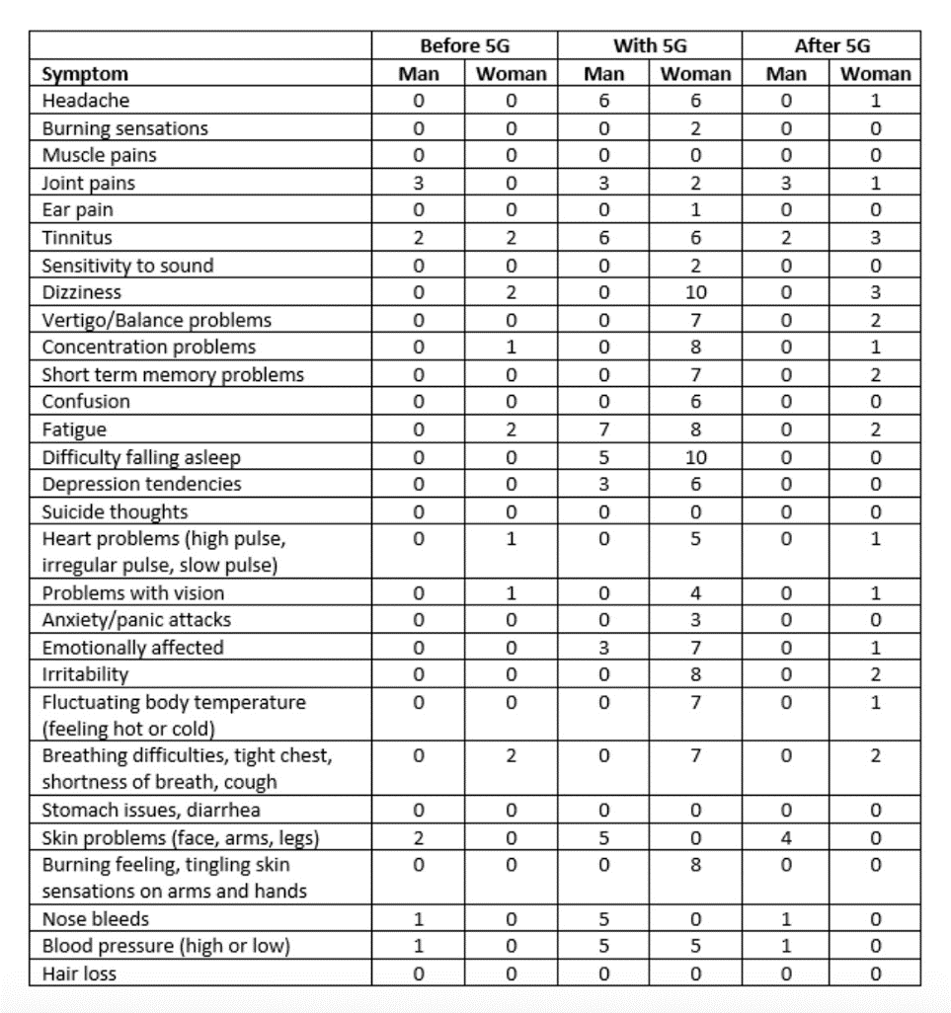
In the first study of its kind, Swedish researchers found 5G radiation causes typical symptoms indicative of “microwave syndrome.”
The study, published in the journal Medicinsk Access, also confirmed that non-ionizing radiation — well below levels allowed by authorities — can cause health problems.
According to the study, a 5G base station installed on the roof of an apartment building caused extremely high levels of non-ionizing radiation in the apartment of the two persons living just below the station.
Within a few days of exposure, the residents of the apartment developed symptoms of microwave syndrome. After moving to a place with lower radiation, the symptoms quickly decreased or disappeared.
Measurements before and after the installation of the 5G installation showed that switching to 5G led to an increase in radiation from 9 milliWatts/m2 to a maximum of 1,690 milliWatts/m2 — high enough for both acute and long-term health effects.
Measurements were taken both before 5G deployment and on several occasions afterward.
Before 5G was installed there were already base stations for 3G or 4G in the same location directly above the apartment. So even though the radiation level before switching to 5G was high, after switching on 5G, the levels increased 188 times.
This shows that non-ionizing radiation from a 5G base station placed on a roof close to a living space can be exceedingly high.
The highest radiation level was detected in the bedroom, located just 5 meters below the base station, prompting the authors of the study to call for further investigation into the effects on people exposed to 5G radiation levels.
“It is shocking that this is the first study performed on 5G health effects, three years after the roll-out of this technology started and after having already exposed the population to 5G high-intensity pulsed microwave radiation for several years,” Mona Nilsson, managing director of the Swedish Radiation Protection Foundation and co-author of the study, told The Defender.
Nilsson added:
“There are no studies that show that this technology and the increasing and common exposure to 5G and 4G base stations at levels allowed by the government is safe. On the contrary, studies have repeatedly and convincingly showed increased risk of the microwave syndrome and cancer, at levels that are far below the levels that the government and the telecom companies falsely claim are safe.”
Oncologist and researcher Dr. Lennart Hardell from the Environment and Cancer Research Foundation, co-authored the study with Nilsson.
Tracking the subjects’ symptoms
In the study, a man and a woman, ages 63 and 62 years old, were exposed to 5G from the roof of their apartment building, beginning in November 2021. The individuals recorded their symptoms both before and after the exposure began.
Table 1 below, column 1, lists typical symptoms of microwave syndrome.
The second column (Before 5G) displays the self-assessed symptoms before 5G was deployed in the apartment, the third column (With 5G) shows the self-assessment after 5G was installed, and the fourth column (After 5G) indicates the perceived symptoms after moving to the new apartment, which had much lower non-ionizing radiation levels.
Table 1. Clinical symptoms graded 0-10, where: 0 = No symptoms, 1 = Mild symptoms, 10 = Unbearable pain and/or discomfort. Previously healthy man and woman, ages 63 and 62, respectively.
The man and the woman experienced fatigue, sleeping problems, dizziness, emotional effects such as irritability and depression, nose bleeds, tinnitus, heart symptoms, memory problems and skin issues, all typically associated with microwave syndrome.
All symptoms ceased or decreased within 24 hours (for the man) and 1-3 days (for the woman) of moving to the new apartment with low radiation levels.
Microwave syndrome — a brief history
Microwave syndrome was described in the 1970s by scientists in the former Soviet Union who were researching occupational risks due to exposure to non-ionizing radiation.
The Soviet researchers described multiple symptoms of the syndrome, including fatigue, dizziness, headaches, difficulty sleeping, concentration problems, mood swings, tinnitus, heart palpitations and memory loss.
The researchers noted the symptoms subsided when exposure to non-ionizing radiation ceased or decreased.

The most common cause of microwave syndrome symptoms is non-ionizing radiation exposure from cell phones, base stations for wireless communication, WiFi and smart meters.
The exposed person usually experiences symptoms in several bodily organs, although most often the symptoms are related to the central nervous system and the heart.
The symptoms vary from person to person, as sensitivity to microwave radiation is individual.
Several studies during the last 20 years have shown increased risk of microwave syndrome symptoms among people living near mobile phone base stations.
For example, a study out of India showed increased incidences of sleeping problems, headaches, dizziness, irritability, concentration problems and high blood pressure.
Increased non-ionizing radiation due to 5G
The Swedish study not only showed that 5G causes microwave syndrome almost immediately, but it also found the levels of non-ionizing radiation increased massively.
The values measured ​​in the home of the man and woman in the study (maximum 1,690 milliWatts/m2) are significantly lower than those deemed safe (10,000 milliWatts/m2 as an average value over 6 minutes) ​​by the Swedish Radiation Safety Authority (SSM).
Because microwave radiation tends to fluctuate wildly, and SSM’s reference is an average value, this means the maximum value is allowed to be significantly higher than 10,000 milliWatts/m2, and it does not protect against large fluctuations which are in fact more biologically active.
Furthermore, SSM’s reference value ​​does not protect against long-term harmful effects, such as the microwave syndrome or cancer, that come with prolonged exposure from base stations, as is the case with exposure in homes, offices or schools.
The reference value applies only to protection against immediate effects as a result of radiation so intense that it heats up tissues within 30 minutes.
This means the general public is completely unprotected against effects other than acute thermal damage, despite the fact that such effects have been shown to cause nervous system harm, oxidative stress and DNA damage. MORE -
https://childrenshealthdefense.org/defender/5g-radiation-microwave-syndrome-symptoms/ This has huge potential for tragedy in the world as they keep installing and expanding the 5 G network worldwide. If you watch the video we have included above concerning Schwab you will realize that this could all be linked. – rdb]

'Defcon 1': Dems panic over new conservative Spanish-language network
Party 'took Hispanics for granted too long'
By Art Moore Published March 10, 2022 at 7:12pm
Amid a growing exodus of Hispanic voters from the Democratic Party, a new conservative Spanish-language media network is about to launch, prompting panic on the left.
NBC News cited a Democratic pollster who calls it a "Defcon 1" moment for the Democrats, who warn of "disinformation," notes the Legal Insurrection blog.
Called Americano, the network will launch first on SiriusXM radio then on streaming TV this summer. It will offer a mix of news programming and commentary, NBC reported.
The network has close ties both to former President Donald Trump's campaign and former Florida Republican Gov. Jeb Bush.
Americano founder and CEO Ivan Garcia-Hidalgo said Democrats are "scared" and "they should be."
"Democrats took Hispanics for granted for too long, and no one thought to create a home for us in conservative media," he told NBC. "There is an appetite for this. You see it on social media. You see it in elections."
Democratic pollster Fernand Amandi, who worked with Barack Obama's campaign, told NBC that for "those concerned about the disinformation problem harming Democrats’ chances with Hispanics, this is a Defcon 1 moment."
"We should worry," he said. "The Democrats' response to all of this Hispanic outreach from Republicans — whether it’s disinformation or conventional campaigning — is to do the bare minimum. Unfortunately, some Democrats are deluding themselves. The ultimate act of disinformation is to pretend that this is not a big problem."
Latino voter turnout spiked 31% between 2016 and 2020, noted The Week. And during that same time period, there was about an 8 percentage-point swing toward Trump in that demographic.
In Texas, where Hispanics on the Mexican border, in particular, are abandoning the Democratic Party, polls show Republican Gov. Greg Abbott is polling dead even with Democratic challenger Beto O'Rourke. That's after Abbott lost the Latino vote by more than 10 points in 2014 and 2018. https://www.wnd.com/2022/03/defcon-1-dems-panic-new-conservative-spanish-language-network/ [This could be good news if the demon-rats don’t steal another election. – rdb]

Chinese firms tied to Hunter Biden could bail out Putin
Negotiating deals poised to help Russian leader fund ongoing invasion
By Art Moore Published March 10, 2022 at 7:51pm
President Biden's son Hunter has done business with two Chinese state oil companies that are in discussions with Beijing to invest in the Russian gas giant Gazprom, which has been sanctioned in response to Vladimir Putin's invasion of Ukraine.
Sinopec, for which Hunter Biden may still hold an indirect investment, and China National Petroleum Corporation hope to take advantage of deep discounts in Gazprom's shares, according to a Bloomberg report highlighted by the Washington Free Beacon.
Hunter Biden is the subject of a U.S. Department of Justice investigation over his taxes and foreign business dealings. The president's son famously was paid some $83,000 a month to sit on the board of a corrupt Ukrainian gas firm while it was under investigation and his vice president father was in charge of U.S. policy for the European nation.
The Free Beacon reported Hunter Biden met in 2011 with an executive from China National Petroleum Corporation to discuss the possible purchase of an oil field in Africa. The meeting took place even after Biden was told that the company had helped rogue nations, including Iran and Sudan, evade U.S. sanctions.
Biden cofounded a private equity firm called BHR Partners that bought a $1.7 billion stake in Sinopec Marketing in 2015.
In December, a lawyer for Biden told the New York Times the president's son no longer holds a stake in BHR. But this week the Washington Examiner reported Biden's firm is still listed as a BHR shareholder, according to Chinese business records. And records in Washington, D.C., show Biden is still the firm's owner.
Gazprom was among more than a dozen Russian companies sanctioned last month by the Biden administration as Putin threatened to invade Ukraine.
The Free Beacon's Chuck Ross observed that the purchase of Russian businesses and commodities "would provide a lifeline to Moscow at a time when the government is trying to fund its illegal war."
"Any deal would likely upset the Biden administration, which warned China this week against helping Russia circumvent sanctions," Ross wrote.
He recalled that Hunter Biden was paid at least $6 million by CEFC China Energy to find investment opportunities in energy companies in the West. https://www.wnd.com/2022/03/4988889/

Commentary:
The Green Immoralists
Victor Davis Hanson Posted: Mar 10, 2022 12:01 AM
Thousands are dying from Russian missiles and bombs in the suburbs of Ukraine.
In response, the Biden Administration's climate-change envoy, multimillionaire and private-jet-owning John Kerry, laments that Russian President Vladimir Putin might no longer remain his partner in reducing global warming.
"You're going to lose people's focus," Kerry frets. "You're going to lose big-country attention because they will be diverted, and I think it could have a damaging impact."
"Impact"?
Did the global moralist Kerry mean by "impact" the over 650 Russian missiles that impacted Ukrainian buildings and tore apart children?
Are Russian soldiers losing their green "focus"? When Putin threatens nuclear war is he merely "diverted"? Would letting off a few nukes be "damaging" to the human environment?
Climate-change moralists love humanity so much in the abstract that they must shut down its life-giving gas, coal, and oil in the concrete. And they value humans so little that they don't worry in the here and now that ensuing fuel shortages and exorbitant costs cause wars, spike inflation, and threaten people's ability to travel or keep warm.
The Biden Administration stopped all gas and oil production in the ANWR region of Alaska. It ended all new federal leases for drilling. It is canceling major new pipelines. It is leveraging lending agencies not to finance oil and gas drilling.
It helped force the cancellation of the EastMed pipeline that would have brought much-needed natural gas to southern Europe. And it has in just a year managed to turn the greatest oil and gas producer in the history of the world into a pathetic global fossil-fuel beggar.
Now gas is heading to well over $5 a gallon. In over-regulated blue states, it will likely hit $7.
The result is left-wing terror that the voters in the coming midterm election might rightly blame Democrats for hamstringing the American ability to travel, keep warm in winter and cool in summer, and buy affordable food.
But how will the Biden Administration square the circle of its own ideological war against oil and natural gas versus handing the advantage to our oil- and gas-producing enemies, as Russia invades Ukraine?
Or put another way, when selfish theory hits deadly reality, who loses? Answer: the American people.
President Joe Biden lifted U.S. sanctions on the Russian-German Nord Stream 2 pipeline designed to provide green Germany with loathsome, but life-saving, natural gas.
But first Biden canceled the Keystone XL pipeline in the United States. He has no problem with pipelines per se, just American ones.
While Biden doesn't like the idea of Germany burning carbon fuel, or Putin reaping enormous profits from Berlin's self-created dependency, or Germans importing liquified natural gas from America, Biden also does not like the idea of forcing German families to turn off their thermostats in mid-winter when there is Russian-fed war not far from Germany's borders.
Here at home, Biden gets even crazier. As our enemies around the world reap huge profits from record high oil and gas prices, did Biden ask Alaska, North Dakota, or Texas to ramp up production?
In other words, did he ask Americans to save fellow cash-strapped Americans from a self-created energy crisis, in the way he assured the Germans that during war reality trumps theory?
Not at all.
Instead, Biden came up with the most lunatic idea in recent diplomatic history of begging autocratic and hostile regimes the world over to pump more oil to lower America's gas prices.
For years, America has sanctioned the oil-rich Venezuelan dictatorship, a narco-terrorist state that wars on its own people and its neighbors. Now Biden is begging strongman Venezuelan President Nicolas Maduro to pump the supposedly dirty fuels America has in even greater abundance but finds it too icky to produce.
Biden also has beseeched the once sanctioned, terrorist Iranian government. He wants Tehran to help us out by upping the very oil and gas production that America has tried to curtail for years. In return, Iran is demanding a new "Iran Deal" that will soon ensure the now petro-rich theocracy the acquisition of nuclear weapons.
On the eve of the Russian invasion, Biden begged Putin to pump even more oil to supplement its current Russian imports to the United States.
Did Putin see that surreal request as yet another sign of American appeasement that might greenlight his upcoming planned invasion? In Russian eyes, was it more proof of American weakness and craziness after the humiliating flight from Afghanistan?
Biden has blasted the human rights record of Saudi Arabia's royal family. Now he is begging the monarchy to pump more of its despised carbon-spewing oil to make up for what his administration shut down at home. Is that why the Saudi royals refused to take his call?
The moral of Biden's oil madness?
Elite ideology divorced from reality impoverishes people and can get them killed. https://townhall.com/columnists/victordavishanson/2022/03/10/the-green-immoralists-n2604367
Wake up, America – They're Trying to Destroy Us
Laura Hollis Posted: Mar 10, 2022 12:01 AM
Throughout our nation's relatively short history, powerful people -- kings, communist dictators, tribal tyrants, warmongering corporatists -- have always resented America. The reason is simple and biblical: America's success was proof that free people who exercise self-restraint grounded in Judeo-Christian principles of human dignity and ordered society can govern themselves and flourish, unencumbered by totalitarian control.
But we have grown weak, dependent and easily manipulated. In 2008, when Barack Obama was first running for president, I remarked on the similarities between those proclaiming Obama to be a messiah of sorts and the ancient Israelites' demand for a king. In the Old Testament book of Samuel, God explains that it is He the people are rejecting as their true king and tells Samuel to warn the Israelites that an earthly king will take their sons for his wars and their daughters for his pleasure. Their property and everything they produce will be taken by the king for his own use and dispensed to his friends as political patronage. "You yourselves," the Lord warns through Samuel, "will become his slaves. When that day comes, you will cry out for relief from the king you have chosen, and the Lord will not answer you ... "
In the 14 years since I wrote that column, we have continued to abandon the discipline and self-reliance that made us strong. In so doing, we risk relinquishing to a new generation of egotistical despots the freedoms that our Founding Fathers declared to be God-given.
We are not yet slaves, but we are governed by a regime installed by a soft coup, with a senile figurehead teetering on top, surrounded by highly visible people of breathtaking stupidity or mendacity (or both). Behind the scenes, those with the real power disseminate lies to shape public opinion, engender fear, foment outrage, obtain compliance and increase their control.
Meanwhile, they are tightening their stranglehold on America. Everything we see happening is being done deliberately: driving up oil prices -- and therefore the price of all goods and services; creating inflation and devaluing the dollar; crippling the supply chain, shuttering American businesses; collapsing the middle class; destroying entire industries; funding and appeasing corrupt regimes (China, Russia, Iran, Venezuela) and launching wars that destabilize and bankrupt nations but create unprecedented wealth for defense contractors and their investors.
The events transpiring in the United States and throughout the world are the poisoned products of an ugly conglomerate: billionaires and bureaucrats with aspirations of global control; the ever-expanding military-industrial complex (that President Dwight Eisenhower warned of in his final address to the American public); Marxist ideologues, cultivated and coddled within the cushy enclaves of academia; totalitarian environmentalists; a spoiled, self-indulgent class of artists and entertainers whose love of license is matched only by their ignorance; and a propagandistic press besotted with leftism and its lies.
The common threads uniting these disparate groups are raging egos, the belief that their inherent superiority qualifies them to impose rules on the rest of the world that they have no intention of living by, and a visceral loathing for the individual -- the "little guy" -- who wants only to be left along to live his life as he sees fit. This vitriolic condescension is made amply evident by the epithets thrown at average Americans, who are called "deplorables," ignoramuses "bitterly clinging" to their religion and their guns, racists, bigots and even "domestic terrorists."
Millions of Americans already understand what's happening. Skyrocketing gas prices may be a wake-up call for millions more. Gas is more than $6 or even $7 per gallon in some parts of the U.S., and some experts are predicting that the prices will go still higher. The "useful idiots" proclaiming their willingness to pay higher gas prices "to punish Russia" belie their ignorance of basic economics. At $10 a gallon, a modest car with a 20-gallon tank would cost $200 to fill. Such weekly or semi-monthly costs are beyond the budgets of millions of Americans.
The impact on the supply chain would be catastrophic. A long-haul semi with two 150-gallon tanks that cost around $600 to fill 18 months ago will cost $3,000 to fuel up for one cross-country trip. What will happen when the costs of production, transportation, refrigeration and storage are five times what they were two years ago? Ten times?
And when the costs of production are beyond what the public can pay, the producers themselves go out of business. The entire economy collapses. Yes, this can happen in a wealthy country. Just ask Venezuela -- one of the countries President Joe Biden is now begging for oil, since his executive orders hampered our own domestic energy production.
The ideologies and tools of pathological egotists may differ, but the results are the same: They will attack everything you believe in, take away everything you own, and destroy everything that means anything to you -- your property, your business, your income, your children, your freedom, your life -- all of which they insist are necessary to remedy the social ills they profess to want to redress. The "better world" they promise never materializes for anyone else; but they themselves grow rich on the spoils of others' sacrifices.
Those pushing this destructive agenda must never get control over the United States. And the power they do have must be wrested from them and their agents. It is not merely the so-called Democrats (who left that party's ideals behind decades ago) who must be unseated but also the cloying, fawning collaborators calling themselves Republicans who put on a clown show but do nothing to stop the onslaught of totalitarianism in the United States.
Wake up, America. Put on the full armor of God, and fight. Before it is too late. https://townhall.com/columnists/laurahollis/2022/03/10/wake-up-america--theyre-trying-to-destroy-us-n2604363
No Sacrifices for Ukraine
Kurt Schlichter Posted: Mar 10, 2022 12:01 AM
We owe the Ukrainians nothing, yet our garbage ruling class is demanding that we brace ourselves for unspecified “sacrifices” for their sake just as they have every time they have made some foreign policy screw-up. We normals are their janitors – we get to clean up their messes and no one is ever held accountable. No thanks.
I like Ukrainians and, while the whole dispute is much more complex than “PUTIN BAD,” there’s no excuse for the brutal invasion and I hope the Russians lose. To the extent that we might spend some money on bullets and Javelins for guerillas to grind down Ivan, okay. The joke’s on their Russian’s new buddies the Chi Coms – we’ll be borrowing the money from China anyway.
But that’s as far as it goes.
No, we’ve sacrificed enough to the foreign policy screw-ups of Ivy League incompetents. Who got us into the Vietnam War? Who got us into Iraq? Not a lot of guys with high school diplomas, but those guys got asked to fight those wars. The same is true here. I see a lot of Twitter tough guys with the yellow and blue flag in their bios and not a lot of them seem to be accepting Ukraine’s appeal for fighters and enlisting in the Bill Kristol Brigade.
Hey, don’t worry – these same neo-commandos will cheer you and your kids on when we go make Ukraine safe for Ukrainians. Your sacrifices will be appreciated, plebs, right up until it’s convenient to start calling you racist, Jesus knuckle-draggers again.
And if you ask why the hell we are not making America safe for Americans, you are in Putin’s pocket because it is somehow in Putin’s interest that we shut down our open border, end crime, and promote free speech here in America. You are just too dumb to appreciate the nuance.
Now, the regime media’s polls tell you a whole bunch of Americans would support a “no-fly” zone over Ukraine. You know the Ukrainians sure would. Hey, if Harry Potter could wave a magic wand and make the Russians stop killing civilians and go home, awesome. Wave away. But that’s nonsense, and unfortunately, at Hogwarts, our ruling class was sorted by the magic hat into house Dumbassyindor.
These people are fools who talk big but think little. A “no-fly” zone means you shoot down any Russian who flies in. That’s an act of war. The Russians get to shoot back, and they might choose to shoot back with something more than a conventional Kaliber cruise missile. But no one mentions that. Instead of polling “Would you support making the Russians stop acting like Russians always do in wars?” maybe we ask “Would you risk Putin – who we are told is crazy and evil – retaliating by detonating a nuclear weapon over your hometown and potentially melting your kids into radioactive goo in order to resolve a border dispute on the dismal side of the globe?”
I anticipate a significantly smaller “Yes” percentage when you ask the right question.
But our sacrifice might be less than a mushroom cloud on the horizon. Maybe it’s just $9 gas. George Takei, the multi-millionaire, demanded on Twitter that we eagerly make this offering on the altar of Ukrainian sovereignty. I doubt he would notice the upcharge, but I bet you would. Weird how the guys demanding sacrifices never seem to lead their own bull to the altar. Even weirder is how all the biggest pro-fossil fuel sacrifice guys are also green energy investors. If I was cynical, I’d think “Scam ahoy.”
What they never tell you is that there is no reason for any sacrifice at all to be had from cutting off Russian imports of oil and gas. We could make up the difference here at home, and in fact, we were doing that, that is until stupid people chose avoiding mean tweets over avoiding economic ruin. Now, our energy industry has been trashed for a year, and it will take time to spin up again in the off-chance President Asterisk chooses to defy the moronic congregation of the angry climate goddess worshippers. Our so-called leaders would rather us go bankrupt paying Iran and Venezuela – more enemies – for oil than let our own oil industry start up again.
They now whine that “Well, we can’t just start pumping gas again and immediately get relief!” True. They never should have wrecked the industry as a – wait for it – sacrifice to the climate hoax to being with. And, of course, our alleged betters never thought to kick-start production again during the months this whole crisis was developing. In fact, they were filibustering Nord Stream 2 sanctions – wait, isn’t filibustering racist?
But remember, they are serious, competent people we must obey without question. And if you doubt them, you love Putin.
We need to reject the idea that we must sacrifice according to the dictates of our elite’s fetishes. We owe the Ukrainians nothing. We have no treaty with them – please do not quote vague promises of protection by Felonia Milhous von Pantsuit’s husband that were never ratified as a treaty by our Senate – and let’s be frank about the reality of the situation. Ukraine is on Russia’s border. Our lousy ruling class’s meddling in Ukrainian politics was going to be seen by the Bear as a threat. Saying so is not somehow backing Russia; it’s reality, something in short supply. Try knowing your enemy – it helps beat him.
The gullibility of our ruling class and its media minions to Ukrainian information operations is no confidence-builder either. No one can blame Ukraine for trying to convince the West to join its fight – its survival is on the line. But we can blame our best and brightest – ugh – for believing every too-good-to-be-true story. There’s a sucker born every minute, and a bunch of them will eventually attend Harvard.
This is not like the beginning of World War 2. It’s not Poland 1939. The tiresome Hitler comparisons are not designed to illuminate but to obscure. You are meant to accept and obey. And what you are meant to accept are things that we should never accept. Grabbing oligarch’s property without due process? Sure, it’s satisfying. But it will be a lot less satisfying when that tactic is deployed against us for defying the ruling class. Just ask the Canadian truckers. And tossing people out of their jobs because they are Russian? This is a double-barreled disaster. Not only is it a dry-run for using these techniques against internal enemies but it also serves to whip-up moral panic hysteria. Everybody hate Putin now! Everybody hate Russians now! Okay, now everyone hate this other person or group! Eventually, you will be the one in the cross-hairs for Official Hate.
You can still want the Ukrainians to repel the invaders without also buying the notion that we should sacrifice blood, treasure, and our rights to do it. This unjust war is the Ukrainians’ to fight. I hope they win. Most of us do. But the idea that we Americans must “sacrifice” our lives, money, and freedoms is itself as great a danger to our country as this border war on the other side of our planet.
We are Americans. Our first priority is America. And our terrible ruling caste should step up and sacrifice its own graft and power in order to defend it. https://townhall.com/columnists/kurtschlichter/2022/03/10/no-sacrifices-for-ukraine-n2604360

THE SHORASHIM BIBLICAL GIFT CATALOG 005
http://mad.ly/7f9f64?pact=20013931524&fe=1
Support Shorashim!

ARUTZ SHEVA
UN Security Council to discuss alleged US biological activities in Ukraine
Russia requests Security Council meeting a day after claiming US conducts “military biological activities" in Ukraine.
Ben Ariel 11.03.22 04:05
The UN Security Council will meet on Friday at Russia’s request to discuss what Moscow claims are “the military biological activities of the US on the territory of Ukraine”, The Associated Press reported on Thursday.
The Russian request, announced in a tweet from its first deputy UN ambassador, Dmitry Polyansky, comes a day after Russia claimed that Ukraine is running chemical and biological labs with US support.
Council diplomats confirmed the meeting would convene at 10:00 a.m. EST, speaking on condition of anonymity ahead of an official announcement.
White House press secretary Jen Psaki on Wednesday rejected the claims from Russia as "false" and "preposterous," and warned they could serve as a pretext for the Russians to deploy chemical weapons in their assault on Ukraine. [There is way too much proof that Psaki is lying rdb
"It’s the kind of disinformation operation we’ve seen repeatedly from the Russians over the years in Ukraine and in other countries, which have been debunked, and an example of the types of false pretexts we have been warning the Russians would invent," Psaki said.
"Also, Russia has a track record of accusing the West of the very violations that Russia itself is perpetrating. In December, Russia falsely accused the US of deploying contractors with chemical weapons in Ukraine," she continued.
Pentagon press secretary John Kirby on Wednesday called the Russian claim “a bunch of malarkey.”
Russia’s claims came hours after it bombed a maternity and children’s hospital in Mariupol, Ukraine, where over 400,000 residents are currently unable to leave.
On Thursday, US Vice President Kamala Harris called for an international war crimes investigation of Russia over its now two-week-old invasion of Ukraine.
Harris told reporters during a joint press briefing in Warsaw with Polish President Andrzej Duda that Russia’s conduct during the war should be investigated amid war crimes allegations.
“Absolutely there should be an investigation, and we should all be watching,” said Harris. https://www.israelnationalnews.com/news/323720

Video exposing the labs on Carlson: https://www.israelnationalnews.com/news/323713

Refugees stuck at Ben Gurion Airport to be transferred to hotel
Shaked and Gantz agree to house Ukrainian refugees waiting at Ben Gurion Airport at a hotel.
Israel National News 10.03.22 23:27
Interior Minister Ayelet Shaked on Thursday ordered that the procedure for handling refugees from Ukraine be changed immediately and that those waiting at Ben Gurion Airport be transferred to a hotel, where they will stay until a decision is made in their case.
Shaked thanked Defense Minister Benny Gantz for the prompt assistance and mobilization of the Home Front Command for this purpose.
Gantz, who accepted Shaked's request, held a quick dialogue within the defense establishment in order to bring about a temporary solution that will lead to the immediate evacuation of those waiting at Ben Gurion Airport.
At the end of the consultation, the decision was made to immediately allocate dozens of available rooms at the Dan Panorama Hotel, which is also used for COVID-19 isolation for returnees from abroad. It is expected that those refugees who are waiting at the airport will be transferred to the hotel on Thursday night.
On Friday, there will be a joint tour of all relevant parties, including the head of the National Emergency Management Agency, Brigadier General (Res.) Yoram Laredo and IDF representatives, in order to arrange the entrance procedure for those arriving from Ukraine.
After the tour, the Minister of Defense will conduct a situation assessment with representatives of the defense establishment regarding the immediate assistance required with the internal and absorption factors.
On Thursday morning, Gantz said, "We are ready to accept many refugees from Ukraine until the end of the fighting, for which we pray, and we are working towards that. Therefore, we will reach and help every Jew, rescue him, and ensure good and sensitive immigration and absorption here in Israel. In this context, the IDF and the defense establishment will also be fully mobilized, as it was during the Aliyah in the 1990s, and as in any national challenge that has come before us. We are preparing for this, and we will provide any assistance that is required and that the IDF can provide." https://www.israelnationalnews.com/news/323713

Russian forces shell nuclear research institute in Kharkiv
Russian shelling in Ukraine’s second-largest city sets buildings on fire, but no change in background radiation reported.
Elad Benari 11.03.22 01:00
Russian forces shelled a nuclear research institute in Kharkiv, Ukraine’s second-largest city on Thursday, setting buildings on fire, an adviser to Ukraine’s Interior Ministry said, according to The Associated Press.
The adviser, Anton Gerashchenko, said a shell hit a building where there is equipment that could release radiation if it were damaged. According to the president´s office, there has been no change in the background radiation.
The shelling caused a fire, but firefighters were able to put it out, according to AP.
The incident came hours after the head of the International Atomic Energy Agency (IAEA) said that Moscow and Kyiv are "ready to work" with the UN atomic watchdog to ensure nuclear safety.
IAEA director general Rafael Grossi met Ukraine's Foreign Minister Dmytro Kuleba and Russia's Foreign Minister Sergei Lavrov in separate meetings in Antalya in Turkey. "We had good meetings, not easy ones, but serious meetings," he told reporters after returning to Vienna, where the IAEA is based, according to AFP.
"Both sides agree... that something needs to be done. They are both ready to work and to engage with the IAEA," added Grossi, who said he would try to "have something more concrete" in the next few days. MORE - https://www.israelnationalnews.com/news/323715

To be removed from this News list, Please click here and put "Unsubscribe" in the subject line.

03/10/2022 NEWS
1812 OVERTURE, amazing FLASHMOB - (Tchaikovsky)
https://www.youtube.com/watch?v=4NJRCCgK_AM

"All warfare is based on deception.
There is no place where espionage is not used.
Offer the enemy bait to lure him."
-- Sun Tzu (c.500-320 B.C.) name used by the unknown Chinese authors
Read the Prophets & PRAY WITHOUT CEASING!
That is the only hope for this nation!
Please  Remember  These  Folks  In  Prayer-  Check often  They  Change! | Pray that the world would WAKE UP! Time for a worldwide repentance!  ALL US soldiers fighting for our freedom around the world  Pray for those in our government to repent of their wicked corrupt ways.  Pray for BB – Severe sciatic needing procedure.  Pray for EL – Had clot embolized to brain – successful ‘clot buster’ but long road to go.  Pray for BB – Severe West Nile Fever –still not mobile- improving!  Pray for RBH – cancer recurrence  Pray for Ella – Child with serious problems  Pray that The Holy One will lead you in Your preparations for handling the world problems. – Have YOU made any preparations?
Exodus 10:¹³And Moses stretched forth his rod over the land of Egypt, and the LORD brought an east wind upon the land all that day, and all the night; and when it was morning, the east wind brought the locusts. ¹⁴And the locusts went up over all the land of Egypt, and rested in all the borders of Egypt; very grievous were they; before them there were no such locusts as they, neither after them shall be such. ¹⁵For they covered the face of the whole earth, so that the land was darkened; and they did eat every herb of the land, and all the fruit of the trees which the hail had left; and there remained not any green thing, either tree or herb of the field, through all the land of Egypt.

Hosting Herzog in landmark visit, Erdogan lauds ‘turning point’ in relations
With Israel, Turkey attempting détente, Israeli president tours Ankara, wishes for a ‘safer and more stable world’; Israeli anthem plays in Ankara for first time since 2008
By TOI staff, Tal Schneider and Agencies Today, 5:50 pm
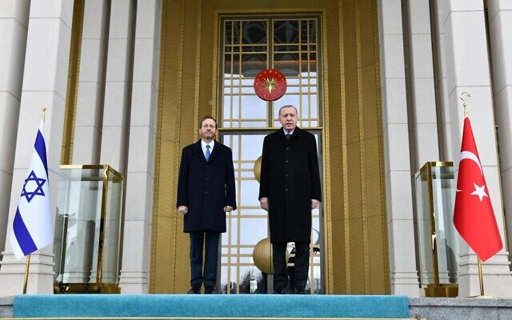  President Isaac Herzog (left) and Turkish President Recep Tayyip Erdoğan outside the presidential complex in Ankara on March 9, 2022. (Haim Zach/GPO) | 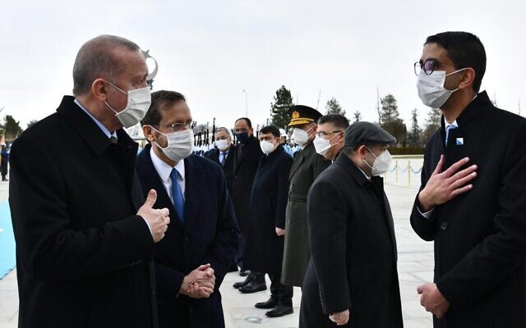  President Isaac Herzog meets Turkish President Recep Tayyip Erdoğan outside the presidential complex in Ankara on March 9, 2022. (Haim Zach/GPO)

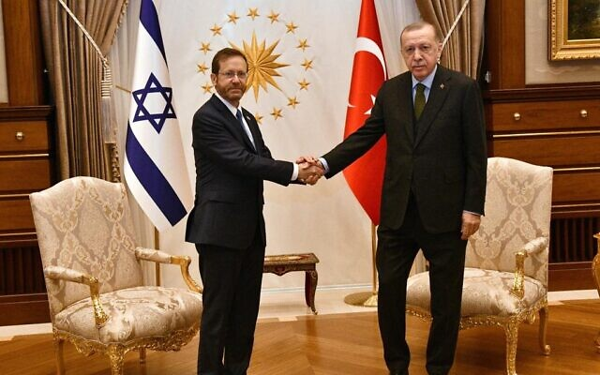  President Isaac Herzog meets Turkish President Recep Tayyip Erdoğan at the presidential complex in Ankara on March 9, 2022. (Haim Zach/GPO) | 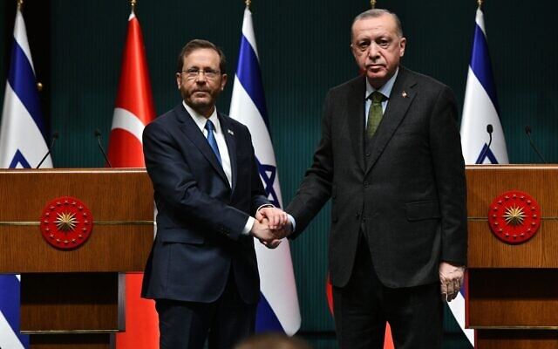  President Isaac Herzog (left) and Turkish President Recep Tayyip Erdoğan at the presidential complex in Ankara on March 9, 2022. (Haim Zach/GPO)
President Isaac Herzog met Turkish President Recep Tayyip Erdogan on Wednesday afternoon, shortly after landing in Ankara for a landmark 24-hour visit.
In remarks to the media, Erdogan said he believed that “this historic visit will be a turning point in relations between Turkey and Israel. Strengthening relations with the State of Israel has great value for our country.” He noted that the meeting with Herzog included a discussion about events in Ukraine and in the Eastern Mediterranean and said he believed “the coming period will bring new opportunities for both regional and bilateral cooperation.”
The Turkish leader expressed hope that “this important visit, taking place after so long, will provide an opening for future joint opportunities.”
Erdogan went on to call antisemitism a crime against humanity, saying that “hate crimes continue to take place all over the world and we will continue to tackle xenophobia, racism, antisemitism and Islamophobia.”
Speaking after Erdogan, Herzog thanked the Turkish president for the warm welcome and opened his speech by saying in Turkish: “My wife and I are very happy to be in Turkey as your guests.”
BREAKING: Israeli President Herzog meets Turkish President Erdogan in Ankara pic.twitter.com/2umR91xFjk
— Barak Ravid (@BarakRavid) March 9, 2022
Addressing the meeting with Erdogan, Herzog said the leaders held “productive” talks and addressed many issues. “This is a very important moment in relations between our countries, and I feel it is a great privilege for both of us to lay the foundations for the cultivation of friendly relations between our states and our peoples, and to build bridges that are critical for all of us,” he said. “Our peoples’ relationship is an ancient one, with strong historical, religious, and cultural roots. The long line of magnificent Jewish leaders, rabbis, poets, sages, merchants, and entrepreneurs represents only part of the Jewish People’s history here in this land,” he said.
“I believe that the relationship between our countries will be judged by deeds reflecting a spirit of mutual respect and will enable us to better confront the regional and global challenges that are common to us all,” he added.
In an incident that caused some confusion, both Herzog and Erdogan announced that Turkish Foreign Minister Mevlut Cavusoglu would visit Israel next month — but apparently caught Israel’s Foreign Ministry off guard.
Herzog said Cavusoglu was expected to meet with Foreign Minister Yair Lapid. Media reports said the two would discuss the reopening of embassies in both countries.
But it later emerged that neither Lapid nor his ministry had been aware of or had okayed such a visit. According to Channel 13 news, Herzog and Lapid’s offices were attempting to sort out the miscommunication.
Lapid’s spokesman told reporters that Cavusoglu had expressed interest in visiting, but that no visit had been scheduled yet.
According to a report by Channel 12, Herzog and Erdogan also discussed Turkey’s relationship with the Hamas terror group, and specifically recent visits by Hamas leaders to Ankara — long a sore point for Israel’s leaders.
According to Channel 13, as part of warming ties, Israel expects Erdogan to expel senior Hamas leaders currently believed to be staying in Turkey, such as Saleh al-Arouri, a top commander of Hamas’s military wing and the terror group’s deputy political chief.
Herzog raised this issue during his meeting with Erdogan, the report said.
Another issue reportedly discussed at the meeting was gas exploration, which Turkey is seeking to promote in the Mediterranean. This may place Israel in a difficult position, considering its commitment to Cyprus and Greece on energy-based cooperation, and their hostile relations with Turkey.
Turkey doesn’t recognize the Greek Cypriot-dominated government in Cyprus, decries its “unilateral” gas searches it says ignore Turkish Cypriot rights to potential mineral wealth and claims much of Cyprus’s exclusive economic zone as its own.
Herzog and Erdogan also discussed establishing a problem-solving mechanism meant to prevent relations from reaching a stalemate in the future.
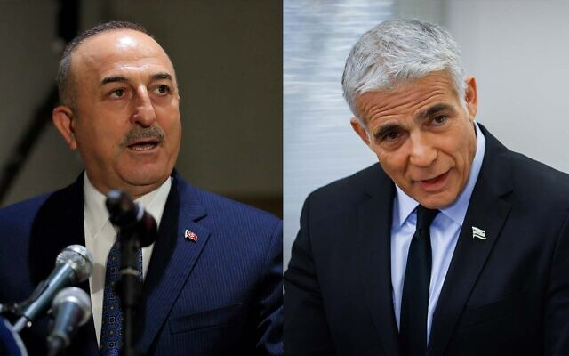
Turkish Foreign Minister Mevlut Cavusoglu (left) and Israeli Foreign Minister Yair Lapid (right). (Hussein Malla/AP; Oliver Fitoussi/Flash90)
The reappointment of ambassadors was not confirmed by either Herzog and Erdogan.
While both leaders expressed high hopes for a brighter future between the nations, a report by Channel 13 indicated that the process may take longer to establish.
According to the report, anti-Israel protesters gathered outside Erdogan’s palace during his meeting with Herzog and replaced Israeli flags with Palestinian flags.
Herzog’s trip marks the highest-level visit by an Israeli official since former prime minister Ehud Olmert made the trip in 2008, and is seen as an important step toward rekindling the two countries’ long-floundering relationship.
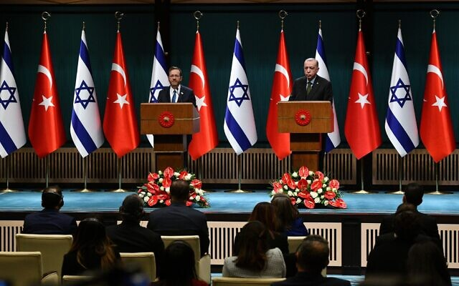
President Isaac Herzog (left) and Turkish President Recep Tayyip Erdoğan at the presidential complex in Ankara on March 9, 2022. (Haim Zach/GPO)
The president arrived on a plane emblazoned with the words “peace,” “future” and “partnership” in Hebrew, Turkish and English.
Arriving at the presidential complex in Ankara, Herzog was greeted by Erdogan and an honor guard, as a band played the Israeli anthem for the first time since 2008.
Herzog and his wife Michal were to be hosted by Erdoghan for a state dinner.
Despite high hopes for a possible diplomatic breakthrough during the meetings, the sides are not slated to discuss or announce the installment of full ambassadors in each others’ capitals, a Foreign Ministry source told The Times of Israel.
شاهدوا جانب من الاستقبال المهيب اللى نظمه الرئيس أردوغان لـ أخيه الرئيس الإسرائيلي وتم عزف النشيد الوطني الاسرائيلي. (شعار الاخوانجية الجديد #التطبيع_أمانة) ????????❤️???????? pic.twitter.com/oO34x4KKeX
— شؤون تركية (@TurkeyAffairs) March 9, 2022
Herzog’s visit to the Turkish capital and to Istanbul was planned weeks before Russia invaded Ukraine, but the conflict could feature at the talks, with both Israel and Turkey playing mediation roles in recent days.
But bilateral issues are likely to dominate following more than a decade of diplomatic rupture between the Jewish state and majority Muslim Turkey.
Prior to his meeting with Erdogan, Herzog visited the mausoleum of Mustafa Kemal Ataturk, the founding father of modern Turkey, and laid a wreath.
Signing a guestbook at the memorial, the Israeli president wished for a “safer and more stable world” for Israel and Turkey.
“It is a distinct privilege to be visiting this historic site, immortalizing the great visionary Mustafa Kemal Ataturk,” he wrote in English. “May we follow in the wisdom of this great leader’s legacy of progress and peace, boldly choosing the path of collaboration and welcoming the many fruits to be reaped from the promise of a safer and more stable world for our nations, our faiths, our region and the world,” he added.
The president and the first lady also toured the Anıtkabir Ataturk Museum.
President Isaac Herzog lays a wreath at the mausoleum of Mustafa Kemal Atatürk, the founding father of modern Turkey March 9, 2022 (Haim Zach/GPO.)
Before departing on his trip, Herzog said rekindling relations with Turkey wouldn’t be easy but it would benefit the Middle East as a whole.
“Relations between Israel and Turkey are important to Israel, important to Turkey and important to the entire region,” he said.
“Hopefully following my visit, a process of in-depth and serious dialogue with Turkey will begin at various levels, and we will eventually see progress with positive relations and results,” he said, noting that his trip was being made in full coordination with Prime Minister Naftali Bennett and Foreign Minister Yair Lapid.
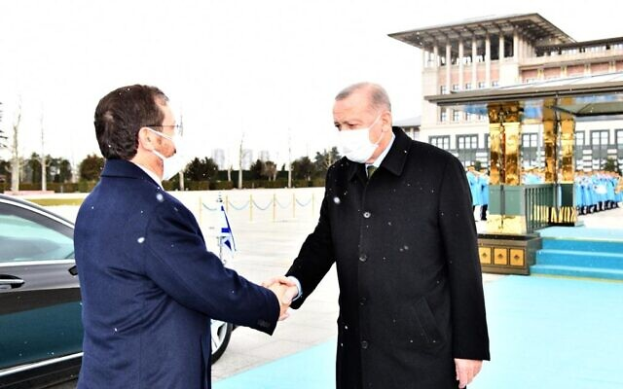
President Isaac Herzog (left) meets Turkish President Recep Tayyip Erdoğan outside the presidential complex in Ankara on March 9, 2022. (Haim Zach/GPO)
Turkey and Israel once were close allies, but the relationship frayed under Erdogan, who is an outspoken critic of Israel’s policies toward the Palestinians. Israel also has been angered by Erdogan’s embrace of Hamas, the terror group that controls the Gaza Strip and is committed to Israel’s destruction.
The countries withdrew their respective ambassadors in 2010 after Israeli forces stormed a Gaza-bound flotilla carrying humanitarian aid for Palestinians that broke an Israeli blockade. The incident resulted in the deaths of 10 Turkish activists.
Relations improved and then broke down again in 2018 when Turkey, angered by the US moving its embassy in Israel to Jerusalem, once more recalled its ambassador, prompting Israel to respond in kind. The two countries have not restored their ambassadors.
The steps toward a rapprochement with Israel come as Turkey, beset by economic troubles, has been trying to end its international isolation by normalizing ties with several countries in the Mideast region, including Egypt, the United Arab Emirates and Saudi Arabia. https://www.timesofisrael.com/herzog-meets-erdogan-in-landmark-visit-as-israel-and-turkey-attempt-detente/ [This visit is very significant. For years Turkey and Israel had reasonable relations and it is most interesting that Erdogan has now suddenly decided to return to a relationship with them. Something doesn’t fit in this picture, but then of course there are many current situations where all the pieces aren’t fitting at this time. Illusion of ? peace and security???? – rdb]

Opposition leader Benjamin Netanyahu tests positive for COVID
Former prime minister feeling well; corruption trial likely to be delayed
By TOI staff Today, 4:35 pm
Opposition leader and former prime minister Benjamin Netanyahu has tested positive for COVID-19, his spokesperson said Wednesday.
Netanyahu, 72, is feeling well and following Health Ministry guidelines, the announcement read.
Following the announcement, Prime Minister Naftali Bennett wished Netanyahu a speedy recovery.
Yamina MK Shirly Pinto from the coalition said on Wednesday she tested positive for COVID-19 as well.
The coalition numbers just 61 of the 120 Knesset members, meaning any single lawmaker can hold the crucial vote on any legislation, complicating the day-to-day business of the government.
The coalition has been forced to pull multiple votes in recent weeks for this reason.
In December last year, Pinto was reluctantly called to the Knesset by her party six days after giving birth due to the opposition’s refusal to offset her absence, in what Bennett called “a new low in behavior” by opposition leader Netanyahu.
Two years into the coronavirus pandemic, the Knesset is yet to approve a process that will allow lawmakers to vote from afar.
On Monday, Netanyahu attended a Likud faction meeting at the Knesset, meaning that everyone who came in close contact with him will need to get tested and remain in isolation until they receive a negative test result if they’re not vaccinated or haven’t recovered from the disease.
Opposition leader Benjamin Netanyahu speaks at a Likud faction meeting at the Knesset in Jerusalem on March 7, 2022. (Yonatan Sindel/Flash90)
Netanyahu’s positive test is also likely to delay his ongoing corruption trial, following several delays over the past few weeks.
Court proceedings were delayed two weeks ago after judge Moshe Bar-Am, one of three judges overseeing the trial, tested positive for COVID-19.
Last week, Israel began rolling back nearly all of its COVID-19 health regulations as a recent wave of infections receded, leaving in place just a handful to prevent a reversal of the positive development.
The changes come as the count of new daily cases has ebbed to barely a ninth of what it was a month ago.
The number of seriously ill patients as of Wednesday morning was 410, nearly a third of what it was just over a month ago. The death toll since the start of the pandemic is 10,322. https://www.timesofisrael.com/opposition-leader-benjamin-netanyahu-tests-positive-for-covid/ [If I am not mistaken Bibi had the Cov before and for sure he is JABBED at least twice. – rdb]

IDF unprepared for attacks on hazmat facilities in wartime, comptroller warns
Investigation finds ‘certain gaps’ in threat of drones, incomplete data on military’s competency to respond to hazardous leaks; army says working to ‘implement recommendations’
By Emanuel Fabian Today, 11:09 am
View of oil refineries in Haifa, on May 5, 2017. (Yaniv Nadav/Flash90)
Security and emergency response forces are not fully prepared to deal with attacks on Israel’s many hazardous materials facilities in the event of war, according to a state comptroller report released Wednesday.
The State Comptroller’s Office found a number of issues in the preparedness of various bodies — including the Israel Defense Forces — when it comes both protecting against attacks on hazmat facilities and responding to the aftermath in the event of a leak.
The threat of an attack on hazmat facilities has become more substantial in recent years, after the leader of the Lebanese Hezbollah terror group threatened to target chemical and oil refineries in Haifa’s bay area in a bid to create an explosion similar to the 2020 Beirut blast. During its 2006 war with Israel, the group fired hundreds of rockets at Haifa.
The report said there were “certain gaps” in Israel’s readiness to deal with the threat of drones potentially targeting hazmat facilities, without elaborating further. Military officials said this week they have seen a trend in Iranian drone attacks in recent years, dubbing it Iran’s “UAV terror.”
Responding to the report, the military said that its Home Front Command considers “the handling of hazardous materials to be of great importance” and that it would work to “implement the recommendations of the comptroller’s report, subject to resources and priorities.”
However, the IDF claimed 99 percent of hazmat facilities were physically protected in the event of an attack.
The military touted the May 2021 11-day war with terror groups in the Gaza Strip as an example of its “a high level of readiness” to deal with attacks on the home front. During that conflict, the Eilat-Ashkelon oil pipeline was hit by a rocket and was on fire for several hours, sparking fears hazardous materials could be spread by the flames.
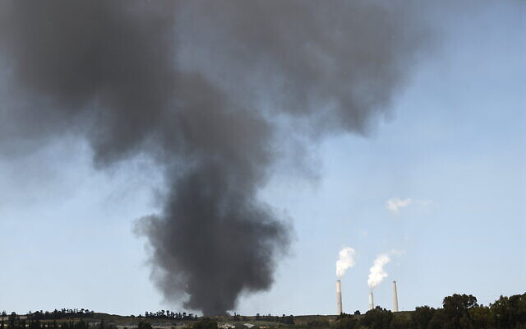
Heavy smoke rises from the Eilat-Ashkelon oil pipeline, after being hit by a rocket on May 12, 2021, near Ashkelon (Gili Yaari/Flash90)
State Comptroller Matanyahu Englman said he found that the IDF’s Planning Directorate and the Defense Ministry’s National Emergency Management Authority had not formulated an updated threat assessment on the home front since 2016. The IDF, however, insisted it had been updated in January 2021 and was valid for the next four years.
While not specifying the exact contents of the updated assessment, the IDF said the Home Front Command also “occasionally examines policy in response to changing threats, and takes necessary steps.”
Englman said there was a lack of complete data on the IDF’s Home Front Command competency to respond to an event of hazardous materials.
In its response, the military said all the Home Front Command battalions train according to standards set by the IDF, including responding to hazmat incidents. “The gaps will be completed over the next two years and the Home Front Command considers their completion as having great importance,” the IDF said.

Israeli State Comptroller Matanyahu Englman speaks at a conference in Jerusalem, February 23, 2022. (Yonatan Sindel/Flash90)
Englman also found the Environmental Protection Ministry had yet to complete a risk assessment survey for the Haifa Bay area, where several hazmat facilities are located. He also found six of nine fire stations that have hazmat response teams were not fully prepared according to standards set by the Israel Fire and Rescue Services.
The report also said the National Cyber Directorate had not prepared for the scenario of cyberattacks on hazmat facilities that are not considered to be part of critical infrastructure. In 2020, Israel faced several cyberattacks targeting its water system.
“The war in Ukraine should serve as a warning light regarding Israel’s readiness for war,” Englman said, possibly referring to Russia’s attacks on nuclear power plants in the course of its invasion of Ukraine.
“Wars are not a thing of the past. Correcting the shortcomings and implementing the recommendations in the report will help Israel’s readiness facing possible aggression,” he said. https://www.timesofisrael.com/idf-unprepared-for-attacks-on-hazmat-facilities-in-wartime-comptroller-warns/ To say this is disappointing is an understatement. Israel has a number of terrible risks throughout the land and hazmat issues are just one of them. There are still multiple locations throughout the land without adequate ‘safe rooms’ because they are older facilities. These people live with he threat of war all the time and an event on Haifa or one of the other facilities with oil or gas production or toxins could have a huge impact on a large segment of the population. – rdb]

IDF chief lands in Bahrain to talk Iran
Kochavi holds a series of meetings with kingdom's top brass to discuss nuclear talks in Vienna as both Jerusalem and Gulf allies fear consequences of Tehran and world powers striking new pact
Yossi Yehoshua | Published: 03.09.22, 20:18
IDF Chief of Staff Aviv Kochavi landed in Bahrain on Wednesday for a series of meetings with top security officials in the Persian Gulf kingdom.
Upon his arrival, Kochavi was greeted by his Bahraini counterpart Lt. Gen. Theyab bin Saqer Al Noaimi. Kochavi also met with the commander of Bahrain's Royal Guard and national security advisor Nasser bin Hamad Al Khalifa, as well as other top brass military personnel.

IDF Chief of Staff Aviv Kochavi (Photo: IDF Spokesperson's Unit)
Israel and Bahrain have been strengthening political and security cooperation against their shared foe Iran, with the former posting a permanent military representative in the Gulf country last month.
Bahrain's foreign ministry said in a statement the appointed IDF officer will work in cooperation with an international coalition comprised of at least 34 countries. It stated that the coalition's goals include securing maritime trade in the region and countering piracy and terrorism.
Kochavi's visit comes after Defense Minister Benny Gantz visited Bahrain last month and signed a security cooperation agreement with the kingdom. Gantz met with the Crown Prince and the Prime Minister of Bahrain Salman bin Hamad Al Khalifa and Defense Minister Abdullah bin Hassan Al Nuaimi.
The MOU came 18 months after the Abraham Accords formalized Israel's relations with Bahrain and the UAE and will promote intelligence sharing, joint military drills and closer ties between the defense industries in both nations.
In his meetings with the Bahraini leadership, Kochavi is slated to discuss sensitive security issues including the ongoing Iran nuclear talks in Vienna.
Both countries fear that Tehran would use garnished funds unfrozen by a potential nuclear pact with world powers to further shore up its military presence in Yemen, Iraq, Syria, and Lebanon.
Gulf nations fear that the talks may mark a U.S. capitulation to Iran.
The Wall Street Journal reported Wednesday morning that the White House has failed to arrange a phone call between U.S. President Joe Biden and crown princes of Saudi Arabia and the United Arab Emirates, who refused to speak with him.
Aside from the Iranian issue, the two Gulf states are also disappointed with the Biden administration's decision to remove the terrorist designation of the Iranian-backed Houthi revolutionaries, who have been locked in a bloody war with the two in Yemen. https://www.ynetnews.com/article/b11yebubq

Senior woman attacked by wild boar in northern Israel
Edna Engel says she was making her way back home from grocery shopping when she was suddenly attacked by 3 adult wild swine that sensed the food she was carrying
Lior El-Hai | Published: 03.09.22, 17:54
A 60-year-old woman was attacked by two adult wild boar in the northern city of Haifa on her way back home from grocery shopping Tuesday.
"The pain in my leg has mostly subsided today, but the terror didn't," Edna Engel told Ynet a day after the attack. "I had nightmares last night, and I woke up a few times in panic. It terrified me. I thought I was going to die. My life has become a nightmare, but I'm not going to give up."
Edna Engel describes the attack (Photo: Nachum Segal)
"As I was going home with the groceries I bought, I parked the car and went into my yard holding two bags, and then I spotted a phenomenon that is not foreign to me, but this time around, it terrified me. I saw 15 little piglets, and next to them was their mother and two large boar. The mother looked at me and started snorting menacingly. I got scared, and decided not to go into the yard and started walking back to the car."
And then the wild boar began chasing her, and even though Engel tried to pick up the pace to avoid them, they kept pursuing her.
"Maybe the female spotted the bags with the food. I could sense them behind me and heard them sniffing loudly. I ran as fast as I could, and as a result, I twisted my ankle and shrieked in pain. One of the boars snatched a bag out of my hand, and all of its content spilled on the road. A second boar encircled me and tried to grab the other bag," Engel said.
Wild boar on the streets of Haifa (Photo: Elad Gershgoren)
~"I felt like I was going to have a heart attack from all the running and the panic. I started screaming, 'Help, help.' The manager of a nearby cafe heard me and ran toward me. She was also frightened because she saw that the boars were determined to try to get the other bag, and they were aggressive. I walked into the cafe with her and felt like I was about to get a heart attack, and she helped me calm me down."
Engel blasted local authorities for failing to solve Haifa's pervasive wild boar problem.
"Those 15 piglets I saw will grow up one day. We find ourselves fighting for our territory, as they grow by the numbers. They lost every ounce of fear, so they become very violent. I mean, a senior citizen like me should not lose all sense of personal security. I'm a tax-paying citizen who lived in Haifa for years. This isn't Tel Aviv here, we don't have that many attractions but we have a lot of flora, trees, and fresh air. So, if you take that away from me, I don't want to live in Haifa anymore."
The Haifa Municipality has yet to respond to a request for comment. https://www.ynetnews.com/article/bk4brz8w9 [Haifa is a major city and population center in northern Israel. It is hard to comprehend why they should have such a problem which obviously has been going on for a long time and not fix the problem. Animal conservation is one thing but this is ridiculous. – rdb]

Zelensky asks to deliver a speech to Israeli parliament
Ukrainian officials approach Knesset Speaker Mickey Levy, requesting to arrange an address by Ukraine's president, which is not possible due to parliamentary recess; Levy to consider a Zoom meeting between Zelensky and MKs
Itamar Eichner | Published: 03.09.22, 22:39
Embattled Ukrainian President Volodymyr Zelensky has asked to deliver a speech to the Israeli parliament amid the ongoing Russian invasion, Knesset officials said Wednesday.
Knesset Speaker Mickey Levy was apparently approached by Ukrainian officials, requesting arrangements be made for Zelensky to deliver a virtual address to the Knesset via Zoom.
The move, however, was not possible due to the current parliamentary recess.Levy's office offered to conduct a Zoom meeting with Zelensky and the Knesset members instead.
The Ukrainian ambassador underlined that Israel didn't deny the request, and that both sides are trying to find a solution that will allow Zelensky to make his address
Aside from the parliamentary recess, the Knesset is undergoing renovations, therefore, a speech cannot take place there, regardless.
A Knesset official told Ynet: "We're for it. The Knesset is starting recess today and the parliament is under renovation. We feared that all the Knesset members wouldn't be able to arrive on such short notice, because they have plans, so Ukraine was offered that Zelensky deliver his speech to several Knesset members over Zoom".
Israel's involvement in the Russia-Ukraine war, meanwhile, continues. On Tuesday, Zelensky thanked Bennett for his mediation efforts in what was their fourth phone conversation since the beginning of the war.
The negotiation process between Russia and Ukraine is taking place in Belarus. Israel's role in the process is to present Putin with the ideas proposed by the West, and then report back to Ukraine and the West with his reaction.
Essentially, Western leaders asked Bennett to depict the situation from Putin's perspective and understand what comes in the way of the negotiations. Israel hasn't proposed any ideas of its own, and doesn't intend on pressuring Zelensky to accept Putin's offers. Israel is aiming to be solely a mediating player in the talks. https://www.ynetnews.com/article/skfa7tuwq

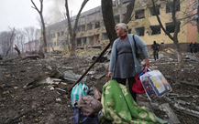
Russian strike devastates hospital in Mariupol; Zelensky: Kids buried under wreckage
At least 17 people confirmed wounded; British PM accuses Putin of ‘targeting the vulnerable and defenseless,’ says Russian leader will account for his crimes
By VADIM GHIRDA and YURAS KARMANAU Today, 9:11 pm

A woman walks outside the damaged by shelling maternity hospital in Mariupol, Ukraine, Wednesday, March 9, 2022. (AP Photo/Evgeniy Maloletka)
KYIV, Ukraine (AP) — A Russian airstrike devastated a maternity hospital Wednesday in the besieged port city of Mariupol and wounded at least 17 people, Ukrainian officials said, amid growing warnings from the West that Moscow’s invasion is about to take a more brutal and indiscriminate turn.
The ground shook more than a mile away when a series of blasts slammed into the Mariupol complex, blowing out windows and ripping away much of the front of one building. Police and soldiers rushed to scene to evacuate victims, carrying out a heavily pregnant and bleeding woman on a stretcher.
Another woman wailed as she clutched her child. In the courtyard, mangled cars burned, and a blast crater went at least two stories deep.
President Volodymyr Zelensky wrote on Twitter that there were “people, children under the wreckage” and called the strike an “atrocity.” Video shared by Zelensky showed cheerfully painted hallways strewn with twisted metal. “There are few things more depraved than targeting the vulnerable and defenseless,” British Prime Minister Boris Johnson tweeted, adding that Russian President Vladimir Putin will be held “to account for his terrible crimes.”
Authorities, meanwhile, announced new ceasefires Wednesday morning to allow thousands of civilians to escape from bombarded towns around Kyiv as well as the southern cities of Mariupol, Enerhodar and Volnovakha, Izyum in the east and Sumy in the northeast.
Mariupol. Direct strike of Russian troops at the maternity hospital. People, children are under the wreckage. Atrocity! How much longer will the world be an accomplice ignoring terror? Close the sky right now! Stop the killings! You have power but you seem to be losing humanity. pic.twitter.com/FoaNdbKH5k
— Володимир Зеленський (@ZelenskyyUa) March 9, 2022
It was not immediately clear whether anyone was able to leave other cities, but people streamed out of Kyiv’s suburbs, many headed for the city center, as explosions were heard in the capital and air raid sirens sounded repeatedly.
From there, the evacuees planned to board trains bound for western Ukrainian regions not under attack.
Civilians leaving the Kyiv suburb of Irpin were forced to make their way across the slippery wooden planks of a makeshift bridge because the Ukrainians blew up the concrete span to Kyiv days ago to slow the Russian advance.
⚡️ Russian airstrike destroys maternity, children's hospital in Mariupol.
According to President Volodymyr Zelensky, there are still adults and kids under the rubble. The number of victims is yet unknown, local authorities report.
Video: Mariupol City Council pic.twitter.com/dBGWRzEQrw
— The Kyiv Independent (@KyivIndependent) March 9, 2022
With sporadic gunfire echoing behind them, firefighters dragged an elderly man to safety in a wheelbarrow, a child gripped the hand of a helping soldier, and a woman inched her way along cradling a fluffy cat inside her winter coat. They trudged past a crashed van with the words “Our Ukraine” written in the dust coating its windows.
“We have a short window of time at the moment,’’ said Yevhen Nyshchuk, a member of Ukraine’s territorial defense forces. “Even if there is a ceasefire right now, there is a high risk of shells falling at any moment.”
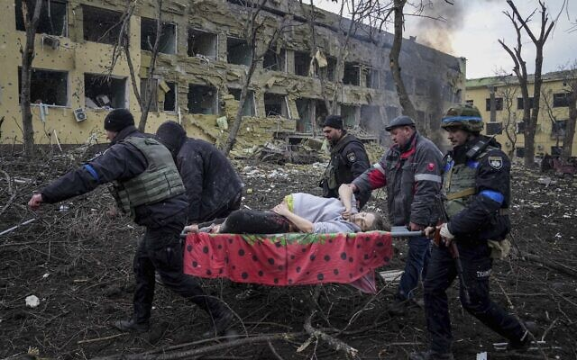
Previous attempts to establish safe evacuation corridors over the past few days largely failed because of what the Ukrainians said were Russian attacks. But Putin, in a telephone call with Germany’s chancellor, accused militant Ukrainian nationalists of hampering the evacuations.

Ukrainian emergency employees and volunteers carry an injured pregnant woman from the shelledng maternity hospital in Mariupol, Ukraine, Wednesday, March 9, 2022. (AP Photo/Evgeniy Maloletka)
In Mariupol, local authorities hurried to bury the dead from the past two weeks of fighting in a mass grave. City workers dug a trench some 25 meters (yards) long at one of the city’s old cemeteries and made the sign of the cross as they pushed bodies wrapped in carpets or bags over the edge.
Nationwide, thousands are thought to have been killed, both civilians and soldiers, in the two weeks of fighting since Putin’s forces invaded. The UN estimates more than 2 million people have fled the country, the biggest exodus of refugees in Europe since the end of World War II.
The fighting knocked out power to the decommissioned Chernobyl nuclear plant, raising fears about the spent fuel that is stored at the site and must be kept cool. But the UN nuclear watchdog agency said it saw “no critical impact on safety” from the loss of power.
The crisis is likely to get worse as Moscow’s forces step up their bombardment of cities in response to what appear to be stronger Ukrainian resistance and heavier Russian losses than anticipated.
Echoing remarks from the director of the CIA a day earlier, British Defense Secretary said Russia’s assault will get “more brutal and more indiscriminate” as Putin tries to regain momentum.
Britain’s Defense Ministry said fighting continued northwest of Kyiv. The cities of Kharkiv, Chernihiv, Sumy and Mariupol were being heavily shelled and remained encircled by Russian forces.
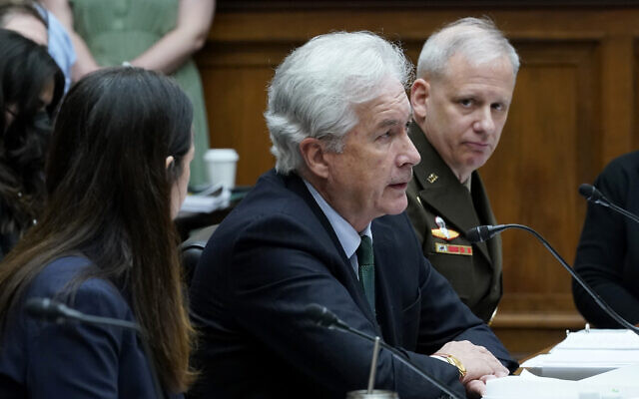
Central Intelligence Agency Director William Burns, center, testifies on Capitol Hill in Washington, March 8, 2022. (AP Photo/Susan Walsh)
Russian forces are placing military equipment on farms and amid residential buildings in the northern city of Chernihiv, Ukraine’s military said. In the south, Russians in civilian clothes are advancing on the city of Mykolaiv, a Black Sea shipbuilding center of a half-million people, it said.
The Ukrainian military, meanwhile, is building up defenses in cities in the north, south and east, and forces around Kyiv are “holding the line” against the Russian offensive, authorities said.
In Irpin, a town of 60,000, police officers and soldiers helped elderly residents from their homes. One man was hoisted out of a damaged structure on a makeshift stretcher, while another was pushed toward Kyiv in a shopping cart. Fleeing residents said they had been without power and water for the past four days.
Regional administration head Oleksiy Kuleba said the crisis for civilians is deepening in and around Kyiv, with the situation particularly dire in the suburbs.
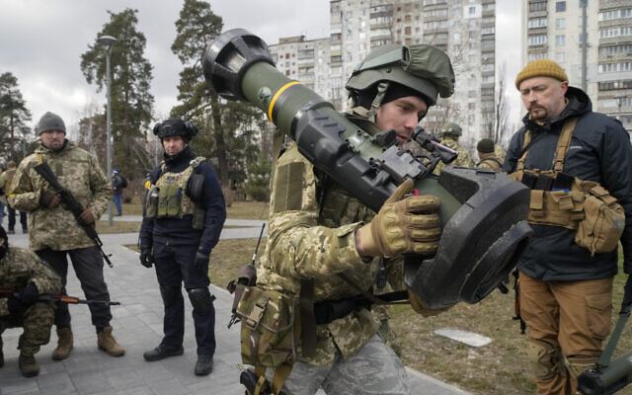
A Ukrainian Territorial Defence Forces member holds an NLAW anti-tank weapon, in the outskirts of Kyiv, Ukraine, Wednesday, March 9, 2022. (AP Photo/Efrem Lukatsky)
“Russia is artificially creating a humanitarian crisis in the Kyiv region, frustrating the evacuation of people and continuing shelling and bombing small communities,” he said.
The situation is even worse in Mariupol, a strategic city of 430,000 people on the Sea of Azov that has been encircled by Russian forces for the past week.
Efforts to evacuate residents and deliver badly needed food, water and medicine failed Tuesday because of what the Ukrainians said were continued Russian attacks.
The city took advantage of a lull in the shelling Wednesday to hurriedly bury 70 people. Some were soldiers, but most were civilians.
The work was conducted efficiently and without ceremony. No mourners were present, no families to say their goodbyes.
One woman stood at the gates of the cemetery to ask whether her mother was among those being buried. She was. https://www.timesofisrael.com/russian-strike-devastates-hospital-in-mariupol-zelensky-kids-buried-under-wreckage/

At Moldova border, Jews from Odesa wonder when they’ll be able to return home
Bracing for a Russian attack on their hometown, many residents escape to neighboring country; reject Putin’s claim of ‘denazifying’ Ukraine
By Jacob Judah Today, 10:26 pm
Thousands of Ukrainians wait to enter the checkpoint at the Ukraine-Moldova border in Palanca, March 5, 2022. (Jacob Judah via JTA)
PALANCA, Moldova (JTA) — Standing under the border post between Ukraine and Moldova, things feel almost normal. There are a dozen cars being processed. There is a border guard drawing on a cheap cigarette. There is even a duty-free shop where one can buy coffee.
And yet there was nothing normal about the scene on Saturday. Thousands of Ukrainians were waiting patiently in the freezing wind to enter the checkpoint, fleeing Russia’s attack on their homeland. Every so often, a border guard waved a few more in, and a trickle of children, women and old men picked up their suitcases and anxiously hurried towards a booth where they were to be stamped into Moldova.
Sofia, 48, had just crossed. Around her, six buses of people from nearby Odesa — Jews and non-Jews — were standing beside a tent where Moldovan volunteers were handing out coffee and tea.
“I have to take my elderly aunt out of Ukraine,” Sofia explained, almost apologetically. “It will take at most two weeks, but then I am going back to Odesa.”
The evacuation has been organized by the American Jewish Joint Distribution Committee, or JDC, whose volunteers are making sure that nobody misses the buses that they have organized to take everyone directly to Bucharest, Romania’s capital.
The JDC, which said it supports some 40,000 Jews across Ukraine, snapped into action since the war began and is working with partners including the Jewish Agency — a nonprofit that aids Jews and helps them immigrate to Israel — to provide support to Jews withstanding or fleeing Russia’s assault.
Jews from Odesa wait at a checkpoint at the border between Ukraine and Moldova. (Jacob Judah via JTA)
The JDC, famous for carrying out relief and rescue missions during World War II, has moved its base of operations in Ukraine from the capital, Kyiv, to the western city of Lviv. In various news releases, JDC said it had been preparing for various “war-related” scenarios and that it was now providing Ukrainian Jews who need help with food, medicine and financial support. It is also arranging transportation and accommodation for Jews who want to leave. Among those who were evacuated to Moldova is a 91-year-old Holocaust survivor.
The Chabad-Lubavitch movement is also offering aid and advice to Jews and non-Jews at synagogues and other Jewish community centers in Moldova’s capital Chisinau.
Since Russia invaded Ukraine on February 24, over 1.7 million Ukrainians have become refugees, according to figures released by the United Nations High Commissioner for Refugees on Monday.
Among them are thousands of Jews like Sofia. “Very many Jews are leaving Odesa,” she said, “but every single one that I know says that they are already dreaming of when they can come back.”
Her husband remained at home, among the men ages 18-60 who are being conscripted to help fortify Odesa against a possible Russian assault.
When Sofia arrived in Bucharest, she intended to call a family meeting to decide where she could send her aunt. “I have a son in Israel, but he is in the military, and I am not sure whether he has the time to look after her properly,” she said. “I have a daughter and friends in Germany who said that they can host her, so maybe we will go there.”
With her small black suitcase, half-empty plastic bag and stoic expression, Sofia looked almost as if she were going on a business trip. She spoke of her shock at the events of the past two weeks. “How is it possible that something like this could happen in the 21st century?” she asked. “We all saw the preparations, but nobody expected that it would actually happen.”
A Ukrainian migrant named Tatyana holds her dog, named Wonderful Life. (Jacob Judah via JTA)
Asked what she made of the claim by Russian President Vladimir Putin that Russia’s invasion was intended to “denazify” Ukraine, she threw her hands in the air and gestured to the people — mostly Jews — standing nearby. “Look around you! Do you see this?”
Palanca, in southeastern Moldova, is the closest border crossing to Odesa, Ukraine’s third-largest city. Since February 24, some 230,000 Ukrainians have entered Moldova, and hundreds of thousands more could follow if Russian troops begin to push across south-western Ukraine.
Few Ukrainians who have entered Moldova want to stay. Some 150,000 have already moved onto Romania from where they can disperse around Europe.
Vlada Ignatieva, 27, came on the same buses organized by Odesa’s Jewish community. She hopes to make it to Switzerland.
“I am not Jewish, but today when I went down to the synagogue to catch the bus, I really felt like I was with my community,” she said. “How do I become Jewish?” she laughed. MORE - https://www.timesofisrael.com/at-moldova-border-jews-from-odesa-wonder-when-theyll-be-able-to-return-home/

Senior US official in Israel: We won’t push Kyiv to accept Russian terms
US Embassy source says Washington supports PM Bennett’s diplomacy; stresses there is no ‘red line’ that would bring about American military intervention
By Carrie Keller-Lynn Today, 6:13 pm
Marking two weeks since Russia invaded Ukraine, a senior US Embassy official in Israel said Wednesday that Washington continues to support the Ukrainian government, but will stay on the sidelines — both militarily and in terms of evaluating negotiated peace terms.
In a briefing to reporters in Tel Aviv, the official said, “The United States stands in solidarity with and will continue to support the government and the people of Ukraine in the face of the Kremlin’s aggression,” adding that, “President [Vladimir] Putin and Foreign Minister [Sergey] Lavrov are directly responsible” for the war.
Prime Minister Naftali Bennett, in line with requests from Ukrainian President Volodymyr Zelensky, has taken an active role in mediating between Kyiv and Moscow. On Saturday, Bennett flew to meet Putin in the Russian capital and has spoken with with both leaders by phone several times since.
The embassy official said the US is supportive of all peace negotiations efforts, including the ongoing efforts led by Bennett.
On Tuesday, Zelensky said that Ukraine is cooling off on its demand to join NATO. A key Russian demand has been to ensure Ukraine does not join the international force.
Without naming NATO specifically, the embassy official responded to this development by reaffirming that “the US is supportive of a solution that Ukraine is supportive of because we’re backing the government of Ukraine and its people in its reaction to this unprovoked, premeditated war.”
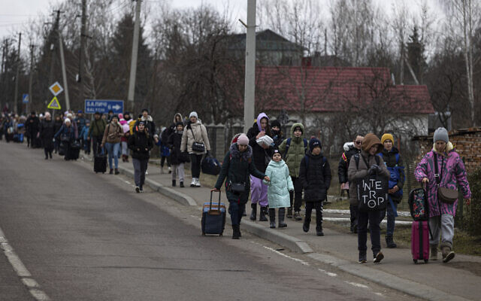
Groups of Ukrainian refugees walk along the road between Lviv and Shehyni, in Volytsya, Ukraine, Saturday March 5, 2022. The number of Ukrainians forced from their country since the Russian invasion has been increasing on a daily basis. (AP Photo/Marc Sanye)
According to an Axios report, the US will not pressure Ukraine regarding terms with Moscow.
The report said Putin is demanding the annexation of Crimea and independence for Donbas and communicated this position to Bennett, who shared it with Zelensky, French President Emmanuel Macron, German Chancellor Olaf Scholz, and US officials. It said the US is not pressuring Zelensky on whether or not to agree to relinquish sovereignty over the regions, contested since Russia first invaded them in 2014.
When asked by The Times of Israel if the US could recognize Russian sovereignty over Donbas and Crimea, the embassy source pointed to past US Eastern European policy.
“The US has a track record here with Baltic states, which after decades under Soviet rule emerged again as full states. We tend to act on principles, at least historically,” the official said, presumably referring to US non-recognition of the Soviet Union’s 1940 incorporation-by-force of Baltic states, and immediate support for their 1991 independence.
“It will be up to the leadership of Ukraine to determine what conditions might be acceptable or unacceptable,” said the embassy source, noting that the US does not force parties to join NATO.
When asked if there was a “red line” that Russia could cross that would prompt direct American military action, the official said that the US does not plan to join the “front lines of this war.”
“We’ve been clear that Russia must stop,” he said. “It’s also clear that, at present, the American people are not looking for US forces on the ground, on the front lines of this war.”
“But the people of Ukraine are doing outstanding jobs and defending themselves,” he added.
On Tuesday the Pentagon ruled out a deal to have Poland send Soviet-era MiG-29 fighter jets to Ukraine, because of fears that Russia would perceive it as NATO stepping into the war effort.
“The Pentagon has termed that proposal to be untenable. This revolves around the question of NATO’s direct engagement in direct hostilities,” the embassy official said.
The American official raised the specter of war crimes being committed, saying that “we don’t have all the evidence yet, but we certainly have things that raise concerns.”
“Ultimately war crimes need to be adjudicated, but there’s certainly been damage to civilian targets, infrastructure, people, and if those are proven to be deliberate, planned, targeted attacks, that’s when it becomes a war crime,” the official said.
While the International Criminal Court’s prosecutor has already announced an investigation into alleged war crimes in Ukraine dating back to 2013, neither the US, Russia, nor Ukraine are parties to the Rome Statute, which is the treaty that establishes jurisdiction by the court. Ukraine, however, can voluntarily accept the court’s authority over crimes committed in its territory.
On Tuesday, US President Joe Biden announced that the US would ban all Russian oil imports, an additional measure to individual sanctions and blocking much Russian access to the SWIFT banking system. The embassy official said sanctions imposed against Russia by the US and Western allies are “unprecedented” and that America would be happy to see Israel join the West in its effort.
“We would like to see our allies and partners imposing strong sanctions. Israel falls into the category of our allies and partners,” the embassy official said. The official added, “Putin chose to start this war and the Russian Federation will be held accountable and bear the consequences of his actions.”
Last week, a senior Foreign Ministry official told The Times of Israel that there is currently no legal infrastructure in place that enables Israel to impose sanctions.
The American official declined to comment on Israel’s refusal to support a UN Security Council resolution condemning Russia, but thanked Israel for its efforts supporting and enlisting other signatories to the March 2 UN General Assembly condemnation.
Parallel to Ukraine, the official said that “there is an active conversation” between US and Israeli officials about the Iran deal currently being negotiated in Vienna.
“You saw that in evidence just two days ago when Foreign Minister Lapid and Secretary Blinken met in Latvia,” the source said. https://www.timesofisrael.com/senior-us-official-in-israel-we-wont-push-kyiv-to-accept-russian-terms/
The US has, by its own actions helped incite and instigate this war. The relationship between Zelenksy and Schwab and those in the west pushing for him to become a NATO country and put arms on the Russian border was totally avoidable but they have an agenda and it was to remove Putin and get someone in Russia who is a globalist. – rdb]

World heading to Yom Kippur War-level oil shock, French minister says
Bruno Le Maire warns Russia’s invasion of Ukraine and subsequent sanctions on crude will send prices to record highs not seen since OPEC embargo following the 1973 conflict
By AFP Today, 1:56 pm
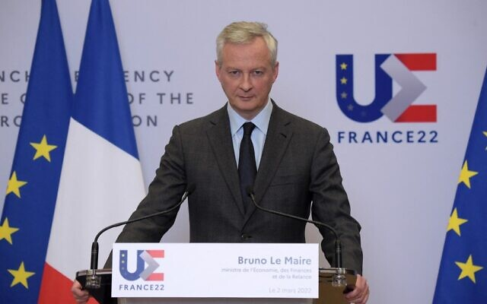
PARIS, France — The spike in energy prices caused by Russia’s war in Ukraine will produce effects comparable to the 1973 oil shock, French Economy Minister Bruno Le Maire warned on Wednesday.
The current energy crisis was “comparable in intensity, in brutality, to the oil shock of 1973,” Le Maire told a conference in Paris.
“In 1973, as you know, the response caused an inflationary shock, leading central banks to massively increase their rates, which killed off growth,” Le Maire added.
“This has a name: stagflation, and it’s precisely what we want to avoid in 2022.”
The first oil shock in the early 1970s was caused by the Yom Kippur War when Egyptian and Syrian forces launched an offensive against Israel.
Six Arab members of the OPEC oil cartel declared an embargo on exports to countries supporting Israel, notably the United States.
French Economy and Finance Minister Bruno Le Maire talks during a press conference at the Economy Ministry after an exceptional Ecofin Visio meeting about the Ukraine crisis, in Paris on March 2, 2022. (Eric PIERMONT / AFP)
They quadrupled the oil price to $11.65 a barrel, provoking recessions in Western countries and steep inflation.
European wholesale gas and crude oil have rocketed to record, or near-record, prices this week due to supply fears linked to Russia’s February 24 invasion of Ukraine.
Advertisement
The United States and Britain announced Tuesday they were cutting off Russian energy imports in response to the war, triggering another surge in prices.
The price of Brent crude, the international benchmark, was up at almost $130 per barrel on Wednesday. https://www.timesofisrael.com/world-heading-to-yom-kippur-war-level-oil-shock-french-minister-says/

Saudi Arabia, UAE leaders not returning Biden's calls, disappointed with US - report
The two Mideast countries are disappointed with the Iran nuclear deal, as well as the American response to Houthi terrorist attacks in recent weeks.
By TAL SPUNGIN Published: MARCH 9, 2022 08:43 Updated: MARCH 9, 2022 15:49
The leaders of Saudi Arabia and the United Arab Emirates have been declining calls from US President Joe Biden for several weeks, The Wall Street Journal reported on Wednesday, citing officials in the Middle East and the United States.
The messages of dissatisfaction sent by Saudi crown prince Mohammed bin Salman (MBS) and Emirati Shiekh Mohammed bin Zayed al Nahyan come as the two leaders share concerns over the American response to recent missile and drone strikes from Yemen, claimed by the Iranian-backed Houthi rebels.
The two nations are also reportedly disappointed with the state of negotiations in the ever-nearing Iran nuclear deal, according to the WSJ.
The deal, which IAEA chief Rafael Grossi called "very complex," does not account for Saudi and Emirati security interests, they claimed.
The US has been pushing to repair its relations with the two nations as it looks to stifle an oil crisis. Biden announced a ban on Russian oil imports on Tuesday as gas prices reach all-time highs globally.
"There was some expectation of a phone call [between Biden and MBS], but it didn’t happen," an American source told WSJ, adding that the call was intended to focus on "turning on the spigot [of Saudi oil]."
In addition, support from the Middle Eastern oil giants is increasingly important to the US in order to create a united front against Russia due to its ongoing invasion of Ukraine.
Saudi Arabia has long been disappointed with its reportedly deteriorating relationship with the US since Biden was sworn in, according to the report. Along with more support in Yemen, the Saudis are reportedly seeking assistance with their own civilian nuclear program, in addition to clarification on the legal position of MBS in the US due to lawsuits filed over the killing of Jamal Khashoggi.
In an interview with The Atlantic earlier this month, the Saudi crown prince commented on his relationship with Biden, stating he "does not care whether Biden misunderstood things about him."
The president should be "focusing on America's interests," MBS said, adding that he "does not have the right to lecture America and the same goes the other way."
The crown prince also reiterated, however, that Riyadh's objective was to maintain and strengthen its "long, historical" relationship with the US. https://www.jpost.com/middle-east/article-700734 Looks to mee that “Bi-Dum" and his group of trolls have just about worn out their welcome with the middle east group because they are recognizing not only his weakness but also his absolute unreliable character and that of the demon-rat group. If they look around they will note if they haven’t already figured it out that there are a bunch of rinos that are just about as bad. We have a total disaster in DC right now and it is with both parties and the deeply entrenched government employee group that is occupying our governance. – rdb]

'No effect': Austria suspends national vaccine mandate
Law made being in country without proof of shots illegal
By Art Moore Published March 9, 2022 at 7:42pm
Last month, Austria became the first country in the world to make it illegal to be without proof of COVID vaccination, but the European nation has suspended its law after protests and reports the measure had no effect.
The government said Wednesday the law was "not proportionate to the threat" of the omicron variant of the virus that caused COVID-19, which while more contagious presents with mild symptoms.
The Austrian daily Kronen Zeitung reported the announcement was made only days before the government was set to impose fines of up to 3,600 euros, about $4,000, for the unvaccinated.
However, Austria's constitutional minister, Karoline Edtstadler, and Health Minister Johannes Rauch said the law remains on the books and could be implemented again.
The German news magazine Der Spiegel reported the Austrian law had "practically no effect" on increasing vaccination, with about 1 million people, or 13% of the population, remaining unvaccinated.
In January, WND spoke with Austrian activist Alexander Tschugguel, who has helped lead a nationwide movement against forced vaccination and other COVID measures.
Tschugguel, 28, said Austrians were being used as "lab rats" for the Western world, noting the "terrible idea of a vaccine mandate" was being copied by Germany despite the admission that the vaccines don't prevent infection and transmission, and the evidence that the vaccinated are equally susceptible to hospitalization and death from COVID-19.
He warned that the the next logical step after the vaccine law is that, among other things, unvaccinated parents could lose their children

See the WND interview:
'Step-by-step Machiavelli' MORE - https://www.wnd.com/2022/03/no-effect-austria-suspends-national-vaccine-mandate/ [Someone got this right, the shot has not real positive effect on the Cov, particularly Omicron and is simply a tool to destroy your immune system and hasten the death of many. – rdb]

Facebook funding COVID vaccine campaign with WHO, CDC, Merck
Social-media giant censors evidence, concerns about safety, effectiveness
By Art Moore Published March 9, 2022 at 7:24pm
Known for censoring information about vaccines and COVID-19 that conflict with the establishment narrative, Facebook has been leading an alliance with the World Health Organization, the CDC Foundation and others that funds promotion of vaccines.
The Alliance for Advancing Health Online, or AAHO, has funded research into "how best to use behavioral science, social media and digital platforms to build confidence in and access to vaccines," the Epoch Times reported.
White House staffers received an email last June announcing Facebook's formation of an alliance to "boost vaccination confidence through social media."
It highlighted a "vaccine confidence fund" described as a $40 million multi-year initiative.
The Epoch Times spoke with several medical scientists and physicians whose evidence-based views have been censored by Facebook and other social-media platforms.
Pierre Kory, president of the Frontline COVID-19 Critical Care Alliance, who is known for his advocacy for ivermectin as a COVID treatment, argued there is no "scientifically-supported public health objective for getting people vaccinated."
Dr. Jay Battacharya, a professor of medicine at Stanford, told the Epoch Times it's "difficult for me to understand this as anything other than a government propaganda campaign."
Dr. Robert Malone, who was banned by Twitter after raising safety concerns about the COVID vaccines, said that if Facebook is going to "play doctor," it must "fulfill the professional and ethical obligations of the profession," which include disclosing the vaccines risks.
Facebook teamed up with Dr. Anthony Fauci to censor the lab-leak theory, including a report by WND. It's now known that Fauci was told early in 2020 by a trusted scientist that the novel coronavirus likely came from a lab and was genetically modified. https://www.wnd.com/2022/03/facebook-funding-covid-vaccine-campaign-cdc-merck/

On hidden camera, New York Times reporter spills beans about Jan. 6 riot
'A ton of FBI informants among the people who attacked the Capitol'
By Bob Unruh Published March 9, 2022 at 11:37am
A New York Times reporter who claimed the Jan. 6, 2021, riot at the Capitol in Washington was "a violent interruption to the transition of power in American history" privately believes the events were "fun" and that the media is "making too big a deal."
The revelations about the opinions from the Times' national security correspondent, Matthew Rosenberg, a Pultizer-winning reporter, came through an undercover video released by Project Veritas.
The organization charged that what Rosenberg has been writing for the publication is in direct contradiction to what he believes.
For example, he said on the undercover video that there were "a ton of FBI informants among the people who attacked the Capitol," after having reported in the newspaper that the notion of FBI informants was a "reimagining of Jan. 6."
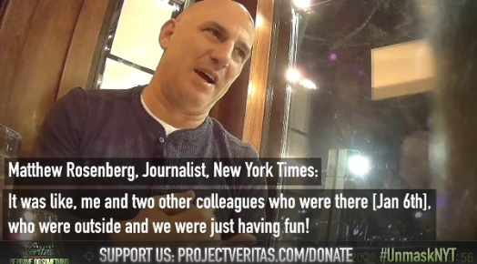
"This was not the only time Rosenberg’s commentary to Project Veritas’ undercover reporter directly contradicted his own published words. Despite telling a Veritas journalist that January 6 was 'no big deal,' his article says that downplaying the events of that day was 'the next big lie,'" Project Veritas reported.
In fact, in the video, Rosenberg claims, "It’s not a big deal as they [media] are making it, because they were making too big a deal. They were making this an organized thing that it wasn't."
Project Veritas founder James O'Keefe pointed out Rosenberg's article, "The Next Big Lies: Jan 6 was No Big Deal, or A Left-Wing Plot," was written about the same time he was making "contradictory statements" to Project Veritas.
And Rosenberg also revealed that January 6 was “fun,” a contradiction to his reporting that January 6 was “a violent interruption to the transition of power in American history."
He said," It was like, me and two other colleagues who were there outside and we were just having fun."
He also explained, "I know I’m supposed to be traumatized, but like, all these colleagues who were in the [Capitol] building, and are like, 'Oh my God it was so scary!' I'm like, 'f--- off!' I'm like 'Come on.' It’s not the kind place I can tell someone to man up but I kind of want to be like, 'dude come on, you were not in any danger.'" https://www.wnd.com/2022/03/hidden-camera-n-y-times-reporter-spills-beans-jan-6-riot/ [One more demonstration of the evil wickedness in our government and media. Believe NOTHING coming from these people. – rdb]

Sheriff releases report on DHS whistleblower Phil Haney's death
Terror expert was punished by feds for pursuing politically incorrect leads
By WND Staff Published March 9, 2022 at 3:00pm
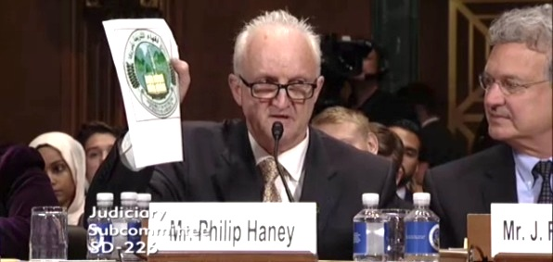
DHS whistleblower Phil Haney at a Senate hearing June 28, 2016 (Screenshot Senate Judiciary Committee video)
The Amador County Sheriff's Office in California has released its report on the death of former Department of Homeland Security officer Philip Haney, concluding he died of a self-inflicted gunshot wound on Feb. 21, 2020.
Haney was an Islam subject-matter expert whose investigations and research challenged the official narrative of the George W. Bush and Barack Obama administrations. His government punished and exonerated him nine times during his career for taking into account the religious dimension to terrorism. He wrote a bestselling book with WND News Editor Art Moore titled "See Something, Say Nothing: A Homeland Security Officer Exposes the Government's Submission to Jihad."
At the time of Haney's death, he was preparing a follow-up book that he said would expose corruption in America's national security and immigration system.
After Haney was found dead from a gunshot wound alongside a rural crossroad southeast of Sacramento, Amador County investigators initially reported that the death was self-inflicted. But the next day, Feb. 22, 2020, the sheriff's office backtracked after it became aware of Haney's background and national stature, declaring an investigation was ongoing.
Undersheriff Gary Redman said at the time that the sheriff's office had reached out to the FBI "to assist in analyzing documents, phone records, numerous thumb drives and a lap top that were recovered from the scene and Mr. Haney’s RV."
Those items and numerous other pieces of evidence were turned over to the FBI for forensic examination.
On Wednesday, along with a statement summarizing the findings, the sheriff's office released 278 pages of documents related to the investigation.

'Purge' of intelligence
Shortly after Haney's death two years ago, in an emotional speech on the House floor, Rep. Louie Gohmert, R-Texas, praised the former DHS officer as a friend who was "one of the finest, most patriotic, competent people I've ever known in my life."
"A man of absolute honesty, complete integrity, who cared deeply about the future of this country."
The congressman said Haney – who saw the intelligence he developed on Islamic terrorists erased by Obama officials – "was a Christian brother, and that certainly affected so much of what he did."
Gohmert recounted Haney's unlikely path to becoming a member of the advanced team at the National Targeting Center near Washington, D.C., which provides actionable intelligence in real time to customs officers at the nation's ports of entry.
Noting the title of Haney's book, Gohmert said the DHS officer "saw things that were a threat to this country, he said something, and he was severely punished for it, because apparently the Obama administration had some radical ties that they did not want anybody, including Philip Haney, to expose."
His book, the Texas lawmaker said, "documents the Obama administration's effort to obfuscate the role of radical Islam in numerous terrorist attacks."
A sequel was underway, Gohmert noted, that would "name names."
Gohmert recalled that Haney testified to a Senate committee in June 2016 of the "purging" of his intelligence on terrorist networks in the U.S. The Obama administration, he said, "modified" or eliminated more than 800 of his records related to the Muslim Brotherhood network in the U.S. because they were deemed to be an offense to Muslims. In addition, a highly successful case he helped develop at the National Targeting Center was shut down by Hillary Clinton's State Department and the DHS Office of Civil Rights and Civil Liberties out of concern for the "rights" of foreign Muslims.
See Rep. Louie Gohmert's tribute to Philip Haney on the House floor:
And after Haney retired honorably in 2015, he discovered that had his case continued, it might have prevented both the Orlando and the San Bernardino terror attacks.
Along with the quashing of the case in June 2012, the administration subsequently ordered the deletion of an additional 67 records concerning a related network.
'A real whistleblower'
Gohmert, clearly referencing the anonymous whistleblower who brought the complaint Democrats used to impeach President Trump the first time, said "Philip Haney was a real whistleblower," noting his Senate testimony.
"That's what a real whistleblower does," Gohmert said. "A whistleblower does not remain anonymous. They come forward, subject themselves to cross-examination, and supposedly have protection."
But the Obama administration didn't protect whistleblowers like Haney, Gohmert said.
"They went after whistleblowers," he said.
"In fact, the Obama administration prosecuted more people for leaking than every other administration in this country's history added together." https://www.wnd.com/2022/03/sheriff-releases-report-dhs-whistleblower-phil-haneys-death/ [The death of Haney was a tragedy because he had enough information to sink a load of swamp people. Did he kill himself. I doubt that seriously. – rdb]

Commentary:
Climate Hoax Hacks Love Putin
Kurt Schlichter Posted: Mar 09, 2022 12:01 AM
Here’s the thing – you cannot claim to both oppose Putin and fight global warming. Of course, Putin exists and global warming is a giant scam designed to separate you from your money and freedom, but regardless, you cannot coherently posture both ways at once. But then, coherence is optional. The green new dealers are Putin’s best pals whose frivolous obsession is killing Ukrainian kids. And we need to never let them forget it.
Also, where did the masks go? I guess we have another official Important Thing to focus on so COVID is over.
Climate Cultists Are Eager Tools of Putin
Once upon a time – like a bit over a year ago – America was a net energy exporter. We drilled and pumped and did not have to pay the Russians to buy their oil. But some of you people were very, very upset that Donald Trump was mean to people on Twitter and you voted for that desiccated old pervert instead. And when Crusty came into office he brought along a whole bunch of religious fanatics who really, really cared about the weather in a century – certainly more than they cared about America.
So the Asterisk Administration declared war on the American fossil fuel. We went from being an exporter under Trump to an importer under Lump. And that was okay. Shutting down pipelines, breaking leases, banning exploration – not only would this innovative masochism keep the polar bears from bursting into flame but it would also crush the dirty, sweaty, patriotic and normal people who worked in the energy industry. Punishing these patriots was a delightful dollop of whipped cream with a cherry on top of making America weaker and poorer. For Democrats and their globalist pals, this was a win-win.
Except now, we have to make up for that fuel deficit by buying Russian oil, and when we buy Russian oil we buy cluster bombs and T-90s and other things that kill little Ukrainian kids. We have been told that killing Ukrainian kids is bad by the regime media, proving the broken clock theory, but boy, is it hard for the climate cultists to deal with the cognitive dissonance.
And that cognitive dissonance is the tension between rising gas prices, which are killing Democrat political prospects in November, and not reversing their long-sought goal of neutering America’s domestic oil industry. The banning the Russian oil part is easy – the pressure is almost certainly going to force Grandpa Badfinger to agree to cut it off soon. But the replacing it part is the problem – prices are going to go up, up, up, and Biden has this easy solution – unleash America’s oil resources – that his lunatics will not let him use.
And people will see it and be furious. They will be paying $8 a gallon when there’s oil right here in America we can’t touch because the liberal donors in Manhattan, Marin County, and Santa Monica won’t let us.
Oh, how I love Democrats being put in this position. Anger the voters or the weather goddess! Or both!
Masks are Stupid
But you knew that. The idiocy of wrapping your face in some fabric that has pores exponentially larger than the virus that it is supposed to stop was always apparent. When Fauci – whatever happened to that creepy little sex dwarf anyway? (BTW, NEVER Google that term) – initially started talking about masks, it was to tell us they were essentially useless. And he was right. Well, he had to be right once, since he’s taken every possible position in his relentless pursuit of science. Of course, “science” means whatever narrative the ruling class wants at a particular moment.
Well, masks are vanishing. I was in the Free State of Florida and there were almost none to be seen. I visited Las Vegas and there weren’t any. There were still some in the airport, but even in LA people were sitting without them in greater numbers. No one hassled me. On the plane I nursed a coffee the whole flight. On one flight, not a whisper about masks. On another flight, they repeated the idiotic “pull your mask up between sips” thing. They can Toobin-pull something.
Even in coastal California, with its surfeit of erotically deprived suburban wine women who find meaning in “surviving” this pseudo-pandemic, there are more and more people just opting out. The lib governors, though, cannot just concede the obvious and end the misery. That would embarrass their strongest supporters, the idiotic aspiring fascist constituency, so the rules are still in effect and are still enforced against little kids with the willing connivance of the public-school teachers unions.
Don’t ever tell me about how great teachers are. They have shafted our kids and they have earned our contempt.
So the pandemic is going away, not because of science – this was never about science – but because of bad polls. They will just have to find some other petty tyranny to inflict on us. Hey, there’s always sacrificing to confront Russia, for some reason. Whatever, it doesn’t matter. Any scam will do, as long as it brings them power. https://townhall.com/columnists/kurtschlichter/2022/03/09/climate-hoax-hacks-love-putin-n2604239
A Morally Weak Biden Invites Putin's Advances
Star Parker Posted: Mar 09, 2022 12:01 AM
I wrote last week about the collapse of the Soviet Union as result of the strength, moral clarity and leadership of President Ronald Reagan.
I quoted Reagan's observation that the ultimate battle we fight, around the world and at home, is one of good and evil.
This battle never ends. Evil always seeks to advance, constantly in search of the retreat of the presence of good, as it seeks opportunities for expansion.
There simply is no other way to understand the horrible realities we confront today.
Russian President Vladimir Putin is an evil man. A murderer and a thief. He chose to advance his outrageous and murderous agenda because he understood that opposite him in the world stood weakness and moral relativism, not strength and moral clarity.
While Putin utilizes Russia's prodigious production of oil and gas as a major weapon in his war of aggression, the Biden administration is fighting its own war against America's oil and gas industry.
I wrote recently about Biden's nomination of Sarah Bloom Raskin to be vice chair for supervision at the Federal Reserve Board of Governors. Raskin is a leading voice to shut down America's oil and gas industry, which she called "a dying industry."
Under President Donald Trump, America's oil and gas industry was booming. However, President Joe Biden has reversed everything.
The Biden administration returned the United States to the Paris Agreement on climate change, from which Trump withdrew.
Biden canceled the Keystone XL pipeline that would have delivered 830,000 barrels per day of Canadian crude oil to the United States.
And the Biden administration has committed to blocking any new oil and gas development on federal lands. One of the first victims has been suspending oil and gas leasing in Alaska's Arctic National Wildlife Refuge.
Now, as Americans see prices at the gas pump skyrocketing, and as Biden and Democrats worry about the fallout of this in an election year, the Biden administration is turning hat-in-hand for supplies to socialist despot Nicolas Maduro in Venezuela, who ruined his own country and was sanctioned by Trump.
Biden also is turning to Gulf producers Saudi Arabia and the United Arab Emirates to increase production.
Aside from the rocky relations we now have with Saudi Arabia as the result of misguided Biden diplomacy, the Saudis and Emiratis are concerned, as The Wall Street Journal points out, about alienating the Russians, who now are a force in the Middle East.
How is it that the Russians have become power brokers in the Middle East?
Israeli leader and former Soviet dissident Natan Sharansky writes in The Wall Street Journal that the Russians stepped in as a force in the Middle East to fill a strategic vacuum left when the Obama administration, of which our current president was a part, chose to ignore its threat to stand against Syrian dictator Bashar al-Assad's use of chemical weapons against his own citizens. Then the Obama administration followed up with its ill-conceived nuclear deal with Iran, which Trump pulled out of and now the Biden administration is working to renew.
Iran poses a threat to Gulf oil producers such as Saudi Arabia and the UAE and also to Israel, which it threatens to destroy.
Sharansky notes that after Obama's retreat, the Russians set up a military base in Syria and now broker its air space. Israel is dependent on Russian goodwill to allow them to counter Iranian aggression in Syria, a direct threat to their security.
Two seats on the board of American's largest oil company, ExxonMobil, were gained last year by Wall Street climate change activists committed to transform the oil company to "clean" energy.
Among Wall Street climate change activists is Larry Fink, CEO of BlackRock, the largest money manager in the world.
Perhaps our president and these billionaire leftists can explain their logic to the Ukrainian citizens now being murdered by Putin. https://townhall.com/columnists/starparker/2022/03/09/a-morally-weak-biden-invites-putins-advances-n2604293
The Widening War
Betsy McCaughey Posted: Mar 09, 2022 12:01 AM
The public needs straight talk about what's happening in Eastern Europe.
President Joe Biden and the United Kingdom's Prime Minister Boris Johnson need to level with their own countrymen about the rising risk of war against Russia. The public's getting double talk -- praise for the Ukrainians' courage but also empty promises that what's happening in Ukraine will stay in Ukraine.
Secretary of State Antony Blinken promised Sunday that "President Biden has been clear that we are not going to get into a war with Russia."
Johnson wrote in the New York Times on Monday that "this is not a NATO conflict and it will not become one."
That's ridiculous. The U.K. and the U.S. can't make that guarantee. There are too many tripwires leading to broad-scale war.
American eyes are on gruesome television images of Ukrainians huddled in the basements of bombed hospitals or running down snowy roads with children in their arms to escape Russian missile fire.
But Russian President Vladimir Putin is eyeing territory beyond Ukraine, including Latvia, Lithuania and Estonia, all NATO allies once under Soviet domination.
These countries and five other NATO members have already triggered Article 4 of the NATO agreement, calling for consultations about the serious Russian threat.
In response, the U.S. and other NATO allies are moving ground troops and tanks into Lithuania, Latvia and Estonia. News broke Monday that the U.S. is considering supplying air defense systems to these three Baltic countries.
On Monday, Blinken also pledged to Lithuania's foreign minister, Gabrielius Landsbergis, that "we will defend every inch of NATO territory if it comes under attack."
Putin himself is laying tripwires for a NATO conflict. Sunday, he warned that foreign countries like Romania that are allowing Ukrainian fighter pilots to use their airstrips may be viewed by Moscow as parties to the conflict. Putin could say the same about Poland's announced decision to lend fighter planes to Ukraine.
Putin even labelled economic sanctions "akin to a declaration of war."
Cowed by Putin's warnings, the U.S. and NATO allies refuse Ukraine's requests for a no-fly zone. Blinken concedes that without NATO pilots fighting off Russian bombers, Ukrainians face bloodier days ahead as the Russians "keep grinding things down," leveling city after city. A high price to pay, and for what?
Lithuanian President Gitanas Nauseda warned Blinken, "if we want to avoid the Third World War," Putin must be stopped in Ukraine. Nauseda is worried his own country will be next, but he nevertheless is driving home a fundamental truth. It won't be easier to stop Putin after he crushes Ukraine.
It's never easier to stop a bully once he's allowed to win a fight.
Though Ukraine is not part of NATO, it's arguable that the U.S. and U.K. owe Ukraine more than they're doing. In 1994, they pressured newly independent Ukraine into surrendering its nuclear weapons to Russia under the Budapest Memorandum with tacit assurances -- now conveniently forgotten -- that they would respond if Russia threatened them.
History aside, the question is, how long can Putin be allowed to continue snuffing out innocent lives in Eastern Europe? Russia's economy is tanking as corporations pull out and the half-hearted sanctions already imposed by the West take effect. If oil and gas exports were also banned, Bloomberg Economics predicts, the Russian economy would contract a devastating 14% this year. Russia may be more a more vulnerable foe now than at another time.
Is NATO ready to fight this weakened foe? Despite neglecting the Russian threat for years, NATO outspends Russia on armaments 15 to 1 and outnumbers Russian ground forces 4 to 1, according to retired Adm. James Stavridis, a former NATO supreme allied commander.
War is a last resort.
Now is the time for the Biden administration to talk honestly about what it already knows is true. The U.S. and NATO allies may be forced into a war with Russia, not because we choose to go to war but because a tyrant leaves us no choice. https://townhall.com/columnists/betsymccaughey/2022/03/09/the-widening-war-n2604306

THE SHORASHIM BIBLICAL GIFT CATALOG 005
http://mad.ly/7f9f64?pact=20013931524&fe=1
Support Shorashim!

ARUTZ SHEVA
White House warns: Russia could use chemical weapons in Ukraine
White House press secretary says Russia could use chemical weapons in Ukraine after Moscow claims US houses biological weapons in Ukrainian territory.
Israel National News 10.03.22 00:57
White House press secretary Jen Psaki on Wednesday warned of the potential for Russia to use chemical weapons in Ukraine after Moscow alleged the United States was housing biological weapons in Ukrainian territory, The Hill reports. [Well what was the US doing funding and supporting bioterrorism laboratories in the Ukraine?????? Obviously we learned nothing from Wuhan and why did the fools in the US who had plenty of warning not destroy and dismantle everything before the Russian invaded. They new that they were planning on inciting them to attack by every action they took. The fault is in the US not the Ukraine nor Russia. We have a wicked and evil group running the show and it has been that way for years. – rdb]
Psaki called the claims from Russia "false" and "preposterous," and warned they could serve as a pretext for the Russians to deploy chemical weapons in their assault on Ukraine. [Sorry lady but Nuland just spilled the beans in her hearing under oath responding to Rubio. Ukraine had weapons labs, there is documentation in memos that the US was supporting and funding them and there is a DOD document listing it as well. YOU LIE Madam. – rdb]p
"It’s the kind of disinformation operation we’ve seen repeatedly from the Russians over the years in Ukraine and in other countries, which have been debunked, and an example of the types of false pretexts we have been warning the Russians would invent," Psaki said in a statement quoted by The Hill.
"Also, Russia has a track record of accusing the West of the very violations that Russia itself is perpetrating. In December, Russia falsely accused the U.S. of deploying contractors with chemical weapons in Ukraine," she continued. [ Once again this is projection where they accuse others of doing exactly what they are doing. The demon-rats are very good at that. – rdb]
"This is all an obvious ploy by Russia to try to try to justify its further premeditated, unprovoked, and unjustified attack on Ukraine. Now that Russia has made these false claims, and China has seemingly endorsed this propaganda, we should all be on the lookout for Russia to possibly use chemical or biological weapons in Ukraine, or to create a false flag operation using them. It’s a clear pattern."
Earlier on Wednesday, Russian foreign ministry spokesperson Maria Zakharova claimed Russia discovered evidence of a program to develop anthrax and other biological weapons run by the United States in Ukraine.
Pentagon press secretary John Kirby later called the claims "absurd" and "laughable." [Another liar as we have seen many times. – rdb]
The comments came hours after Russia bombed a maternity and children’s hospital in Mariupol, Ukraine, where over 400,000 residents are currently unable to leave.
An air strike by the Russian military over the city destroyed the children’s hospital, with Ukrainian President Volodymyr Zelensky saying that women and children were trapped in the remains of the building. The number of dead and injured is unknown.
A video of what Zelensky called a “direct strike of Russian troops” on the maternity and children’s hospital was shared by the Ukrainian leader on Twitter. https://www.israelnationalnews.com/news/323642

Gantz hints at elimination of two Revolutionary Guards officers in Syria
Defense Minister: The IDF is thwarting terrorist acts and the intensification of our enemies - we will continue to do so wherever necessary.
Ido Ben Porat 10.03.22 00:05
Defense Minister Benny Gantz hinted on Wednesday that Israel was behind the killing of two officers from the Iranian Revolutionary Guards in an air strike in Syria attributed to Israel earlier this week.
"The IDF is thwarting terrorist acts and the intensification of our enemies - we will continue to do so wherever necessary, in the face of any significant threat that is being built against us. Anyone who engages in this endangers the country from which he operates - and also endangers himself," Gantz said at an event marking the 100th anniversary of the establishment of the Hagana organization.
Iranian media reported on Tuesday that two members of the Revolutionary Guards were killed the air strike attributed to the Israel Air Force in the Syrian capital of Damascus early Monday morning.
Israel’s public broadcaster, Kan 11 News, noted that the last time Iran admitted there were casualties in an Israeli attack was in April of 2018, when seven members of the Revolutionary Guards were killed in an attack on the T4 airbase east of the city of Homs. At the time, Iran responded a month later with a barrage of rockets fired by its missiles at Israel.
In his remarks on Wednesday, Gantz also commented on President Isaac Herzog’s visit to Turkey, where he met with President Recep Tayyip Erdogan.
“Right now, President Isaac Herzog is on a significant visit to Turkey, a country with a rich history. From here, I wish him good luck. Israel is building its relations with many countries in the region, and strengthens cooperation in the face of threats in the region, including Iran's aggression and attempts to have nuclear weapons. The attempt to renew ties with Turkey also stems from a common security interest of the two countries and the need to maintain the stability of the world and the Middle East. We will continue to strengthen and maintain our ties with our longtime allies in the region, including Greece and Cyprus, and build new collaborations with the required responsibility." https://www.israelnationalnews.com/news/323641

Radical cleric: Israel's Judaization of Al-Aqsa Mosque is doomed to fail
Sheikh Raed Salah says that the Israeli "occupation" will end soon because Allah promised Al-Aqsa to the Muslims.
Dalit Halevi 10.03.22 03:17
Sheikh Raed Salah Avi Dishi/Flash 90
Sheikh Raed Salah, head of the northern branch of the Islamic Movement, said on Wednesday that Israel's "Judaization" plans at the Al-Aqsa Mosque are doomed to fail.
Salah claimed that Israel continues to strive to exercise full sovereignty over the Al-Aqsa Mosque through increasing Judaization measures aimed at gaining control of the site.
He warned against Israeli policy in Jerusalem and in particular the "break-ins" by Jews into the Al-Aqsa Mosque under police security, and religious worship in the mosque plaza.
"The Al-Aqsa Mosque is one of the permanent things that cannot be changed in the history of the Muslims, and it is God's promise in the Holy Qur'an that oppression cannot flourish in it, so the occupation will end soon," Salah said.
Salah was jailed for incitement to terrorism and served a 16-month prison sentence before being released in December.
Salah has been arrested by Israel several times in the past on charges of incitement. The radical cleric served a nine-month jail sentence after being convicted of encouraging violent attacks and inciting racism in a 2007 sermon.
He has in the past labeled Israeli leaders “terrorists” and “enemies of Allah” in a speech to Muslims in Be’er Sheva, and was also jailed for five months in 2010 for spitting at an Israeli police officer.
The Israeli government outlawed the northern branch of the Islamic Movement, which Salah heads, in November of 2015.
To be removed from this News list, Please click here and put "Unsubscribe" in the subject line.

03/09/2022 NEWS
GLORIA IN EXCELSIS DEO. Antonio Vivaldi.
https://www.youtube.com/watch?v=zhhYIZJj6rk

"In war, truth is the first casualty."
-- Aeschylus (525-456 BC) Greek playwright
Read the Prophets & PRAY WITHOUT CEASING!
That is the only hope for this nation!
Please  Remember  These  Folks  In  Prayer-  Check often  They  Change! | Pray that the world would WAKE UP! Time for a worldwide repentance!  ALL US soldiers fighting for our freedom around the world  Pray for those in our government to repent of their wicked corrupt ways.  Pray for BB – Severe sciatic needing procedure.  Pray for EL – Had clot embolized to brain – successful ‘clot buster’ but long road to go.  Pray for BB – Severe West Nile Fever –still not mobile- improving!  Pray for RBH – cancer recurrence  Pray for Ella – Child with serious problems  Pray that The Holy One will lead you in Your preparations for handling the world problems. – Have YOU made any preparations?
Exodus 10:¹⁰And he said unto them: 'So be the LORD with you, as I will let you go, and your little ones; see ye that evil is before your face. ¹¹Not so; go now ye that are men, and serve the LORD; for that is what ye desire.' And they were driven out from Pharaoh's presence. ¹²And the LORD said unto Moses: 'Stretch out thy hand over the land of Egypt for the locusts, that they may come up upon the land of Egypt, and eat every herb of the land, even all that the hail hath left.'

In latest steps against Russia, US and Europe target oil and gas imports
Biden announces US ban on all oil imports, UK says it will phase out such imports by end of 2022; EU plans two-thirds cut in Russian gas purchases this year
By Agencies Today, 7:58 pm
Gas prices are shown on March 7, 2022, in Tumwater, Washington, as the cost of gasoline hit the highest price that American motorists have faced since July 2008. (AP Photo/Ted S. Warren)
US President Joe Biden announced a ban on US imports of Russian oil on Tuesday, in the administration’s most far-reaching action yet to punish Moscow for invading Ukraine. The move was coordinated with an announcement by the UK on phasing out Russian oil, on the same day that the EU said it would cut back on its imports.
“We’re banning all imports of Russian oil and gas and energy. That means Russian oil will no longer be acceptable at US ports and the American people will deal another powerful blow to [President Vladimir] Putin,” Biden said in an address from the White House, adding that the decision was taken “in close consultation” with allies. [That last portion of the “Bi-Dum"’s babbling should be rephrased to state “the American people HAVE BEEN DEALT another powerful blow” and it wasn’t by Pootie Poot or too him. The boycott of Russian oil will only further drive gas prices through the roof and destroy more of the American economy and the pocketbooks of its people. This is a war that was literally incited by the demands of the US to maintain their competitive edge over Russia by putting arms on its border. It was also to keep the money laundering system going in the Ukraine to feed the US political elite. Who loses in this conflict? The US, the Ukrainian and the Russian people. The elite or bourgeoisie are probably the only winners and in the long run they won’t really win because there will be rebellion. – rdb]
The action follows pleas by Ukrainian President Volodymyr Zelensky to US and Western officials to cut off the imports, which had been a glaring omission in the massive sanctions put in place on Russia over the invasion. Energy exports have kept a steady stream of cash flowing to Russia despite otherwise severe restrictions on its financial sector.
The ban came with Democrats threatening legislation to force Biden’s hand, despite the likely impact on already soaring gas prices.
Russian oil makes up only a small part of US imports. Unlike the US, which is a major oil and gas producer, Europe relies on imports for 90 percent of its gas and 97% of its oil products. Russia supplies 40% of Europe’s gas and a quarter of its oil. The US does not import Russian natural gas.
Britain said Tuesday it would phase out Russian oil imports by the end of this year.
“This transition will give the market, businesses, and supply chains more than enough time to replace Russian imports — which make up 8 percent of UK demand,” Business Secretary Kwasi Kwarteng tweeted.
The oil sanction does not apply to Russian natural gas, which accounts for some four percent of UK supply. But Kwarteng said he was “exploring options to end this altogether.”
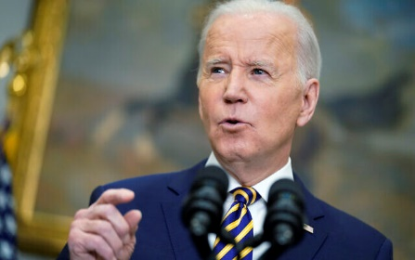
US President Joe Biden announces a ban on Russian oil imports, toughening the toll on Russia’s economy in retaliation for its invasion of Ukraine, on March 8, 2022, in the Roosevelt Room at the White House in Washington, DC. (AP Photo/Andrew Harnik)
It risks exacerbating a cost-of-living crisis in Britain, with prices of petrol and diesel already surging amid market turmoil following energy-rich Russia’s aggression against Ukraine.
But Kwarteng said most of Britain’s crude oil imports come from “reliable partners” such as the US, the Netherlands, and Gulf states.
“We’ll work with them this year to secure further supplies,” he said. “The market has already begun to ostracize Russian oil, with nearly 70% of it currently unable to find a buyer,” the business minister added.
Kwarteng announced a new government task force on oil to help companies transition away from Russian oil.
British dockers at a facility in northwest England on Saturday refused to unload Russian oil from a tanker, calling for the government to close a “loophole” in sanctions allowing deliveries from foreign-flagged ships.
Meanwhile, a top official in the EU said it wants to vastly reduce Russian gas imports this year.
Big tanks are seen at a BP oil refinery in Gelsenkirchen, Germany, on March 7, 2022. Prices for gasoline and diesel reached new highs in Germany due to Russia’s war in Ukraine. (AP Photo/Martin Meissner)
The European Commission, the EU’s executive arm, said it could erase a huge share of its dependency on Russia by tapping new gas supplies, ramping up reserves for next winter, and accelerating efforts to be more energy efficient.
“By the end of this year, we can replace 100 billion cubic meters of gas imports from Russia. That is two-thirds of what we import from them,” EU Commission vice president Frans Timmermans told reporters in Strasbourg, France.
“This will end our over-dependency and give us much-needed room to maneuver,” added Timmermans, who leads EU policy-making on energy and climate change.
In its plan, the EU said the bloc could become fully independent of Russian gas, oil, and coal by 2030.
Timmermans urged caution. Russia supplies 40% of the EU’s gas needs, with Italy, Germany, and several central European countries especially dependent. A quarter of its oil supply also comes from Russia.
“The reality is that there’s quite a number of our member states who would get into real trouble if overnight, all the energy would no longer be provided from Russia,” Timmermans told MEPs earlier. “So we need to make sure… we don’t do more harm to ourselves than we do to Putin,” he added.
The proposal, which is not binding, calls for 90% of gas storage capacity to be filled by September 30, up from about 30% now.
The recommendations from Brussels came just ahead of a meeting of EU leaders who will discuss ways to cut Europe’s energy ties to Russia for the long term.
The 27 leaders will agree “to phase out our dependency on Russian gas, oil, and coal imports,” according to a draft of a declaration intended to end the meeting and seen by AFP. https://www.timesofisrael.com/in-latest-steps-against-russia-us-and-europe-target-oil-and-gas-imports/ [The oil price in the US could easily be rectified if the idiots in DC would allow the free enterprise of American petroleum to continue instead of cutting it off as they did at the insistences of the environmental wakos who think you can power this country by windmills. rdb

Israel mulls European request for gas as Russia threatens to cut EU supplies
Sources in Energy Ministry confirm request from Europe’s Energy Commissioner, say decision tied to the new Karish site coming online
By Sue Surkes Today, 7:58 pm
This undated file photo shows a Qatari liquid natural gas (LNG) tanker ship being loaded up with LNG at Raslaffans Sea Port, northern Qatar. With gas reserves dropping and concerns a war could interrupt flows from Russia, the focus now is getting gas from the United States, Qatar, Algeria and elsewhere until renewables catch up. (AP Photo, File)
Senior sources at the Energy Ministry confirmed on Tuesday that the European Energy Commissioner has asked Israel whether it could supply liquified natural gas to help the continent wean itself off Russian supplies.
Energy Ministry officials told the Times of Israel that the ministry is considering the European request but added that the country’s ability to help would depend on the Karish gas field coming online.
This is expected in the fall. Earlier this week, the field was connected to the country’s national gas line.
The Chevron company, which operates Israel’s Tamar and Leviathan gas fields in the Mediterranean, would not comment on providing gas to Europe.
But early on Tuesday, Fox News quoted Chevron CEO Michael Wirth as telling a conference in Houston that a plan for an eastern Mediterranean natural gas pipeline connecting Israel, Greece, and Cyprus to Italy and on to Europe could be taken out of mothballs.
The eventual aim of that pipeline — from which the US withdrew support earlier this year — was to supply Europe with 10 percent of its gas.
Last year, the European Union imported around 155 billion cubic meters (bcm) of gas from Russia, amounting to 45% of all its gas imports, according to the International Energy Agency.
On Monday, the Russian Deputy Prime Minister, Alexander Novak, threatened to respond to rising sanctions over its invasion of Ukraine by cutting gas supplies to Europe via the Nord Stream 1 pipeline. Last month, Germany halted work on the Russian Nord Stream 2 pipeline project.
On Tuesday, US President Joe Biden announced that the country would be banning imports of Russian oil and gas. The European Commission issued plans to cut EU dependence on Russian gas by two-thirds this year and completely before 2030. The UK said it would phase out Russian oil imports by year’s end.
Israel currently has two working natural gas fields, Tamar and the bigger and newer Leviathan.
Unlike Tamar and Leviathan, which are serviced by fixed offshore production platforms, Karish will use a floating production, storage, and offloading vessel.
Israel has no facilities for liquifying natural gas. The nearest is in Egypt.
Earlier this month, the International Energy Agency issued a 10-point plan to reduce the EU’s reliance on Russian gas.
Among other things, this proposed increasing imports of liquified natural gas (LNG) by 20 billion cubic meters over the coming year. LNG is transported by ship.
Gas import contracts with the Russian company Gazprom, accounting for more than 15 bcm per year and 12% of Europe’s gas imports from the company, will expire at the end of the year, according to the IEA. Contracts with Gazprom covering close to 40 bcm per year are due to expire by the end of this decade. https://www.timesofisrael.com/israel-mulls-european-request-for-gas-as-russia-threatens-to-cut-eu-supplies/ [Perhaps Israel needs to factor in something that this article does not address. If Israel undermines Russia by replacing the Russian gas supply to the EU Russia could well consider that an act of aggression against it which could set off some nasty actions against Israel. HUMMM? Hooks in the bear’s jaw? – rdb]

Israel will allow 25,000 non-Jewish Ukrainian refugees to stay in country — minister
Quota of 5,000 added to some 20,000 already here before war; country expects tens of thousands more who are eligible to make aliyah to do so as a result of the conflict
By TOI staff Today, 7:58 pm
Interior Minister Ayelet Shaked speaks from Jerusalem, on March 8, 2022. (Screenshot/Channel 12)
Israel will allow 25,000 Ukrainians who are not eligible for immigration to stay in the country as refugees amid Russia’s invasion of their nation, Interior Minister Ayelet Shaked announced Tuesday.
The minister said 20,000 of those had been in Israel before the outbreak of hostilities, and an additional 5,000 would be accepted from the time the invasion began.
This in addition to tens of thousands it expects to arrive in the country as part of Jewish immigration in the wake of the war, Shaked said.
Shaked announced the new policy for absorbing non-Jewish Ukrainian refugees as the war was on its 13th day, with no end in sight.
“The sights of war in Ukraine and the suffering experienced by its citizens rattle the soul and don’t allow us to remain indifferent,” she said in a press conference held at the Knesset on Tuesday evening.
She said Israel will “temporarily host” 20,000 Ukrainian citizens who were already in the country before the war broke out, mostly illegally, and won’t take action to deport them. An additional immigration quota for 5,000 Ukrainian citizens seeking refuge in Israel after the war broke out was approved, the minister said.
According to Ynet, some 3,400 non-Jewish Ukrainians have arrived in Israel since Russian troops invaded the country on February 24, 150 of whom were not allowed entry.
Shaked said that under the new rules, any Ukrainian citizen entering Israel will receive a temporary permit to remain for 3 months. She added that if the situation in Ukraine does not improve, they will be allowed to apply for local work.
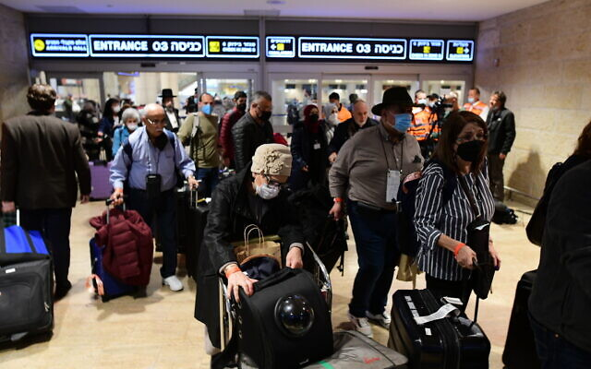
Israeli and Ukrainian refugees arriving from Ukraine on a rescue flight are welcomed at Ben Gurion international airport near Tel Aviv, on March 3, 2022. (Avshalom Sassoni/Flash90)
She further said the ministry had decided to cancel the controversial requirement for refugees to deposit NIS 10,000 ($3,000) upon entering the country, to ensure their eventual departure.
Instead, refugees arriving in Israel as part of the humanitarian quota will only be asked to sign a document committing to leaving the country once the situation in Ukraine allows it.
Israeli citizens will be able to submit a request to host Ukrainian refugees, Shaked said, with a limit of one family per applicant. Such requests will receive higher priority, she noted.
Every Ukrainian refugee seeking to travel to Israel will need to submit an online application on the website of the Foreign Ministry and present it while boarding the plane, Shaked said, adding that the process for submitting an application is relatively simple and quick.
Overall, Israel will host about 25,000 non-Jewish Ukrainian refugees until the war in Ukraine ends, she said, in addition to about 100,000 expected Jewish arrivals from Ukraine and Russia (Israel apparently expects arrivals from the latter due the steep increase in repression as Moscow wages its war).
Shaked said this was an incredibly high number for a country that does not border Ukraine, particularly when compared to Israel’s small size.
“Israeli citizens can be proud” of the efforts taken to provide humanitarian assistance to the Ukrainian people, she said.
Meanwhile, the Education Ministry said it was preparing to absorb as many as 2,000 Ukrainian schoolchildren into the education system over the coming days. Education Minister Yifat Shasha-Biton has ordered plans drawn up for integrating the students and their parents into the educational system and community, the ministry said in a statement.
The UN on Sunday reported over 1.5 million Ukrainian refugees displaced since the invasion began on February 24, calling it Europe’s fastest-growing refugee crisis since World War II. https://www.timesofisrael.com/israel-will-allow-25000-non-jewish-ukrainian-refugees-to-stay-in-country-minister/

Ukraine accuses Russia of attacking humanitarian corridors as civilians flee cities
Kyiv denounces Moscow shelling of evacuation routes in Sumy and Mariupol as ‘genocide,’ as number of refugees fleeing Ukraine tops two million
By Dmitry Zaks and Dave Clark Today, 5:11 pm
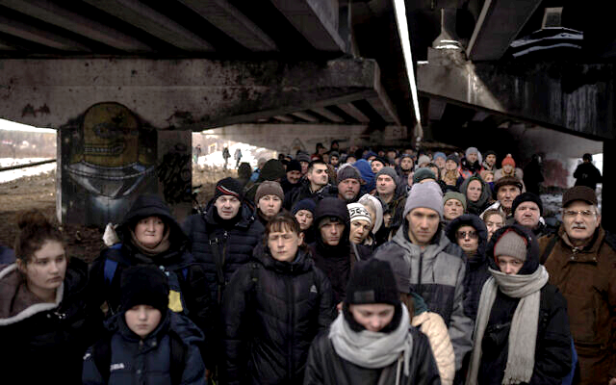
Ukrainians crowd under a destroyed bridge as they try to flee crossing the Irpin river in the outskirts of Kyiv, Ukraine, March 8, 2022. (AP Photo/Felipe Dana)
KYIV, Ukraine (AFP) — Desperate civilians fled besieged Ukrainian cities on Tuesday after Russia offered “humanitarian corridors,” as the number of refugees leaving the country since Moscow’s invasion passed two million.
Civilians boarded buses out of the northeastern city of Sumy, where 21 people were killed in airstrikes overnight, while others took an unofficial escape route out of the bombarded Kyiv suburb of Irpin.
But Ukraine accused Russia of attacking an evacuation corridor out of the beleaguered southern port city of Mariupol, where aid workers said tens of thousands were living in “apocalyptic” conditions.
Kyiv has branded the Moscow-offered corridors from four cities a publicity stunt as many of the exit routes lead into Russia or its ally Belarus. Both sides accuse each other of ceasefire violations.
President Vladimir Putin’s invasion has sparked fears of a wider European war, and unleashed the continent’s fastest growing refugee crisis since World War II as people flood across Ukraine’s borders.
Western allies have imposed sweeping sanctions on Moscow and poured in weapons to Ukraine, while oil giant Shell became the latest among scores of businesses to pull out of Russia.
Efforts to create a humanitarian corridor inside Ukraine to allow people safe passage from areas of heavy fighting fell apart Monday https://t.co/QBic8LUnR4 pic.twitter.com/PIS5iwh3N1
— Bloomberg Quicktake (@Quicktake) March 8, 2022
Ukrainian President Volodymyr Zelensky denounced what he called unkept promises by the West to protect his country, and renewed calls for a no-fly zone that leaders have so far dismissed.
“It’s been 13 days we’ve been hearing promises, 13 days we’ve been told we’ll be helped in the air, that there will be planes,” Zelensky said on a video broadcast on Telegram.
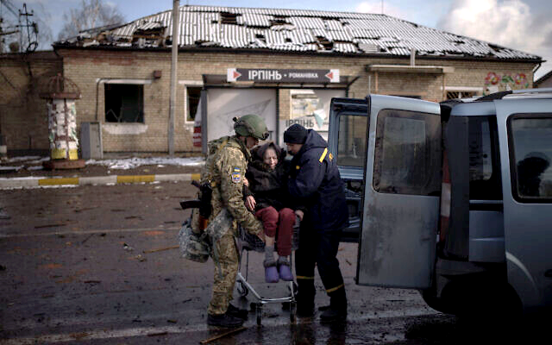
“But the responsibility for that rests also on those who were not capable to take a decision in the West for 13 days,” he added. “On those who have not secured the Ukrainian skies from the Russian assassins.”
Despite the sound of nearby shelling in Irpin, seen as a critical point for Russia’s advance on Kyiv, civilians fled in icy wind and a thick snowfall, AFP reporters saw.
People waited in a long line to cross over the Irpin river on makeshift walkways of planks and mangled metal, after the Ukrainians blew up the bridge leading into the capital to hamper any Russian advance.

A Ukrainian soldier helps an elderly woman who was being evacuated on a shopping cart from Irpin, in the outskirts of Kyiv, Ukraine, March 8, 2022. (AP Photo/Felipe Dana)
“I didn’t want to leave, but there’s nobody left in the homes around us, no water, no gas and no electricity,” Larissa Prokopets, 43, told AFP. She said she was leaving after several days spent “hiding in the basement” of her home, which kept “shaking” due to bombardment nearby.
Russia had refused calls for a humanitarian corridor in Irpin and the nearby suburbs of Bucha and Gostomel “although we had everything ready for this,” Ukrainian interior ministry official Anton Gerashchenko said.
Evacuations had however begun in Sumy, near the Russian border and 350 kilometers (218 miles) east of Kyiv, where Russia had formally declared a humanitarian corridor, officials said.
Dozens of buses had already left in the direction of Lokhvytsia, to the southwest, said the interim chief of the Poltava region, Dmitry Lunin. The corridor is designed to evacuate civilians, including Chinese, Indians and other foreigners, officials said.
The evacuation came after 21 people, including two children, were killed in Sumy when “enemy planes insidiously attacked apartment buildings,” Ukrainian rescue services said.
Ukraine also accused Russia of violating a ceasefire around Mariupol on Tuesday, describing it as “nothing other than a genocide.”
“The enemy has launched an attack heading exactly at the humanitarian corridor,” the defense ministry said on Facebook, adding the Russian army “did not let children, women and elderly people leave the city.”
The International Committee of the Red Cross said Mariupol residents faced “atrocious” conditions and were running out of food, water and medical supplies. “The bottom line today is that this situation is really apocalyptic for people,” ICRC head of media Ewan Watson said in Geneva.
Long lines of cars snaked out of the southern city of Mykolaiv, where sporadic shell fire could be heard. MORE - https://www.timesofisrael.com/ukraine-accuses-russia-of-attacking-humanitarian-corridors-as-civilians-flee-cities/ {The stories are sad to be sure. I would remember that the information from both sides is to be carefully evaluated and taken with a grain of salt. They all have great propaganda machines working . – rdb]

Putin's offer, Zelensky's dilemma: What is going on in negotiations between Russia and Ukraine?
According to sources privy to details about Bennett's trip to Russia, the negotiations are much more serious than what the West has been saying – and Zelensky faces a tough decision.
By BEN CASPIT/MAARIV Published: MARCH 8, 2022 16:44 Updated: MARCH 8, 2022 17:22
Three days after Prime Minister Naftali Bennett's meeting with Russian President Vladimir Putin in Moscow, the details are beginning to emerge. According to people who were privy to details about the meeting, the current situation is that Russia has offered a "final" version of its offer to end the crisis, which Ukrainian President Volodymyr Zelensky needs to accept or decline.
The proposal was deemed "difficult" but not "impossible," the sources said. It is worse than what Zelensky would have gotten before the invasion but "the gaps between the sides are not great."
Putin ordered his forces to halt – and the command for a ceasefire to be enacted was given – in order to wait for Zelensky's decision, the sources said.
If Ukraine's president rejects the proposal, French President Emmanuel Macron's assumption that "the worst is before us" is prone to happen. In that scenario, Putin will order his army to put the pedal to the metal and change the face of Ukraine.
Zelensky is torn, the sources said. On the one hand, he is enjoying immense popularity and has become the perfect Che Guevara. On the other hand, he knows full well what the Argentinian revolutionary and guerrilla leader's end was.
Zelensky can fortify Ukraine's independence but will have to pay a heavy price, the sources said. Assumptions are that he will be forced to give up the contested Donbas region, officially recognize the pro-Russian dissidents in Ukraine, pledge that Ukraine will not join NATO, shrink his army and declare neutrality. If he declines the proposal, the outcome may be terrible: thousands, perhaps tens of thousands of Ukrainians will die and there is a high probability that his country will completely lose its independence.
According to the sources knowledgeable about the content of the talks, Bennett's trip to Moscow was not meant to mediate between the sides and no arbitration proposal was officially offered. Rather, the trip was meant to get a sense of what Putin's position was, what his state of mind was and what his redlines were, and report them to the West.
The real negotiations, according to the sources, are happening directly between Russia and Ukraine and are much more serious than what the West has been saying. Kyiv has not shared with the West what has been going on in the negotiations since they do not want to damper the worldwide sense of emergency.
In reality, however, the Ukrainians know full well what Putin's demands are and they know they will have to make a dramatic decision in the coming days.
No one will pressure the Ukrainians, the sources said; the decision is Zelensky's.
One thing is certain, however: Putin is determined, and the growing complications since the invasion will not deter him. On the contrary, he cannot turn back, so the more the war becomes difficult and casualties mount, the more he will be pressured to show real achievements.
The impression is that, despite the fact that the predictions of a quick victory over the Ukrainian army have been proven false, Putin is as determined as ever. https://www.jpost.com/international/article-700677

Russian forces begin seizure of Ukraine's capital
In-depth: Before advancing deep into Kyiv, Russian forces are attempting to eradicate pockets of resistance on its outskirts, even at the cost of civilian lives; Ukrainian military sets up roadblocks in the capital to ambush encroaching Russian forces
Ron Ben-Yishai | Published: 03.08.22, 16:01
Russian forces have started seizing the Ukrainian capital of Kyiv from all sides on Monday as Moscow prepares to escalate its offensive on the southern neighbor.
In fact, many of the Russian forces have already reached the borders of the city's municipal territory, blocking the capital from the north and the west, all while keeping the southwest roads open.
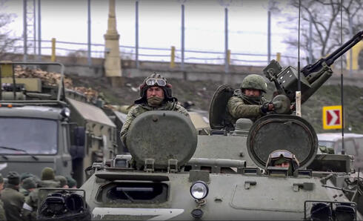
Russian forces making their way to Kyiv (Photo: EPA)
Russian army tanks, as well as anti-tank and infantry units, are all preparing to enter the city from the northwest.
Troops are concentrated at Antonov Airport near the city of Hostomel just outside Kyiv, inside the heavily-bombarded cities of Bucha and Irpin - where a humanitarian corridor was recently established.
The Russians have not yet taken these three cities completely, but they do have a significant troop presence there. Antonov Airport, where the Russians’ logistical center is located, is virtually a battlefield where Ukrainian and Russian forces clash on a regular basis.
It seems that Russian forces around these cities are preparing to enter Kyiv through route E373, which leads to the Podolsk neighborhood in the center of the capital.
Another force is approaching Kyiv through highway E40, which leads to the city’s center directly from the west. And while this force was slightly lagging behind, it has already reached Kyiv’s municipal border.
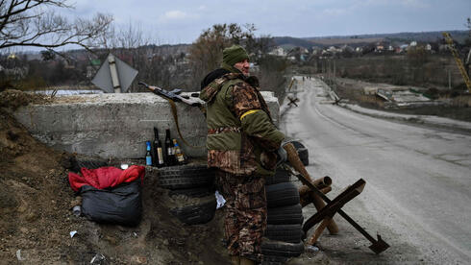
These are the forces that will most likely enter Kyiv first. They will most likely do so from the northwest and west in order to block the highway that enters the besieged capital from the north, along the Dnieper River.

A Ukrainian military checkpoint on the road to Kyiv (Photo: AFP)
The Russian forces threatening the eastern part of Kyiv, east of the Dnieper River, are much further away. They are closing in on the capital from the city of Chernivtsi in the northeast, from the city of Sumy in the east, and from the city of Kanib southeast of Kyiv - each is more than 100 km from the capital.
The Russians, on their part, are in no hurry. They work according to a Soviet military doctrine which focuses on combined-arms warfare as well as on operational warfare.
First, Russian forces fire heavy artillery, mostly on military installations but also on civilian neighborhoods, to prepare for future attacks - since they don’t favor wasting precise and expensive munitions on preparatory attacks.
By all indications, positions and strongholds established by the Ukrainian army and the Ukrainian militias all around Kyiv are viable targets for the Russian’s artillery, which tends to bombard these locations with imprecise fire which often damages civilian structures and kills fleeing bystanders.
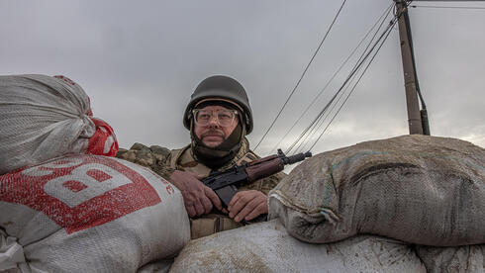
I saw the results of these preparatory attacks with my own two eyes only last Sunday, when eight civilians from Irpin, including several children, were killed while trying to cross a bombed-out bridge between the besieged city and Kyiv.

A Ukrainian militiaman in the outskirts of Kyiv (Photo: EPA)
War correspondent Itai Anghel witnessed a similar attack in northwest Kyiv, in which many Ukrainian soldiers were wounded. He also reported hearing gunfire, indicating that the Russians were less than a kilometer away from his position inside the capital.
But again, the Russians are in no hurry. They prefer that the population and the defenders, who are in the open positions needed to launch anti-tank missiles, all flee before they move into the capital - partly due to a justified fear of ambushes inside the city.
To the east and south of the city, the areas from which the Russians are still far away, the artillery fire is sporadic. It seems that in those areas the Russians are mainly trying to block the main traffic routes and then move along them until they encircle the eastern side of Kyiv.
Territories already occupied by the Russians, in cities northeast of Kyiv's urban area, a military administration is immediately enforced by Russian Interior Ministry forces.
In Kyiv proper, the people act as if the Russian siege has already begun.
The Ukrainian army and the Kyiv municipality are placing more and more anti-tank checkpoints and prefabricated concrete slabs in the streets, all in order to delay and slow the encroaching Russian tanks and make them easy targets for RPG fire and incendiary bombs.
There is also a lot of activity in the diplomatic arena, albeit with very few results.
On Monday there was another meeting between the Russian negotiating team and the Ukrainian one in Belarus. Just like the two prior rounds, there are no tangible results on the horizon.
Russian and Ukrainian negotiation teams meeting in Belarus for a third round of ceasefire negotiations
Moscow has four main demands for a ceasefire.
The first is that the Ukrainian army lay down its arms. The Kremlin stated that the moment Ukrainian forces cease fighting, the Russian army will do the same.
The Ukrainians meanwhile, claim that Russian forces failed to adhere to such past promises. Adding that the Russians continuously target both Ukrainian armed forces and civilians despite declaring a “ceasefire.”
The second is that the Ukrainian government introduce an amendment to the state constitution that prohibits Ukraine from entering into a military alliance with any other country - i.e. NATO.
The third demand is that the Ukrainian government recognize the separatist provinces in the Donbas region - while the fourth demand is that Kyiv recognize Russia's sovereignty over the Crimean peninsula.
The Ukrainians, for the time being at least, have refused these demands, though they keep the diplomacy option open.
Meanwhile, the siege of Kyiv is likely to take place soon, albeit very slowly. The Russians want to minimize casualties among their own troops, as well as among Ukraine's civilians, whom Putin called “an integral part of the Russian people.” https://www.ynetnews.com/magazine/article/hy1ax2e11q [This account is a bit different than that which we have heard on the MSM and other reports. I also have seen a video of a lady in the area who states that much of the shelling on buildings and some of the casualties is coming from Ukrainians who are indiscriminately firing at people. – rdb]

Zelensky says he spoke with Bennett, thanks him for mediation efforts with Russia
Leaders ‘discussed ways to end the war and violence’; emotional Ukrainian ambassador describes harsh situation in Kharkiv, asks Israel for help
By TOI staff Today, 5:11 pm
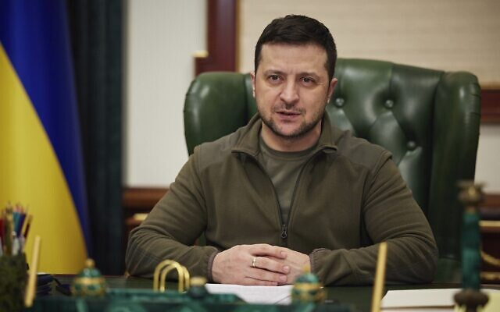
In this photo provided by the Ukrainian Presidential Press Office, Ukrainian President Volodymyr Zelensky addresses the nation in Kyiv, Ukraine, March 7, 2022. (Ukrainian Presidential Press Office via AP)
Ukrainian President Volodymyr Zelensky said Tuesday he’d spoken to Prime Minister Naftali Bennett and thanked him for his efforts to mediate between Moscow and Kyiv.
In an English-language tweet, Zelensky said that the two “discussed ways to end the war and violence.”
He did not mention when the call took place. There was no immediate comment from the Prime Minister’s Office.
This would be at least the fifth call between the two leaders since Russia’s invasion began on February 24.
The Kremlin said Tuesday that Bennett had also spoken to Russian President Vladimir Putin again to discuss the situation in Ukraine, which would be the second phone call between the leaders since Bennett’s trip to Moscow on Saturday.
The PMO has yet to release a statement on either call.
The Israeli premier visited Moscow for a meeting with Putin on Saturday, trying to help broker an end to the war with Ukraine. After meeting with Putin, Bennett spoke to Zelensky and French President Emmanuel Macron, and also visited Berlin on Saturday for talks with German Chancellor Olaf Scholz. Bennett also spoke to Putin by phone on Sunday.
Israel has had an up-and-down relationship with Ukraine since the start of Russia’s invasion on February 24. Zelensky reached out to Bennett early on, urging him to make use of Israel’s working relations with Kyiv and Moscow to mediate between the sides. MORE - https://www.timesofisrael.com/zelensky-says-he-spoke-with-bennett-thanks-him-for-mediation-efforts-with-russia/

Russia publishes an official list of states it deems 'unfriendly' to it
Russian citizens and companies must apply for a special permit to deal with "unfriendly" foreign entities.
By MICHAEL STARR Published: MARCH 7, 2022 13:52 Updated: MARCH 8, 2022 16:54
A list of foreign states that Russia considers as having committed "unfriendly actions" against "Russia, Russian companies and citizens" was published on the Russian government's website on Monday.
The countries, international organizations and territories considered "unfriendly" include: "Australia, Albania, Andorra, United Kingdom, including Jersey, Anguilla, British Virgin Islands, Gibraltar, the member states of the European Union, Iceland, Canada, Liechtenstein, Micronesia, Monaco, New Zealand, Norway, Republic of Korea, San Marino, North Macedonia, Singapore, USA, Taiwan, Ukraine, Montenegro, Switzerland, Japan."
Russia lists Taiwan as being part of China.
A complementary item of legislation from Sunday states that Russian citizens and companies must apply for a special permit to deal with "unfriendly" foreign entities.
The list was created as part of a series of laws to follow a Saturday decree by Russian President Vladimir Putin for "temporary economic measures to ensure the financial stability of the Russian Federation."
Part of the measures the list was to enforce was the law that allows Russian citizens, companies and state bodies to pay back foreign creditors in rubles.
While Israel has publicly condemned Russia for its invasion of Ukraine, it was not included on the list.
Israel has taken on a mediation role during the conflict, seeing Prime Minister Naftali Bennett flying to Moscow on Saturday to speak with Putin. https://www.jpost.com/international/article-700559

Maria Baronova fears ‘we’re on the brink of a nuclear war’ after quitting Russian state-run media over Ukraine
‘I wouldn’t lose my salary and job if I was sure that we are going to be alive for many years,’ Baronova told Fox News Digital
By Brian Flood | Fox News Published March 7, 2022 1:07pm EST
EXCLUSIVE – Maria Baronova resigned as a managing editor of Russia Today, a state-run media operation also known as RT, last week after condemning Russian President Vladimir Putin’s invasion of Ukraine. She’s well aware that anyone who speaks out against the Kremlin could be in danger – but personal safety is the least of Baronova’s concerns.
"The problem is, I know these people very well. They never send threats, they just kill, so there is kind of [a] weird silence around me, but I really think we’re on the brink of a nuclear war right now. I’m not exaggerating," Baronova told Fox News Digital from Moscow, via a WhatsApp call.
"I have a son, I can’t leave because his father won’t allow me to leave with him, and so I just prefer to stay in Moscow … It seems like we’re either in North Korea or we are going to be killed by a thermonuclear mushroom," she said. "I wouldn’t quit, and I wouldn’t lose my salary and job if I was sure that we are going to be alive for many years, but I really don’t know what is going to happen to all of us next."
RT managing editor on Tuesday Maria Baronova resigned after publicly condemning Russia’s invasion of Ukraine. (Photo by Mikhail Svetlov/Getty Images)
While many around the globe are gravely concerned Putin would resort to nuclear weapons, Baronova is worried his behavior will make Russia the target of a catastrophic attack.
"I suspect the Western world will use it," Baronova said. "This is a very dangerous situation."
The blunt Baronova agreed to talk to Fox News Digital until her son’s food was ready. She explained that the last straw before quitting RT wasn’t any sort of on-air propaganda, but rather an Instagram message from her colleague who wrote, "If you are now ashamed of being Russian, don’t worry, you are not Russian," as Putin’s invasion of Ukraine intensified.
"I was really disturbed by that tone and level of support," Baronova said, noting that she publicly responded to her now-former coworker’s message.
"If I chose to be with Russia, this does not mean that I should walk in a totalitarian system, be silent or, for example, rejoice that the regime, which I do not want for my country, is being exported somewhere else," Baronova wrote. "And this regime will finally turn our life into one endless hell. What's there. Already turned."
Baronova then stepped down from the state-run network.
"That was the moment I decided, ‘OK, that’s it,’" she said.
Baronova said she hasn’t garnered much support from fellow Russians since leaving RT and is seen as an opposition activist. But this isn’t the first time Baronova found herself in the public eye for opposing Putin’s regime.
She was featured in a 2012 New York Times piece headlined, "A Face of the Russian Protest Movement," that detailed the time she was charged with inciting a riot while protesting Putin winning a third term. In 2014, Rolling Stone said she was "for a short while, one of the most visible protesters in Moscow," in a piece that detailed anti-Putin activism led by the punk band Pussy Riot.
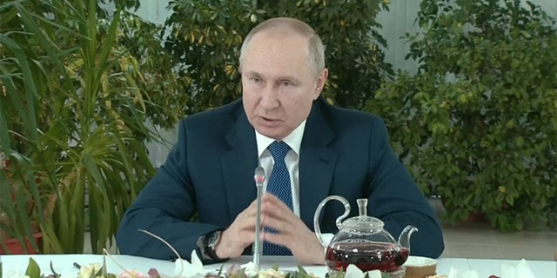
Her life was upended after the arrest and she eventually went to work for Dozhd, Russia’s top independent TV channel which is also known as TV Rain and famously critical of Putin.
Baronova, who was by then a single mother, jumped ship to RT in 2019, irking fellow Putin oppositionists who felt she was abandoning the movement by joining state-run media.
"People felt betrayed when I decided to join RT," she said. "But I decided on purpose in order to have a reasonable conversation with people who are in power right now in Russia."
Russian President Vladimir Putin spoke to female flight attendants in comments broadcast on state television on Saturday, March 5, 2022. (Reuters Video)
Last week, Russian authorities accused TV Rain of peddling "false information regarding the actions of Russian military personnel as part of a special operation" in Ukrainec, and Baronova’s prior network was promptly forced off the air as Putin purged non-state media.
Baronova's two previous employers have suffered different fates over the past few days, as RT remains on air and has echoed Putin’s message throughout the Ukraine invasion.
Baronova, who was the managing editor of RT’s Russian language unit, said she wanted to bring positivity to the state-run outlet and much of her responsibilities focused on covering problems with social institutions. Baronova said she also spent much of her time at RT working on a fundraiser for mothers of children with cerebral palsy, and she was largely kept out of conversations regarding which Kremlin talking points would be spouted by the outlet despite her managing editor title.
Roughly three years after joining the state-run news organization with hopes of forcing change, the activist-turned-journalist had seen enough after Putin’s ruthless attack on Ukraine that was supported by many of her now-former RT colleagues.
"I have nothing else to talk about with them," she said. "Our own government is bombing our relatives, our friends."
Baronova feels many Russians are "brainwashed" and some even buy Putin’s claim that the attack was needed to help "denazify" Ukraine, which the Kremlin has insisted was the true aggressor. Putin has claimed he wants to purge Ukraine of fascism; such messages, experts have told Fox News Digital, are appealing in Russia since loathing for the defeated Nazi Germany regime runs deep.
"I try to talk with people on the streets… they even had arguments like, ‘We are fighting with Hitler,’ but look, I’ve got some news. Hitler died 80 years ago," she said. "It seems like they’re really brainwashed."
Putin has cracked down on non-state news since the invasion of Ukraine began, with social media platforms and independent news operations forced to shut down for refusing to parrot propaganda. Some locals don’t mind that Putin has silenced non-state media and a Moscow taxi driver even told Baronova the now-shuttered TV Rain was filled with "traitors" who opposed the Kremlin.
"A lot of people have these kind of sentiments," she said.
Despite Putin’s attempt to control messaging related to the Ukraine invasion, Baronova is baffled that people still buy into his narrative when accurate information can be found by anyone eager to find it.
"We have internet like everybody else in this world, and you can’t hide information from people in the era of the internet, so I don’t understand how they can be brainwashed. How can they be saying that Russia is fighting with Hitler collaborators in Ukraine when Hitler died 80 years ago? But they really have these kinds of conversations," Baronova said, noting that some Russians have begun to open their eyes because of sanctions and American companies pulling out of the nation.
"People were in favor on [the] first day of invasion. Now they are less convinced and much more skeptical because they understand now that they are going to lose their jobs, they are going to lose their cars, their iPhones, their everything," she said. "So, let’s see what that are going to say in a month ... The whole world is in a bad position."
Painting a bleak picture, Baronova said it feels like 1945, the final year of World War II before quickly correcting herself.
"Probably more like 1939," she said, referring to the year that World War II began. "It is really pointless to predict anything … We are watching a lie on my TV."
Suddenly, Baronova had to go, as her son’s meal was ready – she told him to please put down his phone and eat. Before hanging up, she had one final message for Americans.
"Russians love their children, too," she said. "Stay safe. Everybody, stay safe." https://www.foxnews.com/media/maria-baronova-russia-today-nuclear-war

Russia makes new claims on US-financed biolabs in Ukraine
The US has “covered” Ukraine with a network of biolaboratories linked to the Pentagon, the Russian Defense Ministry says

FILE PHOTO: Commander of the Russian radiological, chemical and biological defense force, Lieutenant General Igor Kirillov, speaks in Moscow, Russia, on February 23, 2022. © Sputnik / Aleksey Kudenko
7 Mar, 2022 18:33
The Ukrainian authorities have been urgently destroying pathogens studied at its laboratories linked to the US Department of Defense, the Russian military claimed on Monday, adding that such activities hint at the military purposes of these studies.
As many as 30 biological laboratories have been established in Ukraine that are actively cooperating with the US military, the commander of the Russian radiological, chemical and biological defense force, Lieutenant General Igor Kirillov, said at a news briefing on Monday.
The list of these laboratories’ partners includes the Pentagon’s Defense Threat Reduction Agency (DTRA) and the Walter Reed Army Institute of Research (WRAIR) – the largest biomedical research facility administered by the US military; the general added.
Many of these laboratories have been active since the 2014 coup d’état in Ukraine and their emergence in the country has coincided with a spike in infectious diseases in the region, including German measles, diphtheria and tuberculosis, the Russian military said.
After the Russian forces launched a military operation in Ukraine on February 24, these laboratories started hastily destroying the materials they had been working on, including the highly pathogenic bacterial and viral agents, Kirillov has said, adding that Moscow has obtained documents related to that process.
Analysis of the documents shows that the laboratories had been working with dangerous infections such as anthrax and the plague. “Assortment and the excessive quantity of the biological agents suggest that the work done in these laboratories had been part of some military biological programs,” the general has said, adding that just one such laboratory in the western Ukrainian city of Lvov had destroyed as many as 320 containers with pathogens causing plague, swamp fever and Malta fever among others.
“If these collections fall into the hands of the Russian experts, they will highly likely prove Ukraine and the US have been in violation of the Biological Weapons Convention,” Kirillov has said, adding that “this is the only reason that can explain the hasty destruction” of those materials.
The general has also expressed his concerns that all the biological materials needed for the alleged military biological program to continue had been already transported to the US.
Kiev has denied developing bioweapons, and Washington has not commented on the Russian military statements so far.
Moscow has been raising alarm about the activities of the US-financed biological laboratories located in the former Soviet states for quite some time. Earlier, it pointed to the Lugar Research Center – a US-funded laboratory in Georgia – as a place where some dangerous experiments are being conducted.
The Pentagon brushed off such accusations as a “Russian disinformation campaign” at that time. https://www.rt.com/russia/551440-ukraine-us-financed-biolaboratories/ [Considering the situation of the NIH “and friends” and Wuhan there is no reason to believe that these labs aren’t in Ukraine as well. The DOD and the NIH have obviously been working on bioterrorism for some time. – rdb]

'We will never go back to Ukraine': DPR fighter jailed for his views by Kiev talks to RT
An interview with a pro-Russian DPR militant from Odessa
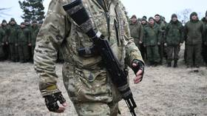
Mobilized citizens of Donetsk People's Republic (DPR) stand in formation in the town of Novoazovsk, Donetsk People's Republic. © Sputnik/Ilya Pitalev
7 Mar, 2022 12:20
With the military operation taking place in Ukraine, some might ask – how will the locals react? Eight years ago, the general consensus was that the southern and eastern regions were pro-Russian, but then the Kiev regime started to brutally repress activists who wanted closer ties with Moscow. An aggressive war propaganda campaign was launched targeting Russia.
RT spoke about this with Vladislav Dolgoshey, an activist from Odessa who spent four years in jail after being charged with “pro-Russian subversive activities” without any proof. In 2019, he was released as part of a prisoner exchange. After this interview, Vladislav went to the frontline as a volunteer and joined the People’s Militia of the Donetsk People’s Republic.
— What was your path to your pro-Russian political views?
I wouldn’t call my political views pro-Russian, they are just Russian. You have pro-Russian views when your position on certain issues reflects that of Russia as a state. I consider myself Russian – ethnically, spiritually, nationally. Yes, I was born in a different country, foreign to Russia, but that’s just my circumstances.
My views were shaped by my surroundings. Odessa is still the most Russian city in Ukraine. The Russian language is absolutely predominant, and even Ukrainian nationalists complain that when a Ukrainian comes to Odessa, they start speaking Russian. And the residents are very protective of their Odessa identity. That facilitates assimilation.
My upbringing also played its part. My father was a pro-Russian politician, but, to his credit, he never imposed any of his views on me, just recommended reading books. I read books written by Ukrainian, Polish, and Russian historians.
— How did the Russian movement in Odessa react to the Euromaidan events?
The situation wasn’t great for us in 2014. President Yanukovych didn’t like the Russian movement very much, and this was his attitude to both nationalists and Orthodox activists. Despite this, more and more people joined our events every year. And these were very diverse groups – nationalists, Orthodox Christians, leftists, all united by one idea – their Russian identity.
Our reaction to the Euromaidan events was negative from the very beginning. First of all, we knew who was behind it. We understood which side Euromaidan turned to and knew for a fact that the West was not the political community we wanted to belong to.
We began to form militia units in February, but we were too late. Maidan had already happened, it had its hit squads and money. We acted fast, like in that saying about Russians taking their time to prepare for something but then moving fast. But we still were unprepared for what was to come. Russians are kind people. We had no idea something like the tragic events of May 2 could really happen. (Ukrainian nationalists murdered 50 pro-Russian demonstrators in the Trade Unions House during the protests. Vladimir Putin promised to find and punish the perpetrators in his 21st February speech — RT.)
The leaders kept saying that it was a peaceful protest, just people defending their rights and fighting for democracy. But once the West comes, there can be no democracy. All pro-Western revolutions were not about democracy – their goal was to create a corrupt system of colonial control. Democracy is something the West wants only for itself. And the West turned Ukraine into an unstable structure vulnerable to outside influence.
— What’s changed after the May 2 tragedy?
There were some legal political activities allowed by the Kiev regime. They were carried out by old people with Communist and religious views. But Ukrainian radicals had the nerve to attack even these grandmas and grandpas. Many healthy strong men went to the frontline, to the Donbass. Of course, not everybody made it. 100-150 inmates would be incarcerated in the Odessa jail at a time – these people were arrested as they tried to make their way to the Donbass.
There were also underground groups operating in Odessa and the Odessa Region. The indictment against me – and I would like to stress that the charges have never been proven – said that the allegedly sabotage unit under my command perpetrated terrorist attacks and sabotage activities across several regions in the southeast of Ukraine. The underground movement existed for around 18 months, engaged in this invisible struggle. Trust me when I say that 18 months is a really long time for an underground movement with no experience, no bases and no resources.
— Why have there been no tragedies comparable to the Odessa one in other cities across the southeastern part of the country?
You have to understand that Odessa was a stronghold of the pro-Russian sentiment in Ukraine. We’ve always been very vocal about it, and even now our people are not happy about the Ukrainian government. There are rumors that the current mayor of Odessa, Gennady Trukhanov, has a Russian passport and actually holds pro-Russian views. I don’t think these rumors are true, even though Trukhanov did make a speech at Kulikovo Pole Square not long before May 2 happened. So, in this period, between the Euromaidan winning and the tragedy, he was on our side. Then he made a U-turn, which is pretty typical of politicians.
Moreover, not many people know that they used force to crush pro-Russian movements in other Ukrainian cities as well. Take Zhitomir. Nothing like May 2 happened there, of course, but Zhitomir is not Odessa – it’s closer to the western part of the country. It was bad in Kharkov, and in Nikolayev they burned a makeshift camp. But it wasn’t on camera and the media didn’t cover it, though it was a real struggle, a street war and there were casualties.
To give you a better idea of what was happening, I can tell you that one Euromaidan supporter who later became part of the Azov Battalion (forbidden in the Russian Federation) claimed that even the war was less scary than Kharkov in 2014. You never knew what direction you could be hit from, you were always on the lookout for a sneak attack. It was the same in Odessa. We had a literal war in the streets, with cars and houses set on fire. People were being killed, some went missing. That was the civil war – it was back then.
— So why did the ideas of the ‘Russian Spring’ fail to triumph in most of the Ukrainian southeast in 2014?
They didn’t fail in 2014. The ‘Russian spring’ ended in 2015, after Minsk II. Until then, even though there were no military hostilities and no frontlines, hundreds and thousands of people were politically active and involved in the underground movement in Odessa and other places. It’s obvious if you look at the sheer number of political prisoners in Ukraine that were later swapped for POWs.
Why did the frontlines end up being in Donetsk and not in Odessa or Nikolayev? Easy – it’s all about the location. Luckily for Donetsk, Russia can supply it with water, energy and humanitarian aid. Volunteers also had no trouble getting there. This was not the case for Odessa. Yes, we’re close to the pro-Russian Transnistria, but it lacked the resources to support the Odessa Region. The local militia wouldn’t have stood a chance.
Still, a fulltime rebellion could’ve gone ahead. We stormed and seized the regional authorities building after all – the same as in Donetsk and Lugansk. But our ‘wise’ politicians – who are pro-Russian, but not Russian – told us to leave and refrain from storming the SBU HQ and avoid provocations. I won’t comment on how pro-Russian I personally think they are.
So let’s imagine Odessa had followed in Donetsk’s footsteps. The Odessa region would have been cut off and left without water or energy supply. It would be simply impossible to resolve these problems. That’s the reason the rebellion didn’t happen, even though an attempt was made. That’s why some Odessa residents went to Crimea when the Crimean Spring began, then on to the Donbass. They went wherever there was armed resistance. They wanted to fight. Not everyone is suited to stealthy underground activities.
— Many Russian-speaking residents of Ukraine’s southeast (primarily, siloviki – law enforcement and security officers) supported the Euromaidan. Is it possible that they did not see the threat?
Ukrainian siloviki are public servants. They are completely devoid of personal political opinions. They talk about their love of Russia when sitting in their own kitchen, drinking vodka with friends. And, by the way, we have seen some of these people, Ukrainian siloviki, arrested, imprisoned, and discharged from service for the things they had said in their homes. But most of them were simply not interested in politics. They didn’t care who was in power. And they realized that nothing would change for most of them – they would be treated by the state the same as before. And they were right – just a year later the Ukrainian siloviki were suppressing a new Maidan protest.
— Are the Donbass republics really determined to fight for the choice they made back in 2014 till the last?
I believe that the people of the Donbass are absolutely determined to do that. For eight years, we have lived expecting war to break out at any moment. Some people might be expecting peace, perhaps, or the implementation of the Minsk Accords. But the majority have been expecting war, which would settle the Ukrainian issue once and for all. When people in Donetsk say that there will be a war, they usually say it with a smile. They are not afraid, there is no panic. War has been there for eight years already and they don’t care if it intensifies a little (or even more than a little). These people are firm in their belief that reunification with Russia is their ultimate historic mission and they will pull through.
— How do you think the Russian Armed Forces or pro-Russian militias will be met in the southeastern regions of Ukraine and Odessa?
Let me tell you a historical anecdote dating back to the time of the Russian Civil War. When the allied troops of the Triple Entente withdrew from Odessa, local residents greeted both the Whites and the Reds with flowers. You see, the people of Odessa are part of the Russian nation – they have Russian roots in them. I am absolutely certain that the local population will greet any Russian troops with flowers. Moreover, I am sure that the men of the Donbass will voice their support by sabotaging the SBU, by launching attacks in the enemy rear. And this would be appreciated the most.
— Is a pro-Russian political movement possible in an independent Ukraine?
No way. All the opinion leaders and those who spearheaded the Russian uprising in 2014 are either dead or in Donetsk and Russia. There are no pro-Russian political forces left in Ukraine, either. However, prior to 2014, we used to have the Russian Bloc in Crimea and the Rodina party in Odessa. There are still some local, decentralized political groups, of course. But the Ukrainian authorities will never allow any big-scale political movement.
— We have seen a massive crackdown on pro-Russian activists, as well as Ukrainization efforts in the southeastern regions of Ukraine over the past eight years. Can we even talk about the Russian national identity left in those parts of Ukraine?
You see, the overwhelming majority of today’s residents of Ukraine and Russia, or at least their parents, were born in the Soviet Union. And you are aware that Russian national identity was never displayed in that country. Moreover, the USSR would never compete against modern Ukraine in terms of propaganda effectiveness and imposing political views on its citizens. But the Russian national identity has survived despite all this.
Russian people will always remain Russian. There will be traitors, of course. There always are. But the majority of people, the salt of the earth, will remain Russian, no matter how much Ukrainian propaganda is poured down on them. Unfortunately, in today’s Ukraine, you can only be Russian until the state takes notice of you.
— Has there ever been a chance of Ukraine fulfilling the Minsk Agreements?
There have been two grave mistakes in the history of the two republics. The first one was made in 2015, when Ukraine made it abundantly clear that it was not going to stick to the Minsk Accords. That’s when we should have struck. The Minsk Accords effectively served as an act of Ukraine’s capitulation. It is such a pity that we missed that opportunity to press on. The second mistake was to believe that Ukraine would ever agree to a peace treaty with the Donbass. The West would never stop nudging Ukraine towards war.
And from the Donbass’ viewpoint, I can assure you that no one there will ever ask to be taken back by Ukraine. It’s not for that that the blood and sweat of the Donbass people have been shed for eight years in attempts to defend their choice. Perhaps, some people would have agreed to that eight years ago, but not now. We have a different mentality, you see, but there used to be a bond tying us to that country. A bond that has been severed.
By Dmitry Plotnikov, a political journalist exploring the history and current events of ex-Soviet states https://www.rt.com/russia/551211-dpr-militant-ukraine-interview/ [This is long but gives some excellent insights into the thinking of a substantial segment of the population of Ukraine who feel they are Russian and not Ukrainian and they view the West as the culprit in the denigration of the land. If you are informed and truly honest you have to agree that the West including the US has undermined and manipulated the activities of many nations around the world for their own purposes. – rdb]

US earmarks $5.5 million for Israeli, Palestinian businesses, female entrepreneurs
Citing skittishness by participants, USAID program administrator declines to name trade associations contracted to distribute grant money from Partnership for Peace Fund
By Tal Schneider Today, 8:39 pm
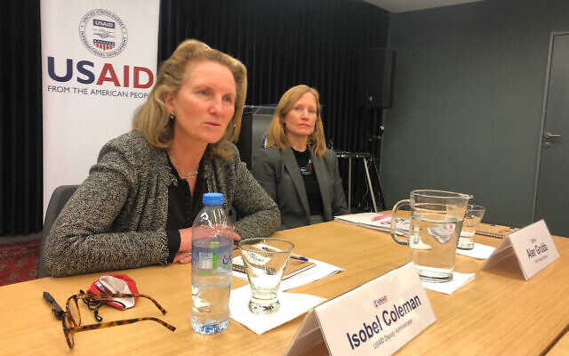
USAID deputy administrator Isobel Coleman speaks to reporters at the US Embassy in Jerusalem, on March 8, 2022. (Tal Schneider/The Times of Israel)
Israeli and Palestinian trade associations will receive millions of American aid dollars to boost cross-border partnerships, but their names will remain confidential, with some potential participants apparently nervous about the joint project.
US Agency for International Development Deputy Administrator Isobel Coleman announced the grants from Jerusalem during a visit there Tuesday.
The aid money, to be given under the Middle East Partnership for Peace Act (MEPPA) Partnership for Peace Fund, will aim to “build partnerships, increase economic growth, and lay the foundation for peace through people-to-people programs,” according to a USAID statement.
Initially, $3.3 million will be distributed to supporting women entrepreneurs, and another $2.2 million will be funneled to small and medium-sized businesses in Israel and the Palestinian Authority interested in collaboration.
To distribute the grants to businesses, the MEPPA Fund will operate through a Palestinian trade association and an Israeli counterpart.
Coleman declined to name the trade associations, noting that businesses were reluctant to have their participation in the program publicly disclosed.
“We’re not actually disclosing the names right now,” she said at a press conference with Israeli and Palestinian journalists. “There are many businesses that are reluctant to engage in this. And so we’re allowing the trade associations some space and some time for them to to get comfortable with that.”
It was unclear if the associations would be disclosed at a later date.
Some Palestinians consider business relationships with Israel taboo and companies may fear a negative backlash if identified as part of the project.
Coleman indicated that the grants would be open to businesses from a wide range of sectors, which would be determined by the trade groups.
The other grant project will allocate support and training funds to businesswomen. The project will focus on training, seed funding, and connecting grantees with veteran entrepreneurs to mentor them. Money will also go to providing business training to young women not already in the field.
Congress created the MEPPA in December 2020 to support Israeli-Palestinian coexistence projects, earmarking $250 million for the scheme. Decisions on how to allocate the funds are made by an advisory panel chaired by George Salem, a Palestinian-American attorney who filled roles in the Reagan and Bush administrations. Later, he was a foreign policy adviser on Republican presidential nominee Mitt Romney’s campaign. [is this beginning to smell BIT FISHY? I think so. We have people living in the streets, We ‘can’t afford to” build the wall and protect our citizens but we can dole out money everywhere even when our national finances are in shambles. Evil and wicked. – rdb]
US ambassador to Israel Thomas Nides has pledged to advance MEPPA projects from Jerusalem, reversing the previous administration, which cut funds to Palestinians, including for coexistence projects.
Aside from the MEPPA, the Biden administration has renewed the Economic Support Fund, which allocates $75 million annually to aid Palestinians in the West Bank and Gaza. The money is slated to go to World Food Program projects, various NGOs, East Jerusalem hospitals, sanitation work, and boosting the private sector, but the fund has yet to distribute any grant money. https://www.timesofisrael.com/us-earmarks-5-5-million-for-israeli-palestinian-businesses-female-entrepreneurs/

Iran’s Revolutionary Guard launches 2nd satellite, state media reports
IRNA says Noor-2 spacecraft blasted off from Shahroud Desert and reached a low Earth orbit, but doesn’t say when
By Amir Vahdat and Jon Gambrell Today, 10:56 am
TEHRAN, Iran (AP) — Iran’s paramilitary Revolutionary Guard launched a second satellite into space, state media reported Monday, just as world powers awaited Tehran’s decision in negotiations over the country’s tattered nuclear deal.
State television identified the launch as taking place in its northeastern Shahroud Desert, without specifying when. However, it came as Iran’s top diplomat at the monthslong talks suddenly flew home late Monday for consultations, a sign of the growing pressure on Tehran as the negotiations appear to be nearing their end.
The Guard said the Noor-2 satellite reached a low orbit of 500 kilometers (310 miles) above the Earth’s surface on the Ghased satellite carrier, IRNA reported. It described the Ghased as a three-phase, mixed fuel satellite carrier.
The Guard did not immediately release photos or video of the launch.
US officials did not immediately respond to a request for comment and an American-maintained catalogue of space objects did not note a new Iranian launch this month. The launch comes days after satellite pictures suggested Iran’s civilian program suffered another failed launch.
Noor means “light” in Farsi. The Guard launched its first Noor satellite in 2020, revealing to the world it ran its own space program.
The head of the US Space Command later dismissed that satellite as “a tumbling webcam in space” that wouldn’t provide Iran vital intelligence — though it showed Tehran’s ability to successfully get into orbit after a series of setbacks.
The US has alleged Iran’s satellite launches defy a UN Security Council resolution and has called on Tehran to undertake no activity related to ballistic missiles capable of delivering nuclear weapons.
Iran, which long has said it does not seek nuclear weapons, previously maintained that its satellite launches and rocket tests do not have a military component. US intelligence agencies and the International Atomic Energy Agency say Iran abandoned an organized military nuclear program in 2003.
Meanwhile, Iran’s state-run IRNA news agency described negotiator Ali Bagheri Kani’s trip home as being “within the framework of the usual consultations during the talks.” However, the top negotiator for the European Union seemed to suggest whether the talks succeeded or failed now rested with the Islamic Republic.
“There are no longer ‘expert level talks.’ Nor ‘formal meetings,’” Enrique Mora wrote on Twitter, responding to comments by an Iranian analyst. “It is time, in the next few days, for political decisions to end the (hashtag)ViennaTalks. The rest is noise.”
Mora’s comments mirror those of British and French negotiators at the Vienna talks, which has been working to find a way to get America back into the accord it unilaterally abandoned in 2018 under then-president Donald Trump. It also hopes to get Iran to again agree to measures that drastically scaled back its nuclear program in exchange for the lifting of economic sanctions.
They also appear to push back against a constant Iranian refrain in the last weeks of talks that tried to blame any delay on America, which hasn’t been in the room for talks since Trump’s withdrawal. US Secretary of State Antony Blinken on Sunday said he believed “we’re close” on reaching a deal, though there were “a couple of very challenging remaining issues.”
The latest wrinkle, however, is a demand Saturday from Russian Foreign Minister Sergey Lavrov that Blinken offer written guarantees over Moscow’s ability to continue trade with Iran as it faces sanctions over its war on Ukraine.
Iranian Foreign Minister Hossein Amirabdollahian spoke Monday by phone with Lavrov, with the sanctions threat apparently discussed, according to a statement from his office.
“We are against war and imposition of sanctions, and it is clear that cooperation between the Islamic Republic of Iran and any country, including Russia, should not be affected by the atmosphere of sanctions,” Amirabdollahian said in the statement.
The 2015 nuclear deal saw Iran put advanced centrifuges into storage under the watch of the International Atomic Energy Agency, while keeping its enrichment at 3.67% purity and its stockpile at only 300 kilograms (661 pounds) of uranium.
As of February 19, the IAEA says Iran’s stockpile of all enriched uranium was nearly 3200 kilograms (7,055 pounds). Some has been enriched up to 60% purity — a short technical step from weapons-grade levels of 90%. https://www.jpost.com/international/article-700677

Worries surge about next target as social media blacks out Russia
'It's impossible not to look at that and think it won't happen to others'
By Bob Unruh Published March 8, 2022 at 12:08pm
Social-media corporations jumped into action when Russia invaded Ukraine, essentially deplatforming Russian interests to restrict their messaging.
The judgment was that Russia information was bad, so it was a good thing to restrict it.
But conservative interests watched the cancellation machinery working its abrupt action and wondered what would stop that same process from being used again against another target, which may not, in fact, deserve such censorship.
"We're seeing Russia being globally deplatformed across the board, and so it's impossible not to look at that and think it won't happen to others in America and elsewhere," Dan Gainor, vice president at the Media Research Center, a media watchdog that tracks censorship on Big Tech platforms, told the Washington Examiner.
He pointed out the complete absence of a standard for such decisions.
"A group of people, the global mob, have decided to target Russia, but they're fine with genocides in China. How is that acceptable? There are no rules, and the few that exist keep changing,” Gainor said.
He pointed out further that such censorship wasn't imposed even when Russia previously invaded other regions, and other nations have inflicted violence on others without similar consequences.
The Examiner explained, "Russia’s attack on Ukraine is one of the first major full-scale military invasions of another country in the age of social media, where online platforms are used by billions — and where a separate war is waged online by governments trying to shape alternative narratives."
The report said two "anti-Ukrainian disinformation operations" that were cut off were tied to "a Russian propaganda news outfit created to make Ukraine look like a failed state by using fake Facebook profiles."
Social media business interests are cooperating "in trying to curb Russian disinformation regarding what is happening in Ukraine due to pressure placed on them by users and government officials around the world," the report said.
But such restrictions – by Facebook, TikTok, Twitter, YouTube and others – alarmed not only conservative observers, but also Republicans in Congress, the Examiner reported.
"In a very limited way, the tech companies should squash Russian disinformation, but they’re now public utilities that are essentially extended realms of the government, which gives me pause," said Rep. Andy Biggs of Arizona.
"I have a dubious, skeptical eye on what the tech companies have chosen to do, which is part of why we need to revisit the laws around tech legal shields," said Biggs.
He openly wondered why similar responses weren't created by tech companies to violence in China and Africa.
"The censorship decisions are mostly a business decision. They’re responding to what consumers want or not and trying to hit their bottom line," explained Ari Cohn, free speech counsel at TechFreedom, a tech think tank.
"Personally, I feel a certain level of discomfort that we’re all collectively saying we don’t want certain content from one place." https://www.wnd.com/2022/03/worries-surge-next-target-social-media-blacks-russia/ Here is another example of a NGO deciding what is acceptable and what is not and who is right and who is wrong by blocking alternative views. This is a gross abrogation of freedom of thought and speech. – rdb]

Is Ukraine Destroying Evidence of US-Funded Bioweapons Programme?
By Rhoda Wilson on March 7, 2022 • ( 13 Comments )
Russia’s Defence Ministry says Ukraine ordered scientists to destroy samples of plague, anthrax, and other lethal pathogens at US-funded laboratories near the Russian border, RT reported yesterday.
“We have received documentation from employees of Ukrainian biolaboratories on the emergency destruction on February 24 of especially dangerous pathogens of plague, anthrax, tularemia, cholera and other deadly diseases,” read a statement from the ministry.
Russia’s Defence Ministry is analysing the documents for authenticity. “In the near future we will present the results of the analysis,” the ministry said, adding that it believes the documents will prove that Ukraine and the US were violating Article 1 of the UN Biological Weapons Convention.
On their Telegram channel, RIA Novosti, a Russian state-owned news agency, posted images of the documents published by the ministry which include: an order from the Ukrainian Ministry of Health to destroy the pathogens; and, lists of the germs in question. The images were accompanied with the comments (translated using Google):
“The facts of the emergency cleansing by the Kiev regime of the traces of the military-biological program being implemented in Ukraine, funded by the US Department of Defence, have been revealed, the Russian Defence Ministry said. Employees of Ukrainian biological laboratories provided documents on the destruction of especially dangerous pathogens of plague and anthrax on February 24
“The Ministry of Defence of the Russian Federation published an instruction of the Ministry of Health of Ukraine on the destruction of pathogens and acts of destruction in the Poltava and Kharkiv biological laboratories.
“Russian Defence Ministry: The Pentagon has serious concerns about disclosing the conduct of secret biological experiments on the territory of Ukraine.
“The received documents confirm that in the Ukrainian biolaboratories, in the immediate vicinity of the territory of Russia, the development of biological weapons components was carried out.
“In order to prevent disclosure of the facts of violation by the United States and Ukraine of Article 1 of the UN Convention on the Prohibition of Bacteriological (Biological) and Toxin Weapons, the Ukrainian Ministry of Health sent an instruction to all biological laboratories to urgently eliminate stored stocks of dangerous pathogens.
“In the near future, the Ministry of Defence of the Russian Federation intends to present the results of the analysis of the received documents.”
The document images shared by RIA Novosti are in Russian, but one twitter user posted a translation of the covering letter and another twitter user translated, using Yandex, the remaining pages. Below are the translated images. MUCH MORE - https://dailyexpose.uk/2022/03/07/ukraine-destroying-evidence-of-us-funded-bioweapons/

New poll reveals one thing most Democrats will do if U.S. is invaded
Republicans and independents would be fighting back as Dems run away
By Bob Unruh Published March 8, 2022 at 1:01pm
If the United States were to be invaded as Ukraine was, by Russia just two weeks ago, 55% of Americans would stay and fight.
But those mostly would be Republicans and independents, because a majority of the Democrats responding to a new poll say they'd cut and run.
The Quinnipiac poll asked Americans if they were in the same position as Ukrainians now are, 55% responded with confirmation they'd stay and fight.
Thirty-eight percent said they'd run.
But among Republicans, the fighters totaled 68% of those responding while those who would run were only 25%. For independents, 57% said they'd stay to fight and 36% said they'd run.
But a full 52% of Democrats, a majority, said they'd run.
Male respondents by a 75%-19% margin said they'd fight, as would whites 57%-35% and Hispanics 61%-33%. Blacks would run, by a 59%-38% margin.
The poll also showed respondents, by a 50%-31% margin, said it was fair to compare Vladimir Putin's invasion of Ukraine and massacres of civilians "to Adolf Hitler's actions against Austria and Czechoslovakia before the outbreak of World War II."
Putin's dictatorial power also was presumed, with 86% saying the Russian people do not have a say in what Putin and his government do.
The polling also explained, "At nearly the end of week two of Russia's invasion of Ukraine, as the U.S. and its allies consider ratcheting up sanctions against Russia, Americans say 71-22 percent that they would support a ban on Russian oil even if it meant higher gasoline prices in the United States. MORE - https://www.wnd.com/2022/03/new-poll-reveals-one-thing-democrats-will-u-s-invaded/

Commentary:
Biden has firmly planted two feet into a Nuclear World War 3
Putin has 6257 nuclear weapons. Does anyone besides Biden and Blinken believe Putin is going to take a possible defeat silently? Op-ed. Mark Langfan 08.03.22 07:52
Did you or do you believe anything the Biden Administration or the main stream media (MSM) has said about the Covid crisis? NO.
Did you or do you believe anything the Biden Administration or MSM has said about the 2020 election when you saw with your own eyes Republican poll watchers banned from Democrat-controlled counting, and hundreds of thousands of Biden votes suddenly thrown into the tally at 2AM? NO.
So, why, on G-d’s dear earth, is anyone going to believe the “Ukrainians are Angels, and Putin is Hitler” narrative the Biden Administration and the MSM is spewing about the Ukraine-Russia crisis?
In this regard, I’m going to ask you to remember one number: 6,257. What’s “6,257”? 6,257 is the number of nuclear weapons Russia currently possesses. The country the dementia-stricken US President Joe Biden wants to play Chicken-Kiev with and go “toe-to-toe” with has 6,257 nuclear weapons. In short, everything Biden and his handlers have done over the past year has had one result: To provoke Russian President Putin to invade Ukraine and escalate the conflict into a nuclear world war.
Look at Putin’s original “red-line”: Ukraine can not join NATO and must be neutral. After the Ukrainian carnage we’ve seen, remind me again, what exactly was wrong with having Ukraine be a “Neutral Zone” between NATO and Russia, a country with 6,257 nuclear weapons? Didn’t we all grow up with pre-woke woke Star Trek where all we ever heard was that there was “The Neutral Zone” between the Federation, and their arch-enemy, the Romulans? Wouldn’t having a buffer neutral Ukraine be good thing?
Not for Biden. That's why, instead of a neutral Ukraine we have a significantly decimated Ukraine with thousands dead. We’ll be extremely lucky if only thousands if not hundreds of thousands will die from Biden’s unnecessary provocations. Because, remember, Putin has 6,257 nuclear weapons.
To make matter worse, the Putin comparisons with Hitler are idiotic at best, and depraved at worst. Adolf Hitler’s 1938 demands for Czechoslovakia weren’t for the Sudetenland Mountains of Western Czechoslovakia to be a neutral zone, he was demanding that the Nazi Army occupy the Sudetenland Mountains, so he could run his tanks downhill instead of fighting uphill through the carefully and effectively guarded narrow Sudeten mountain passes. There isn’t anything particularly militarily “strategic” about eastern Ukraine that would provide Russia with an easier attack on Western Ukraine. And, Russia wasn’t asking for anything more than what they had already:semi-occupied - two Russian-speaking provinces in far-eastern Ukraine. And, just remember, if Hitler had had 6,257 nuclear weapons there wouldn’t be a world.
The Republican and Democrat war-lunatics are telling you “You can’t trust Putin or Russia!!” “Appeasement of Russia is evil!!” That’s news to me, because for 75 years the United States has been entering into all manner of nuclear and conventional arms talks that for the most part Russia and President Putin have abided by. There was no arms control agreement that the Democrats ever voted against. In fact, the Democrats loved the Soviet Union and Russia until Hillary Clinton concocted the Russia-Gate Hoax to tar and feather President Trump with purposeful lies that paralyzed Trump’s ability to build a real alliance with Russia against the real evil of Communist China. But, instead of making a practical alliance with a Russia armed with 6,257 against Communist China, we have now effectively declared economic, if not actual military war, on Russia.
But then Biden Administration admitted knowing that “Sanctions weren’t going to stop the Russian invasion of Ukraine.” Wait a sec, Biden knew that despite the sanctions, Putin would invade Ukraine and many Ukrainians and Russians would die, but he didn’t push a negotiated off-ramp for Ukraine to be declared neutral? Biden and his woke Demo-Hawks are sitting comfortably in Washington fighting Russia armed with 6,257 nuclear weapons to the last drop of Ukrainian blood. And we are supposed to blame Putin for the carnage Biden provoked knowing America wouldn’t militarily step in?
We have delusional Russo-Phobes chomping at the bit to assassinate Putin or create a Ukrainian no-fly-zone that would immediately lead to a nuclear World War 3. Last time I looked, assassinating the Russian President would be an act of war prompting a nuclear exchange.
And, then, you have Sec State Blinken actively pushing NATO countries to fly fighter jets and tens of thousand of anti-tank and Stinger missiles into Ukraine to cripple the Russian advance. Does anyone think Putin is backing down at this point? Just the opposite. Putin is going to order a general mobilization and may likely go tactical Nuclear. What then? Have any of the arm-chair generals watching the Ukrainian carnage been thinking of a realistic durable compromise off-ramp? No. In fact, Sec State Blinken is openly predicting a Russia, armed with 6,257 nuclear weapons, is going to suffer a catastrophic conventional Ukrainian defeat.
Biden's cognitively challenged logic coupled with the noise of his woke Demo-Hawks, only gets worse. What if Putin is actually ousted? Do we know if the next Russian Tsar will be sweeter than Tsar Putin? No. But, along these lines you have the worst of the worst possibility: Russia actually dissolves, the Russian nuclear command and control breaks down, and Russia becomes a failed state that loses control over its 6,257 nuclear weapons.
It is in the United States’ best interests to keep Putin and Russia exactly as they are because anything else could be 6,257 times worse. But, instead of reaching a reasonable compromise with Russia, the United States is willing to play a real live game of nuclear roulette on Ukraine’s “territorial integrity.” The lunatics have the keys to the American Asylum and the American nuclear launch codes. Heaven help us all.
Mark Langfan is Chairman of Americans for a Safe Israel (AFSI) and specializes in security issues, https://www.israelnationalnews.com/news/323502 [A truly great analysis of the current situation. – rdb]

Military Medical Evisceration of America’s Finest
By Kelleigh Nelson|March 8th, 2022
This country has not seen and probably will never know the true level of sacrifice of our veterans”. As a civilian, I owe an unpayable debt to all our military. Going forward let’s not send our servicemen and women off to war or conflict zones unless it is overwhelmingly justifiable and on moral high ground. —Thomas M. Smith
Urge all of your men to pray, not alone in church, but everywhere. Pray when driving. Pray when fighting. Pray alone. Pray with others. Pray by night and pray by day. Pray for the cessation of immoderate rains, for good weather for Battle.Pray for the defeat of our wicked enemy whose banner is injustice and who’s good is oppression. Pray for victory. Pray for our Army, and Pray for Peace. We must march together, all out for God. —George S. Patton
If you find yourself in a fair fight, you didn’t plan your mission properly. —David Hackworth
There is a great deal of talk about loyalty from the bottom to the top. Loyalty from the top down is even more necessary and much less prevalent. One of the most frequently noted characteristics of great men who have remained great is loyalty to their subordinates. —George S. Patton
Biden’s appointed Surgeon General, Vivek Murthy, sent a formal request for information to major tech companies demanding data on “misinformation” related to the COVID-19 vaccine and the virus itself. Vivek demanded the companies provide data on “exactly how many users saw or may have been exposed to instances of Covid-19 misinformation,” as well as the particular demographics most affected by misleading information. Murthy also reportedly demanded data on the sources of COVID-19 misinformation, particularly related to discredited treatments for the virus.
Discredited by those who made beaucoup bucks on the C-19 jabs…we know who they are.
Truthful information on C-19 early treatments and the killer jabs are censored. Dissident physicians, scientists and nurses, along with authors, journalists and American citizens are now considered domestic terrorists for freely speaking/writing the truth.
Meanwhile, the federal government appropriated $1 billion of our tax dollars to pay hundreds of media companies to advertise the dangerous COVID inoculations, now on their fourth jab, and to promote positive coverage of same. The Biden administration purchased ads on TV, radio, in print, and on social media to build vaccine confidence, timing this effort with the increasing availability of the vaccines. So-called conservative media, Fox and Newsmax, also took the money and said nothing to their viewers.
Emerald Robinson wrote, “That is the largest and most comprehensive breach of journalistic ethics that has ever occurred. Almost everybody took the money. Almost everybody lied about the vaccines (knowingly or unknowingly). Almost everybody refused to report anything negative about the vaccines — because they were paid to close their eyes. Almost everybody is implicated.”
The results of this “Operation Warp Speed” jab are terrifying! Humanity has become one giant petri dish for Big Pharma.
Americans as Guinea Pigs
The American government has never thought of their citizens as anything more than the unwashed masses of people available for their never-ending experiments. Our fighting forces are even more exploited as they are conscripted to the government for their years of service.
The ten-part series, American Citizens as Guinea Pigs, was written in 2010 and 2011. Part Five discusses the many experiments on our soldiers. Unfortunately, Part One of the series is missing the rest of the series’ links at the bottom of the page, but you can access all of the series here.
WWI gave us mustard gas, WWII gave us plutonium experiments and atomic bomb tests, Vietnam gave us agent orange, and Desert Storm gave us depleted uranium. For over a century, too many deadly experiments have been performed on America’s finest, far more than the few I’ve mentioned.
Now they face tragic results or death from the Emergency Use Authorization (EUA) of an experimental inoculation they call a “vaccine,” which destroys the immune system resulting in acquired immunodeficiency syndrome and the word is spreading. Link
One-Third of Soldiers Refuse Vax
More than two-thirds of U.S. service members have opted to receive the COVID-19 jab, but the high rate of troops turning it down has lawmakers voicing grave concerns. Thank the Lord one-third of them have had the sense to opt out of this deadly injection.
Speaking before the House Armed Services Committee in mid-February, Defense officials, including Air Force Maj. Gens. Jeff Taliaferro, vice director for operations on the Joint Chiefs, and Steven Nordhaus, director of operations with the National Guard Bureau, said the vaccine acceptance rate for troops is, on average, between 66% and 70%.
Navy SEALS who have refused the jab have been denied deployment after all the rigorous and expensive training they’ve gone through to protect our country, but worse than that, an unvaxxed SEAL with traumatic brain injury was denied permission to travel to a treatment center even after he had offered to pay for expenses himself.
Human Events reports, “It is reprehensible that the Navy would deny health care to a Navy SEAL suffering the effects of traumatic brain injury,” Mike Berry, general counsel for First Liberty Institute, said in a statement.
“Despite the Court’s clear order prohibiting this kind of vindictive abuse, the Navy continues to punish and harass these warriors,” he added. “The Navy continues to deny our clients training and deployment opportunities and is assigning these soldiers menial tasks instead of allowing them to defend our country. This religious discrimination must stop.”
Meanwhile, SEALs are also being denied opportunities for training and deployment.
Revenge Against Marines Who Say, “NO”
Admiral David D. Porter, who died in 1891, said, “A ship without Marines is like a garment without buttons.” There will be plenty of Marines missing from ships and combat in the future. Marines who were smart enough to claim religious exemptions from this experimental COVID vax and those who learned of the dangers from their families, friends and physicians/scientists resisted the “warp speed” jab for a virus whose recovery is 99.8% for healthy people under age 70.
And just what happens to Marines who turn down this experimental jab? Following is a personal story a young Marine told his grandmother; she sent the following to me:
I thought you might be interested in this story.
Our grandson, who joined the Marines the day he turned 18 and whose only goal was to be a Marine, made it home from the Marines (a goal he’d been working on and hoping for since he had refused the clot shot) this week! He did get to come home for the holidays and was expecting to be discharged within a few weeks – definitely before February. But the Marines were in revenge mode.
They had “special ” discharge protocols for those getting out because they wouldn’t take the shot. And, also, “special” treatment during the time he waited for the discharge. He realized it was a mind game that he had to endure.
He had to give back his uniforms (that he had purchased). He gave belts, shoes, etc. to Marines who could use them. When he handed in the uniforms, he found out they meant he had to hand in “everything,” (remember – he had purchased them). So, they charged him and withdrew over $1700 from his account to pay them back for the items he’d given away.
Much earlier they had told him he would not get any of his 401K – not even what he put in. And, because he was in a hurry to save money, he’d been putting in a lot of every check. (Perhaps this was just a threat to make him change his mind, I don’t know how that stands as of now.)
He was made to do nothing but clean toilets for a long time. The last two days, he was made to sit in a Sgt. office but was allowed to eat and go to the toilet. (He didn’t realize how much worse it could have been because he knew nothing about the Jan 6thprisoners.)
He roomed with a “vaccinated” Marine who got Covid and was very sick for almost a week but he never got the least bit sick. He did ask superiors how they could explain that.
He did finally get out in March with a “General” discharge and he hopes to get it revised to “Honorable” because his record was impeccable.
And, he learned some valuable lessons – #1 you may not be rewarded for good behavior and #2, you may be punished for doing what’s right.
So, the military IS being weakened (physically with the shot) and thinned out with (noncompliant). Those who would not comply are being discharged, those who intended to re-up did not and some who planned to join have not.
Oh, and he didn’t get his last two pay checks. It’s anyone’s guess if he’ll get them; he does not expect them.
This miscarriage of justice will unfortunately stand because our military is run by the likes of the Chief of the Joint Chiefs of Staff, General Mark Milley, a man who would rather consort with his communist Chinese counterparts than obey his Commander in Chief. I consider him a traitor and everyone else who is demanding these deadly injections be taken by our fighting forces, and that includes the illegitimate President Joseph Biden.
Military Vax Mandates
In January of 1991, a lawsuit against the military by a soldier and his wife, who argued that the unapproved drugs could not be legally administered without the prior “informed consent” of the military personnel, was shot down by US District Judge Stanley Harris.
The FDA had not approved some of the drugs which included formulas designed to counteract the effects of nerve agents and a vaccine to prevent bacterial poisoning during biological warfare.
In rejecting amotion for a preliminary injunction, U.S. District Judge Stanley Harris said, “The court declines to second-guess the Defense Department’s decisions regarding how to equip and prepare the armed forces for the war with Iraq.” (President George H.W. Bush oversaw the Persian Gulf War.)
A Pentagon official said, “We are obviously pleased by the outcome. We believe the request made of the FDA and its subsequent approval of our request was both medically and legally defensible. It appears that the legal process has found that to be the case as well.”
Now the COVID-19 “vaccines” are being forced on the military by the White House, saying they could opt out with religious and medical exemptions. However, exemption requests have rarely been honored. The Military’s COVID-19 Vaccination Mandate states that service members previously infected with C-19 are not considered “fully vaccinated” despite natural immunity being much stronger than vax immunity. Yes, they want every soldier jabbed with this poison.
Cellular DNA and DMED Proof
A new study is out: Intracellular Reverse Transcription of Pfizer BioNTech COVID-19 mRNA Vaccine BNT162b2 In Vitro in Human Liver Cell Line.What it is saying is: lab studies show that mRNA vaccine DOES integrate itself into human cellular DNA. This means that a shot of the Pfizer vaccine, taken even once, permanently changes the DNA of affected cells. Read the abstract here. A follow-up article showed that the changes occurred in the liver and caused a huge uptick in cancers.
Attorney Thomas Renz shocked listeners when he told Senator Ron Johnson what was really happening. Mr. Renz stated, “In the 9/28/2021, Project Salus Weekly Report, Project Salus is a Defense Department Initiative where they report and they take all this data that doesn’t exist, supposedly, and they give it to the CDC. They’re watching these vaccines. On that date, and around that date, I have numerous instances where Fauci and that entire crew were saying, “It’s a crisis of the unvaxxed; it’s 99% unvaxxed in the hospital.”
In Project Salus, in the weekly report, the DOD document, says specifically, 71% of new cases are in the fully vaxxed and 60% of hospitalizations are in fully vaxxed. This is corruption at the highest level. We need investigations; the Secretary of Defense needs to be investigated; the CDC needs to be investigated…” Here is the power point from Dr. Dreddy proving what Attorney Renz has stated.
In the letter Senator Ron Johnson wrote to Secretary of Defense Lloyd Austin, he stated:
Based on data from the Defense Medical Epidemiology Database (DMED), Renz reported that these whistleblowers found a significant increase in registered diagnoses on DMED for miscarriages, cancer, and many other medical conditions in 2021 compared to a five-year average from 2016-2020. For example, at the roundtable Renz stated that registered diagnoses for neurological issues increased 10 times from a five-year average of 82,000 to 863,000 in 2021. There were also increases in registered diagnoses in 2021 for the following medical conditions.
Renz also informed me that some DMED data showing registered diagnoses of myocarditis had been removed from the database. Following the allegation that DMED data had been doctored, I immediately wrote to you on January 24 requesting that you preserve all records referring, relating, or reported to DMED. I have yet to hear whether you have complied with this request.
Military Evisceration
In a lawsuit filed in United States District Court for the Northern District of Alabama, attorneys for America’s Frontline Doctors et al v. the United States et al, a supplement to the plaintiff’s brief shows data from the Defense Medical Surveillance System (DMSS) Defense Medical Epidemiology Database (DMED) DoD Data – January 2022 with documented increases in diseases and injuries after receiving the COVID-19 injections. Link
The File reveals that prior to the commencement of vaccination within the DOD with the mRNA COVID-19 vaccines, the incidence of certain diseases and medical conditions among DOD personnel was predictable and constant at a certain level over a number of years from 2016 to 2020; however, after the commencement of vaccination within the DOD with the mRNA COVID-19 vaccines in 2021, the incidence of these diseases and medical conditions among DOD personnel spiked dramatically.
As the months pass, the percentages of diseases and injuries are rising exponentially.
Conclusion
Our military has lost one-third of our fighting force because they’ve refused the jab.
Some who have received the injections can no longer function in the military, others may have negative effects down the road, but one thing remains clear, our soldiers are being experimented on, injured and sometimes killed by injections that long ago should have been pulled in disgrace from the market for all humanity.
Post Script: Dr. Lee Merritt, 10 years as Navy orthopedic surgeon says, “Soldiers who have not taken the COVID jab need to stay ready. They may be called to defend our nation.” https://newswithviews.com/military-medical-evisceration-of-americas-finest/
This Invasion Is Brought to You by ... Western Environmentalists
By Dennis Prager Published March 8, 2022
For more than 40 years, the environmentalist movement has been warning that global warming is the result of mankind's burning of fossil fuels and poses an "existential threat" to human and other biological life.
This is one of the many grandiose lies the Left uses to reshape, if not destroy, Western civilization. Other grandiose lies used to achieve that result include America being systemically racist; that violent crime is the result of racism and poverty; men give birth; sex and gender are "nonbinary"; and that former President Donald Trump was a Russian asset.
It should now be obvious that the "Greens," the environmentalist movement — not global warming — poses an existential threat to humanity. For the first time since the Cuban missile crisis of 1962, the world faces the possibility of a nuclear war. Russia is explicitly threatening use of nuclear weapons should the West come to the defense of Ukraine and has put its military on nuclear alert. Given the possibility that Russian President Vladimir Putin is deranged, the threat is far more real than it was in 1962 when Nikita Khrushchev was the leader of the Soviet Union. Putin believes he embodies Russia (just as Hitler believed he embodied Germany). Khrushchev did not believe he embodied Russia.
Were it not for the green movement, Putin would not have been confident that he could get away with invading Ukraine. During Trump's presidency, and due to his policies, the United States became independent of foreign oil for the first time. Within months of assuming power, the Democratic Party, an extension of the environmentalist movement, forced America to revert to dependence on foreign oil, including Russian oil. Beholden to the environmentalists, candidate Joe Biden made promise after promise to curtail oil and gas production: no new fracking on government land, no drilling in the Alaskan Arctic, and shutting down the Keystone pipeline.
Putin got the message.
So, thanks to environmentalists, not only is America once again dependent on foreign oil, Germany is dependent on Russian oil. Angela Merkel, another in a long line of foolish Germans, even shut down Germany's nuclear reactors — which the greens in Germany applauded. They applauded it — despite the fact that nuclear energy is the only viable non-carbon energy that can sustain a country — because the environmentalist movement is not nearly as interested in the environment as it is in restructuring society. The environmentalist movement is as interested in protecting the environment as the communist movement was in protecting workers or the defund-the-police movement is in protecting blacks.
The Democrats came into power in 2021. The average closing price of oil in 2020 was $39.68 a barrel; the closing price of oil in 2019 was $56.99 a barrel. As of this writing it is $138.00 a barrel. The extremely high price of energy — a direct result of the environmentalist policies of the Democratic Party and the liberal and Left parties in Europe — is one of the two primary reasons for the ever-increasing rate of inflation. (The other reason is the result of another Democrat policy: the printing of trillions of dollars.)
Serious inflation leads to very bad things. The Nazis did not come to power because of their antisemitism or even because of the Versailles Treaty as much as they did because of the terrible inflation under the Weimar Republic.
And any day now, the Biden administration will announce an agreement with Iran that will enable Iran to take in billions of dollars for its oil. Yet another victory for Biden, the Democrats and the environmentalists. This agreement, brokered — incredibly — by Russian diplomats, will enable Iran to sponsor worldwide terror, resuscitate Iran's economy and continue its quest for nuclear bombs.
But none of this matters to Biden, the Democratic Party, The New York Times or any other left-wing institution — so strong is the grip of the environmentalist cult and so influential are the uber-wealthy environmentalists who support the Left. They would rather see Ukraine destroyed, the potential for a nuclear war and the decimation of the world economy than allow fracking, drilling or even an oil pipeline between Canada and the United States.
Concern for the environment is a good thing, but the environmentalist movement is not.
Environmentalists use the environment to create a social revolution just as communists used workers to create a social revolution.
Its activists are fanatics.
Its consequences are nihilism.
Environmentalists are, intentionally or not, in collusion with Putin to undermine America and the West. https://jewishworldreview.com/0322/prager030822.php

Twisting Reality to Fit Fairy Tales
Will Alexander Posted: Mar 08, 2022 12:01 AM
When I worked at a Southern California newspaper years ago, we tried to get an interview with the actress who played Tinker Bell at Disneyland in Anaheim. We wanted to know more about the whimsical fairy who was whisked into the sky by pixie dust each night as “Happily Ever After” blended with a burst of fireworks that painted the night sky.
Disney said no.
We weren’t surprised. Finding out in an interview that Tinker Bell was an alcoholic with multiple DUIs would’ve killed the magic. So would learning that on her days off, Tinker Bell was really Tinker “Bill,” a blond-wigged dude with tiny wings and big calf muscles. Flying so high at night, you’d never notice otherwise.
Like the illusionist who guards his magic, the Disney magic glistens brightest when park-goers are hermetically sealed inside a metropolis of make-believe. “Cast members” (employees) who brush up against mere mortals are sworn to secrecy by ironclad rules designed to protect the sparkle of the Magic Kingdom.
And we don’t mind it a bit. The mystery is the entertainment, after all. And we gladly lose ourselves in the fiction.
“That’s the way to tour Disneyland,” novelist Ray Radbury said years ago, “with a complete suspension of disbelief, with a drunken sense of joy and eyes wide with wonder. Let the child come out and play. Laugh and shout!”
But what if Disney’s costumed characters walked out of the magic kingdoms in California and Florida, fanned out across America – not to entertain – but to convince the world that fairy tales are real? That they are real?
Bizarre. I know.
Yet, that’s exactly what it feels like in America these days. As Americans struggle to grapple with the real world, a cast of woke characters with mythical beliefs spout political magic non-stop to try to keep us hermetically sealed inside a world of make-believe.
Pinocchio has become president. Dumbo is vice president. Tinker Bell is the flitting press secretary who, with the touch of her magic wand, dispenses shiny “spin-psaki” – a partisan pixie dust designed to make dark policies sparkle. And the House has become a congress of political Dwarfs who, as America gets darker, paint the skies with rhetorical fireworks at the behest of Speaker Cruella De Ville who sits back in wicked delight as she rubs her fists and licks her dentures.
And no matter how many people get hurt, suffer, or die because of their Neverland policies, they stretch their mouths to a maniacal grin and sing “Happily Ever After” in bizarre unison because, they say, “it’s a small world, after all.”
We’re stuck in the dark magic of a litany of sick fairy tales:
John Kerry muttered his hope that the hideous Vladimir Putin would remember climate change once he’s done blowing Ukrainians to bits.
At the same time that Putin saber-rattles about nuclear war, the U.S. Army is immersing its soldiers in the Pentagon’s Transgender Service Policy that, last year, paved the way for transgenders to serve openly in the military. The training, mandatory for all soldiers by Sept. 30, teaches a fairy tale: gender is not a biological reality, but a social construct.
We used to laugh at “Defund the Police” as Neverland stuff. But we had no idea that Neverland is exactly where woke city councils, district attorneys, courts, media, and big business live and breathe. It’s a place where injustice to victims creates social justice for the perpetrators; where disorder creates order; and where crime disappears when you handcuff police and legalize crime. And where does all the violence and mayhem come from in Neverland? COVID.
Young blacks are the biggest killers of other young blacks. Smash and grabbers are mostly black. Blacks commit violence against Asians, and senselessly resist lawful arrests. But say the magic words: “systemic racism,” “mass incarceration,” “white privilege,” “police brutality,” and “George Floyd” and abracadabra! – the woke crowd becomes colorblind.
The magic of make-believe is how the debacle in Afghanistan became an “extraordinary success”; how, in late 2021, Biden said “our borders are not open”; how trans swimmer Lia Thomas, who’s attracted to women, can say “I’m a woman” while dangling his male privates in the women’s locker room; and how, after millions have lost their livelihoods, reputations, and their lives during the pandemic, COVID ends with a thud; and how, after rolling back Trump’s immensely successful policies, Biden says the country’s troubles are all Trump’s fault. It’s magic.
Although we never got to interview Tinker Bell while I was at the paper, I did find an interview she did last April on a Disney podcast. She’s 5-foot-4 aerialist Gina Rock, daughter of a nuclear physicist who, for 21 years, was Disneyland’s longest-serving Tinker Bell. Rock now works at Homeland Security (FEMA).
In the interview, it was no surprise to learn that the magic of Tinker Bell’s nightly 20-second flights above the 160-foot Matterhorn would not be possible if she were not fully grounded in reality: cables, riggings, ziplines, batteries, vise grips, wind readings, and years of training in acrobatic athleticism.
If historic inflation, out-of-control borders, butchered race relations, partisan bickering, and the frightening rise in big-city murder and mayhem was not enough to awakened us, the tragic invasion in Ukraine screams that it’s far past time for America – especially the Democrat party – to stop bending reality to fit political fairy tales. Were it not for their magical policies and pathological hatred of everything Trump, we could’ve focused the nation’s precious energy on solving problems in the real world.
“World leaders do not understand what is happening,” said Olena Gnes, a Ukrainian mother holding her baby in a bomb shelter when Fox’s Neil Cavuto asked her how her children were doing. “They (world leaders) are more like children because what is happening is terrible … they are killing us! … please, come and save us!”
For the first couple of days, Olena pleaded on every news program she could as if she were speaking to a world that was suspended in disbelief – as if what they were seeing on television wasn’t real.
It wasn’t long before she realized that believing that America – that somebody – would rush in to give Ukraine what she knew it really needed – superior military force – was like believing in a fairy tale. For millions of Ukrainians, it was already too late.
Given the response of John Kerry, the Biden administration, and others to Ukraine – after a few days of shock – it won’t be long before the same cast of woke characters with mythical beliefs spout political magic non-stop to try to keep us hermetically sealed inside a world of make-believe. https://townhall.com/columnists/willalexander/2022/03/08/twisting-reality-to-fit-fairy-tales-n2604228
THE SHORASHIM BIBLICAL GIFT CATALOG 005
http://mad.ly/7f9f64?pact=20013931524&fe=1
Support Shorashim!

ARUTZ SHEVA
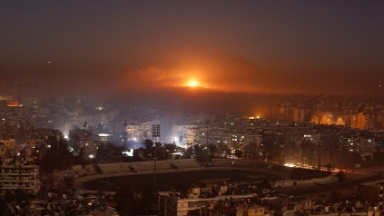
Two members of Revolutionary Guards killed in Syria air strike
Iranian media report that to regime loyalists killed in Monday's air strike attributed to Israel in Damascus.
Israel National News 09.03.22 01:00
Air strike in Syria (archive) Reuters
Iranian media reported on Tuesday that two members of the Revolutionary Guards were killed in an air strike attributed to the Israel Air Force in the Syrian capital of Damascus early Monday morning.
Officials in Syria reported that the attack was carried out from Lebanese airspace, in the southern Beirut region.
Israel’s public broadcaster, Kan 11 News, noted that the last time Iran admitted there were casualties in an Israeli attack was in April of 2018, when seven members of the Revolutionary Guards were killed in an attack on the T4 airbase east of the city of Homs. At the time, Iran responded a month later with a barrage of rockets fired by its missiles at Israel.
Since Russia's invasion of Ukraine on February 24, Jerusalem has emphasized the importance of security coordination between Israel and Russia in relation to the Air Force's activities in Syrian territory against arms transfers to Hezbollah.
During the first days of the war in Ukraine, Russia sent a message to Israel that it would allow the IDF to operate in Syria. https://www.israelnationalnews.com/news/323557

NYPD: Antisemitic hate crimes up 400% in February
56 hate crimes committed against Jews in February 2022, compared to 11 in February 2021.
Jacob Henry/JTA 08.03.22 22:58
According to the NYPD, there were 56 hate crimes against Jews in February 2022, compared with 11 in February 2021.
Many of these incidents targeted Orthodox people dressed in distinctive clothing, like the Jewish man who was punched in Bed-Stuy on Feb. 7 while walking on Shabbat. A 15-year-old was charged with assault and committing a hate crime in that attack.
In addition, there were swastikas drawn on a yeshiva school bus in Brooklyn and a dentist’s office in Queens; in Manhattan, expletives about Jews were spray painted on the dining shed of an Israeli restaurant.
In another incident in February, Bronx resident Frank Abrokwa, 37, was accused of spitting on a Jewish man’s face, calling him an “f—ing Jew” and threatening to kill him. Abrokwa, who was placed on supervised release from jail after the spitting incident in Brooklyn, was charged with harassment last week for smearing feces on a woman’s head while she waited for the subway in the Bronx.
Brooklyn City Council member Lincoln Restler said that the increase in antisemitic attacks “breaks my heart and it must be stopped.” “We are developing an action plan with community leaders to address this spike in hate crimes and build bridges across our communities to deepen cross cultural understanding and respect,” he told The New York Jewish Week on Tuesday.
The NYPD figures showed an overall increase in crime in every major category in February 2022 when compared to the same month last year. Robberies increased 56%, grand larcenies 79% and grand larceny auto doubled from 529 cases in 2021 to 1,083 in 2022.
Hate crimes in New York City as a whole rose 100% in 2021, which also saw an increase in anti-Asian hate crimes. More recently, there were nine reported anti-Asian incidents in February 2022, compared to four during the same month in 2021. MORE - https://www.israelnationalnews.com/news/323555 [Folks it is time to wake up and realize that things are getting dangerous. The problems going on in this world are not the result of any specific group or ethnic culture it is the result of plain old evil and wickedness that has become so widespread as to boggle the mind. – rdb]
To be removed from this News list, Please click here and put "Unsubscribe" in the subject line.

03/08/2022 NEWS
Jerusalem's Archaeological "City Of David" Explained
https://www.youtube.com/watch?v=OhtInzGcGJo

"Wars in old times were made to get slaves.
The modern implement of imposing slavery is debt."
-- Ezra Pound (1885-1972) American poet
Read the Prophets & PRAY WITHOUT CEASING!
That is the only hope for this nation!
Please  Remember  These  Folks  In  Prayer-  Check often  They  Change! | Pray that the world would WAKE UP! Time for a worldwide repentance!  ALL US soldiers fighting for our freedom around the world  Pray for those in our government to repent of their wicked corrupt ways.  Pray for BB – Severe sciatic needing procedure.  Pray for EL – Had clot embolized to brain – successful ‘clot buster’ but long road to go.  Pray for BB – Severe West Nile Fever –still not mobile- improving!  Pray for RBH – cancer recurrence  Pray for Ella – Child with serious problems  Pray that The Holy One will lead you in Your preparations for handling the world problems. – Have YOU made any preparations?
Exodus 10:⁷And Pharaoh's servants said unto him: 'How long shall this man be a snare unto us? let the men go, that they may serve the LORD their God, knowest thou not yet that Egypt is destroyed?' ⁸And Moses and Aaron were brought again unto Pharaoh; and he said unto them: 'Go, serve the LORD your God; but who are they that shall go?' ⁹And Moses said: 'We will go with our young and with our old, with our sons and with our daughters, with our flocks and with our herds we will go; for we must hold a feast unto the LORD.'

Two police officers stabbed near Jerusalem’s Temple Mount; attacker shot dead
Both men taken to hospital in moderate condition; footage from the scene appears to show assailant shot while on the ground
By Emanuel Fabian Today, 6:22 pmUpdated at 8:08 pm
Two police officers were moderately hurt in a stabbing attack in Jerusalem’s Old City on Monday evening, police and medics said.
In a statement, police said an assailant attacked the two officers near an entrance to the Temple Mount, and they responded with gunfire.
The Magen David Adom ambulance service said the two men in their 20s were treated at the scene and then taken to the Shaare Zedek and Hadassah Mount Scopus hospitals in the city.
The alleged Palestinian assailant died of his wounds after being shot, a police spokesperson confirmed to The Times of Israel.
Footage from the scene showed the two officers standing over the assailant, who appears to be lying on the ground shortly after the attack.
One of the officers opens fire, then stands on top of the alleged attacker while shouting expletives.
Warning: graphic footage
إطلاق نار بهدف القتل.
من سوق القطانين في القدس، الاحتلال يطلق النار على شاب بعد طعنه اثنين من عناصره.
في الفيديو يظهر بشكل واضح أن عنصر الاحتلال يطلق النار حتى بعد إصابة المنفذ بجراح وعدم قدرته على التحرك.
الشاب استشهد pic.twitter.com/90Wey3he8r
— أحمد دراوشة (@AhDarawsha) March 7, 2022
The entrances to the area were closed by police as officers launched an investigation.
The alleged assailant was identified as 22-year-old Abd al-Rahman Jamal Qassem, from the Jalazone refugee camp near Ramallah in the central West Bank, according to Palestinian media reports.
Police commissioner Kobi Shabtai said the full video of the attack (above) “shows the officer who was hurt in a difficult way, recovering, closing distance [between him and the attacker] and eliminating the terrorist.”
“The fast response, the determination, the engagement, ended the incident thankfully without any deaths, and with the terrorist dead, this is the end result we expect from an incident like this,” Shabtai added.

In this handout image from police, the knife allegedly used by a Palestinian assailant is seen following an attack in Jerusalem’s Old City on March 7, 2022. (Israel Police)
Monday’s stabbing in Jerusalem comes after two policemen were wounded in a stabbing attack nearby on Sunday morning, with the 19-year-old Palestinian assailant in that incident being shot dead.
Public Security Minister Omer Barlev, who oversees the police, warned in response to Sunday’s attack that “terrorists and extremists will try to set the area on fire” in the coming weeks.
On Monday he repeated that assessment, adding that “a disaster was averted thanks to the [officers’] quick and determined response.”
It also comes after two attacks last week in which two Jewish Israeli men in their 40s were separately stabbed in a store in a West Bank town near Jerusalem under near-identical circumstances. The alleged Palestinian assailant was later arrested.
Police said Monday it was holding a situational assessment after the string of attacks. https://www.timesofisrael.com/two-police-officers-stabbed-near-jerusalems-temple-mount-attacker-shot/ [The never ending arab assault on Jews in Israel is just ridiculous. The western world keeps insisting on two states and a “PA” ‘peace partner’ which is a complete joke. There is no peace partner and never will be so long as they continue to teach their children to hate and kill Jews. – rdb]

IDF airs footage of drone interceptions, accuses Iran of escalating ‘UAV terror’
Military officials see rising trend of Iranian drone activity in recent years, as Tehran aims to supply affiliate groups with thousands of aircraft
By Emanuel Fabian Today, 5:21 pm
As officials in recent days have said a potential nuclear deal between Iran and world powers may be in the offing, the Israeli military on Monday published fresh allegations regarding Tehran’s drone program, including new footage of Israeli planes downing several Iranian unmanned aircraft.
Israel has repeatedly warned that Iranian drones are a significant threat to the region — especially as Tehran arms proxies stationed along Israel’s borders — highlighting the fact that the emerging nuclear deal does not address the drone issue, as well as the larger question of Iranian proxies.
Military officials said Monday that Iran’s “UAV terror” is a new and global issue, accusing Tehran of directly attacking both military and civilian targets in the Middle East.
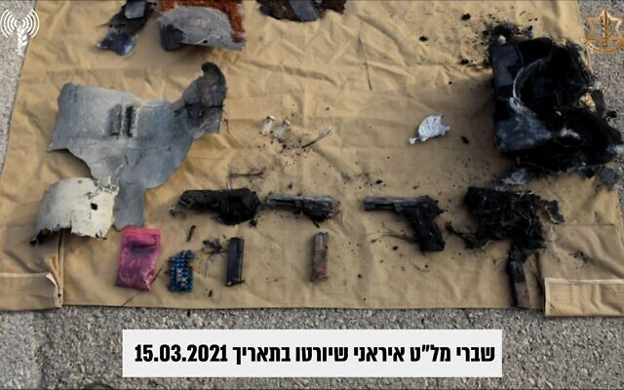
On Sunday evening, the Israel Defense Forces announced that its F-35 jets downed two Iranian drones that were ferrying firearms on March 15 of last year. The military believes the drones were headed to terror operatives in the Gaza Strip and West Bank, based on their flight path, similar to the interception of another aircraft in 2018.
The IDF said it was the first time F-35 jets have been used to take down a drone.
The military published a video (above) of the interceptions, as well as an image showing that one of the aircraft was carrying several pistols.

In this handout image published by the Israel Defense Forces on March 7, 2022, the remains of an Iranian drone with a payload of firearms is seen on March 15, 2021. (IDF)
The military identified the UAVs as Iranian Shahed-197 models. Produced by Iran’s defense industries, the aircraft has a flight range of 2,000 kilometers, a top speed of 200 kilometers per hour, and a wingspan of seven meters. The UAV is capable of carrying a payload of dozens of kilograms, the IDF said.
The IDF also released new details on an Iranian drone downed on February 10, 2018, while it was allegedly ferrying TNT to terrorist operatives in the West Bank, as Defense Minister Benny Gantz revealed last year.
According to military estimates, the Shahed-141 model launched from the T-4 airbase in Syria is capable of flying 185 kilometers per hour, and has a wingspan of 4-6 meters. That drone was downed by Israeli combat helicopters.
A video of the 2018 interception was also published, along with footage of Israel conducting airstrikes in Syria in response.
New details on another Iranian UAV launched toward northern Israel in May 2021, amid an 11-day-war between Israel and terror groups in the Gaza Strip were also published.
The Sammad-type UAV, capable of carrying a 115-kilogram payload, was downed near Beit She’an in northern Israel. That drone was launched from Iraq, apparently by Iran-backed militias in the area.
Military officials said they saw a trend in Iranian drone attacks in recent years, beginning with the UAV downed over northern Israel in 2018, and a massive attack on the Saudi petroleum company Aramco in 2019.
Since then, there have been over a dozen other incidents — which Israel believes Iran is involved in — of drones attacking Israeli-linked vessels at sea, American troops in Iraq, and targets in Saudi Arabia and the United Arab Emirates.
The IDF believes Iran is attempting to arm all of its proxies in the region — in Syria, Lebanon, Iraq, and Yemen — with hundreds and even thousands of UAVs, in addition to providing military training.
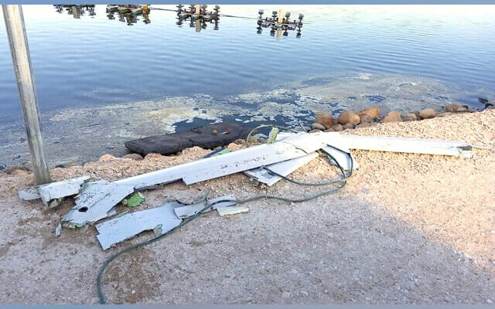
The remains of an alleged Iranian drone that was downed over northern Israel, parts of which fell in a fish pond in Kibbutz Maoz Haim, on May 14, 2021. (Israel Defense Forces)
While Israel has acknowledged it targets the bases of Iranian forces and allied terror groups in Syria, as well as arms shipments believed to be bound for Iran-backed groups in the region, The Times of Israel has learned several of those strikes specifically targeted sites related to Iran’s drone program.
The IDF said all three interceptions were conducted “in coordination with neighboring countries.” Last month, Israeli television reported that Israel and its regional allies were developing a joint defense pact to protect against the threat of drones.
The timing of the IDF’s publication was thought to be related to the ongoing, and reportedly near-completed, nuclear talks in Vienna.
Negotiators on all sides have signaled in recent days that a potential agreement to revive the deal, known formally as the Joint Comprehensive Plan of Action, is close. Last week, Gantz said a nuclear deal may be signed “in the coming weeks, perhaps even in the coming days.”
The original 2015 agreement gave Iran sanctions relief in exchange for curbs on its nuclear program, but the US unilaterally withdrew from it in 2018 under then-president Donald Trump, who reimposed heavy economic sanctions.

In this handout image published by the Israel Defense Forces on March 7, 2022, the remains of an Iranian drone is seen on March 15, 2021. (IDF)
Still, talks have become bogged down due to tensions between Russia — a signatory to the deal — and the West over its invasion of Ukraine late last month.
Gantz called in a Monday Facebook post for the world to “act against Iranian aggression,” vowing that Israel would continue to act in its own defense regardless of any deal reached by world powers with Iran.
Efforts to lobby the international community may be a hard sell as Israel has rebuffed pressure from the West to fully back Ukraine, seeking to balance humanitarian concern and its desire to keep ties with Moscow from souring.
Russia has tacitly allowed Israel to carry out operations against Iran-backed targets in Syria, access that Israel fears will be limited should Russia stop allowing the sorties.
Military officials say the IDF is always on full alert to protect Israel’s skies from drones. However, last month Israeli air defenses failed to down a small drone that entered the country from Lebanon, which the Iran-backed Hezbollah terror group claimed responsibility for launching. https://www.timesofisrael.com/idf-airs-footage-of-drone-interceptions-accuses-iran-of-escalating-uav-terror/ [The world leaders have yet to understand even when warned by another Islamic leader that the Iranian regime will never follow through and keep any part of an agreement because it isn’t in their eschatological plans and certainly isn’t within the standard context of world domination which they believe. – rdb]

Ukraine rejects Moscow proposal for evacuation corridors into Belarus, Russia
Providing safe passage ‘into the arms of the country that is currently destroying yours is nonsense,’ says UK minister, backing Kyiv’s stance as Russians keep up bombing campaign
By Agencies Today, 1:13 pm
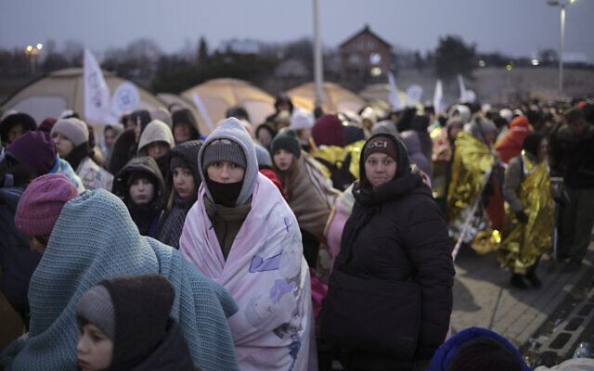
Refugees wait in a crowd for transportation after fleeing from Ukraine and arriving at the border crossing in Medyka, Poland, March 7, 2022. (AP Photo/Markus Schreiber)
KYIV, Ukraine — Ukraine on Monday rejected Moscow’s offer of humanitarian corridors to Russia and Belarus, Deputy Prime Minister Iryna Vereshchuk said.
Russia on Monday said it would cease bombing in certain areas to allow civilians to leave Ukraine, after attempts to evacuate people Sunday were stalled by relentless Russian shelling, Kyiv said.
But with Belarus backing the Russian invasion, Ukraine rebuffed any talk of having its citizens flee into the arms of their attackers.
“This is not an acceptable option,” Vereshchuk said of Russia’s safe passage proffer.
The civilians “aren’t going to go to Belarus and then take a plane to Russia.”
Earlier, a spokesman for Ukrainian President Volodymyr Zelensky called the proposal “completely immoral,” according to the Reuters news agency.
“Providing evacuation routes into the arms of the country that is currently destroying yours is nonsense,” said UK Europe Minister James Cleverly.
The Russian army said earlier on Monday it was opening humanitarian corridors from the capital Kyiv, the second-largest city Kharkhiv in the east, the southeastern port of Mariupol on the Sea of Azov, and Sumy, near the eastern border with Russia.
Even as Russian army spokesman Igor Konashenkov announced the start of ceasefires at 9 a.m. local time Monday to allow civilians to escape, Russia continued to bombard Ukrainian cities and fighting was still ongoing in the four cities where corridors were supposed to lead from.
“They have targeted Mykolaiv and Kharkiv and burned residential areas. It’s terror,” Ukrainian President Volodymyr Zelensky said Monday. “We must fight against inhumane evil.”
Russian forces aimed heavy fire on the city of Mykolaiv, 480 kilometers (300 miles) south of the capital, according to Ukraine’s General Staff. Rescuers said they were putting out fires in residential areas caused by rocket attacks.
Emergency officials in the Kharkiv region said that overnight shelling killed at least eight people and wrecked residential buildings, medical and education facilities and administrative buildings.
Shelling also continued in the suburbs of Kyiv, including Irpin, which has been cut off from electricity, water and heating for three days.
“Russia continues to carry out rocket, bomb and artillery strikes on the cities and settlements of Ukraine,” the General Staff said.
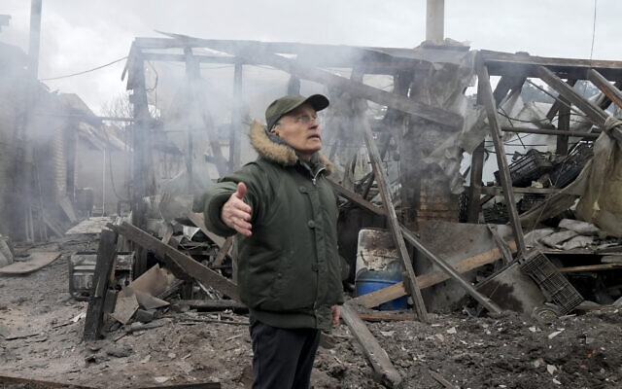
A man opens his arms as he stands near a house destroyed in the Russian artillery shelling, in the village of Horenka close to Kyiv, Ukraine, March 6, 2022. (Efrem Lukatsky/AP)
Two recent attempts to allow thousands of civilians to leave the besieged city of Mariupol have ended in disaster, with civilians under fire and both sides accusing each other of violations.
“Instead of humanitarian corridors, they can only make bloody ones,” Zelensky said Sunday. “Today a family was killed in Irpin. Man, woman and two children. Right on the road. As in a shooting gallery.”
The Ukrainian government is proposing eight humanitarian corridors, including from Mariupol, that would allow civilians to travel to the western regions of Ukraine, where there is no Russian shelling.
“We demand that the Russian Federation stop manipulating and abusing the trust of the leaders of France, China, Turkey and India,” Vereshchuk said.
The Russian proposal was reminiscent of similar ones in Syria. In 2016, a joint Russian and Syrian proposal to set up humanitarian corridors out of besieged opposition-held eastern Aleppo was deeply criticized on humanitarian grounds. Human rights activists said the tactic, coupled by brutal sieges, effectively gave residents a choice between fleeing into the arms of their attackers or dying under bombardment.
The handful of residents who managed to flee Mariupol before the humanitarian corridor closed said the city of 430,000 had been devastated. MORE - https://www.timesofisrael.com/ukraine-rejects-moscow-proposal-for-evacuation-corridors-into-belarus-russia/

Tucker Carlson Tonight 3/7/22 FULL
https://www.youtube.com/watch?v=8MW6gp0aGY0
Carlson with outstanding review of history and issues on Ukraine and Russia – worth the watch!

Ukraine parades Russian troops captured during invasion before cameras
Ukrainian military lines up 10 POWs before press, makes them recite repentances; Red Cross says prisoners ‘must be treated with dignity’
By DAPHNE ROUSSEAU Today, 6:46 pm
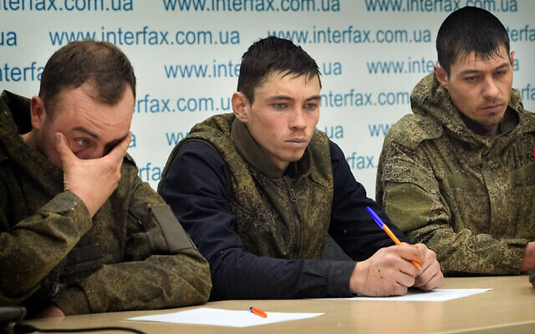
Captured Russian soldiers answer media questions at a press conference in the Interfax news agency in Kyiv, Ukraine, March 5, 2022. (AP Photo/Efrem Lukatsky)
KYIV, Ukraine (AFP) — The Ukrainian military has paraded captured Russian soldiers before the media and made them recite repentances for their invasion, prompting the Red Cross to warn that prisoners must not be mistreated. [This is interesting. The Ukrainians are trying to play the part of the poor victim from Russia screaming international crimes but are still perfectly willing to ignore international prisoner conventions. There are some things going on with this that still makes you wonder who are the real bad guys or are they both in that category. – rdb]
Eyes red, faces gaunt and in some cases scratched, 10 young Russians in green fatigues were lined up before the press and cameras at an event attended by AFP on March 4.
Some of them stared at their boots and avoided looking at the cameras, while others appeared more at ease.
It was the second such act in a week organized by Ukraine’s SBU intelligence service.
Despite being widely recognized as the victim as Russia bombards its cities, Kyiv risks ceding moral ground over the February 24 Russian invasion to Moscow, which has accused it of torturing detainees.
“Prisoners of war and detained civilians must be treated with dignity,” the International Committee of the Red Cross (ICRC) said in a statement.
Prisoners “are absolutely protected against ill-treatment and exposure to public curiosity including images circulating publicly on social media,” it said.
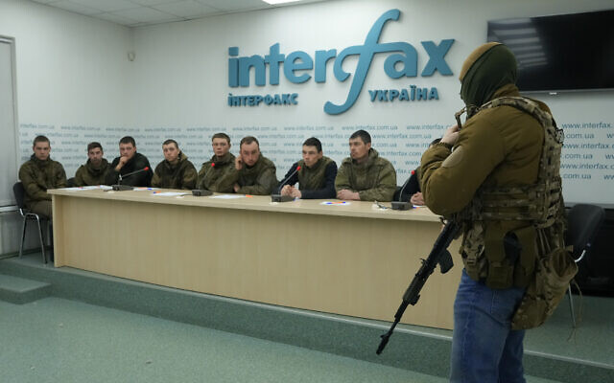
Captured Russian soldiers answer media questions at a press conference in the Interfax news agency in Kyiv, Ukraine, March 5, 2022. (AP Photo/Efrem Lukatsky)
The Ukrainian defense ministry and the SBU did not respond to questions from AFP about their methods.
Presidential adviser Oleksiy Arestovich called in an online video for “humane treatment of prisoners.” He reminded viewers that Ukraine’s Western partners were watchful on the subject.
Speak to the camera
Blindfolded with tape, the soldiers were pushed along on single file, holding one another by the shoulders to keep from falling.
They were then groomed and taken into a room where they were shown videos of Russian bombardments, while a Ukrainian officer named the cities being bombed.
“Look what your army is doing,” the officer said. “They would tell your parents that you died on maneuvers, not that you were here.”
Each soldier then faced the cameras and stated his name, his unit and how he had entered Ukraine.
Each said that he was voluntarily stepping up to condemn Russia’s invasion — using the same phrases as the other soldiers.
Each soldier said he was being well treated and ended by calling on Russians not to believe their President Vladimir Putin’s “lies.”
Incredible video released by officials in Ukraine as a captured Russian soldier tells a press conference that he started to question what he'd been told after seeing his favourite boxers Oleksandr Usyk and Vasyl Lomachenko signing up to fight against him… pic.twitter.com/0unQTLSrCU
— Michael Benson (@MichaelBensonn) March 6, 2022
Russia has not reacted specifically to these appearances, but more generally its defense ministry spokesman Igor Konashenkov on February 27 said Russian prisoners of war were facing “torture.” He compared them to victims of “the German Nazis and their henchmen.”
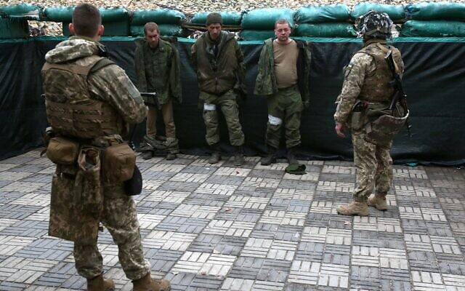
Calling prisoners’ mothers
The Ukrainian military has set up a website to arrange for the mothers of captured Russian soldiers to come to pick them up in Ukraine, via the Polish border.
“Unlike Putin’s fascists, we Ukrainians do not make war against mothers and their captured children,” Ukraine’s defense ministry said in a statement.

Ukrainian forces detain servicemen of the self-proclaimed Luhansk People’s Republic who were captured during an attack on the town of Schast’ye, near the eastern Ukraine city of Luhansk, on February 24, 2022. (Anatolii Stepanov/AFP)
Ukraine’s military command said 200 Russian prisoners of war have been captured since February 24.
Russia’s defense ministry in turn says it has captured 572 Ukrainians.
The figures cannot be verified. The ICRC told AFP it could not exercise its right under the Geneva Convention to visit the prisoners because of the current fighting. https://www.timesofisrael.com/ukraine-parades-russian-troops-captured-during-invasion-before-cameras/

Putin mulls mass mobilization to push his Ukraine objectives. Oil hits $139
Mar 7, 2022 @ 15:11
Would-be Ukraine peace mediators in the last 48 hours, including PM Naftali Bennett, were impressed by President Vladimir Putin’s determination to press on with the Ukraine war until his purpose is achieved. He was reported laying the groundwork for mass mobilization and conscription – even martial law, if necessary – to reinforce his military effort, which is still short of its objectives after 12 days of fighting.
Soaring oil prices – now hitting $139 a barrel – are providing profits for funding his war effort.
On the battlefield, while shelling targeted Ukraine towns, the Russian army has slowed its advance to regroup and take on more manpower, fuel, ammo and other supplies. They are gearing up for the next round of assaults to take Kyiv, Kharkiv and Mikolayiv. The Ukraine General Command reports a large Russian force massing west of Khrakiv – apparently ready for a broad southwestern drive towards the Dnieper River.
According to earlier reports, Moscow has recruited and deployed Syrian fighters with urban combat expertise to help take Kyiv and crush resistance.
On Sunday, Russian missile strikes destroyed the international port of Vinnytsia near Uman, a potential point of entry for military aid to Ukraine.
Putin for now appears to be intent on winning the war he launched on Ukraine and is not demonstrating any willingness to de-escalate hostilities or consider terms that would be acceptable to the West or Ukraine. Still, a Russian delegation took off for Belarus Monday, March 7, for a third round of talks with a Ukrainian delegation.
The Biden administration is seriously considering slamming Russia with an all-out oil embargo to starve Putin’s war effort and further isolate him. Brent again peaked to $139 the barrel – a jump of almost $40 since the Feb. 24 invasion and the highest since 2008.
But first supplies must be secured for the world market, Secretary of State Antony Blinken told a CNN interviewer. To this end, President Joe Biden is considering deals with such oil-rich foes of Washington as Venezuela’s Nicalos Maduras – or even Saudi Crown Prince Muhammed bin Sultan, who has been systematically shunned by the Biden administration after being accused of the capture and murder of Jamal Khashoggi. https://www.debka.com/putin-mulls-mass-mobilization-to-push-his-ukraine-objectives-oil-hits-149/ [If the “Bi-Dum" group of nitwits would allow US exploration and production we could be oil independent and supply the EU but they are mired in their green mindset which is a bit like putting you head in the sand. – rdb]

Bennett: Israel’s ‘sacred’ task is to help Jewish Ukrainian refugees above others
PM tells ministerial committee that country must focus on Jews displaced by Russia invasion; interior minister says cap will come soon on entry of non-Jews
By Amy Spiro and TOI staff Today, 4:45 pm
Prime Minister Naftali Bennett, center, and Aliyah and Integration Minister Tamano-Shata, right, at a meeting of the Ministerial Committee on Aliyah and Integration, March 7, 2022. (Amos Ben-Gershom/GPO)
Prime Minister Naftali Bennett told ministers on Monday that Israel must focus on helping Jewish refugees escaping the Russian invasion of Ukraine.
His remarks came after his Yamina party No. 2, Interior Minister Ayelet Shaked, said that Israel will place a cap the entry of Ukrainian refugees who do not have Jewish ties and are therefore ineligible to immigrate to the Jewish state.
“The State of Israel was founded as a state that is the safest place in the world for Jews,” Bennett said at meeting of the Ministerial Committee on Aliyah and Integration, according to a statement from his office. “This is the heart of its purpose; therefore, we will focus on this, of course.”
Israel, he said, “is a refuge for Jews in distress,” citing other waves of Jewish immigration in the past such as that from former Soviet Union countries, Ethiopia, and Yemen.
“This is our purpose. The State of Israel has done this more than once in its history and we will carry out this sacred task this time as well,” he said.
Noting the far-reaching consequences of the conflict, which has rattled Europe, as Russian forces battle to suppress determined Ukrainian resistance to their invasion, Bennett said that so far Israel has mostly taken in non-Jewish refugees. But he stressed that it is the Jewish community that must be helped first.
“We in the State of Israel have absorbed, as of now, hundreds of refugees, some of them Jews, most of them not,” he said. “Naturally, the State of Israel will focus on Jewish refugees.”
Jewish immigrants fleeing the war in Ukraine, arrive at Ben Gurion airport near Tel Aviv on March 6, 2022. (Tomer Neuberg/FLASH90)
Bennett said the country is facing a “historic opportunity” and that, led by Immigration and Absorption Minister Pnina Tamano-Shata, it will focus on two key goals.
The first, he said, was to “to reach Jews in distress, to reach them in the field and make things easier for them,” so that they do not face a tangle of bureaucracy when they arrive in Israel. The second, according to Bennett, would be successful integration into Israeli society, so that those who come will encourage their remaining family members in Ukraine to follow.
Earlier, Interior Minister Shaked said Israel would limit the number of refugees who cannot automatically immigrate to the country — but did not indicate where the limit would be set.
“We will approve some sort of humanitarian cap on people who are not eligible under the Law of Return,” Shaked told Kan public radio on Monday morning. “In the coming days I will formulate an organized policy, because we have to get this situation in order.”
She declined to specify what number of Ukrainian refugees who are not eligible to become citizens Israel would be willing to accept. She is thought to favor placing the cap on entry as low as possible, while Foreign Minister Yair Lapid reportedly wants Israel to accept a greater number.
The Population and Immigration Authority said Monday morning that since the February 24 outbreak of war, 2,792 Ukrainian nationals have arrived in Israel; 129 of them were denied entry for unspecified reasons.
Throughout the month of February, 3,226 Ukrainians landed in Israel; 248 of them were denied entry and 2,134 exited, the authority said.
Under the Law of Return, anyone with at least one Jewish grandparent is eligible to become an Israeli citizen.
Shaked said that only around 10 percent of those who have entered Israel since the war began are eligible for citizenship. She said that Israel’s primary goal is to absorb fleeing Jews and others who can become citizens, as opposed to all refugees.
“Israel has a huge challenge to absorb those who are eligible under the Law of Return,” she said. “We expect tens of thousands; we could reach hundreds of thousands if a large number come from Russia and other former Soviet nations. That’s our central mission.”
While Ukraine boasts a large Jewish community, it is unclear if such a figure will materialize, and the Jewish Agency has indicated that there does not appear to be a wave of Russian immigration in the works.
While Israel is focused on preparing for a wave of new immigrants, “of course as a Western nation we will also take in refugees generally,” she said.
Shaked said a new policy would be announced in the coming days, and in the meantime, any Ukrainian refugees who show up in Israel are allowed to enter on a tourist visa after a brief inspection. Currently, Ukrainian refugees without first-degree relatives in Israel must provide a NIS 10,000 deposit, to be returned to them upon exiting.
The deposit is held as a guarantee that the Ukrainians will eventually leave Israel, as the country rarely grants refugee status to non-Jews, and instead allows them temporary entry as tourists. Diaspora Affairs Minister Nachman Shai, who flew to Poland on Monday, has called for canceling the deposit requirement, calling it “illogical and inhumane.”
Approximately 400 new immigrants from Ukraine — including around 100 orphans — landed in Israel on Sunday on flights from Poland, Moldova and Romania.
The UN estimates that more than 1.5 million people have fled Ukraine since Russia began its invasion last month. The vast majority have exited via Poland, though many have continued onward since. https://www.timesofisrael.com/bennett-israels-sacred-task-is-to-help-jewish-ukrainian-refugees-above-others/

Bennett's coalition suffers humiliation as two signature bills withdrawn
The coalition was forced to withdraw its signature bills on conversion and limiting a prime minister to eight years in office.
By GIL HOFFMAN Published: MARCH 7, 2022 20:49 Updated: MARCH 7, 2022 22:42
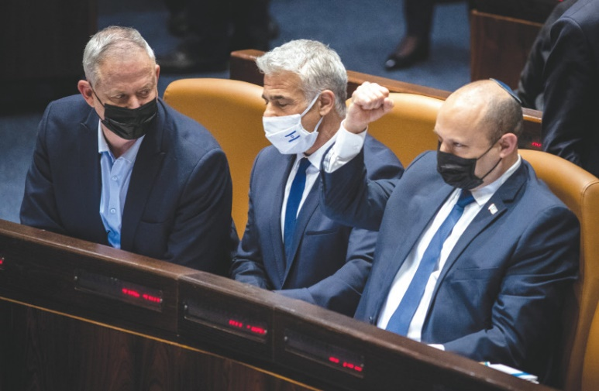
PRIME MINISTER Naftali Bennett, Foreign Minister Yair Lapid and Defense Minister Benny Gantz sit in the Knesset plenum during voting on the new draft legislation last month.(photo credit: FLASH90)
Prime Minister Naftali Bennett’s governing coalition suffered two humiliating blows on Monday, when it was forced to withdraw its signature bills on conversion and limiting a prime minister to eight years in office.
The term limit bill, which already passed all its readings but one, was not brought to a vote because, as legislation that would change a Basic Law, it would need the support of an absolute majority of 61 of the 120 MKs. Because opposition MK Avi Maoz has COVID-19, the 61 coalition had to pair off with him, leaving it without the 61 required.
The conversion bill faced challenges from inside the coalition. Ra’am (United Arab List) raised objections after Religious Zionist Party leader Bezalel Smotrich told him it would lead to Muslims converting to Judaism and Yamina MK Abir Kara protested not receiving benefits promised to him for the independent workers he represents.
Monday was the last day for the coalition to try to pass its bills before the Knesset leaves for its spring vacation on Wednesday night. That means the conversion and term limit bills will not be able to be raised until the Knesset returns from the break on May 9.
Last week, the coalition failed to pass the term limit bill and legislation that would change the makeup of the body that will select the next chief rabbis in December.
The Likud celebrated the victories at its faction meeting on Monday. Likud faction head Yariv Levin mocked the coalition, saying he had set a record for bills passed by the opposition. Opposition leader Benjamin Netanyahu compared Bennett and Alternate Prime Minister Yair Lapid to rabbits.
A dispute within the coalition was resolved on Monday when National Insurance Institute director-general Meir Spiegler was appointed by Bennett and Aliyah and Integration Minister Pnina Tamano-Shata (Blue and White) to head the operation tasked with absorbing Ukrainian Jewish immigrants into Israel.
Tamano-Shata had threatened to resign if a project manager was appointed who would make decisions over her head. Bennett agreed to Tamana-Shata’s recommendation that Spiegler head a task force under her.
“The trials of the Jews in Ukraine are a test for us, we are expecting at least tens of thousands of olim [immigrants],” said Tamano-Shata, “I’m glad that this arrangement has been made.” https://www.jpost.com/israel-news/politics-and-diplomacy/article-700592 [This is rather interesting and disturbing. Once again you have the Likud and the out of power group gloating about legislative failure that would probably improve the political situation in Israel which would be to the advantage of their power hungry leadership rather than thinking about what is actually better for the country in general. It is demonstrative of the problem in most political groups no matter what country you are in. There is a terrible greed for power over people rather than service to people. The US has the same problem and ultimately the quest for power will bring down not only political factions and governments but entire countries. - rdb]

Health Ministry updates guidelines on polio vaccines after first case in decades
Top health official recommends Jerusalem-area kids get first dose at 6 weeks, says there are at least dozens more asymptomatic cases but doesn’t predict wave of infections
By TOI staff Today, 6:09 pm
A top health official on Monday announced the Health Ministry was updating its advice on when some children should be vaccinated against polio, after a case was discovered in Israel for the first time in over 30 years.
Dr. Sharon Alroy-Preis, the ministry’s director of public health, said parents in Jerusalem and the surrounding area should take their kids to get their first dose at the age of six weeks, and the second at 12 weeks.
“Our emphasis at the moment is ensuring that all kids, primarily in the Jerusalem district, be in the best situation in terms of vaccination,” she said, noting the ministry’s recommendation that children receive all four vaccine doses before their first birthday.
According to the Health Ministry, a mutated form of the virus — which can cause illness in the unvaccinated — was discovered in a 4-year-old boy in Jerusalem who had not been vaccinated against the disease.
The case was believed to be the first polio diagnosis in Israel since 1989, after Israel largely wiped out the disease through an aggressive inoculation campaign.
Alroy-Preis encouraged families to get their children vaccinated against polio and said there were likely dozens if not hundreds of asymptomatic cases of the disease. Citing sewage samples, she said the disease was only in the Jerusalem area, but called for broader sewage testing to ensure it has not spread to other regions.
Traces of the virus have been found in sewage samples in Israel from time to time, but have not resulted in any clinical cases for several decades.
“We don’t expect that there will be a wave of kids with symptoms, but we know the virus is going around,” Alroy-Preis said. “A vaccinated child is protected.”
She also noted the Jerusalem Health Bureau has opened an epidemiological investigation into the case and will reach out to anyone who came in recent contact with the infected child.
Like much of the world, Israel administers polio vaccines to children as part of its standard vaccine regimen.
Polio spreads mostly from person to person or through contaminated water. It attacks the nervous system and can sometimes paralyze people within hours. The disease mostly affects children under 5 and has been largely wiped out in wealthy countries. https://www.timesofisrael.com/health-ministry-updates-guidelines-on-polio-vaccines-after-first-case-in-decades/ [My curiosity is peeked at this and my question would be if you have found traces of this in sewage samples in the past why did you not pursue this aggressively them if you think it is so important now. Just because I am an inveterate skeptic it makes me wonder, now that we have had a problem with Cov and the Jabbing had quieted down, and there has been talk of an oral form of the Covid Jab being prepared and needing testing, is it only polio virus that is in their oral medication or is there something else. They have been wanting to get the very little ones “immunized” for some time. HUMMMMMM? – rdb]

Ditching Russian oil will be ‘catastrophic’ for global markets, Moscow warns
Banning oil supplies will send prices to unprecedented records, Russia believes
7 Mar, 2022 19:33
Removing Russian oil from the market would make energy prices skyrocket to over $300 per barrel of oil, Russia’s deputy prime minister, Aleksandr Novak, said on Monday, adding that Russia is not dependent on the West and can “reroute” its supplies elsewhere.
The European officials are “once again seeking to put all the blame for their own recent energy policy shortfalls on Russia,” Novak told journalists, adding that “Russia has nothing to do with the current price hike on market volatility.”
Russia has been a “reliable partner” for Europe for many decades, Novak said, adding that Moscow has been supplying the European nations with roughly 40% of their gas needs. The deputy prime minister made his comments after gas prices in Europe hit record highs of almost $3,900 per 1,000 cubic meters while the price of Brent crude oil surpassed $130 per barrel for the first time in a decade.
The deputy prime minister also slammed Germany’s decision to freeze certification of the Nord Stream 2 gas pipeline project and argued that Moscow has a “full right” to stop supplying gas via Nord Stream 1 pipeline, which has not been targeted by Western sanctions. Russia is not that dependent on the West and “knows where to reroute” its supplies if needed. Still, Moscow will not take reciprocal measures against Europe in this case, he added.
Earlier on Monday, German Chancellor Olaf Scholz admitted that his nation would not be able to replace Russian gas supplies any time soon and expressed his opposition to any sanctions targeting Russia’s “essential” oil and gas industry. Following his statements, the gas price reduced to $2,700 per cubic meter.
Russia’s energy giant Gazprom has confirmed it will be sticking to its commitments under the contracts and deals with foreign customers and also said that it still uses Ukrainian gas transit system “as normal” despite a conflict between Moscow and Kiev. https://www.rt.com/russia/551442-oil-gas-prices-novak/ [Seems like Pootie Poot may be a better chess player than most of those in the west. – rdb]

Blinken assures nervous Baltics that NATO protection against Russia ‘sacrosanct’
US secretary of defense warns ‘no one should doubt our resolve’ to protect allies’ territory, but Lithuanian leader frets if Putin not stopped in Ukraine ‘he will not be stopped’
By Matthew Lee Today, 3:37 pm
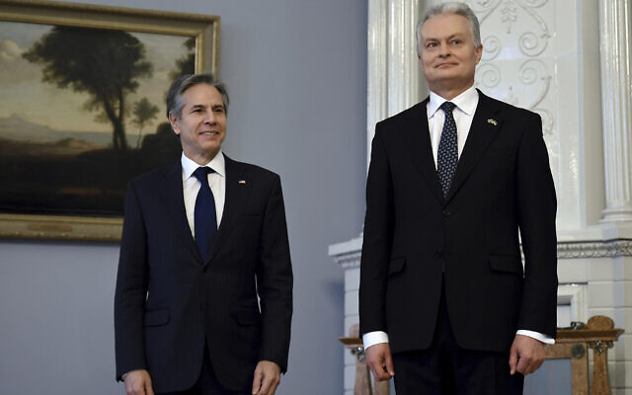
US Secretary of State Antony Blinken, left, and Lithuania President Gitanas Nauseda pose for the media at the Preseident's Office in Vilnius, Lithuania, March 7, 2022. (Olivie Douliery/Pool via AP)
VILNIUS, Lithuania (AP) — US Secretary of State Antony Blinken on Monday assured Lithuania of NATO protection and American support as he began a lightning visit to the three Baltic states that are increasingly on edge as Russia presses ahead with its invasion of Ukraine.
The former Soviet republics of Latvia, Lithuania and Estonia are all NATO members and Blinken is aiming to reassure them of their security in the event Russia chooses to expand its military operations.
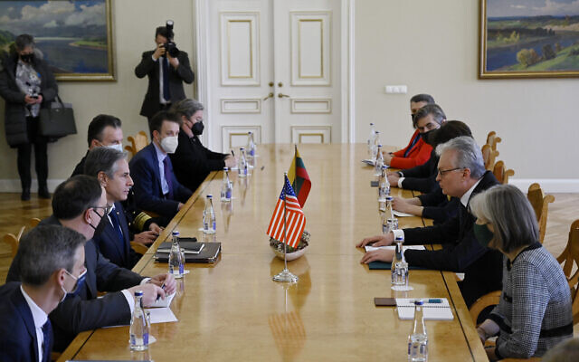
“We are bolstering our shared defense so that we and our allies are prepared,” Blinken said, stressing that the US commitment to NATO’s mutual defense pact is “sacrosanct.”
“We will defend every inch of NATO territory if it comes under attack,” he said. “No one should doubt our readiness, no one should doubt our resolve.” [Does this relate at all to “no one left behind” or anything of that nature? I could certainly understand the apprehension of those individuals particularly after seeing the poor excuse for a withdrawal from Afghanistan and a less than aggressive approach to Ukraine. While Ukraine is not part of NATO there were agreements made to them when they gave up their nuclear arsenal on the past. - rdb]
Memories of Soviet rule are still fresh in the Baltics and since the invasion of Ukraine last month, NATO has moved quickly to boost its troop presence in its eastern flank allies while the US has pledged additional support.
Blinken’s opened his Baltic tour in Vilnius, where Lithuanian support for Ukraine’s resistance to the Russian invasion is palpable as signs of solidarity with Ukrainians are evident in many businesses and on public buildings and buses.
“Unfortunately, the worsening security situation in the Baltic region is of great concern for all of us and around the world,” Lithuanian President Gitanas Nauseda told Blinken. “Russia’s reckless aggression against Ukraine once again proves that it is a long-term threat to European security, the security of our alliance.”
Nauseda said that a policy of deterrence was no longer enough and that “forward defense” was now needed. He predicted that “Putin will not stop in Ukraine if he will not be stopped.”
“It is our collective duty as a nation to help all Ukrainians with all means available,” said Nauseda. “By saying all, I mean, indeed all means all, if we want to avoid the Third World War. The choice is in our hands.”

US Secretary of State Antony Blinken, third left, meets with Lithuania President Gitanas Nauseda, second right, at in Vilnius, Lithuania, March 7, 2022. (Olivie Douliery/Pool via AP)
Lithuanian Foreign Minister Gabrielius Landsbergis called for a surge in assistance to Ukraine, noting that the NATO allies “are doing a lot, but we cannot stop.” He also called for an immediate halt to imports of Russian energy. “We cannot pay for oil and gas with Ukrainian blood,” he said.
Lithuania is also dealing with pressure from another large power — China — for its relationship with Taiwan, the island China regards as a renegade province. China has taken actions, including halting imports of certain products, against Lithuania for allowing Taiwan to open a de facto embassy in Vilnius.
Blinken said the Ukraine situation was relevant to Lithuania’s Taiwan situation as all countries should have the right to pursue their own foreign policies. “Every nation is free to associate with whom it chooses,” he said. The United States continues to stand by Lithuania and every nation to choose its own path.”
Blinken arrived in the Baltics late Sunday from non-aligned Moldova, which is also warily watching the war on its doorstep, and Poland, where he visited the Polish-Ukrainian border and met with refugees from Ukraine.
Later Monday, Blinken will travel to Riga, where he will meet senior Latvian officials and Israeli Foreign Minister Yair Lapid, before visiting Tallinn, Estonia and then going on to Paris for talks with French President Emmanuel Macron on Tuesday.
Israeli Prime Minister Naftali Bennett met with Russian President Vladimir Putin over the weekend and Macron has been in frequent contact with the Russian leader. https://www.timesofisrael.com/blinken-assures-nervous-baltics-nato-protection-against-russia-sacrosanct/

China calls Russia its ‘most important strategic partner’ despite Ukraine war
Beijing continues to refuse to condemn Moscow’s invasion or join Western sanctions, with top diplomat saying ties constitute ‘one of world’s most crucial bilateral relationships’
By KEN MORITSUGU Today, 7:32 pm
BEIJING (AP) — China’s foreign minister on Monday called Russia his country’s “most important strategic partner,” as Beijing continues to refuse to condemn the invasion of Ukraine, despite growing pressure from the US and the European Union to use its influence to rein Moscow in.
Wang Yi said Chinese ties with Moscow constitute “one of the most crucial bilateral relationships in the world.”
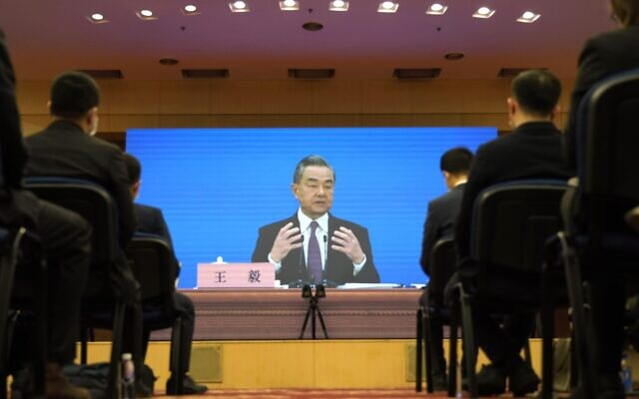
Chinese Foreign Minister Wang Yi speaks during a remote video press conference held on the sidelines of the annual meeting of China's National People's Congress (NPC) in Beijing, on March 7, 2022 (AP Photo/ Sam McNeil)
China has broken with the US, Europe and others that have imposed sanctions on Russia after its invasion of Ukraine. Beijing has said sanctions create new issues and threaten a political settlement of the conflict.
“No matter how perilous the international landscape, we will maintain our strategic focus and promote the development of a comprehensive China-Russia partnership in the new era,” Wang said at a news conference on the sidelines of the annual meeting of China’s ceremonial parliament.
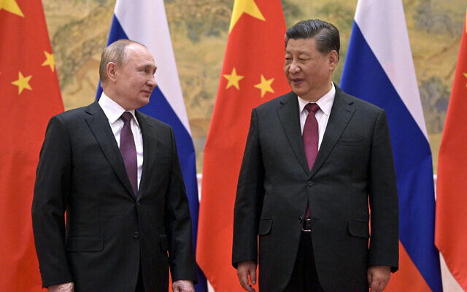
“The friendship between the two peoples is ironclad,” he added.
Much attention has been paid to a meeting between Chinese leader Xi Jinping and Russian President Vladimir Putin in Beijing on February 4, after which a joint statement was issued affirming “strong mutual support for the protection of their core interests.”

Chinese President Xi Jinping, right, and Russian President Vladimir Putin talk to each other during their meeting in Beijing, February 4, 2022. (Alexei Druzhinin, Sputnik, Kremlin Pool Photo via AP, File)
Russia said it endorses China’s view of self-governing Taiwan as an “inalienable part of China, and opposes any forms of independence of Taiwan,” while China backed Russia in opposing the further enlargement of NATO.
Russia’s invasion of Ukraine has drawn comparisons to China’s own threat to invade Taiwan to bring what it considers a wayward province under its control.
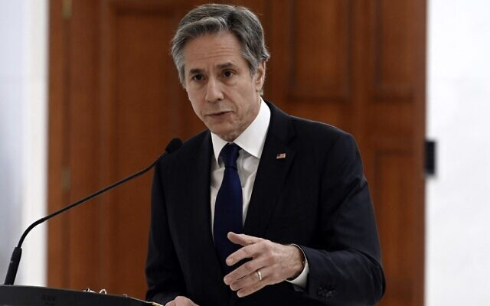
However, Wang said Taiwan was a “fundamentally different” issue from Ukraine because the island is “an inalienable part of China’s territory.”
“Some people, while being vocal about the principle of sovereignty on the Ukraine issue, have kept undermining China’s sovereignty and territorial integrity on the Taiwan question. This is a blatant double standard,” Wang said in a less-than-subtle dig at the US, a Taiwan ally.
China and Russia have increasingly aligned their foreign policies against the liberal Western order and their militaries have carried out exercises together and flown joint air patrols, as their relationship has taken on the trappings of an informal alliance. Wang accused the US on Monday of trying to create an Asian version of NATO.
Xi’s government has refused to criticize the Russian invasion, but tried to distance itself from Putin’s war by calling for dialogue and the respect of national sovereignty. That prompted suggestions that Putin failed to tell the Chinese leader his plans before their February statement.
Along with denouncing trade and financial sanctions on Moscow, Beijing says Washington is to blame for the conflict for failing to take Russia’s security concerns into consideration.

US Secretary of State Antony Blinken gestures as he speaks during a press conference with Moldova’s president at the Presidential Palace in Chisinau, on March 6, 2022. (Olivier Douliery/Pool/AFP)
During an hour-long phone conversation with US Secretary of State Antony Blinken on Saturday, Wang said China opposes any moves that “add fuel to the flames” in Ukraine.
Wang said China hopes the fighting will stop as soon as possible and called for negotiations to resolve the immediate crisis, as well as talks on creating a balanced European security mechanism. He said the US and Europe should pay attention to the negative impact of NATO’s eastward expansion on Russian security.
On a visit to the Lithuanian capital of Vilnius on Monday, Blinken said China’s actions were at odds with its avowed support for stability and “respecting sovereignty.”
Blinken was speaking at a news conference with his Lithuanian counterpart, whose country has come under severe economic pressure from Beijing after it agreed to allow Taiwan to open a de facto embassy in Vilnius.
“From its coercion of Vilnius to its failure thus far to condemn Moscow’s flagrant violation of the sovereignty and territorial integrity of Ukraine today and in 2014, Beijing’s actions are speaking much louder than its words,“ he said, referring to Russia’s earlier annexation of Crimea.
In Brussels, European Commission spokesperson for foreign affairs Peter Stano said the EU would like to see China play a mediating role and convince Russia to stop its war in Ukraine.
“China has the potential to reach out to Moscow because of their relationship, obviously, and we would like China to use its influence to press for a ceasefire and to make Russia stop the brutal unprecedented shelling and killing of civilians in Ukraine,” Stano told reporters Monday.
He noted that China was not among the five countries which voted against a resolution adopted by the UN General Assembly condemning the Russian aggression. China abstained in the vote.
“This is a reason for us to continue and even step up our engagement,” Stano said.
Chinese state-controlled media have been told to post only pro-Russian content and to censor anti-Russian or pro-Western views, according to a copy of instructions that appeared on the social media account of the newspaper Beijing News. The post was later deleted.
On Friday, a translation by state TV of remarks by the head of the International Paralympic Committee during the opening ceremony of the Beijing Winter Paralympics skipped portions that expressed horror about the war in Ukraine and called for peace.
The most senior Chinese leaders have avoided mentioning the war in public.
On Saturday, Premier Li Keqiang, the No. 2 leader, indirectly acknowledged its impact, saying prices of oil, wheat, and other commodities are high and “prone to fluctuation,” but gave no indication why.
Global conditions, Li said, were “increasingly volatile. https://www.timesofisrael.com/china-calls-russia-its-most-important-strategic-partner-despite-ukraine-war/ [Folks this should make the hair on your neck stand up at attention. These are two major nuclear powers with an entirely foreign and different ideological background to that of the west. For them to be so ‘in league with each other” and making such statements of alliance and unity of purpose is terrifying. Neither Russia nor China have been silent about their ultimate goals for primacy in the world. Russia wants the USSR back and China was world economic domination. The US and the west had been the leadership in the past but it is obvious that is no longer the case and our Judeo Christian ethos dominated world is about to see some major changes.- rdb]

Iran waiting for ‘details’ regarding Russian demands on nuclear deal
Following Moscow’s insistence that sanctions over Ukraine not harm its cooperation with Islamic Republic, Tehran says it won’t allow ‘external factor to affect national interests’
By AFP Today, 6:39 pm
TEHRAN, Iran — Iran said Monday it is awaiting “details” of Russia’s demands for US guarantees on restoring Tehran’s 2015 nuclear deal with world powers, but blamed Washington for talks dragging on.
Russia’s Foreign Minister Sergei Lavrov said on Saturday that, before backing the Iran nuclear deal, Moscow wants written assurances from Washington that Western sanctions imposed on it over the Ukraine war will not affect its economic and military cooperation with Tehran.
US Secretary of State Antony Blinken on Sunday dismissed these demands as “irrelevant.” Sanctions on Russia over its invasion of Ukraine “have nothing to do with the Iran nuclear deal,” he said on CBS talk show “Face the Nation.”
Iranian foreign ministry spokesman Saeed Khatibzadeh said Monday “we have also seen and heard Mr. Lavrov’s remarks in the media.”
“We are waiting to hear the details of that through diplomatic channels,” he added during his weekly news conference.
“Iran’s peaceful nuclear cooperation should not be affected or restricted by any sanctions, including Iran’s peaceful nuclear cooperation with Russia” and other countries, he said.
The United States and other Western nations have imposed unprecedented sanctions on Russia following its invasion of Ukraine.
Moscow is a direct party — along with Britain, China, France and Germany — to talks in Vienna aimed at reviving the 2015 nuclear deal. Washington is participating indirectly.
Iran will not allow any “external factor to affect the national interests of the country” in the talks, Tehran’s Foreign Minister Hossein Amir-Abdollahian said on Monday.
He did not elaborate.
The 2015 agreement gave Iran sanctions relief in exchange for curbs on its nuclear program to guarantee that Tehran could not develop a nuclear weapon — something it has always denied wanting to do.
But the US unilateral withdrawal from the accord in 2018 under then-president Donald Trump and the reimposition of biting economic sanctions prompted Iran to begin rolling back on its own commitments.
‘Unclear’ prospect
Parties to negotiations to revive the agreement, formally known as the Joint Comprehensive Plan of Action (JCPOA), have signaled progress in the talks during the past several weeks.
Tehran has said that most of the draft agreement was approved, but outstanding issues depend on the West’s decisions.
“The remaining differences are less than the number of fingers on one hand if no one adds a new issue,” Khatibzadeh said, adding that “all of those (differences) await the response of the United States.”
Iran’s top security official Ali Shamkhani on Monday also blamed the US for the lack of an agreement so far.
The “prospect of a deal in Vienna talks remains unclear due to Washington’s delay in making political decisions,” Shamkhani tweeted.
Tehran has been seeking a lifting of sanctions as well as guarantees that Washington would never again withdraw from the agreement.
As with the original agreement, Moscow is expected to play a key role in the implementation of any fresh deal with Tehran, for example by receiving shipments of enriched uranium from Iran.
“Russia’s approach so far has been a constructive one in order to reach a collective agreement in Vienna,” Khatibzadeh stressed.
The Vienna talks, which started 11 months ago, aim to return the US to the nuclear agreement, including through the lifting of sanctions on Iran, and to ensure Tehran’s full compliance with its commitments.
With the nuclear talks continuing in Vienna, Iranian and American officials have signaled that the two sides are indirectly discussing a possible exchange of prisoners.
Those negotiations have made “some progress,” the Iranian foreign ministry spokesman said.
“If this time, the US side honors its commitments and doesn’t retreat on the night of the implementation, I think we can close one of the important files in the humanitarian field,” he added.
The US envoy for Iran, Robert Malley, had said it is unlikely that Washington would strike an agreement unless Tehran releases four US citizens.
The two sides have made prisoner swaps in the past and are currently known to hold four nationals of each other. https://www.timesofisrael.com/iran-waiting-on-details-regarding-russian-demands-on-nuclear-deal/

Gantz calls on world to 'mobilize' against Iran as Vienna talks continue
Defense minister says Tehran will become direct threat to world peace if allowed to reach nuclear threshold, vows Israel will prevent Islamic Republic from becoming an existential threat
i24NEWS | Published: 03.07.22, 19:29
Defense Minister Benny Gantz on Monday called on the world "to act against Iranian aggression", adding that Israel will use all of its abilities and means to prevent Tehran and its nuclear ambitions from becoming an existential threat.
The defense minister's call comes amid ongoing negotiations in Vienna between Western powers and Iran, meant to revive the tattered 2015 nuclear agreement abandoned by the U.S. in 2018.
“Today, we must reiterate the warning that Iranian aggression, whether it emanates from Iranian territory or through Iranian proxies, is a threat to global peace and to regional stability, as well as a threat to the State of Israel,” Gantz wrote on his Facebook page.
He noted several instances of Iranian activity and those behind it, including the claim made Sunday by the Israeli military that it intercepted an attempt by Iran to transfer arms to Gaza via drones.
“It is during this important time, when a nuclear agreement is being negotiated in Vienna, that we must remember: Today Iranian aggression is conducted without [it holding nuclear weapons]. If Iran reaches a nuclear threshold, it will become even more dangerous to world peace,” Gantz said.
He declared, “Now is the time for the world to mobilize to stop it."
Last week, Gantz said a nuclear deal may be signed “in the coming weeks, perhaps even in the coming days.”
“Whether or not an agreement will be signed, it will not be the end of the road for us - nor should it be for the countries of the region and the world, which must continue to act against Iranian aggression,” Gantz said Monday, according to The Times of Israel. https://www.ynetnews.com/article/ryz2ji711q

Documents reveal feds paid news outlets to praise COVID vaccines
'Corporate media' bought off, and 'the consequence is that many people have needlessly suffered'
By Bob Unruh Published March 7, 2022 at 2:21pm
Only recently has it been revealed that one of the "vaccines" for COVID-19, pushed by the federal government and pharmaceutical industry on Americans, many unwillingly, over the past two years can cause acute kidney injury, acute flaccid myelitis, anti-sperm antibody positive, brain stem embolism, brain stem thrombosis, cardiac arrest, cardiac failure and cardiogenic shock.
And among the 1,291 adverse side effects listed in an appendix of one federal report also are central nervous system vasculitis, deep vein thrombosis, encephalitis brain stem, encephalitis hemorrhagic, frontal lobe epilepsy, foaming at mouth, epileptic psychosis, facial paralysis, fetal distress syndrome, gastrointestinal amyloidosis and generalized tonic-clonic seizure.
Also Hashimoto's encephalopathy, hepatic vascular thrombosis, herpes zoster reactivation, immune-mediated hepatitis, interstitial lung disease, jugular vein embolism, juvenile myoclonic epilepsy, liver injury and low birth weight.
And hundreds more.
And now it has been revealed that while Americans were facing those life-and-death threats, the federal government was paying news outlets $1 billion to promote the experimental shots.
The Blaze reported through a Freedom of Information Act procedure, it found that the government purchased advertising from ABC, CBS and NBC as well as cable news stations Fox News, CNN and MSNBC, "legacy media publications including the New York Post, the Los Angeles Times, and the Washington Post, digital media companies like BuzzFeed News and Newsmax, and hundreds of local newspapers and TV stations."
The report explained, "These outlets were collectively responsible for publishing countless articles and video segments regarding the vaccine that were nearly uniformly positive about the vaccine in terms of both its efficacy and safety."
Chairman Mat Staver of Liberty Counsel, which has been active in fighting COVID-19 shot requirements, said, "People have been injured and died as a result of the most extensive propaganda campaign in U.S. history and it was paid for with our taxpayer dollars.
"These COVID shots are neither safe nor effective. However, the American public has been given propaganda instead of truth from the news media. Sadly, most of the American corporate media has been paid off by the Biden administration to publish propaganda. The consequence is that many people have needlessly suffered as a result of the censorship and propaganda."
Liberty Counsel explained that according to the investigation, Congress appropriated $1 billion in fiscal 2021 for the secretary of health to hand out in attempts to "strengthen vaccine confidence in the United States."
"Then hundreds of news organizations were paid by the federal government to advertise for the shots as part of a comprehensive media campaign by the U.S. Department of Health and Human Services," the organization reported.
The massive flood of money created a "national initiative to increase public confidence in and uptake of COVID-19 vaccines," the report said, by having "trusted messengers and influencers" speak to news organizations to "provide factual, timely information and steps people can take to protect themselves, their families, and their communities."
The Blaze reported the newsrooms then did not tell their audiences that they were getting paid to promote the vaccination agenda, as "common practice dictates that editorial teams operate independently of media advertising departments and news teams felt no need to make the disclosure, as some publications reached for comment explained."
The Blaze report explained federal law allows HHS to hand out money to "carry out a national, evidence-based campaign to increase awareness and knowledge of the safety and effectiveness of vaccines for the prevention and control of diseases, combat misinformation about vaccines, and disseminate scientific and evidence-based vaccine-related information, with the goal of increasing rates of vaccination across all ages ... to reduce and eliminate vaccine-preventable diseases." [This should make your blood boil. The criminal FDA approves a JAB it should never have approved because it had not been demonstrated to be safe with adequate testing and it had now been demonstrated to be the cause of death for many many people in the US and around the world. This was all done with taxpayer dollars so in effect we are paying to kill ourselves. This stuff definitely alters you immune system in addition to the outrageous side effects and with that alteration you life expectance will go down. This is criminal genocide committed by our government. – rdb]
Some of the ads, the report said, were "fear-based," in which patients were allowed to warn others to take the experimental shots.
Some, including Shani George of the Washington Post, said the newsroom is "completely independent" from advertising personnel, and the Los Angeles Times issued a similar comment.
But in fact some articles "reported pro-vaccine statements from CDC director Rochelle Walensky, FDA official Peter Marks, HHS Secretary Xavier Becerra, and University of California, San Francisco epidemiologist George Rutherford," and showed how "boosters work."
Another article advised readers how they could "convince vaccine-hesitant people in their lives to change their minds."
The Blaze reported, "Since the COVID-19 vaccines manufactured by Pfizer-BioNTech, Moderna, and Johnson & Johnson were given emergency approval for use in the United States last year, more than 215 million Americans have been fully vaccinated against COVID-19. An estimated 94.6 million people have also received at least one booster dose. About 65% of the U.S. population has now been fully vaccinated against COVID-19, including 75% of U.S. adults and 88.8% of seniors."
According to Liberty Counsel, Emerald Robinson, an independent journalist who used to be the chief White House correspondent for Newsmax and One America News, reported she was contacted by a whistleblower inside Newsmax who confirmed that Newsmax executives agreed to take the money from Biden’s HHS to push only positive coverage of the new COVID shots."
Liberty Counsel reported "Robinson was also contacted by top Newsmax executives in 2021 and told to stop any negative coverage of the COVID shots. Newsmax told her 'it was problematic' and she was warned many times by multiple executives. She was also contacted by PR experts who worked with Newsmax and was told that medical experts and doctors who might say negative things about the injections would not be booked as guests."
Liberty Counsel reported that a federal judge now has ordered the Food and Drug Administration to release information it used to license the Pfizer/BioNTech injections, and the first 55,000-age page release included a 38-page report on the lit of 1,291 side effects.
Liberty Counsel said the Centers for Disease Control and Prevention "also recently admitted that it withheld critical COVID-19 data from the public because the agency thought it would be 'misinterpreted' and cause 'vaccine hesitancy' since it weakens the case for booster shots in certain demographics. Apparently, the CDC has been collecting detailed data on COVID-19 infections in the United States and organized it by age, race and vaccination status. However, the agency withheld detailed information to the public about breakthrough cases, hospitalizations and deaths, which it has been collecting since the beginning of the COVID shot rollout in 2021."
A CDC spokeswoman recently told the New York Times that the data was withheld for "fear that the information might be misinterpreted."
The Blaze said, "virtually all of these newsrooms produced stories covering the COVID-19 vaccines, the taxpayer dollars flowing to their companies were not disclosed to audiences in news reports." https://www.wnd.com/2022/03/documents-reveal-feds-paid-news-outlets-praise-covid-vaccines/

Watch Ron DeSantis expert roundtable: 'The Curtain Close on COVID Theater'
Governor features Drs. Robert Malone, Harvey Risch, Jay Battacharya, others
By Art Moore Published March 7, 2022 at 1:52pm
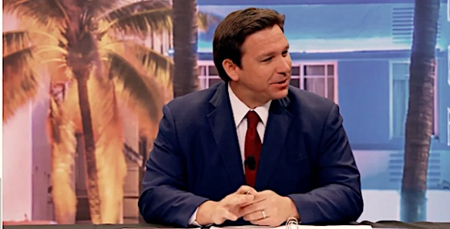
Florida Republican Gov. Ron DeSantis hosts a panel March 7. 2022, titled "The Curtain Close on COVID Theater." (Video screenshot)
Florida's surgeon general announced Monday morning the state has become the first to recommend against vaccinating healthy children for COVID-19.
The announcement by Surgeon General Joseph Ladapo came at the end of an 85-minute roundtable of epidemiologists and other medical scientists hosted by Republican Gov. Ron DeSantis.
It was titled "The Curtain Close on COVID Theater."
The governor posed questions regarding the effectiveness of the vaccines in reducing infection and transmission as well as the crucial issue of safety.
Among the participants were Drs. Robert Malone, Harvey Risch of Yale, Jay Battacharya of Stanford, Sunetra Gupta of Oxford and Martin Kulldorf, formerly of Harvard.
See the event:
Notably, panel member Dr. Joseph Fraiman offered an apology to the three creators of the Great Barrington Declaration, Battacharya, Kulldorf and Gupta.
Fraiman, an emergency medicine physician in New Orleans, explained that after initially supporting the universal lockdowns and other mitigation efforts, he came to realize that the data showed they had an immeasurable benefit, at best, and were causing harm.
He confessed that "initially I did think you all were crazy, or dumb, or maybe you just didn't understand what I was seeing."
"I'm sorry, because I believe now you guys were correct," he said. "And you were correct from the beginning."
Fraiman said he wished "that more people, including myself, had realized that sooner."
The Great Barrington Declaration has argued for focusing protecting on those who are vulnerable to COVID-19 -- people with multiple, chronic underlying health conditions -- while allowing those with little risk to go about their business.
Battacharya, Kulldorf and Gupta were called "fringe epidemiologists" by then-National Institutes of Health Director Francis Collins in an October 2020 email to Dr. Anthony Fauci in which Collins called for "a quick and devastating public takedown" of the declaration.
See Fraiman's apology:
https://www.wnd.com/2022/03/4987819/ [go to the link for the 2 minute video of Dr. Fraiman. – rdb]
Durham: Lies about Trump directed 'Russiagate' probe
'The FBI might have taken any number of different steps'
By Bob Unruh Published March 7, 2022 at 11:29am
What if the powers that be in the FBI and other agencies had known and recognized at the outset that the "Russiagate" conspiracy theory about President Trump was a political scheme, that it was funded by Hillary Clinton's campaign and it essentially was made up?
There likely would have been a different course for the United States, according to a new court filing from special counsel John Durham, who was tasked with uncovering the origins – and crimes – connected to the now-debunked rumors circulated during the administration of Barack Obama, and after, about Trump.
According to a new court filing obtained by Just the News, Durham assessed the situation in the filing.
"Had the defendant truthfully informed the FBI General Counsel that he was providing the information on behalf of one or more clients, as opposed to merely acting as a 'good citizen,' the FBI General Counsel and other FBI personnel might have asked a multitude of additional questions material to the case initiation process," Durham wrote in the filing. "Given the temporal proximity to the 2016 U.S. presidential election, the FBI also might have taken any number of different steps in initiating, delaying, or declining the initiation of this matter had it known at the time that the defendant was providing information on behalf of the Clinton campaign and a technology executive at a private company," he added.
Durham has been investigating, and working with a grand jury, for many months now. He's already obtained one conviction, from an FBI lawyer who admitted lying about evidence to make things look bad for President Trump.
Two others have been accused of lying, and the comments addressed the charges against Michael Sussman, who brought to the attention of federal investigators claims about Trump, as candidate and then president, and claimed he was doing so as a private citizen concerned about evidence he heard.
However, Sussman in fact reportedly was working on behalf of the Clinton campaign at the time.
Just the News reported, "It was an allegation that dogged Donald Trump for three years: a claim the Republican nominee-turned-president had a secret backdoor communications channel with the Kremlin. Repeated endlessly by the liberal media, the allegation was never true."
Sussman is facing a lying charge for claiming he was not working on behalf of any clients at the time – when he delivered to James Baker, then the general counsel for the FBI – wild claims about Trump's purported links to the Kremlin.
"Sussmann recently asked the judge in his case to dismiss a charge of lying to the FBI, arguing his alleged false statement to the FBI was not material to the case and was protected by the First Amendment," Just the News reported.
Now Durham has released a rebuke to Sussmann's demands.
"Far from finding himself in the vulnerable position of an ordinary person whose speech is likely to be chilled, the defendant — a sophisticated and well-connected lawyer — chose to bring politically charged allegations to the FBI's chief legal officer at the height of an election season," Durham explained to the court.
"He then chose to lie about the clients who were behind those allegations. Using such rare access to the halls of power for the purposes of political deceit is hardly the type of speech that the Founders intended to protect. The Court should therefore reject defendant's invitation to expand the scope of the First Amendment to protect such conduct."
He said at a trial he could deliver testimony from FBI and government witnesses that Sussman's false statement was, in fact, material and relevant and even could have influenced the course of the "Russia collusion" claims.
In fact, the material in the case created by Democrats against Trump was assembled using their own Russian sources – and is now suspected of being the product, at least partly, of Russia disinformation.
According to Just the News, Durham explained, "The expected testimony of multiple government witnesses will refute the defendant's argument that the defendant's false statement was immaterial. As noted above, the government expects that current and former FBI employees will testify at trial that understanding the origins of data and information is relevant to the FBI in multiple ways, including to assess the reliability and motivations of the source.
"None of this is novel. An evaluation of a source can (and often does) influence the FBI's decisions regarding its initial opening decisions and subsequent investigative steps. That alone is sufficient to establish materiality."
WND has documented that dozens of senators have told the current attorney general, Merrick Garland, not to interfere with Durham's work.
Warning that Durham's investigation is revealing "highly concerning, and potentially criminal, manipulation and exploitation of federal law enforcement resources," 46 GOP senators have written to Garland insisting he respect the independence of Durham's work.
The warning comes as legacy media outlets have turned from ignoring the newest court filings that suggest Hillary Clinton hired cyberspies to infiltrate the computer servers at Trump Tower, and the White House after Trump took office, and now are claiming that those statements are lies.
Sussman was, in fact, Clinton's campaign lawyer, and Durham has alleged there were campaign links to a tech company hired to "mine" Trump servers "for the purpose of gathering derogatory information about Donald Trump."
That conspiracy theory by Democrats, highlighted by the infamous Steele dossier of unfounded claims against Trump, triggered an earlier special counsel investigation by former FBI chief Robert Mueller, who spent years looking into the evidence and found no support for the Russiagate claims.
Previous evidence has revealed that Obama was, at one point, briefed on a plan by Clinton, then a presidential candidate, to spin up the Russiagate falsehoods against Trump in order to distract American voters from her own scandal raging at the time – her use of an unsecured email system for national security secrets, including those that were classified. https://www.wnd.com/2022/03/durham-lies-trump-directed-russiagate-probe/

Barr: I’ll Still Vote for the ‘Manic’ Man Trashing Me and My ‘Boring’ Book
Anna Venarchik Mon, March 7, 2022, 10:57 a.m.
As bookshelves await the release of former Attorney General Bill Barr’s imminent memoir—which is scheduled to land Tuesday—the feud between Barr and his former boss is reaching new lows.
In a bizarre March 2 letter addressed to NBC News anchor Lester Holt, former President Donald Trump offered a scathing rebuttal to Barr’s autobiography One Damn Thing After Another: Memoirs of an Attorney General.
“Bill Barr cares more about being accepted by the corrupt Washington Media and Elite than serving the American people,” the letter, obtained by Axios, began. “He was slow, lethargic, and I realized early on that he never had what it takes to make a great Attorney General.”
Trump then offered a scathing literary and character analysis of the AG-turned-author and his forthcoming work: “I would imagine that if the book is anything like [Barr], it will be long, slow, and very boring.”
The Worst Things Bill Barr Did as AG
In One Damn Thing After Another, Barr finally turns on Trump and the Trump administration, of which Barr was a very loyal member. He now claims Trump had “neither the temperament nor persuasive powers” to command the nation, and he urges Republicans to find another candidate for the 2024 election. He adds that the 2020 election that booted Trump from office was not fraudulent, as the ousted president still maintains.
There is a limit, however, to how far Barr is willing to distance himself from the man he describes as “manic and unreasonable.” In an interview with NBC’s Today show on Monday, Barr admitted that if Trump is listed on the 2024 presidential ballot, the man he deemed “off the rails” will still get his vote. MORE - https://ca.movies.yahoo.com/barr-ll-still-vote-manic-165727892.html

Commentary:
Vladimir Putin: Russia’s Trump?
By Cherie Zaslawsky|March 7th, 2022
And ye shall hear of wars and rumours of wars… –Matthew 24: 6-8
The two leaders, Trump and Putin, could not be more different in myriad ways. But they are alike in one important regard: both are nationalists at a time when the international globalist cabal is busily endeavoring to checkmate nation states to bring about its vaunted One World Dystopia—I mean One World Government.
Perhaps unsurprisingly, our indefatigably subversive Big Media is excoriating Putin much as it did Trump when he was in office. Cries of “He’s a madman!” “He’s dangerous!” “He’ll start WWIII!” directed at Putin today were aimed at Trump not long ago.
According to our Media Shills, first Trump was Hitler. Now Putin is Hitler. Nice try, guys, but pure balderdash. Could it be that our pundits are so quick to cry Hitler because they so closely resemble Goebbels themselves? Just wonderin’.
Putin rose to prominence in Russia with the collapse of the Soviet Union when assorted oligarchs and criminals were greedily plundering Russia. According to strategic economist, commentator, and investment guru Jim Rickards, Putin jailed a few oligarchs and let the rest keep their ill-gotten gains as long as they stayed out of politics and ceased the plunder. If this is accurate, then Putin cleaning up Russia is reminiscent of America’s Mayor Rudy Giuliani cleaning up New York City back in the day.
WHY UKRAINE?
War is God’s way of teaching Americans geography. –Ambrose Bierce
In 2014 a Soros-funded regime change operation took place in Ukraine. Orchestrated by Obama’s Assistant Secretary of State for European Affairs, Valerie Nuland, this Color Revolution replaced Viktor Yanukovych, the pro-Russian president of Ukraine, with globalist/EU puppets—first Arseniy Yatsenyuk, followed by Petro Poroshenko, and replaced in 2019 by EU/US/NWO shill, Volodymyr Zelenskyy.
Why the regime change? Perhaps in part because the globalists had made Ukraine a prime money-laundering paradise of graft, from Hillary’s infamous Uranium One sellout, to Hunter’s Burisma deals for himself and the Big Guy—you know, the one who thinks Kalumny’s the President.
But the far more important rationale would surely have been to neuter Putin and Russia. Putin is their enemy, as Trump was, for remaining a nationalist as the NWO cabal prepares to plunge all of us into hopeless serfdom à la Soylent Green and The Hunger Games. Can’t have any sovereign nations left—that’s not in their Totalitarian/Fascist/Socialist/Communist/Great Reset playbook.
Hence, the globalists’ takeover of Ukraine, now ratcheted up as they pressure Ukraine to join NATO. Why is this practically a declaration of war against Russia?
Not only does Ukraine possess important access to warm water ports, but some of its territory lies east of Moscow! This means the globalists, including U.S. Deep Staters, who currently more or less “own” Ukraine, have Russia’s capitol surrounded. They can launch nuclear or other weapons directly on Moscow with a mere ten-minute flight time.
Putin absolutely cannot allow this.
REGARDING EVIL
Woe unto them that call evil good, and good evil –Isaiah 5:20
For once the Dems and Reps agree on something: Putin is evil.
Ahem…let’s define our terms. Better yet, let’s consider a few examples of what most rational people would consider evil. By now we know what evil leaders look like: Hitler, Stalin, Mao, Pol Pot, Castro—although Justin Trudeau may argue about that last one, as he resembles the Cuban dictator in more ways than one.
I could go on, but let’s just contrast the above with Putin’s response to being backed into a corner, facing the possibility of having NATO states hostile to Russia on his doorstep. Should he sit on his hands and watch the Davos cabal checkmate Russia?
Perhaps unsurprisingly, controlled opposition “Conservative” pundit Mark Levin spins it this way: “This is Putin. He’s a rogue, evil, genocidal maniac.” “…the enemy here is Russia, the enemy here is Putin.” And this: “Nothing to do with NATO…”. Of course it has everything to do with NATO.
Perhaps Levin, the “Great One” who supports an Article V Convention of the States to undo the Constitution, forgot NATO’s history and mission: NATO stands for North Atlantic Treaty Organization. It was formed in 1949 to provide collective security against the threat posed by the Soviet Union.
MISSION CREEP
In fact, one could argue that with the fall of the Soviet Union, NATO had served its purpose and could be disbanded. The Warsaw Pact, an alliance of the USSR and its satellite states formed to balance power once Germany entered NATO, dissolved in 1991. Instead of following suit, NATO has been slowly but relentlessly expanding both its role and its number of member nations—creeping ominously ever eastward, closer and closer to Russia.
Worse yet, along with the UN and the EU, NATO has become an agency of the One World Government/NWO/Davos/ Reset crowd. And these guys now control Ukraine.
You want proof? Kira Rudik, a member of Ukraine’s Parliament recently spilled the beans, declaring on Fox News that: “We not only fight for Ukraine; we fight for this New World Order.” Thanks, Kira, and now watch your back.
VIRTUE SIGNALING
Frankly, I’m nonplussed by the virtue-signaling in our media and among our politicians, and even those who should know better, who persist in calling Putin “evil”, as Kurt Schlichter recently did in an article for Townhall: You are supposed to confuse “evil” (which Putin is) with “incompetent” or “crazy.”
Since when is it “evil” to protect your country? By the way, was it evil for JFK to oppose Soviet missiles in Cuba, a hundred miles from our border?
And if you still think Putin’s the bad guy here, just remember the same pundits and corrupt media that assured us Trump was unhinged, mentally unfit (how ironic when you consider his, um, replacement), and the worst president ever, even as they assured us that Fauci was trustworthy, and Hillary was going to win in 2016—that media—now tells us Putin wants to take over Eastern Europe and bring back Communism. Very odd that he never made such a move in the 22 years he’s been in power, and odder still that he brought back the Russian Orthodox Church which is by definition, antithetical to Communism. But I digress.
IF IT’S SCRIPTED, IT’S A PSY-OP
Of course, Usurper-in-Chief Biden merely parrots what Valerie Jarret et al. tell him to say. Following the script, Doddering Joe almost gleefully condemned Putin for his “unprovoked and unjustified attack” on Ukraine.
Eager to stay relevant and to promote the globalist agenda while playacting the part of a humanitarian, Hillary had this to say: “The world will hold Russia and Putin accountable for the human suffering and destruction this unjustified and unprovoked war will bring.” [Emphasis mine.] At least the scriptwriters changed the word order.
The irony, which we’re used to by now, is that Obama, Biden, Valerie Nuland, et al. supplied the provocation in 2014 with the overthrow of President Victor Yanukovych and his replacement with “rabidly anti-Russian, and far-right, Arseniy Yatsenyuk,” and have now, under the puppet Zelenskyy, upped the ante to the breaking point, making Putin’s move predictable, necessary and justifiable. And no, I’m not saying Russia should use nukes!
PSY-OP NUMBER THREE
At first glance, it may seem as if the unprecedented sequence of events since 2020 burst upon the scene haphazardly. But as FDR pointed out long ago, “In politics, nothing happens by accident. If it happens, you can bet it was planned that way.”
And once we take into account the overarching NWO plan looming overhead in our day, suddenly all the separate mind-boggling events line up as sequential moves on a worldwide chessboard. The plan is actually simple: the Davos billionaires’ club and associated globalists, including our own Deep State and America-hating Dems and RINOs—in many cases über-rich malcontents—seek to enslave humanity worldwide in their long dreamed-of totalitarian utopia. That’s utopia for them—as the ruling class that owns the world and everything in it—and dystopia for We the People.
Three major psychological operations, aka psy-ops, have relatively recently unmoored our nation and the world, paving the way for the cabal’s New World Order/One World Government. The Covid Plandemic, the Color Revolution here in America that resulted in the theft of our 2020 election and President Trump’s ouster, and now the provoking of Russia regarding Ukraine, which could potentially result in WWIII.
Note that all three serve the globalists’ grandiose agenda. Putin, like Trump before him, is in the globalists’ way, so they’re endeavoring to remove him from power as well. Actually, Putin is the real target here. Ukraine, as usual, is being used as a pawn in the globalists’ game.
If in fact we’re seeing another psy-op by the Davos Reset elites to kneecap Russia and move the world closer to their dreamed of Great Reset dystopia, then the last thing we should be doing is demonizing Putin.
Our own hard Left Dems and Deep Staters, backed up by the likes of Soros, Gates, hefty international banksters and other members of the Billionaire-Sociopaths’ Club, had a relatively easy time ousting President Trump, who offered what they likely considered only mild pushback.
That means they took down one of the two remaining nationalist leaders of powerful countries, with only one to go. That one would be Vladimir Putin. And there’s an ominous war-cry against him in the media and political realm now. If you’re still in doubt as to which side is which, maybe a quote from George Soros, kingpin of Color Revolutions and installation of globalist puppets will make it clear: “We must stand with Ukraine, as they stand for us.” That’s advice from Soros, who, we can safely say by now, is evil.
CANCELLING RUSSIA
Adding fuel to the fire, many are jumping on the Virtue Signaling Bandwagon, trumpeting their support for Ukraine by boycotting Russia. Among others, we find Google, Microsoft, Apple, Disney, Adidas, Nike, H&M, BMW, Honda, Ford, Exxon Mobil, UPS, and more. Not to be outdone, California lawmakers, quick to get on the wrong side of any issue of importance, seek to force pension funds to divest of Russian assets. And Germany just stole a Russian fellow’s boat—his 600 million dollar yacht, to be precise. That oughta show Putin a thing or two.
Funny, I don’t recall anyone boycotting our actual enemy, China… Just sayin’.
DEUTSCHLAND ÜBER EUROPA?
And here’s something eerie from German Chancellor Olaf Scholz: “We are living through a watershed era. And that means that the world afterwards will no longer be the same as the world before.” Does this sound a bit like the New Normal to you? Me too. And like Biden et al., he condemns Putin for “…an absolutely unjustifiable attack on an independent country, on the peaceful order in Europe and the world.” [Italics mine]
Funny that no one mentions Ukraine was historically part of Russia, or that Zelenskyy, the West’s installed puppet, has made it illegal to speak Russian in Ukraine, or that there’s a militant segment of avowed neo-Nazis in Ukraine who participated in the coup d’état against Yanukovych. Details, details…
Scholz goes on to say: “It is clear that we must invest much more in the security of our country. In order to protect our freedom and our democracy. This is a major national undertaking. The goal is a powerful, cutting-edge, progressive Bundeswehr [German armed forces] that can be relied upon to protect us. … The 2022 federal budget will provide a one-off sum of 100 billion euros for the fund. We will use this money for necessary investments and armament projects.”
Hmmm… A much stronger, militarized, heavily armed Germany prepared to take on Russia. Does that ring any bells? Wasn’t the EU formed in part to protect the other European countries from the big guy smack in their midst, with a track record of aggression in two world wars? But I digress.
QANON AD INFINITUM
Not wanting to be left behind, the QAnon franchise has chimed in, recycling its hopium for the incurably naïve. For example, Dave of the X22 Report—whose recent broadcast was praised by another Q spokesman, Charlie Ward, in this small, incestuous cyber-world—reassures his listeners that Trump advises Putin behind the scenes. Dave may have forgotten that Trump is no longer President, and/or that if he were, even now as a private citizen, to reach out to Putin, quislings in the NSA would quickly discover and leak such radioactive phone calls to the New York Times and Trump might be facing a third impeachment, since the Dems haven’t read the Constitution, don’t understand or obey the rule of law, and never quit.
In Dave’s wily and self-serving imaginings, Trump and Putin also conspire with…wait for it…Zelenskyy! You see, they’re all involved in a massive plot to take down the Deep State, but they can’t let on about this because of…optics. In fact, the title of this episode of the X22 Report is: Planned Long Ago, Deep State Stronghold and Bioweapons Destroyed, Trump Never Telegraphs His Moves. These Q promulgaters sure know how to keep their monetizing going strong.
THE FEBRUARY 27TH DIRECTIVE
Our own Deep State, populated with NWO globalists, America-hating subversives and felonious traitors galore, got very busy on February 27th, sending out a veritable flock of rather alarming tweets calling for “regime change” in Russia.
On Sunday, February 27th, a member of the Brookings Institution tweeted out: Regime change: Russia, which another member immediately publicly seconded.
That’s not all. On the same day, the head of the snake, I mean of the Council on Foreign Relations, Richard Haass, had this to say: “Just days ago much of the world was focused on the unwanted prospect of regime change in Ukraine. Now the conversation has shifted to include the possibility of desired regime change in Russia. A week can be a long time in politics.”
Notice the manipulative wordplay: Regime change in Ukraine is “unwanted,” while in Russia it’s “desired.” My question in both cases: by whom, Richard?
Nor was this Twitter 2/27th onslaught limited to the US. Swedish diplomat and former Prime Minister of Sweden Carl Bildt also chimed in: “All of us must now face the reality that we will not have peace in Europe until there is regime change in Russia. Then we should seek to welcome a new Russia as a partner for peace.”
And today, March 4th, the feckless RINO Lindsey Graham astonishingly tweeted: “The only way this ends is for somebody in Russia to take this guy out.” Graham was repeating a statement he made on Fox News late Thursday in case you missed it. “You would be doing your country – and the world – a great service.” He even said, “Is there a Brutus in Russia?” Let that sink in. Lindsey’s publicly advocating the overthrow, by assassination, of a superpower’s leader and government for defending their own turf and interests.
By the way, does anyone else remember how these guys ridiculed Donald Trump for using Twitter to communicate directly with the nation? Guess they were just jealous…
SOME LAST THOGHTS
In 1997, renowned American diplomat George Kennan warned: Expanding NATO would be the most fateful error of American policy in the entire post-cold-war era. Such a decision may be expected to inflame the nationalistic, anti-Western and militaristic tendencies in Russian opinion; to have an adverse effect on the development of Russian democracy; to restore the atmosphere of the cold war to East-West relations; and to impel Russian foreign policy in directions decidedly not to our liking.
Tragically, yet again, our leaders ignored this good advice and set out on a treacherous course instead.
A commenter on an Epoch News article had this to say: “From my 20 years traveling eastern/southern Ukraine, living there, in-laws there, kids born there, it’s clear to me the best solution is for Ukraine to be split in half, into a western Ukrainian speaking West Ukraine and a historical Russian speaking east Ukraine. The two countries would be autonomous buffers to Europe on the west and Russia on the east. Then peace could happen. Enough already.”
Here’s my two cents: You want to make sure WWIII doesn’t happen over a country Millennials couldn’t find on a map? Here are two suggestions:
Butt out of Putin’s business regarding the legitimate security needs of Russia
Ally with Putin against the NWO, recognizing that a US/Russia alliance could protect us from our real enemy, China, and throw a monkey-wrench into the Davos Cabal’s plans
What I have to say to those beating the war drums and clamoring for Putin’s scalp, as well as those buying the media’s anti-Russia narrative, is this: Be careful what you wish for.
You might one day find yourself agreeing with an online commenter, one of many anti-globalist bloggers, who posted this on a recent Epoch Times article: “Putin is the last hope for the world.” https://newswithviews.com/vladimir-putin-russias-trump/
A Black Guy’s Defense of the Constitution
Allen West Posted: Mar 07, 2022 12:01 AM
Recently a leftist journalist from The Nation named Elie Mystal referred to the U.S. Constitution as "trash". He appeared on The View last Friday to promote his new book "Allow me to Retort: A Black Guys Guide to the Constitution". This is the ideological battle in which we are engaged in America.
Mr. Mystal must be commended for having the courage, albeit delusional, to admit to the Country the progressive socialist leftist perspective on the US Constitution. It is no different than Virginia gubernatorial candidate Terry McAuliffe, when he asserted that "parents do not have a right to decide what their children are being taught".
The left in America is so emboldened that they no longer feel the need to hide their disdain for this Nation. The question is, for we, constitutional conservatives, what shall be our response?
The situation in America is no longer about political parties. It is now about two very different philosophies of governance, constitutional conservatism and progressive socialism...Marxism. The crux of the matter comes down to the relationship between the individual citizen and the institution of government. Our founding documents, which Mystal believes are flawed because white men wrote them, establish the individual, their rights, freedoms, liberties, as sovereign over the institution of government. Mystal and his comrades do not believe that to be so.
We are living in a time where the usurpation of individual rights and liberties is rampant. Of course, Mystal believes that the Constitution should be scrapped and replaced with the fundamental ideological beliefs of post-modern, not classical, liberalism. The left's belief is that social justice, which means equality of outcomes, should be the guiding principle. But who exactly gets to decide the outcomes?
Constitutional conservatives embrace the premise of equality of opportunity and in the writings of English political philosopher John Locke and his theory of natural rights -- life, liberty, and property. Thomas Jefferson codified Locke's natural rights theory in our Declaration of Independence -- life, liberty, and the pursuit of happiness.
Mystal's condemnation of our Constitution is based upon the skin color of the writers, the framers, which is insidious. Was it not Dr. King who advocated that we judge based upon the content of character, not the color of skin?
I am wondering, if the Constitution, according to Mystal, is trash, then what happens to freedom of religion and the free exercise thereof? After all, the civil rights movement was faith based. If the Constitution is trash, then what happens to the 13th, 14th, and 15th Amendments which ended slavery, gave slaves citizenship, and codified the right to vote for those new American citizens. Oh yea, those were white men who passed those Amendments, as well as the Amendment giving women the right to vote.
Shall we scrap the Second Amendment of the Constitution? Matter of fact, it was the Ku Klux Klan that certainly did not want newly freed slaves to enjoy that constitutional right. Yea, the KKK served as foot soldiers to the Democrat party.
Mystal even asserts that we should abolish States rights, meaning the 10th Amendment. In essence he is advocating that we are no longer a Constitutional Republic, and he disavows the system of federalism. Mystal and his leftist accomplices want an all-powerful federal government that rules, not governs.
And we must understand, the left does not believe in the three branches of government, but rather the three branches of rule -- media, academia, and the courts. The left does not believe in natural rights theory, no. They believe that their ideological agenda forms the basis of rights, which they can bestow and rescind.
The left does not believe we have a right to life. They have welcomed the cult of death of a woman who was a white supremacist and racist, Margaret Sanger. The left used the US Supreme Court, all white men, to decide that a woman has the right to murder a baby in the womb. They also used the SCOTUS to decide that marriage can be what their ideological agenda states. And, by the way, the Constitution does not give courts the enumerated power to make law.
The abject danger of the ideals of Elie Mystal and the progressive socialist left is that they have no regard for our rule of law...just their rule. Individual rights are impediments to their totalitarian designs and goals. The Constitution of the United States is the document that binds us together as the American people. It is the reason why we are the longest running Constitutional Republic that the world has ever known. It is the document that four generations of Black men in my family took an oath to support and defend. And we are all combat veterans who were willing to make the last full measure of devotion to honor that oath.
This Black man honors and reveres our Constitution. That is why I am blessed to be the Executive Director of The American Constitutional Rights Union (ACRU). This is where I will make my stand, against the clear and present danger represented by Elie Mystal. I wonder if The View would ever have me on the show to retort the delusional "retort" of Elie Mystal?
In closing, we must all take an oath to support and defend the Constitution of these United States of America, our fundamental rule of law that sees not color...but enables our rights, freedoms, and liberty.
Steadfast and Loyal https://townhall.com/columnists/allenwest/2022/03/07/a-black-guys-defense-of-the-constitution-n2604197

Biden Shatters Israel’s Delusions
03/07/2022 Caroline Glick
For decades, senior Israeli defense officials beat a path to the Pentagon, the State Department, the CIA and the National Security Council with briefcases full of documents providing conclusive proof that Iran’s nuclear program is a military program and that its purpose is to transform the Islamic Republic of Iran into a nuclear-armed state. The officers arrived in Washington convinced that the smoking gun they were providing the Americans would compel Washington to abandon its long-held delusion that there is a “grand bargain” to be had with the fanatical Islamist theocracy whose leaders believe that Iran’s rise will herald an era of unmitigated Shiite global domination.
All of the Israeli officers made their best cases to their American counterparts. Most believed the Americans were open to the information they provided, and left Washington convinced that the Americans finally recognized the danger and would act to block Iran from achieving its nefarious goal. On at least one occasion, their efforts were rewarded.
In 2018, after Israel’s Mossad spy agency spirited Iran’s nuclear archive out of a warehouse in Tehran and brought it to Israel, Israel’s spy chiefs flew to Washington to share the findings with the Trump administration. The documents provided incontrovertible proof of Israel’s long-standing contentions that Iran’s nuclear program was initiated, maintained and expanded throughout the years for the primary purpose of developing nuclear weapons. Then-President Donald Trump responded to Israel’s revelations by withdrawing the U.S from the 2015 Joint Comprehensive Plan of Action (JCPOA)—the nuclear deal the Obama administration had concluded with Iran.
The 2015 nuclear deal placed certain restrictions on Iran’s nuclear activities for a limited period. But the JCPOA allowed Iran to continue with its nuclear research and development, and placed no restrictions on Iran’s missile development and proliferation. In other words, Barack Obama‘s deal limited what Iran could do with the nuclear capabilities it had acquired by 2015, but it enabled Iran to massively expand its nuclear capabilities for the future.
During the early years of the JCPOA, Iran developed second-generation centrifuges capable of enriching uranium 10 times faster than it was able to enrich in 2015—and to much higher levels of purity. Iran began deploying the new advanced centrifuges as soon as they were ready, even before Trump abandoned the JCPOA and reinstated the nuclear sanctions the Obama administration had suspended in 2015.
After abandoning the JCPOA, Trump and then-Secretary of State Mike Pompeo announced their “maximum pressure” campaign of harsh sanctions on the Iranian regime. The campaign intended to block the regime from waging war against its neighbors, either directly or through its proxies, and to deter it from attacking U.S. forces and assets in the region.
The maximum pressure strategy was working effectively when Trump left office. Had it been retained by the Biden administration, Iran’s regime would likely have collapsed by this year, rendering its nuclear weapons program dead in the water. But rather than continue a policy that was working, President Joe Biden reinstated Barack Obama’s policy of facilitating Iran’s nuclear program and its regional aggression by agitating for a restoration of American and Iranian compliance with the 2015 deal.
Biden appointed Robert Malley, a former Obama administration nuclear negotiator who had developed strong ties with the Iranian regime during his tenure at the helm of the International Crisis Group, to serve as his envoy to renewed nuclear negotiations with Iran. Both before the talks were initiated in Vienna, and since the talks commenced, in the interests of convincing Iran to agree to a deal, Biden ended enforcement of the most significant sanctions Trump had placed on Iran’s nuclear operations. He delisted Iran’s Yemeni proxy, the Houthis, from the State Department’s formal list of foreign terrorist organizations. And Biden convinced U.S. allies to unfreeze Iranian funds held in their banks due to Iran’s sponsorship of terrorism, in the hopes of proving his benign intentions to the ayatollahs.
This brings us back to the Israeli military officers who have come and gone through the corridors of power in Washington for the past two decades, bearing proof of Iran’s malign intentions and actions. During Obama’s presidency, then-Israeli Prime Minister Benjamin Netanyahu was often the lone voice in Israeli leadership circles warning that the Obama administration had no intention of blocking Iran from becoming a nuclear-armed power. For eight years, Netanyahu fought with the Israeli defense establishment, whose leaders continued to believe that Americans from both sides of the partisan aisle could be trusted when they said they would not permit Iran to become a nuclear power.
Last June, Netanyahu was ousted from power by a narrow coalition of small parties hailing from the establishment right to the far left to the Muslim Brotherhood. Current Prime Minister Naftali Bennett, Foreign Minister Yair Lapid and Defense Minister Benny Gantz came into office promising not to publicly criticize Biden’s nuclear diplomacy with Iran, and even voicing support for a renewed agreement with the mullahs. The Israeli security establishment, which long opposed Netanyahu’s doctrine of muscular public diplomacy and independent action to block Iran from acquiring nuclear weapons, felt vindicated.
Over the past several months, as nuclear talks have dragged on in Vienna, Israel’s dovish new leaders kept to their word. Opposition to rumors of U.S. concessions was voiced politely, and generally in private. Senior military and intelligence officers continued to travel to Washington with their briefcases, brimming with documents and believing it was in their power to shift the U.S. position at the negotiating table in Vienna. Netanyahu’s frequent warnings that now is no time for silence were dismissed as the ravings of a bitter, spurned leader.
But then, last Wednesday, Gabriel Noronha, a former Iran specialist at the State Department, published details of the concessions Malley has already agreed to on his Twitter feed. Noronha wrote that he received the details of the U.S. concessions from his former colleagues at the State Department and National Security Council, as well as from the European Union delegations to the talks. Noronha wrote that his associates, all “career” officers rather than political appointees, “are so concerned with the concessions being made by Rob Malley in Vienna that they’ve allowed me to publish some details of the coming deal in the hopes that Congress will act to stop the capitulation.”
Malley’s capitulation includes delisting Iran’s Revolutionary Guards Corps from the State Department’s list of Foreign Terror Organizations and ending U.S. sanctions on Iran’s senior terror masters—including the terror chiefs responsible for the massacre of 241 U.S. Marines at the Marine barracks in Beirut in 1983 and the 1994 bombing of the Jewish community center in Buenos Aires in 1994, where 85 people were killed.
Malley has agreed to end sanctions on 112 entities and people tied to Iranian dictator Ali Khamenei, through which Khamenei has accrued massive wealth and organized Iran’s global terror and weapons procurement networks. Malley is willing to end sanctions on Iranian entities and individuals involved in the torture and murder of Iranian civilians.
All told, Noronha’s colleagues said Malley has agreed to sanctions relief that will provide Iran with an immediate cash infusion of $90 billion, as well as an additional $50-55 billion annually in oil and gas profits.
On the nuclear front, beyond a few formalities, Biden’s deal will enable Iran to move full-speed ahead with its development of advanced centrifuges and continue its race to the nuclear finish line. All limitations—which are largely unenforceable—will be removed in two and a half years. And Iran’s nuclear program, which constitutes a material breach of the Nuclear Non-Proliferation Treaty of which Iran is a signatory, will be legitimated by the UN and the U.S. government.
All of these concessions guarantee two consequences. First, Iran will go to war. As U.S. Army Col. (res.) Joel Rayburn, who served as Trump’s envoy to Syria and in a range of senior positions related to the Middle East in Central Command, the National Security Council and the State Department explained in a recent interview with Newsweek, with the JCPOA’s implementation in 2015, Iran received billions of dollars in sanctions relief. It used the funds to expand its wars against Israel, against U.S. forces deployed in the Middle East and against Iran’s Sunni Arab neighbors the United Arab Emirates, Bahrain and Saudi Arabia. Iran fought its various foes both directly and through its proxies in Iraq, Yemen, Syria, Lebanon and the Palestinian territories.
The $90 billion that Malley and his colleagues in the Biden administration are poised to now give Iran guarantee that Iran will massively escalate its aggression against these actors.
The second consequence of the new nuclear deal is that Iran will become a nuclear-armed state unless Israel attacks and destroys a sufficient number of Iran’s nuclear installations to significantly scale back Iran’s nuclear capabilities.
And so we return to Israel’s security brass. The most powerful shock wave Noronha’s revelations produced is the one going through Israel’s military high command. Israel’s military leaders can no longer deny the truth that they have gone to near-superhuman heights to wish away for 20 years. Netanyahu, it turns out, was right all along.
The contest between Iran and Israel pits a country of 90 million against a country of nine million; a theocratic regional hegemon with manifold foreign legions against a liberal democracy with no aspirations for territorial conquest. And under the Biden administration, the U.S. is standing with the Iranians. https://carolineglick.com/biden-shatters-israels-delusions/
THE SHORASHIM BIBLICAL GIFT CATALOG 005
http://mad.ly/7f9f64?pact=20013931524&fe=1
Support Shorashim!

ARUTZ SHEVA
Two officers injured in ramming attack in Samaria
Palestinian Arab vehicle rams into vehicle of security forces operating in village of Silat al-Harithiya, injuring two officers. Terrorist arrested.
Elad Benari 07.03.22 23:18
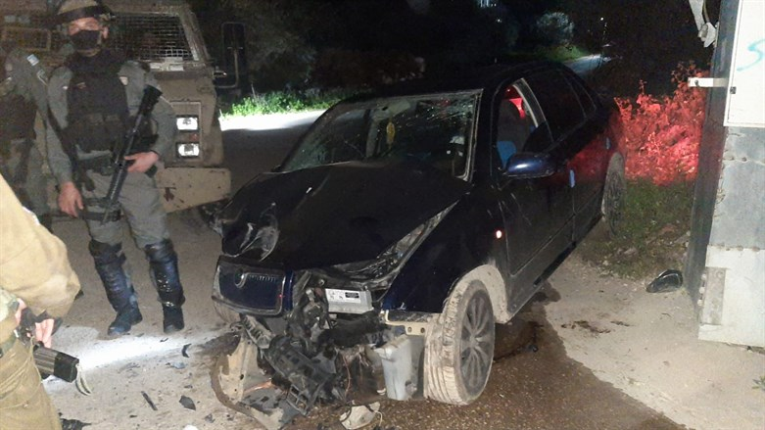
Scene of ramming attack Israel Police spokesperson
Two Border Police officers were lightly injured in a ramming attack in the Palestinian Arab village of Silat al-Harithiya in Samaria on Monday evening.
During an operation by Border Police and IDF forces in the village, the fighters identified a vehicle accelerating towards them. The vehicle soon after collided with the forces' protected vehicle.
As a result of the collision, two Border Police fighters were injured and evacuated for medical treatment at their base. The protected vehicle was damaged.
The terrorist was arrested and taken for questioning.
Earlier on Monday, two policemen were moderately wounded in a stabbing attack near the Lions’ Gate ate in the Old City of Jerusalem.
Magen David Adom paramedics provided the victims with initial treatment and evacuated them to hospital. The terrorist was neutralized.
A similar attack was carried out at the same location early Sunday morning. In that attack as well, two police officers were stabbed. https://www.israelnationalnews.com/news/323489

Justice Department: Iran plotting to assassinate John Bolton and other American officials
Two Iranians from the Quds Force found to have been planning to assassinate former Trump national security advisor John Bolton.
Israel National News 07.03.22 22:54
Two Iranians from the Islamic Revolutionary Guards’ Quds Force have been planning to assassinate former Trump national security advisor John Bolton and other American officials, a Department of Justice (DOJ) official told the Washington Examiner.
The DOJ has strong evidence that the Iranians were plotting the murders but reportedly the Biden administration is refusing to issue indictments against the men, worried that such a public announcement could ruin the Vienna nuclear talks with Iran at a sensitive time when they are close to the finish line. [HUMMMMM? Once again this “Bi-Dum" group is flaunting their stupidity by not acting on threats of those in the USA. Treason we cry. They would rather have an useless unworkable piece of garbage with their signature that will be undone rapidly if a NON-rino GOP gets in. – rdb]
The DOJ official said that evidence of a conspiracy to assassinate Bolton is so serious that public indictments needs to be immediately issued.
The plot appears to involve Revolutionary Guards spying and a campaign to hire an American-based assassin inside the U.S.
The intelligence community discovered the plan while it was in its early stages and was so worried that it gave Bolton full-time Secret Service protection, either in late 2021 or early in 2022. Bolton currently still has Secret Service guards.
The plot was foiled by FBI assets who also helped to protect Bolton. It is likely the reason for current National Security Advisor Jake Sullivan’s January 9 strongly worded statement to Iran that the U.S. would protect government officials "serving the United States now and those who formerly served."
Threats by Iran against other former Trump administration officials have also been made and continue to be of concern, including against former Secretary of State Mike Pompeo and others who worked on the Iran file.
In December 2020, Pomeo’s Diplomatic Security Service detail was left in place past his tenure because of threats from Iran. He is still under protection. https://www.israelnationalnews.com/news/323488
To be removed from this News list, Please click here and put "Unsubscribe" in the subject line.

03/07/2022 NEWS
Evidence of Biblical Earthquake found at the City of David
https://www.youtube.com/watch?v=AA5VXPQhjLM

"Throughout the history of the United States, war has been the primary impetus behind the growth and development of the central state. It has been the lever by which presidents and other national officials have bolstered the power of the state in the face of tenacious popular resistance."
-- Bruce D. Porter (1952- ) Professor of political science at Brigham Young University
Read the Prophets & PRAY WITHOUT CEASING!
That is the only hope for this nation!
Please  Remember  These  Folks  In  Prayer-  Check often  They  Change! | Pray that the world would WAKE UP! Time for a worldwide repentance!  ALL US soldiers fighting for our freedom around the world  Pray for those in our government to repent of their wicked corrupt ways.  Pray for BB – Severe sciatic needing procedure.  Pray for EL – Had clot embolized to brain – successful ‘clot buster’ but long road to go.  Pray for BB – Severe West Nile Fever –still not mobile- improving!  Pray for RBH – cancer recurrence  Pray for Ella – Child with serious problems  Pray that The Holy One will lead you in Your preparations for handling the world problems. – Have YOU made any preparations?
Exodus 10:³And Moses and Aaron went in unto Pharaoh, and said unto him: 'Thus saith the LORD, the God of the Hebrews: How long wilt thou refuse to humble thyself before Me? let My people go, that they may serve Me. ⁴Else, if thou refuse to let My people go, behold, to-morrow will I bring locusts into thy border; ⁵and they shall cover the face of the earth, that one shall not be able to see the earth; and they shall eat the residue of that which is escaped, which remaineth unto you from the hail, and shall eat every tree which groweth for you out of the field; ⁶and thy houses shall be filled, and the houses of all thy servants, and the houses of all the Egyptians; as neither thy fathers nor thy fathers' fathers have seen, since the day that they were upon the earth unto this day.' And he turned, and went out from Pharaoh.

Bennett holds follow-up call with Putin after Moscow meeting
Amid diplomatic efforts to mediate conflict in Ukraine, PM also speaks to French, German leaders; Lapid to meet Blinken on Monday
By TOI staff and Tal Schneider Today, 7:56 pm
Following their meeting in Moscow, Prime Minister Naftali Bennett and Russian President Vladimir Putin spoke on the phone on Sunday, according to a statement from the Kremlin and a spokesperson for the prime minister.
There were no immediate details on the content of the call.
Bennett also spoke with French President Emmanuel Macron and German Chancellor Olaf Scholz, the spokesperson said.
On Saturday, Bennett flew to Moscow to meet with Putin, becoming the first Western leader to sit down with the Russian leader since he invaded Ukraine on February 24. After spending three hours with Putin, Bennett flew straight to Berlin and met with German Chancellor Olaf Scholz, just days after the pair met in Jerusalem.
Few details were provided on the content of either meeting.
Bennett’s trip was seen as an effort to further develop a potential role as mediator between the sides, as Israel has good relations with both Kyiv and Moscow.
During a cabinet meeting Sunday, Bennett said that Israel had a moral obligation to work to broker peace talks between Russia and Ukraine, even if the likelihood for progress was slim.
“I returned from Moscow and Berlin a few hours ago,” Bennett said. “I went there to assist the dialogue between all of the sides, of course with the blessing and encouragement of all players.”
Bennett said that he could not “go into greater detail” on the talks he held with Putin or his phone calls with Ukrainian President Volodymyr Zelensky.
Foreign Minister Yair Lapid is set to meet with US Secretary of State Antony Blinken in Latvia’s capital of Riga on Monday, his office said.
President Isaac Herzog said on Sunday that Israel is taking “welcomed and proper steps” to prevent further bloodshed in Ukraine.
“In this context, and at this hour of a global storm, I wish to pay my respects to the anonymous soldiers working night and day providing humanitarian aid at the front of the war in Ukraine,” he said during a swearing-in ceremony for new judges at the President’s Residence in Jerusalem.
Herzog also thanked officials and civilians working in the war-torn country, saying they are “the beautiful face of our nation.”
“[They] act in the spirit of the sages, who said, ‘Whosoever saves a single life, it is as if he saved an entire world,'” he said. https://www.timesofisrael.com/bennett-holds-follow-up-call-with-putin-after-moscow-meeting/

Ukraine says second evacuation attempt from Mariupol halted, blames Russian shelling
Interior minister rages at ‘sick brain of Russians’ as effort to create humanitarian corridors appears to fail; Zelensky reiterates plea for no-fly zone as bombings continue
By AP and TOI staff Today, 5:49 pm
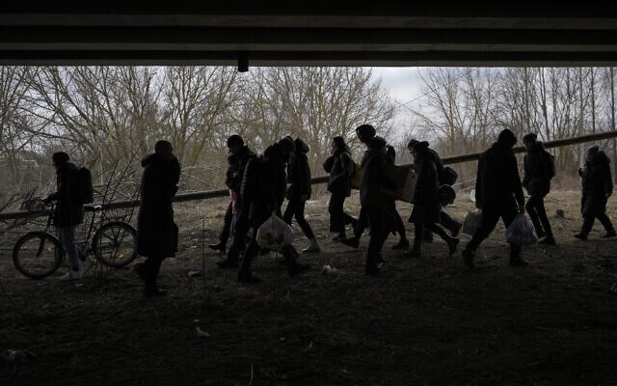
People cross on an improvised path under a bridge that was destroyed by a Russian airstrike, while fleeing the town of Irpin, Ukraine, March 5, 2022. (AP Photo/Vadim Ghirda)
Plans to evacuate civilians from a besieged port city in Ukraine failed to materialize Sunday for the second time along with an expected Russian ceasefire, a Ukrainian official said, as officials tried to persuade Russia to agree on establishing other evacuation routes near Ukraine’s capital.
Residents expected to leave the port city of Mariupol during a 10 a.m. to 9 p.m. local ceasefire, Ukrainian military authorities said earlier in the day. Interior Ministry adviser Anton Gerashchenko said the planned evacuations were halted because of an ongoing assault by Russian troops.
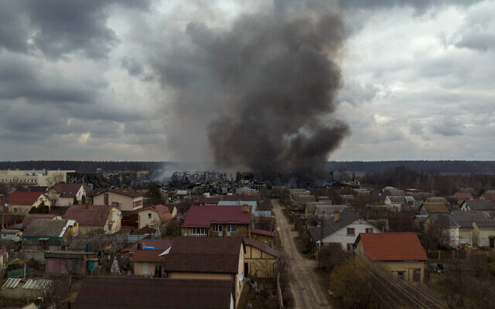
“There can be no ‘green corridors’ because only the sick brain of the Russians decides when to start shooting and at whom,“ Gerashchenko said on Telegram.
During a phone call with French President Emmanuel Macron on Sunday, Russian President Vladimir Putin blamed “Ukrainian nationalists” for the failed civilian evacuations, claiming Kyiv was using the ceasefire to “build up forces and means in their positions,” according to a statement from the Kremlin.
The news dashed hopes of progress in easing, much less ending, the war in Ukraine, which is now in its 11th day and has caused 1.5 million people to flee the country. The head of the UN refugee agency on Sunday called the exodus “the fastest-growing refugee crisis in Europe since World War II.”
The presidents of Turkey and France, as well as Pope Francis, appealed to Putin to negotiate to end the conflict.
Separately, Ukraine’s national security service said Russian forces fired rockets at a physics institute in the city of Kharkiv that contains nuclear material and a reactor. Russian troops already took control of the Zaporizhzhia plant in Ukraine, as well as Chernobyl, the site of the world’s worst nuclear disaster.

A factory and a store burn after being bombarded in Irpin, on the outskirts of Kyiv, Ukraine, March 6, 2022. (AP Photo/Emilio Morenatti)
The security service said a strike on the nuclear facility in Kharkiv could lead to “large-scale ecological disaster.” The service said on Facebook Sunday that the Russians were firing from Grad launchers. Those missiles do not have precise targeting, raising concern that one would go astray.
Ukrainian President Volodymyr Zelensky reiterated a request for foreign protectors to impose a no-fly zone over Ukraine, which NATO so far has ruled out because of concerns such an action would draw the West into the war.
“We repeat every day: close the sky over Ukraine. Close for all Russian missiles, for Russian combat aircraft, for all their terrorists,” he said in a video address Sunday.
“If you don’t, if you don’t give us at least planes so we can protect ourselves, there’s only one thing to conclude: you want us to be killed very slowly.”
During that same address, Zelensky said that a Russian rocket barrage destroyed the airport in the central Ukrainian city of Vinnytsia.
Breaking! pic.twitter.com/VCL5mpOVMi
— Володимир Зеленський (@ZelenskyyUa) March 6, 2022Putin warned Saturday that Moscow would consider a third-party declaration to close Ukrainian airspace to be a hostile act.
The disappointment for women, children and older adults who waited to leave Mariupol and the nearby city of Volnovakha while able Ukrainian men stayed behind to fight came after a similar ceasefire deal collapsed Saturday and foreign leaders sought to bring diplomacy to bear on ending the war.
Putin told Turkish President Recep Tayyip Erdogan that Russia’s invasion of Ukraine could be halted “only if Kyiv ceases hostilities and fulfills the well-known demands of Russia,” according to the Kremlin’s readout of the phone call the two leaders held on Sunday. [While the US and others are having conniption fits with the things going on in Ukraine, I would remind you that this is almost exactly what was done and recorded in the Biblical era and for centuries thereafter during a war. Even during WWII areas were bombed and they “laid Siege” to them until they gave up and cried “uncle” After WWII with the advent of the globalist agenda known as the UN. Waars could no longer really be called wars but were called “conflicts” or “interdictions” or “interventions”. Instead of actually having a plan and a strategy to enter and exit the war they became long drawn out expensive NO WIN situations where the soldiers and the general population suffered the most. There were no real winners or official losers. Only the poor people on whose land it occurred were the losers. Putin is actually carrying out a war for which he intends there to be a winner and a loser and then for it to be over. The Politically correct world globalist leadership just can’t understand this.
All you have to do is look at the pictures of the towns in Poland, Hungary, Germany, France etc to realize that, that was exactly what the Allied forces did in that War. – rdb]
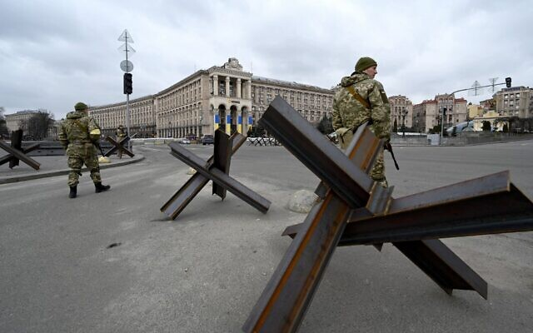
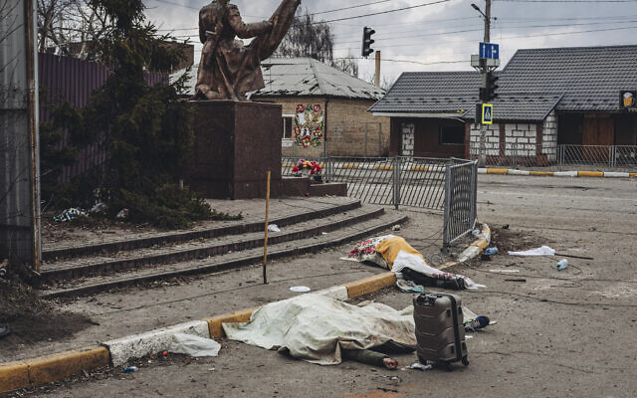
Putin earlier listed “demilitarization” and “denazification” of Ukraine, recognition of Crimea as part of Russia and separatist regions in eastern Ukraine as independent states as the Kremlin’s main demands.
“Hope was expressed that during the planned next round of negotiations, the representatives of Ukraine would show a more constructive approach, fully taking into account the emerging realities.” [In other words if Ukraine wants it to end they can simply agree to not allow the corrupt NATO and western groups to use there land as a nuclear weapons storage land and stop playing footsie with the corrupt leadership in the west. – rdb]
The third round of talks between Russian and Ukrainian negotiators is scheduled for Monday.
In a highly unusual move, Pope Francis said that he had dispatched two cardinals to Ukraine, saying the Vatican was willing to do everything it could to bring peace to end the conflict that began on February 24 when Russia invaded Ukraine.
“In Ukraine, rivers of blood and tears are flowing,” the pontiff said in his traditional Sunday blessing. “This is not just a military operation, but a war that sows death, destruction and misery.’’
As Russian forces surrounded several Ukrainian cities and maintained a convoy outside the capital, Kyiv, Zelensky appeared on television Saturday night wearing what has become a habitual military green T-shirt and rallied his people to remain defiant.
“Ukrainians in all of our cities that the enemy has entered — go on the offensive!’’ Zelensky said. “You should take to the streets! You should fight! … It is necessary to go out and drive this evil out of our cities, from our land.” [It is very easy to tell people to leave your shelter and go out and fight for the motherland when you are located in a relatively safe bunker but it isn’t as clearcut and easy when you are out in the street. – rdb]
Members of the Ukrainian Territorial Defense Forces stand guard next to anti-tank structures blocking the streets of the center of Kyiv on March 6, 2022. (Sergei Supinsky/AFP)
After the ceasefire in Mariupol failed to hold Saturday, Russian forces intensified their shelling of the city and dropped massive bombs on residential areas of Chernihiv, a city north of Kyiv, Ukrainian officials said.
In Mariupol, bereft mothers mourned slain children, wounded soldiers were fitted with tourniquets and doctors worked by the light of their cellphones as bleakness and desperation pervaded.
“The city is in a very, very difficult state of siege,” Mariupol Mayor Vadym Boychenko told Ukrainian TV. “Relentless shelling of residential buildings is ongoing, airplanes have been dropping bombs on residential areas. The Russian occupants are using heavy artillery, including Grad multiple rocket launchers.”
Putin, meanwhile, continued to pin the blame for the war on the Ukrainian leadership, slamming their resistance to Russian forces.
“If they continue to do what they are doing, they are calling into question the future of Ukrainian statehood,” he said Saturday. “And if this happens, it will be entirely on their conscience.”
He also hit out at Western sanctions that have crippled Russia’s economy and sent the value of its currency tumbling. Meanwhile, more companies announced they are suspending operations in Russia, including Mastercard and Visa.
“These sanctions that are being imposed, they are akin to declaring war,” he said during a televised meeting with flight attendants from Russian airline Aeroflot, which on Saturday suspended all international flights except to Belarus. “But thank God, we haven’t got there yet.”
The World Health Organization on Sunday condemned attacks on healthcare workers in Ukraine, saying it verified at least six such attacks that have killed six people and injured 11 others.
The dead bodies of people killed by Russian shelling lay covered in the street in the town of Irpin, Ukraine, March 6, 2022. (AP Photo/Diego Herrera Carcedo)
Attacks on healthcare workers are a violation of international humanitarian law, WHO Director-General Tedros Adhanom Ghebreyesus said on Twitter.
British military officials on Sunday compared Russia’s tactics in Ukraine to those used in Chechnya in 1999 and Syria in 2016, where surrounded cities were pummeled with airstrikes and artillery after Russian forces faced unexpected resistance.
The strength of Ukrainian resistance continues to surprise Russian forces, and they have responded by targeting populated areas, including the cities of Kharkiv, Chernihiv and Mariupol, the UK Ministry of Defense said in its daily intelligence briefing.
The death toll of the conflict is difficult to measure. The UN human rights office said at least 351 civilians have been confirmed killed, but the true number is probably much higher. Russian and Ukrainian defense officials have not provided information on their military causalities.
Ukraine’s military is vastly outmatched by Russia’s, but its professional and volunteer forces have fought back with fierce tenacity. In Kyiv, volunteers lined up Saturday to join the military.
Even in cities that have fallen, there were signs of the resistance Zelensky requested.
Video posted online showed a Russian jet being shot down near Chernihiv, northern Ukraine, on March 5. Later images showed the capture of the pilot, who ejected from his plane but was injured. pic.twitter.com/FP0kRDg19P
— Radio Free Europe/Radio Liberty (@RFERL) March 5, 2022
Onlookers in Chernihiv cheered as they watched a Russian military plane fall from the sky and crash, according to video released by the Ukrainian government. In Kherson, hundreds of protesters waved blue and yellow Ukrainian flags and shouted, “Go home.”
But the struggle to enforce temporary ceasefires in Mariupol and Volnovakha on Saturday showed the fragility of efforts to stop the fighting across Ukraine.
Russia has made significant advances in southern Ukraine as it seeks to block access to the Sea of Azov. Capturing Mariupol could allow Moscow to establish a land corridor to Crimea, which Russia annexed from Ukraine in 2014 in a move that most other countries considered illegal.
The West has broadly backed Ukraine, offering aid and weapon shipments and slapping Russia with vast sanctions. But no NATO troops have been sent to Ukraine, leaving Ukrainians to fight Russian troops.
“Ukraine is bleeding, but Ukraine has not fallen,” Foreign Minister Dmytro Kuleba said in a video released Saturday.
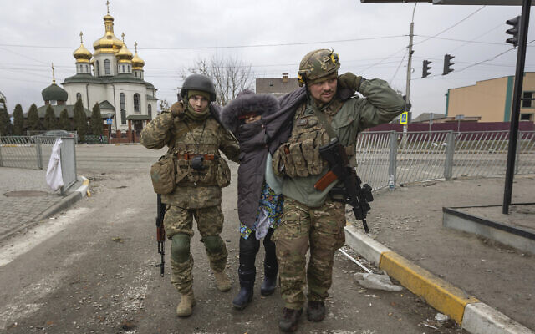
Ukrainian servicemen help an elderly woman, in the town of Irpin, Ukraine, March 6, 2022. (AP Photo/Andriy Dubchak)
US President Joe Biden called Zelensky early Sunday, Kyiv time, to discuss Russia sanctions and speeding US assistance to Ukraine. The White House said the conversation also covered talks between Russia and Ukraine but did not give details.
US Secretary of State Antony Blinken spent the weekend visiting NATO member nations in Eastern Europe that have taken in refugees from Ukraine. In Moldova on Sunday, he pledged support for the western-leaning former Soviet republic that is warily watching Russia’s moves in Ukraine.
The UN said it would increase its humanitarian operations both inside and outside Ukraine, and the Security Council scheduled a meeting for Monday on the worsening situation.
The UN World Food Program has warned of an impending hunger crisis in Ukraine, a major global wheat supplier, saying millions will need food aid “immediately.” https://www.timesofisrael.com/ukraine-says-second-evacuation-attempt-from-mariupol-halted-blames-russian-shelling/ [Have you noticed how all of a sudden there is no information on the COV or the truckers rally or the restrictions of personal rights by the governments like there was just before the Russian invasion of Ukraine? That makes me worried. I question if there the UN group and globalists(aka Schwab, Soros, Gates, etc) are working on the next step of how they will turn the world into a communist one world society. They have been masters of deceptive and criminal behaviors in the past. – rdb]

Russia warns against allowing Ukrainian military to use foreign airfields
Ukraine continued to call for the West to impose a no-fly zone and provide fighter jets.
By JERUSALEM POST STAFF, MICHAEL STARR, TZVI JOFFRE Published: MARCH 6, 2022 18:39 Updated: MARCH 6, 2022 19:37
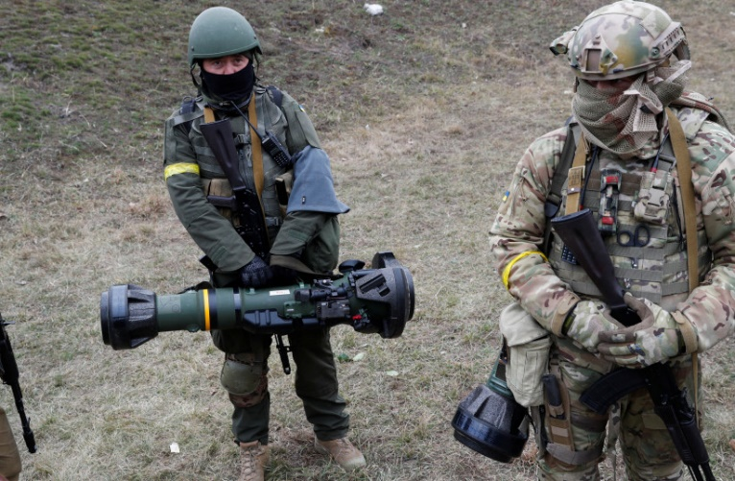
Members of the Ukrainian Territorial Defence Forces hold NLAW anti tank launchers, as Russia's invasion of Ukraine continues, at a checkpoint in Kyiv, Ukraine March 6, 2022(photo credit: REUTERS/VALENTYN OGIRENKO)
The Russian Defense Ministry warned Romania and other countries against allowing Ukrainian military aircraft to use their airfields, saying that doing so could be regarded as "the involvement of these states in an armed conflict," according to TASS.
“Practically all combat-ready aircraft of the Kiev regime have been destroyed," said Defense Ministry spokesperson Maj.-Gen. Igor Konashenkov. "At the same time, we are reliably aware of Ukrainian combat aircraft that previously flew to Romania and other border countries. Please note that the use of the airfield network of these countries for the deployment of Ukrainian military aviation with subsequent use against the Russian armed forces can be regarded as the involvement of these states in an armed conflict"
The Defense Ministry additionally claimed that the airfield of the Ukrainian Air Force in Vinnytsia was destroyed by a high-precision weapon by the Russian Armed Forces on Sunday.
Ukrainian journalist Andriy Tsaplienko had claimed that the missile was fired from the disputed territory Transnistria - a former Soviet breakaway state situated between Moldova and Ukraine - although Transnistria has denied this.
The Ukrainian Air Force later announced that the attack on Vinnytsia was carried out with eight missiles fired from Russian bombers from over the Black Sea.
Ukrainian president Volodymyr Zelensky said Russian rockets had completely destroyed the civilian airport of the central-western region capital of Vinnytsia on Sunday.
Earlier the authorities said emergency services were working to put out fires at the airport caused by the rocket strikes.
Zelensky called again for the creation of a no-fly zone over Ukraine in a Sunday address: "The world has the power to close our skies to Russian missiles, to Russian fighter jets"
Other Ukrainian officials have repeatedly called for a no-fly zone over Ukraine. Western officials have rejected the requests, saying that such a move would mean entering a direct military conflict with Russia. "While someone is afraid to close the skies in Ukraine, our army is doing its job and destroying the enemy," chastised defense minister Oleksii Reznikov. [Ukraine like much of the EU wants someone else to fight their battles for them. That is one of the major faults of NATO. They decided long ago that the US could chip in all the arms and men and they would send a token and wait for someone to bail out their situations. – rdb]
US Secretary of State Antony Blinken confirmed on Sunday that the US is looking into ways that Poland could provide Ukraine with aircraft and the US could provide Poland with aircraft in return. [That could likely get Poland bombed if they aren’t careful. Putin has already thought of your plans. Pootie Poot is not crazy and is not stupid. He want to protect his country from the corrupt west. – rdb]
Russia is concentrating on creating a land corridor between Luhansk and Donetsk and Crimea, and depriving Ukrainian access to the Sea of Azov and Black Sea, the Ukrainian military claimed in a statement.
They also claimed that having already invested all the forces allocated for the campaign, Russia is preparing to send additional units from Russia's Eastern, Central and Western military districts.
Russia reportedly continued to encircle Kyiv, Kharkiv, Chernihiv, and Mykolayiv, but a Sunday morning UK Defense Ministry intelligence update said that "The scale and strength of Ukrainian resistance continue to surprise Russia."
Russia "has responded by targeting populated areas in multiple locations, including Kharkiv, Chernihiv and Mariupol," said the intelligence update. "This is likely to represent an effort to break Ukrainian morale. Russia has previously used similar tactics in Chechnya in 1999 and Syria in 2016, employing both air and ground-based munitions."
The Ukrainian forces also said they were defending Chernihiv, and were preparing the defenses of the Volyn province, which is in the north bordering Belarus and Poland.
A Russian column was claimed to have been stopped as it was advancing from south of Kharkiv in the direction of the river city Dnipro.
"Russian supply lines reportedly continue to be targeted, slowing the rate of advance of their ground forces. There is a real possibility that Russia is now attempting to conceal fuel trucks as regular support trucks to minimize losses," continued the UK Defense Ministry's Sunday intelligence update.
Fighting over the skies of Ukraine
The Ukrainian armed forces have said that they are focusing on air defenses, as both sides have claimed to have downed several jets over the weekend. Despite these losses, Russia has continued to encircle key Ukrainian cities with air support, the Ukrainian military said on Sunday. MORE - https://www.jpost.com/international/article-700495

UN: 1.5 million Ukrainians in ‘fastest growing refugee crisis in Europe since WWII’
Refugee situation expected to worsen as Russian assault intensifies, particularly toward Kyiv; largest number of Ukrainians crossing border head to neighboring Poland
By Agencies Today, 2:20 pm
On Day 11 of Russia’s war on Ukraine, Russian troops shelled encircled cities and a pro-Russian official said safe-passage corridors would open again for residents of the besieged port city of Mariupol.
Ukrainian officials confirmed that evacuations from the city would take place.
A young girl fleeing the waThe World Health Organization said meanwhile that signs of attacks on health centers in Ukraine were increasing, which it said amounts to a violation of medical neutrality and international humanitarian law.
Ukrainian officials said Russian artillery fire and airstrikes had prevented residents from leaving before the agreed-to evacuations got underway Saturday. Russian President Vladimir Putin accused Ukraine of sabotaging the effort.
Russia has made significant advances in the south, seeking to cut off Ukraine’s access to the Sea of Avrov in the south.
Capturing Mariupol could allow Russia to establish a land corridor to Crimea, which it annexed in 2014.
Ukrainian President Volodymyr Zelenskyy said Ukrainian forces were holding key cities in the central and southeastern part of the country, while the Russians were trying to block and keep encircled Kharkiv, Mykolaiv, Chernihiv and Sumy. https://www.timesofisrael.com/un-says-over-1-5-million-ukrainians-flee-in-fastest-growing-crisis-since-wwii/

90 Jewish orphans who fled Ukraine greeted by Bennett, ministers at airport
Children crossed border into Romania with help of Chabad, then were brought to Israel on El Al rescue flight; PM tells them they ‘are safe now’
By TOI staff Today, 6:00 pmUpdated at 6:22 pm
Prime Minister Naftali Bennett, center, welcomes a group of orphans from the Alumim orphanage in the Ukrainian city of Zhytomyr, on arrival to Israel at Ben Gurion Airport, March 6, 2022.(Maya Alleruzzo/AP)
Prime Minister Naftali Bennett and other cabinet ministers were on hand at Ben Gurion Airport Sunday to greet a group of 90 Jewish orphans who fled Ukraine after Russia invaded last month.
El Al, Israel’s largest airline, said the flight was part of a special operation to rescue some 300 Jews from the fighting in Ukraine.
The airline said Ukrainian-speaking staff were on board the flight to assist. Some of the orphans have family members who are still in fighting areas, it added.
Bennett, who was accompanied by Immigration Minister Pnina Tamano-Shata, entered the aircraft to welcome the children, introducing himself to one boy by saying, “I am Naftali, prime minister of Israel. Would you like to come into Israel?”
“We are now seeing children immigrating to Israel. It is the most moving thing there is,” Bennett told media at the bottom of the steps from the plane as the children disembarked.
He later tweeted that he had told the children, “You are safe now, you have reached safe shores.”
90 ילדים מבית הילדים בז'טומיר נחתו עכשיו בישראל. התרגשתי לקבל את פניהם ואמרתי להם – אתם בטוחים עכשיו, הגעתם לחוף מבטחים.
כשעמדתי לצד גילת בנתב"ג צפיתי בילדים נכנסים בשער. ראיתי בעיניים שלהם את התלאות שעברו. pic.twitter.com/hMc9q5ndwM
— Naftali Bennett בנט (@naftalibennett) March 6, 2022
קבלת פנים לעולים החדשים מאוקראינה
ראש הממשלה @naftalibennett נפתלי בנט מקבל את פני העולים החדשים בישראל.
ברוכים הבאים ???????? ???????? ????????????????@EL_AL_ISRAEL @HakerenLeydidut pic.twitter.com/HCNdJ44Yc4
— שמעון ארן شمعون آران (@simonarann) March 6, 2022
The children fled the city of Zhytomyr and with the help of local Chabad groups last week crossed the border to Romania and then stayed in the city of Cluj-Napoca, the Walla news site reported. From there they flew to Israel. Chabad, a Hasidic organization that works to maintain Jewish life around the world, has branches in both Ukraine and Romania.
Roni Shabtai, Israel’s consul in Romania, told Walla last week that the children, the eldest of whom was around 12 and the youngest just 2, walked 400 meters through the snow in below-freezing temperatures in order to cross the border.
He said Israeli officials, including himself, met the orphans at the border.
“Some were in buggies and carriers, and that is how they went in the snow until we met them,” Shabtai said.
Earlier, at the weekly cabinet meeting, Tamano-Shata said she expected tens of thousands of people to immigrate to Israel in the coming months in light of the ongoing Russian invasion of Ukraine.
“We are trying to offer the best possible conditions to Jews and those eligible [to immigrate] under the Law of Return,” she said. “We are not [even] asking them to come with visas.
“The main, massive absorption [of the immigrants] will be for the long term, and we are working on this now. I expect tens of thousands of Jews to arrive in Israel in the coming months,” she said.
Ronen Cohen, the director of the Immigration and Absorption Ministry, told Army Radio on Sunday evening that 400 refugees had landed in Israel in the previous six hours.
The Jewish Agency, which facilitates immigration to Israel, said it has already received thousands of immigration requests from Ukraine over the past week and a half, since the start of the Russian offensive, far more than it normally receives over the course of an entire year. Israeli officials have predicted a similar jump in immigration from Russia.
Last week, Interior Minister Ayelet Shaked said the government was preparing for a wave of tens, if not hundreds, of thousands of Jewish immigrants from Ukraine and Russia.
Over the weekend Bennett traveled to Russia for talks with Russian President Vladimir Putin as Israel tries to mediate an end to the conflict. https://www.timesofisrael.com/90-jewish-orphans-who-fled-ukraine-greeted-by-bennett-ministers-at-airport/

‘Putin is a fascist’: Hundreds of protesters march for Ukraine in Tel Aviv
Demonstrators chant ‘Israel, make your voice heard!’ and ‘Stop the war in Ukraine’ outside Russian embassy as Bennett meets with Russian leader in Moscow
By Tobias Siegal Today, 8:28 am
Hundreds of people marched in Tel Aviv on Saturday night to support Ukraine and protest against the ongoing Russian invasion of the country.
Protesters gathered at city’s Habima Square and marched to the Russian embassy, chanting slogans that included: “Israel, make your voice heard!,” “Putin is a fascist” and “Stop the war in Ukraine.”
Meanwhile, about a hundred protesters also gathered outside Prime Minister Naftali Bennett’s private residence in Ra’anana.
“We’ve come here to support the Ukrainian people,” two protesters originally from Georgia told Walla News.
“We’ve experienced war with Russia so we can relate. We do what we can,” they said.
“I’m from Russia and I’m against this war and Putin. This is the only thing we can do to try and stop the war,” another protester said.
Some protesters were seen holding signs with caricatures comparing the Russian leader to Nazi dictator Adolf Hitler, a comparison that has become popular among demonstrators around the world since the Russian invasion began on February 24.
Others were seen holding signs with swastikas and other Nazi symbols.
The Hitler comparison has also been made in the past by the official Twitter account of Ukraine that posted a caricature image of Putin staring in admiration into the eyes of an oversized Hitler shortly after Russian troops invaded the country.
While Israel avoided taking a clear stand against Russia officially, the Israeli public has expressed a mainly united front against the war and the Russian president, with similar pro-Ukraine protests taking place regularly since the invasion.
The largest gathering took place last Saturday when thousands marched to the Russian embassy in Tel Aviv.
One week later, the Russian invasion is still ongoing with no end in sight.
Demonstrators carry placards and flags during a protest against the Russian invasion to the Ukraine, outside the Russian Embassy in Tel Aviv, March 5, 2022. (Tomer Neuberg/Flash90) | Demonstrators carry placards and flags during a protest against the Russian invasion to the Ukraine, outside the Russian Embassy in Tel Aviv, March 5, 2022. (Tomer Neuberg/Flash90)
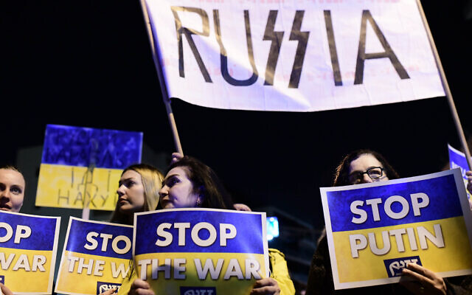  Demonstrators carry placards and flags during a protest against the Russian invasion to the Ukraine, outside the Russian Embassy in Tel Aviv, March 5, 2022. (Tomer Neuberg/Flash90) | 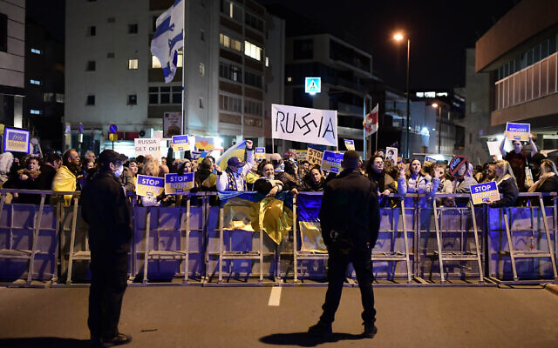  Demonstrators carry placards and flags during a protest against the Russian invasion to the Ukraine, outside the Russian Embassy in Tel Aviv, March 5, 2022. (Tomer Neuberg/Flash90)
As protesters were protesting outside his home, the Prime Minister Naftali Bennett was holding talks with Putin at the Kremlin, a secret trip that was seen as an effort to further develop a potential role as mediator between the sides — as Israel has good relations with both Kyiv and Moscow.
Bennett also spoke twice throughout the evening with Ukrainian President Volodymyr Zelensky following his meeting with Putin. He also flew to Germany to meet with Chancellor Olaf Scholz and had a phone call with French President Emmanuel Macron. https://www.timesofisrael.com/putin-is-a-fascist-hundreds-of-protestors-march-for-ukraine-in-tel-aviv/

Far-right MK pulls gun on alleged Palestinian rock-throwers in West Bank
Itamar Ben Gvir claims he was forced to intervene after IDF soldiers told him they were unable to open fire on Palestinians throwing rocks at cars
By TOI staff Today, 11:03 am
Far-right MK Itamar Ben Gvir pulled a gun on a group of Palestinians who were allegedly throwing rocks at Israeli vehicles traveling along Route 60 near the al-Aroub refugee camp in the West Bank, according to Hebrew media reports.
Ben Gvir tweeted that he “was forced to pull his weapon to drive away” rock-throwing Palestinians near al-Aroub until law enforcement officials could arrive.
There was no immediate confirmation from the military or the police.
The Religious Zionism MK claimed that he encountered “dozens of terrorists” who were throwing rocks at Jewish cars. Ben Gvir said that two IDF soldiers at the scene told him that they were not authorized to fire at the rock-throwers and were awaiting reinforcement.
“Didn’t we say that we changed the rules of opening fire? We must stop abandoning our soldiers!” Ben Gvir tweeted.
The MK was referring to a decision in December by the IDF allowing troops to shoot at Palestinians who had thrown rocks or firebombs at cars, even if the assailants no longer present an immediate threat. The IDF noted at the time that the military’s preferred outcome is still an arrest without shots being fired.
There were no immediate reports of injuries, and some media reports indicated that the Palestinian rock throwers had begun to disperse before Ben Gvir drew his weapon.
The incident occurred less than a few hours after two police officers were wounded in a Jerusalem stabbing attack. The Palestinian attacker was shot dead.
Following that incident, Ben Gvir called for Police Chief Kobi Shabtai and Public Security Minister Omer Barlev to resign.
Ben Gvir is currently under investigation for an incident last year in which he pulled out a pistol during an altercation with Arab security guards over a parking spot.
He was questioned by police last month over the incident. Lawmakers from both coalition and opposition parties called for further investigation into the circumstances of the incident, with a focus on Ben Gvir’s suitability to have a gun permit.
Known for his anti-Arab rhetoric, Ben Gvir has had a number of run-ins with the law and with Arabs, including fellow lawmakers. Prior to entering the Knesset, the ultra-nationalist was a lawyer who represented Jewish terror suspects.
https://www.timesofisrael.com/far-right-mk-pulls-gun-on-alleged-palestinian-rock-throwers-in-west-bank/

French retail giant Carrefour heading to Israel
Multinational supermarket chain's foray into Israeli market could serve to allay woes of Israeli customers who are feeling the pinch at the check-out counter amid recurring price hikes
Meirav Crystal | Published: 03.06.22, 20:59
French supermarket chain Carrefour is set to expand to the Israeli market in a move that could revolutionize the shopping experience for customers all across the country, which is notorious for its high food prices.
The international retailer will open 150 locations nationwide and will replace popular supermarket chains Mega and Yeinot Bitan. With its grand entrance, Carrefour is expected to bring along its brand products to Israel with prices unmatched in the current market.

Carrefour (Photo: Reuters)
"This means no less than a bang in the Israeli retail market, no one will come out of this unscathed," an industry source told Ynet.
"This move can serve to skirt the rules of the game played up until now in the Israeli market in which imports would go directly through a local representation or an exclusive importer. Popular brands will now arrive directly through Carrefour and the diversity in Israel will grow substantially".
Carrefour, which specializes in fresh food, while also selling a variety of frozen goods, is the eighth-largest retail corporation in the world with over 1,300 branches in 47 countries.
It is worth 82 billion euros globally, compared to Israel's entire food industry which is estimated at around 12 billion euros.

(Photo: Yeinot Bitan)
Although most of its branches worldwide are directly managed by the corporation itself, its location in Israeli will be run by Electra Group, the owner of Yeinot Bitan, that will serve as a concessionaire.
Electra Group stated that its goal is to cut prices by at least 20% compared to the current average on the Israeli market, which could pressure other retailers to lower their prices as well.
Carrefour's arrival, with its deep pockets and ability to directly import products without the help of local middlemen, is set to give a jolt to Israel's largest retailers, including Shufersal and Rami Levi, and local importers who have been widely accused of artificially inflating prices while shrinking their products.
Colgate, Gillet, and Barilla are just some of the household brands set to be affected by the move.

This is great news for Israelis who have been reeling under recurring price hikes and left them feeling the pinch at the check-out counter or the gas pump.
In response to public outcry after Israel's latest wave of price increases, the government recently introduced a $1.3 billion economic plan to reduce the cost of living, including tax cuts for working families, child-care subsidies and streamlined regulation to stimulate price-cutting competition for products. https://www.ynetnews.com/business/article/byp6mpmbc

Jewish archaeological sites in West Bank must be preserved - Herzog
"It is important to know that Jewish history did not originate in Tel Aviv, but in Judea and Samaria. Therefore, the roots to the rights to our land are specifically in Judea and Samaria.”
By TOVAH LAZAROFF Published: MARCH 6, 2022 21:16 Updated: MARCH 6, 2022 22:39

Joshua's altar on Mt. Ebal in Samaria. (photo credit: TOVAH LAZAROFF)
Jewish archaeological sites in the West Bank must be preserved, President Isaac Herzog told the English-speaking community in Israel and abroad. He delivered the short virtual address during the third in a series of Judea and Samaria mega-events.
“Much of the Jewish People’s history in this land is rooted in the hills and valleys of Judea and Samaria,” Herzog said.
“Here our Patriarchs and Matriarchs lived and were laid to rest. Here Joshua led the Sons and Daughters of Israel, Bnei Yisrael, into the land; King David began his rule; our prophets spread their teachings, which we teach today, and every Shabbat; and Jewish rebels—from the Maccabees to Bar Kochva—fought for what they believed in,” he explained.
“Beyond any political dispute we should all agree to protect the integrity of Jewish historical and archaeological sites throughout the Land of Israel, as well as the historical sites belonging to other religions and cultures which have left their stamp on this region throughout the ages,” he explained.
“This is not just a Jewish or Israeli issue, but an issue of protecting the heritage of all humanity in the Holy Land,” Herzog said.
Shomron National Park (Sebastia). (credit: Wikimedia Commons)
He also took a moment to speak of Israel’s status as both the Jewish national homeland and a democracy “built on equality and religious freedom.”
It is also important, he said, to work for a future of peace, cooperation and dialogue particularly through the Abraham Accords, under whose rubric Israel normalized ties with four of its Arab neighbors.
His statement to the group was among a number of strong statements Herzog has made in support of the Jewish and Israeli connection to the West Bank, including his visit to the Tomb of the Patriarchs in Hebron.
The mega-events have been sponsored by the Yesha Council, My Israel and the Zionist Organization of America.
The first event focused on the need for Israeli sovereignty in Area C of the West Bank, the second on the issue of illegal Palestinian building and the third on the need to preserve the Jewish archaeological heritage in that area, also known as the biblical heartland.
The Yesha Council and right-wing organizations have long campaigned for the preservation of biblical archaeology in the West Bank, warning that the Palestinian Authority was usurping and destroying the ancient Jewish heritage in that region.
Among the examples the speakers at the event later gave was Sebastia, the capital of the northern kingdom of ancient Israel, as well as a burial cave for priests from the Second Temple near Jericho.
Binyamin Regional Council head Israel Ganz said that “more than 80% of the ancient historical sites” in Judea and Samaria have been damaged.
ZOA Israel director Dan Illouz said that “it is important to know that Jewish history did not originate in Tel Aviv, but in Judea and Samaria. Therefore, the roots to the rights to our land are specifically in Judea and Samaria.”
It is “this fact that our enemies try to uproot when they destroy the archaeological treasures in Judea and Samaria. Yes, they know exactly what they are doing. Our enemies want to disconnect the Land of Israel from Jewish history in order to claim that we are a colonial power that came to a foreign land.”
Illouz said that “it is time for the free world to unite against those who destroy history,” he said.
“When ISIS destroyed archaeological sites the whole world went crazy and justifiably so,” he said. “On this subject there is no difference between ISIS and the Palestinians,” he added. https://www.jpost.com/israel-news/article-700516

As Ramadan approaches, Palestinians anticipate more violence
Hamas, Palestinian Islamic Jihad and the Popular Front for the Liberation of Palestine urged Palestinians to step up the “resistance” against Israel in the coming days and weeks.
By KHALED ABU TOAMEH Published: MARCH 6, 2022 19:08 dated: MARCH 6, 2022 21:36
DEMONSTRATORS GATHER on Friday to protest the possible eviction of several Palestinian families from homes on land claimed by Jewish nationalists in the east Jerusalem neighborhood of Sheikh Jarrah.(photo credit: JAMAL AWAD/FLASH90)
Less than a month before the start of Ramadan, observed by Muslims as a month of fasting, prayer and reflection, a number of Palestinian terrorist groups have called for stepping up attacks on Israel.
Palestinian activists on Sunday said they expect an increase in violence before and during Ramadan, which begins at the beginning of April.
The activists said there were a number of reasons why they believed tensions would escalate in the coming weeks, especially in the West Bank and Jerusalem.
The reasons include, among other things, mounting tensions in Israeli prisons, where thousands of Palestinian prisoners are threatening to go on hunger strike in protest of Israeli “repressive” and “punitive” measures; IDF “incursions” into Palestinian cities, villages and refugee camps; house demolitions in Area C of the West Bank and some Arab neighborhoods of Jerusalem; threats to evict families from the Sheikh Jarrah (Shimon Hatzadik) neighborhood and Israeli security measures in the Old City, including the Aqsa Mosque compound.
Some activists said they were making an effort to bring the Palestinian issue back into the world’s focus in the wake of the Russia-Ukraine war.
“We want to make sure that the world does not forget about the Palestinians,” one activist from east Jerusalem told The Jerusalem Post. “In the past year, we managed to attract a lot of attention because of the Gaza war and the protests in Sheikh Jarrah.” [Don’t forget about the “PA” or they will throw more temper tantrums and terror. How utterly pathetic is that? That is a wonderful way for the world to remember your group. – rdb]
That war, referred to by Israel as Operation Guardian of the Walls, began on May 10, 2021, when Hamas and Palestinian Islamic Jihad launched rockets at Israel. The attack came after Hamas issued an ultimatum to Israel to withdraw its security forces from the Temple Mount and Sheikh Jarrah.
In the days leading up to the war, clashes erupted between Palestinians and police officers in Sheikh Jarrah, the Old City and Damascus Gate, where the protesters demanded the removal of security barriers set up by the police as part of strict security measures during Ramadan.
This year, the police do not intend to place the security barriers at the entrance to Damascus Gate, apparently to avoid unnecessary friction with local residents and worshippers converging on the Aqsa Mosque Compound during Ramadan.
But the decision not to impose security restrictions at Damascus Gate is not likely to ease tensions or prevent an outbreak of violence on the streets of Jerusalem and several parts of the West Bank.
According to another activist who spoke to the Post, the Palestinians are planning to continue the protests against plans to evict Arab families from their homes in Sheikh Jarrah. They are also planning a series of protests against the demolition of unlicensed houses in various parts of east Jerusalem, the activist said.
This year’s Ramadan comes amid increased charges that Israel is stepping up its measures to squeeze the Arab residents of Jerusalem out of the city.
The Palestinian Authority and several Palestinian factions continued to talk about an Israeli “scheme to carry out ethnic cleansing” of the Arabs in Jerusalem.
Additionally, they are continuing to talk about Israeli “conspiracies” and “assaults” against Islamic and Christian holy sites in Jerusalem. Jewish visits to the Temple Mount are described by Palestinian officials and media outlets as “a violent incursion and desecration” of al-Aqsa Mosque.
As if not enough, the Palestinians continue to accuse Israeli security forces of carrying out “extrajudicial executions” of young men and women in Jerusalem and the West Bank. These accusations almost always refer to Palestinians who are killed while carrying out attacks against soldiers, policemen and settlers.
On Sunday, the PA was quick to condemn the killing of Karim Jamal Qawassmeh, 19, who carried out a stabbing attack in the Old City of Jerusalem, as a “heinous crime” and a “field execution.”
Qawassmeh, a resident of the A-Tur neighborhood on the Mount of Olives, was shot dead by police officers after he stabbed a policeman. Another police officer was wounded during the attack.
The attack is seen as yet another sign of growing tensions ahead of Ramadan.
Shortly after Qawassmeh was declared a “martyr,” Hamas and other factions welcomed the “heroic operation,” saying it was a “natural response to Israeli crimes” against the Palestinians in Jerusalem and the West Bank.
In separate statements, Hamas, Palestinian Islamic Jihad and the Popular Front for the Liberation of Palestine urged Palestinians to step up the “resistance” against Israel in the coming days and weeks.
They said their main objectives were to ensure that the Palestinian issue remains under the spotlight and to exert pressure on Israel to halt or change its policies and measures in Jerusalem and the West Bank. https://www.jpost.com/arab-israeli-conflict/article-700497

Iran has used advanced air defense batteries against Israel in Syria
Since Iran has deployed new air defense batteries in Syria last year, the IAF has had to change how they carry out their strikes
By ANNA AHRONHEIM Published: MARCH 6, 2022 12:38 Updated: MARCH 6, 2022 17:01
Iran has used advanced air-defense batteries against Israeli planes carrying out war-between-war operations in Syria in an attempt to challenge IAF pilots.
Tehran first deployed the batteries to Syria last year as Israeli strikes against Iranian weapons and military infrastructure intensified.
Since Israel began its war-between-wars campaign (known as mabam in Hebrew) in 2013, the IAF has carried out thousands of strikes to thwart Iranian entrenchment and the smuggling of advanced weapons to Hezbollah in Syria and Lebanon. According to foreign reports, it has also carried out strikes in Iraq and Yemen.
The Syrian Arab Army is equipped with a range of older Russian-made surface-to-air missile systems, including the SA-2, SA-3, SA-5, SA-6,-SA-8, SA-11, SA-17, SA-19, SA-22 and the Pantsir 1.
Russia has also deployed advanced S-300 and S-400 air-defense batteries but has not given them to the Syrians; instead, they are manned by Russian forces. They have yet to be used against Israeli pilots due in part to the ongoing safety mechanisms in place between Jerusalem and Moscow.
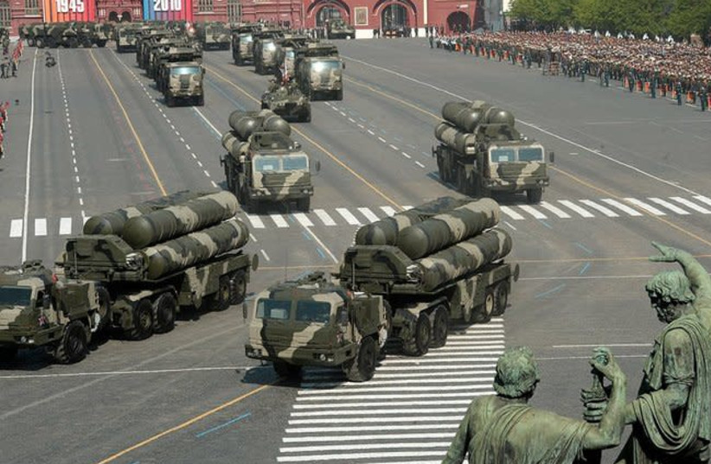
S-400 surface-to-air missile systems displayed during the May Day parade 2010. (credit: Wikimedia Commons)
The response time of Syrian SAMs has decreased, and more than 1,000 missiles have been fired at IAF jets over the past seven years, but they have been unable to deter their missions.
Iran also separates the radars of their SAMs from the missile launchers, leading the IAF to change its operational procedures by sending up larger formations to hit more targets at once rather than having jets return to the same target and risk being downed.
In 2018, an F-16 crashed in northern Israel after it was struck by an SA-5 missile fired by Syrian forces during an IAF operation. Syrian missiles have also landed in Israel in recent years, including this year, when shrapnel from one missile hit northern Tel Aviv, and another errant interceptor missile landed close to the Dimona nuclear site in the Negev Desert.
In July 2020, Ali Abdullah Ayyub, the deputy commander of Syria’s armed forces, and Maj.-Gen. Mohammad Bagheri, chief of staff of Iran’s Armed Forces, signed an agreement to broaden bilateral military cooperation and to develop a robust air-defense system for Bashar Assad’s regime.
“From now on, Iran will strengthen its ties with Syria even more on all levels,” Bagheri said at the time.
Since their introduction, the IAF has been studying the Iranian batteries, which have architecture unlike that of the Russian batteries.
While the IAF continues to carry out missions successfully over Syria, the Iranian batteries are still a new challenge to Israeli pilots.
The IAF understands that the Islamic Republic’s defense industry is robust and constantly works to improve and manufacture systems and platforms that can threaten Israel and other countries in the region.
Last October, Iran carried out a large-scale air-defense drill called Defenders of Velayat Sky 1400, which showcased the capabilities of upgraded systems and weapons, including cruise missiles, radar, surveillance, electronic warfare, communication systems, advanced manned and unmanned stealth drones and optical surveillance networks.
During the drill, Iran used its 3rd Khordad, Mersad, Talash, Khordad 15, Majid and Dezful SAM systems.
Following the drill, Supreme Leader Ayatollah Ali Khamenei said: “In the face of these realities, the enemy must consider Iran’s power and defense capabilities in its calculations and decisions.” https://www.jpost.com/middle-east/iran-news/article-700471

Blinken rejects Russian demand to not link sanctions with Iran deal
US secretary of state dismisses Moscow’s stipulation that new measures it faces over Ukraine invasion won’t impact its rights in talks to revive 2015 nuclear pact
By AFP Today, 9:08 pm
WASHINGTON — US Secretary of State Antony Blinken on Sunday dismissed as “irrelevant” Russian demands for guarantees that new sanctions linked to Ukraine will not affect Moscow’s rights under a reworked Iran nuclear deal.
With the parties to the Iran agreement, which the US abandoned in 2018, now seemingly close to a new accord, Blinken rejected fresh demands voiced Saturday by Russian Foreign Minister Sergei Lavrov.
The sanctions on Russia over its invasion of Ukraine “have nothing to do with the Iran nuclear deal,” Blinken said on CBS talk show “Face the Nation.” [Perhaps Blinken needs to understand that when you have 5 parties or more to a deal that no matter what the reason ONE of the parties decides not to support it the entire deal can be trashed. This might be a great deal for Israel. – rdb]
They “just are not in any way linked together, so I think that’s irrelevant,” he said, speaking from Moldova, a small country on Ukraine’s southwest border.
Blinken added that it was not only in America’s interest but Russia’s as well that Iran not be able “to have a nuclear weapon or the capacity to produce a weapon on very, very short order.”
‘Pragmatic approach’
The latest Russian reservations, coming amid the intense crisis over Ukraine, threaten hopes that an Iran agreement could be wrapped up quickly.
Iran and the United Nations nuclear watchdog had announced tentative agreement early Saturday on an approach for resolving issues crucial to reviving the country’s 2015 nuclear accord with world powers.
Rafael Grossi, chief of the International Atomic Energy Agency (IAEA), said in Vienna that while the UN agency and Iran had yet to settle “a number of important matters,” they had now “decided to try a practical, pragmatic approach” to overcome them.
However, Grossi said there was “no artificial deadline.”
Both US and British officials said late in the week that negotiators in the Vienna talks were close to a possible deal, while cautioning that some issues remained to be settled. [If Iran is still not talking with the US then if they have come cockamamy deal it will be a bad one for sure. – rdb]
But Lavrov said Saturday that Moscow, itself slapped with severe sanctions over its invasion of Ukraine, needed guarantees from Washington before backing the nuclear deal.
He said Russia wanted written guarantees that Ukraine-related sanctions “will not in any way harm our rights to free, fully fledged trade and economic and investment cooperation, military-technical cooperation with Iran.”
Russia is party to the Vienna talks along with Britain, China, France and Germany. The United States is participating indirectly. [So for this negotiation the US is a second class citizen. That is just pathetic. – rdb]
Moscow is expected to play a role in implementing any fresh deal with Iran, for example by receiving shipments of enriched uranium from Iran.
The 2015 nuclear deal has been hanging by a thread since then-US president Donald Trump pulled out in 2018 and reimposed sweeping sanctions, including on Iranian petroleum exports.
‘Very damaging’
The landmark accord was aimed at guaranteeing Tehran could not develop a nuclear weapon — something it has always denied wanting to do.
Iran said last week that it was ready to quickly raise its crude exports to pre-sanctions levels once a deal is signed.
Iranian international relations analyst Fayaz Zahed said the government needed to be very careful about Moscow’s possibly shifting interests.
“Now that Russia is under sanctions, it is perhaps no longer interested in resolving the Iran nuclear issue, a position that could be very damaging,” he said.
The coming days are seen as pivotal because of the rate at which Iran is making nuclear advances.
Its stockpile of enriched uranium has now reached more than 15 times the limit set out in the 2015 accord, the IAEA said this week. https://www.timesofisrael.com/blinken-rejects-russian-demand-to-not-link-sanctions-with-iran-deal/

Arabs warn of Mideast chaos if Biden resurrects Iran nuclear deal
Negotiators 'must realize that the extremist regime will not abide by international laws'
By WND Staff Published March 6, 2022 at 12:19pm
The Biden administration, wrapped up as it is now in responding to Russia's war against Ukraine – and possibly other nations – is creating a threat to the Middle East with its appeasement of the Islamic rogues in Iran.
That's the opinion of Khaled Abu Toameh, an award-winning journalist who is based in Jerusalem, who explained the situation in a column at Gatestone Institute.
He explained Arabs in the Middle East are concerned about Biden's attempts to resurrect the 2015 nuclear deal with Iran.
That deal, brokered under Barack Obama, was abandoned by President Trump because of the dangers it presented to America.
Now, Toameh explained, "The Arabs are warning that the appeasement of the extremist and terrorist regime in Tehran would allow Iran's proxy militias to continue their attacks on America's Arab allies and massively destabilize the Middle East."
He noted Ibrahim al-Nahhas, a prominent Saudi political analyst, said, "The parties of the international community that are negotiating with Iran, especially the P5+1 (the U.S. and the other permanent members of the U.N. Security Council: China, France, Russia, Britain, and Germany), must realize that the extremist Iranian regime has not, and will not, abide by international laws, regulations and agreements, even if it swore and signed or pledged to abide by and implement them... The Iranian regime was founded on the [former supreme leader of Iran Ayatollah] Khomeini ideology that adopts terrorism and believes in exporting chaos and destruction."
Destruction from that ideology, he charged, also has been delivered to Arabs in Lebanon, Yemen, Iraq and Syria.
Nahhas said, according to Toemeh, warned those involved in the original deal made mistakes.
"They agreed to sit with a regime that explicitly declares its support and sponsorship of terrorism and extremism; they agreed to enter into secret talks [with Iran] without the knowledge of the countries that are negatively affected by the terrorism and extremism of the Iranian regime; and they signed an agreement that did not take into account the interests and concerns of the countries and peoples of the region."
The deal effectively meant the Western powers were accepting "extremist political regimes and terrorist and destructive practices," the commentator aid.
Now, Nahhas explained, efforts to revive the deal are dangerous.
"This group works without realizing the direct harm to global security, peace and stability. … It needs to be aware of the great suffering caused by the Iranian regime's terrorism and extremism. It is necessary for this group to listen to the fears and concerns of the countries of the region about the continuation of Iran's nuclear program and to actually learn about the suffering of the peoples affected by the terrorism and extremism of the Iranian regime," he said.
Toameh said Syrian analyst Rami Al-Khalifa Al-Ali agreed, writing, "Although the Biden administration pledged upon its arrival at the White House that it would not be a third term for former President Barack Obama, it is following him step by step... This is evident in the Biden administration's position on the Iranian nuclear issue. This position seems to be weak, hesitant and subject to Iranian blackmail."
Wrote Toameh, "Clearly, many in the Arab world are aware of the dangers that derive from the Biden administration's anemic attitude towards Iran. These Arabs have alerted the world to the fact that they feel mortally threatened by Biden's perceived capitulation to the mullahs in Tehran and the destabilizing consequences for the region." https://www.wnd.com/2022/03/arabs-warn-mideast-chaos-biden-resurrects-iran-nuclear-deal/ [Using the Iran deal is just one more means of destroying the civilized society of the world.- rdb]

'Our last shot at creating change': People's Convoy surrounds D.C.
'This is how you protest safely and get your point across. Without burning things down'
By Joe Kovacs Published March 6, 2022 at 4:28pm
The People's Convoy staging at the Hagerstown Speedway in Hagerstown, Maryland, before driving on the D.C. Beltway around the nation's capital on Sunday, March 6, 2022. (Video screenshot) | The People's Convoy on the D.C. Beltway around the nation's capital on Sunday, March 6, 2022. (Video screenshot)
Traffic on the Beltway encircling the nation's capital was much busier than usual Sunday, as The People's Convoy of truckers showed up in force to champion freedom and protest COVID-related mandates.
"People are tired, they are fed up" at their freedoms being chipped away, said Kris Young, who was livestreaming the event on Facebook from her truck on the Beltway as her husband drove.
"Our kids and our grandkids are not going to be living in the same country that many of us grew up in."
She called the event "very fluid," as the truckers decided against clogging the streets of Washington, D.C.
"We can't just go in there like a bull in a china shop and lock down D.C. and be infiltrated," she said. "There is no long-term plans made. We never knew how big it was going to grow from one day to the next and we still don't know that."
Young was answering questions live from viewers in her comment stream, saying, "Not only do we not know how big it's going to grow, we also don't the know the response we're going to get from D.C. I'm sure at some point they're going to want to talk to us. ... Talking is great, but we're demanding action."
Trucker Stan Sasnak, right, clowns with fellow trucker Reuben from Florida whom he dubbed 'Sam Elliott' due to his resemblance to the actor during The People's Convoy around the nation's capital on Sunday, March 6, 2022. (Video screenshot)
When asked if she thinks the protest will work, she replied: "I hope it will work. I think this is our last shot at creating change. I believe the country has come together. We've said it before: the sleeping giant has been awakened."
"I think this is a one-shot deal and this is it and this is the time and it has to happen, but it's gonna take everybody, not just the people here physically in the convoy. Call your state reps, call your congressmen, go to the capitals if you can't be here with us."
"We haven't demanded removal of anybody. However, if that is necessary to get the changes we're want, that may have to happen," she continued.
"We want the emergency powers ended which will do away with mask mandates, we want congressional hearings for accepting transparency."

Trucks park next to each other at the conclusion of The People's Convoy around the nation's capital on Sunday, March 6, 2022. (Video screenshot)
In a slice of what could be called less-than-pure Americana, Young caught a glimpse of something she hoped her husband at the wheel didn't see.
"There's a girl showing her boobs at the Appalachian Trail overpass! Don't look, Scott!" she shouted.
After commencing last week in California, the truckers staged at the Hagerstown Speedway in Hagerstown, Maryland, on Saturday before making at least two loops around the D.C. Beltway on Sunday afternoon.

(Image courtesy The People's Convoy)
One Twitter posted drone footage of a fraction of the trucks at the racetrack.
"The movement amassed so many cars that the convoy had to split up and stay in neighboring cities as far as 30 miles away from Hagerstown," the tweet indicated.
Some commenters reacting to Young and husband during the event stated:
- "Great thing about this is there's people in vehicles from all over the United States supporting these brave truckers and their families. It is the greatest thing."
- "Freedom doesn't take a day off."
- "Every trucker that is in this convoy is also not carrying goods -- that in itself is making a statement for freedom."
- "Can you imagine traffic on a WEEKDAY? Used to live there, now in WEST VIRGINIA cheering you all on and YES, I donated at ThePeoplesConvoy.org."
- "I've said it before fighting for our freedoms has never been easy, ever! If you're caught in the congestion, understand this is the way We The Peoples convoy has decided to fight for those freedoms. Yeah it's frustrating if you're on that road but understand why they are doing this. I support them, I support the cause to fight for our constitutional rights to stop the mandates. They are unlawful and as such I will go without, I will move over and let them through. God Bless America."
- "This is how you protest safely and get your point across. Without burning things down."
Click here to see more images of The People's Convoy. https://www.wnd.com/2022/03/last-shot-creating-change-peoples-convoy-encircles-d-c/

Fauci's new actions revealed after seemingly disappearing as COVID narrative disintegrates
By Warner Todd Huston, The Western Journal Published March 6, 2022 at 11:45am
The left's favorite COVID scold, Dr. Anthony Fauci, has been conspicuously absent from the national media for the last few weeks, and the outlets he has been relegated to seem to underscore the Democrats' new strategy on COVID.
Deservedly or not, Fauci has been the face of the Democrat response to the coronavirus, scolding Americans to give away their freedoms for "safety" from the "pandemic," demanding that we all must be masked -- with two masks, even -- advocating for our jobs to be shut down and citizens to be locked in their homes and screeching for our schools to be closed. But since early in February, Fauci has gone from appearing on multiple news outlets per day to being nearly invisible to the news-viewing public.
His sudden disappearance, though, seems to coincide with the emerging realization among Democrats that their constant stream of fear porn over the coronavirus is hurting them politically, and their newly inculcated fear that their laser-like focus on draconian COVID mitigation is going to cost them during the 2022 midterm elections.
Radio host Chris Stigall, for instance, recently noted that election consultants are advising the Democrats to "declare victory over COVID and move on," and quickly usher in a return to normalcy -- and conveniently just before the 2022 elections, too.
Democrats are suddenly warning each other in private to drop further COVID restrictions, to open schools and to end mask mandates.
In light of that bubbling undercurrent in Democrat electoral plotting, Anthony Fauci has suddenly been removed from the powerhouse news outlets and has been relegated to lesser-known blogs, publications and the odd Youtube channel.
Indeed, as The Post Millennial noted, Fauci's news section of the National Institute of Allergy and Infectious Diseases website shows only one appearance in March (by March 5), and a scant 14 appearances in all of February. That is a heavy contrast to previous months. In January, for instance, the NIAID news tracker shows that Fauci made 17 appearances and he clocked a whopping 41 in December!
It certainly appears that the Democrat powers that be have decided that the celebrated doc is now a has-been that they don't want seen by the American people.
Meanwhile, mask mandates are being dropped even by deep blue states. At the end of February, California, Oregon and Washington state all announced pullbacks on masking to various degrees, according to the Wall Street Journal. And by the beginning of February, even Biden's homes state of Delaware told citizens that masks were no longer necessary.
The Centers for Disease Control also made an about-face and said that most people can doff the masks and added that masks in schools are not necessary.
The CDC's new guidelines even prompted a group of researchers to urge schools to dump mask mandates for kids altogether.
The end of masking is also amusing. After all, mask zealots claim without evidence that masks "prevent" people from getting COVID, but now these same people are saying that the numbers are down, so we can throw away our masks. But if masks work, shouldn't they want to stick with them until the numbers approach zero? Why the sudden decision to dump the masks? "Election Day" seems to be the answer to that question.
With all this just coincidentally occurring in time for the 2022 elections, the timing is suspicious, indeed.
See new Tweets
Here’s an internal memo from a Democrat polling firm that’s circulating through their party as they attempt to shift away from two years of arbitrary and capricious mandates, lockdowns, and closures. “Declare victory over COVID and move on.” I refuse to allow them to do so.

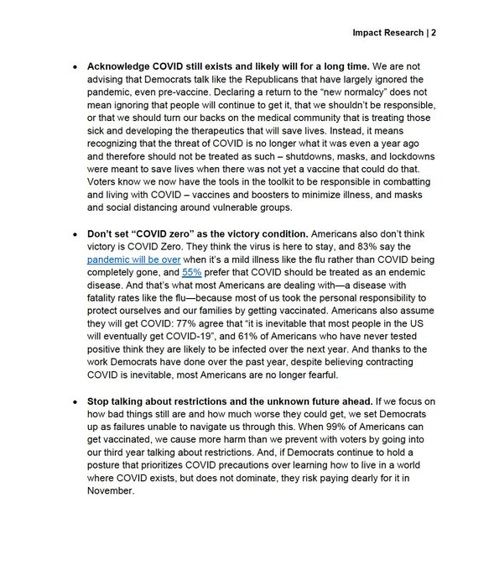
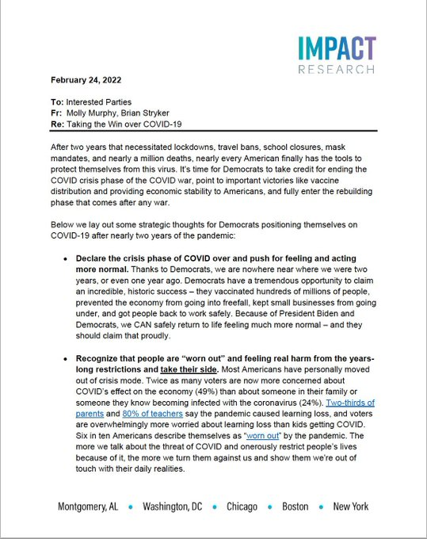
5:38 PM · Feb 25, 2022·Twitter for iPhone
Meanwhile, the vaunted Dr. Fauci’s star is dimming, as he appears on obscure YouTube-style channels in a desperate bid to stay relevant. One would think that appearing with an unknown left-winger on the obscure vlog called "WokeAF" is not the optimal exposure he has become used to.
In case you don't get that title, "Woke" is clear enough, certainly, but the "AF" stands for "as f*ck." So, now Fauci has been relegated to appearing on video channels with curse words in their title!
That is quite a fall from grace.
If you are even remotely interested, here is the video in question:
This article appeared originally on The Western Journal.

Commentary:
Here's Your 'Red Pill' Moment for the Russia-Ukraine War
Wayne Allyn Root Posted: Mar 06, 2022 12:01 AM
It's time for your red pill. Something smells rotten in Ukraine. The story is rotten, rancid, hinky; the story just doesn't add up.
President Joe Biden and the media desperately want you to believe Russia is the bad guy and Ukraine is a little angel. They want you to fall in love with underdog Ukraine. They want you to support America getting involved on behalf of Ukraine.
To get your support, they need the media to sell you a bill of goods. But it just doesn't add up. First, Biden is the one who funded Russia's invasion. Biden killed our pipelines, killed coal and banned drilling, which made us dependent on Russian oil -- which made Russia filthy rich and arrogant. Biden paid for this war.
Second, if Russian President Vladimir Putin is the "bad guy," if Russia is evil, why is Biden continuing to buy billions of dollars of oil from Russia every day? Does this make sense?
Unless it's pure "commie theatre."
Connect the dots. Biden is a feeble, feckless old puppet with dementia. George Soros pulls Biden's strings. Soros is on the side of Ukraine. Soros recently said the whole world must support Ukraine. It's been reported Soros funded Volodymyr Zelenskyy and then installed him as president of Ukraine -- one of the most corrupt nations on the earth.
Keep in mind, evil billionaire Soros is obsessed with hatred for America. He desperately wants to destroy our country. Soros has funded the invasion of our borders. He helps pay for illegal aliens (many of them criminals, MS-13 gang members and murderers) to enter America.
Soros also funded and elected all the horrible, communist district attorneys across America. Soros' DAs are hellbent on destroying America. They have turned our big cities into killing zones where murderers run free without even posting bail while law-abiding citizens are stripped of guns and persecuted for defending themselves.
Soros has paid for the destruction of America. Soros is one of the most evil enemies in our history. If Soros funded the leaders of Ukraine and put them in power, this has to be a trap. Ukraine must be a "bad guy."
Now we come to the mainstream fake news media.
Has the media ever told the truth in the seven years since former President Donald Trump came down that escalator? It's been nonstop lies, fraud and propaganda. The media tells you any lie that advances the cause of Democrats, Soros and the destruction of America.
Now after seven years of lies and propaganda, suddenly you trust the media? You believe this one time they're telling the truth? This one time they have America's best interests at heart? Even though (pure coincidence) Soros is on the same side as the media. They're all one big happy family on the side of Ukraine.
I'll tell what I think.
No. 1: I think this war is a WMD: a weapon of mass distraction to get your mind off the disasters Biden has created at home, including open borders, massive inflation, vaccine mandates crippling the economy, the worst crime wave in history, the worst retreat in U.S. military history from Afghanistan and $6-per-gallon gas.
No. 2: This is pure "wag-the-dog" theatre to save Biden from the worst polls in modern history. Instead of hating Biden, they want you to hate Putin.
No. 3: This is all part of Soros and Klaus Schwab's "Great Reset." They want to make us all obedient serfs and slaves. They need World War III as a distraction while they destroy America and capitalism and take your freedoms away.
Here's my conclusion. I'm not "for" Russia. I'll never be a fan of Putin. He's out for only himself and a new dominant Russian empire. I'm not telling you to take Russia's side. They are "bad guys."
But I know if Soros is behind Ukraine, then Ukraine is also a "bad guy." If Soros wants us involved, I know this war is not in America's best interest. I know the media is feeding us a load of lies and propaganda -- under Soros' direction.
Like Trump, I have only one dog in this hunt. I'm ONLY for "America First." This war is nonsense. It doesn't involve us. We should not be sending billions of dollars in aid or sending billions in military weapons to Ukraine. I don't want this to turn into WWIII. I don't want my kids or your kids dying over Ukraine. We need to stay a million miles away from this conflict.
This isn't war, it's commie theatre. It's a WMD: weapon of mass distraction. Don't believe a thing you read or see coming from the fake news media.
Take your red pill and just say "NO" to this wag-the-dog moment.
Wayne Allyn Root is known as "the Conservative Warrior." Wayne's new No. 1 bestselling book is out, "The Great Patriot Protest & Boycott Book." Wayne is host of the nationally syndicated "Wayne Allyn Root: Raw & Unfiltered" on USA Radio Network, daily from 6 p.m. to 9 p.m. EST and the "WAR RAW" podcast. https://townhall.com/columnists/wayneallynroot/2022/03/06/heres-your-red-pill-moment-about-the-russiaukraine-war-n2604165

Our Only and Last Hope
By Rob Pue|March 6th, 2022
The world is still amazed at how brutally the Prime Minister of Canada ended the Freedom Convoy protest in Ottawa, using an Emergency Measures Act that had not yet even been approved by parliament. The House of Commons did, finally, approve Trudeau’s Emergency Measures — reserved for times of war — on February 22nd by a margin of 185-151, but that was after great damage and harm had already been done several days earlier.
As we saw the video coverage by citizen reporters on the scene, we were shocked at the brutality that police were inflicting on the people who were assembled there — peacefully seeking a redress of grievances with the politicians that supposedly represent them. But we’ve now learned that many of those “police” were not Canadians at all — they were UN soldiers, who arrived on two airliners in North Bay, Ontario February 19th. It seems that because the Canadian military refused to participate in attacks on the people they swore an oath to protect, Trudeau brought in the UN.
These soldiers wore no UN markings or symbols, but clearly, they were not Canadian. They had no badges, no name tags, they were masked, and could not speak English or French. And their arrival in Ottawa coincided with the arrival of two UN planes in North Bay, just 200 miles away. This was after the Canadian government had raided the truckers’ GiveSendGo account, harvested the names of all the donors, and then seized the bank accounts of the donors — among them, all the assets of a single Mom who had donated $50 to the truckers’ cause. A cause she believed in — but apparently, she held “unacceptable views.”
And we’ve all heard what Pastor Art Pawlowski has gone through these past two years in Canada. But he was arrested again on February 8th, as he attempted to leave his home to go preach to the truckers in Calgary, Alberta. This time, he’s been denied bail and is being held in solitary confinement.
The judge stated the following: “I have concluded that the Crown’s … grounds (for seeking detention) are substantial and that there is a substantial likelihood that the accused will, if released from custody, continue on offending, or interfering with the administration of justice.
“The accused’s pattern of behavior speaks volumes about his willful commission of offenses and/or violations of court and public health orders. His conduct…has contributed to enormous economic harm to the local, provincial and national economy and substantial community harm to ordinary Canadians.”
Basically, they know he won’t just obey and remain silent, so he’ll remain in jail, indefinitely now. His supporters plan to deliver a letter, pleading his case to members of parliament, which has been signed by nearly 10,000 people. But it’s very doubtful anyone in authority will even look at that letter, much less come to his aid. Like in this country, there IS no justice in Canada anymore. Only totalitarian rule. You either obey, comply and conform or you rot in prison. “Guilty,” even if proven innocent.
Now, the “People’s Convoy” is coming together here in the US. With truckers leading the way, people from all walks of life — and driving all types of vehicles — can join the convoy, which is headed to Washington DC. However, leadership has already stated they won’t actually enter DC but just go as far as the beltline around the area… because they don’t want to become political prisoners or victims of radical Leftist judges there, like those who attended the January 6 rally last year. Meanwhile, Biden has already stated that his COVID mandates, which were set to expire March 1st, will be extended indefinitely.
We have yet to see how things will end for America’s “People’s Convoy” protest. But based on what we’ve already seen in countries around the world, where millions have filled the streets to protest the never-ending mandates and ever-increasing restrictions and revocations of basic freedoms and human rights, we’ll likely see similar brutality as we’ve seen in Australia, New Zealand, France, Germany, Austria and now Canada.
This situation is not just happening in one or two isolated areas. This is a world-wide phenomenon, unlike anything we’ve ever seen before. It’s not UP to the leaders of individual countries. This is all being orchestrated and dictated by the New World Order Globalists. Leading the way is Klous Schwab of the World Economic Forum, who has mentored many of the world leaders currently in office, vetted them to make sure they’ll follow orders obediently, and then made certain they were securely placed in office. And they’ll remain in office for as long as they’re useful to the cause. You know, there’s much more to the American election fraud of 2020 than any of us realize. Why do you think that despite overwhelming proof of an obviously stolen election, not even our so-called “good Republicans” will do anything about it?
Why do you think the burning, looting, destroying and killing we’ve seen the past two years has been drilled into our heads as “peaceful protests” by “legitimate” organizations (including the self-proclaimed Marxist Black Lives Matter and ANTIFA)? For the Globalist Great Reset to work, America MUST fall, so therefore, it’s perfectly ok for covert government agencies to stockpile loads of bricks and rocks on city streets, ready for throwing through windows of local businesses by the thugs they hire — and then order law enforcement to “stand down” and let everything burn — and as we now see happening, refuse to prosecute the crime of mob looting nation-wide.
Friends, this is all orchestrated. It’s all been pre-planned. The scam of the COVID “pandemic” is just the latest — but the most effective tactic — to bring about an end to national sovereignty and personal freedoms. Extremely powerful people are behind all this. The Trudeaus and Bidens of the world are mere puppets to these people. And they also have the backing of just about every major corporation in the world. Follow the money, and learn what you can about Klous Schwab, the World Economic Forum and the planned “Great Reset.”
All this is very distressing, but as I mentioned in my last message, all of this could end tomorrow if we would simply understand one thing: this is a SPIRITUAL battle, playing out now in the physical realm. The angels of God and demons of Satan are at war, as they’ve always been, but Satan has ramped things up, as he knows his time now is short. Absolutely, I support standing up for truth and freedom and resisting the wickedness of the government mandates, the pharmakea of the “jab” and lies of the media and government officials.
But there’s no political solution to this and never will be. Our so-called “representatives” are not only NOT going to listen to a word we have to say, no matter how many truck parades we have or how many millions gather in protest — they’re going to laugh at us, even as they’re directing their minions to haul us off to prison for having “unacceptable views.” They’re not going to relinquish their power over us now that they’ve secured it. Yes, we must fight and resist, but we will not win a spiritual battle with fleshly tactics.
So what, then, shall we do? There’s only one solution: repent! The world has forgotten God, and America, once the missionary to the nations, has led the way in apostasy and rebellion. So what’s fallen on us now is nothing short of the wrath of God, but He’s been infinitely patient with us, and many — like myself — have been sounding the warning for years, but all our warnings have fallen on deaf ears.
God made a covenant with us and we broke the deal. Deuteronomy 28: “Now if you faithfully obey the Lord your God and are careful to follow all His commands I am giving you today, the Lord your God will put you far above all the nations of the earth. All these blessings will come and overtake you, because you obey the Lord your God: You will be blessed in the city and blessed in the country. Your descendants will be blessed…You will be blessed when you come in and blessed when you go out.
“The Lord will cause the enemies who rise up against you to be defeated before you. They will march out against you from one direction but flee from you in seven directions. The Lord will grant you a blessing on your storehouses and on everything you do; He will bless you in the land the Lord your God is giving you…The Lord will make you prosper abundantly with children…The Lord will open for you His abundant storehouse, the sky, to give your land rain in its season and to bless all the work of your hands. You will lend to many nations, but you will not borrow. The Lord will make you the head and not the tail; you will only move upward and never downward if you listen to the Lord your God’s commands I am giving you today and are careful to follow them. Do not turn aside to the right or the left from all the things I am commanding you today, and do not go after other gods to worship them.”
Deuteronomy 6: “These words that I am giving you today are to be in your heart. Repeat them to your children. Talk about them when you sit in your house and when you walk along the road, when you lie down and when you get up. Bind them as a sign on your hand and let them be a symbol on your forehead. Write them on the doorposts of your house and on your gates.”
Our once-Christian nation has tossed God and His Word to the curb long ago. Even our churches refuse to follow the commands of God, instead coveting the admiration of men. We’ve come to love our lives of luxury and ease and we’ve sought after the fleshly desires of this world rather than the Holy Spirit of God. I have news for you: the days of luxury and ease are over. Welcome to the New Normal.
Deuteronomy 28 explains it all: “…if you do not obey thy Lord your God by carefully following all His commands and statues I am giving you today…you will be cursed in the city and cursed in the country…the Lord will send against you curses, confusion and rebuke in everything you do until you are destroyed and quickly perish, because of the wickedness of your actions in abandoning Me….the Lord will make pestilence cling to you…the Lord will cause you to be defeated before your enemies…the Lord will afflict you with madness, blindness and mental confusion…You will be oppressed and robbed continually and no one will help you…you will be powerless to do anything. A people you don’t know will eat your land’s produce and everything you have labored for. You will only be oppressed and crushed continually. You will be driven mad by what you see.”
How long have I — and so many others — sounded this warning? Yet still, as a nation, and as the modern American “Church,” we’ve stood by, while 70 million babies have been slaughtered. Our shepherds refused to even speak of abortion, much less lead the people out to the killing centers to stop the bloodshed of the innocent. One “pro-life Sunday” a year doesn’t “cut it,” pastor! Most of our shepherds said nothing at all when the Supreme Court declared sodomite so-called “Marriage” the “law of the land.” They obediently closed their church doors when told to, as they agreed with the government that they truly were “non-essential.” And they’ve said nothing about the tyranny of the COVID scam or the deadly jab, leaving their people to just believe the lies. Indeed, they, themselves have chosen to believe the lies. They dare not bring “politics” into the pulpit for fear of offending people and bringing conviction to seared hearts.
Today, instead of training up disciples to witness and evangelize for Christ, most pastors look upon those who DO witness in public as weirdos and trouble-makers. Fanatics.
But as I’ve said before, it is time NOW for the Word of God to be boldly proclaimed on every street corner, in every school, college and workplace, calling all who will, to repent and return to God. Repentance should be the word on every tongue and the action of every heart. Our ONLY hope now lies in Jesus Christ and His mercy. Yet so few — even professing believers — will do any more than agree with me. Many will listen. Few will DO. So ashamed, we seem to be, of our Lord.
Everyone knows 2 Chronicles 7:14 but few do more than recite it: “If My people, who are called by My name, will humble themselves and pray and seek My face and turn from their wicked ways, then I will hear from heaven, and I will forgive their sin and will heal their land.” Herein lies our only, and last hope.
Audio CDs and text versions of this message are available when you call me at Wisconsin Christian News, (715) 486-8066. Or email Rob@WisconsinChristianNews.com. Ask for message number 351. https://newswithviews.com/our-only-and-last-hope/

What Happened To The Integrity Of Our Elected Officials, Part 3
By Roger Anghis|March 6th, 2022
I have not seen a democrat since JFK worthy of a vote from the American people. Lyndon Baines Johnson was a racist POC and escalated the Viet Nam war for, I believe, his personal benefit. Jimmy Carter hated Israel and was not capable of understanding how an economy works, not that any democrat that I have seen does. Clinton was and is a lowlife womanizer, Obama wasn’t even eligible to be president because both parents have to be citizens at the time of his birth and his father never became a citizen. This fact was not challenged by the democrats for obvious reasons but the Republicans didn’t challenge it either.
The character of our elected officials has become worse and worse over the last hundred years. Woodrow Wilson was a racist and re-segregated our military which had been integrated since the Civil War. FDR tried to nationalize everything and kept us in the Great Depression for ten years longer than we should have been because of his ineffective economic policies of tax and spend. Biden actually believes we can spend our way out of debt. He stated so during the last economic recession that started in 2008. That quote has been mysteriously scrubbed for the net.
In the modern era, we have primarily democrats that have exhibited the worst character that I have ever seen. The former governor of New York during the COVID attack actually put COVID-infected people in nursing homes with the most vulnerable people, the elderly with underlying conditions, and we ended up with massive deaths. To do what Cuomo, Gov. Gretchen Whitmer of Michigan, Gov. Gavin Newsom, Gov. Phil Murphy of New Jersey, and Pennsylvania Gov. Tom Wolf[1] did should be a crime but because they are Democrats, they got off scot-free.[2] About one-third of all COVID deaths happened in nursing homes.[3] In a nation of laws, this should not happen. In a nation run by a dictator, this is normal.
The vast majority of these infractions are by members of the Democrat Party but there is little to no opposition from Republicans, they are just as guilty. They have threatened to ‘investigate’ this kind of stuff if they get the majority back in 2022 but they had the majority in 2016 and did nothing about the fake sassier, the deleted 20,000 emails, the foreign funding of Hillary’s campaign, John Kerry’s secret negotiations with Iran in violation of the Logan Act, and they didn’t do squat about Hunter Biden’s dealings with Ukraine, the Communist Chinese Party, and all the other things he’s been involved with. I have little faith that the present members of the Republican party will do anything about any of this when they get back in power.
The mandates that have been put into place by Biden are not legal. They violate the Constitution and even override the Nuremberg Code of forcing medical procedures on people without their consent. Not many Republicans are opposing these overreaches. Unless we replace the vast majority of the people in Congress, we will not see the action we need to turn all of this around. The Democrats have gone full-blown communist and the Republicans are full of RINOs, Lindsey Graham, Lisa Murkowski, Susan Collins, just to name a few and not many of the rest have the backbone to oppose the Democrats.
My only hope is there are a handful of trustworthy prophets that have called the last couple of years to a tee. And they say that God is going to do a reset, not the Democrats. His reset will set this nation back on track. He is not done with America. They have also declared that those that have worked to steal the election, and it was stolen, will be exposed and brought down. All the corruption that has been exposed will be brought to light and the party behind it will be decimated.
When Trump took out the ISIS leader al-baghdadi Nacy Pelosi had a fit because Trump didn’t notify congressional leadership of the raid. There might have been a real good reason for that like al-baghdadi being tipped off of the raid. Remember John Kerry’s daughter is married to a muslim. Well, the fake president Biden takes out a top ISIS leader al-Qurayshi in Syria and it turns out that the top congressional leadership was not informed of that raid either. I guess we should be expecting an apology from Pelosi real soon. Don’t hold your breath on that one.
As I mentioned a few paragraphs ago John Kerry’s negotiations with Iran without the approval of Trump was a violation of the Logan Act. Kerry, in my opinion, has been a traitor to America since the Viet Nam War. His involvement with the dirtbag George Soros is another indication he’s a traitor. In an article from August of 2015 concerning the Iranian nuclear deal he negotiated we see this: Kerry’s family connection to Iran is no secret, and in the melting pot that is the United States, it is not entirely surprising. What is significant is that as part of the wedding preparations, Kerry went to a dinner party hosted by George Soros at his Manhattan penthouse. He undoubtedly met the best man Mahdi Zarif, and also met his father, Mohammad Javad Zarif, current Iranian Foreign Minister, who acted as the chief negotiator during nuclear talks, across the table from Kerry. This revelation was made by former Congressman Allen West on his website on July 28.
On Sunday, Iran’s Foreign Ministry “strongly rejected” the claim, calling it a “sheer lie and ‘news fabrication,” as reported by Fars News Agency. “Some media outlets that lack credit [sic] fabricate such news in pursuit of special objectives, including finding more viewer [sic],” the foreign ministry claimed.
Though no formal accusations have been made, neither have any inquiries or investigations been conducted. The accusation and the refutation stand on their own merits. Kerry’s close family connection was not mentioned in his confirmation hearings before the Senate Foreign Relations Committee.[4]
It is time we started sending people to Washington who love America not our enemies. 2022 would be a good time to start.
FootNotes
5 governors besides Cuomo who sent covid positive patients into-nursing homes
Nursing home deaths covid justice department no investigation
Coronavirus nursing homes
Nuclear nepotism hushed up truth Kerry’s personal Iran connection middle east
https://newswithviews.com/what-happened-to-the-integrity-of-our-elected-officials-part-3/

THE SHORASHIM BIBLICAL GIFT CATALOG 005
http://mad.ly/7f9f64?pact=20013931524&fe=1
Support Shorashim!

ARUTZ SHEVA
Israel carried out air strike in Damascus, air defense systems activated
Syrian media reports Israeli air strike in the Damascus area. Explosions heard in the area.
Elad Benari 07.03.22 05:33
Missile seen over Damascus Reuters
Syrian media reported early Monday morning that Israel carried out an air strike in the Damascus area, and the country’s air defense systems were activated.
Explosions were also reported in the area.
In late February, Syrian media reported that the country’s air defense systems had been activated following an Israeli air strike in the Damascus area.
Heavy explosions were reported in the area.
A source in the Syrian army said that three soldiers were killed in the air strike and that much property was damaged.
He claimed that the Syrian air defense systems intercepted most of the missiles.
A day earlier, a source in the Syrian army told Syria’s official news agency SANA that Israel carried out an air strike in the Quneitra area.
According to the source, the air strike caused damage and it was carried out from the Golan Heights using surface-to-surface missiles.
Earlier, the Lebanese news agency Elnashra reported that the IAF had attacked a military post in the Quneitra area. https://www.israelnationalnews.com/news/323413

To be removed from this News list, Please click here and put "Unsubscribe" in the subject line.

03/06/2022 NEWS
Virtually Israel: Jerusalem & the Dead Sea
https://www.youtube.com/watch?v=Bp698Td0mXU

"Only a debt-backed system of paper money could finance the great wars, the social improvements and the fevered dreams of the 20th century."
-- Brian Maher Managing Editor, The Daily Reckoning
Read the Prophets & PRAY WITHOUT CEASING!
That is the only hope for this nation!
Please  Remember  These  Folks  In  Prayer-  Check often  They  Change! | Pray that the world would WAKE UP! Time for a worldwide repentance!  ALL US soldiers fighting for our freedom around the world  Pray for those in our government to repent of their wicked corrupt ways.  Pray for BB – Severe sciatic needing procedure.  Pray for EL – Had clot embolized to brain – successful ‘clot buster’ but long road to go.  Pray for BB – Severe West Nile Fever –still not mobile- improving!  Pray for RBH – cancer recurrence  Pray for Ella – Child with serious problems  Pray that The Holy One will lead you in Your preparations for handling the world problems. – Have YOU made any preparations?
Exodus 10:¹And the LORD said unto Moses: 'Go in unto Pharaoh; for I have hardened his heart, and the heart of his servants, that I might show these My signs in the midst of them; ²and that thou mayest tell in the ears of thy son, and of thy son's son, what I have wrought upon Egypt, and My signs which I have done among them; that ye may know that I am the LORD.'

Bennett flies to Moscow, meets with Putin about Ukraine war, Iran nuke talks
Orthodox PM makes rare trip on Shabbat to meet with Russian leader, having offered to mediate between Moscow and Kyiv; later speaks with Ukrainian President Zelensky
By TOI staff Today, 7:46 pmUpdated at 8:34 pm
Prime Minister Naftali Bennett traveled to Moscow on Saturday for a meeting with Russian President Vladimir Putin to discuss the war in Ukraine.
The meeting at the Kremlin lasted for 3 hours.
“The prime minister took off for Moscow early this morning, after the conversation between the leaders last Wednesday,” the Prime Minister’s Office said in a statement
Kremlin spokesman Dmitry Peskov said the two discussed “the situation around Ukraine,” according to Russian news agencies. The statement from the Prime Minister’s Office did not mention Ukraine or Russia’s invasion of the country.
An Israeli official diplomatic source said the meeting was coordinated with the United States, Germany, and France, “in continuous dialogue with Ukraine.”
The source said Bennett spoke with Putin about “the situation of Israelis and the Jewish communities as a result of the conflict” and the ongoing talks in Vienna to restore the 2015 Iran nuclear deal, which Russia is a signatory to.
“The prime minister expressed the position of Israel, which is opposed to a return to the nuclear deal,” the source said.
Earlier Saturday, Russia said it would demand guarantees from the US before backing the Iran nuclear deal, citing the current wave of Western sanctions against Russia.
Bennett’s office said the premier was accompanied by Housing Minister Ze’ev Elkin, acting as a translator and advisor. Elkin, a Russian speaker and native of Ukraine, served a similar role under former prime minister Benjamin Netanyahu.
National Security Adviser Eyal Hulata, senior policy adviser Shimrit Meir, and Bennett’s spokesman Matan Sidi also traveled with the prime minister, his office said.
Bennett, Israel’s first Orthodox premier, made the flight to Moscow on Shabbat, which observant Jews are barred from doing under Jewish law, though exceptions are made for medical or security situations in which life is threatened. Elkin is also religious.
Following the meeting with Putin, the Prime Minister’s Office said Bennet spoke with Ukraine’s President Volodymyr Zelensky. It did not specify what the two discussed.
Bennett’s office said that from Moscow, the prime minister was flying to Berlin to meet with German Chancellor Olaf Scholz before returning to Israel.
The premier’s spokesman did not say what the two would discuss; Germany is a party to the Iran nuclear deal and has also called for an end to Russia’s invasion, while moving to provide Ukraine with some military aid. Scholz was in Israel on Wednesday for a visit.
The trips to Moscow and Berlin came after Bennett held two back-to-back phone calls with Putin and Zelensky in recent days, as Moscow pressed on with the invasion of its neighbor.
Israel has sought an elusive middle ground in the conflict: siding with its Western allies while avoiding a rift with Moscow. Russian forces control the airspace in neighboring Syria, where Israeli planes often operate against militias affiliated with Iran; Israel sees Iran as an existential threat.
Israel has offered on several occasions to mediate talks to end the invasion. Ukrainian officials have also said they support the idea, but the initiative has not yet gone any further.
On Tuesday, Bennett said that Israel was seeking to “help quietly” while maintaining its own strategic interests. Israel has expressed its support for the Ukrainian people and has sent a shipment of 100 tons of humanitarian aid. Foreign Minister Yair Lapid condemned the invasion as a “breach of the international order.”
But Bennett has avoided calling out Putin by name, refused Ukrainian requests for military equipment, and vowed to stake out a cautious policy.
“From the beginning, the State of Israel has taken a measured and responsible approach, which allows us not only to protect our interests but also to be useful, to be a reliable player — one of the few that can communicate directly with both parties — and assist as required,” Bennett said in a Tuesday speech.
Russia and Ukraine are expected to hold a third round of talks to end hostilities on Monday, Ukrainian negotiator David Arakhamiya said in a Saturday Facebook post, without providing further details.
The first two rounds of talks on resolving the Russia-Ukraine war produced no breakthrough, though the two sides agreed to meet again. https://www.timesofisrael.com/bennett-flies-to-moscow-holds-talks-with-putin-on-ukraine-war/ [Bennett needs to be very careful with this “shuttle diplomacy” because he just could well be caught up in a very difficult and “politically HOT” situation. Bennett is a good businessman but contrary to the current US VP “diplomacy” is more than simply interpersonal relationship. Diplomacy can bite you in the butt. – rdb]

US-sanctioned Russian oligarchs reportedly barred from hiding private jets in Israel
Gov’t yet to decide whether to join sanctions on ultra-wealthy businessmen tied to Kremlin; official: ‘We mustn’t be seen as a country through which sanctions can be circumvented’
Israel has yet to reach a decision on whether to join the US and numerous other nations in sanctioning Russian oligarchs after the invasion of Ukraine, but reportedly moved Saturday to bar them from landing their planes in the country.
According to Hebrew media reports, the Israel Airports Authority instructed staff at Ben Gurion Airport not to approve long-term parking of private jets belonging to US-sanctioned Russians, to prevent them from being stashed in Israel in an attempt to bypass sanctions.
The Ynet news site said a similar order was given to bar them from mooring their yachts at Israeli ports.
“We must not be seen as a country through which sanctions can be circumvented,” an unnamed Israeli official told the news site.
The US imposed sanctions on the ultra-wealthy Russian oligarchs at the heart of Russian President Vladimir Putin’s regime on Thursday in the latest ratcheting up of pressure on the Kremlin to halt its invasion of Ukraine.
The oligarchs — government officials and business owners who have amassed vast wealth in an economy where only Putin loyalists can get ahead — are seen as vulnerable because much of their wealth is tied to Western interests.
They and their family members “will be cut off from the US financial system, their assets in the United States will be frozen and their property will be blocked from use,” the White House said in a statement.
“The United States and governments all over the world will work to identify and freeze the assets Russian elites and their family members hold in our respective jurisdictions — their yachts, luxury apartments, money, and other ill-gotten gains.”
The sanctions matched earlier EU measures against Russia’s wealthiest figures, but also include a ban on travel to the US and preventing these targeted people from hiding their assets through transfer to family members.
A picture taken on March 3, 2022, in a shipyard of La Ciotat, near Marseille, southern France, shows a yacht, Amore Vero, owned by a company linked to Igor Sechin, chief executive of Russian energy giant Rosneft. (Nicolas Tucat/AFP)
On Friday, Channel 12 news reported that an inter-ministerial committee is set to give recommendations to the government on Sunday regarding sanctions that Israel could employ against Russia.
One scenario that might potentially need to be addressed is how to prevent sanctioned Russian oligarchs from using Israel as a financial safe haven for their assets. As things stand, the network said, there is no legislation that would prevent oligarchs with Israeli citizenship from putting their money into bank accounts here.
The report also said policymakers in Israel recognize they won’t be able to maintain their relatively ambiguous policy regarding Russia’s invasion of Ukraine for much longer, as the crisis there further escalates.
While Jerusalem expressed its concern regarding the Russian military operation early on, Prime Minister Naftali Bennett has avoided criticizing Moscow or Putin, as he seeks to maintain the green-light the Kremlin has long given Israel, allowing the IDF to operate in Russia-controlled skies over Syria against Iranian proxies below.
Israel co-sponsored a UN General Assembly resolution condemning Russia on Wednesday, but only after it refused to do so when the same measure came before the Security Council last week — a decision that drew the ire of the Biden administration.
Jerusalem has sent a 100-ton shipment of humanitarian aid to Ukrainians, but turned down Kyiv’s request for military equipment. Israel has welcomed Jewish Ukrainians who have fled the country, but has refused to do the same for non-Jewish refugees and those who have arrived at Ben Gurion have been forced to pay a NIS 10,000 ($3,050) fee in order to remain temporarily in the country.
Bennett has heeded calls from Ukrainian President Volodymyr Zelensky to mediate between Kyiv and Moscow, and has held a pair of phone conversations with both the Ukrainian leader and Putin since the start of the invasion last Thursday. But Russia has yet to express interest in Israel playing the role of mediator and analysts are skeptical Jerusalem has enough leverage over Putin to keep him at the table. https://www.timesofisrael.com/us-sanctioned-russian-oligarchs-reportedly-barred-from-hiding-private-jets-in-israel/ [This is a good way to try to keep the problem players at a distance and help keep Israel out of the simmering cookpot. - rdb]

Ukraine halts Mariupol evacuation, accusing Russia of violating local ceasefire
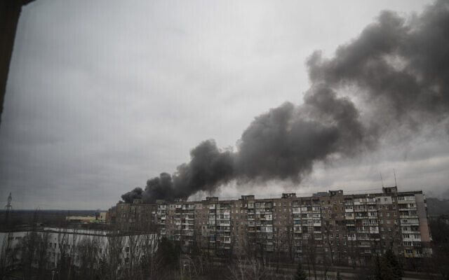
Officials say city, humanitarian corridor under attack; Zelensky to address US Senate; UN says 1.37 million refugees fled across border, 230 civilians killed in war
By Agencies and TOI staff Today, 7:47 pm

Smoke rise after shelling by Russian forces in Mariupol, Ukraine, on March 4, 2022. (AP Photo/Evgeniy Maloletka)
A strategic Ukrainian city put off a planned evacuation of residents Saturday, blaming Russia for breaking a temporary ceasefire as Russian President Vladimir Putin warned the West of a wider war if a no-fly zone is set up.
“Any movement in this direction will be considered by us as participation in an armed conflict by that country,” Putin said.
With his Ukrainian counterpart Volodymyr Zelensky criticizing NATO for ruling out a no-fly zone for fear of sparking nuclear conflict, Putin spoke of “colossal and catastrophic consequences not only for Europe but also the whole world,” if such a zone was set up.
For Zelensky, on day 10 of the invasion, under an escalating bombardment that has flattened more and more infrastructure and sent nearly 1.4 million civilians fleeing for their lives, the Western military alliance’s “no” to a no-fly zone had essentially given “the green light for further bombing of Ukrainian cities and villages.”
Under siege, Mariupol proudly resisted Moscow-backed rebels during a 2014 conflict, but the Azov seaport has for days been without electricity, food, and water in the dead of winter and people began gathering for the evacuation.
However, city officials called for a delay in the evacuation, saying: “The Russian side does not adhere to the ceasefire and has continued shelling both Mariupol itself and its environment, and for security reasons, the evacuation of the civilian population has been postponed.”
A medical worker reacts after he failed to save the life of an 18 month-old boy, who was fatally wounded by shelling, at a hospital in Mariupol, Ukraine, on March 4, 2022. (AP Photo/Evgeniy Maloletka)
;There is no way to verify if the circumstances listed are true or not but I can assure you that when you are a healthcare provider and you loose a child the emotional consequences are dreadful. – rdb]
Negotiations were underway “to establish a ceasefire and ensure a safe humanitarian corridor,” Mariupol authorities added.
An evacuation had been seen as a prelude to a final assault that, if successful, would see the Russian army push north from occupied Crimea and link up with their forces from the east and take control of Ukraine’s coast on the Azov sea.
After Russia’s defense ministry declared the ceasefire — to open a humanitarian corridor out of the war’s fiercest battles — officials said the city’s 450,000-strong population could begin to leave by bus and private cars.
“This is not an easy decision, but… Mariupol is not its streets or houses. Mariupol is its population, it is you and me,” said mayor Vadim Boychenko.
Scenes of devastation
The siege came as more Russian forces inched closer to the capital Kyiv amid fierce fighting, particularly in the western suburbs and the northern town of Chernihiv.
Dozens of civilians have been killed in shelling, missile attacks, and air raids, and those remaining live among the town’s ruins and in craters.
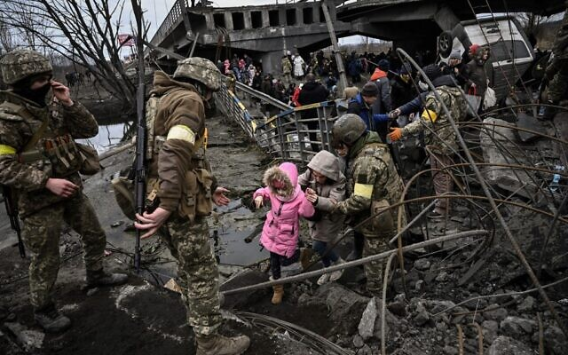
“There were corpses all over the ground,” Sergei told AFP, as air raid sirens wailed once more. “They were lining up here for the pharmacy that’s just there, and they’re all dead.”
AFP reporters saw scenes of devastation — despite Moscow’s insistence it is not targeting civilian areas.

People cross a destroyed bridge as they evacuate the city of Irpin, northwest of Kyiv, during heavy shelling and bombing on March 5, 2022, 10 days after Russia launched a military invasion on Ukraine. (Aris Messinis/AFP)
Fears are rising in Kyiv that the capital will suffer the same fate once Russian missile artillery is deployed within range.
Ukrainian Defense Minister Oleksiy Reznikov alleged Russia had changed tactics after encountering tough resistance.
Ukraine, he said, had defeated plans to quickly storm major cities and overthrow Zelensky’s government, forcing Moscow to resort to “cowardly” attacks on civilians.
Zelensky remains defiant, announcing Saturday that Ukrainian forces were counter-attacking around Kharkiv, the country’s second-largest city, which has seen Russian incursions and fierce bombardments, as well as other parts of the country.
Video published by Ukraine’s Defense Ministry showed a Russian military helicopter being shot down, with British investigative website Bellingcat saying the incident occurred north of Kyiv, in the town of Kozarovychi.
#stoprussia
⚔️ Так гинуть російські окупанти. Цього разу у вертольоті!
Слава Україні та її захисникам! Разом до перемоги! ????????@GeneralStaffUA pic.twitter.com/raFOepF06P
Advertisement
— Defence of Ukraine (@DefenceU) March 5, 2022
It is not immediately clear when the video was taken.
The low-flying helicopter is seen being hit by a missile, before crashing moments later.
Zelensky said Ukrainian forces were holding key cities in the central and southeastern part of the country Saturday, while the Russians were trying to block and keep encircled Kharkiv, Mykolaiv, Chernihiv, and Sumy.
“We’re inflicting losses on the occupants they could not see in their worst nightmare,” he said.
He alleged that 10,000 Russian troops were killed in the 10 days of the war, a claim that could not be independently verified. The Russian military doesn’t offer regular updates on their casualties. Only once, on Wednesday, did they reveal a death toll, numbering nearly 500.
“This is horrible,” Zelensky said. “Guys 18, 20 years old… soldiers who weren’t even explained what they were going to fight for.” [This claim is dreadful but I would remind everyone that Zelenky was an actor before he was elected to his position and actors live in a world of illusion (or maybe delusion). I would take much of what he says with a box of salt because I have seen a number of claims that were obviously in his imagination. – rdb]
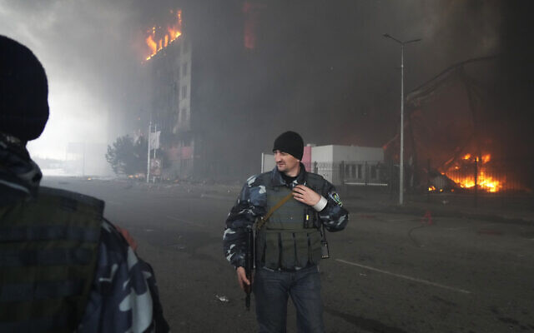
Ukrainian servicemen walk as fire and smoke rises over a building following shelling in Kyiv, Ukraine, on Thursday, March 3, 2022. (AP/Efrem Lukatsky)
Since Putin’s army invaded on February 24, Russia has pummeled Ukrainian cities, with officials reporting hundreds of civilians killed. Europe’s largest atomic power plant has even come under attack sparking fears of a catastrophic nuclear accident.
But Moscow has so far only seized two key cities in its 10-day-long invasion — Berdiansk and Kherson on Ukraine’s southern Black Sea coast.
Capturing Mariupol represents a bigger prize for Russian forces, as it would deal a severe blow to Ukraine’s maritime access and connect with troops coming from annexed Crimea and the Donbas.
However, it seems Russia is not in complete control of Kherson, with videos on social media showing thousands of Ukrainians protesting in the city Saturday morning, several days after its capture.
One video posted online showed a protester jumping on top of a Russian military vehicle while waving a Ukrainian flag.
Massive protests in Ukrainian cities occupied by Russia, making short work of Putin’s outlandish claims that the @UN-condemned invasion is “liberation.” This is Kherson after the Russian conquest pic.twitter.com/jv5pXrLGAc
— Bojan Pancevski (@bopanc) March 5, 2022
Russian army entered Kherson, but something went wrong. Brave Ukrainians climb on their tanks on the go with UA flags. pic.twitter.com/WTeYWsxLp4
— Liubov Tsybulska (@TsybulskaLiubov) March 5, 2022
The Kremlin said it was waiting for a third round of talks with Ukraine in Belarus, and one of Kyiv’s negotiators said it hoped to hold them this weekend.
“The third leg could take place tomorrow or the day after, we are in constant contact,” Ukrainian presidential advisor Mykhailo Podolyak said Friday.
Zelensky was to appeal to Washington for more assistance Saturday with an address to the US Senate after some lawmakers urged US President Joe Biden to take tougher measures, including banning Russia’s oil imports.
With fears growing of direct conflict between Western forces and Russia — both nuclear-armed — the US and Moscow have set up a new direct phone line to reduce the risks of “miscalculation,” the Pentagon said Friday.
Russian forces attacked and seized the Zaporizhzhia nuclear plant on Friday, pushing Kyiv to accuse Moscow of “nuclear terror.” [More Zelensky fantasy. – rdb]
Ukrainian monitors say there has been no spike in radiation after a fire in a training facility.
Moscow denied it had shelled the plant.
Media exodus
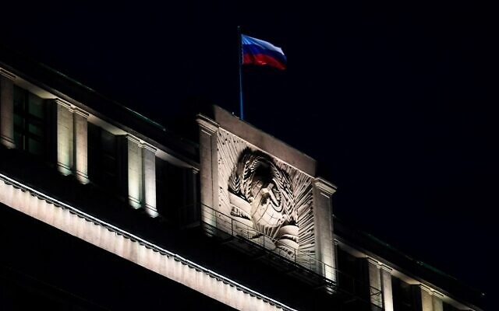
Russian authorities have imposed a news blackout and several media outlets have halted operations.
Multiple media websites were partially inaccessible in Russia. Twitter was restricted and Facebook blocked.

The Russian national tricolor flag flutters on top of the building of the State Duma, the lower chamber of Russia’s parliament, in central Moscow on the evening of March 3, 2022. (AFP)
The BBC, Bloomberg, and German public broadcasters ARD and ZDF, as well as Italy’s Rai, said they were suspending work in Russia after lawmakers in Moscow passed legislation to impose fines and jail terms of up to 15 years for publishing “fake news” about the army.
CNN said it would halt broadcasting in Russia, while independent Russian newspaper Novaya Gazeta said it would remove Ukraine content.
The Kremlin on Saturday defended the new law, saying it was “necessary as the country was facing “an unprecedented information war.”
Global hunger
Putin has been unmoved as Russia has become isolated in economic, sporting, and cultural fields.
Spanish clothing giant and Zara fast-fashion chain owner Inditex on Saturday joined the list of major companies suspending operations in Russia.
Flagship airline Aeroflot said it was suspending all its international flights from March 8, citing “circumstances that impede the operation of flights.”
At the Winter Paralympics in Beijing, Ukrainian athletes overcame all the hurdles to hit the top of the medal table with a haul of seven on day one.
In the men’s vision-impaired biathlon race, Vitalii Lukianenko took gold and said: “I want to dedicate this medal to the guys who protect our cities.”
Casualties
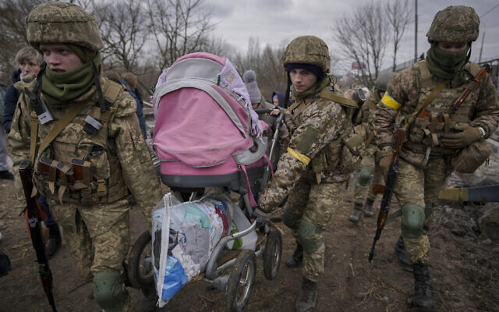
Russia said Wednesday that 498 Russian troops had been killed in Ukraine, its first announced death toll.
Ukraine and Western sources claim that the real toll is far higher. Ukraine says around 10,000 Russian soldiers have been killed.

Ukrainian servicemen carry a baby stroller after crossing the Irpin river on an improvised path under a bridge that was destroyed by a Russian airstrike, while assisting people fleeing the town of Irpin, Ukraine, on March 5, 2022. (AP Photo/Vadim Ghirda)
The UN said Wednesday it had recorded nearly 230 civilian deaths in Ukraine, including 15 children, warning the true toll was likely far higher.
Almost 1.37 million refugees have fled Ukraine in the week since the invasion, with over half going into Poland, according to the UN refugee agency. https://www.timesofisrael.com/ukraine-halts-mariupol-evacuation-accusing-russia-of-violating-local-ceasefire/

No-fly zone would be world catastrophe, warns Putin, after NATO spurns Zelensky plea
Ukraine’s president lashes out at West for giving ‘green light to further bombing of Ukrainian cities and villages’; Blinken says no-fly zone could ‘lead to a full-fledged war’
By AFP Today, 4:40 pm
MOSCOW — Russian President Vladimir Putin said Saturday that any country that sought to impose a no-fly zone over Ukraine would be considered by Moscow to have entered the conflict.
“Any movement in this direction will be considered by us as participation in an armed conflict by that country,” the Russian leader said during a meeting with Aeroflot employees.
His comments came after NATO on Friday rejected Ukraine’s request to impose a no-fly zone that could force Russia to stop its jet fighters, bombers, and helicopters from attacking Ukraine.
Putin added that imposing a no-fly zone would have “colossal and catastrophic consequences not only for Europe but also the whole world.” [I don’t think I would want to put Putin to the test on this one. He appears to be determined enough to complete his task that I don’t think he would let anything or anyone get in the way – rdb]
Putin also dismissed rumors that Russia is planning to declare martial law with his country’s military incursion in Ukraine in its second week.
“Martial law should only be introduced in cases where there is external aggression… we are not experiencing that at the moment and I hope we won’t,” Putin said.
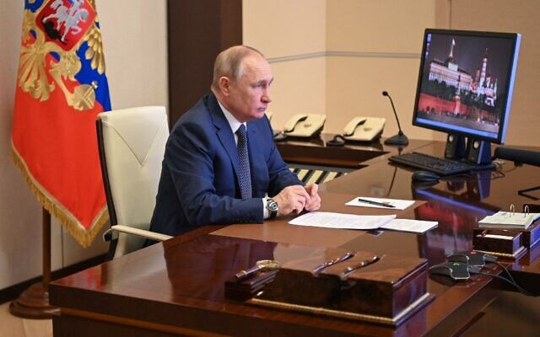
Russian President Vladimir Putin attends a flag-raising ceremony on the ferry Marshal Rokossovsky via a video link at the Novo-Ogaryovo state residence outside Moscow, on March 4, 2022. (Andrey Gorshkov/Sputnik/AFP)
NATO chief Jens Stoltenberg had said the alliance would not intervene in the conflict over fears of a direct clash with Moscow that could spiral into a wider conflict. That is probably the wisest decision that man has ever made. – rdb]
“The only way to implement a no-fly zone is to send NATO fighter planes into Ukraine’s airspace, and then impose that no-fly zone by shooting down Russian planes,” Stoltenberg said during a meeting on Friday.
“If we did that, we’ll end up with something that could end in a full-fledged war in Europe, involving many more countries and causing much more human suffering.”
Ukrainian President Volodymyr Zelensky lashed NATO for ruling out the measure, saying Friday that the Western military alliance knew further Russian aggression was likely.
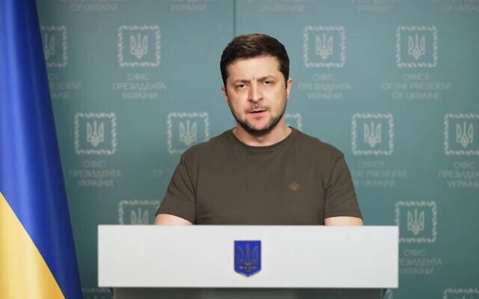
Ukraine’s President Volodymyr Zelensky in a video address posted to Facebook, on March 4, 2022. (Screenshot)
“Knowing that new strikes and casualties are inevitable, NATO deliberately decided not to close the sky over Ukraine,” Zelensky said in a video published by the presidency.
“We believe that the NATO countries themselves have created a narrative that the closing of the skies over Ukraine would provoke direct Russian aggression against NATO.”
Zelensky insisted that the NATO gathering was a “weak summit, a confused summit.”
“All the people who die starting today will also die because of you. Because of your weakness, because of your disconnection,” he said.
“ Today the leadership of the alliance gave the green light for further bombing of Ukrainian cities and villages, refusing to make a no-fly zone.”
US Secretary of State Antony Blinken said Friday that the suffering of Ukrainians will likely worsen, but defended the West’s focus on sanctions and limited military support as an effective way to stop Russia’s invasion.
US Secretary of State Antony Blinken, center, tours a reception center for displaced persons from Ukraine, at the Ukrainian-Polish border crossing in Korczowa, Poland, on March 5, 2022. (Olivier Douliery/Pool Photo via AP)
Amid rising pressure for US and European allies, and especially NATO, to help Kyiv more on the battlefield, Blinken said that their actions so far against Moscow were only just beginning to have a punishing impact.
But he also said that more military support and more sanctions, as well as increased humanitarian aid for Ukrainians, were the focus of a day of talks at the NATO and European Union headquarters in Brussels.
“The terrible expectation is that the suffering we’ve already seen is likely to get worse before it gets better,” Blinken told reporters.
Blinken, who has taken a lead role in organizing global retaliation against Russia, said a no-fly zone would be impossible to enforce without expanding the conflict.
“The only way to actually implement something like a no-fly zone is to send NATO planes into Ukrainian airspace and to shoot down Russian planes. That could lead to a full-fledged war,” he said. https://www.timesofisrael.com/no-fly-zone-would-be-world-catastrophe-warns-putin-after-nato-spurns-zelensky-plea/ This all boils down to the question “do you want a WWIII nuclear encounter or are you willing to let Putin take over Ukraine. – rdb]

Russia says won’t back Iran nuke deal without US guarantees over Ukraine sanctions
Lavrov says ‘avalanche of aggressive sanctions’ mustn’t impact Moscow’s rights under agreement, shortly after Tehran, IAEA announce ‘pragmatic approach’ to resolve remaining issues
By Agencies and TOI staff Today, 2:43 pmUpdated at 4:10 pm
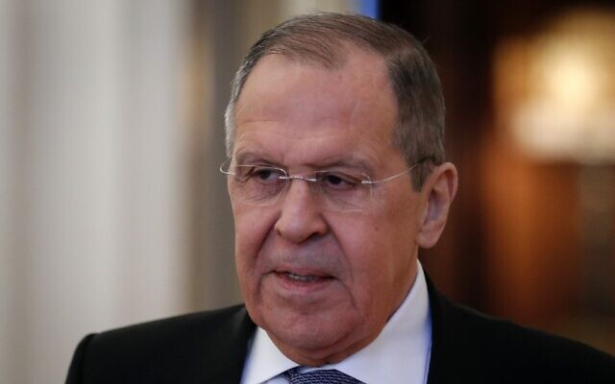
Russian Foreign Minister Sergei Lavrov attends a meeting with his Kyrgyz counterpart in Moscow. on March 5, 2022. (Sergei Ilnitesky/Pool/AFP)
Russian Foreign Minister Sergei Lavrov said Saturday that Moscow is demanding guarantees from the US before backing the Iran nuclear deal, citing the current wave of Western sanctions against Russia.
Lavrov said that the nuclear talks have covered most issues and “from our point of view, if Iran agrees, this document can already be launched into the acceptance process.”
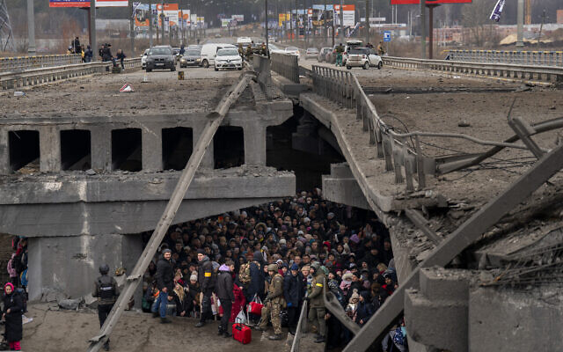
But he added that there are “problems that have appeared recently from the point of view of Russia’s interests,” due to concerns over the terms of the deal concerning Moscow’s involvement in the civilian nuclear sector in Iran and arms sales to Tehran.
Ukrainians crowd under a destroyed bridge as they try to flee crossing the Irpin river in the outskirts of Kyiv, Ukraine, on March 5, 2022. (AP Photo/Emilio Morenatti)

Lavrov cited the “avalanche of aggressive sanctions that the West has started spewing out, which hasn’t ended as far as I understand,” over the Ukraine conflict.
He said this meant Moscow had to ask the US for guarantees first, requiring a “clear answer” that the new sanctions will not affect its rights under the nuclear deal.
“We requested that our US colleagues… give us written guarantees at the minimum level of Secretary of State that the current [sanctions] process launched by the US will not in any way harm our right to free, fully-fledged trade and economic and investment cooperation and military-technical cooperation with Iran,” Lavrov said at a news conference. [ It appears that Putin may have “Bi-Dum" in a most untenable position. Loose his so called accord with Iran or give up sanctions on Russia. Could this be a checkmate? – rdb]
A senior Iranian official criticized the Russian demand, telling Reuters it was “not constructive” to the ongoing nuclear talks in Vienna. [Hummmm? Maybe Iran will realize that to Russia they are simply a tool. – rdb]
“Russians had put this demand on the table [at the Vienna talks] since two days ago. There is an understanding that by changing its position in Vienna talks Russia wants to secure its interests in other places. This move is not constructive for Vienna nuclear talks,” the unnamed official was quoted as saying.
The comments came shortly after Iran and the International Atomic Energy Agency said at talks in Tehran that they agreed on an approach to resolve issues crucial in efforts to revive the nuclear deal.
IAEA chief Rafael Grossi said the UN agency and Iran “did have a number of important matters that we needed… to resolve,” but that they had now “decided to try a practical, pragmatic approach” to overcome them.
Atomic Energy Organization of Iran chief Mohammed Eslami said the two sides had come to the “conclusion that some documents which need to be exchanged between the IAEA and the Iranian organization should be exchanged” by May 22.
Grossi of the International Atomic Energy Agency described his weekend visit to Tehran as a means “to address outstanding questions” as negotiators back in Europe appear to be reaching a deadline to see if the 2015 accord can be revived.
“It would be difficult to believe or to imagine that such an important return to such a comprehensive agreement like the [nuclear deal] would be possible if the agency and Iran would not be seeing eye to eye on how to resolve these important safeguards issues,” Grossi said. Safeguards in the IAEA’s parlance refer to the agency’s inspections and monitoring of a country’s nuclear program.
Grossi met later with Iranian Foreign Minister Hossein Amirabdollahian.
International Atomic Energy Organization, IAEA, Director General Rafael Mariano Grossi, left, and Iran’s Foreign Minister Hossein Amirabdollahian shake hands prior to their meeting in Tehran, on March 5, 2022 (AP Photo)
The nuclear deal saw Iran agree to drastically limit its enrichment of uranium in exchange for the lifting of crushing economic sanctions. But a 2018 decision by then-US President Donald Trump to unilaterally withdraw America from the agreement increased tensions and attacks across the wider Mideast.
Today, Tehran enriches uranium up to 60% purity — its highest level ever and a short technical step from weapons-grade levels of 90% and far greater than the nuclear deal’s 3.67% cap. Its stockpile of enriched uranium also continues to grow, worrying nuclear nonproliferation experts that Iran could be closer to the threshold of having enough material for an atomic weapon if it chose to pursue one.
Iran has long denied seeking nuclear weapons. However, US intelligence agencies, Western nations, and the IAEA have said Iran ran an organized nuclear weapons program until 2003. Grossi didn’t elaborate what outstanding issues remained, but some of them may deal with ongoing investigations into that program.
The 2015 deal saw the IAEA’s then-director-general also come to Tehran and visit one suspected weapons-program site at Parchin, with inspectors taking samples for analysis.
Grossi’s inspectors also face challenges in monitoring Iran’s current advances in its civilian program. Iran has held IAEA surveillance camera recordings since February 2021, not letting inspectors view them amid the nuclear negotiations.
In Vienna, negotiators appear to be signaling a deal is near — even as Russia’s war on Ukraine rages on. Russia’s ambassador there, Mikhail Ulyanov, has been a key mediator in the talks and tweeted Thursday that negotiations were “almost over.”
Meanwhile, on Saturday, Iran’s paramilitary Revolutionary Guard unveiled what it described as two new underground missile and drone bases in the country.
רגע לפני שחותמים על הסכם הגרעין המחודש, חיל האוויר של משמרות המהפכה חושף היום עוד בסיס תת קרקעי של טילים ומל"טים. מלווה במנגינה דרמטית לפרקים pic.twitter.com/yLApydMKz1
— roi kais • روعي كايس • רועי קייס (@kaisos1987) March 5, 2022
An online state TV report said the bases contained surface-to-surface missiles and armed drones capable of “hiding themselves from enemy radar.” https://www.timesofisrael.com/russia-says-wont-back-iran-nuke-deal-without-us-guarantees-over-ukraine-sanctions/

Herzog to visit Turkey this week
Herzog will be the first Israeli leader to visit Turkey since 2008 and the first president since 2003.
By LAHAV HARKOV, GREER FAY CASHMAN Published: MARCH 5, 2022 19:41 Updated: MARCH 5, 2022 19:47
President Isaac Herzog plans to embark on a two-day state visit at the invitation of Turkish President Recep Tayyip Erdogan on Wednesday, the President's Office confirmed on Saturday.
Herzog will be the first Israeli leader to visit Turkey since 2008 and the first president since 2003.
The president will visit Ankara, where he and his wife Michal Herzog will be welcomed to the Presidential Complex in an official ceremony, and then Istanbul, where they will meet members of the Jewish community.
The presidents are expected to discuss Israel-Turkey relations and the potential for expanding collaboration between their respective countries.
The rapprochement between Israel and Turkey in recent months, following years of frosty relations, began with Erdogan calling Herzog to congratulate him on his election victory. They have spoken several times since.
Earlier this month, Prime Minister Naftali Bennett said in February that Israel was treading cautiously regarding Erdogan’s overtures.
“Things are happening very slowly and gradually,” he said, adding that Herzog’s trip to Ankara was being fully coordinated with him, and praising Herzog’s role in Israel’s international relations.
Erdogan called for improved ties with Israel several times last year, including in December to the Alliance of Rabbis in Islamic States. Despite his differences with Israel over finding a solution to the conflict with the Palestinians, Erdogan said, relations between Turkey and Israel are essential for the security and stability of the region.
Turkey’s change in policy might be related to its declining economy and growing diplomatic isolation, which it has sought to resolve, including through a rapprochement with the UAE.
At the same time, Turkey harbors Hamas terrorists, Erdogan has accused Israel of intentionally killing Palestinian children, and state-controlled media outlets have broadcast antisemitic television series. Earlier this year, the Turkish Foreign Ministry criticized Israel for evicting Palestinians who had illegally built their homes and businesses on public land, and Turkey’s Religious Affairs Ministry organized a “symposium meant to raise awareness about conflict in Jerusalem and al-Aqsa Mosque,” among other destabilizing activities in Israel’s capital.
Tensions between Israel and Turkey began in 2008, when then-prime minister Ehud Olmert met with Erdogan and launched Operation Cast Lead in the Gaza Strip days later. They peaked in 2010 when the Erdogan-linked IHH (Humanitarian Relief Foundation) sent the Mavi Marmara ship to bust the IDF’s naval blockade on Gaza, arming some of the people aboard. IDF naval commandos stopped the ship, were confronted by IHH members aboard and killed nine of them.
Israel and Turkey maintained diplomatic relations in the aftermath, even reinstalling ambassadors in 2016. But two years later, Ankara expelled Israel’s ambassador over the IDF’s response to rioting on the Gaza border.
During his visit to Nicosia last week and Athens the week before that, Herzog gave assurances to the that mending fences with Turkey would not affect Israel's excellent relations with Cyprus and Greece.
Before leaving for Turkey, Herzog will host the largest swearing-in ceremony for judges that has ever been held at the President's Residence, where 50 new judges, including one for the Supreme Court, will pledge their allegiance without fear or favor on Sunday evening.
For more than twenty years, there has been a serious backlog in dealing with cases in all the courts, and this large scale of judicial appointments is in response to an urgent need to relieve the logjam. https://www.jpost.com/israel-news/article-700423

Palestinians decry world's ‘double standards’ on Russia-Ukraine war
The Palestinian leaders’ main argument is that the international community is being hypocritical and racist by being more sympathetic towards the Ukrainians because of their color, religion and race.
By KHALED ABU TOAMEH Published: MARCH 5, 2022 16:34 Updated: MARCH 5, 2022 18:16
While Palestinian leaders have chosen not to take sides in the Russia-Ukraine war, they have nevertheless begun accusing the international community of applying two sets of rules in dealing with various crises.
The Palestinian leaders’ main argument is that the international community is being hypocritical and racist by being more sympathetic toward the Ukrainians because of their color, religion and race.
They are also taking it to task for allegedly ignoring Israeli “crimes” against the Palestinians while condemning Russia for its invasion of Ukraine and suspected “war crimes.”
Mahmoud al-Habbash, a senior adviser to Palestinian Authority President Mahmoud Abbas, on Friday condemned the international community over its “silence on Israeli violations while rushing to denounce human rights violations in other parts of the world.”
Addressing the international community in a sermon he delivered during Friday prayers in Ramallah, Habbash asked, “Does international legitimacy apply according to religion, color, race or geography?”
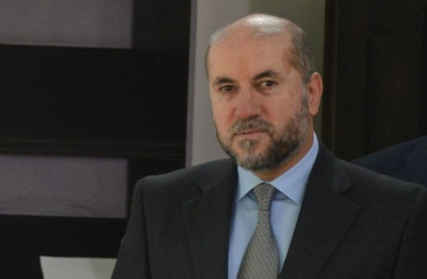
Mahmoud al-Habbash (credit: Wikimedia Commons)
Referring to the Russia-Ukraine war, Habbash said that “when events occur here or there, the international community is mobilized. But no one notices the Palestinian people who have been facing injustice for more than 70 years. Justice and law do not accept selectivity.”
Echoing the same sentiment, another senior Palestinian official, PLO Executive Committee member Hussein al-Sheikh, wrote on Twitter: “When color, religion and race become an identity, values, morals and humanity are lost. When international legitimacy is breached by double standards, justice is lost, rights are destroyed and power becomes tyrannical.”
When #color, #religion and #race become an #identity, its when values, morals and #humanity are lost. When #international legitimacy is violated by two standards, #justice is lost, rights are destroyed, and power has become tyranny. https://t.co/v4oVoA86SN
— حسين الشيخ Hussein Al Sheikh (@HusseinSheikhpl) March 4, 2022
As part of an attempt to liken the Russia-Ukraine crisis to the Israeli-Palestinian conflict, Sheikh and other Palestinian officials said the international community needs to notice that the Palestinians, like the Ukrainians, are also facing “occupation” and “displacement.”
An official with the PA Ministry of Foreign Affairs pointed out that since the beginning of the Russia-Ukraine war, various international bodies and organizations have condemned Russia and even accused it of committing war crimes while “ignoring Palestinian suffering and Israeli crimes.”
“This is a clear example of the double standards of the international community,” the official said. “If Russia is committing war crimes, what about Israeli crimes? If the Ukrainian people are victims in the eyes of the international community, what about the Palestinians, who are also victims of [Israeli] occupation?”
Osama Kawassmeh, a spokesperson for the ruling Fatah faction, also lambasted the international community for applying different sets of principles for the Russia-Ukraine war and the Israeli-Palestinian conflict.
“Do some consider Palestinian blood to be second-class blood?” Kawassmeh asked in a statement on Saturday. “Is humanity classified according to race and color?”
In an editorial, the Palestinian daily Al-Quds said the Ukraine crisis “raises many questions” about the American and European positions.
“If they are keen on protecting their rights and their future, and are afraid of Russian expansion, then the big question is: What is their position toward the Israeli occupation?” the newspaper asked.
“The double standards of the US and the West are the focal point of tension, violence and bloodshed and make Washington an unacceptable mediator and a country that is unable to achieve stability in the world. This unfair and illogical duality of positions will only lead to more instability and the rejection of the irrational US policy.” https://www.jpost.com/international/article-700408 [The “PA” is the world’s expert at playing the victim. There is very little if any comparison between the Ukraine and the “PA”. The Ukraine has hundreds of years of history of being controlled by Russia and other European countries ant the “PA” is a creation of Arafat the rat from the 1960’s. They are not on the same planet. – rdb]

Ukrainian President Zelenskyy is tied to Klaus Schwab, Justin Trudeau, and other global elites
Like Trudeau, Zelenskyy is an acolyte of the World Economic Forum.
Jack Bingham Thu Mar 3, 2022 - 12:28 pm EST
(LifeSiteNews) – Ukraine’s President Volodymyr Zelenskyy has stated that Canadian Prime Minister Justin Trudeau was one of the reasons he got into politics.
After leaving his career as a comedian and entertainer and becoming Ukraine’s president in April 2019, Zelenskyy hailed Trudeau as “one of those leaders who inspired” him “to join politics,” when he became Ukraine’s president in 2019.
@JustinTrudeau was one of those leaders who inspired me to join politics. pic.twitter.com/DZYwLDgvkv
— Володимир (@ZelenskyyUa) July 2, 2019
While Zelenskyy has shot to stardom from relative obscurity from the perspective of the West since the Russo-Ukrainian conflict became international news last week, his admiration for Trudeau comes as less of a surprise when looking into his background.
Like Trudeau, Zelenskyy is an acolyte of Klaus Schwab’s World Economic Forum, the globalist organization behind the now-infamous “Great Reset” agenda, which tells the world that by the year 2030, “You’ll own nothing and you’ll be happy.”
The ubiquitous support for Zelenskyy by the elite, including support from “defund the police” and Black Lives Matter leftist mega-donor George Soros, Trudeau, American President Joe Biden, and all sides of mainstream media, has led many to question the true motivation behind the West’s condemnation of Russia and a concern that a push for yet another foreign war involving the West is underfoot.
On Tuesday, for example, Ukrainian journalist Daria Kaleniuk made an emotional demand to British Prime Minister Boris Johnson, asking him to instruct NATO to enter the war in Ukraine. After the event was praised in Western media, reports surfaced showing that Kaleniuk is not just a journalist, but a member of the WEF and runs initiatives backed by Soros throughout Eastern Europe.
While many are skeptical of Russian President Vladimir Putin and his former ties to the KGB, scrutiny of the other side of the conflict seems absent in mainstream outlets which has worried many considering the radical nature of the WEF and their Great Reset goals.
The Great Reset is a radical socialist plan designed by global elites to “reset” the world economy, and install a centralized, and heavily regulated totalitarian international system similar to that of China’s Social Credit System.
In fact, the WEF’s founder and chairman Klaus Schwab has consistently praised Chinese Communist President Xi Jinping, including a statement from this year in which he told the leader of China that his dictatorial regime has made “significant social and economic achievements” under his “inclusive” leadership. Schwab’s praise and reference to China as “inclusive” comes despite evidence that China is carrying out a genocide on its Uyghur Muslim population, is running a massive organ-harvesting program, and has been referred to by critics as the “nightmare of the world’s first truly totalitarian state.”
From a purely strategic standpoint, with an emphasis on keeping deaths and casualties to a minimum, there are those too who reject the notion that the West should become involved in the war as it may serve to escalate, not end, the conflict
According to American public affairs consultant J. Robert Smith, the West should, at this time, reject U.S. and NATO military involvement in Ukraine, which he thinks would only worsen the already tumultuous and deadly situation.
“The gruesome impact of major wars is often underestimated at their outsets. Take the Civil War. Few people, South or North, imagined the war would claim anywhere from 600,000 to 850,000 lives, depending on estimates. At the beginning of World War I, neither side foresaw a staggering 40 million causalities, military and civilian, in that pointless conflict,” wrote Smith.
“Who really believes that a U.S./NATO-Russia war could be contained to Ukraine? Wars are inherently unpredictable; they have their own dynamics. Either through design or blunder, spillover to NATO nations seems a smart bet. Why wouldn’t Putin strike enemy targets beyond Ukraine’s borders? Why wouldn’t the U.S. and NATO retaliate, if not initiate? https://www.lifesitenews.com/blogs/why-would-the-ukrainian-president-cite-justin-trudeau-as-an-inspiration/

Putin explains why Ukraine attack went beyond Donbass
The Russian leader claims Moscow wanted to prevent the West from helping “nationalists”
5 Mar, 2022 14:42
Russian President Vladimir Putin said on Saturday that he chose to attack Ukraine beyond the borders of the Donetsk and Lugansk People’s Republics (DPR and LPR) to prevent the West from “endlessly” supplying “nationalists and radicals” with various resources, such as weapons and money. He added that the Russian forces were “practically done” destroying Ukrainian military sites, such as air defenses and weapons depots.
The president stated that he had ordered Russian troops to invade Ukraine last week in order to neutralize the “real threat” coming from Kiev and NATO. Moscow has long protested the Western military infrastructure along its borders and Ukraine’s aspirations to join the US-led bloc.
“They began to say more actively that they will admit [Ukraine] to NATO. What will this lead to? All other members of the alliance must back Ukraine in the case of a military conflict,” Putin said. “They will [attack] Crimea, and we will be forced to go to war with NATO. Do you understand the consequences?” The president stated that he wanted Ukraine to become a neutral country.
Crimea voted to leave Ukraine and join Russia shortly after the 2014 coup in Kiev. It was during that time that the DPR and LPR broke away from Ukraine.
“Let’s acquire nuclear weapons, they say [in Ukraine]. We can’t simply ignore it,” Putin said, referring to President Volodymyr Zelensky’s remark last month that Kiev might be forced to reconsider its status as a non-nuclear-weapons state.
Russia invaded its neighbor on February 24, arguing that it was defending the DPR and LPR. Putin also claimed he was seeking the “demilitarization and denazification” of the country.
Kiev said the attack was entirely unprovoked and appealed to the international community for help. Many countries, including the US, the UK, and EU member states, have since imposed sweeping sanctions on Russia. https://www.rt.com/russia/551314-putin-explains-ukraine-tactic/

By using Ukraine to fight Russia, the US provoked Putin's war
After backing a far-right coup in 2014, the US has fueled a proxy war in eastern Ukraine that has left 14,000 dead. Russia's invasion is an illegal and catastrophic response.
Aaron Maté 5 hr ago

"The United States aids Ukraine and her people," Adam Schiff declared in January 2020, "so that we can fight Russia over there, and we don’t have to fight Russia here."
Schiff made this statement during the opening of Donald Trump's first impeachment trial, where the Democratic Party's bid to ensure unimpeded US weapons sales to Ukraine was presented, and widely accepted, as a valiant defense of US democracy and national security.
Two years later, the US use of Ukraine to "fight Russia over there" has reached its logical end-game: illegally, murderously, and catastrophically, Russia has invaded Ukraine to end the fight. MUCH MORE - https://mate.substack.com/p/by-using-ukraine-to-fight-russia?s=r [This is fairly long but a most interesting and informative education on the US political international corruption that is going on. Notice carefully in the picture who is there proudly with the Ukrainian soldiers? HUMMMMM? Does this raise a few questions? Time to start looking at the financial records of those in DC very carefully. You know they have been harping on The Donald’s finances for some time, years actually. Remember that little psychological issue called “Projection” when you project your problems onto someone else. Maybe this is a very bad case of projection and the tables need to turn. – rdb]

Corn and Soybean Farmer to Americans: Your Grocery Bill Is Going to Go Up $1,000 a Month
By Warner Todd Huston March 4, 2022 at 4:30pm
A farmer joined Tucker Carlson’s Fox News show Wednesday to warn that Joe Biden’s failed economic policies and the war in Ukraine are going to cause the costs of food to skyrocket in the coming months.
If you think the high cost of gasoline is a problem now, wait until summer when your grocery bill soars.
During his March 2 broadcast, Carlson informed his audience that Russia is a leading producer of the fertilizers and additives that American farmers use to help grow the crops that subsequently supply our grocery store shelves with food.
But the war in Ukraine is set to put a major crimp in the ability of American farmers to import the nutrients they need just as the planting season approaches, with the U.S. and other nations levying sanctions on Russia for its aggressive invasion of Ukraine.
Ben Riensche, the owner of Blue Diamond Farming Company in Iowa and a farmer of 16,000 acres in that state, told Carlson that the sanctions will have a far-reaching impact on our food supplies in the very near future.
“Soaring fertilizer prices are likely to bring spiked food prices,” Riensche said. “If you’re upset that gas is up a dollar or two a gallon, wait until your grocery bill is up $1,000 a month, and it might not just manifest itself in terms of price. It could be quantity as well. Empty-shelf syndrome may be starting.”
Riensche went on to point out that costs to raise his crops have already gone up 40 percent because the cost of nitrogen is three times higher than last year. Phosphorus and potassium fertilizer prices have doubled, he added.
The farming expert also warned that these skyrocketing production costs cannot be changed in the near term. The costs are already set for now.
“The planting season in the northern hemisphere is just weeks away,” Riensche explained. “There is no miracle technology that can cut that in half or a third. It’s a pretty fixed formula. For me to grow an acre of corn on my farm, I need 200 pounds of nitrogen, 200 pounds of phosphorus, and 100 pounds of potash. We just — it’s going to be hard how this plays out. Will farmers switch to other crops that produce less? We’re certainly not going to literally pour on the groceries to grow this crop.”
But it isn’t just the war in Ukraine and the sanctions on Russia’s ability to export fertilizer supplies that farmers are facing. Failed Biden energy policies and leftist climate-change policies are also wrecking havoc.
Riensche added that, “what’s really affecting us are things that could have been prevented. The ESG things (Environmental, Social and Governance policies). This could kind of be described as the food crisis of the Green New Deal.”
The farmer then pointed to Biden’s energy policies as a major contributor, saying, “policies that have made us more dependent on foreign energy, energy plants that have been decommissioned from other power sources and transitioned to natural gas, and thus competing against the fertilizer input stocks, Wall Street taking an activist investor role with strategic plant closures.”
There is one more major problem, as Riensche sees it: “But the kingpin in this — the worst part for a farmer — is this action that has been taken by the International Trade Commission, the tariffs that they put in place creating monopolies that we can’t buy from friendly parties that have a third of the supplies.”
This is yet another Biden tax on the middle and lower classes that are already struggling under the massive Bidenflation the president’s policies have wrought.
But even before we find our wallets drained for food, we are already seeing Biden’s destruction of our energy sector with $5-per-gallon gas prices. And experts warn that we will probably see $7-dollar-per-gallon prices come before we know it.
Gasoline has been on the rise for eight straight weeks, and energy strategist Dan Dicker told Fox Carolina that he can see gas prices in some areas “might even get to $6.50 or $7.”
Per-gallon prices have already doubled over the last two years. Gas was just $2.17 per gallon, on average, at the end of 2020. And it is no coincidence that 2020 was the last full year we had a president who wanted the U.S. to be energy independent.
The bad news keeps hitting us, though. On the cusp of Biden’s first State of the Union speech on Tuesday, oil surpassed $106 per barrel for the first time in nearly a decade. And the unheard of has already occurred: On Thursday, San Francisco became the first city in America to find gas hit the $5-per-gallon mark, Fox Business Network reported.
Brace yourself, America. Joe Biden’s policies are not being reversed, and that means the pain is just beginning. https://www.westernjournal.com/corn-soybean-farmer-americans-grocery-bill-going-go-1000-month/ [Folks this is not just fear mongering. These are people who in the system that indicate the entire objective of this group is to dismantle the US economy and break everyone’s bank. You need to understand that in today’s world where literally we are economically interconnected and interdependent on everyone else, when you do stupid thinks you end up with consequences and we the American people as well as those of other countries will suffer greatly from their actions. They can glibly say that “we need to be willing to give up something to stand for principles” but the problem is one of their own making. The US has been playing the whore with the Ukraine for years and that is why they want to keep their Ukrainian mistress. – rdb]
It is time to start prepping your soil in your garden to get ready in a week or so to plant. The way things are going in the world today and in the “US Government” you may need the produce to get through the year. Lots of things can be planted in containers if you don’t have space for a traditional garden. – rdb]

India wants to bypass dollar to keep trading with Russia
New Delhi considering switching to rupee-ruble settlements amid sanctions on Moscow
5 Mar, 2022 10:14
India is in search of efficient tools to skirt around the latest penalties imposed on Russia over the conflict in Ukraine, as New Delhi looks to keep trade with Moscow going, Indian media reports.
Among the options reportedly being considered are making settlements via foreign financial institutions that don’t operate in countries that have supported the punitive measures against Russia, routing payments through minor Russian lenders unaffected by the SWIFT ban, and boosting its rupee-ruble arrangement.
Russian banking majors Sberbank and Gazprombank have been exempted from the latest sanctions so far due to their essential role in processing payments for the EU’s gas and oil imports from Russia.
“We are looking into this. Even if these banks face sanctions from the US, payments can be made in euros as these transactions are still being carried out until further sanctions,” said a government official, as quoted by The Economic Times.
The official added that the full impact of the latest penalties against Russia is yet to be felt.
Repaying Russian debt through a rupee auction held by the Bank of Russia is reportedly another option under consideration. Such a repayment is made through the exports of identified commodities and services.
In 2014, India and Russia agreed to make payments through the rupee-ruble trade after India faced a threat of secondary sanctions over a defense agreement with Russia. Washington has once again threatened New Delhi with sanctions over the arms deal this week.
Bilateral trade between India and Russia amounted to $8.1 billion in the fiscal year ended March 2021, with exports to Russia at $2.6 billion and imports at $5.5 billion. https://www.rt.com/business/551272-india-bypass-dollar-russia-trade/ [This may seem like a temporary or small issue since it is just India BUT you need to think long and hard about this. You already have Russia and China working to bypass the Dollar Burse and you also have Iran and North Korea bypassing the $ burse. There are other countries who are moving toward bitcoin and gold or silver exchanges for their financial issues. If the Dollar is no longer the benchmark for financial trading in the world which it has been for years thanks to the FED who saw to it we went off the gold and silver standard so we now have fiat money, you could well see an enormous crash of the entire US financial system because the US is enormously in debt to the rest of the world. Were they to decide they could literally own the US. Thank you Federal Reserve and crooked government for undermining our entire financial system and the country. – rdb]

Supreme Court lets cops use cameras to spy on private citizen, without warrant
Justices decline to address privacy issue
By Bob Unruh Published March 5, 2022 at 4:54pm
The U.S. Supreme Court has said, by its decision not to take up the argument, that it's fine for police departments to mount multiple cameras to spy on a private citizens for more than a year – without a warrant.
That word comes from the Rutherford Institute, which had sounded off with the high court on the case Travis Tuggle v. U.S. The high court declined to take up the issue, leaving a lower court's ruling that the police actions were fine standing.
"Unfortunately, we are steadily approaching a future where nothing is safe from the prying eyes of government," said constitutional attorney John W. Whitehead, president of The Rutherford Institute and author of "Battlefield America: The War on the American People." "As the Seventh Circuit Court of Appeals recognized, 'Foreseeable expansion in technological capabilities and the pervasive use of ever-watching surveillance will reduce Americans' anonymity, transforming what once seemed like science fiction into fact.'"
The non-decision by the Supreme Court let stand a ruling from a lower court that found there was no "search" in violation of the Fourth Amendment when police posted multiple hidden cameras to have extended, round-the-clock access to details about the private actions at the property in question.
The Rutherford Institute and the Cato Institute had filed an amicus brief in the case suggesting that without adequate safeguards in place, there would be no turning back from the kinds of intrusions "posed by such expansive, ever-watching surveillance technology capable of revealing intimate details of a person's life."
Jim Harper with TechLaw at the University of Arizona College of Law assisted The Rutherford Institute and the Cato Institute in advancing the Fourth Amendment privacy arguments in Tuggle.
The case developed as police in Illinois worked on a drug trafficking crackdown.
Their "Operation Frozen Tundra," had police officers post three hidden surveillance cameras on poles facing Tuggle's home starting in August 2014.
The suspect lived in a residential neighborhood with lightly traveled roads, which made physical surveillance difficult for officers. But, the report explained, the agents used live feeds from the three video cameras to monitor Tuggle’s activities and visitors in his yard and driveway, and stored the data on a server at the FBI's office.
The cameras were equipped to be able to record at night, and could pan, zoom and tilt to take aim at whatever law enforcement agents wanted to see.
From the time of installing the first camera, agents surveilled Tuggle’s residence around the clock for over a year and a half without ever obtaining a search warrant to do so," the institute reported.
While Tuggle eventually was charged and convicted on charges, he contested the validity of the warrantless video-surveillance as a violation of his Fourth Amendment rights.
The district court and 7th U.S. Circuit Court of Appeals came down on the side of the officers' spying.
However, that opinion did warn about creating a "constellation of ubiquitous public and private cameras accessible to the government that catalog the movements and activities of all Americans."
The Supreme Court simply decided not to consider the case. https://www.wnd.com/2022/03/supreme-court-cops-use-cameras-spy-private-citizen-without-warrant/ [Once again the deep state government courts decide not even to hear a cases which is an obvious breach of the Bill of Rights. The fact that this man was found guilty does not mean that his 4th Amendment right should have been breached. They could of obtained a warrant for the surveillance of this person which would have made it legal but the courts NOT the Federal agency is the determiner of that issue. This is not that much different than the extra judicial executions that the US has done on US citizens. They may be creepy bad people but when you stop ensuring constitutional rights one, you have no idea where that will stop. The constitution is the be the wall around infringement of personal freedoms in this country. – rdb]

Commentary:
Exclusive from Gen. Flynn: Here's How We Can End the Ukraine Crisis Today
By Michael Flynn March 3, 2022 at 5:13pm
If you are not upset about what is happening in Eastern Europe, you are not paying enough attention to what is happening right here at home.
Everything is changing before our eyes. A war on our own soil is a very real possibility. Should this occur, what will you have done to try to prevent the war? Everyone talks problems; what we need right now is solutions.
Like many across America, I am troubled by the Ukraine debacle — a totally avoidable situation, as I have already stated in a prior Op-Ed.
Think back in recent history to October and examine the Biden administration’s visit to Ukraine. Never mind researching the 1939 European borders or understanding the results of America’s war to defeat Naziism.
While you’re at it, consider the history of the Budapest Agreement, three identical political agreements signed at a conference of the Organization for Security and Co-operation in Europe in Budapest, Hungary, on Dec. 5, 1994. It provided security assurances from its signatories related to the accession of Belarus, Kazakhstan and Ukraine to the Treaty on the Non-Proliferation of Nuclear Weapons. (Look it up — we are all in violation of it.)
And let’s stop with the hypothetical question of what former President Donald Trump would do in this situation. The reality is that this crisis did not occur during his administration because of a variety of factors. Topping the list is demonstrated and strong leadership, so stop with the backward-looking questions and start with where we are right now.
In this piece, I want to offer an option. There are many — most are not good, and all will come with compromise and cost. However, without these, the real advent of a nuclear standoff — or worse, a nuclear exchange — is on the horizon. We can no longer kid ourselves about this reality. We have allowed ourselves to get to this avoidable point in history.
Background: It was a horrible mistake that Russian President Vladimir Putin made. He overestimated his popularity. While it is true that in Crimea, Donetsk and Luhansk he has about 51 percent support, in my assessment, he expected that level of support across the entire country of Ukraine. Clearly, that support never materialized.
Now Putin needs a safe way out. Hundreds of thousands of lives are being destroyed every day this continues. Something must be done to stop the death and ruination on both sides. Russians are dying by the scores as well, causing Putin more problems if he can’t get it under control quickly. There is an old saying: Better to deal with the devil you know than the devil you don’t.
First, let’s try to understand Vladimir Putin. He is not crazy, as the propaganda media is trying to portray him as now. He is behaving as he always does. The best example of Putin’s personality is the story of New England Patriots owner Robert Kraft and his Super Bowl ring.
If you aren’t aware of the story, here goes: In 2005, Kraft met Putin. He took off the ring to show it to Putin, Putin admired it, and Kraft held out his hand to take it back. Putin put the ring in his own pocket and walked out, essentially stealing it. The White House insisted that Kraft said it was a gift, but many years later he told the true story of the theft of his ring.
Putin will do anything he can if he thinks he can get away with it. He will stop only when he thinks he cannot get away with it. It was why nothing ever happened when Trump was in power. He respected Trump and knew he couldn’t get away with anything. Now, under this feckless U.S. administration, Putin has seized his opportunity. He knows well what he can get away with.
He also believed (wrongly) that Ukraine would at least moderately support the invasion. If Ukraine did not welcome the Russians as heroes, Putin believed they would at least be tolerated. He and his advisers and generals have miscalculated badly.
There is an option that would give Putin an out. This option needs to be thoroughly analyzed and discussed. It gets Putin what he wants, affords Ukraine a unique and long-term security opportunity, allows Europe and the world to take a deep breath, and can stop this madness along with the horrible killing taking place on both sides (and this may only be the beginning).
I believe the key to unlocking this crisis is the Budapest Agreement.
As smart readers will remember, when the Soviet Union broke up after decades of the now-distant Cold War, Ukraine had more nuclear weapons than China and was the third-biggest nuclear power in the world.
Among other critical issues, the Budapest Agreement stipulated that Ukraine would give up its nuclear weapons if both Russia and the U.S. agreed not to invade it. That is the basic agreement. Putin is in gross violation of this agreement, which affords the U.S. (and select European nations) the opportunity to enforce it. But this is only a starting point to a broader conversation about a peaceful solution.
The real conversation goes like this.
Part One: Russia wants a neutral Ukraine. The Budapest Agreement can be considered an agreement of neutrality. Obviously, if Russia adheres to the agreement, then Ukraine doesn’t need to join NATO. And NATO can agree that having Ukraine join would be a violation of the Budapest accord. This is something that I believe Putin would seriously consider (and possibly accept), and it meets half of his demands. This gives him a way out without killing more people.
Part Two: Putin wants Ukraine to renounce any claim to Crimea. Ukraine should agree, with a major caveat.
Putin argues that Crimea was unlawfully given to Ukraine in the 1950s and, true or not, he wants it back. Well, Ukraine will never get Crimea back under any conditions without a major war. Most don’t realize it, but Putin is popular in Crimea and there is a strong attachment to Russia in the region, so it is a loss to Ukraine, but not a substantial loss. (That is the reality of global geopolitics.)
The major caveat should be that Ukraine has made a lot of improvements in Crimea since the ’50s. A large price should be put on that. Russia is not just taking Crimea; it is paying for all the care that Ukraine has given Crimea since the ’50s. It should be a significant and long-term repayment.
Part Three: Finally, Putin must emphasize that the targeting of civilians was against his orders and that he will help to rebuild some of Ukraine. He can claim that senior generals or other Russian defense officials failed to follow his orders and publicly fire them. (Maybe those fired will be allowed to come to the U.S. and work at a Washington, D.C., think tank). However the provision may be described, it gives Putin the chance to call this insane war off.
In the end, America has always stood for self-determination and the right to choose one’s government. Whatever claim Putin may try to make on Ukraine, either based on reality or his own fiction, it will never outweigh the people’s right to a free and fair election for a government that represents them.
As another famous president said about a voting bloc in our country, what do you have to lose? I do think this would be agreeable to Putin if the alternative is brutal sanctions and a reputation as a pariah.
What I don’t know is whether Ukraine would be agreeable. I do believe that if Ukraine can forgo NATO, it should be given immediate consideration for European Union membership. Obviously, Crimea would be a bigger pill to swallow, but Ukraine isn’t getting it back anyway. Bite the bullet for the good of humanity and the reality that you stand to lose your entire nation or worse if the situation continues. Push for a large payment from Russia and it will likely give it.
On this latter note, which I’m certain will get the most attention, Russia will lose the money in any case, either to economy-crushing sanctions or in paying back Ukraine. Better the money goes to Ukraine than just disappears due to sanctions. Russia doesn’t lose too much, and Ukraine gains a lot.
This option is sound. I believe it would be acceptable to both sides, and it gives Putin an off-ramp, something he desperately needs.
The bigger problem is that our current administration is not strong enough to deal with Putin. He likely has other cards to play against us. Maybe this option is one the U.S. should stay away from and instead can be pushed by Prime Minister Boris Johnson in the U.K. or President Emmanuel Macron in France.
A final point to be highlighted regarding the Budapest Agreement is nuclear weapons on a sovereign nation’s soil. The accord encouraged certain countries to give up nuclear weapons. With other nations now contemplating joining the nuclear club (like it or not), one lesson in all of this is to never give up your nuclear weapons. If a nation-state cannot rely on other countries to honor its borders, possessing nuclear weapons acts as a guarantor of security.
Like all options, this one is worthy of consideration. As I asked above, what do we have to lose (except everything)? https://www.westernjournal.com/exclusive-gen-flynn-can-end-ukraine-crisis-today/

Another War, Another Buck, Part 2
By Servando Gonzalez|March 5th, 2022
Part Two: The Destruction of Russia and the Creation of the Soviet Union
The Soviet Union was not a natural phenomenon. Is wan artificial creation of international bankers and oil magnates whose purpose was putting Russia into a freezer —which they did for 60 long years— and curtail Tsar Nicholas II’s intentions of turning the country into a major oil competitor in the free market.
On 13 March 1881, following the assassination of Alexander II, his son, Alexander III became Russia’s Tsar and his grandson Nicholas became Tsarevich (heir). A few years later, in 1890, Alexander III began an ambitious industrialization program, which included the creation of a modern railroad red unifying the country. The result of this effort was the construction of the 5,400 mile-long Trans-Siberian railroad, the most ambitious railroad project at the time, which would transform Russia’s entire economy and change the country into a modern industrial society.
Nicholas took the throne in 1894 at the age of 26 following Alexander III’s unexpected death. On May 14, 1896, Nicholas was formally crowned as Russia’s Tsar. Nicholas II continued his father’s economic policies, particularly the railroad project. The man in charge of the railroad plan was Count Sergei Witte, Russia’s minister of finance.[1] Witte’s efforts soon changed Russia’s role of “breadbasket” provider to British grain-trading houses into a potentially modern industrial nation. As expected, his effort was strongly opposed by the British government.[2] But Witte’s efforts suddenly stopped when Tsar Nicholas II was deposed as a result of the 1905 Russian “revolution.”
The main problem the conspirators had with Russia, however, was not its efforts to become and industrialized nation, but that a large amount of oil had been discovered in Baku, near the Caspian Sea in Azerbaijan. At the time, the Baku oil field was considered the largest known oil deposit in the world. By the early 1880s, Russian crude production reached 10.8 million, almost a third of the U.S. production. [3]
As expected, John D. Rockefeller and his criminal associates of the American International Corporation (AIC), Andrew Mellon, J.P. Morgan and Andrew Carnegie, were deeply alarmed about the Russians challenging their ambitions of controlling the world’s oil supply, and began conspiring to develop a plan to stop the Russians in their tracks.[4] So, they concluded that the only way to achieve their goal was to depose Czar Nicholas II, and the only way to accomplish that was through a “revolution.”
History books, mostly written by unscrupulous CFR-controlled disinformers passing as historians, have painted the Russian revolution as the result of a spontaneous uprising of the Russian exploited proletarian masses against their oppressive government. According to this vision, Russia’s disastrous participation in WWI, which had cost the lives of four million men, created widespread discontent. A growing economic crisis and food scarcities contributed to increase the problems. Demonstrations of people asking for food started in many cities. This chaotic situation created the conditions for the revolt that overthrew the czarist government and eventually changed Russia into the Soviet Union, a new society based on the anti-capitalist, communist principles of Marxism.[5]
This vision, however, is not exactly true.
Thanks to the efforts of scholars like Antony Sutton,[6] G. Edward Griffin[7] and others, now we know that the “spontaneous” Russian “revolution” was actually a covert operation planned and carried out by international bankers and oil magnates. It would have been impossible to succeed without the money supplied by some of the most notable millionaires at that time.
Though initially he favored his father’s autocratic ideas, eventually Tsar Nicholas II had initiated the implementation of a series of reforms directed to change Russia from a medieval into a modern society, which included the emancipation of the serfs, the creation of a Duma —a national assembly—, and rural communes. These reforms would have encouraged the Russian people to think about the possibility of a benign government in which the people would democratically participate.
But some influential Wall Street bankers and oil magnates were not happy with those changes in Russia, and conceived another plan. In order to proceed with their plan, John D. Rockefeller, together with fellow conspirators, like bankers Mellon and Morgan and steel magnate Andrew Carnegie, plus several of America’s robber barons, joined their resources for up to $50 million (an enormous sum at the time), and created the American International Corporation (AIC), a powerful cartel allegedly devoted to stimulate world trade. The truth, however, is that the AIC was created to fund the overthrow of Tsar Nicholas II by a small group of professional revolutionaries: the Bolsheviks.[8]
To this effect, between 1907 and 1910 the conspirators met several times with Russian revolutionary Leon Trotsky, already living in exile in New York, and with Vladimir I. Lenin, another Russian revolutionary living in exile in Zürich. Eventually the arch-capitalists struck a deal with the arch-anti-capitalists: in exchange for financing their “revolution,” the capitalists would be allowed to have a hidden hand in designing the economy of what was soon to become the Soviet Union — allegedly the staunchest anti-capitalist nation in the world.
With the help of the conspirators, Lenin returned to Russia with plenty of gold in his famous “sealed” train, and, soon after Trotsky, under the protection of President Wilson and Colonel House, followed Lenin’s path with more gold. This gold made possible the Russian “revolution.”
But some people knew about Lenin’s activities and who were his true masters. In a speech to the House of Commons on November 5, 1919, Winston Churchill exposed in a few words the whole conspiracy:
“Lenin was sent into Russia . . . in the same way that you might send a vial containing a culture of typhoid or of cholera to be poured into the water supply of a great city, and it worked with amazing accuracy. No sooner did Lenin arrive that he began beckoning a finger here and a finger there to obscure persons in sheltered retreats in New York, Glasgow, in Bern, and other countries, and he gathered together the leading spirits of a formidable sect, the most formidable sect in the world . . . With these spirits around him he set to work with demoniacal ability to tear to pieces every institution on which the Russian State depended.”
What Churchill failed to mention, though, was that the hidden actorts who had disseminated the Communist plague were bankers from England, Europe and the U.S., among them the Rothschilds, Sir George Buchanan and Lord Alfred Milner (members of the Round Table, who had been instrumental in the creation of the CFR), the Warburgs, the Rockefellers and J.P. Morgan. With their investment, the conspirators had created a pseudo-enemy they controlled —to some extent. Soon after, the Soviet Union became the bogeyman the conspirators used for many years as a credible threat to manipulate and control the U.S. and other Western countries. The rest is history.
But the conspirators failed to foresee that Communism and Marxist economy are such total disasters that, since the very beginning, the monster they had created never managed to provide for its own sustenance, and was always teetering on the verge of collapse. So, while ostensibly fighting to destroy it, they had to put all their ingenuity on keeping the Soviet communist monster artificially alive and kicking.
In his massive scholarly work, Western Technology and Soviet Economic Development, and later in his National Suicide: Military Aid to the Soviet Union, and finally in The Best Enemy Money Can Buy,[9] professor Antony Sutton extensively documented how, militarily, the Soviet Union was kept alive thanks to massive technology transfer, mostly from the United States. Moreover, this technology transfer was not the result of the good work of Soviet spies, but of the treachery of CFR agents at the highest levels of the U.S. government.
Probably the two most outstanding accomplishments of the CFR conspirators were giving the Soviets the technology for producing, first, nuclear weapons and, later, for building better intercontinental ballistic missiles.
According to the official story, Soviet spies Ethel and Julius Rosenberg stole and gave the Soviet Union in 1950 the scientific documents necessary to create an atomic bomb. But this is simply not true.[10] The Soviets didn’t have to steal the atomic bomb secrets because CFR secret agents infiltrated into the U.S. government gave them the information in 1943 disguised under the Lend-Lease program.[11]
Actually the Rosenbergs belonged to what Sun Tzu called “expendable agents,”[12] foolish spies actually designed to be caught. One of the uses of expendable agents is to distract the enemy’s attention from the real spies. Obviously, the CFR conspirators at the highest levels of the U.S. government knew that the Rosenbergs were fake spies —which perhaps explains Truman’s rush to destroy the evidence by ordering their unnecessary execution.
Professor Sutton has also documented in detail the second case, the willful transfer of American technology to make Soviet ICBMs more accurate.[13] According to Sutton, without that technology transfer the threat of annihilation of the United States and the West by inter-continental Soviet nuclear missiles would have never existed. Moreover, if President Richard Nixon and National Security adviser Henry Kissinger had heeded warnings in 1970 from its own Department of Defense and outside experts that the Soviets were lagging in missile production technology and required specific technologies from the West to MIRV[14] their fourth generation ICBMs would have never been produced.[15]
Sutton didn’t mention, however, that both Nixon and Kissinger were secret CFR members. They failed to pay attention to the warnings not because they were ignorant or fools, but because the conspirators’ plan precisely consisted in giving this advanced technology to the Soviets.
The Cold War was the conspirators’ tool to justify their imperialist aggressive policies. With the support of the mainstream media they brainwashed and scared the American people into accepting these treasonous and destructive policies. Despite the fact that communism was a total economic disaster, the Soviet Union, thanks mostly to the conspirator’s constant help, unwittingly played for many years its scripted role of artificially created bogeyman. But, after the unexpected fall of the Soviet Union, the Wall Street Mafia moved quickly to surround Russia with unfriendly states as well as to enslave it economically to avoid its rebirth as a world power.
After accomplishing that, some secret CFR agents apparently saw their road to world power free of impediments and began talking openly of a new era of American imperialism —though a “benign” one. According to CFR agent Charles Krauthammer, American imperialism (actually Wall Street imperialism) had come out of the closet. Another CFR agent who joined the new “empire” cacophony was Robert Kagan. But both Krauthammer and Kagan agreed that it was a “benign” empire.
But the time of Wall Street’s unopposed control of the world, which they termed the “unipolar era,” proved to be short-lived. The Russians discovered the ruse, got a second air, managed to get out of the IMF trap, and quickly recovered economically and decided to restore their military power.
Paradoxically, it seems that the Russians currently know more about what is really going on in the U.S. than most Americans. There is an explanation for this: contrary to most Americans who still seem to be living in a dream, the Russian people experienced for 60 years the results of a communo-fascist totalitarian dictatorship in their country.
In April 27, 2009, in an article entitled “American Capitalism Gone With a Whimper,” appeared in his well-read blog Mat Rodina [Motherland] Russian blogger Stanislav Mishin stated:
“It must be said, that like the breaking of a great dam, the American descent into Marxism is happening with breathtaking speed, against the backdrop of a passive, hapless sheeple, excuse me dear reader, I meant people.”
“True, the situation has been well prepared on and off for the past century, especially the past twenty years. The initial testing grounds was conducted upon our Holy Russia and a bloody test it was. But we Russians would not just roll over and give up our freedoms and our souls, no matter how much money Wall Street poured into the fists of the Marxists.”
“Those lessons were taken and used to properly prepare the American populace for the surrender of their freedoms and souls, to the whims of their elites and betters.”
Several years after the implosion of the Soviet Union, Vladimir Putin called it the greatest geopolitical tragedy of the 20th century. He was right, but for the wrong reasons. Actually, the unexpected disappearance of the Soviet Union, the enemy the globalist conspirators invested so much time, effort and money to create, was a true disaster because it deprived them of the justification for their aggressive policies and the huge military budgets benefiting them: the fear of Communism.
Proof of it is that, soon after the disappearance of the USSR, they had to produce the 9/11 events, a makeshift false flag operation whose only goal was the creation a new bogey man: the War on Terror. But, despite so much help, the terrorists never terrorized enough and, a few years later, they had to create a new source of terror: an invisible virus.
Nevertheless, despite all efforts and pressures upon the people and a couple of years of scare tactics and lies, most people began losing their fear of the virus and tried to go back to some sense of normality. Obviously, this was a source of great concern to the globalist conspirators. But, with his war against the Ukraine, Vladimir Putin, has become their best ally in the production of a new terror —the globalist’s best tool to keep the people under control.
This explains why, despite all claims on the contrary, the globalist conspirators love Putin from the bottom of their crooked hearts. Currently, their greatest fear is a victorious Putin and the end of the war in Ukraine. So, they are working hard to avoid this to happen and keep pushing for a new Cold War.
Unfortunately, is seems that the war Putin has in mind will be anything but cold. On the other hand, given the fact that the globalist madmen’s publicly expressed their ultimate goal, which is nothing but the elimination of 85 percent of the people in this planet, maybe Putin unknowingly becomes the right tool for the job. Their only hope, I guess, that Putin don’t get too wise and retarget some of his missiles to the Patagonia.
© 2022 Servando Gonzales – All Rights Reserved
FootNotes
[1]. William Engdahl’s A Century of War: Anglo-American Oil Politics and the New World Order (London: Pluto Press, 2004), p. 32.
[2] Ibid, p. 33.
[3]. Daniel Yergin, The Prize: The Epic Quest for Oil, Money and Power, Part I (New York: Pocket Books, 1991), p. 59.
[4]. John Christian Ryter, “The Secret Life of AIC,” NewsWithViews.com, March 31, 2009.
[5]. It seems, however, that Clinton Roosevelt discovered the principles of communism a few years before Marx.
[6]. Antony C. Sutton, Wall Street and the Bolshevik Revolution (New Rochelle, New York: Arlington House, 1974)
[7]. G Edward Griffin, The Creature From Jekyll Island: A Second Look at the Federal Reserve (Appleton, Wisconsin: American Opinion, 1994)
[8]. Ryter, op. cit.
[9]. Antony C. Sutton, The Best Enemy Money Can Buy (Billings, Montana: Liberty House, 1986)
[10]. Most likely the Rosenbergs, true Communist fanatics, ignored that their true role was to disinform the American people by paying with their lives.
[11]. For a detailed account of the treachery see George Racey Jordan, From Major Jordan’s Diaries (Boston: Western Islands, 1965), pp. 72-106. Major Jordan’s accusations seem to have been substantiated many years later in a novel written in 1980 by Franklin Roosevelt’s son James Roosevelt. See, James Roosevelt A Family Matter (New York: Simon & Schuster, 1980)
[12]. Sun Tzu, The Art of War [translated by Samuel B. Griffith] (London: Oxford University Press, 1963), p. 146.
[13]. Sutton, The Best Enemy Money Can Buy, pp. 101-111.
[14]. MIRV, the capability of an intercontinental missile to fire more than a single warhead.
[15]. Sutton, op. cit., p. 101.
https://newswithviews.com/another-war-another-buck-part-2/

Erdoğan, in Trouble at Home, Fishing for Trouble in the Aegean
by Burak Bekdil March 5, 2022 at 5:00 am
To this day, the Turks are proud that their Ottoman ancestors had made the Aegean and Mediterranean Seas "a Turkish lake." To this day, they lament that the Aegean is now widely a Greek lake and the Mediterranean is anything but a Turkish lake.
A century after the collapse of the Ottoman Empire and the birth of the modern Turkish Republic, Turkey's irredentist Islamists are flexing their muscles not exactly to make the Aegean a Turkish lake again, but to distract the Turkish masses who many well be economically disgruntled into embracing the illusion that a neo-Ottoman Armada is back on the blue waters.
At home, Turks are economically paralyzed: the official annual inflation rate is running at 48% (although independent researchers measure it at 114%); there are basic commodity shortages; gasoline, natural gas and electricity costs have doubled within a year; the national currency has lost half of its value against major Western currencies, and per capita GDP has been in freefall for the past seven years. The minimum wage, at barely $375 a month, is, after Albania, the second lowest in continental Europe. This gloomy picture has emerged just 16 months before Turkey's Islamist autocrat, President Recep Tayyip Erdoğan, will go for an all-or-nothing election in June 2023.
Like any other third-world autocrat, Erdoğan blames the economic collapse on "foreign powers plotting against Turkey's graceful rise." He often describes his unorthodox economic policies as an "economic war of independence." He needs more than that, however, to make poverty-stricken Turks feel better. How about: "Our mighty navy is making the Aegean a Turkish lake again"? Not bad, especially if you think that the average Turk is a seventh-grade drop-out who would not bother to check the map and see that some Greek islands are swimming distance from the Turkish shore.
Feeling threatened, traditional Aegean rival Greece in January showcased its newly acquired defense capabilities by flying six Rafale fighter jets over the Acropolis hours after they arrived from France -- along with a bill for €11.5 billion.
"The six planes that Greece bought are too few to face Turkey," responded Turkish Defense Minister Hulusi Akar.
Echoing the minister, Turkey's top defense procurement official, Ismail Demir, said that Turkey will keep working to have a stronger and more deterrent naval force in the "blue homeland," a term Turks use for the Aegean and Mediterranean Seas.
Demir's office is running hundreds of armament programs. But observers have noticed a recent tendency to give prominence to naval programs targeting exclusively Greece, as Turkey does not have other littoral rivals.
In December, the procurement agency SSB invited bids for the construction of three Turkish-designed Istanbul-class frigates to join five others under its national corvette (MILGEM) program. The frigates are designed for reconnaissance and surveillance, target identification, early warning, base and port defense, anti-submarine, anti-aircraft, surface warfare, amphibious operations and patrolling missions.
Turkey's decision to have three frigates built -- instead of one at a time of budgetary constraints -- has a geo-strategic message. "The political authority is telling Turkey's regional adversaries that it will not reconcile in geo-strategic disputes in the Aegean and eastern Mediterranean seas," Özgür Ekşi, editor-in-chief of the defense news website TurDef, told this author.
There are other Turkish naval programs signaling a return to tensions on the Aegean Sea.
In August 2021, Turkish shipyard Ares said it designed and developed an unmanned anti-submarine warfare vessel. Ares said the ULAQ DSH/ASW successfully passed laser-guided firing tests. In October, Ares and defense technology company Meteksan Savunma launched a surface-warfare version of the ULAQ: Turkey's first armed unmanned surface vessel. The system reportedly has a 400-kilometer range and can travel at speeds up to 65 kph.
In January, Turkey also commissioned into service the country's first intelligence-gathering ship, TCG Ufuk, which will be jointly operated by the National Intelligence Organization and the Turkish Navy.
Also in January, the government announced that it would start the construction of a prototype ship that eventually will become part of a planned fleet of "Turkish-type assault boats." Military analysts say these boats will "destroy/inactivate enemy assets at seas."
Shortly after that, the Turkish Navy decided to replace its ageing inventory of about 350 U.S.-made Harpoon anti-ship missiles with the Atmaca, an indigenous anti-ship missile that reportedly has a range of over 220km, can cruise at an altitude as low as three meters and "navigate around islands and islets," a not-so-hidden reference to their use in the Aegean Sea. It will be fitted aboard the Ada-class corvettes, the Istanbul-class frigates and the TF2000-class destroyers.
Then there is what will become the Turkish Navy's jewel, the TCG Anadolu, a $1.2 billion landing helicopter dock. Ankara recently decided to convert this ambitious vessel into a drone carrier, as a Turkish drone manufacturer, Baykar, has been building TB3 drones exclusively for the Anadolu. The Anadolu is expected to become operational within a year.
Turkish military and defense procurement officials are working day and night to run scores of other, smaller naval programs, despite the country's severe economic constraints. This expansion reflects a political process of prioritizing guns over butter -- all as theater for Turkish voters before they go to the ballot box.
Burak Bekdil, one of Turkey's leading journalists, was recently fired from the country's most noted newspaper after 29 years, for writing in Gatestone what is taking place in Turkey. He is a Fellow at the Middle East Forum.
https://www.gatestoneinstitute.org/18271/erdogan-trouble-aegean

THE SHORASHIM BIBLICAL GIFT CATALOG 005
http://mad.ly/7f9f64?pact=20013931524&fe=1
Support Shorashim!

ARUTZ SHEVA
Israel to set up field hospital in Ukraine
Field hospital will be staffed by Israelis, include first aid clinic, delivery room, emergency room, and more.
Israel National News 05.03.22 21:29
The field hospital Sheba Medical Center
In an attempt to increase the aid provided to the Ukrainian nation, Israel's Foreign and Health ministries next week will send a medical delegation to Ukraine, to set up a field hospital there.
The field hospital will be operated by Sheba Medical Center, Clalit Health Services, and medical staffs from other hospitals. The field hospital will include wards for children and adults, an emergency room, a delivery room, and a first aid clinic. It will make use of advanced telehealth technology.
Professor Yitshak Kreiss, Director General of Sheba Medical Center, said: "This is our personal, professional, and national obligation towards every person, whoever he may be. We have the means and ability, and we must not stand on the sidelines."
Ruth Ralbag, Director General of Clalit Health Services, said, "As part of the delegation coming together, which will leave to treat refugees in Ukraine, Clalit took upon itself to [send] expert staff at Schneider Children's Hospital to treat children." She added that "additional medical staffs will be added to the delegation, according to the needs on the ground."
Health Minister Nitzan Horowitz (Meretz) said, "We are fulfilling our moral obligation, increasing humanitarian aid and extending help to the Ukrainian nation." He added, "We will continue to help, as much as necessary, in order to save the lives of civilians whose world was destroyed in one moment." https://www.israelnationalnews.com/news/323322

Terrorist wounds two officers in Lions' Gate in the Old City
Terrorist stabs two police officers at Lions’ Gate before being neutralized by security forces.
Israel National News Published: 06.03.22 05:09 Updated: 06.03.22 05:58
Stabbing attack in Old City of Jerusalem Hatzalah Lelo Gvulot
A terrorist arrived early Sunday morning at the Lions' Gate in the Old City of Jerusalem and stabbed two police officers with a knife.
The officers suffered light-to-moderate injuries. Other officers who were at the scene opened fire and neutralized the terrorist.
On Thursday, undercover Border Police officers acting under the direction of the Israel Security Agency (Shin Bet) arrested a suspect in connection with two stabbing attacks that occurred in one day in the village of Hizma.
The officers arrested the suspect, a man in his 20s, at his home and took him for questioning. https://www.israelnationalnews.com/news/323337

North Korea conducts another spy satellite test
North Korea conducts test for reconnaissance satellite systems for the second time in a week.
Israel National News 06.03.22 05:26
North Korea said on Sunday (local time) it conducted "another important" test for reconnaissance satellite systems, Reuters reported, citing state news agency KCNA.
The report comes a day after North Korean military authorities reported the launch of a ballistic missile from the country for the second time in a week.
North Korea's National Aerospace Development Administration (NADA) and the Academy of Defence Science conducted the launch "under the plan of developing a reconnaissance satellite," KCNA reported.
It was the second such launch in a week to test satellite equipment, and the ninth missile launch this year.
"Through the test, the NADA confirmed the reliability of data transmission and reception system of the satellite, its control command system and various ground-based control systems," KCNA said.
The report did not elaborate on the type of rocket used in the launch, but authorities in South Korea said it appeared to be a ballistic missile fired from an area near Pyongyang where its international airport is located.
South Korea's military said the North Korean missile reached a height of about 560 km (350 miles) and flew 270 km (170 miles).
North Korea has carried out nine missile tests since January. One of those launches was a test of a Hwasong-12 mid-range ballistic missile. This marked the first time Pyongyang has tested a weapon that powerful since 2017.
Pyongyang restarted its missile tests after denuclearization talks with the United States came to a halt.
Former US President Donald Trump tried to reach an agreement with North Korea while in office. Kim and Trump met in Hanoi in 2019 for a summit that left nuclear talks at a standstill.
The pair had met three times since June 2018 but made little progress towards denuclearization.
The Biden administration reached out to North Korea shortly after taking office, but the country did not respond to those overtures.
In Biden’s first policy speech to Congress, he said nuclear programs in North Korea and Iran posed threats that would be addressed through “diplomacy and stern deterrence”.
Responding to that speech, North Korea dismissed the idea of talks with Washington, saying Biden’s speech was “intolerable” and “a big blunder." https://www.israelnationalnews.com/news/323339
To be removed from this News list, Please click here and put "Unsubscribe" in the subject line.

03/05/2022 NEWS
איציק אורלב ה' אחד הקליפ הרשמי | Itzik Orlev HaShem Echad
https://www.youtube.com/watch?v=jsPonxryRY0
"Lonely islands there among the mountains - standing alone in front of Gd  Shouts without words - everything inside - my heart in front of you everything is visible  Calling you - shouting at you - and in your name ...... cloud ...  The Lord is one and His name is one forever - God is one and His name is one forever  Or or Sala - or or Sala  Or or Salah - Or or Salah Let's all announce the same name together | Time to think about life - Generations go Generations come  And what is left in the end - and when it's all over - from the hallway to the lounge  "Please bring me closer - strengthen me - the privilege of being close - to see again a description that we will not fall."

"Jurors should acquit, even against the judge’s instruction ... if exercising their judgment with discretion and honesty they have a clear conviction that the charge of the court is wrong."
-- Andrew Hamilton (c.1676-1741) Scottish lawyer in colonial America
Read the Prophets & PRAY WITHOUT CEASING!
That is the only hope for this nation!
Please  Remember  These  Folks  In  Prayer-  Check often  They  Change! | Pray that the world would WAKE UP! Time for a worldwide repentance!  ALL US soldiers fighting for our freedom around the world  Pray for those in our government to repent of their wicked corrupt ways.  Pray for BB – Severe sciatic needing procedure.  Pray for EL – Had clot embolized to brain – successful ‘clot buster’ but long road to go.  Pray for BB – Severe West Nile Fever –still not mobile- improving!  Pray for RBH – cancer recurrence  Pray for Ella – Child with serious problems  Pray that The Holy One will lead you in Your preparations for handling the world problems. – Have YOU made any preparations?
Exodus 9:³³And Moses went out of the city from Pharaoh, and spread forth his hands unto the LORD; and the thunders and hail ceased, and the rain was not poured upon the earth. ³⁴And when Pharaoh saw that the rain and the hail and the thunders were ceased, he sinned yet more, and hardened his heart, he and his servants. ³⁵And the heart of Pharaoh was hardened, and he did not let the children of Israel go; as the LORD had spoken by Moses.

$$$ Hidden Camera: FDA Exec Reveals Future COVID Policy
‘Biden Wants to Inoculate As Many As Possible’ $$$$$
https://www.redvoicemedia.com/video/2022/02/hidden-camera-fda-exec-reveals-future-covid-policy-biden-wants-to-inoculate-as-many-as-possible
6 minutes PLEASE WATCH

Candace Owens - (Prepare Yourself!!) "This Is JUST THE BEGINNING”
https://www.youtube.com/watch?v=pv9Rljt5zQk&t=169s
This is 8 minutes of TRUTH – how we got here and where we are going

It is time to start prepping your soil in your garden to get ready in a week or so to plant. The way things are going in the world to day and in the “US Government” you may need the produce to get through the year. Lots of things can be planted in containers if you don’t have space for a traditional garden. – rdb]

Russia blocks Facebook and Twitter, okays jail time for ‘fake news’ about military
Access to BBC, independent news sites restricted as Moscow cracks down on dissent amid Ukraine invasion; G7 ministers warn of more sanctions; Russian convoy said stalled
By Agencies Today, 10:55 pm
MOSCOW — Russia on Friday blocked Facebook, restricted access to Twitter, and moved to impose harsh jail terms for publishing “fake news” about the army as part of efforts to muffle dissent over Moscow’s invasion of Ukraine.
Social media staple Facebook was blocked over several instances of “discrimination” of Russian state media, according to media regulator Roskomnadzor.
“Soon millions of ordinary Russians will find themselves cut off from reliable information… and silenced from speaking,” said Nick Clegg, president of global affairs at Facebook’s parent Meta. [To imply that facebook gives you reliable information is a total farse. It has blocked reliable information for the past 2years PLUS during the pandemic. Facebook only lets run what agrees with their narrative. – rdb]
After blocking Facebook, Roskomnadzor quickly followed up by declaring a block on Twitter.
The agency said it cut access to Twitter in line with the Russian Prosecutor General’s office decision. The watchdog has previously accused Twitter of failing to delete the content banned by the Russian authorities and slowed down access to it.

The news came as Russian President Vladimir Putin signed into law a bill introducing jail terms of up to 15 years for publishing “fake news” about the Russian army.
Russia’s lower house said in a statement that if fake news stories “led to serious consequences, [the legislation] threatens imprisonment of up to 15 years.”
Amendments were also passed to fine or jail people calling for sanctions against Russia.
The BBC, which has a large bureau in Moscow and runs a Russian-language news website, reacted by announcing a halt of its operations in Russia.
“This legislation appears to criminalize the process of independent journalism,” BBC Director-General Tim Davie said in a statement. [Independent Journalism? That is an interesting concept. There hasn't been independent journalism for years. Every story in mainstream media is always slanted to one persons preferred narrative. If you look back at WWII there was very controlled release of what could be presented in the media. – rdb]
He warned that journalists could face “the risk of criminal prosecution simply for doing their jobs.”
Two Russian outlets, Nobel Prize-winning newspaper Novaya Gazeta and business news website The Bell, said Friday they will stop reporting on Russia’s invasion of Ukraine to protect their journalists.
The past year has seen an unprecedented crackdown on independent and critical voices in Russia that has intensified since the invasion.
Russia’s media watchdog said Friday it had restricted access to the BBC and other independent media websites, further tightening controls over the internet.
The independent news website Meduza, German broadcaster Deutsche Welle, and the Russian-language website of the US-funded Radio Free Europe/Radio Liberty, Svoboda, were “limited,” said Roskomnadzor, following a request from prosecutors.
Valery Fadeyev, the head of the Kremlin’s human rights council, accused Western media of being behind “a huge flow of false information that comes from Ukraine” and said the council had set up a project to stop it.
In another attack on critical voices, Russian police on Friday were carrying out searches at the office of the country’s most prominent rights group, Memorial, which was ordered to close late last year, sparking an international outcry.
Russia’s invasion has already claimed hundreds of lives, displaced more than a million people, and spurred allegations of war crimes.
Western-led sanctions leveled against Russia in retaliation have sent the ruble into freefall, forcing the central bank to impose a 30-percent tax on sales of hard currency after a run on lenders.
Moscow has few economic tools with which to respond, but the Duma, or lower house, on Friday adopted a bill that would freeze any assets inside Russia of foreigners “violating rights of Russians.”
Russian media have been instructed to publish only information provided by official sources, which describe the invasion as a military operation.
Also Friday, G7 foreign ministers warned Russia would face further “severe sanctions” for its invasion of Ukraine, and called on Moscow to stop its attacks near nuclear power plants.
“We will continue to impose further severe sanctions in response to Russian aggression, enabled by the Lukashenko regime in Belarus,” the ministers from the G7 club of wealthy nations said in a statement.
The foreign ministers from Canada, France, Germany, Italy, Japan, Britain, and the United States condemned the overnight attack on Ukraine’s Zaporizhzhia atomic power plant, Europe’s largest.
“We urge Russia to stop its attacks, especially in the direct vicinity of Ukraine’s nuclear power plants,” they said.
“Any armed attack on and threat against nuclear facilities devoted to peaceful purposes constitutes a violation of the principles of international law.”
The ministers said they support an offer by Rafael Grossi, director-general of the International Atomic Energy Agency (IAEA), to travel to Ukraine to negotiate with Ukraine and Russia on ensuring the safety of nuclear sites.
IAEA Director-General Rafael Mariano Grossi speaks at a press conference about the situation at the Zaporizhzhia Nuclear Power Plant in Ukraine in Vienna, Austria, on Friday, March 4, 2022. (AP Photo/Lisa Leutner)
In view of the rapidly worsening humanitarian situation, the G7 ministers also welcomed the announcement of an arrangement between Kyiv and Moscow to create evacuation corridors for Ukrainian citizens “as an important step.”
[As a matter of interest – I have seen at least two reports that the fire and the situation at the reactor was at least embellished if not fabricated. – rdb]
These humanitarian corridors need to be implemented “reliably and swiftly,” the seven nations said.
“We re-emphasize that indiscriminate attacks are prohibited by international humanitarian law.
“We will hold accountable those responsible for war crimes, including indiscriminate use of weapons against civilians,” the statement said.
Allies will also counter “Russia’s disinformation campaign.” [Personally I think the allies should work to counter their own disinformation. The history of Ukraine leadership and various coup de tete needs to be honestly relayed to people. The undercover relationships between US groups (deep state and other government actors) needs to be release to the public as well. – rdb]
“Their steady stream of fabricated claims is putting additional lives at risk,” the G7 ministers added.
White House press secretary Jen Psaki reiterated the Biden administration remains resistant for now on banning Russian oil imports, raising concerns that such a ban could have a negative impact on the US and European economies. She added, however, that the administration was “looking at options we could take right now to cut US consumption of Russian energy.”
Separately, a Western official said a huge Russian military convoy advancing on Kyiv has made little progress for several days.
The official said the convoy, which has been estimated at up to 40 miles (64 kilometers) long, had become a huge traffic jam that included damaged or destroyed vehicles.
The official, who spoke on condition of anonymity to discuss intelligence, said the convoy had been attacked from the air by the Ukrainians, but that Ukraine’s ability to do so was limited.
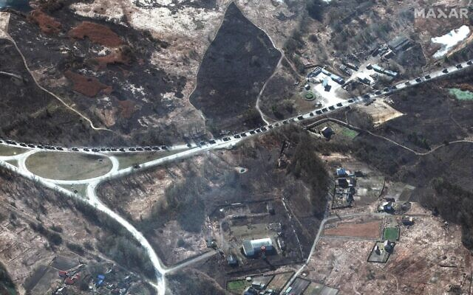
A satellite image taken by the US company Maxar, which it says shows part of a 40-mile-long Russian military convoy assembled northwest of Kyiv, Ukraine. (Satellite image ©2022 Maxar Tech/Agencies)
The official assessed that Ukrainian forces remain in control of much of the country’s territory, but that Russia holds the cities of Kherson, Melitopol, and Berdiansk in the south.
Multiple Western officials have said Russia’s invasion of Ukraine has advanced more slowly than planned, with Russian forces meeting stiff Ukrainian resistance and encountering myriad logistical problems.
In a phone call Friday with German Chancellor Olaf Scholz, Putin “confirmed that Russia is open to dialogue with the Ukrainian side, as well as with everyone who wants peace in Ukraine. But under the condition that all Russian demands are met,” according to the Kremlin.
These include the neutral and non-nuclear status of Ukraine, its “denazification,” recognition of Crimea as part of Russia, and the “sovereignty” of separatist territories in eastern Ukraine.
“Hope was expressed that during the planned third round of talks, the representatives of Kyiv will take a reasonable and constructive position,” the Kremlin added.
The next meeting of delegations from Russia and Ukraine is expected during the weekend, according to one of Kyiv’s negotiators.
Putin also denied that Russian troops were bombing Ukrainian cities, dismissing such information as fake, the Kremlin said. https://www.timesofisrael.com/russia-blocks-facebook-approves-jail-time-for-fake-news-about-military/

Putin warns neighbors ‘not to escalate’ Ukraine crisis; NATO rules out no-fly zone
Kremlin says ‘now is not the time’ for Russian leader to meet Zelensky; Ukrainian FM accuses Moscow’s forces of rape, urges West to ‘act now before it’s too late’
By Agencies and TOI staff Today, 4:39 pm
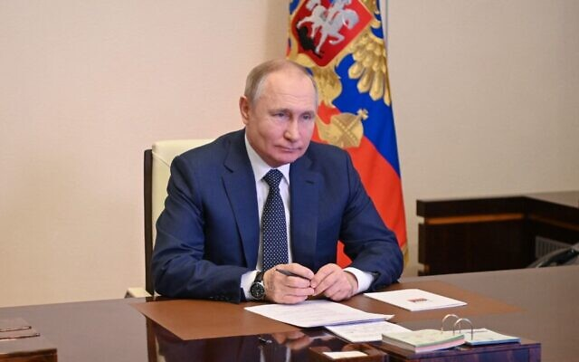
Russian President Vladimir Putin attends a flag-raising ceremony via video link at the Novo-Ogaryovo state residence outside Moscow, on March 4, 2022. (Alexey Nikolsky/Sputnik/AFP)
Russian President Vladimir Putin on Friday urged Russia’s neighbors “not to escalate” the crisis in Ukraine, more than one week after Moscow invaded the country.
“There are no bad intentions towards our neighbors. And I would also advise them not to escalate the situation, not to introduce any restrictions. We fulfill all our obligations and will continue to fulfill them,” Putin said in televised remarks, according to Reuters.
“We do not see any need here to aggravate or worsen our relations. And all our actions, if they arise, they always arise exclusively in response to some unfriendly actions, actions against the Russian Federation,” he added.
Separately, the Kremlin urged Russians to rally around Putin.
“Now is not the time to be divided,” the Kremlin’s spokesman Dmitry Peskov tells reporters, responding to a question on pleas from public figures to end the war.
“Now is the time to unite, to unite around our president.”
Since Russia sent ground troops into Ukraine last week following a plea from separatist leaders, Russian public figures have been divided on the operation.
“Yes, indeed, there are heated debates among cultural figures,” Peskov said.
“Many support the president, sincerely the president. There are those who completely misunderstand the essence of what is happening,” he added.
A number of prominent Russians are echoing a chorus of global celebrities condemning Moscow’s war on Ukraine, with some already beginning to suffer the consequences for defying the Kremlin line.
Other Russian celebrities are signaling their support. The Munich Philharmonic fired conductor and Kremlin loyalist Valery Gergiev on Tuesday after he failed to denounce Moscow’s invasion.
The Kremlin’s spokesman said Putin had no immediate plans to speak with US President Joe Biden about the conflict, and said any contact between Russian and Ukraine officials should be through conflict negotiators, not leaders.
“Now is not the time,” he said in response to a question about a possible meeting with Ukrainian President Volodymyr Zelensky.
Meanwhile, NATO Secretary-General Jens Stoltenberg said the military organization will not police a no-fly zone over Ukraine, warning that such a move could end in a widespread war in Europe.
Speaking after chairing a meeting of NATO foreign ministers, Stoltenberg said “we are not going to move into Ukraine, neither on the ground, nor in the Ukrainian airspace.”
Putin’s forces have ramped up their attacks in Ukraine, launching hundreds of missiles and artillery strikes on cities and making significant gains in the south.
Zelensky has appealed to the West to enforce a no-fly zone over his country, most recently after a fire overnight at one of Ukraine’s nuclear plants, the largest in Europe.
“The only way to implement a no-fly zone is to send NATO fighter planes into Ukrainian airspace, and then impose that no-fly zone by shooting down Russian planes,” Stoltenberg said. “We understand the desperation, but we also believe that if we did that, we would end up with something that could end in a full-fledged war in Europe.”
“We have a responsibility as NATO allies to prevent this war from escalating beyond Ukraine,” he said.
Stoltenberg warned that “the days to come are likely to be worse, with more death, more suffering, and more destruction as Russian armed forces bring in heavier weaponry and continue their attacks across the country.”
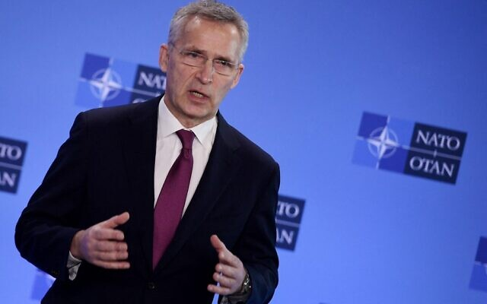
NATO Secretary-General Jens Stoltenberg speaks to the media prior to the start of a foreign ministers’ meeting following Russia’s invasion of Ukraine, at the Alliance’s headquarters in Brussels, on March 4, 2022. (Oliver Doulirey/Pool/AFP)
Ukrainian Foreign Minister Dmytro Kuleba addressed the alliance via videolink from Kyiv.
He tweeted afterward: “My message: act now before it’s too late. Don’t let [Russian President Vladimir] Putin turn Ukraine into Syria. We are ready to fight. We will continue fighting. But we need partners to help us with concrete, resolute and swift actions, now.”
NATO members have rushed thousands of troops to eastern Europe to bolster the alliance’s flank closest to Russia and are sending weapons to help Ukraine defend itself.
“We will continue to do what it takes to protect and defend every inch of NATO territory. NATO is a defensive alliance. Our core task is to keep our 30 nations safe,” Stoltenberg said.
“We are not part of this conflict and we have a responsibility to ensure it does not escalate and spread beyond Ukraine.”
Kyiv has said that if NATO is not willing to shut Ukrainian airspace then the allies should supply warplanes and air defense systems to help stop Russian air attacks.
European nations have so far said they will not deliver planes and most arms deliveries have focused on light weapons, and anti-tank and shoulder-fired anti-aircraft missiles.
Also Friday, Kuleba accused Russian troops of raping women and backed a call for the creation of a special tribunal to punish Moscow’s aggression.
“We have numerous cases of, unfortunately, when Russian soldiers rape women in the Ukrainian cities,” Kuleba told a briefing at London’s Chatham House think-tank.
He did not provide details, but supported an appeal by former British prime minister Gordon Brown and a swathe of international law experts for a special tribunal.
International law “is the only tool of civilization that is available to us to make sure that in the end, eventually, all those who made this war possible will be brought to justice,” Kuleba said, as civilian casualties mount in Ukraine.
“We are fighting against the enemy who is much stronger than us,” he said.
“But the international law is on our side, and hopefully… it will make its own contribution to help us prevail.”
Dignitaries including Brown, former judges, and law experts on Wednesday called for the creation of a special tribunal, as the International Criminal Court studies whether to prosecute alleged war crimes in Ukraine.
https://www.timesofisrael.com/putin-warns-neighbors-not-to-escalate-ukraine-crisis-nato-rules-out-no-fly-zone/ How much is true and how much is propaganda? – rdb]

Ukraine’s Zelensky in plea to Europe: ‘If we fall, you will fall’
The war-torn nation’s leader also rails at NATO for ruling out a no-fly zone over his country as it continues to fight against invading Russian forces
By Agencies Today, 2:27 am

Demonstrators watch an address of Ukrainian President Volodymyr Zelensky on the big screen during a rally in support of Ukraine in Tbilisi on March 4, 2022. (Vano SHLAMOV / AFP)
Ukrainian President Volodymyr Zelensky called on European nations Friday to support his country’s fight against the invading Russian military.
Zelensky appeared on video as he addressed thousands of people protesting the war in several European cities, naming among them Paris, Prague, Lyon, Frankfurt and others. He asked the big crowds not to be silent about what’s going on in his country.
“Don’t turn a blind eye on this,” he said. “Come out and support Ukraine as much as you can,” he said though a translator.
“If we fall, you will fall,” he said.
“And if we win, and I’m sure we’ll win, this will be the victory of the whole democratic world, this will be the victory of our freedom, this will be the victory of light over darkness, of freedom over slavery. And if we win we will become as blossoming as Europe. And Europe will be flourishing more than ever,” he said.
“All of you are Ukrainians today, thank you for this.”
???????? ???????? pic.twitter.com/Ix1rrlzWtW
— Molly McKew (@MollyMcKew) March 4, 2022
Président @ZelenskyyUa speaking to the demonstrators in Prague !pic.twitter.com/miv60wapZW
— Simone Rodan-Benzaquen (@srodan) March 4, 2022
Separately, Zelensky lashed NATO on Friday for ruling out a no-fly zone over his country saying the Western military alliance knew further Russian aggression was likely.
Earlier Friday, NATO rejected Ukraine’s request to impose a no-fly zone to halt Russia’s bombing, but Western allies did warn President Vladimir Putin of fresh sanctions if he does not stop the war. MORE - https://www.timesofisrael.com/ukraines-zelensky-in-plea-to-europe-if-we-fall-you-will-fall/

Israel said likely to shift to more pro-Ukraine stance as Russian invasion escalates
Senior official says US has given Israel leeway, recognizing security concerns, but that patience will soon run out; ministers to weigh taking in refugees, sanctions against Moscow
By TOI staff Today, 11:41 pm
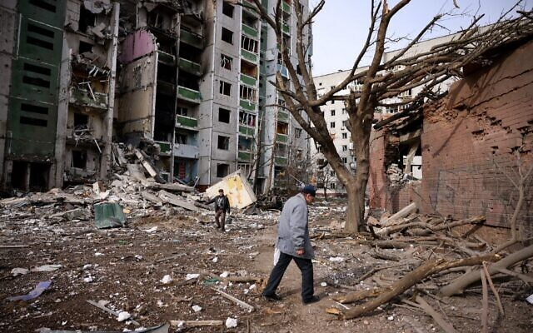
Policymakers in Israel recognize they won’t be able to maintain their relatively ambiguous policy regarding Russia’s invasion of Ukraine for much longer as the crisis there further escalates, Israeli television reported Friday.
“If things calm down in the next few days and are headed to dialogue, Israel will maintain its current approach… of humanitarian support for Ukraine, declarative condemnations of the Russian invasion and no sanctions,” an unnamed government source told Channel 12 news. “But if the situation continues to escalate, and [Russian President Vladimir] Putin deepens the invasion, and the victims and killing mount, Israel will be compelled to join the Western effort to impose sanctions.”
The network also quoted a “very senior Israeli source” who said the Biden administration to date has given Israel leeway, recognizing Jerusalem’s need to maintain working relations with Russia. However, the source said, “the longer that this war continues, we will no longer be able to sit on the fence. We’ll have to follow a different policy — in words and deeds. We’ll have to take a side far more clearly.”
While Jerusalem expressed its concern regarding the Russian military operation early on, Prime Minister Naftali Bennett has avoided criticizing Moscow or Putin, as he seeks to maintain the green-light the Kremlin has long given Israel, allowing the IDF to operate in Russia-controlled skies over Syria against Iranian proxies below.
Israel co-sponsored a UN General Assembly resolution condemning Russia on Wednesday, but only after it refused to do so when the same measure came before the Security Council last week — a decision that drew the ire of the Biden administration.
Men walk past a residential building damaged in yesterday’s shelling in the city of Chernihiv, on March 4, 2022. (Dimitar Dilkoff/AFP)
Jerusalem has sent a 100-ton shipment of humanitarian aid to Ukrainians, but turned down Kyiv’s request for military equipment. Israel has welcomed Jewish Ukrainians who have fled the country, but has refused to do the same for non-Jewish refugees and those who have arrived at Ben Gurion have been forced to pay a NIS 10,000 ($3,050) fee in order to remain temporarily in the country.
Bennett has heeded calls from Ukrainian President Volodymyr Zelensky to mediate between Kyiv and Moscow, and has held a pair of phone conversations with both the Ukrainian leader and Putin since the start of the invasion last Thursday. But Russia has yet to express interest in Israel playing the role of mediator and analysts are skeptical Jerusalem has enough leverage over Putin to keep him at the table. In a step that will likely make the prospect of an Israeli mediator role even more irrelevant, Channel 12 reported Friday that an inter-ministerial committee is set to give recommendations to the government on Sunday regarding sanctions that Israel could employ against Russia.
One scenario that might potentially need to be addressed is how to prevent sanctioned Russian oligarchs from using Israel as a financial safe haven for their assets. As things stand, the network said, there is no legislation that would prevent oligarchs with Israeli citizenship from putting their money into bank accounts here.
According to the Kan public broadcaster, Foreign Minister Yair Lapid plans to introduce a proposal at the upcoming cabinet meeting on Sunday that would see Israel begin to take in non-Jewish refugees from Ukraine.
It is unclear whether the policy will have the support of more right-wing members of the government, such as Interior Minister Ayelet Shaked, but the cabinet debate will take place as criticism of Israel at home and abroad grows over Jerusalem’s refusal to take in refugees en-masse. Israel is currently granting citizenship to Ukrainian Jews under the Law of Return. However, non-Jewish Ukrainians who arrive at Ben Gurion Airport are required to pay a NIS 10,000 fee to stay temporarily.
Meanwhile, Channel 12 reported Friday that some cabinet ministers are growing increasingly worried over the price Israel is paying on the global stage for not aligning closely enough with Ukraine.
Ukraine’s ambassador to Israel, Yevgen Korniychuk, Ukrainian citizens and supporters attend a special prayer for the Ukrainian people organized by Businessman Arie Schwartz, at the Western Wall, in Jerusalem’s Old City on March 2, 2022. (Yonatan Sindel/Flash90)
Ukrainian Ambassador to Israel Yevgen Korniychuk told the Kan public broadcaster Friday he understands that Israel might not be able to provide Ukraine with weapons due to its need to maintain ties with Russia. However, Korniychuk pleaded with Israel for military protective gear, which he said Ukraine needs more right now than the humanitarian shipments Israel has agreed to send.
“Can you kill with personal protection?” Korniychuk asked. “That could save the people’s lives. We’re not talking about military. They all need the self-protection.”
Other countries, such as Japan, have announced that they would be sending Ukraine military vests and helmets, as Israel remains on the fence.
“Our government believes that as a partner and a friend, you can do more,” Korniychuk said.
He told Kan that the donations already made by Israeli civilians are appreciated, but that from the perspective of those in Kyiv who don’t see the limits to Israel’s ability to act from up close, there is disappointment regarding Jerusalem’s stance.
For his part, Vladislav Roitberg, a Hebrew-speaking adviser to Zelensky, thanked “all the Israelis who are supporting” Ukraine in a Friday interview with Channel 12.
“It is very much felt,” he said from Kyiv. “The citizens supporting the Ukrainian people — I thank them very, very much.”
In what could further complicate Jerusalem’s efforts to distance itself from Moscow, a Russian delegation is scheduled to land in Israel next Thursday for a monthly meeting on security coordination between the sides in Syria, the Kan public broadcaster reports.
Such meetings have been a regular occurrence in recent years, but it will be the first to take place since Russia began its invasion of Ukraine.
On Thursday, Zelensky himself expressed his disappointment with Bennett’s stance, saying that unlike a group of Jews he saw photographed at the Western Wall, Bennett does not seem to be “wrapped in our flag.”
“I spoke to the prime minister of Israel. And I’m telling you candidly, and this might sound a little insulting, but I do think I have to say it: Our relations are not bad, not bad at all. But relations are tested at times like these, at the hardest moments, when help and support are needed. And I don’t feel that he [Bennett] is wrapped in our flag,” Zelensky told reporters at a press conference.
As for Russia, it has been less open about its feelings regarding Israel’s stance. Last Friday, Moscow’s Ambassador to Tel Aviv Anatoly Viktorov told The Times of Israel that the Kremlin hopes Israel “will continue [taking] a wise diplomatic approach,” in what could either be interpreted as a compliment or possibly a subtle warning.
Russia’s foreign ministry summoned Israel’s Ambassador to Alex Ben-Tzvi demanding that he clarify Israel’s position on the invasion hours after Lapid issued a statement that directly criticized Russia. https://www.timesofisrael.com/israel-said-likely-to-shift-to-more-pro-ukraine-stance-as-russian-invasion-escalates/ Israel is still dancing on the head of a pin and falling off can be deadly for the nation. – rdb]

US lawmakers react to call for Putin assassination
4 Mar, 2022 22:45
Senator Lindsey Graham’s remarks were slammed as irresponsible and bloodthirsty warmongering
American lawmakers from across the political spectrum have criticized their colleague’s statements as dangerous and unhinged, after Graham claimed “the only way” to end Russia’s invasion of Ukraine was to kill President Vladimir Putin.
On Thursday, US Senator Lindsey Graham invoked the assassination of Roman dictator Julius Caesar and the botched plot to kill Nazi German leader Adolf Hitler as examples of what should be done in his opinion. On Friday he doubled down on his threatening rhetoric, telling Fox News that Russians must “rise up and take [Putin] down.”
“This is an exceptionally bad idea,” Texas Senator Ted Cruz wrote on Twitter. “Use massive economic sanctions; BOYCOTT Russian oil & gas; and provide military aid so the Ukrainians can defend themselves.”
But we should not be calling for the assassination of heads of state.
“Seriously, wtf?,” Representative Ilhan Omar (D-MN) wrote on Twitter. “I really wish our members of Congress would cool it and regulate their remarks as the administration works to avoid WWlll.”
As the world pays attention to how the US and its leaders are responding, Lindsey’s remarks, and remarks made by some House members, aren’t helpful.
“While we are all praying for peace & for the people of Ukraine, this is irresponsible, dangerous & unhinged,” tweeted Representative Marjorie Taylor Greene (R-GA).
We need leaders with calm minds & steady wisdom. Not blood thirsty warmongering politicians trying to tweet tough by demanding assassinations. Americans don’t want war.
“When has Sen. Graham encouraging regime change ever ended badly?” Representative Matt Gaetz (R-FL) tweeted.
The White House also distanced itself from Graham’s statements, with Press Secretary Jen Psaki saying on Friday “that is not the position of the United States government and certainly not a statement you'd hear come from the mouth of anybody working in this administration.”
We are not advocating for killing the leader of a foreign country or regime change. That is not the policy of the United States.
The open call for the assassination of the Russian president provoked fury in Moscow, with Russia’s Embassy in the US strongly condemning such statements, as well as demanding Washington hold the official accountable for his remarks.
“It is unbelievable that a senator from a country that preaches its moral values as a ‘guiding light’ for all of mankind could allow himself [a] call for terrorism as a means to achieve Washington’s goals on the international stage,” Russia’s ambassador in the US, Anatoly Antonov, said.
Graham has been driven crazy by the ongoing tensions between Moscow and the West, Kremlin spokesman Dmitry Peskov implied, saying “not everyone can remain cool-headed these days, some [people] lose their senses.”
Moscow maintains its military offensive in Ukraine is a “special operation” aimed at the “demilitarization” and “denazification” of the nation in the name of protecting the people of the two Donbass republics Russia has recently recognized.
Kiev said the attack was unprovoked, insisting it had not been seeking to retake Donetsk and Lugansk by force. The two republics split from Kiev back in 2014 in the aftermath of the Maidan coup, which ousted Ukraine’s government. https://www.rt.com/news/551259-lawmakers-graham-putin-assassination/

From a humble Polish hotel, Israel’s unique situation room works to extract citizens
Foreign Ministry staff from Ukraine, Poland and beyond bring blankets, documents, and guidance to those stuck at the border, trying to flee Ukraine
By Lazar Berman Today, 7:38 pm
Irit Yakhnes, head of public diplomacy at the Israeli embassy in Poland, speaks on the phone in the Foreign Ministry situation room in Przemysl, Poland. (Lazar Berman/The Times of Israel)
PRZEMYSL, Poland — From the lobby, it seems like a perfectly average Soviet-era Polish hotel, situated near Przemysl’s old town, first settled in the 8th century.
Normal for this week, anyway. With thousands of refugees coming across the border from Ukraine, the hotel is full of Polish police officers, who sleep and dine there between shifts at the border crossings and the roads leading to them.
Since Russia began its latest invasion of Ukraine last week, the hotel (which Israeli diplomats asked I not identify for security reasons) is also the home of the Foreign Ministry’s situation room on the Ukraine-Poland border.
In a large, mostly-empty room on the hotel’s second floor, Israel’s ambassador to Ukraine Michael Brodsky stood speaking on the phone in a corner (Brodsky was lightly injured in a car crash Friday and returned to Israel for medical care). Consul-General Lilach Attias, her voice barely audible after weeks of answering calls, sat at a table in the back, nevertheless still speaking on the phone as well.
Deputy ambassador Yoav Bistritsky, a retired military officer now in his second career as a diplomat, was out in the field, working to find Israelis stuck in the long lines at the Korczowa-Krakovets border crossing.
The entire staff of Israel’s embassy in Ukraine is now situated in Poland after being pulled out of its temporary office in Lviv last Saturday. Israel’s Polish embassy had one diplomat in the situation room, public diplomacy head Irit Yakhnes.
The Foreign Ministry flew in some heavy hitters to support the operation as well. Israel’s former ambassador to neighboring Belarus, Alon Shoham, sat with two security officers, sketching the layout of one of the crossings on a sheet and discussing how to secure their diplomats in the field.
The ⁦@IsraelMFA⁩ situation room in action in Przemysl, Poland pic.twitter.com/nW3gPD296P
— Lazar Berman (@Lazar_Berman) March 4, 2022
“We have people calling and writing us on the border. Maybe they have problems with their documents, people with babies without documents,” explained embassy spokeswoman Alexandra Ben Ari.
Israelis in line at the two nearby border crossings — Medyka and Korczowa — are able to identify the diplomats searching for them by the fluorescent yellow vests they are wearing with “Foreign Ministry” written across the back.
Israeli officials at the crossings have the ability to issue temporary travel documents on the spot with a special pressure stamp. Travelers then have two weeks to get proper passports issued in Israel itself.
There is a pile of blankets, thermoses, and other cold-weather equipment in one corner of the room.
Lilach Attias, consul-general at Israel’s embassy in Ukraine, speaks on the phone in the Foreign Ministry situation room in Przemysl, Poland. (Lazar Berman/The Times of Israel)
“You see a line of cars,” said Ben Ari. “You cannot take the car out of line, but you see someone who is cold. You can give them water. You can give them a blanket, even if you cannot pass the line.”
“Some of the people, they don’t know where to go,” she continued. “They don’t know what to do. So we are advising them what to do.”
The lines could turn dangerous on the Ukraine side, said Brodsky.
“Men are standing alone. It’s a very big crowd, a few thousand angry men,” he said. “It’s a very loaded situation. You could feel this pressure in the air. And it could be dangerous.”
Brodsky said that there are no bathrooms, food, or water. “People spend 24, 48 hours in their cars and buses. People are angry, people are tired, sleepless.”
The way to the borders can be perilous as well. On Monday, an Israeli father of two was shot to death outside of Kyiv when a member of a civil defense unit opened fire on his car.
Every day, the embassy sends out updates about the wait time at the various border crossings.
While Israeli diplomats helped citizens move to the head of the line at first, they understand the dangers involved as the number of refugees trying to cross grew, in inverse proportion to their patience.
“We don’t want people to get mad,” explained Ben Ari. “We are doing it in a way that everyone is comfortable. ”
Israelis sometimes get upset that the Foreign Ministry can’t help them get to the front of the line any longer, said Ben Ari, but added that she understands the stress they are feeling.
Israel is the only country in the world with their representatives at all the major border crossings out of Ukraine to the west, according to Ben Ari. Some major Western countries have called Israel’s team in Poland to consult and hear about Israel’s operation at the borders.
Beyond helping citizens stuck at the borders, officials also organize “rescue buses” to spirit Israelis and their relatives out of Ukrainian cities.
Though the Israelis crossing the border do not get free flights to Israel, explained Ben Ari, the goal is to have them get there quickly.
“We can take care of our citizens in our country,” she said. https://www.timesofisrael.com/from-a-humble-polish-hotel-israels-unique-situation-room-works-to-extract-citizens/

Diaspora minister urges end of ‘inhuman’ NIS 10,000 deposits for Ukraine refugees
Lapid, Shaked said advancing plan to grant year-long residency and work permits to some Ukrainians fleeing Russia’s invasion; 100-tons of Israeli humanitarian aid arrives in Poland
By TOI staff Today, 5:41 pm
Diaspora Minister Nachman Shai on Friday called on the government to stop requiring refugees fleeing Russia’s invasion of Ukraine to deposit NIS 10,000 ($3,050) as a condition of entry to Israel.
“Ukrainian refugees are arriving and will continue to arrive,” Shai wrote on Twitter. “We must immediately remove the illogical and inhuman demand for a NIS 10,000 deposit for refugees entering Israel from now on.”
The deposit is held as a guarantee that the Ukrainians will eventually leave Israel, as the country rarely grants refugee status to non-Jews, and instead allows them temporary entry as tourists.
The requirement has been criticized by Ukraine’s ambassador to Israel.
According to Hebrew media reports Friday, Interior Minister Ayelet Shaked and Foreign Minister Yair Lapid were advancing a new policy to grant year-long residency and work permits to Ukrainians escaping the war.
However, the two were reportedly at odds over how many refugees to allow into Israel, with Army Radio saying Lapid was pushing for 2,000 to be granted entry. It was not clear what number Shaked backed.
Shaked said Friday that 1,555 Ukrainians have arrived in Israel since Russia launched the invasion, 150 of whom are eligible for Israeli citizenship under the Law of Return.
“We are preparing to absorb and immediately give citizenship to some 100,000 people who are eligible,” she was quoted as saying by the Kan public broadcaster.
She said the government is focusing on Jewish refugees and those entitled to Israeli citizenship, “but we are showing flexibility and a willingness to help Ukrainian citizens in general.”
On Thursday, Shaked predicted a huge number of Jewish refugees fleeing the war in Ukraine could immigrate to Israel.
“We think tens of thousands if not hundreds of thousands of immigrants will arrive from Russia, Ukraine, and former Soviet states,” she said during a conference with local council leaders at the Golan Regional Council.
Shaked later tweeted that she had ordered a three-month suspension on the requirement for a notarized police background check for immigrants from Russia and Ukraine to ease their immigration to Israel. MORE - https://www.timesofisrael.com/diaspora-minister-urges-end-of-inhuman-nis-10000-deposits-for-ukraine-refugees/

Israel to resume all flights to Dubai with new security deal, Shin Bet says
Dispute over airport security in UAE financial hub forced countries to cut back services, slated to be halted outright next week; Israeli airlines welcome resolution, will resume full operations
Reuters | Published: 03.04.22, 12:45
Israel and the United Arab Emirates agreed on a security arrangement that will allow Israeli airlines to resume a full schedule of flights to Dubai, the Shin Bet security agency said on Friday.
A dispute over airport security in Dubai had forced them to cut back services and without a resolution, all flights would have been halted by March 8.
Shin Bet said an agreement was reached with Emirati counterparts.
"Shared working principles and security arrangements were agreed upon that will allow Israeli airlines to once again fly to Dubai on a regular basis," it said.
Nonstop flights from Tel Aviv to Dubai were among the fruits of a landmark 2020 deal establishing ties between Israel and the UAE. Hundreds of thousands of Israelis have visited the UAE and Gulf commercial hub since.
Israel's flag carrier El Al welcomed the resolution and said it would immediately return to operating up to three or four flights a day to Dubai.
Israel's Shin Bet security service had previously voiced concerns — which it did not publicly detail — about arrangements at Dubai International Airport.
El Al and two smaller rivals that fly to Dubai had said that one issue had been securing enough security tags for personnel to allow them to handle a full flight schedule. https://www.ynetnews.com/travel/article/h1tropjbc

EU holds PA funds after reform of antisemitic textbooks fails
The PA uses textbooks that demonstrate "antisemitic narratives and glorification of violence" despite a promise to reform.
By JERUSALEM POST STAFF Published: MARCH 5, 2022 01:08
Millions of euros from the European Union (EU) that are meant to aid the Palestinian Authority have been delayed in EU offices as officials discuss whether to condition parts of the foreign assistance on reforms to Palestinian textbooks.
A cross-party group of EU legislators called for reduction of funds to the PA over the failed textbook reform in a letter to EU commission president and demanded that funding be conditional upon the reform. The textbooks in question have demonstrated "antisemitic narratives and glorification of violence," according to the EU-commissioned Georg Eckert Institute (GEI),
Despite promises made to donor nations to revise the textbooks, the PA Ministry of Education reprinted last year's textbooks with the same issues raised by the EU. Moreover, the PA wrote thousands of pages of new material, roughly equivalent in size to all the textbooks in the curriculum. The new material contains content that is worse than current or previous Palestinian textbooks, with a greater number of lessons that directly incite violence and propagate overt antisemitism.
The new material brought to the European Parliament demonstrates, for example, how Israelis are "Satan's aide", calls for students to die as martyrs and liberate the Al-Aqsa mosque, and teaches students to kill infidels in exchange for great rewards.
the Institute for Monitoring Peace and Cultural Tolerance in School Education (IMPACT-SE) has briefed Members of the European Parliament (MEPs), who signed letter to Commission President.
"years of negotiation with the PA and repeated commissions pledged of "zero tolerance" for antisemitism have unfortunately failed to bring about the desired change," was written in the letter to the commission president. "Palestinian children continue to be abused as they are being taught to hate. Asking the PA to revise these books is an imposition but self-evident and non-negotiable duty."
“These parliament members are angry and frustrated," Said IMPACT-SE CEO Marcus Sheff. "After passing legislation condemning the Palestinian textbooks and after the European Union extracted a commitment that it would remove the hate, the Palestinian Authority clearly set out to deceive Brussels by simply reprinting the old books for the new year. The EU was entirely unaware of this and of the ten thousand pages of new, hateful teaching material the PA produced on their dime. The legislators have good reason to be outraged.”
The European Union is the largest single donor to the PA, which constitutes as a significant part of the West Bank economy. The EU funds salary of many Palestinian professionals who write those education textbooks, and in return the EU has asked for assurance that those books will uphold most basic EU and UNESCO standards for education. https://www.jpost.com/middle-east/article-699378

8,817 COVID Vaccine Injuries Reported to CDC Among Kids 5 to 11, as Study Shows Pfizer Vaccine Only 12% Effective in That Age Group
VAERS data released Friday by the Centers for Disease Control and Prevention included a total of 1,151,450 reports of adverse events from all age groups following COVID vaccines, including 24,827 deaths and 200,331 serious injuries between Dec. 14, 2020, and Feb. 25, 2022.
By Megan Redshaw 03/04/22
The Centers for Disease Control and Prevention (CDC) today released new data showing a total of 1,151,450 reports of adverse events following COVID vaccines were submitted between Dec. 14, 2020, and Feb. 25, 2022, to the Vaccine Adverse Event Reporting System (VAERS). VAERS is the primary government-funded system for reporting adverse vaccine reactions in the U.S.
The data included a total of 24,827 reports of deaths — an increase of 425 over the previous week — and 200,331 reports of serious injuries, including deaths, during the same time period — up 4,128 compared with the previous week.[That 425 deaths would have been more than enough to terminate any other vaccine program = and that was in one week. – rdb]
~Excluding “foreign reports” to VAERS, 774,373 adverse events, including 11,312 deaths and 74,257 serious injuries, were reported in the U.S. between Dec. 14, 2020, and Feb. 25, 2022.
Foreign reports are reports foreign subsidiaries send to U.S. vaccine manufacturers. Under U.S. Food and Drug Administration (FDA) regulations, if a manufacturer is notified of a foreign case report that describes an event that is both serious and does not appear on the product’s labeling, the manufacturer is required to submit the report to VAERS.
Of the 11,312 U.S. deaths reported as of Feb. 25, 18% occurred within 24 hours of vaccination, 22% occurred within 48 hours of vaccination and 60% occurred in people who experienced an onset of symptoms within 48 hours of being vaccinated.
In the U.S., 552 million COVID vaccine doses had been administered as of Feb. 25, including 325 million doses of Pfizer, 208 million doses of Moderna and 18 million doses of Johnson & Johnson (J&J).
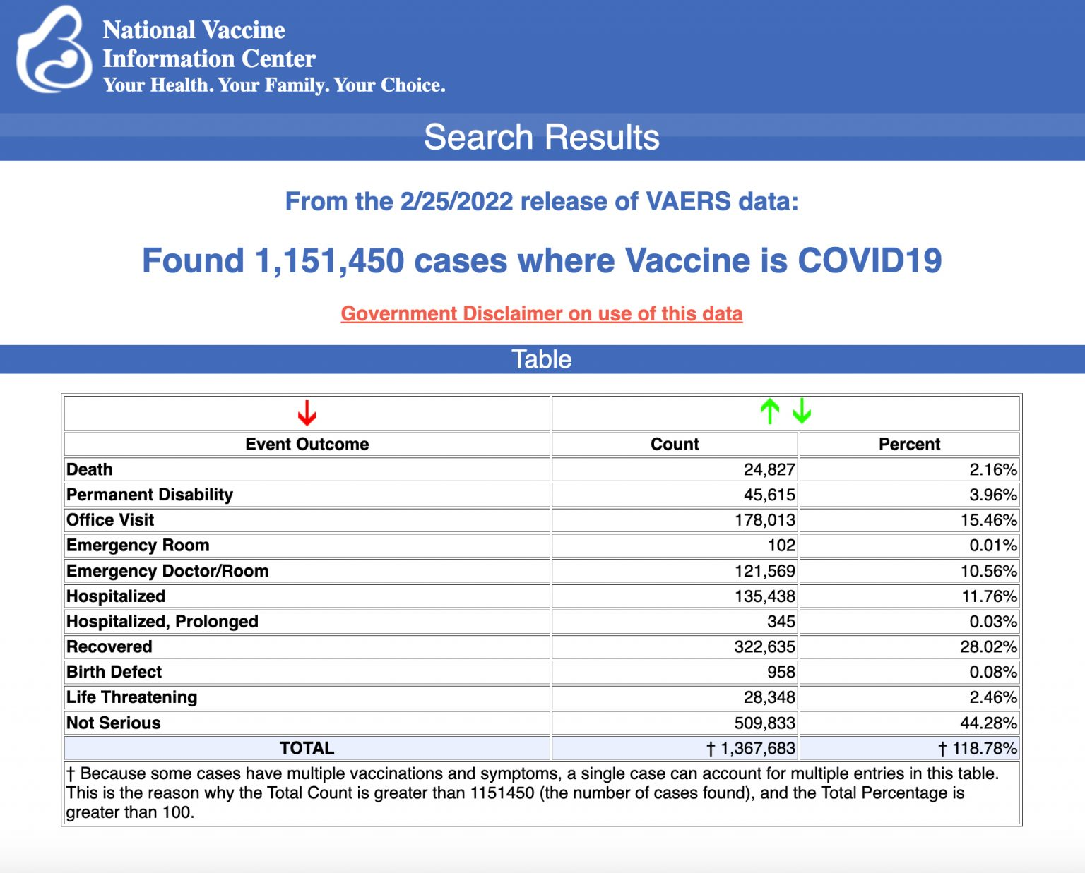
Every Friday, VAERS publishes vaccine injury reports received as of a specified date. Reports submitted to VAERS require further investigation before a causal relationship can be confirmed. Historically, VAERS has been shown to report only 1% of actual vaccine adverse events.
U.S. VAERS data from Dec. 14, 2020, to Feb. 25, 2022, for 5- to 11-year-olds show:
8,817 adverse events, including 200 rated as serious and 4 reported deaths.
The most recent death involves an 8-year-old boy (VAERS I.D. 2109625) from Mississippi who died 7 days after his second dose of Pfizer’s COVID vaccine when he was found blue and lifeless at home.
He was taken to the hospital with a full code in process. A pulse was detected several times, but the boy ultimately died in the ICU. It was reported to the doctor who filed the report that the boy died from multisystem inflammatory syndrome. He did not have COVID.
- 17 reports of myocarditis and pericarditis (heart inflammation).
- 32 reports of blood clotting disorders.
U.S. VAERS data from Dec. 14, 2020, to Feb. 25, 2022, for 12- to 17-year-olds show:
- 29,797 adverse events, including 1,714 rated as serious and 39 reported deaths. MORE -
https://childrenshealthdefense.org/defender/vaers-cdc-covid-vaccine-injuries-kids-5-to-11-pfizer-vaccine

Dr. Robert Malone to CDC chief: 'Time to show us the data'
Reacts to Walensky's remarkable admissions regarding COVID response
By Art Moore Published March 4, 2022 at 7:35pm
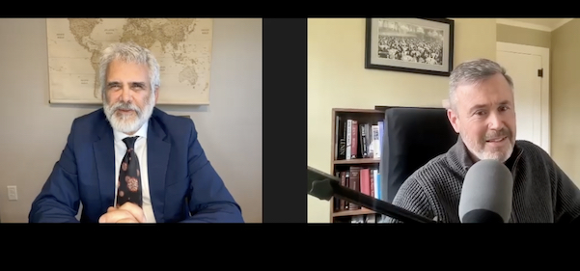
Dr. Robert Malone reacts to CDC Director Dr. Rochelle Walensky's admissions regarding her agency's COVID response in an interview March 4, 2022 (Video screenshot)
CDC Director Dr. Rochelle Walensky's admissions regarding her agency's COVID-19 response are welcome – affirming the concerns of many censored and maligned health scientists over the past two years – but they are not enough, said Dr. Robert Malone in a video interview Friday with WND.
"I'm to the point now where I have no faith in these kinds of words. I want to be shown the information," said Malone, the key inventor of the mRNA technology platform that later was used in the Pfizer-BioNTech and Moderna vaccines.
"I think it's now time to show us the data. That is the only thing that matters now."
As WND reported Friday, Walensky admitted in remarks Thursday night at the Washington University Medical School in St. Louis that the CDC exercised "too little caution and too much optimism" about the effectiveness of the vaccines; had a sophisticated COVID data system (while, as the New York Times reported, the agency withheld data from the public); gave the public the impression science is "foolproof"; and didn't balance the risk of COVID-19 with the unintended consequences of mitigation efforts, such as opioid deaths and "mental health challenges."
See the WND interview with Dr. Robert Malone:
Malone – who has been banned from Twitter and LinkedIn for making and referencing factual statements and science-based observations about the pandemic – said it was "very kind" of Walensky to admit she was too optimistic about the vaccines, but "it would have been more useful if she had done it in real time."
Regarding "the data," Malone said "we're past the point of assuming good intent on the part of the CDC."
"I think they have spent that currency, and we now just need to see the data and stop playing word games," he said.
In December, President Biden clearly had Malone and other medical scientists in mind when he angrily charged that the "vaccine hesitancy" of an estimated 40 million Americans had been "fueled by dangerous misinformation".
'The depth and consequences of their actions'
Walensky's admission that she and her agency mischaracterized "science" is significant, Malone said, but she "still is not going all the way to acknowledging that the government is not the sole arbiter of truth and that she is not the bastion of truth."
"We're not hearing any language to the effect that we (the CDC) should have more actively engaged in the broader community, that we should have been more modest, that we should have sought the counsel of docs who were actively practicing and treating COVID patients," he said.
"We're not seeing anything that indicates remorse, humility or a recognition that there needs to be a major change in the CDC and Department of Health and Human Services."
Malone said Walensky also is "taking no ownership of the rather overt advocacy on behalf of the pharmaceutical and vaccine industry."
"These comments strike me as a little coy," he said. "I don't see evidence of a bureaucrat who has come to terms with the depth and consequences of their actions over the last two years."
Malone said the "reputation of the CDC has been destroyed under her watch."
Walensky, he said, basically has "overseen the weaponization of the CDC to serve a political agenda during the course of this outbreak."
"This is not something that can be excused. There must be accountability."
Biden 'still dug in'
Malone is taking a cautious view of the lifting of mandates by Democratic governors, noting that in Europe skeptics of the European Union's easing of COVID restrictions are warning it may be a temporary reprieve. The Eurosceptics argue there is legislation underway to make vaccine requirements permanent.
He said that he and many of his colleagues are "very, very wary of the government and government messaging and believe that we can trust nothing until it's been verified."
President Biden, he noted, is still "dug in on insisting that we have a current medical emergency and that that justifies the invocation of the emergency powers," which was renewed a week ago.
"It's nice to hear the pretty words from Dr. Walensky," he said. "But I am tired of pretty words. I want to see actions." https://www.wnd.com/2022/03/dr-robert-malone-cdc-chief-time-show-us-data/ The CDC doesn’t want to show anyone any data because it will blow the lid off their corrupt murderous genocidal activities. She is a wretched excuse for someone who us supposed to be supervising and control the US’s major health monitoring organization. She needs to be tried for her crimes. – rdb]

CDC director makes startling admissions about pandemic response
Candid discussion with faculty, students at her medical school
By Art Moore Published March 4, 2022 at 3:30pm
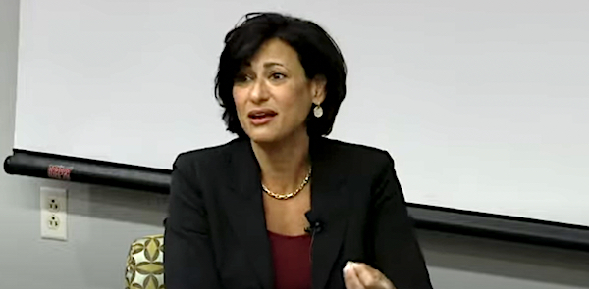
CDC Director Rochelle Walensky in a forum at Washington University in St. Louis on March 3, 2022 (Video screenshot)
In a candid interview-format presentation Thursday at her alma mater, CDC Director Rochelle Walensky made a number of significant admissions about her agency's messaging and handling of data during the deadly COVID-19 pandemic, affirming the concerns of many health scientists who have been censored and maligned over the past two years as purveyors of "misinformation."
She admitted, among other things, in her remarks at the Washington University Medical School in St. Louis that:
- The CDC exercised "too little caution and too much optimism" about the effectiveness of the vaccines in preventing infection, transmission and deaths.
- She was "proud of our ability to get data out," describing a new, "modern" data assimilation and analysis system that provided crucial information on vaccine effectiveness to health care officials and the public about every 48 hours. The comment is significant in light of the recent admission of unnamed CDC officials to the New York Times that the agency has withheld most of its data regarding COVID-19 -- presumably including data regarding the adverse effects of vaccines -- for fear it would be misinterpreted by critics. And she still has not fulfilled her promise to a senator on Jan. 11 to provide "the data" on vaccine-related deaths.
- When she declared during the pandemic that the CDC would "lead with the science," the public took that as a statement that science is "foolproof." But science isn't "black and white," Walensky acknowledged Thursday. It's "gray," and "sometimes it takes months and years to actually find out the answer." Johns Hopkins University professor Dr. Marty Makary said recently the CDC has been "using science as political propaganda."
- The CDC and establishment media emphasized the data regarding cases and deaths. But in future pandemics, the unintended impacts of pandemic mitigation need to be taken into account, Walensky said, such as opioid deaths, mental health challenges, cancer screenings and deferred elective surgeries. That was the message of many medical scientists, including those behind the "Great Barrington Declaration," who were targeted and maligned by National Institutes of Health Director Francis Collins as "fringe epidemiologists."
'Proud of our ability to get data out'
At the event Thursday, Walensky was interviewed by Dr. William G. Powderly, the co-director of the Division of Infectious Diseases at Washington University.
Campbell asked Walensky what the CDC got right, that will be helpful in the future.
She touted the delivery of 550 million shots and said she was "proud of our ability to get data out."
The CDC, Walensky said, needed to provide "vaccine effectiveness data as fast as we can have it."
"Because everybody wants to know how long this vaccine is working and is it waning," she said.
Over the past year, she said data on effectiveness was published, on average, every 48 hours, "which is kind of extraordinary."
Walensky described a new "pedal to the metal" system of data assimilation and analysis that enables the CDC to link "vaccine immunization data to testing data … to death data."
"And because of that we can now, within four weeks, look at vaccine effectiveness for cases and deaths for two-thirds of America," she said.
"We can stratify by age, we can stratify by date of vaccine, we can stratify by which vaccine you got."
'Too little caution and too much optimism'
Asked where the CDC could improve, she pointed to her statement when the vaccines were rolled out that they would be "95% effective."
"So many of us wanted it to be helpful, so many of us wanted to say, 'OK, this is our ticket out, we’re done,'" Walensky said.
"So, I think we had perhaps too little caution and too much optimism for some good things that came our way. I really do," she said.
"Nobody," Walensky claimed, said the vaccines "will wear off."
"Nobody said, 'Well, what if the next variant — it’s not as potent against the next variant.'"
'Science is gray'
Another lesson, she said, arises from how she communicated the nature of science.
"I have frequently said we're going to lead with the science, science is going to be the foundation of everything we do. That is entirely true," Walensky began.
"I think public heard that as the science is foolproof. Science is black and white. Science is immediate, and we get the answer and we make a decision based on the answer."
The truth, she said is "science is gray."
"And science is not always immediate. And sometimes it takes months and years to actually find out the answer. But you have to make decisions in a pandemic before you have that answer."
Campbell asked Walensky how best to prepare for future pandemics.
"I think our data sources need to be key," she said.
"I think we need to be able to have a full line of sight, almost a 30,000 foot view of all of the respiratory viruses that could potentially lead to this."
'We're not telling that as much'
She discussed the balancing of the risks from COVID-19 with the risks from mitigation efforts.
She noted that in newscasts, the number of cases and deaths was displayed on TV screens.
But she emphasized that that there are "so many other things we are counting that don't make the headlines," such as "opioid deaths, mental health challenges," cancer screenings, deferred elective surgeries
"We're not telling that as much. I think we will be telling that in the future." https://www.wnd.com/2022/03/cdc-director-makes-startling-admissions-pandemic-response/ I do believe the woman has the same problem that grouchy Fauci has and is an inveterate compulsive liar. – rdb]

Answers to 6 Big Questions About Putin’s Nuclear Threats
Fred Lucas / @FredLucasWH / Patty-Jane Geller / @pj_geller / March 02, 2022
"A Russian nuclear attack on Ukraine would be unnecessary, unjustified, and absolutely criminal," Heritage Foundation analyst Patty-Jane Geller tells The Daly Signal. Pictured: Russian President Vladimir Putin meets Feb. 24 with Russian business leaders at the Kremlin in Moscow. (Photo: Alexei Nikolsky/TASS/Getty Images)
After launching an invasion of Ukraine, Russian President Vladimir Putin sparked even more global concerns by putting his nuclear forces on high alert.
The Daily Signal asked Patty-Jane Geller, policy analyst for nuclear deterrence and missile defense in The Heritage Foundation’s Center for National Defense, what to make of Putin’s provocative rhetoric.
Geller, who has written extensively on Russia’s nuclear capabilities, previously worked on the staff of the Senate Armed Services Committee.
Here are Geller’s answers to six questions from Fred Lucas of The Daily Signal, The Heritage Foundation’s multimedia news organization.
1. Putin put Russia’s nuclear forces on high alert during the invasion of Ukraine. What is the likelihood he would use nuclear weapons, and on who and what?
The simplest answer to this question is that while the likelihood is not high, it is not zero either. The threat must be taken seriously. Unlike in the U.S., where Americans generally believe nuclear weapons should never be used, Russia incorporates nuclear weapons into its warfighting doctrine.
It has over 2,000 low-yield, nonstrategic—aka battlefield—nuclear weapons that Russia might use in a conventional conflict in Europe to compel the enemy to back down. Putin had been using nuclear saber-rattling during the buildup to his invasion of Ukraine, threatening nuclear war and conducting nuclear exercises.
If Russia continues to fail in its conventional military efforts to take hold of Ukrainian cities and topple the Ukrainian government, Putin might see the explosion of a nuclear weapon in Ukraine or at sea as his best way to compel Ukrainians to surrender—or prevent additional outside intervention. But Putin should know that using nuclear weapons would break the 75-year taboo the world has established against using such weapons.
Doing so would certainly cause Putin and Russia more harm than hurt. A nuclear attack on Ukraine, beyond the potential damage to the Ukrainian countryside and people, would only immensely strengthen the international response, deeply undermining Russia’s efforts at subjugating its neighbor.
Less likely is a nuclear attack on a NATO state or the U.S., because Putin knows well that he can expect a prompt nuclear response on Russian soil. But the important message here is that in the fog of war—especially against an aggressive autocrat—the United States and its allies should be prepared for anything.
2. A nuclear attack by Russia on the United States seems extremely unlikely. But what should be the U.S. response, and that of NATO, if Russia hits Ukraine with a nuclear weapon?
A nuclear attack on Ukraine would be unnecessary, unjustified, and absolutely criminal. Putin started this war of choice in the absence of a real threat to Russian security—despite Russian disinformation. Failure on the battlefield of an illegal and immoral conflict would hardly be a reason to resort to the world’s most dangerous weapons.
Ukraine is not a NATO member, and therefore the United States does not extend its nuclear umbrella over Ukraine. Nor are the United States and NATO currently involved in the conflict militarily, so they have no obligation to respond using military force.
That said, the United States, with its NATO allies, would need to coordinate a strong response that addresses the horror of Putin’s nuclear attack on Ukraine, and deters further aggression.
3. Just out of curiosity, how much of the United States could be reached by a Russian nuclear attack?
All of it. Russia deploys at least 1,500 warheads on hundreds of missiles based from air, land, and sea platforms that can strike the entire U.S. homeland.
Russia also is developing brand new “novel” capabilities that can strike the U.S., like hypersonic missiles and a nuclear-powered cruise missile and torpedo. Fortunately, the United States also maintains a nuclear triad that can strike all of Russia, providing a strong deterrent to a Russian attack.
The difference is that while Russia has modernized its nuclear forces about 90% of the way through, the U.S. still relies on platforms built during the Cold War. For instance, the U.S. is still squeezing life out of the Minuteman III intercontinental ballistic missile that was designed in 1960.
Programs to replace these outdated capabilities with modern systems are just getting underway, and each year must overcome opposition from far-left members of Congress.
4. Does the United States have an adequate missile defense system in place under the worst-case scenario to defend itself or to defend allies from a Russian nuclear attack? Do Eastern European allies have adequate missile defense systems?
Many Americans find it hard to believe that we have no way to defend against a major Russian nuclear attack. The U.S. missile defense system is designed to defend against limited nuclear attacks from rogue states such as North Korea. We have 44 homeland interceptors that could not defend against Russia’s hundreds of nuclear missiles.
Instead, it has been U.S. policy to rely on nuclear deterrence to address the Russian nuclear threat to the homeland. This policy has been a subject of debate for decades, with critics arguing that building up our missile defense will compel Russia to build more offensive weapons, even though history shows multiple examples of that not happening.
In Europe, the U.S. deploys an Aegis Ashore missile defense system in Romania and is building one in Poland, but those are directed at the Iranian missile threat. Russia’s missile arsenal can overwhelm those systems.
Moscow also alleges that the U.S. can launch offensive missiles from those defense systems at Russia, but that is also not true—the systems are purely defensive.
5. By most counts, Russia has several hundred more nuclear warheads than the United States. How relevant is this? Or would such a conflict bring such annihilation that it almost wouldn’t matter?
The disparity you see is explained by what we call Russia’s “nonstrategic” nuclear weapons, which I spoke of earlier. When it comes to strategic nuclear forces, like ICBMs able to reach each other’s homelands, the U.S. and Russia have rough parity from the New START arms control treaty. But New START excludes this entire category of nonstrategic weapons. As mentioned, Russia has at least 2,000 of these weapons, and is even predicted to double this number by the end of the decade.
Meanwhile, the U.S. has only about 200 nonstrategic weapons—with only 100 forward-deployed to Europe. That’s very concerning, because we don’t want Russia to exploit its numeric advantage here and think it can get away with using these tactical weapons.
The United States actually initiated development of a new nonstrategic weapon—a sea-launched cruise missile—but the Biden administration reportedly wants to scrap it. That would be dangerous. The United States needs to catch up in this category, reducing Russia’s asymmetric advantage–to ensure it can fully deter Russia—and not to mention an increasingly nuclear-capable China, too.
6. Anything else about Russia’s nuclear capabilities that Americans should keep in mind as Putin’s rhetoric harshens?
Americans should understand the different roles that nuclear weapons play in Russia and in the U.S.
Moscow considers its status as a major nuclear state critical to its desire to be treated as a great power. Despite public statements to the contrary, Moscow seems to believe nuclear weapons can be used in a conflict to win. Russia violates nuclear treaties and lies about it.
The United States views nuclear weapons as a tool primarily for deterrence—preventing war completely or preventing war from escalating beyond the conventional. While Russia builds new and dangerous nuclear systems, we have to fend off proposals from the left to dismantle our nuclear triad.
Bottom line: As much as U.S. policymakers might like to wish away nuclear weapons from existence, unfortunately, the enemy gets a vote. Putin’s recent inflammatory rhetoric, nuclear saber-rattling, and military actions in Ukraine are proof of the need for a strong, modern U.S. nuclear force. https://www.dailysignal.com/2022/03/02/answers-to-6-big-questions-about-putins-nuclear-threats/ [Very interesting analysis on the state of the Nuclear threat of Russia. – rdb]

Russia Involved in Plot To Help Iran Bust US Oil Sanctions
Sanctioned Russian ships ferrying illicit Iranian crude oil in new sanctions-busting scheme
Adam Kredo • March 3, 2022 4:25 pm
Sanctioned Russian tankers are carrying illicit Iranian oil, providing a fresh financial lifeline for Tehran and highlighting significant gaps in the Biden administration’s enforcement of sanctions.
The two tankers, named the Pegas and Linda, were recently sanctioned as part of U.S. efforts to isolate Russian businesses over the Ukrainian invasion. It has now become apparent that the two ships have been ferrying illicit Iranian crude oil in recent months, a move experts see as a scheme to evade U.S. sanctions and signal an increase in Tehran-Moscow relations. Satellite imagery and detailed information on both vessels were provided to the Washington Free Beacon by United Against Nuclear Iran (UANI), a watchdog group that closely tracks Tehran’s illicit oil trade.
Russia’s involvement in the shipment of sanctioned Iranian crude oil highlights the growing ties between both regimes, particularly as Moscow faces international isolation for its unprovoked invasion of Ukraine. As Russia is choked off from Western financial institutions, it is likely to further bolster Tehran’s illicit sanctions-busting schemes to help it offset international sanctions.
Russia, UANI said in a Thursday statement on the situation, "has joined its ally China in participating in Iranian sanctions-busting schemes to smuggle crude oil and gas." Russia, China, and Iran are now leading the charge to bust U.S. oil sanctions. The anti-U.S. alliance between these rogue nations is generating scrutiny amid Russia’s invasion of Ukraine and efforts by the Biden administration to ink a revamped version of the 2015 nuclear deal with Iran—an agreement that will provide the hardline regime in Tehran with billions of dollars in cash windfalls. Russia has emerged as the United States' top interlocutor in these talks, drawing outrage from many hawks in Congress who want to see Moscow completely isolated.
"Iran has continuously worked to evade sanctions on its oil exports. Given that Russia and Iran have openly expressed their desire to expand cooperation, it is not surprising that Iran has found a partner in Russia to help it do this," Claire Jungman, UANI’s chief of staff, told the Free Beacon. "Through the use of these now-sanctioned Russian tankers, Iran continues to generate billions in revenue to fund its malign activity. As Russia becomes more isolated, we might see these two countries working even closer together as they work to evade sanctions and generate revenue."
The tanker Linda first loaded Iranian crude oil on Jan. 30, via a ship-to-ship transfer from the Emerald, another flagged tanker that was accused of leaking Iranian oil off of Israel’s coast, according to the satellite imagery reviewed by the Free Beacon. The Linda is now heading for Malaysia with the Iranian oil in tow. Malaysia indicated on Tuesday that it will block the ship entry as part of an effort to penalize Russia for its war in Ukraine. There is also evidence the Linda may have changed its name to Inda in a bid to avoid detection in international databases.
The second tanker, the Pegas, took on Iranian oil at the end of August 2021, according to UANI’s tracking information. The ship attempted to transfer this oil to the Turkish port of Marmara on Jan. 18, but was rejected. UANI had petitioned the terminal’s operator to reject the transfer, citing gross sanctions violations. While the group did not get a response, it appears these warnings were heeded.
The Pegas departed the Marmara terminal on Jan. 24 still carrying Iranian crude oil. Since that time, the vessel has been moored at Marmara Ereglisi Quarantine Anchorage. UANI again petitioned the Marmara terminal operators for information about the ship and its payload on Jan. 26, but did not receive a response.
Watchdog groups like UANI see the Iran-Russia alliance as a chief source of concern amid global destabilizing activities by both nations. "Russia and Iran have openly expressed their desire to expand cooperation, especially in the arms and energy sectors," the group said in its Thursday statement.
When the international arms embargo on Iran expired in October 2020, Russia and China were the first to express an interest in striking new arms deals with Iran.
In a sign of these growing ties, Iran’s ambassador to Russia met Thursday with Russian president Vladimir Putin's special envoy to Afghanistan "to discuss bilateral ties and latest regional developments," according to a report in Iran’s state-controlled press.
China is the largest importer of illicit Iranian crude oil. Illicit Iranian oil shipments jumped by 40 percent in 2021, with China, the United Arab Emirates, Syria, Venezuela, and Russia being the largest importers, the Free Beacon first reported in January.
With Russia facing its own set of crushing sanctions, it can leverage its alliance with Iran to skirt international measures and strengthen the anti-U.S. axis of nations.
"As Moscow becomes more isolated," UANI said, "it may assess that it is in its interest to further strengthen a U.S. adversary both economically and militarily." https://freebeacon.com/national-security/russia-involved-in-plot-to-help-iran-bust-us-oil-sanctions/ [Folks this is one more link in the preparation of Gog Magog. Things are getting very close to a huge event. – rdb]

Commentary:
Russia, the Virtue-Signalling West, and Israel
03/04/2022 Caroline Glick
On Wednesday evening, Israeli journalist Ron Ben-Yishai reported from Kyiv that the memorial site at Babi Yar is unharmed. For a full news cycle Tuesday, Ukraine’s leadership from President Volodymyr Zelenskyyy down a report of an alleged Russian bombing of the site where Ukrainian and Nazi forces massacred 33,000 Jews in two days in September 1941 as a means to demonize Russia. They also used the alleged Russian bombing to whitewash Ukraine’s record of massive collaboration with the Nazis in the genocide of Ukrainian Jewry during the Holocaust.
Ukraine’s obscene and cynical exploitation of Babi Yar and the Russian bombing that didn’t happen, must serve as a lesson to Israel that there’s much more gray than black or white in the war between Russia and Ukraine.
Since the Western and Israeli media have given saturation coverage the blackness of Russia’s invasion of Ukraine, it makes sense to consider the dubiousness of Ukraine’s claim to the mantel of liberal democracy.
Russian President Vladimir Putin and his aides have made over the top statements accusing Ukraine of being a Nazi state. But just because the accusations are wild exaggerations doesn’t mean they are unfounded. There are a lot of Nazis in Ukraine.
To be sure, Ukrainian President Volodymyr Zelenskyy is Jewish. But as Germany’s Die Welt reported in 2020, Zelenskyy owes his election to the support he received from Ukraine’s then-Minister of the Interior Arsten Avakov. Avakov, who served under Zelenskyy until last July, has been the most powerful patron of Ukrainian Nazis since the Maidan Revolution in 2014.
The Maidan Revolution, which brought down Ukraine’s pro-Russian President Viktor Yanukovych, is widely viewed as having been a liberal revolution. But the truth is more complicated. The Maidan Revolution would not have succeeded without the support of the Azov Battalion neo-Nazi militia.
Avakov, who began his seven-and-a-half-year tenure as Interior Minister in 2014, integrated the Azov Battalion into the Ukrainian National Guard. Avakov made Vadym Troyan, one of the heads of the Azov Battalion, his deputy.
Although Avakov’s successor Denys Monastryrsky is a member of Zelenskyy’s party, he is widely considered to be Avakov’s man. At a minimum, Monastryrsky has made no move to purge Azov Nazis from Ukraine’s National Guard. Media reports over the past week have shown them taking significant roles in the fighting in Mariupol and Kharkiv.
Ukraine isn’t the only supposed good guy suffering from moral impairment. There are also its Western supporters. And the West’s response to Russia’s invasion of Ukraine should worry Israel specifically far more than either the Ukrainian Nazis or Russian invasion forces.
The first aspect of the West’s behavior that deserves scrutiny is its role in fomenting the Russian invasion. While Putin is obviously the person most responsible for Russia’s invasion, US President Joe Biden, German Chancellor Olaf Sholz, and Sholz’s predecessor Angela Merkel are also culpable for Putin’s decision to pull the trigger and invade.
A month and a half ago, Biden effectively gave Putin a green light to invade Ukraine when at a press conference he said NATO wouldn’t know how to respond if Russia carried out a “minor incursion” in Ukraine.
As for Germany, under both Scholz and Merkel, Germany has been Russia’s most steadfast apologist. Germany adopted a hypocritical, ecologically insane energy policy that made Germany and much of Europe dependent on Russia for their gas and oil, and all but ended domestic German production of clean nuclear energy.
To be sure, in the weeks leading up to the Russian invasion, Biden and his advisors ratcheted up their rhetoric against Russia. But their statements were so hysterical it was hard to take them seriously. The shrillness of their warnings that a Russian invasion was imminent compelled Zelenskyy to tell them to calm down repeatedly. Their threats of sanctions were vague and seemed barely vetted. And indeed, the initial sanctions Biden announced after Russia invaded were fundamentally unserious.
But suddenly, over the last week, the situation was utterly transformed.
In the annals of modern warfare, there is no precedent to the financial campaign Western nations have initiated against Russia. The sanctions that the US, Canada, Australia, Japan and the states of Europe are instituting are so harsh that despite the fact that Russia has developed a largely self-sustaining, highly diverse economy and has built up a massive reserve of foreign currency, all Russians are feeling their bite. The ruble lost 30% of its value in days. The decision of technology giants Google and Apple to block use of their payment systems in Russia, the expulsion of Russia’s largest banks from the SWIFT system, and other moves have plunged all Russian citizens into significant financial distress.
What accounts for the whiplash-inducing shift in the West’s position? How did it come to pass that one day the Germans and Americans were giving at best a yellow light to a Russian invasion, and the next day they adopted financial measures aimed at bringing the Russian people to their knees and forcing Putin from power?
It isn’t morality that is pushing their buttons. If Biden and his partners were most concerned about morality they wouldn’t be keeping the gas lines and oil shipments coming from Russia, and so financing Putin’s war. So too, they wouldn’t be impoverishing the Russian people to bring down Putin in the service of morally compromised Ukraine while letting Russia dictate the terms of the nuclear negotiations with Iran in Vienna.
And indeed, it is in the West’s continued collusion with Russia in Vienna, that the claim the sanctions the US and its allies are imposing on Russia are morality-based fall apart.
Wednesday, former State Department official and Iran sanctions expert Gabriel Noronha published a long post on Twitter where he reported the details of the nuclear deal that the US is poised to conclude next week in Vienna with Iran. Noronha sourced his report to career officials at the National Security Council, the State Department and the European Union who divulged the contents of the all-but-completed agreement to him in the hopes of getting Congress to block Biden from moving forward before it is too late.
Noronha’s sources described a total collapse of all the U. positions, replete with a willingness to abrogate all sanctions against Iranian terror masters. Biden’s envoy Robert Malley reportedly has agreed to remove Iran’s Revolutionary Guards Corps from the State Department’s list of foreign terror groups. He has also agreed to remove weapons of mass destruction proliferators, and the Iranian institutions that fund and conduct terror, WMD proliferation, repression, mass murder, torture and other crimes.
The sanctions relief that Biden is conceding will provide Iran with a cash injection of more than $90 billion immediately after the deal is concluded and an additional $50 billion annually through oil and gas revenues. The deal of course will also provide the Iranians with US and UN legitimacy as they cross the nuclear finish line and begin producing nuclear warheads within two and a half years.
A sanctions regime against Iran that induced but a fraction of the pain the West’s financial war against Russia is unleashing would bring down the regime and free the long-suffering Iranian people in short order. It would remove the greatest and most dangerous force of instability, terror, war and nuclear proliferation in the Middle East. Instead of doing so, Biden has been obsessed with reaching a nuclear deal with the mullahs, regardless of its provisions since the moment he was sworn in. The Europeans, for their part, have waged a 20-year campaign to protect Iran and its nuclear program from Israel and the US.
Morality is not the only thing lacking from the West’s unprecedented efforts to break the Russian economy. Strategic rationale is also hard to discern.
Strategy begins with geography. Ukraine is located between Russia and the EU/NATO. From a strategic perspective, there are only two possible fates for a nation located smack in the middle of two competing powers. It can either be neutral in the contest between them or it can become a satellite state of one camp. Neutrality will induce stability. Unless both powers agree that the border state can join one of the camps, attaching a border state to one of the competing powers will generate instability and increase the probability of war.
Russia was willing to accept the possibility of Ukraine as a neutral state, but over the past 15 years, Putin has said repeatedly that he viewed the prospect of Ukraine joining NATO or the EU as a casus belli. The Minsk Protocol from 2014, which Ukraine accepted and the West sponsored, paved the way for Ukraine to become a neutral state. If the US and its allies were acting strategically, they would have urged Zelenskyy to implement the Minsk Protocol, which provided autonomy for the pro-Russian provinces in eastern Ukraine. Instead, as Putin deployed tens of thousands of Russian forces to the Ukrainian border, Biden reportedly gave Zelenskyy the impression that Ukrainian membership in NATO would happen at any time. And now the EU is applauding Zelenskyy’s request for EU membership, thus reducing to near zero the prospect that the conflict will be peacefully resolved.
Watching the virtue signaling statements by Western leaders since Russia invaded Ukraine, the unmistakable impression is that what we are seeing is not morality-based or strategic policymaking. We are witnessing how a herd makes policy. Herd policymaking involves all parties embracing the same policy because everyone is embracing the same policy. In the current context, everyone agrees Ukraine is a paragon of liberal democracy because everyone agrees that Ukraine is a paragon of liberal democracy. Everyone agrees that Putin is evil and crazy and must be ousted from power because everyone agrees that Putin is evil, crazy and must be ousted from power.
The West’s embrace of herd policymaking against Russia is a strategic menace to Israel.
To be sure, Israel is not Russia. And the Palestinians and Iran are not Ukraine. Whereas there is a strong case to be made against Russia and for Ukraine, there is no strategic rationale nor moral justification for the hostility that the EU and the progressive left in the US demonstrate towards Israel. There is no strategic rationale nor moral justification for their support for the Palestinians or for the Iranian regime, who both pledge Israel’s destruction.
There is an antisemitic explanation for the West’s positions. And there is a policy-by-herd explanation for their positions.
If the West’s financial total war against Russia is successful, it is a foregone conclusion that it will rapidly be adopted as a standard operating procedure. There are many leaders in the Western herd who love to try it out on Israel. As a consequence, Israel must be concerned that the next time its enemies start a war against it, those voices in the herd will raise to call to turn their new weapon against the Jewish state. https://carolineglick.com/russia-the-virtue-signalling-west-and-israel/
Ukraine crisis' warning to America
By Rich LowryPublished March 4, 2022
United Nations resolutions feel good. Twitter hashtags are nice. Cutting off corporate services is better than the alternative.
But the situation on the ground in Ukraine demonstrates that at the end of the day, nothing is as helpful to the Ukrainian national cause as Javelin missiles.
There is a drastic imbalance between soft power and hard power in Ukraine. The Ukrainian resistance has all of the former — a righteous cause, an inspiring leader, the support of most of the world — and Russia has a preponderance of the latter.
It looks like the multiple-launch rocket systems are going to win out, at least in reducing and occupying Ukrainian cities for now.
One lesson for the United States should be obvious: We need more and better weapons for a newly threatening security environment.
Russia's aggression underlines the potential of the United States having to fight simultaneous wars in Europe and Asia, to defend NATO and to stave off a China attack on Taiwan or elsewhere, when our forces may not be adequate to winning one fight.
Just as the new era of great-power competition was aborning, we decided to drastically reduce defense spending. From fiscal years 2010 to 2015, we cut it from $794 billion to $586 billion (in terms of constant 2018 dollars).
Readiness took a hit, and so did modernization. During these years, the Army and the Navy declined to their lowest end-strength, or number of active-duty personnel, since before World War II, and the Air Force shrank to the smallest it had been since its inception in the immediate aftermath of World War II.
An increase in spending in the first years of the Trump administration relieved some pressure but was hardly transformative. In fiscal years 2020 and 2021, spending actually fell in real terms.
This is not a prudent posture for deterring, let alone fighting and defeating should it come to that, two ambitious and cynical revanchist powers. In war games conducted by US analysts, Russia and China routinely defeat us.
As the National Defense Strategy Commission explained a few years ago, "These two nations possess precision-strike capabilities, integrated air defenses, cruise and ballistic missiles, advanced cyberwarfare and anti-satellite capabilities, significant air and naval forces, and nuclear weapons — a suite of advanced capabilities heretofore possessed only by the United States."
Biden signed a $770 billion defense bill into law for 2022 after Congress bumped up his initial request by $25 billion. The next defense budget should be north of $800 billion, and we should be headed toward $1 trillion.
We'll need to adjust to the new threats. The Army doesn't necessarily need to be larger. It needs different tools, including many more anti-air and anti-missile capabilities to protect its bases and tank brigades, and more of it will have to be deployed in Europe.
The Air Force should put an emphasis on long-range, stealthy planes to stay out of range of enemy missiles.
Inside Ukriane's desperate fight against Russia at Kiev airport The Navy will have to be much larger, more like 500 ships than the current 296. The Navy's shipyards, which fail to keep up to the task of repairing our submarines, desperately need to be upgraded.
We should push hard for continued technological advance in our long-range, high-precision missiles and ensure that we have the surge capacity to replenish the supply in crisis.
The nuclear force has to been modernized, both the triad of bombers, ICBMs and subs and the underlying infrastructure.
Finally, we must focus on innovation in cutting-edge areas such as space, cyber, artificial intelligence, quantum computing and directed energy, once the stuff of science fiction but now potentially decisive in a future war.
Abraham Lincoln put it well in an 1862 message to Congress: "As our case is new, so we must think anew and act anew." And, we should add, to ensure that we don't lose our military edge, spend anew. https://jewishworldreview.com/0322/lowry030422.php

Clarity on Russia, Ukraine and the American National Interest
Josh Hammer Posted: Mar 04, 2022 12:01 AM
More so than perhaps any story in my adult lifetime, there is now an astonishing amount of disinformation pertaining to Vladimir Putin's war of aggression in Ukraine. Russian disinformation and Russian propaganda, by now infamous for any American with even a cursory knowledge of the 2016 and 2020 presidential elections, has of course proliferated on social media.
But, crucially, so has Ukrainian disinformation and Ukrainian propaganda. Amidst Putin's reckless revanchism, Ukraine's defiant president, Volodymyr Zelensky, has seized the opportunity to play a naturally sympathetic Western audience like a fiddle. How else to characterize the Ukrainian government's opportunistic analogizing of Russia's damaging of the Babi Yar Holocaust Memorial with the actual World War II-era genocide committed at Babi Yar -- a genocide committed by German Nazis, that is, with no shortage of complicity from all-too-eager local Ukrainians? How else to describe the mysterious blue-checked Twitter account "@Ukraine," which blasts out mawkish videos highlighting the ubiquity of Western support for the besieged country? Indeed, the Ukrainian cause replaced John Lennon's "Imagine" as the apotheosis of liberal internationalist fantasizing.
To make such sober, hard-headed observations is not to engage in "whataboutism" or "both sides-ism," let alone pro-Putin apologia. It is simply to note that the situation at hand is more complicated, and more nuanced, than the specious "retrograde Russian imperialism versus enlightened Western liberal democracy" dichotomy falsely proffered by a gullible Western press. It's time to revisit some basics.
Putin is, obviously, a thug. He rose through the ranks of the old KGB during the Cold War, and he has repeatedly described the fall of Communism and the dissolution of the Soviet Union as one of the greatest tragedies in modern political history. If Putin had his druthers, he would forcibly resuscitate the old Soviet Union in its entirety. He harbors a vestigial anti-Americanism as a result of his Cold War origins, and he routinely allies with some of the very worst geopolitical actors -- Iran, Syria and, of course, China -- on the world stage. On the home front, Putin has overseen mixed economic results (at best), as modern-day Russia now has a smaller GDP than such small countries as Italy and South Korea, and increasingly resembles a Persian Gulf-style petrostate. He poisons and murders domestic political foes. And his war of aggression in Ukraine is, at the end of the day, wrong -- period.
But one can acknowledge all of that while simultaneously recognizing that modern post-Soviet Ukraine is not, and never has been, anything like the U.S./U.K.-style bastion of "liberal democracy" that midwit cable news talking heads -- to say nothing of the propagandist @Ukraine Twitter account -- depict it as. Ukraine is just as corrupt and just as oligarchic as Russia, if not more so. At the time of Ukraine's 2014 color revolution (itself clandestinely abetted by liberal NGO types), which deposed the pro-Russian president, Viktor Yanukovych, the nation ranked as one of the absolute most corrupt nations in the world. There are neo-Nazi paramilitary units, such as the Azov Battalion, active in Ukraine. Ukraine, lest amnesic Westerners forget, is also the country of Hunter Biden and Burisma. Ukrainian oligarch Victor Pinchuk was, for years, a massive donor to the Clinton Foundation. And Zelensky himself, of course, was at the center of President Donald Trump's first (entirely bogus) impeachment. It seems there is something fundamentally rotten about modern Ukraine that no enterprising investigative journalist has yet uncovered.
The nation of Ukraine is also, for many Westerners, a convenient vehicle by which to act out on the world stage their long-incubated anti-Russian fervor. For a certain type of emotionally fragile Western liberal, it is all too easy to see how the pathological hysteria of the 2016 Russiagate hoax might lead, now half a decade later, to a performative virtue-signaling display of a Ukrainian flag in one's Twitter bio. In this war, the Ukrainians are the clear victims and the Russians are the clear aggressors, but that does not mean Putin's war fits neatly into the one-size-fits-all "black versus white" faux dichotomy we have been sold.
The U.S. national interest, which is the sole criterion by which U.S. foreign policy should be implemented, is indeed best served by Zelensky staying in power. Belarus, Ukraine's northerly neighbor, is at this point a total Russian satrapy -- it was, for instance, one of only five nations to vote against the UN General Assembly's recent condemnation of Putin's war. America's closest Central and Eastern European allies, such as Poland, would prefer -- especially given the Belarus juxtaposition -- to maintain Ukraine as a Putin-free buffer zone. That preference is logical, and it militates in favor of U.S. support for Zelensky.
But it is imperative that the means of American support stay sober and prudential, lest we get sucked into a new conflict in the European theater at a time that America's great 21st-century geopolitical rival, China, builds up its army at an alarming rate and looks ever-so-longingly across the Taiwan Strait. Any and all calls for escalation should be soundly dismissed. Statesmen must now focus on seeking de-escalation and, ultimately, peace. As but one practical measure, President Joe Biden should formally take the prospect of NATO membership for Ukraine off the table.
Above all, Americans must remain clear-eyed about the current morass. Putin is in the wrong for launching this conflict and setting off such a horrific humanitarian nightmare. He should certainly be punished for that. But Putin is not Hitler, and this is not the beginning of World War III. Temper your emotions and your hot takes, accordingly. https://townhall.com/columnists/joshhammer/2022/03/04/clarity-on-russia-ukraine-and-the-american-national-interest-n2604123
THE SHORASHIM BIBLICAL GIFT CATALOG 005
http://mad.ly/7f9f64?pact=20013931524&fe=1
Support Shorashim!

ARUTZ SHEVA
Hebron: Arab rioters throw objects at IDF troops
PA officials report seriously wounded teen from IDF fire during riot in Hebron.
Israel National News 04.03.22 20:54
Palestinian Authority officials reported on Friday that a 13-year-old Palestinian Arab was seriously wounded from IDF fire during a riot in Hebron.
According to the PA “health ministry”, three others were wounded as well and evacuated to hospital.
The IDF Spokesperson’s Unit said that “in recent hours, there has been a violent disturbance in the Hebron area with the participation of dozens of Palestinians. They set fire to tires and threw rocks and blocks at IDF fighters, who responded by using riot dispersal means and by opening fire.
Palestinian Arab organizations had declared Friday to be a day of escalation and confrontation with the "occupation" at all points of friction.
The organizations on Thursday praised the daily fight of "the heroes of the popular resistance and the young rebels in the West Bank and Jerusalem" and called for Friday to be "a great uprising in the face of the occupation and a fight against its crimes."
(Israel National News' North American desk is keeping you updated until the start of Shabbat in New York. The time posted automatically on all Israel National News articles, however, is Israeli time.) https://www.israelnationalnews.com/news/323307
To be removed from this News list, Please click here and put "Unsubscribe" in the subject line.

