05/14/2021 NEWS AM
Israel - What's Really Happening and Why Now? - Jeremy Gimpel
https://www.youtube.com/watch?v=7WwrZ0gzTxc
"The Federal Reserve Bank is nothing but a banking fraud and an unlawful crime against civilization.
Why? Because they "create" the money made out of nothing, and our Uncle Sap Government issues their "Federal Reserve Notes" and stamps our Government approval with NO obligation whatever from these Federal Reserve Banks, Individual Banks or National Banks, etc."
-- H. L. Birum, Sr. Source: American Mercury magazine, August 1957, p. 43
Read the Prophets & PRAY WITHOUT CEASING!
That is the only hope for this nation!
Please  Remember  These  Folks  In  Prayer-  Check often  They  Change! | Pray that the world would WAKE UP! Time for a worldwide repentance!  ALL US soldiers fighting for our freedom around the world  Pray for those in our government to repent of their wicked corrupt ways.  Pray for AB family – Wife just diagnosed with brain tumor  Pray for EL – multiple problems  Pray for AS – post knee replacement – some problems and another one scheduled.  Pray for TR – abnormal Mammogram having double biopsy – Mastectomy Scheduled  Pray for ZH - having trouble with PTSD  Pray for LAC – recurrent cancer getting treatment  Pray for KL – troubling spiritual situation.  Pray for Ella – emotionally disturbed abused child and brother with ? heart problem  Pray for JN – Neuro disease  Pray for MS – Job issues and change  Pray for BB – Severe West Nile Fever –still not mobile- improving!  Pray for RBH – cancer recurrence  Pray for Felicia – post op problems – continuing  Pray for SH and family – lady’s husband passed away and she is in Nursing home. Not doing well.  Pray for MP – Very complex problems  Pray that The Holy One will lead you in Your preparations for handling the world problems. – Have YOU made any preparations?
Genesis 28:¹And Isaac called Jacob. And he blessed him and commanded him, and said to him, You shall not take a wife from the daughters of Canaan. ²Go up, go to Padan-aram, to the house of Bethuel your mother's father. And take a wife for yourself from there, from the daughters of Laban the brother of your mother. ³And may God Almighty bless you and make you fruitful, and add to you; and may you become an assembly of nations. ⁴And may He give to you the blessing of Abraham, to you and to your seed with you, for you to possess the land of your travels, which God gave to Abraham. ⁵And Isaac sent away Jacob. And he went to Padan-aram, to Laban, the son of Bethuel the Aramean, brother of Rebekah, the mother of Jacob and Esau.

Yonina- Shmor Na Aleinu
https://www.youtube.com/watch?v=zdUCz0zKmAw
A prayer of song - the lyrics translate:
Watch over us like children, watch over us and don't let go, give us light and joy of youth,
give us more and more strength.
IDF: Overnight bombardment targeted Hamas’s tunnel network under Gaza City
Military says 160 aircraft dropped 450 missiles on 150 targets in operation, as ground troops in Israel struck terror operatives who try to attack them
By Judah Ari Gross Today, 10:04 am
Some 160 aircraft flying simultaneously conducted a massive attack on a network of tunnels dug by the Hamas terror group under the northern Gaza Strip around midnight Thursday in the largest Israeli strike since the outbreak of fighting earlier this week, the military said Friday.
According to the Israel Defense Forces, in this air campaign, which lasted nearly 40 minutes, some 450 missiles were dropped on 150 targets in northern Gaza, particularly around the city of Beit Lahiya. The military said it was still working to determine the extent of the damage caused to the underground infrastructure, which IDF Spokesperson Hidai Zilberman told reporters was a “strategic asset” to Hamas, and the number of terrorist operatives killed in the strikes.
In addition to the aerial assault, Israeli tanks, artillery cannons and infantrymen on the Gaza border conducted accompanying barrages at Hamas operatives — specifically anti-tank guided missiles and rocket-launching teams — who came out during the assault to conduct attacks on Israeli targets, Zilberman said.
He clarified that the ground troops remained on Israel’s side of the border and did not enter the Gaza Strip, despite earlier claims to the contrary by the IDF, causing incorrect reports of a ground invasion to spread through leading news outlets around the world. The spokesman said the military was investigating what caused the “miscommunication.”
In total, some 500 artillery shells — some flares and some explosive — along with 50 tank shells were fired during this subsequent bombardment. Palestinians in Gaza reported that the Israeli strike lasted over an hour and caused a number of casualties, though an exact tally was not immediately available.
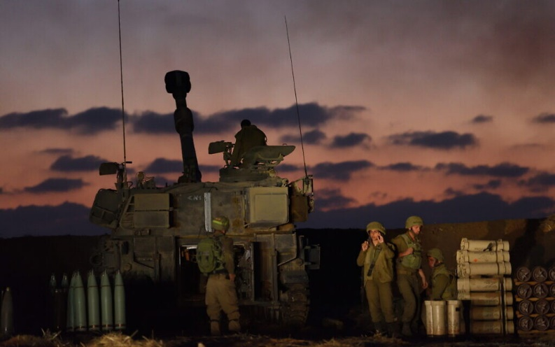
An IDF artillery unit near the Israel-Gaza border in southern Israel, May 13, 2021. (Gili Yaari /Flash90)

Zilberman said the operation was the result of large amounts of intelligence and careful planning. The military released video footage (above) showing both its preparations for the attack and some of the strikes themselves on the tunnel network, which the IDF refers to as “the metro.”
The IDF spokesman said that throughout early Friday morning, the military conducted further attacks on Hamas and Palestinian Islamic Jihad targets in the Strip, specifically rocket production facilities and additional anti-tank guided missile teams.
Huge bombardment in the north and the east of #gaza strip , involving gunboats, fighter jets, and helicopters pic.twitter.com/6OkKCVO4Aa
— Rushdi Abualouf (@Rushdibbc) May 13, 2021
The Hamas-run Gaza health ministry on Friday morning raised its total death toll to 115 Palestinians, 27 of whom it said were children. These updated figures did not appear to include all those killed in the IDF’s midnight attack. Israel maintains that most of those killed in Gaza were terror group members or, in a few cases, died from errant Palestinian rockets, including several of the children.

Ido Avigal, who was killed in his home in Sderot by a rocket fired from Gaza, May 12, 2021. (Twitter)

Shortly after the start of the assault, Prime Minister Benjamin Netanyahu vowed to exact a “very heavy price” from Hamas, the Gaza-ruling terror group which has fired upwards of roughly 2,000 projectiles at Israel since Monday afternoon, killing nine people, including a 5-year-old boy hit by a rocket fragment in Sderot, an 87-year-old woman who suffered a head injury while running to a bomb shelter, a 50-year-old woman who fell while rushing to a bomb shelter on Tuesday and was pronounced dead Friday, and a soldier hit by an anti-tank guided missile on the Gaza border. Dozens of Israelis have also been injured, and a number of elderly Israelis have also suffered heart attacks brought on by air raid sirens.
Following the Israeli attack, Hamas launched multiple waves of rocket attacks on southern and central Israel, firing rockets toward the cities of Ashkelon, Ashdod, Beersheba, Yavne and many surrounding communities, injuring at least two people.
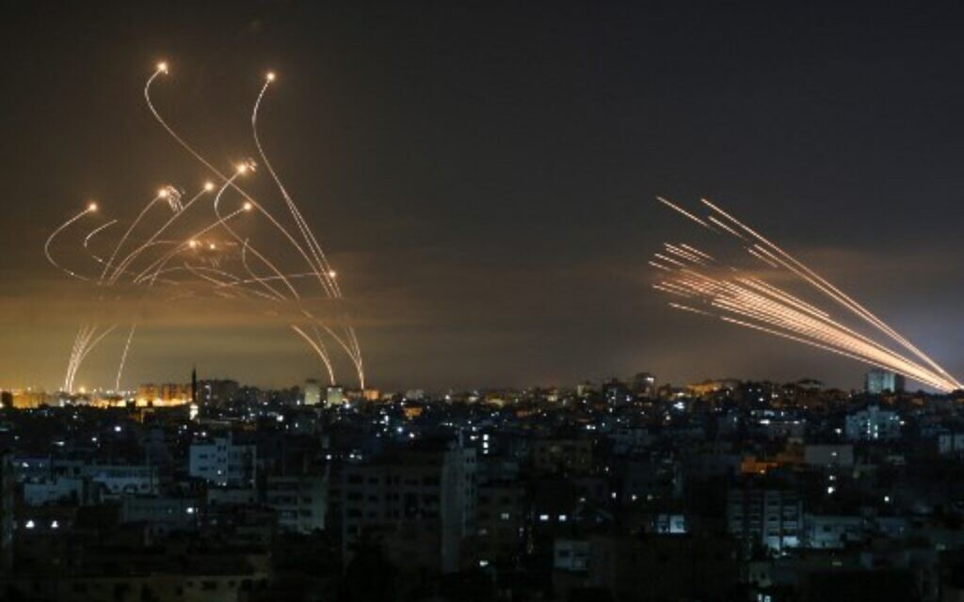
Rockets (l) are seen in the night sky fired towards Israel from Beit Lahia in the northern Gaza Strip on May 14, 2021, while Iron Dome interceptors rise to meet them (Photo by ANAS BABA / AFP)

One rocket directly struck a building in the city of Ashkelon, seriously injuring a 60-year-old man, Israeli authorities said. A 90-year-old man in the same building was lightly injured after he hit his head while running to a bomb shelter, medics said.
Hamas attacks continued into Friday morning around Ashdod, Ashkelon and Israeli communities surrounding the Gaza Strip.
Some of the incoming projectiles were intercepted by the Iron Dome missile defense system, several landed in open areas where they caused no injuries, and a small number landed inside populated areas, causing damage.
Minutes after the IDF onslaught began, Netanyahu issued a statement promising the operation would continue as long as needed to punish Hamas.
“I said that we would exact a very heavy price from Hamas and the other terrorist organizations. We are doing so and we will continue to do so with great force,” he said. “The last word has not been said and this operation will continue as long as necessary in order to restore the quiet and security to the State of Israel.
Prime Minister Benjamin Netanyahu, tonight:
"We are dealing with a campaign on two fronts. The first front – Gaza. I said that we would exact a very heavy price from Hamas and the other terrorist organizations. pic.twitter.com/5eHS8QZ3Mv
— PM of Israel (@IsraeliPM) May 13, 2021
The IDF’s campaign in Gaza has so far been conducted primarily by airstrikes, as well as artillery shellings from the ground and the sea, but the military said it was preparing for the possibility of a ground incursion.
Zilberman said plans for a ground invasion were presented for approval by the IDF General Staff on Thursday, at which point they were given to Israel’s political leadership for consideration.
However, Israeli defense officials have made clear that the goal of this current Gaza campaign, known as Operation Guardian of the Walls, was not to topple the Hamas terror group, but only to weaken the group significantly and restore deterrence to prevent future attacks.
In total, the IDF on Friday said it had so far bombed more than 750 targets in the Strip since the outbreak of fighting, including many dozens of terrorist operatives and several senior commanders; four high-rise buildings used, at least in part, as Hamas military facilities; dozens of tunnels and bunkers; and nearly 200 buried rocket launchers, according to Israeli Air Force statistics.
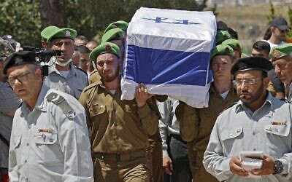
The military has also destroyed dozens of rocket production facilities, some of which the IDF believes will take years to replace.
International efforts to broker a ceasefire, mostly led by the Egyptian military and the United Nations, have not made significant progress, as Israeli leaders have said they plan to continue the operation until it has achieved its goals.

Mourners attend the funeral of Israeli soldier Omer Tabib, 21, in Elyakim in northern Israel, on May 13, 2021. Tabib was killed when Palestinian terrorists in Gaza fired an anti-tank missile near the border. (JACK GUEZ / AFP)

According to the IDF, some 2,000 rockets and mortar shells have been fired toward Israel by terror groups in Gaza since fighting broke out on Monday evening, including 220 projectiles launched between 7 p.m. Thursday and 7 a.m. on Friday. Around 330 of the total projectiles launched landed inside the Palestinian enclave, and in at least one case killed a number of children when the rocket hit a school.
The majority of the rockets have been fired toward southern Israel, particularly the city of Ashkelon, which has been pummeled in this round of fighting, as well as the town of Sderot and small communities surrounding the Strip, known as the Gaza periphery. Hundreds of rockets have also been fired toward central Israel, at the Tel Aviv metropolitan area, including Ben Gurion International Airport.
In light of the attacks, Israel closed the Tel Aviv-adjacent airport to incoming passenger flights, diverting them to Eilat’s Ramon Airport. Hamas said it subsequently targeted that airfield as well, though its attack fell far short of the city.
Hundreds of the projectiles fired from Gaza have been intercepted by Iron Dome missile defense batteries, according to the military, which refuses to give precise statistics on the matter as they could be used by terror groups to find ways to outmaneuver the system.
The IDF on Thursday said the air defense system had a roughly 90 percent interception rate of projectiles heading toward populated areas, stressing that it did not provide “hermetic” protection. Terror groups have been launching rockets in massive barrages to try and overwhelm the system. A number of rockets in these barrages have made it past the Israeli air defenses in this way.
Hamas also said it had launched a number of “suicide drones,” unmanned aerial vehicles carrying explosive payloads, into southern Israel from the Gaza Strip and out to sea, in an apparent effort to strike Israel’s Tamar natural gas rig, which was depressurized and put temporarily out of service toward the start of the fighting this week. The military confirmed downing at least six such drones as of Friday morning, including with an Iron Dome missile defense battery, in the first known use of this system, which was initially designed to intercept only rockets. In one case, a drone heading out to sea was shot down using an F-16 fighter jet, the military said.
On Thursday, the IDF said it bombed seven Hamas cells preparing to launch anti-tank guided missiles at targets in southern Israel over the course of the day, striking the teams before they could carry out their attacks. The military said it also hit an anti-tank guided missile launcher that had been positioned on an apartment building in the southern Gaza Strip.
לוחמי מגלן תקפו משגר נ"ט של ארגון הטרור החמאס שמוקם בבניין מגורים רב קומות בדרום רצועת עזה. ארגון הטרור חמאס ממקם במכוון את נכסיו הצבאיים בלב האוכלוסייה האזרחית ברצועת עזה. צה״ל ממשיך לתקוף מטרות טרור ברחבי רצועת עזה וימשיך לפעול בעוצמה ככל שיידרש pic.twitter.com/QJXi8kIdOy
— צבא ההגנה לישראל (@idfonline) May 13, 2021
Palestinian media reported that a number of Israeli airstrikes launched on Thursday targeted residential areas. Some of those reports claimed entire families were killed in some cases.
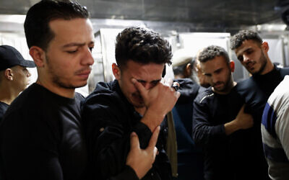
IDF officials have said the military makes a significant effort to prevent civilian casualties, calling buildings ahead of attacks to tell those inside to leave and using what’s known as the “knock on the roof” method of dropping non-explosive munitions on a target as a warning before bombing the building, but that collateral damage was effectively unavoidable as Hamas intentionally operates within a densely populated area to use Palestinian civilians as human shields.

Relatives mourn during the funeral of Reema Telbani and her 5-year-old son Zaid, who were killed in Israeli airstrikes on their family apartment building, at Dar Al-Shifa Hospital in Gaza City on May 12, 2021. (AP/Adel Hana)

The IDF in recent days has deployed additional ground troops — from the Paratroopers Brigade, Golani Infantry Brigade and 7th Armored Brigade — to the Gaza border, sending with them tanks and armored personnel carriers, which could be seen being transported by trucks on highways throughout southern Israel.
On Thursday, the army said it was canceling all weekend leave for combat soldiers as it prepared for the possibility of a ground operation. Zilberman said the military had called up 7,000 reservists. Roughly half of those were troops from air defense, artillery and medical units, and half serve in administrative and intelligence positions, Zilberman said.
Israel has fought three large operations against Hamas and other terror groups in the Gaza Strip since 2008, most recently in 2014 with a 51-day war known as Operation Protective Edge, as well as over a dozen smaller battles.
https://www.timesofisrael.com/idf-overnight-bombardment-targeted-hamass-tunnel-network-under-gaza-city/

Israeli air, ground forces bombard northern Gaza in heaviest strike yet
For 4th night, Hamas fires rockets at central, southern Israel; 87-year-old woman dies after hitting her head while running to bomb shelter; PM vows to exact heavy price from Hamas
By Judah Ari Gross Today, 2:58 am
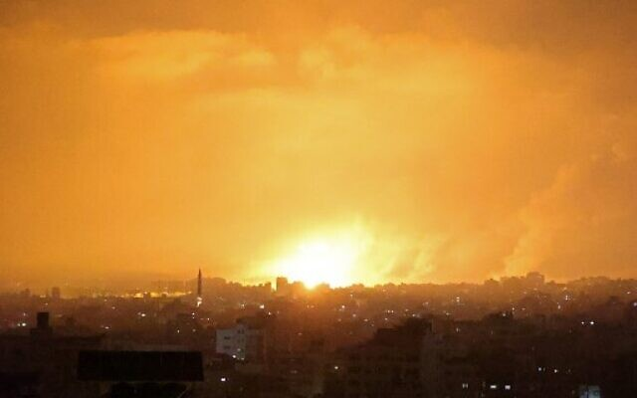
An explosion lights the sky following an Israeli air strike on Beit Lahia in the northern Gaza Strip early on May 14, 2021. (MOHAMMED ABED / AFP)

The Israel Defense Forces launched a massive bombardment on a large number of targets in the northern Gaza Strip shortly around midnight on Thursday, using both ground and air forces, the military said. Prime Minister Benjamin Netanyahu vowed to exact a “very heavy price” from Hamas, the Gaza-ruling terror group which has fired some 1,750 projectiles at Israel since Monday afternoon.
After initial confusion on the matter, the IDF clarified that it had not launched a ground invasion into the Gaza Strip during the attack, which reportedly lasted over an hour.
The IDF did not immediately identify its targets in the strike, saying it would do so shortly.
Following the Israeli assault, the Hamas terror group launched multiple waves of rocket attacks on southern and central Israel, firing rockets toward the cities of Ashkelon, Ashdod, Beersheba, Yavne and many surrounding communities.
Huge bombardment in the north and the east of #gaza strip , involving gunboats, fighter jets, and helicopters pic.twitter.com/6OkKCVO4Aa
— Rushdi Abualouf (@Rushdibbc) May 13, 2021
At least one rocket directly struck a building in the city of Ashkelon, seriously injuring a 60-year-old man, Israeli authorities said. Another landed next to a car, damaging it.
Some of the incoming projectiles were intercepted by the Iron Dome missile defense system and several landed in open areas, where they caused no damage or injuries.
Minutes after the IDF onslaught began, Netanyahu issued a statement promising the operation would continue as long as needed to punish Hamas.
“I said that we would exact a very heavy price from Hamas and the other terrorist organizations. We are doing so and we will continue to do so with great force,” he said. “The last word has not been said and this operation will continue as long as necessary in order to restore the quiet and security to the State of Israel.
Prime Minister Benjamin Netanyahu, tonight:
"We are dealing with a campaign on two fronts. The first front – Gaza. I said that we would exact a very heavy price from Hamas and the other terrorist organizations. pic.twitter.com/5eHS8QZ3Mv
— PM of Israel (@IsraeliPM) May 13, 2021
According to the IDF, some 1,750 rockets and mortar shells have been fired toward Israel by terror groups in Gaza since fighting broke out on Monday evening, including 190 projectiles launched between 7 a.m. and 7 p.m. on Thursday. Around 300 of the total projectiles launched landed inside the Palestinian enclave, and in at least one case killed a number of children when the rocket hit a school.
The IDF on Thursday said it had so far bombed upwards of 600 targets in the Strip, over 100 of them in the previous 24 hours.
Earlier in the evening, terrorists in the Strip also launched multiple barrages of rockets toward southern and central Israel, at Ben Gurion Airport and the Shfela region, as well as Tel Aviv. Another barrage targeted Ashdod and Ashkelon, with one rocket landing in the latter city.
Another round of rockets aimed at the southern city of Beersheva, with at least three projectiles hitting buildings.
The majority of the rockets were intercepted by the Iron Dome air-defense system.
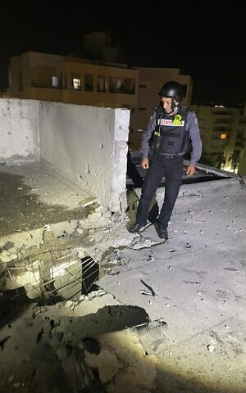
A firefighter stands over the impact site of a rocket fired from the Gaza Strip that hit a building in the city of Ashkelon, injuring a man, on May 14, 2021. (Fire and Rescue Services)

During one of the rocket barrages, an 87-year-old woman died after falling and hitting her head while running to a shelter in Shtulim, near Ashdod, Magen David Adom paramedics reported.
With the IDF carrying out multiple airstrikes on terror targets in the Gaza Strip throughout the day, the Hamas-run Gaza health ministry raised its death toll to 103 Palestinians, 27 of whom it said were children.
The increased death toll came after a number of reports in local Palestinian media of Israeli airstrikes targeting residential areas. Some of those reports claimed entire families were killed in some cases.
Israel maintains that most of those killed in Gaza were terror group members or, in a few cases, died from errant Palestinian rockets.
Earlier Thursday, Hamas operatives fired rockets at the Tel Aviv area and Beersheba and toward Eilat’s airport, in what the terror group said was an act of revenge for its commanders who were killed in Israeli strikes this week.
A few dozen rockets were fired in the attacks, which triggered sirens throughout central Israel and the northern Negev desert.
Earlier in the day, Israel closed Ben Gurion International Airport to incoming passenger flights, diverting them to Eilat’s Ramon Airport. Hamas said it subsequently targeted that airfield as well.
No sirens were heard in the rocket fire toward Eilat, as the projectile landed in an open area far outside the city, where it caused neither injury nor damage.
מטח כבד לעבר ערי המרכז. תיעוד האזעקות בת"א. צילום: אבשלום ששוני pic.twitter.com/AZ3BATrTAY
— Hosam Nabil (@nonime33) May 13, 2021
The military denied Hamas’s claims — widely echoed by Israeli media — that it fired some 100 rockets at central and southern Israel in the afternoon barrage. Rather, the Israel Defense Forces said, the terror group in fact launched 25 to 30 rockets in the attack. [That is 25 to 30 too many. – rdb]
Hamas also said it had launched a number of “suicide drones,” unmanned aerial vehicles carrying explosive payloads, into southern Israel from the Gaza Strip. The military confirmed downing at least two such drones. Channel 12 news reported that the drones appeared to have primitive capabilities and did not seem to represent a serious danger.
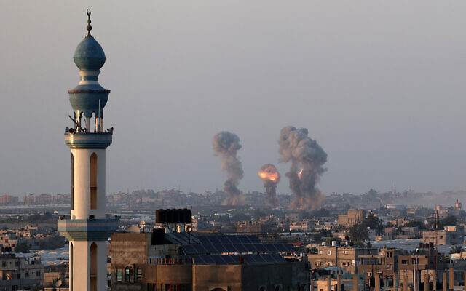
On Wednesday morning, the Israel Defense Forces and Shin Bet security service conducted a large-scale operation targeting a number of top commanders in Hamas, including the head of its Gaza City battalion and several people involved in its weapons production operations in the Strip, the military said.
Following the Thursday afternoon rocket fire, the IDF hit a number of sites in Gaza, including one the military said served as the main command center for Hamas’s surveillance network.

Smoke and flames rise after an Israeli airstrike in the southern Gaza Strip, May 12, 2021. (Abed Rahim Khatib/Flash90)

It was not immediately clear how many Hamas members were killed in the strike, which the IDF said occurred as dozens of people were in the building.
The IDF said it also launched strikes on four “operations apartments” of senior Hamas commanders in Gaza: the deputy commander of Hamas’s Jabalia regiment in the northern Strip, as well as three company commanders in northern and central Gaza.
All the apartments were allegedly used to direct recent rocket attacks at Israeli cities.
The military also said it bombed the “operational apartment” of Samer Abu Daka, the head of Hamas’s drone operations, after the drone launches.
The military said the apartment was used for military purposes. It also said the same apartment was targeted in the 2014 war.
The IDF also said it struck a main Hamas rocket production site and a military post of the Hamas naval force in the central Gaza Strip. In addition, a number of other weapons production sites were struck throughout the day, according to the military.
Also Thursday the IDF said it bombed four Hamas cells preparing to launch anti-tank guided missiles at targets in southern Israel over the course of two hours, striking the teams before they could carry out their attacks. The military said it bombed an anti-tank guided missile launcher that had been positioned on an apartment building in the southern Gaza Strip, accusing Hamas of using the occupants as human shields.
לוחמי מגלן תקפו משגר נ"ט של ארגון הטרור החמאס שמוקם בבניין מגורים רב קומות בדרום רצועת עזה. ארגון הטרור חמאס ממקם במכוון את נכסיו הצבאיים בלב האוכלוסייה האזרחית ברצועת עזה. צה״ל ממשיך לתקוף מטרות טרור ברחבי רצועת עזה וימשיך לפעול בעוצמה ככל שיידרש pic.twitter.com/QJXi8kIdOy
— צבא ההגנה לישראל (@idfonline) May 13, 2021
Hundreds of the projectiles fired from Gaza have been intercepted by Iron Dome missile defense batteries, according to the military, which refuses to give precise statistics on the matter as they could be used by terror groups to find ways to outmaneuver the system.
The IDF on Thursday said the air defense system had a roughly 90 percent interception rate of projectiles heading toward populated areas. Terror groups have been launching rockets in massive barrages to try and overwhelm the system.
In the most serious rocket attack overnight Wednesday-Thursday, two people were moderately injured by shrapnel and six others were treated for smoke inhalation after a Hamas rocket from Gaza struck in between homes in Petah Tikva shortly after midnight, sparking a fire. The buildings near the fire sustained moderate damage.
On Wednesday night and Thursday morning, the Israeli military expanded its targets in the Gaza Strip to include institutions that Hamas uses to rule the Palestinian enclave, notably its treasury and banks, IDF Spokesperson Hidai Zilberman said.
In addition, the Israeli Air Force bombed Hamas’s internal security headquarters used in counterintelligence operations, destroyed the home of Iyad Tayeb, a battalion commander in Hamas’s military wing, and killed a squad of Hamas’s naval forces, Zilberman said.
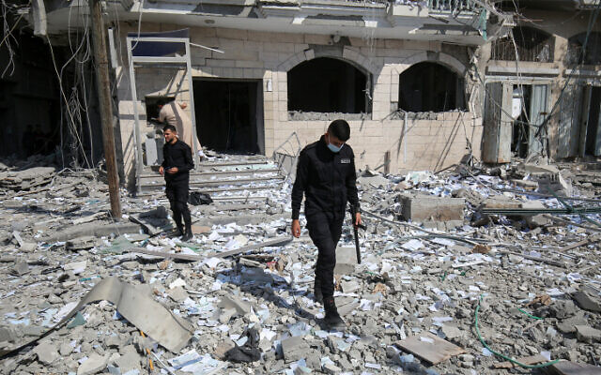
Palestinians assess the damage caused by an Israeli airstrike at the Islamic National Bank of the Hamas terror group in Khan Younis, in the southern Gaza Strip, on May 13, 2021 (Abed Rahim Khatib/Flash90)

The IDF’s campaign in Gaza, officially dubbed Operation Guardian of the Walls, has so far been conducted primarily by airstrikes, as well as artillery shellings from the ground and the sea, but the military said it was preparing for the possibility of a ground incursion.
Zilberman said plans for a ground invasion would be presented for approval by the IDF General Staff on Thursday, at which point they would be given to Israel’s political leadership for consideration.
The IDF in recent days has deployed additional ground troops — from the Paratroopers Brigade, Golani Infantry Brigade and 7th Armored Brigade — to the Gaza border, sending with them tanks and armored personnel carriers, which could be seen being transported by trucks on highways throughout southern Israel.
On Thursday the army said it was canceling all weekend leave for combat soldiers as it prepared for the possibility of a ground operation. Zilberman said the military had called up 7,000 reservists. Roughly half of those were troops from air defense, artillery and medical units, and half serve in administrative and intelligence positions, Zilberman said.
In the evening, Defense Minister Benny Gantz gave the military approval to call up as many as 9,000 reservists if needed, his office said.
The reservists would come from combat units and command center operators, to serve in the Southern Command, Central Command, and Northern Command so that soldiers regularly stationed there could be sent on other missions, according to his office. https://www.timesofisrael.com/israeli-air-ground-forces-bombard-northern-gaza-in-heaviest-strike-yet/

IDF calls up reservists as rockets continue to pound Israel
Rocket barrage comes as IDF prepares for possible ground invasion of the Gaza Strip. Plans are to be presented on Thursday to Netanyahu.
By ANNA AHRONHEIM, TZVI JOFFRE MAY 13, 2021 19:08
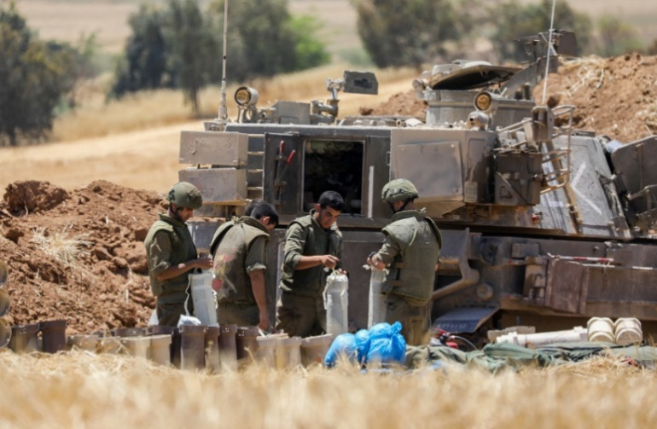
IDF Artillery Corps soldiers are seen by the Gaza border amid the ongoing escalation, on May 12, 2021.(photo credit: NOAM REVKIN FENTON/FLASH90)

The Israeli military is prepared to continue with its strikes on Hamas and other terror groups in the Gaza Strip for several days and has called up 7,000 reservists as rocket barrages continue to pound central and southern Israel, some of them falling in open areas.
Hamas launched suicide drones laden with explosives into Israel on Thursday. At least two were intercepted midair in central Israel by the IDF. The drone attacks were preceded by the firing of 20-30 long-range rockets toward central Israel, including Tel Aviv, and as far south as Eilat. Four people were injured.
The IDF also targeted a launch site for long-range missiles in the northern part of the Strip.
Subsequent UAV warnings were sounded in the area of Nachal Oz and Alumim near the Gaza border.
The alleged target of one of the UAVs was an Israeli gas rig in the Mediterranean. It was not specified which one. Since the fighting began, the Israeli Air Force downed three Hamas drones, some laden with explosives, that crossed into Israel. The drones were downed by the IAF using a Python-5 missile and Iron Dome missile batteries before crossing into Israel while others exploded in the air somewhere in central Israel.
Later on Thursday, the IDF targeted the operational complex of the commander of Hamas' UAV system, Samer Abu Daka. The same apartment was targeted during Operation Protective Edge in 2014.
A total of 1,600 rockets have been fired toward Israel since Monday, with a third of them falling inside the Gaza Strip.
The attacks came as the IDF called up reservists serving in artillery, Iron Dome batteries, doctors, paramedics, IAF, intelligence and other combat units. Another Iron Dome battery was also added to those placed around the country.
Combat troops will also not be able to leave their bases and additional ground troops have been redeployed to the border ahead of a possible ground operation, including from the Paratroopers Brigade, Golani Infantry Brigade and 7th Armored Brigade.
IDF Spokesperson Brig.-Gen. Hidai Zilberman said that a ground invasion remained a viable option. The plans will be presented to IDF Chief of Staff Lt.-Gen. Aviv Kohavi and then to the security cabinet for approval later on Thursday.
Speaking to reporters Zilberman said that the plans are being put together by the Gaza Division and Southern Command and will be then given to Israel’s political echelon for approval.
After a large barrage of rockets towards central and southern Israel on Thursday afternoon, Abu-Ubaida, spokesman of Hamas's military wing the Izzadin al-Qassam Brigades, claimed that Hamas was launching rockets towards Ramon Airport using the 250 Ayyash rocket which he claimed has a range greater than 250 km.
After the barrage, the Hevel Eilot Regional Council, located in the southern Negev, announced that a rocket had fallen in the regional council. No injuries were reported.
Despite the continued rocket fire and threats, Ben-Gurion Airport will remain open for departing flights. All inbound flights will be rerouted to the Ramon International Airport near Eilat.
In the four days since Operation Guardians of the Walls began, an operation which is 95% airstrikes, over 700 Hamas targets have been hit by the Israeli Air Force and 60 operatives including senior commanders, have been killed.
دمار كبير في الشوارع المحيطة بمجمع "أبو خضرة" وسط مدينة غزة بعد قصف الاحتلال الليلة. pic.twitter.com/PZ0YkEXSm3
— وكالة شهاب للأنباء (@ShehabAgency) May 13, 2021
MORE - https://www.jpost.com/arab-israeli-conflict/israeli-ground-offensive-in-gaza-on-table-as-rocket-barrages-continue-668048

Soldier viciously beaten in Jaffa, synagogue burned in Lod, as rioting deepens
Numerous reports of shootings, other acts of violence in Jewish-Arab cities throughout country; Gantz extends emergency order in Lod, epicenter of escalating unrest
By TOI staff 13 May 2021, 11:48 pm
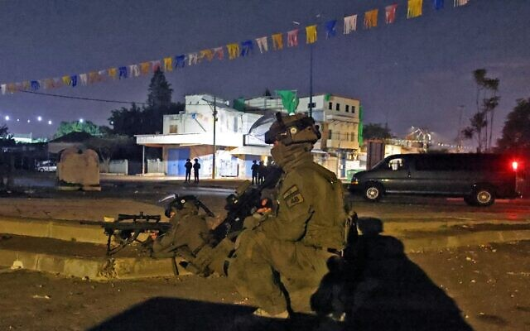
Israeli special forces gather in the mixed Jewish-Arab city of Lod on May 13, 2021. (Ahmad Gharabli/AFP)

Fresh violence erupted Thursday evening in several Jewish-Arab cities, a night after some of the worst internal unrest in years, as intense fighting also continued between Israel and Palestinian terror groups in the Gaza Strip.
Two civilians and a policeman were reported to have been shot by Arab assailants in Lod and Ramle.
In Jaffa, a 19-year-old soldier was in serious condition after being beaten, and was suffering from a skull fracture and a cerebral hemorrhage, Ichilov Medical Center in Tel Aviv said, after he drove himself there.
In Lod, a central city with Jewish and Arab populations that has become an epicenter of the ethnic violence gripping the country, a Jewish paramedic was lightly wounded after being shot. Reports later said a second Jewish man was shot in the city, after an overnight curfew took effect at 8 p.m. for a second night in a row.
Arab rioters also torched a synagogue, the fifth in the city to be set alight in the recent violence, according to Channel 12 news.
בית הכנסת דוסא עולה באש. pic.twitter.com/PGZmMUe2Ul
— מאיר ליוש Meir Layosh (@MLayosh) May 13, 2021
Kan news posted video from the city of what it said were armed citizens accompanying officers to the site of clashes.
החלו התפרעויות בלוד: בתיעוד – שוטרים וקבוצת אזרחים חמושים בדרכם לזירת המהומות@hadasgrinberg pic.twitter.com/3JtnypBQxd
— כאן חדשות (@kann_news) May 13, 2021
Along with the curfew, which ends at 3 a.m., police began barring non-residents of Lod from entering the city as of 5 p.m.
Amid the continued violence in the city, Defense Minister Benny Gantz extended the state of emergency there by 48 hours, a move his office said came at the request of police.
In nearby Ramle, a police officer was shot and wounded, according to Channel 12 news. There was no immediate word on his condition. He was reportedly being treated at the scene.
Meanwhile, footage from southern Tel Aviv showed journalists from Kan being attacked and beaten by several far-right rioters. Cameraman Roland Novitzky was beaten and had his camera taken away, before being taken to the hospital. Reporter Yoav Zehavi, who was with him, said they filed a police complaint.
Two suspects were arrested over the assault.
צוות שלנו, הצלם רוליק ו@Yoav__Zehavi מותקפים כי באו לסקר הפגנה
לא מאחלת לאף אחד את חוסר האונים כשאת רואה את החברים שלך מותקפים מול העיניים
שכונת התקווה תל אביב 2021 pic.twitter.com/R70tofJWuF
— Liel Kyzer (@lielkyzer) May 13, 2021
Far-right activists were also organizing on social media to attack Arabs in Jerusalem, according to the Haaretz daily.
In other acts of violence, a Jewish family was attacked by Arab rioters in Umm al-Fahm after entering the Arab city by accident, according to Hebrew media reports.
Police rescued the couple and three young children, with the help of local civilians. The family all sustained mild injuries.
Municipal officials issued a strong condemnation of the attack, with Mayor Samir Mahamid later calling the father and expressing “his shock and revulsion at the incident.”
עירית אום אל פחם: "מגנים בכל תוקף תקיפתה של המשפחה על ידי קומץ צעירים. במקביל, שולחים תודה גדולה לתושבים, שסייעו למשפחה, ובכך בטאו את ערכי התרבות האנושית, הערבית והאסלאמית. ראש העיר ד"ר מחאמיד סמיר התקשר לאבי המשפחה והביע זעזוע ושאט נפש מהאירוע" @eran_singer
— כאן חדשות (@kann_news) May 13, 2021
An 8-year-old Jewish girl was wounded after being hit in the head by a rock thrown at a car she was traveling in near Beersheba, medics said. The girl sustained moderate injuries and was taken to Soroka Hospital for further treatment. The stone-throwers are believed to have been from a nearby Bedouin village.
In Haifa, eight Arabs were arrested on suspicion of throwing rocks at Jews.
A pro-peace protest against the violence was held in Jerusalem and a similar rally took place outside the city, near the town of Abu Ghosh.
Earlier, Prime Minister Benjamin Netanyahu visited Lod, where he said he would approve far-reaching measures to quell the violence seen across Israel, including deploying military forces.
His comments contradicted those of Defense Minister Benny Gantz, who has said he does not agree to using the military for policing operations.
Meeting with Border Police officers sent to the city, Netanyahu said: “We have no bigger threat now than these pogroms, and we have no choice but to restore law and order via determined use of force.”
Despite his call for Israel Defense Forces troops to be deployed, it is unlikely that Netanyahu has authority to approve such action independently.
Apparently siding with Gantz, Shabtai was quoted by Hebrew media following Netanyahu’s comments as telling associates that he objects to deploying the army.
Netanyahu also proposed the use of administrative detention of rioters, a controversial measure commonly deployed against Palestinians in the West Bank.
Administrative detention enables authorities to detain people for extended periods of time without leveling formal charges against them, in a practice decried by critics as undemocratic and abusive, but defended by the security establishment as a necessary measure in cases where revealing the evidence would harm national security.
Prime Minister Benjamin Netanyahu meeting Border Police officers in the central Israeli city of Lod, May 13, 2021.(Kobi Gideon/GPO)

Gantz on Thursday ordered a major call-up of Border Police reservists to bolster officers working to contain the unrest, but specifically ruled out deploying troops at this time.
Later Thursday, Gantz, who also serves as justice minister, was reported to have agreed with Attorney General Avichai Mandelblit and other senior officials that top priority would be given to investigating the violence that is currently taking place across the country.
Despite two previous days of ever-expanding violence, and a call-up of reinforcements for both police and Border Police, law enforcement once again Thursday seemed unequipped to handle the scope of the chaos, with many scenes of violence going ahead.
Violence continued Thursday morning with a Jewish man, 34, stabbed near a market in Lod, a city with Jewish and Arab populations that has become an epicenter of the ethnic violence gripping the country. The man, who was moderately injured, was on his way to prayers and was attacked near a mosque in the city, according to Hebrew media reports.
An Arab woman in the city was also seriously injured by a rock thrown at her head. She was pregnant and gave birth to a healthy baby at the hospital after the attack, according to reports.
Incidents were also reported in the south, the Jewish-Arab city of Acre in north and in the Arab town of Kfar Qasim, two police patrol cars were torched.
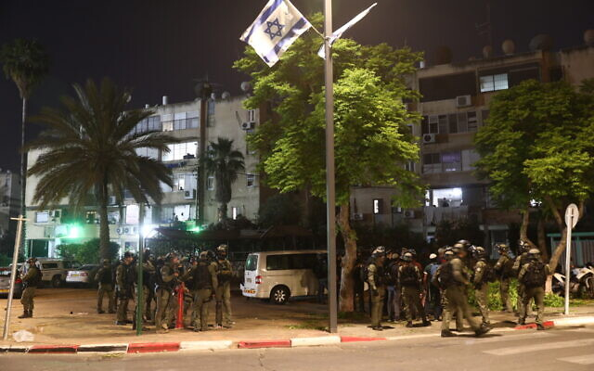
Police offers seen on the streets of the central Israeli city of Lod after Arab rioters torched cars and burned synagogues, on May 12, 2021. (Yossi Aloni/Flash90)

Five people were arrested in Jerusalem on suspicion of attacking a Jewish man near the Damascus Gate to the Old City, police said. In a video of the incident, several youths were seen running up behind an ultra-Orthodox man, knocking him to the floor and trampling on him before running off. The man required medical treatment, police said.
Commenting Thursday on the previous night’s violence, in which more than 400 people were arrested, Israel Police spokesman Mickey Rosenfeld said most of those arrested last night were Arab Israelis, not Jewish Israelis.
“We arrested Jewish people, but many fewer, because the majority of disturbances were conducted by Israeli Arabs,” Rosenfeld said.
Rosenfeld also claimed there was a difference between the Jewish mobs and the Arab mobs.
“There have been certain Jewish groups and Jewish individuals who have said ‘if necessary, we will protect ourselves.’ There have been a number of instances in which they took the law into their own hands…but that is very different than those thousands who sought to kill as many people as possible,” Rosenfeld said.
Violence between the Jewish and Arab communities spiraled from confrontations in Jerusalem surrounding the month-long Muslim month of Ramadan and clashes on the Temple Mount, and came to a head as Israel engaged in an escalating clash with terrorist groups in the Gaza Strip.
President Reuven Rivlin, who celebrated a Ramadan iftar meal just weeks ago, on Wednesday condemned what he termed a “pogrom” by a “bloodthirsty Arab mob.” As Jewish mobs joined the fray, he later called on all sides to “stop this madness.” https://www.timesofisrael.com/soldier-viciously-beaten-in-jaffa-synagogue-burned-in-lod-as-rioting-renews/

Bennett rules out ‘change gov’t’ amid national unrest, renews talks with Likud
Yamina leader tells associates that ‘when there is a wave of pogroms by Arabs across the country, and when IDF forces must be involved, this is a reality-changing event’
By Tal Schneider and Raoul Wootliff 13 May 2021, 10:01 pm
In a dramatic decision Thursday that remakes Israel’s coalition-building arithmetic, Yamina party leader Naftali Bennett ruled out the option of forming a government with Yesh Atid chief Yair Lapid that would replace Prime Minister Benjamin Netanyahu, citing the rioting and chaos unfolding throughout Israel as extremist Arab and Jewish mobs vandalize and terrorize numerous cities.
A political source told The Times of Israel on condition of anonymity that Bennett has renewed his negotiations with Likud due to the emergency situation, and teams from both parties met Thursday.
Until the conflict with Gaza broke out this week, and the subsequent Jewish-Arab violence ensued, Bennett had been in advanced stages of forming a power-sharing government with Lapid, with the support of the Islamist Ra’am party.
However, Ra’am halted the talks, as the conflict with Hamas in Gaza escalated.
Bennett explained in private conversations Thursday that he believed a government dependent on the Arab party could not face the challenges at hand.
“When there is a wave of pogroms by Arabs across the country, and when IDF forces must be involved, this is a reality-changing event,” he said, according to the source. “The ‘change government’ being formed won’t be able to deal with that.”
He said the security situation was the top priority and that he was working to form a “broad national unity government.”
Channel 12 news reported that Bennett had reached a deal with Netanyahu and Abbas for both Yamina and Ra’am to support the premier’s initiative to hold direct elections for prime minister, which Netanyahu has been seeking as a way to break the political deadlock and cement his power. MORE - https://www.timesofisrael.com/bennett-rules-out-change-govt-amid-national-unrest-renews-talks-with-likud/

Jews and Arabs start to push back against violence, rallying nationwide
Shocked by series of arson and mob attacks in Jewish-Arab cities and beyond over recent days, Israelis demonstrate for calm
By Sue Surkes Today, 1:45 am
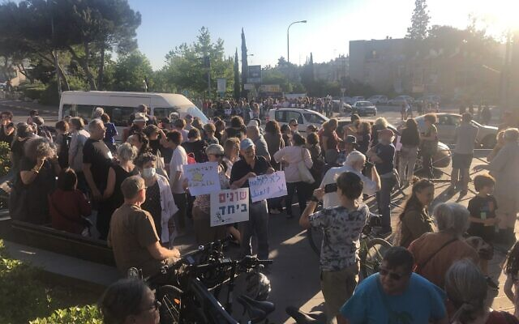
Demonstrating for calm and coexistence at the Oranim junction in south Jerusalem, May 13, 2021. (Sue Surkes/Times of Israel)

Shocked by the unprecedented scenes of violence between Jews and Arabs over recent days, Israelis took to the streets on Thursday to push back and call for calm and peaceful coexistence.
In Jerusalem, hundreds rallied with the Yad be Yad (Hand in Hand) organization at the Oranim junction in the south of the city and at the Mashbir department store in the downtown area.
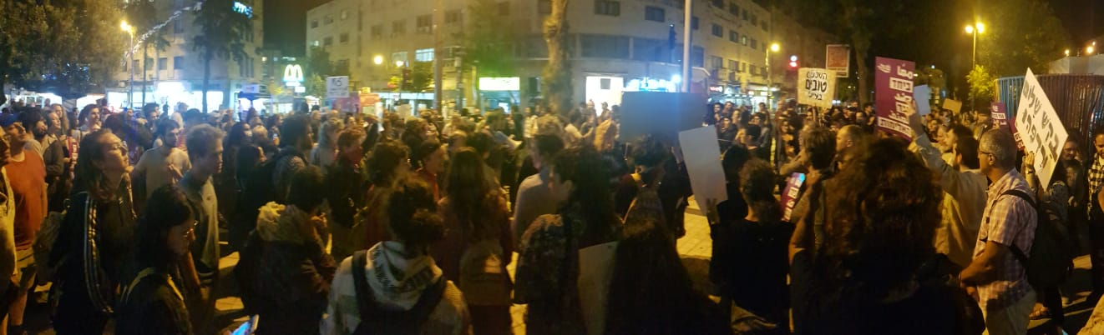
Hand in Hand is a not-for-profit organization that runs several Jewish-Arab schools, including one in the capital.
Earlier in the day, some 300 school principals and educators rallied for coexistence and against violence in front of the Knesset at an event organized by the Branco Weiss School Principals Forum.

Some 300 Jerusalemites demonstrate against violence and for coexistence in central Jerusalem, May 13, 2021. (Whatsapp group)

300 אנשי ונשות חינוך נגד אלימות ובעד חיים משותפים.אנו גאים במנהלים ובמנהלות שלנו שארגנו היום עצרת למען חיים משותפים ונגד אלימות !מעט מן האור דוחה הרבה מהחושך.גאים בכם!!
Posted by ‎ברנקו וייס – Branco Weiss‎ on Thursday, May 13, 2021
Another rally of educators was scheduled for the mixed city of Lod, where some of the worst internecine violence has taken place over the past 48 hours.
Crowds also gathered at Habima Square in Tel Aviv and at the Hemed junction near Jerusalem. At the Nahalal junction in northern Israel, Jews and Arabs proclaimed that their shared and fragile fabric of life could not be harmed.
והנה בכיכר הבימה בת"א-
(צילום- עומדים ביחד)
<< pic.twitter.com/g3ZvPosmtc
— Noa Shpigel (@NoaShpigel) May 13, 2021
תחת הכותרת "ערבים ויהודים מסרבים להיות אויבים" נערכו משמרות מחאה בכמה צמתים בגליל בהשתתפות ערבים ויהודים בדרישה לעצור את גל הנקמה והאלימות ולמען שמירה על שכנות טובה pic.twitter.com/qZ5SCDfARo
— sami abdulhamid سامي عبد الحميد (@samiaah10) May 13, 2021
<<
בחזרה למשגב-
הנה השכנים מהר כמון- תושבים מכאמנה, מכמנים וכמון
(צילום- אבי יוכטמן)
<< pic.twitter.com/LaA5EO2TLL
— Noa Shpigel (@NoaShpigel) May 13, 2021
וואו! מחלף חמד מלא ביהודים וערבים. pic.twitter.com/c6AFQHTiBr
— עומדים ביחד نقف معًا Standing Together (@omdimbeyachad) May 13, 2021
צומת נהלל עכשיו pic.twitter.com/hGvT5ic0s9
— danny (@danny_altman) May 13, 2021
The Tag Meir organization, which campaigns against hate, handed out thousands of flowers at locations throughout the country, from the Meir Hospital in Kfar Saba in central Israel and the Arab town of Abu Ghosh near Jerusalem, to the Fureidis junction and Gush Halav in northern Israel and the Nahalal junction in the Jezreel Valley.
The flowers were distributed with blessings for the Jewish holiday of Shavuot, which begins Sunday evening, and the Muslim Eid al-Fitr, which marks the end of Ramadan, and was celebrated Wednesday and Thursday.
"Love your brother as you love yourself" – Jews and Arabs who love coexistence and tolerance hand out flowers to passers-by, Arabs and Jews. The cohesion between the various factions in Israeli society is rooted despite the challenges. (Photo: תג מאיר) @IsraelArabic https://t.co/0R13zDAM7J
— Avi Kaner (@AviKaner) May 13, 2021
“We took to the streets to strengthen each other, to remember that we are brothers, and to ensure that we continue to live together — with respect and brotherhood,” the organization’s website said.
Other rallies took place in Haifa and in Modi’in, between Tel Aviv and Jerusalem.
כיכר השעון יפו. הפגנה משותפת לערבים ויהודים למען שלום ודו קיום. pic.twitter.com/WI2cag73e3
— Uri Misgav (@UriMisgav) May 13, 2021
הפגנה עכשיו במודיעין בצומת שילת – נגד האלימות במדינה, נגד מלחמת אזרחים, בעד מדינת ישראל ושלטון החוק.
אין לנו ארץ אחרת ???????? pic.twitter.com/FxMl2rDxT6
— ???????????? איתי אלמוג-בר Itay Almog Bar (@itay_almog_bar) May 13, 2021
Also on Thursday, city council members from Acre, Lod, Haifa, Tel Aviv-Jaffa, Ramle and other mixed Jewish-Arab cities issued a joint call for calm as part of an effort by the Abraham Initiatives, which work for equality between the two peoples, according to Mekomit, a leftwing news site.
Leaders of both communities also came together in northern Israel and in the Negev to call for an end to the violence.
“The real fear is from the rift within the State of Israel,” said Ofir Libstein, head of the Sha’ar Hanegev Regional Council of communities close to the Gaza Strip. “We will face Hamas. But this is the biggest problem,” he said.
Hospitals in Israel are one of the main places where Jews and Arab work together and are treated alongside one another.
At Haifa’s Rambam Hospital, Jewish and Arab colleagues posed together with posters calling for peace.
יחד, כל הדרך – הצוותים המטפלים של רמב"ם שולחים מסר של שלום ודו-קיוםשלושה ימים סוערים וההסלמה במצב הביטחוני, הובילו את…
Posted by ‎רמב''ם הקריה הרפואית‎ on Wednesday, May 12, 2021
And at the Emek Medical Center in Afula, they sang “Peace will still come.”
סלאם עוד יבוא שלום עלינו ועל כולם.سلام * עשרות אנשי צוות, ערבים ויהודים פצחו בשירת שיר של שלום, בהתכנסות שהתקיימה במרכז הרפואי העמק בעפולה pic.twitter.com/Y6UuHO2DPt
— sami abdulhamid سامي عبد الحميد (@samiaah10) May 13, 2021
https://www.timesofisrael.com/jews-and-arabs-start-to-push-back-against-violence-rallying-nationwide/

ICC may probe current Israel-Gaza round of violence in war crimes investigation
Chief prosecutor Bensouda says court could look at ‘evolution of these events’ as part of probe focusing on intense 2014 fighting and subsequent events
By TOI staff Today, 1:02 pm
The International Criminal Court’s chief prosecutor Fatou Bensouda has said the court may look into the current fighting between Israel and Gaza as part of its current probe into alleged war crimes in the region, the Reuters news agency reported Thursday.
“These are events that we are looking at very seriously,” Bensouda said, adding that “we are monitoring very closely and I remind that an investigation has opened and the evolution of these events could also be something we look at.”
Since Monday, Gaza terror groups have fired some 2,000 rockets and mortars toward Israel. The Israeli military in turn has struck hundreds of sites in the coastal enclave, as Prime Minister Benjamin Netanyahu vowed to exact a “very heavy price” from Hamas, the Gaza-ruling terror group. MORE - https://www.timesofisrael.com/icc-may-probe-current-israel-gaza-round-of-violence-in-war-crimes-investigation/

European Jews brace, yet again, for antisemitic attacks spurred by Gaza unrest
Many fear ‘the import of the conflict’ phenomenon will increase assaults; in 2014, Europe saw the worst wave of antisemitic violence since the Holocaust amid Israel-Hamas fighting
By Cnaan Liphshiz Today, 11:59 am
JTA — As the body count in hostilities between Israelis and Palestinian rises, so do fears that European Jews will be targeted in a phenomenon that many in the continent call “the import of the conflict.”
That’s what happened when Hamas and Israel exchanged blows in 2014, triggering the worst wave of antisemitic violence in Europe since the Holocaust in terms of its prevalence and scope.
That summer, dozens of men, most of them from a Muslim background and some of them coming from a large pro-Palestinian rally, besieged a crowded synagogue in Paris. For long minutes, Jewish men held the crowd at bay as the attackers hurled heavy objects at them, including pieces of furniture from a nearby café.
A dozen synagogues, most of them in France, were torched. And in the Paris suburb of Sarcelles, rioters smashed the windows of multiple Jewish-owned businesses, producing an aftermath that for some evoked Kristallnacht, the 1938 pogroms that presaged the Holocaust. MORE -https://www.timesofisrael.com/european-jews-brace-yet-again-for-antisemitic-attacks-spurred-by-gaza-unrest/

GOP senators to Biden: End Iran talks while it funds Hamas terrorism
'United States should take all steps necessary to hold Tehran accountable'
By WND News Services Published May 13, 2021 at 7:35pm By Thomas Catenacci Daily Caller News Foundation
A group of Senate Republicans urged President Joe Biden to stand with Israel and stop offering sanction relief to Iran, which funds Palestinian Islamist group Hamas. The group of 44 Republicans led by Florida Sen. Marco Rubio asked Biden to immediately end ongoing negotiations with Iran in a letter sent Thursday morning. The senators said the U.S. shouldn’t continue to offer sanctions relief to Iranian leaders in light of ongoing hostilities between Israel, a top U.S. ally, and the Palestinian militant group Hamas, which receives funding from Iran.
"Over the past couple days, Palestinian terrorists in Gaza, who are funded by Iran, have launched a series of rocket attacks into Israel," the Republican senators wrote in the letter. "This is troubling as members of your administration are currently in Vienna negotiating with Iran, the world's leading state sponsor of terrorism."
"In light of these recent attacks by Hamas against Israel, the United States should take all steps necessary to hold Tehran accountable and under no circumstances, provide sanctions relief to Iran," the letter continued.
Since the beginning of the week, Hamas has fired hundreds of rockets at Israel, most of which have been shot down by Israeli defense systems. Hamas’ barrage of rockets began after Palestinians in the region started violently protesting against the Israeli government over its alleged mistreatment of Arab communities, according to The New York Times.
The first sign of unrest took place around the al-Aqsa mosque, Islam's third-holiest site, in Jerusalem on Saturday, The Guardian reported. Muslims praying at the site were angry about Israel's stringent coronavirus restrictions preventing tens of thousands from entering the mosque and were upset at reports that Israeli authorities might soon evict Palestinians from the Sheikh Jarrah neighborhood in Jerusalem, according to The Guardian.
The Israel Defense Forces (IDF) has responded with multiple coordinated airstrikes targeting Hamas leaders hiding among civilians in Palestine. On Wednesday, an IDF airstrike killed a top Hamas commander.
Meanwhile, the U.S. and a handful of Western nations are negotiating with Iran over the 2015 nuclear agreement. Former President Donald Trump withdrew from the agreement in 2018.
The Biden administration has promised to remove some of its sanctions against Iran if the Middle Eastern country agreed to return to the agreement.
But Rubio, Toomey and the other Republicans noted Thursday that Iranian Supreme Leader Ayatollah Ali Khamenei recently tweeted that Palestinians should “use the tools at their disposal” to attack Israel. In a follow up tweet, Khamenei said Palestinians "must increase their strength, stand strong, confront the enemy, and force them to stop their crimes."
Khamenei has also labeled Israel a "despotic regime" and said it's not a legitimate nation.
"The United States engaging in active negotiations with Iran and potentially providing billions of dollars in sanctions relief will no doubt contribute to Iran's support of Hamas and other terrorist organizations who attack Americans and our allies," the senators said in the letter to Biden.
"We call on you to immediately end negotiations with Iran, and make clear that sanctions relief will not be provided," they continued.
Republican Sens. Pat Toomey, Tim Scott, John Kennedy, Josh Hawley, Mitt Romney, Tom Cotton, Ben Sasse and Ted Cruz all signed the letter. Rubio is the vice chairman of the Senate Select Committee on Intelligence. https://www.wnd.com/2021/05/gop-senators-biden-end-iran-talks-funds-hamas-terrorism/

Dems move on court-packing even though Biden commission 'studying'
Agenda includes installing leftists to be majority
By Bob Unruh Published May 13, 2021 at 7:44pm
President Biden, with a long political history of opposing plans to pack the Supreme Court, was facing political demands that he do exactly that, and delayed recently. He announced a "commission" to study the issue that even members of the court and leftist icons like the late Justice Ruth Ginsburg opposed.
It was clear what the recommendation of the study group, made up of mostly leftist and progressive activists, would be.
But Democrats weren't content to wait for the predetermined outcome: they've already proposed legislation to change the makeup of the court and give Biden permission to appoint four new liberals to the court.
The result inevitably would be vast expansions in abortion, LGBT privilege, and taxes, with a corresponding reduction in freedoms and religious rights.
The plan recently was highlighted by a report at the American Center for Law and Justice.
There, Jordan Sekulow explained how the new legislation is by Rep. Jerry Nadler, D-N.Y., and Sen. Ed Markey, D-Mass.
He said they are "circumventing" the president who has named 36 individuals to his study commission.

The Democrats want to have 13 justices on the court, instead of the nine now. The problem as they see it is that because of President Trump's appointees, there is a 6-3 or 5-4 conservative majority now, depending upon the issue.
Adding four justices picked by Biden would give Democrats a 7-6 majority at worst.
The report said House Speaker Nancy Pelosi initially didn't support the plan, but, "But don’t let that fool you. This is a test balloon as the court-packing commission gets going."
It is ACLJ Senior Counsel Andy Ekonomou who explained what the Democrats are doing.
"They've already made up their mind. What's the point of having a commission if you've made up your mind that you’re already going to expand the Supreme Court to thirteen justices? And that's exactly what has happened here. The commission seems to be redundant. There's no need to have a commission if you've already decided that you're going to expand the court by adding four justices."
He continued, "And it seems that there’s a disconnect perhaps between the White House and Congress in terms of what the plan is. But the Congress – Nadler, Hank Johnson, and Ed Markey have already gone on and made their decision that they’re going to hostilely take over the Supreme Court of the United States, and that’s exactly what they’re doing."
The ACLJ analysis predicted Joe Biden, Pelosi and other Democrats "would sign on in a heartbeat if they felt confident there would be no blowback."
ACLJ Chief Counsel Jay Sekulow said, "You’ve got to understand what this is. It’s pure politics. But it’s politics that’s very dangerous. You would give four appointments to the current president of the United States."
The ACLJ noted that Biden, while a senator, had called packing a "bonehead idea."
But the Democrats are dependent on the courts to impose their leftist agenda points when they cannot get them through Congress, and that makes a reliably progressive court so important to them.
"The more you look at the new commission, the clearer it becomes just how correct Justice Ginsburg was [that packing the court was a bad idea]. Senate Minority Leader Mitch McConnell puts it in stark perspective, 'This faux-academic study of a nonexistent problem fits squarely within liberals' years-long campaign to politicize the court, intimidate its members, and subvert its independence as part of a malicious campaign to gain absolute power. This is not some new, serious, or sober pivot away from Democrats' political attacks on the court," the report said.
Critically, the commission is assigned to look at the length of service and turnover on the court, the membership there, and its case selection.
There are 36 on the commission, "most of them are hard-left partisans – individuals politically predisposed to have hostile viewpoints toward originalism and the role of the Constitution. It is likely that the majority of its members have already made up their minds on expanding the Supreme Court," the ACLJ reported.
Chiefs there are leftist political campaign lawyer Bob Bauer who worked for Barack Obama and Kate Andrias, who also worked in the Obama White House.
Others are Cristina Rodríguez, yet another supporter of Barack Obama, and Laurence Tribe, is a Harvard Law professor who has openly supported packing the Supreme Court. https://www.wnd.com/2021/05/dems-move-court-packing-even-though-biden-commission-studying/

BREAKING: ‘Significant Discrepancies’ Discovered In Arizona Audit, Ballots Off Up to 17.5%, ‘Likely Joe Biden Did Not Win’
"They're hiding the disaster in which they handled this election, and likely, the fact that Joe Biden did not win in Arizona."
by Tom Pappert May 13, 2021
The ongoing audit of ballots cast in Maricopa County, Arizona has uncovered “significant discrepancies” in the number of ballots versus the supposed number of ballots that were supposed to exist. Political strategist Boris Epshteyn adds that the discrepancies may be as high as 17.5%, and it is “likely Joe Biden did not win Arizona”.
Arizona Senate President recently sent a letter to the Maricopa County Board of Supervisors, outlining the major issues discovered already in the audit, and offering to settle them without additional subpoenas or compulsory action. In the letter, says Epshteyn on Steve Bannon’s podcast, it reveals, “Pallet five, batch 2976, 200 pink slip total, actual total 165. They are missing 35 ballots out of that batch.” He added, “35 out of 100 is 17.5%. 10 out of 200 is 5%.”
“Do you know how shocking that is? 17.5% discrepancy in a batch is beyond belief.” He added, “In one they’ve got 18 more than there’s supposed to be, which is a 9% discrepancy. Again, if we are to have any confidence in elections in this country, how can we possibly be okay with discrepancies of double digit percentages? It’s absolutely mind boggling, anything above a tiny fraction of a percentage is unacceptable, by the way, unacceptable according to the Federal Elections Commission.”
Ephsteyn explained that several databases subpoenaed for the purpose of the audit have been removed, including files that contain the election results and how they were tallied. “There’s evidence these databases were removed as recently as March, right before handed over, and while being subject to a subpoena. That’s criminal activity.”
“We now know why the Maricopa County Board of Supervisors have been fighting this subpoena so hard, why Perkins Coie has come in, why the Democrats are pushing back, why you’ve got mainstream media melting down,” he explained, “Because they’re hiding this. They’re hiding the disaster in which they handled this election, and likely, the fact that Joe Biden did not win in Arizona.” (READ MORE: Mark Kelly Hires Perkins Coie To Sue National File, Here’s How You Can Help)
The official Maricopa Arizona Audit Twitter account, controlled by Arizona Former Secretary of State Ken Bennett, confirmed the discrepancy and its significance. “Breaking Update: As we open boxes of ballots delivered by Maricopa County, we are discovering significant discrepancies between the number of ballots therein and the batch reports included in the boxes.”
Breaking Update: As we open boxes of ballots delivered by Maricopa County, we are discovering significant discrepancies between the number of ballots therein and the batch reports included in the boxes.
— Maricopa Arizona Audit (@ArizonaAudit) May 13, 2021
Democrats have repeatedly attempted to interfere with the audit process using the media, the courts, and public statements from Arizona Secretary of State Katie Hobbes, a Democrat. As National File reported, “Secretary of State Katie Hobbs, whose team is now monitoring the audit, has shown blatant bias, tweeting out the hashtag #fraudit. The Maricopa Arizona Audit official Twitter account told Hobbs to stop ‘attempting to disrupt the audit process.’” https://nationalfile.com/breaking-significant-discrepancies-discovered-in-arizona-audit-ballots-off-up-to-17-5-likely-joe-biden-did-not-win/ [So how do they demon-rats want to deal with this little problem? Look at the article below…… rdb]

Democrats set sights on arresting, charging, extraditing President Trump
Reports explain Trump Derangement Syndrome-inspired agenda
By Bob Unruh Published May 13, 2021 at 7:51pm
President Trump's pro-America, pro-business and pro-religious rights agenda when he was in the Oval Office offended many Democrats and other leftists.
They tried, while he was in office, to find a way to destroy him, including bringing charges against him. They investigated taxes, his campaign – remember the debunked Russia collusion conspiracy theory? – and capped their war against him with not one, but two, impeach-and-remove campaigns.
Numerous Democrats admitted that those costly and time-consumer efforts were launched mainly because they feared what he could do if he eventually returned to the White House, for which he technically is eligible.
But they all failed.
Now that he's out of office, is seems, their affliction, known by the Trump Derangement Syndrome moniker during his term, is getting worse.
Big League Politics is reporting that "government officials" who are close to President Biden and his family "are plotting ways to charge Donald Trump with crimes before he can run for the presidency again in 2024."
And Politico confirmed West Palm Beach authorities are making plans for when, or if, he is charged for "whatever crime that left-wing prosecutors concoct from whole cloth," Big League Politics said.
The report explained, "Big League Politics has reported on how Democrats have been fantasizing for years about arresting their political opposition using any justification."

House Speaker Nancy Pelosi, for example, once openly channeled the idea of arresting all of President Trump's administration.
"Well, let me just say that we, do have a jail down in the basement of the Capitol," she claimed at the time. "But if we were arresting all of the people in the administration we would have overcrowded jail situation, and I’m not for that."
Commented the report, "The rule of law is dead, and Democrats have killed it. American patriots will have tough decisions in the years to come with regards to what needs to be done to defend freedom in these dire times."
There is a complication with any plan to arrest the former president at his West Palm Beach residence or other property, as Florida state law allows the governor, Ron DeSantis, the authority to review any extradition demand – and possibly not comply.
Big League Politics said Democrats are trying to find a way around that.
Joe Abruzzo, clerk of the federal court there, has deep ties to the Biden family.
But he confirmed the law allows the interpretation that the governor could potentially not comply with extradition, and he promised "the law" will be followed.
The Hill documented that reports suggest an indictment could be coming from Manhattan District Attorney Cy Vance Jr.
Politico said it is possible if there is an indictment, DeSantis could intervene to prevent action against Trump.
At the Gateway Pundit came the explanation that the possibility of Democrats launching a move to arrest Trump could prove to have "thorny extradition issues."
Vance earlier investigated Trump's insurance and banking relationships. Now he's apparently reviewing business loans Trump has had over the years. https://www.wnd.com/2021/05/democrats-set-sights-arresting-charging-extraditing-president-trump/
[These criminals are simply insane. They know that The Donald had lots of dirt on them that he acquired while president and they are desperate to shut him up and get rid of him. – rdb]

Commentary:
Israel's Jihad Crisis is the World's Jihad Crisis
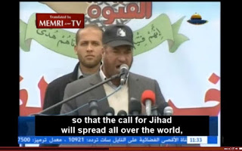
Daniel Greenfield May 12, 2021
Israel is a not a war zone because of geopolitics, but because it shares a common crisis with Europe, America, Russia, China and numerous other countries, most of whom are trying to buy time for their own internal Islamic insurgencies by siding with the Jihadist insurgency inside Israel.
A sizable hostile minority within your borders is always an explosive element, but Islamic migration is unique in that it emerged and still emerges from a tribal and religious manifest destiny of world conquest.
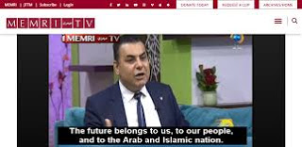
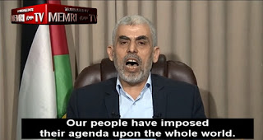
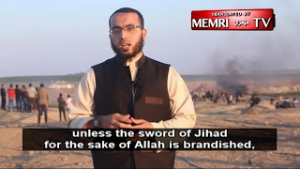
Israel's Islamic minority is particularly hostile because unlike those of America, Europe, Russia, and China it came to the Jewish State as a conquering force and made up the 'Herrenvolk', the colonial master race, within living memory (religiously, if not ethnically under the Ottoman Empire). The hostility was fed by a succession of foreign powers, Britain before and after WW2, Germany in WW1 and WW2, by Russian during the Cold War, by Iran, Qatar, and Russia after the Cold War, but it's still innate.
Tribal hostility is bad enough as even a brief look at Rwanda and African genocides, or those in the Balkans ought to show, but combine that with Islamic manifest destiny and you have a perpetual war.
While the legal fiction that is the international community has kept on pressuring Israel to "resolve" the conflict with territorial concessions, providing the insurgency with dedicated territory has worsened it.
Nor have any of the nations or alliances pressuring Israel to resolve the conflict managed to do it.
The responses have ranged from integration and appeasement in America and Europe, Russia's efforts to convince its Muslims that they have a common enemy in the West, and China's ruthless crackdown. What all these varying efforts have in common is trying to convince or compel a Muslim population to see itself as part of the local nation or empire, to bind its destiny to European liberalism, to the Han Chinese, to Greater Russia, or to American democracy, and not to a global Ummah of which it is a fragmented piece.
Israel's strategy of integrating the Arab Muslim population within randomly defined borders, convincing them to see themselves as part of the Jewish State, while treating those outside those borders as autonomous is even more paradoxical and contradictory than these same failed strategies.
The fragmented Muslim populations of the world are the remnants of an aspiring empire created by centuries of conquests and invasions. Islam convinces them to see themselves as part of that Ummah, a civilizational empire that is meant to encompass the world. Tribalism sharpens the edge of that religious hostility by giving it a personal edge and a familial aspiration.
Critics say that Muslim terrorism kills more Muslims than non-Muslims. That's true, but not much of a defense.
Islamic manifest destiny has traditionally destroyed Muslim societies comprehensively, but then again Roman imperialism and European colonialism destroyed their own societies quite thoroughly. Globalism usually destroys any society arrogant enough to be infected by the fever which is one reason why America is so endangered. It's also why China has survived for thousands of years by xenophobically turning inwards at key moments in its history. That's why China is likely to leave the scene within the next generation, taking its 'prizes' and going home, or will destroy its own society.
Israel doesn't have that option.
The Jewish State isn't suffering from an Islamic insurgency because it wanted to operate on a global scale, but because foreign invading powers, most notably the Syrian-Greeks and the Romans, imposed their dominion using Arab mercenaries. When Byzantium declined and fell, the barbarians they had been using to keep the peace turned on the Eastern Roman Empire, just as the barbarians Goths had turned on the Western Roman Empire, and assembled together a religion from the scraps of Judaism, Christianity, and assorted local pagan faiths based on their imperatives of conquest and domination.
The Islamic conquests failed to assemble any kind of global utopian empire. But then they never had a chance of doing that. They did however destroy countless peoples, eliminate many cultures, and create broken mirror images of the original Mohammedan Jihad with little emirates ruled by little Mohammeds. And they killed countless millions and ushered in a thousand years of tyranny and terror.
The fall of the Ottoman Empire revived Jewish hopes for reclaiming their homeland, but the Zionists had not counted on the endurance of that original war imperative or on the weakness of civilization.
And so the conflict continues.
It continues in Israel, in Europe, and in America, in Russia, and in China, and around the world.
The conflict has been particularly sharp in Israel because where Muslims are a minority in America, China, and (for a limited time before they become a majority) in Europe and Russia, they are a regional majority. And because of the strategic importance of the region, half the world has made it its business to intervene.
Israel's current two major factional antagonists, Fatah and Hamas, are products of the Soviet Union and Nazi Germany.
The Nazis shaped the Muslim Brotherhood and the Soviet Union shaped the PLO with their strategies, tactics, and organizations, so that Israel is fighting both the Communists and the Nazis in its own territory.
But underneath the overlay of Third World liberationism and genocidal nationalist antisemitism familiar from the Soviet and Nazi projects is the old Jihadist manifest destiny and its much older antisemitism.
And while National Socialism has yet to control a major government or play more than a marginal role in America or Europe (though not for a lack of effort by the new generation of 'Hipster Nazis' more familiarly known as the alt-right), Marxism is a major player in American and European politics.
So the campaign against Israel gets plenty of support from the Left. As does Islamic terror in general.
Israel faces a sharper version of the dual crisis of Jihad that the world does.
The first part of the crisis is an internal insurgency while the second part of it is the development of nuclear weapons by Islamic powers like Iran and Pakistan that can destroy civilization (aided and abetted by the familiar Russian, Chinese, and North Korean pipeline for Third World insurgencies).
The Jewish State has adroitly managed to form a temporary alliance through the Abraham Accords with some regional traditional Sunni powers that have become alarmed at the threat of both of Shiite Iran and Islamist transnational ideological groups like the Muslim Brotherhood, but Iran and the Brotherhood have a direct insurgency operating on its soil.
Combine that with the fall of the Trump administration and the rise of a pro-Iran and a pro-Brotherhood Biden regime in Washington D.C. and the current conflict was inevitable.
But it was inevitable anyway.
Iran, Qatar, and various other players have not been investing a fortune in Hamas and other terrorist groups just to have them sit on the money. After a certain number of years they start a war to test Israel's defenses, military and diplomatic, leading to chaos, carnage, and a pressure for more concessions.
This time is no different.
The roots of the crisis are ancient, but they're also more recent. When confronting a civilizational Jihad, it takes only mistake. And a bad Israeli government mad that mistake in the 90s by agreeing to create an autonomous territory for the insurgents. Another bad government made another one a decade ago by withdrawing from Gaza and leaving it as a truly autonomous territory governed by Hamas.
Both moves were based on a fundamental misunderstanding of the resulting consequences.
Modern Islamic governments pursue utopian socialist schemes using a corrupt ruling class, much like the Communists and the Nazis, resulting in corruption, economic disaster, and external conflict.
Hamas and the PLO/Fatah, like ISIS, is no more capable of running a functional government.
Instead humanitarian NGOs, in this case UNRWA, provide some basic services for the population while the Jihad forges onward to kill and kidnap its enemies operating much like organized crime.
(A lot of Democrat inner cities run on the same gang warfare slash welfare state principle.)
Autonomy never does anything other than expand and spread the crisis. Treaties just define the starting point for the next phase of the conflict. Negotiations are a theater for extracting the maximum amount of concessions as a starting point for the next war whether it's with Iran, the PLO, or any Jihadists.
Israel hasn't figured out how to resolve the problem. But neither has anyone else in the world.
And there may be no answer.
The world is facing a 7th century crisis and trying to deal with it through 21st century means.
To be modern means believing that all problems have answers whereas to be postmodern is to believe that the answer is to repent of our past. The modern approach has led to ceaseless negotiations while the postmodern approach has meant endless appeasement and apologies for our past misdeeds.
Neither the modern nor postmodern way has done anything other than play into the hands of the Jihad.
Netanyahu, like other conservative Likud leaders, has appeared modern while eschewing modernity's preference for pat solutions and postmodernity's apologies and appeasement. And so Israel has been living in a premodern moment, adapting rapidly to circumstances as it has in some ways throughout its modern existence. But that's a survival strategy and not a healthy one either.
Israelis tend to take each day as it comes.
Flying El-Al is very different than flying normal airlines. Everything appears unready even minutes before boarding. The orderly process of boarding by class and status in most airlines is present only in theory as everyone rushes to get on board. It seems impossible that this whole thing should work or that the plane should take off in time. And yet it does, more reliably than most airlines, and works out.
That's Israel in a nutshell. And it's a familiar observation for Americans in Israel.
Israelis are always in crisis mode and they take one crisis at a time, and what ought to be a shambles somehow turns around. It's frustrating to the modern mind and many Americans can't take it.
Yet Israel persists.
But that perpetual crisis mode, a legacy of thousands of years of Jewish history, may offer few lessons to the world. Crisis mode works until it doesn't. And then the failure can be catastrophic.
Israel has fought an almost impossible war bravely, gallantly, and dashingly, jumping from one innovation to another, and then being miraculously rescued with that familiar certainty that neither it nor the Jewish people could exist without a G-d who intervenes invisibly at crucial moments so that the survivors of the ashes of the death camps went on to defeat enemy armies and found a nation.
But the world needs a better answer.
The answer may not be simple, but it begins with countries recognizing that they share a common problem and after generations of 'bargaining' with the Jihad, recognizing that we're all facing the same war, and that across cultures and even political affiliations, the West and the East, Right and Left, we may be enemies, but we also share a common enemy. One whose assault civilization may not survive.
We can either unite against the Ummah, that embryonic empire of Sharia and Jihad, whose boundaries are those of the world, or we can cut our separate deals with its separate parts, which will all fail.
And then we will fail and fall with them. http://www.danielgreenfield.org/2021/05/israels-jihad-crisis-is-worlds-jihad.html
Dr. Anthony S Fauci: America’s Angel of Death, Part One
By Cherie Zaslawsky|May 13th, 2021
“That one may smile, and smile, and be a villain.” –Hamlet, Act 1, Scene 5
Hollywood celebrities recently honored Dr. Fauci with an award for “courage” during a virtual gala for the AIDS Foundation. The glitterati heaped praises on the doctor, best summed up by actor Morgan Freeman who thanked him “for all of his efforts to keep as many of us alive as possible.”
So much for Hollywood virtue signalers. Now let’s do some fact-checking to determine exactly what we can thank Dr. Fauci for:
Funding outlawed gain-of-function research at the Wuhan Institute of Virology where fiendish scientists figured out how to make bat viruses “species-jump” to humans, and without which the pandemic of 2019-2020 would never have happened. Think about that. And see the recent article by Nicholas Wade.
Dictating the draconian lockdown of America, putting the public under virtual house arrest, destroying the livelihoods of millions of our citizens, and driving many to despair and some to suicide, while killing others via denial of normal medical care to “make room” for the millions of Covid hospitalizations that never materialized
Declaring Hydroxychloroquine (HCQ) “ineffective”, thereby condemning thousands to death who never got this highly successful treatment
Pimping for Moderna and Pfizer experimental mRNA “vaccines” that have already resulted in thousands of deaths–3,848 listed in VAERS as of April 2021—and an additional 44,606 “adverse events”, including stroke and paralysis.
WHAT DID FAUCI KNOW AND HOW DID HE KNOW IT?
Interestingly, as the keynote speaker at Georgetown University’s forum on January 10th, 2017, just days before Trump’s inauguration, Dr. Fauci chose as his topic: Pandemic Preparedness in the Next Administration. Here are a couple of quotes:
“There is no question that there will be a challenge to the coming administration in the arena of infectious diseases…but also there will be a surprise outbreak..”
“The thing we’re extraordinarily confident about is that we are going to see this [outbreak] in the next few years.”
Um…Tony… just curious: If this pandemic outbreak would come as a complete surprise to President Trump, how did you happen to know about in advance? That wouldn’t have anything to do with your agency’s sneaking around Congress to fund “gain-of-function” virus research in Communist China’s Wuhan bioweapons lab now, would it?
HOW THE FAUCH STOLE CHRISTMAS
Remember how shocked we were watching videos of Wuhan—a city of over 8 million people—turned into an eerie, empty ghost-town on the orders of the CCP, as we breathed a collective sigh of relief to be living in America? When asked on January 23, 2020, if such a thing could happen in the US, Fauci himself said, “There’s no chance in the world that we could do that to Chicago or to New York or to San Francisco,” Then on March 8, he described China’s lockdown as a “draconian” measure that wouldn’t be “feasible” in America.
So far so good.
But a few days later Dr. Flip-Flop changed his tune: suddenly a nationwide 2-week shutdown seemed like a bright idea. And we all know how that went. Not only did the Fauch steal Christmas, he stole Easter, Independence Day, Thanksgiving and New Year’s Eve as well as cancelling our weddings, birthdays, anniversaries, graduations, baptisms, bar mitzvahs, vacations, sporting events, concerts, theater, and even memorial services for loved ones we lost.
FLATTEN THE CURVE, SLOW THE SPREAD, SCRAP YOUR LIBERTY
So how was Dr. Faustus able to smoothly pull off this diabolical turnaround from a mere two weeks to the foreseeable future, and make it stick? Of course he had plenty of help from both our own subversive media, and that of the UK and others, in addition to Johns Hopkins’ phony baloney “Dashboard” tracking Covid “cases” and predicting a terrifying geometric progression of fatalities.
But Fast Tony did something very crafty on his own as well. He assured us that though we felt fine and had no symptoms and just plain weren’t sick, we were likely harboring this supposedly highly contagious pandemic virus. Overnight, We the People were christened as “asymptomatic carriers.” Therefore, we all had to submit to the very “draconian lockdown measures” he’d assured us would never be used in America. After all, we were “all in this together.”
So the premise underlying the whole government-driven agenda—over a year and counting—that upended our country and our lives, is asymptomatic contagion.
And what pray tell does Dr. Fauci have to say about this phenomenon? Prepare for a shocker: “In all the history of respiratory-borne viruses of any type, asymptomatic transmission has never been the driver of outbreaks. The driver of outbreaks is always a symptomatic person.” Translation: Asymptomatic transmission is negligible! No one who’s not coughing and sneezing close to you can make you sick!
So what happened to “trust the science, Tony?” Because if we’d followed the science you just admitted to, there would have been no lockdowns, no quarantining of healthy people, no masks, no “social distancing,” no testing of healthy people—in short, no shutting down of America.
FORKED-TONGUE FAUCI BAMBOOZLING AMERICA
Remember also that Dr. Fauci, while scaring the daylights out of Americans, quietly co-authored an article in the highly esteemed New England Journal of Medicine opining that Covid-19 had the profile of a bad seasonal flu, no worse than what we’d seen dozens of times in the past. Here’s the “cya” (cover your arse) conclusion:
“If one assumes that the number of asymptomatic or minimally symptomatic cases is several times as high as the number of reported cases, the case fatality rate may be considerably less than 1%. This suggests that the overall clinical consequences of Covid-19 may ultimately be more akin to those of a severe seasonal influenza…” .
And let’s keep in mind that in 2020, as a top advisor on the Covid Task Force under VP Judas Pence, Dr. Faustus singlehandedly discredited the highly effective cure for Covid-19: Hydroxychloroquine plus zinc and Z-pack, which have been used successfully around the world. Yet, no doubt to make Trump look bad, as well as deflecting attention back to Big Pharma’s vaccine juggernaut just around the corner, Fauci assured the nation that HCQ was unproven and unsafe—thereby costing thousands of Americans their lives. And in case you’re entertaining the idea that Fauci made an honest mistake, allow me to disabuse you of that notion. The Fauci-led National Institutes of Health had published research in August of 2005 in their own Virology Journal entitled, “Chloroquine is a potent inhibitor of SARS coronavirus infection and spread.”
Perhaps you can tell us, Herr Doktor, why you were so terribly cautious over the salutary use of HCQ in an emergency situation when it had been shown in the field to be saving lives, but so reckless in brazenly promoting experimental gene-modifying “vaccines” to the entire American population? Not enough studies on hydroxychloroquine to suit you? So where are the “randomized placebo controlled” long-term studies of the Pfizer and Moderna concoctions, Tony?
VOICES CRYING IN THE WILDERNESS
Why haven’t we been warned that people who get these mRNA vaccines at present are guinea pigs participating in an experimental trial of a new and apparently dangerous medical intervention? Well, some brave and honest souls have been sounding the alarm. Let’s see what a few of them have to say.
Dr. Sherri Tenpenny has been in the forefront of medical researchers studying the Covid inoculations with their novel mRNA delivery system, which she describes as a “very well-designed killing machine”. She refuses to even call the Moderna, Pfizer and Johnson & Johnson shots “vaccines”, since they are altogether different in concept and delivery from any vaccine heretofore given, and are so dangerous, Dr. Tenpenny has discovered no fewer than twenty “mechanisms of injury” these injections are likely to cause.
Dr. Peter McCullough, renowned in his field of cardiology and internal medicine, professor, and editor of two medical journals, has this to say: “If COVID-19 had been treated early with out-patient, successful therapies (e.g., HCQ, Ivermectin, monoclonal antibodies), 85% of hospitalizations and deaths could have been prevented.” This is astounding—and utterly damning. It means that 85% of the Covid deaths and hospitalizations, as well as the shutting down of our country with all the attendant misery, can be laid at Feckless Fauci’s door. Depending on whether we use the “died from Covid” or “died with Covid” numbers, that’s tens of thousands to hundreds of thousands of needless deaths—far surpassing the record of Tony’s buddy Andrew Cuomo, responsible as he is for some 8,000 deaths of frail elderly in nursing homes—the very people we shut down the country to protect.
And here’s McCullough on immunity: “People who develop COVID have complete and durable immunity. And (that’s) a very important principle: complete and durable. You can’t beat natural immunity. You can’t vaccinate on top of it and make it better. There’s no scientific, clinical or safety rationale for ever vaccinating a COVID-recovered patient. There’s no rationale for ever testing a COVID-recovered patient.”
Dr. Michael Yeadon, formerly one of Pfizer’s top scientists, goes further: “I’m well aware of the global crimes against humanity being perpetrated against a large proportion of the worlds population…I have absolutely no doubt that we are in the presence of evil (not a determination I’ve ever made before in a 40-year research career) and dangerous products.”
He elaborates: “For example, if someone wished to harm or kill a significant proportion of the world’s population over the next few years, the systems being put in place right now will enable it. It’s my considered view that it is entirely possible that this [Covid inoculations] will be used for massive-scale depopulation.”
ANOTHER AWARD FOR THE POISONER
It is the bitterest of ironies that the March of the Living, an organization that honors the memory of the 6 millions Jews who perished under the Third Reich, chose to bestow its “Moral Courage in Medicine” award on this year’s Holocaust Remembrance Day to none other than Dr. Anthony Mengele Fauci—the man arguably most responsible for shutting down America, annihilating small businesses, gut-punching the working and middle classes, discrediting proven cures for Covid—and thereby effectively sentencing thousands of patients to death—and last but not least, pushing the experimental, non-FDA-approved, genetically manipulating “vaccine” onto millions of unsuspecting human guinea pigs, thousands of whom have already died in just the first few months of these inoculations.
FAUCI’S COHORTS AND MASTERS: THE DAVOS CABAL RESET GANG
As culpable as Fauci may be, he’s not the head of this snake. There are extremely powerful players behind him, as we can deduce from the nearly worldwide censorship that keeps the game-changing facts about Covid, the “plandemic,” and the dangers of the gene-altering vaccines out of sight in the conspiratorial mainstream media.
Add to that the censoring of whistleblowers by Google, Facebook, Twitter, etc., the daily dose of fear-mongering on the one hand, and pro-vaccine propaganda on the other from CNN et al., and we can understand how millions of Americans have been duped into getting a jab of “protection” that they may come to regret as long as they survive, which may not be long at all.
Speaking of snakes, we can find Fauci’s pal Bill Gates’ fingerprints in every aspect of the Covid histoire, from sponsoring Event 201 that “predicted” the plandemic a couple of months before it occurred, to funding Moderna’s first ever “vaccine” project brought to market, and more. Vaccines are a massive money-maker for Gates, and not bad for Fauci either, whose agency owns many patents and reaps enormous financial rewards from Big Pharma.
In fact, when Gates launched his “Decade of Vaccines” in January, 2010, along with the usual suspects: the United Nations, the World Health Organization (WHO), and UNICEF, guess who else jumped right onto this warped bandwagon: none other than Dr.Tony Fauci, head of the National Institute of Allergy and Infectious Diseases (NIAID).
Since Fauci’s NIAID is so intertwined with Gates’ mass vaccination program, we may be forgiven for wondering whether the doctor, in his insistence on vaccination for all, has been merely following orders, or is driven by the prospect of his conflict-of-interest vaccine royalties. Then again, he might simply be intoxicated by his newfound power and celebrity status. My best guess is all of the above, plus an added bonus: duper’s delight—the telltale smile of one who knows he’s got you fooled. I’ll wager he enjoyed that bit of theater where he got “vaccinated” in public with, I’m guessing, a syringe full of harmless saline.
THE FAUCIAN BARGAIN: A CATASTROPHE IN THE MAKING
But there may be another agenda at work here as well, as suggested by Dr. Yeadon above. Let’s not forget that Gates, like a number of billionaire elites, is a big fan of “depopulation”—decreasing the human population to, you know, lower carbon emissions and save the planet. Could this be why Gates, Ted Turner and other pooh-bahs in the New World Order club, give millions to the U.N., which is the front for this agenda, aka Agenda 2030? Here’s one of earlier U.N. documents on this subject, from 1992:
“The present vast overpopulation, now far beyond the world carrying capacity, cannot be answered by future reductions in the birth rate due to contraception, sterilization and abortion, but must be met in the present by the reduction of numbers presently existing. This must be done by whatever means necessary”. Initiative for the United Nations ECO-92 EARTH CHARTER.
We should also recall that the Luciferian globalist elites always subtly announce their intentions, perhaps believing this increases the potency of their nefarious plans. I’ve also read that when there’s no massive protest, they take it to mean We the People have consented! Keep this in mind as you ponder the mysterious Georgia Guidestones monument—an eerie Stonehenge-like structure erected in Elbert County, GA, in 1980, inscribed with what seems to be a parody of the Ten Commandments. The first of these “guiding” statements should concern us most: Maintain humanity under 500,000,000 in perpetual balance with nature. Considering that the world population today is nearing eight billion, this means that over six-billion people would need to be exterminated to fulfill what may well be the Cabal’s plan. And it doesn’t look like they intend to wait to gently curb population over the next 200 years.
So no, Dr. Evil, We the People don’t condone your getting an award for “morality” any more than we condone Andrew Cuomo’s Emmy for committing the mass murder of helpless elderly people in New York under his watch by forcing nursing homes to take sick, contagious people back from hospitals, rather than sheltering them on the capacious, fully equipped Navy hospital ship, the USNS Comfort, that President Trump sent to New York, or using the Javits Center or empty hotels—all of which would have saved many thousands of lives. And don’t forget that Fauci praised Cuomo’s response to Covid-19; these two are birds of a feather. Birds of prey.
When, months from now, we witness the carnage these “vaccines” are likely to cause, it may be time for a new version of the Nuremburg Trials, and I, for one, nominate Dr. Anthony Fauci to be tried as one of the chief perpetrators of this new genocide, along with Bill Gates, and the NWO Great Reset honchos–George Soros, Klaus Schwab and the rest of the psychopathic global “Elites” who insist on playing God while doing the devil’s work. https://newswithviews.com/dr-anthony-s-fauci-americas-angel-of-death-part-one/

THE SHORASHIM BIBLICAL GIFT CATALOG 005
http://mad.ly/7f9f64?pact=20013931524&fe=1
Support Shorashim!

ARUTZ SHEVA
Hotovely on the BBC: Would you have sat quietly if London had been attacked?
Israel’s Ambassador to the UK: At this time, all democracies should stand by Israel in the fight against Islamic terrorism.
Shimon Cohen , May 14 , 2021 4:05 AM
Israel’s Ambassador to the United Kingdom, Tzipi Hotovely, has in recent days conducted interviews with the foreign media, as part of Israel's public diplomacy campaign in the international arena.
Among others, Hotovely was interviewed by CNN, Sky News and a number of programs on the BBC.
In an interview with Sky News, Hotovely blasted the Palestinian Authority envoy to Britain after he accused Israel of ethnic cleansing, saying, "I have never heard such hypocritical things. Jews and Arabs have lived side by side in Jerusalem for years. Those young Arab provocateurs are the ones who hurt this fabric. They are the ones who need to provide explanations as to why they are attacking innocent Jews in the city."
In an interview with the BBC, Hotovely said, "Jerusalem is not a settlement and Jews are not settlers in their country. The State of Israel gives Muslims full freedom of worship on the Temple Mount, but unfortunately they took advantage of the holy site to launch a violent attack on innocent Israelis."
"Would you have sat quietly if London had been under constant missile attack? At this time, all democracies should stand by Israel in the fight against Islamic terrorism," Hotovely stated. https://www.israelnationalnews.com/News/News.aspx/306199

US evacuates personnel from Israel as IDF eyes ground operation
IDF preparing for possible ground operation, army official says, as US airlifts military and civilian personnel out of Israel
David Rosenberg , May 13 , 2021 8:24 PM
IDF deploys more tanks to Gaza border, May 13th 2021
Noam Revkin Fenton/Flash90

The US has pulled out 120 personnel from Israel, as terrorist rocket attacks on the Jewish state continue, CNN reported Thursday.
According to the report, the personnel include both military service members and civilian workers.
The personnel departed Israel via a C-17 transport aircraft, flying to the Ramstein air base in Germany.
An Israeli military spokesperson said that the IDF is amassing forces on the border with the Hamas-ruled Gaza Strip, and that Israeli forces are “preparing themselves for ground operations,” The Independent reported.
Earlier on Thursday, Defense Minister Benny Gantz green lighted the call up of an additional 9,000 army reservists.
Some 1,800 rockets have been launched at Israel from the Gaza Strip since Monday, including 160 rockets launched on Thursday.
A total of 300 rockets have landed inside the Gaza Strip, including 30 of the rockets fired Thursday, the IDF said.
Seven people have been killed in Israel by terrorist rocket and missile attacks since Monday, with more than 200 others injured.
The Gaza Strip’s health authority has reported 87 dead from Israeli retaliatory strikes, along with 530 injured. https://www.israelnationalnews.com/News/News.aspx/306179

450 bombs in 35 minutes: This is how the IDF tricked Hamas
IDF publishes unclear notice - causing Hamas to panic, escape into terror tunnels.
Arutz Sheva Staff , May 14 , 2021 1:49 PM
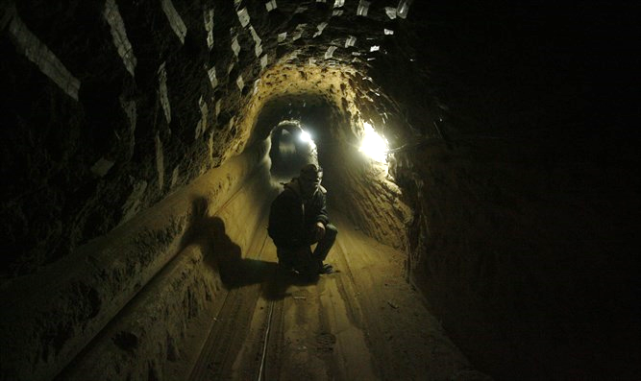
Terror tunnel Photo by Abed Rahim Khatib/Flash90

Just after midnight on Friday morning, Israel announced that "air and ground forces from the IDF are now attacking in Gaza. More details to follow."
The military columnists in Israel understood that this meant the armored corps and artillery deployed near Gaza will attack, but the unclear notice led foreign reporters to report the beginning of a ground operation in Gaza.
Now it has been clarified that the unclear announcement was a planned trick by the IDF to eliminate a large number of Hamas terrorists within a short time.
Infantry, artillery, and tanks were moved towards the IDF border, and Hamas believed that Israel was about to begin a ground invasion. As a result, Hamas sent its fighters into its underground tunnel system beneath Gaza City. https://www.israelnationalnews.com/News/News.aspx/306223
To be removed from this News list, Please click here and put "Unsubscribe" in the subject line.

05/13/2021 NEWS AM
Israel's 'Smart Shooter' Revolutionizes World of Military
https://www.youtube.com/watch?v=91sf7B6WpbI
"When we have begun to take charge of our lives, to own ourselves, there is no longer any need to ask permission of someone."
-- George O'Neil (1896-1940) American poet, playwright, novelist and film writer
Read the Prophets & PRAY WITHOUT CEASING!
That is the only hope for this nation!
Please  Remember  These  Folks  In  Prayer-  Check often  They  Change! | Pray that the world would WAKE UP! Time for a worldwide repentance!  ALL US soldiers fighting for our freedom around the world  Pray for those in our government to repent of their wicked corrupt ways.  Pray for AB family – Wife just diagnosed with brain tumor  Pray for EL – multiple problems  Pray for AS – post knee replacement – some problems and another one scheduled.  Pray for TR – abnormal Mammogram having double biopsy – Mastectomy Scheduled  Pray for ZH - having trouble with PTSD  Pray for LAC – recurrent cancer getting treatment  Pray for KL – troubling spiritual situation.  Pray for Ella – emotionally disturbed abused child and brother with ? heart problem  Pray for JN – Neuro disease  Pray for MS – Job issues and change  Pray for BB – Severe West Nile Fever –still not mobile- improving!  Pray for RBH – cancer recurrence  Pray for Felicia – post op problems – continuing  Pray for SH and family – lady’s husband passed away and she is in Nursing home. Not doing well.  Pray for MP – Very complex problems  Pray that The Holy One will lead you in Your preparations for handling the world problems. – Have YOU made any preparations?
Genesis 27:⁴¹And Esau hated Jacob because of the blessing with which his father had blessed him. And Esau said in his heart, The days of mourning for my father are near; then I will kill my brother Jacob. ⁴²And the words of her older son Esau were told to Rebekah. And she sent and called her younger son Jacob. And she said to him, Behold! Your brother Esau is going to ease himself on you, to kill you. ⁴³And now, my son, listen to my voice, and rise, flee for yourself to my brother Laban, to Haran. ⁴⁴And stay with him some days until your brother's fury turns away, ⁴⁵until your brother's anger turns back from you, and he forgets what you have done to him. And I will send and take you from there. Why should I also be bereaved of two of you in one day? ⁴⁶And Rebekah said to Isaac, I am weary of my life from the daughters of Heth. If Jacob takes a wife from the daughters of Heth, like these from the daughters of the land, what is my life to me?

Gaza rocket volleys target south at dawn as IDF hits key Hamas positions
Military bombs Hamas treasuries, internal security HQ, naval commandos and bunker under a school; 8 Israelis injured as rocket sparks fire in Petah Tikva
By Judah Ari Gross and TOI staff Today, 9:29 am
Palestinian terrorists in the Gaza Strip renewed rocket fire into Israel at dawn Thursday after a three-hour lull in attacks overnight. Meanwhile, the Israel Defense Forces continued to attack what it said were key Hamas targets, destroying the terror group’s treasuries and hitting more top leaders.
Rocket sirens sounded in areas around the Gaza Strip on Thursday morning, with no immediate reports of injuries or damage. The predawn attacks were relatively modest compared to the massive barrages that were fired into Israel during the two preceding nights.
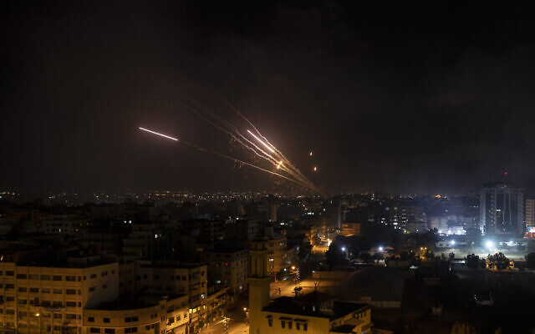
Rockets are launched from the Gaza Strip towards Israel, Wednesday, May 12, 2021. (AP Photo/Khalil Hamra)

Yet, in light of the ongoing rocket fire toward central Israel, Ben Gurion Airport was closed to incoming commercial flights on Thursday morning, with planes being diverted instead to Ramon Airport north of Eilat. Private planes and freight aircraft were still permitted to land at Ben Gurion, and departures were allowed to continue as normal, an Israel Airports Authority said.
Some 150 rockets and mortar shells were fired from the Gaza Strip at Israel from 8 p.m. Wednesday to 6 a.m. Thursday, 24 of which landed inside the Palestinian enclave, according to an IDF tally. In total, Palestinian terrorists have fired nearly 1,500 projectiles toward Israel since the outbreak of fighting on Monday evening, with roughly a fifth landing inside Gaza, the IDF said.
Dozens to hundreds of the projectiles heading toward Israel have been intercepted by Iron Dome missile defense batteries, according to the military, which refuses to give precise statistics on the matter as they could be used by terror groups to find ways to outmaneuver the system. The IDF on Thursday said the air defense system had a roughly 90 percent interception rate of rockets and mortar shells heading toward populated areas.
In the most serious rocket attack overnight, two people were moderately injured by shrapnel and six others were treated for smoke inhalation after a Hamas rocket from Gaza struck in between homes in Petah Tikva shortly after midnight, sparking a fire. The buildings near the fire sustained moderate damage.
On Wednesday night and Thursday morning, the Israeli military expanded its targets in the Gaza Strip to include institutions that Hamas uses to rule the Palestinian enclave, notably its treasury and banks, IDF Spokesperson Hidai Zilberman said.
In addition, the Israeli Air Force bombed Hamas’s internal security headquarters, which was used in counterintelligence operations, destroyed the home of Iyad Tayeb, a battalion commander in Hamas’s military wing, and killed a squad of Hamas’s naval forces, Zilberman said. MORE - https://www.timesofisrael.com/rocket-volleys-target-south-at-dawn-as-idf-hits-key-hamas-positions/

Northern Israel struck in latest midnight barrage of Gaza rockets
The five-year-old boy succumbed to his wounds several hours after a direct hit to his Sderot home. Several hours earlier an IDF soldier was killed in Hamas anti-tank missile attack.
By ANNA AHRONHEIM, SARAH BEN-NUN, TZVI JOFFRE MAY 13, 2021 03:33
After several hours of quiet, rocket fire resumed early Thursday, and sirens were heard in Ashkelon and the surrounding regions. They also sounded across the center and south of the country, as well as northern Israel, as far as the Galilee region. One rocket is reported to have directly hit Rishon Lezion, and another in Petah Tikva.
Five people are being treated for minor injuries in Petah Tikva, several of them caused by anxiety and smoke inhalation.
Israel's security cabinet on Wednesday night approved the recommendation of IDF Chief of Staff Lt.-Gen. Aviv Kohavi to escalate retaliatory airstrikes into the Gaza Strip. Defense Minister Benny Gantz is briefing members of the Knesset as Prime Minister Benjamin Netanyahu declared that Israel will not accept a ceasefire with Hamas and Palestinian Islamic Jihad.
An IDF soldier was killed by an anti-tank missile early Wednesday morning and a five-year-old boy was killed later in the day when a rocket scored a direct hit on his family's apartment building in Sderot. More than 1,200 rockets have been fired into Israel since the fighting began on Monday.
A rocket barrage was launched toward central Israel on Wednesday evening and sirens sounded in Tel Aviv and throughout the South as Hamas launched the rockets to avenge the deaths of its top commanders by Israel earlier in the day.
Two people were reportedly injured in a terrorist attack in the West Bank (Samaria) late Wednesday night, and the terrorist was neutralized on the spot, according to the IDF. The incident is under review.
The rockets either fell in open areas or were intercepted by the Iron Dome missile defense system. In Ashkelon though, one of the rockets scored a direct hit on a home, causing extensive damage to one of the bedrooms. A child had been sleeping there moments earlier and was whisked to safety when the sirens sounded.
Earlier in the day, IDF St.-Sgt. Omer Tabib was killed and three other soldiers were injured after a Hamas-fired Kornet anti-tank guided missile (ATGM) hit his jeep near the Gaza border. The attack came after a night of intense rocket barrages toward the center of the country. MORE -https://www.jpost.com/israel-news/four-dead-from-latest-wave-of-rockets-aimed-at-central-israel-667902

6-year-old critically hurt, dozens others injured as Gaza rockets pound Israel
Fresh volleys target south, center of country; boy struck by shrapnel that penetrated window of fortified room during major Hamas barrage; IDF levels 14-story building in enclave
By TOI staff Today, 9:59 pm

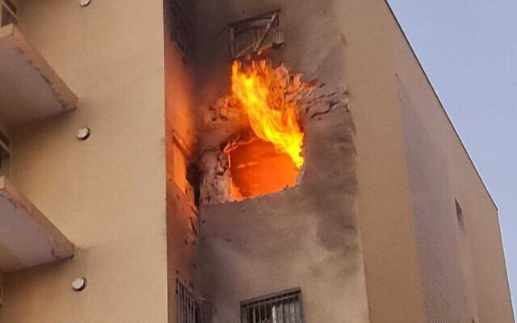
The scene of a direct rocket hit on a building in Sderot, southern Israel, on May 12, 2021 (Sderot Municipality)

At least 20 Israelis were hurt, including a six-year-old boy in critical condition, as Gaza-based terrorists fired a fresh volley of rockets, setting off warning sirens Wednesday night in the Tel Aviv metropolitan area and cities in the south.
According to the Israeli army, 180 rockets were fired at Israel since 6 a.m. on Wednesday, of which 40 fell in Gaza. Dozens of the incoming projectiles that were heading toward populated area were intercepted by the Iron Dome missile defense system, the Israel Defense Forces said. In total, nearly 1,300 rockets and mortar shells have been fired at Israel since the start of the fighting on Monday evening, according to the IDF’s tally.
The Gaza-ruling Hamas terror group said it fired a massive barrage at Israel on Wednesday night that included 130 rockets in retaliation for a strike on a multi-story building in Gaza City. The Palestinian Islamic Jihad terror organization also said it fired volleys of rockets at the Jewish state.
The latest barrage saw some rockets directly hit buildings. The city of Ashkelon came under a particularly heavy rocket bombardment, with the army telling residents to remain in fortified areas for several hours.
In the Gaza border town of Sderot, seven people were hurt, including a young boy in a direct hit on a building. The boy’s mother grabbed him and took him to the fortified room when the incoming rocket sirens sounded, Channel 12 news reported. But in a rare incident, the rocket shrapnel broke through the shelter’s window, critically injuring him and also wounding his mother.
The Magen David Adom ambulance service said among the others hurt in Sderot, two were in moderate condition, a 40-year-old woman and a 5-year-old boy.
The rest of those wounded suffered mild injuries.
מצבו של הילד שנפצע בפגיעה הישירה בשדרות מוסיף להיות אנוש. הוא נפגע מרסיס שחדר מהחלון של הממד בו שהה@DanaYarkechy @Itsik_zuarets pic.twitter.com/DswQZibPyz
— כאן חדשות (@kann_news) May 12, 2021
A paramedic said the missile struck an apartment in a nearby residential building, sparking a fire, but no one was in the building. He said rescue workers then went to the adjacent building where they found the six-year-old unconscious with shrapnel wounds. Medical personnel gave him urgent treatment and rushed him to the local hospital.
A rocket also struck a home in the southern coastal city of Ashkelon. There were no immediate reports of injuries from the direct hit.
הירי לדרום | תיעוד מתוך הבית באשקלון שספג פגיעה ישירה@Itsik_zuarets pic.twitter.com/krTTGYT5iW
— כאן חדשות (@kann_news) May 12, 2021
Police said they are deployed at 14 sites in Ashkelon following rocket attacks on the city, and in three sites in Sderot. It is not clear whether each of the sites was hit by a rocket or shrapnel.
Also in the south, several communities in the southern Sha’ar Hanegev area have lost power following the latest rocket barrage from Gaza, a spokesperson for the municipality said, and an empty kindergarten was hit. The spokesperson said the rockets also sparked a fire.
Hamas said the initial barrage was a response to Israel’s leveling of the al-Shourouk tower, which Israeli fighter jets demolished after repeatedly warning those inside to leave, according to reports from the Strip.
The Israel Defense Forces said the 14-story building housed the offices of Hamas’s military intelligence office and “communications infrastructure that was used to transfer tactical-military messages by the terror groups.”
“The IDF will continue to attack terror targets as long as required,” the military said in a statement.
Al-Shourouk was the third high-rise building containing more than 10 stories to be destroyed by the IDF in this current round of fighting.
مشهد تدمير قوات الاحتلال الصهيوني لبرج الشروق وسط مدينة #غزة.. "إسرائيل" تهدم الأبراج السكنية. #فلسطين_تقاوم pic.twitter.com/36BAFRPGrJ
— Yasser (@yasserashour95) May 12, 2021
According to Gaza news outlets, the security manager of the building was told to evacuate the structure and it was hit by a number of so-called “knock on the roof” attacks, in which non-explosive missiles are dropped on a building to warn those inside to exit, before larger bombs dropped by fighter jets destroyed the building.
The IDF also said one of its aircraft bombed a Palestinian Islamic Jihad team as it was preparing to launch rockets into Israel from the central Gaza Strip.
“The cell was attacked as it was making preparations for rocket launches at Israeli territory,” the military said.
Shortly after, Islamic Jihad’s military wing threatened to send another barrage of rockets toward Israel at 9 p.m.
“The time of glory,” a picture published by the terror group stated, promising “a terrifying death.”
Meanwhile, Defense Minister Benny Gantz appealed to residents of Gaza in an Arabic-language statement released by the military liaison to the Palestinians in which he commented on the Eid al-Fitr holiday marking the end of Ramadan, which began Wednesday evening.
“The last time we met on Eid al-Fitr I was the chief of staff in [Operation] Protective Edge and Gaza is still trying to recover,” he said, referring to the 2014 war in the territory. “Today I’m the defense minister and if the Hamas violence doesn’t stop, the blow of 2021 will be much tougher and painful than that in 2014.”
He said the leaders of Hamas bore full responsibility for the violence and resulting damage in Gaza.
“They are sacrificing you for their own personal reasons. If in Israel people sleep in protected spaces, Gaza will burn. There is no other equation,” Gantz said.
He added: “The terror groups are presenting a false picture that they’re winning, but they’re not! Some of the people are no longer among the living and they won’t be the last ones to part.”

Smoke and a ball of fire rise above buildings in Khan Younis in the southern Gaza Strip during an Israeli air strike on May 12, 2021, in retaliation to rocket fire by Palestinian terror groups in the coastal enclave. (Said Khatib/AFP)

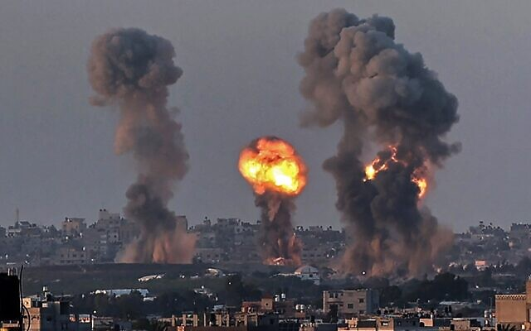
The high-level security cabinet met on Wednesday evening and approved operational plans to expand its strikes in Gaza, according to Channel 12.
Earlier Wednesday, Hamas operatives fired an anti-tank guided missile at an IDF jeep on the Gaza border, killing one soldier and injuring two others along with a civilian who helped pull them from the vehicle, according to Israeli authorities.
Immediately after the missile attack, terrorists in the Strip fired waves of mortar shells at the area, around the community of Netiv Ha’asara just north of the Strip, in an apparent effort to keep medical teams and security forces away.
Staff Sgt. Omer Tabib, 21, from the Nahal Infantry Brigade, who was killed when an anti-tank guided missile struck his jeep north of the Gaza Strip on May 12, 2021. (Israel Defense Forces)

The slain soldier was identified as a member of the Nahal Infantry Brigade’s 931st Battalion, Staff Sgt. Omer Tabib, 21, from Elyakim.
The IDF then launched a series of coordinated strikes in Gaza City and Khan Younis, killing four top commanders in Hamas’s military leadership who were associated with its weapons development and production efforts.
“In addition, 10 other operatives from Hamas’s weapons production and research and development department were killed,” the Shin Bet security service said.
The military said the deaths of those 16 Hamas members — four top leaders, two lower-ranking commanders and 10 others — represented a major achievement for Israel in this round of fighting, though Israeli defense officials anticipated that the killings would likely prompt Hamas and the Palestinian Islamic Jihad to renew their attacks on central Israel.
Shortly after the IDF-Shin Bet strikes, Hamas fired dozens of rockets at the cities of Ashdod and Beersheba, as well as the town of Dimona, home to Israel’s main nuclear reactor.
Before the deadly anti-tank guided missile attack, there had been a brief lull in fighting between the two sides on Wednesday morning. Earlier in the day, the IDF launched massive raids on Hamas targets in the Gaza Strip, as terrorists in the Strip fired large barrages of rockets at central and southern Israel, killing an Arab Israeli man, Khalil Awwad, and his teenage daughter Nadeen.
At least six people in Israel were killed — three on Wednesday and three on Tuesday — and dozens more injured in the attacks from Gaza, some seriously, including a 5-year-old girl in critical condition.
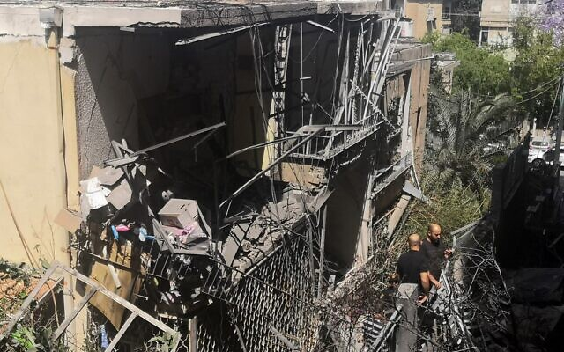
IDF spokesperson Hidai Zilberman said the Iron Dome air defense system had an interception rate of between 85 and 90 percent for rockets heading toward populated areas.

Israelis inspect a damaged house in the Tel Aviv suburb of Givatayim on May 12, 2021, after it was hit by a rocket fired from Palestinian terrorists in the Gaza Strip. (Alexandra Vardi/AFP)

In response to the rocket fire, the IDF launched strikes on upwards of 500 targets in the Gaza Strip, aimed at Hamas personnel, weaponry and infrastructure throughout the enclave, with plans to attack more in the coming hours and days, Zilberman said.
Those included further targeted killings of top Hamas and Palestinian Islamic Jihad commanders and the destruction of a number of high-rise buildings that the IDF said were used by the terror groups as command centers, intelligence bases and weapons research and development facilities, as well as for housing senior members of the terror groups.
According to the Strip’s Hamas-run health ministry, 65 Palestinians have died since Monday night, including 16 minors, and 365 have been wounded. The IDF said more than half of those killed were members of terror groups involved in the fighting and that some, including several of the children, were killed by errant rockets fired from Gaza that fell short of the border and landed inside the Strip, not by Israeli strikes.
The military has also said it was taking steps to avoid Palestinian civilian casualties such as the “knock on the roof” technique. In at least one case on Tuesday, the military actively negotiated with the manager of a building over the amount of time needed to evacuate the structure before the attack. https://www.timesofisrael.com/6-year-old-critically-hurt-dozens-others-injured-as-gaza-rockets-pound-israel/

Palestinian man tries to stab Israeli soldiers in Hebron, is shot — IDF
Assailant said to be in moderate condition after being ‘neutralized’ by troops; no servicemen injured
By TOI staff Today, 8:00 pm
A Palestinian man on Wednesday tried to stab Israeli soldiers at a checkpoint in the southern West Bank city of Hebron and was shot by troops at the scene, according to the military.
The Israel Defense Forces said the assailant had been “neutralized,” without further elaborating. He was reported to be in moderate condition.
None of the soldiers were hurt.
The attempted stabbing followed a number of other recent attacks in the West Bank — including a drive-by shooting earlier this month that killed 19-year-old yeshiva student Yehuda Guetta and injured two others — and as intense fighting between Israel and terror groups in the Gaza Strip dragged on for a third day.
The army on Tuesday said a would-be Palestinian gunman was killed and another was seriously injured after pulling a weapon on troops at Tapuah Junction, the site of the shooting that killed Guetta. But according to Army Radio, the incident was a case of mistaken identity and it remains unclear whether the Palestinians were armed. Both were members of Palestinian intelligence services, a Palestinian security source told AFP, without giving further details. MORE -https://www.timesofisrael.com/palestinian-man-tries-to-stab-israeli-soldiers-in-hebron-is-shot-idf/

Chevron shuts Tamar offshore gas platform as Hamas says it targeted facility
Energy Ministry says it asked the US-based company to shut down the site near Ashkelon a day ago, denies move connected to terror group’s announcement
By TOI staff Today, 6:29 pm
An aerial view of the Israeli 'Tamar' gas processing rig, 23 kilometers off the southern coastal city of Ashkelon. (Moshe Shai/Flash90)

US energy giant Chevron announced Wednesday it was shutting down operations at the Tamar offshore platform at Israel’s request, as Hamas said it targeted the natural gas field amid intensive fighting between Israel and the Gaza-ruling terror group.
“In accordance with instructions received from the Ministry of Energy, we have shut in and depressurized the Tamar platform,” a Chevron spokeswoman told S&P Global. “Chevron’s top priority is the safety of our personnel, our facilities, and the environment of the communities in which we operate.”
The spokeswoman added: “Chevron is closely monitoring the situation and focusing on the safe and reliable supply of gas for the benefit of the Israeli domestic market and to our regional customers.”
The Energy Ministry denied any connection between the shutdown and the Hamas statement. Energy Minister Yuval Steinitz’s office said he gave the order to halt operations at Tamar on Tuesday as an “extra precaution.”
“The minister did so by virtue of his authority, after consulting with security officials and experts in the energy sector,” a statement from Steinitz’s office said.
His office also said “various steps have been taken to ensure the continuation of the gas supply to power plants for industrial factories throughout the country and there’s not expected to be any disruption of the power supply in Israel.”
“All the energy sector’s needs are being supplied in full,” it added.
The statements came as the Izz ad-Din al-Qassam Brigades, the armed wing of Hamas, said Wednesday it targeted a “Zionist gas platform” off Gaza.
The Chevron spokeswoman said operations were continuing at the larger Leviathan gas field off Israel’s northern shore. Tamar is 23 kilometers off (14 miles) the coast of Ashkelon, a southern city that has been pummeled by the ongoing rocket fire that killed two women on Tuesday.
“We are continuing to supply customers from Leviathan and are working with customers and the relevant regulatory bodies to ensure that gas supplies continue in a safe and reliable manner,” she said.
Israel has previously shuttered Tamar during fighting between the military and Palestinian terrorists in Gaza. When Steinitz ordered operations to stop there in May 2019, Tamar was the country’s only operating natural gas source as Leviathan had not yet begun pumping gas, causing power stations to use other fuels to meet electricity demands.
The California-based Chevron owns a 39.66 percent share in Tamar through its acquisition of Noble Energy.
The Hamas announcement that it targeted Tamar came after a large tank in Ashkelon belonging to the Eilat-Ashkelon oil pipeline was hit by a rocket; it has been on fire since, with firefighters working to douse the blaze. Israeli authorities have said there is no risk of dangerous chemicals being released into the air, but health officials have instructed residents of the area to remain inside and close their windows.

A fire rages at a refinery in Ashkelon early on May 12, 2021, after it was hit by rockets fired by the Hamas terror group the previous day. (Jack Guez/AFP)

Over 1,000 rockets and mortar shells have been fired from the Gaza Strip toward Israel since the outbreak of fighting on Monday evening, according to the IDF on Wednesday morning. Roughly 200 failed to clear the border and landed inside the enclave, the military said. IDF Spokesperson Hidai Zilberman said the Iron Dome air defense system had an interception rate of between 85 and 90 percent for rockets heading toward populated areas. MORE - https://www.timesofisrael.com/chevron-shuts-tamar-offshore-gas-platform-as-hamas-says-it-targeted-facility/

Police impose overnight curfew in Lod after mass rioting
Clashes break out for 3rd night, police car torched, despite order barring residents of central city from leaving their homes between 8 p.m. and 4 a.m.
By TOI staff Today, 7:15 pm
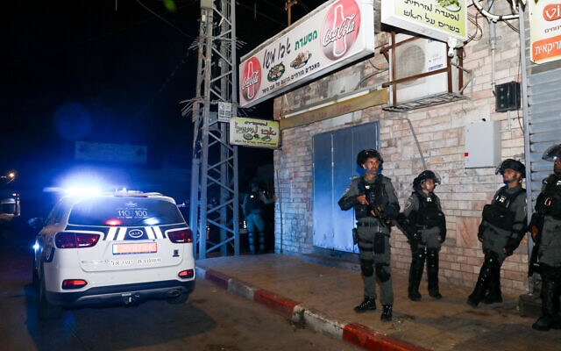
Border Police forces in Lod during riots and clashes between Arab and Jewish residents, December 11, 2021. (Yossi Aloni/Flash90)

Police on Wednesday announced a curfew in Lod between 8 p.m. and 4 a.m. as forces amassed in the central city to prevent a third night of rioting and violence.
Despite the order, violent clashes were reported in the city on Wednesday night and a police car was set on fire, according to Hebrew media reports.
The curfew came hours after a state of emergency was declared in Lod, where intense Arab rioting late Tuesday saw three synagogues and numerous shops torched, along with dozens of cars.
A police statement said the curfew was ordered by Central District Commander Moshe Barkat after a “special” assessment led by Police Commissioner Kobi Shabtai, and that the move was aimed at “safeguarding the well-being, security and property of Lod residents.”
ניידת משטרה הוצתה עכשיו בלוד. pic.twitter.com/yttDBgwJlK
— Moav Vardi (@MoavVardi) May 12, 2021
The only cause to leave one’s home during those hours will be to seek shelter from rockets fired by Palestinian terrorists in Gaza, for medical attention or due to other specifically authorized urgent needs — with police providing the following numbers to seek such approval: Hebrew: 08-9279201/08-9279217
Arabic: 08-9279123
Police warned that anyone violating the curfew could face up to three years in prison.
“The Israel Police asks the public to get prepared in the remaining hours before the restrictions begin and to listen to the instructions of police on the ground,” the statement said. “The police will continue to do everything to ensure the safety of the residents of Lod and the area.”
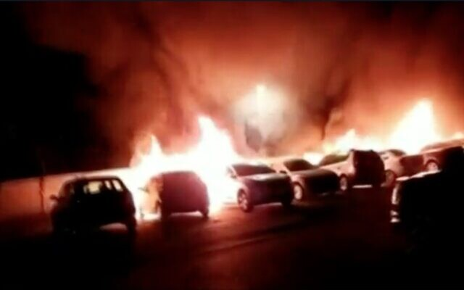
Cars on fire in Lod after being set alight by mobs of rioters, May 11, 2021 (video screenshot)

On Wednesday evening, before the curfew went into effect, some rioting was reported in the city. A short while before the curfew went into effect, a rocket alert siren sounded in Lod. It was met with fireworks and cheers from some Arab residents, according to Channel 12.
The clashes continued past the 8 p.m. deadline.
On Wednesday morning, Israel ordered a massive boost to police forces deployed in cities with Jewish and Arab populations, with several Border Police companies urgently dispatched to restore order in Lod after a rare state of emergency was declared.
A state of emergency gives police officers more authority and freedom to operate in the locality where it was declared. They can close off areas of the city, enter any place to carry out their duties and employ “reasonable force” to compel civilians to obey their orders.
On Tuesday, some Lod residents said power was cut in their homes and Molotov cocktails were thrown through their windows, and police acknowledged having to escort residents from a community center to their homes as Arab mobs marauded in the streets, according to Channel 12.
A local man, 56, was seriously hurt when a rock slab hit his car, and was hospitalized. Another local resident was also seriously hurt.
The mayor, Yair Revivo, said City Hall and a local museum were also attacked, and compared the situation to the Nazis’ 1938 Kristallnacht pogrom. “Civil war” was breaking out, he said, lamenting that decades of coexistence efforts had collapsed.
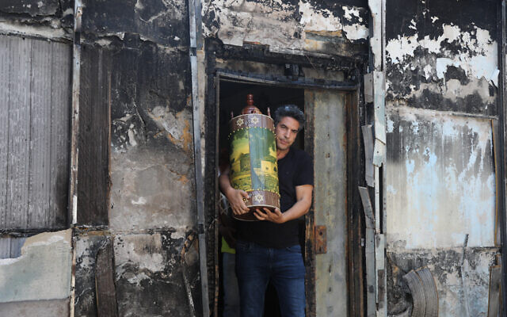
President Reuven Rivlin on Wednesday called the violence a “pogrom” carried out by “bloodthirsty” Arab rioters, while Prime Minister Benjamin Netanyahu said it was reminiscent of dark periods in Jewish history. Netanyahu visited the city during the night to oversee the efforts to impose order and end the riots.
Footage posted on social media showed a torched synagogue and two Torah scrolls being salvaged — unharmed — from its ruins.

Israelis carry out Torah scrolls from a torched synagogue in the central Israeli city of Lod, following a night of heavy rioting by Arab residents in the city, on May 12, 2021 (Yonatan Sindel/Flash90)

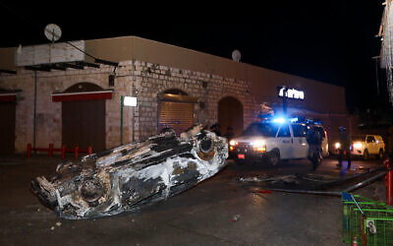
The prime minister urged Lod residents to stay home and on Tuesday night said he would impose a curfew if needed. “We will restore law and order with an iron fist,” he said.
Three Jewish men were arrested Tuesday over the fatal shooting of an Arab man during clashes Monday night. They were being questioned on suspicion of murder, while maintaining that the shots were fired in self-defense.
But an initial investigation indicated that the shots were fired toward a man standing dozens of meters away, and a court on Wednesday extended their remand by three days, with Judge Tal Aner saying the self-defense claim “doesn’t match the objective findings.”
Also Wednesday, Shabtai moved his official office to Lod to oversee the situation and called the situation there unprecedented.

Israeli police during riots and clashes between Arab and Jewish residents, in the central Israeli town of Lod, on May 12, 2021 (Yossi Aloni/Flash90)

“We are seeing a situation in… [Jewish-Arab] cities that we have never seen before, including the incidents of October 2000,” the police commissioner said, referring to widespread rioting that broke out among Arab Israelis at the start of the Second Intifada.
Alongside the clashes in Lod, two residents were killed overnight in a direct rocket strike from Gaza on a vehicle in the city’s outskirts.
Khalil Awwad, 52, and his 16-year-old daughter Nadeen Awwad were killed, and his wife was seriously wounded, in Dahmash, an unrecognized Arab village just outside Lod with a population of 800.
The direct hit by terrorists in Gaza came as part of a major flare-up that has seen more than 1,000 rockets launched at Israeli civilians — including hundreds directed at Tel Aviv and other central Israel cities — in a day and a half of fighting. Four Israeli civilians, an Indian national, and an IDF soldier have been killed and dozens injured.
https://www.timesofisrael.com/police-to-impose-overnight-curfew-in-lod-after-mass-rioting/

Israel in chaos: Lynchings in Acre, Bat Yam; right-wing riots in Tiberias
Riots spread across several cities throughout Israel with mixed Arab and Jewish populations.
By IDAN ZONSHINE MAY 12, 2021 22:44
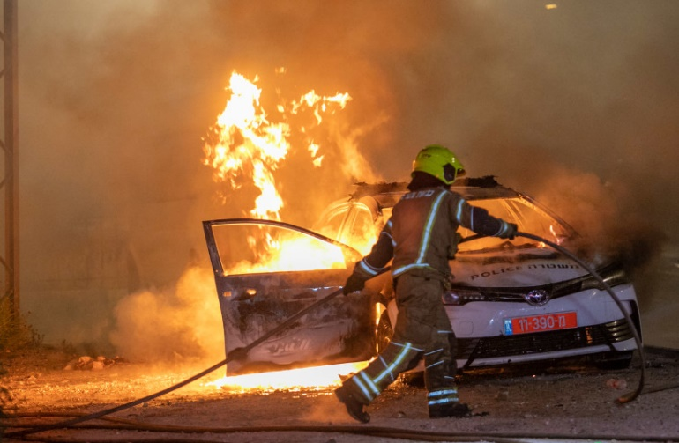
Israeli police seen on the streets of the central Israeli city of Lod, where last night synaogues and cars were torched as well as shops damaged, by Arab residents rioted in the city, and ongoing this evening. May 12, 2021 (photo credit: YOSSI ALONI/FLASH90)
Jewish-Arab violence and riots erupted across the country on Wednesday amid the ongoing fighting between Israel and Hamas in the Gaza Strip.
A Jewish citizen in his 30s was in critical condition after he was attacked by a mob of Arab demonstrators near Egged Square in the city of Acre. Police said he was attacked in his car by Arab Israeli protesters armed with sticks and stones.

מהומות בעכו: יהודי נפצע קשה לאחר שהותקף על ידי מתפרעים ערבים@CBeyar pic.twitter.com/vehRvLZ4T9
— כאן חדשות (@kann_news) May 12, 2021
Magen David Adom staff evacuated him to the Galilee Medical Center in Nahariya unconscious, in serious condition and suffering from a head injury.
Police said the vehicle was attacked by a number of rioters who had previously been throwing rocks towards police, after which the driver accidentally hit one of the rioters.
After the driver and the injured rioter were evacuated, rioters set fire to the car.
Senior MDA medic, Firas Reis, said that "We were near the area when we saw the wounded man lying unconscious and suffering from a bleeding head injury. We immediately began life-saving medical treatment that included bandaging and breath support and evacuated him in stable condition for further treatment at the hospital."
Four were arrested as right-wing Jewish extremists rioted in the streets of Bat Yam on Wednesday evening, smashing windows and throwing bricks at Arab owned businesses while chanting "death to Arabs" and "may your village burn."
בת ים- הריסת חנות בבעלות ערבית pic.twitter.com/icYzc25jYJ
— Rachel (@Rachel12042155) May 12, 2021
Independent journalist Aviya Schatz reportedly warned police beforehand of the expected riot, which was seemingly organized on WhatsApp groups.
אלו בדיוק הקבוצות שהועברו למשטרה - היה אפשר לעצור את הפרעות pic.twitter.com/Yyj28HhFzR
— Achiya Schatz (@schatzah) May 12, 2021
"We warned of threats of death and violence, we sent them to all media channels and filed a police complaint. Didn't help. They're in the streets," Schatz wrote in a tweet, accompanied by a video of rioters.
בת ים: תקיפות וונדליזם בחנויות של ערבים pic.twitter.com/cLkkmx6tv0
— עז (@jewgibor) May 12, 2021
Bat Yam Mayor Tzvika Brot said of the riots that "The acts were organized by provocateurs who came from outside the city. This is not our way."

מהומות גם בטבריה: עימותים בין יהודים לערבים בעיר @rubih67 pic.twitter.com/8gfi8GpzD5
— כאן חדשות (@kann_news) May 12, 2021
Kan News reported that a Jewish man in his 30s was lynched by protesters who mistook him for an Arab. He was evacuated to the hospital and his condition is classified as serious, but stable.
תיעוד מהשניות הראשונות שהובילו ללינץ' בבת ים #חדשותהערב pic.twitter.com/iBn48BisOb
— כאן חדשות (@kann_news) May 12, 2021
Sephardi Chief Rabbi Yitzhak Yosef, one of Israel's two chief rabbis, appealed for restraint in response to the violence, saying "We must not be dragged into provocations and inflicting harm on people or property."
"The Torah of Israel grants no license for taking the law into one's hands and acting violently," he added.
In Haifa, a 26-year-old man was injured after being run over by a car near the demonstrations in the city. He was evacuated to Rambam Medical Center in the city in light to moderate condition. The 20-year-old driver fled the scene, but was apprehended and detained by police.
חיפה: ניידת משטרה הוצתה לאחר שהושלך אליה בקבוק תבערה. אין נפגעים באירוע@CBeyar pic.twitter.com/iHjzMq7PH0
— כאן חדשות (@kann_news) May 12, 2021
Right wing extremist rioters were also seen in Tiberias and Lod, and more are expected to show up in other cities with a largely mixed Arab and Jewish population.
טבריה pic.twitter.com/GL6fsKzM2s
— Real News IL (@RealNewsIL) May 12, 2021
The Tiberias municipality released a statement condemning the riots, saying that "We ask everyone to stop the practice of unnecessary demonstrations that do not contribute anything. These demonstrations can cause unnecessary harm to people and even be life threatening."
"It's time to calm down and help the people of the south as much as possible," the statement added.
Due to the severe violence seen in Lod on Monday and Tuesday, the Border Police established a task force headquarters in the city on Wednesday, with a force of some 500 Border Police personnel, including tactical border police, detectives, investigators and other law enforcement personnel.
Posts on social media by settler activists stated that at least 30 Jewish youths from the Yitzhar region in the Samaria district of the West Bank traveled to Lod on Tuesday night and engaged in clashes with Arab rioters. https://www.jpost.com/israel-news/right-wing-rioters-smash-windows-of-arab-owned-businesses-in-bat-yam-667993

U.S. sends diplomat to try to quell Israeli-Palestinian violence
Blinken tells Netanyahu in a phone conversation the U.S. will send Deputy Assistant Secretary of State Hady Amr to de-escalate the biggest round of unrest between Israel and Gaza in years; says Israel has obligation to avoid civilian casualties
Reuters | Published: 05.12.21 , 21:29
The United States dispatched a senior diplomat on Wednesday to urge Israelis and Palestinians to calm the worst flare-up in violence between them in years, which has appeared to catch the Biden administration off guard as it pursued other priorities.
In remarks welcomed by Prime Minister Benjamin Netanyahu, Secretary of State Antony Blinken defended Israel's right to protect itself and condemned rockets fired by Hamas, the Islamist group that controls the Gaza Strip. He also said Israel had a particular obligation to avoid civilian casualties.
Israel said it killed 16 members of the Hamas armed wing in Gaza in a barrage on Wednesday. At least 56 people have been killed in Gaza since violence escalated on Monday, according to the enclave's health ministry. Six people have been killed in Israel, medical officials said.
The military action follows unrest involving Israeli police and Palestinian protesters near Al-Aqsa Mosque in East Jerusalem.
“FULLY ENGAGED”
Blinken, who spoke by telephone to Netanyahu, said he had sent Deputy Assistant Secretary of State Hady Amr to meet with both sides.
"He will urge, on my behalf and on behalf of President (Joe) Biden, a de-escalation of violence."
Biden has yet to name an ambassador to Israel, a post his predecessor Donald Trump had filled before his inauguration. Other top state department officials handling the region are still awaiting approval from the Senate.
Deflecting suggestions that the long-standing conflict has not been a priority, Blinken repeatedly described the administration as "fully engaged".
"We are deeply engaged across the board. State Department, White House, senior officials, with the Israelis, Palestinians and other countries and partners in the region to call for and push for de-escalation," Blinken said.
A senior State Department official, asked if Biden would speak with Netanyahu, said further "high level engagement" from Washington was to be expected.
In his remarks, Blinken drew a distinction between "a terrorist organization, Hamas, that is indiscriminately raining down rockets in fact targeting civilians, and Israel's response, defending itself."
However, he added: "I think Israel has an extra burden in trying to do everything they possibly can to avoid civilian casualties, even as it is rightfully responding in defense of the people." [If the dolt knew anything of the Israeli process he would already be aware of their extraordinary efforts to avoid hurting civilians but then of course he is probably totally ignorant of the ME history like most of the leftists. – rdb]
Netanyahu's office said: "Prime Minister Netanyahu thanked Blinken for the U.S. support for Israel's right to self-defense, a right that the secretary of state reiterated in this call." https://www.ynetnews.com/article/Byj7n9F00u

U.S. airlines cancel flights to Tel Aviv amid escalating conflict
United Airlines, Delta Air Lines, and American Airlines issue travel waivers for a host of flights to Ben Gurion Airport after Hamas claimed it had fired rockets at Israel's only port of entry; United spokeswoman says company will 'monitor the situation
Reuters | Published: 05.12.21 , 22:48
United Airlines, Delta Air Lines, and American Airlines have canceled flights between the United States and Tel Aviv, according to data by flight tracker FlightAware, amid an escalating conflict in Israel.
Israel said it killed 16 members of the Hamas armed wing in Gaza in a barrage on Wednesday and Palestinian militants rained rockets into Israel in one of their most intense hostilities in years.

Rockets seen above Ben Gurion Airport

United Airlines said it had canceled flights from Chicago and Newark to Tel Aviv on May 11 and flights from San Francisco and Newark on May 12.
"We have issued a travel waiver to allow customers to adjust their travel through May 25 and will continue to monitor the situation," a United spokeswoman said.
A spokesman for Delta, which flies to Tel Aviv from New York's John F. Kennedy International (JFK) airport, said it has issued a travel wavier for flights between May 11 and 13 and has "no determination about resumption at this juncture".
American Airlines, which also flies to Tel Aviv from JFK, did not immediately comment.
El Al Israel Airlines said earlier on Wednesday it stood ready to operate extra flights as required "to keep Israel's skies open". This could include special flights to repatriate Israelis stranded "in locations from which it is not possible to return home," it said in a statement.
Israel on Monday briefly halted takeoffs from its main Ben Gurion Airport and diverted incoming flights after a Hamas rocket barrage on the Tel Aviv area. The country has a smaller airport in the south, called Ramon, designed to serve as a stop-gap should wartime threats force longer closures of Ben Gurion.
https://www.ynetnews.com/travel/article/HkYrynK00u

Hamas official tells Russia: We’re ready for ceasefire with Israel
But Moussa Abu Marzouk conditions truce on Jewish state halting ‘military actions’ on Temple Mount, tells local media terror group will continue to fire long-range rockets
By TOI staff and Aaron Boxerman Today, 8:59 pm
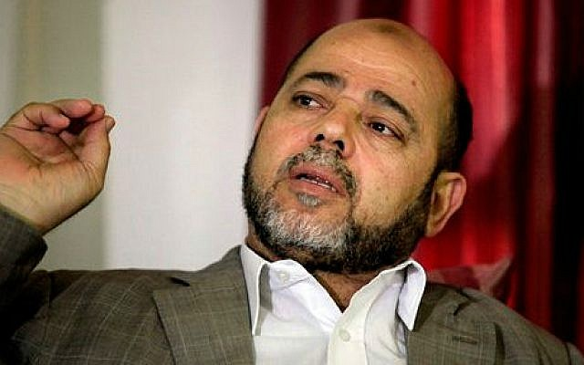
Senior Hamas leader Moussa Abu Marzouk (AP Photo/Hatem Moussa)
A senior Hamas official on Wednesday said the terror organization is ready to end the current intensive fighting with Israel, the Russian foreign ministry said in a statement.
Deputy Chairman of the Hamas political bureau Moussa Abu Marzouk made the offer during a telephone conversation with Russian Deputy Foreign Minister Mikhail Bogdanov, who also oversees Middle East issues.
Abu Marzouk conditioned it, however, on Israel halting strikes and on the international community pressuring the Jewish state to end “military actions” at the Al-Aqsa Mosque on the Temple Mount.
Israel is not seeking a ceasefire at this time, according to the army.
Abu Marzouk struck a different tone in interviews Wednesday with Hamas-linked media, saying: “The Europeans contacted us and told us to stop firing short-range missiles, otherwise they would not participate in the reconstruction of Gaza. I told them we will stop our short-range missiles and use long-range missiles instead.”
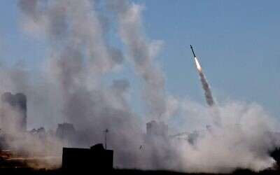
Israel’s Iron Dome aerial defense system is activated to intercept a rocket fired from the Gaza Strip, May 12, 2021. (EMMANUEL DUNAND / AFP)

Abu Marzouk’s comments came after three days of rocket fire from the Gaza Strip at Israel during which over 1,000 projectiles were launched at the Jewish state, killing five civilians and injuring dozens. An Israeli soldier was killed by anti-tank missile fire on the Gaza border.
The capital Jerusalem and the commercial center Tel Aviv were both targeted as well as towns and cities in the south and central regions. Israel has responded by pounding hundreds of Hamas and other terror group targets, including strikes that killed senior terror organization commanders.
Palestinian terror groups have tied the attacks to rioting in Jerusalem connected to prayer on the Temple Mount during the Muslim holy month of Ramadan and also the pending eviction of a number of Palestinian families from their homes in East Jerusalem’s Sheikh Jarrah neighborhood amid a court dispute.
According to Russia, Abu Marzouk, speaking on behalf of the Hamas leadership, is ready “to stop any military actions against Israel on a reciprocal basis on the understanding that the international community will exert the necessary pressure on the Israeli side to suppress military actions in the Al-Aqsa Mosque complex,” according to the statement.
Abu Marzouk further conditioned the apparent offer for a ceasefire on the end of what he termed “unlawful” measures by Israel against Jerusalem’s “indigenous Arab inhabitants.”
The phone call was held at the request of the Palestinians, the ministry said. Abu-Marzouk talked about the sharp escalation in violence over the past few days and also raised the issue of the Palestinian families who face eviction in Sheikh Jarrah. He also complained over what he said was Israeli shelling of residential neighborhoods in the Gaza Strip.
Bogdanov stressed the importance of an immediate end to the violence as well as “the inadmissibility of attacks on civilians regardless of their nationality and religion, including strikes on civilian targets in Israeli and Palestinian territory,” the statement said.
Israeli officials on Wednesday said they had no intention of entering an immediate ceasefire and plan to have the IDF continue striking targets associated with Hamas, Islamic Jihad and other terror groups in the Strip in order to both restore deterrence against them to prevent future attacks and to significantly weaken their capabilities.
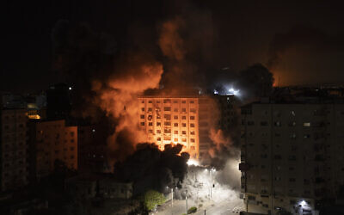
“We are not talking about a ceasefire, certainly not in the coming two days,” IDF spokesman Hilda Zilberman told the Kan public broadcaster.

Smoke caused by Israeli retaliatory airstrikes for rocket fire is seen at a residential building in Gaza City, May 12, 2021. (AP Photo/Khalil Hamra)

“There is currently no end date for the operation. Only when we achieve complete quiet can we talk about calm,” Defense Minister Benny Gantz said during a tour of rocket-hit Ashkelon. “We will not listen to moral preaching from any organization or institution regarding our right and duty to protect the citizens of Israel.”
As of Wednesday morning, over 1,050 rockets and mortar shells have been fired from the Gaza Strip toward Israel since the outbreak of fighting on Monday evening, according to the IDF. Roughly 200 of the total number of rockets failed to clear the border and landed inside the enclave, the military said. IDF Spokesperson Zilberman said the Iron Dome air defense system had an interception rate of between 85 and 90 percent for rockets heading toward populated areas.
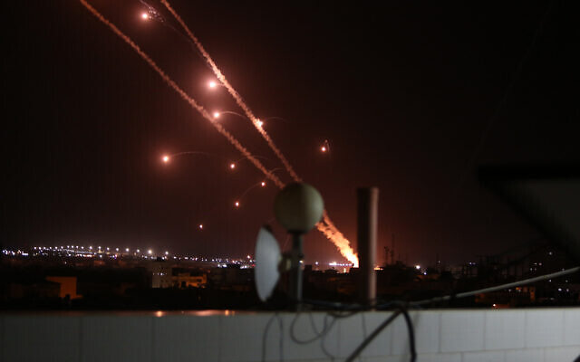
Rockets are launched towards Israel from Rafah, in the southern Gaza Strip, early on May 12, 2021. (Abed Rahim Khatib/Flash90)

At least six people in Israel were killed — three on Wednesday and three on Tuesday — and dozens more injured in the attacks from Gaza, some seriously, including a five-year-old girl and a six-year-old boy in critical condition. One of those killed was an Israeli soldier who died after Hamas fired an anti-tank missile at the jeep he was in on the Israel-Gaza border.
A 67-year-old woman suffered a heart attack that was brought on by rocket sirens in central Israel, and in Tel Aviv, an 80-year-old man suffered an apparent heart attack while running for a shelter and was in serious condition, medics said.
In response to the rocket fire, the IDF launched strikes on upwards of 500 targets in the Gaza Strip, aimed at Hamas personnel, weaponry and infrastructure throughout the enclave, with plans to attack more in the coming hours and days, the military said. Those included further targeted killings of top Hamas and Palestinian Islamic Jihad commanders and the destruction of a number of high-rise buildings that the IDF said were used by the terror groups as command centers, intelligence bases and weapons research and development facilities, as well as for housing senior members of the terror groups.
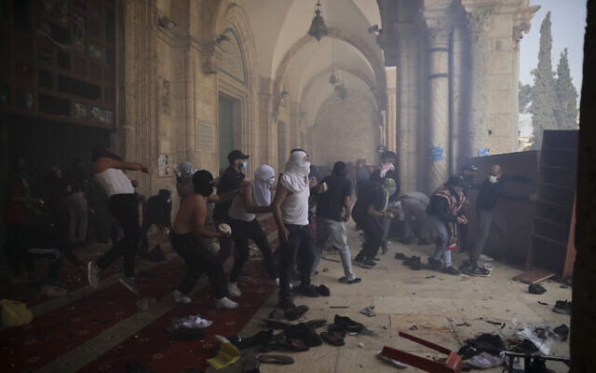
According to the Strip’s Hamas-run health ministry, 53 Palestinians have died since Monday night, including 14 minors and three women, and 320 have been wounded. The IDF said more than half of those killed were members of terror groups involved in the fighting and that some, including several of the children, were killed by errant rockets fired from Gaza that fell short of the border and landed inside the Strip, not by Israeli strikes.

Palestinians clash with Israeli security forces on Temple Mount aka the Al-Aqsa Mosque compound in Jerusalem’s Old City, May 10, 2021. (AP Photo/Mahmoud Illean)
The Gaza rocket attacks came after several days of violent clashes between Palestinian protesters and Israeli police in East Jerusalem, with the Temple Mount a focal point of the unrest. Hundreds of Palestinians were reportedly injured and dozens of police officers hurt.
Rioting, against the background of the Jerusalem turmoil and the clashes with Hamas, has spread to Arab Israeli communities, in particular Lod, a city with both Jewish and Arab populations.
Hamas, which is avowed to the destruction of the State of Israel, took effective control of the Gaza Strip in 2007 from the Palestinian Authority in a violent coup. Since then, Israel has imposed a naval blockade on the enclave, as well as stiff control over what can enter the Strip, maintaining that it is necessary in order to prevent terror groups from smuggling weapons into the area.
Israel has fought three large operations against Hamas and other terror groups in the Gaza Strip since 2008, most recently in 2014 with a 51-day war known as Operation Protective Edge. MORE - https://www.timesofisrael.com/hamas-official-tells-russia-were-ready-for-ceasefire-with-israel/

Increase of Hamas and pro-Iran regime members in Berlin - German intel
“Iranian cyber actors are also trying to gain access to protected information in Germany"
By BENJAMIN WEINTHAL MAY 12, 2021 19:45
The intelligence agency for the city-state Berlin registered in its newly released report on Tuesday an increase in the number of Hamas, pro-Iranian regime and Muslim Brotherhood individuals.
According to the 136-page German language document reviewed by The Jerusalem Post, the intelligence agency reported an increase of Hamas members from 70 in 2019 to 80 in 2020.
The State Office for the Protection of the Constitution report covers the year 2020. The United States and the European Union both classify the jihadi movement, Hamas, which rules the Gaza Strip, a terrorist entity.
The document lists an increase of people loyal to the Islamic Republic of Iran in the category: “Others, especially Iranians loyal to the regime.” The report said the increase of pro-Iranian regime supporters rose to 50 in 2020 from 40 in 2019. Iran was cited 13 times in the intelligence report.
The Islamic threat to Berlin numbered 2,170 people and the group is capable of committing terrorism attacks.
The Iranian regime-sponsored Hezbollah movement had 250 members in Berlin during 2020. The Lebanese Shi’ite terrorist organization also had 250 members in 2019. In 2020, Germany’s Interior Ministry banned all Hezbollah activities within the federal republic. The military wing was already considered a terrorist organization.
The number of Muslim Brotherhood supporters rose from 100 in 2019 to 150 in 2020, according to the intelligence report.
The agency to protect the constitution documents serious threats to Berlin’s democratic order. The intelligence agency is the rough equivalent to Shin Bet (Israel Security Agency).
There are 450 documented violent Salafists in Berlin from a sector of 1,100 radical Sunnis.
The report noted that Iran’s regime, along with Russia and China, is active in cyber espionage. “Iranian cyber actors are also trying to gain access to protected information in Germany. A major cyberattack campaign was recently discovered in which employees of German companies received fake job offers by means of spear phishing emails,” the intelligence agency stated.
The intelligence report said about the Iranian cyberattack: “When executing the corresponding applications, malware could be loaded onto the computer unnoticed. One reason for the increase in Iranian cyber operations in Germany is likely to be the political tensions in the Persian Gulf region.”
The report added that “Iran has a fundamental interest in obtaining political and economic information” and “to circumvent existing sanctions” against the regime in Tehran. https://www.jpost.com/middle-east/iran-news/increase-of-hamas-and-pro-iran-regime-members-in-berlin-german-intel-667985 [it would be most interesting to see what the numbers of that type of individual would be for the USA and various cities therein. I will be willing to wager you that it is much higher than anyone thinks. – rdb]

GOP wants Dems investigated over Jan. 6 Capitol 'reconnaissance' claims
Lawmakers go to war with each other over unnerving claim
By WND Staff Published May 12, 2021 at 8:15pm
House Republicans filed an ethics complaint Tuesday against House Democrats who claimed that Republican members gave "reconnaissance" tours to constituents ahead of the Jan. 6 breach of the Capitol.
Pointing out that the Democrats presented no evidence to back their claim, the GOP letter to the Committee on Ethics argues House rules prohibit a member "from making false, spurious, and unsubstantiated accusations against other Members," the Daily Caller reported.
Several dozen Democrats, led by New Jersey Rep. Mikie Sherrill, alleged that GOP members of Congress led "suspicious" groups through the Capitol Complex ahead of the Jan. 6 incident, which happened during and after a rally by President Trump in which he encouraged supporters to "peacefully" protest the certification of the 2020 vote.
The complaint, from GOP members of the House Administration Committee, noted Sherrill had said she was worried some of her colleagues had provided "reconnaissance" tours.
Sherrill had claimed: "The visitors encountered by some of the Members of Congress on this letter appeared to be associated with the rally at the White House the following day. Members of the group that attacked the Capitol seemed to have an unusually detailed knowledge of the layout of the Capitol Complex. The presence of these groups within the Capitol Complex was indeed suspicious."
However, Capitol Police decided not to respond, and Democrats have not been able to provide evidence to support the accusations.
The House Republicans, emphasizing the claims were made "without evidence," noted that in an "official appearance from her congressional office, which was broadcast on her official Facebook account, Rep. Sherrill doubled down on these unsubstantiated allegations, arguing for punishment for crimes that did not occur."
Sherill said: "I also intend to see that ... those Members of Congress who had groups coming through the Capitol that I saw on January 5th for reconnaissance for the next day—those Members of Congress who incited the violent crowd, those Members of Congress that attempted to help our president undermine our democracy—I’m going to see that they’re held accountable."
Previously, House Republicans had asked House Speaker Nancy Pelosi to explain what happened with security before and on that day.
Pelosi’s office responded to Fox News by putting blame on the Republican lawmakers and saying that safety is not their priority, the report said.
Now the Republicans are blaming Pelosi for not securing the building.
The GOP letter said: "The problem is that no Republican Member of Congress led any kind of 'reconnaissance' tours through the Capitol on any date, including January 5, 2021. Security footage captured by the U.S. Capitol Police easily confirms these facts. Despite the threat presented by the Sherrill Letter to these Republican Members and to the House itself, Respondents appear not to have let their lack of evidence or the truth stand in the way of making these false accusations."
The Republicans also charge the Democrats have failed to "adhere to the highest moral principles" and that had the same remarks been made on the House floor, the speakers likely would have been censured.
They say the Sherrill accusations are "a public allegation of a crime," requesting an investigation into the Democrats' "cavalier behavior."
The letter, signed by Rep. Barry Loudermilk, R-Ga., said: "It has been my hope that, following the attack on January 6th, Members of Congress of both parties would work together in a bipartisan manner to investigation those events and ensure they do not happen again. Letters like the one drafted by Respondents are irresponsible and only work to spread misinformation and impugn the reputation of the House and its Members."
The letter was addressed to the chairman of the Committee on Ethics, Theodore Deutsch, and ranking member Jackie Walorski. https://www.wnd.com/2021/05/gop-wants-dems-investigated-jan-6-capitol-reconnaissance-claims/ [There are a host of demon-rats that need to be taken to the woodshed and walloped. – rdb]

Poll: Only 11% of unvaccinated will 'definitely' get a shot
Lack confidence in safety, concerned about side effects
By Art Moore Published May 12, 2021 at 7:55pm
Only 11% of American adults who have not received a COVID-19 shot say they definitely plan to be vaccinated, according to a new poll.
The survey by the Associated Press-NORC Center for Public Affairs Research found 35% of Americans say they have not received a COVID-19 vaccine compared to 64% who said they have, the Hill reported.
Of the group that has not been vaccinated, 11% said they will "definitely" get inoculated compared to 27% who said they "probably" will.
A total of 61% of unvaccinated respondents said they would likely not get a vaccine.
The poll was conducted April 29-May 3.
The Hill pointed out that demand for the COVID-19 vaccine has declined as those eager to get vaccinated have already done so.
President Biden has set a goal of having 70% of the population receive at least one dose of a vaccine and 160 million fully inoculated by the Fourth of July.
To date, 46% of the population has had at least one dose and more than 34% has been fully inoculated.
The survey asked the "hesitant" to explain any concerns.
Among them, 76% lacked confidence in the safety of the vaccine. And 61% said they are worried about side effects. https://www.wnd.com/2021/05/4915197/ [A large number of healthcare workers and medical personnel are not planning on taking the Jab because we have read the history of mRNA attempted vaccines and know what the outcome has been and it hasn’t been good. It is not the immediate response with a negative reaction that is worrisome it is the long term and subsequent effects that have been terrible. – rdb]

Tucker Carlson: Biden’s lunatics making a mess of U.S. economy
https://tv.gab.com/channel/gee/view/tucker-bidens-making-a-mess-of-609b9d360ae87c06665b512f

Commentary:
We’re In A Battle For Freedom. Where’s The War?
By Ron Ewart|May 12th, 2021
“The receptivity of the masses is very limited, their intelligence is small, but their power of forgetting is enormous. In consequence of these facts, all effective propaganda must be limited to a very few points and must harp on these in slogans until the last member of the public understands what you want him to understand by your slogan.” —Adolf Hitler
Many experiments have been done with animals to determine their behavior in certain situations, or for some nefarious reasons to modify their behavior. The primates are the behavioral scientist’s or social psychologist’s favorite subjects because they more closely represent their nearest human cousins. The usual process is for the researchers to provide a stimulus to the subject animal and record the response. The stimulus can be either a punitive action, or a reward action.
One of the more famous experiments with primates was the Monkey and Banana conditioning exercise. The scientists put five monkeys in a cage with a very tall ladder and a bunch of bananas on the top of the ladder. Eventually, one of the monkeys would venture to climb the ladder to reach the bananas. But they had a surprise waiting for them. They were sprayed with a powerful stream of water and driven off the ladder before they could get to the bananas. The experimenter then proceeds to spray the other four monkeys in a similar manner.
Sitting there, wet and cold, the monkeys huddle and move about until another monkey is drawn to the bananas and starts to climb the ladder. The experimenter drives the second monkey off the ladder with a powerful stream of water and then turns the hose on the other four monkeys.
When a third monkey starts to climb the ladder to reach the bananas, the other four monkeys pull him off and beat him so as to avoid being sprayed by the water again.
The experimenter then replaces one of the monkeys with a new monkey. When the new monkey goes after the bananas, the other four monkeys pull him off and beat him as well.
Once again, the experimenter removes one of the other original monkeys and replaces it with a new monkey. When the new monkey starts to climb the ladder the other four pull him off as before and beat him, including the monkey that had never been sprayed. By the end of the experiment, all of the monkeys were new and none of the original monkeys were left. And yet, despite none of the new monkeys ever experiencing the cold, wet, spray, they had all learned never to try and go for the bananas. That is social conditioning.
Now replace the bananas with FREEDOM! As you attempt to climb the ladder to freedom you are being sprayed by a tyrannical government with a toxic mixture of lies and propaganda so you can never reach it. Cancel culture, censorship and the attack on free speech are a part of this toxic mixture. In addition, government is exploiting the public education system, including K-12 and college, to brainwash multiple generations. (See: “To Kill A Free Nation Take Over Public Education”)
Using lies, propaganda and social conditioning, governments “manipulate” their citizens regularly to control the behavior of the masses for a government-desired outcome. Since humans tend to move as one, like a flock of birds in the sky, or a school of fish in the sea as far as social norms are concerned, the monkey-banana experiment proves how easily it is to “manipulate” animals and make even a human behavioral change permanent.
Since the late 1920’s and early 30’s the American government has been working diligently to control citizen behavior under the highly subjective alleged science known as social psychology. These earlier experiments on social engineering and modifying human behavior were conducted by the University of Chicago and Harvard University and funded by the Rockefeller Foundation. “In a final report of the 1938 Harvard Laboratory of Industrial Psychology showed conclusively that they had been successful in influencing employees’ subconscious attitudes about their jobs with this new science. Their approach was a form of thought-control which they felt Americans would accept.” (Source: “Politics of Change by Dr. Robert N. Crittenden) In point of fact, Americans had no idea how they were being manipulated and they had no say in the science or the methods being used to control their thoughts. How is this any different than Nazi Joseph Goebbels’ propaganda machine to manipulate the German people leading up to and during the Second World War? It isn’t.
The American government has been lying to the American people for a very long time about a wide range of important subjects that affect our every day lives. Now, with the help of academia, social media and the news media, the “woke” government under socialist Democrats, RINO Republicans and our massive bureaucracy has been lying to and propagandizing citizens in many different fields, from economics, to education, to climate change, to environmentalism, to junk science, to health care, to speech, to gun rights, to vaccines, to masks, to immigration, to trillions in deficit spending and printing money, to racism, to foreign policy, to military and domestic intelligence and God knows what else. Climate change is propaganda. Critical Race Theory is propaganda. Social justice, inclusiveness, equity, white privilege and systemic racism are all propaganda, designed by government and special interests to “manipulate” citizen behavior, just like the above described five-monkey experiment.
Our federal institutions, like the FBI, the DOJ and the CIA have been hopelessly corrupted and acting virtually without constraint or accountability. Even large and small corporations and unions are parroting this “woke” ideology, spawned over 100 years, out of the loins of Progressivism. Progressivism is just another word for socialism.
Due to Democrat President’s Wilson, FDR, Johnson, Clinton, Obama and Biden’s socialist policies, freedom has lost its remaining sanctuaries in our Declaration of Independence and our Constitution. The war on freedom by these administrations include FDR’s New Deal, Johnson’s Great Society, Clinton’s President’s Council on Sustainable Development, Obama’s Obama Care and now Biden’s march towards absolute socialism with massive government multi-trillion dollar federal assistance programs. Biden’s open borders, to packing the Supreme Court, to repealing the Senate filibuster rule, to adding Democrat-run states to the 50 states, to racism and to health care are all designed to make American citizens dependent on the government and increase Democrat political power. Through lies and propaganda, government and special interests have divided and conquered us without a shot being fire. So where is the war?
Government today and probably throughout history, due to human failings, has been, is and always will be about “power”, but very seldom about “principle”. However, if we choose to avoid principle, we do so at our own peril. Many governments have fallen for far less. This great land of ours could easily share the same fate unless we return to these principles, for which millions of brave men and women have sacrificed their lives, their limbs and their minds to defend. (See: “18 Basic Principles For America”)
Governments only get powerful because the American people let them. Political parties get powerful because we let them. Illegal aliens crash our borders in huge numbers because we let them. Large corporations and legal or illegal organizations get powerful because we let them. Environmental groups get powerful because we let them. Unions get powerful because we let them. The larger these entities become, the more they will try to increase their power.
But WE THE PEOPLE in the form of individuals and families have the ultimate power, if we will only exercise that power. We must act as one in the defense of our unalienable rights as granted to us by our creator and instituted into law by men under our Constitution and further by living up to our civic duties, obligations and individual responsibilities. But if we are divided, if we fight amongst ourselves, if we allow ourselves to be bought off by the promises of government largess to buy our votes, that always comes with a loss of freedom. If we ignore America’s time-tested constitutional principles, we are rendered impotent and the “powerful” elite, ruling class will fill the gap, as they already have ….. because we let them.
Ladies and gentlemen, this socialist Democrat American government has become the enemy of a free people, an instrument to relieve us of our liberty and spend us into debt oblivion. We are, so far, in a limited and peaceful battle for freedom. But the vicious and relentless attack on our individual liberties and national sovereignty by socialist Democrats, radical environmentalists and globalists, forces us to ask, “Where is the war?” Why haven’t Americans been issuing “The Mandate” to their Senators and Representatives? When will they fight back against the toxic mixture of lies and propaganda and climb the ladder to freedom?
After over 100 years of moving away from freedom under Progressivism, we are truly at a crossroads and the fate of our cherished America could go either way. But “just one act of courage” by just one person, might very well make the difference between freedom and perpetual enslavement.
On the battlefield, one man, risking everything, motivated by powerful emotions of unbridled anger, or blind rage over something that happened to one of his buddies, will attack the enemy single handedly, from whence heroes are born. In many cases, that single act of courage incites others to follow him, from whence wars are won.
If you stand up, you could be the “butterfly” that “flaps its wings” in Arizona and starts an uprising in Michigan. In chaos theory, the butterfly effect is the idea that small things can have huge non-linear impacts on a complex system. The concept is imagined with a butterfly flapping its wings in Guiana and causing a typhoon in the Western Pacific.
The seeds of freedom have already been sewn by many single acts of courage and the “butterflies” are poised to take wing. Others, less courageous and sitting on the sidelines, are waiting for you to make the first move.
The aristocrats, criminals and the anarchists have taken over while tens of millions of Americans watched and did nothing. Social Democrats have drawn the battle lines and more. “Where, for Pete’s sake, is the frickin’ War?”
“A tribute to our nation’s Mothers”
To all you mothers out there
In this great land of the free,
We stand in awe for the gifts you give
To America’s cultural family.
Love, caring, nurturing and more,
You give of your self so unselfishly.
The kids are crying on the kitchen floor
But you keep your cool
In a voice that reaches out so tenderly.
You are what you are
And we take you that way.
No you’re not perfect
You can’t always be on every day.
But we pay you this tribute
On this yearly Mother’s day,
To show you we haven’t forgotten
How special you are in every way.
https://newswithviews.com/were-in-a-battle-for-freedom-wheres-the-war/

Mask Hysteria
Kurt Schlichter Posted: May 12, 2021 12:01 AM
I always thought, correctly, that the mask thing was a ritual of solidarity with the establishment rather than a science-based prophylactic measure. I was right, as demonstrated by the bizarre idea that we should be wearing these stupid scarfs in a post-vax world.
Also, Greg Abbott’s recent failure to confront and defeat the BLM/Antifa garbage people in Plano is a sign that we need even more proactive cons in charge. Ron DeSantis wouldn’t have put up with this, and we voters won’t either.
Time To End The Mask Idiocy
Here’s the thing – masks are stupid and are part of the bizarre virtue signaling theater that has infected our culture. From laughable security checks at airports to attempts to police language, our society has decided that it’s the presentation that matters and the reality, well, that’s racist or something.
Masks are silly, in general. The insane mask performance art rules governing them are even sillier. Walking through a restaurant, you must drape a towel over your lips. Sitting at your chair, not so much. Masks protect you in the big box stores of Dem corporate donors, but not in churches. And you must wear them outside too, unless you are that malignant dwarf Fauci at a baseball game. He doesn’t need to. Kids, who won’t catch it, must do it in schools to protect their useless public school teachers, who won’t teach anyway.
It’s all stupid, and I won’t play.
There are vaccines all over the place now. If you want one – and I don’t care if you do or you don’t get one – you can get one. And if you get one, the best information is that you won’t get the disease – which, incidentally, is not that bad in the first place if you are not within one of the high-risk categories. I know – I had it.
Here’s the thing: By not wearing a mask, if you are endangering anyone – and you aren’t – but if you are, you would only be endangering people who chose to face that danger by not getting vaccinated. In other words, I’m supposed to put that badge of servitude around my mug to accommodate peeps who decided to not get a vaccine? I don’t care if you don’t get a vaccine – that’s none of my business. But, conversely, such folks have no reason to expect I will conform my behavior to their choices and bind my lips to protect them (and, in my experience, the No-VAX people don’t expect me to – it’s the Yah-VAX nuts who do).
So, stop caring if other people wear masks.
First, my immunological status is none of your damn business. You aren’t my doctor and you aren’t by boss. I’ll do as I please.
But here’s the thing – if you’re so damn scared of the flu, get a vaccine. You can cower with your cats in your creepy apartment until it takes effect and then you are “safe.” So, why would you care if someone else didn’t have a mask? You aren’t catching it. It’s not your problem, or your business.
The last time some tub of goo shouted “Wear a mask!” at me as I walked outside like a normal American, I invited it to perform an act that would have been challenging enough if it were in good shape. Next time, perhaps, instead of defaulting to laughing and profanities, I’ll ask “What’s it to you?”
If COVID is such a big deal, Karen certainly got vaccinated, which means Karen can’t get it, which means it’s not Karen’s problem.
But that’s the thing – it’s Karen’s calling. Karen has a need to boss others around to hide the pain of her lonely, empty existence. No one loves her – she’s awful, after all – and as long as she’s nagging others who are presenting no danger to her, it salves the pain of her miserable life.
I’m going to have to take a pass on being a prop in the personal psychodramas of liberal weirdos.
Time to end America’s mask foolishness.
What The Hell, Greg Abbott?
So, on my last Unredacted podcast for you VIP members, I talked about the lack of outrage on the part of Texas Governor Greg Abbott when a bunch of BLM/Antifa dirtbags blocked a road and the one cop on scene hassled…the citizen who complained.
And Abbott was on the job, tweeting about his lovely golden retriever, Peaches. I like golden retrievers. We got our first in 1971 and have had nearly a dozen. Great dogs. And maybe that’s not what your priority should be when communist scumbags are attacking citizens.
In response to me and other people pointing out this humiliating failure on social media, some people argued that it’s not Abbott’s fault what happen in Plano, to which I responded that a real leader would make it his problem – and solve it.
You think Ron DeSantis would let the lunatics take over the asylum?
Nope.
That’s the new standard, folks.
That’s what conservatives not merely expect but demand.
No excuses.
No rationalizing failure.
We want results.
Results.
R.E.S.U.L.T.S.
Texas is an important state and Governor “Hey, Here’s A Tweet Of My Dog” is not cutting it. It is trending blue, and this isn’t helping. Oh, he sent some tweets about all the conservative stuff he’s done, but who cares? We expect that. That’s merely doing his job, not excelling. We cons are not giving out participation trophies anymore.
We don’t want resistance to the blue onslaught. We want a ruthless counterattack to defeat it and roll it back.
So, Greg! and Asa! and Kristi! and Nikki! and all the rest of you half-steppers, take note. It ain’t 2005 anymore, and good enough to please the Chamber of Commerce isn’t good enough to please us. Abbott should have had the Texas Rangers rolling on those criminals, and they should be in jail right now. Florida cops don’t play that. It’s an embarrassment that Texas cops apparently do, and that Governor Good Boy Have A Milkbone just takes it. https://townhall.com/columnists/kurtschlichter/2021/05/12/mask-hysteria-n2589211

Iran's Proxy War Against Israel
by Khaled Abu Toameh May 12, 2021 at 5:00 am
The Iranian-backed Palestinian Islamic Jihad (PIJ) organization announced on May 11 that its members fired a burst of "Badr-3" missiles into Israel, killing two women and injuring dozens others. The announcement was made by PIJ's military wing, Al-Quds Brigades, after the group and other terror factions in the Gaza Strip, including Hamas, fired hundreds of rockets into Israel within 24 hours.
The "Badr-3" missile is an Iranian-made missile that appeared for the first time on the battlefields of the Middle East in April 2019, when the Iranian-backed Houthi militia used it during the fighting in war-torn Yemen.
The "Badr-3" missile carries an explosive warhead weighing 250 kg, and has a range of more than 160 km, according to Debka, an Israeli website that reports on military issues. "The missile explodes within 20m of target and releases a 1,400-piece shower of shrapnel fragments," the website reported.
PIJ was the first terrorist organization to use the Iranian missile against Israel in 2019.
Until a few years ago, PIJ, Hamas and other Gaza-based terrorist groups used to receive rockets and other weapons directly from Iran -- smuggled in by sea or across the border between the Gaza Strip and Egypt. For some years now, however, according to Israeli intelligence sources, these terrorist groups have used years of experience with Iranian and other rockets to develop their own versions.
Over the past 15 years, Iran became the most dominant weapon supplier to Hamas and PIJ. The major smuggling route was from Iran to Sudan, on to Egypt and the Sinai Peninsula, and from there to the Gaza Strip. These weapons include long range rockets, mortar shells, anti-tank missiles, tons of standard explosives and raw materials for explosive production.
Last year, Iran's Supreme Leader Ayatollah Ali Khamenei admitted for the first time that his country was supplying the Palestinian terrorist groups with weapons. "Iran realized Palestinian fighters' only problem was lack of access to weapons," Khamenei said in an online speech.
"With divine guidance and assistance, we planned, and the balance of power has been transformed in Palestine, and today the Gaza Strip can stand against the aggression of the Zionist enemy and defeat it."
Khamenei went on to offer the reason why Iran was sending rockets, missiles and tons of explosives to the Gaza Strip: "The Zionist regime is a deadly, cancerous tumor in the region. It will undoubtedly be uprooted and destroyed."
Khamenei's admission shows how the mullahs in Tehran have been lying to the West for many years. In 2011, Mohammad Khazaee, the Permanent Representative of Iran to the United Nations, sent a letter to the President of the United Nations Security Council in which he vehemently denied that Iran was smuggling weapons into the Gaza Strip:
"The Islamic Republic of Iran categorically rejects the allegations concerning the so-called smuggling of advanced weapons into the Gaza Strip, which are based on false and misleading information provided by the Zionist regime. Iran's support for the peoples of Palestine has been of a moral, humanitarian and political nature."
The denial exposes the extent of Iran's scheme to deceive the international community not only regarding its supply of weapons to the Palestinian terrorist groups, but also concerning its plan to acquire nuclear weapons and bolster its production of nuclear material.
So while the Obama administration was sending $400 million of cash to Iran, the Iranians were continuing to supply rockets and missiles to their proxies in the Gaza Strip so that they could use them to destroy the "Zionist entity."
In 2015, the Obama administration, the UK, France, China, Russia and Germany reached a deal with Iran, whereby it agreed to limit its nuclear activities and allow in international inspectors in return for the lifting of economic sanctions. Iran, however, repeatedly violated the terms of the nuclear deal, according to the UN's nuclear monitoring Atomic Energy Agency.
The same Iran that lied about the smuggling of the weapons into the Gaza Strip also managed to deceive the US and the world powers regarding its willingness to adhere to the nuclear deal.
Last month, a report published by the Israeli Walla news website revealed that in 2006, Iran opened a route to smuggle missiles and ammunition to the Palestinian terrorist groups in the Gaza Strip through Yemen and Sudan. The smuggling operations were led by Hamas military commander Mahmoud al-Mabhouh, who was assassinated by Israel in 2010.
On April 9, Mahmoud Mardawi, a Hamas leader and former member of the group's military wing, Izaddin al-Qassam Brigades, told the Al-Monitor news website:
"Hamas wants to explore all sources of military supplies from every country and movement, mainly from Iran. We will not stop knocking on doors to find parties to provide us with weapons."
An arms smuggler who deals with Hamas told Al-Monitor that Iran's Islamic Revolutionary Guard Corps sent weapons to the Palestinian terrorist groups through the Suez Canal all the way to the Mediterranean Sea, where Iranian ships dock off the coast of the Gaza Strip in Egyptian territorial waters. When night sets, he revealed, Hamas frogmen transport the weapons in closed containers.
Earlier this year, the secretary-general of Palestinian Islamic Jihad, Ziyad al-Nakhaleh, disclosed that Qassem Soleimani, the slain commander of Iran's Quds Force, "personally" managed a complex operation to send weapons to the Gaza Strip. Nakhaleh said that Soleimani, who was killed in a US drone attack on January 3, 2020 near Baghdad International Airport in Iraq, traveled to several countries to supply weapons for the Palestinian terrorist groups in the Gaza Strip.
Were it not for Iran's financial and military aid, the Palestinian terrorist groups would not have been able to attack Israel with thousands of rockets and missiles. Like their patrons in Tehran, Hamas and PIJ do not recognize Israel's right to exist and are committed to its destruction.
In the past, Iran used its proxy in Lebanon, Hezbollah, to attack Israel. Iran is now using its Palestinian proxies to achieve its goal of eliminating Israel and killing Jews. This is a war not only between Israel and the Palestinian terrorist groups. Rather, it is a war waged by Iran against Israel.
The Western powers that are currently negotiating with Iran about the revival of the 2015 JCPOA nuclear deal are emboldening the mullahs and allowing them to continue their war of "kill[ing] all the Jews."
Khaled Abu Toameh is an award-winning journalist based in Jerusalem. https://www.gatestoneinstitute.org/17364/iran-proxy-war-israel

THE SHORASHIM BIBLICAL GIFT CATALOG 005
http://mad.ly/7f9f64?pact=20013931524&fe=1
Support Shorashim!

ARUTZ SHEVA
Ambassador Erdan to CNN: Hamas is committing dual war crimes
Israel’s Ambassador to the US: Hamas is using their civilians as human shields, and deliberately launching their rockets on our civilians.
Arutz Sheva Staff , May 13 , 2021 12:40 AM
Israel’s Ambassador to the US, Gilad Erdan, on Wednesday accused Hamas of committing dual war crimes amid the rocket attacks from Gaza.
“I grew up in the city of Ashkelon, it’s a city that has been severely bombarded in the last few days. My parents still live there and I have to get in touch with them every few hours in order to make sure that they got to a safe shelter whenever they heard the siren. That is the reality that millions of people in Israel are facing now,” Erdan told CNN in an interview.
He added that he was on the phone call between Prime Minister Benjamin Netanyahu and US President Joe Biden.
“I was very very pleased to hear the strong commitment of President Biden to Israel’s right to defend itself and to the safety and security of the people of Israel. That’s what I heard in that conversation,” said the Israeli Ambassador.
On the Israeli attacks in Gaza, Erdan said, “Right now our goal is to make Hamas stop trying to terrorize and to murder our citizens. They deliberately launched thousands of rockets and missiles at our cities and we have to restore our deterrence in a way that they will understand that this vicious method cannot be used anymore.”
Asked about civilian casualties in Israeli attacks in Gaza, the Ambassador stressed, “We mourn the loss of lives of civilians and children on both sides. What is happening in Gaza is a tragedy, but who is responsible for that tragedy? It’s only Hamas because Hamas is committing a dual war crime. They are using their civilians as human shields, and they are deliberately launching their missiles and rockets at our cities, on our civilians.” https://www.israelnationalnews.com/News/News.aspx/306118

Bennett to Al-Jazeera: 'We'll hunt down every Hamas commander, every post, until we win'
MK Naftali Bennett, Yamina chairman, speaks to Al Jazeera about the rocket fire and retaliatory strikes on Gaza, and about Israeli politics.
Arutz Sheva Staff , May 13 , 2021 1:04 PM
MK Naftali Bennett, who heads the Knesset's Yamina party, spoke with Al Jazeera about the political situation in Israel and the recent rocket fire on Israeli civilians.
"It's up to Hamas" whether the situation gets better, Bennett said. "As long as Hamas keeps its deliberate attack in order to murder Israelis across the state - by the way, Arabs and Jews alike; Hamas already murdered two Arab Israelis in Lod, a dad, 52 years old, and his daughter Nadin, 16 years old, Israeli Arabs who were murdered. A Holocaust survivor, 85 years old, was murdered by Hamas, in her wheelchair."
"If Hamas thinks they can get away with this, they're wrong. We'll hunt down every commander, every post, until we win."
When asked about the 53 people who died in Gaza due to Israeli airstrikes, Bennett clarified: "Indeed Hamas killed them. Because when you hide your rockets behind women and children, you are effectively murdering your own people."
"We will defend ourselves," he emphasized. "And if Hamas decides to turn schools into terror bases, and hospitals, in a cowardly manner, into terror bases, they are responsible for murdering their own people."
Adding that blaming Israel for the lack of bomb shelters in Gaza is "nonsense," Bennett explained, "Hamas instead of taking its money and investing in hospitals, in schools, in building a future for its people, it's spending all its money on terror, on trying to kill Israelis. It's stupid and wrong."
"We are all united, we stand strong united. And there's one way for this to stop: For Hamas to lay down its arms, and then - it'll stop."
Regarding the coalition negotiations and their influence on the security situation, Bennett told Al Jazeera: "This is not about [Israeli Prime Minister Binyamin] Netanyahu, and it's not about left and right in Israel, and I will certainly back Netanyahu and [Defense] Minister [Benny] Gantz (Blue and White) and the government of Israel at this very difficult moment. When we get hundreds of rockets a night on Israel, we all stand united. No one will divide us and we'll fight back."
"We're a democracy, I'm darn proud of that that we're a democracy, and yes part of democracy is the ability to criticize one another. but we in Israel have a sort of an unspoken rule: When we're at war with an enemy that wants to annihilate us, we stand together," Bennett said.
Regarding whether he would act differently regarding the two-state solution, he emphasized that the lack of a country for the "Palestinian" Arabs is "not the root cause" of this. "The root cause is a decision of the terrorists that whatever happens, they want to destroy Israel."
"We gave Hamas everything, unfortunately...They control - and if they decide that they want to start governing and stop being a failed terror state which is a miserable future for their own people, they'll find a peaceful neighbor. But if they continue this, it's just going to get worse.
"And I'm telling every commander, every soldier of Hamas: We're after you. We're coming after you. We're not going to let [you] off. So you might as well stop shooting at Israel."
What would change with the creation of a "Palestinian" state, Bennett explained, is that "it would create a terror state that does not exist yet in Judea and Samaria and would effectively deem Israel unable to defend ourselves. The whole width of Israel is just about seven or eight miles."
"We see what they turned Gaza into. No Israeli is going to give up Judea and Samaria and allow them to create a terror state that's just a few minutes away from my home. Would you?"https://www.israelnationalnews.com/News/News.aspx/306152
To be removed from this News list, Please click here and put "Unsubscribe" in the subject line.

05/12/2021 NEWS AM
ARI GOLDWAG - ASHIRA LASHEM ft DOVID PEARLMAN
https://www.youtube.com/watch?v=S36CIWBjmAE&list=PLratgs71lCGC2XTBsJepbqJzQaO94CtVu&index=5
It can seem so hard to  See the brighter side of things  But when I look I find You,  Master of Everything,  The sunshine, the thunder,  It all makes me wonder  what tomorrow's gonna bring,  So I sing to You…  I can spend forever,  Singing for Your name,  'Cuz everything gets better,  The more I grow and change,  The sunshine, the thunder,  It all makes me wonder,  If I appreciate,  So I sing to You… | אשירה לה׳ בחיי  לה׳ כי גמל עלי  I thank you all of my life  אשירה לה׳ בחיי  My heart is alive inside  לה׳ כי גמל עלי  Now everything is changing  Moving at a lightning speed  Just gotta keep on gaining  move up and take the lead  wake up from my slumber  climb out from under  to where I wanna be  so I can sing to You | It’s not something so easy  To look at just where I’ve been  But if I’m all too busy  I gotta start thinkin’  wake up from my slumber  climb out from under  the darkness that I’m in  so I can sing to You

"There are no mistakes. The events we bring upon ourselves, no matter how unpleasant, are necessary in order to learn what we need to learn; whatever steps we take, they're necessary to reach the places we've chosen to go."
-- Richard Bach (1936- ) Author
Read the Prophets & PRAY WITHOUT CEASING!
That is the only hope for this nation!
Please  Remember  These  Folks  In  Prayer-  Check often  They  Change! | Pray that the world would WAKE UP! Time for a worldwide repentance!  ALL US soldiers fighting for our freedom around the world  Pray for those in our government to repent of their wicked corrupt ways.  Pray for AB family – Wife just diagnosed with brain tumor  Pray for EL – multiple problems  Pray for AS – post knee replacement – some problems and another one scheduled.  Pray for TR – abnormal Mammogram having double biopsy – Mastectomy Scheduled  Pray for ZH - having trouble with PTSD  Pray for LAC – recurrent cancer getting treatment  Pray for KL – troubling spiritual situation.  Pray for Ella – emotionally disturbed abused child and brother with ? heart problem  Pray for JN – Neuro disease  Pray for MS – Job issues and change  Pray for BB – Severe West Nile Fever –still not mobile- improving!  Pray for RBH – cancer recurrence  Pray for Felicia – post op problems – continuing  Pray for SH and family – lady’s husband passed away and she is in Nursing home. Not doing well.  Pray for MP – Very complex problems  Pray that The Holy One will lead you in Your preparations for handling the world problems. – Have YOU made any preparations?
Genesis 27:³⁷And Isaac answered and said to Esau, Behold, I have set him over you as a ruler, and I have given him all his brothers for servants; I have girded him with grain and wine. And what then can I do for you, my son? ³⁸And Esau said to his father, Is one blessing left to you, my father? Bless me, me also, my father. And Esau lifted up his voice and wept. ³⁹And his father Isaac answered and said to him, Behold, your dwelling shall be from the fat of the earth and from the dew of the heavens above; ⁴⁰and you shall live by your sword, and you shall serve your brother; and when it shall be that you are restless, you shall break his yoke from your neck.

1 killed, 3 injured as Hamas fires anti-tank missile at Israeli jeep
IDF says it is targeting terror group’s leadership and munitions, moving additional troops to the border; 43 Palestinians reported killed, IDF says most were terrorists
By Judah Ari Gross Today, 12:58 pm
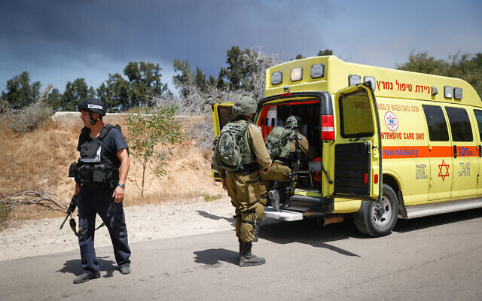
Israeli soldiers near the site of where a jeep was hit by an anti-tank missile fired from Gaza, May 12, 2021 (Yonatan Sindel/Flash90)

Hamas operatives fired an anti-tank guided missile at an Israeli jeep on the Gaza border on Wednesday morning, killing one person seriously injuring one and moderately injuring two more, according to Israeli authorities, as fierce fighting between the Israeli military and Palestinian terrorist group entered its third day with no signs of abating.
Immediately after the missile attack, terrorists in the Strip fired waves of mortar shells at the area, around the community of Netiv Ha’asara just north of the Strip, in an apparent effort to keep medical teams and security forces away. The injured people were eventually taken to the nearby Barzilai Medical Center in Ashkelon. Medics said the four men, three in their 20s and one in his 40s, all sustained injuries from shrapnel and the force of the blast.
The Israel Defense Forces immediately launched a series of strikes in the area, apparently targeting the cell that fired the missile, killing at least four people, according to Palestinian media. Additional Israeli strikes were reported throughout northern Gaza following the anti-tank guided missile attack.
The missile attack came after a brief lull in fighting between the two sides on Wednesday morning. Earlier in the day, the IDF launched massive raids on Hamas targets in the Gaza Strip, as terrorists in the Strip fired large barrages of rockets at central and southern Israel, killing an Arab Israeli man, Halil Awad, and his teenage daughter Nadine.
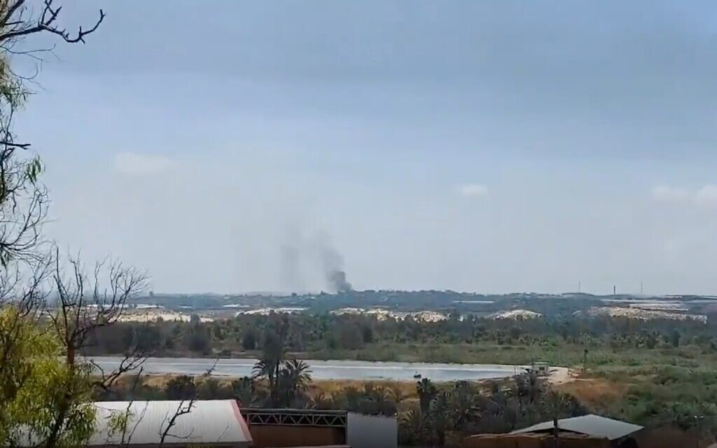
Smoke rises from the Gaza Strip following an IDF attack in response to an anti-tank guided missile attack from the enclave on an Israeli jeep near the community of Netiv Ha’asara on May 12, 2021. (Screen capture)

Over 1,050 rockets and mortar shells have been fired from the Gaza Strip toward Israel since the outbreak of fighting on Monday evening, including some 200 on Tuesday night and Wednesday morning alone, according to the IDF. Roughly 200 of the total number of rockets failed to clear the border and landed inside the enclave, the military said. IDF Spokesperson Hidai Zilberman said the Iron Dome air defense system had an interception rate of between 85 and 90 percent for rockets heading toward populated areas.
At least six people in Israel have been killed — three on Wednesday and three on Tuesday — and dozens more have been injured in the rocket attacks from Gaza, some seriously, including a 5-year-old girl in critical condition.
A 67-year-old woman suffered a heart attack that was brought on by rocket sirens in central Israel, and in Tel Aviv, an 80-year-old man suffered an apparent heart attack while running for a shelter and was in serious condition, medics said.
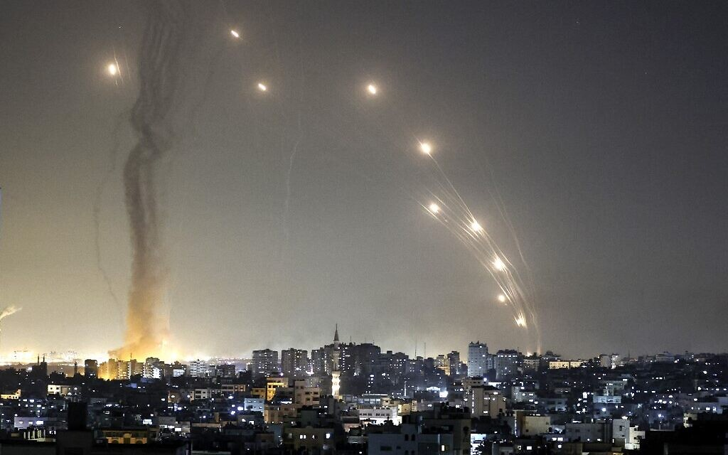
Rockets are launched towards Israel from Gaza City on May 11, 2021. (MAHMUD HAMS / AFP)

In response, the IDF launched strikes on upwards of 500 targets in the Gaza Strip, aimed at Hamas personnel, weaponry and infrastructure throughout the enclave, with plans to attack more in the coming hours and days, Zilberman said.
Those included targeted killings of top Hamas and Palestinian Islamic Jihad commanders and the destruction of a number of high-rise buildings that the IDF said were used by the terror groups as command centers, intelligence bases and weapons research and development facilities.
The IDF spokesman said the military was also conducting large-scale arrest raids of Hamas operatives in the West Bank out of concern that they may attempt to carry out attacks there in parallel to the fighting in Gaza.
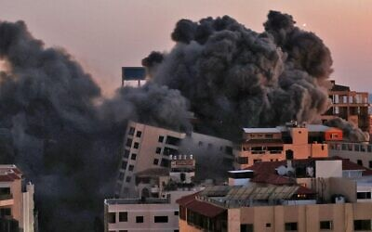
Smoke billows from an Israeli air strike on the Hanadi compound in Gaza City, controlled by the Palestinian Hamas terror group on May 11, 2021. (MOHAMMED ABED / AFP)

According to the Strip’s Hamas-run Health Ministry, 43 Palestinians have died since Monday night, including 13 minors and three women, and 296 have been wounded. The IDF said more than half of those killed were members of terror groups involved in the fighting and that some, including several of the children, were killed by errant rockets fired from Gaza that fell short of the border and landed inside the Strip, not by Israeli strikes.
The military has also said it was taking steps to avoid Palestinian civilian casualties. In the cases of attacks on the high-rise buildings, that has included calling those inside and telling them to leave prior to the impending attack and using the “knock on the roof” technique of dropping a non-explosive missile on a building as a warning to those inside to exit before demolishing the structure. In at least one case on Tuesday, the military actively negotiated with the manager of a building over the amount of time needed to evacuate the structure before the attack. https://www.timesofisrael.com/1-killed-3-injured-as-hamas-fires-anti-tank-missile-at-israeli-jeep/

2 women killed by rockets in Ashkelon amid massive barrages from Gaza
Caregiver from India, Soumya Santosh, 32, dies in assault; second victim not immediately identified; Iron Dome malfunction leads to failed interceptions
By Judah Ari Gross and Aaron Boxerman Today, 4:39 pm
Two women were killed and dozens injured, including two seriously, when Palestinian terror groups in the Gaza Strip fired massive barrages of rockets at southern Israel throughout Tuesday, drawing deadly retaliatory airstrikes from the Israel Defense Forces.
The deaths marked the first fatalities in Israel in the round of fighting with Gaza terrorist groups that began Monday evening, which has seen hundreds of rockets fired at Israeli territory.
The Hamas terror group claimed that at one stage on Tuesday it fired 137 rockets in around five minutes in an apparent attempt to overwhelm the Iron Dome missile defense system.
In a subsequent barrage on the southern coastal city of Ashkelon, less than an hour later, two women were killed by rockets in apparently separate hits.
The deadly rocket attack directly struck a home where an elderly woman and her caregiver, 32-year-old Soumya Santosh, lived. Santosh was killed while her elderly charge, 80, was hospitalized in serious condition, according to Hebrew media reports.
Channel 12 reported that the rocket shelter was at least a minute’s run away from the woman’s home and the pair did not manage to reach it in time. The home did not have a fortified room of its own.
According to the Haaretz daily, Santosh is survived by her husband and nine-year-old daughter.
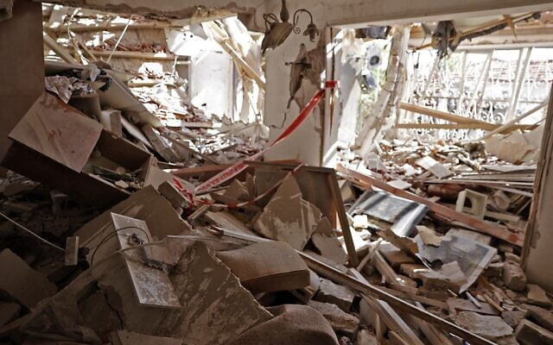  A heavily damaged house from rocket fire in the southern Israeli city of Ashkelon on May 11, 2021 (JACK GUEZ / AF | 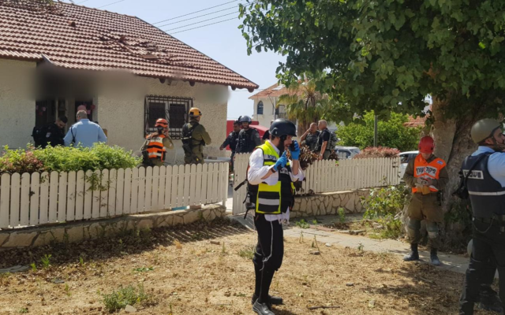  A building in Ashkelon where a woman was killed by a rocket fired from Gaza, May 11, 2021 (Zak
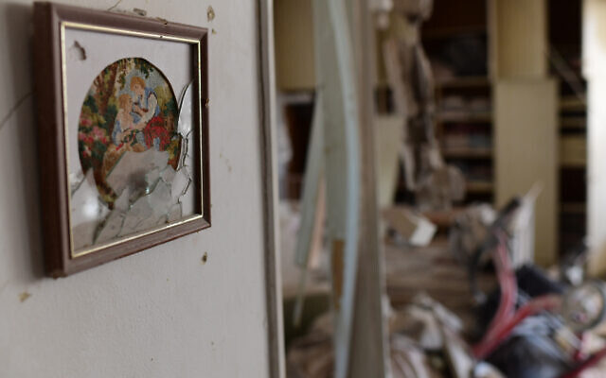  The scene where a rocket fired from the Gaza Strip hit a house in the southern Israeli city of Ashkelon on May 11, 2021. (Tomer Neuberg/Flash90) | 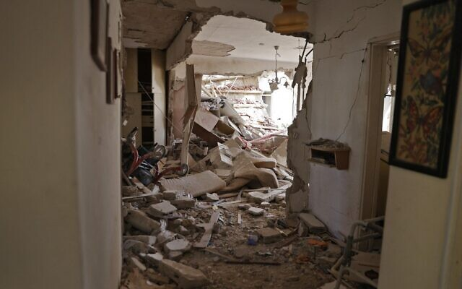  A heavily damaged house from rocket fire in the southern Israeli city of Ashkelon on May 11, 2021 (JACK GUEZ / AFP
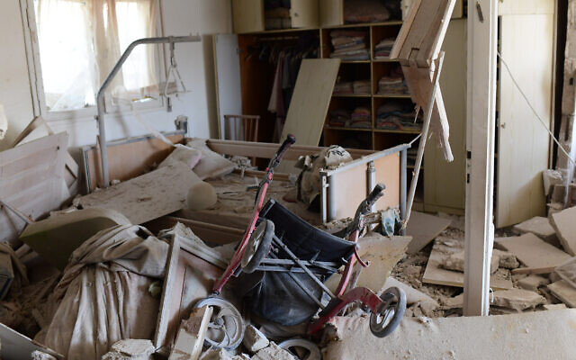
The scene where a rocket fired from the Gaza Strip hit a house in the southern Israeli city of Ashkelon on May 11, 2021. (Tomer Neuberg/Flash90)

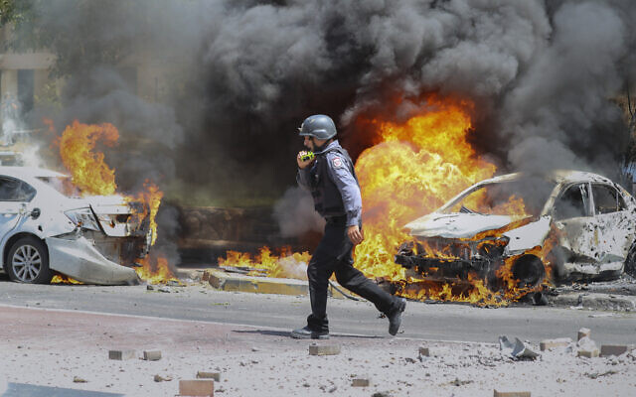
An Israeli firefighter walks next to cars hit by a rocket fired from Gaza Strip, in the southern Israeli town of Ashkelon, May 11, 2021. (AP Photo/Ariel Schalit)

ההרוגה מפגיעת הרקטה באשקלון: טהומיה סנטוש, בת 32 מהודו@pozailov1https://t.co/cExkOglLTo pic.twitter.com/7ZWi7RE95f
— כאן חדשות (@kann_news) May 11, 2021
A technical issue with an Iron Dome battery during the massive rocket barrage toward the coastal city prevented some rockets from being intercepted and may have been responsible for the casualties and deaths.
The malfunction was repaired and the battery returned to being fully operational shortly after, Hebrew-language media reports said.
The Barzilai Medical Center in Ashkelon on Tuesday said that it treated 95 casualties, including two seriously wounded and two in moderate condition.
With a number of buildings in the city suffering direct hits over the course of the day, and concerns over the number of residential buildings without bomb shelters, the Israel Defense Forces instructed residents to remain in reinforced areas. The restriction was later lifted — followed, minutes later, by additional rocket alert sirens on the city.
Ashkelon Mayor Tomer Glam said some 25 percent of residents don’t have access to a protected area when rockets are fired at the city.
“It is impossible when normal life becomes a state of emergency within minutes,” he told Army Radio. “There are houses from the 1960s where there is no basic protection — it is time for treasury officials and decision-makers to understand what is happening here in the city.”
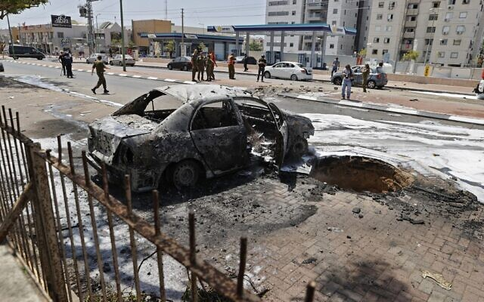
A picture shows a burnt vehicle in Ashkelon as rockets were fired from the Gaza Strip on May 11, 2021 (JACK GUEZ / AFP)

Over 630 rockets were fired at Israel from Monday evening through Tuesday afternoon, 200 of which were intercepted by Iron Dome missile defense batteries while 150 others fell short of their targets and landed inside the Strip, according to the army.
Tuesday afternoon saw the rocket attacks shift slightly northward, with projectiles fired at Ashdod including a rocket that directly hit a residential building. Buildings were also hit in Ashkelon, including an empty school.
On Monday night, a rocket directly struck a house in the Sha’ar Hanegev region, damaging it but not injuring its occupants.
In the early hours of Tuesday, a missile hit a residential building in Ashkelon, wounding six Israelis, four of them members of the same family: parents in their 40s, an 8-year-old and an 11-year-old. The father was seriously hurt with a head wound, and the others sustained light injuries from shrapnel.

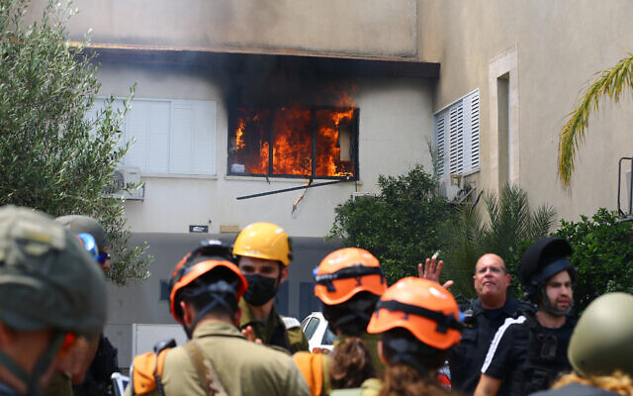
Israeli security forces at an Ashdod home hit by a rocket fired from the Gaza Strip on May 11, 2021 (Flash90)

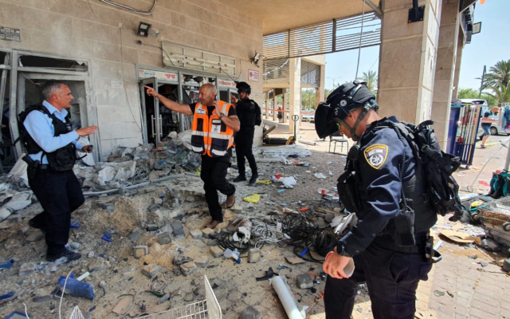
The assaults continued Tuesday after a night of almost constant rocket fire on Israeli communities near the Gaza Strip and as the IDF conducted strikes on more than 100 targets in the coastal enclave, as part of what it has called “Operation Guardian of the Walls,” the military said. The previous day saw a major outbreak of violence from Gaza, including rare rocket fire on Jerusalem, where Palestinians have been clashing with police for days.

The scene after a rocket hit Ashkelon, May 11, 2021 (Israel Police)

In response to the ongoing rocket rockets, IDF fighter jets, aircraft and tanks struck some 130 targets in the Gaza Strip, most of them associated with Hamas, but also some linked to other terror groups in the enclave, including the Palestinian Islamic Jihad.
Hamas and the Palestinian Islamic Jihad terror groups reported that several high-ranking commanders were killed in Israeli raids, including three top PIJ leaders in a drone strike on a building in the upscale Rimal neighborhood of Gaza City.
One of those killed was the brother of another top PIJ commander, Baha Abu al-Ata, who was killed in an Israeli strike in November 2019, kicking off a major round of fighting in the Strip. Islamic Jihad vowed revenge for the death of the three commanders in its armed wing, saying the response will be “harsh.”
Additionally, the IDF said it killed the head of Islamic Jihad’s special rocket unit, in an operation carried out in cooperation with the Shin Bet. Sameh Abed al-Mamluk was killed along with several other senior rocket officials, the army said.
According to the IDF, the military’s targets also included the home of a top Hamas commander, Hamas’s intelligence headquarters in southern Gaza, two attack tunnels that approached the border with Israel, rocket production and storage sites, observation posts, military installations and launchpads.
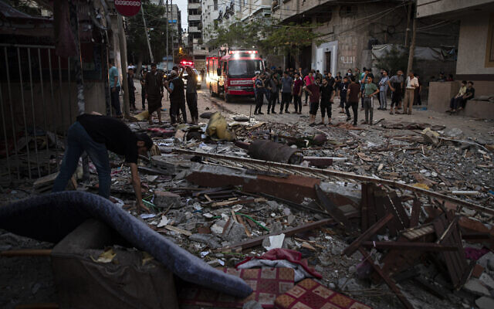
The IDF said it was also targeting terrorist operatives as they fired rockets or attempted to launch anti-tank missiles at Israel. On Monday, an Israeli man was lightly injured when Palestinian terrorists fired an anti-tank guided missile at his car.

A Palestinian man inspects the rubble of a partially destroyed residential building after it was said to have been hit by Israeli retaliatory strikes on the al-Shati refugee camp in Gaza City, May. 11, 2021. (AP Photo/Khalil Hamra)

Palestinian media also reported strikes around the southern cities of Rafah and Khan Younis and on an apartment building in the al-Shati camp near Gaza city. A building was also destroyed in Gaza City’s upscale Tel al-Hawa neighborhood.
The Hamas Health Ministry said 28 Gazans were killed, including nine minors, and 125 wounded in the ongoing escalation with Israel. Fifteen Gazans sustained serious injuries, according to Hamas Health Ministry spokesperson Ashraf al-Qidra. Israel said more than half were Hamas fighters.
IDF Spokesperson Hidai Zilberman said a number of those killed in Gaza, including at least three children, were hit by errant rockets fired by Palestinian terrorists, not by Israeli airstrikes.
The IDF spokesperson said Israel was taking steps to avoid Palestinian civilian casualties, but that they were liable to occur anyway as Hamas deliberately operates within a densely populated area, using the residents of the Strip as human shields.
Israel on Tuesday showed no indications that it was interested in an immediate ceasefire, as Zilberman said the fighting was expected to last at least several days.
IDF Chief of Staff Aviv Kohavi on Tuesday afternoon gave the military a green light to keep targeting Hamas and PIJ members operating in the Strip and bombing sites connected to the terror groups’ rocket production and storage efforts.
Soldiers from the IDF’s Golani Infantry Brigade and 7th Armored Brigade were sent to the Gaza border as reinforcements and additional troops were called in to aerial defense, intelligence and air force units, the military said. The police said that eight reserve companies of Border Police would be called up to help deal with disturbances across the country.
Zilberman said the military was deploying additional air defenses throughout the country, notably in the Tel Aviv metropolitan area. Tel Aviv had yet to be targeted as of Tuesday afternoon, but the IDF suspected that rocket fire may be directed there as well.
Defense Minister Benny Gantz said the IDF would continue striking Hamas and other terrorists in the Strip until “long-term and complete quiet” is restored. Gantz also threatened Hamas’s leadership, saying its commanders would “be held responsible and pay the price for the aggression.”
In light of the ongoing rocket attacks, Gantz declared the area within 80 kilometers (50 miles) of the Gaza Strip to be under military control, giving the IDF the power to issue directives to civilians there. The IDF ordered schools closed in communities near Gaza on Tuesday and limited gatherings to groups of 10 people outdoors and 50 people indoors. Businesses would be allowed to open only if they had easy access to bomb shelters.
The military also limited gatherings in the Tel Aviv metropolitan area and the Shfela region around Beit Shemesh to 30 people outdoors and 50 people indoors. Schools and businesses there could also only be opened if they had easy access to a bomb shelter. A number of cities in central Israel announced they were preemptively canceling schools on Tuesday as a precautionary measure.
Meanwhile, the Hamas-run Health Ministry in Gaza said that the Strip’s sole power plant was running low on diesel fuel after Israel closed all of its crossings on Monday evening in response to the hundreds of rockets fired.
The coastal enclave normally receives most of its fuel through the Kerem Shalom commercial crossing with Israel, and according to the Gaza Electrical Company, one of the plant’s generators has already been turned off and the plant as a whole will likely shut down “soon” due to lack of fuel, threatening to severely restrict the number of hours of electricity Gazans receive.
Al-Qidra said that an electrical shortage would threaten the effectiveness of Gaza’s health care system.
“This will have a serious effect on public health and the health of our society,” al-Qidra said.
Hamas, which is officially dedicated to the destruction of the State of Israel, took effective control of the Gaza Strip in 2007 from the Palestinian Authority in a violent coup. Since then, Israel has imposed a naval blockade on the enclave, as well as stiff control over what can enter the Strip, maintaining that it is necessary in order to prevent terror groups from smuggling weapons into the area.
The military initially believed that Hamas was not interested in a large-scale conflict with Israel at this time, but that assessment changed over the past two days and the IDF began preparing accordingly.
Palestinian terror groups have tied the attacks to the unrest in Jerusalem connected to both prayer on the Temple Mount during the Muslim holy month of Ramadan and the pending eviction of a number of Palestinian families from their homes in East Jerusalem’s Sheikh Jarrah neighborhood.
Israel has fought three large operations against Hamas and other terror groups in the Gaza Strip since 2008, most recently in 2014 with a 51-day war known as Operation Protective Edge. https://www.timesofisrael.com/2-killed-by-rockets-in-ashkelon-amid-massive-barrages-from-gaza/

‘You never get used to it’: Ashkelon shaken by first rocket deaths in 2 years
Two women killed in southern city; with up to a quarter of the city lacking shelters in their homes, residents say they’re living on ‘Iron Dome and luck’
By Agencies and TOI staff Today, 6:19 pm
Residents of the southern city of Ashkelon ran to public shelters nearly all day Tuesday as rockets fired from the Gaza Strip pummeled the southern city, killing two women and turning homes, a school and cars into smoldering wreckage.
The firing of hundreds of rockets at Ashkelon underlined the lack of access to shelters in the southern city, with the mayor saying that one-quarter of its residents are dependent on public fortified areas and many cannot reach them on time.
Guy Mann, who lives in Ashkelon near a building that suffered a direct hit, lamented the poor access to shelters in an interview with Army Radio Tuesday.
“I was woken with by a big explosion which was extremely intense,” he said. “The house is not protected and it is not realistic to get to the neighborhood shelters, especially when the barrages are so continuous. We can only rely on the Iron Dome [missile defense system] and luck.” MORE -https://www.timesofisrael.com/you-never-get-used-to-it-ashkelon-shaken-by-first-rocket-deaths-in-2-years/

Massive forces sent to Lod as Netanyahu vows to restore order with ‘iron fist’
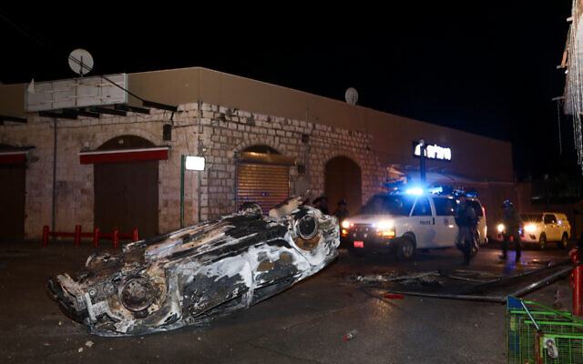
Synagogues torched in widescale Arab riots described by city’s mayor as ‘Kristallnacht’ and ‘civil war’; 3 Jewish suspects remanded over fatal shooting Monday of Arab man
By Michael Bachner and TOI staff Today, 10:36 am

The aftermath of riots in the central Israeli town of Lod, seen in the early hours of May 12, 2021. A state of emergency was declared after hours of Arab mob violence (Yossi Aloni/Flash90)

Israel ordered a massive boost Wednesday morning to police forces deployed in cities with Jewish and Arab populations. The move came hours after a state of emergency was declared in Lod, where intense Arab rioting late Tuesday reportedly saw three synagogues and numerous shops torched, along with dozens of cars.
The rare emergency declaration in the central Israeli city prompted the urgent dispatching of several Border Police companies to work to restore order.
A state of emergency hands police officers more authority and freedom to operate in the locality where it was declared. They can close off areas of the city, enter any place to carry out their duties, and employ “reasonable force” to compel civilians to obey their orders.
Some Lod residents said power was cut in their homes and Molotov cocktails were thrown through their windows, Channel 12 news reported late Tuesday, and police acknowledged having to escort some residents from a community center to their homes as Arab mobs marauded in the streets.
A local man, 56, was seriously hurt when a rock slab hit his car, and was hospitalized. Another local resident was seriously hurt.
Lod residents salvage unharmed Torah scrolls from the ruins of a synagogue torched by Arab rioters, May 12, 2021. (Screenshot: Twitter)

The mayor, Yair Revivo, said City Hall and a local museum were also attacked, and compared the situation to the Nazis’ 1938 Kristallnacht pogrom. “Civil war” was breaking out, he said, lamenting that decades of coexistence efforts had collapsed.
בית כנסת שרוף בעיר לוד, רק בנס לא נשרפו ספרי התורה.
פוגרום תשפ"א pic.twitter.com/DsSQtK1PM2
— בנצי רובין (@bentzi_r) May 12, 2021
Footage posted on social media showed a torched synagogue and two Torah scrolls being salvaged — unharmed — from its ruins.
Israel Police Commissioner Kobi Shabtai on Wednesday moved his official office to Lod to oversee the situation.
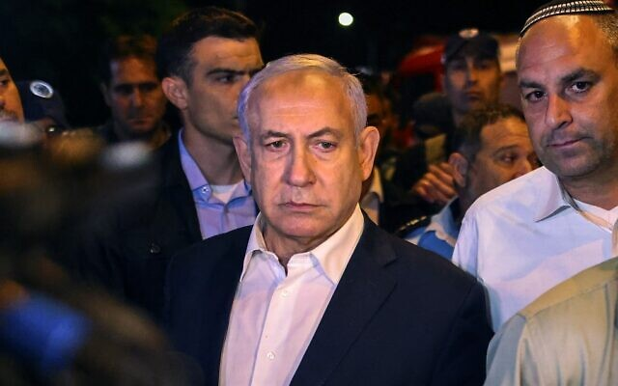
Prime Minister Benjamin Netanyahu tours the mixed Jewish-Arab city of Lod early on May 12, 2021, as a state of emergency is imposed following Arab riots. To his right is Lod Mayor Yair Revivo. (AHMAD GHARABLI / AFP)

Prime Minister Benjamin Netanyahu visited the city during the night to oversee the efforts to impose order and end the riots.
“I have been receiving updates all day on what is happening here in the city and I view it extremely gravely. It’s anarchy from rioters and we cannot accept it,” Netanyahu said.
The prime minister urged Lod residents to stay home and said he would impose a curfew if needed. “We will restore law and order with an iron fist,” he said.
????A synagogue is burning in Lod
pic.twitter.com/Qk0smCbtow
— Gabriel Hébert-Røuillier (@Gab_H_R) May 11, 2021
Three Jewish men were arrested Tuesday over the fatal shooting of an Arab man during clashes Monday night. They were being questioned on suspicion of murder, while maintaining that the shots were fired in self-defense.
But an initial investigation indicated that the shots were fired toward a man standing dozens of meters away, and a court on Wednesday extended their remand by three days, with Judge Tal Aner saying the self-defense claim “doesn’t match the objective findings.”
On Wednesday, Public Security Minister Amir Ohana tweeted that the shooter’s arrest was “terrible.” Ohana said that had the matter been under his authority, he would order the suspect released immediately and recommended that police do so, because “civilians carrying weapons are helpful to authorities in immediately neutralizing threats or dangers.”
Arab violence erupted in numerous other cities across Israel, alongside reports of Jewish attacks, including in Lod, where a Muslim cemetery was set ablaze. MORE -https://www.timesofisrael.com/massive-forces-sent-to-lod-as-netanyahu-vows-to-restore-order-with-iron-fist/

33-year-old man killed in Lod amid violent riots across Israel
"The residents were forced to shoot in the air in front of a crowd that did not care, until they fired in their direction and wounded two of the rioters," a witness told Israeli media.
By IDAN ZONSHINE MAY 11, 2021 20:34
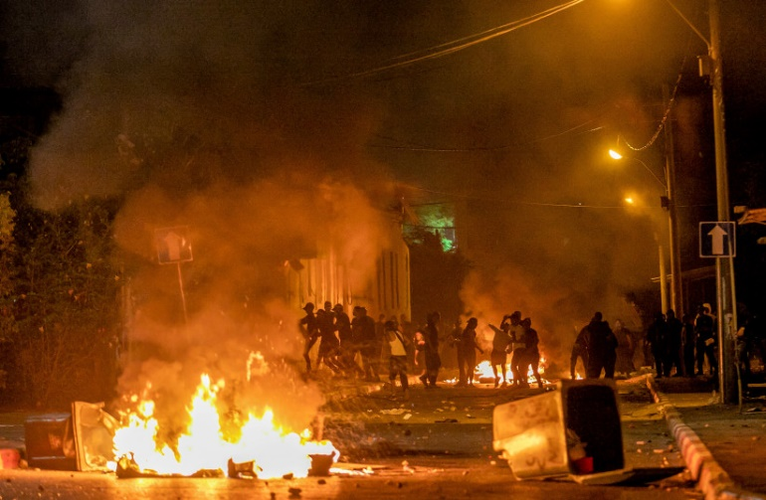
Violent riots broke out in Ramla last night amid the ongoing violence between Palestinians and Israelis in east Jerusalem.
(photo credit: YOSSI ALONI/FLASH90)

A 33-year-old Lod resident and father of three named Musa Malakh Hassuna was shot dead on Monday night on Hahashmonaim Street in the city of Lod, near a large protest by Arab-Israelis demonstrating in solidarity with Palestinians in east Jerusalem and Gaza, as violent riots swept the country, Israel Police reported.
Two more people were moderately injured in the incident, including a 20-year-old man.
The Magistrate's Court in Rishon Lezion on Tuesday evening extended until Thursday the detention of the three suspects involved in the shooting incident.
Hundreds of Arab residents from Lod protested Monday night, throwing rocks and Molotov cocktails while marching toward the Jewish neighborhood of Ramat Eskhol.
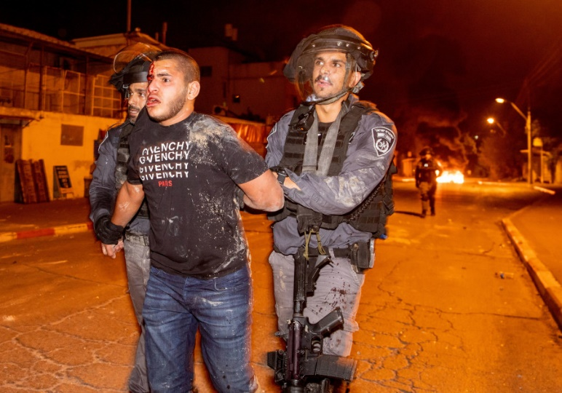
Violent riots broke out in Ramla last night amid the ongoing violence between Palestinians and Israelis in east Jerusalem. (Yossi Aloni/Flash 90)

Haaretz reported that police suspect that Hassuna and the others were shot by one of the Jewish residents of the neighborhood, after witnesses reported that he and the other shooting victims participating in the riots.
A resident of the neighborhood, Meir Liush, told Haaretz that "the Arab crowd tried to break into the neighborhood; the police did not arrive for many long minutes."
"The residents were forced to shoot in the air in front of a crowd that did not care, until they fired in their direction and wounded two of the rioters," Liush added.
Video uploaded to social media shows people running toward a vehicle with a Molotov cocktail, and then gunshots are heard.
Another video shared on social media showed a demonstrator in Lod on Monday night climbing a streetlight, taking down an Israeli flag and replacing it with a Palestinian flag.
לוד: הסרת דגל ישראל ותליית דגל פלסטין לקולות ההמון. כשתיאור המקום הוא: "לוד-פלסטין". pic.twitter.com/A2nFtMaELs
— אור רביד | Or Ravid (@OrRavid) May 10, 2021
The rioters in Lod also set fire to the Maoz pre-military preparatory academy in the city, causing extensive damage to the property, the academy announced on Tuesday. During the incident, Arab rioters disgraced Torah scrolls at the academy as well.
Violent riots broke out in Ramla last night amid the ongoing violence between Palestinians and Israelis in east Jerusalem. (Yossi Aloni/Flash 90)
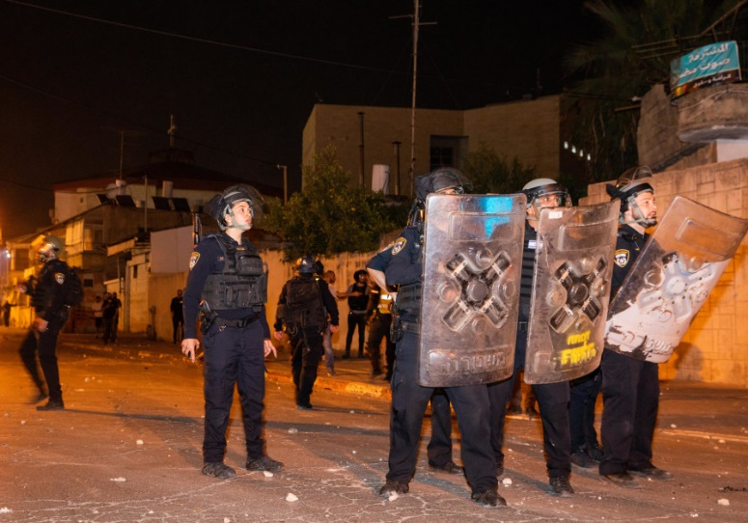
"It could have ended in disaster," said Danny Zamir, the head of the academy. "Fortunately, the students and the educational staff were not present at the preparatory school. This violence will not deter us: We will rehabilitate the place."

Israel police in Ramla-Lod reported that 16 demonstrators were arrested on Monday evening during riots in which around 200 youths arrived to protest solidarity with Palestinians in east Jerusalem. Many were seen throwing stones and bottles and launching fireworks at police and buildings, while also burning trash cans and tires.
Dozens of riots were reported in northern Israel as well, with Israel Police reporting on Tuesday morning that they had arrested 67 people for lighting fires and throwing stones. Police intend to request that the arrests be extended.
Border Police arrested five suspects in disturbances and riots overnight Monday at the Qalandiya Crossing and Rachel's Tomb. About 200 suspects threw stones, Molotov cocktails and fireworks at security forces at the crossing and about 300 suspects threw stones, Molotov cocktails and glass bottles at Rachel's Tomb.
A Border Police commander and 10 officers were lightly injured during the disturbances.
Over 40 fires were sparked in terrorist incidents in the West Bank overnight, according to Israel Fire and Rescue Services, including stone-throwing, Molotov cocktails and burning tires.
Many of the incidents occurred along main roads and near settlements.
A firefighting team was caught in riots while extinguishing a fire in the Binyamin district, with stones thrown at their firetruck.
A vehicle caught on fire after it was hit by a Molotov cocktail thrown by Palestinians near Tekoa in the West Bank overnight.
"Judea and Samaria District is prepared and ready in accordance with the orders of the Israel Fire and Rescue Service," said Shiko Bar Dov, commander of the Judea and Samaria District of the Israel Fire and Rescue Services. "The stations are reinforced with additional firefighters, the district command center is reinforced and a redeployment of forces has been made in accordance with operational needs."
Eight Border Police reserve brigades were called up on Tuesday morning to help police handle the violence breaking out across Israel. https://www.jpost.com/breaking-news/25-year-old-man-killed-2-more-injured-in-shooting-incident-in-lod-667815

Jewish teen seriously hurt in Beersheba stabbing; Arab Israeli suspect arrested
Violence comes during pro-Palestinian protest and right-wing counter-protest over Jerusalem, amid spiraling ethnic tensions in the country
By Emanuel Fabian Today, 7:17 pm
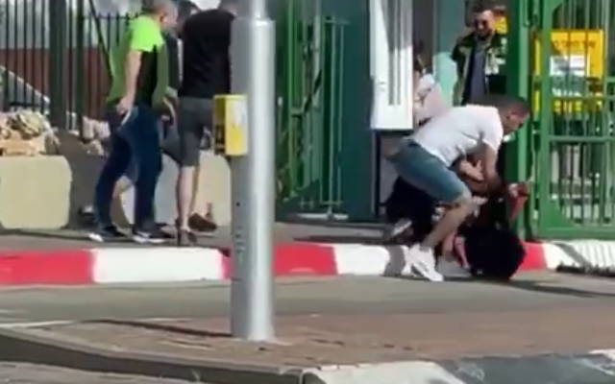
People attempt to subdue an assailant with a knife outside the Soroka Medical Center in Beersheba on May 11, 2021. (Screenshot)

A Jewish teenager was seriously wounded in a stabbing outside the Soroka Medical Center in Beersheba on Tuesday, amid a clash between Arab and Jewish student protesters.
Pro-Palestinian demonstrators had been rallying outside the southern city’s Ben Gurion University over the pending evictions in East Jerusalem, as Jewish students organized a counter-protest across the street, outside the hospital.
As police attempted to separate the sides, a suspect, said to be an Arab Israeli, stabbed an 18-year-old man in the chest, leaving him in moderate-to-serious condition.
The suspected assailant was chased by the counter-protesters and hospital security guards, one of which fired into the air from his handgun. The man fled into the hospital grounds, where he was arrested.
The clashes between the demonstrators began after right-wing extremists joined the pro-Israel crowd, Gili Oren, a student who was at the scene, told The Times of Israel on Tuesday. [It actually appears that this may be the beginning of another major intifada in Israel with all these wild eyed Islamic radicals rioting all over. – rdb]

Protesters wave Israeli flags and chant outside the Soroka Medical Center in Beersheba on May 11, 2021. (Screenshot)

“Both sides were acting violently, throwing stones at each other, cursing and yelling,” he said.
The pro-Palestinian demonstrators were apparently protesting against the pending evictions in the East Jerusalem neighborhood of Sheikh Jarrah, eyewitnesses told told The Times of Israel. MORE -https://www.timesofisrael.com/jewish-teen-seriously-hurt-in-beersheba-stabbing-arab-israeli-suspect-arrested/

IDF says it thwarted West Bank shooting, would-be Palestinian gunman killed
Second Palestinian suspect seriously wounded by Israeli fire after one of them allegedly pulls out a gun at Tapuah Junction, site of a recent deadly terror attack
By Emanuel Fabian Today, 8:10 pm
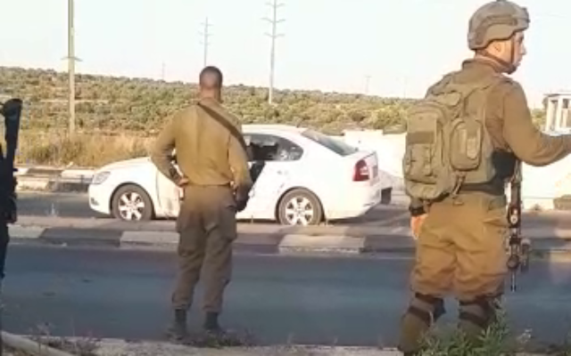
Israeli soldiers stand by the Palestinian vehcile from which two suspects allegedly attempted to commit a shooting attack at Tapuach Junction in the West Bank on May 11, 2021. (Screenshot)

Two Palestinian suspects were shot near the Tapuah Junction in the West Bank on Tuesday after they apparently attempted to open fire toward Israeli soldiers stationed in the area, the military said.
The two suspects arrived at the junction in a car, opened the window, as one pulled out a handgun, the Ynet news site reported. The soldiers opened fire toward the suspects, killing one and seriously wounding the other.
The wounded suspect was taken to a hospital in serious condition, Rescuers Without Borders, a Jewish emergency service operating in the West Bank, said.
Last week, a Palestinian terrorist opened fire toward Israeli civilians at the junction, resulting in the death of 19-year-old yeshiva student Yehuda Guetta, and the injury of two others.
During that attack, soldiers from the IDF’s Givati Brigade who were at the scene returned fire, hitting the vehicle used and the terrorist driving it. Despite being shot, the gunman fled the scene, ditching the car used in the drive-by shooting in the nearby town of Aqraba where it was torched by locals as soldiers arrived to seize the vehicle. MORE - https://www.timesofisrael.com/idf-says-it-thwarted-west-bank-shooting-would-be-palestinian-gunman-killed/

Iran now enriching uranium to 63% purity — UN watchdog
Amid talks on renewing nuke deal, IAEA said to conclude Tehran exceeding 60% enrichment cap it announced, bringing it even closer to weapons-grade level
By TOI staff Today, 11:38 am
Iran has enriched uranium to 63-percent purity, higher than the 60% it has announced, which is already way beyond the 3.67% allowed under the 2015 nuclear deal, a report said Tuesday, citing a document by the International Atomic Energy Agency.
“According to Iran, fluctuations of the enrichment levels… were experienced,” the UN nuclear watchdog said in a confidential report, according to the Reuters news agency.
“The agency’s analysis of the ES [environmental samples] taken on 22 April 2021 shows an enrichment level of up to 63% U-235, which is consistent with the fluctuations of the enrichment levels [described by Iran],” the document said.
That is a short technical step away from the weapons-grade 90%. Iran insists it doesn’t plan to build a nuclear bomb, even as its leaders routinely threaten to annihilate Israel and flatten its cities.
The development comes as world powers have been holding high-level talks aimed at bringing the United States back into the nuclear deal with Iran, with both sides signaling a willingness to work out the major stumbling blocks. The talks began in Austria in early April, and a fourth round was held last Friday. MORE -https://www.timesofisrael.com/iran-now-enriching-uranium-to-63-purity-un-watchdog/

'Phantom votes' emerge in 2020 election lawsuit
Trump calls it a 'bombshell' as votes 'intentionally switched' from Trump to Biden
By WND Staff Published May 11, 2021 at 11:10am
The Michigan county embroiled in controversy when it counted thousands of votes for Joe Biden that were cast for Donald Trump isn't out of the woods yet: A judge has been told that 1,061 "phantom votes" have been found there.
Officials in Republican-majority Antrim County initially reported voters chose Joe Biden in the the 2020 presidential race. But tabulation errors were discovered and Trump was shown to be the winner. State and county officials blamed the proble on human error, but two local citizens have filed a lawsuit contending the Dominion Voting Systems machines used in the tabulation could have been used to manipulate the election.
The Washington Examiner reports attorney Matthew DePerno, representing Antrim County resident William Bailey, told County Circuit Judge Kevin Elsenheimer during a virtual hearing on Monday that a recount in December tallied 15,962 ballots. However, the Michigan secretary of state's database shows only 14,901 votes were cast. That means 1,061 don't exist on voter rolls.
New discoveries and filings today:
(1) 1,061 phantom ballots discovered in Antrim
(2) nearly 100% turnout between ages 65 and 80
(3) 20.3% of all ballots sent to PO boxeshttps://t.co/IYzEsT5E7d
— Matthew S. DePerno, Esq. (@mdeperno) May 8, 2021
The defendants in the lawsuit, including Michigan Secretary of State Jocelyn Benson, insist Bailey has no right to sue.
DePerno explained in a court filing the discovery of the "phantoms" is why an audit of the county's results should be conducted.
He also noted that voters ages 65 to 80 had a near 100% turnout, the Examiner reported.
The newspaper got no response when it sought comment from state officials.
Former President Trump joined the discussion.
"The major Michigan Election Fraud case has just filed a bombshell pleading claiming votes were intentionally switched from President Trump to Joe Biden," he said in a statement shared by his Save America PAC, the Examiner reported.
"The number of votes is MASSIVE and determinative. This will prove true in numerous other States. All Republicans must UNIFY and not let this happen. If a thief robs a jewelry store of all of its diamonds (the 2020 Presidential Election), the diamonds must be returned. The Fake News media refuses to cover the greatest Election Fraud in the history of our Country. They have lost all credibility, but ultimately, they will have no choice!"
A previous recount found Trump with 9,749 votes and Biden with 5,959. Across the state, Biden won by only about 150,000.
The lawyer also told the judge there are questions about 138 ballots that a state official instructed two volunteers to count even though they had "the very same signature in Central Lake Township," the report said.
Michigan was one of six battleground states that drew charges of election fraud. Several states suspended counting on election night with Trump leading. Hours later, after massive ballot dumps that were nearly 100% for Biden, the Democrat took the lead when counting resumed. https://www.wnd.com/2021/05/phantom-votes-emerge-2020-election-lawsuit/

Biden warned he needs to reverse course on Iran 'before it is too late'
Rogue regime responds to 'maximum pressure,' but not conciliation
By Bob Unruh Published May 11, 2021 at 12:02pm
A U.S. senator and a former national security adviser have joined together in a commentary published at Real Clear Politics to warn President Biden he must reverse course on Iran "before it is too late."
Sen. Bill Hagerty, R-Tenn., and H.R. McMaster, a retired Army lieutenant general who was President Trump's national security adviser from 2017 to 2018, contend that Biden's agenda of "conciliation" to Iran, like the same practice used by former President Barack Obama, is failing.
They wrote, "Media outlets around the world recently reported on leaked audio comments in which Iranian Foreign Minister Javad Zarif admitted that Iran's Islamic Revolutionary Guard Corps controls all of Iran's foreign policy decisions. Although President Joe Biden was careful to mention neither Zarif nor Iran in his speech before Congress last month, Zarif's embarrassingly candid revelations have direct implications for Biden's entire Iran policy: namely, it underscores that reducing economic sanctions in order to moderate the Iranian regime cannot work."
That means trying to accommodate the regime's wishes, trying to cooperate, trying to make friends, simply won't work.
For years, they explained, America has "mistakenly assumed the regime can be tamed by conciliatory diplomacy. Western efforts to placate Tehran have failed consistently since the revolutionaries took power in 1979, yet recent reports indicate President Biden is in the process of repeating this failure."
"Just as the Obama administration did with its disastrous 2015 Iran nuclear deal, the Biden administration is now seeking to lift economic sanctions against Iran in exchange for temporary commitments from Tehran to curb its nuclear program. A senior State Department official recently revealed that the Biden administration is reviewing all U.S. terrorism and human rights sanctions on Iran since 2017 to assess whether those sanctions were 'legitimately imposed,' and that some sanctions will need to be lifted to ensure Tehran is 'benefiting' from the nuclear deal," they explained. " Like Obama, Biden hopes that relaxing economic pressure can convince the regime to put aside its nuclear ambitions, focus on Iran's economy and people, stop bankrolling terrorist proxies, and become a normal member of the international community."
That's not only "misguided," but "naïve," they said.
That Obama-Biden mirage is that "conciliation can change not only the behavior, but also the very nature, of the Iranian regime is based on the false assumption that U.S. policy drives the Iranian regime's attitudes and behaviors."
They said actually, "Since 1979 the regime has based its decision making on an expansionist revolutionary ideology that is fundamentally hostile to the United States, Israel, Iran's Arab neighbors, the West, and our allies around the world…"
Any moderation of Tehran's behavior, they explained, has happened "in response to intense political, economic, and military pressure."
The two said the U.S. needs to work to maintain and improve "defenses against Iranian military and terrorist capabilities," keep focused on disrupting Tehran's nuclear weapons agenda, and impose financial costs on the regime to limit what the radicals have to wage proxy wars.
"During our time in the Trump administration, we both were directly involved in persuading U.S. allies to join in enforcing sanctions designed to deny Khamenei the cash he requires to fund proxy wars," the wrote. "Convincing Japan to cease importing Iranian oil, for example, was a hard-won achievement that took months of tough negotiations, but created real leverage, as did similar efforts with other oil importers."
But they said such advances require "tending" and the Biden administration is failing.
"Noting Biden’s intent to relax sanctions on Tehran, China has increased imports of Iranian oil to nearly one million barrels per day, a threefold increase from last year," they wrote.
"President Biden should reverse course before it is too late." https://www.wnd.com/2021/05/biden-warned-needs-reverse-course-iran-late/ [The demon-rats are totally clueless and simply want to destroy the USA and if that means using Iran to do it that is fine. They could care less about this country as is obvious from their Hate America campaign in the schools from the communist secondary educators and those whom have been placed in positions of power. They are now working to destroy the US both from the inside by race baiting and from the outside by their international trolls like the ayatollah. – rdb]

120 American generals: U.S. may not survive Biden's attack on Constitution
'Our nation is in deep peril'
By Bob Unruh Published May 11, 2021 at 7:21pm
A letter that has been signed by some 120 retired military leaders who served America in some of its darkest hours and places is warning that the nation may not survive the attack on the Constitution being orchestrated by Joe Biden, the president.
"Our nation is in deep peril," says the letter, which was posted online at The Federalist.
"We are in a fight for our survival as a constitutional republic like no other time since our founding in 1776. The conflict is between supporters of socialism and Marxism vs. supporters of constitutional freedom and liberty."
Biden has, of course, implemented a multitude of socialist ideas for Americans, essentially without even the benefit of Congress, and the letter pointed that out.
"The current administration has launched a full-blown assault on our constitutional rights in a dictatorial manner, bypassing the Congress, with more than 50 executive orders quickly signed, many reversing the previous administration's effective policies and regulations," they wrote. "Moreover, population control actions such as excessive lockdowns, school and business closures, and most alarming, censorship of written and verbal expression are all direct assaults on our fundamental rights."
They pointed to the 2020 elections, however, as the most significant red flag.
"Without fair and honest elections that accurately reflect the 'will of the people' our constitutional republic is lost. Election integrity demands insuring there is one legal vote cast and counted per citizen. Legal votes are identified by state legislature's approved controls using government IDs, verified signatures, etc.
"Today, many are calling such commonsense controls 'racist' in an attempt to avoid having fair and honest elections. Using racial terms to suppress proof of eligibility is itself a tyrannical intimidation tactic. Additionally, the 'Rule of Law' must be enforced in our election processes to ensure integrity," they wrote
"The FBI and Supreme Court must act swiftly when election irregularities are surfaced and not ignore them as was done in 2020."
And they warned against the Democrats' openly proclaimed congressional agenda point of taking over all elections in the nation entirely, banning state security requirements and imposing hugely suspect processes such as mail-in ballots for all and hired ballot collectors who would take votes from individuals – and then turn them in.
The report said the signatories include President Ronald Reagan's former National Security Adviser John Poindexter, President George W. Bush's former Deputy Undersecretary of Defense William Gerald Boykin and retired Army Brig. Gen. Donald Bolduc, who is now running for Senate in New Hampshire.
They object to the "litany of left-wing pursuits showcased in the first 100 days of the new administration led by President Joe Biden, who has redefined what it means to run a far-left presidency," the report said.
They cited the Democrats' attack on elections, demand for open borders, unlimited censorship from Big Tech, the attempt to return to the Iran nuclear deal, the damage to the nation's energy independence, and more.
"Under a Democrat Congress and the current administration, our country has taken a hard left turn toward socialism and a Marxist form of tyrannical government," they charged.
Biden, whose president rests on no more than some 43,000 votes spread across three battleground states – where election actions and results prompted calls for investigations into alleged fraud – is working with a 50-50 Senate and an extremely narrow margin of majority in the House, which may be why he's doing so many actions by executive fiat.
The letter asks Americans to toss out far-left politicians and instead choose candidates who value fiscal responsibility and individual rights over socialism. https://www.wnd.com/2021/05/120-american-generals-u-s-may-not-survive-bidens-attack-constitution/

Report: Zuckerberg's grant program demanded control of elections
Money for municipalities came with strings from leftist Big Tech player
By Bob Unruh Published May 11, 2021 at 8:42pm
The Amistad Project, an election integrity organization that has spent much time since November reviewing the outside and possibly illegal influences on the 2020 president election, already has filed a complaint with the Wisconsin Elections Commission against its administrator and the mayor of Racine, Wisconsin, alleging they violated the U.S. Constitution in allowing an outside group to be part of the management of the 2020 presidential election.
"In the November 2020 general election, the city of Racine adopted private corporation conditions on the election process affecting state and federal elections," the complaint states. "In this case, Racine involved private corporations and their employees in the city's state and federal election administration."
And Racine broke state laws in that act, it alleges.
The same organization has claimed in another complaint before the commission that officials in Green Bay, Wisconsin, turned over some of their operations and responsibilities to "private activist groups" during the election.
Director Phill Kline said it was a "shadow government" that actually ran the 2020 election there.
The allegations are all part of a campaign to uncover what leftist Facebook CEO Mark Zuckerberg demanded from cities and counties when he donated some $400 million to local election officials to help them with their election work.
The money actually went to the Chicago-based Center for Tech and Civic Life, which handed out millions of dollars but put strings on the money, with provisions that it could get the money back if local elections officials didn't allow the CTCL's own designated private groups essentially to run the elections. MORE - https://www.wnd.com/2021/05/report-zuckerbergs-grant-program-demanded-control-elections/

CDC greatly exaggerated risk of outdoor virus transmission
Mask guidance based on rate possibly 100 times higher than true figure
By Art Moore Published May 11, 2021 at 6:13pm
Parks and playgrounds have been shuttered while the Centers for Disease Control and Prevention continues to recommend that masks be worn outdoors in many situations, even by people who are vaccinated.
But "the science" upon which those guidelines are based apparently is far from reality, according to a New York Times report.
The CDC has estimated that the risk of COVID-19 transmission while outdoors is about 10%. But the true figure may be less than 1% -- and possibly even less than 0.1%.
If it is 0.1%, that means the CDC's estimate was 100 times too high.
The Times reported the 10% figure is based "partly on a misclassification" of some virus transmission from a study. Some of the settings classified as outdoor, such as construction sites, actually were a mix of both outdoor and indoor.
On Tuesday, CDC director Dr. Rochelle Walensky was confronted by Sen. Susan Collins, R-Maine, regarding the Times report. The senator noted it was another example of conflicting and confusing guidance, along with recommendations related to school reopenings and summer camps.
Walensky explained that the 10% benchmark was derived from a study published in the Journal of Infectious Disease in November that synthesized various studies.
A CDC official told the Times there are limited data on outdoor transmission.
"The data we do have supports the hypothesis that the risk of outdoor transmission is low. Ten percent is a conservative estimate from a recent systematic review of peer-reviewed papers," the official said.
"CDC cannot provide the specific risk level for every activity in every community and errs on the side of protection when it comes to recommending steps to protect health," the official said. "It is important for people and communities to consider their own situations and risks and to take appropriate steps to protect their health."
Now you tell us
Constitutional scholar Jonathan Turley noted Tuesday the outdoor risk "has been a major source of disagreement with many contesting mandatory mask rules for those walking or working or recreating outside."
Cities such as Chicago closed parks and New York City shuttered playgrounds used by the lowest-risk population. And states closed parks and trails, Turley noted, "that could have been key areas of release for people during lock downs."
Trillions have been spent on the pandemic, the George Washington University professor pointed out, yet there "appears to have been little time or money spent on the basis for this key component of the mandatory policies supported by the CDC and mandated by many states."
"I can understand the reliance on an article in the prestigious Journal of Infectious Diseases," he said. "I cannot understand the failure to closely examine its basis since it appears to have been the primary basis for the policy.
"Hundreds of millions of Americans were impacted as well as the economy," Turley continued. "Yet, CDC is only now noting that the article appears to have been fundamentally flawed in its underlying assumptions and calculations." https://www.wnd.com/2021/05/report-cdc-exaggerated-risk-outdoor-virus-transmission/

Commentary:
The COVID Jab, a Genocidal Weapon of Mass Destruction
By Kelleigh Nelson|May 11th, 2021
What connects two thousand years of genocide? Too much pwer in too few hands. —Simon Wiesenthal
The more it (vaccination) is supported by public authorities, the more will its dangers and disadvantages be concealed or denied. ― M. Beddow Bayly, British physician
The duty of the survivor is to bear testimony to what happened . . . You have to warn people that these things can happen, that evil can be unleashed. Race hatred, violence, idolatries—they still flourish. —Elie Wiesel
We have seen more than once that the public welfare may call upon the best citizens for their lives. It would be strange if it could not call upon those who already sap the strength of the State for these lesser sacrifices. The principle that sustains compulsory vaccination is broad enough to cover cutting the Fallopian tubes. Three generations of imbeciles are enough. —US Supreme Court Justice Oliver Wendell Holmes, Buck v. Bell, 1927
Justice Holmes’ ruling in the notorious Buck v. Bell decision allowed that a state statute permitting compulsory sterilization of the unfit, including the intellectually disabled, “for the protection and health of the state” did not violate the Due Process Clause of the Fourteenth Amendment to the United States Constitution. The entire ruling was flawed, the case was a lie because Carrie Buck was not promiscuous, she was raped, but the overwhelming legitimization of Galton’s 1883 eugenics resulted in an 8-1 decision against Carrie Buck. State statues have been repealed, but Buck v. Bell has never been overturned and involuntary sterilizations still occur today.
The Rockefeller Foundation helped found the German eugenics program years before Hitler and even funded the program that Josef Mengele worked in before he went to Auschwitz. Eugenics would have been so much bizarre parlor talk had it not been for extensive financing by corporate philanthropies, specifically the Carnegie Institution, the Rockefeller Foundation and the Harriman railroad fortune. They were all in league with some of America’s most respected scientists hailing from such prestigious universities as Stamford, Yale, Harvard, and Princeton. These academicians espoused race theory and race science, and then faked and twisted data to serve eugenics’ racist aims. Link
Eugenics and Covid-19
Investigation reveals both the Gates family and their foundation have documented ties to reinvented eugenics movements of the modern age. The work carried out by this organization shows an array of ulterior motives that are contrary to saving lives.
The Gates Family, Eugenics and Covid-19.
America is killing humanity and shaking hands with the devil…brought to us by the United States government via their stakeholders: The Gates Foundation, the Center for Disease Control (CDC), the National Institutes of Health (NIH), the World Health Organization (WHO), Big Pharma and our democrat-controlled propaganda media and their favorite mouthpiece, Dr. Anthony Fauci. Media are promoting an evil injection which is causing countless worldwide deaths and disastrous side effects. They have made a commitment to promote mass vaccination for the Covid virus. We may well be witnessing the largest number of unnecessary vaccine-induced deaths in American history, despite a 99.75% overall recovery from the virus.
Dangerous Injections
In Leo Hohmann’s recent article, he states that America has had 3,544 deaths and 12,619 serious injuries reported between Dec. 14, 2020 and April 23, 2021, yet it is left to patients to report adverse effects to Vaccine Adverse Effect Reporting System (VAERS). Hohmann included Alex Newman’s 30-minute interview with Dr. Peter McCullough, essential information. McCullough holds the honor of being the most cited medical doctor on COVID-19 treatments at the National Library of Medicine, with more than 600 citations. He has testified before Congress and won numerous awards during his distinguished medical career. He said if this were any other vaccine it would have been pulled from the market by now for safety reasons.
“A typical new drug at about five deaths, unexplained deaths, we get a black-box warning, your listeners would see it on TV, saying it may cause death,” McCullough said. “And then at about 50 deaths it’s pulled off the market.”
The U.S. has a precedent for this. In 1976 during the Swine Flu pandemic the U.S. attempted to vaccinate 55 million Americans, but at that point the shot caused about 500 cases of paralysis and 25 deaths.
“The program was killed, at 25 deaths,” McCullough said.
But billions of Covid-vaccines are being made. Pfizer’s Covid vaccine earned the company $3.5 billion in the first three months of this year, 25% of Pfizer’s total revenue, which I don’t have a problem with, but no one is stopping this mRNA inoculation, and it has already killed thousands and injured thousands more.
Inoculation Pressure!
Want to fly, send your children to school, go into your office? You can’t come to my party if you’re not vaccinated! Pressure to get the jab is enormous.
The swine flu vax was stopped at 25 deaths, yet 203 people died in 2019 from the flu vaccine. In 2018, 119 people died. In 2017, 85 people died from the flu vaccine. It was not removed from the market because thousands of youngsters and elderly die each year from seasonal flu. According to the CDC, there were 959,000 hospitalizations and 79,400 deaths attributed to influenza during the 2017–2018 season, and that includes babies and toddlers. Yet, we can choose whether we wish to take the seasonal vaccine, which at times has only covered 10% of the year’s virus.
Tucker Carlson recently stated that roughly 30 people have died every day from the Covid-mRNA vaccines between late December and April 20th. These numbers are from VAERS, but the real numbers are not known; less than one percent are reported.
In less than four months, the Covid inoculations have caused nearly 4,000 deaths, and that is more than all other vaccines administered in the US between mid-1997 and the end of 2013…nearly 15 years.
Many preeminent physicians you’ll never hear on mainstream media are saying this is the single most deadly inoculation in history. No one has ever charted the deaths from the polio vaccine which caused soft tissue cancers by being grown on Simian monkey kidneys. Simian Virus 40 (SV40) has probably killed millions and is genetically passed, and the polio vaccine was given in the late 50s and early 60s.
Know the Law
The pressure is heavy, but know the law…these inoculations are not licensed by the FDA and you cannot be forced to take the vaccine.
Ever since the Food and Drug Administration granted “emergency use authorization” (EUA) for two new “vaccines” in December 2020, (Pfizer/BioNTech and Moderna) employers, schools, and other organizations are grappling with whether to require Covid-19 vaccination.
While organizations are certainly free to encourage their employees, students, and other members to be vaccinated, federal law provides that, at least until the vaccine is licensed, individuals must have the option to accept or decline to be vaccinated.
The clinical trials the FDA will rely upon to ultimately decide whether to license these vaccines are still underway and are designed to last for approximately two years to collect adequate data to establish if these vaccines are safe and effective enough for the FDA to license.
Given the uncertainty about the two vaccines, their EUAs are explicit that each is “an investigational vaccine not licensed for any indication” and require that all “promotional material relating to the Covid-19 Vaccine clearly and conspicuously … state that this product has not been approved or licensed by the FDA, but has been authorized for emergency use by FDA.”
When Dr. Amanda Cohn, the executive secretary of the CDC’s Advisory Committee on Immunization Practices, was asked if Covid-19 vaccination can be required, she responded that under an EUA, “vaccines are not allowed to be mandatory. So, early in this vaccination phase, individuals will have to be consented and they won’t be able to be mandatory.” Cohn later affirmed that this prohibition on requiring the vaccines applies to organizations, including hospitals. Link
The first US lawsuit was filed in February 2021, against Doña Ana County Manager in Las Cruces, New Mexico for the unlawful mandating of Covid Vaccines.
Injection Injuries
In Del Bigtree’s interview with three horribly injured health care workers, two of the three healthcare workers didn’t even know about VAERS, and the one who did, had a co-worker whose child was paralyzed from the waist down by a flu vaccine. They had to report to VAERS as their physicians and hospitals never did. Most shocking is that 90% of the inoculation injuries occur in women.
Harvard Medical School did a study of VAERS, paid for by the CDC, and they determined that less than one percent of vaccine adverse events are reported. Physicians won’t even acknowledge the deaths and side effects of these injections, so it’s up to the patient or their family to report it. If healthcare workers do not know of VAERS, certainly most Americans don’t either.
Statistics show children have more chronic health issues than ever before. At the same time, they are the most vaccinated children who ever existed. See the connection?
Jabs, Dangerous and Useless
In an exclusive interview with Alex Newman of the New American Magazine, German microbiologist Sucharit Bhakdi explained how coronavirus vaccines affect the body at the cellular level. He warned that these vaccines are set to cause a global catastrophe and decimate the human population. He pleads with people not to get the “vaccine.” Dr. Bhakdi states that the injections are either useless or dangerous.
Remember the Johns Hopkins report issued by Dr. Genevieve Briand…the original article was on the web and then pulled two days later. The report stated there were no more deaths in 2020 than in previous years. Deaths related to cancer, heart disease, flu, pneumonia, diabetes, etc. have all been categorized in Covid-19. The total decrease in deaths by other causes almost exactly equals the increase in deaths by Covid-19; the 2020 yearly death rate remains the same.
The question remains, why do we need an untested and unlicensed dangerous inoculation for a virus that has a 99.75% recovery?!
mRNA Dangers
A recent Israeli study claimed Pfizer’s vaccine is 40% more dangerous than the Covid virus. According to a Yale epidemiologist, as reported in The Gateway Pundit, over 50% of new Covid cases involve people who have already been vaccinated.
A startling new report in *Microbiology and Infectious Disease* finds the mRNA vaccines could trigger Alzheimer’s disease, ALS (Lou Gehrig’s Disease), and other neurological and cognitive degenerative diseases.
Life Site News reported that the experimental vaccine death rate for Israel’s elderly is 40 times higher than Covid-19 deaths. “Pfizer’s vaccine killed about 40 times more (elderly) people and 260 times more of the young than what the Covid-19 virus would have claimed in the given time frame.”
Deaths began skyrocketing in Vietnam and Cambodia once the vaccine was administered to the public. The cure with the experimental gene therapy vax is far deadlier than the asymptomatic disease that has a 99% survival rate.
Life Site News reported that thousands ended up in hospital in the UK after receiving the injection and tested positive for Covid. Their excuse was the vaccine hadn’t had enough time to work. India’s inoculations started in February and now the rise of Covid cases has accelerated.
American Guinea Pigs
In 2010, I wrote a 10-part article entitled, American Citizens as Guinea Pigs. Our government has a penchant for experimentation on her citizenry, and especially on our military.
The U.S. government poisoned alcohol during prohibition. The bootlegged gin and whiskey often made people sick, but this time it was our own government. They decided making alcohol taste bad was the answer during the 13 years without legal liquor. A New York medical examiner found Kerosene, Brucine, Gasoline, Benzine, Cadmium, Zinc, Formaldehyde, Chloroform, Acetone and more in the government’s renatured industrial alcohol which disproportionately affected the poor who couldn’t afford smuggled alcohol and booze cruises. It didn’t work. Instead, by the end of Prohibition in 1933, the federal poisoning program had killed at least 10,000 people by most estimates.
I’ve mentioned the polio vaccine countless times.
Opioid manufacturers’ settlements have been in the news despite using our troops to secure Afghan poppy fields.
Vioxx was a popular drug to treat arthritis, but Merck and Co. pulled it off the market in 2004. Research linked the drug to approximately 140,000 heart attacks and 60,000 deaths. Merck is said to have used flawed methodologies for predetermined results and exaggerated positive effects.
From 1932 to 1972, our U.S. Health Department, now the CDC, had no problem with black men in Tuskegee, Alabama being used in an ethically abusive and evil experiment and study to observe the natural history of untreated syphilis. None of the Health Department physicians felt compassion, guilt or regret for what they had done.
Thalidomide was a rapidly approved drug introduced in 1957, to address nausea and insomnia in pregnant women. It was marketed in 50 countries before being withdrawn in 1962 due to malformations in newborns. Be careful with what comes in a rapidly approved vaccine.
Former Director of the CIA, Allen Dulles, committed appalling human experiments with mind control. Link
Over and over again, the military has conducted dangerous biowarfare experiments on Americans. On September 20, 1950, a US Navy ship just off the coast of San Francisco used a giant hose to spray a cloud of microbes into the air and into the city’s famous fog. The military was testing how a biological weapon attack would affect the 800,000 residents of the city.
Human radiation experiments, especially those committed in Oak Ridge, TN during WWII were evil and diabolical, more than one can imagine. Plutonium experiments on babies and soldiers were exposed in Eileen Welsome’s book, The Plutonium Files.
The U.S. Government has a secret history of grisly experiments; unethical human experimentation in America was a common occurrence in the 20th century. Here is a list of 30 human experiments that will give you nightmares.
Throughout American history, government experiments took advantage of vulnerable populations who were not given sufficient details to give informed consent.
Using American citizens as guinea pigs for this unlicensed experimental Covid injection is pure evil.
Conclusion
The Nuremburg Codes written after the horrors of the Nazi Holocaust, specify first and foremost the consent of the human subject is essential. I have yet to find one person who has received the Covid injections who has been told that the shot is not licensed and approved by the FDA.
How many healthcare employees are told to give this shot and are not informed of VAERS, the statistics, the deaths and adverse effects? Are they just doing as they’re told?
Obedience to authority was the excuse for many Nazi perpetrators. Some got off, but others were sent to the gallows.
The Milgram experiment by psychologist Stanley Milgram at Yale University showed explicit reactions to authority. His experiments began in July 1961, a year after the trial of Adolf Eichmann in Jerusalem. Milgram devised the experiment to answer the question: Could it be that Eichmann and his million accomplices in the Holocaust were just following orders? What he found was telling.
Ordinary people are likely to follow orders given by an authority figure, even to the extent of killing an innocent human being. Obedience to authority is ingrained in us all from the way we are brought up.
Milgram summed up his findings in his 1974 article “The Perils of Obedience.” The results are frightening. https://newswithviews.com/the-covid-jab-a-genocidal-weapon-of-mass-destruction/

And then…
Palestinians: Our True Goal is to Destroy Israel
by Bassam TawilMay 11, 2021 at 5:00 am
When former Iraqi dictator Saddam Hussein fired 39 Scud missiles at Israel in 1991, many Palestinians took to the streets to celebrate the attacks. Many demonstrations took place in the West Bank, Gaza Strip and east Jerusalem even while Palestinians were being issued gas masks by the Israeli authorities to protect them against a possible chemical attack by Iraq against Israel.
The Los Angeles Times reported back then that "several Palestinians expressed joy at last week's [Iraqi] missile assault on Tel Aviv and Haifa."
When the Iranian-backed Hezbollah terrorist group launched rocket attacks on Israel from Lebanon in 2015, Palestinians took to the streets to celebrate, holding Hezbollah flags and handing out sweets to drivers and passersby.
For the Palestinians, anyone who attacks Israel or threatens to destroy it is a real "hero."
In the past few days, the Palestinians have been cheering another "hero": Mohammed Deif, the shadowy figure who heads the military wing of the Palestinian Islamist movement, Hamas.
Deif has been Israel's most wanted terrorist for the last 25 years because of his involvement in several terror attacks, including the killing of Israeli soldiers, suicide bombings and kidnappings. In 2015, the US State Department added Deif to its list of Specially Designated Global Terrorists.
Because of his direct involvement in terrorism against Israel, Deif has always been regarded by many Palestinians as a "hero."
Now, after Deif warned Israel of retaliation if it does not change its policies in east Jerusalem, he seems to be even more popular among the Palestinians.
In a rare public statement, the arch-terrorist, who is based in the Hamas-ruled Gaza Strip, said that Israel will pay a "heavy price" if it does not stop the eviction of Palestinian families living in Jerusalem's Sheikh Jarrah neighborhood. "This is a clear and final warning," Deif threatened, hinting that Hamas would resume its rocket attacks and other forms of terrorism against Israel.
The threat came after a Jerusalem court approved the eviction of a number of Arab families in Sheikh Jarrah from homes that had belonged to Jews before the establishment of Israel in 1948.
During mass demonstrations in Jerusalem and some parts of the West Bank over the past few days, thousands of Palestinians chanted slogans in praise of Deif and urged him to carry out his threat to fire rockets at Israel. The Palestinians also chanted slogans in support of Hamas's military wing, Izaddin al-Qassam, which is responsible for thousands of terrorist attacks against Israel during the past three decades.
"We are the men of Mohammed Deif," thousands of Palestinians chanted during a demonstration at the al-Aqsa Mosque, the third holiest site in Islam. They also called on him to "strike" Tel Aviv with rockets, thereby echoing the 1991 call to Saddam Hussein: "O' beloved Saddam, strike, strike Tel Aviv!"
The demonstrations in Jerusalem began on the first day of the Muslim fasting month of Ramadan, when scores of youths attacked police officers and Jewish residents with rocks, firebombs and other objects. The protesters initially justified the attacks by arguing that the Israel Police had set up barricades at one of the entrances to the Old City of Jerusalem, thus preventing them from gathering at night to celebrate Ramadan.
The riots, however, continued even after the police removed the barricades. The rioters said that they were protesting the possible eviction of the families from Sheikh Jarrah and attempts by Jews to "storm" the al-Aqsa Mosque, a reference to routine visits by Jews to the Temple Mount, the holiest site in Judaism.
So how does Deif, the chief Hamas terrorist, fit into the clashes between Palestinians and the Israel Police in Jerusalem?
By invoking the name of Deif and calling on him to bomb Tel Aviv, the protesters exposed the truth: that their protests were less about the al-Aqsa Mosque or the controversy surrounding the Sheikh Jarrah houses or the police barriers at the Old City than about the elimination of Israel.
It is worth noting that Israel has not taken any new measures to "alter the historical or legal status" of the al-Aqsa Mosque, as the Palestinians and other Arabs have claimed.
The Palestinians are upset because Jews are being permitted to tour the Temple Mount. The Palestinians do not want to see Jews visiting their holy site; they do not want to see Jews in Jerusalem, and they do not want to see any Jew at all in the land that stretches from the Jordan River to the Mediterranean Sea.
How does the bombing of Tel Aviv help the cases of the Arab families in Sheikh Jarrah, who are challenging the eviction order in Israeli courts? How does calling on Hamas to launch terrorist attacks against Israel assist the Palestinians in their campaign to stop Jews from touring the Temple Mount?
By raising Hamas flags and chanting slogans in support of an arch-terrorist at the al-Aqsa Mosque, the demonstrators desecrated the holy site, not the Jews. Those who used the mosque compound to throw rocks and other objects at police officers are the ones who defiled the holy site. You cannot attack police officers and then complain that Israel sent police to "raid" and "desecrate" the al-Aqsa Mosque -- unless your mind has been twisted by terrorist logic.
No one is disputing the Palestinians' right to protest Israeli policies. Yet when the protests turn into large pro-Hamas demonstrations, with calls for bombing Tel Aviv and killing Jews, they expose the true deadly intention of the protesters.
When thousands of Palestinians chant "We are all Mohammed Deif," they are saying that they see themselves as terrorists ready to attack and destroy Israel. They are also saying that Deif is their role model because he managed to murder many Jews and remains at large, despite Israeli attempts to apprehend or kill him.
The violence that erupted in Jerusalem over the past few days shows that Hamas has a large following among Palestinians, including residents of east Jerusalem who hold Israeli-issued ID cards but are not Israeli citizens. After Israel annexed east Jerusalem in 1968, it gave the Palestinians living there the right to apply for Israeli citizenship. Most of them, however, chose not to ask for Israeli citizenship out of fear of being branded traitors.
As permanent residents of Israel, the Palestinian residents of Jerusalem enjoy all the rights bestowed on Israeli citizens with one exception: the right to vote for the Israeli parliament, the Knesset. At the same time, these residents are entitled to apply for Israeli citizenship any time they wish and several thousand have already done so.
Hamas's popularity is on the rise not only in east Jerusalem, but also in the West Bank, where some Palestinians also heaped praise on Deif and urged him to unleash a new wave of terror against Israel.
Hamas owes its growing popularity to the anti-Israel inflammatory campaign waged in the Palestinian media, especially social media platforms, the mosques and public rhetoric of Palestinian leaders. Hamas also owes its popularity to the ongoing corruption and incompetence of the Palestinian Authority and its autocratic president, Mahmoud Abbas.
Abbas had good reason to delay until further notice the parliamentary and presidential elections he was planning to hold on May 22 and July 31. He knew very well that his rivals in Hamas were headed toward a victory similar to the one they scored in the last parliamentary election in 2006.
Yet Abbas did not have the courage to admit that this was the real reason why he called off the elections. Instead, he chose to blame Israel by falsely accusing it of preventing the Palestinians in Jerusalem from participating in the elections.
As he sits in his living room and watched thousands of Palestinians in Jerusalem denouncing him as a traitor and hailing Hamas and Deif, Abbas must have heaved a sigh of relief that the elections were indefinitely postponed. The pro-Hamas demonstrations in Jerusalem should worry not only Israel, but Abbas and his Palestinian Authority as well.
The demonstrations in favor of Hamas should also sound alarm bells with the Biden administration and serve as an accurate indicator as to Palestinian priorities. The Biden administration is talking about reviving the stalled peace process between Israel and the Palestinians on the basis of the "two-state solution." Hamas and the thousands of Palestinians who chanted slogans in support of Hamas and Deif, however, have a different solution in mind: the annihilation of Israel and the deaths of Jews -- the more the merrier.
Bassam Tawil is a Muslim Arab based in the Middle East.
https://www.gatestoneinstitute.org/17361/palestinian-goal-destroy-israel
And…
Are We to Be the World's Greatest Force for Good or Not?
Dennis Prager Posted: May 11, 2021 12:01 AM
America is going through convulsions that may destroy it as the country we and the world have known for more than two centuries.
For all its flaws -- virtually all of which were not unique to America but universal throughout human civilization -- America has been regarded more than any other nation in modern times as a force for good in the world.
When a country is hit with a severe earthquake, its people do not look first to France or Germany -- let alone to Russia or China -- for assistance. They look to America. When bad people invade a country, the people of the invaded country hope and pray America will come to their aid. And for more than a century, when beleaguered people saw American troops, they generally danced with joy.
When people in any country in the world want to better their lives, whether in terms of freedom, human rights or economic opportunity, they think of emigrating to America more than to any other country.
Approximately 340,000 Africans came to America as slaves. But millions of Africans have come to America because they wanted to. To these millions and to many millions of Africans who have not been given visas to emigrate to America, America is the land of systemic opportunity, not systemic racism.
The only people to deny these facts are America's homegrown America-haters. They see America as a force of evil at home and abroad.
So, too, they deny that on the planet called Earth, without a credible threat of American intervention, evil triumphs. In addition to America's seminal contribution to vanquishing German and Japanese fascism, had America not won the Cold War, communism would have destroyed millions more lives than the more than 100 million it did. Had America not sacrificed 37,000 of its finest young men, all of Korea would be the giant concentration camp that became North Korea. Had America triumphed in Vietnam, that country, too, would have ultimately been half-free instead of entirely enslaved. The Stalinist communists who conquered South Vietnam produced a society so hellish nearly a million Vietnamese "boat people" risked drowning, being devoured by sharks, and murdered, tortured and raped by pirates on the high seas to leave the communist hell that followed America's withdrawal from their country.
I remember the shame I felt as an American when I saw crowds of Vietnamese who had helped America begging to be taken out of Vietnam along with American troops when the last American helicopters left Vietnam. And who were simply abandoned to their fate.
Now America is poised to do in Afghanistan what it did then -- abandon the people it defended to the Islamist sadists known as the Taliban. How many Afghan boys and women will be raped when we leave? How many Afghan men will be tortured to death? Only God knows. But you don't have to be God to know that it will be a large number.
So, why would we do such a thing -- again?
Three reasons are given.
One is, "We cannot stay in Afghanistan forever."
That argument is offered as if it is so self-evident that it needs no explanation. Which is probably why no one seems to offer one. But why can't we stay there "forever," if doing so saves a country and tells the world that America sticks to its commitments and protects its allies?
We have stayed in Germany and South Korea "forever." Is the world better or worse for it?
The second argument is, "We cannot nation-build." That argument, too, is offered as if it is self-evidently valid. But it's a phony argument. No one argued that we were in Afghanistan to "nation-build." We were there because 9/11 was launched against us from there. And there is every reason to assume more terror will be directed from Afghanistan if we leave. And our presence there has kept Pakistan from falling into the control of Islamists.
We were not there, as Bret Stephens recently argued, "to kill Osama bin Laden, who was just one in a succession of terrorist masterminds. It was to prove Bin Laden wrong about America's long-term commitments, especially overseas. In August 1996, Bin Laden issued his notorious fatwa declaring a war on the United States that he hoped would be long and bloody. He observed that, in one conflict after another, the Americans always cut and run."
The third argument is that remaining in Afghanistan costs America blood and treasure. The blood argument is emotionally irrefutable. Every American killed in Afghanistan is an immeasurable tragedy. But in the last six years, the U.S. has lost fewer than 20 service members annually in hostile engagements in Afghanistan. Between 2006 and 2018, we lost twice as many service members to training accidents than to all overseas actions. As for treasure, we spend between $50 and $100 billion a year in Afghanistan. That is far more morally justifiable than the trillion or more dollars we have spent in the last year to bail out Democratic governors and mayors and the unions they serve.
For the record, I would have made the identical argument if Donald Trump were president and removed us from Afghanistan. But the actual withdrawal is being conducted in a different administration.
Moral arguments didn't matter to one Democratic senator in 1975. As he put it in a Senate speech on April 23: "I do not believe the United States has an obligation, moral or otherwise, to evacuate foreign nationals ... The United States has no obligation to evacuate one, or 100,001, South Vietnamese." That senator was Joseph Biden of Delaware.
To Democrats and Republicans who support the retreat from Afghanistan, I have a question: If Afghanistan comes to resemble Cambodia's killing fields, will you still think it was the right decision? Or, to put it another way: Is there any level of evil, any emboldening of America-hating Islamists, any effect of an American defeat on the world or on America that would make you regret your decision to withdraw? https://townhall.com/columnists/dennisprager/2021/05/11/are-we-to-be-the-worlds-greatest-force-for-good-or-not-n2589241

THE SHORASHIM BIBLICAL GIFT CATALOG 005
http://mad.ly/7f9f64?pact=20013931524&fe=1
Support Shorashim!

ARUTZ SHEVA
Netanyahu: Hamas will pay a heavy price
PM, DM Gantz release joint statement on response to rocket attacks, warn Hamas will pay for attacking Israeli citizens.
Arutz Sheva Staff , May 11 , 2021 11:09 PM
Prime Minister Benjamin Netanyahu and Defense Minister Benny Gantz issued a joint statement tonight (Tuesday) at the end of a security assessment they conducted at the Kirya in Tel Aviv.
Prime Minister Netanyahu said, "The IDF has attacked hundreds of terrorist targets. We eliminated dozens of terrorists, including senior commanders. We bombed headquarters, demolished buildings and towers. We continue to attack with all our might."
"Hamas and Islamic Jihad have paid, and will pay a very heavy price for, their aggression - their blood is on their heads," Netanyahu added.
Defense Minister Benny Gantz said that "the IDF has been working with the Shin Bet ... for the last 24 hours to conduct hundreds of attacks in Gaza. There are a lot of targets in the pipeline - this is just the beginning."
"I know the Gaza arena, the terrorist organizations have been hit hard and will continue to be damaged by their foolish decision to shoot into Israeli territory. We will restore peace and security and do so in the long run. I met the heads of the authorities in the [Gaza] envelope, who give their full backing to the move - and so do all the citizens of Israel. The IDF, I would like to remind you, guard and protect everyone - Jews and Arabs alike, and I call on all citizens of Israel - it is time to act responsibly and avoid mutual violence and violence in general.
"I, the Prime Minister and the entire political echelon support all the security forces and the IDF under the leadership of the Chief of Staff. They can do their job as needed, they do a great job and they can continue.
"I would like to say to the leaders of the countries of the world - there is no sovereign state that would receive fire on its citizens and population centers. We do not accept that either. We have the right and the duty to act - so we do. I would like to express my condolences to the families who lost their loved ones, to wish the wounded a recovery and to ask all Israeli citizens - keep the Homefront Command guidelines, they do save lives and we should not underestimate the situation we are in. We will all be united, strong and determined," Gantz concluded. https://www.israelnationalnews.com/News/News.aspx/306023

Ra'am chairman calls for calm
Mansour Abbas in statement to the Arab public following two days of violence: We must prevent further escalation that could claim human lives on both sides.
Elad Benari , May 11 , 2021 11:47 PM
Ra'am chairman Mansour Abbas on Tuesday evening published a statement to the Arab public following two days of violence.
"I am calling for calm. We must prevent further escalation that could claim human lives on both sides, and allow a return to a normal routine of life, especially during Ramadan, and in light of the holiday of Eid al-Fitr and the holiday of Shavuot," he said.
On Monday, Abbas announced that the negotiations on the formation of a government have been halted in light of the escalation in the south, the launching of rockets at Israel and the riots in Jerusalem.
A senior Ra’am official told Kan 11 News that they do not know if they will be able to resume negotiations before Yair Lapid's mandate to form a government expires, and that this depends on the extent of the escalation.
Also on Monday, Abbas canceled a tripartite meeting with Lapid and Naftali Bennett. The meeting was scheduled to take place at 4:30 p.m., before the rocket attacks from Gaza toward Israel began.
Religious Zionist Party chairman Bezalel Smotrich visited the Shimon Hatzadik (Sheikh Jarrah) neighborhood in eastern Jerusalem on Monday and warned against the formation of a government supported by Abbas.
"The legitimacy that is being given right now to Abbas and the supporters of terrorism is being spilled over onto the citizens of Israel. The citizens of Jerusalem are under siege and it is a shame and a disgrace," said Smotrich.
"Whoever gives the terrorist supporters legitimacy to be part of the Israeli government - it should come as no surprise that the terrorists then raise their heads against the people of Israel," he added. https://www.israelnationalnews.com/News/News.aspx/306026

Police commander rammed in northern Israel
Search for driver continues after police commander is rammed in northern Israel.
Arutz Sheva Staff , May 12 , 2021 2:40 PM
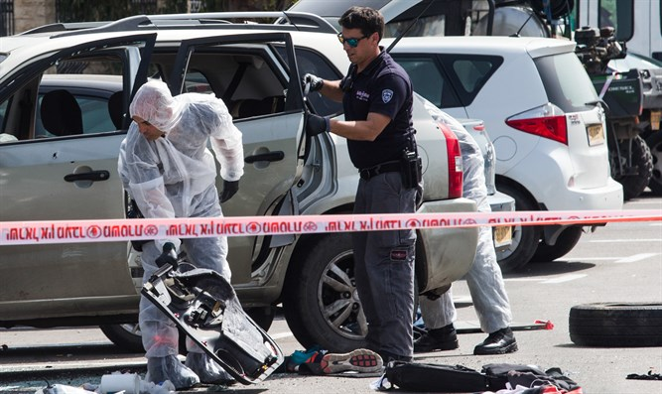
Ramming attack scene Flash 90

Israel Police are investigating a ramming attack in which a police commander was injured in northern Israel.
The ramming occurred Tuesday night on Route 65 in the Wadi Ara area.
The Wadi Ara valley and the area around it are populated mostly by Israeli Arabs.
Police officers arrived at the scene of the ramming following reports of rioters who checked the identities of the drivers prior to attacking them.
Immediately after police arrived at the scene, another vehicle passed through the area, injuring a police commander, who was taken to a local hospital for medical treatment.
Responding to the attack, police detectives fired at the escaping vehicle.
The driver who rammed the officer has not yet been located.
Also on Tuesday night, rocks were hurled and police were attacked near Bedouin settlements in southern Israel. https://www.israelnationalnews.com/News/News.aspx/306066

55 suspects arrested overnight in southern Israel
Police arrest 55 for attacking police officers, hurling rocks. 'Anarchy and a loss of control,' owner of damaged bus says.
Arutz Sheva Staff , May 12 , 2021 2:08 PM
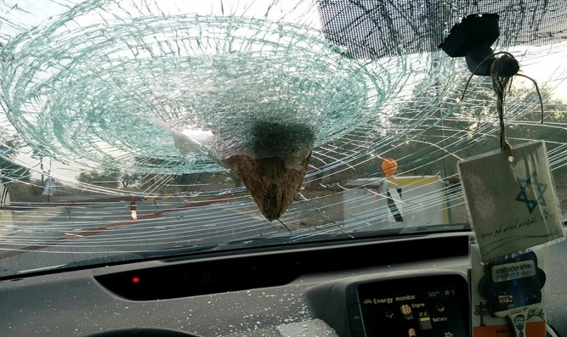
Rock attacksT.P.S.

Israel Police on Tuesday night arrested 55 people suspected of hurling rocks, attacking police officers, and disturbing order in Bedouin settlements in the Negev and on nearby highways.
The suspects will be brought Wednesday morning to the Be'er Sheva Magistrates Court for an extension of their arrest.
At the same time, the police are continuing their investigation of the incidents, and additional arrests are expected.
According to 24DimoNews, rocks were thrown at a private tour bus at 4:30a.m. Wednesday morning. At the time of the attack, only the driver was on the bus.
The local news outlet stated that the bus was near Abu Talul, between Dimona and Be'er Sheva, at the time of the attack. The bus company's owner, Odeh Abu Assa, told 24DimoNews: "This is anarchy and a loss of control. When you harm infrastructure, you harm your home. I feel that this violence is very dangerous, and in my private vehicle as well, I became trapped in an area where rocks were being thrown." https://www.israelnationalnews.com/News/News.aspx/306061
To be removed from this News list, Please click here and put "Unsubscribe" in the subject line.

05/11/2021 NEWS AM
Yonina- Jerusalem of Gold (Live from Mt. Olives)
https://www.youtube.com/watch?v=I0z-3cuf1Ws
"You cannot bring about prosperity by discouraging thrift.
You cannot help small men by tearing down big men.
You cannot strengthen the weak by weakening the strong.
You cannot lift the wage-earner by pulling down the wage-payer.
You cannot help the poor man by destroying the rich.
You cannot keep out of trouble by spending more than your income.
You cannot further the brotherhood of man by inciting class hatred.
You cannot establish security on borrowed money.
You cannot build character and courage by taking away men's initiative and independence.
You cannot help men permanently by doing for them what they could and should do for themselves."
-- William Boetcker (1873-1962) German-born Presbyterian clergyman
Read the Prophets & PRAY WITHOUT CEASING!
That is the only hope for this nation!
Please  Remember  These  Folks  In  Prayer-  Check often  They  Change! | Pray that the world would WAKE UP! Time for a worldwide repentance!  ALL US soldiers fighting for our freedom around the world  Pray for those in our government to repent of their wicked corrupt ways.  Pray for AB family – Wife just diagnosed with brain tumor  Pray for EL – multiple problems  Pray for AS – post knee replacement – some problems and another one scheduled.  Pray for TR – abnormal Mammogram having double biopsy – Mastectomy Scheduled  Pray for ZH - having trouble with PTSD  Pray for LAC – recurrent cancer getting treatment  Pray for KL – troubling spiritual situation.  Pray for Ella – emotionally disturbed abused child and brother with ? heart problem  Pray for JN – Neuro disease  Pray for MS – Job issues and change  Pray for BB – Severe West Nile Fever –still not mobile- improving!  Pray for RBH – cancer recurrence  Pray for Felicia – post op problems – continuing  Pray for SH and family – lady’s husband passed away and she is in Nursing home. Not doing well.  Pray for MP – Very complex problems  Pray that The Holy One will lead you in Your preparations for handling the world problems. – Have YOU made any preparations?
Genesis 27:³³And Isaac was terrified with a very great anxiety. And he said, Who then was the one who hunted game and came to me; and I ate from it all before you came; and I blessed him? Yea, he shall be blessed. ³⁴When Esau heard the words of his father he cried out a great and very bitter cry. And he said to his father, Bless me, me also, my father. ³⁵And he said, Your brother came with deceit and took your blessing. ³⁶And he said, It is because his name is called Jacob, and this twice he took me by the heel; he took my birthright and, behold, now he has taken my blessing. And he said, Have you not reserved a blessing for me?

Gaza terrorists hundreds of rockets at Israel; IDF pummels Hamas, Islamic Jihad
At least 24 Israelis hurt, one seriously; 23 Palestinians said killed, among them children; military says most were Hamas members or were killed by errant Gazan rockets
By Judah Ari Gross Today, 6:34 amUpdated at 1:42 pm
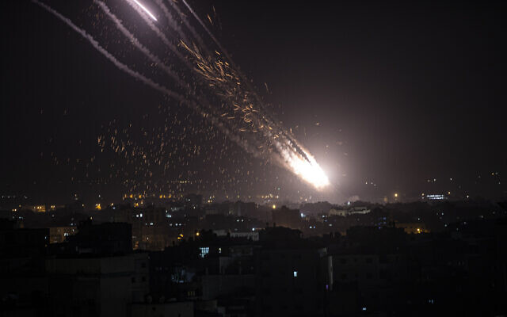  Rockets are launched from the Gaza Strip towards Israel, Monday, May. 10, 2021. (AP Photo/Khalil Hamra) | 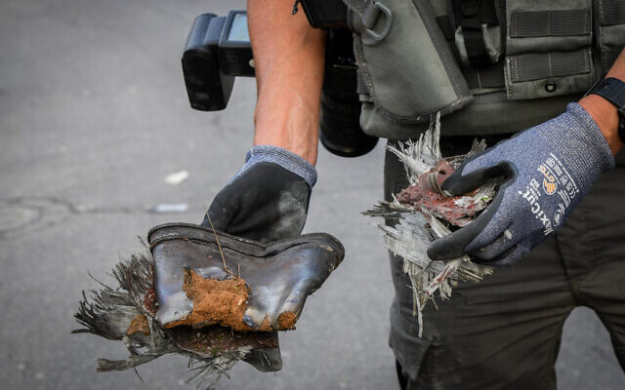  A rocket fired from the Gaza Strip that directly struck an apartment building in Ashkelon on May 11, 2021. (Flash90)
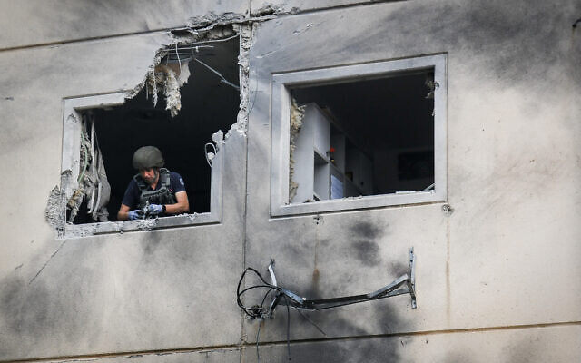  An apartment building that was hit by a rocket fired from the Gaza Strip in the city of Ashkelon on May 11, 2021. (Flash90) | 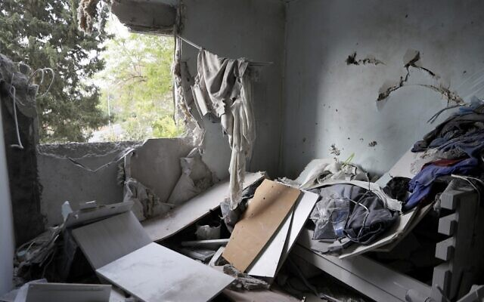  A picture taken early on May 11, 2021 shows a damaged building in the southern Israeli city of Ashkelon after rockets were fired by the Hamas terror group from the Gaza Strip towards Israel overnight amid spiraling violence (JACK GUEZ / AFP)
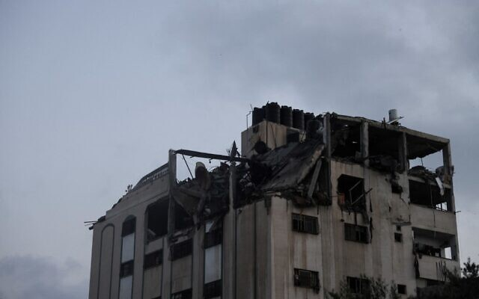  Parts of an apartment building is destroyed following Israeli airstrikes in the Gaza Strip on May 11, 2021 (MOHAMMED ABED / AFP) | 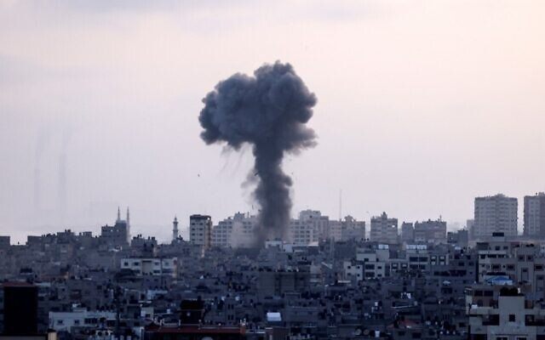  Smoke from Israeli airstrikes in the Gaza Strip, controlled by the Palestinian Hamas terror group, on May 11, 2021. (MAHMUD HAMS / AFP)
Palestinian terror groups in the Gaza Strip fired a massive barrages of rockets at southern Israel throughout Tuesday, wounding at least 24 people and drawing deadly retaliatory airstrikes from the Israel Defense Forces.
The assaults continued a night of almost constant rocket fire on Israeli communities near the Gaza Strip and as the IDF conducted strikes on more than 100 targets in the coastal enclave, as part of what it has called “Operation Guardian of the Walls,” the military said. The previous day saw a major outbreak of violence from Gaza, including rare rocket fire on Jerusalem, where Palestinians have been clashing with police for days.
According to Gaza’s Hamas-run Health Ministry, at least 23 people in the Strip were killed on Monday night and Tuesday, including nine minors. Another 107 Palestinians were injured to varying degrees, the ministry said. The IDF said at least 15 of those killed were members of the Hamas terror group who were launching rockets or anti-tank guided missiles at Israel.
Rockets are fired from Gaza City towards Israel on May 11, 2021 (Atia Mohammed/Flash90) | 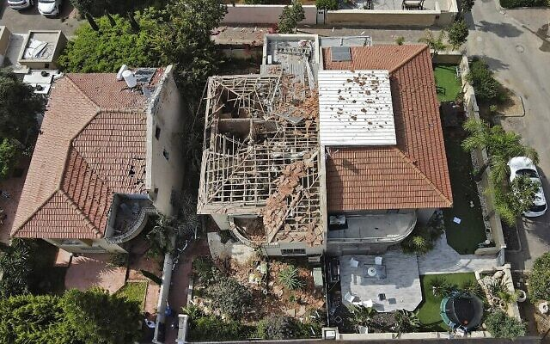  An overhead view of an Ashkelon home badly damaged by a rocket fired from Gaza on May 11, 2021. A man was seriously hurt in the attack. (JACK GUEZ / AFP)
IDF Spokesperson Hidai Zilberman said a number of those killed in Gaza, including at least three children, were hit by errant rockets fired by Palestinian terrorists, not by Israeli airstrikes.
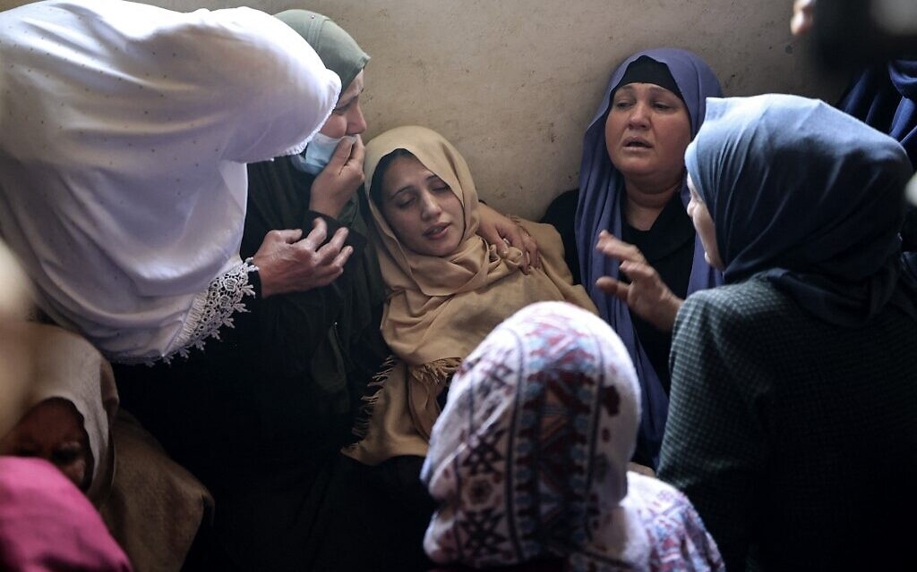
The mother of Palestinian Hussien Hamad, 11, is comforted by mourners during his funeral in Beit Hanoun in the northern Gaza Strip on May 11, 2021 (MAHMUD HAMS / AFP)

Hamas and the Palestinian Islamic Jihad terror groups reported that several high-ranking commanders were killed in Israeli raids on Tuesday, including two top PIJ leaders in a drone strike on a building in the upscale Rimal neighborhood of Gaza City, one of whom was the brother of another top PIJ commander, Baha Abu al-Ata, who was killed in an Israeli strike in November 2019, kicking off a major round of fighting in the Strip.
IDF Chief of Staff Aviv Kohavi on Tuesday afternoon gave the military a green light to keep targeting Hamas and PIJ members operating in the Strip and bombing sites connected to the terror groups’ rocket production and storage efforts.
The IDF spokesperson said Israel was taking steps to avoid Palestinian civilian casualties, but that they were liable to occur anyway as Hamas deliberately operates within a densely populated area, using the residents of the Strip as human shields.
Israel on Tuesday showed no indications that it was interested in an immediate ceasefire, as Zilberman said the fighting was expected to last at least several days and that the coming hours would be particularly punishing for Hamas.
“We have an intense day ahead of us,” Zilberman told reporters on Tuesday morning, adding, “We have a goal and we will not stop until we’ve reached it.”
Soldiers from the IDF’s Golani Infantry Brigade and 7th Armored Brigade were sent to the Gaza border as reinforcements and additional troops were called in to aerial defense, intelligence and air force units, the military said.
“The chief of staff said the IDF will continue to act determinedly in order to return security to residents of the south, and all headquarters should prepare for a wider conflict, which has no time limit,” the IDF said.
Asked about the potential for a ground invasion or targeted killing of top terrorist commanders, Zilberman said the military “was prepared for anything.”
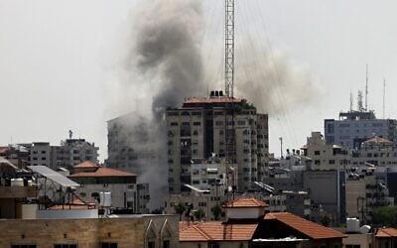
Smoke billows from a building targeted by in an Israeli strike on Gaza City amid rocket fire from the Strip on May 11, 2021 (MOHAMMED ABED / AFP)

According to the IDF, over 200 rockets and mortar shells were fired from the Gaza Strip toward Israel from 6 p.m. Monday to 6 a.m. Tuesday, dozens of which were intercepted by Iron Dome missile defense batteries. The military said the Iron Dome had a successful interception rate of over 90 percent of projectiles heading toward populated areas.
According to Zilberman, roughly a third of the projectiles fired from Gaza landed inside the Strip.
Most of the others landed in open fields, where they caused no injuries, but a small number landed inside Israeli communities, causing damage to nearby buildings and infrastructure. One rocket directly struck a house in the Sha’ar Hanegev region on Monday night, damaging it but not injuring its occupants, and two hit apartment buildings in Ashkelon on Tuesday morning, injuring those inside.
Video footage of the Tuesday morning attack showed dozens of rockets being fired at Ashkelon, with Iron Dome interceptor missiles screaming up into the gray morning sky to try and bring them down.
מטחי רקטות כבדים לעבר אשקלון ויישובים במועצות חוף אשקלון ואשכול. כך נראה אחד מהמטחים בשמי אשקלון
(צילום: ליטל טימסיט) pic.twitter.com/0yWD5NkSKF
— כאן חדשות (@kann_news) May 11, 2021
Six Israelis were wounded in that attack, four of them members of the same family: parents in their 40s, an 8-year-old and an 11-year old. The father was seriously hurt with a head wound, and the rest sustained light injuries from shrapnel. A 63-year-old man was also moderately injured by shrapnel, and a man and a woman in their 80s were lightly injured, medics said. On Monday, an Israeli man was lightly injured when Palestinian terrorists fired an anti-tank guided missile at his car.
In total, Ashkelon’s Barzilai Medical Center and Beersheba’s Soroka Medical Center said they was treating 24 people who were wounded on Monday night and Tuesday morning, 22 of them with light injuries. In addition to those hit by rocket fire, a number of those were hospitalized for injuries sustained while running to bomb shelters, and eight people suffered acute anxiety attacks brought on by rocket sirens, medics said.
Barrage of rockets fired by Palestinian militants a short time ago against the city of Ashkelon. #Israel #Gaza pic.twitter.com/DrDcmIEjvo
— Joe Truzman (@Jtruzmah) May 11, 2021
In response to the ongoing rocket rockets, IDF fighter jets, aircraft and tanks struck some 130 targets in the Gaza Strip, most of them associated with Hamas, but also some linked to other terror groups in the enclave, including the Palestinian Islamic Jihad.
According to the IDF, they included the home of a top Hamas commander, Hamas’s intelligence headquarters in southern Gaza, two attack tunnels that approached the border with Israel, rocket production and storage sites, observation posts, military installations and launchpads. The IDF said it was also targeting terrorist operatives as they fired rockets at Israel. The military released footage of some of its strikes, including the attack on the Hamas officer’s apartment building (below).
Hamas in Gaza said it had launched the morning attack on Ashkelon in response to the IDF strike on the commander’s apartment building. The terror group said it would “turn Ashkelon into hell” if Israel targeted civilians in Gaza.
Palestinian media also reported strikes around the southern cities of Rafah and Khan Younis and on an apartment building in the al-Shati camp near Gaza city. A building was also destroyed in Gaza City’s upscale Tel al-Hawa neighborhood.
Zilberman said the military was deploying additional air defenses throughout the country, notably in the Tel Aviv metropolitan area. Tel Aviv had yet to be targeted as of Tuesday morning, but the IDF suspected that rocket fire may soon be directed there as well.
Earlier, the Hamas military wing issued an ultimatum that it would carry out a massive attack by 2 a.m. if Israel did not vacate its forces from the Temple Mount. It later claimed that it had suspended plans for the attack after police withdrew from the holy site.
There was no confirmation from Israel that police had left the compound.
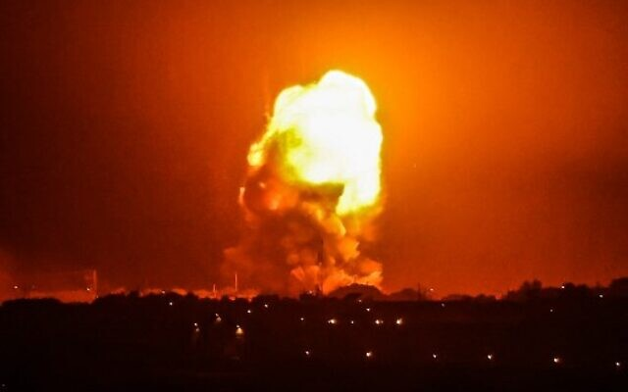
Defense Minister Benny Gantz said the IDF would continue striking Hamas and other terrorists in the Strip until “long-term and complete quiet” is restored.

Fire billows from Israeli air strikes in Rafah, in the southern Gaza Strip, on May 11, 2021.(Photo by SAID KHATIB / AFP)

Gantz also threatened Hamas’s leadership, saying its commanders would “be held responsible and pay the price for the aggression.”
The waves of rocket fire began at 6 p.m., the time Hamas had earlier threatened it would attack Israel if it did not remove its security forces from the Temple Mount and the neighborhood of Sheikh Jarrah in East Jerusalem, following weeks of unrest in the capital. Monday saw widespread clashes between Palestinians and Israel Police officers on the Temple Mount, as well as multiple attacks by Palestinian rioters against Israeli civilians. Hundreds of Palestinians were reportedly injured, along with dozens of police officers and a number of Israeli civilians.
In addition to the attack on the capital — the first time Jerusalem was targeted by rocket fire since the 2014 Gaza war — Palestinian terror groups fired rockets and mortar shells at Israeli cities and towns near the Gaza border, mostly at Ashkelon and Sderot, as well as smaller communities in the Sha’ar Hanegev region of southern Israel. MORE -https://www.timesofisrael.com/6-israelis-wounded-as-hamas-launches-massive-rocket-barrage-on-ashkelon/

Gaza terrorists fire barrages at Jerusalem, southern Israel, raising fear of war
Israeli man injured as missile hits his car near Sderot; IDF retaliates, killing at least 11 Hamas members firing rockets; Palestinians say 20 killed in total, including 9 minors
By Judah Ari Gross Today, 9:05 pmUpdated at 10:08 pm
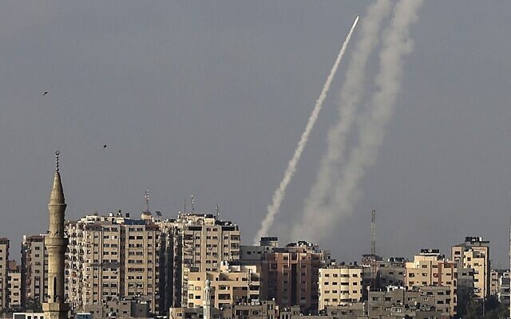
Palestinians terrorists fire rockets from Gaza City toward Israel on May 10, 2021. (Mahmud Hams/AFP)

Palestinian terror groups in the Gaza Strip fired massive barrages of rockets at Israel on Monday evening, including seven projectiles that were fired by Hamas toward Jerusalem, in a major escalation of violence from the enclave signaling the possible start of a wider conflict.
The attacks drew Israeli retaliatory airstrikes in Gaza, which killed at least 20 people, including nine minors, according to the Strip’s Health Ministry. The Israel Defense Forces said at least 11 of those killed were members of the Hamas terror group who had launched rockets at Israel.
“In the next few days, Hamas will feel the long arm of the [Israeli] army. It won’t take a few minutes, it will take a few days,” IDF Spokesperson Hidai Zilberman told reporters.
The spokesman said the military was prepared for a wide range of possibilities, including a broader conflict with a ground operation, as well as a return to targeted killings of top terrorist leaders.
“Everything is on the table,” Zilberman said.
In addition to the attack on the capital — the first time Jerusalem was targeted by rocket fire since the 2014 Gaza war — Palestinian terror groups fired dozens of rockets at Israeli cities and towns near the Gaza border, including Ashkelon and Sderot, as well as smaller communities in the Sha’ar Hanegev region of southern Israel.
According to Zilberman, most of the rockets either landed in open fields or were intercepted by the Iron Dome missile defense system. The military said it was tabulating a precise tally of the number of projectiles fired from the Strip.
An anti-tank guided missile was also fired at an Israeli civilian’s car that was traveling on a hill south of Sderot, lightly injuring him, the military said. The Palestinian Islamic Jihad took responsibility for the attack and later released footage of the strike.
In the video, the Israeli man can be seen approaching the jeep from a hill overlooking the Gaza Strip. As he gets close, the anti-tank missile is fired at the car, causing a large blast. The man was reportedly blown back from the vehicle by the blast and sustained shrapnel wounds to the face and extremities.
There were no other immediate reports of direct Israeli injuries from the barrages. A number of people were treated after they experienced acute anxiety attacks, medics said.
The Israeli Air Force began conducting airstrikes on targets in the Strip around 6:30 p.m. in response to the ongoing attacks from the enclave. Zilberman said the military was targeting rocket-launching cells. The military said it had killed at least 11 members of such cells.
The IDF said it had also bombed two Hamas launchpads and two of its observation posts.
The Gaza Health Ministry reported that 20 people were killed in the Israeli strikes, including nine minors. Hamas accused Israel of killing three children in the Gazan city of Beit Hanoun, but Israeli officials said they died as a result of a failed rocket launch from the Strip.
In light of the ongoing rocket attacks, Defense Minister Benny Gantz declared the area within 80 kilometers (50 miles) of the Gaza Strip to be under military control, giving the IDF the power to issue directives to civilians there. The IDF ordered schools closed in communities near Gaza for the following day and limited gatherings to groups of 10 people outdoors and 50 people indoors. Businesses would only be allowed to open if they had easy access to bomb shelters.
The military also limited gatherings in the Tel Aviv metropolitan area and the Shfela region around Beit Shemesh to 30 people outdoors and 50 people indoors. Schools and businesses there could also only be opened if they had easy access to a bomb shelter.
The waves of rocket fire began at 6 p.m. when Hamas threatened it would attack Israel if it did not remove its security forces from the Temple Mount and the neighborhood of Sheikh Jarrah in East Jerusalem, following weeks of unrest in the capital. Monday saw widespread clashes between Palestinians and Israel Police officers on the Temple Mount, as well as multiple attacks by Palestinian rioters against Israeli civilians. Hundreds of Palestinians were reportedly injured, along with dozens of police officers and a number of Israeli civilians.
Damage caused to a house outside of Jerusalem that was struck by debris after a rocket fired from the Gaza Strip landed nearby on May 10, 2021. (Courtesy)

Hamas claimed responsibility for firing the seven rockets at Jerusalem, one of which was intercepted by the Iron Dome missile defense system, according to the IDF. One rocket landed near a home in a community outside Jerusalem, causing light damage, but no injuries.
The attack triggered sirens in the capital, as well as in the city of Beit Shemesh and surrounding towns. The Knesset plenum was evacuated, as was the Western Wall complex, where thousands of Israelis had gathered to celebrate Jerusalem Day, which marks the reunification of the city after the IDF captured its eastern neighborhoods and the Old City in the 1967 Six Day War.
In the subsequent hour, dozens of rockets were fired at Israeli towns near the Gaza border, triggering wave after wave of sirens, as residents hunkered down inside bomb shelters.
Zilberman said a number of terror groups conducted the rocket launches, but all with the approval and at the direction of Hamas, the de facto ruler of the Gaza Strip.
*נס בעוטף עזה| בהמשך לירי הנט לעבר כלי רכב*בוצע ירי נ״ט לעבר רכב אזרחי, פונה אזרח במצב קל מאוד מאוד, ע״י רבשצ אחד היישובים במועצה אזורית שער הנגב.מצורף סרטון בלעדי לאחר הירי.*חדשות בטחון שדה*
Posted by ‎חדשות בטחון שדה‎ on Monday, May 10, 2021
“We have a clear address: that is Hamas. The group will pay a dear price for its actions. We will respond fiercely,” he said.
Over the past day, the IDF has significantly boosted its presence along the Gaza border both in terms of ground troops and air defense systems, Zilberman said.
The military initially believed that Hamas was not interested in a large-scale conflict with Israel at this time, but that assessment changed over the past two days and the IDF began preparing accordingly.
Ahead of the attack, the IDF halted train service between Beersheba and Ashkelon, closed Zikim Beach just north of the Strip, and barred visitors from lookout points on hilltops near the Gaza border.
In addition, the military closed off the Route 4 highway from Zikim to Kibbutz Nir Am, the Route 34 highway from Yad Mordechai to Kibbutz Erez, and the Route 232 highway from Mefalsim to the Kfar Aza Junction.
Cities and towns near the Gaza border also opened their public bomb shelters.
Recent days have seen a number of rocket and mortar shell attacks from the Gaza Strip, as well as a major return of balloon-borne incendiary and explosive devices being launched from Gaza, which have burned large swaths of southern Israel.
Palestinian terror groups have tied the attacks to the unrest in Jerusalem connected to both prayer on the Temple Mount during the Muslim holy month of Ramadan, and the pending eviction of a number of Palestinian families from their homes in East Jerusalem’s Sheikh Jarrah neighborhood.
In response to the violence from Gaza, Israel on Monday morning announced it was closing the pedestrian Erez Crossing to the enclave “until further notice,” with the exception of emergency humanitarian cases. On Sunday, Israel closed the Strip’s fishing zone, cutting off a major source of income for thousands of Palestinians in the coastal enclave. MORE - https://www.timesofisrael.com/gaza-terrorists-fire-barrages-at-jerusalem-southern-israel-raising-fear-of-war/

Southern Israel pounded by ongoing Gaza rocket barrages
No injuries reported as at least 100 rockets fired primarily at Gaza border communities; Palestinians say 20 killed as IDF hits Hamas targets in Strip, including military positions and rocket launchers; PM warns escalation could last for some time
Ynet, News Agencies | Published: 05.10.21 , 22:40
Southern Israel was hit by repeated barrages of rocket fire from the Gaza Strip on Monday night, as Palestinian terror groups in the coastal enclave attacked civilian targets over what Hamas called Israeli "crimes and aggression" in Jerusalem.
There were no reports of injuries in the wave of attacks, which set off sirens in multiple locations in the south. Two people did go to the ER at Barzilai Medical Center in Ashkelon suffering from shock.
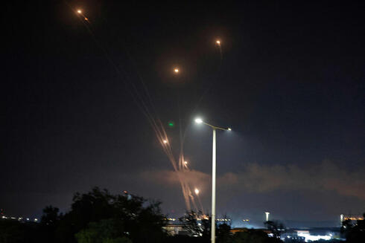  The Iron Dome missile defense system intercepts rockets over Ashkelon on Monday night (Photo: AFP) | 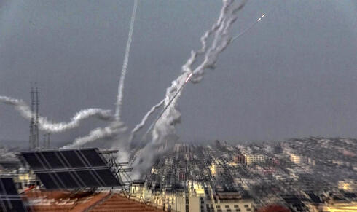  Rocket from Gaza at southern Israel on Monday (Photo: EPA)
The IDF said some 100 rockets were fired into Israel throughout the evening, most of them aimed at Gaza border communities. [That number has been revised upwards. – rdb]
One rocket fell in the southern city of Sderot on Monday night, causing some damage to a building and a road.
There were no casualties reported but a woman was treated for shock.
School has been cancelled throughout southern Israel on Tuesday and the IDF has closed some roads near to the Gaza border.
Israel was also bracing for rocket fire on the center of the country, including its cultural and economic hub of Tel Aviv.
Hamas, which rules Gaza, launched a rocket strike on the Jerusalem area shortly after 6pm Monday, having warned of a response if Israel did not withdraw its security forces from the Temple Mount compound and the East Jerusalem neighborhood of Sheikh Jarrah by then.
Both locations were the scenes of clashes between Palestinian protesters and Israeli security forces on Monday.
Following the rocket attacks, Islamic Jihad issued the statement: "Watch 9pm." The heavy rocket fire resumed soon after.
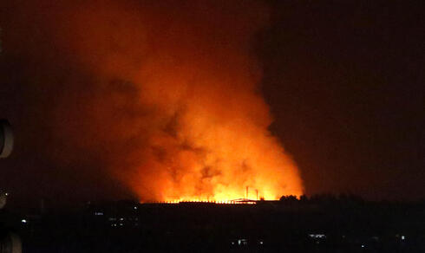  The aftermath of an IAF strike on Gaza on Monday night  (Photo: AP) | 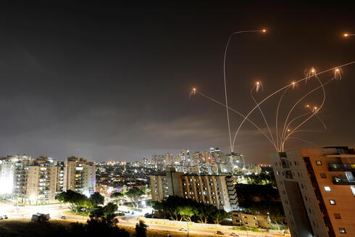  The Iron Dome missile defense system intercepts rockets over Ashkelon on Monday night  (Photo: Reuters)
The IDF responded with airstrikes on Hamas targets throughout Gaza. The army said rocket launchers, two military posts and eight Hamas terrorists had been targeted. The IAF attacks came after the security cabinet authorized a "significant airstrike" in the Gaza Strip, with no ground action.
An Israeli official said following the cabinet meeting that, "Hamas has to be dealt a hard blow, but we all understand our limitations. We have no will for major wars and there is nothing to be gained from them. Obviously we will pay a certain price, but they will pay a heavy price. Everyone hopes that this will be over by Eid al-Fitr - within two or three days."
Prime Minister Benjamin Netanyahu warned after the attack on Jerusalem on Monday that the terrorist groups in Gaza "have crossed a red line." "Israel will respond with great force. Those who attack us will pay a heavy price," he said. "The current confrontation could last for some time. We do not want an escalation, but those who do chose to escalate will feel our might."
The Hamas military wing, meanwhile, warned that if Israel harmed civilian infrastructure or the homes of Gaza residents, "the response will be stronger and more painful than expected."
In Gaza, health officials reported a total of 20 deaths in the airstrikes Monday, including nine children. It did not provide a breakdown, but at least seven members of a family, including three children, were killed in a blast in the northern town of Beit Hanoun.
It was not immediately clear if the blast was caused by an airstrike or errant rocket. The IDF said a rocket had misfired.
Ashraf al-Masri, a member of the family, said there was an explosion outside the house.
"We don't know where it came from," he said. "We are trying to get the children for burial but the situation is difficult in Beit Hanoun and we are afraid to leave our houses."
Abu Obeida, a spokesman for Hamas' military wing Izz al-Din al-Qassam Brigades, said the rocket attacks were a response to what he called Israeli "crimes and aggression" in Jerusalem.
"This is a message the enemy must understand well," he said. https://www.ynetnews.com/article/NHW7NS60Z

IDF sends reinforcements to Gaza border as Hamas issues ultimatum on Jerusalem
As tensions simmer in the capital, terrorists in the Strip fire a mortar shell toward southern Israel, airborne arson attacks spark fires
By Judah Ari Gross Today, 5:26 pm
The Israel Defense Forces said it was sending reinforcements to the Gaza Division on Monday as terror groups in the Strip threatened to step up their attacks in light of growing unrest in Jerusalem.
Shortly after the military announced the move, terrorists in the enclave fired a mortar shell toward southern Israel, which failed to clear the border and landed inside the Strip, the IDF said.
The military also announced it was closing down a number of roads and sites around Gaza, as well as train service in the area, fearing that they may come under attack shortly. Air traffic in and out of Israel was diverted away from the Strip, with planes traveling on flight paths to the north of Ben Gurion International Airport.
The city of Ashkelon opened its public bomb shelters on Monday evening as a precautionary measure, its mayor Tomer Glam said.
The Hamas terror group threatened Israel with an ultimatum on Monday afternoon, saying all Israeli security forces had to be removed from the Temple Mount and the Sheikh Jarrah neighborhood of East Jerusalem by 6 p.m., or else the so-called “joint operations room” — a body representing the various terror groups in the Strip — would attack. MORE - https://www.timesofisrael.com/idf-sends-reinforcements-to-gaza-border-as-hamas-issues-ultimatum-on-jerusalem/

Police change route of Flag March through Old City as Jerusalem simmers
Organizers cancel parade, but marchers continue to stream toward Western Wall; decision to redirect march from Damascus Gate over fears of clashes said made by Netanyahu
By TOI staff Today, 5:52 pm
Israelis wave national flags during a Jerusalem Day march, in Jerusalem, May 10, 2021. (AP Photo/Ariel Schalit)

In an about-face, police on Monday said the route of the Flag March for Jerusalem Day would be changed amid concerns of further violence in the city following major clashes on the Temple Mount.
The announcement came as the annual march of mostly young religious nationalist Israeli Jews was already underway. Organizers subsequently said they were calling off the parade, but marchers continued to stream toward the Western Wall, where an event for Jerusalem Day was to be held.
As the parade began at 4 p.m., police said the march would enter the Old City through the Jaffa Gate and from there go to the Western Wall, rather than pass through the Damascus Gate and Muslim Quarter on the way there.
A police statement said the change came after a situational assessment and was “in accordance with the decision of the political leadership and the recommendation of security officials.”
Israeli officials told Hebrew media that it was Prime Minister Benjamin Netanyahu who ordered the march redirected away from the Damascus Gate.
Public Security Minister Amir Ohana opposed the move, according to the Kan public broadcaster.
Police also said officers were deployed throughout the city “to ensure the safety of participants, prevent disturbances of the peace and regulate movement.”
The decision came after the Israel Defense Forces, Shin Bet security service and military liaison to the Palestinians all recommended that the planned route of the march be changed to limit the chances of direct confrontations between the participants and the Muslim residents of the city.
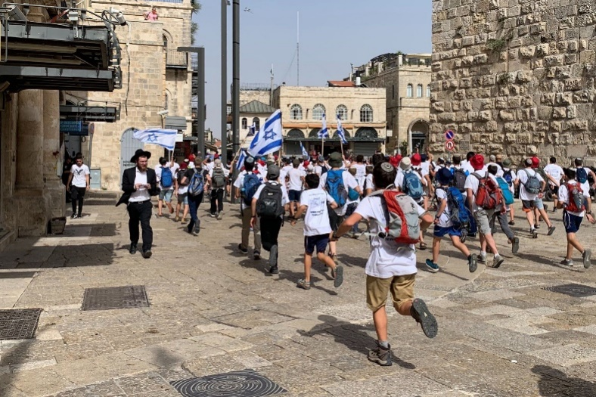
According to Channel 12, Defense Minister Benny Gantz also called for police to alter the route.
Police initially said they weren’t planning on changing the route, before backtracking hours later.
The annual Old City march often sees clashes between far-right Jews and Palestinians. This year, with tensions already at a boiling point, security officials were reportedly convinced the event would be marked by violence between the sides.

Israelis stream into Jerusalem’s Old City through the Jaffa Gate during the annual flag march on May 10, 2021 (Sarah Tuttle-Singer/Times of Israel)

Organizers said in a statement that they were canceling the march due to “the prime minister’s decision to prevent the marchers from passing through Damascus Gate.”
“We will not march on the territories of divided Jerusalem. The event at the Western Wall will be held as usual,” organizers said in a statement.
It was unclear if participants making their way through the Old City via the Jaffa Gate were aware of the decision.
In the morning, police decided to bar Jews from entering the Temple Mount on Jerusalem Day due to the spiraling tensions in the capital, drawing fury from right-wing legislators but support from the left.
After the police decision, major clashes broke between police and Palestinian rioters at the flashpoint holy site, with hundreds said wounded.
Police entered the Temple Mount compound in the morning after thousands of Palestinians had gathered there overnight, having collected numerous rocks and other makeshift weapons. Police said dozens of rioters attacked a police post and hurled rocks from the Temple Mount toward a road south of the compound, blocking the road but causing no injuries or damage.
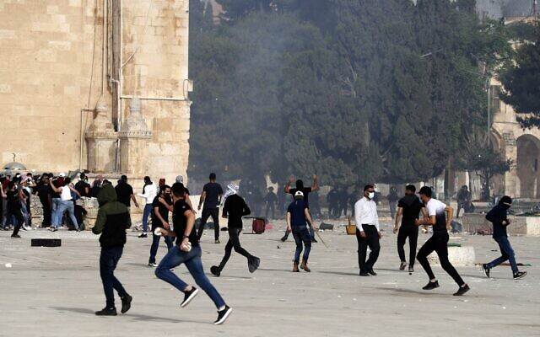
Sunday night saw fierce clashes between Palestinian protesters and police in Jerusalem. At least 25 people were wounded and 23 people arrested.

Palestinians clash with Israeli security forces at Jerusalem’s Temple Mount compound on Jerusalem Day, May 10, 2021. (Ahmad Gharabli/AFP)

The Temple Mount is considered holy by both Muslims and Jews. The site contains the Al-Aqsa Mosque — the third holiest site in Islam — and is revered by Jews as their holiest site, where both biblical Temples stood. Jews have been barred from entering the site in recent days amid the tensions, which coincide with the end of the holy Muslim month of Ramadan.
Jerusalem has seen violent nights for the past week. Demonstrators have been protesting over tensions surrounding the Mount as well as the pending eviction of Palestinians from East Jerusalem’s Sheikh Jarrah neighborhood.
The protests have devolved into clashes with police, with security forces using high-pressure water cannons, rubber-tipped bullets, and stun grenades to disperse the demonstrators. But matters came to a head on Friday night when police clashed with Palestinians on the Temple Mount, with dozens of people wounded.
Jerusalem Day celebrates Israel’s unification of Jerusalem, with the capture of East Jerusalem and the Old City from Jordan in the 1967 Six Day War. The annual march is widely perceived as provocative, as hardline nationalist Israelis, guarded by police, walk through the Damascus Gate of the Old City and through the Muslim Quarter to the Western Wall, the holiest site where Jews can pray.
This year the march coincides with the Muslim holy month of Ramadan, a time of heightened religious sensitivities, and follows weeks of clashes. That, combined with Palestinian anger over the eviction plan in the nearby Sheikh Jarrah neighborhood, set the stage for an especially volatile day.
Addressing a special cabinet meeting ahead of Jerusalem Day, Netanyahu said Sunday that Israel “will not allow any extremists to destabilize the calm in Jerusalem. We will enforce law and order decisively and responsibly.”
The violence, along with the planned evictions in East Jerusalem, have drawn condemnations from Israel’s Arab allies and expressions of concern from the United States, Europe and the United Nations.
The UN Security Council was set to meet on Jerusalem violence later Monday.
There were also signs the violence was spreading to the Gaza Strip and West Bank. https://www.timesofisrael.com/police-change-route-of-flag-march-through-old-city-as-jerusalem-simmers/ [I would say Bibi and the politicians miscalculated this one by a huge amount. When you already are having demonstrations of this sort and then you put in a Jewish holiday it is a recipe for an enormous problem. – rdb]

Ra’am freezes coalition talks with ‘change bloc,’ amid violence
Source in Islamist party says unclear if negotiations will resume before Lapid’s mandate to form coalition expires; anti-Netanyahu parties call for forceful response to attacks
By Alexander Fulbright Today, 9:27 pm
The Islamist Ra’am party on Monday announced it was suspending coalition talks with the “change bloc” of anti-Netanyahu parties after Palestinian terrorists in the Gaza Strip fired a barrage of rockets toward Jerusalem and southern Israeli border communities, in a potentially major blow to the efforts by parties opposed to Netanyahu to form a government.
A Ra’am source told the Kan public broadcaster that it was unclear if they would again hold talks with Yesh Atid leader Yair Lapid — who is currently tasked with forming a government — before his mandate to assemble a coalition ends on June 2, as the resumption of negotiations would depend on the scope of the violence.
Ra’am leader Mansour Abbas was scheduled to meet with Lapid and Yamina chief Naftali Bennett before the rocket fire, but the meeting was delayed, apparently due to the major clashes that broke out in the morning between Palestinian rioters and police on the Temple Mount, after Jews were barred from the flashpoint holy site on Jerusalem Day.
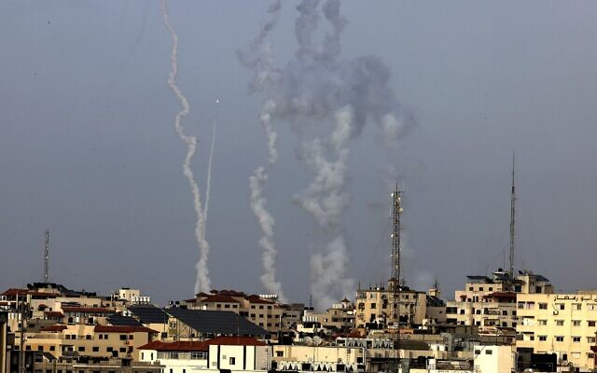
Jerusalem has been at the center of escalating Israeli-Palestinian tensions that have also seen attacks in the Gaza border area and West Bank.

Palestinians terrorists fire rockets from Gaza City toward Israel on May 10, 2021. (Mahmud Hams/AFP)

Lapid, Bennett and other “change bloc” lawmakers, meanwhile, backed a forceful response to the Gaza rocket fire.
“No country can allow citizens to live under the threat of terror,” Lapid tweeted. “Israel must act resolutely and forcefully to restore deterrence.”
Lapid also vowed to back the Netanyahu-led transition government “in the war against Israel’s enemies.”
Bennett, who is holding talks with Lapid on forming a government that will see the two switch off as premier, called for Israel to respond with an “iron fist.”
“Whoever puts Israelis into shelters needs to know he will regret this,” Bennett wrote on Twitter. “We’ll back a determined response by the Israeli government.”
Yamina No. 2 Ayelet Shaked linked the rocket fire from Gaza to the government’s response to recent violence on the Temple Mount in Jerusalem’s Old City.
“Whoever surrenders on the Temple Mount in the first campaign will get rockets on Jerusalem in the second campaign. It’s either firmness or weakness,” she wrote on Twitter.
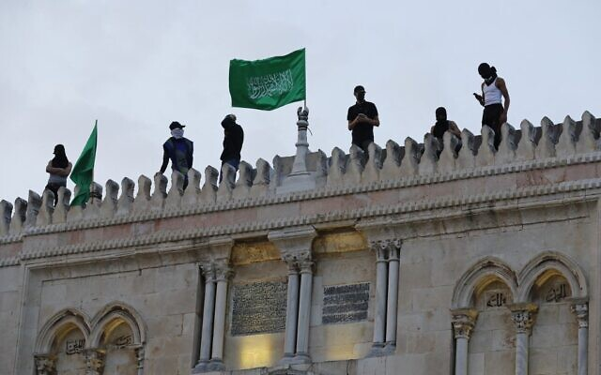
Palestinians place Hamas flags atop al-Aqsa mosque in Jerusalem’s Old City on May 10, 2021. (Ahmad GHARABLI / AFP)

New Hope chief Gideon Sa’ar, who is also in negotiations with Lapid and Bennett, similarly issued a tweet calling for a strong response to “Hamas aggression,” referring to the Gaza-ruling terror organization.
“We’ll back decisions of the government that will lead to this,” he said.
Yisrael Beytenu leader Avigdor Liberman, who resigned as Netanyahu’s defense minister in 2018 to protest what he said was an insufficiently forceful response to rocket fire from Gaza, tore into the prime minister.
“Once again, it has been proven that Netanyahu’s resolution policy is language whitewashing a policy of surrendering to terror that brings painful consequences,” Liberman wrote on Twitter, referring to the efforts to reach a long-term ceasefire with Hamas.
He added: “Now we must focus on restoring security to the State of Israel and putting the issue at the top of the agenda.”
Yisrael Beytenu MK Eli Avidar appeared to imply that Netanyahu, who is fighting for his political and legal survival, had an interest in the escalating violence and called on Attorney General Avichai Mandelblit to declare the premier no longer fit to remain in office.
“The man is a pyromaniac. He is not fit and not in control of the situation,” Avidar said.
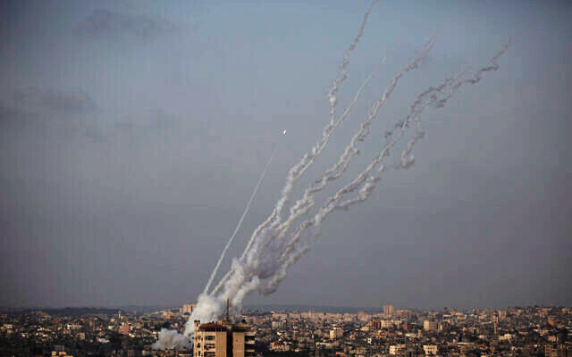
Palestinian terrorists fire rockets from the Gaza Strip toward Israel, May 10, 2021. (AP Photo/Khalil Hamra)

Among Netanyahu’s supporters, Likud MK Miki Zohar suggested the premier’s rivals were to blame for trying to form a unity government after the prime minister again failed to assemble a narrow right-wing coalition, after a fourth election in two years.
“I’m concerned that the political chaos in Israel, along with the progress on forming a left-wing government with the support or abstention of the [majority Arab] Joint List, is allowing our enemies to lift their heads. I hope Bennett will understand the destruction he is leading us to,” Zohar told Army Radio.
He did not mention the Likud-led right-wing religious bloc’s own unsuccessful efforts to enlist the Islamist Ra’am party, which both sides have been courting to secure majority support for their prospective coalitions.
Zohar also claimed a ground operation was not a question of “if,” but “when.”
Religious Zionism head Bezalel Smotrich, whose far-right party’s opposition to relying on Ra’am blocked Netanyahu from forming such a government, issued a fresh appeal to Bennett and Sa’ar to join forces with the premier’s bloc.
“Put everything aside and let’s form an emergency government of the national camp today. Everything else can wait,” Smotrich tweeted. https://www.timesofisrael.com/raam-freezes-coalition-talks-with-change-bloc-amid-violence/

Separated by cops, Joint List, Religious Zionism MKs face off in East Jerusalem
Far-right MKs arrive to show solidarity with Sheikh Jarrah’s Jewish residents, while MKs from majority-Arab parties arrive to support Palestinian families facing eviction
By TOI staff Today, 8:17 pm
Religious Zionism MKs are guarded by police as they arrive at the Sheikh Jarrah neighborhood on May 10, 2021. (Screen capture/Twitter)

Lawmakers from the majority-Arab Joint List and the ultranationalist Religious Zionism party faced off Sunday in the flashpoint East Jerusalem neighborhood of Sheikh Jarrah with walls of police officers dispatched to separate between the sides.
Bezalel Smotrich and Itamar Ben Gvir arrived in Sheikh Jarrah in what they said was a demonstration of solidarity with the handful of Jewish families in the almost exclusively Palestinian neighborhood. The area has seen intense clashes for over a week as mainly Arab protesters have demonstrated against efforts by ultranationalist Jewish groups to evict dozens of families in Sheikh Jarrah.
The handful of Jewish residents have been exposed to an uptick in violence from demonstrators who disapprove of their presence, which came at the expense of Palestinian families who were evicted.
In a statement to the large throng of reporters at the scene, Smotrich called the decision to delay a hearing that could have led to the eviction of four Palestinian more families in Sheikh Jarrah “an enormous disgrace.”
מפגינים פלסטינים ניסו למנוע מחברי הציונות הדתית לעבור בשייח גראח. המשטרה פינתה את הדרך pic.twitter.com/VP0CQTWlt7
— Maya Horodniceanu (@mayahorodnicean) May 10, 2021
“The police have abandoned Jerusalem,” Ben-Gvir added.
Meanwhile, Palestinian demonstrators could be heard chanting, “Jerusalem is Arab” farther down the street.
Joining those demonstrators in solidarity with the Palestinian Sheikh Jarrah residents were Joint List MKs, including Ahmad Tibi, Aida Touma-Sliman, Sami Abou Shehadeh and Ofer Cassif.
Footage from the scene showed police shoving Touma-Sliman and other demonstrators back as the MK shouted, “Shame on you!” and warned that she was a lawmaker and hence holds parliamentary immunity.
שייח גראח פינת כנסת ישראל pic.twitter.com/Dq3GgfyB6y
— Maya Horodniceanu (@mayahorodnicean) May 10, 2021
Israel’s Supreme Court was slated to a hearing on Monday on an appeal by four Palestinian families against their evictions in Sheikh Jarrah. However, following pressure from senior government officials, including Prime Minister Benjamin Netanyahu and Defense Minister Benny Gantz, who were concerned the session would further fan the flames of tension in the city, the court announced the cancellation of the hearing.
Attorney General Avichai Mandelblit office also asked the Supreme Court for two weeks to consider the matter after the Palestinian families asked him to become a party to the case.
The court gave Mandelblit until June 8 to consider whether he will become a party to the case. The planned evictions — already approved by lower courts — will not go forward in the interim.
“A new date will be determined within the next 30 days. In the meantime, until further notice, I order a freeze on the decision by the appellate court, which does not imply any position regarding [that lower court’s decision],” Justice Yitzhak Amit wrote in the ruling.
In all, over 70 Palestinians in Sheikh Jarrah are set to be evicted in the coming weeks, to be replaced by right-wing Jewish Israelis. The Palestinians live in houses built on land that courts have ruled were owned by Jewish religious associations before the establishment of Israel in 1948.
According to Ir Amim, a left-wing human rights group focusing on Jerusalem, around 200 families in East Jerusalem are under similar threat, with cases slowly moving through administrative bodies and Israeli courts.
The evictions are based in part on a 1970 Israeli law that allows Jews to reclaim East Jerusalem land owned by Jews before 1948. No similar law exists for Palestinians who lost their homes in what is now Israel during the 1948 war and fled to what was then Jordanian-controlled territory. In fact, the Knesset passed a law in 1950 barring Palestinians from reclaiming property in East Jerusalem from before 1948.
For its part, the Foreign Ministry issued a statement Friday accusing the Palestinian Authority of “presenting a real estate dispute between private parties, as a nationalistic cause, in order to incite violence in Jerusalem,” adding that Ramallah would bear responsibility for any violence that ensued.
Sheikh Jarrah has long been a focal point of Jewish-Arab tensions. A small Jewish community lived in the area before 1948, when East Jerusalem fell under Jordanian control. Home to a shrine revered as the final resting place of Shimon Hatzadik, a third-century BCE high priest also known as Simeon the Just, the neighborhood is often visited by Jewish pilgrims.
The anticipated decision to evict the families came as Jerusalem lives through tense, violent days. The city has been on edge in recent weeks, as Palestinians have clashed with Israeli police, with both sides blaming the other for igniting the confrontations.
The altercation at Sheikh Jarrah was one of many that were taking place Monday. MORE - https://www.timesofisrael.com/separated-by-cops-joint-list-religious-zionism-mks-face-off-in-east-jerusalem/

UN Security Council statement on Jerusalem held up by US
Statement would condemn looming evictions of Palestinians in Sheikh Jarrah, but include panning of Gaza rockets, thanks to push from US, UK diplomats
By Jacob Magid and Agencies Today, 11:56 pm
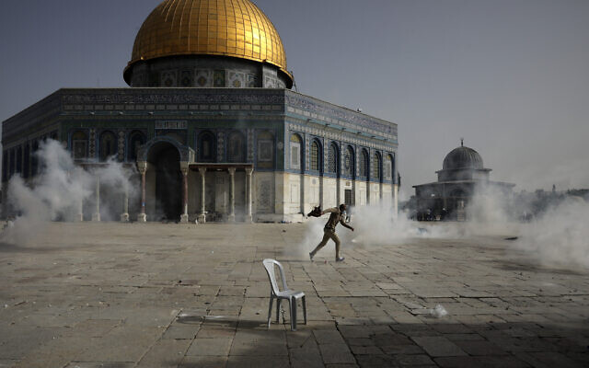
A Palestinian man runs away from tear gas during clashes with Israeli security forces in front of the Dome of the Rock Mosque at the Al Aqsa Mosque compound in Jerusalem's Old City, on May 10, 2021. (AP/Mahmoud Illean)

NEW YORK — Hesitation from the US mission to the United Nations prevented the release of a joint statement by the Security Council’s members on the ongoing escalations in Jerusalem, after the top UN body held an emergency meeting on the subject earlier Monday, a diplomat involved told The Times of Israel.
During the meeting, the Norwegian mission introduced a proposal for a joint statement urging Israel to prevent the looming evictions of Palestinian families in the East Jerusalem neighborhood of Sheikh Jarrah, and calling for “restraint” and respect for “the historic status quo at the holy sites,” diplomats involved in the meeting confirmed. The original statement also urged both sides to act in order to deescalate the situation, they said.
Recent days have seen police clash with Palestinian protesters near the homes of families facing eviction in Sheikh Jarrah as well as at the Temple Mount/Haram al-Sharif compound, where tens of thousands of Muslim worshipers have gathered daily. Tensions peaked Monday with over 300 injured in clashes with cops at the latter site and Gaza terror groups firing dozens of rockets at southern Israel and at Jerusalem, in an apparent response to the East Jerusalem violence.
The Norwegian statement underwent a number of amendments per requests from the US and UK, whose representative made sure it included a condemnation of the firing of incendiary devices and rockets from Gaza, a Security Council diplomat said.
The proposed statement called on Israel “to cease settlement activities, demolitions and evictions, including in east Jerusalem in line with its obligations under international humanitarian law” and refrain from unilateral steps “that exacerbate tensions and undermine the viability of the two-state solution.”
The statement would also reiterate the council’s support for a negotiated solution to the decades-old Israeli-Palestinian conflict where “two states, Israel and an independent, democratic, contiguous and sovereign Palestine, live side by side in peace within secure and recognized borders.” [This is a perfect example of the essence of the old adage “Doing the same thing over and over again and expecting a different result is the definition of insanity. – rdb]
Fourteen of the 15 Security Council members backed the updated draft of the statement, but it failed to move forward after the US mission asked for more time to deliberate the matter, adding that such a step might not be useful at this time, two diplomats present told The Times of Israel.
In response to a query on the matter, a spokesperson for the US mission said, “The United States is engaging constructively to ensure any action by the Security Council is helpful in deescalating tensions.”
The Monday morning session featured an update from UN’s Special Coordinator for the Middle East Peace Process Tor Wennesland, and was followed by reactions from various member states, which largely fell in line with their traditional stances on the Israeli-Palestinian conflict.
Ireland’s UN Ambassador Geraldine Byrne Nason, who joined in calling for the emergency meeting, said during the session that “the Security Council should urgently speak out, and we hope that it will be able to do so today.”
Israel’s Ambassador to the UN Gilad Erdan issued a statement after the meeting lambasting members of the Security Council for “their failure to understand the reasons behind the Palestinian violence.”
The envoy claimed recent condemnations of Israel over its actions surrounding Jerusalem have been “disruptive and further inflamed the tensions.” He blamed members that have yet to condemn “Palestinian incitement,” along with rocket fire from Gaza and noted that Israel was doing all it could to maintain calm, even barring the entry of Jewish visitors to the Temple Mount earlier Monday.
Later in the day, the US issued several statements condemning rocket fire from Gaza. White House Press Secretary said Washington was “continuing to closely monitor the violence in Israel.”
“We have serious concerns about the situation, including violent confrontations that we’ve seen over the last few days,” she added, without getting into specifics.
Psaki went on to recall the phone call that took place on Sunday between US National Security Adviser Jake Sullivan and his Israeli counterpart, Meir Ben Shabbat, during which the former raised concerns over the potential eviction of Palestinians in Sheikh Jarrah. She said both sides “agreed that launching of rockets and incendiary balloons toward Israel is unacceptable and must be condemned.”
MORE - https://www.timesofisrael.com/un-security-council-statement-on-jerusalem-held-up-by-us/ [This is simply a repeat of the blindness and ineffectual nature of the worthless group called the UN. They should have been defunded and booted out of the US. – rdb]

Two safety engineers from Meron disaster detained for questioning
Development marks first interviews by police since last month’s tragedy at religious festival, where 45 people were crushed to death
By TOI staff Today, 11:12 am
Police on Monday detained for questioning two engineers who were involved in approving arrangements at a religious festival last month where 45 people were crushed to death in an overcrowded walkway.
Investigators from the Lahav 433 national crime unit brought in the safety engineer and the safety adviser who signed off on the Lag B’Omer festival at Mount Meron.
It marked the first formal questioning or gathering of testimony by police as they probe the disaster that happened 11 days ago.
Police also visited the offices of the engineers in the Arab town of Ka’abiyye to search for relevant documents, Channel 13 News reported.
Last week Attorney General Avichai Mandelblit announced that a joint investigative team from the Israel Police and the Justice Ministry’s Police Internal Investigations Department will lead a probe into the deadly incident.
In a statement, Mandelblit said the team will be assisted by the State Attorney’s Office, including the stand-in state prosecutor, Amit Aisman.
Police and the PIID had already launched independent probes. State Comptroller Matanyahu Englman had also announced that he will investigate the matter.
There have been increasing demands for a state commission of inquiry into the tragedy, with the focus directed at the organization of the annual Lag B’Omer events at Mount Meron.
Though political leaders, including Prime Minister Benjamin Netanyahu, have urged a thorough investigation, so far there has been no move to set up a commission of inquiry, as many current and former government officials have called for. MORE - https://www.timesofisrael.com/two-safety-engineers-from-meron-disaster-detained-for-questioning/

Several indicted in submarine affair; ex-navy chief, Netanyahu’s cousin off hook
Cases closed against PM’s former lawyer David Shimron and past navy leader chief Eliezer Marom; other suspects face charges including money laundering, tax offenses
By Stuart Winer and TOI staff Today, 4:40 pm
Four years after a probe was first launched, state prosecutors filed indictments Monday against suspects in a sprawling alleged corruption scandal involving the purchase of navy vessels worth hundreds of millions of dollars from a German shipbuilder.
Alongside the indictments, cases were closed against David Shimron, cousin and former personal lawyer to Prime Minister Benjamin Netanyahu, as well as former commander of the Israeli Navy Eliezer Marom, after prosecutors accepted their defenses at their respective pre-indictment hearings.
The so-called submarine affair, also known as Case 3000, revolves around allegations of a massive bribery scheme in the multibillion-shekel state purchase of the naval vessels from German shipbuilder Thyssenkrupp. The case netted several close associates of Netanyahu, as well as high-ranking military officials, but not the premier himself.
Indictments for bribery, money laundering, and tax offenses were filed at the Tel Aviv District Court Monday against Miki Ganor, who was the local agent for Thyssenkrupp, and Avriel Bar-Yosef, once Netanyahu’s pick to be head of the Israel National Security Council, was indicted for bribery and breach of trust.
In addition, indictments for bribery, money laundering, and breach of trust were filed against Netanyahu’s former chief of staff David Sharan; former chair of the fundraising organization Keron Hayesod (United Israel Appeal) Eliezer Sandberg; Brig. Gen.(res.) Shay Brosh, a former commander of the Israeli Navy’s commando unit; Rami Taib, a former political adviser to Likud minister Yuval Steinitz; and media adviser Yitzhak Liber.
Prosecutors had previously said they planned to file, pending a hearing, money-laundering charges against both Shimron and Marom, with the latter also facing accusations of bribery and tax offenses. MORE -
https://www.timesofisrael.com/several-indicted-in-submarine-affair-ex-navy-chief-netanyahus-cousin-off-hook/

Syria says IDF chopper bombs site near border, 1 injured, in rare daytime strike
Opposition group says the person who was wounded worked for the Hezbollah terror group on the Syrian Golan
By Judah Ari Gross Today, 6:51 pm
An Israeli helicopter bombed an alleged Hezbollah site on the Syrian Golan Heights, injuring one person, in a rare daytime strike on Monday, according to Syrian sources.
The Israel Defense Forces refused to comment on the matter.
Syrian state news outlet SANA said the Israeli helicopter struck a target near the town of Khader, an area known as deeply tied to Syrian dictator Bashar Assad’s regime and his allies, Iran and the Lebanese Hezbollah terror group, both of which Israel says maintain a presence on the Golan.
The man who was injured in the strike was identified in Syrian media as Tahir Mahmoud, a resident of Khader. SANA said he was a civilian, though photographs shared on social media showed him in military garb, carrying a rifle.
The rare daytime Israeli airstrike in Quneitra wounded a 'civilian,' according to Syrian reports. The 'civilian,' Tahir Mahmoud, is in serious condition at a local hospital. #Syria #Israel pic.twitter.com/snBNEgnDAR
— Joe Truzman (@Jtruzmah) May 10, 2021
According to the Syrian Observatory for Human Rights, a group linked to Syria’s opposition, Mahmoud worked on behalf of Hezbollah, which maintains bases of operation near the border with Israel and has carried out and attempted a number of attacks on Israeli troops from there over the years.
Daytime strikes by Israel are highly unusual and are generally only conducted in order to prevent impending attacks.
Earlier this month, Israeli helicopters bombed targets near the city of Quneitra on the Syrian Golan border, according to Syrian media. SANA said the attack caused neither injuries nor damages. Then too, the IDF declined to comment on the reported strikes, in accordance with its policy to neither confirm nor deny most of its operations in Syria.
Also earlier this month, SANA reported that Israeli aircraft carried out major airstrikes in northern Syria that killed one person and wounded six. The report claimed the casualties were civilians. Videos posted to social media showed a large fire and several loud explosions at the scene of the blast, likely indicating that the target was a weapons cache. SANA said the site was a plastics factory. Israel has reportedly bombed sites connected to Iran’s alleged missile production and arms depots in the areas of Latakia and Hama before.
The IDF has launched hundreds of strikes in Syria since the start of the civil war in 2011 against moves by Iran to establish a permanent military presence in the country, as well as efforts to transport advanced, game-changing weapons to terrorist groups in the region, principally Hezbollah. https://www.timesofisrael.com/syria-says-idf-chopper-bombs-site-near-border-1-injured-in-rare-daytime-strike/

US Coast Guard fires 30 warning shots at 'unsafe & unprofessional' Iranian military ships during flotilla encounter – Pentagon
10 May, 2021 20:15
A US Coast Guard ship fired warning shots in the course of a close encounter with vessels from Iran's Islamic Revolutionary Guard Corps Navy (IRGCN) in the Strait of Hormuz off Iran, a Pentagon spokesperson has said.
"Earlier today a large group of IRGCN fast boats conducted unsafe and unprofessional maneuvers and failed to exercise due regard for the safety of US forces as required under international law," Pentagon Press Secretary John Kirby told a news briefing on Monday.
Kirby said the 13 fast attack boats approached US vessels at "high speed," coming as close as 150 yards (450 feet) to six US Navy vessels that were escorting the guided-missile submarine USS Georgia through the Strait of Hormuz.
He said a US Coast Guard cutter fired around 30 warning shots from a .50 caliber machine gun at the Iranian vessels after other warnings, including radio communication and horn blasts.
After the second round of shots as the boats allegedly came closer to the US fleet, the Iranian vessels left the area, Kirby added. Iranian officials have not commented on the claims.
This latest encounter is the second such incident with IRGCN ships reported by the US Navy in the last fortnight.
Late last month, the US Fifth Fleet said in a statement that Iranian vessels had come within 68 yards (204 feet) of the USS Firebolt patrol boat and another American ship in the Persian Gulf, north of the Strait of Hormuz.
According to the statement, the Iranian ships failed to heed radio and loudspeaker warnings and only dispersed to a safe distance after the Firebolt's crew fired warning shots.
The developments come as US and Iranian negotiators are taking part in delicate indirect talks in Vienna to revive the 2015 JCPOA nuclear deal. https://www.rt.com/news/523418-us-fired-warning-shots-iran-vessels/

'Pretty awful': Healthy 17-year-old boy gets blood clots in brain after COVID vaccine
Mom: 'You can't help but question it when it all goes wrong'
By WND Staff Published May 10, 2021 at 11:18am
A mother in Utah is warning parents about the possible dangers of COVID-19 vaccines after her 17-year-old, basketball-playing son got a shot and developed three blood clots in and near his brain.
The report comes from the ABC News affiliate in Salt Lake City.
The mother is Cherie Romney of Draper, Utah.
"The hardest thing was I let him get that shot. And he was healthy and well before," she told the station. "But you question it, you can’t help but question it when it all goes wrong."
The report said that playing basketball could have aggravated the swelling caused by the vaccine.
Everest Romney, 17, felt his neck swell the day after his COVID-19 Pfizer vaccine shot and he then experienced severe headaches, the report said.
A doctor dismissed the symptoms as a pulled muscle, but Cherie Romney was convinced there was something more.
"He could not move his neck without the assistance of his hands," she said.
She eventually took her son, a Corner Canyon High School basketball player, for tests. Doctors discovered two blood clots inside his brain and one on the outside.
He was treated for a time in the intensive care unit and remains hospitalized.
Cherie Romney said she wants parents to make the best decisions for their children and doctors to understand the new vaccines might bring challenges to the conventional wisdom, according to the report.
She said that with what she now knows, she would have made a different decision.
"It was pretty awful," she said. https://www.wnd.com/2021/05/pretty-awful-healthy-17-year-old-boy-gets-blood-clots-covid-vaccine/

Biden's new definition of sex is 'total nightmare'
'Policy is really about forcing medical professionals to adhere to leftist ideology'
By WND News Services Published May 10, 2021 at 4:52pm By Mary Margaret Olohan Daily Caller News Foundation
President Joe Biden’s new policy redefining sex puts doctors at risk, American Principles Project President Terry Schilling told the Daily Caller News Foundation Monday.
The Biden administration announced Monday that it would reinterpret “sex” in the context of healthcare anti-discrimination laws to include “sexual orientation” and “gender identity,” reversing a Trump administration policy that defined “sex” as gender assigned at birth.
"Make no mistake," Schilling said. "The policy announced by HHS today is not about 'fix[ing] a broken bone' or 'screen[ing] for cancer risk.' No American was being denied access to these treatments for identifying as 'LGBTQ.' Rather, this policy is really about forcing hospitals and medical professionals to adhere to leftist ideology regarding sexuality and gender—and in particular to provide sex-change procedures to all comers, including children." [Since when does a bunch of nitwits in a government with little or no training in science decide or determine the definition of a scientific term. A person’s sex is determined by their genetics not by some cockamamie political objective or goal. The entire woke and progressive group are simply vile and stupid. XX = female XY = male. What you feel like in side is not relevant. I may feel like a Zebra but that doesn’t make me a zebra – rdb]
The Office for Civil Rights (OCR) will interpret Section 1557 and Title IX prohibitions on discrimination based on sex to include discrimination on the basis of sexual orientation and on the basis of gender identity, the Department of Health and Human Services announced in a memo released Monday.
"The Supreme Court has made clear that people have a right not to be discriminated against on the basis of sex and receive equal treatment under the law, no matter their gender identity or sexual orientation. That's why today HHS announced it will act on related reports of discrimination," HHS Secretary Xavier Becerra said in a Monday statement. [Perhaps the SCOTUS needs to stop expanding their thinking and including the psychobabble garbage in their adjudications. – rdb]
“Fear of discrimination can lead individuals to forgo care, which can have serious negative health consequences,” Becerra said. “It is the position of the Department of Health and Human Services that everyone — including LGBTQ people — should be able to access health care, free from discrimination or interference, period.” MORE -
https://www.wnd.com/2021/05/bidens-new-definition-sex-total-nightmare/

The next political battleground: school boards
Stef W. Kight May 9, 2021
The debate over coronavirus precautions and school reopening has fueled a surge of new candidates for school boards across the country.
Why it matters: What was traditionally a nonpartisan, hyper-local role is now at center of a swirling national political debate. Conservative and progressive parents have clashed over when and how to reopen classrooms — and it's pushed some of them to run for office themselves.
"Historically, we've actually seen where some school board seats have gone uncontested — sometimes for years — and now we're seeing multiple candidates for seats," National School Boards Association CEO Anna Maria Chávez told Axios.
- "This is something that we've seen during the pandemic because, again, every kitchen table has become a public school classroom."
More people are "looking to express their political fervor in all different avenues," Troy Flint, Chief Information Officer for the California School Boards Association, told Axios.
- "And school boards, as the most approachable elected body, is a natural first step" — both for activists and those wanting to run for office.
What's happening: Grassroots conservative groups are getting involved in school board races all across the country.
- "Patriots for Delaware" endorsed five pro-school-reopening candidates for the state's May 11th elections.
- Parents in Pennsylvania formed their own political action committee to support school board candidates running to keep kids in school in person.
- In El Paso, Texas, the Facebook group "Let Schools Ring" supported Leslie Hoard, who reportedly questioned the use of masks in school and supported school reopening. Hoard lost to incumbent Josh Acevedo, who told Axios running against Hoard, who he described as science denier, was "really, really intense."
- A group called "Moms for Liberty" has been pressuring school board members in Brevard County, Florida to drop its mask mandate for students.
Between the lines: Despite the polarized national debate that's driving some of this partisan involvement, school board elections can scramble traditional ideological alignments. MORE -https://www.axios.com/the-next-political-battleground-school-boards-b5f5be3e-0937-42d6-b71d-5bd5fbcc22d7.html [The indoctrination of the children in the USA begins at a very early age by our public school systems. Those serving as teachers in general have been trained with eh Dewey concepts of education which are fundamentally Marxist socialist oriented. If there is ever to be a positive change in our society and a return to our fundamental American strength, you must begin at the youngest ages and prohibit the ludicrous sociological and historical concepts that are being inculcated into the heads of our children. They need to learn accurate history and civics. Maybe and Just maybe we may be able to stem the slide of our country into the sewers of socialism. – rdb]

Commentary:
For Some Arabs, Preventing Peace with Israel Is More Important Than Combating Coronavirus
by Khaled Abu Toameh May 10, 2021 at 5:00 am
Hatred for Israel (and Jews) in many Arab countries continues to take priority over economic, health and political problems. Some Arabs prefer to dedicate more time and energy to combating peace with Israel than to dealing with the deadly fallout of COVID-19 in their own backyards.
Jordan, an Arab country that signed a peace treaty with Israel in 1994, is no exception.
On March 31, Jordan reported 111 COVID-related deaths, the highest daily toll since the outbreak of the pandemic. The report came as some Jordanians took to the streets to protest the government's failed policies, especially in healthcare and the economy.
Instead of focusing their efforts on trying to find solutions to the severe medical crisis in the country, many Jordanians are busy condemning a meeting between Jordanian and Israeli women. These aggrieved Jordanians are dubbing the meeting an act of treason and calling for a commission of inquiry into the encounter.
The Jordanian women have been forced to go on the defensive and issue all kinds of justifications and semi-apologies for committing the "crime" of meeting with Israeli women. Worse, the charges of treason turn these Jordanian women into easy targets for violence.
Some Jordanians actually called for punishing the women who met with the "Zionist enemy." They accused the women of agreeing to serve as "tools to promote the Zionist enemy" and said that economic hardship was not an excuse for engaging in normalization activities with Israelis.
"A free woman is one who prefers to starve rather than engage in treacherous activities with the Zionist enemy," stated an anti-normalization group.
The uproar began after a video and photos of the meeting appeared on social media platforms.
The gathering was organized by a group called "Bless Your Hands," a women's entrepreneurship project to support the socio-economic and environmental well-being of Israeli and Jordanian women from both sides of the Wadi Arava, an area south of the Dead Sea Basin that forms part of the border between Israel and Jordan.
According to the group, its business model is that of a sustainable community economy, divided into Israeli and Jordanian joint mandates: product development, marketing and branding, tourism and content team. "Our goal is to provide an economic alternative for income for the Israeli and Jordanian artists, and to improve the diversity of employment available in the Wadi Arava area," the group wrote.
The project sounds like the type of assistance that Jordanian women need, especially during this difficult period of the economic and health crises in their country.
This hope for improvement in their lives is undoubtedly why some of the Jordanian women agreed to participate in the "Bless Your Hands" initiative -- particularly as its goals are apolitical and solely related to boosting the economy and creating job opportunities for many families on both sides of the border.
The Israel-haters and enemies of peace nevertheless seem to care nothing about the welfare of the women in Jordan and other Arab countries. They would rather see these women remaining unemployed and restricted to their homes, in poverty and misery, than cooperate with Israeli women to improve their living conditions.
What particularly irritated the anti-normalization activists and groups in Jordan was that some of the Jordanian women appeared in a video praising the project and talking about how happy they were to join forces with their Israeli neighbors on the other side of the border.
"Every second in the video, every hug and smile on both sides was a knife stabbing my heart," commented Jordanian activist Tayeb Awwad.
His sentiment reflected the feeling among many Jordanians upon watching the video of the Israeli and Jordanian women during the warm encounter.
"It is true that the video shows Jordanian women happy with this kind of normalization of cooperation," admitted Jordanian writer Mohammed Sweidan, an opponent of peace and normalization with Israel. Sweidan claimed, however, that Jordanian women are "totally opposed" to any form of normalization with Israelis and "hate" Israel.
This Jordanian writer has taken it upon himself to be the spokesman for all of the women in his country. He claims to have some special knowledge of their actual intentions. Notably, he did not even bother to contact the Jordanian women to ask them about their attitude toward the joint project with the Israeli women.
"The normalization project," according to a report in the Arab news website Raseef22.net, "sparked widespread anger in the popular Jordanian circles, as activists expressed their categorical rejection of any attempt to normalize relations with Israel."
Instead of thanking the Israeli women for their effort to help poverty-stricken families in Jordan, the report quotes several "activists" who accuse Israel of exploiting the difficult economic situation in Jordan to promote normalization between the two countries, even though the "Bless Your Hands" initiative is an independent project with no links to the Israeli authorities.
The aim of this project, another anti-normalization group in Jordan claimed in a statement, is "to use Jordanian women as tools to promote the Israeli narrative."
Mohammed Marwan, an Islamist member of the Committee for Resisting Normalization (with Israel), said that he was surprised that the Jordanian government had "facilitated the normalization" meeting between the Jordanian and Israeli women.
"Everyone should expose and denounce these activities rather than be dragged into participating in them," Marwan said. He pointed out that this was not the first time that Israel had tried to "penetrate this region through suspicious associations and sometimes school trips."
Another anti-Israel Jordanian activist, Hisham al-Bustani, cautioned that the encounter between Israeli and Jordanian women aimed to "send a message that normalization [with Israel] has become acceptable."
Some of the beleaguered Jordanian women, out of fear for their lives, are now trying to distance themselves from the "Bless Your Hands" plan.
Nayfa al-Nawasrah, chairwoman of a Jordanian women's circle, whose members participated in the meeting, said that her group had nothing to do with the program. She claimed that the visit of the Israeli women to Jordan took place without her knowledge. "The participation of one or two members of our group does not mean that we have anything to do with the project," Nawasrah emphasized.
The vicious attacks on the Jordanian women were predictable. They are the natural result of the decades-old campaign of anti-Israel incitement in the Jordanian and Arab media.
What else happens when the Arab media and leaders demonize Israel and Jews, day in and day out? These leaders and media have filled the Arab people with so much hate against Israel that participating in a positive, productive endeavor becomes a major crime.
As long as such incitement against Israel in the Arab world continues, any talk about peace will be a pipe dream with hopes going up in smoke.
Khaled Abu Toameh is an award-winning journalist based in Jerusalem. https://www.gatestoneinstitute.org/17248/arabs-preventing-peace-israel
An Unaware and Compliant Citizenry, Part 3
By Dr. Dennis Cuddy|May 10th, 2021
I was talking with a young man named “AJ” at a mailing place I go to about Part 2 of this series, and he recounted something that happened to him. He said that one day he was wondering about whether someone, Google or the government or someone else was monitoring him. So he decided to conduct an experiment. He picked a product, prune juice, and a brand name that he had never used before, and he just said it about 5 or 6 times in a conversation with somebody (not on his cell phone, just a regular verbal conversation). He said he was then very surprised and concerned that within a few minutes, there appeared an ad for that exact product and brand name on his social media! And if you think all they are listening to is your product preferences, you are very much mistaken. They are listening to your most private conversations about your most personal matters. Decades ago, the American people would not have tolerated such invasions of privacy, but now it is tolerated—–an unaware and compliant citizenry!
They are not just listening to you, but they can actually change your beliefs! Think not? As far back as 1966, Dr. James McConnell, a professor of psychology at the University of Michigan stated: “I teach a course called the Psychology of Influence, and I begin it by stating categorically that the time has come when, if you give me any normal human being and a couple of weeks,…I can change his behavior from what it is not to whatever you want it to be, if it’s physically possible….I can turn him from a Christian to a communist and vice versa….Look, we can do these things. We can control behavior.”
In Part 2, I related that Dr. Robert Epstein indicated Google can be listening to people in their homes. Remember that the startup money for Google was provided by the CIA and National Security Agency, so there is no reason to believe that these government agencies do not have access to what Google hears. Relevant to that, almost since the beginning of the CIA, it had a division called Technical Services Staff/Chemical Division from which the MK-Ultra program came. A CIA document dated May 5, 1955 stated that TSS/CD is also partly “devoted to the discovery of the following materials and methods: substances which will promote illogical thinking and impulsiveness to the point where the recipient would be discredited in public;…physical methods of producing shock and confusion over extended periods of time and capable of surreptitious use;…substances which alter personality structure in such a way that the tendency of the recipient to become dependent upon another person is enhanced….” Sound familiar today?
For keen observers of what is happening today, they recognize it as a type of FRIENDLY FASCISM, which is the tile of a 1979 book by Bertram Gross, with a subtitle of “The New Face of Power in America.” In this book, Gross explains: “I see Big Business and Big Government as a joint danger….Anyone looking for black shirts, mass parties or men on horseback will miss the telltale clues of this creeping fascism….In America, it would be super modern and multi-ethnic—as American as Madison Avenue, executive luncheons, credit cards, and apple pie….It would be fascism with a smile….One can look forward to improved capabilities…for the use of induced heart failure…induced suicide…and ‘accidental’ automobile fatalities.”
Gross’ book contains a section titled “A Good Neighbor in a New World Order.” And in another section titled “Womb to Tomb Dossiers,” Gross describes how “high grade intelligence on individuals” is now possible through, among other means, “the new statistical data banks being set up in the fields of education, health and mental health….As of early 1980 detailed plans were worked out to register the nation’s young people without their knowing through what is known as ‘passive’ or ‘faceless’ registration. This would be done by compiling a computerized list of names and addresses by assembling the information from school records, the Internal Revenue Service, the Social Security systems, and state drivers’ license bureaus.”
Gross proceeds to explain how information could be used for “direct character assassination and defamation….The creative assembly of unrelated sounds is now possible through electronic means….Through ‘tape-recording’, a person’s voice may be used to say something that the tape recorders want him to say.” The author describes how this also might be done in a editing of film and videotapes by “the use of new RAVE methods (Random Access Video Editing).” Gross continues: “With the growth of a computerized dossier network, and enough R&D investment in its perfection, it will be possible to keep up-to-date inventories of all employees in America….Outcries against misinformation in files could be met by procedures for providing fuller information….The central thrust of those demanding protection of individual rights to privacy and due process could be deflected by developing complicated devices for the purging or destruction of incriminating files—devices that the oligarchs themselves could easily utilize for their own protection and that of their most trustworthy managerial and technical aides.”
Regarding oligarchs, in famous author Jack London’s THE IRON HEEL (1907), he says that “the textbook” the “oligarchs” will use to rule the future will be W.J. Ghent’s OUR BENEVOLENT FEUDALISM (1902). London will say that the oligarchs and plutocrats will have new ways “of moulding the thought processes of the nation,” and that the banks will constitute one of the most important forces of the Oligarchy….The labor castes, the Mercenaries, and the great hordes of secret agents and police…were all pledged to the Oligarchy….The condition of the people of the abyss was pitiable….All their old liberties were gone.”
To see what the future of “an unaware and compliant citizenry” will be, read what I quoted from W.J. Ghent’s “The Next Step: A Benevolent Feudalism” (THE INDEPENDENT, April 3, 1902) in my NewsWithViews column “Our Feudal Future” (July 24, 1906) at http://www.newswithviews.com/Cuddy/dennis72.htm
Again, the response to my columns seem staggeringly underwhelming, demonstrating that the “compliant citizenry” is here. So, I am now going to try to shock you people out of your lethargy, if that is possible. You will remember about a year ago in March 2020, the American Medical Association issued an edict that hydroxychloroquine was NOT to be used on Covid-19 patients despite my and others requesting it. Millions of people died (including my mother) between then and this past November when, very quietly, the AMA issued an “Oops, we were wrong” Resolution 509 rescinding what they said the previous March (see pages 16-18 of the following AMA document) . What has the reaction of the lethargic compliant citizenry been? Has the AMA been held accountable for the deaths of millions? Fat chance—-not as long as the government and the AMA can count on our compliant citizenry to do nothing. And if the compliant citizenry will do nothing when the lives of millions of people are unnecessarily lost, what does the Power Elite have to fear from anybody?
Part 1, Part 2, Part 3 https://newswithviews.com/an-unaware-and-compliant-citizenry-part-3/
THE SHORASHIM BIBLICAL GIFT CATALOG 005
http://mad.ly/7f9f64?pact=20013931524&fe=1
Support Shorashim!

ARUTZ SHEVA
Arabs riot in Lod, torch synagogue
Dozens of Arab residents of Lod shot fireworks at police officers, set a synagogue on fire, and tried to set fire to a police station.
Ido Ben Porat , May 11 , 2021 2:08 AM
Hundreds of Arabs rioted on Monday night in several hotspots in the city of Lod, shooting fireworks at police officers, burning a synagogue and trying to set fire to a police station.
Jews who were defending their lives repelled the rioters by opening fire.
An Arab who was shot during the riots died of his wounds at Assaf Harofeh Hospital. Another Arab arrived at the hospital on his own, also suffering from gunshot wounds and in moderate condition.
The chairman of the Religious Zionist Party, MK Bezalel Smotrich, called on the Minister of Internal Security Amir Ohana and the police to send large forces to Lod. "I am warning once again, the events in Lod are out of control and the police response is far from sufficient. Riots in dozens of hotspots. A terrorist killed, which will, God forbid, escalate events."
"The beit midrash of the mechina was set on fire, same with the new mosaic museum. An incited lot. If someone upstairs does not come to his senses immediately, this night will end in disaster," Smotrich warned. https://www.israelnationalnews.com/News/News.aspx/305951

Pacific Palisades area of LA defaced with "The Jew is Guilty" graffiti
Neon spray painted anti-Semitic phrase has been found up and down popular beach pathway on benches and on the ground in recent weeks.
Dan Verbin , May 10 , 2021 10:09 PM
The anti-Semitic phrase “The Jew is Guilty” has been showing up in neon spray paint up and down the Pacific Palisades area of Los Angeles county in recent days.
The offensive statement has been discovered painted onto benches and pathways from Will Rogers State Park all the way south into Venice during the last month, reported CBS Lost Angeles.
Resident Celia Grail said she was “just shocked but also disgusted.”
Her husband Gabriel Lerner was equally appalled. “I am especially offended because we are Jewish. It’s scary.”
There were also other anti-Semitic phrases painted in the same style and bright colors along the pathways.
Public works crews have been cleaning up and covering up the defacement but new graffiti shows up.
Stand with Us CEO Roz Rothstein told CBS that it’s not enough for the city to simply clean up the graffiti. She wants city leaders to speak out about the historic dangers of scapegoating Jews and where that can lead.
She is asking city leadership to “make a statement about how wrong and how evil and how bad this is.”
“We’re seeing so much division now, and so why not during this division… target Jewish or target Asian groups. It is absolutely dangerous and we cannot take it for granted, not even a little bit,” she said.
In late April, a Jewish resident of Los Angeles first discovered the anti-Semitic phrase painted on the sidewalk of the Abbott Kinney area of Venice Beach and took it upon himself to remove it. https://www.israelnationalnews.com/News/News.aspx/305945

Israel's president urges Arab leader to rein in violent attacks
President Rivlin calls on Israeli Arab leader to 'calm the situation' following night of rioting and attacks on Jews.
Arutz Sheva Staff , May 11 , 2021 12:30 PM
President of Israel Reuven (Ruvi) Rivlin had an urgent phone call Tuesday morning with Mudar Yunes, chair of the Forum of Arab Heads of Local Councils, and conveyed a strong message regarding Arab violence in the streets of some of Israel’s mixed cities, including Lod, Ramla and others.
“We must not allow these sights to recur. We must not be held hostage by murderous Hamas and Islamic Jihad terrorists, who are firing indiscriminately on Israeli citizens,” said the president.
He noted that such sights and deeds should be a matter of concern to the Arab leadership no less than they are to the Jewish leadership, and that if there is no clear expression of concern about damage to Israel’s holy sites and to the fabric of shared existence, the damage could become irreparable.
He added, “I appeal to you to do whatever you can to calm the situation. The Israeli people, Jews and Arabs alike, need to hear the Arab leadership speak out strongly and clearly against violence, against damage to synagogues, against this outburst of disorder.”
The president noted that the police will do everything necessary to restore public order and requested the cooperation of the Arab leadership to bring quiet and law and order back to the streets. https://www.israelnationalnews.com/News/News.aspx/305985

Khamenei calls on Palestinians to unite against Israel
Iran’s Supreme Leader: All Palestinians must unite in order to attack Israel.
Elad Benari , May 11 , 2021 6:41 AM
Iran’s Supreme Leader, Ayatollah Ali Khamenei, on Monday called on Palestinian Arabs to unite in order to attack Israel.
“All Palestinians, including those in Gaza, in Quds, in the West Bank, in the lands of 1948 and even those in refugee camps, form a single unit. They should adopt a Strategy of Coalescence. Every part should defend other parts and under pressure use the tools at their disposal,” he tweeted.
The tweet came as Gaza terrorists fired more than 150 rockets at Israel, including seven rockets that were fired at Jerusalem and many more towards communities in southern Israel.
Responding to Khamenei’s tweet, Israel’s Ambassador to the US and UN, Gilad Erdan, tweeted, “Typical that Khamenei, leader of the axis of evil, would urge Palestinians to unite in violence and hatred towards Israel.”
“I will continue to urge moderate and peace loving nations in the Middle East to adopt a strategy of coalescence in opposition to Iran’s nuclear program,” added Erdan.
Khamenei, who regularly attacks Israel, last Friday called on Muslim nations to keep fighting against Israel, which he said was not a state but a "terrorist garrison" against Palestinian Arabs.
In one incident, the Iranian Supreme Leader posted a tweet in which he threatened to implement the Nazi "Final Solution" against the Jewish state.
After Prime Minister Binyamin Netanyahu responded to those threats, Khamenei asserted that, in using the term “Final Solution”, he did not refer to Jews but rather only to the State of Israel.
Khamenei was later at it again, threatening that "the Zionist virus will not last long and the Zionist regime will not survive - and will be destroyed.” https://www.israelnationalnews.com/News/News.aspx/305959
To be removed from this News list, Please click here and put "Unsubscribe" in the subject line.

05/10/2021 NEWS AM - Don’t Miss Shorashim Insights – Link:
https://madmimi.com/p/4206521?pact=1028726-163153134-1683292940-3e129f1555654927bbf50e93cf8350faaba93a46
Happy Yom Yerushalayim
Israeli Band Hatikva 6 Performs Song for IDF Combat Soldiers
https://www.youtube.com/watch?v=_c6R4dzThbM

"Nothing is easier than spending public money.
It does not appear to belong to anybody.
The temptation is overwhelming to bestow it on somebody."
-- Calvin Coolidge (1872-1933) 30th US President
Read the Prophets & PRAY WITHOUT CEASING!
That is the only hope for this nation!
Please  Remember  These  Folks  In  Prayer-  Check often  They  Change! | Pray that the world would WAKE UP! Time for a worldwide repentance!  ALL US soldiers fighting for our freedom around the world  Pray for those in our government to repent of their wicked corrupt ways.  Pray for AB family – Wife just diagnosed with brain tumor  Pray for EL – multiple problems  Pray for AS – post knee replacement – some problems and another one scheduled.  Pray for TR – abnormal Mammogram having double biopsy – Mastectomy Scheduled  Pray for ZH - having trouble with PTSD  Pray for LAC – recurrent cancer getting treatment  Pray for KL – troubling spiritual situation.  Pray for Ella – emotionally disturbed abused child and brother with ? heart problem  Pray for JN – Neuro disease  Pray for MS – Job issues and change  Pray for BB – Severe West Nile Fever –still not mobile- improving!  Pray for RBH – cancer recurrence  Pray for Felicia – post op problems – continuing  Pray for SH and family – lady’s husband passed away and she is in Nursing home. Not doing well.  Pray for MP – Very complex problems  Pray that The Holy One will lead you in Your preparations for handling the world problems. – Have YOU made any preparations?
Genesis 27:³⁰And it happened that when Isaac had made an end of blessing Jacob, then it came about that Jacob had hardly gone out from the face of his father Isaac, and his brother Esau came in from his hunting. ³¹And he also made delicious things and came to his father. And he said to his father, Let my father rise and eat from the game of his son, so that your soul may bless me. ³²And his father Isaac said to him, Who are you? And he said, I am your son, your first-born, Esau.

Some 300 Palestinians, 9 cops said hurt in latest heavy clashes in Jerusalem
Police forces again burst into Temple Mount after attacks from Arab demonstrators, amid sky-high tensions surrounding Al-Aqsa, Jerusalem Day and Sheikh Jarrah neighborhood
By Judah Ari Gross, TOI staff and Agencies Today, 1:25 pm
Hundreds of Palestinian protesters and nine police officers were injured throughout Monday morning in fierce clashes on Jerusalem’s Temple Mount, accoring to medical officials and police.
The Palestinian Red Crescent reported that 278 people were hurt in the confrontation between Palestinians and police, as the latter burst onto the Temple Mount and into its Al-Aqsa Mosque. The Israel Police said rioters had been hurling rocks and other objects from the holy site and launching fireworks at officers, leading them to enter the compound, a relatively uncommon move by Israeli security forces.

Palestinians clash with Israeli security forces on Temple Mount aka the Al-Aqsa Mosque compound in Jerusalem's Old City, May 10, 2021. (AP Photo/Mahmoud Illean)

Riot police responded with tear gas, stun grenades and rubber-coated bullets.
Around 305 Palestinians were hospitalized, of whom seven were in serious condition, the first aid organization reported. Nine police officers were injured, including one who required hospitalization, police said.
At certain points during the clashes, the police emptied the Temple Mount and temporarily barred people from returning but eventually let them back in.
The riots came shortly after police on Monday morning decided to bar Jews from entering the flashpoint holy site on Jerusalem Day due to spiraling tensions in the capital, drawing fury from right-wing legislators but support from the left.
It was still not clear whether police would allow a planned annual parade by nationalist Jews through the capital, amid recommendations by security officials to alter the route of the Flag March in order to limit the chances of direct confrontations between the participants and the Muslim residents of the Old City.
During a situational assessment by Israel’s political leadership, the Israel Defense Forces, Shin Bet security service and Israel’s military liaison to the Palestinians all said they believed that the current route, which would have thousands of Jewish Israelis pass through the flashpoint Damascus Gate and Muslim Quarter, was likely to result in violence.
According to Channel 12, Defense Minister Benny Gantz accepted this position and called for the police to change the route, though the final decision was not his to make. MORE -https://www.timesofisrael.com/some-280-palestinians-9-cops-hurt-in-latest-heavy-clashes-in-jerusalem/
Last nights’ account….
25 wounded, 23 arrested as Palestinians, Arab Israelis protest across Israel
Fierce clashes again in Jerusalem amid fears of further violence at planned Jerusalem Day Flag March; Arab Israelis stage large protests in cities across northern Israel
By Aaron Boxerman Today, 2:16 am
Palestinians and Arab Israelis across the country held demonstrations on Sunday night against Israeli policies in Jerusalem, with fierce clashes continuing in the holy city. At least 25 people were wounded and 23 people arrested.
The latest violence comes a day before a contentious Jerusalem Day march was set to go ahead, despite reported warnings from security officials that the event could lead to a further major escalation in violence.
Clashes broke out again between Israeli forces and Palestinian demonstrators in East Jerusalem’s Sheikh Jarrah neighborhood on Sunday night, which has emerged as a flashpoint due to the pending eviction of several dozen Palestinian residents in favor of right-wing Jewish nationalists.
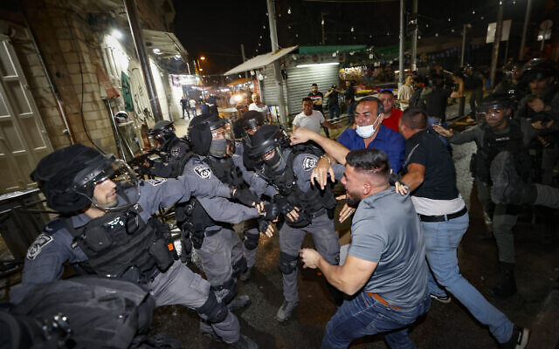  Police officers clash with protesters outside Damascus Gate in Jerusalem on May 09, 2021. (Yonatan Sindel/Flash90) | 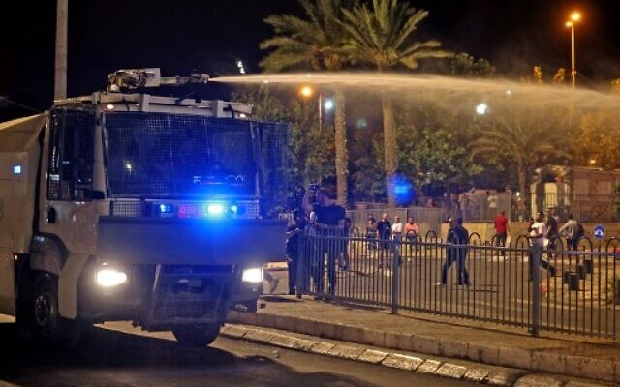  Israeli security forces fire water cannon during clashes with Palestinian protesters outside the Damascus Gate in Jerusalem’s Old City on May 9, 2021. (Photo by Menahem KAHANA / AFP)
Police used water cannons spewing foul-smelling “skunk” water and mounted officers against demonstrators, who reportedly burned a car belonging to Jewish residents and shot fireworks at local Jewish homes.
In videos circulating on social media, Palestinians could also be seen throwing stones and bottles at police near the Old City’s Damascus Gate. Police fired numerous stun grenades and deployed “skunk” water cannons in an attempt to disperse Palestinians on the scene.
The Palestinian Red Crescent reported that 19 Palestinians were wounded in clashes across Jerusalem on Sunday night, including one of their medics, who was hit with a rubber-tipped metal bullet; five of them were hospitalized.
Earlier on Sunday, three police officers and three Jewish Israelis were wounded in clashes near Jerusalem’s Hebrew University. The Shaare Zedek Medical Center said the three civilians were treated for light injuries sustained by stone-throwing.
Three Palestinians were arrested.
Violent clashes near Mount Scopus are relatively rare. Recent confrontations between police and Palestinians have largely centered around flashpoint sites in East Jerusalem, such as Damascus Gate and the Temple Mount.
צמד לוחמי מג״ב בעמדה בשער שכם עם עצור. מספר צעירים ללא היסוס מיידים לעברם אבנים ובקבוקים pic.twitter.com/FNiy52A6s3
— לירן תמרי | Liran Tamari (@liran__tamari) May 9, 2021
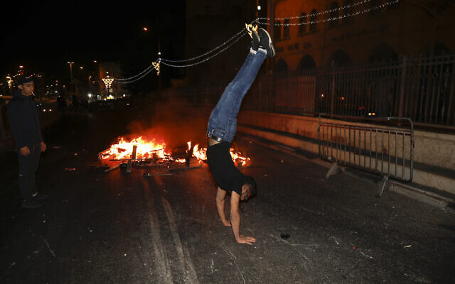
Also Sunday, thousands of Arab Israelis demonstrated in the northern cities of Haifa, Nazareth, Shfaram and Tira. The protesters blocked main roads and, in Nazareth, set trash cans ablaze in the middle of the street.
In Haifa, hundreds of demonstrators marched through the city’s main thoroughfare to the city’s German Colony neighborhood.
The participants sang “My Homeland,” an unofficial pan-Arab anthem, chanted slogans and waved Palestinian flags. “From Sheikh Jarrah to Silwan, we want to end settlements,” demonstrators called.

A Palestinian protester does a handstand next to a fire which was set on a road during clashes with Israeli police near Damascus Gate just outside Jerusalem’s Old City, Sunday, May 9, 2021. (AP Photo/Ariel Schalit)
According to Israel Police, demonstrators blocked a main road and threw rocks and bottles at cops. No stone-throwing could be seen in videos circulated on social media. Police declared the protest illegal and arrested 15 Arab Israelis for “rock-throwing and attacking cops.” Police fired riot grenades into the crowd in an attempt to disperse them.
Hundreds of Arab Israelis also demonstrated in Nazareth, waving Palestinian flags as they marched down the city’s main thoroughfare. Five demonstrators were arrested after clashes with police. With spirit and blood we shall redeem you, O Aqsa!” some protesters chanted.
Police could be seen using stun grenades there too.
الناصرة قبل قليل????נצרת לפני זמן קצר. pic.twitter.com/PhTzvH5wNL
— |فرات نصار|פוראת נסאר|FURAT NASSAR (@nassar_furat) May 9, 2021
Joint List leader MK Ayman Odeh accused the government of deliberately inciting violence.
“Violent arrests in Sheikh Jarrah, stun grenades in Haifa and the government approved the flag parade tomorrow at Damascus Gate. This is seriously escalating the situation — which serves the continuation of the occupation and the politicians who feed on it,” Odeh said in a statement.
Police Commissioner Kobi Shabtai said he hoped the Flag March would go ahead as planned, and was doing everything he can to ensure this, the Walla news site reported. A further situation assessment is to be held early Monday morning, however.
The march, which annually draws tens of thousands of participants and usually proceeds into the Old City via Damascus Gate and on through the Muslim Quarter to the Western Wall. However, the Damascus Gate area and Old City have seen days of clashes, including a major eruption of violence on the Temple Mount on Friday night.
Jerusalem Day celebrates the unification of Jerusalem, with the capture of East Jerusalem and the Old City from Jordan in the 1967 war, and religious nationalists hold parades and other celebrations in the city. MORE - https://www.timesofisrael.com/25-wounded-23-arrested-as-palestinians-arab-israelis-protest-across-israel/ [Just in case you were wondering, after perusing most of the news, the entire world has just gone bonkers. – rdb]

Supreme Court delays session on Sheikh Jarrah evictions amid Jerusalem violence
Justices grant attorney general’s request to postpone Monday hearing on pending removal of several Palestinian families from homes claimed by Jewish nationalists
By Aaron Boxerman Today, 5:32 pmUpdated at 6:01 pm
The Supreme Court, amid daily violent clashes in East Jerusalem, has canceled a hearing scheduled for Monday that could have determined whether four Palestinian families in the city’s Sheikh Jarrah neighborhood will be evicted.
After the families asked Attorney General Avichai Mandelblit to become a party to the case, Mandelblit’s office asked the Supreme Court for two weeks to consider the matter.
The court gave Mandelblit until June 8 to consider whether he will become a party to the case. The planned evictions — already approved by lower courts — will not go forward in the interim.
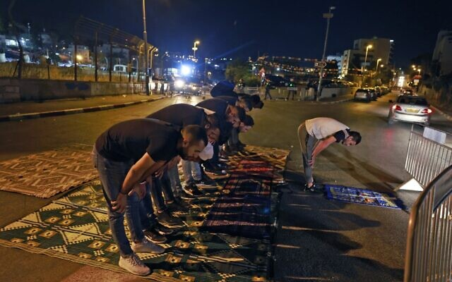
“A new date will be determined within the next 30 days. In the meantime, until further notice, I order a freeze on the decision by the appellate court, which does not imply any position regarding [that lower court’s decision],” Justice Yitzhak Amit wrote in the ruling.

Palestinians pray during a protest as local Palestinian families face eviction in the Sheikh Jarrah neighborhood of East Jerusalem, on May 8, 2021 (Menahem KAHANA / AFP)

In all, over 70 Palestinians in Sheikh Jarrah are set to be evicted in the coming weeks, to be replaced by right-wing Jewish Israelis. The Palestinians live in houses built on land that courts have ruled were owned by Jewish religious associations before the establishment of Israel 1948.
The anticipated decision to evict the families came as Jerusalem lives through tense, violent days. The city has been on edge in recent weeks as Palestinians have clashed with Israeli police, with both sides blaming the other for igniting the confrontations.
Over 300 Palestinians have been wounded in the confrontations, including several seriously injured by rubber-tipped bullets in the head, eye and jaw, according to the Palestinian Red Crescent. More than 20 Israeli officers were lightly injured.
Mandelblit on Sunday presented a sealed affidavit containing the recommendations of “relevant policymakers” regarding the Sheikh Jarrah case, for the court’s eyes only. According to the Walla news site, the affidavit contained opinions from senior Israeli security officials warning that evicting the families could lead to escalating tensions between Israelis and Palestinians. MORE - https://www.timesofisrael.com/supreme-court-delays-session-on-sheikh-jarrah-evictions-amid-jerusalem-tensions/ [Is Mandelblit and the court trying to see how the political winds are blowing before they finally get to their decision rather than looking strictly at the truth and merit of the case based upon its facts? Makes one wonder how much the politic will play in the affair. Sounds like the courts in the USA. I do believe there is a Torah prohibition against that. – rdb]

3 rockets fired from Gaza in early morning attack, at least 1 intercepted
Launches triggers sirens in Sderot, nearby towns; military announces it is closing the Strip’s pedestrian Erez Crossing until further notice
By Judah Ari Gross Today, 7:23 amUpdated at 9:47 am
Terrorists in the Gaza Strip fired three rockets toward southern Israel in the early hours of Monday morning, triggering sirens in the town of Sderot and surrounding communities, the Israel Defense Forces said.
At least one of the incoming projectiles was intercepted by the Iron Dome missile defense system, according to local government officials.
There were no immediate reports of injuries or damage.
The attack came at roughly 6:20 a.m., an unusual time for such rocket launches from the Strip, which generally occur at night.
On Monday morning, Palestinians in Gaza resumed launching balloon-borne explosive and incendiary devices into southern Israel. One such device landed in a field in the community of Dorot, northeast of the Strip in the Sha’ar Hanegev region. Police sappers were called to the scene to remove the suspected bomb, a Sha’ar Hanegev spokesperson said
A suspected balloon-borne explosive device lands in the southern Israeli community of Kibbutz Dorot on May 10, 2021. (Sha’ar Hanegev regional council)
In response to the rocket fire, Israel announced it was closing the pedestrian Erez Crossing to the Gaza Strip “until further notice,” with the exception of emergency humanitarian cases. This came after Israel also closed the Strip’s fishing zone, cutting off a major source of income for thousands of Palestinians in the coastal enclave.
On Sunday night, Palestinian terrorists fired two rockets from Gaza toward the city of Ashkelon and surrounding communities. One was intercepted while the other landed in an open area, the IDF said. MORE -https://www.timesofisrael.com/3-rockets-fired-from-gaza-in-early-morning-attack-at-least-1-intercepted/

Police mull limiting or canceling Jerusalem Day events amid violence, tensions
Security officials said to warn cabinet that Flag March could lead to escalation; police source says cops told to avoid live fire amid fears fatalities will exacerbate tensions
By TOI staff Today, 11:39 am
Security officials are reportedly considering placing limits on Jerusalem Day events or canceling them entirely, as tensions remained high in the capital with further violence at the conclusion of Sunday morning prayers.
According to Hebrew media reports, the fast-moving situation meant that police were holding assessments every few hours to leave all options on the table for as long as possible ahead of the commemorations set to begin on Sunday evening.
Additionally, the Haaretz daily reported that security officials warned the cabinet that the contentious Flag March set to be held on Monday could lead to an escalation in violence.
Amos Gilad, a former head of Military Intelligence and former top Defense Ministry official, told Army Radio that the march should be scrapped this year. “I would eliminate anything that creates friction. Jerusalem is currently a powder keg that could explode,” Gilad said. [Do concessions to the radical islamics ever really solve anything? Not from what we have seen in the past. – rdb]
Police Commissioner Kobi Shabtai held a security assessment on Saturday on the recent tensions in Jerusalem and ordered commanders, in particular in the Jerusalem area, to “significantly” boost their forces ahead of “another series of expected events over the coming days.”
That was apparently referring to Jerusalem Day, a national holiday that begins Sunday night, in which Israel celebrates the unification of Jerusalem and religious nationalists hold parades and other celebrations in the city.
The main event on Monday, the so-called Flag March, usually draws tens of thousands to Jerusalem’s Old City, including a large contingent of Jewish religious nationalists. Mass prayer services and gatherings were also expected to be held Sunday night.

Muslim worshipers pray in front of the Dome of the Rock in Jerusalem’s Old City, May 8, 2021 (Jamal Awad/Flash90)

Meanwhile, an anonymous police official told Channel 12 news that there were concerns that any potential fatalities in Jerusalem could deteriorate very quickly into a larger and more widescale conflict. Therefore, the source said, officers on the ground had been told to avoid using live fire unless necessary
Tensions remained high in Jerusalem on Sunday morning with rioters throwing rocks at police at the conclusion of morning prayers. The violence came after a second night of riots in the capital as well as on the Gaza border, with terrorists also firing a rocket from the Strip toward Israel.
According to Hebrew-language reports, protesters gathered near the gates to the Temple Mount on Sunday morning and some rioters began to throw rocks at police officers stationed nearby.
Police entered the area and responded to the rioters with “crowd-dispersal means,” the Kan public broadcaster reported. The Palestinian Red Crescent said 10 people were injured with one person hospitalized for treatment. There were no reports of Israeli injuries.
In footage broadcast by Kan, protesters chanted: “In spirit and in blood, we will redeem Al-Aqsa.” The outlet said that demonstrators also shouted slogans of support for the Hamas terror group in the wake of the firing of a rocket overnight.
אחרי ליל העימותים: קריאות "ברוח ובדם נפדה את אל-אקצא" אחרי תפילת השחר בהר הבית. הסהר האדום דיווח על עשרה פצועים הבוקר באזור ההר, אחד מהם פונה לבית חולים@nurityohanan pic.twitter.com/sb5FpwPTlf
— כאן חדשות (@kann_news) May 9, 2021
On Friday, 200 Palestinians and 17 Israeli police officers were wounded as hundreds rioted in the Temple Mount and cops broke into the compound to quell the unrest.
On Saturday night, as some 90,000 Muslim worshipers prayed at the site, the clashes with police continued around Jerusalem’s Old City, leading to some 90 Palestinian injuries.
Also on Saturday night, hundreds of Palestinians rioted along the Gaza border fence with Israel, burning tires and throwing explosives at Israeli troops before being dispersed by tear gas. MORE -https://www.timesofisrael.com/police-mull-limiting-or-canceling-jerusalem-day-events-amid-tensions-report/

Gaza incendiary balloons spark dozens of fires in south for 4th straight day
Police sappers work to defuse suspicious device attached to balloon; airborne attacks come amid heightened tensions in Jerusalem, West Bank
By TOI staff Today, 4:32 pm
Firefighting teams were working on Sunday in southern Israel to extinguish fires caused by balloons carrying incendiary devices that were launched from the Gaza Strip.
According to fire services, teams responded to dozens of blazes in the region.
Amid the fires, Israel Railways said it had temporarily shut down train service between the Ashkelon and Netivot stations due to a blaze that broke out near the southern town of Sderot. The station at Sderot was also closed temporarily.
Additionally, police said sappers were working near Kibbutz Gevim to defuse a suspicious device attached to a balloon that was found in the area.
There were no reports of injuries or danger to nearby towns.
A field burns near Sderot in southern Israel on May 9, 2021. (Sha'ar Hanegev Regional Council) | 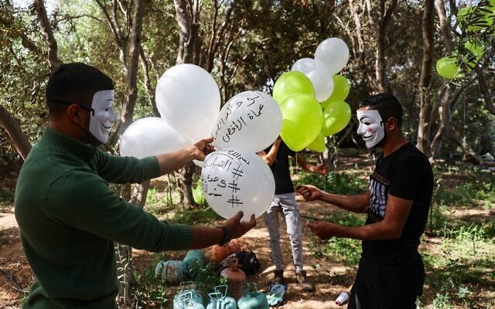  Masked Hamas members apparently prepare incendiary balloons to be launched toward Israel from the Gaza Strip, May 8, 2021 (MOHAMMED ABED / AFP)
The fires came amid reports from the so-called “balloon units” in the Gaza Strip saying that they had begun to launch balloon-borne incendiary devices toward southern Israel. Sunday marked the fourth straight day of such attacks.
גל שריפות בדרום | תנועת הרכבות בין אשקלון לנתיבות וכן תחנת שדרות נסגרו זמנית בשל שריפה שפרצה סמוך למסילה בשדרות. נבדק חשד כי נגרמה כתוצאה מבלון תבערה@Itsik_zuarets (צילום: חדשות ביטחון שדה) pic.twitter.com/32uSxERzrd
— כאן חדשות (@kann_news) May 9, 2021
The attacks came amid rising tensions in Jerusalem, the West Bank and along the Gaza border. Police bolstered their presence in Jerusalem on Saturday following violent clashes that saw some 200 Palestinians and 17 Israeli police officers wounded.
The tensions are related to the holy month of Ramadan in the Temple Mount, as well as the potential eviction of dozens of Palestinians from East Jerusalem’s Sheik Jarrah neighborhood in favor of Jewish tenants, in a case that is being reviewed by the courts.
Recent days saw over a dozen fires sparked in the Gaza border area as a result of incendiary balloons. Gaza’s so-called “independent balloon unit” warned on Thursday that “this is just the beginning.” Another smaller unit affiliated with the Gaza-based Mujahideen Brigades terror group announced on Saturday morning they had begun to mobilize their members to start launching balloons.
The practice of launching balloon-borne incendiary and explosive devices from the Gaza Strip toward Israel has waxed and waned over the past two years, though there have been relatively few launches until the past few days. The Israeli government and Gaza-ruling Hamas terror group have been engaged in indirect talks about a long-term ceasefire.
MORE - https://www.timesofisrael.com/gaza-incendiary-balloons-spark-dozens-of-fires-in-south-for-4th-straight-day/

IDF sends 3 more battalions to West Bank in bid to curb violence
Military sees limited attacks from Gaza as a positive sign, but fears unrest may continue through next week
By Judah Ari Gross Today, 9:50 pm

IDF Chief fo Staff Aviv Kohavi, right, meets with Border Police officers who responded to a shooting attack in the West Bank two days prior, on May 9, 2021. (Israel Defense Forces)

The Israel Defense Forces deployed an additional three battalions to the West Bank on Sunday as it seeks to curb the growing violence in the area, the military said.
Those reinforcements — units that were originally meant to be in training — are in addition to four battalions already sent to the West Bank since the start of the month of Ramadan in April. That represents thousands more IDF soldiers deployed to the West Bank than usual.
The military said the additional troops were specifically meant to be deployed along the so-called “seam line,” the border between the West Bank and Israel.
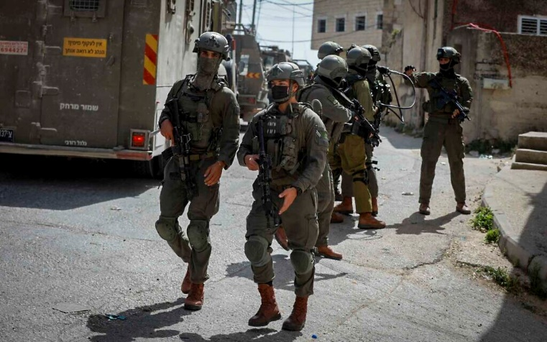
The move was not the result of a specific threat, but due to a general concern that the situation in the West Bank may get out of control, particularly if the violence in the capital escalates.
Recent weeks have seen a major spike in violence in Jerusalem, with nightly clashes between Palestinian residents of the city and Israeli security forces. The Palestinian Authority, Hamas, Islamic Jihad, and other Palestinian groups have called for additional clashes.

Israeli soldiers search for a Palestinian suspect in a drive-by shooting attack, in the northern West Bank town of Aqraba, May 4, 2021. (Flash90)

The violence has spread from Jerusalem to the West Bank, where there have been a number of attacks and attempted attacks against Israeli civilians and security forces in recent weeks, including a deadly shooting attack last week in which one Israeli student was killed and another seriously injured.
On Wednesday, according to Palestinian health officials, 16-year-old Palestinian teenager Said Odeh was shot and killed by Israeli forces, who said he was throwing Molotov cocktails at troops during a protest. MORE -https://www.timesofisrael.com/idf-sends-3-more-battalions-to-west-bank-in-bid-to-curb-violence/

In swipe at Biden, Netanyahu pledges to ‘build in Jerusalem’ despite ‘pressure’
Amid ongoing clashes in the capital, PM vows to ‘guard freedom of worship for all faiths’, while preventing ‘violent disturbances’
By TOI staff Today, 5:53 pm
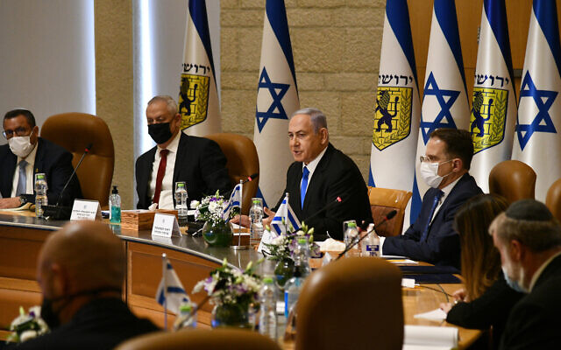
Prime Minister Benjamin Netanyahu addresses a special cabinet meeting to mark Jerusalem Day, at Jerusalem City Hall, May 9, 2021 (Haim Zach / GPO)

Prime Minister Netanyahu weighed in on the recent tensions in Jerusalem at the start of the weekly cabinet meeting on Sunday, emphasizing that Israel retains the right to “build in Jerusalem,” after the Biden administration criticized the impeding evictions of Palestinian families in East Jerusalem and Israeli construction in the West bank.
“We emphatically reject the pressures not to build in Jerusalem. Unfortunately, these pressures have been increasing of late. I say even to our best friends: Jerusalem is the capital of Israel. Just as every people builds its capital and in its capital, so too do we reserve the right to build Jerusalem and in Jerusalem. This is what we have done and what we will continue to do,” he said, according to a statement from his office.
The cabinet meeting was held in Jerusalem’s City hall in honor of Jerusalem Day on Monday.
Three times since the beginning of April, US officials reached out to the Prime Minister’s Office to express their opposition to Israeli steps to build beyond the Green Line, Channel 12 reported Thursday.
Netanyahu has repeatedly dismissed these objections.
The US last week also expressed concerns over the East Jerusalem neighborhood of Sheikh Jarrah, where over 70 Palestinian residents are threatened with eviction and could be replaced by right-wing Jewish nationalists in a legal battle being waged in the courts.
The case has been cited as one of the key issues sparking some of the worst clashes seen in years at Jerusalem’s Temple Mount compound on Friday and further violence Saturday amid the Muslim holy month of Ramadan.
Beyond the Biden administration, the impending eviction has drawn criticism from allies throughout Europe, as well as Israel’s newfound friends in the Persian Gulf, the United Arab Emirates and Bahrain. [The EU has little room to talk about creating problems with Islam. French generals are warning that the EU countries are potentially facing a major revolution because of their poor handling and management of their Islamic invaders. – rdb]
On Sunday, the Supreme Court canceled a hearing scheduled for Monday that could have determined whether four Palestinian families in Sheikh Jarrah would be evicted.
According to a secret legal opinion, Israeli security officials were worried the hearing could further fuel tensions, the Walla news site reported.

Jewish Orthodox marchers gather to celebrate Jerusalem Day at the Old City’s Damascus gate in Jerusalem on June 2, 2019. (MENAHEM KAHANA/AFP)

Monday also marks Jerusalem Day, when tens of thousands of Jewish nationalists are expected to march through the Old City of Jerusalem to mark 54 years since its capture during the Six Day War. Security officials are considering placing limits on Jerusalem Day events or canceling them entirely, Hebrew media reported Sunday.
During the cabinet meeting, referring to the riots at the Temple Mount over the weekend, Netanyahu also said Israel “will continue to guard freedom of worship for all faiths, but we will not allow violent disturbances.”
On Friday, 200 Palestinians and 17 Israeli police officers were wounded as hundreds rioted in the Temple Mount and cops broke into the holy compound to quell the unrest. On Saturday night, as some 90,000 Muslim worshipers prayed at the site, the clashes with police continued around Jerusalem’s Old City, leading to some 90 Palestinian injuries.
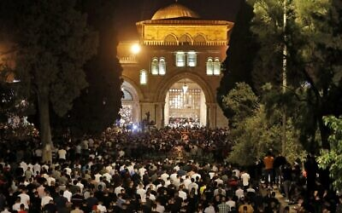
Palestinians take part in Laylat al-Qadr prayers outside the Dome of the Rock on the Temple Mount in Jerusalem’s Old City, during the Muslim holy month of Ramadan, May 8, 2021. (Ahmad Gharabli/AFP)

The Temple Mount has long been one of the main flashpoints of Israeli-Palestinian friction. The holiest place in Judaism — as the site of the two biblical temples — it is also home to the Muslim holy sites of the Al-Aqsa Mosque and Dome of the Rock.
Netanyahu emphasized that Israel “will uphold law and order – vigorously and responsibly, and warned the Hamas terror group that “Israel will respond powerfully to any act of aggression from the Gaza Strip.”
Those comments referred to a rocket fired from Gaza at southern Israel Saturday night, which landed in an open field. The Israel Defense Forces responded with a strike on a Hamas post in the southern Strip.
Also on Saturday night, hundreds of Palestinians rioted along the Gaza border fence with Israel, burning tires and throwing explosives at Israeli troops before being dispersed by tear gas.
Defense Minister Benny Gantz also addressed the ongoing tensions at the special cabinet meeting, echoing Netanyahu’s statement that Israel is committed to maintaining freedom of worship.
Gantz, who is also justice minister, said that ministry is working with defense officials to address incitement to violence on social media.
“Unfortunately, I can say some of the social media companies, particularly Facebook, are not sufficiently cooperating on everything related to taking down inciting text on the networks. I hope we get broader cooperation to calm the tensions,” Gantz said, according to a statement from his office. https://www.timesofisrael.com/in-swipe-at-biden-netanyahu-pledges-to-build-in-jerusalem-despite-pressure/

2 Haredi MKs call on Netanyahu to step aside to avert Bennett-Lapid government
UTJ’s Porush Eichler suggest Likud leader let someone else lead a right-wing coalition for a year and a half, then return to his post
By TOI staff Today, 8:57 pm
Deputy Education Minister Meir Porush and MK Yisrael Eichler of the ultra-Orthodox United Torah Judaism party on Sunday asked Prime Minister Benjamin Netanyahu to step aside and let another lawmaker from the right lead a new government.
The request from the two senior allies of Netanyahu and his Likud party came as Yesh Atid MK Yair Lapid and Yamina chief Naftali Bennett plowed ahead with their own efforts to build a majority coalition in the wake of March’s inconclusive elections, reportedly making significant progress.
In a letter to Netanyahu, the two UTJ members said that four inconclusive elections had failed to produce a right-wing government as they had hoped and that if the current political deadlock leads to a fifth vote, it will spell defeat for the right-wing and religious parties in the Knesset.
They urged Netanyahu to step down for the first year and a half of a coalition and then return later to his position.
“During the past two years, and over the course of four rounds of elections, the ultra-Orthodox and religious parties supported the bloc led by Likud, with the intention of establishing a strong right-wing government on the basis of values and tradition, regrettably without success,” the lawmakers wrote.
Noting that they understand Netanyahu’s keenness to persevere his bloc in order to prevent the opposing right-center-left bloc from forming a government, they wrote, “We have no desire to get to fifth elections that are likely to end with a defeat for the right-wing and ultra-Orthodox parties.”
“The only way to prevent a left-wing government and also to prevent elections is a clear declaration from you, before a left-wing government is established, that you will grant someone from the right-wing bloc, who will manage to unite 65 right-wing MKs, the premiership for the first year and a half in a rotation,” they wrote, referring to the number of lawmakers in the Knesset from right-wing parties, minus the right-wing secularist Yisrael Beytenu party.
Porush and Eichler said that during that time, Netanyahu would be able to continue as alternate prime minister and concentrate his efforts on diplomacy with the Biden administration in the US, regional peace efforts, and developments regarding talks to revive the Iran nuclear deal with world powers.
In April, Hebrew media reports said that ultra-Orthodox lawmakers had warned Netanyahu that they would not follow him to a fifth round of elections. It was not clear if the warning came from UJT or Shas party members. MORE -https://www.timesofisrael.com/haredi-mks-call-on-netanyahu-to-step-aside-to-avert-bennett-lapid-government/

‘Change bloc’ seeking to swear in new government as early as Tuesday
With pressure from Netanyahu on Yamina MKs, Lapid and Bennett are working to finalize coalition agreements between 7 parties in the next two days
By Raoul Wootliff and Tal Schneider Today, 11:56 am
Yesh Atid leader Yair Lapid and Yamina chair Naftali Bennett are trying to expedite coalition negotiations in order to swear in a new government as early as Tuesday this week, sources in the “change bloc” told The Times of Israel on Sunday.
According to the sources, the haste comes over concerns with respect to Prime Minister Benjamin Netanyahu’s efforts to convince Yamina members to oppose the government, following the announcement last week of MK Amichai Chikli that he will vote against it.
Netanyahu and his Likud party are pressing Yamina as a whole, as well as individual MKs, to not join with Lapid in forming a government, with efforts focused on getting other lawmakers from Bennett’s right-wing party to adopt Chikli’s position.
In order to bypass Netanyahu’s efforts, Lapid and Bennett are working to finalize coalition agreements between the parties in the next two days, the sources said.
Lapid and Bennett’s respective negotiating teams held marathon talks Saturday night until the early hours of Sunday morning during which “significant progress” was made, the Kan public broadcaster reported. The network also said that the two hope to close negotiation agreements by Monday.
According to the report, the general mechanisms and basic principles by which such a government would operate have been largely agreed upon, and the main issue of contention is now the distribution of ministries and Knesset posts in the coalition.
Lapid, who last week received the presidential mandate to try to form a government, is leading the negotiations on behalf of the center-left. The sides are believed to have agreed that Bennett will serve as prime minister for the government’s first two years, with Lapid serving for the latter two.
The “change bloc” coalition-building efforts hang by a thread, however, as opposition from further MKs could potentially scupper them: without Chikli the prospective change bloc, including Yamina, has 57 seats in parliament compared to 53 (including Chikli) for the parties backing Netanyahu.
While the government does not need an absolute majority of 61 seats in the 120-seat Knesset to be voted in, it does need more MKs to vote in favor of it than those that oppose it. The Islamist Ra’am party, with four seats, could therefore take the change bloc to 61, or prevent a government from being formed by giving pro-Netanyahu bloc 57 and causing a tie.
Lapid and Bennett were set to meet with party chair Mansour Abbas Sunday in an effort to convince Ra’am to back the new government.
Abbas has so far resisted backing either side, positioning himself as a would-be kingmaker by saying he will support a government best placed to deal with the issues facing the Arab Israeli community he represents.
He will not, however, demand a ministerial position in the new government and will instead suffice with the chairmanship of a Knesset committee — either internal affairs or economic affairs — sources in the change bloc said Sunday.
Beyond gaining Abbas’s support and preventing defections from Yamina, the change bloc is also working to resolve several disagreements between the seven parties that would make up the prospective government — Yesh Atid, Yamina, Blue and White, Yisrael Beytenu, New Hope, Labor and Meretz.
According to reports, Lapid would be foreign minister in Bennett’s cabinet, with Yisrael Beytenu chief Avigdor Liberman as finance minister, but a number of disagreements remain between the seven parties over several key ministries.
Channel 12 news reported that Yamina has given its potential partners an ultimatum that Bennett’s close ally Ayelet Shaked must be appointed justice minister or there will be no deal. Shaked served in the post in 2015-2019.
The justice portfolio is currently also being demanded by New Hope party chief Gideon Sa’ar. Sa’ar had preferred the defense portfolio, but Blue and White’s Benny Gantz is insisting on retaining that.
Channel 12 said Yamina is demanding most of the top so-called “ideological” portfolios in the government, including justice, religious affairs, public security and education, leaving few top posts for other parties.
The Education Ministry specifically is a sticking point, with the left-wing Meretz party’s Nitzan Horowitz demanding the post, while New Hope wants it for its own Yifat Shasha-Biton.
The parties were also reported by Haaretz to be considering a rotation of the Knesset speakership between Yesh Atid’s Meir Cohen and New Hope’s Ze’ev Elkin. MORE - https://www.timesofisrael.com/change-bloc-seeking-to-swear-in-new-government-as-early-as-tuesday/

Matching half of 2,000-year-old lamp found in Jerusalem said located in Budapest
Hungarian archeologist reaches out to Israelis to say he may have found a match for the rare face-shaped piece discovered on road used by Jewish pilgrims on way to 2nd Temple
By Raoul Wootliff Today, 3:05 pm
A bronze oil lamp discovered in Budapest in 2012 (R) which matched one found in Jerusalem's City of David in May 2021 (L). (Ágnes Bakos/Bence Tihanyi; Koby Harati/City of David) | A bronze oil lamp discovered in Budapest in 2012 (R) which matched one found in Jerusalem’s City of David in May 2021 (L). (Ágnes Bakos/Bence Tihanyi; Koby Harati/City of David)
A rare 2,000-year old oil lamp shaped like half of a grotesque face that was discovered in Jerusalem last week appears to have a matching partner — that was discovered in Budapest nine years ago.
The Israel Antiquities Authority said last week that the lamp, estimated to be from the late 1st century or the early 2nd century CE, was the first finding of its kind in Israel, and one of just a few worldwide.
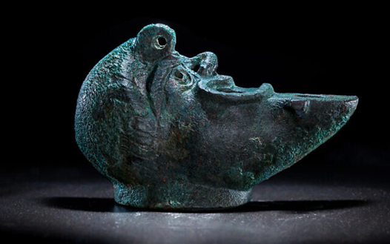  A bronze oil lamp discovered in the foundations of a Roman-Era building in Jerusalem’s City of David Pilgrimage Road, May 2021. (Koby Harati/City of David) | A bronze oil lamp discovered in Budapest in 2012 which matched one found in Jerusalem’s City of David in May 2021. (Ágnes Bakos/Bence Tihanyi)
According to Jerusalem’s City of David archeological site, after the announcement of the find, Hungarian archeologist Dr. Gabor Lassanyi reached out to say that he may be in possession of the other half, which was uncovered during a 2012 excavation in Budapest.
“In an excavation we conducted at Aquincum (modern-day Budapest), we found a remarkably rare object: at the bottom of the building, we discovered a bronze half-lamp depicting the right half of a face shaped like a Roman theater mask,” Lassanyi wrote to Ari Levy, the head of the Jerusalem excavation.
According to Lassanyi, “Only a few known creations that resemble this exist from this time period, and they sit in museums and throughout private collections in the world, yet none of them are like these two halves. It is very difficult to craft in such an accurate way, and therefore, it is likely that the two halves of the lamps were created in the same artisan house and may even have served as a pair to one complete piece.”
right-hand side.
Upon an initial examination of the two lamps, Lassanyi and Levy found that the two halves had exactly the same dimensions. Additionally, the lamp in Hungary has a connecting slot that is depressed, while the lamp discovered in Israel has a protruding ridge, indicating they could connect together.
Levy said he was “incredibly surprised and excited to receive such a response” from Lassanyi. “From the start, it was clear to us that this lamp was made abroad in one of the European countries, but I could not imagine that I would receive such an incredible message. The presence of a similar counterpart in Hungary, an area that was under the control of the Roman Empire at the time, allows us to look at the issue in a much deeper and broader way than we expected,” Levy said.
Israel Antiquities Authority researchers said last week that they believe the bronze lamp was used as a foundation deposit — a ritual burial of an offering — to bring good fortune to the Roman Period building’s residents.
According to the Israel Antiquities Authority, the lamp was poured into a sculpted mold that was shaped like half of a face of a bearded man with a grotesque appearance. The tip of the lamp is shaped like a crescent moon, and the handle is shaped like an acanthus plant. The decoration that appears on the lamp is reminiscent of a common Roman artistic motif, similar to a theatrical mask.
Lassanyi and his team also likened their find to a theatrical mask [link in Hungarian].
Israeli archeologists are currently examining various options to explore whether the two lamps are indeed a matching pair, including the possibility of printing a three-dimensional model of the lamp from Israel and sending it to Hungary so that researchers there could try to connect the two halves, the City of David said in a statement.
The finding, in the City of David’s Pilgrimage Road, also included the lamp’s wick, which was unusually well-preserved.
The Pilgrimage Road was used by Jewish pilgrims 2,000 years ago when they visited Judaism’s holiest site, the Temple Mount. https://www.timesofisrael.com/matching-half-of-2000-year-old-lamp-found-in-jerusalem-said-located-in-budapest/

Saudi Arabia releases first-ever photos of holy Kaaba stone
With hajj pilgrimage limited due to COVID restrictions, kingdom publishes high-resolution images of al-Hajar al-Aswad, which believers say fell from heaven at time of Adam and Eve
By TOI staff Today, 10:11 am

A closeup image of the black stone of the Kaaba in Mecca. (Saudi Arabia General Presidency of the Grand Mosque and the Prophet's Mosque)

With attendance at the annual hajj pilgrimage in Mecca limited for the second year in a row due to coronavirus restrictions, Saudi Arabia has for the first time released images of the ancient holy stone of the Kaaba, a black masonry cube at the center of the ritual that Muslims around the world pray to daily.
The General Presidency for the Affairs of the Saudi Grand Mosque and the Prophet’s Mosque released photos of the al-Hajar al-Aswad, or the Black Stone, as part of a series showing a number of holy artifacts that play a role in the hajj.
The General Presidency, which oversees the holy sites in Mecca, said 1,050 high-resolution photographs were taken in a seven-hour session. The images are up to 49,000 megapixels in size and took more than 50 hours to photograph and develop, the religious agency said.
The stone, which Islamic tradition holds fell at the time of Adam and Eve, is framed in pure silver at the southeast corner of the Kaaba, itself said to have been constructed by Abraham and his son Ishmael.
During the hajj, which Muslims are instructed to complete at least once in their lifetime, pilgrims perform Tawaf, or circumambulation, seven times counter-clockwise, around the Kaaba.
Worshipers usually touch, kiss, or wave at al-Hajar al-Aswad stone when walking past it.
Observant Muslims around the world pray toward the Kaaba five times a day.
At this year’s hajj, which takes place during the holy month of Ramadan, Saudi Arabia has limited daily attendance to 50,000 pilgrims inside the Grand Mosque, only allowing individuals who have been vaccinated or recently recovered from COVID-19 to perform prayers at the Kaaba. https://www.timesofisrael.com/saudi-arabia-releases-first-ever-photos-of-holy-kaaba-stone/

Russia commemorates Victory Day with military might as tensions with West soar
Over 12,000 troops, 80 military aircraft and over 190 pieces of military hardware, incl. intercontinental ballistic missile launchers march in Moscow's Red Square on 76th anniversary of USSR's victory over Nazi Germany in WWII
Reuters | Published: 05.09.21 , 19:14
President Vladimir Putin reviewed Russia's traditional World War Two victory parade on Sunday, a patriotic display of raw military power that this year coincides with soaring tensions with the West.
The parade on Moscow's Red Square commemorating the 76th anniversary of the Soviet Union's victory over Nazi Germany in World War Two featured over 12,000 troops and more than 190 pieces of military hardware, including intercontinental ballistic missile launchers, and a fly-past by nearly 80 military aircraft under cloudy skies.
(Photo: Reuters)
Russian service members and cadets march during a military parade on Victory Day, which marks the 76th anniversary of the victory over Nazi Germany in World War Two, at the Red Square in central Moscow
Putin, who has been in power as either president or prime minister since 1999, stood beside Soviet war veterans on a review platform set up on Red Square.

Russian President Vladimir Putin during the Victory Day march in central Moscow (Photo: Reuters)

"Unfortunately there are once again attempts to deploy many things from the ideology of the Nazis, those who were obsessed with a delusional theory on their exclusiveness. And not only (by) all sorts of radicals and international terrorist groups," Putin said in what appeared to be a common denunciation of the West but what the Kremlin said was aimed at the rise of neo-Nazism in Europe.
"Russia will, again and again, uphold international law, but at the same time we will firmly protect national interests (and) ensure the security of our people."
This year's parade precedes parliamentary elections in September and comes at a time when Moscow's relations with the West are acutely strained over issues ranging from the conflict in Ukraine to the fate of jailed Kremlin critic Alexei Navalny.
The United States and Russia have expelled each other's diplomats in recent months in a series of retaliatory moves and Moscow and EU member states have been involved in a similar tit-for-tat diplomatic dispute.
Sunday's parade follows a massive show of Russian military force near the borders of Ukraine and in Crimea, which Russia annexed from Kyiv in 2014, and an uptick in fighting in eastern Ukraine between Russian-backed separatists and Ukrainian government forces.
Moscow said the build-up, which alarmed the West, was a training exercise in response to activity by the NATO military alliance and Ukraine. It has since ordered a withdrawal of some troops. read more
Smaller military parades took place on Sunday in cities across Russia and in annexed Crimea, and at Russia's Hmeymim airbase in Syria. https://www.ynetnews.com/article/SyTgeYBuO

EU did not renew its order for AstraZeneca Covid-19 jabs beyond June, bloc’s vaccines boss says
9 May, 2021 14:16 / Updated 2 hours ago
The EU has not made any new orders for AstraZeneca shots beyond June, the head of the bloc’s vaccine task force has said. The EU has been at odds with the drug maker over sloppy deliveries for months.
No new orders for the AstraZeneca vaccine – recently rebranded as Vaxzevria – have been made by the European Union, with the contract set to expire in June, European Internal Market Commissioner Thierry Breton told France Inter on Sunday.
Read more
“We have not renewed the order after June. We will see what will happen,” Breton stated.
Relations between the EU and the British-Swedish pharmaceutical company have deteriorated over the past few months, as AstraZeneca failed to deliver the pre-agreed number of coronavirus shots on time. Last month, Brussels took legal action against the company, accusing it of breaching the contract and not having a reliable plan to ensure timely deliveries.
While Breton described the AstraZeneca shot as a “a very good vaccine,” its safety has been called into question lately. On Friday, the European Medicines Agency (EMA) said it was assessing reports of a rare immune disorder found in vaccinated people.
The disorder in question, Guillain-Barré syndrome (GBS), affects the nerves and can cause pain, as well as feelings of numbness and weakness. While the condition is treatable, it can have a long-term impact on people’s health. [You will recall that the Swine flu vaccine did the same thing. – rdb]
The allegations of a link between the AstraZeneca shot and GBS follow reports of hundreds of blood clotting cases – and dozens of deaths – registered in people who received the shot. The blood clotting concerns have already led to limitations in the distribution of the vaccine in multiple countries.
The EU is expected to have a longer relationship with other major drug makers, in particular Pfizer and BioNTech – the companies will provide the bloc with around 1.8 billion doses of their coronavirus shot over the 2021-23 period, Breton stated, adding that half of these doses are optional to purchase. At the same time, the cost of these contracts might be higher than initially expected, the commissioner warned without giving any concrete figures. https://www.rt.com/news/523321-eu-astrazeneca-covid-order/

Top science writer: Evidence points to Wuhan lab leak
'Political agendas of governments and scientists have generated thick clouds of obfuscation'
By Art Moore Published May 9, 2021 at 11:43am
Amid calls by Republicans to investigate the origin of the COVID-19 pandemic, a prominent science journalist who worked for the journal Nature and the New York Times has published an in-depth report concluding the evidence points to a leak from the Wuhan Institute of Virology in China.
Nicholas Wade – in "Origin of Covid — Following the Clues: Did people or nature open Pandora’s box at Wuhan?" – explained his intent was to "sort through the available scientific facts, which hold many clues as to what happened, and provide readers with the evidence to make their own judgments."

Nicholas Wade

In his nearly 11,000-word analysis, he acknowledged that the origin of the pandemic remains uncertain. But that is, in part, because "the political agendas of governments and scientists have generated thick clouds of obfuscation, which the mainstream press seems helpless to dispel."
Toward the end of his piece, he addressed the ideological and political divide over the issue, observing that many in establishment media and politics reflexively took a contrarian view to President Trump's open conjecture that the virus escaped from a Chinese lab.
Eventually, Wade wrote, the "common sense perception that a pandemic breaking out in Wuhan might have something to do with a Wuhan lab cooking up novel viruses of maximal danger in unsafe conditions could eventually displace the ideological insistence that whatever Trump said can’t be true." MORE - https://www.wnd.com/2021/05/top-science-writer-evidence-points-wuhan-lab-leak/

New app that can actually read your emotions comes under heavy fire
The program would have to monitor 'everything'
By Bob Unruh Published May 9, 2021 at 1:20pm
A coalition of privacy organizations and allies are urging a leading digital media company to stop the development of a new technology that purportedly can listen to a person and identify his or her emotional state.
The Electronic Privacy Information Center and more than 100 recording artists, 69 non-profit groups and many prominent individuals are urging Spotify to close down its research.
It's because Spotify obtained a new patent that would "allow the company to identify individuals' 'emotional state, gender, age, or accent' to recommend music."
But there are significant concerns that aren't being addressed, the critics said in a letter.
EPIC cites multiple threats of "emotional manipulation, discrimination, massive privacy violations and increased inequality within the music industry."
While Spotify argued its technology has not been implemented, and it claimed it has "no plans" to do so, EPIC said concerns remain.
The letter, dated this week, is to Daniel Ek, co-founder of the company, in Sweden.
"We write to you as a group of concerned musicians and human rights organizations from across the globe who are deeply alarmed by Spotify's recently approved speech-recognition patent," the groups said.
"Spotify claims that the technology can detect, among other things, 'emotional state, gender, age, or accent' to recommend music. This recommendation technology is dangerous, a violation of privacy and other human rights, and should not be implemented by Spotify or any other company."
The letter explained the danger: "Monitoring emotional state, and making recommendations based on it, puts the entity that deploys the tech in a dangerous position of power in relation to a user."
The discrimination would be unavoidable, the letter said.
"It is impossible to infer gender without discriminating against trans and non-binary people, and others who do not fit gender stereotypes. It is also impossible to infer someone's music taste based on accent, without assuming there's a 'normal' way of speaking or falling into racist stereotypes."
The threat to privacy is obvious, because the program would have to monitor "everything."
"While we are pleased to hear that Spotify has no current plans to deploy the technology, it begs the question: why are you exploring its use? We call on your company to make a public commitment to never use, license, sell, or monetize the recommendation technology."
Signers include Amnesty International, the Center for Digital Democracy, Heartland Initiative, Mozilla Foundation and Public Citizen. https://www.wnd.com/2021/05/new-app-can-actually-read-emotions-comes-heavy-fire-privacy-groups/ [One of the big pushes of the WEC(World Economic Council) who are pushing the globalization and reset agenda is to increase the AI (artificial intelligence) aspects of the world today which in effect could turn people into drones. Or more appropriately borgs. It is ALL about control just like their covid crisis was. – rdb]

'Devastating': College gals suspended, lose tuition for not wearing masks outside and off-campus
'It's heartbreaking'
By WND News Services Published May 9, 2021 at 3:23pm
(WBZ) -- ANDOVER, Massachusetts – Andover parents Kristin and Scott are speaking out on behalf of their daughter. She along with two of her friends are freshmen at UMass Amherst. A picture posted on social media of the three friends not wearing masks outside was handed over to the university and that has landed them in serious trouble.
“There was a photo sent to the administration of these girls outside off campus on a Saturday. This is why they lost a whole semester of their schooling,” Kristin said.
Teresa and RJ’s daughter was also suspended. “She was valedictorian and class president of her high school. She did everything right,” RJ said. MORE - https://www.wnd.com/2021/05/devastating-college-freshmen-suspended-not-wearing-masks-outside-off-campus/ [Talk about mind and body control. These liberal fools running most of the so called “places of higher education” are the socialist crackpots that have destroy most of our youth and their ways of thinking. – rdb]

78 members of Congress tell court Biden doesn't control state taxes
His 'American Rescue Plan' called 'blatantly unconstitutional'
By Bob Unruh Published May 9, 2021 at 1:03pm
Seventy-eight members of Congress have gone to court to say that President Biden's "American Rescue Plan" is "blatantly unconstitutional" because it purports to control the decisions states make regarding their own taxes.
The friend-of-the-court brief was filed by the American Center for Law and Justice on behalf of the members of Congress in a case already pending that was brought by 13 attorneys general.
They sued Biden because of the demand, authored by the Schumer-Pelosi regime in Congress, that "prohibits states from lowering state taxes anytime between now and 2024."
"In other words, throughout President Biden's first term," the ACLJ explained.
The delegation is being led by Sens. Mike Crapo and Tim Scott and Reps. Jim Banks and Kevin Brady.
The provision "limits how states and localities can use their $360 billion windfall. States can use the loot to provide government services, cover revenue losses during the pandemic and 'respond to the public health emergency' or 'its negative economic impacts, including assistance to households, small businesses, and nonprofits, or aid to impacted industries such as tourism, travel, and hospitality.'"
But the Wall Street Journal noted that, "Much of the relief will invariably flow to government union pension funds, which are underfunded in states like Illinois, New Jersey and Connecticut."
But it "explicitly bars states from cutting taxes."
The ACLJ explained, "This is a gross overreach of the empowered radical Left. Perhaps most insulting and infuriating is that while the Left essentially tells states they are not allowed to lower their residents' taxes, both the federal government and states retain the right to raise taxes all they want."
The organization's legal argument note Congress may impose certain conditions on funds, but "it may not impose conditions so intrusive that it amounts to coercing the states to do its will."
The ACLJ already had filed a friend-of-the-court brief on behalf of 74 members of Congress in another case, brought by Ohio, which sued because of the ban.
The new filing is supporting 13 other states that have filed their own lawsuit in federal district court in Alabama, including: Alabama, Alaska, Arkansas, Florida, Iowa, Kansas, Montana, New Hampshire, Oklahoma, South Carolina, South Dakota, Utah, and West Virginia.
The ban simply "either an invalidly ambiguous condition or an unambiguous, compulsory encroachment upon the states' sovereign rights," the ACLJ said.
The filings argue, "The 'Tax Mandate' in the American Rescue Plan Act of 2021 . . . exceeds Congress’s power under the Spending Clause, U.S. Const. art. I, §8, cl. 1. The conditions, i.e., the 'Tax Mandate,' purportedly set by Congress controlling State recipients of the ARPA funds and prohibiting such States from lowering their taxes, exceed the conditioning power recognized by the Supreme Court. If the Tax Mandate is unambiguous, it amounts to an impermissible assault on the States’ sovereignty. If it is ambiguous, it fails to pass one of the Supreme Court’s clear limitations on Congress’s conditioning authority. As a result, the ultra vires Tax Mandate is unconstitutional."
Explained the ACLJ's Jordan Sekulow in his report, "The bottom line is that the Left is grabbing for as much power as it can, and this despotic overreach cannot be allowed to stand. Right now they are dangling relief funds in front of states that desperately need them to keep police officers, firefighters, and other necessary services running and saying, 'You can only have this if you do what we say.' That is not how things are done in a constitutional republic." https://www.wnd.com/2021/05/78-members-congress-tell-court-biden-doesnt-control-state-taxes/

Commentary:
Guinea Pigs in a World-Wide Experiment
By Rob Pue|May 9th, 2021
I realize that in these days it’s difficult to keep up with all the news and information that continually bombards us. It’s often hard to know what’s true and what’s not true. Even sources we would like to think we could trust often run with stories prior to doing any sort of independent fact checking. We must all work harder than ever to get the real truth because real truth is now censored by the internet conglomerates and social media platforms. Try researching the truth about any of the things I’m sharing with you, and you’ll find plenty or articles online debunking these things, but you’ll need to dig very deeply to find the real stories. Here’s a tip: if YouTube or Facebook has banned or censored something, chances are that what they’ve banned or censored is true.
Things are made even more difficult for the average citizen to get the truth, when there is so much deliberate DISinformation and liberal talking points regarding the New World Order agenda being pushed by the mainstream media — sources we once THOUGHT we could trust; though their “Operation Mockingbird” tactics have long since been unmasked. Unfortunately, only those willing to research the official narrative (because none of it makes any common sense) will ever question what is spoon-fed to them by the mainstream press. For most, if it’s on the TV news, it MUST be true. We are so easily deceived as a nation. We question almost nothing anymore and people of all generations are now embracing easily discernable lies as facts; simply because it’s constantly drilled into our heads.
How else can you explain so many people still wearing face masks everywhere they go, more than a year after our “two-week plan” to “flatten the curve” — and even though they’re completely healthy; while it’s been proven that breathing in and recirculating your own CO2 is very UN healthy?
How else can you explain so many lining up to get experimental poisons (yes, POISONS — by the CDCs own admission) injected into their bodies, despite a substantially higher infection and death rate — and severe, life altering adverse reactions — among those who have received the injections versus those who have not? Indeed, it’s now been shown by top doctors and scientists around the world (ALL who have been de-platformed, fired from their jobs and censored by the press) that thousands more have died or experienced adverse reactions after receiving their injections than before. Previously perfectly healthy people get the injection, and then have serious life-long TERRIBLE side effects. Or they just die. Simply “the cost of doing business” with the New World Order.
What’s even worse, it’s now been shown — both here in America and in Europe — that those receiving the injections are much more likely to spread serious illnesses to those around them in the days and weeks following the injections. So even if you don’t get one, those who did have now become so contaminated — “super spreaders,” of a wide array of diseases — that if you have chosen to not be a government guinea pig, your chances of getting extremely ill or dying, simply by coming in contact with an injected person, are substantially increased. Rather than protecting others by being injected, you’re actually putting everyone you come in contact with at serious risk of illness and death if you have chosen the “jab.”
According to the CDC’s own data, the COVID “vaccines” are not vaccines at all, but experimental gene therapy. And according to the VAERS system, which stands for “Vaccine Adverse Event Reporting System,” which you can find at VAERS.hhs.gov, as of reporting April 25th, the CDC now says the injection is linked with more than 348,000 deaths in the US. The CDC further states that more than 60% of pregnant women have a serious side effect, including 16% that have their babies die in the womb within a week or two. You can analyze the VAERS information yourself and you will see, by their own admission, these injections kill at a rate 32 times higher than regular vaccines.
Meanwhile, Facebook recently removed a popular and rapidly growing group where members could post stories about negative COVID “vaccine” side effects. The group was known as “COVID 19 VACCINE VICTIMS AND FAMILIES, and had over 120,000 followers, and gaining more than 10,000 new followers each week when Facebook closed it down and removed it. These were real life stories, heartbreaking stories, from real people. Simply wiped away. Again, because the truth is no longer allowed if it goes contrary to the “Agenda,” and understand this: if it is TRUE, then it definitely goes contrary to the official agenda.
To muddy the waters even more, corporate America is parroting the New World Order agenda with blatant propaganda in television commercials. For example, I’ve seen countless companies come out with commercials endorsing the militant Marxist movement known as “Black Lives Matter,” continuing to urge face masks and actively promoting the experimental gene-modification injections now passing as “vaccines.” And just recently, I saw a TV commercial featuring two lesbian “parents” with two adopted children, and this was touted as the “new normal” American family. No, the LGBT thing isn’t going away. It’s still being drip-fed into our minds like an IV by media of every sort.
So I would like to bring up a few topics that you probably aren’t aware of, if you are one who considers “alternative media” sources like ours to be “right wing conspiracy theories.” I assure you, the information I’m sharing today IS a conspiracy, but it’s far from a theory. These things are really taking place, and it seems, nobody is noticing and nobody cares.
First some old business. Whatever happened to the massive body of evidence on Hunter Biden’s laptop? Evidence of Biden sexually abusing and trafficking children? Evidence of Biden receiving billions of dollars from foreign enemy countries in exchange for favors from his father? This evidence is irrefutable and has been in the hands of our justice department, FBI and CIA for well over a year now. Yet nothing has been done, and I dare say, nothing will ever be done.
What about an obviously fraudulent election — stated that it would be so even prior to November 3rd by the illegitimate RESident of the White House himself on live TV? Despite absolute proof the election was more than rigged, it was outright STOLEN from real American voters, nothing will be done. Even with the startling forensic audits now taking place in Arizona — and perhaps more coming in other states — the average “Joe Sixpack” American has just let it go. It’s so low on their list of priorities it no longer even registers, and it’s only been a few months. So I have no doubt that justice will never be done in any of these cases. It’s just sad that so many have gone so quickly back to their slumber, without demanding justice, and all these atrocities are quickly forgotten, easily swept under the rug, since the “news” media will never breathe a word of any of this to the American public.
We now find ourselves in a world of complete lawlessness. The guilty are set free and the innocent jailed. We’re also messing with God’s created design for mankind… from weather modification to genetically-modified foods, and now, genetically modified humans… Not to mention, coming soon, genetically modified BEINGS. Have you heard that a US/Chinese team of scientists are experimenting with human stem cells implanted into the embryos of monkeys? The creation of a monkey-human hybrid should concern you. The purpose for creating these mixed-species “chimeras” is to harvest their organs for human transplant. Yes, this is really happening.
And the insanity continues in Canada, when on March 16, Robert Hoogland was arrested at the British Columbia Supreme Court in Vancouver. His crime? Speaking against court-ordered testosterone injections for his teenage daughter. Hoogland was denied bail and remained in prison until his trial. He pled “guilty” — to the crime of SPEAKING — and received a sentence of 18 months’ probation. The British Columbia Supreme Court (in February 2019) ordered that Hoogland’s daughter should begin receiving testosterone injections when she was 14 years old, regardless of parental consent. The court further declared that if either of the girl’s parents referred to her ‘as a girl or with female pronouns,’ that parent would be considered guilty of family violence.
Also in British Columbia, in the small town of Lytton, Charles Hoffe has been a medical doctor for 28 years. Dr. Hoffe was given 900 doses of the Moderna experimental injections and administered them to those who wanted them. From those injections, two people went into shock, one person died and several others have sufferred permanent disabilties. He says that one of his patients is now in so much pain, she would prefer death to life. For the record, no one in the community died from COVID 19 before the injections.
Dr. Hoffe reported these adverse reactions by email to the medical personnel in his community and received a very stern rebuke from his superiors at the Interior Health Authority. They forbade him from saying anything negative about the shots and issued a gag order against him. As he continued to see more injuries the following week, he became very angry about his gag order. He was told that if he had any concerns about the injections that he had to contact the medical health officer in charge of the Moderna “jabs.” When he did, his reputation was besmirched as he was basically declared a “quack” in official statements from the Interior Health Authority.
You may have heard of the Polish pastor in the Calgary area of Canada, who ordered Canadian police and a health official to leave the church he pastors, calling them “Nazis, fascists and communists.” That was last month. But the police tried to shut his church down again recently — and twice in one day, were thrown out by the men of the church. Pastor Pawlowski was previously fined $1200 for violating social distancing orders as he fed the homeless in his community.
Meanwhile in Edmonton, Alberta, more than 200 police descended upon a GraceLife church, surrounding the church, erecting a tall chain-link fence around it, chaining the doors shut with a lock and shutting it down. They held the pastor in jail for nearly three months.
Here in America, a St. Louis chiropractor was recently charged by the Federal Trade Commission after he advised his clients to build up their immune systems using zinc and Vitamin D. You probably are not aware that in 2020, the U.S. Congress quietly installed a new censorship clause in a “coronavirus emergency response and relief package.” In HR 133, Congress gave the FTC supreme authority to target, arrest and fine anyone who doesn’t follow the government’s narrative on lock downs, masks, quarantines and vaccines. Anyone who promotes a healthy immune system can now be charged and fined for the “criminal” act of helping people treat and overcome respiratory infection.
Let ME go on record and state that our God-given immune systems are greatly preferable to experimental gene-altering therapies that have been proven to cause death and life-long health problems. Yes, I recommend keeping your immune system strong with Vitamin C, Vitamin D3 with K2, zinc and Potassium Iodide, to name just a few of the more important supplements that WILL keep you healthy.
Meanwhile, the Connecticut House of Representatives passed a bill that hopes to end the state’s religious exemption from immunization requirements for schools. It’s interesting how when we were kids, we were raised to not be peer pressured into taking experimental drugs. Now… we’re being peer pressured into taking experimental drugs. And soon, I have no doubt, it will be mandated by the government, just as we were forced to buy Obamacare.
If you think that the idea of “Vaccine Passports” will never happen here, you should be aware that they’re already in effect in many countries, as well as New York State, where you can get SOME of your freedoms back if you can prove that you’ve been fully vaccinated. And Hawaii has some of the strictest rules. For example, you’ll need to be fully “vaccinated” and have had a negative test, registered with an approved government agency within 72 hours of traveling to the Islands — OR you will face 14-day confinement when you arrive. Citizens of Hawaii must be fully vaccinated and have a negative test result from an approved government agency to travel between islands. And of course, visitors coming from the mainland will still be required to wear masks during their entire flight — AND constantly while visiting Hawaii — even when outdoors on beaches.
Please beware of the false information out there, that is rampant today. And also be aware that the government does NOT have your best interests in mind. We are in the midst of a world-wide scientific experiment, and WE are the test subjects. This experiment is being run by those who have long proposed de-population of the planet. They view human life as the problem, and their goal is to eliminate human life as much as they’re able, and then wield total control over the survivors.
“Be sober, be vigilant, because your adversary the devil walketh around as a roaring lion, seeking whom he may devour.” (1 Peter 5:8). Wake up, folks. Pay attention. You may not have been devoured yet, but plenty of others have and it’s only a matter of time before the devil knocks on your door. “Trust in the Lord with all your heart and lean not on your own understanding; but in all your ways, acknowledge Him, and He will direct your paths.” (Proverbs 3:5 & 6).
Audio CDs and transcripts of this message are available when you call me at Wisconsin Christian News, (715) 486-8066 https://newswithviews.com/guinea-pigs-in-a-world-wide-experiment/

And then…
America’s Lack Of Judicial Integrity, Part 2
By Roger Anghis|May 9th, 2021
As we all know the police officer in the George Floyd case was convicted of three counts of murder. Since Floyd took a lethal amount of drugs that day, how can it be murder? Asking for a friend. How can that be justice? He was a violent criminal, on several illegal drugs, passing a counterfeit $20 bill and resisting arrest, but the cop is at fault. Seriously?
We are seeing another case of socialist justice in Wisconsin concerning Kyle Rittenhouse. Riots in Kenosha brought out people to defend their property. Kyle was there to help. He busted a bunch of thugs trying to burn a used car lot. One tried to attach him and Kyle defended himself and shot him. He did try to stop the bleeding but was chased off by the other thugs. He was then attacked but others that were chasing him. One started hitting him with a skateboard and Kyle used his weapon to defend himself. A third attacker came at him with a handgun and Kyle again defended himself. There are so many aspects to this story that I don’t have time to get into in this article but the bottom line is a seventeen-year-old simply defended himself from three violent attacks yet he is the one charges have been filed against. The last attacker he shot illegally had the handgun he was carrying yet I have not heard of any charges against him. He even stated he was sorry he hadn’t shot Rittenhouse when he had the chance.
Why is it that when a person exercises their right to defend themselves and their property that they are charged with the crime but the actual criminals skate? All of the blame can rest on the Democrat Party and their refusal to uphold the law. Some of the blame can go to the international dirtbag George Soros. While America’s political kingmakers inject their millions into high-profile presidential and congressional contests, Democratic mega-donor George Soros has directed his wealth into an under-the-radar 2016 campaign to advance one of the progressive movement’s core goals — reshaping the American justice system.
The billionaire financier has channeled more than $3 million into seven local district-attorney campaigns in six states over the past year — a sum that exceeds the total spent on the 2016 presidential campaign by all but a handful of rival super-donors.
His money has supported African-American and Hispanic candidates for these powerful local roles, all of whom ran on platforms sharing major goals of Soros’, like reducing racial disparities in sentencing and directing some drug offenders to diversion programs instead of to trial. It is by far the most tangible action in a progressive push to find, prepare and finance criminal justice reform-oriented candidates for jobs that have been held by longtime incumbents and serve as pipelines to the federal courts — and it has inspired fury among opponents angry about the outside influence in local elections.
“The prosecutor exercises the greatest discretion and power in the system. It is so important,” said Andrea Dew Steele, president of Emerge America, a candidate-training organization for Democratic women. “There’s been a confluence of events in the past couple years and all of the sudden, the progressive community is waking up to this.”[1] The worthless DA that tried to try the McCloskey’s was funded by Soros. Soros supports the Democrat Party and the Democrats love his money. Case closed.
What is the worst part of this story is that many law enforcement officers have sided with Rittenhouse, as they should since they have sworn t uphold the Constitution. But many have been reprimanded for doing so.[2], [3] What kind of a justice system do we have when we fire police for supporting our Constitution rights?
We have had more shootings this year, I believe because Democrats demand more gun laws and gun bans not to mention gun confiscation. There is no common sense in today’s so-called justice. When Daunte Wright was shot MSM went nuts. White cop shoots defenseless black. As usual, they left out all the facts. Daunte was not a saint. He was a criminal. Daunte Wright had multiple criminal charges on his record when he was pulled over and fatally shot by police.
Wright, the 20-year-old black man who was shot by in an apparent accidental discharge, had previously been charged with first-degree aggravated robbery, fleeing from police, and possession of a handgun without a permit. Wright also had a warrant for his arrest out at the time of his fatal shooting after failing to appear in court for the fleeing and weapons charges.
The aggravated robbery charge stemmed from a 2019 incident in which Wright and an acquaintance attended a party at an apartment and were told to leave around 2:30 a.m. by two women who rented the apartment, according to court documents. But the two men said they did not have a ride, prompting the women to allow them to stay the night.
The next morning, one of the women left the apartment to get $820 in cash to pay the other for her share of the rent before leaving for work. The other woman stayed behind while Wright and his acquaintance waited for their ride. Then, the woman alleged that Wright blocked the door and pulled out a handgun “with silver trim out from either his right waistband or his right coat pocket” and demanded that the woman hand over the $820 while pointing the gun at her.[4] He was resisting arrest and had climbed back into his car. The officers didn’t know if he was going for a weapon or not and had the right to defend themselves as they deemed necessary. Remember he was wanted on an arms charge and he was resisting arrest. If he hadn’t resisted, he’d be alive today. Play stupid games, win stupid prizes.
Let’s put a cherry on top of this liberal desert. The city manager, Curt Boganey, stated that the police officer involved in the shooting deserved due process. That part of our rule of law that the Democrats hate to give anyone but fellow Democrats, and was promptly fired for taking that stand. This is justice in America now? Yes, we need a reset so we can return to what we were before stupid became our method of Operation.
© 2021 Roger Anghis – All Rights Reserved
E-Mail Roger Anghis: roger@buildingthetruth.org
Foot Notes
George Soros criminal justice reform
George Soros criminal justice reform
Virginia City fires police lieutenant over donation to Kyle Rittenhouses legal defense fund
https://news.yahoo.com/city-manager-fired-calling-due-130455245.html
https://newswithviews.com/americas-lack-of-judicial-integrity-part-2/

Here's How You Know Democrats Rigged and Stole the 2020 Election
Wayne Allyn Root Posted: May 09, 2021 12:01 AM
Let me put this in terms even Democrats can understand.
Let's say a white police officer killed a black man who did nothing wrong. Unlike George Floyd, this man had not committed any crime, did not resist arrest, didn't have fentanyl in his system and had no record of violent crime. Assume this poor guy was a law-abiding, taxpaying, churchgoing American and that the cop killed him for the crime of "driving while black."
How do the police react? They say the shooting was righteous. They refuse to investigate. There is bodycam footage, but they refuse to release it. And get this: They refuse to allow anyone to even talk about it. If any cop talks about it, he loses his job. If anyone in the black community talks about it, social media will suspend them or ban them for life.
What would all of that mean to you? Guilty as charged, right? The police must be covering up a crime. No one who's innocent acts like that, right?
Guess what? That's equivalent to the reaction (or, should I say, overreaction) of liberals, Democrats and assorted socialists and communists when Republicans make accusations of massive voter fraud in the 2020 presidential election.
I thought we're all allowed to have our opinion in America. I thought we have free speech. I thought we have a right to investigate. I thought we have a right to see the videotapes. I thought we have a right to forensic audits.
I was wrong.
The fix is in. It's crystal clear to me now that not only was the election rigged but so is everything post-election. It's simple psychology. Just look at the absurd reaction, or overreaction, by Democrats.
Would anyone dare ban the right to discuss a possibly racist police killing? Can you imagine the reaction by liberals, black activists and the American Civil Liberties Union? What if the Minneapolis police were to permanently ban any discussion of George Floyd's death? What if every black American trying to give his or her opinion on Twitter, Facebook or YouTube were banned for life?
Who would react like that? Only guilty people.
Here are the questions I want answered.
-- If Democrats didn't rig and steal the election, why are they so afraid of forensic audits in key battleground states, specifically the current audit in Arizona?
-- When Trump was an 8-to-1 landslide favorite with bettors around the world late on election night and clearly headed toward a landslide electoral victory, why did five states suddenly announce they would pause counting for the night? And how come Biden was suddenly ahead by morning?
-- How come Michigan apparently had a dump of 149,772 votes at 6:31 a.m. on Nov. 4, 96% of which went to Biden?
-- How did Wisconsin count 149,520 votes for Biden from 3:26 to 3:44 a.m. on Nov. 4?
-- How come Philadelphia vote counters were so desperate to keep witnesses out of the counting room? Why did they refuse entry to witnesses (to Republicans) until those witnesses had a court order in hand?
-- Why were the windows in a vote-counting location in Detroit covered with cardboard so nobody (no Republican) could see inside?
-- There are videotapes filmed in Detroit of vans pulling up in the middle of the night with what obviously look like boxes of ballots. In Atlanta, there are videotapes that clearly show ballot containers appearing at a vote-counting location after a fake water main break was used to force all GOP witnesses out of the counting room. Why can't we discuss these videotapes?
-- How come Twitter banned me for life over mentioning these videotapes?
-- How come the Arizona Senate's liaison for the vote audit says Maricopa County hasn't complied with the subpoena by turning over passwords to Dominion voting machines?
-- How come the Biden DOJ suddenly wants to stop the Arizona audit?
These are all valid questions. Why do we get backlash for asking them and posting them on social media? What are Democrats hiding? What are they so afraid of?
In the end, that's the proof Democrats rigged and stole the 2020 presidential election. The truth is in their ridiculous, heavy-handed overreaction. They're desperate to stop you from looking into or even talking about this.
Democrats are guilty as sin. https://townhall.com/columnists/wayneallynroot/2021/05/09/heres-how-you-know-democrats-rigged-and-stole-the-2020-election-n2589148
THE SHORASHIM BIBLICAL GIFT CATALOG 005
http://mad.ly/7f9f64?pact=20013931524&fe=1
Support Shorashim!

ARUTZ SHEVA
Jewish driver attacked by Arab lynch mob near Old City of Jerusalem
Jewish man injured as Arab rioters mob his car outside of the Old City of Jerusalem during Jerusalem Day riots, causing his car to flip over
Arutz Sheva Staff , May 10 , 2021 10:37 AM
An Israeli Jew was injured Monday morning after he was assaulted by a mob of Arab rioters outside of the Old City of Jerusalem.
The attack, which took place as Israel celebrates Jerusalem Day marking the liberation of the Old City from Jordanian occupation, took place outside of the Lions’ Gate Monday morning.
Rioters hurled large numbers of rocks at the victim’s car as he drove by, causing him to crash, with the car overturning.
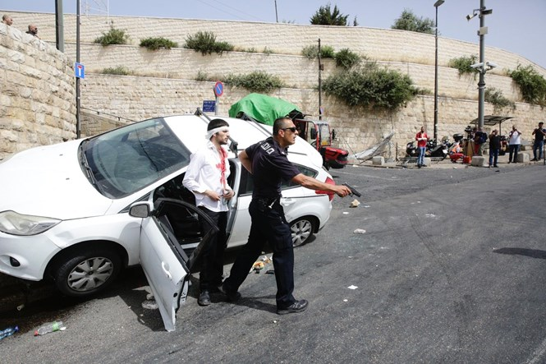
The Arab mob then tried to lynch the driver, who was saved by the intervention of Israeli police officers.
MDA emergency first responders were dispatched to the scene to treat the driver.
Earlier on Monday, Arab rioters attacked police officers on the Temple Mount, hurling stones and firebombs and shooting fireworks at officers. Rioters also threw rocks at the Mughrabi Bridge, which links the Western Wall Plaza to the Temple Mount.
Monday's riots are the latest in a wave of Arab violence during the month of Ramadan, with attacks reported across Israel, including in Jerusalem, Haifa, and Jaffa.
Photos:שלו שלום/TPS
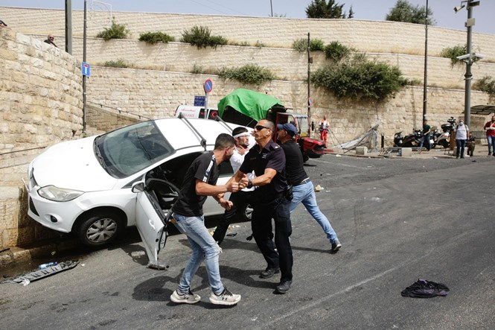

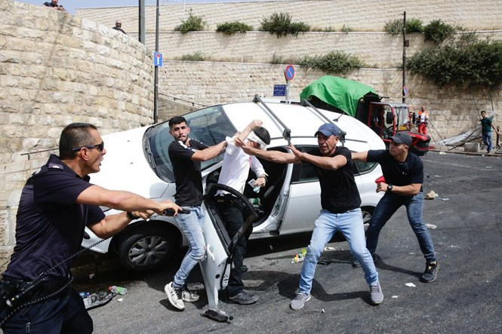

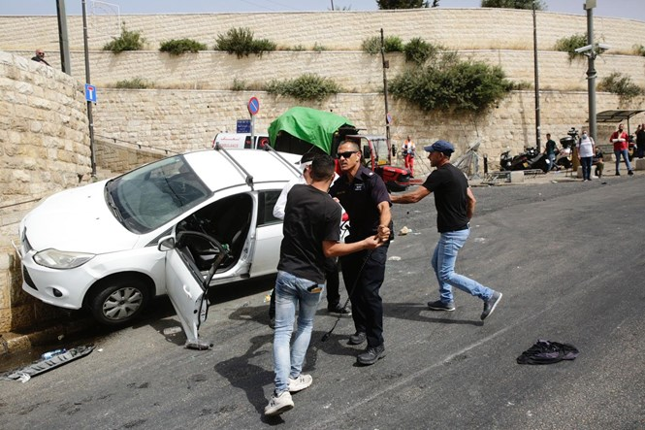
To be removed from this News list, Please click here and put "Unsubscribe" in the subject line.

05/09/2021 NEWS AM -tonight at sundown begings Yom Yerushalayim – commemoration of the reunification of Israel (54th year)
Jerusalem's D-Day: When Heaven Altered the Course of History
https://www.youtube.com/watch?v=6wlPw3NUeb0

In the Jewish tradition, there is at the same time Jerusalem in the heavens and Jerusalem on the ground. Jerusalem is a living city, but also the heart, the soul of the Jewish people and the state of Israel.
Yitzhak Rabin
Read the Prophets & PRAY WITHOUT CEASING!
That is the only hope for this nation!
Please  Remember  These  Folks  In  Prayer-  Check often  They  Change! | Pray that the world would WAKE UP! Time for a worldwide repentance!  ALL US soldiers fighting for our freedom around the world  Pray for those in our government to repent of their wicked corrupt ways.  Pray for AB family – Wife just diagnosed with brain tumor  Pray for EL – multiple problems  Pray for AS – post knee replacement – some problems and another one scheduled.  Pray for TR – abnormal Mammogram having double biopsy – Mastectomy Scheduled  Pray for ZH - having trouble with PTSD  Pray for LAC – recurrent cancer getting treatment  Pray for KL – troubling spiritual situation.  Pray for Ella – emotionally disturbed abused child and brother with ? heart problem  Pray for JN – Neuro disease  Pray for MS – Job issues and change  Pray for BB – Severe West Nile Fever –still not mobile- improving!  Pray for RBH – cancer recurrence  Pray for Felicia – post op problems – continuing  Pray for SH and family – lady’s husband passed away and she is in Nursing home. Not doing well.  Pray for MP – Very complex problems  Pray that The Holy One will lead you in Your preparations for handling the world problems. – Have YOU made any preparations?
Genesis 27:²⁷And he came near and kissed him. And he smelled the smell of his clothes. And he blessed him, and said, See, the smell of my son is as the smell of a field which Jehovah has blessed. ²⁸And may God give you of the dew of the heavens, and of the fatness of the earth, and much grain and wine. ²⁹May the nations serve you and peoples bow to you; be a ruler to your brothers, and may your mother's sons bow to you, and cursed be those who curse you, and blessed be those who bless you.

Yerushalayim Shel Zahav - Ofra Haza
https://www.youtube.com/watch?v=72QC8EGnxTw

80 Palestinians hurt in Jerusalem clashes; IDF strikes Gaza after rocket fired
Violent protests held at Damascus Gate and along Strip’s security fence; Israeli aircraft targets Hamas post after projectile lands in field
By TOI staff Today, 12:38 am
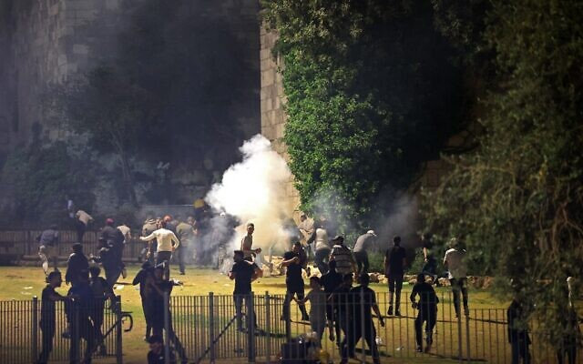  Palestinian protesters run from tear gas fired by Israeli security forces in Jerusalem's Old City on May 8, 2021. (Photo by EMMANUEL DUNAND / AFP) | 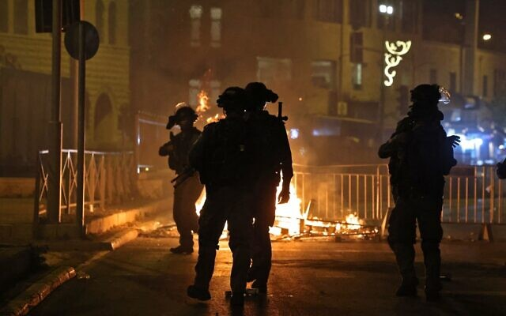  Israeli security forces stand next to a burning barricade erected in Jerusalem's Old City on May 8, 2021. (EMMANUEL DUNAND / AFP)
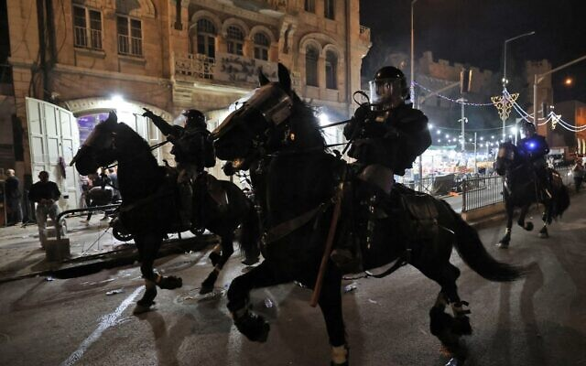  Israeli mounted police deploy to disperse Palestinian protesters outside the Damascus Gate in Jerusalem's Old City on May 8, 2021. (EMMANUEL DUNAND / AFP) | 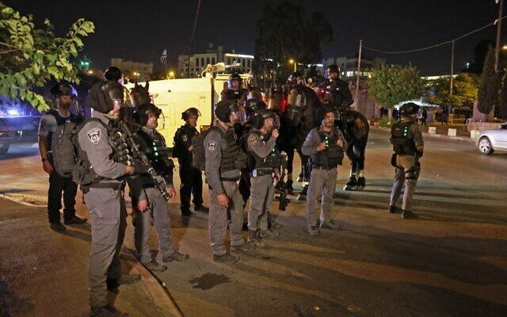  Israeli security forces deploy to disperse a protest by Palestinians against a possible eviction of local Palestinian families in the Sheikh Jarrah neighborhood of East Jerusalem, on May 8, 2021. (Menahem KAHANA / AFP)
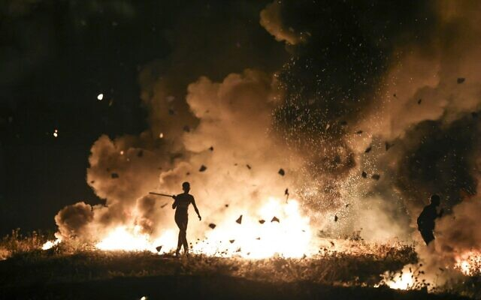  Palestinian protesters burn tires during a riot along the Israel-Gaza border, east of Gaza city on May 8, 2021. (MAHMUD HAMS / AFP) | 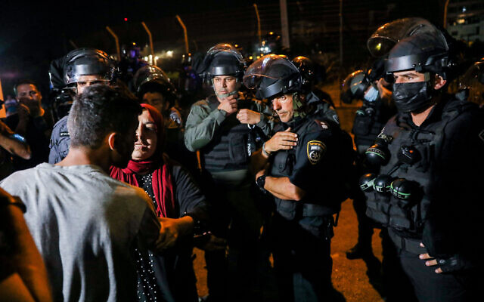  Israeli security forces clash with protesters outside a home of a Jewish family in the East Jerusalem neighborhood of Sheikh Jarrah on May 8, 2021. )Olivier Fitoussi/Flash90
A rocket was fired at Israel from the Gaza Strip overnight Saturday-Sunday, as Palestinians clashed with Israeli police in Jerusalem and rioted along the Gaza border with Israel, amid a serious flare-up of violence over tensions surrounding the Temple Mount.
The uptick of violence in the south and the capital came a day after Jerusalem saw some of the city’s worst violence in years, with 200 Palestinians and 17 Israeli police officers wounded as hundreds rioted in the Temple Mount and cops broke into the compound to quell the unrest. Terror groups in Gaza have threatened to retaliate against Israel.
The riots in Jerusalem and Gaza were apparently contained overnight Saturday-Sunday by Israeli security forces, with the violence subsiding around 2 a.m.
Around 1:30 a.m., a rocket was fired from the Gaza Strip into southern Israel, the Israel Defense Forces said. Rocket alert sirens were only triggered in an open field, where the projectile apparently landed. There were no reports of injuries or damage.
The army later said it carried out a reprisal strike on a Hamas military post in southern Gaza.
“Terror has consequences,” the IDF tweeted.
Earlier, in Jerusalem, 80 Palestinians were hurt in riots at Damascus Gate outside the Old City and 14 were hospitalized, according to the Palestinian Red Crescent, after protesters hurled bottles and rocks at Israeli security forces and the police responded with stun grenades and water cannons.
Some 90,000 Palestinians attended Laylat al-Qadr prayers at the Temple Mount, marking the Ramadan holiday’s holiest night. Worshipers at the compound chanted in support of the Hamas terror group’s military wing, which reiterated its threat to attack Israel over recent tensions in Jerusalem.
“Strike Tel Aviv,” the Palestinian worshipers chanted. “In spirit and in blood, we will redeem al-Aqsa.” Similar calls were heard at the Damascus Gate. [Sure folks – this is a holy night so lets go out and riot. The mentality of the “PA” and Islamic group is just unfathomable. – rdb]
Palestinian demonstrators also set fire to a police barricade near Damascus Gate during the ensuing riot, which involved hundreds.
Not far from Jerusalem’s Old City, renewed clashes broke out in the Sheikh Jarrah neighborhood, the site of tensions over the pending eviction of several Palestinian families from homes claimed by nationalist Jews.
Police said a small protest there turned into rioting that included “waving Palestinian flags and throwing rocks toward the forces.” The officers responded with riot dispersal means.
Two Palestinian suspects were arrested after pepper-spraying Israeli officers, police said. The suspects were found to be carrying “means of attack,” it said, without specifying.
Meanwhile, on the Gaza border, some 450 Palestinians at four locations along the fence separating the Strip from Israel set fire to tires and hurled improvised explosive devices at Israeli soldiers. The military launched flares over the area, as well as responding with tear gas and rubber-tipped bullets, Palestinian media reports said.
The explosions from the IEDs could be heard in nearby Israeli towns along the Gaza border. “There is no danger and there is no change in the guidelines,” a spokesperson for the Sdot Negev Regional Council told residents.
Officials said three incendiary balloons were launched into Israel, causing fires but no injuries.
Saturday also saw at least 10 fires in southern Israel caused by balloons from Gaza carrying incendiary devices. There were no reports of any injuries or danger to nearby towns.
Israel has boosted its security presence in all potential arenas of conflict, and is also deploying Iron Dome batteries near potential targets of Gaza rockets, while also making efforts behind the scenes to calm Palestinian spirits.
The international community, including Israel’s Arab allies, condemned the Jewish state Saturday for security forces “storming” of Al-Aqsa during the clashes.
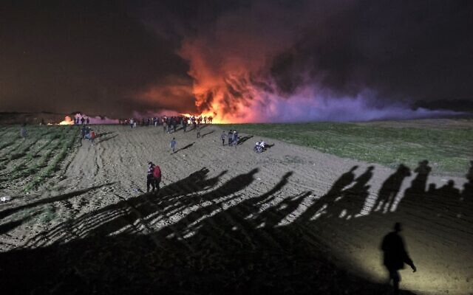
The Temple Mount in the Old City of Jerusalem has long been one of the main flashpoints of Israeli-Palestinian friction. The holiest place in Judaism — as the site of the two biblical temples — is also home to the Muslim holy sites of the Al-Aqsa Mosque and Dome of the Rock.
Israel fears the potential for a major escalation of the conflict in the coming days, and was braced for more violence in Jerusalem, the West Bank and the Gaza Strip.

Palestinians riot at the Israel-Gaza border, in al-Bureij in the central Gaza Strip, on May 8, 2021. (MOHAMMED ABED / AFP)

On Saturday Prime Minister Benjamin Netanyahu met with top security officials to assess the situation. “We are acting responsibly to ensure law and order in Jerusalem while maintaining freedom of worship at the holy sites,” Netanyahu said in a statement.
Israel Defense Forces Chief of Staff Aviv Kohavi, and Police Commissioner Kobi Shabtai announced on Saturday that troop levels would be bolstered in the West Bank and in Jerusalem respectively.
Hamas leader Ismael Haniyeh said Friday that Israel would “pay a price” for the clashes at the Al-Aqsa Mosque. [Who caused the riot in the first place which required the police to respond? These fools get everything twisted and turned around! HUMMMM? Maybe they are demon-rats. – rdb]
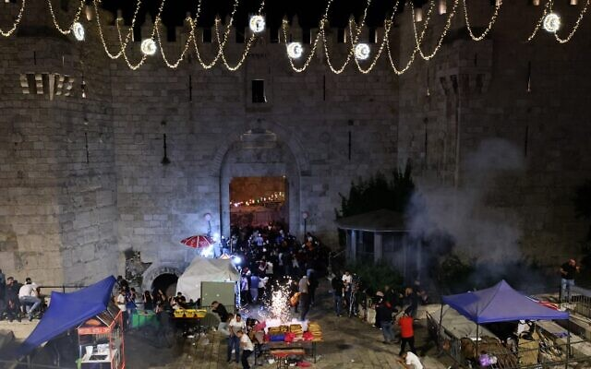
Islamic Jihad, a terror group that often fires rockets from Gaza into Israeli territory, also threatened Israel over the Al-Aqsa clashes.
The central committee of Fatah, the movement led by Palestinian Authority President Mahmoud Abbas, warned Saturday night that “the continuation of the settler attacks on the holy places and the homes of Palestinian residents, their expulsion and expansion of settlements — will lead to an all-out conflict in all the Palestinian territories.”

Palestinian protesters run from stun grenades fired by Israeli security forces outside the Damascus Gate in Jerusalem’s Old City on May 8, 2021. (EMMANUEL DUNAND / AFP)

Tensions have been rising across Jerusalem, the West Bank and Gaza for the past several weeks. MORE - https://www.timesofisrael.com/53-palestinians-hurt-in-jerusalem-clashes-gazans-riot-along-border-fence/

UAE, Bahrain pan Israel’s ‘storming’ of Al-Aqsa, amid international condemnation
Gulf states say Israel has responsibility to de-escalate, blast its ‘provocations’; nations also warn against pending evictions of Sheikh Jarrah Palestinians from their homes
By TOI staff and Agencies Today, 6:13 pm
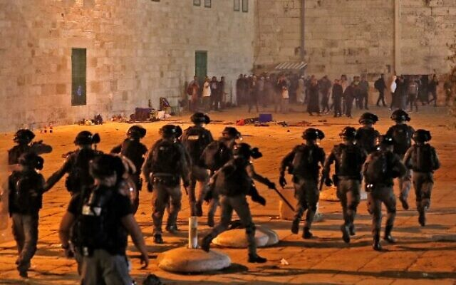
Israeli security forces advance amid clashes with Palestinian protesters near the Al-Aqsa Mosque in Jerusalem, on May 7, 2021 (Ahmad GHARABLI / AFP)

The international community, including Israel’s Arab allies, condemned the Jewish state Saturday for the violence in Jerusalem a day earlier that saw 200 Palestinians and 17 Israeli police officers wounded, as well as for pending evictions of Palestinians in East Jerusalem’s Sheikh Jarrah neighborhood. [so it is more appropriate to treat the Islamic breach of law and disturbances like the demon-rats in DC and around the US are doing in some of our cities so they can destroy and burn the place down? Cure Stupid NO WAY. When people are breaking the law and creating a disruption and destroying things you stop them no matter what it takes. It is way past time the fools in “leadership” around the world leaned that you can not cave in to bullies and criminals. Europe has essentially been destroyed by their complete ignorance in the immigration policies and their unwillingness to challenge and control the Islamic radicals and criminals around their countries. They have turned much of the EU into trash heaps just like many of the blue cities in the USA. – rdb]
The United Arab Emirates, which normalized relations with Israel last year and has so far had warm ties with the country, expressed “deep concern over the violence” in Jerusalem. It condemned “Israeli authorities’ storming of the Holy Al-Aqsa Mosque” as well as plans to evict East Jerusalem residents. [the UAE and others need to call Abbas and Haniyah and tell them to put a lid on your riots and stop inciting or you will get a bunch of people killed if they don’t stop. – rdb]
Abu Dhabi added that Israel must protect Palestinian rights to practice their religion. It said Israel had a “responsibility for de-escalation” and urged it to “end all attacks and practices that lead to continued tension.” [since when does practicing religion equate to riots??? – rdb]
Bahrain, which also established ties with Israel last year as part of the Abraham Accords, expressed “strong condemnation” over Israel’s actions on the Temple Mount, saying it must “stop these rejected provocations against the people of Jerusalem, and work to prevent its forces from attacking worshipers in this holy month.”
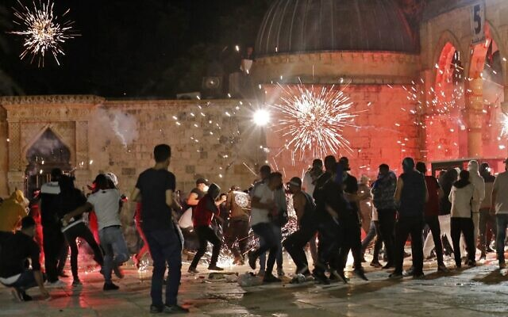
The widespread clashes and riots in the Al-Aqsa compound followed prayers held there on the last Friday of the Muslim holy month of Ramadan.

Clashes between Palestinian protesters and Israeli security forces after riots broke out at the al-Aqsa mosque compound in Jerusalem, on May 7, 2021. (Ahmad GHARABLI / AFP)

The Gulf nation also condemned the “Israeli plan to evict the citizens of Jerusalem from their homes,” referring to the situation in the Sheikh Jarrah neighborhood, where over 70 Palestinian residents are threatened with eviction and could be replaced by right-wing Jewish nationalists, in a legal battle being waged in Israel’s Supreme Court. MORE -https://www.timesofisrael.com/uae-bahrain-pan-israels-storming-of-al-aqsa-amid-international-condemnation/

Arabs across Israel protest Jerusalem clashes; cops block buses to Temple Mount
Massive traffic jams on main highway to capital after police stop worshipers for hours; officials assert some passengers planned to riot at the holy site
By TOI staff Today, 8:53 pm

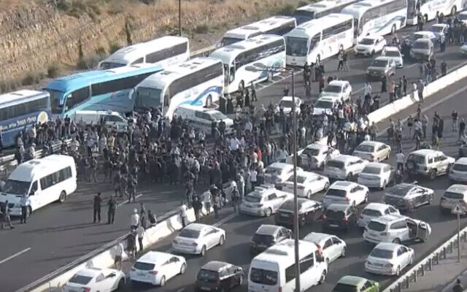
Arab Israelis block traffic on Route 1 after the buses they were traveling on were stopped en route to Jerusalem, amid rising violence in the city, on May 8, 2021. (Screen capture)

Arab Israelis protested throughout the country Saturday over the government’s actions in Jerusalem, including how it handled major violent clashes on the Temple Mount Friday and the potential eviction of dozens of Palestinians from an East Jerusalem neighborhood.
Largely peaceful protests were held in numerous communities. Protesters briefly blocked traffic on a section of Route 65 in northern Israel. Five people were detained in Umm al-Fahm in the north over suspicions they threw rocks near the city’s police station. In East Jerusalem, two people were arrested on suspicion of throwing rocks at police officers. [Largely peaceful protests? Have these folks been taking lessons from the demon-rats and the US “news media”? Sounds like it. I have seen a number of “peaceful protests” in Israel Islamic areas and they are anything but peaceful. – rdb]
Several buses carrying Arab Israelis to Jerusalem’s Temple Mount were held up at a police checkpoint on the major Route 1 highway outside the city, which was bracing for further violence after seeing some of its worst clashes in years on Friday. Saturday night is Laylat al-Qadr, the most sacred night in the Muslim holy month of Ramadan. Worshipers were set to gather for nighttime prayers at the Al-Aqsa Mosque.
The move caused massive traffic jams in both directions on the main highway to the capital.
Video showed passengers getting off the buses and marching along the highway, with some blocking traffic in both directions.
Police said they stopped the buses because they had intelligence indicating some of the passengers were planning to riot on the Temple Mount. They said only “suspicious” passengers would be forced off, while others would be allowed to drive on. The blockages were eventually opened up after some three hours.
איך ההחלטה לעצור את האוטובוסים עזרה לשמור על הסדר הציבורי? מאות צועדים על כביש 1 וקוראים: "ברוח ודם נפדה את אל-אקצא" pic.twitter.com/aVmT5UMGGB
— Inbar Tvizer ענבר טויזר (@inbartvizer) May 8, 2021
The move to stop the buses faced harsh condemnation from Arab MKs. Meretz MK Issawi Frej blasted police for “preventing thousands of Israeli civilians from marking the holiest night in Islam, Laylat al-Qadr… trying to stop them from participating in one of the most important events in Islam.” He accused authorities of “on the one hand allowing [Itamar] Ben Gvir to create provocations in Sheikh Jarrah and on the other preventing Muslim citizens from reaching Al-Aqsa. They’re not trying to calm things down, but to inflame them.”
On Thursday evening, Religious Zionism’s Ben Gvir, a far-right activist, set up what he declared to be a parliamentary office in the East Jerusalem neighborhood — a table under an awning with a sign — in response to what he said was a lack of protection for Jewish families in the area. This was followed by intense clashes between Jewish and Arab residents in the area.
Labor MK Ibtisam Mara’ana tweeted that police were “terribly impeding the freedom of religion and freedom of movement of so many citizens.”
Meanwhile Saturday evening also saw Jewish demonstrators march through the Muslim Quarter of Jerusalem’s Old City while chanting, in an apparent show of force to locals.
משטרה שעוצרת מתפללים וחוסמת את כביש מס 1 ביום משמעותי לקראת סוף הרמאדן אבל מאפשרת את התהלוכות האלה ברובע המוסלמי היא או פוליטית או לא מתפקדת. או גם וגם. https://t.co/ypif5nmx3c
— נדב איל Nadav Eyal (@Nadav_Eyal) May 8, 2021
Jerusalem District Police Commander Doron Turgeman predicted Saturday that there would be attempts to provoke violence in the city after major clashes erupted Friday night on the Temple Mount between police and Muslim worshipers, amid rising Israeli-Palestinian tensions and as Ramadan comes to an end.
“We won’t allow rioting,” he was quoted saying by Kan news.
Friday saw some of the worst violence in Jerusalem for years, with 200 Palestinians and 17 Israeli police officers wounded.
Police and the military were preparing for fresh violence on Saturday, and were on heightened alert in East Jerusalem, the West Bank and the Gaza border, where mass protests were expected in the evening.
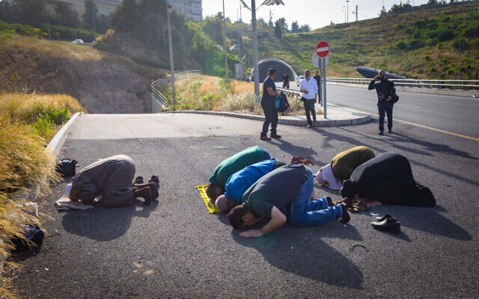
According to the Haaretz newspaper, police believe the clashes on the Temple Mount were being led by Hamas operatives, and linked the recent violence at the Jerusalem holy site to Palestinian Authority President Mahmoud Abbas’s decision to indefinitely delay legislative elections that were scheduled for later this month.
Former prime minister Ehud Olmert told Kan news Saturday that “a kind of intifada is brewing, which is possible to prevent.” He warned of “extreme elements in the Jewish population who are fanning the fire and adding to the problem [in Sheikh Jarrah], which needs to be decided judicially.”

Hundreds of Arab Israelis marching on Route 1 making their way to Jerusalem, May 8, 2021 (Nowm Revkin Fenton/Flash90)

On Saturday Defense Minister Benny Gantz held an assessment of the security situation with senior officials from the military, police and Shin Bet. At the end of the meeting, the IDF said there would be a reinforcement of troop numbers as part of preparations for a potential escalation.
“Extremists on both sides cannot be allowed to cause an escalation of the situation,” Gantz said in a statement. “Israel will continue to act to preserve freedom of worship at the Temple Mount and at the same time not allow terror to raise its head or harm public order.”
Police Commissioner Kobi Shabtai also held a special security assessment in light of the recent tensions in Jerusalem.
A police statement said Shabtai ordered commanders, in particular in the Jerusalem area, to “significantly” boost their forces ahead of the most sacred night of Ramadan on Saturday evening and “another series of expected events over the coming days.” This apparently was referring to Jerusalem Day, a national holiday that begins Sunday night, in which Israel celebrates the unification of Jerusalem and religious nationalists hold parades and other celebrations in the city.
“I stress here that the right to protest will be preserved but rioting will be answered firmly and with zero tolerance. I call on everyone to act with responsibility and restraint,” Shabtai was quoted saying in the statement.
Palestinians in the Gaza Strip and Arab Israelis were expected to hold mass protests on Saturday in the wake of the violence in Jerusalem on Friday night. MORE - https://www.timesofisrael.com/arabs-protest-over-jerusalem-throughout-israel-cops-block-buses-to-temple-mount/

Security officials said to fear escalation toward larger conflict within days
Military, police have acute alerts of potential terror attacks, Channel 12 says; many Palestinians reportedly view clashes as a ‘war for Jerusalem and Al-Aqsa’
By TOI staff Today, 10:22 pm
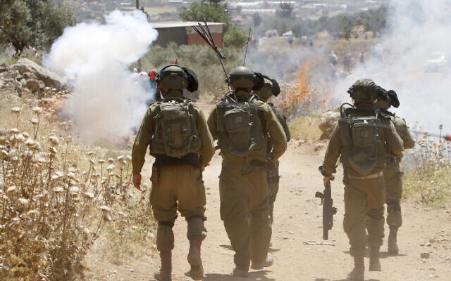
Israeli soldiers clash with Palestinians during a protest in the village of Beit Dajan, near the West Bank city of Nablus on May 7, 2021 (Nasser Ishtayeh/Flash90)

Israel’s security establishment is preparing for several critical days in Jerusalem that could determine whether the country sees a return to calm or a major conflagration, according to media reports Saturday.
Police and the military were bracing for renewed violence a day after Jerusalem saw some of the city’s worst violence for years, with 200 Palestinians and 17 Israeli police officers wounded as hundreds rioted in the Temple Mount and cops broke into the compound to quell the unrest.
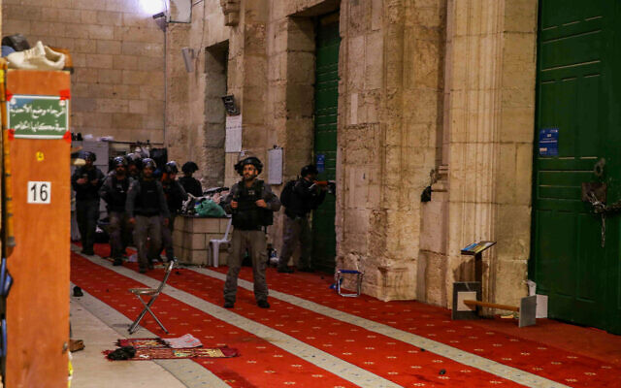
Channel 12 reported there are acute alerts of potential terror attacks in the West Bank and Jerusalem in the coming days, after a week that has seen a deadly shooting attack, a failed shooting attack on soldiers and repeated clashes in the capital that have left dozens of policemen and hundreds of Palestinians wounded.
The network cited unnamed security officials as saying that with Saturday marking the holiest night of Ramadan and Sunday-Monday seeing Jewish celebrations of Jerusalem Day, the capital could potentially see an escalation in violence that would lead to a larger conflict.

Israeli riot police clash with Palestinian worshippers at the Al-Aqsa mosque compound in Jerusalem Old City on May 7, 2021.(Jamal Awad/Flash90)

According to Channel 12, current discourse in the Palestinian street is of a “war for Jerusalem and the Al-Aqsa Mosque.” The network said that in the Gaza Strip, Hamas is currently avoiding firing rockets, but that could quickly change. In the meantime, the terror group is encouraging its West Bank operatives to carry out attacks there and inflame tensions.
Israel has boosted its security presence in all potential arenas of conflict, and is also deploying Iron Dome batteries near potential targets of Gaza rockets, while also making efforts behind the scenes to calm Palestinian spirits.
Security officials are hoping to avoid bloodshed and deaths in the coming days that could spark wider unrest, Channel 12 said.
At the same time far-right MK Itamar Ben Gvir on Saturday called to enable policemen “to defend themselves and use weapons including live fire” against “the terrorists in the Temple Mount and throughout the country.”
He said policemen whose lives are endangered “should be firing and not dealing with riot dispersal measures.”
Channel 12 reported that while Fatah and Hamas are both encouraging mass protests in response to events in the capital, Fatah is interested in keeping the events contained, and does not want serious escalation. Palestinian Authority President Mahmoud Abbas’s organization is thus attempting to focus the outrage on the Palestinian street on Jerusalem alone, to keep the demonstrations limited in scope, as Hamas attempts to widen the front to the rest of the West Bank and Gaza.

Palestinians pray during a protest as local Palestinian families face eviction in the Sheikh Jarrah neighborhood of East Jerusalem, on May 8, 2021 (Menahem KAHANA / AFP)

Tensions have been rising across Jerusalem, the West Bank and Gaza for the past several weeks.
On Friday, three Palestinian gunmen opened fire on Border Police troops in the northern West Bank. Two of them were killed in the firefight and a third was critically injured. Israeli military officials said the three were en route to carry out a “major” terrorist attack on civilians inside Israel, with reports saying they were heading for Jerusalem.
Israeli yeshiva student Yehuda Guetta was shot in a Palestinian terror attack in the West Bank on Sunday before he died of his wounds on Wednesday night. Israeli security forces arrested a suspect in his killing.
On Wednesday 16-year-old Palestinian teenager Said Odeh was shot and killed by Israeli forces who said he was throwing Molotov cocktails at troops.
In recent days, Palestinians have held demonstrations in East Jerusalem’s Sheikh Jarrah neighborhood. Over 70 Palestinian residents are threatened with eviction and could be replaced by right-wing Jewish nationalists, in a legal battle being waged in the courts.
An Israeli court has ordered the families to leave, as the property was owned by a Jewish religious association before 1948. A 1970 Israeli law allows Jews to reclaim property in East Jerusalem from before it fell into Jordanian hands; no similar law exists for Palestinians.
Additionally, at the beginning of Ramadan, Palestinians repeatedly clashed with Israeli police in Jerusalem in protest of restrictions at the Damascus Gate area. Some videos also circulated on Palestinian social media showing young Arab men attacking Ultra-Orthodox passersby. MORE - https://www.timesofisrael.com/security-officials-said-to-fear-escalation-to-larger-conflict-within-days/

Anti-Netanyahu protesters bring boxes to Balfour to 'help Bibi pack'
Protesting organizations urge the "Bloc of Hope" to complete negotiations, form gov't
By TAMAR BEERI MAY 8, 2021 22:06
A fake moving truck titled "Crime Minister Movers" on Balfour comes to "Take Bibi home" (photo credit: Courtesy)

Protesters opposing Prime Minister Benjamin Netanyahu's continued leadership amid his ongoing trial for bribery, fraud and breach of trust brought a large pile of boxes, taken in a van labeled "Crime Minister Movers" to tell Netanyahu that he is on his way out of leadership.
"Bibi, start packing!" Crime Minister, the protesting organization that put together the large display, said. "We will not let you fortify Balfour and bring the place down into chaos. The people demand a government of change!"
The boxes, part of a display titled "Until the Very Last Box," were individually labeled with numerous jokes and jabs at the Netanyahu family.
One box, for example, said, "B.A., M.A. Certificates," comically referring to the leaked phone recording of Sarah, Netanyahu's wife, screaming that she has a bachelor's and a master's degree in Psychology.
Another box said, "XS condoms."
A sign hanging beside the display read, "You came to wreck, we came to pack."
Thousands of protesters piled into Paris Square, at the corner of Balfour street ahead of the Prime Minister's Residence, and cried out "Bibi, go home!"
The protesting organizations called on Yesh Atid head Yair Lapid, who was given the mandate on Wednesday to form the next government, and Yamina head Naftali Bennett – his expected partner in a potential coalition – to complete their negotiations and remove Netanyahu from leadership.
This comes after Netanyahu received the mandate following the March elections, but failed to form a coalition.
"You were chosen to save our country from Netanyahu," the No Way protesting organization said. "The burden of proof is on you!"
The regular protests on Balfour street, as well as the march from the Chords Bridge at the entrance of the city to Balfour, were greatly delayed due to police blockades along the highway leading up to Jerusalem. This was due to ongoing clashes between prayer-goers and protesters on the Temple Mount and Israel Police on the scene, which led to hundreds of injuries and a handful of arrests on Friday night. MORE - https://www.jpost.com/israel-news/politics-and-diplomacy/anti-netanyahu-protesters-bring-boxes-to-balfour-to-help-bibi-pack-667615

Amid reports of progress, Lapid, Bennett said seeking coalition in coming week
Yamina leader says there is ‘good’ atmosphere but warns serious differences remain between parties; sides said arguing over ministries and other key roles
By TOI staff 8 May 2021, 4:04 am
Yamina party chair Naftali Bennett and the leaders of the so-called change bloc in the Knesset have made progress in talks on forming a government, according to multiple reports Friday, and hope to seal the matter in the coming week — though numerous difficulties remain.
According to an unsourced report by Kan news, the general mechanisms and basic principles by which such a government would operate have been largely agreed upon, and the main issue of contention is now the distribution of ministries and Knesset posts in the coalition.
Comments made by Bennett Friday afternoon indicated ideological issues may still be a key bone of contention, as he described differences that “are not easy to bridge” between the seven disparate parties making up the unlikely coalition that would remove Prime Minister Benjamin Netanyahu from power after 12 years.
According to Channel 12 news, Yamina has given its potential partners an ultimatum that Bennett’s close ally Ayelet Shaked must be appointed justice minister or there will be no deal. Shaked served in the post in 2015-2019.
The justice portfolio is currently also being demanded by New Hope party chief Gideon Sa’ar. Sa’ar had preferred the defense portfolio, but Blue and White’s Benny Gantz is insisting on retaining that.
Channel 12 said Yamina is demanding most of the top so-called “ideological” portfolios in the government, including justice, religious affairs, public security and education, leaving few top posts for other parties.
The Education Ministry specifically is a sticking point, with the left-wing Meretz party’s Nitzan Horowitz demanding the post, while New Hope wants it for its own Yifat Shasha-Biton.
The parties were also reported by Haaretz to be considering a rotation of the Knesset speakership between Yesh Atid’s Meir Cohen and New Hope’s Ze’ev Elkin.
Yesh Atid party leader Yair Lapid, who this week received the presidential mandate to try to form a government, is leading negotiations on behalf of the center-left. The sides are believed to have agreed that Bennett will serve as prime minister for the government’s first two years, with Lapid serving for the latter two. Lapid would be foreign minister in Bennett’s cabinet, with Yisrael Beytenu chief Avigdor Liberman as finance minister.
The “change bloc” coalition-building efforts hang by a thread, however, as opposition from any single MK could scupper them: Yamina MK Amichai Chikli on Thursday vowed not to back a coalition with the left, meaning the prospective change bloc, with Yamina, currently has 57 seats in parliament. Outside support from Ra’am — which is essential — would give the bloc 61 seats in the 120-seat legislature.
Any further defections in Bennett’s party could thus doom the effort — though the other Yamina MKs on Thursday publicly declared their backing for the leader.
In a Facebook post Friday afternoon, Bennett said the atmosphere in negotiations was “good” but stressed that “the differences are not easy to bridge.” He added: “I think it’s obvious that I’m willing to go far and to pay a personal political price with my base, if only a government can be formed.”
Bennett said he did not know if the effort would succeed but that he would “try with all my might” to prevent a fifth election. He added, however, that “there are core principles I will not give up, red lines I will not cross.”MORE -https://www.timesofisrael.com/amid-reports-of-progress-lapid-bennett-said-seeking-coalition-in-coming-week/ [Everyone still pushing and shoving and fighting for their piece of the pie (and ultimately control of budget and money. – rdb]

Hospitals to strike on Monday: ‘Doctors thrown out like the garbage’
“We are aware of the damage a strike causes,” Israel Medical Association's chairman said. “We are not looking for a bonus. We are looking to give the citizens of Israel the healthcare they deserve."
By MAAYAN JAFFE-HOFFMAN MAY 8, 2021 22:09
Hospitals across the country are expected to launch a 24-hour strike on Monday after the Finance Ministry refused to continue funding some 600 physicians who were hired to help manage the COVID-19 pandemic.
“We have found no other way to deal with the unlimited power of the Finance Ministry,” Prof. Zion Hagay, chairman of the Israel Medical Association, told The Jerusalem Post. “We saw exhausted doctors in 2020. There is severe burnout and post-trauma.”
During the COVID-19 pandemic, the Finance Ministry approved hiring some 600 additional doctors, mostly residents, to help manage the crisis. These doctors’ contracts expire in June and, despite health officials saying that the positions were sorely needed even before coronavirus, the Finance Ministry has refused to continue funding them.
There are also 1,600 nurses whose contracts are not expected to be renewed.
“Funding for these positions came from sources outside the regular budget, which was earmarked for coronavirus,” the Finance Ministry told the Post last month. “The Health and Finance ministries are discussing the various alternatives ahead of formal budget discussions that will take place in the near future.”
Hagay said that nothing has changed since then.
“These 600 doctors worked very hard to combat the pandemic,” Hagay said. “They worked long hours and risked their lives and now they find, when the morbidity is very low, that the Finance Ministry does not need them anymore and they are just throwing them out like the garbage.”
Moreover, he explained that Israel has fewer doctors on average than most OECD countries at 3.2 per 1,000 people. That number is expected to become even lower in the next decade, reaching a low of three per 1,000 as older doctors retire. [It is interesting because according to WHO the US in 2017 had only 2.6 physicians per 1000. I would guess part of that is due to the fact that Israel and the EU have socialized healthcare systems and the US doesn’t (at least not s of this date).– rdb]
“We know that the median age of physicians in Israel is over 55, like in Italy,” Hagay told the Post.
Additionally, the Israeli population is aging and there are expected to be around 400,000 people over the age of 75 within the next 10 years. Older patients require three times more health services than the average population, which means more care will be needed at a time when the number of doctors is on the decline.
Hagay charged that the Finance Ministry is continuing a policy of “starving the healthcare system in Israel,” the same policy that he said caused the country to lockdown so quickly at the start of the pandemic, and that caused two additional shut downs over fears that the hospitals would break under the pressure of so any severe COVID-19 cases.
“We had to lock down for longer periods and quicker than we would have had to if we had more doctors and beds,” Hagay explained.
Among the hospitals that will be on strike on Monday are Sheba Medical Center, Tel Aviv Sourasky Medical Center, Rambam Health Care Campus and Hadassah Medical Center. All public hospitals and hospitals that are operated by Clalit Health Services will be on strike, meaning that only emergency cases will be admitted.
“We are aware of the damage a strike causes,” Hagay said. “We are not looking for a bonus. We are looking to give the citizens of Israel the healthcare they deserve.” https://www.jpost.com/israel-news/hospitals-to-strike-on-monday-doctors-thrown-out-like-the-garbage-667614

Israel sends 2nd planeload of medical aid to virus-wracked India
Shipment includes oxygen generators, ventilators; Ashkenazi: ‘We stand by India in these difficult times just as India stood by us in the first weeks of the coronavirus crisis’
By TOI staff Today, 8:04 am
Tons of medical equipment donated by Israel arrived on Friday in India where the health system is collapsing under a wave of resurgent coronavirus infections.
The Indian Air Force plane that took off from Ben Gurion Airport was the second transport of the week, with further shipments to be sent in the coming days.
“The operation to bring medical aid to India is in full swing,” tweeted Foreign Minister Gabi Ashkenazi. “We stand by India in these difficult times just as India stood by us in the first weeks of the coronavirus crisis when they facilitated the arrival of vital medical equipment to Israel.”
The Foreign Ministry said Monday the shipments will include hundreds of oxygen generators and ventilators, as well as other medical equipment urgently needed by India.
Aid ready to be loaded onto an Indian Air Force plane at Ben Gurion Airport before it is sent to the virus-wracked country, May 8, 2021 (Foreign Ministry) | An Indian Air Force plane at Ben Gurion Airport is loaded up with aid from Israel that is to be sent to the virus-wracked country, May 8, 2021 (Foreign Ministry)
Several ministries and other government bodies, including the Israeli and Indian embassies in each country, were involved in setting up the operation, the ministry said.
Last week the Kan public broadcaster reported that an unofficial request for medical equipment, including oxygen supplies and various drugs, was made to the Israeli embassy in India.
Israel and India have cooperated in the past on the coronavirus and last April, the New Delhi government reportedly sent Israel five tons of the drugs hydroxychloroquine and chloroquine, which are used to treat malaria. At the time, the drugs were being reviewed in various countries as a possible treatment for the coronavirus.
Prime Minister Benjamin Netanyahu and his Indian counterpart Narendra Modi have close personal relations in addition to the ties between the two nations.
Modi is facing growing pressure to impose a strict nationwide lockdown, despite the economic pain it will exact, as a startling surge in coronavirus cases that has pummeled the country’s health system shows no signs of abating.
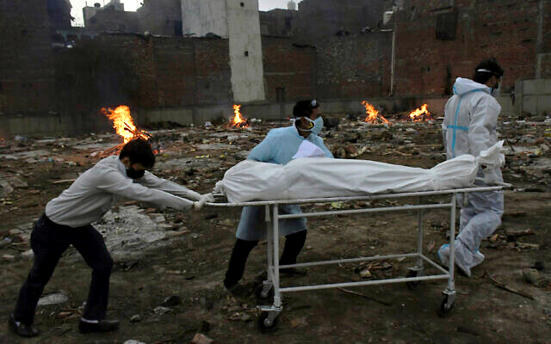
Modi has so far left the responsibility for fighting the virus in this current surge to poorly equipped state governments and faced accusations of doing too little. His government has countered that it is doing everything it can, amid a “once-in-a-century crisis.”

The body of a COVID-19 victim is wheeled in for cremation in a ground that has been converted into a crematorium in New Delhi, India, May 6, 2021 (AP Photo/Ishant Chauhan)

On Friday India reported a new daily record of 414,188 confirmed cases and 3,915 additional deaths. The official daily death count has stayed over 3,000 for the past 10 days.
That brings the total to more than 21.4 million COVID-19 infections and over 234,000 deaths. Experts say even those dramatic tolls are undercounts. https://www.timesofisrael.com/israel-sends-2nd-planeload-of-medical-aid-to-virus-wracked-india/

Massive fire breaks out near Iran's Bushehr nuclear power plant - Watch
The cause of the fire is still unknown, according to Iranian media reports.
By JERUSALEM POST STAFF MAY 8, 2021 23:08
A massive fire broke out in Iran’s southwestern city of Bushehr near the Islamic Republic's only functioning nuclear power plant late on Friday night, the semi-official Fars News Agency reported on Saturday.
#BREAKING The Bushehr Port of #Iran is totally ablaze.
It is a major oil export port.
Again, Iran skimping on maintenance is biting them in the rear. One would think after all the sites which have exploded over the last couple years they actually would be increasing maintenance. pic.twitter.com/Jh71bStqnC
— Cali Dreaming NaphiSoc (@NaphiSoc) May 7, 2021
Dozens of people in Bushehr were quick to upload footage of the fire to social media as bystanders moved away from the flames.
Watch: A massive fire engulfed in Bushehr city, Bushehr Province, #Iran. The cause of the fire still remains unknown. The Bushehr Nuclear Power Plant is also located in this city. Coordinates
28°49′46.64″N 50°53′09.46″E pic.twitter.com/lBi2UmtINM
— Rich Kids of Tehran (@RKOTOfficial) May 7, 2021
The cause of the fire is still unknown, according to Iranian media reports. The IRGC-affiliated Tasnim News Agency reported that the fire was "intentional," without providing further details.
Huge fire tears through Bushehr, capital city of Bushehr Province, Iran.
-
بوشهر - ميدان برج pic.twitter.com/JfwKBdwscr
— Rich Kids of Tehran (@RKOTOfficial) May 7, 2021
Last July, the city of Bushehr saw another large fire break out at the Delvar Shipyard. Iran has been witnessing dozens of mysterious fires and explosions across the country since mid-2020, many of which have taken place near nuclear facilities. https://www.jpost.com/breaking-news/massive-fire-breaks-out-near-irans-bushehr-nuclear-power-plant-report-667581

The origin of COVID: Did people or nature open Pandora’s box at Wuhan?
By Nicholas Wade | May 5, 2021
The COVID-19 pandemic has disrupted lives the world over for more than a year. Its death toll will soon reach three million people. Yet the origin of pandemic remains uncertain: The political agendas of governments and scientists have generated thick clouds of obfuscation, which the mainstream press seems helpless to dispel.
https://thebulletin.org/2021/05/the-origin-of-covid-did-people-or-nature-open-pandoras-box-at-wuhan/

This is a long report that was featured on Water’s World Saturday PM. It is well worth the read if you want to understand the arguments and probable origin of Sars II and who is probably responsible for the problem. Follow the $$$$$$’s- rdb

Leaked, Chinese Document Reveals Malevolent Intent for Coronaviruses
By Nick Koutsobinas | Saturday, 08 May 2021 01:47 PM
A document titled The Unnatural Origin of SARS and New Species of Man-Made Viruses as Genetic Bioweapons, written by Chinese scientists and Chinese public health officials in 2015, discussed the weaponization of SARS coronaviruses. It postulates a World War III scenario fought with biological weapons.
The paper describes coronavirus as a "new era of genetic weapons," according to news.com.au, and details how coronaviruses can be "artificially manipulated into an emerging human disease virus, then weaponised and unleashed in a way never seen before."
According to a Politico article published in March, one United States official had said, "If there was a smoking gun, the CCP [Communist Party of China] buried it along with anyone who would dare speak up about it... We'll probably never be able to prove it one way or the other, which was Beijing's goal all along."
But according to Peter Jennings, executive director of Australian Strategic Policy Institute, this newly uncovered document may be as close to a "smoking gun" as we have.
"I think this is significant because it clearly shows that Chinese scientists were thinking about military application for different strains of the coronavirus and thinking about how it could be deployed," said Jennings.
Jennings added, "It begins to firm up the possibility that what we have here is the accidental release of a pathogen for military use."
The document would also explain why China was reluctant to cooperate with investigations on the virus's origin.
"If this was a case of transmission from a wet market it would be in China's interest to cooperate… we've had the opposite of that."
Robert Potter, who works as a cybersecurity specialist analyzing the Chinese government said, the document definitely is not fake.
"We reached a high confidence conclusion that it was genuine … It's not fake but it's up to someone else to interpret how serious it is," Potter stated.
Potter stated that it is unlikely the virus escaped from a lab.
"It emerged in the last few years … they (China) will almost certainly try to remove it now it's been covered."
According to the World Health Organization, COVID-19 was most likely of animal origin, which crossed over from humans to bats. Director of public health pathology Dominic Dwyer, who acts as a representative for the WHO, went to the wet market in Wuhan, where one theory states the virus originated. He said the wet market might not be the source of the virus. [The WHO ‘investigation’ was a total farce. – rdb]
"The market in Wuhan, in the end, was more of an amplifying event rather than necessarily a true ground zero. So we need to look elsewhere for the viral origins," Dwyer said.
One of the critical worries from a United States senior administration official was that, "This was just a peek under a curtain of an entire galaxy of activity, including labs and military labs in Beijing and Wuhan playing around with coronaviruses in ACE2 mice in unsafe labs ... It suggests we are getting a peek at a body of activity that isn't understood in the West or even has precedent here." https://www.newsmax.com/newsfront/covid19-leaked-origin/2021/05/08/id/1020638/ [Again – Follow the $$$$’s – who was funding it? – rdb]

Ransomware used in cyber attack on one of US’ largest fuel pipelines
8 May, 2021 16:58 / Updated 7 hours ago Nick Oxford
Cyber attackers who shut down one of the US’ main fuel pipelines used so-called ransomware to lock up the system. Moving 100 million gallons of fuel a day, the pipeline is a critical target.
A gasoline and diesel pipeline running the length of the US East Coast was temporarily shut down following a cyber attack on Friday. The pipeline’s operator, the Colonial Pipeline Company, released a statement on Friday night acknowledging the “cybersecurity attack” and announcing that “all pipeline operations” had been halted in response.
"We have since determined that this incident involves ransomware," the company declared in an updated statement on Saturday.
Typically deployed by cybercriminals, ransomware locks down systems by encrypting data, until the victims pay up. Reuters notes that such attacks have become more common over the last five years.
A ransomware attack in the Netherlands last month targeted a logistics company and led to shortages of packed cheese and other groceries in the country’s largest supermarkets. The company got its systems back under control, but declined to say whether it paid the ransom to do so.
Colonial said that it has notified law enforcement, and hired private cybersecurity firms to investigate “the nature and scope of this incident.”
Colonial’s pipelines supply more than 45% of all fuel consumed in the East Coast, according to data from the company’s website. With its pipes transporting 100 million gallons of gasoline, diesel and kerosene from refineries in Texas all the way to New York every day, a shutdown could very realistically lead to fuel shortages in multiple states.
The firm gave no details about when the fuel supply would be turned on again. “We are working diligently to address this matter and to minimize disruption,” its statement concluded.
As of yet, there is no indication as to who is behind the attack. However, the pipeline isn’t the first piece of critical infrastructure targeted by cyber attackers. A water treatment plant in Florida was breached by hackers back in February, months after the SolarWinds ‘hack’ left upwards of 250 government agencies and businesses unprotected for weeks. The latter incident was blamed, without evidence, on Russia.
The Biden administration responded to the attack in Florida by calling on energy providers to beef up their security procedures. "The United States faces a well-documented and increasing cyber threat from malicious actors,” Energy Secretary Jennifer Granholm said last month. "It's up to both government and industry to prevent possible harms… so Americans can rely on a resilient, secure and clean energy system."
Historically, the main threats to Colonial’s pipelines were natural ones. Hurricane Harvey shut down the line in 2017, while underground leaks and construction accidents interrupted service to the entire east coast in 2016. https://www.rt.com/usa/523269-colonial-pipeline-attack-ransomware/

Report: Mexican drug cartels openly growing pot in California
'This is the border crisis basically in our backyard'
By WND Staff Published May 7, 2021 at 7:52pm
Mexican drug cartels apparently are operating illegal marijuana farms in California, according to investigative reporter Sara Carter.
In an interview Thursday night on Fox News' "Hannity," she discussed the results of an investigation done in cooperation with Rep. Mike Garcia, R-Calif.
The two visited "miles and miles of warehouses and fields that stood as testaments to President Biden's border policy failures."
Garcia said the "border crisis basically in our backyard; some three-four hundred miles away from [Mexico]."
"It's affecting everyday American lives right now: it’s not good for Americans [or] those who are here illegally," he said.
The investigation took place near Lancaster, California.
Carter said she was stunned to see alleged cartels operations out in the open.
"They have become extremely more brazen," Carter said. "They don't hide it because they don't feel they will ever be held accountable for it and they continue to sell their product – not only across the United States, but according to law enforcement, they are moving millions of dollars, if not billions, overseas, and we don't even know where that's going."
She said many local residents did not want to appear on camera.
"At one point, a car spotted Carter's cameras from down the road, shifted in reverse, and drove quickly out of sight of the cameras," the report said.
Carter said the whole setup showed a great deal of expertise, calling it "sophisticated."
Fox News reported the "cartel-linked marijuana growing operations have become a criminal plague."
Garcia said one warehouse may hold 20,000 or more marijuana plants.
Carter told Hannity that law enforcement authorities are overwhelmed at the southern border by the flood of illegal immigrants and cannot simultaneously handle the influx of cartel criminality in the Antelope Valley.
Los Angeles County Sheriff Alex Villanueva described the region as becoming, once again, the "Wild West." https://www.wnd.com/2021/05/report-mexican-drug-cartels-openly-growing-pot-california/ [The US has a criminal enterprise currently running the country that needs to be stopped and indicted and convicted for their crimes. -rdb]

Debate over taxes finished except for 1 variable
Expert notes increases 'will be undone by future elections, as the consequences become apparent'
By WND News Services Published May 8, 2021 at 2:31pm By Thomas Kirchner Real Clear Markets
Tax hikes are coming. Key proposals by the White House involve an increase in long-term capital gains rates to income tax levels, an increase in the corporate tax rate, and an elimination of the step-up basis on estates. Taken together, they have the effect of creating a confiscatory tax environment. We look at how such confiscatory tax regimes have failed in other countries in the last decade and discuss some of the academic studies that claim to show massive tax evasion by the wealthy. Finally, we debunk the widely-held belief in offshore tax evasion by the wealthy on a massive scale.
Confiscatory rates justify abolition of the estate tax
A key element of the Administration's tax hike proposal is the elimination of the so-called step-up basis. Under current tax laws, a deceased person pays an estate tax of up to 35% on assets upon death. The heirs then receive what is left, and their tax basis reflects the value of the assets upon receipt. The U.S. differs with this approach from the rest of the world where not the deceased person is taxed, but the heirs on their respective share of the inheritance. Hence, the term "inheritance tax" rather than "estate tax" is used everywhere else.
The problem with the elimination of the step-up basis lies in its combination with the estate tax and the proposed higher tax rates on long-term capital gains, which will lead to overall tax burdens of nearly 90%.
A simplified example illustrates the toxic interaction of these three taxes. Consider an estate worth $100 million that consists of founders' shares in a business, so we can assume a tax basis of zero. Upon the death of the founder, an estate tax of 35% is due. For simplicity, we ignore the current $10 million exemption, which is going to sunset in a couple of years anyway.
After paying the estate tax, the heirs will be left with $65 million. The problem is that most heirs won't have an extra $35 million lying around that they can hand over to the IRS. So, they will be forced to liquidate the estate. With the tax basis of the shares at zero, they will need to pay $52 million in long term capital gains taxes if they are located in high-tax states such as New York or California. Add to that the $35 million in estate tax, and the total tax burden is $87 million, or nearly 90%.
These are confiscatory tax levels. We believe that eliminating the step-up basis is a good reason for the abolition of the estate tax altogether. After all, it leads to a triple taxation of income: corporate taxes are paid on the profits of the business. Capital gains are merely the discounted cash flows of the after-tax corporate earnings, so that capital gains taxes are already a form of double taxation. Taxing such gains again with an estate tax then amounts to triple taxation.

Parallels to the French tax debacle
Former French President Hollande gained infamy for not only stating that he hates rich people, but also for acting this way. In 2012, he introduced a 75% "supertax" on earners over 1 million Euros, who were faced with a total tax burden, including social security, of well over 90%. He found out the hard way that such confiscatory taxes don't work: many high earners moved to London or Geneva and conducted their business from there; those who stayed behind avoided realizing gains in anticipation of a future repeal. MUCH MORE - https://www.wnd.com/2021/05/debate-taxes-finished-except-1-variable/ [Even with these exorbitant taxes there is no way that the US government can ever begin to pay for the obscene and ridiculous spending that has been going on for the last 50+ years. They simply print funny money so you dollar is worth less and less every day and the value in dollars for items keeps going up and very soon if it keeps going on the US will end up like Germany when they were taking a wheelbarrow of money to the store to buy a loaf of bread. There is absolutely no excuse for what the government has done since they went off the gold and silver standard the entire monetary system has essentially collapsed. You are living off the governments imagination which will fold very soon. Stock market numbers may look good but much that is also imagination because it isn’t for tangible goods. If you are wise you will prepare for a major financial crunch. – rdb]

Commentary:
Misleading Students May Kill Our Onetime Republic
By Ron Edwards|May 8th, 2021
If one objectively looks at the political, academic, and religious landscape throughout the United States, they are probably very concerned about the future of our nation. The United States was literally founded and built upon a collection of solid principles. If they were more closely adhered to, individuals like Nancy Pelosi, Way out Maxine Waters or Gavin Newsome would not be considered for sewer management. Currently, some amendments of the United States Constitution such as the second amendment are under open brutal assault. Still others like the tenth amendment are being totally ignored. That is why the now openly socialist oriented government is wrongly functioning in so many areas not enumerated in the Constitution as government responsibilities. At one time, sovereign United States citizens understood and cared about the connection between good moral standards and the greatness of our beloved republic now turned into a balkanized mobocracy. It was once commonly known that wisdom derived from both reading the word of God and seeking His wisdom through prayer. I believe it was founding father, Ben Franklin who first urged his colleagues to regularly pursue God’s wisdom through prayer before each meeting.
Because the founders dedicated their pursuit of liberty and justice for all to God Almighty, the United States was destined to become the greatest nation in history. Through the grace of God, the United States became the envy of the world. Great men like Benjamin Rush a signer of the Declaration of Independence and one of America’s most influential Founding Fathers, was one of the first Founders to call for free, public schools. A distinguished physician and scientist, he understood the role of an educated citizenry as regards to the stability of a republic, stating: “I believe no man was early instructed in the truths of the Bible without having been made wiser or better by the early operation of these impressions upon his mind.” “If moral precepts alone could have reformed mankind, the mission of the Son of God into our world would not have been necessary. He came to promulgate a system of doctrines, as well as a system of morals. The perfect morality of the Gospel rests upon a doctrine which, though often controverted, has never been refuted.”
Benjamin Rush, like arguably the greatest Founding Father of them all, George Washington understood the importance of a good education. Mr. Rush also recognized the desperate need for students to be properly instructed in the word of God and encouraged to live by a high more code. The Founders knew that if “We the People” ever failed to maintain our connection with God, a high moral standard and no longer provide good education for the young, our freedoms would be lost. Then soon after, perhaps our entire nation would be doomed for destruction. I do not have to point out the obvious, but I will. Dear reader, for well over a century, there has been a concerted effort via government schools to wean each succeeding generation of young Americans away from good moral standards. Since the 1960s after the height of the bastardized rights movement, the quality of government school education began the precipitous decline that continues to this very day. Government schools have for the most part achieved the dastardly goal of God hater John Dewey. The nineteenth century statist/atheist’s goal of wiping God out of society via government school indoctrination has for the most part been achieved.
Today, the United States is literally in mortal danger of becoming a second or possibly a third tier nation in the not too distant future. When the adults of a nation mislead their children and students, those young ones grow up to do the same and the nation shall wax worse with each new generation. Unfortunately, for the past sixty years, parents allowed their children to be indoctrinated against moral absolutes and the results are now plaguing us from the White House, to small town America. Is there hope for our beleaguered USA? Absolutely there is. Our greatest hope of all is Jesus Christ and the providential Wisdom of God. Next the reestablishment of good moral standards must occur. We must also reinstate the Constitution and Bill of Rights as the template for which our rights are recognized and the restraints upon the federal government are put back in place. Government through civilian law enforcement must a source of great fear to those who seek to engage in criminal activity. A high moral standard will lead to a higher quality of every human activity, including the rearing of children which includes training them in the way that they should go, so that they do not permanently depart from that which is good. If not, the children of the United states will simply continue to be misled, which will cause the death of our onetime republic. God bless you, God bless America and may America bless God. Do check out the Ron Edwards American Experience talk show. It happens every Sunday through Friday at 3:00 PM ET, 12:00 PM PT on Mojo50.com, iHeartRadio, Spreaker and terrestrial radio outlets. Also don’t miss a page from The Edwards Notebook radio commentary overnights during the Captain’s America Third Watch talk show on the Salem radio network and a host of independent radio outlets. https://newswithviews.com/misleading-students-may-kill-our-onetime-republic/

AND THEN…
Will Returning to the JCPOA Prevent Iran from Getting Nuclear Bomb?
Cyrus Yaqubi Posted: May 08, 2021 12:01 AM
As indirect talks between the representatives of the Iranian and American regimes in Vienna to return to JCPOA and lift the sanctions of former US President Trump continue behind closed doors, and different news of an approaching agreement is leaked after each round of talks, the burning question still remains to be answered: Will reaching a new accord under the same 2015 agreement prevent the regime from gaining access to the atomic bomb?
Apparently, Joe Biden's diplomatic apparatus is naively optimistic that negotiations and reaching an agreement can prevent the mullahs from gaining access to the atomic bomb. But the fact is that such a notion is completely wrong. To understand the issue, prior to anything else, one must know the true nature of the mullahs' regime. Examining the Iranian government over the past 42 years makes it clear that the regime will never give up its nuclear weapons, as they, like North Korea, see nuclear weapons as one of the foundations of their government's survival. If the Iranian regime, now like in 2014, is willing to negotiate, it is because of the devastating economic situation, unemployment, poverty, and the explosive conditions of society, and the sanctions that it is facing.
In 2014, due to the disclosure of the regime's nuclear program by the Iranian Resistance (National Council of Resistance of Iran, NCRI), Iran was on the verge of being placed under Chapter VII of United Nations Charter and a military conflict with the world. And since it did not have the capacity for this confrontation, it agreed to temporarily stop its nuclear program.
Iran is now facing a serious internal conflict that has endangered its survival, to the extent that more than 90% of Iranians want regime change. And if this change has not happened yet, it is solely because of the stifling atmosphere and the terrible repression that prevails in Iran, a situation that suppresses any voice of protest in the strongest possible way. But Khamenei knows full well that he will not be able to contain this explosive atmosphere for a long time by means of repression, and sooner or later this barrel of gunpowder will explode and his government will be overthrown according to the historical experience.
Now more than 80 percent of people live below the poverty line. The middle class has disappeared, and while the regime affiliates live their affluent lives in multimillion-dollar apartments and villas, or their children live like millionaires in Europe and America, millions of Iranians have not tasted meat and fruit for a long time. Things that in the past did not exist at all in Iran are now abundant, such as garbage scavenging for food or advertisements for the sale of organs such as kidneys, corneas, liver and even the heart. And some reportedly even offer their children for sale.
Just a quick look at the daily protests in different cities can show the level of people's dissatisfaction, from strikes by workers who have not been paid for months, to retirees whose meager monthly wages do not even cover a week, to employees, teachers, nurses and even doctors.
Now, with the exception of the Revolutionary Guards (IRGC) and agents affiliated with the IRGC and Khamenei’s entourage, who use government subsidies and huge low interest loans at government exchange rate to import goods at a cheap rate and sell them at staggering prices and making astronomical profits, no class or stratum of Iranian society is satisfied with the current situation.
The Iranian regime’s illegitimacy not only is demonstrated by daily protests in Iran but also by very low participation rate of Iranians in so-called elections as well. The regime’s intention by holding so-called elections is only to legitimize itself internationally. In last year's parliamentary elections, despite all the fraud, the regime was no longer able to claim astronomical figures due to the empty polling stations, and according to the government, in Tehran only 16% of the people participated in the elections.
Now the presidential election is scheduled for June 18. Despite the fact that all the leaders of the regime—from Khamenei to the representatives of the two ruling factions, and all the Friday prayer clerics—advocate that participating in the elections is a religious duty and the only means of resolving existing conflicts, the people in their protest rallies have announced their intention to boycott the elections with slogans such as "We have heard too many lies, we will not vote anymore" or "Our vote is regime overthrow." That is why Khamenei, who denounced both Western and Eastern politics, has now reached out to China and Russia and wants to save himself with a shameful 25-year deal that is in fact like selling parts of Iran to China.
But the mullahs still see the secret of their survival in acquiring nuclear weapons and suppressing protests and exporting terrorism, and this is not something they will give up. They may stop their activities for awhile or continue secretly due to the dire situation, but as we have seen before, they will not back down from this desire. Now, in the process of negotiating and bargaining for ransom and getting the maximum from the US government, they have raised the issue of 60 percent uranium enrichment and the use of advanced IR9 centrifuges.
Along with this, they continue launching missiles and seeking ransom by terrorism. Apparently, these empty threats have been effective and have worried the United States to the extent that as it has softened its stance against the regime. But if Joe Biden continues to beat the drums of sanctions and even increases them, the protests and opposition of the people inside Iran on the one hand and the financial inability of the regime to supply its terrorist forces in the region on the other will not allow the mullahs' rule to be prolonged.
Any deal with the regime and the opening of financial resources will increase the life of this regime and in addition to the fact that the Iranian people will have to pay the price, it will also bring closer the prospect of Khamenei’s access to nuclear weapons.
Cyrus Yaqubi is a Research Analyst and Iranian Foreign Affairs Commentator investigating the social issues and economy of the middle east countries in general and Iran in particular. https://townhall.com/columnists/cyrusyaqubi/2021/05/08/will-returning-to-the-jcpoa-prevent-iran-from-getting-nuclear-bomb-n2589104

How President Trump’s New Platform Can Save Social Media
Alex Bruesewitz Posted: May 07, 2021 9:00 AM
The rise of social media has been one of the most powerful technological advances in world history. It has given a voice to the voiceless, a platform to every person across the globe, and a forum to those without a space to share their thoughts – from the small farmer in a third world country, to the President of the United States. With the click of a button, anyone – world leaders, activists, news outlets, and the average user – has the power to transmit the latest, bleeding-edge information, ideas, and news instantaneously.
But over the last few years, as social media has risen as the world’s premier platform for communication, so too has it risen as the world’s premier censor. Individual social media companies have increasingly blurred the lines of competition with big corporations – and Big Tech has morphed into an oligarchy of opinion with a monopoly on free speech.
The four most popular social media sites of the last decade (Facebook, Messenger, WhatsApp, and Instagram) are all owned by Facebook. Microsoft owns #6 ranked Skype, Google owns #9 ranked YouTube, and Twitter, owned by its parent company of the same name, comes in at #10. Facebook alone supports over 1 billion active users across the globe – while the other companies represent billions more. Meanwhile, Amazon and Google reign supreme over the rest of the internet – including its search engines and ads.
This small coalition of Big Tech giants controls virtually every iota of online discourse: what can be said, who can be heard, and whether it can be seen at all. And as their total monopoly over social media solidifies, they have only grown more emboldened in their efforts to bend public discourse to their will.
In the last year alone, Twitter, Facebook, and Instagram banned President Trump from their platforms. Apple, Amazon, and Google removed conservative social media site Parler from their app stores. The platforms censored damaging stories about liberal candidates, demonetized conservative news outlets, and manipulated search algorithms to promote their social and political objectives. This week’s hearing of Facebook Oversight’s Board—and their ultimate decision to continue banning President Trump’s access—shows just how cancerous Big Tech’s censorship truly is.
Big Tech is systematically manipulating social media to shape our values, our opinions, and our politics. From an Ivory Tower in Silicon Valley, Big Tech executives are deciding every day how every American should feel about every issue – and punishing those who don’t fall in line. Never mind the disturbing bias against conservatives: what’s truly terrifying about this trend are the consequences it will have, both on our Constitutional rights and on the future of our society.
For the sake of free speech and democracy, America is in desperate need of a competing platform that enables a truly free exchange of ideas, without bias and without indoctrination. This week, President Trump announced a new, one-way platform— “From the Desk of Donald J. Trump”—to begin re-establishing his communication with Americans. It’s a fantastic start—but there is also potentially an even greater opportunity if the President chooses to create an another platform that allows for a free-flowing, open marketplace of ideas from every single person.
In the fight against the woke Big Tech monopolies, cancel culture mobs, and liberal propaganda, President Trump has the unique opportunity of creation a platform that will win by:
Ensuring a free-flowing, wide-ranging, open marketplace of opinions. Violence and hate shouldn’t be tolerated – but the platform must always ensure no one will ever be cancelled or kicked off because of their opinion.
Ending selective content curation, shadow banning, and stopping censorship altogether. Every thought, belief, and idea will be given the exact same exposure as the next.
Banning the Chinese Communist Party—and other authoritarian regimes—from influencing or participating in the platform.
Without President Trump’s intervention, free speech – one of this nation’s founding values – will be obliterated. Public discourse will be constrained to the woke ideals of Mark Zuckerberg and Jack Dorsey. And our entire society will be subject to the kind of dystopian thought policing of Orwell’s 1984. It’s time for free speech to truly be free—and President Trump’s social media savvy, combined with his new platform, is the key to unlocking the power that it holds once again. https://townhall.com/columnists/alexbruesewitz/2021/05/07/how-president-trumps-new-platform-can-save-social-media-n2589067
THE SHORASHIM BIBLICAL GIFT CATALOG 005
http://mad.ly/7f9f64?pact=20013931524&fe=1
Support Shorashim!

ARUTZ SHEVA
In wake of Arab riots: Sanders & AOC attack Israel
Bernie Sanders, Alexandria Ocasio-Cortez, respond to Muslim Arab riots by demanding Israel not evict homes in Arab neighborhood in Jerusalem.
Arutz Sheva Staff , May 08 , 2021 11:53 PM
US senator Bernie Sanders responded to the Muslim Arab riots and violence against Jewish civilians, tweeting that Israel should not evict residents of Jerusalem's Sheikh Jarrah neighborhood.
"The United States must speak out strongly against the violence by government-allied Israeli extremists in East Jerusalem and the West Bank, and make clear that the evictions of Palestinian families must not go forward," Sanders wrote in a Saturday evening tweet. [Leave it to the leftist/communist twits in the US to put their two cents worth into trying to slam Israel, even if they are purported to be Jewish. – rdb]
Also on Saturday evening, ‎US Representative Alexandria Ocasio-Cortez responded to the events by tweeting: "We stand in solidarity with the Palestinian residents of Sheikh Jarrah in East Jerusalem. Israeli forces are forcing families from their homes during Ramadan and inflicting violence." [Perhaps AOC should go over and see what she can do about it. Maybe someone could help her in the Islamic neighborhoods. – rdb]
"It is inhumane and the US must show leadership in safeguarding the human rights of Palestinians.
"From the paramilitary violence in Colombia and Shiekh Jarrah, to the detention of children on our own border and the militarization of US police departments, the United States must seriously assess its role in state violence and condition aid."
On Friday, spokesman for the US State Department Ned Price issued a statement claiming that the US is "deeply concerned about the potential eviction of Palestinian families in Sheikh Jarrah and Silwan neighborhoods of Jerusalem, many of whom have lived in their homes for generations." [Obviously post Pompeo we now have the US State Department reverting to their old anti-Semitic ways. – rdb]
"It is critical to avoid steps that exacerbate tensions or take us farther away from peace. This includes evictions in East Jerusalem, settlement activity, home demolitions, and acts of terrorism," the statement added.
On Saturday, Israeli Prime Minister Binyamin Netanyahu held a briefing on the situation, and in an unusual Saturday announcement said: "Israel is acting responsibly in order to ensure law and order in Jerusalem, while protecting freedom of religion at holy sites." https://www.israelnationalnews.com/News/News.aspx/305791

Jerusalem Mayor: Unprecedented incitement by PA, Hamas
Moshe Leon says Hamas and PA inciting riots over Sheikh Jarrah property dispute.
Arutz Sheva Staff , May 09 , 2021 11:11 AM
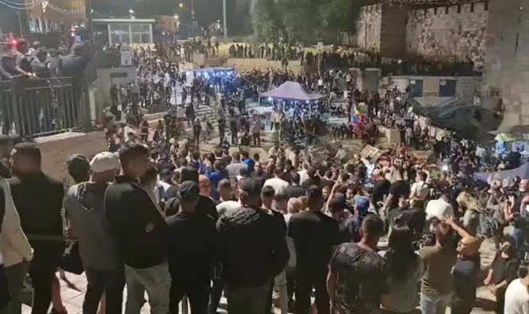
riot at Damascus Gate Police spokesperson

Moshe Leon, the mayor of Jerusalem, spoke this morning (Sunday) with Golan Yokfaz and Anat Davidov on 103FM about the clashes in the riots in the Shimon Hatzaddik (Sheikh Jarrah) neighborhood and the Arab attempt to cause a larger conflict over Jerusalem.
"There is no connection between Sheikh Jarrah and the Temple Mount, in Sheikh Jarrah this is a property dispute. This is an unprecedented incitement by the Palestinian Authority that is trying to lead to violence and unnecessary acts," Leon clarified.
"The Palestinian Authority and Hamas are trying to ignite Jerusalem, this is the problem and it needs to be addressed. It happens every year. There is no doubt that we all need to act to calm down and have zero violence, and we have zero tolerance for violence. The ministers are doing everything to calm the situation down." https://www.israelnationalnews.com/News/News.aspx/305815

Tennessee governor: We will act for Israeli sovereignty and against Palestinian state
Binyamin council head Yisrael Gantz is in US, meeting with US officials to garner support for settlement in Binyamin region.
Ido Ben Porat , May 09 , 2021 11:04 AM
Gantz and Lee Binyamin spokesperson
Tennessee Gov. Bill Lee and Binyamin Council Chairman Yisrael Gantz met in the United States to discuss ways to strengthen settlement of Judea and Samaria and the Binyamin area.
In these days when Joe Biden's new US administration is formulating its policy positions regarding the Middle East, the head of the Binyamin Council sees importance in harnessing prominent forces in American politics especially during this period to protect and strengthen settlement.
Yisrael Gantz's meeting with Tennessee Gov. Bill Lee, a representative of the Republican Party, took place at the governor's office, who gave his wishes for the strengthening of Binyamin and said that the residents of Binyamin, Judea and Samaria can see him as a partner who will do everything possible to prevent a Palestinian state in the heart of the Land of Israel. He said the US will also later help bring about Israel's full application of sovereignty in Judea and Samaria.
At the meeting, the head of the council and the governor discussed the challenges in this area and the potential that the Binyamin area has among the millions of American citizens who see it as the land of the Bible intended for the people of Israel.
Gantz said to the governor: "The people of Israel are happy and proud to meet partners in the path of truth that know how to differentiate between good and evil and strengthen the State of Israel and settlement. As governor of Tennessee, I am happy that Binyamin has found a close friend who will work to preserve our important and shared values with respect to protecting the Land of Israel, and in general."
As part of the trip to the United States, CGantz is holding additional meetings with government officials in the United States to promote cooperation and connections between communities in New York and communities in the Binyamin.
He met with a number of senators, members of Congress and government officials from New York City. In the meetings, Ganz described the significant development that is taking place in settlement of Judea and Samaria and in the areas of the Binyamin Regional Council that surrounds Jerusalem, in the process of developing construction, infrastructure, improving employment centers and establishing an advanced medical center. Gantz emphasized the main challenge he faces, which is the development of transportation infrastructure in all of Binyamin and the Jerusalem envelope area.
Gantz told representatives he met with that "if the countries of the world really wanted to help the Palestinians, they would strengthen the hand of the Israeli government to apply sovereignty, for the development of roads and the region." He said that "it is the Palestinians who turn to the council and ask for help in these areas. The Palestinian Authority does not care about any of this."
At the meetings, the participants were given a special gift - a copy of an ancient urn from the Mishkan site in ancient Shiloh. https://www.israelnationalnews.com/News/News.aspx/305816 [Bypass “Bi-dumb”. – rdb]

IDF launches largest military exercise in its history
Despite tensions with Hezbollah in north, Chief of Staff decides to hold month-long exercise to practice emergency scenarios across regions.
Arutz Sheva Staff , May 09 , 2021 8:26 AM
The IDF launches today, Sunday, the largest exercise in its history and, ahead of it, the terrorist organization Hezbollah has significantly increased its alertness, Kan News reported.
The exercise will last about a month and its participants will practice combat and emergency scenarios in all regions. Chief of Staff Aviv Kohavi decided to hold the "Chariots of Fire" exercise according to plan, despite security tensions in Jerusalem, the south and the north.
During the exercise, the forces will simulate a "month of war" for the first time since the Israeli army was founded in order to increase the IDF's readiness and fitness for war.
Regular and reserve IDF forces from all the commands and forces will participate in the exercise. In addition, the political echelon, the Ministry of Defense, the National Emergency Authority, the Ministry of Foreign Affairs and other security bodies will participate.
The exercise will practice a broad, synchronized maneuver in the depths of enemy territory based on General Staff capabilities and special forces activity.
In addition, the transition from routine to emergency, continuity of functioning within the IDF and between organizations, the Home Front and civilian assistance, fire and maneuvering in built-up area, and more will be practiced. As part of the exercise, research teams for drawing conclusions from the exercise alongside lessons learned from previous General Staff exercises will be activated. https://www.israelnationalnews.com/News/News.aspx/305808 [Sounds like a call up of troops to handle an impending war. – rdb]
To be removed from this News list, Please click here and put "Unsubscribe" in the subject line.

05/08/2021 NEWS AM
IDF orphans with Harel Skaat and Ili Butner
in an exciting performance - child and father and mother https://www.youtube.com/watch?v=h-s3mVqqWzU
Whenever the sun goes down  And when a plane in the sky passes  You are there in all of these, guard from above  That nothing will be missing here  And when the first rain comes  And the night is dark and alienated  You are there in all these, worrying from above  Let us not be cold  And between us is the sea  The sky and maybe the world  Nor will they separate us, my little children  And you can try and smile, love and move forward  And in the end we will meet and be again  Child and father and mother | Whenever there is a birthday  And friends come to the house  You are there in all of these, watching up  May it only be delicious here  And when crying a baby hurts  It stabs and burns the heart  You are there in all of these, guard from above  Let me not be in pain  And between us is the sea ..

The key insight of Adam Smith's Wealth of Nations is misleadingly simple: if an exchange between two parties is voluntary, it will not take place unless both believe they will benefit from it. Most economic fallacies derive from the neglect of this simple insight, from the tendency to assume that there is a fixed pie, that one party can gain only at the expense of another."
-- Milton Friedman (1912-2006) Nobel Prize-winning economist, economic advisor to President Ronald Reagan, "ultimate guru of the free-market system"
Read the Prophets & PRAY WITHOUT CEASING!
That is the only hope for this nation!
Please  Remember  These  Folks  In  Prayer-  Check often  They  Change! | Pray that the world would WAKE UP! Time for a worldwide repentance!  ALL US soldiers fighting for our freedom around the world  Pray for those in our government to repent of their wicked corrupt ways.  Pray for AB family – Wife just diagnosed with brain tumor  Pray for EL – multiple problems  Pray for AS – post knee replacement – some problems and another one scheduled.  Pray for TR – abnormal Mammogram having double biopsy – Mastectomy Scheduled  Pray for ZH - having trouble with PTSD  Pray for LAC – recurrent cancer getting treatment  Pray for KL – troubling spiritual situation.  Pray for Ella – emotionally disturbed abused child and brother with ? heart problem  Pray for JN – Neuro disease  Pray for MS – Job issues and change  Pray for BB – Severe West Nile Fever –still not mobile- improving!  Pray for RBH – cancer recurrence  Pray for Felicia – post op problems – continuing  Pray for SH and family – lady’s husband passed away and she is in Nursing home. Not doing well.  Pray for MP – Very complex problems  Pray that The Holy One will lead you in Your preparations for handling the world problems. – Have YOU made any preparations?
Genesis 27:²⁴And he said, Are you then my son Esau? And he said, I am. ²⁵And he said, Bring to me and let me eat of my son's game, so that my soul may bless you. And he came near to him; and he took and he ate. And he came to him, and he drank wine. ²⁶And his father Isaac said to him, Now come and kiss me, my son.

Police burst into Temple Mount compound as hundreds riot after Ramadan prayers
Officers use stun grenades after Palestinians throw rocks and bottles at police; at least 3 cops, 13 protesters injured in clashes on flashpoint holy site
By TOI staff Today, 9:38 pm
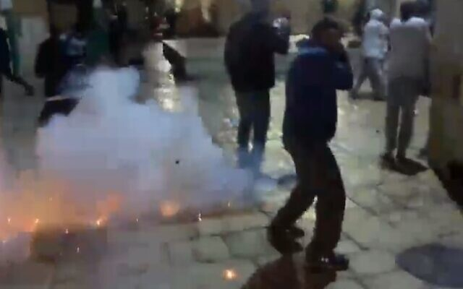
Israeli police clash with Palestinian protesters on the Temple Mount in Jerusalem on May 7, 2021 (Screencapture/Twitter)

Israeli police burst into the Temple Mount compound of Friday evening after Palestinians threw rocks and bottles at officers, as widespread clashes in Jerusalem spread to the holy site after prayers were held there on the last Friday of the Muslim holy month of Ramadan.
Police said that “forces have started to restore order, using riot dispersal means, following violent disturbances on the Temple Mount, during which hundreds of suspects began throwing stone, bottles and objects at police officers.”
Video from the scene showed pitched battles, with Palestinians throwing chairs, shoes rocks and bottles and police responding with stun grenades and tear gas. At least three officers were wounded, police said. Hebrew media said 13 Palestinians were hurt.
#BREAKING : Ongoing Clashes between #Palestinians and Israel security near Temple Mount / Aqsa Mosque area in #Jerusalem.
This comes on last Friday of #Ramadan, #Israel security using sound grenades to disperse protests: pic.twitter.com/ZVaLMGku09
— Global.TV (@GlobalTelevsion) May 7, 2021
Protesters chanted “Allahu Akbar,” or God is great. Several wounded demonstrators could be seen being carried away on stretchers. The Palestinian Red crescent said some of the wounded were hit by rubber-coated metal pellets.
“We will not allow riots, violence and attempts to harm police officers through taking advantage of the freedom of worship and religion, and turning it into a violent incident,” police said.
Demonstrators were calling for more people to try and reach the compound, but police were blocking roads leading to the site.
The Temple Mount in the Old City of Jerusalem has been one of the main flashpoints of conflict. The holiest site in Judaism, the site of the biblical temples, is also home to the Muslim holy sites of the Al-Aqsa Mosque and Dome of the Rock Shrine.
Another video from tonight at Al-Aqsa/Temple Mount (credit: unknown). This appears to be the most intense incident at Al-Aqsa since 2017. pic.twitter.com/XQ9oUakSZP
— Aaron Boxerman (@aboxerman1) May 7, 2021
Earlier, as tens of thousands gathered for afternoon Ramadan prayers, some worshipers waved flags of the Hamas terror group and reportedly called for attacks on Israel.
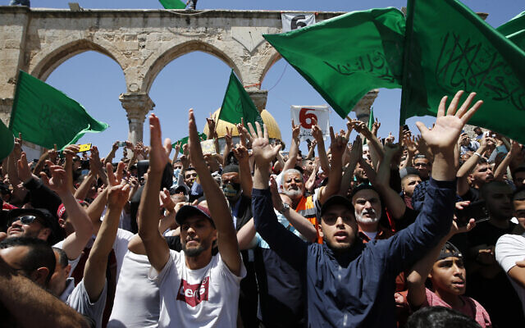
Video showed throngs of people on the compound, some of whom were waving the green flag of Hamas, the Islamist terror group that rules the Gaza Strip.
Some worshipers also reportedly chanted in support of Hamas and called for it to carry out attacks on Israel.
“We are all Hamas, waiting for your orders commander Mohammed Deif. Hamas — shoot a rocket at Tel Aviv tonight,” they were quoted as chanting by Channel 13 news, referring to the head of the terror movement’s armed wing.

Palestinians wave flags of the Hamas terror group after afternoon prayers for the last Friday of the holy Muslim month of Ramadan, on the Temple Mount in Jerusalem’s Old City, May 7, 2021. (Jamal Awad/Flash90)
The clashes came amid spiraling tensions over the pending eviction of four Palestinian families in the Sheikh Jarrah neighborhood as part of a long legal battle with right-wing Jewish Israelis trying to acquire property in the neighborhood.
On Tuesday, Deif warned Israel would pay a “heavy price” if the evictions went ahead, raised fears of a wider conflict could be sparked as Hamas and other factions in Gaza warn of renewed violence over the issue.
Tensions in Jerusalem, specifically around the Old City, also flared last month after police prevented people from congregating outside Damascus Gate at the start of Ramadan, which Arabs said was an inflammatory move that obstructed a long-held tradition of gathering at the site during the Muslim holy month. Authorities later canceled the policy. MORE -https://www.timesofisrael.com/police-burst-into-temple-mount-compound-as-hundreds-riot-after-ramadan-prayers/

17 policemen, 200 Palestinians said hurt after hundreds riot on Temple Mount
One officer moderately wounded in intense clashes after Ramadan prayers; police use stun grenades, rubber-coated bullets after Palestinians throw rocks and bottles
By TOI staff 7 May 2021, 9:38 pmUpdated: Today, 3:47 am
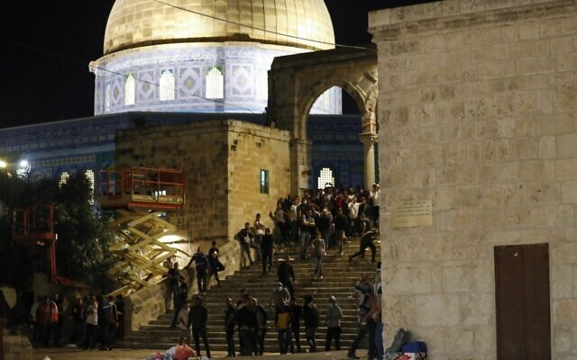
Palestinian protesters look on during clashes with Israeli security forces at the Temple Mount compound in Jerusalem, on May 7, 2021. (Photo by Ahmad GHARABLI / AFP)
Israeli police burst into the Temple Mount compound on Friday evening after Palestinians threw rocks and bottles at officers, as widespread clashes in Jerusalem spread to the holy site following prayers held there on the last Friday of the Muslim holy month of Ramadan.
Police said 17 police officers were hurt and around half of those hospitalized, with one in moderate condition after taking a rock to the head. Meanwhile the Palestinian Red Crescent reported that at least 205 Palestinians were wounded in clashes throughout Jerusalem, mostly around the Temple Mount and by Damascus Gate. Eighty-eight Palestinians were hospitalized, mostly for injuries with rubber-coated steel bullets, it said.
By midnight the rioting seemed to have subsided, with most protesters dispersing.
Police said Friday evening that force used “riot dispersal means following violent disturbances on the Temple Mount, during which hundreds of suspects began throwing stone, bottles and objects at police officers.”
Video from the scene showed pitched battles, with Palestinians throwing chairs, shoes, rocks and bottles, and shooting fireworks, and police responding with stun grenades, tear gas and rubber bullets. MORE -https://www.timesofisrael.com/police-burst-into-temple-mount-compound-as-hundreds-riot-after-ramadan-prayers/

‘Major attack’ in Israel foiled as 3 gunmen shot in firefight near military base
Security official says attackers opened fire after being stopped by border police officers conducting routine inspections on a bus with illegal Palestinian workers
By Emanuel Fabian Today, 4:45 pm

An Israeli soldier stands guard as the bodies of two Palestinian attackers, who opened fire and were killed by Israeli security forces, lie on the ground in front of the IDF military base of Salem near the West Bank town of Jenin, on May 7, 2021. (Photo by Jack GUEZ / AFP)
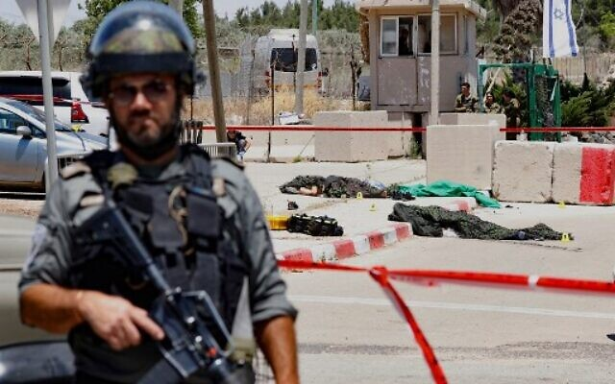
Three Palestinians who opened fire at Border Police soldiers near a military base in the northern West Bank on Friday had initially planned to commit a “major attack” against civilians in central Israel, army and police officials said on Friday. Two of the gunmen were killed and the third was critically injured in a firefight with the Israeli troops.
The three attackers, all in their early 20s, were traveling on a bus with illegal Palestinian laborers en route to central Israel, and intended to commit the shooting there, a security official said.
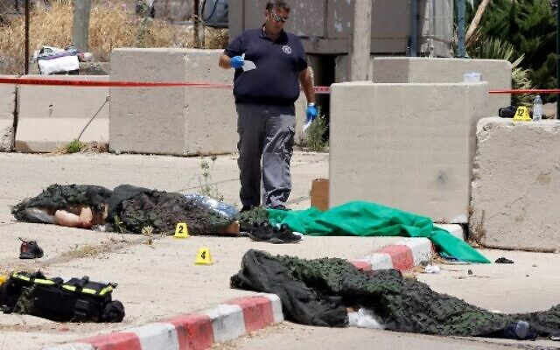
Forces had halted the bus near the border crossing between Israel and the West Bank as part of routine security efforts to stop illegal laborers from entering Israel. Shortly after, the three Palestinians got off the bus and opened fire at the soldiers.
“A major attack was prevented thanks to the sharp, determined and professional combat efforts of the border police officers,” said the head of the IDF’s Central Command Tamir Yadai, during a visit to the scene.

A forensic expert checks the bodies of two Palestinian attackers, who opened fire and were killed by Israeli security forces, in front of the IDF military base of Salem near the West Bank town of Jenin, on May 7, 2021. (Photo by Jack GUEZ / AFP)

Yadai said forces had been on high alert and reinforced during the Muslim holy month of Ramadan.
“According to our assessment, you managed to prevent the terrorists from carrying out an attack inside Israel,” Police Commissioner Kobi Shabtai told the officers at the scene.
A security official told Army Radio that forces had foiled “a Sarona 2,” a reference to the June 2016 terrorist attack where gunmen opened fire on the upscale Sarona market and restaurant area in Tel Aviv, killing four people.
Channel 12 reported that the three were believed to have been trying to reach Jerusalem.
As the three were about to be searched, they opened fire.
“The terrorists fired at the gate of the base. Border Police officers and an IDF soldier responded by firing and neutralizing the three terrorists,” police said in a statement.
Two of the attackers were killed and the third was critically wounded when officers on the scene returned fire. The injured attacker was taken by the IDF to the Emek Medical Center near Afula for treatment.
He was later transferred to Rambam hospital in Haifa, with very serious head injuries.
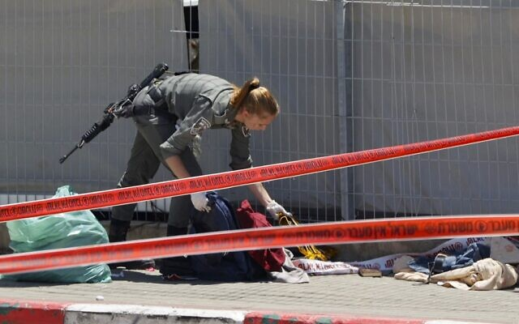
An Israeli soldier checks the belongings of two Palestinian attackers, who opened fire and were killed by Israeli security forces, in front of the IDF military base of Salem near the West Bank town of Jenin, on May 7, 2021. (Photo by Jack GUEZ / AFP)

The official said there was no prior intelligence that the three planned an attack and they did not have a history of involvement in terror groups. Initial investigations indicated that the bus driver was unaware of their intentions.
However, Israel’s Kan public broadcaster, quoting Palestinian sources, said the three were identified with the Hamas terror group.
They said two came from the West Bank village of Shuweika, while the third was from the city of Tulkarem
Aside from the makeshift Carlo-style submachine gun each assailant used, knives were found on each of their bodies.
Sergeant S. who led the force during operational activity outside the gate of the base said she and her soldiers identified three armed suspects running towards them, and opening fire.
“We loaded our weapons and grabbed cover as we responded with gunfire. During the gunbattle we heard bullets whizzing over our heads, she said, adding that she “hopes this will be the last event like this.” https://www.timesofisrael.com/major-attack-in-central-israel-foiled-as-3-gunmen-shot-near-military-base/

UN: Pending Israeli evictions in East Jerusalem could be a ‘war crime’
Rights office urges Israel not to remove Palestinian families from homes claimed by right-wing Jews; Foreign Ministry: It’s ‘a real estate dispute between private parties’
By Agencies and TOI staff Today, 5:16 pm
The United Nations urged Israel on Friday to call off any pending evictions in East Jerusalem, warning that its actions could amount to “war crimes.” Israel dismissed the tensions as a “real estate dispute.”
“We call on Israel to immediately call off all forced evictions,” UN rights office spokesman Rupert Colville told reporters in Geneva.
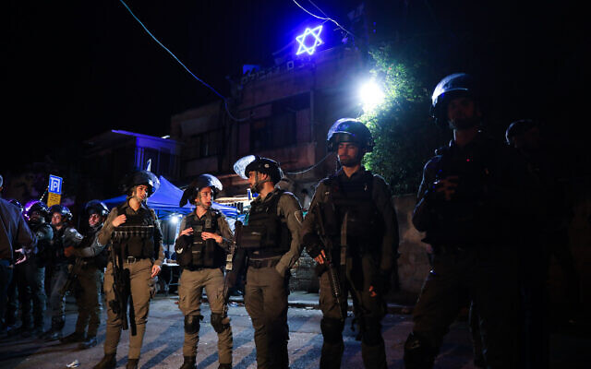
His comment came after 15 Palestinians were arrested in East Jerusalem overnight in clashes with police and Israelis over an eviction threat against four Palestinian families.
The second straight night of rioting in the Sheikh Jarrah neighborhood was fueled by a years-long land dispute between Palestinians and right-wing Jewish nationalists in the strategic district near Jerusalem’s Old City.

Israeli security forces outside a home of a Jewish family in the East Jerusalem neighborhood of Sheikh Jarrah on May 6, 2021. (Olivier Fitoussi/Flash90)

A long-running legal case over the homes of four Palestinian families on land claimed by Jews is due to go before the Supreme Court on Monday.
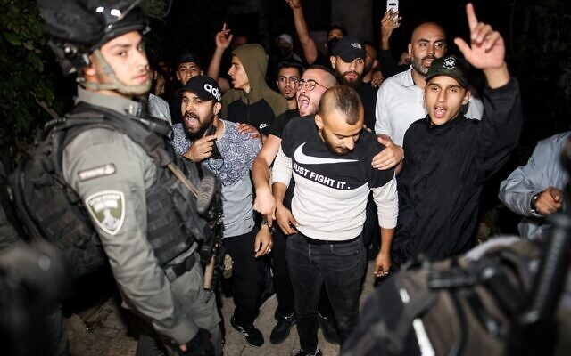
Palestinians chant slogans in front of Border Police on May 6, 2021, as they protest against the pending eviction of several Palestinian families in the Sheikh Jarrah neighborhood of East Jerusalem. (Ahmad Gharabli/AFP)

“We wish to emphasize that East Jerusalem remains part of the occupied Palestinian territory, in which international humanitarian law applies,” Colville said.
“The occupying power… cannot confiscate private property in occupied territory,” he said, adding that transferring civilian populations into territory considered occupied under international law was illegal and “may amount to war crimes.” [The only people occupying are the arabs who have no real title to the land. – rdb]
Colville demanded that Israel halt actions that “further contribute to a coercive environment or leads to a risk of forcible transfer.”
“We further call on Israel to respect freedom of expression on assembly, including with those who are protesting against the evictions, and to exercise maximum restraint in the use of force,” he said.
Israel’s Foreign Ministry, meanwhile, issued a statement pushing back on criticism of the pending evictions and accused the Palestinian Authority and terror organizations of fanning the tensions.
“Regrettably, the PA and Palestinian terror groups are presenting a real estate dispute between private parties, as a nationalistic cause, in order to incite violence in Jerusalem,” it said. “The PA and Palestinian terror groups will bear full responsibility for the violence emanating from their actions. The Israel police will ensure public order is maintained.”
Neighboring Jordan, which made peace with Israel in 1994 and is the custodian of Al-Aqsa mosque on the Temple Mount, also weighed in on Friday, saying “Israel’s continuation of its illegal practices and provocative steps” in the city is a “dangerous game.”
“Building and expanding settlements, confiscating lands, demolishing homes and deporting Palestinians from their homes are illegal practices that perpetuate the occupation and undermine the chances of achieving a just and comprehensive peace, which is a regional and international necessity,” Jordan’s Foreign Minister Ayman al-Safadi tweeted. MORE - https://www.timesofisrael.com/un-pending-israeli-evictions-in-east-jerusalem-could-be-a-war-crime/

Arab Israelis, Gaza groups plan mass protests Saturday after Jerusalem clashes
Arab Israeli leadership panel decries ‘bloody terrorist aggression against Al-Aqsa Mosque’ as it calls for demonstrations across Israel; US calls for all sides to deescalate
By TOI staff Today, 6:37 amUpdated at 7:16 am
Arab Israelis and Palestinians in the Gaza Strip were expected to hold mass protests on Saturday in the wake of Friday’s clashes in Jerusalem between Palestinians and the Israel Police, in which some 200 Palestinians and 17 officers were wounded.
The Arab High Follow-Up Committee, a body that represents Arab Israelis, called for protests in Arab towns and cities across the country in response to the violence.
The Hamas terror group’s official media outlet said Gaza-based groups were calling for demonstrations near the border fence with Israel on Saturday in protest of Israeli actions in Jerusalem.
The Israeli Committee called for “support of Jerusalem and its people” in the face of “the bloody terrorist aggression against Al-Aqsa Mosque.” It said it planned to organize delegations to Jerusalem, including to East Jerusalem’s Sheikh Jarrah neighborhood, which has been at the center of recent demonstrations, and to the Al-Aqsa Mosque. https://www.timesofisrael.com/arab-israelis-gaza-groups-plan-mass-protests-saturday-after-jerusalem-clashes/

Lapid and Bennett hold talks with political leaders aimed at ‘unity government’
Meetings ‘held in good spirits and with a willingness to proceed,’ but tensions said growing between Yamina and Labor; Liberman issues list of demands to enter coalition
By TOI staff Today, 1:09 pmUpdated at 2:14 pm
Left to right: Yesh Atid party leader Yair Lapid (Miriam Alster/Flash90); Yamina party chief Naftali Bennett; and New Hope party head Gideon Sa'ar (Yonatan Sindel/Flash90)
Yesh Atid leader Yair Lapid, currently tasked with forming a government, and Yamina chair Naftali Bennett, held a series of meetings with political leaders on Friday aimed at establishing a unity government.
“The meetings were all held in good spirits and with a willingness to proceed,” a joint statement from the “change bloc” leaders said after the talks.
A first meeting was held with New Hope leader Gideon Sa’ar. Yesh Atid said in a statement that the discussions, held at Lapid’s home in Tel Aviv, “advanced positively.”
Lapid and Bennett have been negotiating coalition terms in recent weeks, reportedly closing in on agreements in many areas, with the Yesh Atid leader saying he is ready to let Bennett serve first as prime minister in a rotation agreement.
After the meeting, Bennett met separately with Labor party leader Merav Michaeli at her home in Tel Aviv before he and Lapid met with Blue and White chief Benny Gantz.
Indicating some tension, Michaeli’s partner, comedian Lior Schleien, tweeted that: “The head of a party with six seats is trying to explain to the head of a party with 7 seats why he should be prime minister and she should be agriculture minister. I miss the tap dancer who used to live in the apartment above me, he annoyed me less.”
Bennett and Lapid then held meetings with Meretz leader Nitzan Horowitz and Yisrael Beiteinu chief Avigdor Liberman.
The so-called “change bloc” of parties opposed to Prime Minister Benjamin Netanyahu is said to be formulating laws that would allow the wide range of factions to work together, the Haaretz daily reported.
With parties from all over the political spectrum united in their aim to replace Netanyahu, the sides would likely need to make baseline agreements, the Kan public broadcaster said.
“Whatever passes will pass — and what falls will fall,” a source involved in the political negotiations told Kan, referring broadly to potential laws that would be brought up for a vote if such a government would be formed.
President Reuven Rivlin announced Wednesday that he had tasked Lapid with forming Israel’s next government after Netanyahu a day earlier admitted he had failed to build a coalition in the 28 days he was given to do so.
While acknowledging the difficulties in forming a unity government, Lapid said on Thursday that his coalition “will have a simple goal: to take the country out of this crisis — the coronavirus crisis, the economic crisis, the political crisis and mostly the crisis within us, within the people of Israel.”
In addition to resolving their own differences, Lapid and Bennett must muster a majority coalition from an unlikely mixture of right-wing, left-wing and centrist parties as well as the Islamist Ra’am party, which complicates matters and raises the question of how stable such a government would be to begin with.
And they must placate their own party members, who will likely struggle to reconcile their views with their emerging coalition partners.
Yamina’s Amichai Chikli has said he will vote against the planned coalition. Several other Yamina Knesset members said Thursday that Netanyahu has been attempting to persuade them to defect from the party and declare their opposition to entering a coalition with left-wing factions; they said they had rejected the efforts.
Yamina MK Matan Kahana on Friday said the time had come for a unity government.
“Netanyahu is busy dragging Israel to the fifth election. I think this is the worst option,” Kahana said in a post on his Facebook page.
Kahana said that Israel needed a government that “won’t hand over Hebron, won’t release thousands of terrorists, won’t vote for the expulsion of Jews from their homes, and won’t do many things that, yes, Benjamin Netanyahu did.”
Meanwhile, Liberman published on Friday a list of requirements for his party to enter a unity government, including passing the so-called draft law, which would require ultra-Orthodox Israelis to be conscripted to the military like most other Israelis.
Liberman’s demands did not widely differ from the party’s platform, including de-monopolizing the Chief Rabbinate’s control over the kosher certification for food in Israel and a demand for civil marriage.
However, an unnamed source from the Islamist Ra’am party told Channel 12 news that it would not agree to civil marriage and the “violation of family values.”
If Lapid fails to cobble together a coalition during his 28-day window, which ends June 2, a majority of lawmakers could try to endorse any Knesset member as prime minister.
If that 21-day period fails to yield a coalition, the country would be forced into the unprecedented scenario of a fifth election in two and a half years. https://www.timesofisrael.com/lapid-meets-with-bennett-and-saar-says-coalition-talks-advanced-positively/ [Still a complete mess – rdb]

Young and female: The soldiers operating Israel's eyes in the sky
Satellite Unit 9900 recruits 'creative nerds' out of high school who show extraordinary skills in math and physics but in theatre and the arts too; they are problem solvers who make critical decisions in real time as they control the country's watchers from space
Udi Etzion | Published: 05.07.21 , 19:13
One of the most sensitive military intelligence units recently celebrated a major anniversary. There was even cake and a card to congratulate unit members on the achievements of the past year.
The IDF's satellite unit was marking seven years since the launch of the Ofek 10 into orbit and only the guest of honor was missing. It was circling the earth in -270°C (-454°F) temperatures.

Members of the IDF satellite unit (Photo: Michal Shamir)

The command center of Unit 9900 is far less futuristic looking or impressive than one would expect, given the technology it is using, with screens showing aerial maps and satellite routes dotted all along the walls.
While most such command centers employ engineers in their 40s, here the satellites are operated by mostly female 19-year-old soldiers selected after they excelled in math in high school and were put through a rigorous five-month course.
The soldiers must sign on to serve a year longer than their peers who are completing their national service.
"We search for creative nerds with extra credit in mathematics, physics, computer studies but also theatre, arts and dance," says Captain S., a 32-year-old aerospace engineer from Holon who is in the final stages of pregnancy.
"Technology is not the only criteria. We need people who can problem solve because we often encounter situations that require real time sensible decision-making to prioritize satellite missions. Our soldiers must know how best to put this valuable resource to use. While the number of satellites in space is increasing, our team size remains the same," she says.
"We have a personal connection with our satellites," says Captain S.
"Some of our work here is not just to retrieve information for intelligence purposes but also to ensure the longevity of the satellite. Our babies are each worth upwards of $100 million and we must be attuned to their problems so that we can solve them remotely," she says.
"In our unit, we celebrate each satellite's birthday according to the day of launch. Our work is very stressful, and we need these moments of celebration to blow off some steam."

Computerized model of Israeli satellite Ofek 10 in orbit (Photo: Defense Ministry)

The soldiers in the unit call each one of their six operational satellites "national assets" - and rightly so.
The unit was created a little over 40 years ago, with a handful of diehards from the intelligence corps under the leadership of Brig. Gen. Haim Eshed.
Eshed convinced then-prime minister Menachem Begin that this small and not very wealthy nation was capable of building and launching spy satellites into space.
It was a feat costing billions of dollars that only superpowers such as the United States or the former Soviet Union had achieved.
Now, after years of effort and a share of failures, satellites are a main tool in Israel's intelligence gathering.
The foreign media often reports on alleged Israeli attacks behind enemy lines, in Syria, Iraq, the Red Sea and Africa.
Recently such reports described mysterious attacks on Iranian vessels and inside nuclear facilities in Iran. Such operations could not be carried out without a constant 24/7 flow of intelligence made possible by satellites.

A passenger plane flying in an enemy country as snapped by the Ofek satellite (Photo: IDF Spokesperson's Unit)

Originally, the satellites were meant to alert Israel to possible Egyptian violations of the 1979 Camp David peace accords but over time (and with the financial assistance of South Africa, according to foreign media reports), they have become a key tool in the fight against Iranian aggression, detecting new missile sites, suspicious vessels or convoys transporting weapons anywhere in the region.
The unit that operates the satellite center was awarded a commendation by the IDF chief of staff for its role in the success of a covert operation against Iran, carried out by branches of the military and the Mossad intelligence agency.
There are six spy satellites in orbit at the same time, each completing a full circle around earth every 90 minutes, which translates to 96 orbits in a 24-hour period or one every 15 minutes.
Operators have a 15-minute window in which to relay instructions, download images and update software as they remotely handle their refrigerator-sized, 350-kilogram equipment operating in the harsh conditions of space.
Ofek 16, the newest satellite that was launched in July 2020, became operational in recent weeks, giving Israel its largest fleet so far.
It too is deserving of celebration, for after a long process that included calibrating its camera and embedding it into the military's intelligence data systems, it has begun providing better quality images than any of its predecessors.
"Most of the work is planned in advance but a call can always come in on a Friday night, from the head of Military Intelligence or the chief of staff with a particular request. And it is up to us to provide them with the images they require," says 32-year-old Lt. M., a systems engineer.
"We can't share any of this with our families," she says. "They have become accustomed to our discretion and we've all developed a poker face to use when the media reports about events that we have been working on." MORE - https://www.ynetnews.com/magazine/article/rkH2Yb00D00

COVID revolution: How pandemic could change the hospital's role forever
Hospitals were forced to reinvent themselves almost overnight.
By MAAYAN JAFFE-HOFFMAN MAY 7, 2021 12:25
The COVID-19 pandemic re-educated the country of the importance of the hospital within the healthcare system. It also taught hospitals the need to be flexible, forward-thinking and to adopt technology.
From an emphasis on fully staffing facilities, to new technologies and telemedicine changing the way doctors provide care, the post-COVID health system will look different than it did before.
“The importance of the health funds is something we knew all the time, but in the end, the capacity of the entire country to operate depended on the hospitals’ ability to take care of severely sick patients,” Prof. Arnon Afek, deputy director-general of Sheba Medical Center, told the Magazine.
It was a fear that medical centers would get crushed under the pressure of too many severe patients that led Israel’s leaders to repeatedly lock down the country.
Health experts believed that Israel’s underfunded and understaffed hospitals could only manage 800 severe COVID-19 patients before collapsing. Although ultimately there were some 1,200 serious cases, as infection rates rose, lawmakers kept one eye on the economy and the other on the health system.
Part of the Health Ministry’s strategy during the first wave was to require hospitals to cease providing elective and routine patient care in order to free up staff for COVID-19 patients. At the same time, people’s fears of contracting COVID in the hospital led many patients to forego preventative care. According to Wolfson Medical Center director Dr. Anat Engel, “We are now seeing a jump in the number of patients coming to us in all areas.... We see that patients are coming with more complex medical problems and in more severe stages.”
In any future pandemic or other mass casualty event, Engel said, the goal should be to have enough staff to ensure hospitals can maintain routine.
Hospitals were forced to reinvent themselves almost overnight. A paper recently published by Sheba in the peer-reviewed Emergency Medicine Journal shared what it was like to establish a COVID treatment center from a clinical, organizational and logistical standpoint under extreme conditions.
Sheba’s first COVID unit was situated on the periphery of the hospital grounds, about 1,500 meters from the main campus – a decision made by a COVID task force that the hospital quickly established. The task force consisted of representatives from the hospital management, the Center for Disaster Medicine, and the departments of emergency medicine, internal medicine, infectious disease, infection prevention and control, medical informatics, telemedicine, logistics, human resources and public relations.
By placing the complex within the boundaries of the hospital, staff had access to all hospital resources. At the same time, keeping COVID treatment out of the main building helped prevent widespread contamination of staff and other patients.
But using the facility came with its set of challenges. MORE -https://www.jpost.com/health-science/covid-revolution-how-pandemic-could-change-the-hospitals-role-forever-667334

On al-Quds Day, Iran’s Khamenei says Israel ‘is a terrorist base, not a country’
Iranian supreme leader says ‘fighting this despotic regime is everyone’s duty’; protesters burn Israel, US, Indian flags in Pakistan; kids rally in Syria; flag drawn on Iraqi road
By Agencies and TOI staff Today, 3:48 pm
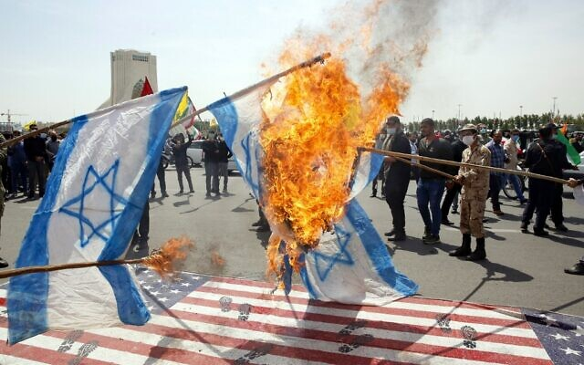  Iranians set Israeli flags on fire as they step on a US flag during a rally marking al-Quds Day at the capital Tehran's Azadi (Freedom) square, on May 7, 2021 (AFP) | 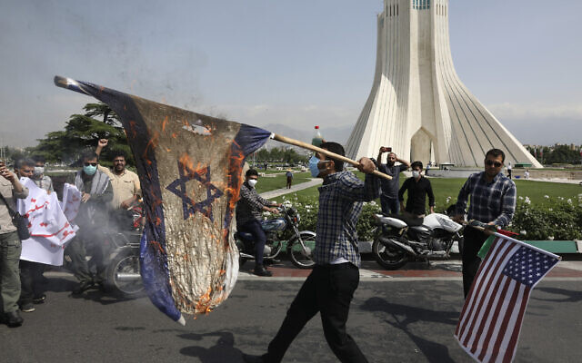  Demonstrators burn representations of Israeli and US flags during the annual Al-Quds Day rally in Tehran, Iran, May 7, 2021 (AP Photo/Vahid Salemi)
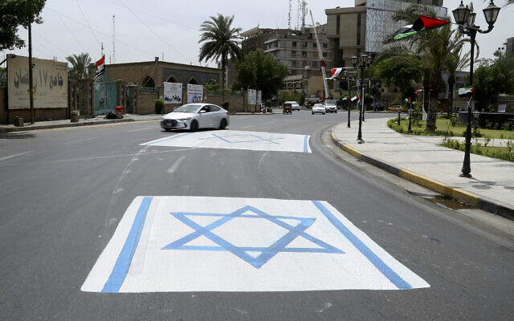  A representation of an Israeli flag is placed outside the 17th of Ramadan mosque during 'al-Quds' Day in central Baghdad, Iraq, May 7, 2021. (AP Photo/Hadi Mizban) | Syrian and Palestinian children take part in a rally to mark al-Quds Day, on May 7, 2021, at the covered bazaar of Hamidiya in Syria's capital Damascus (Louai Beshara / AFP)
In a speech to mark the annual al-Quds Day, Iran’s supreme leader Ayatollah Ali Khamenei on Friday called Israel “not a country, but a terrorist base” and said its downfall was imminent.
“Israel is not a country, but a terrorist base against the nation of Palestine and other Muslim nations,” Khamenei said in live televised remarks.
“Fighting this despotic regime… is everyone’s duty,” Khamenei said.
Khamenei also stressed that “the decline of the enemy Zionist regime has begun and will not stop.”
He blasted Israel’s normalization of ties with “some weak Arab governments” as attempts to undermine “the nightmare of Muslim unity,” calling on Palestinians to continue their resistance and for Muslim governments to support them.
Iran initiated al-Quds Day, or Jerusalem Day, in 1979, the year of the Islamic Revolution. It commemorates it with anti-Israel speeches, events and threats to “liberate” Jerusalem from Israeli control.
This year the day falls close to Israel’s own Jerusalem Day, celebrated on May 10, which marks the unification of the capital during the 1967 Six Day War.
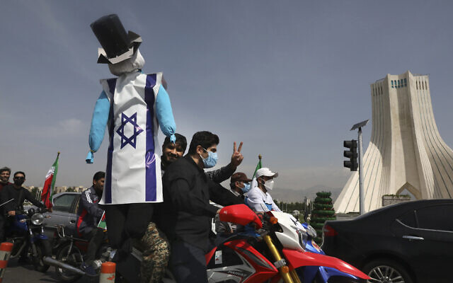
Despite virus restrictions, a number of people came out “spontaneously” in the capital Tehran, state TV said, showing the usual burning of flags and chants of “Death to America” and “Death to Israel.”

A demonstrator on a motorcycle holds an effigy representing Israel and the United States during the annual Al-Quds Day rally in Tehran, Iran, May 7, 2021 (AP Photo/Vahid Salemi)

In a Wednesday tweet ahead of the commemorations, Iranian Foreign Minister Mohammed Javad Zarif branded Israel “an apartheid regime.”
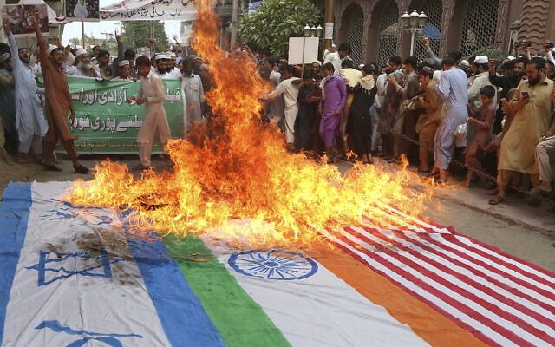
“Palestine is a yardstick for justice. Few measure up. But Iran has proudly stood with Palestinian people — who resist the brutality of an apartheid regime #QudsDay is yearly reminder of moral imperative of global solidarity for Palestine,” Zarif wrote on Twitter.
Meanwhile, protesters in Peshawar in Pakistan burned American, Israeli and Indian flags to the day, held on the last Friday of the holy month of Ramadan.

Demonstrators chant slogans after burning representations of Israeli, US and Indian flags during the annual Al-Quds, or Jerusalem, Day rally in Peshawar, Pakistan, May 7, 2021 (AP Photo/Muhammad Sajjad)

Rallies were also held in Syria and Israeli flags were painted on Iraqi roads for cars to drive over.
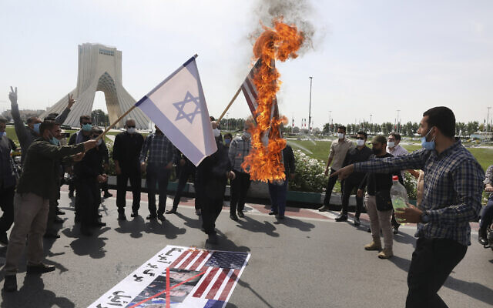
However, Berlin banned the annual anti-Israel Quds Day march this year, the first time the city has taken a stand against the event since it became a local tradition in 1996. It is illegal in Germany to call for the destruction of Israel.
Last month, the National Cyber Directorate warned that coordinated attacks against Israel were expected to mark al-Quds Day and the end of the Muslim holy month of Ramadan.

Demonstrators burn representations of Israeli and US flags during the annual Al-Quds Day rally in Tehran, Iran, May 7, 2021 (AP Photo/Vahid Salemi)

The actions, expected to come around May 7 and to be coordinated by anti-Israel hackers around the world under the banner “#OPJerusalem,” will seek to spread propaganda messages by way of website corruption, text messages and attacks aimed at grabbing public attention, the directorate said in a statement. Each year the directorate warns against expected attacks linked to the day.
In last year’s attacks, various affected websites displayed a video simulating Israeli cities being bombed and messages threatening the destruction of the Jewish state. Despite the number of websites that were defaced, cybersecurity experts said the scale of the attack was relatively small because all were attacked via a single access point.
Tensions have risen between Israel and Iran, with the countries blaming each other for recent attacks on each other’s ships that have caused damage but no injuries or sinkings. In addition, Iran has blamed Israel for an explosion at a key nuclear facility that reportedly caused significant damage, but no injuries, by knocking out power systems. https://www.timesofisrael.com/on-al-quds-day-irans-khamenei-says-israel-is-a-terrorist-base-not-a-country/ [Just a little thought to keep in mind. This is the group of people and the nitwits in DC are insisting we need to have some form of ‘accord’ with in order to allegedly keep them from building a nuclear weapon (which they already have plans for) and are willing to do stupid things like give them a $1billion ‘good faith’ incentive to sign their accord. This looks like a perfect way to describe terminally stupid. – rdb]

Reported Vaccine Injuries Continue to Climb, Pfizer Seeks Full Approval for COVID Vaccine
VAERS data released today showed 157,277 reports of adverse events following COVID vaccines, including 3,837 deaths and 16,014 serious injuries between Dec. 14, 2020 and April 30, 2021.
By Megan Redshaw
The number of reports of injuries and deaths following COVID vaccines continues to rise, according to data released today by the Centers for Disease Control and Prevention (CDC). The data comes directly from reports submitted to the Vaccine Adverse Event Reporting System (VAERS).
VAERS is the primary government-funded system for reporting adverse vaccine reactions in the U.S. Reports submitted to VAERS require further investigation before a causal relationship can be confirmed.
Every Friday, VAERS makes public all vaccine injury reports received as of a specified date, usually about a week prior to the release date. Today’s data show that between Dec. 14, 2020 and April 30, a total of 157,277 total adverse events were reported to VAERS, including 3,837 deaths — an increase of 293 over the previous week — and 16,014 serious injuries, up 2,467 since last week.
In the U.S., 240.2 million COVID vaccine doses had been administered as of April 30. This includes 105 million doses of Moderna’s vaccine, 127 million doses of Pfizer and 8 million doses of the Johnson &Johnson (J&J) COVID vaccine.
Of the 3,837 deaths reported as of April 30, 24% occurred within 48 hours of vaccination, 16% occurred within 24 hours and 39% occurred in people who became ill within 48 hours of being vaccinated.
This week’s VAERS data show:
- 21% of deaths were related to cardiac disorders.
- 54% of those who died were male, 44% were female and the remaining death reports did not include gender of the deceased.
- The average age of death was 75.1 and the youngest deaths reported include two 15-year-olds (VAERS I.D. 1187918 and 1242573 ) and a 16-year-old (VAERS I.D. 1225942). There were other reported deaths in children under 16 that could not be confirmed or contained obvious errors.
- As of April 30, 805 pregnant women reported adverse events related to COVID vaccines, including 235 reports of miscarriage or premature birth.
- Of the 1,597 cases of Bell’s Palsy reported, 51% were reported after Pfizer-BioNTech vaccinations, 40% following vaccination with the Moderna vaccine and 131 cases, or 10%, of Bell’s Palsy cases were reported in conjunction with J&J.
- There were 162 reports of Guillain-Barré Syndrome with 41% of cases attributed to Pfizer, 45% to Moderna and 19% to J&J.
- There were 44,348 reports of anaphylaxis with 38% of cases attributed to Pfizer’s vaccine, 47% to Moderna and 14% to J&J. MORE -
https://childrenshealthdefense.org/defender/vaers-vaccine-injuries-climb-pfizer-seeks-full-approval/

Not only blood clots? EMA ‘assessing reports’ of AstraZeneca jab link to rare IMMUNE DISORDER
7 May, 2021 13:40
The European Medicines Agency (EMA) is investigating reports of AstraZeneca’s Covid-19 vaccine causing Guillain-Barre syndrome, as the pharmaceutical company remains embroiled in controversy over the jab’s link to blood clotting.
In a meeting this week, the European Medicines Agency’s Pharmacovigilance Risk Assessment Committee (PRAC) revealed that it was “assessing reports” of the rare immune system disorder being found in people following vaccination.
“As part of the review of the regular pandemic summary safety reports for Vaxzevria, AstraZeneca’s Covid-19 vaccine, the PRAC is analysing data provided by the marketing authorization holder on cases of Guillain-Barre syndrome (GBS) reported following vaccination”, the PRAC declared.
“GBS was identified during the marketing authorization process as a possible adverse event requiring specific safety monitoring activities”, the committee continued, adding that it has requested “further detailed data” on the cases and will release new information as it becomes available.
According to the UK’s National Health Service (NHS), Guillain-Barre syndrome is a “very rare and serious condition that affects the nerves”, and can create feelings of numbness, weakness, and pain in those who have it.
Though the NHS advises that Guillain-Barre syndrome is a treatable condition and that “most people will eventually make a full recovery”, it can also be life-threatening and leave those who have had it with “long-term problems”
Following hundreds of cases of blood clotting – and dozens of deaths – AstraZeneca’s Covid-19 vaccine has already been restricted in many countries to older people only.
In the UK, those under the age of 40 are set to be offered an alternative vaccine provided this causes no “delays” in the vaccination program, however the European Medicines Agency maintains that the vaccine’s benefits outweigh the risk for much of the population. https://www.rt.com/uk/523182-ema-astrazeneca-immune-disorder/ [HUMMMM? I am not sure you fully recover from being on a respirator for 6 months to a year and being paralyzed even if it is so called temporary. If they come with the Jab RUN don’t walk. – rdb]

Biden gets scolded for not paying 'fair share' in taxes
'He and his wife Jill exploited a loophole of questionable legality'
By Bob Unruh Published May 7, 2021 at 12:01pm
President Biden was scolded this week in a commentary at the Federalist for not paying his "fair share" of taxes, a phrase that he has used over and over in recent weeks as he promotes his plans to raise taxes across the United States by massive amounts.
"With his own taxes, Joe Biden didn't pay his 'fair share,'" explains columnist Christopher Jacobs. "Upon leaving the vice presidency in early 2017, he and his wife Jill exploited a tax loophole of questionable legality to dodge hundreds of thousands of dollars in taxes – and used the savings to fund lavish real estate holdings."
The column cited how Biden, in a recent speech to Congress as well as in his "multi-trillion-dollar plan for 'human infrastructure,'" proposed yet another tax increase.
"In his address … Biden used the words 'fair share' on no fewer than five separate occasions to justify these proposed revenue hikes," the column noted.
But it pointed out Biden, personally, "avoided more than $500,000 in taxes to fund his luxury lifestyle" while demanding that others "pay their fair share."
The column reported from 2017 through 2019 the Bidens "classified a total of $13.5 million in book and speech income as profits from their two corporations, rather than as cash wages."
That means they avoided "paying $513,540 in payroll taxes on their $13.5 million in declared corporate profits."
"Tax experts interviewed by the Wall Street Journal in 2019 called the Bidens' maneuvers 'pretty aggressive,' and stated that they existed solely to circumvent paying payroll taxes," Jacobs wrote.

He noted at the same time that the Bidens were "dodging" taxes, they spent more than $2.7 million for a beach house.
"At the time, Biden told a local paper the move fulfilled a lifelong dream to own a beach house."
And, too, Biden then was renting a separate residence that was estimated to cost about $20,000 per month. That "house" got Biden nearly 12,000 square of space, a grand piano in the living room, a sauna and home gym, and parking for 20-plus cars.
"Given his behavior, President Biden's speech last week sounded a bit rich – not in terms of wealth, but his own hypocrisy," the column scolded.
It isn't the first time Biden's tax avoidance has been an issue.
Just weeks ago, WND reported on a letter from Rep. Jim Banks, R-Ind., the chairman of the Republican Study Committee, to Biden asking him if he would make good on the taxes owed.
The letter cited the Bidens' decision to route $13 million in income through two S-corporations "to avoid paying some $500,000 in taxes that help fund Medicare and Obamacare."
"Do you intend to undo your hypocrisy and pay these taxes back to the American people?" Banks asked.
"We write to highlight for the American people the hypocrisy you have exhibited in using a tax shelter strategy derided by the Left to avoid paying Obamacare taxes," Banks said. "Over the past several years, you and the First Lady, through a legally dubious tax strategy, appear to have avoided payment of over $500,000 in payroll taxes. As you may know, these payroll taxes fund Medicare for our nation's seniors, and were increased by President Obama's Affordable Care Act."
Banks said media reports "indicate that you both directed revenue from book royalties and speaking appearance fees into these two corporations, avoiding self-employment payroll tax liabilities that would have flowed to America's Medicare program that provides care to over 60 million seniors."
The letter cited a tax expert saying there's "no reason for these [earnings] to be in an S-corp – none, other than to save on self-employment tax."
"Accordingly, we ask one simple question: Do you intend to undo your hypocrisy and pay these funds back to the American people?"
Biden's two S-corporations, CelticCapri Corp. and Giacoppa Corp., reported profits of more than $13 million for 2017 and 2018, according to reports.
But during his Democratic National Convention acceptance speech last August, Biden called for "ending loopholes" for the wealthy.
"Because we don't need a tax code that rewards wealth more than it rewards work. I’m not looking to punish anyone," he said at the time. "Far from it. But it's long past time the wealthiest people and the biggest corporations in this country paid their fair share." https://www.wnd.com/2021/05/biden-gets-scolded-not-paying-fair-share-taxes/
Obviously has been taking lessons form the likes of Pelosi, Schumer, Newsom and a bunch of other crooks. – rdb]

Judge rules gun maker not liable for individual's criminal act
Decision a blow to Biden's campaign to curb 2nd Amendment rights
By WND Staff Published May 7, 2021 at 4:32pm
A federal judge has dismissed a lawsuit against the gun maker Glock brought by the Brady Campaign to Prevent Gun Violence on behalf of a man who was shot and paralyzed by a gunshot.
"A fair reading of the [federal law] shows that Congress intended the scope of its preemption to include claims like the plaintiff's. The [law's] plain text extends preemption to plaintiff's tort and products liability claims," wrote U.S. District Judge Susan Brnovich.
Her ruled the statute constitutional and affirmed the immunity from liability granted in the 2005 Protection of Lawful Commerce in Arms Act.
"Its unambiguous terms bar any civil cause of action, regardless of the underlying theory, when a plaintiff's injury results from 'the criminal or unlawful misuse' of the person or a third party, unless a specific exception applies," the judge said.
The little-notice decision was profiled Friday by Paul Bedard in his "Washington Secrets" column. Bedard pointed out that the ruling is just now drawing attention.
The suit against Glock was filed on behalf of Carlos Travieso Jr. He was in a vehicle with others returning from a church event in 2018 when another teenager found the 9 mm pistol in the car and apparently thought it was safe because the magazine holding the bullets was missing.
But there was a bullet in the chamber, and when she pulled the trigger, the shot hit Travieso.
The ruling was a setback for President Biden, Bedard said, who recently had begged for divine help in removing the immunity afforded gun makers.
Last month, Biden falsely claimed that the firearms industry is "the only industry in America" that can’t be sued."
"This is the only outfit that is exempt from being sued. If I get one thing on my list, (if) the Lord came down and said, 'Joe, you get one of these,' give me that one," Biden said at the White House.
He claimed that gun makers soon would have "a come-to-the-Lord moment."
Glock argued it was covered by the immunity act because the shooting was a criminal act, and the judge agreed.
Mark Oliva of the National Shooting Sports Foundation told Bedard the dismissal was welcome news.
"This is an example of lawyers attempting to put the blame for negligent use of a firearm on a manufacturer. The facts of the case are clear. The negligent mishandling of a firearm resulted in tragic effects. There was no defect in the product, design flaw, and as the opinion clearly notes, claims of warning notifications do not make for a claim of product defect," he said.
"These attempts to hold manufacturers responsible for the criminal and negligent misuse of firearms are misguided and are attempts at legislation through litigation. The PLCAA law was passed with a bipartisan majority in both chambers of Congress to keep activists from attempting to bankrupt firearm manufacturers by tying them up in court with unfounded claims. This demonstrates why protecting this legislation against attacks by President Biden and gun control factions in Congress is critical," he added.
Bedard noted God "didn’t deliver for President Joe Biden." https://www.wnd.com/2021/05/judge-rules-gun-maker-not-liable-individuals-criminal-act/ [Guns don’t kill and gun manufacturers don’t kill. PEOPLE kill. The vast majority of incidents with weapons is the result of criminal or careless behavior. – rdb]

Ohio Republican Party Censures US Rep. Gonzalez for Voting to Impeach Trump
Friday, 07 May 2021 04:48 PM
Rep. Anthony Gonzalez on Friday joined a growing list of lawmakers being censured by state Republican Party officials for voting to impeach former President Donald Trump on a charge of inciting the deadly attack on the U.S. Capitol.
Gonzalez, a two-term lawmaker from Ohio and former professional football player, was also called upon by the Ohio Republican Party to resign his seat in Congress, as Trump reasserts his grip on the party.
Ohio Republican Party Chairman Bob Paduchik said in a statement that the action against Gonzalez "addresses an unconstitutional, politically motivated process that served no purpose," apparently referring to the House impeachment of Trump.
Last January, Gonzalez was one of 10 House Republicans voting to impeach Trump, who'd been accused of inciting a breach on Jan. 6 at the U.S. Capitol, which resulted in five deaths, including a Capitol Police officer. Trump supporters were attempting to stop Congress from certifying Joe Biden's victory as president.
Weeks later, the Senate acquitted Trump on a vote of 57-43, short of the two-thirds majority needed for a conviction. Seven Republican senators joined all 50 Democrats in voting to convict the former president.
Aides to Gonzalez were not immediately available for comment. MORE -https://www.newsmax.com/politics/gonzalez-impeach/2021/05/07/id/1020578/

Judges let government bureaucrats sue citizens over criticism
Case is 'road map for how government officials can retaliate'
By WND Staff Published May 7, 2021 at 7:47pm
An appellate court has ruled that government entities and officials have a constitutional right to sue critics who are exercising their constitutional right to object to official actions.
And it could create a bad precedent, unless the Supreme Court responds to a request to take up the fight, reported Just the News.
The battle is between the Pennsylvania School Boards Association and anti-union and free speech activists.
The 3rd U.S. Circuit Court of Appeals ruled the PSBA was allowed to sue activist Simon Campbell and Pennsylvanians for Union Reform "to make them stop filing embarrassing public records requests and pressuring members to leave the PSBA."
The critics, asserting their constitutional rights, appealed.
The 3rd Circuit said the PSBA lawsuit was "objectively baseless," but the group still held "petitioning immunity" and had a First Amendment right "to file lawsuits against individuals using their own First Amendment rights to criticize it."
Erwin Chemerinsky, dean of the California-Berkeley law school, recently joined the case on behalf of the petitioners.
"The Third Circuit's opinion is a road map for how government officials and other state actors can retaliate against their critics with impunity by using the judicial process," he told Just the News.
The report explained it is constitutional for a government to file a lawsuit to stop a critic of government decisions in Pennsylvania, New Jersey and Delaware.
The petition notes that Campbell and PFUR obtained and posted PSBA "guidance" emails that instructed member school districts – sometimes falsely – how to resist Right to Know Law requests.
The critics then filed requests for financial records and contractual relationships with PSBA, a private corporation run by elected officials, and explicitly called on members to "stop making taxpayers fund" its salaries and pensions, the report said.
PSBA alleged the critics made defamatory statements, abused the public records process and interfered with its members.
Just the News noted the petition charges that "the Supreme Court has never shielded government entities from civil rights liability for First Amendment retaliation through baseless litigation, based on their own supposed First Amendment rights."
UCLA law professor Eugene Volokh told Just the News the issue of First Amendment rights for state and local governments was "surprisingly unsettled" in the courts.
The Institute for Free Speech, in a friend-of-the-court brief, said, however, "Governments do not have constitutional rights; they exercise powers limited by the Constitution."
Officials making statements in their formal roles, including authorizing a lawsuit against critics "can actually be constrained by the First Amendment as they exercise government power," the brief says.
"To suggest that government speech is both immune from, yet protected by, the First Amendment is a constitutional non sequitur," it states. https://www.wnd.com/2021/05/judges-let-government-bureaucrats-sue-citizens-criticism/ [One great step for stupidity by another court. It just goes on and on and gets worse by the day. – rdb]

Commentary:
Tucker Dares to Discuss One Forbidden Topic Concerning the COVID-19 Vaccines
Leah Barkoukis Posted: May 06, 2021 3:15 PM
Anyone who’s watched Fox News’s Tucker Carlson knows there is no topic he’s afraid to discuss or report on. He takes on politicians from both sides of the political aisle, no matter their rank. And when it comes to COVID-19, he’s proven equally unafraid to ask the questions that, in more normal times, every journalist would be probing.
On Wednesday, he broached one topic that is particularly blacklisted—the side effects, including death, from the COVID-19 vaccines.
As he pointed out, we’ve all heard the pros of the vaccines—especially for vulnerable individuals. But what about the risks?
“We all assume the risks are negligible,” he said referring to the COVID-19 shots. “Vaccines aren’t dangerous. That’s not a guess, we know that pretty conclusively from the official numbers. Every flu season, we give influenza shots to more than 160 million Americans. Every year, a relatively small number of people seem to die after getting those shots. To be precise, in 2019, that number was 203 people. The year before, it was 119. In 2017, a total of 85 people died from the flu shot. ”
Looking at the bigger picture, while each death is tragic, society seems to have concluded that the benefit of the flu shot outweighs the cost. But how do the COVID-19 vaccines compare so far?
We checked today. Here’s the answer, which comes from the same set of government numbers that we just listed: Between late December of 2020, and last month, a total of 3,362 people apparently died after getting the COVID vaccines in the United States. Three thousand, three hundred and sixty-two — that’s an average of 30 people every day. So, what does that add up to? By the way, that reporting period ended on April 23. We don’t have numbers past that, we’re not quite up to date. But we can assume that another 360 people have died in the 12 days since. That is a total of 3,722 deaths. Almost four thousand people died after getting the COVID vaccines. The actual number is almost certainly much higher than that — perhaps vastly higher.
The data we just cited come from the Vaccine Adverse Events Reporting System — VAERS — which is managed by the CDC and the FDA. VARES has received a lot of criticism over the years, some of it founded. Some critics have argued for a long time that VARES undercounts vaccine injuries. A report submitted to the Department of Health and Human Services in 2010 concluded that "fewer than one percent of vaccine adverse events are reported" by the VARES system. Fewer than one percent. So what is the real number of people who apparently have been killed or injured by the vaccine? Well, we don’t know that number. Nobody does, and we’re not going to speculate about it. But it’s clear that what is happening now, for whatever reason, is not even close to normal. It’s not even close to what we’ve seen in previous years with previous vaccines. (Fox News)
Carlson also pointed to the vaccine for bacterial meningitis, which one person in the U.S. died from between 2010 and 2015.
"So, compare that to what’s happening now," he said. "In just the first four months of this year, the U.S. government has recorded more deaths after COVID vaccinations than from all other vaccines administered in the United States between mid-1997 and the end of 2013. That’s a period of 15 and a half years. Again, more people, according to VAERS, have died after getting the shot in four months during a single vaccination campaign than from all other vaccines combined over more than a decade and a half. Chart that out. It’s a stunning picture."
One physician involved in treating COVID-19 patients described it to Carlson as the "single deadliest mass-vaccination event in modern history."
Aside from death, there are other serious side effects being reported in VAERS, such as tinnitus, or ringing in your ears. According to former New York Times reporter Alex Berenson, the COVID-19 vaccines account for nearly a third of all tinnitus reports in the VAERS system. Additional issues include deep vein thrombosis, heart attacks, anaphylaxis and appendicitis.
There are serious questions that need answering about the vaccines, their long-term effect, and the VAERS system, but the problem is they're not even being asked. "No one even mentions the numbers. And in fact, you’re not allowed to," he said. "You’ll be pulled off the internet if you do. The people in charge do not acknowledge them. Instead, they warn us about what might happen if we don’t take the vaccine."
Carlson pointed to LifeSiteNews, which was banned from Facebook for reporting on the VAERS numbers, and the media's treatment of Joe Rogan as an "anti-vaxxer kook" because he dared to question whether healthy people ought to get inoculated.
"If American citizens are going to be forced to take this vaccine or any other medicine, they have an absolute right to know what the effects of it might be," the Fox News host concluded. "And they have an absolute right to ask that question. Without being silenced or censored or mocked or given the finger. No amount of happy talk or coercion or appeals to false patriotism can change that. Period." https://townhall.com/tipsheet/leahbarkoukis/2021/05/06/tucker-monologue-on-covid-vaccine-n2589036
And then…
Johns Hopkins Doctor Dismisses Walensky Fear-Mongering: 'Most Of The Country Is At Herd Immunity'
Scott Morefield Posted: May 06, 2021 8:55 PM
Dr. Marty Makary, a surgeon at Johns Hopkins Hospital, disputed CDC Director Dr. Rochelle Walensky's contention that COVID-19 variants could set back the march to herd immunity from COVID-19 during a Thursday afternoon appearance on Fox News' "The Story."
Walensky on Wednesday called the various COVID-19 scariants, er, variants a "wild card" that could "reverse" the progress made so far.
The CDC director said COVID-19 variants "are a wild card that could reverse this progress we have made and could set us back." Wednesday (5/5), Dr. Rochelle Walensky said that current vaccines "are protecting against the predominant variants circulating in the country." pic.twitter.com/8yIuT5nbal
— WJZ | CBS Baltimore (@wjz) May 5, 2021
In an op-ed for the New York Post published Tuesday titled "Don’t buy the fearmongering: The COVID-19 threat is waning," Makary argued against buying into the "fear" that variants could "evade vaccines."
Look at the facts: About 57 percent of adults are vaccinated and approximately half of unvaccinated people have natural immunity from prior infection. That’s why US cases have been plummeting, down 31 percent over the past 18 days.
To put things in context, during the mildest flu season in the last eight years, there were 24 million cases, according to the Centers for Disease Control, and approximately 447,000 daily cases during its peak week. By comparison, we’re averaging 49,641 daily COVID cases. That same mild flu season resulted in 280,000 hospitalizations. By comparison, current COVID hospitalizations as of May 1 are 34,905.
Let me be clear: COVID is not the flu, and we should not downplay the risk among susceptible people. But for the millions of Americans who are immune and live where the cases are low, the public-health threat is now defanged and below seasonal-flu levels. Given the harm of social isolation, we need to abandon the goal of absolute risk elimination at all cost.
"Look, we’ve had dozens of variants and they’re all entirely encompassed by the vaccine and preventing serious outcomes," Makary told Fox News anchor Trace Gallagher. "So, we've got to be careful right now and not scare people. People need something to look forward to and if you look at the numbers, we’re doing well right now."
Johns Hopkins' @MartyMakary dismisses CDC Director Walensky's scarients fear-mongering.
"Most of the country is at herd immunity." pic.twitter.com/ajAVUQhyip
— Scott Morefield (@SKMorefield) May 6, 2021
The Johns Hopkins surgeon went on to debunk the desire among some health officials, sometimes referred to as "zero COVID," that COVID-19 can be eradicated completely.
Well, unfortunately, we have this perception now that's being created by some public health leaders that we need to reach total eradication. We're not gonna get to total absolute risk elimination. That is a false goal and quite honestly it’s being used now to manipulate the public. We heard today again from our public health leaders that if we get to 70% vaccination, then we can start seeing restrictions removed. That’s dishonest. Most of the country is at herd immunity. Other parts will get there later this month. San Francisco had 12 cases yesterday, most asymptomatic. What do you call that? I call that herd immunity. And I think what's happening is our public health leaders are dismissing natural immunity from prior infection, which changes the path to get to more population immunity. It invokes mandates, it means kids may have to get it and it demonizes those that are hesitant rather than respecting their decision.
Blue-state lockdown-lovers drunk on their own power like Democratic Michigan Gov. Gretchen Whitmer who insist on a 70 percent vaccination rate in order to ease up on mandates and restrictions are ignoring the science completely in order to hold their people hostage to an unobtainable, unnecessary goal.
Indeed, you don't have to have a medical degree to know that the formula for herd immunity has always been vaccinated plus natural immunity, but then again, when have Democrats ever been good at math? https://townhall.com/tipsheet/scottmorefield/2021/05/06/johns-hopkins-doctor-dismisses-walensky-fearmongering-most-of-the-country-is-at-herd-immunity-n2589086
Caroline lights a fire…
A Powder Keg, Courtesy of Washington
05/07/2021 Caroline Glick
Since the Democrats took control of the White House and both Houses of Congress a hundred days ago, the Middle East has become a powder keg. But Israel’s ruling class sees nothing.
In Afghanistan and Iraq, violent attacks against U.S. forces are rising steeply. From January through April, attacks on U.S. forces increased 40%. President Joe Biden’s announcement that the U.S. will withdraw its forces from the country by September 11, the 20th anniversary of the jihadist attacks on the U.S. worsened the situation by communicating a message of profound American weakness and defeatism. The Taliban, al Qaeda and Iran clearly believe they are now free to humiliate and bleed the U.S. as they take control of the country.
In Iraq, Iranian-controlled Shiite militias launched three missile strikes against U.S. bases in the past week. Hoping to avoid confrontation with Iran as its emissaries appease it in Vienna, the Biden administration is assiduously avoiding acknowledging that Iran is behind the attacks, and so it guarantees that more attack will soon follow. As in Afghanistan, Iran reads U.S. behavior as an invitation to strike with immunity.
In Syria, Iran’s Syrian proxy President Bashar Assad and Iran’s Lebanese proxy Hezbollah continue to wage a war of extermination against Syrians who oppose them. In southern Syria last weekend, after opposition forces from the village of Am Batana, six kilometers from the border with Israel attacked a joint Syrian military and Hezbollah base nearby, the military ordered the entire village to evacuate by 2 pm last Saturday, or else. Most of the villagers reportedly fled their homes.
While turning a blind eye to Syria, the Biden administration continues to empower the Lebanese armed forces and government – both wholly controlled by Iran through Hezbollah. Last month, the administration transferred armored trucks valued at $14 million to the Hezbollah-controlled Lebanese military and asked that Congress provide financial assistance to the government. Hezbollah for its part has launched a charm campaign on the public. Having caused the government to go bankrupt and forced the people of a once prosperous land into destitution, Hezbollah is now carrying out a well-publicized food drive, handing out Iranian basic foodstuffs to starving Lebanese along with Hezbollah membership cards.
Just months ago, hope abounded that Saudi Arabia would join the UAE, Bahrain, Morocco and Sudan in the Abraham peace accords with Israel. But the picture is now reversed. Recognizing the U.S. has changed sides, the Saudis no longer believe that with Israel they can contain Iran. So now they are hoping to cut a deal with the ayatollahs.
Ties between Israel and the UAE are also showing signs of stress. Last week, the UAE joined the anti-Israel cavalcade, releasing a statement condemning Israel for quelling Arab violence against Jews in Jerusalem. And this week reports emerged that Iranian Foreign Minister Mohamed Javad Zarif paid a visit to the Emirates.
In Vienna Iran’s Deputy Foreign Minister Abbas Arachi told journalists that the U.S. team has agreed to remove economic sanctions from Iranian oil sales, banks, maritime shipping, firms and officials. Arachi said that the U.S. has agreed to release $7 billion in frozen funds and Britain has agreed to release an additional $400 million pounds in return for four American and one British hostage being held in Iran. The U.S. also agreed to release four Iranians being held in U.S. prisons. After days of vague denials, the State Department confirmed major sanctions relief is on the table.
While the Biden administration has yet to focus on the Palestinians, its statements and appointments have empowered Fatah and Hamas to launch a new campaign against Israel.
Following Palestinian Authority and Fatah Chairman Mahmoud Abbas’s cancellation of the Palestinian elections, Fatah returned to killing Jews. For the first time in years, Fatah’s Nablus office took credit for Monday’s terror attack in northern Samaria where one seminary student was murdered and two more were critically wounded in a drive by shooting as they stood at a bus stop.
Ahead of Israel’s Jerusalem Day next week, Iran’s Jerusalem Day this week and the end of Ramadan, both Hamas and Fatah are focused on Israel’s capital. Although the focal point of Arab violence was initially the Damascus Gate to the Old City, where Arab gangs beat Jews in the street, it has now moved to Sheikh Jarrah neighborhood in north-east Jerusalem.
After decades of court battles, and countless court orders requiring Arab squatters to be removed from the Jewish owned homes in Sheikh Jarrah, the Supreme Court is set to end the legal saga with a final verdict May 10. Hamas leaders Khaled Mashal and Ismail Haniyeh announced this week that May 9 will be “a turning point for the war against the occupation and the settlers.”
Hamas’s terror kingpin Muhamed Deif joined the threatening chorus as well. In his first statement since 2014 Deif threatened, that if Israel evicts the squatters, “The move will not go unanswered and the occupation will pay a heavy price.”
Thursday night the riots in Sheikh Jarrah began in earnest with Arab mobs setting fire outside Jewish homes and assaulting Jewish residents of the neighborhood. Earlier in the week, the Palestinians launched their political warfare campaign to demonize Israel.
As the excellent Telegram page, “Abu Ali Express” which tracks events in the Arab world reported, the Palestinians put English subtitles on a video of Israeli police arresting an Arab suspect in Sheikh Jarrah. In it, the suspect says, “You are suffocating me,” as the police restrain him on the ground and handcuff him.
The purpose of the video is obvious – the Palestinians seek to draw a direct line between the police killing of George Floyd in Minneapolis and Israeli law enforcement in Jerusalem. And it is working.
Thursday the EU and the governments of most major EU states along with the Biden State Department issued statements condemning Israel and insisting that Israel’s control over its unified capital along with Judea and Samaria is “illegal.” Whatever is coming next week will be the first expression of a coordinated Palestinian-Western assault against Israeli control over Jerusalem, Judea and Samaria since Biden entered office.
The Palestinians understand two key truths. First, the only unified foreign policy the EU has is delegitimization of Israel. And second, for the Biden administration and Democrats as a whole, there is no difference between foreign policy and domestic policy. The administration is supportive of Iran and the Palestinians because Biden and his advisors apply the same identity politics to their foreign policy as they do to their domestic policy.
Identity politics hold that the U.S. was born in sin and systemically racist. To cleanse its soul, America must adopt a two-tier system of governance in which members of recognized “victim” groups are given extraordinary rights and members of recognized “oppressor” groups must be punished. And just as America is morally infirm and must mend its evil ways, so its allies –particularly Israel – must be similarly punished and forced to transform itself.
Biden gave voice to this position in his speech before Congress this week. There he presented a portrait of the U.S. as an inherently racist state. This racism, he claimed was preserved and enforced by the law enforcement system which suffers from “systemic racism.” Police reform laws that he and his fellow Democrats intend to promulgate, he said, will remedy the situation.
To understand what Biden was referring to we can look to New York State, where the Democrat-controlled government passed a bail reform law in 2019. The new law effectively gave tens of thousands of violent criminals a get-out-of-jail-free card by making it extremely difficult for judges to either remand criminal suspects to custody pending their trial or impose bail as a condition for pre-trial release. The consequence of the reform has been a massive increase in violent crimes statewide.
This week, and not for the first time, New York’s Jews were victimized by their state’s no-bail policy. For 11 days, a black assailant terrorized the Jewish community of Riverdale in the Bronx. Jordan Burnette vandalized four synagogues, some multiple times before police arrested him. After one judge imposed $20,000 bail on Burnette, the local prosecutor went to a more politically savvy judge who cancelled her colleague’s ruling and set him free.
Thanks to Democrat control over the White House and both houses of Congress, soon the entire country will have the two-tiered justice system now in place in New York, where favored groups are protected and disfavored groups are left to fend for themselves.
The tyranny of the identity politics driven Democrats has brought about a level of social and political polarization in America unseen since the Civil War. It is not a stretch to say that today there are two Americas and two American peoples living side by side in hostility and fear. While it is impossible to foretell how things will develop, it is also impossible to believe that a positive or peaceful outcome to this explosive situation is likely.
This brings us to Israel. At this moment of profound and perilous uncertainty, Israel’s ruling class – particularly in the media and the security establishment — is dangerously blind to what is happening. On Tuesday, Avi Benayahu, a former IDF Spokesman and a fixture in the media-security establishment gave voice to the ruling class’s myopia in post on his Twitter account. Benayahu presented the current situation in the U.S. as utopian and gushed that Israel can enjoy the same lucky fate if Likud and the rightist bloc are replaced by what the left has euphemistically dubbed a “government of change.” That is, a leftist government joined by anti-Semitic Arab parties and opportunistic formerly rightist parties.
Benayahu gushed, “You want to see what ‘change’ looks like? Look at the U.S. under Biden. Look and listen to the quiet, to the normalcy, to the sanity and tranquility that have fallen on America. There’s no fake news, no racist statements, no attacks on the media and the judges and there’s great attention being paid to domestic affairs. Biden is working for America’s citizens. For everyone. That’s what change looks like!”
Benayahu’s position owes to two factors. First, like his fellow leftists, Benayahu shares the Democrats’ progressive mindset. Second, Israel’s ruling class gets its information on Israel’s most important ally from media organs like the New York Times and CNN. Benayahu and his fellow elitists fail to recognize that these outlets have long abandoned their role as news organizations and have transformed themselves in to the propaganda arm of the Democrat Party.
The reality obscured by the Democrats’ media echo chamber is that Biden’s domestic policies have launched American society into a downward spiral driven by hatred and fear. His foreign politics have placed Israel in the eye of a storm of epic proportions.
With its members now grasping the reins of power, Israel’s ruling class must face the truth of the situation. https://carolineglick.com/a-powder-keg-courtesy-of-washington/
THE SHORASHIM BIBLICAL GIFT CATALOG 005
http://mad.ly/7f9f64?pact=20013931524&fe=1
Support Shorashim!

ARUTZ SHEVA
The Guardian calls early support for Zionism one of its "worst errors" in 200 years
UK newspaper states, "Israel today is not the country the Guardian foresaw or would have wanted,” causing outrage from Jews and Israeli gov.
Dan Verbin, Canada , May 07 , 2021 8:02 PM
The UK’s Guardian newspaper provoked anger and disbelief from Jewish groups and the Israeli government after it called its 1917 editorial support for the Balfour Declaration one of the newspaper’s “worst errors in judgement over 200 years.”
The statement was made in a feature story on the newspaper’s 200th birthday, titled "What we got wrong: The Guardian's worst errors of judgement over 200 years."
The 1917 Balfour Declaration, which paved the way for the eventual creation of the State of Israel, was a public decree by the British government during the last years of WW I that announced support for the establishment of a “national home for the Jewish people” in historic Palestine, then an Ottoman region.
“A daily newspaper cannot publish for 200 years without getting some things wrong. This one has made its share of mistakes,” the article stated.
It continued, “When Arthur Balfour, then Britain’s foreign secretary, promised 104 years ago to help establish a national home for the Jewish people in Palestine, his words changed the world. The Guardian of 1917 supported, celebrated and could even be said to have helped facilitate the Balfour declaration.”
The article said that at the time the newspaper’s editor CP Scott was a “supporter of Zionism and this blinded him to Palestinian rights.”
The article went on to say, “In 1917 he wrote a leader on the day the Balfour declaration was announced, in which he dismissed any other claim to the Holy Land, saying: “The existing Arab population of Palestine is small and at a low stage of civilization.” [Which was and is true. – rdb]
The Guardian’s early support for Zionism is summed up as, “Whatever else can be said, Israel today is not the country the Guardian foresaw or would have wanted.”
In a statement on Friday, the Board of Deputies of British Jews President Marie van der Zyl called the Guardian’s article “breathtakingly ill considered.”
“In its eagerness to disassociate itself in any way from its early support for Zionism, the Guardian chooses not to focus on the simple fact that had such a national homeland existed even a decade earlier than 1948, many millions of Jews — our close relatives — murdered in the Holocaust might still be alive,” she stated.
She accused the Guardian of seeming “to do everything it can to undermine the legitimacy of the world’s only Jewish state.”
The article also noted the Guardian’s support for the Confederacy during the American Civil War and its slandering of Abraham Lincoln as a “fraud” and someone who was responsible for “an evil day for America and the world.”
The ADL tweeted its outrage over the article. “By expressing regret for supporting Zionism, alongside regret supporting the Confederacy & British imperialism, @guardian traffics in the blatantly #antisemitic view that, of all people, only Jews lack the right to self-determination in their homeland,” the ADL wrote. MORE -https://www.israelnationalnews.com/News/News.aspx/305764 [This is probably one of the most outrageous things for a so called newspaper to print that I have ever seen. This is not a newspaper it is a bloody political propaganda “RAG” – rdb]
To be removed from this News list, Please click here and put "Unsubscribe" in the subject line.

