05/15/2023 NEWS
PLEASE NOTE: News will be suspended for a few days.
We will be away from our computer for a few days - RDB

The Original 3000 Year Old Melody of Psalm 27 - Revealed?
https://www.youtube.com/watch?v=cW4pNx4FjXo

"To prevent inquiry is among the worst of evils."
-- Thomas Holcroft (1745-1816) English dramatist, miscellanist, poet and translator
Source: The Adventures of Hugh Trevor, 1794

Read the Prophets & PRAY WITHOUT CEASING!
That is the only hope for this nation!
Please  Remember  These  Folks  In  Prayer-  Check often  They  Change! | Pray that the world would WAKE UP! Time for a worldwide repentance!  ALL US soldiers fighting for our freedom around the world  Pray for those in our government to repent of their wicked corrupt ways.  Pray for BB – Severe sciatic Had surgery and doing well  Pray for EL – Had stoke – Now having coronary angiogram  Pray for KH – diagnosed with Multiple Myeloma  Pray for BB – Severe West Nile Fever –still not mobile- improving!  Pray for RBH – cancer recurrence  Pray for Ella – Child with serious problems  Pray that The Holy One will lead you in Your preparations for handling the world problems. – Have YOU made any preparations?
Exodus 18:¹¹Now I know that the LORD is greater than all gods; yea, for that they dealt proudly against them.' ¹²And Jethro, Moses' father-in-law, took a burnt-offering and sacrifices for God; and Aaron came, and all the elders of Israel, to eat bread with Moses' father-in-law before God. ¹³And it came to pass on the morrow, that Moses sat to judge the people; and the people stood about Moses from the morning unto the evening.

Some police critical of force after violence at journalist’s funeral in Jerusalem
But others accuse public security minister of not backing officers and pressuring police chief to open probe after widespread international condemnation
By TOI staff Today, 9:26 pmUpdated at 9:59 pm
Police and mourners are seen during the funeral procession of Al Jazeera journalist Shireen Abu Akleh in Jerusalem, on May 13, 2022. (AHMAD GHARABLI/AFP)
Some officials in the Israel Police have criticized the force over its handling of the funeral for Al Jazeera journalist Shireen Abu Akleh, while others accused Public Security Minister Omer Barlev of not backing officers and pressuring police chief Yaakov Shabtai to launch an investigation.
Abu Akleh, 51, was killed by gunfire Wednesday morning while covering clashes between Israeli troops and Palestinian gunmen during an Israeli military operation in the West Bank city of Jenin.
Following violent scenes at her funeral on Friday which prompted widespread international condemnation of Israel, Shabtai ordered an internal investigation of the events. Videos from the funeral showed officers charging Palestinians who were holding and surrounding the casket, while beating them with batons and nearly toppling the coffin.
“The Jerusalem District Police should have realized that this event needs to be allowed to take place, especially because of the ramifications and the international aspects of it,” an unnamed police source quoted by Channel 12 said.
“Even if Palestinian flags were waved and even if anti-Israel statements were heard and even if several stones were thrown, the commanding officers should have thought carefully before ordering officers to rush with batons and reach coffin carriers,” the source added.
Meanwhile, senior police officials cited by Hebrew media argued Saturday that the probe was a result of political pressure applied by Barlev.
“If it was up to the police, the probe would never have been opened,” senior officials told the Ynet news site, accusing the minister of not backing the police.
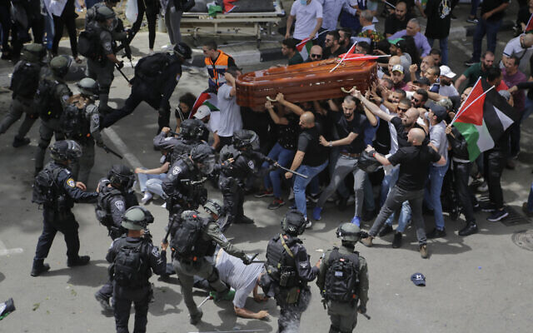
Israeli police confront mourners as they carry the casket of slain Al Jazeera veteran journalist Shireen Abu Akleh during her funeral in East Jerusalem, on Friday, May 13, 2022. (AP Photo/Maya Levin)
According to a report by Channel 13, there is “a lot of anger” against Barlev among the police force, with some officials insisting that he “forced” Shabtai to launch a probe.
Police officers involved in the incident have maintained the violent clashes were the result of rioters throwing rocks toward them.
Senior police officials have stated that all efforts were made to allow a peaceful and respectful funeral, including coordinating the event’s logistics with the deceased reporter’s family.

Palestinian mourners wave national flags as they carry the casket of slain Al Jazeera journalist Shireen Abu Akleh, during her funeral procession outside the walls of Jerusalem’s Old City, on May 13, 2022. (Ronaldo Schemidt/AFP)
“On the other hand,” the officials argued, “hundreds of rioters sought to interfere with the ceremony and hurt police officers.”
“As is the case in any operational incident, and especially one that saw officers exposed to violence by rioters and forced to resort to using force, the Israel Police will investigate the incident,” they added.
The officials also vowed not to let officers “be scapegoats in the most complex security situation seen in the last few years.”
“These are officers who sacrifice their own safety to protect Israeli citizens from terrorism,” they said.
Also Saturday, Kan public broadcaster reported that despite ordering the probe, Shabtai has indicated no disciplinary steps will be taken against any officers involved.
Video released by Israel Police showed at least one Palestinian hurled an object at Israeli officers before the dispersal began. The footage then showed Palestinians throwing objects at police after officers had moved in to disperse the crowd.
מיידים אבנים וחפצים לעבר כוחות הביטחון: המשטרה מפרסמת תיעוד נוסף מהעימותים בבית החולים הצרפתי בירושלים, בזמן יציאת ארונה של העיתונאית שירין אבו עאקלה@VeredPelman pic.twitter.com/ggLDiG38IL
— כאן חדשות (@kann_news) May 14, 2022
Barlev announced the probe into the incident earlier Saturday, saying it was important to “draw conclusions” from the conduct of police during the ceremony.
Results will be presented to officials in the coming days, according to the minister.
A statement issued by the police read: “The Israel Police supports its police officers, but as a professional organization that seeks to learn and improve, it will also draw lessons from the incident.”
Responding to images from the funeral, White House Press Secretary Jen Psaki said they were “deeply disturbing.”
US President Joe Biden said he did not know the details surrounding that incident but noted that it “has to be investigated.”
The European Union said it was “appalled.”
The clashes erupted at Saint Joseph’s Hospital after Palestinians sought to carry Abu Akleh’s coffin on foot, waving several Palestinian flags, to the Old City.
Police had designated that the procession would begin at the Jaffa Gate, less than two miles away.
Police instructed the crowd to return the coffin to the hearse, “but the mob refused,” police said. “Police intervened to disperse the mob and prevent them from taking the coffin, so that the funeral could proceed as planned in accordance with the wishes of the family.”
The crowd seized the coffin, leading the Palestinians gathered in the hospital square to cheer, carrying her casket forward.
Another video showing ISF elements who stormed Saint Joseph Hospital beating a group of Palestinians carrying the body of late Journalist Shireen Abu Aqla who was shot dead by ISF during ISF operation in Jenin City three days ago. pic.twitter.com/RAhqpbxDGb
— Local Focus – Security Alerts (@LocalFocus1) May 13, 2022
After a brief standoff, police officers rushed the crowd, beating mourners and firing stun grenades. Abu Akleh’s casket almost toppled to the ground during the skirmish.
Abu Akleh’s body was then taken by van, surrounded by a police escort, to the Greek Melkite Church near Jaffa Gate.
Officers tore Palestinian flags off of the van as well before escorting it to the ancient sanctuary, according to footage.
Israel Police later said that six people had been detained after riots “that had included stone-throwing.”
In an interview with the BBC on Friday, Abu Akleh’s brother appeared to dispute the Israel Police version of events, saying that the family and mourners hoped to hold a “small procession” but were “bombarded” by officers as they left the hospital. He did not clarify if the planned procession was on foot or by car.
Abu Akleh was one of the most beloved Palestinian journalists working in Arabic media. A longtime correspondent for the pan-Arab network Al Jazeera, many also saw her as a trailblazing model for women in a field dominated by men.
On Saturday, the Palestinian Authority said that while international bodies could “participate” in the investigation, Israel would not be permitted to join the probe into Abu Akleh’s death. https://www.timesofisrael.com/some-police-critical-of-force-after-violence-at-journalists-funeral-in-jerusalem/

Erez Crossing with Gaza set to reopen following two-week closure
In first public appearance amid Israeli threats, Hamas chief in Strip Yahya Sinwar visits Al Jazeera offices: ‘I’m not hiding’
By TOI staff Today, 9:37 pm
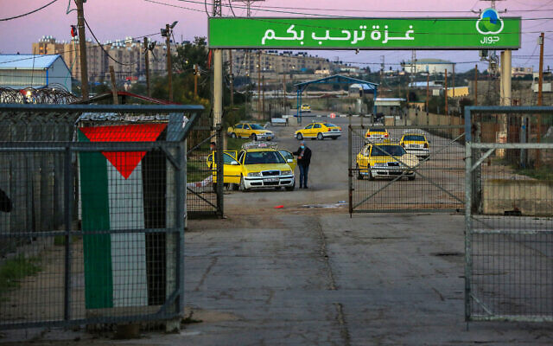
Palestinian workers are seen at the Erez crossing in the northern Gaza Strip, as they wait to enter Israel for work, on March 13, 2022. (Attia Muhammed/Flash90)
The Erez Crossing with the Gaza Strip is slated to reopen on Sunday nearly two weeks after it was shuttered, Israel’s military liaison to the Palestinians announced on Saturday evening.
“The continuation of the civil policy will be possible in accordance with situational assessments and the preservation of security stability,” the Defense Ministry body, known as COGAT, said in a statement.
Reopening the crossing will enable the 12,000 Palestinians in the Hamas-ruled enclave who hold Israeli work permits to once again enter Israel.
The Erez Crossing has been closed since May 3, when Israel shut down crossings to both Gaza and the West Bank during Memorial Day and Independence Day. It was due to reopen on May 6, but Israel kept it shuttered in the wake of a deadly terror attack in Elad on Independence Day.
Justice Minister Gideon Sa’ar spoke out against the move.
“Renewing the entry of workers from Gaza into Israel at this time is not justified or correct,” Sa’ar said. “Sinwar and Hamas, who are engaged nonstop in terror and incitement, should be removed from their comfort zone.”
Yahya Sinwar, Hamas leader in Gaza, visits Al Jazeera’s offices in the coastal enclave on May 14, 2022. (Screen capture: Twitter)
Sa’ar was referring to Hamas in Gaza chief Yahya Sinwar, who made a public appearance on Saturday for the first time since calls began to echo in Israel for his assassination following the Elad terror attack.
On Independence Day, two Palestinian terrorists used an axe and a knife to kill three Israelis in Elad before fleeing the scene and being captured only 60 hours later. The attack came days after Sinwar gave a speech urging Palestinians to strike Israelis with whatever they had — including axes.
Advertisement
“Let everyone who has a rifle, ready it. And if you don’t have a rifle, ready your cleaver or an axe, or a knife,” Sinwar said at the time.
Following the attack, Israeli officials reportedly warned Sinwar that he could face retaliation if he continues his incitement.
On Saturday afternoon, paying a visit to the Gaza offices of Al Jazeera, Sinwar said he was not afraid of such threats.
“I’m not hiding,” he said.
Palestinian mourners wave national flags as they escort the casket of slain Al-Jazeera journalist Shireen Abu Akleh, during her funeral procession near Jaffa Gate, in the Old City of Jerusalem, on May 13, 2022. (Ahmad Gharabli/AFP)
Sinwar visited the TV station’s offices in a show of support following the death of journalist Shireen Abu Akleh on Wednesday during clashes between Palestinian gunmen and Israeli troops during a military raid in the West Bank.
“Abu Akleh was killed more than once: First when they shot her and the second time with the attempts to prevent the funeral,” Sinwar said during his visit, referring to violent scenes at her funeral on Friday for which Israel has faced widespread condemnation. https://www.timesofisrael.com/erez-crossing-with-gaza-set-to-reopen-following-two-week-closure/

Hamas warns against Jews visiting Temple Mount on Nakba Day: ‘Will lead to a clash’
Gaza-ruling terror group urges ‘masses’ to foil ‘occupation’s evil plans’ as Jewish activists plan to tour Jerusalem holy site for Second Passover on Sunday
By TOI staff Today, 5:34 pm
Palestinians wave Palestinian and Islamic flags as they rally at the Al-Aqsa Mosque on the Temple Mount in Jerusalem, following the last Friday prayers of the Muslim holy month of Ramadan, on April 29, 2022. (Ahmad Gharabli/AFP)
The Gaza-ruling Hamas terror organization on Saturday warned Israel of a “clash” as it urged Palestinians to flock in mass to the Temple Mount in Jerusalem’s Old City for Nakba Day on Sunday.
May 15 marks the 74th anniversary of what the Arab world calls the “Nakba” or “catastrophe” surrounding the establishment of Israel, referring to the displacement and dispossession of Palestinians during the Israel’s War of Independence in 1948-1949.
This year, Nakba Day coincides with Pesach Sheni, or Second Passover, during which Jews who were unable to participate in the religious festival observe it a month later.
Appearing to respond to calls on social media by Temple Mount activists for Jews to visit the holy site on Sunday, Hamas spokesperson Hazem Qassem warned of a “clash” for which he said the “Zionist occupier” would be responsible.
“The extremist statements calling on [Jews] to storm the Al-Aqsa Mosque tomorrow on Nakba Day and the approval of the ‘occupation forces’ to do so are a dangerous escalation that constitutes a provocation toward our people and our feelings that will lead to a clash that the ‘Zionist occupier’ will be held responsible for,” the spokesman warned in a statement.
“We call on the masses of our people in Jerusalem, the West Bank and occupied Israel to come to the Al-Aqsa Mosque and foil the occupation’s evil plans,” he added.
The warning following weeks of increased tensions and frequent clashes between Palestinians and Israeli troops in the capital, with Passover, the Muslim holy month of Ramadan and the Christian holiday of Easter all intersecting last month.
Under the prevailing status quo at the Temple Mount, Muslims are allowed to visit and pray at the site, while Jews are only allowed to visit during limited time slots and cannot pray. The site is the most sacred place for Jews as the location of the biblical temples, and the Al-Aqsa Mosque, which sits atop the Temple Mount, is the third-holiest site for Muslims.
During Passover in April, a plan by Jewish extremists to sacrifice a goat at the Temple Mount roiled Palestinians and was stopped by police, who have repeatedly reiterated their commitment to maintaining the status quo at the flashpoint site.
In an attempt to limit clashes in the Temple Mount compound last month, Israel barred non-Muslims from visiting the Temple Mount during the last roughly ten days of Ramadan, a policy that has been in place for years.
Israel has also highlighted a campaign of incitement led by Hamas and other extremist groups that falsely claim Israel aims to violate the status quo at the Temple Mount.
The Hamas warning also comes amid ongoing tensions between Palestinians and Israel following the death of Al Jazeera reporter Shireen Abu Akleh earlier this week in the northern West Bank city of Jenin amid clashes between Palestinian gunmen and Israeli forces during an Israeli arrest raid. Palestinians blame Israel, which has said it remains unclear who fired the shot that killed her.
Abu Akleh’s death has further hindered an already shaky relationship between Israel and the Palestinian Authority, with the latter refusing to hold a joint investigation with Israel and rejecting its request to share findings from the reporter’s autopsy, which may prove vital in finding out who shot the fatal bullet.
An interim report issued by the IDF earlier on Friday set out two likely scenarios regarding who fired the fatal shot — an instance of Palestinian terrorists’ gunfire and of Israeli sniper fire — in neither of which Abu Akleh was deliberately targeted. MORE - https://www.timesofisrael.com/hamas-warns-jews-visiting-temple-mount-on-nakba-day-will-lead-to-a-clash/

‘Edge of Tomorrow’: Israeli program set to 'revolutionize' combat soldiers
Developers say cutting-edge program will enable infantry teams to work seamlessly together, using networked warfare tech, and will improve 'soldiers' lethality, survivability, situational awareness, stamina and more'
The Media Line, Ynet | Published: 05.14.22, 18:40
Israel earlier this week unveiled an innovative program, called “Edge of Tomorrow,” which is set to revolutionize the concept of combat soldiers.
Defense Ministry's Directorate of Defense Research and Development (DDR&D) developed the program along with Elbit Systems, one of the main companies producing defense electronic devices in Israel.
The program incorporates networked warfare technologies for each and every soldier on an infantry team, and aims to improve the combat team’s modern urban warfare, according to the Defense Ministry.
“‘Edge of Tomorrow’ is an innovative program that is extremely unique thanks to our change in perspective," Lt. Col. Shlomi Buskila, head of the LWSOF Branch in the DDR&D, said in a statement.
"The program aims to enable optimal operational value for the ground forces combat soldiers by strengthening the synergy between them and their team. The program incorporates a wide array of advanced technologies used by the soldiers and their teams, leading to a whole much greater than the sum of its parts.”
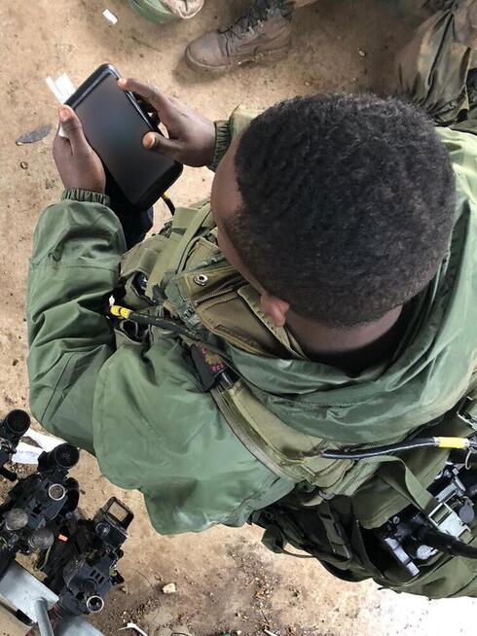
An IDF soldier using Elbit technology (Photo: Elbit Systems)
Mayan Lazarovich, spokesperson for the Defense Ministry, said the program has been “a multiple-year effort that has continually improved the infantry soldiers’ lethality, survivability, situational awareness, stamina and more”.
An industry source, who provided an in-depth explanation of the plan, described it as a suit which consists of a set of wearable technologies that include many connected subsystems.
He said that there will be specialized suits for every kind of soldier on a team. “There are different roles within a team, so everyone gets his specific suit and it’s all connected. There is going to be a soldier suit, a commander suit, a sharpshooter suit, etc.,” he said.

Illustration, IDF intelligence officer (Photo: Uri Bareket)

The source added that this set of technologies includes many different devices such as display googles, a sleeve that helps with transmitting information within the group, computerized rifles, night vision systems, a component that can help with carrying weight, and fire detection capability. “The soldier can carry a very small device that can detect the direction of hostile fire so it can be spawned very quickly and very effectively,” he said.
He added that looking back between 50 years and 100 years ago, there was only incremental change in the technological capabilities that were provided to an infantry soldier.
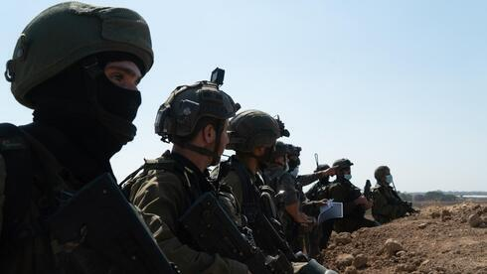
Now, he said, “what we are talking about is actually a step change trying to bring about, you know, real transformation technologically speaking. We’re looking at the infantry soldier and at the team level.”

IDF forces on the Gaza border (Photo: IDF Spokesperson's Unit)
He said that the plan will improve the individual infantry soldier and the team as a whole: “Not just a better rifle, a better weapon, better night-vision goggles, but we look at it as a comprehensive capability.”
Lazarovich said that the plan is still in development, and the timing of the launch of the program is still uncertain.
“The Edge of Tomorrow is a program focused on development. Decisions regarding the program’s launch will be made in the future,” she said.https://www.ynetnews.com/magazine/article/by2ojp585
European nations urge Israel to scrap plans for new settlement homes
In joint statement, 15 countries say construction of over 4,000 planned units ‘would constitute an additional obstacle to the two-state solution’
By AFP and TOI staff Today, 4:45 pm

A view of construction work in the Jewish settlement of Givat Ze'ev, between Jerusalem and Ramallah, in the West Bank on May 10, 2022. (Ahmad Gharabali/AFP)
BERLIN — Fifteen European nations on Friday implored Israel to drop newly approved plans for more than 4,000 settler homes in the West Bank, cautioning that the construction interferes with developing peace between Israelis and Palestinians.
“The new housing units would constitute an additional obstacle to the two-state solution,” said the countries in a statement issued by their foreign ministries. [Still hallucinating over an irrational and unworkable concept that has been dead for years. – rdb]
“Israeli settlements are in clear violation of international law and stand in the way of a just, lasting and comprehensive peace between Israelis and Palestinians,” they added.
The 15 European countries signing up to Friday’s statement include France, Belgium, Denmark, Finland, Poland, Germany, Greece, Ireland, Italy, Luxembourg, Malta, the Netherlands, Norway, Spain and Sweden.
The Defense Ministry body that authorizes West Bank construction green-lit plans Thursday for 4,427 new settlement homes.
All 25 plans on the docket were advanced by the Civil Administration’s High Planning Subcommittee. More than half of the homes received final approval for their construction.
This picture taken on May 10, 2022, shows construction work in the West Bank settlement of Givat Ze’ev, near Jerusalem. (Ahmad Gharabli/AFP)
The projects for both the Palestinians and the Israeli settlers will be located in Area C, where Israel maintains civilian control. Roughly 330,000 Palestinians and 450,000 Israeli settlers live in the 60 percent of the West Bank that makes up Area C, according to figures from the UN and Israeli authorities respectively.
In addition to approving thousands of new homes, the plans retroactively legalized the Mitzpeh Dani and Oz V’gaon outposts. The former is a neighborhood of the Ma’aleh Michmash settlement in the heart of the West Bank, while the latter is a nature reserve and education center that was built following the kidnap and murder of Israeli teens Gil-ad Shaer, Eyal Yifrach and Naftali Fraenkel in the summer of 2014.
Advertisement
On Thursday, the UN special coordinator for the Middle East peace process condemned the Israeli approvals.
“I condemn today’s decision by Israeli authorities to advance plans for over 4,000 housing units in settlements in the occupied West Bank. These include the retroactive approval of two illegal outposts and a park,” Tor Wennesland said in a statement. “Continued settlement expansion further entrenches the occupation, encroaches upon Palestinian land and natural resources, and hampers the free movement of the Palestinian population.” https://www.timesofisrael.com/european-nations-urge-israel-to-scrap-plans-for-new-settlement-homes/

Biden assures Abdullah US recognizes Jordan as custodian of holy places
“The President recognized the Hashemite Kingdom of Jordan’s crucial role as the custodian of Muslim holy places in Jerusalem,” the White House says.
By OMRI NAHMIAS Published: MAY 14, 2022 20:39 Updated: MAY 14, 2022 21:24
WASHINGTON – US President Joe Biden met on Friday with King Abdullah II of Jordan “and reaffirmed the close and enduring nature of the friendship between the United States and Jordan,” the White House said.
According to a readout of the conversation, Jordan is a critical ally and force for stability in the Middle East, “and the President confirmed unwavering US support for Jordan and His Majesty’s leadership.”
“The leaders consulted on recent events in the region and discussed urgent mechanisms to stem violence, calm rhetoric and reduce tensions in Israel and the West Bank,” the White House said.
The statement goes on to say that Biden affirmed his “strong support for a two-state solution to the Israeli-Palestinian conflict and cited the need to preserve the historic status quo at the Haram al-Sharif/Temple Mount.”
“The president also recognized the Hashemite Kingdom of Jordan’s crucial role as the custodian of Muslim holy places in Jerusalem,” the White House said.
JORDAN’S KING ABDULLAH II speaks after being welcomed by US House Speaker Nancy Pelosi to the US Capitol in Washington earlier this month. (credit: REUTERS/ELIZABETH FRANTZ)
The two discussed several other issues, including the political and economic benefits “of further regional integration in infrastructure, energy, water and climate projects, with Jordan a critical hub for such cooperation and investment.” https://www.jpost.com/middle-east/article-706692 [Has the dolt in the oval office ever looked or reviewed what happened to Jerusalem and the Holy sites when it was under complete Jordanian control for for about 19 years? All the Holy sites were trashed except the Islamic ones. – rdb]

US Embassy in Jerusalem to hold walk-in day for children’s passport services May 19
From 7:45 a.m. to noon next Thursday, those without appointments can apply at American diplomatic mission, avoid extended wait times for appointments
By TOI staff Today, 4:42 pm
The US Embassy in Jerusalem said Friday that it will allow walk-ins for consular services for one day, on May 19, to make it easier for kids to get their passports this summer.
From 7:45 a.m. to noon next Thursday, those without an appointment can apply for their children’s passports at the embassy’s consular section on David Flusser Street in Jerusalem.
Consular services for US citizens in Israel and for those applying for a US visa have been profoundly affected by lockdowns and other safety measures since the beginning of the coronavirus pandemic, according to an embassy spokesperson.
Processing time of a new passport is seven weeks, according to the Bureau of Consular Affairs website. Some consular services can be completed through the mail, but children’s passports must be renewed in person.
The open day could help accelerate the process for many parents who are waiting for appointments to renew or apply for children’s passports.
The walk-in day will not include applications for adult renewals, lost passports or reports of birth abroad. While there is no need to sign up in advance, the embassy said those with an existing appointment in Jerusalem or at the embassy’s branch office in Tel Aviv should not attend.
The embassy also said it expects for wait times during the open day to range from one and six hours, warning it does not have facilities such as shade, bathrooms, chairs or water outside the compound, which will only be available upon entry.
The Jerusalem Embassy and its extension in Tel Aviv drastically have reduced their in-person services since the beginning of the pandemic in Israel starting in March 2020.
Because of the heavy backlog, finding appointments for passport applications have taken longer than usual. Last year, US citizens living in Israel formed a petition that was sent to US lawmakers, the White House and the embassy in Israel. The petition had over 1,000 signatures. https://www.timesofisrael.com/us-embassy-in-jerusalem-to-hold-walk-in-day-for-childrens-passport-services-may-19/

Secret UK propaganda campaign stoked Israel hatred to appear authentic — documents
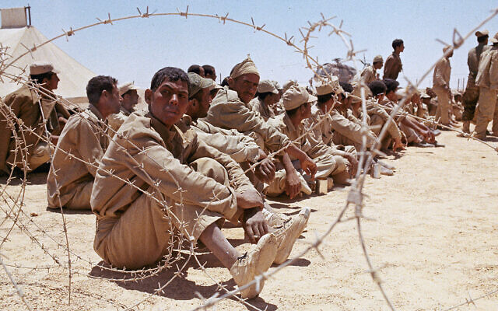
Declassified files show Britain attempted to sow division between Moscow and its Arab allies using fake reports blaming both sides for Egypt’s defeat in the 1967 Six Day War
By TOI staff Today, 11:43 pm

Illustrative: Egyptian prisoners of war are shown during the Arab-Israeli Six Day War in June 1967. Exact date and location unknown. (AP Photo)
The British government ran a secret propaganda campaign aimed at destabilizing the country’s enemies during the Cold War by inciting violence, supporting racial tensions and encouraging hatred toward Israel, according to newly declassified documents.
The documents, which were reported on by The Guardian, highlighted a “black propaganda” campaign from the mid-1950s to late 70s that mostly targeted African countries, the Middle East and parts of Asia with fake reports that were ultimately intended to spread anti-communist sentiment.
The term refers to the creation of false news reports meant to appear as if written by those the pieces were meant to discredit — in this case, foes of the Western alliance during the Cold War.
According to the documents, the extensive campaign attempted to turn Muslims against Moscow and occasionally used anti-Israel propaganda in order to appear authentic.
It was led by the UK’s Information Research Department (IRD), which was established after World War II as a response to Soviet propaganda targeting Britain and was coordinated with the CIA’s war propaganda operations.
Rory Cormac, an expert in the history of subversion and intelligence, told the Guardian the declassified papers were “the most important of the past two decades.”
“It’s very clear now that the UK engaged in more black propaganda than historians assume and these efforts were more systemic, ambitious and offensive. Despite official denials, [this] went far beyond merely exposing Soviet disinformation,” Cormac argued.
Cormac had stumbled upon the declassified documents when researching material for a book. His study of the documents constitutes the most extensive insight yet into the IRD’s disinformation operations to date, according to the report. MORE - https://www.timesofisrael.com/secret-uk-propaganda-campaign-stoked-israel-hatred-to-appear-authentic-documents/ [It would seem that the Brits are as bad with their biased and targeted propaganda as the toads in DC. – rdb]

Hezbollah’s weapons divide Lebanon as it holds parliamentary elections Sunday
Calls to dismantle terror group have dominated campaigns of rival factions ahead of vote, the first since economic collapse and deadly Beirut port blast
By Agencies Today, 6:20 pm
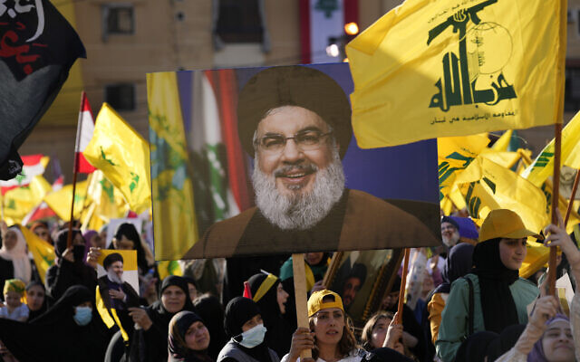
Hezbollah supporters wave portraits of Hezbollah leader Sayyed Hassan Nasrallah and their group flags, during an election campaign, in the southern suburb of Beirut, Lebanon, May 10, 2022. (AP Photo/Hussein Malla)
BAALBEK, Lebanon — It was a sea of yellow as thousands of men, women and children waving Hezbollah flags and wearing the group’s trademark yellow caps rallied on a giant plot of land in the ancient eastern city of Baalbek in support of the heavily armed terrorist group.
One after another, many attendees vowed to vote Sunday for the Shiite Muslim Hezbollah and its allies in Lebanon’s closely watched parliamentary elections, rejecting any attempt to disarm the powerful group.
Despite a devastating economic collapse and multiple other crises gripping Lebanon — the culmination of decades of corruption and mismanagement — the deeply divisive issue of Hezbollah’s weapons has been at the center of the vote for a new 128-member parliament.
Disarming the group has dominated political campaigns among almost all of the group’s opponents. Those include Western-backed mainstream political groups and independents who played a role in nationwide protests since the start of the economic meltdown in October 2019.
“This is the biggest misinformation campaign. Why? Because they are implementing America’s policy against the resistance weapons,” senior Hezbollah official Hussein Haj Hassan told The Associated Press on Friday ahead of the rally in Baalbek.
Hezbollah was the only group officially allowed to keep its weapons after the 1975-90 civil war because it was fighting Israeli forces occupying parts of south Lebanon. In 2000, Israel withdrew from Lebanon but Hezbollah and others in the small Mediterranean nation insisted its weapons were necessary to defend it against Israel, which has one of the strongest armies in the region.

A Hezbollah supporter holds up an Arabic banner that reads, “At your service Nasrallah,” as he attends an election campaign, in Baalbek, east Lebanon, May 13, 2022. (AP Photo/Hussein Malla)
Hezbollah has since fought a monthlong war with Israel in 2006 that ended in a draw and after the start of the conflict in neighboring Syria, the Iran-backed group sent thousands of fighters to fight alongside Syrian President Bashar Assad’s forces helping him tip the balance of power in his favor.
Hezbollah’s rivals say its weapons and its backing of regional forces such as Assad’s and the Iran-backed Houthi rebels in Yemen have harmed Lebanon’s relations with oil-rich Persian Gulf nations. Those nations have categorized the Lebanese group as a terrorist organization and withheld crucial financial support for the country.
Haj Hassan, a legislator since 1996 and a cabinet minister three times, said claims that Hezbollah is responsible for Lebanon’s collapse were “a big lie.”
“They forgot the political system, economic system, corruption, the war in Syria and its effects on Lebanon and they forgot the American sanctions,” he said at his home near Baalbek.
The bespectacled 62-year-old lost two brothers who fought for Hezbollah during Lebanon’s civil war and a nephew in Syria.
Hezbollah maintains its weapons are to defend Lebanon and not for internal use. But the group used them against rivals in May 2008 in the worst fighting at the time in many years. The Hezbollah offensive came after the government of then-Hezbollah opponent Fouad Saniora decided to dismantle the terror group’s military telecommunications network.
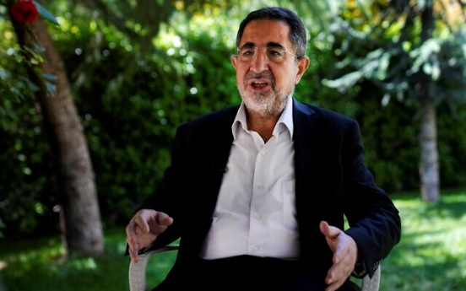
Hezbollah lawmaker Hussein Haj Hassan, speaks during an interview with the Associated Press, at his house, in Baalbek, east Lebanon, Friday, May 13, 2022. (AP Photo/Hussein Malla)
“No Lebanese group should have the right to be armed while other Lebanese are not,” said Samy Gemayel, head of the right-wing Kataeb party, in comments to the local LBC station Friday night.
The vote this year is the first after the economic collapse, described by the World Bank as one of the worst the world has witnessed in more than 150 years. It is also the first since the August 2020 blast at Beirut’s port that killed more than 200, injured thousands and caused largescale damage in the capital.
Three former cabinet ministers allied with Hezbollah were charged in the port blast investigation but have refused to show up for questioning by the investigative judge. Hezbollah’s leader has blasted the judge and called for his replacement, and the investigation has been suspended for months following legal challenges by politicians.
Parliamentary elections are held once every four years and the last vote in 2018 gave a majority of seats to Hezbollah and its allies with 71 legislators.
As Lebanon sinks deeper into poverty, many Lebanese have been more openly critical of Hezbollah. They blame the group — along with the ruling class — for the devastating, multiple crises plaguing the country, including a dramatic currency crash and severe shortages in medicine and fuel.
Some expect its main Christian ally, the Free Patriotic Movement founded by Lebanese President Michel Aoun, to lose seats. Others have expressed disappointment at Hezbollah’s unshakable alliance with Nabih Berri, Lebanon’s longtime parliament speaker seen by many as the godfather of Lebanon’s corrupt sectarian-based and elite-dominated political system.
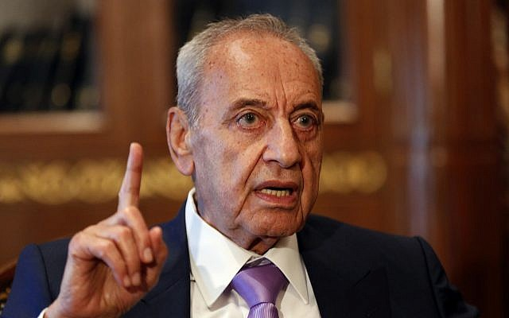
Lebanese Parliament Speaker Nabih Berri, in Beirut, Lebanon, May 11, 2018. (AP Photo/Hussein Malla)
Still, a win by Hezbollah is not in doubt. The group has a solid base and masterfully maneuvers its alliances and the electoral system. Intimidation ensures no Shiite threat emerges: Three Shiite candidates allied with the Saudi-backed Lebanese Forces group withdrew from the race in the Baalbek region within days.
In a Shiite village in southern Lebanon, residents were attacked last month as they headed to attend a rally for candidates running against Hezbollah. Weapons were fired in the air to disrupt a gathering by a Shiite cleric running against the Hezbollah-led alliance in Baalbek.
Hezbollah was blamed for intimidating the Shiite candidates, a claim Haj Hassan denied.
“They don’t want opposition within the [Shiite] sect. This is clear,” said Hilal Khashan, a political science professor at the American University of Beirut. Khashan added that Hezbollah and its Shiite ally the Amal group of Berri are trying to maintain control of the 27 seats allocated for the sect.
Little change is expected from the election as mainstream political parties and politicians remain strong while opposition candidates are fractured. Still, Western-backed mainstream parties are hoping to strip the parliamentary majority from Hezbollah, while many independents are hoping to break through traditional party lists and candidates.
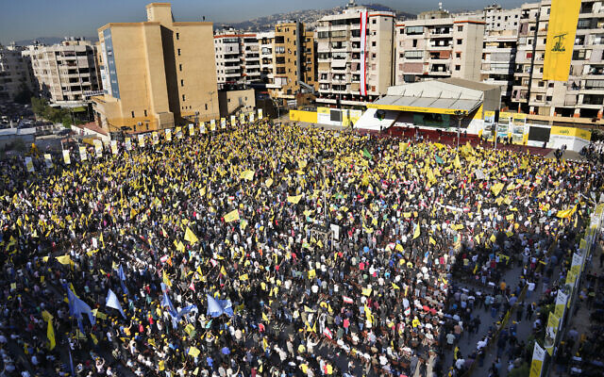
Hezbollah supporters wave their group flags, as they attend an election campaign, in the southern suburb of Beirut, Lebanon, May 10, 2022. (AP Photo/Hussein Malla)
The vote comes after a powerful Sunni leader, former Lebanese prime minister Saad Hariri, suspended his work in politics. Some have warned this may help Hezbollah’s Sunni allies to win more seats.
“I consider the ballot box as a line of defense for us,” said nurse Hoda Falah during the rally in Baalbek. Falah said Hezbollah’s weapons have defended eastern Lebanon from attacks by the Islamic State group and al-Qaeda-linked militants over the years.
Top Hezbollah official Nabil Kaouk said in a speech last month that the elections will show that his group enjoys the most support in the small nation. He claimed that money flowing from Saudi Arabia, United Arab Emirates and the US to their “tools” in Lebanon will not change results.
“May 15 will prove that the American project to target the resistance is sterile and they will only harvest disappointments,” Kaouk said. https://www.timesofisrael.com/hezbollahs-weapons-divide-lebanon-as-parliamentary-elections-to-be-held-sunday/

Crown prince, longtime de facto ruler Mohamed bin Zayed elected UAE president
Succeeds half-brother Sheikh Khalifa day after his death; MBZ led push for Gulf nation’s normalization with Israel
By Agencies and TOI staff Today, 2:05 pm
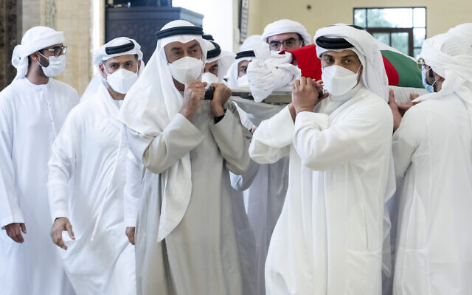
ABU DHABI — The UAE’s long-time de facto ruler Sheikh Mohamed bin Zayed Al Nahyan was elected as president on Saturday, official media said, a day after the death of former leader Sheikh Khalifa.
Sheikh Mohamed was elected by the Federal Supreme Council, WAM news agency said, becoming the ruler of the oil-rich country founded by his father in 1971.
WAM described the vote as unanimous among the rulers of the country’s sheikhdoms, which also includes the skyscraper-studded city of Dubai.
“We congratulate him, and we pledge allegiance to him, and our people pledge allegiance to him,” Dubai’s ruler, Sheikh Mohammed bin Rashid Al Maktoum, said on Twitter after the vote. “The whole country is led by him to take it on the paths of glory and honor, God willing.”
Sheikh Mohamed, often known as “MBZ,” met members of the Federal Supreme Council, made up of rulers of the UAE’s seven emirates, as the oil-rich country enters a period of mourning for his half-brother Sheikh Khalifa.
His ascension, which was widely expected, formalizes his position as leader of the desert state of 10 million after years of calling the shots while Sheikh Khalifa was sidelined by poor health.

This photo made available by the Ministry of Presidential Affairs, shows Sheikh Mohamed bin Zayed Al Nahyan, ruler of Abu Dhabi, front left, and Sheikh Mansour bin Zayed Al Nahyan, UAE Deputy Prime Minister and Minister of Presidential Affairs, front right, carry the body of Sheikh Khalifa bin Zayed Al Nahyan, president of the United Arab Emirates, with other members of royal family at Sheikh Sultan bin Zayed The First mosque, in Abu Dhabi, May 13, 2022. (Hamad Al Kaabi/Ministry of Presidential Affairs via AP)
Sheikh Khalifa took over as the UAE’s second president in November 2004, succeeding his father as the 16th ruler of Abu Dhabi, the richest of the federation’s seven emirates.
He has rarely been seen in public since 2014, when he had surgery following a stroke, although he has continued to issue rulings. The cause of death was not immediately released.
The UAE, a former British protectorate, has gone from a desert outpost to a booming state in its short history, fueled by its oil wealth and Dubai’s rise as a trading and financial center.
Under Sheikh Mohamed’s low-key direction, the United Arab Emirates has put a man in space, sent a probe to Mars and opened its first nuclear reactor, while using its oil-funded clout to develop a more assertive foreign policy.
In 2020, Sheikh Mohamed led the process to normalize diplomatic relations with Israel.
Israeli leaders expressed their condolences to the UAE over the president’s death.
“Sheikh Khalifa’s legacy and tremendous deeds are greatly admired in Israel,” Prime Minister Naftali Bennett said in a statement. “The State of Israel stands alongside the United Arab Emirates at this difficult time.”
Closely allied with Saudi Arabia, it has emerged as a leader of a reshaped Middle East since the retreat of traditional powers and the reduced involvement of the United States, joining a war against Iran-backed militants in Yemen and urging the West to take a harder line toward Tehran over concerns about its nuclear program. https://www.timesofisrael.com/crown-prince-longtime-de-facto-ruler-mohamed-bin-zayed-elected-uae-president/

Herzog to represent Israel at funeral of late UAE leader
President to meet new Abu Dhabi ruler ‘alongside other leaders’ during brief trip to Gulf state; Lapid congratulates MBZ on selection as president
By TOI staff Today, 11:56 pm
President Isaac Herzog is scheduled to travel to the United Arab Emirates on Sunday to attend the funeral of Emirati leader Sheikh Khalifa bin Zayed Al Nahyan.
According to a statement issued by his office Saturday, Herzog will be in the United Arab Emirates for several hours and “alongside other leaders” will meet with the new president, Abu Dhabi’s Sheikh Mohamed bin Zayed Al Nahyan, commonly known by his initials as MBZ.
The visit will be the president’s second to the UAE since he took office last year.
Herzog on Friday called the late Emirati ruler’s death “a great loss for our friends in the UAE and for the whole region.”
“Sheikh Khalifa’s bold leadership contributed so much to the advancement of the UAE and its people and to the growing partnership between our countries and is a great legacy for his successors,” he said. MORE - https://www.timesofisrael.com/herzog-to-represent-israel-at-funeral-of-late-uae-leader/

Ukraine says Russian troops pushed out of Kharkiv as war enters ‘long-term’ phase
Meanwhile, Russia’s offensive in Donbas appears to be turning into a village-by-village, back-and-forth fight with no major breakthroughs on either side
By OLEKSANDR STASHEVSKYI and david keyton Today, 3:02 pm
KYIV, Ukraine (AP) — Russian troops are withdrawing from Ukraine’s second-largest city after weeks of heavy bombardment, the Ukrainian military said Saturday as Kyiv and Moscow’s forces engaged in a grinding battle for the country’s east.
Ukraine’s general staff said the Russians were pulling back from the northeastern city of Kharkiv and focusing on guarding supply routes, while launching mortar, artillery and airstrikes in the eastern Donetsk region to “deplete Ukrainian forces and destroy fortifications.”
Ukrainian Defense Minister Oleksii Reznikov said the country was “entering a new — long-term — phase of the war.”
As the country’s top prosecutor put a Russian soldier on trial for war crimes, the first of dozens that could face charges, Ukrainian President Volodymyr Zelensky said Ukrainians were doing their “maximum” to drive out the invaders and that the outcome of the war would depend on support from Europe and other allies.
“No one today can predict how long this war will last,” Zelensky said in his nightly video address late Friday.
Russia’s offensive in the Donbas, Ukraine’s eastern industrial heartland, appeared to be turning into a village-by-village, back-and-forth slog with no major breakthroughs on either side. After failing to capture Kyiv, Ukraine’s capital, the Russian military decided to concentrate on the Donbas, but its troops have struggled to gain ground.
Zelensky said Ukraine’s forces made progress, retaking six Ukrainian towns or villages in the past day. Western officials said Ukraine had driven Russian forces back around Kharkiv, which was a key target for Moscow’s troops.
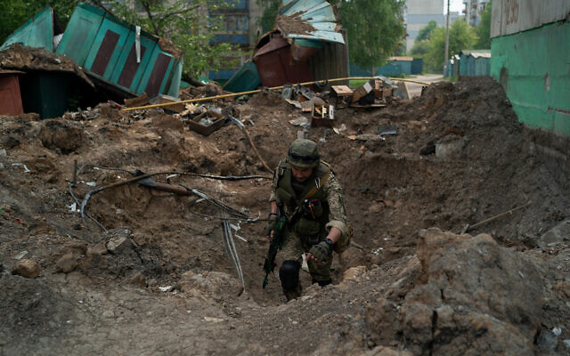
A special task force policeman inspects a site after an airstrike by Russian forces in Lysychansk, Luhansk region, Ukraine, on May 13, 2022. (AP Photo/Leo Correa)
“The Russians really haven’t made much in the way of tactical gains recently,” one Western official said, describing the war’s front line as “oscillating.”
“The Ukrainians continue to launch counterattacks, particularly around Kherson and Kharkiv. We expect this to settle into a long attritional battle,” the official said on condition of anonymity to discuss intelligence.
The Ukrainian military chief for the Luhansk region of the Donbas said Friday that troops had nearly full control of Rubizhne, a city with a prewar population of around 55,000.
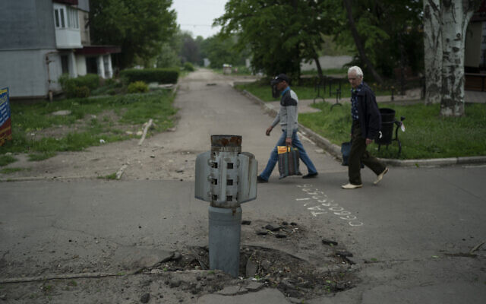
Fighting was fierce on the Siversky Donets River near the city of Severodonetsk, where Ukraine has launched counterattacks but failed to halt Russia’s advance, said Oleh Zhdanov, an independent Ukrainian military analyst.

People walk past part of a rocket that sits wedged in the ground in Lysychansk, Luhansk region, Ukraine, on May 13, 2022. (AP Photo/Leo Correa)
“The fate of a large portion of the Ukrainian army is being decided — there are about 40,000 Ukrainian soldiers,” he said.
However, Russian forces suffered heavy losses in a Ukrainian attack that destroyed a pontoon bridge they were using to try to cross the river in Bilohorivka, Ukrainian and British officials said, in another sign of Moscow’s struggle to salvage a war gone awry.
Ukraine’s airborne command released photos and video of what it said was a damaged Russian pontoon bridge over the Siversky Donets River and at least 73 destroyed or damaged Russian military vehicles nearby.

In this handout photo provided by the Ukraine Armed Forces, on May 12, 2022, a ruined pontoon crossing with dozens of destroyed or damaged Russian armored vehicles on both banks of Siverskyi Donets River after their pontoon bridges were blown up in eastern Ukraine. (Ukrainian Presidential Press Office via AP)
Britain’s Defense Ministry said Russia lost “significant armored maneuver elements” of at least one battalion tactical group in the attack. A Russian battalion tactical group consists of about 1,000 troops. It said the risky river crossing was a sign of “the pressure the Russian commanders are under to make progress in their operations in eastern Ukraine.”
In other developments, a move by Finland and, potentially, Sweden to join NATO was thrown into question when Turkish President Recep Tayyip Erdogan said his country is “not of a favorable opinion” toward the idea. He accused Sweden and other Scandinavian countries of supporting Kurdish militants and others Turkey considers terrorists.
Russian President Vladimir Putin undertook the war aiming to thwart NATO’s eastward advance. The invasion of Ukraine has other countries along Russia’s flank worried they could be next.
Zelensky said in his nightly video address to the nation that Ukrainians were doing everything they could to drive out the Russians, but “no one today can predict how long this war will last.”
“This will depend, unfortunately, not only on our people, who are already giving their maximum,” he said. “This will depend on our partners, on European countries, on the entire free world.”
With Ukraine pleading for more arms to fend off the better-equipped Russians, the European Union’s foreign affairs chief announced plans to give Kyiv an additional 500 million euros ($520 million) to buy heavy weapons.
Reznikov, Ukraine’s defense minister, welcomed the heavy weapons making their way to the front lines but also said no quick end to the war was in sight.
“Extremely difficult weeks await us. How many there will be? No one can say for sure,” he wrote in a Facebook post. In the ruined southern port of Mariupol, Ukrainian fighters holed up in a steel plant faced continued Russian attacks on the last stronghold of resistance in the city. Sviatoslav Palamar, deputy commander of Ukraine’s Azov Regiment, said his troops will hold out “as long as they can” despite shortages of ammunition, food, water and medicine.
And in Kyiv, Ukrainian soldiers dressed in white protective suits loaded bodies of Russian soldiers onto refrigerated train cars. The bodies were wrapped in white body bags and stacked several layers deep.
Col. Volodymyr Lyamzin, who supervised the operation, said several hundred bodies were being stored on the trains in the capital and in several other storage trains elsewhere. He said Ukraine was ready to hand the bodies over to Russia, but so far there was no agreement to do so.
Journalists packed a small courtroom in Kyiv on Friday for the trial of a captured Russian soldier accused of killing a Ukrainian civilian in the early days of the war — the first of dozens of war crimes cases that Ukraine’s top prosecutor said her office is pursuing.
Shyshimarin could get life in prison if convicted of shooting a 62-year-old Ukrainian man in the head through an open car window in a village in the northeastern Sumy region on February 28, four days into the invasion.
Shyshimarin, a member of a tank unit that was captured by Ukrainian forces, admitted that he shot the civilian in a video posted by the Security Service of Ukraine, saying he was ordered to do so. The trial, which resumes Wednesday, will be closely watched by international observers to ensure its fairness.
Ukrainian Prosecutor General Iryna Venediktova said she is readying war crimes cases against 41 Russian soldiers for offenses including bombing civilian infrastructure, killing civilians, rape and looting. https://www.timesofisrael.com/ukraine-says-russian-troops-pushed-out-of-kharkiv-as-war-enters-long-term-phase/

Russia warns of response if NATO moves nuclear forces closer
UK defense ministry: Ukraine's Kherson region to request accession into Russia • Moscow has "no hostile intentions" towards Finland, Sweden
By REUTERS Published: MAY 14, 2022 09:19 Updated: MAY 14, 2022 13:20
Moscow will take adequate precautionary measures if NATO deploys nuclear forces and infrastructure closer to Russia's border, Russian news agencies quoted Deputy Foreign Minister Alexander Grushko as saying on Saturday.
"It will be necessary to respond ... by taking adequate precautionary measures that would ensure the viability of deterrence," Interfax agency quoted Grushko as saying.
Moscow has no hostile intentions towards Finland and Sweden and does not see "real" reasons for those two countries to be joining the NATO alliance, Grushko added.
He also reiterated the Kremlin's earlier statement that Moscow's response to NATO's possible expansion will depend on how close the alliance moves military assets toward Russia and what infrastructure it deploys. Read full story
Finland's plan to apply for NATO membership, announced on Thursday, and the expectation that Sweden will follow, would bring about the expansion of the Western military alliance that Russian President Vladimir Putin aimed to prevent.
Kherson region to join Russian Federation?
The Russian-imposed military-civilian administration in Ukraine's Kherson region said it will ask Russia to include it in the Russian Federation, the British defense ministry said on Saturday.
If Russia carries out an accession referendum in Kherson, it will almost certainly manipulate the results to show a clear majority in favor of leaving Ukraine, Britain said in a regular Twitter bulletin.
Economic pressure
Group of Seven foreign ministers vowed on Saturday to reinforce Russia's economic and political isolation, continue supplying weapons to Ukraine and work to ease global food shortages stemming from the war.
After meeting at a 400-year-old castle estate in the Baltic Sea resort of Weissenhaus, senior diplomats from Britain, Canada, Germany, France, Italy, Japan, the United States and the European Union also pledged to continue their military and defense assistance for "as long as necessary."
They would also tackle what they called Russian misinformation aimed at blaming the West for food supply issues around the world due to economic sanctions on Moscow and urged China to not assist Moscow or justify Russia's war, according to a joint statement.
The key to putting more pressure on Russia is to ban or phase out buying Russian oil, with EU member states expected next week to reach an agreement on the issue even if it remains opposed by Hungary.
"We will expedite our efforts to reduce and end reliance on Russian energy supplies and as quickly as possible, building on G7 commitments to phase out or ban imports of Russian coal and oil," the statement said. https://www.jpost.com/breaking-news/article-706659

Russia’s oil revenue soars despite sanctions – Bloomberg
The country has earned roughly $20 billion per month from crude exports this year
14 May, 2022 13:08
Russia's oil export revenue has jumped some 50% since the beginning of 2022, Bloomberg reports, citing data from the International Energy Agency (IEA).
According to the agency’s monthly market report, Moscow has earned some $20 billion each month this year from sales of crude oil and oil-related products.
The earnings growth came despite Western sanctions over Russia’s military operation in Ukraine. As part of these penalties, the US banned all Russian oil imports, the EU and UK announced plans to scrap all purchases of Russian crude by the end of the year, and international oil giants such as Shell and TotalEnergies vowed to stop buying oil from the country.
However, according to the IEA, Russian shipments have only increased – by some 620,000 barrels per day compared to March to 8.1 million in April, returning to their average before the Ukraine crisis and the ensuing sanctions. Due to increased demand, more shipments were directed toward Asia, with China and India claiming supplies that were previously destined to go elsewhere, according to the agency. In addition the EU, despite its stance, has so far remained the largest market for Russian fuel with 43% of the country’s oil exports going to the bloc in April, the IEA said.
According to the agency, global energy markets, already tight due to uncertainty over Russian crude, may encounter further headwinds, with the combination of a European embargo on Russian oil and a demand rebound from China as Covid-19 lockdowns are lifted. The agency estimates that global supplies, which were already down by around 1 million barrels a day last month, might lose three times as much in the second half of the year. https://www.rt.com/business/555418-russia-oil-revenues-soar/

Fauci denies to Congress he smeared top scientists as 'fringe'
Parses words under oath when confronted by lawmaker
By Art Moore Published May 14, 2022 at 2:39pm
In a House hearing, Dr. Anthony Fauci denied that he ever characterized the Oxford, Harvard and Stanford epidemiologists who authored the Great Barrington Declaration as "fringe" scientists.
The exchange took place Thursday with Rep. Ben Cline, R-Va., in a hearing of a House Appropriates subcommittee broadcast by CSPAN 2 (Cline begins speaking at the 127:50 mark).
"On what basis did you identify these scientists as fringe?" Cline asked, referring to Dr. Martin Kulldorf of Harvard, Dr. Jay Bhattacharya of Stanford and Dr. Sunetra Gupta of Oxford.
" I never characterized them as fringe scientists, if you look at the record. That is incorrect," replied Fauci, the director of the National Institute of Allergy and Infectious Diseases since 1984.
"I never called them fringe scientists," he said.
However, the available evidence indicates Fauci agreed with Collins' characterization, regardless of whether he used the term.
In an Oct. 8, 2020, email to Fauci, Collins said the Great Barrington Declaration came from "three fringe epidemiologists" and told the NIAID director there needs to be a "quick and devastating published takedown."
Five days later, Collins made his viewpoint public when he was quoted in a Washington Post story saying the Great Barrington Declaration is a "fringe component of epidemiology."
Collins emailed to Fauci a link to the Post story and wrote, "My quotes are accurate, but will not be appreciated in the [Trump White House]."
Fauci replied: "They are too busy with things to worry about. What you said was entirely correct."
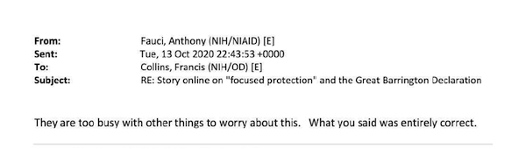
Collins wrote in his Oct. 8, 2020, email that the Great Barrington Declaration was a "proposal from three fringe epidemiologists" who met with then Health and Human Services Secretary
He noted it even had a co-signature from Nobel Prize winner Mike Leavitt at Stanford.
"There needs to be a quick and devastating published takedown of its premises," the NIH chief continued. "I don't see anything like that on line yet – is it underway?"
The Great Barrington Declaration criticized universal lockdowns, calling for focused protection of the vulnerable older population based on data showing they are more than a thousand times more likely to die from COVID infection than the young.
"As immunity builds in the population, the risk of infection to all – including the vulnerable – falls," the epidemiologists wrote. "We know that all populations will eventually reach herd immunity – i.e. the point at which the rate of new infections is stable – and that this can be assisted by (but is not dependent upon) a vaccine. Our goal should therefore be to minimize mortality and social harm until we reach herd immunity."
Fauci, shortly after the declaration came out, condemned the idea of relying on herd immunity to curb the spread of the novel coronavirus as "nonsense and very dangerous."
The declaration has been signed by 15,316 medical and public health scientists, and 45,154 medical practitioners.
Levitt, mentioned by Collins in the email as a declaration signatory, is a biophysicist and professor of structural biology at Stanford University. He was recipient of the 2013 Nobel Prize in chemistry.
Among other Great Barrington signatories are Dr. David Katz, the founder of the Yale University Prevention Research Center, and Dr. Cody Meissner, a professor of pediatrics at the Tufts University School of Medicine who is known as an expert on vaccine development, efficacy and safety.
Early in the pandemic, then-New York Democratic Gov. Andrew Cuomo mentioned Katz on several occasions in his daily briefing, openly wondering if his advice against the universal lockdowns should be heeded.
See the email:
Stanford's Bhattacharya is a physician, epidemiologist, health economist and public health policy expert focusing on infectious diseases and vulnerable populations.
"So now I know what it feels like to be the subject of a propaganda attack by my own government," he said in response to the Collins email.
"Discussion and engagement would have been a better path."
Harvard's Kulldorff has since left Harvard as a professor of medicine. He is a biostatistician and epidemiologist with expertise in detecting and monitoring infectious disease outbreaks and vaccine safety evaluations.
Oxford's Gupta is an epidemiologist with expertise in immunology, vaccine development and mathematical modeling of infectious diseases. https://www.wnd.com/2022/05/fauci-denies-congress-smeared-top-scientists-fringe/

Total ‘Blood Moon’ eclipse to rise over US this weekend
The moon will turn red during an eye-popping spectacle unlike any other in the night sky in 2022 -- as long as it isn't cloudy.
By Brian Lada, AccuWeather meteorologist and staff writer Published May 11, 2022 3:09 PM CDT | Updated May 14, 2022 9:39 AM CDT
The East Coast will be able to see the entire five-hour event. The West Coast will be able to see totality, which will last around an hour and a half.
The moon will plunge into darkness this weekend to create a celestial spectacle that has not been seen in the sky over the entire contiguous United States since the turn of the decade.
Just as the sun sets over North America on Sunday evening, the sun, Earth and moon will begin to align to create a total lunar eclipse.
Folks may have to stay awake later than usual for a chance to see Sunday night's eclipse as it unfolds throughout the first half of the night. However, losing some sleep will be worth it as the eclipse could be the top astronomy event of 2022.
This weekend's event will be the first total lunar eclipse visible from the entire contiguous U.S. since Jan. 21, 2019. There was a total lunar eclipse visible from the country on May 26, 2021, but it could be seen from only the western U.S., Alaska and Hawaii. MORE - https://www.accuweather.com/en/space-news/blood-moon-total-lunar-eclipse-sunday-night/1185955

Commentary:
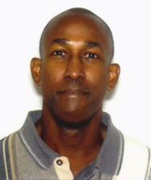
Humanizing the Most Vulnerable Promotes Life for All
By Guest Writer|May 13th, 2022 by Rolaant McKenzie
More than a decade ago, I was doing IT support work at a local Jewish Community Center. The Jewish librarian, knowing I was a Christian, asked me a question regarding what I thought of the abortion issue. She was in favor of keeping this practice legal. I think I gave her an answer that she did not expect, because it was not really a political one.
I told her that 150 years ago people that looked like me were considered less than fully human. Therefore, it was permissible to enslave people like me and dispose of us when we were no longer considered useful or convenient. More than 65 years ago in much of Europe, people like her were declared to be less than human, the cause of the ills of society, and inconvenient to be allowed to exist. Therefore, it was permissible and mandated that they be exterminated. Today, there is another group that has been similarly dehumanized because they were not considered useful or convenient. Tens of millions of this group have been killed already. They are babies in the womb.
I went on to say that when a society dehumanizes and exterminates the weakest and most vulnerable among them, no one is safe from being similarly treated. Where there is no sanctity of human life, when society deems us to be inconvenient, then we will likewise be dehumanized and eliminated.
I do not know if she ever changed her mind regarding abortion, but I could tell that what was said gave her something to seriously consider.
One of the reasons God found so many of the inhabitants of Canaan so detestable that He sent the children of Israel to utterly destroy them was because they practiced, among other evil things, passing their children through the fire. That is, they sacrificed children as burnt offerings to their false pagan gods (such as Molech). They were able to do this because they adopted a view of human life that allowed them to see their own children as a sacrificial commodity by which they could “purchase” benefits from their gods.
As Israel prepared to enter the Promised Land, the Lord through Moses gave strict warnings not to imitate the detestable things of the nations they were commanded to drive out.
“When you enter the land which the LORD your God gives you, you shall not learn to imitate the detestable things of those nations. There shall not be found among you anyone who makes his son or his daughter pass through the fire, one who uses divination, one who practices witchcraft, or one who interprets omens, or a sorcerer, or one who casts a spell, or a medium, or a spiritist, or one who calls up the dead. For whoever does these things is detestable to the LORD; and because of these detestable things the LORD your God will drive them out before you.” (Deuteronomy 18:9-12)
If the Lord so judged those nations that were engaged in child sacrifice, I wonder what will become of nations today that do so on a far greater scale through abortion?
Much of Western society, however imperfect, previously had a strong Judeo-Christian foundation. It held to a belief in God and our accountability to Him. There was a general belief in the Biblical view of humanity. In addition to being God’s special creation made in His image, human beings were more than physical bodies plus breath. There was an immaterial aspect to each person formed from the womb that made human life unique and sacred, consistent with being made in the image of God (Genesis 9:6). But when Western society centuries later adopted Darwinian evolution and rejected God, materialism became the prevailing view. Human beings were no longer made in God’s image but were just body plus breath with no spirit formed by random chance. In time this view has contributed to the idea that a person is not alive until birth. Children in the womb could be sacrificed when deemed inconvenient or profitable. Today, there are even some in society openly promoting and working to pass laws to kill babies after they are born.
Of all the kings of Judah and Israel, Manasseh of Judah was probably the evilest one of all. His story can be found in 2 Kings 21 and 2 Chronicles 33. He engaged in the kind of evil that characterized the abominations of the nations that God had driven out before Israel. He erected altars to pagan gods, worshiped the host of heaven and built altars for them in the temple courts, shed much innocent blood from one end of Jerusalem to the other, practiced witchcraft and divination, and took part in sorcery and consulted mediums. He even made his own sons pass through the fire. His reign of evil misled the people of Judah to sin more than the nations that the Lord destroyed before Israel.
Even though God spoke to Manasseh and the residents of Judah, they refused to listen and turn back from their downward spiral into depravity. In response, the Lord sent the nation of Assyria against Judah. Manasseh was captured, bound, and carried off in humiliation to Babylon.
But in Manasseh’s affliction, something wonderful happened.
“When he was in distress, he entreated the LORD his God and humbled himself greatly before the God of his fathers. When he prayed to Him, He was moved by his entreaty and heard his supplication, and brought him again to Jerusalem to his kingdom. Then Manasseh knew that the LORD was God.” (2 Chronicles 33:12-13)
The rich grace and forgiveness of God led Manasseh to genuine repentance (Romans 2:4). For the remainder of his reign he worked to undo all the evil he had done. He destroyed the pagan idols and altars and called upon the people of Judah to serve the LORD God of Israel (2 Chronicles 33:15-16). This return to the Lord set the stage for the great national revival that took place under his grandson King Josiah.
“Josiah removed all the abominations from all the lands belonging to the sons of Israel, and made all who were present in Israel to serve the LORD their God. Throughout his lifetime they did not turn from following the LORD God of their fathers.” (2 Chronicles 34:33)
“Then the king commanded all the people saying, ‘Celebrate the Passover to the LORD your God as it is written in this book of the covenant.’ Surely such a Passover had not been celebrated from the days of the judges who judged Israel, nor in all the days of the kings of Israel and of the kings of Judah. But in the eighteenth year of King Josiah, this Passover was observed to the LORD in Jerusalem. Moreover, Josiah removed the mediums and the spiritists and the teraphim and the idols and all the abominations that were seen in the land of Judah and in Jerusalem, that he might confirm the words of the law which were written in the book that Hilkiah the priest found in the house of the LORD. Before him there was no king like him who turned to the LORD with all his heart and with all his soul and with all his might, according to all the law of Moses; nor did any like him arise after him.” (2 Kings 23:21-25)
Many of us may have previously in life held to false religious or philosophical worldviews that over time developed into acceptance of, or participation in, some very evil things. But thanks be to God for the grace and forgiveness that is found in Jesus Christ. Just how big is God’s forgiveness? It is big enough to forgive the worst of sins and the worst of sinners. How great is the cleansing power of the blood of Jesus’ blood? It can make the most deeply embedded crimson stain of sin whiter than snow. (Isaiah 1:18)
“For while we were still helpless, at the right time Christ died for the ungodly. For one will hardly die for a righteous man; though perhaps for the good man someone would dare even to die. But God demonstrates His own love toward us, in that while we were yet sinners, Christ died for us. Much more then, having now been justified by His blood, we shall be saved from the wrath of God through Him. For if while we were enemies we were reconciled to God through the death of His Son, much more, having been reconciled, we shall be saved by His life.” (Romans 5:6-1)
[BIO: Rolaant McKenzie operates Gospel Outreach Ministries Online, a Christian apologetics ministry dedicated to the proclamation of the gospel of the Lord Jesus Christ online, and discussing important contemporary issues from a Biblical perspective. https://newswithviews.com/humanizing-the-most-vulnerable-promotes-life-for-all/
The EU and the Biden Administration Give in to Iran's Mullahs
by Majid Rafizadeh May 14, 2022 at 5:00 am
The Biden administration and the European Union are trying hard to appease the Iranian regime in order to revive a nuclear deal that will provide the ruling mullahs of Iran with additional billions of dollars of revenue, enhance the regime's legitimacy on the global stage, and actually open the path for Iran to have a nuclear arsenal.
The EU recently dropped its own bomb when it unabashedly said that it wanted new nuclear deal so that EU countries could buy oil from Iran -- one of only four countries on the US State Department's list of state sponsors of terrorism (the other three are Cuba, Syria and North Korea). Josep Borrell, the EU's foreign affairs representative, recently said:
"We Europeans will be very much beneficiaries from this [nuclear] deal, the situation has changed now. For us it was something . . . 'well we don't need it', [but] now it would be very much interesting for us to have another [crude] supplier."
The EU is basically admitting that it views the nuclear deal with Iran's ruling clerics from the perspective of economic opportunity. That should not be the objective of the nuclear talks. Instead, European leaders ought to be seeking a strong deal that will prevent the Iranian regime from acquiring nuclear weapons, especially -- as they should have learned from Russia by now -- because those nukes may soon be aimed at their countries.
In addition, by revealing its desperation to buy oil, the EU is empowering Iran's ruling clerics to gain the upper hand in the nuclear talks and obtain even more concessions to revive the nuclear deal. Desperation, to the Iranian regime, means weakness.
The recent statement by Borrell has also made the Iranian regime more determined to cling to its top demand: removing the Islamic Revolutionary Guard Corps (IRGC) and Quds Force from the lists of terrorist organizations. The designation of the IRGC as a foreign terrorist organization has nothing to do with Iran's nuclear program, but is linked to the IRGC and Quds Force terror activities across the world.
Now, however, the EU appears to have given in to the Iranian leaders' demand. The EU suggested recently that it is offering a compromise to delist the IRGC from the terror list as a last attempt to revive the nuclear deal. "At a certain moment," Borrell pointed out this week, "I will have to say, as coordinator [of the Vienna talks] I make this proposal on the table, formally... the only equilibrium point possible would be this one."
When it comes to the US position, the Biden administration, on the other hand, seems to be looking for a foreign policy achievement or a diplomatic win amidst the crisis The nuclear talks have been dragging on for a long time and the Biden administration has been facing criticism over its handling of the Ukraine crisis, China, Russia, Afghanistan and Iran. According to the latest Quinnipiac poll, a majority of the American people disapprove of the Biden administration's handling of foreign policy.
To appease Iran's mullahs, the EU and the Biden administration are also turning a blind eye to China's violating the sanctions on Iran. China has been steadily ramping up its oil imports from Iran, to currently nearly 1 million bpd, and global oil prices have increased. Reportedly, the Iranian regime is exporting more than 1.5 million bpd. The ruling mullahs of Iran are exporting approximately 80% of the oil they used to export before the sanctions. Iran's revenues heavily rely on oil exports; the sale of oil accounts for more than 50% of the regime's export revenues.
The EU, moreover, has yet to join the US in imposing sanctions on the Iranian regime. In fact, European countries are still trading with Tehran in spite of the US sanctions. Tehran Times reported:
"The value of trade between Iran and the European Union reached €4.863 billion in 2021, registering a nine-percent growth compared to the previous year.... According to the data released by the Tehran Chamber of Commerce, Industries, Mines and Agriculture (TCCIMA), Iran exported €554 million worth of commodities to the union during the said nine months, while importing goods valued at €2.7 billion".
It seems clear that the nuclear deal was never about stopping the predatory regime of Iran from obtaining nuclear weapons. For the EU, the nuclear deal is about trade, making money and buying oil from the world's leading state sponsor of terrorism; for the Biden administration, it is about a "diplomatic win". In return, the ruling mullahs will have a legal path to blackmail the world, using nuclear weapons and missiles, into sending Iran's regime billions for their terror and militia groups to torment everyone.
Dr. Majid Rafizadeh is a business strategist and advisor, Harvard-educated scholar, political scientist, board member of Harvard International Review, and president of the International American Council on the Middle East.
https://www.gatestoneinstitute.org/18531/eu-biden-iran-mullahs

Has the U.S., U.K., E.U., AND NATO Objective in Ukraine Evolved?
Douglas MacKinnon Posted: May 14, 2022 12:01 AM
Shockingly -- at least to some conservatives -- 149 Republicans in the House joined with every single Democrat to pass a bill being cheered-on by Nancy Pelosi to send another $40 Billion in U.S. taxpayer money to Ukraine. Money which has zero accountability once it is delivered to the Ukraine leadership.
Let’s all agree that Russian President Vladimir Putin’s invasion of Ukraine was illegal, reprehensible, and tragic. That settled, can we now ask what is ultimately in the best interests of the citizens of the United States? Especially in the face of record high fuel prices, inflation, and growing food shortages.
To this very point, Republican Senator Rand Paul of Kentucky said in part during a floor speech in the Senate: “My oath of office is to the U.S. constitution, not to any foreign nation and no matter how sympathetic the cause, my oath of office is to the national security of the United States of America.
“We cannot save Ukraine by dooming the U.S. economy. In March, inflation hit a 40-year high. Gasoline alone is up 48%, and energy prices are up 32% over the last year. Food prices have increased by nearly 9%. Used vehicle prices are up 35% for the year, and new vehicle prices have increased 12% or more.”
Indeed. The last time I checked, as citizens with our tax-money and increased risk to ourselves in the game, we still have the right to strongly oppose the invasion of Ukraine by Russian President Vladimir Putin while questioning some of the tactics or personalities involved.
To this very day, much of the narrative “reported” about the Ukraine-Russia war begins with: “As Ukraine reported…,” or “As Ukrainian President Volodymyr Zelensky and his team observed…” Maybe that’s all accurate. That said, there seems to be very little independent and verifiable reporting coming out of the country.
Knowing that, and understanding that in the collective fogs of war, politics, self-interest, and even war-time profiteering, things are often not how they seem, the strategy for leaders from the west should always be to take certain claims coming out of Ukraine with a grain of salt.
In the days after Putin invaded Ukraine, a number of politicians, pundits, academics, celebrities, and even journalists were calling for the Ukrainians to take up arms and take to the streets to fight the massive Russian war machine. Ten weeks later, as the countries supporting the innocent people of Ukraine continue to pour collectively tens of billions into the conflict, should we at least reevaluate how that advised strategy is actually helping Ukraine as more and more of its citizens are killed and more and more of its infrastructure gets reduced to rubble?
That tragic situation aside, we come to an exponentially more important question. That being: Has the U.S., U.K., E.U., NATO strategy “evolved” since the beginning of this war? Meaning, where initially, the only objective seemed to be about helping the innocent people of Ukraine. But now, as least to some, it appears that the ground has shifted dramatically under that initial objective.
An objective which now may have now morphed into: Destabilizing Russia and Vladimir Putin. Should that be the case, that shift in objectives would represent the single largest Neon-Red-flashing warning sign of our time.
If our politicians are open to embracing such an objective, it then becomes a moral imperative that the citizens of the nations they lead be informed of that policy shift. A policy shift which immediately and exponentially exposes the very real trip-wires in and around Ukraine which could be stepped upon to trigger a nuclear strike.
A nuclear strike list which might very well be topped with targets in Europe and the United Kingdom. A nightmare scenario Russian officials have been hinting at with growing frequency.
I recently spoke with a high-level intelligence official here in the United States regarding such a horrific possibility. He point-blankly stated: “When Putin first invaded, we put the odds of him using one of his tactical nuclear weapons at about thirty-percent. Today, our estimate is now up to sixty-percent.”
Insanely – at least to me – the rising possibility of a nuclear warhead actually being launched seems to be like a piece of lint to be brushed off the suit of those demanding the U.S. and Europe dial up the aggression against Putin and Russia.
Putin is unpredictable. As are his most loyal Generals. Even if the chance of a nuclear strike is only one-percent, it is the highest order of political and governmental malpractice not to factor that unpredictable risk into every single discussion regarding this war.
“Risk” being the bureaucratic-speak for “hundreds of thousands to millions of lives lost.”
Every sane and caring person in our country wants to help the innocent people of Ukraine. But, as our economy continues to unravel here in the United States, those same people have the right to ask – and know -- if the objective in Ukraine has “evolved” into one which dramatically increases the risk to them and their families.
https://townhall.com/columnists/douglasmackinnon/2022/05/14/has-the-us-uk-eu-and-nato-objective-in-ukraine-evolved-n2607234

THE SHORASHIM BIBLICAL GIFT CATALOG 005
http://mad.ly/7f9f64?pact=20013931524&fe=1
Support Shorashim!

ARUTZ SHEVA
Germany: Explosives, far-right literature, found at teen suspect's home
Explosives, antisemitic literature found at home of German teenager suspected of planning school attack.
Cnaan Liphshiz, JTA 14.05.22 20:57
German police found explosives and antisemitic, far-right literature at the home of a teenager they suspect of planning a terrorist attack at a school.
Federal officers took the 16-year-old suspect, who was not named in the German media, into custody on Thursday, the Tagesschau news site reported. He is suspected of planning to bomb a high school in Essen, a city about 250 miles west of Berlin.
Separately, German police are investigating a suspected arson at a Jewish cemetery near Cologne. Both incidents closely followed the release of a report indicating a 28% rise in antisemitic hate crimes in 2021.
In the incident in Cologne on Wednesday evening, an unidentified person poured a flammable substance on the wall around the Jewish cemetery of Bocklemünd, a western suburb of Cologne, Rundschau Online reported. Police are investigating whether the incident was an antisemitic hate crime, the report said.
The report published Tuesday by the Federal Ministry of the Interior and Community recorded 3,027 antisemitc incidents in 2021 — a 28% increase over the 2020 tally.
That increase occurred amid a drop in other forms of hate crimes, according to the report, titled “Politically-motivated Criminality in the Year 2021.”
In the same report, the ministry recorded a decrease in the number of other types of hate crimes, including anti-Muslim crimes (a decrease of 28% to 732 incidents); anti-Christian crimes (down 22% to 101 cases) and anti-foreigner hate crimes (down 10% to 4,735 cases).
Also on Thursday, the office of Berlin’s police commissioner declined to authorize a protest rally planned by pro-Palestinian activists seeking to commemorate what they call Nakba Day. Nakba in Arabic means catastrophe, and is used to describe the aftermath of the Arab defeat during Israel’s independence war of 1948.
Hundreds of thousands of Arabs left or were driven out of their homes in what is today Israel in that war.
The police said they blocked the gathering due to the likelihood of antisemitic speech and incitement at the event, based on previous rallies. The organizers are appealing the police’s decision with the court system, the Der Tagesspiegel newspaper reported Friday. https://www.israelnationalnews.com/news/327526

Ten dead in mass shooting at Buffalo supermarket
Shooter entered synagogue[SIC ???? – not a synagogue] wearing military-style gear, report says.
Israel National News 14.05.22 22:49
Multiple people have been injured in a mass shooting in Buffalo, New York, WIVB reported.
The shooting took place at Tops Markets, and the conditions of the victims are not known at this time, the report said,
According to Buffalo Police, the shooter is in custody.
BNO News put the number of people shot at nine, and claimed that several had been shot in the head.
Later, NBC Chicago said according to sources, the suspect "entered the store carrying a rifle and wore military-style gear or a type of body armor." It added that the gunman was among the dead.
AP said that the gunman shot and killed at least ten people before being taken into custody.
According to AP, investigators believe the man had been livestreaming the shooting and are investigating whether he posted a manifesto online.
Erie County Executive Mark Poloncarz tweeted: "I have been advised of an active multiple shooting event at the Tops Markets on Jefferson Street in Buffalo. Police are on scene. Please stay away from the area."
New York State Governor Kathy Hochul said, "I am closely monitoring the shooting at a grocery store in Buffalo. We have offered assistance to local officials. If you are in Buffalo, please avoid the area and follow guidance from law enforcement and local officials." https://www.israelnationalnews.com/news/327533
To be removed from this News list, Please click here and put "Unsubscribe" in the subject line.

05/14/2023 NEWS
Music & the Mikdash, with Rabbi David Louis: The Flute of Moses
https://www.youtube.com/watch?v=x4O301lbkiU&t=190s

"Everybody is in favor of free speech. Hardly a day passes without its being extolled, but some people's idea of it is that they are free to say what they like, but if anyone says anything back, that is an outrage."
-- Sir Winston Churchill (1874-1965) Prime Minister of the United Kingdom (1940-1945, 1951-1955)

Read the Prophets & PRAY WITHOUT CEASING!
That is the only hope for this nation!
Please  Remember  These  Folks  In  Prayer-  Check often  They  Change! | Pray that the world would WAKE UP! Time for a worldwide repentance!  ALL US soldiers fighting for our freedom around the world  Pray for those in our government to repent of their wicked corrupt ways.  Pray for BB – Severe sciatic Had surgery and doing well  Pray for EL – Had stoke – Now having coronary angiogram  Pray for KH – diagnosed with Multiple Myeloma  Pray for BB – Severe West Nile Fever –still not mobile- improving!  Pray for RBH – cancer recurrence  Pray for Ella – Child with serious problems  Pray that The Holy One will lead you in Your preparations for handling the world problems. – Have YOU made any preparations?
Exodus 18:⁸And Moses told his father-in-law all that the LORD had done unto Pharaoh and to the Egyptians for Israel's sake, all the travail that had come upon them by the way, and how the LORD delivered them. ⁹And Jethro rejoiced for all the goodness which the LORD had done to Israel, in that He had delivered them out of the hand of the Egyptians. ¹⁰And Jethro said: 'Blessed be the LORD, who hath delivered you out of the hand of the Egyptians, and out of the hand of Pharaoh; who hath delivered the people from under the hand of the Egyptians.

US ‘deeply disturbed’ over images of Israeli police beating mourners; EU ‘appalled’
Scenes of police using force against Jerusalem funeral procession, almost toppling casket of slain Al Jazeera journalist Shireen Abu Akleh, draw widespread condemnation
By Jacob Magid, Aaron Boxerman and Agencies Today, 10:31 pm
Israeli police confront mourners as they carry the casket of slain Al Jazeera veteran journalist Shireen Abu Akleh during her funeral in East Jerusalem, Friday, May 13, 2022. (AP Photo/Maya Levin)
Scenes of Israeli police rushing the funeral of the late Al Jazeera journalist Shireen Abu Akleh, beating mourners who raised Palestinian flags and nearly toppling her casket drew widespread condemnation on Friday with the White House saying it was “deeply disturbing,” while the European Union said it was “appalled.”
Over ten thousand Palestinians paid their respects to Abu Akleh — killed during a firefight early Wednesday between Israeli troops and Palestinian gunmen in Jenin — during a long, tense funeral procession that wound across the city from Sheikh Jarrah to the Mount Zion cemetery.
The clashes at Saint Joseph’s Hospital erupted after Palestinians sought to carry Abu Akleh’s coffin on foot, waving several Palestinian flags, to the Old City. Police had designated that the procession would begin at the Jaffa Gate, less than two miles away.
Officers rushed the crowd, beating mourners in an apparent attempt to force them to take down the Palestinian flags. Police fired stun grenades in an attempt to disperse the crowd, including towards those carrying Abu Akleh’s casket, which almost toppled to the ground.
Police later claimed that mourners near the coffin had thrown rocks and objects at officers during “violent riots.”
“Officers had to disperse and repel the rioters and make arrests in order to allow the funeral to take place,” Israeli police said in a statement, adding that six people had been detained.
Another video showing ISF elements who stormed Saint Joseph Hospital beating a group of Palestinians carrying the body of late Journalist Shireen Abu Aqla who was shot dead by ISF during ISF operation in Jenin City three days ago. pic.twitter.com/RAhqpbxDGb
— Local Focus – Security Alerts (@LocalFocus1) May 13, 2022
In footage from the scene, no such stone-throwing is evident before police rushed the crowd, although some Palestinians were later filmed throwing objects during the clashes.
Israeli police later escorted the casket in a black van, ripping Palestinian flags off the vehicle as it made its way to the church.
White House press secretary Jen Psaki called the images “deeply disturbing.”
The focus should be “marking the memory of a remarkable journalist who lost her life,” Psaki told reporters. “We regret the intrusion into what should have been a peaceful procession.”
WH Press Sec. Jen Psaki on "disturbing" images of Israeli police beating mourners who attended the funeral procession of journalist Shireen Abu Akleh in Jerusalem:
"We regret the intrusion of what should have been a peaceful procession." pic.twitter.com/RZWhTEQ9fL
— The Recount (@therecount) May 13, 2022
“We have urged respect for the funeral procession, the mourners and the family at this sensitive time,” Psaki said.
Asked if she condemned the Israeli forces’ actions, she responded: “I think when we said they were disturbing, we obviously were not justifying them.”
Biden officials also reached out privately to their Israeli counterparts to express their dismay over the police’s conduct during the funeral, an Israeli official told The Times of Israel.
US Ambassador to the UN Linda Thomas-Greenfield also condemned the incident.
“Deeply distressed by the images from Shireen Abu Akleh’s funeral procession. The tragedy of her killing should be handled with the utmost respect, sobriety, and care.”
The police’s conduct was also lambasted by several lawmakers in the US.
“This is awful to watch,” said Democratic Sen. Chris Murphy. “I’m traveling in Connecticut today, but I have my team working to get answers about what happened here.”
“Agree,” Democratic Sen. Chris Van Hollen chimed in. “This simply adds trauma on top of a tragedy. Need immediate accountability for these attacks on people mourning the death of American journalist Shireen Abu Akleh. And her killer must be brought to justice.”
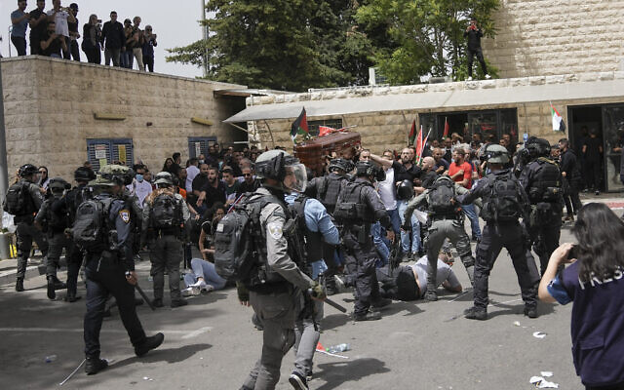
Israeli police confront mourners as they carry the coffin of slain Al Jazeera veteran journalist Shireen Abu Akleh during her funeral in Jerusalem, Friday, May 13, 2022. (AP Photo/Mahmoud Illean)
“This is sickening. Violent racism, enabled by $3.8B in unconditional military US funds. For the Israeli apartheid government, Shireen’s life didn’t matter – and her dehumanization continues after death,” tweeted Democratic Rep. Rashida Tlaib, calling on the State Department to issue a condemnation.
Criticism of Israeli police was also voiced by Democratic Sens. Bernie Sanders and Elizabeth Warren along with Democratic Reps. Ilhan Omar, Sara Jacobs and Andy Levin.
The European Union also condemned the incident, saying it was “appalled.”
“The EU condemns the disproportionate use of force and the disrespectful behavior by the Israeli police against the participants of the mourning procession,” an EU statement said.
“Allowing for a peaceful farewell and letting mourners grieve in peace without harassment and humiliation, is the minimal human respect,” it said.
The French consulate general said “police violence” at the hospital had been “deeply shocking.”
UN Secretary-General Antonio Guterres “was deeply disturbed by the confrontations between Israeli security forces and Palestinians gathered at St. Joseph Hospital, and the behavior of some police present at the scene,” a spokesperson said
UN Special Envoy for the Middle East Peace Process Tor Wennesland tweeted, “there is no place for such acts at a mournful event.”
In Qatar, where Al Jazeera is based, the foreign ministry said: “The occupation forces were not content with killing Shireen… they also terrorized those who accompanied her to her last resting place.”
Al Jazeera said in a statement that the police action “violates all international norms and rights.”
“Israeli occupation forces attacked those mourning the late Shireen Abu Akhleh after storming the French hospital in Jerusalem, where they severely beat the pallbearers,” it said. The network added that it remains committed to covering the news and will not be deterred.
This case has drawn heavy scrutiny because Abu Akleh was so well-known in the region and also a US citizen.
The White House has called for an “immediate and thorough” probe into Abu Akleh’s death.
Born in Jerusalem, Abu Akleh spent time in the United States as a child and held US citizenship along with her Jerusalem residency card.
Israel is insisting it cannot determine who shot her without examining the bullet removed from her neck, Channel 12 reported Friday, adding that Israel has asked the US for assistance in the case in persuading the Palestinian Authority to cooperate.
The Israel Defense forces said earlier Friday that the Palestinians had rejected offers to be present and take part in the inquiry alongside an American representative. https://www.timesofisrael.com/us-deeply-disturbed-over-images-of-israeli-police-beating-mourners-eu-appalled/ [This is most unfortunate and if the comments about rock throwing are not accurate, Israel will face a tremendous backlash. – rdb]

Syria says five killed, 7 hurt in Israeli airstrikes in northwest
State media claims a large number of missiles launched by jets over Masyaf; footage shows fire at site in area thought controlled by Iran-backed forces
By Emanuel Fabian Today, 10:52 pm
A fireball rises after an alleged airstrike near the Syrian city of Masyaf, on May 13, 2022. (Screenshot/Twitter)
Five people were killed and seven others were hurt in an alleged Israeli airstrike on Friday night in northwestern Syria, the country’s state news agency said.
It was the second alleged Israeli strike on the country in days, after missiles were reportedly launched at a site just across the border from Israel in the pre-dawn hours of Wednesday.
The state-run SANA said a large number of missiles were launched by Israeli fighter jets over Masyaf during the Friday night strike.
SANA quoted an unidentified Syrian military official as saying most of the missiles were intercepted.
The Syrian military claims to shoot down incoming missiles after nearly every alleged Israeli strike, which Israeli military officials and civilian defense analysts largely dismiss as empty boasts.
According to SANA, one of those killed is a civilian, meaning the other four were military forces. The network said seven other people, including a child, were hurt in the airstrikes.
Damage was also caused to a site in the area, SANA said, without elaborating further. Footage posted to social media apparently showed a site that was hit multiple times by the Israeli missiles, with fire rising from the area.
Looks like the SSRC was targeted. pic.twitter.com/oxF838uSvR
— Aurora Intel (@AuroraIntel) May 13, 2022
The Masyaf area is thought to be used as a base for Iranian forces and pro-Iranian militias and has been repeatedly targeted in recent years in attacks attributed to Israel. The area was struck allegedly by Israel as recently as last month.
The area is also home to a facility belonging to the Scientific Studies and Research Center, known as CERS, which itself has been struck several times in the past.
Western officials have long associated CERS with the manufacture of chemical arms. According to the United States, sarin gas was developed at that center, a charge denied by the Syrian authorities.
There was no immediate comment from the Israel Defense Forces, which does not normally comment on individual strikes.
Israel has carried out hundreds of sorties over Syria in the last decade, mostly to stymie attempts by Iranian forces to transfer weapons or establish a foothold.
Israeli strikes have continued in Syrian airspace, which is largely controlled by Russia, even as ties with Moscow have deteriorated in recent weeks. Israel has found itself at odds with Russia as it has increasingly supported Ukraine, while seeking to maintain freedom of movement in Syria’s skies. https://www.timesofisrael.com/syria-says-five-killed-7-hurt-in-israeli-airstrikes-in-northwest/

‘One of the best’: Officers, officials mourn death of police commando Noam Raz
Veteran counterterrorism officer killed in clashes near Jenin; leaves behind a wife and six children; PM vows to continue to fight terrorism with an iron fist
By TOI staff Today, 6:10 pm
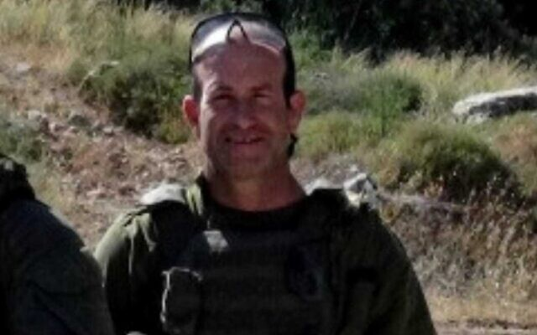
Police commando Sgt. Maj. Noam Raz, 47, who was killed in an operation in Jenin on May 13, 2022 (Police)
Noam Raz, a veteran police commando who was killed in an Israeli operation near Jenin in the West Bank on Friday, was hailed as a hero and beloved family man.
Raz, 47, was a founding member and resident of the settlement of Kida in the West Bank and leaves behind a wife and six children.
Police chief Kobi Shabtai said Raz, a 23-year veteran of the elite Yamam counterterrorism unit, was one of the best officers in the force.
“We bow our heads in the memory of Noam Raz z”l who fell in an exchange of fire with terrorists,” said Shabtai. “Noam was a dedicated husband, an exemplary father, and one of the best fighters in the Israel Police.”
He revealed that Raz, who was a paramedic in the unit, saved the life of a seriously wounded comrade during a recent previous clash in Jenin.
“Heroism and values were inherent in his character and operational activity in the Yamam,” he said.
לוחם הימ"מ נעם רז שנהרג בפעילות בג'נין, היה מתנדב באיחוד הצלה, הכרתי אותו מאד טוב, הוא הציל חיים של מאות אנשים, הלב נשבר. יהיה זכרו ברוך. pic.twitter.com/wniEIrLugb
— חמי טרכטנברג (@CHAMiT1221) May 13, 2022
Raz was hit by gunfire during an operation that included raids on terror suspects’ homes in the town of Burqin, near Jenin in the West Bank. He was evacuated to the Rambam Medical Center in Haifa.
Hospital officials said he arrived in a critical condition. They attempted prolonged efforts to resuscitate him, but he had complex wounds to his upper body and eventually, they were forced to declare him dead.
Raz was among the founders of the Kida settlement, according to a statement issued by the Mateh Binyamin Regional Council following his death.
“Noam was a pillar in his community. A humble family man connected to the Land of Israel with every fiber of his being… He was loved by everyone,” the statement said. “The community of Kida and the residents of Binyamin send their condolences to the family during this difficult time.”
Prime Minister Naftali Bennett said that Israel has lost a hero.
“During his 23 years of service in the unit, Noam participated in numerous counter-terror operations, risked himself, and saved lives, as his commanders would testify — with courage and humility,” Bennett said.
A masked Palestinian gunman fires an automatic weapon during clashes with Israeli security forces in the West Bank city of Jenin on May 13, 2022. (Jaafar Ashtiyeh/AFP)
“We will continue to fight terrorism decisively and with an iron fist until we overcome it and return security to Israeli citizens. This is Noam’s legacy,” the Israeli premier added.
President Isaac Herzog also sent “condolences from the depths of my heart to his grieving family,” saying he had participated in numerous special operations and saved many lives.”
Defense Minister Benny Gantz sent condolences to the family and said Israel would continue its relentless campaign against terrorism.
“ We will continue to fight terrorists, those who send them, their accomplices, and anyone who attempts to harm Israel’s citizens,” Gantz tweeted.
Raz was shot during an operation that included raids on terror suspects’ homes.
The Israel Defense Forces earlier acknowledged that forces from the military and Shin Bet as well as Yamam were operating in Burqin in order to arrest a number of suspects.
During the operation, Israeli forces fired at armed terrorists who opened heavy fire and threw explosives toward them… As part of the operation, forces used various special measures to arrest a suspect who barricaded himself inside his home and eventually surrendered together with his brother,” a joint statement issued by police and the IDF read.
Footage on social media showed masked Palestinians firing rifles in the direction of Israeli soldiers, as heavy gunfire could be heard.
Palestinian reports said Israeli forces surrounded the home of a suspect and called on everyone inside to surrender. The Islamic Jihad terror group identified the suspect, Mohammad al-Dab’i, as a member of its military wing.
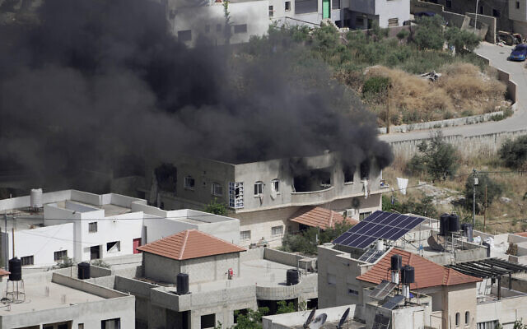
Smoke rises from a home during an Israeli military operation in the West Bank town of Jenin, Friday, May 13, 2022. (AP Photo/Majdi Mohammed)
Video showed an Israeli soldier firing a shoulder-launched missile at the home, with smoke then seen rising from the building.
A separate clip showed the house on fire. It was unclear if anyone was inside.
Raz’s death comes amid heightened tensions between Palestinians and Israeli forces in the West Bank amid a terror wave that has killed 19 Israelis since mid-March.
More than 30 Palestinians have been killed in recent weeks, most of them involved in attacks or clashes with Israeli forces. https://www.timesofisrael.com/one-of-the-best-officers-officials-mourn-death-of-police-commando-noam-raz/

Matan Kahana resigns Religious Affairs Ministry to ‘help strengthen the coalition’
Move will see Kahana returning to Knesset as an MK, bumping out Yomtob Kalfon who it was feared might be the next Yamina member to quit teetering government
By Carrie Keller-Lynn and Shalom Yerushalmi Today, 8:12 pm
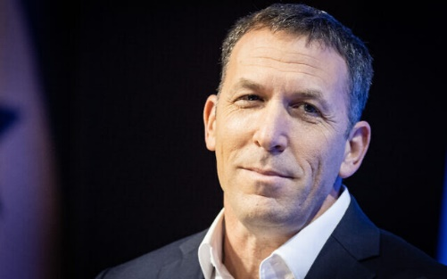
Religious Affairs Minister Matan Kahana. (Yonatan Sindel/Flash90)
Religious Affairs Minister Matan Kahana announced Friday that he is resigning his post and will return to serve as a Yamia MK in the Knesset in order to “help strengthen the coalition,” in what is seen as the latest maneuver by the beleaguered party to stay in power.
Kahana said he had informed Prime Minister Naftali Bennett, also of Yamina, of his intention to resign which would take effect immediately.
The move is widely seen as preventing a further defection from the party that has already lost two lawmakers, leaving the eight-party coalition without a clear majority.
Sources said MK Yomtob Kalfon was the latest Yamina MK planning to defect and was the target of the maneuver.
Under the so-called Norwegian Law, Kahana — elected to the Knesset under Yamina’s slate — resigned his parliamentary seat upon taking his position as minister. His vacated seat was then passed onto another candidate on Yamina’s electoral slate.
Also under the law, Kahana’s ministerial resignation immediately sends him back into the Knesset, bumping out Kalfon, who is the last MK on Yamina’s current slate.
Bennett’s right-wing Yamina party has been the weak link in a fragile coalition, with two of its MKs elected to the slate either never supporting the coalition or resigning from it.
The first of these two, now-independent MK Amichai Chikli, was ousted from Yamina last month, and now faces potentially career-ending electoral sanctions.
The second, former coalition whip MK Idit Silman, threw the coalition into a tailspin when she departed from it last month, reducing the coalition’s thin 61-seat majority to a 60-60 seat parity with the opposition.
Party sources said the move was coordinated between Kahana and Bennett and deliberately announced late Friday afternoon just before the start of the Sabbath. The resignation goes into effect after 48 hours meaning that Kahana will be in the Knesset on Monday and Kalfon will remain home.
Kalfon raised concerns in the party that he was shifting his positions when he visited the Temple Mount on Independence Day.
“Happy Independence Day,” he wrote in a tweet that included a photo of him during the visit.
Known as the Temple Mount to Jews and Haram al-Sharif, or the Al-Aqsa complex to Muslims, Jerusalem’s most holy hilltop has been a crucible for violence in the weeks leading up to and during Ramadan, which coincided this year with Passover and Easter.
Kalfon could not be reached for comment after the start of the Sabbath.
Kahana, who has launched widespread reforms in the Religious Affairs Ministry, will likely be appointed a deputy minister their allowing him to continue with his efforts.
The government has been struggling to survive since losing its majority, amid tensions in Yamina and with the Islamist Ra’am party. MORE - https://www.timesofisrael.com/matan-kahana-resigns-religious-affairs-ministry-to-help-strengthen-the-coalition/

Shimrit Meir, top aide to Bennett, resigns after one year in position
Meir was reportedly the prime minister’s closest aide but clashed with Bennett’s political team and his right-wing party members
By Michael Horovitz and Carrie Keller-Lynn Today, 9:01 pm
Israeli Prime Minister Naftali Bennett speaks with his foreign policy adviser Shimrit Meir at the Prime Minister's Office in Jerusalem on January 26, 2022. (Yonatan Sindel/Flash90)
Shimrit Meir, a top diplomatic adviser to Prime Minister Naftali Bennett resigned from her position on Friday, in a move seen as a further blow to the premier.
Meir, who has served in the position since Bennett took office in June 2021, will leave her position on June 1, according to her resignation letter.
The resignation was seen as a further sign of instability in the government, which is struggling to survive after losing its majority.
Meir was considered to be one of Bennett’s closest aides. However, she reportedly repeatedly clashed with his political advisers who felt that she was trying to extend her influence into their spheres, including advising Bennett on his political strategy, and responses to crises such as the coronavirus and the departure of MK Idit Silman from the coalition, the Ynet site reported.
She was also seen as pulling Bennett toward the political center to the ire of his right-wing Yamina party.
“She did not get along well with Tal Gan-Tzvi,” a Yamina senior adviser, referring to Meir’s relationship with the prime minister’s chief of staff, told Ynet. “Shimrit tried to handle things that Tal handles, stuff outside of the realm of diplomatic areas.”
“Frankly, I don’t think she got along with any of the MKs or ministers in the party,” the source adds, while noting that Meir had a strong relationship with her handpicked staff, including the prime minister’s foreign media adviser and diaspora affairs adviser.
“I thank you for this opportunity to contribute to the State of Israel in such important areas and wish you good luck,” Meir wrote to Bennett. “It has been a busy year, from morning until night. The series of tasks you assigned to me required considerable sacrifices in my personal life. Towards the end of a year of close joint work, it’s time to leave,” she added.
MORE - . https://www.timesofisrael.com/shimrit-meir-top-aide-to-bennett-resigns-after-one-year-in-position/

Israel and world powers look to aid flailing Palestinian economy
Semi-annual Ad Hoc Liaison Committee meeting puts Israeli and Palestinian Authority officials in same room with international representatives; Palestinians say PA, Israeli economies directly intertwined
The Media Line | Published: 05.13.22, 09:38
With no political process involving the Palestinians seen on the horizon, Israel’s government and the international community have made efforts instead to strengthen the Palestinian economy, which is struggling from a lack of sufficient revenue and an increased absence of donor funding.
However, the Palestinian Authority says, the economies of the PA and Israel are directly intertwined, and one cannot exist without the other.
This was the context for Tuesday’s meeting of the Ad Hoc Liaison Committee (AHLC) in Brussels. Born of the Oslo process meant to bring peace between Israel and the Palestinians, the semi-annual meetings of the AHLC serve as the principal policy-level coordination mechanism for development assistance to the Palestinian territories.
The AHLC is chaired by Norway and co-sponsored by the European Union and the United States. In addition, the United Nations participates, together with the World Bank and the International Monetary Fund (IMF). The AHLC seeks to promote dialogue between donors, the Palestinian Authority and the government of Israel.
On Tuesday, representatives from the U.S., the EU, the UN, the World Bank, the IMF and other Arab and donor countries took part.
“I say, frankly, that it’s in our interest and in the international interest to have a strong Palestinian Authority,” Israel’s Regional Cooperation Minister Isawi Frej said immediately following Tuesday’s meeting. He attended the meeting along with Palestinian Authority Prime Minister Mohammad Shtayyeh. The meeting was hosted by EU Foreign Affairs head Josep Borrell and chaired by Norwegian Foreign Minister Anniken Huitfeldt.[Does this fellow have any idea of the concept of history and what has transpired over the past 50 years? - rdb
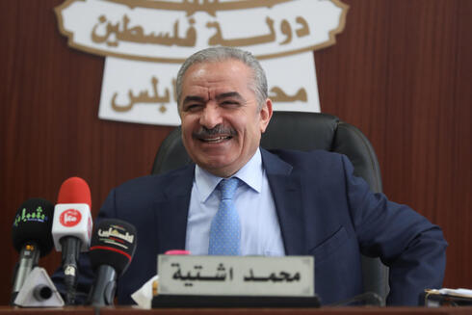
Palestinian Prime Minister Mohammad Shtayyeh during cabinet meeting held in Nablus (Photo: EPA)
“We discussed all of the achievements in the six months since the last (AHLC) conference,” Frej said, adding that Israel "supported the Palestinian economy with more than 20,000 worker permits for the Gaza Strip, which is the highest number in the last 15 years".
"We are working on developing the eVAT (electronic Value Added Tax), which will digitize the invoices between us and the Palestinians and will increase the income tax of the PA, which is very important. The import and export of goods increased to the West Bank, thanks largely to an agreement we signed with Jordan. Gaza reconstruction, water, electricity, an Allenby Bridge expansion – we’re working on all of it.
“The financial situation of the PA is very bad, and this is a critical moment for the Palestinians and the region,” Frej added.
Prior to Tuesday’s meeting, Huitfeldt offered her assessment of the situation between Israel and the Palestinians.

Regional Cooperation Minister Isawi Frej (Photo: Hadar Yoavian)
“There has been increased cooperation between Israel and [the Palestinians] in recent months to find solutions to key issues relating to the economy, infrastructure and trade. However, there are still no political negotiations between the parties. Violence must end and the parties must take steps to resume negotiations of a two-state solution,” Huitfeldt said.
Since the last meeting held in Oslo in November 2021, Germany, the Netherlands and the United Kingdom have headed individual working groups. The three countries are working together to promote progress in areas such as water, trade and the Palestinian economy. This has created a new dynamic in the AHLC. The Israelis and Palestinians are discussing relevant issues more constructively than has been the case for years, Huitfeldt added.
The AHLC is one of the few forums in which Israelis and Palestinians jointly participate in meetings with major allies to discuss how best to assist the Palestinians.
The World Bank reported on Monday that foreign aid to the Palestinian Authority plummeted from 27% of gross domestic product in 2008 to just 1.8% of GDP in 2021. During the nearly two years of COVID-19 restrictions, when the critical tourism sector was paralyzed, more than 110,000 Palestinians slipped below the poverty line, with the World Bank reporting that income fell in more than 60% of Palestinian households, and 20% of the previously employed workforce found itself jobless. MORE - https://www.ynetnews.com/magazine/article/bjra9vq89

UAE ruler Sheikh Khalifa bin Zayed Al Nahyan dies at 73
Country declares 40 days of mourning for its leader; Crown Prince Mohamed bin Zayed, long the de facto ruler, is expected to succeed
By Agencies and TOI staff Today, 1:47 pmUpdated at 3:24 pm
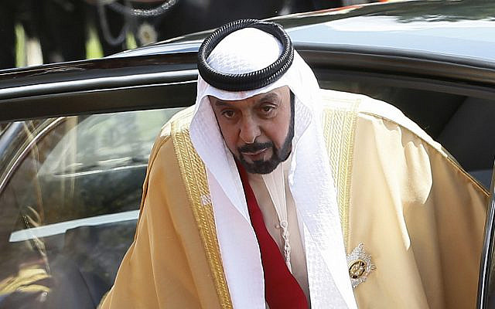
In this 2013 file photo, President of the United Arab Emirates Sheik Khalifa bin Zayed Al Nahyan arrives to meet Britain's Queen Elizabeth II in Windsor in England (AP Photo/Kirsty Wigglesworth, pool)
The United Arab Emirates’ President Sheikh Khalifa bin Zayed Al-Nahyan died aged 73 on Friday, state media said, after battling illness for several years.
Sheikh Khalifa’s rule since 2004 saw his country’s meteoric rise on the international scene.
“The Ministry of Presidential Affairs condoles the people of the UAE and the Islamic world… on the passing of Sheikh Khalifa bin Zayed Al-Nahyan on Friday, May 13,” the official WAM news agency said.
The ministry announced a 40-day period of mourning and a three-day suspension of work in all ministries and the private sector beginning Friday, including flags to be flown at half-staff.
The late head of state was rarely seen in public since a stroke in January 2014, and the country has largely been ruled by his half-brother Mohamed bin Zayed Al Nahyan, known colloquially as MBZ.
MBZ, who led the country’s normalization process with Israel in 2020, is expected to ascend to the presidency of the small Gulf nation.
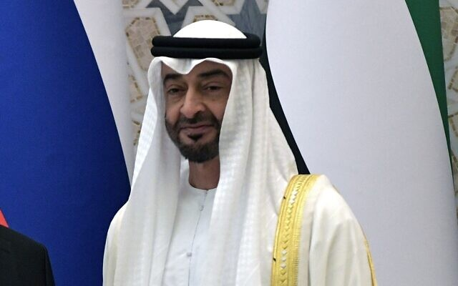
Abu Dhabi Crown Prince Mohamed bin Zayed al-Nahyan in Abu Dhabi, United Arab Emirates, Tuesday, Oct. 15, 2019. (Alexei Nikolsky, Sputnik, Kremlin Pool Photo via AP)
Israeli leaders expressed their condolences to the UAE over the president’s death.
“Sheikh Khalifa’s legacy and tremendous deeds are greatly admired in Israel,” Prime Minister Naftali Bennett said in a statement. “The State of Israel stands alongside the United Arab Emirates at this difficult time.”
President Isaac Herzog called the Emirati ruler’s death “a great loss for our friends in the UAE and for the whole region.”
“Sheikh Khalifa’s bold leadership contributed so much to the advancement of the UAE and its people and to the growing partnership between our countries and is a great legacy for his successors,” he said.
Sheikh Khalifa took over as the UAE’s second president in November 2004, succeeding his father as the 16th ruler of Abu Dhabi, the richest of the federation’s seven emirates. MORE - https://www.timesofisrael.com/uae-ruler-sheikh-khalifa-bin-zayed-al-nahyan-dies-at-73/

German police: 5 stabbed and wounded on train in suspected Islamic terror attack
Iraqi-born man stabs five passengers on train near city of Aachen before being overpowered by a police officer and two other passengers
By AP Today, 5:31 pm
VIENNA — Police have arrested an Iraqi-born man and are investigating a possible Islamic extremist motive after five passengers received knife wounds on a regional train in western Germany, authorities said Friday.
The train was traveling near the western city of Aachen Friday morning when a man began attacking fellow passengers “randomly and arbitrarily,” state interior minister Herbert Reul said, according to the news agency dpa.
There were approximately 270 passengers on the train, Reul said. A police officer who happened to be among the passengers overpowered the 31-year-old suspect with the help of two other passengers, state police confirmed.
Reul described the incident as “a gruesome crime that was stopped in an enormous act of courage.”
In total, five people were wounded, Reul said. Police confirmed the casualties were being treated at local hospitals and that none of them was in critical condition.
Reul said the suspect was already known to authorities. However, he added that authorities suspected, but have not confirmed that he had an Islamist motive for the attack. https://www.timesofisrael.com/police-five-stabbed-and-wounded-on-german-train-in-suspected-islamic-terror-attack/

Germany detects Hitler fans in its security ranks
Government report shows that over 300 members of German security services have links to ‘right-wing’ extremism
13 May, 2022 21:15
A German government investigation has revealed that more than 300 members of the country’s security agencies have links to “right-wing” extremism, including officers who were found to have joined in “Heil Hitler” chants and Nazi salutes.
“We will not allow our democratic constitutional state to be sabotaged from within by right-wing extremists,” Interior Minister Nancy Faeser said in a statement on Friday. “Every case of extremism must have clear consequences.” She added that Berlin will exhaust all current legal options to deal with extremists in the country’s security ranks, and she will propose legislation to help “remove enemies of the constitution from the public service more quickly.”
The probe examined 860 suspected cases of extremist behavior dating as far back as July 2018 and revealed “concrete evidence” against 327 employees of security services at federal and state levels. Germany’s military intelligence service (MAD) was most rife with offenders, with 83 employees found to have been involved in activities “against the free democratic basic order,” the report said. The federal police ranked second, with 18 such employees.
The Interior Ministry identified 138 extremists working at federal agencies and 189 at the state level. More than 640,000 people work in Germany’s security services.
“Each of these cases is one too many,” Faeser told reporters, adding that more than 500 disciplinary actions have been taken against security workers with confirmed links to extremism.
Friday’s report comes nearly two years after Germany’s first nationwide study of far-right extremism in the country’s security agencies found hundreds of cases of alleged misconduct involving soldiers, police officers and other officials. Although the number of cases was small relative to the size of Germany’s security workforce, the 2020 report’s authors acknowledged that “it can basically be assumed that there is also a dark field” of undetected extremists.
Many of the cases involved the sharing of extremist symbols or pictures, such as swastikas. The latest review found a “diverse” range of verboten activities, such as joining extremist chat groups, spreading extremist propaganda and making “politically motivated insults.” Some employees were suspected of being members of the “Reichsburger” movement, which denies the legitimacy of the modern German state.
Concerns over extremism within Germany’s security ranks increased in recent years, amid a string of high-profile cases involving police officers and members of the military. Those cases included prosecution of an army officer who was accused of plotting a terrorist attack in which he would pose as a Syrian refugee. https://www.rt.com/news/555460-germany-reports-extremists-in-security-services/ [You may recall that just last week a Lufthansa employee blocked all obvious Jews from a flight because 2 orthodox refused masks. There is a huge problem with anti-Semitism in Germany. - rdb]

Russia warns of ‘military-technical’ retaliation as Finland moves toward NATO
Finnish president tells Moscow to blame itself for Helsinki’s decision to seek membership in alliance: ‘Look in the mirror’; Kyiv holds war crimes trial for Russian soldier
By OLEKSANDR STASHEVSKYI Today, 12:47 pm
In this photo from October 25, 2021, NATO Secretary-General Jens Stoltenberg (L) meets with Finland's Prime Minister Sanna Marin during the The North Atlantic Council's (NAC) visit in Helsinki. (Jussi Nukari/Lehtikuva/AFP)
KYIV, Ukraine (AP) — The Kremlin warned it may take retaliatory “military-technical” steps after Finland’s leaders said they favor joining NATO, and Sweden could do the same within days, in a historic realignment triggered by Russia’s invasion of Ukraine.
Meanwhile, the first war-crimes trial of a Russian soldier since the start of the conflict was set to open Friday in Kyiv. A 21-year-old captured member of a tank unit is accused of shooting to death a civilian in the war’s first week.
On the ground, Russian forces were pounding areas in central, northern and eastern Ukraine, including the last pocket of resistance in Mariupol, as part of their offensive to take the industrial Donbas region. Ukraine recaptured some towns and villages in the northeast.
Two and a half months after Russia’s invasion of Ukraine sent a shiver of fear through Moscow’s neighbors, Finland’s president and prime minister announced Thursday that the Nordic country should apply right away for membership in NATO, the military defense pact founded in part to counter the Soviet Union.
“You (Russia) caused this. Look in the mirror,” said Finnish President Sauli Niinisto.
Finland’s Parliament still has to weigh in, but the announcement means it is all but certain to apply — and gain admission. The process could take months to complete. Sweden, likewise, is considering putting itself under NATO’s protection.
That would represent a major change in Europe’s security landscape: Sweden has avoided military alliances for more than 200 years, while Finland adopted neutrality after its defeat by the Soviets in World War II.
Public opinion in both nations shifted dramatically in favor of NATO membership after the invasion, which stirred fears in countries along Russia’s flank that they could be next.
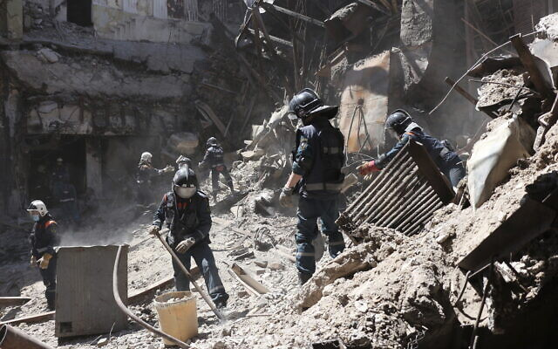
Donetsk People Republic Emergency Situations Ministry employees clear rubble at the side of the damaged Mariupol theater building during heavy fighting in Mariupol, in territory under the government of the Donetsk People’s Republic, eastern Ukraine, May 12, 2022. (AP Photo)
Such an expansion of the alliance would leave Russia surrounded by NATO countries in the Baltic Sea and the Arctic and would amount to a stinging setback for Russian President Vladimir Putin. He had hoped to divide and roll back NATO in Europe but is instead seeing the opposite happen.
NATO Secretary-General Jens Stoltenberg has said the alliance would welcome Finland and Sweden with open arms. [They are backing the bear into a corner and the NATO group which is poorly done and poorly managed is simply inviting a nuclear conflict with Russia. Stupid move. They think they are winning but in reality they are simply setting up the prophetic scenario of a global conflict with no winners. – rdb]
Russia’s Foreign Ministry warned that Moscow “will be forced to take retaliatory steps of military-technical and other characteristics in order to counter the emerging threats to its national security.”
NATO’s funneling of weapons and other military support to Ukraine has been critical to Kyiv’s surprising ability to stymie the invasion, and the Kremlin warned anew that the aid could lead to direct conflict between NATO and Russia.
“There is always a risk of such conflict turning into a full-scale nuclear war, a scenario that will be catastrophic for all,” said Dmitry Medvedev, deputy head of Russia’s Security Council.
As the fighting and Russian strikes persisted, teachers were trying to restore some sense of normalcy after the war shuttered Ukraine’s schools and devastated the lives of millions of children. In Kharkiv, Ukraine’s second-largest city, lessons are being given in a subway station used as a bomb shelter that has become home for many families.
“It helps to support them mentally. Because now there is a war, and many lost their homes … some people’s parents are fighting now,” said teacher Valeriy Leiko. In part thanks to the lessons, he said, “they feel that someone loves them.”
Primary school-age children joined Leiko around a table for history and art lessons in the subway station, where children’s drawings now line the walls.
An older student, Anna Fedoryaka, was monitoring lectures on Ukrainian literature being given by Kharkiv professor Mykhailo Spodarets online from his basement.
Internet connections were a problem, Fedoryaka said. And, “it is hard to concentrate when you have to do your homework with explosions by your window.”
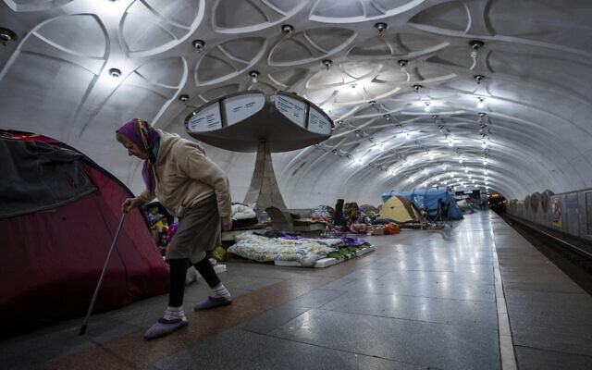
An elderly woman walks inside a metro station being used as a bomb shelter in Kharkiv, Ukraine, May 12, 2022. (AP Photo/Mstyslav Chernov)
At least two civilians were killed on the outskirts of Kharkiv on Thursday, authorities said. The attacks also damaged a building housing a humanitarian aid unit, municipal offices and hospital facilities, Vyacheslav Zadorenko, the mayor of the suburban town of Derhachi, wrote in a Telegram post. [How many civilians were killed in Chicago or Baltimore or NY on Thursday? We have an internal war because the leftist ‘leadership’ refuses to hold people accountable. – rdb]
None of the sites “had anything to do with military infrastructure,” Zadorenko said.
The Ukrainian military chief for the eastern Luhansk region said Friday that Russian forces opened fire 31 times on residential areas the day before, destroying dozens of homes, notably in Hirske and Popasnianska villages, and a bridge in Rubizhne.
Russia’s advance in the Donbas has been slow, but its forces have gained some ground and taken some villages.
Britain’s Defense Ministry said Russia’s focus on the Donbas has at the same time left its remaining troops around Kharkiv vulnerable to counterattack from Ukrainian forces, which recaptured several nearby towns and villages.
In other developments, Ukrainian officials said their forces took out another Russian ship in the Black Sea.
The Vsevolod Bobrov logistics ship was badly damaged but not thought to have sunk when it was struck while trying to deliver an anti-aircraft system to Snake Island, said Oleksiy Arestovych, an adviser to the Ukrainian president.
A spokesman for the Odesa regional military administration said the vessel caught fire after the strike. There was no confirmation from Russia and no reports of casualties. MORE - https://www.timesofisrael.com/russia-warns-of-military-technical-retaliation-as-finland-moves-toward-nato/

Key NATO member against Sweden and Finland in bloc
Turkey has opposed the alliance intentions of the Scandinavian nations, claiming they are like ‘a guesthouse for terrorists’
13 May, 2022 16:34
Turkish President Recep Tayyip Erdoğan declared on Friday that Ankara opposes the possibility of Sweden and Finland’s accession to NATO because he believes the two Scandinavian nations harbor ‘terrorists’.
By ‘terrorists’, the Turkish leader meant militants of the Kurdistan Workers’ Party (PKK), a separatist movement operating in southeastern Turkey, and members of the Revolutionary People’s Liberation Front (DHKP/C), an outlawed Turkish communist party.
The statement came after Helsinki and Stockholm demonstrated their intention to join the US-led military alliance.
“We are currently following the developments regarding Sweden and Finland [joining NATO], but we are not favorable towards it. At this point, it is not possible for us to have a positive approach,” the Turkish president told journalists.
“Scandinavian countries are unfortunately almost like guesthouses for terrorist organizations. PKK and DHKP/C are nested in Sweden and the Netherlands. And I'm going even further, in their parliaments,” he added.
In April, concerned with Russia’s military action in Ukraine, Sweden and Finland started to consider dropping their neutral status and joining NATO. Top Finnish officials have already supported the initiative. Sweden is set to decide on its accession to the military bloc on May 15. MORE - https://www.rt.com/news/555455-turkey-sweden-finland-accession-nato/

US may have to suspend weapons shipments to Ukraine
Aid to Kiev may be disrupted if Congress doesn’t pass $40 billion spending package by May 19, Pentagon says
3 May, 2022 22:29
The flow of US weapons to Ukraine might be cut off, at least temporarily, unless Congress quickly approves nearly $40 billion in new spending to help Kiev repel Russia’s offensive in the former Soviet republic, the Pentagon has warned.
“May 19 is the day we really, without additional authorities, we begin to not have the ability to send new stuff in . . .,” Pentagon spokesman John Kirby told reporters on Friday. “By the 19th of May, it’ll start impacting our ability to provide aid uninterrupted.”
Weapons shipments to Kiev wouldn’t immediately stop on May 20 without new funding because there would still be some supplies in the pipeline purchased under the approximately $100 million in spending authority that the Pentagon currently has remaining for Ukraine aid, Kirby said. However, he added, but by losing its ability to source new cargoes, the Pentagon would face “a period of time with nothing moving” if there’s an extended delay in the new funding approval.
“We’ve been moving at a fairly fast clip here, both in terms of the individual packages that have been approved and how fast that stuff is getting into Ukrainian hands,” Kirby said. “Literally, every day, there are things going in, and we would like to continue to be able to continue that pace for as long as we can.”
Washington’s latest Ukraine aid package, valued at $39.8 billion, was overwhelmingly approved by the House on Tuesday night, but the Senate failed in an effort to fast-track the bill for approval on Thursday. Senator Rand Paul (R-Kentucky) objected to unanimous consent – a provision that allows for bills with strong bipartisan support to go to a quick vote without debate – after Senate Majority Leader Chuck Schumer (D-New York) refused to add language to the aid legislation requiring that an inspector general be appointed to oversee how the money is spent. [Thank heavens for Rand Paul. He is one of the few in DC that actually tries to mind the dollars and cents and watch over the finances. Unfortunately with the other idiots in DC they could care less. Ukraine is not our biggest problem and neither is Russia. Russia simply doesn’t want a reverse Cuban missile situation on their borders but the US wants to keep their KICKBACK scheme working. – rdb]
Schumer excoriated Paul for standing in the way of quickly approving the massive aid package and argued that Washington has a “moral obligation” to help Ukraine fight Russian forces. Senate Minority Leader Mitch McConnell (R-Kentucky) also pressed for an immediate vote on the bill, but Paul’s objection meant that passage would be delayed to next week at the earliest. [Schumer like the vast majority of the “long timers’ in DC needs to go away permanently and it should have happened long ago. He is a crooked as a dog’s hind leg just like PEEEElosi and the rest of them. – rdb]
Paul argued that Americans are already “feeling the pain” of an inflation crisis, which he said was driven by excessive deficit spending, “and Congress seems intent on only adding to that pain by shoving more money out the door as fast as they can.” He added, “We cannot save Ukraine by dooming the US economy.”
Kirby reiterated a Pentagon request to provide new Ukraine funding by the third week of May. “Obviously, we continue to urge the Senate to act as quickly as possible so that we don’t get to the end of May and not have any additional authorities to draw upon.”
Although the aid bill passed the House with support from all Democrats and all but 57 Republicans, the vote revealed increasing division over the issue on the GOP side of the aisle. Representative Dan Crenshaw (R-Texas) praised the bill as a way to fund a proxy war against Russia, “investing in the destruction of our adversary’s military without losing a single American troop.” [Every GOP rino in DC needs to be replaced. All those who voted in the House for this and those in the Senate that vote for it need to go away. – rdb]
Critics, including Representative Marjorie Taylor Greene (R-Georgia), countered that anti-Russia sanctions are only exacerbating a US inflation crisis, and prioritizing aid to Ukraine is distracting from more important domestic issues. “While you spend $40 billion for your proxy war against Russia, I’m focused on baby formula for American babies,” she told Crenshaw.
Paul noted that the latest spending package will bring total US aid to Ukraine to $60 billion since the conflict began in February, nearly as much as Russia earmarks annually for its entire defense budget. https://www.rt.com/news/555462-us-ukraine-aid-may-be-delayed/

Vast majority of Chinese have positive view of Russia – poll
A new survey claims nearly 80% of respondents in China have a favorable attitude towards Russia but views on the US have worsened
13 May, 2022 18:38
A recent survey has revealed that a majority of Chinese citizens hold a favorable view of Russia, while most respondents named the US as the least positively perceived out of a list of 25 countries.
The online survey was conducted by the Central European Institute of Asian Studies think tank in March, shortly after Russia launched its military operation in Ukraine, and was published earlier this week. Researchers questioned more than 3,000 residents in mainland China to evaluate their perception of the world at a time of war, presenting them with a list of 25 countries which they were asked to rank in terms of favorability.
“This is a unique survey which gives broad and detailed insights into Chinese people’s attitudes at a crucial time in international relations, just after the Russian invasion of Ukraine,” said Dr. Richard Q. Turcsanyi, who led the survey. “Our findings show that the Chinese public was not disturbed by the Russian moves and actually seems to support Russia in the war,” he added.
Of the 25 countries that respondents were asked about, Russia was revealed to be the most positively perceived nation, while the US was the most negatively viewed one. Researchers found that nearly 80% of respondents had positive feelings about Russia, and around the same proportion said their view of the country had improved over the past three years.
Asked why their view of Russia had improved, many cited their admiration for the country’s leadership. Some of the common responses were “Trust Putin,” “Putin has guts,” and “Strong leadership.” Many Chinese people also stated that they felt a “brotherly love” between Russia and China, while some said they believed that “the enemy of an enemy is our friend.”
During the same three-year period, Chinese views of the US seem to have significantly worsened as less than a third of respondents claimed to have a favorable view of the country. The US was ranked the most negatively viewed country of the 25 mentioned, with some participants stating that while they perceive the US as an advanced and powerful state, they feel it is hostile to China, untrustworthy and has a tendency to interfere in other countries’ affairs.
Other countries that were favorably perceived by respondents included Pakistan, Singapore, North Korea and Germany. Meanwhile, countries like India, Japan, Vietnam, South Korea and Ukraine were the most negatively perceived.
The report suggests that Chinese people’s views of foreign countries seem to correspond to their perception of those countries’ views of China. Nearly 60% of participants stated that they believed Americans had a generally negative view of China, while only about 10% thought that Russians were ill-disposed towards Chinese people.
The researchers stated that while the view of the US is generally negative in China, there is still a long way to go before tensions spill out into a Cold War.
“The tense diplomatic relations have not significantly damaged the Chinese public’s admiration for American culture, and a majority of Chinese still considered the US culturally attractive. We are not in a full-fledged Cold War yet,” Tao Wang, research associate at Manchester China Institute and co-author of the report, said in a statement. https://www.rt.com/news/555449-china-russia-us-survey/ [It would be very interesting to see the attitudes of the general populations of multiple other countries of Russia and the US. I am not so sure that we would be very positively perceived by many of them. While there are many from very poor and criminally dominated countries that want to come here the issue is always purely money and what they can get, not really that much “leadership” abilities. – rdb]

Testimony warns China's 'organ harvesting' is killing 50,000 per year
Those ages 28-29 disappear as that's the 'exact stage' of development executioners want
By Bob Unruh Published May 13, 2022 at 3:31pm
China may be killing as many as 50,000 concentration camp victims each year to surgically remove – and sell – their organs, according to one of the world's leading experts on China's forced organ harvesting industry.
A report in Breitbart documents the testimony from Ethan Gutmann, who said each concentration camp victim could yield as many as two or three organs from the Chinese Communist Party regime to sell.
Gutmann testified, "There are two kinds of people who leave the camps early: The first are young people, about 18 years old. The announcement that they are 'graduating' is often made during lunch. Sometimes light applause is encouraged. 'Graduation' is a euphemism for forced labor, often at a factory out east," he said.
The second group is those in the age of 28 or 29 because that's the "exact stage of physical development that the Chinese medical establishment prefers for organ harvesting."
Those, he said, vanish in the middle of the night.
"If we assume that at any given time since 2017, there are approximately a million Uyghurs, Kazakhs, Kyrgyz and Hui in the camps, my estimate is that 25,000 to 50,000 camp detainees are being harvested every year," he said.
Gutman is a senior research fellow in China studies at the Victims of Communism Memorial Foundation. He's also co-author of "Bloody Harvest" and "The Slaughter."
The hearing was assembled by Rep. Chris Smith, R-N.J., who heads the Tom Lantos Human Rights Commission, and focused on the evidence of China's "forced organ harvesting."
Also testifying on Enver Tohti, a surgeon from East Turkistan who said he had been forced to "harvest organs from a political prisoner in 1995."
A study published by the Australian National University also focused on the massacres, accusing China of "execution by heart removal."
The Breitbart report said, "China has built a network of upwards of 1,000 concentration camps in occupied East Turkistan, its westernmost region and home to the majority of members of the Uyghur ethnic group, in the past half-decade, using them to torture, indoctrinate, enslave, rape, and kill Uyghurs and other members of religious and ethnic minorities. Chinese officials do not deny the existence of the camps, but claim they are 'vocational training centers' where indigenous people Beijing perceives as backwards learn trade skills to compete in the modern Chinese economy."
Gutman said the free world needs to shun the Chinese transplant industry.
He explained, "We need to abolish all Western contact with the Mainland Chinese transplant industry. No Chinese transplant surgeons in our medical journals, our universities, and our conferences. And a freeze on all sales of surgical equipment, pharmaceutical development, and testing in China."
The Daily Caller News Foundation said the panel follows the release of an American Journal of Transplantation paper that focused on "the intimate involvement of transplant surgeons in China in the execution of prisoners via the procurement of organs."
"Doctors in China performed organ transplants without following the standard procedures for establishing brain death," Smith told the hearing, citing the paper which analyzed almost 3,000 Chinese medical journal articles.
The Chinese Embassy did not immediately respond to a request for comment from The Daily Caller News Foundation, it reported.
WND has been reporting on the Chinese effort to harvest organs from prisoners long before 2013 when the Israeli Knesset held a conference to expose China's practice of executing dissidents by harvesting their organs.
The Chinese regime denied then it was engaged in organ harvesting aimed at dissidents, but experts and survivors said evidence of the practice was overwhelming.
WND's reports date to 2004 when the issue of coercive organ harvesting appeared. Multiple reports have been published on the issue of coercive organ harvesting in China. MORE - https://www.wnd.com/2022/05/testimony-warns-chinas-organ-harvesting-killing-50000-year/

Judge rules Durham can have most of the Fusion GPS emails
Investigation includes Democrats' scheme to deliver disinformation about Trump's 2016 campaign
By Bob Unruh Published May 12, 2022 at 7:14pm
A federal judge has ruled that special counsel John Durham, who is investigating the Democrats' scheme to create and deliver disinformation to the American public about the 2016 Trump campaign, can have most of the emails involving Fusion GPS that he sought.
The company, which hired a British agent to create the "Steele Dossier" of unfounded claims about then-candidate Donald Trump, claimed the information all was protected from disclosure by attorney-client privilege.
The judge said a few were, but 22 were not, and ordered them turned over to the prosecutor who already has obtained the conviction of one former FBI lawyer and has charges pending against a former Clinton campaign lawyer for lying.
The New York Post reported Judge Christopher Cooper ruled that Fusion must turn over 22 documents – of the 38 that Durham had requested. The remaining 16 are not required to be turned over now, although that does not mean they could be required at some time in the future.
The communications mostly involve discussions among Fusion workers, and aren't protected, according to the ruling, because they reveal Fusion agents were planning to push their findings to the press.
"Because these emails appear not to have been written in anticipation of litigation but rather as part of ordinary media-relations work, they are not entitled to attorney work-product protection," the judge said.
The Hillary Clinton campaign claimed it hired Fusion for legal consulting related to defamation and libel during the campaign, Cooper noted.
But Cooper said, "It is clear that Fusion employees also interacted with the press as part of an affirmative media relations effort by the Clinton Campaign. That effort included pitching certain stories, providing information on background, and answering reporters’ questions."

Democrats before and during the 2016 election created all sorts of claims about Trump, and pressed for their friends in the liberal media to publicize them – to Trump's detriment. Evidence shows that even Barack Obama was briefed on a plot by Hillary Clinton to create – and publicize – unfounded claims of the Trump campaign's links to Russia in order to deflect the public's attention from her own email scandal.
At a Substack report, it was revealed the disclosures will include, "Internal Fusion GPS e-mails discussing the Alfa Bank data and e-mails circulating draft versions of the Alfa Bank white papers that were 'ultimately provided to the press and the FBI.'"
The unfounded allegation was that the Trump campaign had a secret computer link to Alfa Bank in Russia.
The emails that Durham will not get, at least for now, include eight that are internal communications among Fusion workers, and eight that are among several Fusion executives and others.
The judge also said, "Court takes no position on the other approximately 1500 documents that Fusion GPS withheld as privileged."
The Substack report said, "We can assume based on this ruling that the majority of those documents would not be privileged. Durham will likely get most of them." MORE - https://www.wnd.com/2022/05/judge-rules-durham-can-fusion-gps-emails/

Nearly 30,000 Deaths After COVID Vaccines Reported to VAERS, CDC Data Show
VAERS data released Friday by the Centers for Disease Control and Prevention show 1,261,149 reports of adverse events from all age groups following COVID-19 vaccines, including 27,968 deaths and 228,477 serious injuries between Dec. 14, 2020, and May 6, 2022.
By Megan Redshaw 05/13/22
The Centers for Disease Control and Prevention (CDC) today released new data showing a total of 1,261,149 reports of adverse events following COVID-19 vaccines were submitted between Dec. 14, 2020, and May 6, 2022, to the Vaccine Adverse Event Reporting System (VAERS). VAERS is the primary government-funded system for reporting adverse vaccine reactions in the U.S.
The data included a total of 27,968 reports of deaths — an increase of 210 over the previous week — and 228,477 serious injuries, including deaths, during the same time period — up 1,774 compared with the previous week. There were 5,794 additional total adverse events reported to VAERS over the previous week.
Excluding “foreign reports” to VAERS, 815,384 adverse events, including 12,899 deaths and 81,830 serious injuries, were reported in the U.S. between Dec. 14, 2020, and May 6, 2022.
Foreign reports are reports foreign subsidiaries send to U.S. vaccine manufacturers. Under U.S. Food and Drug Administration (FDA) regulations, if a manufacturer is notified of a foreign case report that describes an event that is both serious and does not appear on the product’s labeling, the manufacturer is required to submit the report to VAERS.
Of the 12,899 U.S. deaths reported as of May 6, 16% occurred within 24 hours of vaccination, 20% occurred within 48 hours of vaccination and 59% occurred in people who experienced an onset of symptoms within 48 hours of being vaccinated.
In the U.S., 578 million COVID-19 vaccine doses had been administered as of May 6, including 341 million doses of Pfizer, 218 million doses of Moderna and 19 million doses of Johnson & Johnson (J&J).
Every Friday, VAERS publishes vaccine injury reports received as of a specified date. Reports submitted to VAERS require further investigation before a causal relationship can be confirmed.
Historically, VAERS has been shown to report only 1% of actual vaccine adverse events.
U.S. VAERS data from Dec. 14, 2020, to May 6, 2022, for 5- to 11-year-olds show:
- 10,560 adverse events, including 272 rated as serious and 5 reported deaths.
- 20 reports of myocarditis and pericarditis (heart inflammation).
The CDC uses a narrowed case definition of “myocarditis,” which excludes cases of cardiac arrest, ischemic strokes and deaths due to heart problems that occur before one has the chance to go to the emergency department.
The Defender has noticed over previous weeks that reports of myocarditis and pericarditis have been removed by the CDC from the VAERS system in this age group. No explanation was provided.
- 43 reports of blood clotting disorders.
U.S. VAERS data from Dec. 14, 2020, to May 6, 2022, for 12- to 17-year-olds show:
- 31,504 adverse events, including 1,812 rated as serious and 43 reported deaths. VAERS reported 44 deaths in the 12- to 17-year-old age group last week.
- 65 reports of anaphylaxis among 12- to 17-year-olds where the reaction was life-threatening, required treatment or resulted in death — with 96% of cases attributed to Pfizer’s vaccine.
- 650 reports of myocarditis and pericarditis with 638 cases attributed to Pfizer’s vaccine.
- 166 reports of blood clotting disorders with all cases attributed to Pfizer.
MORE - https://childrenshealthdefense.org/defender/deaths-covid-vaccines-vaers-cdc-data

Child protective services promotes drag queen story time, drag show for 'Kiddie Korner'
'Pride' events also include burlesque
By WND Staff Published May 13, 2022 at 5:58pm
"Pride" promoters in Illinois have moved far beyond promoting alternative sexual lifestyle choices to adults now with a "Kiddie Korner" announced for an upcoming "Pride" celebration that will feature "affirming books," "drag queen story time," "face painting" and a "family friendly drag show."
The Daily Herald said the Lake County promotion of "LGBTA+ Pride Month" in Waukegan in June will have all the festivities: "music and performances, food trucks, a beer and beverage tent, craft and artisan vendors, a resource fair, games and entertainment for children, multiple drag shows, a dance tent and more."
It's sponsored by, among others, the Illinois Department of Children and Family Services.
Director Nikki Michele said it's important that the community provide "this safe and inclusive space for our LGBTQ+ family to celebrate our joy."
The report said, "The Kid Korner will be open at the fest from 12 p.m. – 4 p.m., featuring affirming books, drag queen story time, face painting, an inflatable soccer field, kids' dress up, and arts and crafts. A family-friendly drag show will take place at 4 p.m."
There also will be burlesque.

At the Twitchy site, comments included that "anti-critical race theory warrior Christopher Rufo has recently been smeared as homophobic for some of his recent posts and that critical queer theory is his latest grift."
But the report pointed out leftists are accusing conservatives of casting aspersions by being concerned over "groomer" activities, and Discovery+ was launching plans for a show about teens on a "drag journey."
Online reactions to the Waukegan events included, "Wow, this is horrible," and "This is parody right?"
Another demanded, "Why do they insist on sexualizing our children? Sickos."
Actually, WND already has reported on "Drag" events for children at a Montana Air Force Base, the "drag" "performance art" on PBS, related events in churches, those drag queen story times in libraries and schools, and of course, when a drag queen making an appearance in Houston actually was a convicted child-sex offender. https://www.wnd.com/2022/05/child-protective-services-promotes-drag-queen-story-time-drag-show-kiddie-korner/ [Good heavens – Talk about an abomination. The Fact the Illinois DCF is cosponsoring this? I well recall when practicing in the ER in Illinois having dreadful problems with the DCF group and apparently they were just beginning their long road into perverse incompetence then. – rdb]

Commentary:
Better Questions to Ask Americans on Abortion
David Harsanyi Posted: May 13, 2022 12:01 AM
With the leak of a Supreme Court draft opinion by Justice Samuel Alito overturning Roe v. Wade, the media has gone into hyperdrive trying to obscure the real contours of the debate. One of the most obvious ways they do it is by highlighting politically motivated surveys and conducting push polling.
Take Politico's recent Morning Consult poll, which informs us that 53% of voters say Roe should not be overturned. Even among Republican voters, only 48% support overturning Roe. First of all, who cares? It's a completely irrelevant query, really. The court exists not to care what polls tells them. And, really, on what constitutional grounds do these 53% of Americans maintain the decision should be upheld? There is tons of evidence illustrating that, other than in the broadest terms, most Americans have no idea what Roe entails.
If you want to delve into the topic, a far more worthwhile line of inquiry would be: "Do you believe the issue of abortion should be a protected constitutional right, or should voters be able to decide the issue on a state level?" This properly lays out the reality of choices that voters face. And I suspect the numbers would look quite different when the issue is framed properly. But, of course, that would mean informing those being questioned that overturning Roe doesn't necessarily mean an abortion ban. That would be inconvenient.
The Morning Consult poll also finds that 41% of voters say it is "very important" for them to vote for a candidate in the 2022 midterms who supports "abortion access." Every Republican-led law that's been enacted on the issue of abortion in recent years, including the Mississippi bill that sparked the Dobbs v. Jackson Women's Health case, provides "access" to abortion. Maybe some future bill won't, but these do. Do you think those 41% understand this reality, one that is purposely obscured by the question? I don't.
And anyway, why are pollsters posing inexact theoretical questions about abortion when they can ask precise ones that would properly gauge where the public stands on the debate that does exist? Democrats run Washington, and Chuck Schumer, who runs the Senate, has already brought the Women's Health Protection Act bill to the floor. This bill had tangible policy components that properly reflect the Democratic Party's position on abortion, so pollsters don't have to guess.
Some easy questions might be:
-- Do you support the Democratic Party's effort to legalize abortion through all nine months of pregnancy in all 50 states?
-- Do you support the Democrats' efforts to prohibit states from passing laws that forbid abortions after viability?
-- Do you support the Democrats' efforts to prohibit states from passing laws against sex-selective abortions?
-- Do you support the Democrats' efforts to overturn existing laws that require parental or guardian notification for minors?
-- Do you agree with Democrats that non-doctors should be given the right to perform abortions?
-- Do you agree with the Democratic Party's efforts to strip medical workers of conscience rights and compel them to participate in abortion procedures or lose their jobs?
-- Democrats, including President Joe Biden, want to eliminate the Hyde Amendment so that the federal government can fund abortions with taxpayer dollars. Do you agree?
-- Do you agree with the Biden administration that more abortions are vital in keeping down the poor population, increasing labor force participation and helping the economy?
-- A few years back, Republicans in Congress attempted to pass a 20-week limit on abortion. Do you think such a limit is reasonable?
-- In Florida and Mississippi, Republican governors have signed laws limiting legal abortion to the first 15 weeks of pregnancy. Would you support similar limits in your state?
Rather, Politico asks about the prospect of prison for women who obtain abortions, which 73% oppose. Not only has there never been a serious anti-abortion bill that proposes jail time for women who get abortions -- Texas, for instance, specifically exempts women from homicide charges for abortions -- but it has never been part of the anti-abortion policy agenda. Why would you ask this particular question and not any of the others? To fearmonger and mislead participants.
It is undeniable that American attitudes regarding abortion are complex and often contradictory. But media outlets have further obfuscated the issue to protect Democrats. It is perhaps most obvious in the questions they ask.
https://townhall.com/columnists/davidharsanyi/2022/05/13/better-questions-to-ask-americans-on-abortion-n2607145

Umbrella Tree
By Guest Writer|May 13th, 2022 By Paul Cappadona
Hello everyone. I have been looking into worldwide corruption for 45 years. Why do we keep choosing corruption over liberty? Especially with all the evil going on today. As it gets worse and worse, I was brought to remember something I read years ago in “Occult Theocrasy” by Lady Queen borough. Yes, we are in a battle of Truth vs Opinion but more important this is a spiritual war, a battle to the death,for the flesh and blood of humanity. The lie starts out with a gang of Nimrods caring and offering help to make life easier as a mighty provider in the face of God.
Come all ye that are tired and hungry enjoy our abundance, and our (second to none) protection, Enjoy the shade of easy living. We will keep you safe from all harm just make US rulers over you. So went the temptation of men ruling over men and away from God’s rules for Liberty. The base of the Umbrella Tree feed the false world empires. It starts with the “something for nothing” fraudulent (money system) that feeds all their delusions. Below that is evil that directs which gang is needed in their destructive scheme.
There are many governments, gangs, perverts, and thieves of all kinds among the branches some seeming very good. Enjoy the vice of your choice all will be fine. This Marvelous scheme to control and live off of man is to offer their Occult tree of life for your fealty and ever-increasing cost of the labor of your life. All that they promise is what they take from us and it never stops.Everything under the Umbrella Tree is designed to keep you an un-aware slave of the theocracy. Along with real wolves there are very many wolves wearing sheep’s clothing none of which care about you or liberty.One of their goals is to grow this Umbrella tree to cover the earth concealing truth of another way, the way of truth. The Way of truth is the only way where men do not rule over other men.
Well, it’s time to get to the meat of the matter. The definitions given are here to make things clearer for all involved.
OCCULT: Hidden from the eye or understanding; being concealed. (If you knew what was going on they would be brought before the people’s bar.)
THEOCRACY: Government by direction of God or by the assumed direction of a supposititious divinity, or the state thus governed.(They tell you it’s we the people but each day proves the people have NO say.)
OCCULT THEOCRACY: By concealment claiming or bearing authority over men from God or some god or from men as in WE THE PEOPLE. The power of theocracy or exercise of government rule over the masses by a hierarchy of priests or adepts with rules from the leaders of the particular secret society.
Part of their concealment is to have their branches set in degrees. Like the pagans of old they have temple virgins and temple whores. Some people join one or more of these secret cults to network, do good as a group and for better lives. Others join to get into the upper workings of the group. If you or anybody you know is in such a group beg them to get out.
Wars are a way to keep people in line and keep other cults from growing larger to heights of power beyond their scope. All cults are part of the team of deceptions and will work together to control and feed off the masses, which sometimes for the elite its pronounced with a silent m. Most financial aid is directed to the occult branches to keep their people in line.From below, deep in the roots they will build up the sect needed to implement the next wicked goal. See Georgia Guild Stones erected in 1990 but being carried out now right before our eyes.
LICEN´TIOUS, a. [L. licentiosus.] Using license; indulging freedom to excess; unrestrained by law or morality; loose; dissolute; as a licentious man.
Exceeding the limits of law or propriety; wanton; unrestrained; as licentious desires. Licentious thoughts precede licentious conduct.
LICEN´TIOUSLY, adv. With excess of liberty; in contempt of law and morality.
LICEN´TIOUSNESS, n. Excessive indulgence of liberty; contempt of the just restraints of law, morality and decorum. The licentiousness of authors is justly condemned; the licentiousness of the press is punishable by law.
Law is the god of wise men; licentiousness is the god of fools.
Now here are the words from the book mentioned earlier.
“Miss Mayo, in her book Mother India, published in 1927, gives an interesting description of a temple of Kali. “Kali Ghat” — place of Kali — is the root-word of the name Calcutta.” Kali is a Hindu goddess, Heckethorn, Secret Societies of all Ages and Countries, vol. II, p. 307. 62 OCCULT THEOCRACY wife of the great god Siva, whose attribute is destruction and whose thirst is for blood and death-sacrifice.” (Doesn’t that reminds you of Hillary,) Kali has thousands of temples in India, great and small. Heckethorn further explains that ” the association of Thugs, after having existed in India for centuries, was only discovered in 1810. The names by which the members were known to each other, and also to others, was Funsiegeer, that is, ‘ men of the noose‘. The name Thug is said to be derived from thaga, to deceive, because the Thugs get hold of their victims by luring them into false security. One common mode of decoying young men having valuables upon them is to place a young and handsome woman by the wayside, and apparently in great grief, who, by some pretended tale of misfortune, draws him into the jungle, where the gang are lying in ambush, and on his appearance strangle him. The gang consists of from ten to fifty members; and they will follow or accompany the marked-out victim for days, nor attempt his murder until an opportunity, offering every chance of success, presents itself. After every murder they perform a religious ceremony, called Jagmi; and the division of the spoil is regulated by old-established laws — the man that threw the handkerchief gets the largest share, the man that held the hands the next largest proportion, and so on. In some gangs their property is held in common. Their crimes are committed in honor of Kali who hates our race, and to whom the death of man is a pleasing sacrifice. 24 “Kali, or Bhowany, for she is equally well known by both names, was, according to the Indian legend, born of the burning eye which Shiva has on his forehead, 24. Heckethorn, op. cit., p. 318, vol. II. BRAHMINISM 63 •whence she issued, like the Greek Minerva, out of the skull of Jupiter, a perfect and full-grown being. She represents the Evil Spirit, delights in human blood, presides over plague and pestilence, and directs the storm and hurricane, and ever aims at destruction. She is represented under the most frightful effigy the Indian mind could conceive; her face is azure, streaked with yellow; her glance is ferocious; she wears her disheveled and bristly hair displayed like the peacock’s tail and braided with green serpents. Her purple lips seem streaming with blood; her tusk-like teeth descend over her lower lip; she has eight or ten arms,sometimes a human head dripping with gore. (Does that not remind you of sweet Cathy holding Trump’s head,)With one foot she stands on a human corpse. She has her each hand holding some murderous weapon, and temples, in which the people sacrifice cocks and bullocks to her, but her priests are the Thugs, the ‘ Sons of Death ‘, who quench the never-ending thirst of this divine vampyre.” 25 As regards the sect of Kali’s worshippers, Hecke-thorn gives the following details: “A newly admitted member takes the appellation of Sahib-Zada. He commences his infamous career as lughah, or gravedigger, or as belhal, or explorer of the spots most convenient for executing a projected assassination, or bhil. In this condition he remains for several years, until he has given abundant proof of his ability and good will. He is then raised to the degree of Bhuttotah, or strangler, which advancement, however, is preceded by new formalities and ceremonies. On the day appointed for the ceremony, the candidate is conducted by his guru into a circle, formed in the 25. Heckethorn, op. cit, vol. II, p. 318 and, for recent corroboration, see Katherine Mayo, Mother India. 64 OCCULT THEOCRASY sands and surrounded by mysterious hieroglyphics, where prayers are offered up to their deity. The ceremony lasts four days, during which the candidate is allowed no other food but milk. He occupies himself in practicing the immolation of victims fastened to a cross erected in the ground. On the fifth day the priest gives him the fatal noose, washed in holy water and anointed with oil, and after more religious ceremonies, he is pronounced a perfect bhuttotah. He binds himself by fearful oaths to maintain the most perfect silence on all that concerns the society, and to labor without ceasing towards the destruction of the human race. He is the rex sacrificulus, and the person he encounters, and Bhowany places in his way, the victim. Certain persons, however, are excepted from the attacks of the Thugs. ” 26 The political significance of such a sect in any Theoc-rasy can be easily understood when one realizes what it means to the rulers of a land to have at their disposal a staff of fanatics trained to kill anyone on the order of a priest! The utility of such organizations is obvious in a hierarchy where the rulers are also priests reigning by “Divine Right”.
All this and there’s so much more, is not intended to frighten, but so that you realize you’re under the wrong tree or covering. We are fallen beings, and if you seek peace and liberty, you must repent and get out from under the accursed umbrella tree. Don’t expect the Lord to pull you off of your perches, you must repent and turn to Him. We have been living under the biggest satanic con of all time.Please be aware that the republicans, although look good, are just another branch of the tree, a fallback position, they can’t and won’t save you!All the false leaders need you more than you need them. Come out from among them and be ye separate, as for me and mine we will follow the Lord. Here are three pastors that explains just how the Kingdom of God works with-in this sinful world.
godsendusmen.com
hisholychurch.org suggest free download of The Covenants of the gods
bibleversusconstitution.org
If you would like a part two,(this could be a book), or if you have any questions, please let me know.
https://newswithviews.com/umbrella-tree/
Can We Take Back Our Election Process?
By Tom DeWeese|May 12th, 2022
What If We Just Said None of the Above!
The clamor is growing louder every day. “They don’t listen.” “We have no real choice of candidates.” “The system is rigged for the elite.” “There’s no difference between the two parties.”
You hear it every election. Endless talk about the need to create jobs, build the economy, make the nation a “better place to live for our families,” and, my favorite, “restore trust!”
Who’s not for those wonderful things! The slogans work for Democrats and Republicans alike. These so-called issues are interchangeable. They are, in fact, nothing more than empty rhetoric.
Meanwhile, do we hear any serious discussion about how to stop our money from becoming more worthless every day from government spending and rampant inflation? The last serious statement I heard was from Biden, telling us to avoid inflation by not buying things! What about the destruction of our education system as it’s used for behavior modification while true academics are eliminated from the curriculum? Has any elected representative from either party taken the lead to stop schools from simply becoming factories that produce global village idiots?
Does any candidate dare mention the hopelessness taking over our inner cities as federal welfare policies enslave whole generations to the ever-expanding government plantation? As the hopelessness grows in these government compounds, invaded by drug dealers and violent gangs, as disinterested bureaucrats ignore broken windows, trash pileups, and broken air conditioning, government policy is demanding more government control of housing in the name of environmental protection. When have we heard these issues is ever mentioned in local, state, or federal campaigns? Never! Any candidate who would try would be immediately labeled an extremist!
Our political parties choose candidates that are “acceptable,” middle of the road, not rocking the boat, and not too extreme. In short, they force us to choose between two equally bad evils. Election after election the drone goes on. And what are we to do? These are the candidates the power mongers have chosen for us for city council, county commission, state legislature, Congress, and President. Yes, we have primaries to choose from, but I think we all know they have rigged just about all elections to assure the powers in charge get whom they want. Open primaries assure that.
Is it any wonder millions of Americans don’t vote or participate in our nation’s debate because they think it doesn’t matter anyway? The “average voter” increasingly feels that the decisions have been made for them. Worse, those who hold conservative points of view that our nation should live within the Constitution now believe socialism is inevitable, so why bother going to the polls. The Republic is lost, they say. The poor understand they are simply pawns in a vice grip between big money and special interests that control the elections.
And the growing proof of massive cheating in the last Presidential election has increased the feeling of helplessness which now rules the world’s once greatest democratic Republic. What political party is currently leading the charge to fix the election system? Meanwhile, as people stay home or trudge to the polls to hold their noses to vote for the next lesser of two evils, 93% of incumbents are routinely returned to office – year after year after year.
The instant a candidate is elected and joins the ranks of the incumbents, they begin the dance. Get the money for the next campaign. How? Special interest groups, corporations, and foreign interests flood into their offices to make deals, promote their agendas and show the way to fame, fortune and perpetual office – if only the incumbents go along. They have the whole process well in hand. Campaigns become little more than big PR projects, promoted in positive platitudes, specifically designed to assure nothing negative sticks. Just get through it and keep the gravy train running.
Above all, do not talk about controversial subjects like dollar values, global trade, or immigration; just stick to issues like health care, and the environment – coincidentally, two issues bought and paid for by the special interests. See how it works?
So year after year, we officially hold elections and politicians pontificate about how our going to the polls is a revered right, a valued tradition, underpinning a free society. And they wonder why there is such division in the nation! How did we end up in such a mess? We voted for these guys. But did we enjoy it? Are we satisfied with the results? Would we like to demand a do-over?
Is it hopeless? Is there any way to change it? Do you want the people to have control of the election process and the choice of candidates offered? Do you want to force the power elites to listen to you? I’ve got a solution.
Don’t despair. Don’t give up. There is a logical, effective way out of this. But it won’t happen by depending on political parties to lead the way. We have to take things into our own hands. We need an effective, binding form of protest to say “NO” to bad candidates. There is such a way.
Imagine going into the voting booth and looking down the list of candidates offered. None really appeal. None seem to offer satisfaction as an answer to the issues that concern you. If only there was something else you could do. A write-in won’t help. It would be a difficult and very expensive effort. It rarely works.
Then you look further down the ballot. Something new. It says “NONE OF THE ABOVE.” It’s a final choice at the bottom of the list of the candidates in every category, from president, to congress to the city council. What does it mean?
It means you have the power to decide who will hold office – not the power brokers. When the votes are tallied, if “NONE OF THE ABOVE” gets a majority of votes over any of the candidates listed, then “NONE OF THE ABOVE” wins. And that means none of those candidates will win the office. The office will remain vacant until a new election is held. To set up another election and fill the spot would work exactly like the process provided in the Constitution when an incumbent dies or resigns, and a special election is held. Now new candidates will have to try to win the public’s support.
Fixing the election process could be that simple. You, the voter, would be completely in the driver’s seat with the power to reject candidates, forcing a new election with new choices. The political parties would be forced to provide candidates the people want — or face being rejected. They would have to talk about real issues – or face being rejected. Incumbents would have to answer for their actions in office – or face being rejected. “NONE OF THE ABOVE.” Period. The power of labor unions and international corporations would be broken.
Think of the consequences. No longer would voters have to settle for the lesser of two evils. If all the candidates are bad – none would be able to force their way into office. It would mean that powerful special interests could no longer rely on their money to buy elections. They could buy all the ads they wanted, spend millions on “volunteers” going door to door and slinging their dirt, but if the voters aren’t buying, none of it will save their candidate from being rejected by “NONE OF THE ABOVE.”
Moreover, the power of entrenched incumbents who have been unbeatable because of their massive war chests and party ties would be broken. Picture McConnell or Pelosi unable to run for office because they were rejected by “NONE OF THE ABOVE.”
However, to work, “NONE OF THE ABOVE” would have to be binding. It would have to have the power of law behind it. It cannot be just a “protest” vote that has no other meaning. “NONE OF THE ABOVE” is completely non-partisan. There is no way to control its outcome. There is no need for a massive campaign chest to support “NONE OF THE ABOVE,” although it could certainly be done. But the option, once permanently placed on the ballot, would always be there. America’s representative system would be restored.
To get the job done, activists in every state would have to begin a campaign to demand that “NONE OF THE ABOVE” be given a permanent spot on the ballot. It would not require a Constitutional Amendment. It would have to be done state by state. Some states have ballot referendums and initiatives using petition drives to get an issue on the ballot, so the people can decide. It’s difficult and expensive to do, but popular ideas have a chance.
In other states, “NONE OF THE ABOVE” advocates would have to find a friendly state representative or senator to introduce the idea before the state legislature and then get enough votes to pass it in both houses and then have it signed by the governor. The main drawback to that effort is obvious – in that it has to pass in state legislatures where, if successful, then every one of those incumbent legislators will have to face “NONE OF THE ABOVE” on the ballot for their re-election. They probably won’t be too excited about the idea.
So why would they support the idea? It would be only because supporters succeed in creating a strong movement of voters which demand it. No one is saying this will be an easy process. But such movements have succeeded before. For example, local activists could begin by demanding that candidates support the measure, much like they now sign “no tax” pledges. In short, they would support it because there is strong popular support, and they simply have no choice. We must change the political debate – why don’t elected officials support my right to have a “citizen’s choice?”
Of course, one of their main objections to the “NONE OF THE ABOVE” idea would be the requirement for holding a new election, should it win. Too expensive, our responsible public servants would say, as they dismissed the idea. However, if it means getting better candidates, isn’t it worth it to hold a new election, especially considering how much a very bad candidate would cost us if he got into office? The fact is, such a need for a new election would probably not arise often once political power brokers began to understand that they must offer candidates acceptable to the people rather than to the special interests. That’s all they really must do. It’s all we want. It only takes a couple of “None of the Above” victories to see that the electorate is back in charge.
The idea of “NONE OF THE ABOVE” has been around for a long time. Over the years, most states have had legislation introduced supporting the concept. Nevada actually has it on the ballot – but it is not binding. It doesn’t force a new election. It is just a measure of protest. That’s not good enough to make it effective.
One of the reasons it has not been successful is because there has never been a serious national drive to promote the idea. However, with the growing dissatisfaction voters are feeling with the lack of quality candidates seeming to get worse every election, perhaps there has never been a better time to start a national discussion on the issue.
The best part is that “NONE OF THE ABOVE” isn’t a conservative or liberal idea. It’s not a Republican of Democrat proposal. Republican leadership might see it as a good way to break the back of big labor’s influence over elections. Equally, Democrats could see it as a way to stop the power and influence of the Republican’s big business money. However, the parties want to look at it, the bottom line is that the voters win.
This will be a long-term process, and is primarily aimed at local, state, and congressional candidates. The real power comes from rejecting the candidates at ever level.
But all of that depends on the voters. Do you want to take back control, or are you satisfied to have your choices made for you behind closed doors? Because that’s what we have now. How’s that working for you? https://newswithviews.com/can-we-take-back-our-election-process/
THE SHORASHIM BIBLICAL GIFT CATALOG 005
http://mad.ly/7f9f64?pact=20013931524&fe=1
Support Shorashim!

ARUTZ SHEVA
Terrorist attack foiled in central Israel
Police arrest 19-year-old Arab who was armed with a knife and a rock after receiving reports of suspicious person in the Sharon region.
Israel National News 13.05.22 22:34
The knife found in the terrorist's possession Israel Police spokesperson
Israeli police officers on Friday evening arrested a Palestinian Arab terrorist who was planning to carry out an attack in the Sharon region in central Israel.
The terrorist, a 19-year-old resident of Tulkarm, was arrested near the community of Tzur Yitzhak. He was found to be in the possession of a knife, a rock and a letter in which he expressed his intention to carry out an attack.
Police forces located him and arrested him after receiving a report of a person walking around the area in a suspicious manner.
The suspect had reportedly entered Israel from the PA-assigned territories of Judea and Samaria despite not having a permit. https://www.israelnationalnews.com/news/327517

Joint List MK Ofer Cassif filmed hitting police officer in the head
Cassif caught on video striking police officer who was blocking him from driving through a closed military zone.
Israel National News 13.05.22 18:48
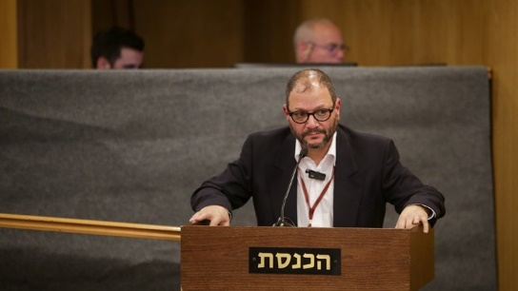
Ofer Cassif Flash 90
Joint List MK Ofer Cassif was filmed on Friday striking an Israeli police officer who was blocking him from driving to a demonstration against the evacuation of buildings on Mount Hebron.
Cassif hit in the head an officer after his car was stopped by the police while he was on his way to the protest against buildings built illegally in a fire area in Safar Yatta in the southern Hebron Mountains.
Cassif took advantage of his political immunity and entered the area with his vehicle even though it was declared a closed military area.
"Ofer Cassif should be questioned as early as Sunday about assaulting a police officer. There is no parliamentary immunity or permission to break the law, disrupt public order and use violence – not against civilians and certainly not against security forces who do their job faithfully,” Communications Minister Yoaz Hendel said.
Minister of Interior Ayelet Shaked also responded to the incident on Twitter, saying: "Police officers, Border Police fighters and all the forces that are in the area on Friday afternoon, to keep us all safe: I know how hard you work these days and how you divide your body between terrorism and Israeli citizens. Do this sacred work and ignore depraved people like Ofer Cassif."
A serious incident was also recorded yesterday after MK Ahmad Tibi confronted police in East Jerusalem and helped smuggle a detainee. The suspect was apprehended and arrested for questioning by the police.
"We take seriously the conduct of the elected official, who abused his immunity and allowed the escape of a suspect during his detention (without such success)," police said. "Disruption of police activity for the maintenance of law and order is an improper act, especially when it is committed by an elected official who is to serve as a personal example and not to thwart police activity." https://www.israelnationalnews.com/news/327508
To be removed from this News list, Please click here and put "Unsubscribe" in the subject line.

