12/20/2021 NEWS AM Don’t miss Lev U’Neshama End of Year Report at end of posting!
ETBPF has been supporting and advocation for their work for many years.

What Child Is This (from The Chosen Christmas Special)
https://www.youtube.com/watch?v=sNYpxYKtC_w
"Remember this, if you can. There is nothing more precious than time. You probably feel you have a measureless supply of it, but you have not. Wasted hours destroy your life just as surely at the beginning as at the end, only in the end it becomes more obvious."
-- Herman Wouk (1915-) American author
Read the Prophets & PRAY WITHOUT CEASING!
That is the only hope for this nation!
Please  Remember  These  Folks  In  Prayer-  Check often  They  Change! | Pray that the world would WAKE UP! Time for a worldwide repentance!  ALL US soldiers fighting for our freedom around the world  Pray for those in our government to repent of their wicked corrupt ways.  Pray for “A” family – three admitted with Covid very sick. Multiple Comorbidities - Two passed away  Pray for TH - Knee and Blood pressure problems.  Pray for J P– sick with flu bad episode 5 years ago  Pray for RR – young man with enlarged heart ventricle  Pray for family of RY – Passed away from Covid  Pray for EL – Had clot embolized to brain – successful ‘clot buster’ but long road to go.  Pray for BB – Severe West Nile Fever –still not mobile- improving!  Pray for RBH – cancer recurrence  Pray for GB – bad reaction from Cancer drug  Pray for Ella – Child with serious problems  Pray that The Holy One will lead you in Your preparations for handling the world problems. – Have YOU made any preparations?
Genesis 50:⁴And when the days of weeping for him were past, Joseph spoke unto the house of Pharaoh, saying: 'If now I have found favour in your eyes, speak, I pray you, in the ears of Pharaoh, saying: ⁵My father made me swear, saying: Lo, I die; in my grave which I have digged for me in the land of Canaan, there shalt thou bury me. Now therefore let me go up, I pray thee, and bury my father, and I will come back.' ⁶And Pharaoh said: 'Go up, and bury thy father, according as he made thee swear.'

If you watch NOTHING this year watch this!
https://www.youtube.com/watch?v=7vPRtkc2f-4

This is a bit long, but it is the best presentation on what our government is and is supposed to be you will ever see. Constitutional law in 1.3 hour and how return America to its proper relationships.
The video is called “NonCompliant”
Are you a slave or are you a free person?
Stabbing attack attempted near Jerusalem's Damascus Gate
The attacker reportedly tried to stab two young ultra-Orthodox Jews who were Breslov hassidim at a parking lot near Damascus Gate.
By JERUSALEM POST STAFF Published: DECEMBER 19, 2021 18:49 Updated: DECEMBER 19, 2021 19:42
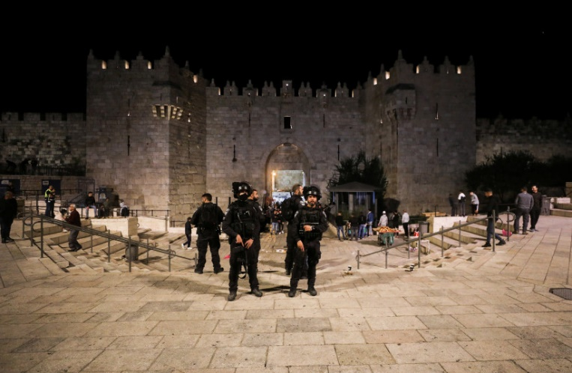
Israeli police officers stand guard outside the Damascus Gate, in Jerusalem, December 4, 2021. (photo credit: REUTERS/AMMAR AWAD)
A possible stabbing attack took place in Jerusalem Sunday when a man attempted to stab two Israelis.
The attacker reportedly tried to stab two young ultra-Orthodox Jews who were Breslov hassidim at a parking lot near Damascus Gate. The two are currently being questioned by police, ynet reported.
According to KAN, the attacker approached the hassidim and took a knife out of his bag and hit one of them but was unable to stab. He then threw the knife away and fled.

ניסיון פיגוע ליד שער שכם בירושלים: חשוד הלך אחרי שני גברים חרדים, הוציא סכין מתיק, נתן מכה לאחד מהם - אך לא הצליח לדקור. לאחר מכן הוא זרק את הסכין ונמלט. הסכין אותרה והחשוד, תושב ענאתא בשנות ה-20 לחייו, נעצר@VeredPelman
(צילום: משטרת ישראל) pic.twitter.com/HQvmqs0hcG
— כאן חדשות (@kann_news) December 19, 2021
The attacker, a 20-year-old Palestinian from Anata, was arrested shortly after by law enforcement personnel and the knife was discovered and confiscated.
Police will now intensify ongoing security in the area.
The incident follows other high-profile stabbing attacks by Palestinians against Israelis in Jerusalem.
Earlier in December, a 14-year-old Palestinian girl stabbed an Israeli mother in the Sheikh Jarrah neighborhood of east Jerusalem.
That attack followed a 23-year-old Palestinian stabbing a haredi man outside Damascus Gate before he was shot and killed by Border Police officers.
This is a developing story. https://www.jpost.com/breaking-news/possible-assault-incident-reported-in-jerusalem-689182

Shin Bet: Suspects in deadly West Bank shooting are members of Islamic Jihad
Terror group takes responsibility for last week’s attack, in which one man was killed and two were injured, outside Homesh outpost
By Judah Ari Gross Today, 10:59 amUpdated at 12:47 pm
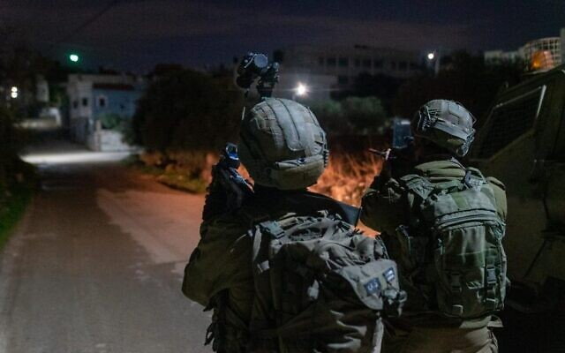
Israeli special forces conduct a raid in the village of Silat al-Harithiya, near Jenin to arrest the men suspected of having carried out a deadly shooting attack outside the Horesh outpost in the West Bank earlier in the week, on December 19, 2021. (Israel Defense Forces)
The terror cell suspected of carrying out last week’s deadly shooting attack in the northern West Bank last week belongs to the Palestinian Islamic Jihad terror group, the Shin Bet security service said Sunday.
In the predawn hours of Sunday morning, Israeli security forces conducted a series of raids in in the northern West Bank village of Silat al-Harithiya, near Jenin, arresting at least six people in connection with the terror attack outside the illegal outpost of Homesh last Thursday, in which one man, Yehuda Dimentman, was killed and two others were lightly wounded.
The military initially refrained from commenting on any ties between the suspects and terror groups, but later the Shin Bet confirmed that they were believed to be members of Islamic Jihad.
The Islamic Jihad did not take responsibility through its official channels, but a spokesperson for the group’s military wing in the West Bank was quoted by Hamas-affiliated media as saying it was behind for the attack. The spokesman said it was retaliation for the death of Jamil al-Kiel, a Palestinian man who was shot by Israeli troops last week, during a clash in Nablus in which he allegedly threw Molotov cocktails at them.
Palestinian officials identified the arrestees as Muhammad Youssef Jaradat, Ibrahim Musa Tahaineh, Mahmoud Ghaleb Jaradat, Taher Abu Salah, Ghaith Ahmed Yassin Jaradat, and Omar Ahmed Yassin Jaradat.
Two of the suspects were believed to have conducted the actual shooting, while the rest were suspected of helping them and otherwise being involved in the cell.
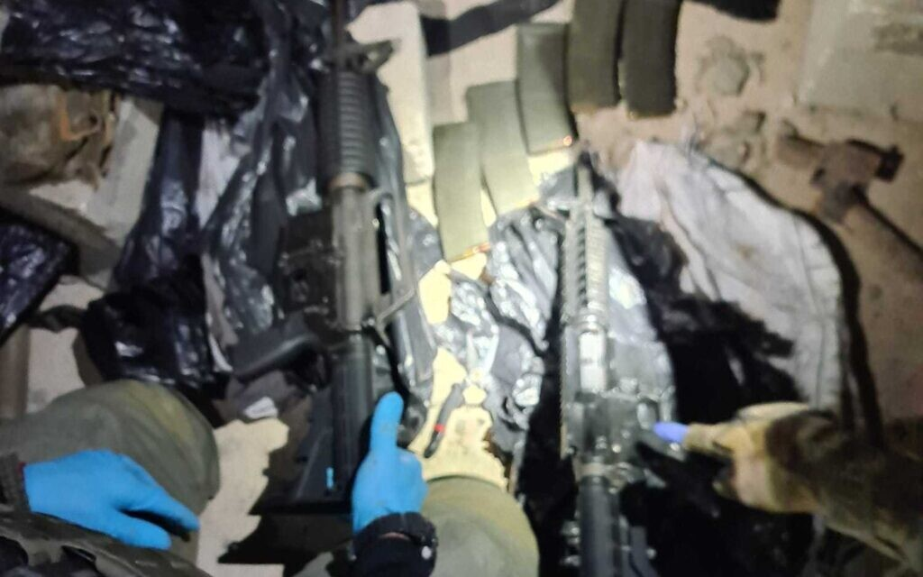
A photo released by the Israel Police on December 19, 2021, shows guns allegedly used in a deadly terror attack near the West Bank outpost of Homesh. (Israel Police)
The six men, arrested at three locations in the overnight raid, were all handed over to the Shin Bet for interrogation. The guns that were suspected of having been used in the attack, as well as the car that was allegedly used to ferry them to the scene, were seized in the raids.
IDF Spokesperson Ran Kochav said the military believed that the arrests of the cell members likely prevented additional attacks and could lead to further arrests.
Two gunmen opened fire at Dimentman and the two other men as they left Homesh on Thursday night. A military official said their car was ambushed from the side of the road. The 25-year-old Dimentman, a father of a 9-month-old, was a student at the yeshiva, or religious school, near where the attack took place and lived in the nearby Shavei Shomron settlement. Homesh was an Israeli settlement that was evacuated in 2005 as part of then-premier Ariel Sharon’s so-called disengagement, but has since become the site of the illegally operated yeshiva.
Prime Minister Naftali Bennett hailed the arrest of the suspects, saying in a statement: “Every terrorist must know that the State of Israel will settle the score with them.”
Defense Minister Benny Gantz also congratulated the IDF and the Shin Bet on a “prompt, professional and determined operation.”
The past few weeks have seen a rise in Palestinian terror attacks, with four taking place in Jerusalem alone, including a deadly shooting committed by a member of Hamas.
There has also been a noted rise in settler violence toward Palestinians. A group of extremist settlers assaulted Palestinians and vandalized property in a West Bank village near Nablus overnight Thursday, Palestinian media reported Friday, hours after the attack. https://www.timesofisrael.com/shin-bet-suspects-in-deadly-west-bank-shooting-are-members-of-islamic-jihad/

Israeli forces raze structures set up at illegal outpost after deadly terror attack
Family of victim say his legacy should be the legalization of the Homesh yeshiva: ‘Otherwise we feel that this innocent victim’s death was in vain’
By Judah Ari Gross Today, 3:23 pm
Israeli security forces on Sunday razed a number of structures set up on the illegal Homesh outpost in the aftermath of last week’s deadly terror attack nearby, Israeli officials said.
On Thursday night, Palestinian terrorists opened fire at a car full of students from the illegally constructed yeshiva, or religious school, at Homesh, killing one of them, Yehuda Dimentman, and wounding two more.
In response to the attack, on Saturday night, hundreds of settlers broke into the outpost, assaulting the soldiers who were guarding the area, and constructed a number of additional structures at the site, the Israel Defense Forces said.
“Troops from the IDF, Border Police, and Israel Police tried to block the entrance of the settlers, who used physical and verbal violence, vandalized military property and blocked the paths of security forces. In addition, an IDF soldier was lightly wounded after getting hit by one of the settler’s cars,” the military said in a statement on Sunday evening, nearly 24 hours after the events.
No arrests were made. A military spokesperson said the soldiers on the scene were waiting to police arrive so that they could make the arrests as the suspects are Israeli citizens. IDF troops are legally permitted, even required, to arrest suspects of violent crimes in the West Bank, regardless of nationality.
In its statement, the IDF said it denounced all forms of violence against security forces and would continue to “enforce laws and prevent illegal activities of all types.”
On Sunday morning, the IDF declared the site a closed military zone and representatives from the Defense Ministry’s Civil Authority, guarded by Israel Police officers, went up to the site and demolished the newly constructed plywood buildings, a spokesperson for Israel’s military liaison to the Palestinians confirmed.
Video footage from Homesh, which was shared by far-right Knesset member Bezalel Smotrich, showed bulldozers demolishing some of the structures.
A spokesperson for the Civil Administration, which oversees day-to-day management of the West Bank, said that only the structures built over the weekend were destroyed, not the yeshiva building, which was left intact.
ממשלת השמאל הרופסת החליטה להעניק פרס לטרור והורתה לצה"ל ולמשטרה לחסל את הישיבה בחומש בתגובה לפיגוע שבו נרצח יהודה דימנטמן הי"ד. את בתי המחבלים הם לא הורסים אבל את הישיבה כן. הם יפגשו מולם אלפים ורבבות אוהבי הארץ נחושים שיאבקו בהחלטה האומללה הזו וינצחו אותם. כולנו נהיה שם. pic.twitter.com/drPQhmFE9j
— בצלאל סמוטריץ' (@bezalelsm) December 19, 2021
The spokesman refused to comment on the rationale behind the decision to leave up the yeshiva, which was not only constructed without the proper permits but was built on a site that it is illegal for Israelis to visit under the 2005 law behind the Disengagement, when Israel pulled out unilaterally from the Gaza Strip and four northern West Bank settlements.
In a tweet, Smotrich lambasted the government for the demolition, saying it was a “prize to terror.”
The demolition came as Dimentman’s family called for the government to legalize the Homesh outpost.
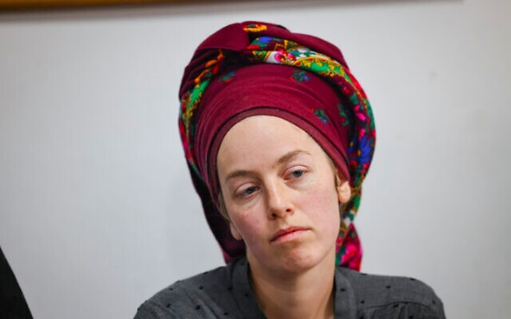
“I turn to Prime Minister Naftali Bennett — there is a yeshiva in Homesh, we need to legalize it and secure it. I turn to you and ask you to allow the people of Israel to go up there,” said his widow, Ettya Dimentman, in a direct appeal to the prime minister, a member of the right-wing Yamina party.
“The blood of Yehuda is too precious. It is impossible to return to routine after the blood of such a pure soul has been shed,” she said.

Ettya Dimentman, whose husband Yehuda was killed outside the illegal outpost of Homesh in the northern West Bank, gives a press conference on December 19, 2021 (Yonatan Sindel /Flash90)
“Yesterday a friend of his showed me what he wrote six and a half years ago when asked what he would do if he only had one week to live, and Yehuda answered that he would study Torah in Homesh,” Ettya said at a press conference, hours after her husband’s suspected killers were arrested.
Israeli security forces demolish illegally constructed buildings on the Homesh outpost, which were set up following a deadly terror attack nearby, on December 19, 2021. (Screen capture: Twitter) | 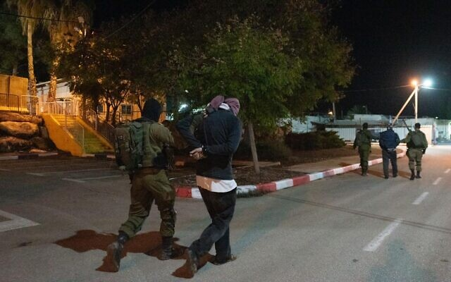  Israeli special forces arrest two men suspected of being part of the cell that carried out a deadly shooting attack outside the Horesh outpost in the West Bank, on December 19, 2021. (Israel Defense Forces)

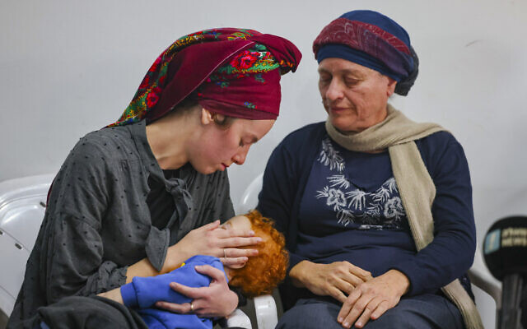
Ettya Dimentman (L), whose husband Yehuda was killed outside the illegal outpost of Homesh in the northern West Bank, gives a press conference on December 19, 2021 (Yonatan Sindel /Flash90)
Yehuda’s father, Mordechai, thanked the security forces who captured his son’s suspected killers and said the arrests should act as a deterrence,. He also called for the outpost to be legalized.
“The terrorists need to know that they will be reached and this may deter them from committing the next murder. Thank you to the security forces and the Israeli government,” he said.
The father noted that in the opinion of the family, the resettlement of the outpost should be Yehuda’s legacy.
“This yeshiva will be legalized and the IDF will secure it. Otherwise we feel that this innocent victim’s death was in vain,” Mordechai said. MORE - https://www.timesofisrael.com/israeli-forces-raze-structures-set-up-at-illegal-outpost-after-deadly-terror-attack/

Israel braces for arrival of major winter storm ‘Carmel’
Minister vows emergency forces will be ready for ‘challenges and surprises’ ahead of Monday’s expected landfall; outdoor school activities canceled, travelers told to avoid parks
By TOI staff Today, 9:49 pm
United Hatzalah volunteers check their rescue gear in the northern city of Safed on December 19, 2021, as emergency crews were on high alert ahead of winter storm 'Carmel.' (David Cohen/ Flash90)
Israel on Sunday was gearing for the arrival of a major winter storm dubbed “Carmel,” which is expected to bring major rainfall and strong winds, causing serious disruptions throughout the country.
Emergency services were readying for various rescue tasks, while local authorities prepared backup generators and trimmed vegetation near powerlines to prevent cuts when the storm makes landfall on Monday.
Police and fire services warned the public to refrain from unnecessary travel during the storm, which is expected to last until Wednesday. They also urged Israelis to avoid underground parking garages and other areas that could experience flooding, amid expectations of up to 150 millimeters (nearly six inches) of rain in some locations.
Along with the rainfall, the weather depression was expected to bring near-gale force winds and high seas.
“We are facing tough days and levels of precipitation that will lead to dangers,” Public Security Minister Omer Barlev said after holding an assessment with emergency and security officials. “The emergency forces will be ready for the challenges and surprises.”
“I ask Israeli citizens — take care of yourselves,” he added.
Citing the storm, Keren Kayemeth LeIsrael Jewish National Fund (KKL-JNF) urged Israelis not to visit national parks and forests until Friday, while the Education Ministry announced the cancelation of all school hikes and other outdoor activities during the storm.
The ministry also said in-person classes would not be held at educational institutions in areas that are at risk of flooding.
Sunday’s preparations came amid a lull in the stormy weather after rainfall and high winds lashed parts of Israel on Saturday, when a homeless man in Tel Aviv died of hypothermia.
The Carmel weather system was given its moniker by a team of Israeli meteorologists in conjunction with their Greek and Cypriot counterparts. The storm first pounded Greece and Cyprus, before heading toward Israel. https://www.timesofisrael.com/israel-braces-for-arrival-of-major-winter-storm-carmel/
Tel Aviv no longer Israel's most liberal city
Out of 31 cities and local authorities that were examined and rated, Givatayim was chosen as the country's 'freest' city 2021; Tel Aviv finished 2nd and mostly Haredi Beitar Illit was rated as Israel's most illiberal city
Sivan Hilaie | Published: 12.19.21, 12:42
For the first time in years Tel Aviv has been knocked down off the top spot in the ranking of Israel's most liberal cities, according to a report published Sunday.
The report by the religious pluralism group Israel Hofsheet, or Israel Be Free, ranked the city of Givatayim as the "freest" city in Israel in 2021, effectively dethroning its neighbor, which just last month was crowned as "the costliest city in the world."
Givatayim (left) and Tel Aviv (right) (Photo: Yakir Lahan)
This is the fourth year the group has ranked 24 of the largest Israeli cities according to their attitudes about 10 social and religious questions, including: the supervision of religious organizations; exclusion of women from public space; attitude towards LGBTQ community; freedom of trade and public transportation on Shabbat; possibility of civil marriage; and the quality of religious services as well as the examination of religious pluralism.
The ranking was based on data from the Israel Central Bureau of Statistics, the Interior Ministry, and other public and government data sources. In total, 31 cities and municipalities were examined and rated.
This year, Tel Aviv - which in 2020 shared first place along with Herzliya - was ranked second with 75%, the third place was given to Kfar Saba, followed by Rishon LeZion, and Herzliya which came only fifth with 67%.

Pride parade in Tel Aviv (Photo: Guy Yechiely)
On the other end, Bnei Brak, Modi'in Illit, Beit Shemesh and Ramla were ranked as the most conservatives, with the Haredi Jewish-Israeli settlement of Beitar Illit taking the final spot, with an overall rating of 0%, which means it is the most illiberal city in Israel.
In total, the overall average of the liberal index is 38.8% in each of the selected cities and municipalities, compared to 42.7% last year. https://www.ynetnews.com/article/r10epw35t

Jerusalem church leaders warn ‘radical groups’ driving Christians from Holy Land
Guardian of Christian holy places laments ‘unchecked, unpunished’ attacks, as archbishops blame Israeli settlers and security barrier; accusations draw protest from British Jews
By Stuart Winer Today, 11:33 pm
Illustrative: A priest checks the damage after a man poured out flammable liquid inside the Church of All Nations at the Garden of Gethsemane, in East Jerusalem, on December 4, 2020. (Ahmad Gharabli/AFP)
Christian leaders in the Holy Land have issued warnings that their communities are under threat of being driven from the region by extremist Israeli radical groups, urging dialogue to discuss preserving their presence.
Fr. Francesco Patton, the Catholic Church’s Custos of the Holy Land and guardian of the Christian holy places in the Holy Land, wrote in an opinion piece published Saturday by the UK’s Daily Telegraph that “our presence is precarious and our future is at risk.”
Last week, the patriarchs and heads of churches in Jerusalem issued a joint statement similarly warning of the danger posed by radical groups they said are aiming at “diminishing the Christian presence.”
Patton wrote that in recent years, the lives of many Christians have been made “unbearable by radical local groups with extremist ideologies.”
“It seems that their aim is to free the Old City of Jerusalem from its Christian presence, even the Christian quarter,” he said.
Holy sites, including churches, have been desecrated and vandalized, while offenses have been committed against priests, monks and worshipers, he charged.
“These radical groups do not represent the government or the people of Israel. But as with any extremist faction, a radical minority can too easily burden the lives of many, especially if their activities go unchecked and their crimes are unpunished.”
Fr. Francesco Patton, Custos of the Holy Land, Guardian of the Christian Holy Places in the Holy Land on behalf of the Catholic Church (Courtesy)
Patton wrote that whereas the Christians were once 20 percent of Jerusalem’s population, today they are less than 2%. He issued an appeal to the world for support “so that we can continue to preserve the rich diversity of this Holy Land.”
More warnings came for Britain’s Archbishop of Canterbury Justin Welby in a joint article written with the Anglican Archbishop of Jerusalem, Hosam Naoum, published in the UK’s Sunday Times. They said the article was prompted by the statement last week from the Jerusalem churches.
Welby and Naoum wrote that there is a “concerted attempt to intimidate and drive” away Christians.
The archbishops said that the increase in Israeli settler communities, coupled by the restrictions on movement posed by the security barrier Israel built to stymie terror attacks from the West Bank, had “deepened the isolation of Christian villages.”
As a result, they wrote, there is “a steady stream of Palestinian Christians leaving the Holy Land to seek lives and livelihoods elsewhere.”
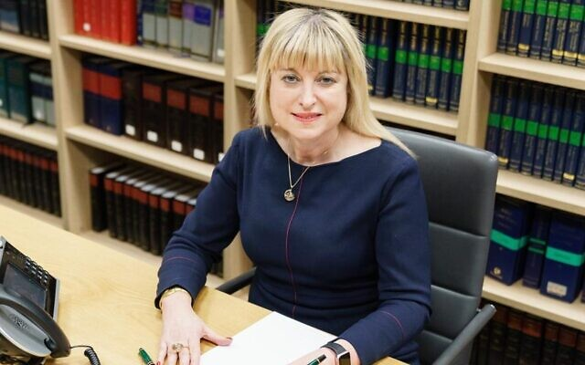
President of the Board of Deputies of British Jews Marie van der Zyl. (Courtesy)
However, the archbishops’ article drew protest from the Board of Deputies of British Jews over some of the assertions they made on what is causing the waning of Christian presence in Israel.
Board president Marie van der Zyl wrote a letter to Welby in which she expressed “great regret” at his published remarks and called for a meeting to discuss “deeply troubling” aspects of his article, the Jewish Chronicle reported.
While noting that attacks on the Christian community are unacceptable, van der Zyl questioned the causes of a decline in the Christian community, stressing that there are “more complex reasons than those raised in the article, which appeared to attribute this decline to Jewish settlers and the barrier built to halt the wave of terror attacks of the Second Intifada.”
Last week’s statement, issued by the Diocese of Jerusalem on behalf of the patriarchs and heads of churches in Jerusalem, warned of the “current threat to the Christian presence in the Holy Land.”
While acknowledging “with gratitude the declared commitment of the Israeli government to uphold a safe and secure home for Christians in the Holy Land,” the statement went on to lament that “radical groups” are acquiring properties in the Christian Quarter “with the aim of diminishing the Christian presence.” [This is rather interesting because from several years ago I learned that much of the property in the Christian Quarter was being taken up by radical Islamic groups not radical Jewish groups. Perhaps those in the Roman Church are having difficulty telling the difference. – rdb]
Such groups, the statement said, are “often using underhanded dealings and intimidation tactics to evict residents from their home,” decreasing the Christian presence and disrupting pilgrimage routes between Bethlehem and Jerusalem.
The statement noted the benefits that Christian pilgrims bring to Israel, citing a University of Birmingham report that it brings $3 billion to the economy.
Church leaders requested “urgent dialogue” with authorities of “Israel, Palestine and Jordan,” all of whom, they said, have declared their commitment to protecting religious freedom.
They said the talks should focus on the “challenges presented by radical groups” in Jerusalem and on the creation of a “special Christian cultural and heritage zone to safeguard the integrity of the Christian Quarter in the Old City of Jerusalem.”
Welby tweeted the “unprecedented statement” and urged his followers to “read their heart-cry.”
The Vatican News reported Wednesday that Christian organizations across the world responded to the statement with messages of support.
The World Council of Churches, representing 349 churches, gave its backing, with acting general secretary Rev. Ioan Sauca saying in a statement that Christians in the Holy Land should be “respected and valued as part of both the heritage and future of the region.” [When you read this you need to be aware of a number of issues. The head of the Roman church for the past several papacies has had their eye on an international control of Jerusalem lead of course by the Church of Rome. For that reason you need to be most cautious of things emanating from them. Secondly most should be aware that the World Council of Churches is less than a legitimate actor in most any affairs because they are a leftist liberal group that most true Christians would not have any affiliation. I must question if Rome is not colluding with them to accomplish their goal of an international Jerusalem. - rdb
Churches for Middle East Peace, a US-based advocacy group, also issued a statement stressing the importance of Christian communities in the Holy Land, Vatican News reported. [The group cited here is a dreadful group of anti-Semites who have worked for years to promote the “PA” agenda. – rdb]
Though neither Patton nor the Church leaders statement mentioned it by name, Ateret Cohanim is a religious-Zionist organization that works to populate the Old City and other East Jerusalem neighborhoods with Jewish residents by purchasing properties from non-Jewish owners. [Most of their properties have been acquired from Islamic owners not from Christian owners. – rdb]
Separately, extremist Jewish activists have for years carried out vandalism against Christian sites in Jerusalem and other areas of Israel, including hate graffiti and arson. The extremists also target Palestinians.
Israel seized East Jerusalem from Jordan in the 1967 Six Day War and later extended sovereignty over it, in a move never recognized by the international community. It now considers the entirety of Jerusalem its capital, citing the Jewish historical and biblical connection there. https://www.timesofisrael.com/jerusalem-church-leaders-warn-radical-groups-driving-christians-from-holy-land/ [The comment that Israel ‘seize’ East Jerusalem gives you an idea of the thinking of the author of this article. True Israel WON BACK the city after it was held and desecrated by the Jordanian group for some 19 years between the war of independence and the 67 war, during which time the Jordanians destroyed most synagogues and desecrated graves and cemeteries and forbid the practice of anything but islam. That should tell you something. – rdb]

Israel confirms 40 new Omicron cases, bringing total to 175
Ministry says 380 others suspected to have new strain; vast majority of infections are among returning travelers; Knesset building imposes restrictions after workers contract COVID
By TOI staff Today, 5:53 pm
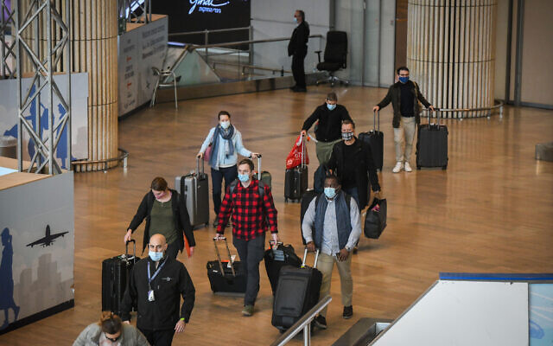
Arriving travelers at Ben Gurion Airport on December 19, 2021. (Flash90)
The Health Ministry on Sunday announced 40 more people have been diagnosed with the Omicron variant of the coronavirus, bringing the number of confirmed cases in Israel to 175.
The ministry said the vast majority of Omicron infections, 113, were detected among travelers returning from abroad. Another 31 people tested positive for the strain after exposure to someone recently overseas and 17 infections were from community spread.
The source of the other 14 cases was still being probed.
Of the confirmed Omicron cases, 122 were listed as “protected,” which the Health Ministry defines as anyone who received a booster vaccine shot, or got their first two vaccines or recovered from COVID-19 in the past six months. [Which show you just how useless the JAB really is. It doesn’t protect from the virus and it doesn’t stop transmission. This should tell you that there is something else going on which is why they are pushing for everyone to get JABBED! WHY? For some reason that is nefarious. -rdb]
The ministry said it was also awaiting results from 380 more cases in which there is a “high suspicion” of exposure to Omicron.
Among both confirmed and suspected Omicron infections, 229 people had COVID-19 symptoms and 325 were asymptomatic. The ministry said it was “in the process of checking” the remaining case. [What kind of COV symptoms? Fever, loss of smell or taste? Were they having breathing trouble? From what I have read this is a mild flu and not life threatening. Wo why the hysteria?– rdb]
Israel has so far reported only one serious illness stemming from Omicron — an unvaccinated man who was hospitalized — and no deaths.
Meanwhile, the Knesset announced new restrictions at the parliament building after a number of recent infections there.
The measures included suspending tours and visits, canceling events and conferences, closing the gym, forbidding eating in the cafeteria, and limiting capacity in the plenum and meeting rooms, among others.
The new rules came after nine lawmakers were instructed to quarantine earlier Sunday after being exposed to a suspected Omicron carrier. Several other MKs have also entered quarantine in recent days after exposure to parliamentary workers who tested positive for COVID, including opposition leader Benjamin Netanyahu.
Also Sunday, the Health Ministry recommended the government designate another 10 countries as “red” due to Omicron fears. Ministers were expected to vote later in the day on barring travel to the United States, Italy, Germany, Belgium, Hungary, Canada, Morocco, Portugal, Switzerland and Turkey.
The decision is driven by data seen by Prime Minister Naftali Bennett showing the likelihood of “a significant outbreak” of COVID-19 within three weeks, with the peak surpassing that of the Delta wave, which started in June.
Bennett’s office said the premier would be holding a press conference at 8 p.m. on Sunday, dealing with the pandemic. [Bennett is beginning to sound like the Hysterical ABC news 5:30 PM anchor who always sounds like the world has come to its end. – rdb]
Israel has in recent days already added nine countries to the “red,” no-fly list: the UK, Denmark, France, Spain, the United Arab Emirates, Ireland, Norway, Finland, and Sweden. South Africa and a slew of other African countries were added at the start of the month.
Those wanting to travel to “red” countries need to obtain special permission from a government committee.
On Thursday, the cabinet voted to extend the current travel restrictions, including the ban on foreigners entering the country and a requirement for all returning Israelis to quarantine for three days upon entry. The limitations will now last until December 29 at least.
Health Minister Nitzan Horowitz said Sunday that the restrictions were needed to “buy time” for the vaccination campaign.
“We are facing a new situation. Most of the infection from Omicron is coming from abroad, so we must limit the rate of entry of the virus into Israel in order to buy time and vaccinate as much as possible before the spread also occurs in Israel,” Horowitz told Army Radio.
But in a statement released after Sunday morning’s cabinet meeting, in which expanding the no-fly list was discussed, Transportation Minister Merav Michaeli said she told ministers that she would not back any further restrictions on travel “until the issue of support for airline companies is resolved.”
Bennett has come under criticism in recent weeks for the policy steps he has taken; however, according to the Haaretz daily, the premier believes he has bought the time needed to slow the entry of the highly contagious variant into the country, giving scientists a window to study it as well as buying time for the vaccination and booster campaign.
The Health Ministry said Sunday that 372 new COVID-19 infections were diagnosed the day before, a low number reflecting reduced testing over the weekend.
According to the ministry, there were 81 COVID-19 patients in serious condition and 41 on ventilators. Most patients in serious condition are over 60 and unvaccinated.
Since the start of the pandemic, 5.8 million Israelis — out of the total population of 9.3 million — have received two vaccine doses, and over 4.1 million have gotten a third, booster shot.
The death toll in Israel since the start of the pandemic stood at 8,232 on Sunday. https://www.timesofisrael.com/israel-confirms-40-new-omicron-cases-bringing-total-to-175/ This is a totally irrational response if you read what is coming out from other locations, It has to be a bunch of political garbage. – rdb]

Entry ban on Diaspora Jews ‘moral disgrace’ says South African chief rabbi
Goldstein made his remarks as Israel is set to add more countries to its red list.
By JEREMY SHARON Published: DECEMBER 19, 2021 19:19 Updated: DECEMBER 19, 2021 20:28

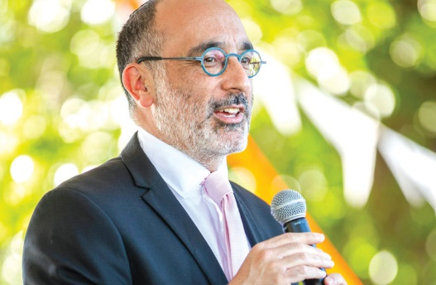
South Africa’s Chief Rabbi Warren Goldstein. (photo credit: Courtesy)
Chief Rabbi of South Africa Dr. Warren Goldstein has branded Israel’s border closure to foreign Jews “a moral disgrace” and said that country must reverse the ban or risk long-term damage to the country’s relationship with Diaspora Jews.
The rabbi said Israel’s draconian entry regulations were dividing families and undermining the very reason for the state’s existence, to be a state for the Jewish people.
Goldstein made his remarks as Israel is set to add more countries to its red list, including the US with the largest Jewish community in the world outside of Israel, making it almost impossible for foreign nationals from the countries to visit the Jewish state, or for Israelis to visit them.
Many immigrants in Israel have grown increasingly frustrated with the tight entry regulations for foreign nationals that have restricted the ability of their relatives to visit the country, while Israelis have been able to freely visit countries, not on the red list.
Poor implementation of the exceptions for the entry ban that do exist and the hostile treatment of some incoming foreign nationals by Israel’s Population and Immigration Authority have caused further problems.
Jewish Diaspora women arriving in Israel (credit: MOMENTUM)
“The Israeli travel ban is doing serious damage to relations between the State of Israel and Diaspora Jewry,” said Goldstein.
“It’s casing terrible human suffering, it’s dividing families, people can’t come for family celebrations or to just their relatives,” continued the rabbi.
He said the “heartlessness of these policies” was demonstrated when friends of the family of Eli Kay, who was slain in a terrorist attack last month, came from South Africa to support the family and were barred from entry to the country after the entry regulations changed while they were in the air en route, and were forced to violate Shabbat when the Population Authority forcibly boarded them on plane out of the country on Friday afternoon.
Goldstein, together with other senior rabbis in South Africa, sent a letter to Prime Minister Naftali Bennett strongly objecting to the incident, but says he did not receive a reply.
The rabbi said the government must not jeopardize the health of its citizens, but that it has to apply the same rules to Israeli passport-holders as other Jews.
“By doing what it is doing the government is saying, ‘You are not part of us, we are not part of you, and our borders are locked to you,’” said Goldstein.
“Its a moral disgrace, and cannot be defended on grounds of medical safety. The future sustainability and success of Israel depend on if it fulfills the reason for its existence. That is to be a Jewish state. If you violate the Jewish identity of the Jewish state, if you take away its reason for being, that is a strategic threat to the State of Israel.”
Added the rabbi, “They have no moral or spiritual right to deny Jews entry into the Land of Israel.”
Goldstein said some in his community who are “proud Zionists” feel “totally alienated by the actions of the Israeli government,” and that the persistent entry bans for Diaspora Jews were damaging the relationship between the Jewish state and its brethren abroad.
“You can’t have a situation in which Israelis have all the privileges, Diaspora Jews have nothing, and then afterwards go back to normal as if nothing happened,” said the rabbi.
He noted that Bennett recently wrote to the Jewish Federations of North America saying he “deeply regrets” the pain caused to Diaspora Jews by the travel bans, but said that regret requires change, and that the government is still yet to change its policies as a reflection of its regret.
“The consequences, if nothing is changed, will start to emerge over the coming months and years, because the relationship has been changed. You can’t fundamentally change the relationship between Israel and the Jewish Diaspora and then expect everything will proceed as usual.” https://www.jpost.com/diaspora/entry-ban-on-diaspora-jews-moral-disgrace-says-south-african-chief-rabbi-689186 [Either Bennett and his administration and medical advisors are terribly stupid or they are all evil and in accord with the globalist WEC group and trying to depopulate the land. – rdb]

Minister to probe police violence after cops seen whipping anti-vaccine protesters
Officers reportedly knock journalist to the floor during rally against COVID measures near PM’s Ra’anana home; separately, right-wing Jerusalem protesters hit by water cannon
By TOI staff Today, 9:55 pm
Public Security Minister Omar Barlev held a meeting Sunday evening with top police officials after cops were accused of using violence against protesters in two separate demonstrations over the weekend.
Anti-vaccine protesters said they were whipped by mounted officers near the prime minister’s private home in Ra’anana, while right-wing demonstrators were blasted with water cannons in Jerusalem.
Barlev, whose ministry is responsible for police, was to be briefed on what happened at both locations, according to earlier Hebrew media reports.
In Ra’anana, protesters against restrictions ordered by the government due to the COVID-19 pandemic clashed with police outside Prime Minister Naftali Bennett’s home in the central region city.
There were reports by several protesters that police on horseback used the leather reins of their mounts to whip demonstrators. [HUMMM? Is that like they did in Texas to the illegals? NOT– rdb]
“A policeman whipped me when my hands were on my face [for protection],” Roy Peleg told Haaretz. “He could have hit me directly in the face.”
Nir Pich, who was also at the protest, said a policewoman was lashing with her reins “in all directions” and claimed she was not alone in her actions.
Pich said the use of reins in that way is humiliating.
“It has unpleasant connotations,” he said.
Video footage from the protest appeared to show a mounted officer lashing protesters.
לא משנה מה הדעות שלכם לגבי מדיניות הממשלה בנושא הקורונה, הדבר הזה מטורף ואמור להטריד כל אזרח:
בהפגנה נגד התו הירוק ומגבלות הקורונה שנערכה הערב ברעננה סמוך לבית רה"מ בנט, שוטרים על סוסים היכו מפגינים בשוט!
הגיעו אלי 3 דיווחים משלושה אנשים שונים. ראו בסרטון בשניות הראשונות את השוט pic.twitter.com/3s5uFhbCz9
— Or-ly Barlev ~ אור-לי ברלב (@orlybarlev) December 18, 2021
Ran Shimoni, a Haaretz reporter who was also at the demonstration, said he was knocked to the floor even though he identified himself as a journalist.
Barriers had been set up some 300 meters from Bennett’s home in accordance with instructions from the attorney-general for holding protests near the homes of elected officials.
However, protesters claim police positioned the barriers in a way that forced the demonstration into an unnecessarily small space.
“It is a miracle that no one was crushed,” Peleg said.
Three people were arrested for disturbing the peace, Haaretz reported.
The disturbances in Ra’anana came as another demonstration in Jerusalem demanded the government do more against terror attacks in the wake of a deadly shooting attack last Thursday that killed an Israeli man and injured two others in the West Bank, and also turned violent.
Officers used water jets to disperse protesters with video footage showing people walking along the street being knocked over and one woman being blown off her feet by the force of the jet.
חסימה שניה, עוד עצורה נוספת. המשטרה ממלאת את המפגינים במים וקפוא רצח בחוץ.
בוידאו פגיעת מכתזית במפגינה צעירה שעפה מהזרם pic.twitter.com/M6cjNtggCu
— Haim Goldich | חיים גולדיטש (@HGoldich) December 18, 2021
Police said they arrested 13 people for disorderly conduct, including one person who was carrying “weapons.” According to Ynet, these included a knife and brass knuckles. https://www.timesofisrael.com/minister-to-probe-police-violence-after-cops-seen-whipping-anti-vaccine-protesters/

Barkat is Netanyahu’s top successor for Likud leadership - poll
The poll of 650 respondents representing a statistical sample of the Israeli adult population found that Benjamin Netanyahu is by far the strongest candidate as head of Likud.
By GIL HOFFMAN Published: DECEMBER 19, 2021 07:15 Updated: DECEMBER 19, 2021 15:24
Former Jerusalem mayor Nir Barkat could bring the Likud many more seats than other potential successors to former prime minister Benjamin Netanyahu, according to a Panels Research poll taken on Wednesday and Thursday for media outlets in The Jerusalem Post Group.
The poll of 650 respondents, representing a statistical sample of the Israeli adult population, found that Netanyahu is by far the strongest candidate as head of Likud.
If elections were held now with Likud and other parties maintaining their current leadership, Likud would win 33 seats, Yesh Atid 19, Blue and White 9; Shas and the Religious Zionist Party 8, United Torah Judaism, the Joint List and Labor 7, Yisrael Beytenu and Yamina 6, Meretz and Ra’am (United Arab List) 5.
Justice Minister Gideon Sa’ar’s New Hope Party would not cross the electoral threshold. If Barkat would head Likud, the party would win 29 seats, losing four mandates to Yamina, Shas, the Religious Zionist Party, and Blue and White. But Likud would still beat Yesh Atid by 10 seats.
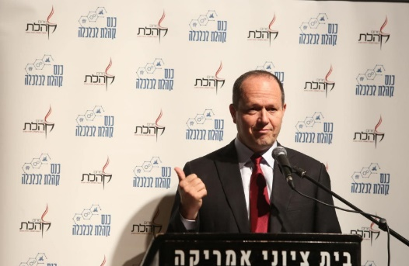
Likud MK Nir Barkat addresses a Kohelet Policy Forum event, February 12, 2020. (credit: MICHAL FATTAL/KOHELET POLICY FORUM)
By contrast, MKs Yuli Edelstein, Israel Katz, and Miri Regev would have a harder time winning the most seats as head of Likud.
Katz would win 22 seats and Edelstein 21, each narrowly defeating Yesh Atid, which would win 20 mandates. The Likud would be harmed by New Hope crossing the threshold and taking mandates away.
If Regev would head Likud, the party would tie with Yesh Atid at 20 seats. Elections for the Likud’s candidate for prime minister in the next election have yet to be set. The poll had a margin of error of 3.4%.
Meanwhile, Channel 12 reported on Saturday night that Ra’am (the United Arab List) has decided to boycott Interior Minister Ayelet Shaked due to disputes over several legislative issues pertaining to her ministry. The main dispute is over Ra’am faction chairman Waleed Taha’s electricity bill, which would allow thousands of illegally built Arab homes to be hooked up to the national electricity grid.
According to the report, Ra’am has asked to work with someone else in the government instead of Shaked.
Ra’am leader Mansour Abbas faced criticism inside his party over the weekend for his consistent conciliatory approach. He especially angered Ra’am officials when he defended Jewish settlers and asked not to make generalities about them, just like any other sector.
Shaked will face another challenge on Sunday when a controversial immigration bill proposed by the Religious Zionist Party MK Simcha Rothman will come to a vote in the Ministerial Committee on Legislation. He intends to bring it to a vote in the Knesset plenum on Wednesday.
The Knesset is also due to vote this week on the government’s plan to draft yeshiva students into the IDF. https://www.jpost.com/israel-news/politics-and-diplomacy/barkat-is-netanyahus-top-successor-for-likud-leadership-poll-689142

Iran inspects new IAEA cameras for nuclear site allegedly targeted by Israel
Tehran’s atomic agency lays out demands for reinstalling surveillance gear at Karaj, including ‘legal and security investigations into the sabotage’ at the centrifuge facility
By AFP Today, 6:29 pm
Rafael Mariano Grossi, director general of the IAEA, presents a surveillance camera at the International Atomic Energy Agency's headquarters in Vienna, Austria, on December 17, 2021. Alex Halada/AFP)
TEHRAN, Iran — Iran said Sunday the technical inspection of new surveillance cameras for the Karaj nuclear facility had begun after Tehran said previous cameras were damaged in an attack it blamed on Israel.
The new cameras, provided by the International Atomic Energy Agency (IAEA), are to replace those Iran says were damaged on June 23 during an Israeli “sabotage” operation.
Tehran and the Vienna-based IAEA announced Wednesday that they had reached agreement on replacing the cameras at the TESA nuclear complex in Karaj, west of Tehran, a facility that makes centrifuges.
Behrouz Kamalvandi, spokesman for the Atomic Energy Organization of Iran, listed the three conditions set by Tehran for the reinstallation.
Iran demands “legal and security investigations into the sabotage,” the IAEA’s condemnation of the matter, and a “technical and security investigation of the cameras” before their installation, he said, speaking on state television.
“The authorization given by Iran did not come in the form of a new agreement, but after the three prerequisites were met,” Kamalvandi added.
The IAEA was not able to recover the camera memory cards destroyed in June, and on Friday the agency’s director general Rafael Grossi said he had “doubts” over a missing camera memory unit.
Suspicions have been raised in Iran that June’s attack could have been enabled by the hacking of the cameras.
But Grossi dismissed that suggestion as “absurd,” insisting the monitors were tamper-proof and that, once installed, they had no means of remote data transmission.
For the rest of the cameras at Karaj, as well as at other sites where the IAEA’s activity has been restricted since February, Iran has said the footage will only be available to the IAEA once US sanctions are lifted.
How and when Iran could get sanctions relief is one of the topics being discussed at the Vienna talks.
Former US president Donald Trump pulled out of the nuclear deal in 2018 and imposed sweeping sanctions including a unilateral US ban on Iran’s oil sales, vowing to bring the US adversary to its knees.
The talks — aimed at bringing the US back into the agreement and Iran to roll back its nuclear activities — started in April this year, but then stopped for several months as the Islamic Republic elected a new ultraconservative government.
The talks finally resumed in late November and on Friday European diplomats warned that they were “rapidly reaching the end of the road.” https://www.timesofisrael.com/iran-inspects-new-iaea-cameras-for-nuclear-site-allegedly-targeted-by-israel/

Iran’s regime posts image of seeking to engulf Israel in flames
The picture shows Israel composed of nails and matches and a book of matches.
By BENJAMIN WEINTHAL Published: DECEMBER 19, 2021 17:18

The picture shows Israel composed of nails and matches and a book of matches next to words in Hebrew and English declaring: “Just try and you will see.” (photo credit: SCREENSHOT/TWITTER)
An Arabic language Twitter account of the Islamic Republic of Iran on Sunday published an image that shows the planned burned elimination of the Jewish state in 2022.
The picture shows Israel composed of nails and matches and a book of matches next to words in Hebrew and English declaring: “Just try and you will see.”
The book of matches, which is situated next to Israel in the image, says “Ballistic matchstick” and shows an Iranian regime flag on it. The apparent message is that the clerical regime is prepared to detonate the matches to destroy Israel in 2022.
Just try and you will see
פשוט תנסה ותראה pic.twitter.com/FpZBHwj9aq
— إيران بالعربية (@iraninarabic_ir) December 17, 2021
The tweet came from the account Islamic Republic of Iran. The account says it joined Twitter in February 2020 and has 39,800 followers. On December 15 the Tehran Times wrote on its front page “One wrong move,” with military targets listed within Israel.
In late November the spokesman for the Islamic Republic of Iran’s armed forces, Brig.-Gen. Abolfazl Shekarchi, urged the total elimination of the Jewish state during an interview with an Iranian regime-controlled media outlet.
"We will not back off from the annihilation of Israel, even one millimeter. We want to destroy Zionism in the world,” Shekarchi told the Iranian Students News Agency.
Sheina Vojoudi, an Iranian dissident who fled the Islamic Republic of Iran due to repression, told The Jerusalem Post, that "The Islamic Republic in Iran is only provoking Israel, it's been years that the Islamic Republic is threatening to wipe Israel off the map but now it's become more serious because the regime knows that the end for this evil regime has come, especially after Vienna Talks which had no results." https://www.jpost.com/middle-east/iran-news/irans-regime-posts-image-of-seeking-to-engulf-israel-in-flames-689177 [Sure they can say they have no intention of getting a bomb but with this you can believe nothing. – rdb]

Latest teen sexual 'predator' at CNN identified as Jake Tapper's producer
'Our world has just been completely flipped upside down'
By WND Staff Published December 19, 2021 at 4:54pm
After being inundated with requests from numerous journalists, Project Veritas is finally releasing the name of the latest CNN producer embroiled in a disturbing sex scandal, allegedly openly fantasizing to others about sex with young teen girls, as well as soliciting nude images of teenagers.
"After ensuring the family involved is safe, Project Veritas has made the decision to release the name, Rick Saleeby," said James O'Keefe, the group's head, noting in bold letters that "Saleeby is a producer on 'The Lead with Jake Tapper.'"
O'Keefe says he reached out to the cable news network multiple times for comment, but no one has responded to date.
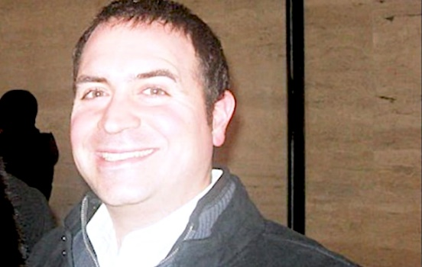
Rick Saleeby
He further explained the mother of the children involved in the tragic story sent Project Veritas a heartfelt note, which stated, in part:
I wanted to reach out to sincerely thank you again. I am very grateful toward you guys and everything you've done for me and my children. Our world has just been completely flipped upside down, but none of that matters. We are all safe. I'm hoping, praying, and pushing for charges to be brought against him, so he can never do this to another child/family again.
I want the public and any predators to know, without a shadow of a doubt, that I will go to the absolute ends of the earth to protect my babies. And I am tremendously grateful that you guys have saved us all from him.
Despite the hardships ahead, I am going to continue to sit with these feelings of gratitude toward you guys and the woman who provided you with the information. Gratitude will get us through to the other side of all this. Thank you from the bottom of my heart and Merry Christmas. ❤️
Interestingly, Saleeby had been quoted by Project Veritas in a 2019 sex scandal involving another CNN producer, Steve Brusk. Brusk reportedly resigned just weeks after being implicated by a network colleague of sexual misconduct, in leaked videos. MORE - https://www.wnd.com/2021/12/latest-teen-sexual-predator-cnn-identified-jake-tappers-producer/

Unnerving: Dr. Peter McCullough warns Americans of biggest public health crisis
It's 'led to large numbers of deaths, hospitalizations and permanent disability'
By Art Moore Published December 19, 2021 at 11:37am
Dr. Peter McCullough speaks to Joe Rogan on the "The Joe Rogan Experience" podcast (Screen capture)
In a podcast interview that would not have been allowed on YouTube, medical scientist Dr. Peter McCullough charged that media and government censorship related to COVID-19 treatments have caused untold harm, contributing to many deaths.
Joe Rogan, the nation's No. 1 podcaster, told McCullough that on nearly every other online platform, including YouTube, their conversation would be censored.
"But what you're saying is incredibly important," said Rogan, whose podcast, "The Joe Rogan Experience," is streamed by Spotify.
"Censorship that has suppressed for two years information on safe and effective early treatment and censorship on vaccine safety has led to large numbers of deaths, hospitalizations and permanent disability," McCullough said.
"There is no bigger public health crisis than the impact of censorship in COVID-19."
McCullough has testified before the U.S. Senate on the suppression of early treatments that have been shown to be effective for COVID-19, including hydroxychloroquine and ivermectin. His concern about the COVID-19 vaccines centers on the unusually high number of reports of deaths and severe adverse events, such as myocarditis, compared to previous vaccines.
'Why won't they let the vaccine injured tell their stories?'
Social-media networks such as YouTube, Twitter and Facebook have been among the chief censors of the opinions of qualified physicians and medical scientists such as McCullough.
YouTube suspended the account of Sen. Ron Johnson, R-Wis., in early November after he posted video of a roundtable event with a panel of medical experts and vaccine-injured people discussing vaccine mandates.
"Once again Big Tech is censoring the truth," Johnson said in a statement. "Why won't they let the vaccine injured tell their stories and medical experts give a second opinion? Why can’t we discuss the harmful effects of mandates? Apparently, the Biden administration and federal health agencies must not be questioned. How many more lives will be needlessly destroyed?"
When the renowned British Medical Journal published a report on a whistleblower's claim, supported by documents, of poor practices in the clinical trial of the Pfizer vaccine that could impact data integrity and safety, Facebook slapped a "false information" label on posts of the article.
Readers were directed to a "fact check" by Facebook contractor Lead Stories. The editors fired back with an open letter to Facebook CEO Mark Zuckerberg charging the "fact check" was "inaccurate, incompetent and irresponsible."
Among other things, they wrote, it failed "to provide any assertions of fact that The BMJ article got wrong."
In early 2021, Facebook censored WND articles providing evidence to support the theory that the pandemic originated with a leak from the Wuhan Institute of Virology. Now, with evidence continuing to mount, Facebook acknowledges it's a plausible theory, if not the best explanation.
The mockery and censorship of the theory that the world-changing, novel coronavirus was engineered in a Chinese lab was fueled largely by a letter published in the prestigious British medical journal The Lancet by a scientist with a clear conflict of interest, Peter Daszak. The British zoologist received funding from Dr. Anthony Fauci's National Institutes for Allergy and Infectious Diseases to help the "bat lady" researcher, Shi Zhengli at the Wuhan lab manipulate coronaviruses in animals and make them transmissible to humans.
Daszak's February 2020 stated: "We stand together to strongly condemn conspiracy theories suggesting that COVID-19 does not have a natural origin."
Two months after Daszak published his letter in The Lancet, he emailed Fauci to thank him for "publicly standing up and stating that the scientific evidence supports a natural origin for COVID-19 from a bat-to-human spillover, not a lab release from the Wuhan Institute of Virology."
"From my perspective, your comments are brave, and coming from your trusted voice, will help dispel the myths being spun around the virus’s origins,” Daszak told Fauci in the April 18, 2020, email.
This week, the editor of The Lancet admitted he knew about Daszak's links to the Chinese lab for a year before acknowledging the conflict of interests.
'There is no science without disagreement'
Censorship of medical scientists such as McCullough prompted Hillsdale College to launch a new branch in the nation's capital called the Academy for Science and Freedom. The aim is to combat "widespread abuses of individual and academic freedom made in the name of science."
Scholars at the new academy include Drs. Scott W. Atlas of Stanford University's Hoover Institution, Jay Bhattacharya of the Stanford School of Medicine and Martin Kulldorff of the Harvard Medical School.
Atlas, who briefly served as a member of the coronavirus task force during the Trump administration, said in a recent interview with Tucker Carlson that he was astonished at the "lack of knowledge about the data" displayed by Fauci and other members of the team.
"They never cited a scientific study. They never knew a critical assessment. They never gave a refutation of any study, nor a refutation or disagreement of each other. Never. Not once. I mean, that's unheard of in science," Atlas said.
"There is no science without disagreement."
In June, amid growing evidence that the novel coronavirus was leaked from a lab funded by his agency, Fauci declared in an MSNBC interview that criticism of him amounts to attacks on science itself.
In October 2020, Fauci was asked by his boss, Francis Collins, to carry out a "quick and devastating published takedown" of the Great Barrington Declaration, according to an email revealed Friday. The declaration -- signed by 15,316 medical and public health scientists, and 45,154 medical practitioners -- criticized universal lockdowns, calling for focused protection of the vulnerable older population based on data showing they are more than a thousand times more likely to die from COVID infection than the young.
Collins, who is stepping down as director of the National Institutes of Health, said the proposal came from "three fringe epidemiologists," meaning Dr. Martin Kulldorf of Harvard, Dr. Jay Bhattacharya of Stanford and Dr. Sunetra Gupta of Oxford.
Collins: We need to figure out how to influence human behavior
In a recent interview with NPR reflecting on his 12 years with NIH, Collins lamented "the 60 million people still holding off of taking advantage of lifesaving vaccines," which he said "is pretty unexpected."
"It does make me, at least, realize, 'Boy, there are things about human behavior that I don't think we had invested enough into understanding.'"
Collins said the nation "basically have seen the accurate medical information overtaken, all too often, by the inaccurate conspiracies and false information on social media."
"It's a whole other world out there. We used to think that if knowledge was made available from credible sources, it would win the day. That's not happening now," he said.
NPR's Selena Simmons-Duffin asked Collins if more money should be invested "in the behavioral research side of things."
"We're having serious conversations right now about whether this ought to be a special initiative at NIH to put more research into health communications and how best to frame those [messages] so that they reach people who may otherwise be influenced by information that's simply not based on evidence," Collins replied. "Because I don't think you could look at the current circumstance now and say it's gone very well." https://www.wnd.com/2021/12/unnerving-dr-peter-mccullough-warns-americans-biggest-public-health-crisis/ The only fringe epidemiologists are Fauci and friends. These people who have been reporting have been well credentialed individuals. - rdb

Covid-19: Stop tracing and quarantining of contacts, says Ministerial Advisory Committee
Getrude Makhafola 19 Dec
The Ministerial Advisory Committee (MAC) on Covid-19 has written to Health Minister Joe Phaahla, recommending that the quarantining of contacts be stopped as it is no longer viable in the current social and economic climate.
Furthermore, the committee said contact tracing was no longer necessary and should also be halted with immediate effect.
The MAC is co-chaired by Professors Koleka Mlisana and Marian Jacobs.
In a memo to Phaahla on Thursday examining contact tracing and quarantining, the committee said several changes to the Covid-19 situation had occurred since 2020, necessitating the re-evaluation of the management of the disease.
More people had developed an immunity to Covid-19, MAC said.
It said:
The proportion of people with immunity to Covid-19 (from infection and/or vaccination) has risen substantially, exceeding 60-80% in several serosurveys [measuring of antibody levels against infectious diseases].
"We have learned more about the manner in which Covid-19 is spread, and also now have to contend with variants of concern whose epidemiology differs from that of the ancestral strains of SARS-CoV-2.
WATCH | SIU probes contractor who allegedly bagged open-ended contract to renovate Covid-19 clinic
"Crucially, it appears that efforts to eliminate and/or contain the virus are not likely to be successful. Therefore, it is critical that the role of containment efforts like quarantine and contact tracing is re-evaluated."
With only a small number of contacts identified from a proportionally small Covid-19 cases, quarantining was no longer effective for containing the spread of the disease, MAC said.
The committee said testing was highly skewed toward detecting symptomatic cases, while the vast majority of cases are asymptomatic and go undetected.
"In addition, among the small proportion of symptomatic cases, testing is far from universal, since patients may not seek testing when their symptoms are mild and when testing would be burdensome and expensive. Furthermore, the SARS-CoV-2 test sensitivity is suboptimal, sometimes leading to false negative results.
"The inability of the current testing strategy to identify the bulk of cases is illustrated by the high SARS-CoV-2 seropositivity rates seen across multiple provinces in serosurveys, implying that only a fraction of cases (perhaps one in 10, or even less) are ever diagnosed."
It added:
It stands to reason that if the vast majority of cases are not diagnosed, then the vast majority of case contacts are also not diagnosed. This means that quarantining and contact tracing are of negligible public health benefit in the South African setting.
According to the MAC, quarantining has a substantial economic and social burden and impacts significantly on the depleting staffing levels at healthcare facilities, and other front line workers, which could threaten the integrity of these institutions.
It also reduces economic and governmental activities due to high levels of employees who have to leave their work and quarantine for at least 10 days.
"On an individual level, the consequences of prolonged quarantining include loss of income, loss of employment, and loss of schooling time. We propose that quarantining be discontinued with immediate effect for contacts of cases of Covid-19. This applies equally to vaccinated and non-vaccinated contacts. No testing for Covid-19 is required irrespective of the exposure risk, unless the contact becomes symptomatic. We further propose that contact tracing be stopped," it said.
Phaahla announced on Thursday that South Africa will remain on adjusted Level 1 lockdown restrictions during the festive season following the identification of a new Covid-19 variant named Omicron.
At least 16 080 new case have been recorded since the last reporting period, and 48 Covid-19 related deaths, bringing total deaths to 90 345 to date. https://www.news24.com/news24/southafrica/news/covid-19-stop-tracing-and-quarantining-of-contacts-says-ministerial-advisory-committee-20211219 So South Africa is not quarantining and tracking which is assume to be he result of a ‘less toxic variant. – rdb

Half of US oil pipelines sit empty
19 Dec, 2021 06:20 By Charles Kennedy for Oilprice.com
Half of all crude oil pipelines across the United States are not being utilized amid lower fossil fuel production following the outbreak of the global coronavirus pandemic.
Prior to the pandemic, the utilization rate of US oil pipelines stood at 60 to 70%, but now it’s down to 50% as production dropped from a record 13 million bpd to 11 million bpd.
The average, however, is not distributed equally across the country’s oil fields. The Gray Oak Pipeline in the Permian, for example, is being utilized at 94%, according to Wood Mackenzie’s head of oil data, Ryan Saxton. The BridgeTex pipeline, which ships oil from Midland and Colorado City to Houston, is being utilized at 70% of its capacity.
This state of affairs is intensifying competition in the midstream oil sector as pipeline operators have to fight for more barrels. It is, however, something that is not happening for the first time. In the boom stage of a commodity cycle in oil and gas, the industry rushes to build new transport capacity only to find out it is excessive during the bust stage.
The last such rush in the United States took place in the Permian and was prompted by an actual shortage of pipeline offtake capacity, which was affecting the prices of the crude pumped in the most productive US shale oil play.
A string of new pipeline projects alleviated the situation and helped boost prices, but then the pandemic hit, rendering much of that pipeline capacity unnecessary. Yet production in the Permian is once again on the rise, with the Energy Information Administration forecasting it could hit 5 million bpd next year. Total shale oil production is seen topping 8.43 million barrels daily in January 2022 https://www.rt.com/business/543428-us-oil-pipelines-empty/ [This should also infuriate you. – rdb]

Commentary:
The Trial of 'Jesus the Palestinian'
Jonathan Feldstein Posted: Dec 19, 2021 12:01 AM
Each year around Christmas, an insidious tradition takes place that undermines the very nature of the holiday and biblical history, which undermines the birth of Jesus, Christianity, and Jewish tradition from which Jesus and Christianity come.
Efforts to propagate anti-biblical malicious lies grow stronger and more brazen each year. It’s like Christmas in Fantasyland: a campaign of theological deception, whose goal is to erase Jewish history from Israel, and Israel from the map. Denying and trying to erase the centrality of Judaism to Israel, and the State of Israel, is bad and ridiculous enough. But doing so also undermines the origin of Christianity, the celebration of Jesus’ birth, and is why Jews and Christians should be alarmed and concerned.
For generations, Palestinian Arabs have led the charge to delegitimize Israel. A major tactic is by declaring that Jews have no history in Israel, despite biblical, archeological, and other historic accounts. By delegitimizing Jewish centrality and history in Israel, it’s a slippery slope to more historical and theological revisionism. The “Palestinian gift” at this season is saying that Jesus was not a Jew, but a “Palestinian.” Some say he’s “the first Palestinian,” a “Palestinian messenger,” “the great–grandfather of the Palestinian people.” Others refer to him as a “the first Palestinian martyr.” Other than being false, why is this so bad?
The New Testament is unambiguous, and rich with accounts of Jesus being a Jew. It describes his lineage, his participating in countless Jewish rituals, debating and preaching Jewish law, worshiping in the Temple, and the Last Supper being a Passover seder (not a Ramadan break fast). When one propagates the lie of Jesus being a “Palestinian,” it is not just historically inaccurate, but denies the foundation of Christianity.
If the New Testament were not good enough to dispel the lie of “Jesus the Palestinian,” historically there’s irrefutable evidence as well. The fact is that it wasn’t until a century after the crucifixion of Jesus, when the Jews fought Roman occupation (known as the Bar Kokhba Revolt), that the term “Palestine” was applied to the Land of Israel. Only after the Romans defeated the Jews in 135 did they rename the Land of Israel “Palestina” to punish and humiliate the Jews. The Romans hijacked the proper Jewish (and biblical) name, Judea, replacing it with the name of an ancient enemy of the Jews as if to complete the vanquishing of the Land and its People.
Because the name “Palestine” only came into being 100 years after his crucifixion, it is not possible that Jesus was a “Palestinian.” Not only that, Jesus would never have even heard that term. He’d have been just as likely to know about Martians, or Vulcans.
Claiming Jesus as a “Palestinian,” the Palestinian Authority gives voice to their national aspiration, not by building their own society, but by undermining Israel and its legitimacy. If actual historical and biblical facts don’t jive with their narrative, no problem. They just change the truth. There’s very little that the Palestinian Authority does from inciting, celebrating, and funding terrorism, to promoting the myth of Jesus as a “Palestinian” that is not meant to undermine Israel.
By hijacking Jesus this way, they ascribe to him characteristics of being a “Palestinian terrorist.” Indeed, the Arabic for martyr, shahid, is commonly used posthumously to “honor” those who have died in propagating terror or jihad, holy war, sacrificing his or her life for their Islamic beliefs. In the “Palestinian” case, that’s about fighting Israel and murdering Israelis. That would make Jesus a murderer of his own people. Ultimately, it's a lie of biblical proportions that’s a hybrid between Palestinian nationalism and the ultimate Islamic replacement theology.
I’m no theologian and, as an Orthodox Jew, certainly no expert in Christianity or the Gospels. However, I know a dangerous and offensive ambush on both Judaism and Christianity when I see it. When today’s “Palestinians” erase and rewrite whole sections of scripture that are the foundation of Judaism and Christianity, it must be called out.
There are many, many examples of this, but one of the best is when Palestinians say that there was never a Temple on the Temple Mount, the focal point of Biblical Jerusalem. This landmark was destroyed, rebuilt, destroyed again in the year 70 CE, and replaced by two mosques hundreds of years later, to spread the dominance of Islam over Jerusalem, which is never mentioned in the Koran, as an Islamic city.
The denial of the Temple’s very existence also undermines Jews and Christians who share so much in common over the foundation of our respective faiths. This is one egregious example, but one doesn’t have to look too hard to find plenty more, the same way one doesn’t have to dig too deep in Jerusalem to find archeological remains, evidence of the reality we know from the Bible.
The awakening in the past century of Christians who understand the biblical injunction to bless Israel, and who know that Israel’s rebirth is fulfillment of prophecy, needs to be met with open arms by Jews, and reciprocated. When a “Palestinian” leader refers to Jesus as a “Palestinian,” it’s a combination of historic revisionism and cultural appropriation that’s an affront to the foundation of Christianity.
In modern times, when the British took control of Palestine from the Ottomans it was governed under what was known as the British Mandate. Then, those who were referred to as Palestinian were the Jews. Jewish stamps, coins, and newspapers said “Palestine,” and nobody cared. Arabs in neighboring countries never called themselves Palestinians, but rather Syrians, Lebanese, Jordanians, Egyptians, etc.
Today, nobody questions the use of the word “Palestine” and that is a shame. It makes it that much easier to hijack the narrative when nobody cares or knows better. Pretending that the land of the Bible is Palestine, not Israel, that Jesus is a Palestinian, not a Jew, that Israel’s rebirth is a catastrophe, not fulfillment of prophesy, the Jewish people are illegal occupiers, not indigenous and rightful owners, are all interrelated, twisted, and false.
Call me crazy, but if I am trying to build a nation, I’d do so on a strong positive foundation, not on trying to erase another. Replacing undeniable Jewish connections to the Land over thousands of years, and creating an imaginary history of Palestinians in place of Jews, and Jesus as a Palestinian, is a sinister form of replacement theology that undermines Judaism and Christianity and must be taught against and resisted at every opportunity. https://townhall.com/columnists/jonathanfeldstein/2021/12/19/the-trial-of-jesus-the-palestinian-n2600682
[Jonathan is a good friend of mine from Israel. He lives in Efrat just outside Bethlehem and is orthodox Jewish. – rdb]

Democrats Demand America Becomes Socialist, Part 2
By Roger Anghis|December 19th, 2021
Gigi Sohn is not the only one that is a blatant socialist. Saule Omarova has been nominated for Comptroller of the Currency and this person is a full-blown communist. She wants to eliminate all personal bank accounts and bankrupt the oil and gas and coal industries for the sake of global warming a non-existent threat to the world. Saule Omarova, a Cornell University law professor, has raised eyebrows for comments she has made, which include saying the banking industry is the “quintessential a—— industry,” as well as calling for an end to banking “as we know it” by “the complete migration of demand deposit accounts to the Federal Reserve.”
Omarova made headlines again this week when footage reemerged in which she seemed to support energy industries going “bankrupt” for the sake of tackling climate change.
“Saule Omarova is eminently qualified and was nominated for this role because of her lifetime of work on financial regulation, including in the private sector, in government, and as a leading academic in the field. The White House continues to strongly support her historic nomination,” the White House said in a statement to FOX Business this week.
If she is confirmed, Omarova will head a branch of the Treasury Department that polices more than 1,000 banks.
Omarova was born in 1966 in the Kazakh Soviet Socialist Republic, which was part of the Soviet Union. She told MSNBC host Chris Hayes during an interview in October that she grew up “in a small, tiny Kazak provincial town on the outskirts of the Soviet Empire.”
Omarova excelled as a student, going on to study philosophy at Moscow State University in 1989, where she won a V.I. Lenin Scholarship for academic excellence.[1] This woman is no more qualified to control America’s currency than Biden is qualified to be president.
She may be educated but she isn’t qualified. Education has nothing to do with intelligence. People with PHDs after their name are some of the dumbest people I know. This nomination is an attempt to take a giant step towards socialism. Let me assure you that if we didn’t have the 2nd Amendment, we’d already be there.
Biden’s nominee for the ATF, Alcohol, Tobacco, and Firearms, has radical socialist ideas. His nomination was withdrawn because he refused to cooperate with Congress on definitions of assault weapons[2] and his disdain for gun owners is appalling. In a recent opinion piece on Fox News, Sen. Thom Tillis (R-NC) laid it out pretty succinctly as to the reason, “Confirming Chipman would be the most significant victory for gun control activists in decades, which is why they are pushing so hard for him to be confirmed.”
Letting Chipman run the ATF would be putting the proverbial fox in charge of the hen house.
As GunsAmerica previously reported, Chipman currently serves as the senior policy advisor for the anti-gun organization Giffords. This guy literally makes his living pushing policies to restrict the 2A rights of law-abiding citizens.
Apart from maybe Shannon Watts and Michael Bloomberg, the Biden Administration couldn’t have selected a more anti-gun prospect for the position.
As Tillis noted, “when advocating for background checks, Chipman implied that background checks could be used as a way to ‘arrest people before committing crimes.’ On top of that, Chipman has said under oath that the federal government should require the registration of all existing ‘assault weapons’ and ban the future manufacture and sale of ‘assault weapons,’ yet during a hearing to consider his nomination before the Senate Judiciary Committee he refused to define an ‘assault weapon.’”
Chipman refused to define an “assault weapon,” Tillis posited, because he wants to create a regulatory environment where the goalposts are always moving, thus the list of banned firearms has the potential to expand indefinitely.
SEE ALSO: CCRKBA Demand ‘Investigate Chipman’s Alleged Racial Bias or Drop Nomination’
“And the fact that Chipman supports a national firearms registry for these lawful weapons is extremely concerning and could open the door to a national registry for all guns in this country,” added the Republican senator from North Carolina.
As extreme as Chipman’s positions are, what’s even more unsettling is his apparent contempt for gun owners. Like many D.C. insiders, he has a “rights for me, but not for thee,” mentality.[3]
Nominees like Chipman, Sohn, and Omarova are not nominees you want if you want to hold to the Constitution and individual freedoms. These are the nominees you want when you are trying to flip a nation towards socialism/communism. I’m sure you’ve heard that elections have consequences. They do and those consequences are not good when you let anybody hold an office and you don’t know the background of that person. Even party affiliation doesn’t mean that much. Though I am an independent I tend to lean towards the Republican party but not all Republicans are good conservatives and support the American experiment.
Take Henry Kissinger from the Nixon administration and even Nixon himself. Nixon set aside the principles of America’s prosperity to try to gain global dominance of the food supply supported by Kissinger. The Nixon Administration began the process of destroying the domestic food production of developing countries as the opening shot in an undeclared war to create a vast new global market in “efficient” American food exports. Nixon also used the post-war trade regime known as the General Agreement on Tariffs and Trade (GATT) to advance this new global agribusiness export agenda.
In Henry Kissinger’s 1974 report “National Security Study Memorandum 200” (NSSM 200), he directly targeted overseas food aid as an “instrument of national power.” The policy shifts during the 1970s were toward increased deregulation, which meant increased private regulation by the large and powerful global corporations. This led to an increase in corporate mergers and the rise of transnational corporations (which today often have larger gross domestic products than many nation states).[4] There may not be a major problem trying to be the world’s biggest supplier of food which is actually a natural result of the freedoms we have but, when it destroys the individuals who actually make it happen, that is a problem. President Calvin Coolidge commented on those that don’t vote but what he said also addresses those that don’t pay attention to who they vote for: “If the people fail to vote, a government will be developed which is not their government… The whole system of American Government rests on the ballot box. Unless citizens perform their duties there, such a system of government is doomed to failure.”
We now have an administration that doesn’t just want us to go down the path towards communism but demands that we do. If we didn’t have the 2nd Amendment we would already be there. Look at Australia if you doubt that. The plan to do this goes back a hundred years and we were warned by Republican Senator George Malone from Nevada in a speech on the Senate floor in 1957: “I believe that if the people of this nation fully understood what Congress has done to them over the past forty-nine years, they would move on Washington. It adds up to a preconceived plan to destroy the economic and social independence of the United States.” It is time we wake up and say, enough! https://newswithviews.com/democrats-demand-america-becomes-socialist-part-2/
China's US Enablers
by Peter Schweizer December 19, 2021 at 5:00 am
One of the sadder realities of modern business is seeing how China has managed to co-opt and make hostages of American capitalists dazzled by the riches of the Chinese market. Ray Dalio of Bridgewater Associates is just the latest financial titan to play the "Who am I to judge how another country runs itself?" card.
For Dalio, moral relativism is great for business.
Bridgewater's business is investment funds. Having more of those in China means more money for Bridgewater. It is really that simple. In China, however, business deals are not done with fellow capitalists who are dedicated to economic liberty and the free flow of capital to its most rational uses. They are conducted with western-educated, government-tied, military-tied, intelligence-tied Chinese kingpins and princelings who understand their ultimate loyalty is to the Chinese Communist Party.
After the Wall Street Journal reported that Dalio had raised $1.25 billion to create Bridgewater's third investment fund in China, Dalio was asked by a CNBC host the frequently asked questions about doing business in China, given its many human rights abuses. Dalio demurred, claiming "I can't be an expert in these types of things." When asked in the same interview about the Chinese regime "disappearing" tennis star Peng Shuai from the public view for a month, Dalio stuttered out the explanation that the Chinese regime is really "like a strict parent." He even tossed in the moral relativist's favorite argument:
"And then I look at the United States and I say, well, what's going on in the United States and should I not invest in the United States because other things, err, human rights issues or other things?"
For a man once described by former FBI director James Comey as "one smart bastard," Dalio's willfully ignorant defense of Chinese communism looks pathetic. It is actually even worse than that -- it is the calculated hypocrisy of the rope-selling capitalist.
Dalio is actually deeply knowledgeable about how things work in China. He has called Wang Qishan, the second most powerful man in the Chinese Communist Party, a "personal hero." In his 2017 book, Principles, Dalio confessed, "Every time I speak with Wang, I feel like I get closer to cracking the unifying code that unlocks the laws of the universe."
Jamie Dimon of JPMorgan might not have quite Dalio's level of reverence for someone known throughout China as "Xi's enforcer," but Dimon came to understand the importance of the "Who am I to judge?" principle of business etiquette in China. While in Hong Kong recently, Dimon casually joked that "the Communist Party is celebrating its 100th year. So is JPMorgan [referring to the firm's Chinese business]. And I'll make a bet we last longer."
That will not do. And sure enough, Dimon quickly walked back the comment. "I regret and should not have made that comment. I was trying to emphasize the strength and longevity of our company," he said. A corporate spokesperson said the bank was committed to China and that Dimon had made clear during the discussion in Boston that "China and its people are very smart and very thoughtful... Dimon acknowledges that he should never speak lightly or disrespectfully about another country or its leadership," the spokesperson added.
It is tempting to write off such obviously insincere apologies as simply a necessary part of business etiquette -- the flattery necessary to make a buck in a hostile environment. That is what most Americans assume when they read stories about basketball star Lebron James upbraiding another NBA team's general manager for supporting pro-democracy protesters in Hong Kong. James, who earns millions in licensing fees for jerseys and other items bearing his name and likeness in China, said that Houston Rockets' GM Daryl Morey was "either misinformed or not really educated on the situation" regarding Chinese repression of dissent in the territory.
But this masks a darker implication: that major American businesses are more worried about the prospect for growing or even losing their Chinese business revenues than about standing up against tyranny abroad, the silencing of Americans at home, and the outspoken intention of the Chinese Communist Party to supplant the United States -- and the freedom that comes with it -- as the world's preeminent nation. There is a dangerous parallel between the thought-policing that has been mainstreamed on American college campuses and the self-censorship of American business.
Apple's Tim Cook pioneered the company's entrance into China as Apple's operations chief, which helped make Apple the most valuable company in the world. Apple now assembles nearly all of its products and earns a fifth of its revenue in the China region. Apple also bowed to the Chinese government's demand to give it full access to the data of its customers in China, even banning apps that would allow ordinary Chinese citizens to bypass their government's sophisticated surveillance. This is in contrast to Apple's refusal in 2016 of an FBI request to break into the encryption of its iPhone after a domestic terrorist mass shooting incident in San Bernardino, California. Tim Cook told Apple employees at the time that his refusal was based on civil liberties concerns, which apparently did not stop him from agreeing to the Chinese Communist Party's demands.
In 2015, President Xi stopped off in Silicon Valley before meeting with President Barack Obama, meeting the heads of Amazon, Airbnb, Facebook, and Microsoft. According to Matt Sheehan's book, The Transpacific Experiment: How China and California Collaborate and Compete for Our Future, after Xi entered the gathering a thunderstruck Cook asked, "Did you feel the room shake?"
Viewed simply as the over-enthusiastic gushing of a businessman with dollar-signs for eyes, Cook's swooning, Dimon's kowtowing, or Dalio's feigned ignorance of Chinese repression as "strict parenting" are cringeworthy enough. But with China flexing its muscles on the world stage more every day, one must wonder, is there any line they won't cross?
It was all too much for Jake Tapper of CNN, who did not mince words in criticizing them all: "The millionaires and billionaires of Hollywood and the NBA and the IOC and Wall Street are all so eager for Chinese cash, they're pretending none of this is happening," he recently said.
"Of course, Apple and Nike publicly claim to decry slave labor. But to be clear, the behavior we are seeing from US corporations is not about a company surviving: It's about discontent with just hundreds of millions of dollars, desiring instead billions of dollars."
Tapper concluded, "There is no amount of money that can buy enough soap to wash that blood off their hands."
https://www.gatestoneinstitute.org/18035/china-us-enablers
THE SHORASHIM BIBLICAL GIFT CATALOG 005
http://mad.ly/7f9f64?pact=20013931524&fe=1
Support Shorashim!

ARUTZ SHEVA
Sarah Palin vows never to get a COVID shot: 'Over my dead body'
Palin, who recovered from COVID this spring, cited previous statements by Dr. Fauci that natural immunity is sufficient.
Israel National News ט"ו בטבת תשפ"ב 22:52 19.12.21
Sarah Palin Reuters
Highlighting contradictory statements made over the past few years by top U.S. health official Dr. Anthony Fauci, prominent Republican Sarah Palin has publicly vowed never to get a COVID-19 vaccine.
“Over my dead body,” Palin said, speaking at “Americafest,” a three-day event held in Phoenix, Arizona, by a conservative student movement.
Fauci is “the most inconsistent talking head,” Palin told her audience on Sunday. “Do you remember how he once said that if you had COVID, you would be naturally immune?
“So, at the time we were led to believe that we wouldn’t need to have the shot. Well, then they changed their tune. Those of us who have had COVID – they’re telling us that even though we’ve had it, we have natural immunity – now we still have to get a shot.”
According to the CDC (Centers for Disease Control), those who have recovered from Covid-19 are still advised to get at least one vaccine shot for better protection, and this is also the Israeli government’s position, despite recent findings in a study examining health outcomes for almost six million Israeli citizens over the summer of 2021, showing that the benefit derived from a vaccine shot following COVID recovery is minimal and verging on the statistically insignificant.
“It’ll be over my dead body that I get a shot,” Palin continued. “I will not. I won’t do it, and they better not touch my kids either.”
Palin herself recovered from COVID in the spring of 2021. Despite her statements against getting a vaccine shot following infection, she has made other statements in support of mask-wearing, calling it “better than doing nothing.” https://www.israelnationalnews.com/news/318903

Fauci warns of 'bleak winter' due to Omicron
Dr. Anthony Fauci cautions against too much optimism over Omicron's severity.
Ben Ariel ט"ז בטבת תשפ"ב 05:32 20.12.21
Top US pandemic advisor Dr. Anthony Fauci on Sunday warned of a “bleak winter” ahead as the Omicron variant of COVID-19 spurs a new wave of infections globally, AFP reports.
"One thing that's very clear... is (Omicron's) extraordinary capability of spreading," Fauci was quoted as having told NBC News. "It is just... raging through to the world."
Fauci cautioned against too much optimism over Omicron's severity, noting that in South Africa, while the hospitalization-to-case ratio is lower than with the Delta variant, this could be due to underlying immunity from widespread previous infections.
"No matter how you look at it," he underscored, "when you have so many, many infections, even if it is less severe, that overcomes this slight to moderate diminution in severity."
"Our hospitals, if things look like they're looking now in the next week or two, are going to be very stressed," particularly in areas of the country with low levels of vaccination, added Fauci.
Fauci urged unvaccinated Americans to get a shot and the vaccinated to get boosters.
While a little more than 70 percent of the US population has had at least one shot, according to the Centers for Disease Control and Prevention, another 50 million eligible people remain unprotected, Fauci said.
"With Omicron... it is going to be a tough few weeks to months as we get deeper into the winter," he added.
Fauci’s comments came as Senator Elizabeth Warren (D-MA) and Senator Cory Booker (D-NJ) announced on Sunday that they tested positive for COVID-19 in breakthrough cases.
In September, Rep. Tim Ryan (D-OH) tested positive for COVID-19 despite being vaccinated. At the time, 10 other lawmakers had also tested positive for COVID-19 despite being vaccinated: Reps. Vern Buchanan (R-FL.), Ralph Norman (R-SC), Sharice Davids (D-KS), Troy Nehls (R-TX), Mike Doyle (D-PA) and Darren Soto (D-FL), as well as Sens. Lindsey Graham (R-SC), Roger Wicker (R-MS), Angus King (I-ME) and John Hickenlooper (D-CO).
Fauci commented in August on the phenomenon of “breakthrough infections”.
“No vaccine is 100% effective, so you can expect breakthrough infections. Most of these infections are going to be asymptomatic or mild,” he explained.
Fauci added that people who have been infected should still get the vaccine in order to add a stronger layer of protection, noting the delta variant is producing more reinfections. https://www.israelnationalnews.com/news/318911 [Fauci continues the same “fear porn” to push his JABs. – rdb]

To be removed from this News list, Please click here and put "Unsubscribe" in the subject line.

Dear Friend, Supporter and Prospective Ambassador,
At the end of every fiscal year, I usually send an End of the Year Letter to inform everyone how and what Lev U’Neshama was doing to help our families in Tzfat. I’m writing this letter instead of an End of the Year Report because LUN is in a difficult situation. I’ll explain . . .
Lev U’Neshama began in December 2001. Our programs evolved according to community needs. We work to efficiently use supporters donations.
Lev U’Neshama is a registered Israeli Amutah (non-profit charity organization). We have no overhead, no rent, no salaries, no perks. All donations go to those in need. We are the machine, fueled our donors that we may provide for: Food Fund, Holiday Food Fund, Education Fund and Slush Fund (emergencies). We currently help 82 families regardless of their religious affiliation.
This fall I asked Felicia, my “right hand”, to take our annual census and to update family information. I schmooshed the Education Fund and the Slush fund into one, temporarily, and called it the Winter Fund.
After contacting the first 22 families on our list, we had received requests for 64 pairs of shoes, 22 pairs of eyeglasses and we gave one new, warm blanket per family (limited because of resources). We are unable to provide children's winter jackets as we had intended to do.
With additional donations we were able to fill the requests for 15 additional families; 53 pairs of shoes, 10 pairs of eyeglasses (and one blanket). As of the first week in December, nine families had their requests filled; 52 pairs of shoes, 10 eyeglasses (and one blanket).
Donations could not keep pace with the demands and I have 1,000 NIS remaining and 44 additional families who need to be evaluated for their requirements.
Our ability to continue helping requires additional donations. Any amount is a tremendous help.
We serve families having a disabled parent, some with disabled children, single parent families, widows, parents working part time with delayed or insufficient salaries to cover their basic family needs.
Some of our families have a meter in their homes into which they insert coins to buy a period of electricity since they are unable to pay a regular electric bill. Homes here generally do not have centrally heating so space electric space heaters are placed around the home; no electricity - no heat, no lights, no refrigerator, etc.
Some can only afford phone service allowing incoming calls but they can’t call out. One mother, awareFelicia had called two times, thought it must been important so her husband watched the children and she walked a considerable distance at night to knock on Felicia’s door. After a tearful 1 ½ hour conversation, we learned more about the family’s plight. The mother lost her job because the store where she worked was closed and the husband lost his work because that business also closed. There are many heartbreaking stories . . .
Two local merchants and a local optician provide Lev U'Neshama generous discounts which you can see by the these low prices: 1 pair of shoes: $33 1 eye exam and eyeglasses: $66 1 blanket: $33
The average cost for the requests of one family: 7 pairs of shoes, 2 pairs of eyeglasses and one blanket total $406. For each block of 9 families it would total about: $2,715
For the sake of the children in the remaining 44 families, please -
1) make a donation by selecting one or more of the above items to fund.
2) share a copy of this letter with family, friends, colleagues, synagogue friends, church group, etc.
3. Send this letter prefaced with your personal comments, to others via email.
We critically need more donors to join in the effort to complete the Winter Project. Additionally, more donors will help maintain our other programs and enable us to help more families. We have some on a waiting list for food assistance.
Donations may be made by PayPal using the recipient email address of: mortsmo@aol.com
US checks (Canadian checks in US funds) may be sent to my daughter in Denver and made payable to her:
Terri Smolensky
Send to: Terri Smolensky, 177 S Syracuse St. Denver CO 80230 USA
If someone else needs a US tax receipt, that can be arranged, please contact me.
We are very eager to hear from you. Your help is sorely needed. Become an Ambassador for Israel and Lev U’Neshama. Please spread the word to others to join our effort to help Tzfat’s struggling families!
Yaffa Smolensky, Volunteer Program Manager
Lev U’Neshama, Tzfat Israel
email: mortsmo@aol.com
Web site: www.levuneshama.com (donations can be made on this web site on the “How You Can Help” page.)

12/19/2021 NEWS AM Don’t miss Lev U’Neshama End of Year Report at end of posting!
ETBPF has been supporting and advocation for their work for many years.
Texas COVID-19 Summit: COVID-19 Vaccines: Are They Safe and Effective?
https://www.youmaker.com/video/82ee2637-3771-44a5-bf20-4367d509a3c9
Just in case you missed and wanted to see some REAL Truth & Science. This is a bit long but worth the watch.

"Waiting for the Vaccine" (Wellerman Sea Shanty)
https://www.youtube.com/watch?v=jtNO0i1TFXY
"A family member asked my wife, "Aren't you concerned about his (our son's) socialization with other kids?"
My wife gave this response:
"Go to your local middle school, junior high, or high school, walk down the hallways, and tell me which behavior you seethat you think our son should emulate." "
-- Manfred B. Zysk German-American engineer and researcher philosopher
Read the Prophets & PRAY WITHOUT CEASING!
That is the only hope for this nation!
Please  Remember  These  Folks  In  Prayer-  Check often  They  Change! | Pray that the world would WAKE UP! Time for a worldwide repentance!  ALL US soldiers fighting for our freedom around the world  Pray for those in our government to repent of their wicked corrupt ways.  Pray for “A” family – three admitted with Covid very sick. Multiple Comorbidities - Two passed away  Pray for TH - Knee and Blood pressure problems.  Pray for J P– sick with flu bad episode 5 years ago  Pray for RR – young man with enlarged heart ventricle  Pray for family of RY – Passed away from Covid  Pray for EL – Had clot embolized to brain – successful ‘clot buster’ but long road to go.  Pray for BB – Severe West Nile Fever –still not mobile- improving!  Pray for RBH – cancer recurrence  Pray for GB – bad reaction from Cancer drug  Pray for Ella – Child with serious problems  Pray that The Holy One will lead you in Your preparations for handling the world problems. – Have YOU made any preparations?
Genesis 50:¹And Joseph fell upon his father's face, and wept upon him, and kissed him. ²And Joseph commanded his servants the physicians to embalm his father. And the physicians embalmed Israel. ³And forty days were fulfilled for him; for so are fulfilled the days of embalming. And the Egyptians wept for him threescore and ten days.

.

If you watch
NOTHING
this year watch this!
https://www.youtube.com/watch?v=7vPRtkc2f-4

This is a bit long, but it is the best presentation on what our government is and is supposed to be you will ever see.
Constitutional law in 1.3 hour and how return America to its proper relationships.
The video is called “NonCompliant”
Are you a slave or are you a free person?

Israeli man stabbed, lightly hurt by Palestinian woman, 65, in Hebron
Suspect attacks settler near checkpoint close to Tomb of the Patriarchs; troops subdue and detain her, police say
By TOI staff Today, 11:36 amUpdated at 11:57 am
Israeli security forces at the scene of a stabbing attack, in the West Bank city of Hebron on December 18, 2021 (Wisam Hashlamoun/Flash90)
A 38-year-old man was lightly hurt on Saturday morning when he was stabbed at a checkpoint close to the Tomb of the Patriarchs in the West Bank city of Hebron.
Police said the attacker, a 65-year-old woman from the nearby town of Idhna, was taken for questioning.
The victim, a resident of the Kiryat Arba settlement, struggled with the Palestinian attacker before Israeli troops subdued her without opening fire, police said in a statement.
According to the Haaretz daily, when the Israeli troops approached, she threw the knife to the ground and lay down on the floor.
The Kan public broadcaster said the victim was treated on the scene for injuries to his face.
The attack occurred close to the Tomb of the Patriarchs, which is considered holy by both Jews and Muslims and is used for prayers by worshipers of both faiths. It has been a major flashpoint for violence.
Footage from the scene of the suspected stabbing attack in Hebron. pic.twitter.com/NbgWcqm6PR
— Emanuel (Mannie) Fabian (@manniefabian) December 18, 2021
The tomb is frequented by Jews during Shabbat and holidays and often under military protection.
It, and the nearby area, have been the site of numerous attacks and attempted attacks against Israelis. It is also the site of one of the worst incidents of settler violence against Palestinians, the 1994 massacre carried out by far-right extremist Baruch Goldstein, who opened fire during prayers, killing 29 people and wounding more than 100.
Saturday’s attack came amid a rise in Palestinian terror attacks in recent weeks, with a man shot dead on Thursday evening, and four taking place in Jerusalem alone, including a deadly shooting committed by a member of Hamas.
Meanwhile, the manhunt continued on Saturday in the area surrounding the West Bank city of Jenin to find the attackers behind Thursday’s deadly terror shooting.
Yehuda Dimentman was killed and two others were lightly hurt after they were fired on while driving a car as they left Homesh. A military official said the car had been ambushed from the side of the road.
According to television reports on Friday evening, security officials were said to be concerned the cell could attempt to carry out another attack before it is captured. MORE - https://www.timesofisrael.com/man-stabbed-lightly-hurt-in-west-bank-city-of-hebron-palestinian-attacker-detained/

Police arrest 13 at Jerusalem protest calling for government action against attacks
Officers use water cannon to disperse demonstrators blocking highway; protesters chant ‘death to Arabs’ in video from scene
By TOI staff and Emanuel Fabian Today, 11:32 pm
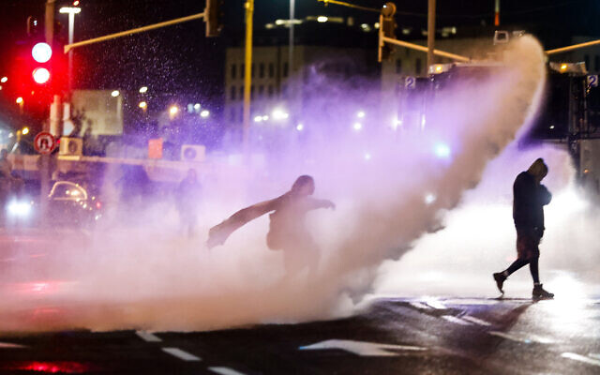
Police use a water cannon to disperse a group of protesters in Jerusalem, on Saturday, December 18, 2021. (Olivier Fitoussi/Flash90)
Dozens of right-wing protesters gathered at the entrance to Jerusalem on Saturday evening calling on the Israeli government to take action following a series of Palestinian terror attacks in recent weeks, including a deadly shooting in the West Bank Thursday that claimed the life of a 25-year-old yeshiva student.
Police said they arrested 13 people for disorderly conduct, including one person who was carrying “weapons.” According to Ynet, these included a knife and brass knuckles.
In footage from the demonstration Saturday, police can be seen using a water cannon to disperse some protesters, whom they said were trying to block a highway. One person was lightly hurt, medics said.
In one video from the scene, some of the protesters — mainly Jewish youths — can be heard chanting “death to Arabs,” while waving Israeli flags.
The protest Saturday came hours after a 38-year-old man was lightly hurt when he was stabbed at a checkpoint close to the Tomb of the Patriarchs in the West Bank city of Hebron by an elderly Palestinian woman.
The victim, a resident of the Kiryat Arba settlement, struggled with the Palestinian attacker before Israeli troops subdued her without opening fire, police said in a statement.
המפגינים בגשר המיתרים: "מוות לערבים. שיישרף לכם הכפר" pic.twitter.com/71qzMz8XnF
— שחר גליק (@glick_sh) December 18, 2021
The attack occurred close to the Tomb of the Patriarchs, which is considered holy by both Jews and Muslims and is used for prayers by worshipers of both faiths. It has been a major flashpoint for violence.
The tomb is frequented by Jews during Shabbat and holidays and often under military protection.
The incident came amid a rise in Palestinian terror attacks in recent weeks, with four alone taking place in Jerusalem, including a deadly shooting late last month committed by a member of Hamas. MORE - https://www.timesofisrael.com/police-arrest-13-at-jerusalem-protest-calling-for-government-action-against-attacks/

IDF Cyber Defense unit holds drill with US Cyber Command
Joint exercise this week included training for ‘a variety of cyber defense challenges,’ military says
By Emanuel Fabian Today, 8:40 pm
In this handout image published by the Israel Defense Forces on December 18, 2021, a United States Cyber Command officer and an Israeli Joint Cyber Defense Division officer are seen at a US Cyber ​​Command facility in the United States. (Israel Defense Forces)
The Israeli military said Saturday that its Joint Cyber Defense Division (JCDD) and the United States Cyber Command held a joint exercise over the past week.
The drill included training for “a variety of cyber defense challenges,” the Israel Defense Forces said.
“This event demonstrates the strategic partnership between the two militaries, which allows both to achieve cyber network superiority,” the IDF added.
The JCDD is part of the army’s Cyber-Communications and Defense Division, a technological operational body that is in charge of providing the Israeli army and all of its systems with the defense it needs from cyberattacks.
The drill took place at a US Cyber ​​Command facility in the United States, and is the sixth such joint exercise between the JCDD and the US Cyber ​​Command, the military said.
“Cyberspace is changing and evolving into an everyday global combat space, that threatens to harm governmental, private and civilian bodies,” Maj. Gen. Lior Carmeli, the head of the Cyber Defense Directorate said.
Earlier this month, Israel led a 10-country, 10-day-long simulation of a major cyberattack on the world’s financial system by “sophisticated” players, with the goal of minimizing the damage to banks and financial markets.
The Finance Ministry led the scenario with help from the Foreign Ministry, and said the “war game” was the first of its kind.
The exercise simulated several scenarios, including sensitive data surfacing on the dark web alongside fake news, leading to global financial chaos.
Participants included representatives from the US, United Kingdom, United Arab Emirates, Germany, Italy, Austria, Switzerland, the Netherlands, Thailand, the International Monetary Fund and the World Bank.
The simulation “featured several types of attacks that impacted global foreign exchange and bond markets, liquidity, integrity of data and transactions between importers and exporters,” Reuters reported at the time.
Israeli officials said international cooperation was the only way to counter the threat of major cyberattacks.
In October, the National Cyber Directorate issued a general warning to Israeli businesses to be aware of potential cyberattacks, as the country faced an uptick in hacking attempts.
This week, Israeli cybersecurity giant Check Point said that a hacking group identified with the Iranian regime was using a computer vulnerability called one of the worst ever seen to attack Israeli targets.
Governments and internet security experts have raised alarms over the flaw, known as Log4j, which lets internet-based attackers easily seize control of everything from industrial control systems to web servers and consumer electronics.
According to Tel Aviv-based Check Point, hacking group APT35, also known as Charming Kitten, attempted to use the exploit against seven Israeli targets from the business and government sectors on Tuesday and Wednesday.
APT35, which is thought to be linked to Iran’s Islamic Revolutionary Guards Corps, is known mainly for carrying out phishing attacks on journalists, activists, NGOs and others, with many of its efforts focused on Israel. https://www.timesofisrael.com/idf-cyber-defense-unit-holds-drill-with-us-cyber-command/

India working on free trade agreements with Israel, Middle East nations
India is working on at least six free trade agreements, including one with the United Arab Emirates that can create a gateway for Indian trade to the Middle East and Africa.
By RAJEEV JAYASWAL/HINDUSTAN TIMES/TNS Published: DECEMBER 18, 2021 20:21 Updated: DECEMBER 18, 2021 20:29
India is working on at least six free trade agreements (FTAs), including one with the United Arab Emirates (UAE) that can create a gateway for Indian trade to the Middle East and Africa and New Delhi may set up a huge India Mart in Dubai to tap that market, commerce minister Piyush Goyal said on Friday.
"In fact, tomorrow (Saturday) I will be in Mumbai engaging with exporters and Indian retail industry to examine what are the benefits that UAE FTA can give us. Along with that, we are looking at other engagements with the UAE, which should be announced shortly. But we are still working to see whether we can have something like a large Indian Mart in Dubai where huge number of stores can come up to display Indian products... and that can become a place to spread our wings all across Africa and Middle East and other parts of the world," the minister said. Speaking at the annual convention of Federation of Indian Chambers of Commerce and Industry, Goyal said: "Commerce ministry working at a time almost six FTAs, and one or two more may be added in the next few days."
India is negotiating trade deals with the UAE, the UK, the European Union (EU), Australia, Canada, Israel and a group of countries in the Gulf Cooperation Council (GCC). The deal with the UAE is expected soon, a government official said requesting anonymity.
The commerce minister on Monday said trade negotiations between India and the UAE were at an advanced stage and the two partners were expected to wrap up a Comprehensive Economic Partnership Agreement by January 2022. HT reported this development on December 14.
Along with an FTA with the UAE, India is "simultaneously in discussion" with other countries, Goyal said. "Australia in advanced stage; UK, will launch possibly next month. Canada we may launch by about March or April... The EU has already been launched, will start getting down onto the drawing board now...All GCC countries have approached us to start negotiations on behalf of the entire GCC grouping," he said asking, the industry to be prepared to grasp these opportunities.
On October 12, HT reported about the government's aggressive timelines for trade agreements with at least three countries — the UAE, the UK and Australia — by 2022 as part of its ambitious target of $500 billion exports by FY23. The report said a CEPA is expected to be formalized with the UAE by early 2022 followed by a free trade agreement with the UK. The minister urged the industry to "think big and set accelerated and aggressive targets", and said that India can aspire to reach $1 trillion each of services and merchandise export by around 2030. https://www.jpost.com/international/india-working-on-free-trade-agreements-with-israel-middle-east-nations-689120

Israelis get a whiff of European Christmas experience with special festival
The 'Holiday of Holidays' festival in the Arab Israeli neighborhood of Wadi Nisnas in Haifa offers holiday-themed food markets and gift shops, with the purpose of promoting coexistence and tolerance among all religions
Anat Lev-Eldar | Published: 12.18.21, 13:54
It's 5pm, the day is almost over, and it's starting to get dark. But in the neighborhood of Wadi Nisnas in the city of Haifa, it's precisely the time when everything comes to life, with Christmas lights illuminating the whole area, creating that special holiday spirit.
Last year, due to the COVID pandemic, the Jewish Arab neighborhood had to cancel its annual "Holiday of Holidays" festival, normally celebrated through all of December. Its purpose is to highlight the northern city's mixed population and promote coexistence and tolerance among the people.
'Holiday of Holidays' festival in Haifa (Photo: Haifa Municipality)
This year the festival has been finally brought back, and we recommend to anyone who wants to dive into the holiday Christmas experience to come and see the magical lights being lit in the city's alleyways, balconies, shops, and churches. To see Santa Claus appear on every corner, do some window shopping of Christmas trees, decorations, reindeer figurines, snowflakes, and sleds - all to welcome the upcoming holiday.
We have chosen to join a two visitors' tours that take place in the neighborhood - a delicious one and a spiritual one, thanks to guides from the Beit Ha'Gefen Arab-Jewish Cultural Center.
We managed to enjoy street art, authentic Arabic food, and Santa stories combined with local tales from the Wadi alleys, which we heard from Radir, a guide who took us on the tours and was full of energy and knowledge (including the knowledge of the Mandarin language, which she learned to guide tour groups from China).
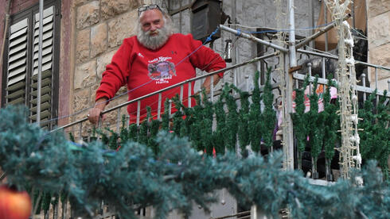
Haifa's Santa Claus looks on from a balcony (Photo: Nachum Segal)
We met Radir at the Beit Ha'Gefen art gallery on Ha Gefen Street 2 and headed towards the home of Haifa's Santa Claus - that's what they call the house in an alley near Haddad Street, which has local myths attached to it.
On the way there, we stopped at an observation point for a view of the entire Wadi Nisnas neighborhood, while Radir explained to us the surprising meaning of the name "Nisnas".
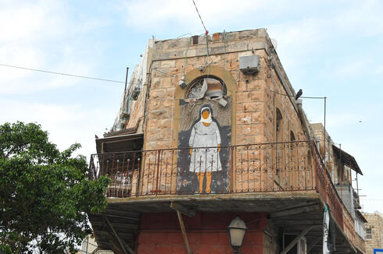
"Nisnas in Arabic is a mongoose, the first people who lived on this valley had faced with a lot of mongooses that were swept into their homes during the rains, so they decided to name it after this strange phenomenon," said Radir.
"But don't let the mongoose bother your thoughts, just look around at the many artworks, scattered around the public space, designed to promote thoughts and conversations about coexistence."

Aunt Emani above the 'Female Power' junction (Photo: Nachum Segal)
Then we arrived at the "Female Power" junction, which received its name due to a lot of female-created art and heroic stories about local women, associated with the place.
Above the junction, there is the image of Aunt Emani, a painting by artist Nasrin Abu Baker, who is involved with the Arab feminism movement.
The faceless aunt is covered with a hijab, but her body language is determined and belligerent as someone who does not intend to give up her place. Even the dress she wears on the painting is defiantly shorter than permitted in the Arab culture, and Radir explains that this is the artist's way of saluting the legacy of the women in her dynasty.
Local food stands in Wadi Nisans neighborhood (Photo: Nachum Segal) | St. Elias Greek-Melkite Cathedral (Photo: Nachum Segal)
Further down the street, you can find a lot of local food shops and stands, which include vegetables, fruits, and fresh seasonal merchandise.
There are also many Christmas shops, in which you can choose holiday presents, decorations, and much more.
Towards the end of the tour, we arrived at the St. Elias Greek-Melkite Cathedral - which was covered with golden lights and had a big Christmas tree on the front yard.
The Greek church is named after Elijah, who according to the Books of Kings in the Torah, was a prophet and miracle worker who lived in the northern kingdom of Israel.
It is recommended to finish the tour in the gallery of the Beit Ha'Gefen, which has been beautifully restored, and presents a new set of exhibitions that run from the gallery halls to the public space. https://www.ynetnews.com/magazine/article/r100rcgu5f [You don’t really think much about Israel celebrating Christmas because it is a Jewish land but there are a significant number of arab Christians and also indigenous people who are believers in Yehsua and His birth is recognized in Israel. Many Israeli’s love the lights and the trappings accompanying the celebration. – rdb]

Bracing for ‘significant outbreak,’ Israel looks to expand no-fly list
Cabinet to vote on adding US, Canada, Germany, Turkey, Morocco and other countries to ‘red’ states where travel is barred, as worries over Omicron grow
By TOI staff Today, 10:21 pm
The Israeli cabinet is expected to weigh the addition on Sunday of a number of countries to the “red” no-fly list, including the US, Canada, Germany, and Turkey, as the country braces for a wave of new COVID-19 infections driven by the Omicron variant.
Channel 12 reported Saturday that Prime Minister Naftali Bennett was presented with data showing “a significant outbreak” of COVID-19 within three weeks, and that the peak would surpass that of the Delta wave, which started in June. [But the patients are really very sick with Omicron so why panic? They will get a degree of immunity that will far surpass anything the JAB can provide. - rdb]
Bennett is “looking to buy time” to possibly delay the wave of infections by “closing the skies,” according to the TV report.
The full list, which also includes Portugal, Morocco, and Hungary, will be brought for cabinet approval on Sunday. If okayed, these countries will enter the no-fly list by the end of the week.
Israel had already added nine countries earlier this week to the list: the UK, Denmark, France, Spain, the United Arab Emirates, Ireland, Norway, Finland, and Sweden.
Channel 12 noted that with the addition of the new countries, Israel would be “de facto, closing the skies” to Israeli travelers.
Those wanting to travel to “red” list countries will first need to first obtain special permission from a government committee.
Israelis who return from “red” countries will be required to enter quarantine in state-run hotels until their first COVID test comes back negative, after which they can leave, but must remain in home quarantine for seven days, even if they are fully vaccinated.
On Thursday, the cabinet voted to extend the current travel restrictions, including the ban on foreigners entering the country and a requirement for all returning Israelis to quarantine for three days upon entry. The limitations will now last until December 29 at least.
Health Minister Nitzan Horowitz said Saturday that the move to expand the list of no-fly countries would be a bid “to buy time, to delay the Omicron wave” but this wave “is coming,” he warned, pointing to the rapid increase of cases in Europe where countries are reimposing restrictions or introducing new ones.
The Omicron variant is “multiplying a worrying rate,” he said. “Given the high transmissibility, the most important thing to do is get vaccinated,” he added.
Channel 12 reported that Horowitz had favored a more measured plan on travel restrictions, but that the list of “red” countries was “a compromise” between the two.
Also Saturday, Professor Eran Segal, a computational biologist from the Weizmann Institute of Science and a top adviser to the government’s coronavirus cabinet, said that there were still many unknowns about the Omicron variant but that Israel may see “a significant morbidity wave” and “a doubling of cases every two to three days, compared to every 10 days with Delta.”
Segal estimated that the uptick in cases will occur in about 2-3 weeks.
He said that currently available data on Omicron’s severity was “contradictory,” with initial “encouraging” data from South Africa, which raised the alarm about the new variant in late November, offset by data from the UK.
Segal said Israel has been able to buy itself some time, “but the vaccination campaign is virtually treading water,” with more than three million people not fully vaccinated including a million children and another million adults who have yet to receive their booster shots, the third dose of the vaccine.
Horowitz said Saturday that the number of stations near schools where children can get their COVID-19 vaccinations will increase tenfold next week.
“If until now there were 50 locations [outside schools], then it will be 500 next week every day,” Horowitz said, adding that parents were responsible for vaccinating their children.
The Health Ministry was also considering vaccinating the elderly population with a fourth dose, pending further research on such a move, the minister said
“We’ll discuss this week whether to give 4th shot to the elderly population,” Horowitz said.
The Health Ministry said Saturday that 873 new COVID-19 infections were diagnosed on Friday, and another 264 cases were identified Saturday by 6:30 p.m, the highest daily figures in about two months. Some 838 new COVID-19 cases were diagnosed Thursday, 45 of which had been confirmed to be of the Omicron variant, bringing the total number of Omicron cases in Israel to over 130. [Remember that is simply the number of positive tests, not the number of ‘really sick” people. – rdb]
Most of the cases were found in people returning from overseas. The ministry did not provide a breakdown for the Friday-Saturday figures.
There were currently 81 patients in serious condition and 41 on ventilators. Most patients in serious condition are over 60 and unvaccinated.
Since the start of the pandemic, 5.8 million Israelis have received two vaccine doses, and over 4 million have gotten a third booster shot.
The death toll in Israel since the start of the pandemic stood at 8,232 Saturday evening. https://www.timesofisrael.com/bracing-for-significant-outbreak-israel-looks-to-expand-no-fly-list/

WHO says Omicron found in 89 countries, cases doubling every few days
Number of cases multiplying in 1.5 to 3 days in places with community transmission, health organization warns
By TOI staff and Agencies Today, 5:21 pm
The omicron variant of the coronavirus has been detected in 89 countries, and COVID-19 cases involving the variant are doubling every 1.5 to 3 days in places with community transmission and not just infections acquired abroad, the World Health Organization said Saturday.
The variant, first discovered in late November, has been spreading rapidly even in countries with high vaccination rates or where a significant proportion of the population has recovered from the disease, but it is not yet clear if Omicron’s rate of transmission was because it was less prone to immune responses, higher transmissibility, or a combination of both, the WHO said.
“There are still limited data on the clinical severity of Omicron. More data are needed to understand the severity profile and how severity is impacted by vaccination and pre-existing immunity,” the organization said.
“There are still limited available data, and no peer-reviewed evidence, on vaccine efficacy or effectiveness to date for Omicron,” it added.
But Omicron’s “substantial growth advantage” over the Delta variant means it is likely to soon overtake Delta as the dominant form of the virus in countries where the new variant is spreading locally, the UN health agency said.
South Africa reported Omicron to the WHO on November 24, prompting countries around the world to impose travel bans and reintroduce domestic restrictions to slow its spread.
The WHO said earlier this week that Omicron was more transmissible than the Delta strain and reduces vaccine efficacy but causes less severe symptoms, according to early data.
Faster transmission was noted in South Africa, where Delta is less prevalent, and in Britain, where Delta is the dominant strain.
Dr. Mike Ryan, the executive director of the WHO Health Emergencies Program, said Friday that “we have had “two years of serial transmission in millions and millions of human beings, so the virus has had two years to really become much better adapted to entering human cells.”
The Omicron variant has “a change in its genetic sequence that has changed the shape…and the ability of the spike protein to attach to human cells…And that is probably what is giving it its transmission advantage,” said Ryan, adding that there are still many unknowns such as the survivability of virus variant on surfaces.
In Israel, the latest Health Ministry coronavirus figures released Friday showed 838 new COVID-19 cases diagnosed the previous day, the highest daily figure in some two months.
The number represented an increase of 181 from the previous day, as the pandemic appeared to be on an upward trajectory in Israel once more amid concerns over the spread of the Omicron variant.
The latest numbers also showed Israel’s basic virus reproduction rate had risen to 1.07. Also known as the “R-number,” the figure represents the number of people each confirmed patient infects, on average. Any number over 1 signifies that case numbers are rising.
The Omicron coronavirus strain has dominated policy talks, leading Israel to once again shutter its borders to most foreigners and impose fresh restrictions on Israelis returning from countries with high infection rates.
Advertisement
The ministry said 45 of the new cases had been confirmed to be of the Omicron variant, bringing the total number of Omicron cases in Israel to 134. Most of the cases were found in people returning from overseas. There were an additional 207 likely cases waiting to be confirmed.
The ministry added that 92 of the 134 cases were in people who were considered “protected” with either a booster shot, two doses in the last six months or recently recovered. It did not say how severe their cases were.
The threat of a rapid spread of the new strain has also led the government to briefly announce the implementation of the Green Pass system at malls starting Friday (requiring proof of immunity or a negative test to access non-essential shops). But a public outcry from business owners and threats of rebellion has led the plan to be shelved for now.
It is not clear that the rise in infections in Israel has been caused by Omicron, but the highly mutated strain is growing in presence in the country.
On Friday, opposition leader Benjamin Netanyahu and some 130 others at the Knesset entered quarantine, after four parliamentary personnel were confirmed to be carriers of coronavirus, officials said.
According to Hebrew-language media reports, at least one is suspected to be a carrier of the Omicron variant of COVID-19.
There is also growing concern about the spread of coronavirus among students. On Thursday, an all-girls religious school in Jerusalem was closed temporarily and went to remote learning after at least 62 COVID cases were reported there (though it was not yet clear whether the cases were of Omicron). https://www.timesofisrael.com/who-says-omicron-found-in-89-countries-cases-doubling-every-few-days/ [More fear port and hysteria. That is what all this is about. – rdb]

School district warns parents of 'sudden cardiac arrest' in students
State on verge of requiring COVID-19 vaccination for students amid myocarditis alert
By Art Moore Published December 17, 2021 at 7:13pm
Amid concerns about COVID-19 vaccines causing serious heart inflammation in young people, a school district on Long Island in New York informed parents it is hiring a physician to comply with new regulations requiring them to treat and monitor students who exhibit symptoms of sudden cardiac arrest.
A parent who received the email from Eastport-South Manor Central School District in Suffolk County, New York, contacted The Gateway Pundit. The timing was suspicious, the parent said, because New York state is close to mandating the COVID shot for students to attend school.
The email says nothing about the reported cases of myocarditis and pericarditis related to the COVID-19 vaccines. But the parent found it "disturbing that they are now bringing on the new medical staff who specialize in sudden cardiac arrest."
A study published in the journal Nature Medicine on Tuesday from Oxford University showed the COVID-19 vaccines can cause myocarditis in young people at a rate higher than the incidence of COVID-19. On Friday, a Danish study was published in the British Medical Journal that found Moderna's COVID-19 vaccine is up to four times more likely to cause inflammation of the heart muscle than the Pfizer-BioNTech shot.
The email to Suffolk County parents and others mentioned "new regulations regarding Sudden Cardiac Arrest."
"All districts are now required to ensure that nurses and coaches can address the treatment and monitoring of students who exhibit signs and symptoms of sudden cardiac arrest," the email said. "In addition, districts are required to make sure that all staff are aware of the warning signs of sudden cardiac arrest and what to do if a person experiences sudden cardiac arrest."
The email came with an attachment with more information on sudden cardiac arrest.
In November, the district's Board of Education released a statement addressed to New York Democratic Gov. Kathy Hochul stating its opposition to mandatory vaccination for children.
"As a school district, we adamantly oppose such a mandate for our students and believe the decision to vaccinate a child should be left to their individual family in consultation with their health care provider," the board said. "A sweeping mandate to inoculate all school-aged children with the COVID-19 vaccine is an overreach of power and will leave polarizing effects across our great state.
In October, citing concerns of myocarditis, the Food and Drug Administration delayed its decision on administration of the Moderna vaccine to young people.
At the time, Sweden, Finland and Norway halted the Moderna COVID-19 vaccine for younger people, and Iceland stopped administering the shot to everyone. https://www.wnd.com/2021/12/4968930/

New York legislation provides for indefinite detention of unvaxxed at governor's whim
Language is purposefully vague
By WND News Services Published December 18, 2021 at 3:09pm
(NATIONAL PULSE) – On January 5th, 2022, the New York Senate and Assembly will vote on a bill that would, if passed into law, grant permissions to remove and detain cases, contacts, carriers, or anyone suspected of presenting a “significant threat to public health” and remove them from public life on an indefinite basis.
Bill A416 presents a serious risk to the basic liberties of all Americans in the state of New York, including their right to choose whether or not to receive medical treatment and vaccinations related to thus far undetermined contagious diseases. [I would move immediately. - rdb
The bill gives the Governor of New York, his or her delegates – including but not limited to the commissioner and heads of local health departments – the right to remove and detain any individuals or groups of people through issuing a single order. The orders only have to include the individual’s name(s) or “reasonably specific descriptions of the individuals or groups.” https://www.wnd.com/2021/12/new-york-legislation-provides-indefinite-detention-unvaxxed-governors-whim/

South Africa reports lower hospitalizations amid global omicron panic
Data counters U.K. study by disgraced scientist Neil Ferguson
By Art Moore Published December 17, 2021 at 7:49pm
A widely reported U.K. study has found "no evidence" the omicron variant is milder than delta, but in South Africa, where omicron is now the dominant COVID-19 strain, officials reported Friday hospitalizations are down considerably.
South Africa, seen as a harbinger of omicron's spread elsewhere since announcing discovery of the variant on Nov. 25, reported only 1.7% of identified COVID-19 cases were admitted to hospitals in the second week of infections in the fourth wave. That's compared with 19% in the same week of the third delta-driven wave, South African Health Minister Joe Phaahla said at a press conference reported by Bloomberg News.
In fact, the U.K. researchers cautioned in the report of their findings that hospitalization data "remains very limited at this time."
The U.K. study was led by Neil Ferguson, the infectious disease modeler and government science adviser whose call for lockdowns, based on a model of 2.2 million U.S. deaths, was used by White House coronavirus advisers Dr. Anthony Fauci and Dr. Deborah Birx to convince President Trump to call for unprecedented stay-at-home measures in the spring of 2020. [The dude is a bozo and I would believe nothing that he puts out. He has been wrong on most everything he has touched. = rdb]
Ferguson said his new omicron study "finds no evidence of omicron having lower severity than Delta, judged by either the proportion of people testing positive who report symptoms, or by the proportion of cases seeking hospital care after infection," the Financial Times reported
But South African health officials presented evidence that the omicron strain is milder and that infections may already be peaking in the country's most populous province, Gauteng.
Many scientists, including Dr. Anthony Fauci, have said the early indications are that the omicron strain is considerably less virulent than delta but much more contagious.
That assessment shows up in the South Africa data, where officials recorded more than 20,000 in one week compared to 4,400 in the same week of the third wave.

Currently there are about 7,600 people with Covid-19 in South African hospitals, about 40% of the peak in the second and third waves.
In May 2020, Ferguson was outed by the Daily Telegraph for violating the lockdown rules he had championed so he could to conduct an affair with a married woman.
In March 2021, amid widespread criticism, Ferguson acknowledged his COVID-19 model was based on undocumented, 13-year-old computer code that was designed for an anticipated influenza pandemic. He refused to release his original code so his results could be peer-reviewed.
He's made many predictions that didn't turn out to be true, as the Wall Street Journal's John Fund has documented.
In 2001, Ferguson's prediction that thousands of people could die from an outbreak of foot-and-mouth disease prompted the killing of 11 million sheep and cattle. But fewer than 200 people have died.
In 2002, he forecast that 50,000 people would die from mad cow disease in beef. But only 177 died in the U.K.
In 2005, Ferguson predicted bird flu would kill up to 150 million people. But between 2003 and 2009, only 282 people died worldwide.
In 2009, Ferguson's advice was the basis for the British government's "reasonable worst-case scenario" that the swine flu would cause 65,000 British deaths. Only 457 people died in the U.K. https://www.wnd.com/2021/12/4968876/

CDC’s miscalculated jab data poses risk as winter looms
18 Dec, 2021 21:23
The US Centers for Disease Control has overcounted the number of Americans who have received Covid-19 vaccines, recording numerous second doses and boosters as first shots, state officials told Bloomberg.
While the CDC’s data suggests some 240 million Americans have received at least one shot, the statistics claim just 203 million are fully vaccinated, a statistic which would suggest 37 million Americans started - but did not finish - their course of injections.
However, state and local officials who spoke to Bloomberg on Saturday found those numbers “improbable,” suggesting instead that the government had incorrectly recorded Americans’ vaccine data on a grand scale, mis-counting second doses and booster shots as first doses and thus overestimating the number of vaccinated Americans altogether. [This shouldn’t be surprising since the number of COV actual cases have been severely overstated by the CDC and the number of adverse reactions way understated. Statistics don’t lie but statisticians do -rdb]
As a result, both the completely-vaccinated and the completely-unvaccinated are overcounted in the CDC’s statistics. According to the article, state health departments have been quietly tweaking their statistics in the hope of coming up with more realistic numbers over the last month, measuring those against the national figures and adjusting accordingly, but it’s difficult to know what the real numbers are.
Not only does each individual state maintain its own numbers, but some have several repositories of data and all state health departments receive input from health insurers, federal programs, and pharmacies. The national vaccine rollout took place not just at pharmacies and doctors’ offices but also at pop-up sites, with everyone from public transit agencies to school districts setting up spaces to maximize the amount of shots entering arms. Further complicating matters, many patients received their second or booster shots at different locations, with some even receiving different brands of vaccine - and nothing but a paper vaccine card to tie the fragments together.
Many state health officials were pessimistic about the ability to reconcile national numbers with their own data, noting that the mismatched figures made it “really difficult” to “target our booster messaging.”
“We don’t have any faith in the numbers on the CDC website, and we never refer to them,” Philadelphia Department of Public Health spokesman James Garrow told Bloomberg. The state of Pennsylvania lowered its estimate for adults who’d received one shot from 98.9% to 94.6% last month, and plans to submit another round of revised figures by the end of the year.
The state of Illinois found it had overcounted both the unvaccinated and the fully-vaccinated - with 540,000 more unvaxxed over the age of 12 and 730,000 totally vaccinated who had somehow been skipped in previous counts.
While the official statistics appear to indicate the US - with 72.5% of its population having received at least one shot but just 61.3% fully-vaxxed - is a major outlier compared to other Group of Seven countries, the discrepancy is more likely to be due to the fragmentation of recordkeeping.
According to Bloomberg's statistics, the European Union has just a 2.6% gap between the singly-vaxxed and the fully-jabbed, and while the US has the largest disparity at 11%, the UK is second among G7 nations with a 6.7% gap. https://www.rt.com/usa/543648-cdc-wrong-vaccination-numbers/

Pfizer moving to 3-dose trial for kids after 2-shot vaccine fails
Decision made following review by independent watchdog over clinical trials
By Art Moore Published December 17, 2021 at 5:00pm
Pfizer-BioNTech announced Friday its two-shot vaccine didn't perform adequately in children ages 2 to 5 years old, and it will test a three-dose series for official authorization. [For a group that doesn’t need the JAB at all it is insane to continue with the charade of JABBING these kids. More will get sick from the JAB than the disease. These are criminals doing this. – rdb]
The pharmaceutical companies said they will expand ongoing clinical trials of their COVID-19 vaccine in children to include a third dose for participants as young as 6 months old, NPR reported.
Healthy children have, statistically, virtually no chance of death or hospitalization from a COVID-19 infection, according to data from the Centers for Disease Control.
The decision, the companies said, was made "following a routine review by the external independent Data Monitoring Committee," which acts as a watchdog over the clinical trials.
They insisted, however, that no "safety concerns" were identified, and the 3 microgram doses "demonstrated a favorable safety profile in children 6 months to under 5 years of age."
The FDA has authorized the Pfizer-BioNTech vaccine only for emergency use in children aged 5 and older. Adults get 30 micrograms of the Pfizer shot per dose, and children ages 5 to 11 get 10 micrograms. In November, the FDA authorized a third booster dose for all U.S. adults.
Last week, the inventor of the mRNA technology behind the Pfizer and Moderna vaccines, Dr. Robert W. Malone, issued a video statement explaining why more than 15,000 physicians and medical scientists around the world have signed a declaration that healthy children should not be vaccinated for COVID-19.
He warned parents that the decision to inject their children is "irreversible," and they need to be aware of "the scientific facts about this genetic vaccine, which is based on the mRNA vaccine technology I created."
Malone argued the Pfizer and Modern mRNA vaccines inject a viral gene that forces the body to make toxic spike proteins that can cause permanent damage in children's critical organs.
Secondly, he said, the novel vaccine technology has not been adequately tested, with the vaccines introduced in one-fifth the minimum time typically given for clinical trials. Finally, he contended that the reason public health officials are "giving you to vaccinate your child is a lie."
"Your children represent no danger to their parents or grandparents, he said. "Ir's actually the opposite. Their immunity, after getting COVID, is critical to save your family if not the world from this disease."
In summary, Malone said there is "no benefit for your children or your family to be vaccinating your children against the small risks of the virus, given the known health risks of the vaccine that as a parent, you and your children may have to live with for the rest of their lives."
"The risk-benefit analysis isn’t even close," he said.
"As a parent and grandparent, my recommendation to you is to resist and fight to protect your children." https://www.wnd.com/2021/12/4968890/ [Government wholesale child abuse- criminal - rdb]

Ex-Army generals fear insurrection or 'civil war' in 2024
Express concerns if results of election not accepted by sections of military
By WND Staff Published December 18, 2021 at 8:50pm
Three retired U.S. Army generals have warned of insurrection or possibly even civil war if the results of the 2024 presidential election are not accepted by sections of the military.
You'll never believe who should be held responsible – the Jan. 6 defendants.
Retired Major Generals Paul D. Eaton and Antonio M. Taguba joined retired Brigadier General Steven M. Anderson urged today's leaders to act to prevent such scenes, calling on today's leaders to "war-game" an attempted coup.
In an op-ed for the Washington Post published on Friday and reported as a news story in Newsweek, the former military leaders said they were "increasingly concerned" about the "potential for lethal chaos inside our military, which would put all Americans at severe risk" in the aftermath of the election.
They warned of the potential for "total breakdown of the chain of command along partisan lines" and the risk of a "shadow government" led by a losing candidate who refuses to concede defeat, directly referencing former President Donald Trump.
"In short: We are chilled to our bones at the thought of a coup succeeding next time," they wrote.
They outlined four preventative steps they argue should be taken – all dangerous:
• First, the leaders of the Capitol riot should be held accountable. They called on the Department of Justice, the House of Representatives' Select Committee investigating Jan. 6 and Congress to "show more urgency."
• Second, the Pentagon "should immediately order" a soldier review on the Constitution and electoral integrity, and on the laws of war and how to deal with an illegal order. "No service member should say they didn't understand whom to take orders from during a worst-case scenario," they wrote. The Army's actions should also involve finding and removing "potential mutineers" and stopping efforts to subvert the chain of command through propaganda.
• Finally, the generals advised the Department of Defense to war-game a potential insurrection or attempted coup following the 2024 presidential election "to identify weak spots" and deal with them.
In explaining their concerns, the generals pointed to the fact that some veterans and active duty personnel were involved in the storming of the Capitol on Jan. 6 and expressed concern that divisions in wider society will affect military personnel.
"The potential for a total breakdown of the chain of command along partisan lines – from the top of the chain to squad level -- is significant should another insurrection occur," the generals wrote. "The idea of rogue units organizing among themselves to support the 'rightful' commander in chief cannot be dismissed."
"Imagine competing commanders in chief – a newly reelected Biden giving orders, versus Trump (or another Trumpian figure) issuing orders as the head of a shadow government," they went on. "Worse, imagine politicians at the state and federal levels illegally installing a losing candidate as president."
The generals warned that while U.S. service members take an oath to uphold the Constitution, in the case of a disputed election, loyalties would be split and some might choose to follow orders from the losing candidate who does not accept defeat.
Like Hillary Clinton did – without cause?
"Under such a scenario, it is not outlandish to say a military breakdown could lead to civil war," they wrote. If such a situation were to arise, the generals warn the enemies of the U.S. could take advantage of it.
Nonetheless, the generals seemed hopeful that could be prevented if Congress and the military "take decisive action now."
Why now? Why not wait for the new Congress? https://www.wnd.com/2021/12/ex-army-generals-fear-insurrection-civil-war-2024/ [This is not very far fetched. The people of the US ARE the government since they established their states and the states established the Federal government as stated in the constitution. The consent of the governed is paramount and the Fed has been out of control. Waiting for the next election sounds nice but when you have almost no difference between parties whose members primary interest is getting re-elected and not in preserving the freedom and interests of the constituents who elected them, another election may not solve the problem. The liberties taken by all branches of the fed are beyond belief and the cause of our problems today – rdb]

Veterinarian wins round in free speech fight over talks with pet owners
'Giving advice online' is protected by 1st Amendment
By Bob Unruh Published December 18, 2021 at 7:02pm
A Texas veterinarian has won a round in his fight with the state of Texas over his plan to offer advice to pet owners – over the phone and online.
The Institute for Justice says a federal judge has ruled that the state's Board of Veterinary Medical Examiners must meet the requirements of the Constitution's highest standard for free speech if it wants to restrict what Ron Hines tells pet owners.
Online medical advice has turned from a novelty to being relatively common under the COVID-19 pandemic, and now patients routinely access their physicians online, or by telephone, for consultant, even prescriptions.
But in Texas, the state has required veterinarians to see the pet before offering any advice.
The threats of disciplinary action from the state prompted Hines to get the assistance of the Institute for Justice, which is suing the state on behalf of the Brownsville, Texas, doctor. The IJ said the recent ruling from U.S. District Court for the Southern District of Texas means that Hines' free speech
"Today’s decision recognizing that Dr. Hines’ advice is entitled to the greatest constitutional protection is the latest milestone in a long fight in which, for years, courts insisted that he had no First Amendment rights at all. Giving advice online is speech protected by the First Amendment," explained IJ Senior Attorney Jeff Rowes. MORE - https://www.wnd.com/2021/12/veterinarian-wins-round-free-speech-fight-talks-pet-owners/ [Thank heavens there are still some judges and groups that will fight for individual freedom – rdb]

Belarus comments on possibility of hosting Russian nukes
18 Dec, 2021 18:02 / Updated 3 hours ago
Belarus could decided to host Russian nuclear weapons on its territory amid growing tensions with the West and fears of a NATO buildup in neighboring states, specifically Poland, Minsk's foreign minister has warned.
“As President [Alexander] Lukashenko said, we are considering the possibility of deploying nuclear weapons on the territory of Belarus as one of the potential responses to future possible actions by the NATO bloc on the territory of Poland,” Belarusian Foreign Minister Vladimir Makei told RT Arabic in an exclusive interview on Friday.
In late November, Lukashenko floated the idea as an option if US atomic missiles were to be deployed deeper into Eastern Europe.
“I will suggest that [Russia’s President Vladimir] Putin return nuclear weapons to Belarus,” Lukashenko stated, adding that “those nuclear armaments would be the most effective” deterrent.
Shortly after the collapse of the Soviet Union, Belarus joined the Treaty on the Non-Proliferation of Nuclear Weapons (NPT), voluntarily giving up the nuclear weaponry it inherited. The remaining systems were transferred to Russia by late 1996.
Belarus has other, less dramatic options to retaliate against the hostile moves by the West, Makei stated, with economic measures also on the table. He reiterated the idea of stopping the transit of natural gas for the Western European market from going through the country’s territory.
“It is just one of the possible responses to the sanctions that the West has imposed against Belarus,” he said.
The relationship between Belarus and the West rapidly deteriorated after the country’s August 2020 presidential election and mass protests that followed. The EU has refused to recognize the outcome of the vote, in which Lukashenko secured a solid win according to the official tally. It has also targeted select officials with sanctions for “violence” and the alleged “falsification” of the results
Ties have deteriorated even further over the past few months, after Minsk said it had opted to stop turning back migrants seeking to reach the EU in retaliation for the sanctions imposed by the bloc. The EU, in turn, accused Belarus of artificially stirring up illegal migration as a part of its alleged “hybrid warfare” against the bloc, a charge that Belarus has consistently denied.
Minsk’s move has resulted in a particularly heated situation at its border with Poland, with hundreds of people trying to get into the EU by force. Poland deployed a massive number of police officers and soldiers in response, seeking to prevent illegal entries. Currently, some 1,000 illegal migrants still remain on Belarusian soil, according to the country’s foreign minister. https://www.rt.com/russia/543632-belarus-hosting-russian-nukes/ [The trash in DC and the EU are all just itching to try to start a war with Russia and if they keep it up they may get the job done. What most of these fools don’t recognize is with the current military leadership incompetence Russia could well win the battle or even wipe the west off the map. – rdb]
Putin Demands No NATO Troops in East Europe
Saturday, 18 December 2021 12:25 PM
Russia on Friday published draft security demands that NATO deny membership to Ukraine and other former Soviet countries and roll back the alliance's military deployments in Central and Eastern Europe — bold ultimatums that are almost certain to be rejected by the U.S. and its allies.
The proposals, which were submitted to the U.S. and its allies earlier this week, also call for a ban on sending U.S. and Russian warships and aircraft to areas from where they can strike each other's territory, along with a halt to NATO military drills near Russia.
The demand for a written guarantee that Ukraine will not be offered membership already has been rejected by the West, which said Moscow does not have a say in NATO's enlargement.
NATO's secretary-general emphasized Friday that any security talks with Moscow would need to take into account NATO concerns and involve Ukraine and other partners. The White House similarly said it is discussing the proposals with U.S. allies and partners, but noted all countries have the right to determine their future without outside interference.
The publication of the demands — contained in a proposed Russia-U.S. security treaty and a security agreement between Moscow and NATO — comes amid soaring tensions over a Russian troop buildup near Ukraine that has raised fears of an invasion. Moscow has denied it has plans to attack its neighbor but wants legal guarantees precluding NATO expansion and deploying weapons there.
Deputy Foreign Minister Sergei Ryabkov said Russia's relations with the U.S. and NATO have approached a "dangerous point," noting that alliance deployments and drills near Russia have raised "unacceptable" threats to its security.
Moscow wants the U.S. to start talks immediately on the proposals in Geneva, he told reporters.
NATO Secretary-General Jens Stoltenberg said the alliance had received the Russian documents, and noted any dialogue with Moscow "would also need to address NATO's concerns about Russia's actions, be based on core principles and documents of European security, and take place in consultation with NATO's European partners, such as Ukraine."
He added the 30 NATO countries "have made clear that should Russia take concrete steps to reduce tensions, we are prepared to work on strengthening confidence building measures." [The thirty NATO countries are all very inept and have allowed their military to deteriorate since they have all relied on the USA which is now falling into grave disrepair and a rotten state of readiness due to their stupid military leadership and the fact that you have a ‘commander’ who has no functional brain. – rdb]
White House National Security Adviser Jake Sullivan said the administration is ready to discuss Moscow's concerns about NATO in talks with Russian officials, but emphasized Washington is committed to the "principle of nothing about you without you" in shaping policy that impacts European allies.
"We're approaching the broader question of diplomacy with Russia from the point of view that ... meaningful progress at the negotiating table, of course, will have to take place in a context of de-escalation rather than escalation," Sullivan said at the event hosted by the Council on Foreign Relations. He added "that it's very difficult to see agreements getting consummated if we're continuing to see an escalatory cycle."
While U.S. intelligence has determined that Russian President Vladimir Putin has made plans for a potential further invasion of Ukraine in early 2022, Sullivan said the U.S. still does not know whether he has decided to move forward.
White House press secretary Jen Psaki noted that strategic security talks with Moscow go back decades, saying that "there's no reason we can't do that moving forward to reduce instability, but we're going to do that in partnership and coordination with our European allies and partners."
"We will not compromise the key principles on which European security is built, including that all countries have the right to decide their own future and foreign policy free from the outside interference," Psaki said.
Moscow's draft also calls for efforts to reduce the risk of incidents involving Russia and NATO warships and aircraft, primarily in the Baltic and the Black seas, increase the transparency of military drills and other confidence-building measures.
A senior U.S. official said some of the Russian proposals are part of an arms control agenda between Moscow and Washington, while some other issues, such as transparency and deconfliction, concern all 57 members of the Organization for Security and Cooperation in Europe, including Ukraine and Georgia.
The official, who briefed reporters on the condition of anonymity in order to talk about the proposals, said the U.S. is looking at how to engage every country whose interests are affected in prospective talks on European security issues and will respond to Moscow sometime next week with concrete proposals after consulting with the allies.
President Vladimir Putin raised the demand for security guarantees in last week's video call with U.S. President Joe Biden. During the conversation, Biden voiced concern about a buildup of Russian troops near Ukraine and warned him that Russia would face "severe consequences" if Moscow attacked its neighbor.
Russia annexed Ukraine's Crimean Peninsula in 2014 and shortly after cast its support behind a separatist rebellion in the country's east. More than seven years of fighting has killed over 14,000 people and devastated Ukraine's industrial heartland, known as the Donbas.
The Russian demands would oblige Washington and its allies to pledge to halt NATO's eastward expansion to include other ex-Soviet republics and rescind a 2008 promise of membership to Ukraine and Georgia. The alliance already has firmly rejected that demand from Moscow.
Moscow's documents also would preclude the U.S. and other NATO allies from conducting any military activities in Ukraine, other countries of Eastern Europe and ex-Soviet republics in the Caucasus and in Central Asia.
The Ukrainian Foreign Ministry commented on Moscow's proposals by emphasizing that it's up to the alliance and Ukraine to discuss NATO membership prospects and its military cooperation with other countries.
"The Russian aggression and the current Russian escalation along the Ukrainian border and on the occupied territories is now the main problem for the Euro-Atlantic security," said its spokesman Oleg Nikolenko.
The Russian proposal also ups the ante by putting a new demand to roll back NATO military deployments in Central and Eastern Europe, stating that the parties agree not to send any troops to areas where they hadn't been present in 1997 — before NATO's eastward expansion started — except for exceptional situations of mutual consent.
Poland, Hungary and the Czech Republic joined NATO in 1999, followed in 2004 by Bulgaria, Romania, Slovakia, Slovenia and the former Soviet republics of Estonia, Latvia and Lithuania. In the following years, Albania, Croatia, Montenegro and North Macedonia also became members, bringing NATO membership to 30 nations.
The draft proposals contain a ban on the deployment of U.S. and Russian warships and aircraft to "areas where they can strike targets on the territory of the other party."
Moscow has long complained about patrol flights by U.S. strategic bombers near Russia's borders and the deployment of U.S. and NATO warships to the Black Sea, describing them as destabilizing and provocative.
Russia's draft envisages a pledge not to station intermediate-range missiles in areas where they can strike the other party's territory, a clause that follows the U.S. and Russian withdrawal from a Cold War-era pact banning such weapons.
The Russian draft also calls for a ban on the deployment of U.S. and Russian nuclear weapons on the territory of other countries — a repeat of Moscow's longtime push for the U.S. to withdraw its nuclear weapons from Europe.
Dmitri Trenin, the director of the Carnegie Moscow Center, noted that the publication of the Russian demands signals that the Kremlin considers their acceptance by the West unlikely.
"This logically means that Russia will have to assure its security single-handedly" using military-technical means, he said on Twitter. https://www.newsmax.com/newsfront/nato-eastern-europe-military-alliance/2021/12/18/id/1049183/

US hypersonic weapon test fails third time in a row
18 Dec, 2021 19:22
The US military didn’t succeed in conducting a test of a hypersonic missile prototype, with the munition failing to decouple from its carrier aircraft. This is the third failure in a row for the US ARRW hypersonic weapon program.
The unsuccessful attempt to test the new missile prototype was made by the US Air Force on Wednesday. The munition failed to leave its carrier aircraft for an unspecified reason, returning safely back to the ground.
“On 15 Dec. 2021, the Department of the Air Force attempted a booster test flight of the AGM-183A Air-Launched Rapid Response Weapon (ARRW) from a B-52 Stratofortress,” Air Force Brig. Gen. Heath Collins told The War Zone magazine in a statement.
The launch sequence was aborted before release with an unknown issue. The missile will return to the factory and analysis of the telemetry and onboard data will begin immediately. The program will seek to resume flight test as quickly as possible.
The ARRW is one of the US’ programs to develop hypersonic weaponry, with the Pentagon hoping it will beat competition from Russia and China. The stated goal of the program is to reach initial operational capability with the missile in September 2022, yet underwhelming testing progress might push that objective further into the future. [This should give you some indication of how behind the US is militarily when you have both China and Russia with functional supersonic capabilities plus a lot more. Don’t pick a fight when there is a good chance you will lose the battle. – rdb]
The new unsuccessful test of the AGM-183A missile is the third failure for the US hypersonic weapons program this year. Two previous tests, conducted back in April and July were also unsuccessful. The April test appeared to be similar to the new flop, with the missile failing to separate from the carrier aircraft. During the second test attempt in July, the missile decoupled from the plane yet its engine failed to ignite, with the projectile plummeting to its doom. The failure was described as a ‘partial success’ by the US military back then, as the testing team was able to collect some data related to the missile’s launch procedure. https://www.rt.com/usa/543638-us-hypersonic-missile-fail/

Pentagon documents reveal ‘deeply flawed’ US air war in Middle East — NYT
Report says Defense Department has ‘drastically undercounted’ civilian deaths, undermining American claims of precision strikes
By AFP 19 December 2021, 12:30 am
WASHINGTON — Newly obtained Pentagon documents show that the US air wars in the Middle East have been marked by “deeply flawed intelligence” and resulted in thousands of civilian deaths, including many children, the New York Times reported Saturday.
It said a trove of confidential documents covering more than 1,300 reports of civilian casualties undercuts the government’s portrayal of a war fought with precision bombs.
Pledges of transparency and accountability, it said, had regularly fallen short.
“Not a single record provided includes a finding of wrongdoing or disciplinary action,” the paper reported in what it said was the first of a two-part series.
While several of the cases mentioned by the Times have been previously reported, it said its investigation showed that the number of civilian deaths had been “drastically undercounted,” by at least several hundred.
Surveillance flaws
Among three cases cited was a July 19, 2016 bombing by US special forces of what were believed to be three Islamic State group staging areas in northern Syria. Initial reports were of 85 fighters killed. Instead, the dead were 120 farmers and other villagers.
Another example was a November 2015 attack in Ramadi, Iraq, after a man was seen dragging “an unknown heavy object” into an Islamic State position. The “object,” a review found, was a child, who died in the strike. MORE -
https://www.timesofisrael.com/pentagon-documents-reveal-deeply-flawed-us-air-war-in-middle-east-nyt/ [This is further indication of the terrible condition of our readiness. – rdb]

Two rockets fired towards US embassy in Baghdad
One rocket fell near the US embassy in Baghdad while another rocket was intercept by the C-RAM defense system.
By TZVI JOFFRE Published: DECEMBER 19, 2021 01:56 Updated: DECEMBER 19, 2021 03:03
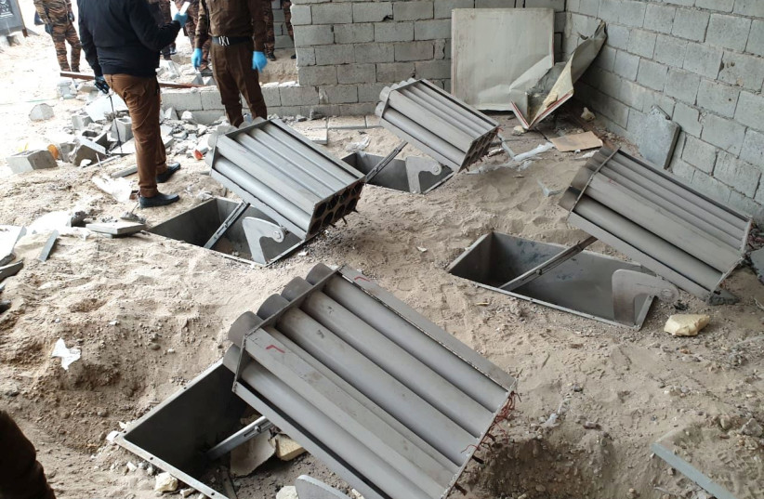
Katyusha rocket launchers found by the Iraqi Army, are seen in Umm al-Izam. (photo credit: REUTERS)
Two rockets were fired towards the Green Zone where the US embassy is located in Baghdad on Saturday night, according to Iraq's Security Media Cell.
The C-RAM defense system was activated to intercept the rocket fire. One rocket was intercepted, while a second rocket fell near the Grand Festivities Square near the Green Zone, causing damage to two civilian vehicles.
No group has taken responsibility for the rocket attack as of yet.
The attack comes as the New Years deadline set by Iran-backed militias in Iraq for the withdrawal of US forces from the country nears. The militias have threatened to attack US forces in the country if they stay after December 31st.
The US-led coalition conducting Operation Inherent Resolve in Iraq announced on December 9 that it had completed its transition to a non-combat role, but would keep troops in Iraq to advise and assist Iraqi forces. https://www.jpost.com/breaking-news/rockets-fired-towards-us-embassy-in-baghdad-report-689133

Commentary:
Democrats are Destroying Public Schools. Republicans Should Help Them.
Daniel Greenfield December 16, 2021
During the pandemic, millions of upper middle class white parents experienced for the first time the high quality education that minority public students had been receiving for generations.
The housing values of America’s communities are based on taxing homeowners to subsidize school systems that are radical, corrupt, and wasteful, but that suburban parents keep on funding because they believe it will prepare their children for college and success in life.
The administrators and teachers expect high levels of parental involvement in local school systems and understand that the ungodly sums of money being poured into their systems depend on parents sacrificing to make sure their kids are going to be able to afford to live in the same kind of communities and repeat the cycle of sending their kids to the same schools.
The Left smears this as systemic racism, but the only systemic thing is the sheer amount of money and effort that suburban parents put into maintaining schools that fail to meet the basic educational standards of virtually every previous generation, but still give their children a future.
The systemic racism does not come from the superiority of suburban schools, but from the way Democrat cities and teachers’ unions broke urban schools in minority areas. The issue, despite media lies, isn’t money. The per student spending in major cities like New York City ($28.000), Chicago ($16,000), and Los Angeles ($24,000) remains staggering. But as with any number of government bureaucracies from the Pentagon to the homeless crisis, the money doesn’t buy anything except an expansion of the system that is rapidly gobbling up all the cash put into it.
The more schools are in crisis, the worse their standards become. And the worse the standards, the worse the crisis because the system exists to perpetuate the crisis for political reasons. Suburban schools aren’t better because they spend more money, but because constant parental involvement keeps the same educational forces that destroyed urban schools at bay.
The crisis finally arrived at suburban schools with the pandemic. Administrators and officials rapidly dismantled standards, shut down any kind of accountability, moved classes to Zoom, and went on with the business of demanding more money to solve a crisis they had created.
Absenteeism skyrocketed, grades dropped or were dropped, and teachers were free to jettison standards and focus on woke political agendas while neglecting any actual education.
The urban ghetto model had finally come to the best suburban schools not by way of race, as the Left and their media often insisted, but by cutting parents out of the loop and letting the system have its way. This was not simple laziness and greed by the teachers’ unions, though that was a definite added bonus, but a plot to destroy educational standards nationwide.
The plan is largely succeeding as colleges that formerly valued the SAT and other admission testing metrics discard them as part of their equity plans, and school districts eliminate gifted and talented programs, and write new rules discouraging firm grades and deadlines, allowing tests to be retaken and essays to be rewritten as often as it takes to get students promoted.
Some of this is happening under the pretext of the pandemic and some as part of the extended commemoration of George Floyd’s drug overdose death, but all of it is part of an existing plan to move education away from standards and toward politics. In the new educational standards you don’t need to learn grammar, to understand how a cell divides, or what 2 + 2 equals. The new standards all involve students learning to become activists who advocate for leftist views while reporting each other for thought crimes to woke social media lynch mobs.
The criticisms of critical race theory in classrooms are valid, but they often miss the forest for the trees. Teaching children that they’re born racists or victims because of their skin color is horrifying, but it’s one component of a larger educational program that has rebooted civics as a program for radicalizing students into a Red Guard to take over every institution they enter.
The program isn’t new and the speed with which corporations fall into line behind woke agendas testifies to its previous existence and its growing effectiveness. Many suburban parents were relatively comfortable with having their children turned into militant environmentalists, pro-abortion, or gay rights activists. Some are now drawing the line not at civil rights activism, but at a classroom process that explicitly demeans their children and takes away their future.
Their partial awakening is welcome, but it’s a little late and extremely incomplete.
Many parents did not care what their students learned as long as the system appeared to be putting them on track for college and success in life. Now the system has begun announcing that it doesn’t believe in success and that their children don’t deserve it anyway. The educational standards forming the basis for the future they had been paying extortionate property taxes to maintain were suddenly being dismantled before their unbelieving eyes.
The Virginia gubernatorial election and the elections in New York and New Jersey are the first shock waves of outrage hitting the system. Youngkin didn’t just run on critical race theory, as some social media echo chambers from out of state thought, but on building up schools because suburban parents are still convinced that more money for education will fix everything.
Putting more money into the public school system empowers the destroyers dismantling educational standards for equity’s sake and electing their political allies to public office.
For every dime that goes to increasing educational standards, 90 cents will be used to hire more administrators, implement new equity plans, funnel more cash to educational consultants and giant textbook publishers, and raise teacher salaries which will put more cash and clout in the pockets of the unions bent on destroying the system. The hole in the boat will only get bigger.
The problem with American education is not a lack of money. The public school system will be no better at educating students if it were “funded like the military”, as activists argue, than the military is at winning wars. Just as in wars, what’s missing isn’t resources, it’s the objective.
The American school system, like the rest of our institutions, is in an uncomfortable state of transition between its traditional goals and values, and the new radical agendas of the Left. The educational system, as leftist educrats protest, is still built around a traditional approach to education, but it has been captured from the top down and the bottom up by radicals who want to radicalize not only the subject matter of education, but its purpose and method.
The pandemic provided them with a pretext for “Cloward-Pivening” the system by destroying educational standards across the system, not just in isolated areas. By refusing to teach students, the teachers’ unions all but ensured that they would fail to meet educational standards. And, as in the ghettos, every failing student became part of a constituency for dismantling educational standards. And those parents who had struggled to keep their children learning during the pandemic were expected to abandon standards in the name of equity.
The same corrupt system which had destroyed education insisted that parents were racist and selfish for refusing to understand how hard it was for all the other students. But, just as in urban schools, it was hard for those students because the system had deliberately made it so.
The public school system broke itself and, like union boss Randi Weingarten, blamed the breakage on everyone else, while insisting that the destruction be institutionalized.
Anything else would be systemic racism.
But the only systemic racism in schools is educational wokeness. Many suburban parents embraced wokeness alongside standards because it helped give their children a competitive advantage over Asian, Indian, and other high-performing minorities. The corrupt bargain fed into a college admissions system that valued social justice activism over academic brilliance.
The ideal balance between wokeness and standards made suburban white liberal students more competitive than their high performing or underperforming minority counterparts, not to mention academically gifted students in more conservative rural areas. But now the woke devil must have his due. And the price is not only the competitive advantage, but all of education.
Students who want to get ahead in the new system have to develop an appetite for woke activism, for turning in their peers for politically incorrect thoughts, for marching in rallies, discovering a sexual interest in their own sex or deciding that they are really the opposite sex.
And the system is performing brilliantly as students conform to its radical expectations.
Parents have been slow to understand the sheer scale of what is happening and conservatives have been equally slow to spell it out in clear and unambiguous language. After Virginia, education is on the radar and Republicans are planning to use it as a model for winning the battle and losing the war by promising to outspend Democrats on public school systems.
This is a strategy for short term political victories and catastrophic long term cultural defeats.
Republicans are right to assert support for strong educational standards. That’s an area where Democrats have become vulnerable after tipping their hand. But restoring standards to a system that is becoming institutionally opposed to them is more than a matter of winning elections.
The problem, as lefties like to say, is systemic. And the system must be dismantled.
The real lesson of Virginia is that conservatives do better with local control and lefties with national control. But, despite election victories, the momentum is with the nationalization of public schools, from the Department of Education to Bill Gates’ Common Core projects, to the Biden administration’s use of the FBI to intimidate local parents speaking out at board meetings.
The only way to reverse that momentum is to truly decentralize education by funding students, not systems, abandoning the public school model and replacing it with vouchers and subsidies for private schools that will allow parents to choose the education that fits their values.
Cloward-Piven works both ways. The deliberate destruction of the system is also an overreach that allows conservatives to propose alternatives to a leftist system instead of propping it up.
And yet every time the Left pulls out its Cloward-Piven plot, the GOP tries to prove that it can manage a declining system better than any of its leftist political opponents. It’s true, but it’s no accomplishment. When hijackers are trying to fly a plane into the World Trade Center, boasting that you can do a better job than them of keeping it level is a low bar that solves nothing.
If Republicans want to start winning culture wars, instead of culture battles, they need to think like the Left and reinvent systems instead of competing on systemic competence. The Left isn’t destroying education because it’s incompetent, but because it wants to reinvent it.
Are Republicans also willing to also reinvent American education or just manage its decline? ` https://www.danielgreenfield.org/2021/12/democrats-are-destroying-public-schools.html

Declaring War on the Unvaxxed
Michael Reagan Posted: Dec 18, 2021 12:01 AM
I’m sick and tired of wearing masks.
I’m sick and tired of vaccine mandates.
I’m sick and tired of hearing the dire warnings and broken promises of politicians and incompetent public health officials.
For almost two years they’ve ordered us around like children and told us what individual freedoms we must sacrifice if we are to ever win the war against COVID-19.
Now a new variant, omicron, has knocked us backwards again.
Though it doesn't appear as lethal as other variants, the media have rebooted their panic machines and America is masking up and locking down once more.
Corporations are telling employees to work from home. Broadway plays are being closed. Holiday parties are being canceled.
Without a vaccination card, you already can’t do some things or eat inside some restaurants.
The almighty Dr. Fauci even says if you invite your brother to Christmas dinner, you should make him show you his vax card before you let him in the door.
Dr. Science wasn’t kidding.
He, Democrat politicians and the liberal media have recently made our national COVID nightmare worse by dividing our already politically split country into two new warring camps – the vaxxed and the unvaxxed.
The vaxxed are the good people and the unvaccinated have become Public Health Enemy No. 1. They are the bad, selfish and presumably Trump-leaning Americans who are preventing our total victory over Covid.
It’s as if some people who have taken the Covid shots carry a cross around with them and when they see someone un-vaxxed they bring it out like they’ve encountered Dracula.
If only every un-vaxxed person in America would give up their bodies and get the jab (or two) – even if they don’t need it or want it – they’d make Fauci, President Biden and the East Coast media nannies very happy.
Then, our leaders promise us, the threat from Covid-19 and its variants would disappear and all our lives could return to “normal” – whatever it is going to look like when we’re all still forced to wear masks and show our vax passports everywhere we go.
I don’t blame the un-vaxxed for the continuing pandemic. As I tweeted the other day, I don’t care whether someone is vaxxed like I am or not.
I don’t hate them, either. I realize I’ve hugged, shook hands and eaten dinner with dozens of people who haven’t been jabbed.
People tell me, “You could die.”
Yeah. I’m 76. I could die of a lot of stuff. But I stay healthy. I take all my meds.
So far, thanks to the thugs running China who created the virus, more than 800,000 Americans have died of – or with – COVID-19. Most, by far, were very old or already very sick or unhealthy.
About 1,100 Americans are still dying every day despite the fact that we’ve had vaccines for almost a year and we’ve done everything Fauci, government experts and politicians have ordered us to do.
Unfortunately, nothing they did worked to stop the pandemic.
First we were told we had to flatten the curve for a few weeks ….
Oops.
Then we were told we had to “shelter in place” in our basements for six months ….
Oops.
Then if you wore a mask indoors and outdoors – and while you played sports …
Oops.
Then if you got the vaccine, you’d never have to worry …
Oops.
Then if you get a booster – or two – you’ll really be protected ….
Oops.
Now these same geniuses want to give the vaccine to every kid 5 years old and younger – even though the science says they don’t need it.
The vaccine makers have done tests on some kids and they guarantee it’s completely safe.
But how will the vaccines affect the kids’ bodies five or 10 years from now, or during a pregnancy? And what about boosters – and more boosters?
The answers to those important questions are unknown but they might turn out to be some pretty horrible “Oops.”
Meanwhile, everyone have a merry Christmas and don’t let Santa down your chimney unless he’s been vaxxed – oops. https://townhall.com/columnists/michaelreagan/2021/12/18/declaring-war-on-the-unvaxxed-n2600740

Jackbooted Jerk Branden Needs to be Booted Out of Office
By Sidney Secular|December 18th, 2021
The jackbooted jerk, “Illegit” Joe, allowed to take the reins of power illicitly, is letting that power to go to his head or what little remains of it. His actions are way over the top now that he is on top. His latest treasonous action should topple him from his perch if patriots would only act and stop propping him up by doing nothing to remove him. Any support or sympathy for him should have evaporated once he sought to remove forty US Navy SEALs from the military and punish them for seeking religious exemptions from the offensive Department of Defense and US Navy “Covid Vaxx” mandates. Their requests were summarily rejected with no justifications provided! The DoD’s refusal to protect the religious liberties, and hence the First Amendment rights of its service members, is unprecedented.
The SEALs are just the most visible service group to have their exemption requests turned down. However, it should be noted that a significant number of the service members that are refusing the Covid jabs come from special operations forces such as the SEALs. The First Liberty Institute (www.firstliberty.org) has taken up their case. The forty SEALs involved have over 100 combat deployments and 350 years of service among them, yet they are facing harassment, threats and intimidation from their superiors (at least in rank) for the “crime” of exercising their First Amendment rights as Americans.
When one SEAL informed his commander he would seek a religious exemption to the DoD mandate, his fate was “sealed,” so to speak, and he was told to surrender his Special Warfare Pin known as the “Trident.” This act would not only mean dismissal from the SEALs per se but would make him an outcast from the SEAL community, cutting off his ability to interact with anyone in that community. In other words, he was facing personal disgrace and banishment, all for exercising his right as an American by seeking a religious exemption to a seriously flawed mandate. The applicable Navy directive applies only to religious exemptions and not to any medical or other exemptions. This distinction makes of the directive an attack on personal religious beliefs and basically eliminates the long-standing and accepted “conscientious objector” status category in the military.
Adding significant insult to injury, the directive also “mandates” that religious objectors will lose their pay regardless of whether the exemption is granted or not! It only needs to be sought to occasion this punitive and vindictive effort to silence any effort to avoid what itself is an outrageous and unconstitutional effort by the GovMint to nullify the Constitution. By “losing pay,” the FedGov seeks to recoup from those SEALs who reject the mandate all the money spent training and maintaining them. It is estimated to cost $350,000 to $500,000 to train a single Navy SEAL. To keep one SEAL operational and deployable overseas costs some where around 1,000,000 per year. The Navy SEALs are the most elite fighting force on Earth, yet the present mindless “Commander-In-Thief” wants to make an example of them and punish them beyond all law or reason. This is an unconscionable act of tyranny of an unprecedented nature, at least in the modern West.
The Navy cannot simply snap its fingers and generate more SEALs on demand as if they were ordering a replacement cog in a wheel. It takes years to recruit, train, and develop the select few able to meet the high standards of the SEAL force. Now with the unbelievable mistreatment that affected SEALs and their families will be enduring, it is more than probable that there will not be enough qualified SEAL candidates to “seal” the enlistment quota in the future. Of course, as our present “government” and its “leaders” hate this country, it is also probable that none of those in the Deep State care how weak we become and what the results of that weakness will be. No two ways about it, we need the real President to return to the White House! https://newswithviews.com/jackbooted-jerk-branden-needs-to-be-booted-out-of-office/

THE SHORASHIM BIBLICAL GIFT CATALOG 005
http://mad.ly/7f9f64?pact=20013931524&fe=1
Support Shorashim!

ARUTZ SHEVA
Ra'am boycotts Shaked over Electricity Law
Ra’am demands Interior Minister's powers when it comes to Electricity Law be removed.
Israel National News ט"ו בטבת תשפ"ב 03:51 19.12.21
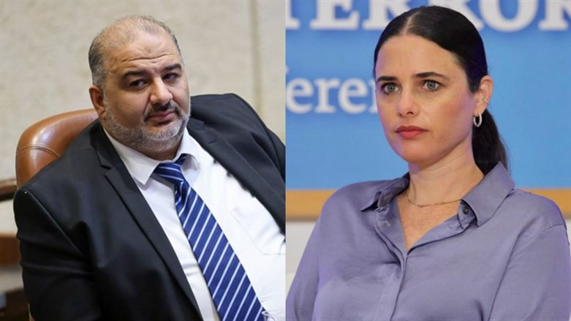
Mansour Abbas and Ayelet Shaked Ronen Topelberg and Noam Moskowitz/Knesset spokesperson
The Ra’am party is stepping up its attacks on Interior Minister Ayelet Shaked as the controversy over the Electricity Law continues.
"We will no longer work with Minister Shaked and will demand that another representative of the government take the duties of of the Ministry of the Interior," Ra’am members were quoted as having said in a Channel 12 News report which aired on Saturday night.
Ra’am is essentially calling for the powers of Interior Minister Shaked, when it comes to the discussions on the Electricity Law, to be taken from her, or for the Knesset to be dissolved and for immediate elections to be called.
The Electricity Law is intended to allow tens of thousands of homes built without a permit to be connected to the electricity grid. The uproar in the coalition began after Shaked said during a recent session in the Knesset that the law does not apply at all to Bedouin settlements in the Negev.
"The Electricity Law was an order from 2014 which was then extended in 2017 and 2019," she said and clarified to MK Yariv Levin of the Likud, "It does not talk at all about the Bedouin in the Negev, despite the lies that your friends are spreading. It is not a question of connecting to electricity in the Negev at all, but of comprehensive plans."
"A person who wants to connect his home to electricity must pay 200,000 shekels ... Mayors in the mixed cities - including mayors from the Likud - think the law is appropriate and would make it easier to charge payments to the Israel Electric Corporation, and thus residents will not be connected to electricity in a pirated manner. There are no detailed plans and there is no normalization at all," insisted Shaked. https://www.israelnationalnews.com/news/318851 [Me thinks Shaked may have just lit the fuse to blow up their coalition. Even to me this sounds very biased. – rdb]

Hamas and Islamic Jihad improving preparations for war
Senior commanders of Hamas and Islamic Jihad meet to improve military coordination.
Dalit Halevi ט"ו בטבת תשפ"ב 02:37 19.12.21
A meeting was held over the weekend between the commanders of Hamas’ military wing, the Al-Qassam Brigades, and the Islamic Jihad’s military wing, the Al-Quds Brigades, on strengthening the organizations' military strength and raising the level of coordination between them.
The Palestinian Arab Safa news agency reported that the participants stressed the paramount importance of the development of military force in the Gaza Strip and the activity of a joint war room in conducting the military campaign against Israel and readiness for a military confrontation in the face of "Zionist threats."
The commanders of Hamas and Islamic Jihad also praised the escalation of terrorist attacks in Judea and Samaria and Jerusalem "in response to settler terrorism and the crimes of the occupation soldiers," stressing that the continuation of Israel's "aggressive" policy will lead to a strong response from the Palestinian resistance organizations.
They expressed support for the establishment of popular resistance committees which will act against the “settlers” and IDF soldiers.
Senior Hamas figures recently threatened to escalate the armed resistance against Israel in response to difficulties in the Egyptian-mediated negotiations on an exchange deal in which more than 1,000 terrorist prisoners will be released by Israel in exchange for the bodies of IDF soldiers being held by Hamas. https://www.israelnationalnews.com/news/318849 [Smells like they may be ready for ‘another action’ aka war. – rdb]

Popular singer claimed: 'Coronavirus is flu'
In censored segment, singer Mordechai Ben David claims 'coronavirus is flu,' says it's 'Pfizer's money mill.'
Israel National News ט"ו בטבת תשפ"ב 00:05 19.12.21
Popular singer Mordechai Ben David, commonly known as MBD, claimed that COVID-19 is "just flu" and that the media is fear-mongering.
"Coronavirus is flu," Ben David said in an interview with Radio Kol Hai's Menachem Toker. "In my opinion it's just money, it's Pfizer's money mill. The media is trying to instill fear in us, so that everyone will get vaccinated out of fear."
He added: "Those whose rabbis have told him to get vaccinated - should get vaccinated."
According to Ishay Cohen from Kikar Hashabbat, Toker chose to cut the above segment, and not air it.
"I would have expected Toker to stop MBD in real time, and put him in his place," Cohen said.
MBD, whose full name is Mordechai Werdyger, is a 70-year-old American hasidic singer. https://www.israelnationalnews.com/news/318846 [Sounds to me that perhaps more and more are waking up to the fraud that is going on. – rdb]

To be removed from this News list, Please click here and put "Unsubscribe" in the subject line.

Dear Friend, Supporter and Prospective Ambassador,
At the end of every fiscal year, I usually send an End of the Year Letter to inform everyone how and what Lev U’Neshama was doing to help our families in Tzfat. I’m writing this letter instead of an End of the Year Report because LUN is in a difficult situation. I’ll explain . . .
Lev U’Neshama began in December 2001. Our programs evolved according to community needs. We work to efficiently use supporters donations.
Lev U’Neshama is a registered Israeli Amutah (non-profit charity organization). We have no overhead, no rent, no salaries, no perks. All donations go to those in need. We are the machine, fueled our donors that we may provide for: Food Fund, Holiday Food Fund, Education Fund and Slush Fund (emergencies). We currently help 82 families regardless of their religious affiliation.
This fall I asked Felicia, my “right hand”, to take our annual census and to update family information. I schmooshed the Education Fund and the Slush fund into one, temporarily, and called it the Winter Fund.
After contacting the first 22 families on our list, we had received requests for 64 pairs of shoes, 22 pairs of eyeglasses and we gave one new, warm blanket per family (limited because of resources). We are unable to provide children's winter jackets as we had intended to do.
With additional donations we were able to fill the requests for 15 additional families; 53 pairs of shoes, 10 pairs of eyeglasses (and one blanket). As of the first week in December, nine families had their requests filled; 52 pairs of shoes, 10 eyeglasses (and one blanket).
Donations could not keep pace with the demands and I have 1,000 NIS remaining and 44 additional families who need to be evaluated for their requirements.
Our ability to continue helping requires additional donations. Any amount is a tremendous help.
We serve families having a disabled parent, some with disabled children, single parent families, widows, parents working part time with delayed or insufficient salaries to cover their basic family needs.
Some of our families have a meter in their homes into which they insert coins to buy a period of electricity since they are unable to pay a regular electric bill. Homes here generally do not have centrally heating so space electric space heaters are placed around the home; no electricity - no heat, no lights, no refrigerator, etc.
Some can only afford phone service allowing incoming calls but they can’t call out. One mother, awareFelicia had called two times, thought it must been important so her husband watched the children and she walked a considerable distance at night to knock on Felicia’s door. After a tearful 1 ½ hour conversation, we learned more about the family’s plight. The mother lost her job because the store where she worked was closed and the husband lost his work because that business also closed. There are many heartbreaking stories . . .
Two local merchants and a local optician provide Lev U'Neshama generous discounts which you can see by the these low prices: 1 pair of shoes: $33 1 eye exam and eyeglasses: $66 1 blanket: $33
The average cost for the requests of one family: 7 pairs of shoes, 2 pairs of eyeglasses and one blanket total $406. For each block of 9 families it would total about: $2,715
For the sake of the children in the remaining 44 families, please -
1) make a donation by selecting one or more of the above items to fund.
2) share a copy of this letter with family, friends, colleagues, synagogue friends, church group, etc.
3. Send this letter prefaced with your personal comments, to others via email.
We critically need more donors to join in the effort to complete the Winter Project. Additionally, more donors will help maintain our other programs and enable us to help more families. We have some on a waiting list for food assistance.
Donations may be made by PayPal using the recipient email address of: mortsmo@aol.com
US checks (Canadian checks in US funds) may be sent to my daughter in Denver and made payable to her:
Terri Smolensky
Send to: Terri Smolensky, 177 S Syracuse St. Denver CO 80230 USA
If someone else needs a US tax receipt, that can be arranged, please contact me.
We are very eager to hear from you. Your help is sorely needed. Become an Ambassador for Israel and Lev U’Neshama. Please spread the word to others to join our effort to help Tzfat’s struggling families!
Yaffa Smolensky, Volunteer Program Manager
Lev U’Neshama, Tzfat Israel
email: mortsmo@aol.com
Web site: www.levuneshama.com (donations can be made on this web site on the “How You Can Help” page.)

12/18/2021 NEWS AM Don’t miss Lev U’Neshama End of Year Report at end of posting!
ETBPF has been supporting and advocation for their work for many years.
Texas COVID-19 Summit: COVID-19 Vaccines: Are They Safe and Effective?
https://www.youmaker.com/video/82ee2637-3771-44a5-bf20-4367d509a3c9
Just in case you missed and wanted to see some REAL Truth & Science. This is a bit long but worth the watch.

Extinct tree from the time of Jesus rises from the dead in Israel
https://www.youtube.com/watch?v=o0y5Z8_tefY
"Education rears disciples, imitators, and routinists, not pioneers of new ideas and creative geniuses. The schools are not nurseries of progress and improvement, but conservatories of tradition and unvarying modes of thought."
-- Ludwig von Mises (1881-1973) Economist and social philosopher
Read the Prophets & PRAY WITHOUT CEASING!
That is the only hope for this nation!
Please  Remember  These  Folks  In  Prayer-  Check often  They  Change! | Pray that the world would WAKE UP! Time for a worldwide repentance!  ALL US soldiers fighting for our freedom around the world  Pray for those in our government to repent of their wicked corrupt ways.  Pray for “A” family – three admitted with Covid very sick. Multiple Comorbidities - Two passed away  Pray for TH - Knee and Blood pressure problems.  Pray for J P– sick with flu bad episode 5 years ago  Pray for RR – young man with enlarged heart ventricle  Pray for family of RY – Passed away from Covid  Pray for EL – Had clot embolized to brain – successful ‘clot buster’ but long road to go.  Pray for BB – Severe West Nile Fever –still not mobile- improving!  Pray for RBH – cancer recurrence  Pray for GB – bad reaction from Cancer drug  Pray for Ella – Child with serious problems  Pray that The Holy One will lead you in Your preparations for handling the world problems. – Have YOU made any preparations?
Genesis 49:³¹There they buried Abraham and Sarah his wife; there they buried Isaac and Rebekah his wife; and there I buried Leah. ³²The field and the cave that is therein, which was purchased from the children of Heth.' ³³And when Jacob made an end of charging his sons, he gathered up his feet into the bed, and expired, and was gathered unto his people.

If you watch
NOTHING
this year watch this!
https://www.youtube.com/watch?v=7vPRtkc2f-4

This is a bit long, but it is the best presentation on what our government is and is supposed to be you will ever see.
Constitutional law in 1.3 hour and how return America to its proper relationships.
The video is called “NonCompliant”
Are you a slave or are you a free person?

IDF chief says Israel will expand West Bank manhunt until terror shooters are found
‘We will not stop until we capture the terrorists,’ Kohavi vows at site of attack that killed Yehuda Dimentman; police dismantle makeshift buildings at new outpost named for victim
By Emanuel Fabian Today, 6:41 pm
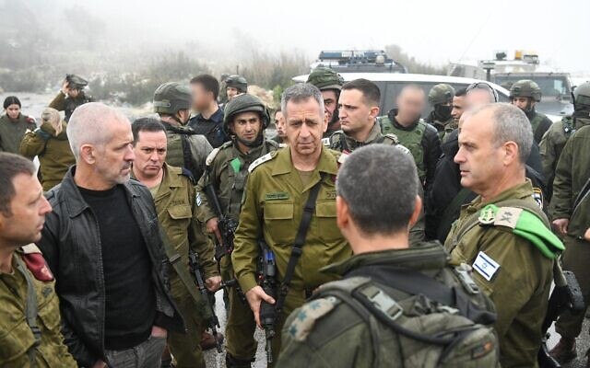
IDF chief Aviv Kohavi speaks with military and security officials at the scene of a shooting attack near Homesh in the West Bank, on December 17 2021. (Israel Defense Forces)
IDF chief Aviv Kohavi on Friday toured the site of a deadly terror shooting that occurred the previous night, vowing to expand the manhunt until the Palestinian gunmen are found.
“The Israel Defense Forces and security forces continue to pursue the terrorists involved in the attack,” Kohavi said while visiting the site near the West Bank outpost of Homesh, according to a statement released by the IDF.
“Along with using intelligence capabilities, we will also increase combat forces and will continue to act and expand operational activities as needed,” Kohavi said.
“We will not stop until we capture the terrorists,” he added, as he surveyed the area with senior military and security officials.
Yehuda Dimentman was killed and two others were lightly hurt after they were fired on while driving a car as they left Homesh on Thursday night. A military official said the car had been ambushed from the side of the road.
Three additional infantry battalions of troops, along with special forces and intelligence units, were deployed to the West Bank following the attack, as the military, Shin Bet security service and Israel Police scoured the Nablus area for the assailants.
According to Palestinian media, at least three Palestinians were arrested in overnight raids in the village of Burqa, just north of where the attack took place, outside the Homesh outpost.
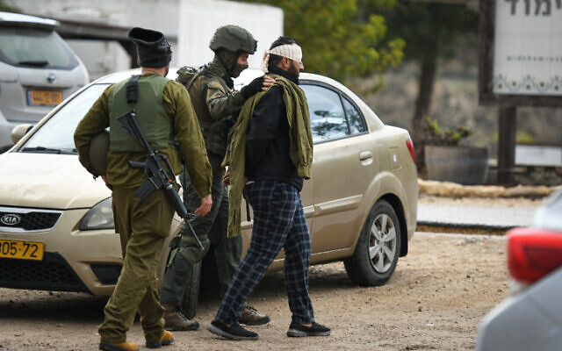
Israeli special forces arrest a Palestinian man outside Shavei Shomron, in the West Bank, on December 17, 2021, following a deadly shooting attack near Homesh (Sraya Diamant/Flash90)
Dimentman was a student at a yeshiva, or religious school, near where the attack took place. Homesh is a settlement that was meant to have been abandoned as part of a 2005 eviction but is now the site of the illegally operated yeshiva.
The 25-year-old was a father of a nine-month-old son and lived in the West Bank settlement of Shavei Shomron.
Hundreds of people took part in the funeral that began at the West Bank outpost of Homesh. Eulogies were made there, and a procession then visited the place of the attack before traveling to Jerusalem’s Givat Shaul cemetery, where Dimentman was interred.
Military and police forces heavily secured the event.
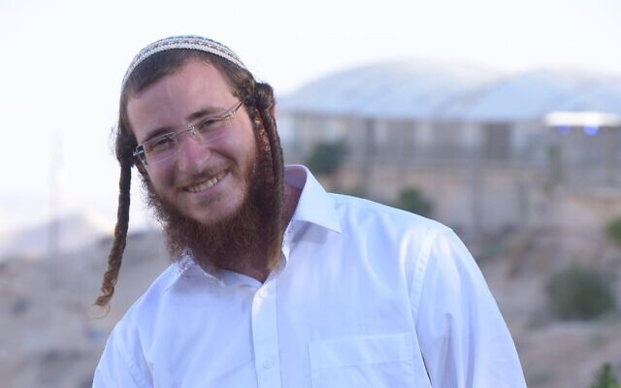
Yehuda Dimentman. (Courtesy)
In response to the attack, settlers set up a makeshift structure near Kiryat Arba in the southern West Bank, in an attempt to establish a new outpost, naming it “Yehuda’s Views,” after the terror victim.
Hours later, the building was dismantled by police, and a dozen settlers were evacuated from the hilltop near the Route 60 highway. Two were briefly detained amid the evacuation, the Ynet news site reported.
חברי תנועת 'נחלה' הקימו היום מאחז חדש לזכר יהודה דימנטמן, סמוך לקרית ארבע. ח"כ @mossi_raz ממרצ: "פניתי בדרישה לפנות אותו. לא נרשה מאחזים חדשים" @glick_sh pic.twitter.com/a676MT2GM3
— גלצ (@GLZRadio) December 17, 2021
The Palestinian terror groups Hamas, Islamic Jihad and Popular Front for the Liberation of Palestine praised Thursday’s attack, but did not take responsibility for it.
The past few weeks have seen a rise in Palestinian terror attacks, with four taking place in Jerusalem alone, including a deadly shooting committed by a member of Hamas. MORE - https://www.timesofisrael.com/idf-chief-says-israel-will-expand-west-bank-manhunt-until-terror-shooters-are-found/

‘This place is fully ours’: Hundreds at terror victim’s funeral in West Bank outpost
Calls for revenge heard as Yehuda Dimentman laid to rest; IDF makes arrests in hunt for gunmen who killed him; investigators suspect two attackers ambushed car
By Judah Ari Gross and TOI staff Today, 10:03 am
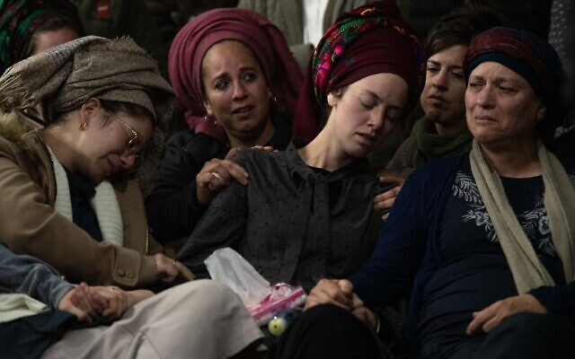  Family and friends attend the funeral of Yehuda Dimentman, in Homesh, in the West Bank, on December 17, 2021. Dimentman was shot dead in a December 16 terror attack. (Sraya Diamant/Flash90) | 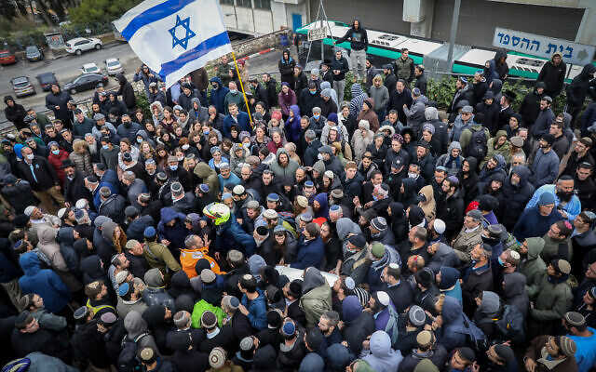  Family and friends attend the funeral of Yehuda Dimentman, in Jerusalem, on December 17, 2021. Dimentman was shot dead in a December 16 terror attack. (Noam Revkin Fenton/Flash90)
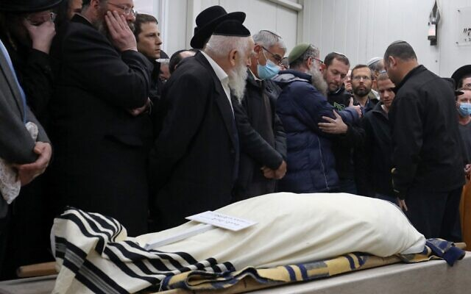  Mourners attend the funeral of Yehuda Dimentman, in Jerusalem, on December 17, 2021. Dimentman was shot dead in a December 16 terror attack. (GIL COHEN-MAGEN / AFP) | 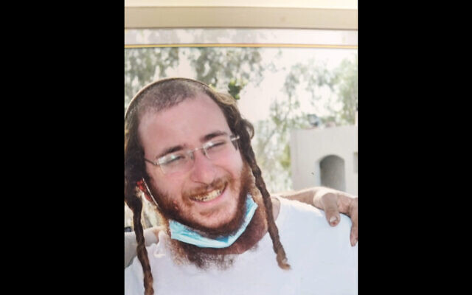  Yehuda Dimentman. (Courtesy)
Hundreds of people took part in funeral events for Yehuda Dimentman Friday as security forces intensified the search for the terrorists who opened fire on his vehicle and killed him the previous night.
The funeral began at the West Bank outpost of Homesh, where Dimentman had studied and near which he was shot dead. Eulogies were made there, and a procession then visited the place of the attack before traveling to Jerusalem’s Givat Shaul cemetery, where Dimentman was interred.
Military and police forces heavily secured the event.
Speaking at the funeral, the head of his yeshiva, Rabbi Elishama Cohen, called Dimentman “a soldier of the Torah,” while adding that “Homesh will say loudly and clearly that this place is fully ours.”
Homesh was meant to have been abandoned in 2005 as part of then-prime minister Ariel Sharon’s so-called disengagement, but has since been illegally retaken by a group of settlers.
The head of the far-right Religious Zionism party, Bezalel Smotrich, said Homesh should be strengthened and further built as a response to the attack.
He said he believed God “sent Yehuda to us to instruct us to return to Homesh, to build the Yeshiva, to strengthen Torah at Homesh.”
Dimentman’s brother Shlomi also called on the government to “renew Homesh.” He said that “the Arabs here are celebrating and happy to see how we are humiliated, mainly by the High Court of Justice and other haters of Israel aiding them.
“We will be here and remain here. May God avenge his blood.”
Some calls for revenge were also heard by funeral-goers as Dimentman was eulogized.
Likud MK Nir Barkat said “Jews are allowed to live wherever they want, and we will protect that right.”
הרב שמואל אליהו יחד עם חברי הכנסת ניר ברקת ואורית סטרוק עם ראש המועצה יוסי דגן בהלוויה הבוקר בחומש של הנרצח בפיגוע אתמול יהודה דימנטמן הי"ד@NirBarkat @oritstrock pic.twitter.com/FNh14nGzVS
— מרדכי עמאר (@mordechay_amar) December 17, 2021
Deputy Defense Minister Alon Schuster rejected the notion of rebuilding Homesh in response to the attack, saying the government “will not make far-reaching diplomatic moves,” adding that building in the illegal settlement would be “a direct hit on agreements Israel is signed on to.”
Israeli forces conducted a number of arrests and set up roadblocks throughout the northern West Bank overnight Thursday as they continued searching for the killers.
Three additional infantry battalions of Israel Defense Forces troops, along with special forces and intelligence collection units, were deployed to the West Bank following the attack, as the military, the Shin Bet security service and Israel Police scoured the Nablus area for the assailants.
“At this time, security forces — the IDF, Shin Bet, police and additional forces — are pursuing the murderers. We’re going to put our hands on the terrorists and capture them,” said Gen. Yehuda Fuchs, head of the IDF’s Central Command.
“We’re responsible for defense here, and we’ll do everything in our ability to provide protection for the residents and capture the murderers and terrorists that carried out this attack,” Fuchs said.
According to Palestinian media, at least three Palestinians were arrested in overnight raids in the village of Burqa, just north of where the attack took place, outside the Homesh outpost.
Investigators suspect the attack was carried out by two assailants who fired on the vehicle from close range, according to Army Radio.
Brig. Gen. Avi Bluth, commander of the IDF division responsible for the area, said at least 10 bullets were fired into the car. He said the car was hit by an ambush from the side of the road, not from a passing vehicle, and that troops had found the spot where the terrorists sat before the attack.
“We are grabbing any threads there are to pull,” said Bluth, commander of the IDF’s Judea and Samaria Division, named for the biblical term for the West Bank.
Details about the investigation into the attack were barred from publication under a court-issued gag order. MORE - https://www.timesofisrael.com/funeral-begins-for-west-bank-terror-victim-as-idf-makes-arrests-in-hunt-for-gunmen/ [The carnage continues and has certainly increased over the last couple of months. – rdb]

After deadly shooting, extremist settlers accused of assaulting Palestinians
Group allegedly smashed property in village near Nablus, broke into a home and beat a resident after killing of yeshiva student
By TOI staff Today, 10:44 am
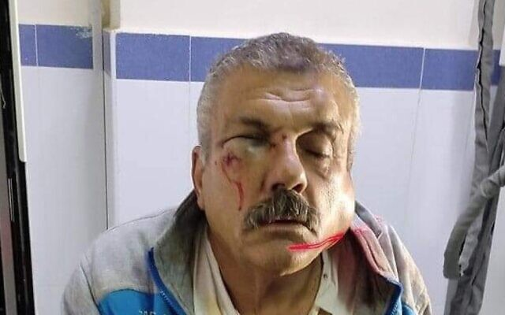
Wael Moqbel, a resident of the village of Qaryut allegedly attacked by extremist settlers on December 17, 2021 (Courtesy)
A group of extremist Israeli settlers assaulted Palestinians and vandalized property in a West Bank village near Nablus Thursday overnight, Palestinian media reported Friday, hours after a settler was killed and two others were injured in a shooting attack.
The reports said dozens of cars were damaged in Qaryut, south of Nablus, and three people were wounded. Assailants broke into the home of one family, smashed furniture and beat one of its inhabitants, Wael Moqbel.
Photos shared on social media showed Moqbel in hospital with intense swelling in his face.
Police said they had received reports of the attack and were investigating the matter.
It seemed likely that the alleged assault was a so-called “price tag” attack following the deadly shooting earlier. Perpetrators claim such attacks are retaliation for Palestinian violence or government policies seen as hostile to the settler movement.
Recent days have seen a national discussion over settler violence, after Public Security Minister Omer Barlev announced that he had discussed the issue with a visiting American diplomat earlier this week, leading the coalition’s right-wing flank to censure him and defend the settler movement.
????️ إصابة مواطن فلسطيني وزوجته في اعتداء للمستوطنين على منزلين وثلاث مركبات في بلدة قريوت جنوبي #نابلس pic.twitter.com/K9LAte3xnA
— قناة الأقصى الفضائية (@SerajSat) December 17, 2021
Foreign Minister Yair Lapid told an American periodical earlier this month that extremist violence is “a stain on Israel.”
The past year has seen a substantial increase in violent attacks by Israeli extremists against Palestinians.
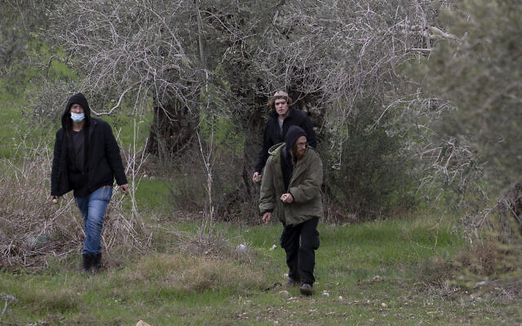  Jewish settlers throw stones towards Palestinian homes, just after the funeral of Yehuda Dimentman, 25, who was killed in a shooting attack by a Palestinian gunman, in the West Bank village of Burqa, Friday, Dec. 17, 2021. (AP Photo/Majdi Mohammed) | 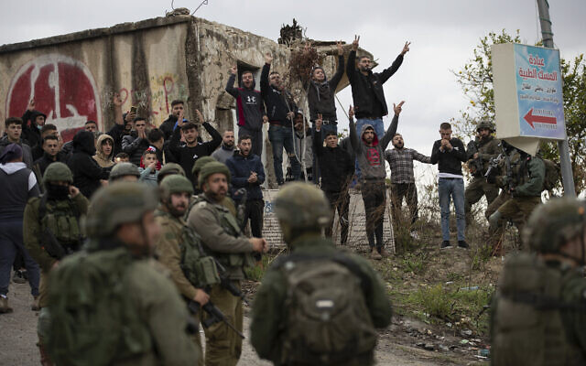  Israeli soldiers stand between Palestinians and a Jewish settlers following a settler attack on the West Bank village of Burqa, Friday, Dec. 17, 2021 after the funeral of Yehuda Dimentman, 25, who was killed in a shooting attack by a Palestinian gunman (AP Photo/Majdi Mohammed)
The fatality from Thursday’s terror shooting was named as Yehudah Dimentman, 25, a father of one from the West Bank settlement of Shavei Shomron. He was a student at the yeshiva, or religious school, in the Homesh outpost in the West Bank, near where the attack took place.
Dimentman and two others were fired on while driving a car as they left Homesh on Thursday night. A military official said the car had been ambushed from the side of the road. The other two passengers sustained light injuries in the attack from broken glass.
Security forces were searching Friday for the perpetrators. https://www.timesofisrael.com/after-deadly-shooting-extremist-settlers-accused-of-assaulting-palestinians/

Press watchdog protests after police assault AP photographer in East Jerusalem
Mahmoud Illean says he identified himself as a journalist, but officers still pushed him to the ground, punched him repeatedly; FPA says he is hospitalized with head injuries
By Emanuel Fabian and TOI staff Today, 7:35 pmUpdated at 8:39 pm
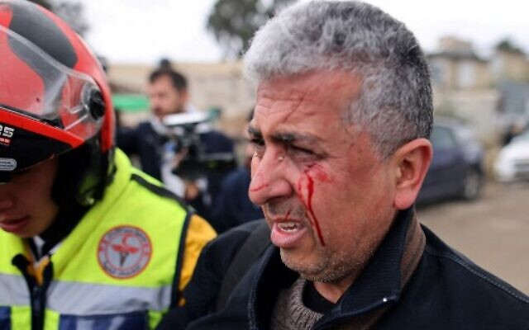
AP photographer Mahmoud Illean reacts after being attacked by Israeli security forces during the coverage of a demonstration in the East Jerusalem neighborhood of Sheikh Jarrah, on December 17, 2021. (AHMAD GHARABLI/AFP)
Israel’s Foreign Press Association issued a protest on Friday after an Associated Press photographer was hospitalized with head injuries after being assaulted by Border Police troops while covering a Friday demonstration in the East Jerusalem neighborhood of Sheikh Jarrah.
Mahmoud Illean said that police had tossed stun grenades toward him and then physically attacked him without any provocation, some 15 minutes after the protest had ended, the FPA said in a statement.
Illean said he repeatedly identified himself as a journalist but to no avail.
Video from the scene showed officers surrounding the photographer before one pushes him to the ground and begins to punch him a number of times.
According to the FPA, Illean sustained injuries to his head and was taken to a hospital.
“The Foreign Press Association strongly condemns this behavior, which raises serious questions about the discipline and professionalism of the officers,” the organization said, adding that “this is the latest in a string of unprovoked attacks in recent years by border police on journalists working for international media.”
Video from violent incident today towards AP photographer (See FPA statement) pic.twitter.com/Lu3EMLk1V2
— Foreign Press Assoc. (@FPAIsPal) December 17, 2021
A spokesperson for Israel Police told the Times of Israel that the incident will be investigated by the “relevant authorities,” without elaborating further.
Formed in 1957 by a group of journalists, the FPA is a nonprofit organization that aims to assist foreign reporters in covering news from Israel, the Palestinian Authority and Gaza. It says that its mandate is “to clarify bureaucratic problems and to protect our interests.”
Earlier on Friday, police said dozens of people were rioting and hurling chairs at officers at the scene. A cop was lightly hurt after being hit in the head with one of the chairs and was taken to receive medical care.
Police said they arrested two suspects, one for throwing the chair that hit the policeman and another for making threats.
שוטר נחבל בראשו מכיסא שהושלך עליו בעימותים בשכונת שייח ג'ראח בירושלים@VeredPelman pic.twitter.com/UGuTfRxlEB
— כאן חדשות (@kann_news) December 17, 2021
Sheikh Jarrah, a neighborhood that is a 10-minute train ride away from Jerusalem’s city center, has emerged as a symbolic flashpoint in the Israeli-Palestinian conflict. Over the past few years, a handful of Jewish nationalists have moved into the mostly Palestinian neighborhood, mostly through complex eviction cases.
Tensions in the neighborhood have risen in recent months due to long-simmering court battles over dozens of homes in the neighborhood in which Palestinian families have lived for decades, but which Jewish groups claim legally belong to them.
Many Palestinians and their supporters see that conflict as part of a larger effort by Israel to expunge their presence from the contested capital. The dispute — along with clashes at the Temple Mount — played a role in the Hamas terror group’s decision to fire a barrage of rockets at Jerusalem in May, sparking a brutal 11-day conflict between Israel and the Gaza Strip.
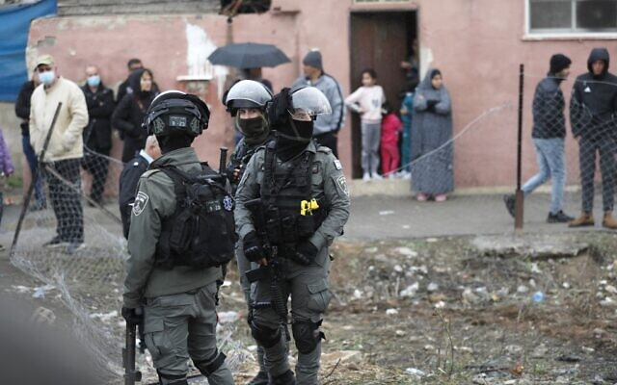
Border Police troops stand guard during a demonstration in the East Jerusalem neighborhood of Sheikh Jarrah, on December 17, 2021. (Ahmad GHARABLI / AFP)
On Thursday police said prosecutors plan to indict a 14-year-old Palestinian girl who allegedly stabbed a Jewish woman in Sheikh Jarrah last week.
A ccording to police, the girl planned the morning of the attack to carry out the stabbing, and followed her target — 26-year-old Moriah Cohen — for several minutes before stabbing her in the back in the neighborhood, where they both live.
Cohen — who was with her children at the time of the attack — was treated at the hospital and released the same day.
The past few weeks have seen a rise in Palestinian terror attacks, with four taking place in Jerusalem alone. https://www.timesofisrael.com/press-watchdog-protests-after-police-assault-ap-photographer-in-east-jerusalem/

Revealed: What Netanyahu really thought of UAE envoy’s peace for no-annexation offer
When landmark op-ed appeared, Israeli envoy Dermer called Emirati counterpart irate at being kept out of loop, and warned that Jerusalem would have no choice but to annex, ToI told
By Jacob Magid Today, 4:16 pm
WASHINGTON — In June 2020, the United Arab Emirates’ Ambassador to the US Yousef al-Otaiba penned an op-ed in Israel’s Yedioth Ahronoth daily that laid the groundwork for his country’s normalization agreement with Israel a mere two months later.
But according to two officials familiar with the matter, official Israel’s first response to that piece was, in fact, anger.
The officials told The Times of Israel that al-Otaiba received an irate phone call from then-Israeli Ambassador to the US Ron Dermer who was incensed over the Emirati envoy’s conditioning of an improved relationship with Abu Dhabi on the shelving of the West Bank annexation plans being led by then-prime minister Benjamin Netanyahu.
The op-ed by Otaiba was published in Hebrew on the front page of Yedioth — a direct appeal to the Israeli public, the likes of which had never been seen before. It was written weeks before the July 1 “deadline” when Netanyahu had pledged to begin applying Israeli sovereignty to large chunks of the West Bank.
Otaiba used the opportunity to warn Israelis of what they had to lose if the controversial move was seen through. “Recently, Israeli leaders have promoted excited talk about normalization of relations with the United Arab Emirates and other Arab states. But Israeli plans for annexation and talk of normalization are a contradiction,” the UAE ambassador wrote.
“These are the carrots – the incentives, the upsides – for Israel. Greater security. Direct links. Expanded markets. Growing acceptance. This is what normal could be,” he continued. “Normal is not annexation. Instead, annexation is a misguided provocation of another order.”
The op-ed’s message resonated overwhelmingly with Israelis, with 80 percent of the population backing the forgoing of annexation in exchange for a normalization agreement.
It also kickstarted marathon negotiations between al-Otaiba, then-senior White House adviser Jared Kushner and Dermer, which ultimately led to the announcement of the Abraham Accords in August 2020 and to annexation plans being postponed indefinitely.
Yet, the op-ed infuriated Netanyahu and his inner circle, who had been in the midst of a campaign to convince the Israeli public along with world leaders that the Arab world did not actually care if Israel moved forward with its annexation plans, an aide to a then senior Israeli official told The Times of Israel.
Roughly two weeks before al-Otaiba’s editorial was released, the pro-Netanyahu daily Israel Hayom published an above-the-fold “exclusive,” relying on sourcing provided to the writer from those close to the prime minister, the aide said. The story was headlined “Under the radar: Arab countries agree to annexation” and appeared alongside pictures of Jordan’s King Abdullah, Egypt’s President Abdel-Fattah el-Sissi and Saudi Crown Prince Mohammed bin Salman. All of them, the article alleged, had given a green light to annexation behind closed doors, despite opposing the plan vehemently in public forums.
Al-Otaiba’s op-ed presented a contradictory message and highlighted not only the UAE’s opposition to Netanyahu’s plan but that of other Arab allies in the region as well.
“A unilateral and deliberate act, annexation is the illegal seizure of Palestinian land. It defies the Arab — and indeed the international — consensus on the Palestinian right to self-determination. It will ignite violence and rouse extremists. It will send shockwaves around the region, especially in Jordan, whose stability — often taken for granted — benefits the entire region, particularly Israel,” wrote the Emirati envoy, a close confidant of UAE Crown Prince Mohammed bin Zayed.
Hours after the op-ed was published, al-Otaiba received a call from Dermer who fumed over having not been given a heads-up, the aide recalled. Al-Otaiba had enlisted the support of American-Israeli business mogul Haim Saban to place the article in Yedioth and ran the piece by Kushner, but did not inform Netanyahu’s office.
Dermer also warned al-Otaiba during the phone call that as a result of the op-ed, the Netanyahu government would now be left with no choice but to move forward with its annexation plans because it could not be seen as having caved to the Arab world, the aide said.
“I think the op-ed caught certain Israelis off guard and it very much irritated them,” another official involved told ToI.
Dermer did not immediately respond to a request for comment.
This story was first told a year ago to The Times of Israel off the record. The sources granted permission to publish the information on Thursday. Some of the details were written in Israeli reporter Barak Ravid’s book “Trump’s Peace” published in Hebrew earlier this month.
That book also told of Washington’s outrage over Israel’s annexation plans which, it claimed, caught the administration completely by surprise, and led to tense exchanges between the US and Israeli leadership. https://www.timesofisrael.com/uae-op-ed-that-offered-normalization-to-nix-annexation-riled-netanyahu-toi-told/

COVID-19 and the Grinch that stole Israel's Christmas
Operators like www.TouristIsrael.com are offering a Christmas Eve in Jerusalem and Bethlehem tour on December 24.
By GIL ZOHAR Published: DECEMBER 16, 2021 21:33
While Bethlehem Mayor Anton Salman inaugurated the Christmas holiday season on Monday (December 4) with an impressive fireworks display in Manger Square and the illumination of the traditional tree there capped with a golden star, residents of the city’s three refugee camps – Aida, Dehaishe and Jibrin, also known as Azza Camp – have been protesting daily against the Palestinian Authority.
While the protests, including burning tires and blocking roads, are aimed at gaining the release of several Palestinians arrested by the PA security forces for waving banners of Hamas and the Popular Front for the Liberation of Palestine (PFLP) during the funeral last month of Amjad Abu Sultan, they also threaten to ruin the Christmas festivities in the little town where Mary gave birth to Jesus some 2,000 years ago.
Factor in Israel’s two-week ban on foreign tourists imposed after the Omicron variant was discovered, extended 10 more days to December 22, and it looks increasingly like the Grinch will again steal Christmas this year in Bethlehem – just like last year’s holiday season proved to be a COVID-19 catastrophe.
Paradoxically, the absence of overseas tourists means Bethlehem is increasingly relying on local visitors – notwithstanding that it is illegal for Israeli citizens to enter Area A of the West Bank.
Operators like www.TouristIsrael.com are offering a Christmas Eve in Jerusalem and Bethlehem tour on December 24. Beginning in the early afternoon, pilgrims will drive past Jerusalem’s Mount of Olives, Kidron Valley and Old City walls before heading to Bethlehem. Following a festive dinner, celebrants will watch Midnight Mass at the Church of St. Catharine (adjoining the Greek Orthodox and Armenian Basilica of the Nativity built above the grotto where Jesus was born) on the huge screen set up in Manger Square. But with so few foreign guests, it may be possible to enter the Roman Catholic church – an all but impossible ticket to get hold of in normal times.
YMCA's lit-up Christmas tree in Jerusalem. (photo credit: JERUSALEM INTERNATIONAL YMCA) | Santa's house (credit: GIL ZOHAR)
So thanks, you Xmas grinches.
While Jerusalem is more associated with the death of Jesus at Easter than the birth of the Christian savior in a manger 10 km. to the south, Christians in Israel’s capital also turn the city into a colorful and joyous seasonal celebration. Advent, the period leading up to Christmas which started on November 28, was marked the evening before by a pilgrimage procession from Jerusalem to Bethlehem by the Roman Catholic Custos of the Holy Land.
The Old City’s Christian Quarter is decorated with festive lights. Not to be missed is the completely over-the-top Ho Ho Holyland! celebration put on nightly from 5 to 8 p.m., until December 31 by Issa Anis Kassissieh – the world’s only Father Christmas who rides a camel rather than driving the famous six-reindeer sleigh – at his home in an alleyway in the Christian Quarter. From the Jaffa, or New Gate, just ask anyone how to get there.
A former basketball player, Issa – whose name in Arabic means Jesus – has been the official ambassador of the Holy Land Santa for six years, and is a graduate of the Charles W. Howard Santa Claus School in Midland, Michigan. This year he launched the holiday season by kayaking with a Christmas tree at Kursi in the Golan Heights.
Slightly more conventional, but still great fun, the celebrations at the YMCA on King David Street offer Jerusalem’s most impressive decorations and the Christmas Eve concert on December 24 featuring various musical ensembles.
But if you’re really serious about experiencing Christmas without flying to the red countries of Europe, I recommend visiting Nazareth – the Lower Galilee city with the largest Christian community in Israel composed of Catholics, Orthodox, Copts, Baptists, Maronites and Anglicans.
At a press conference on Wednesday (December 8), the city’s ebullient Mayor Ali Salam extolled Christmas in the place where the Angel Gabriel announced to Mary she would give birth to a son.
“Christians and Muslims are living together – one home, one family,” he said of his city of 100,000, one third of whom are Christians. “We will be the bridge for peace,” he promised, inviting all Israelis to join in the festivities.
As in Bethlehem and Jerusalem, city officials are hopeful internal tourists will replace those unable to visit from abroad.
FR. SIMAAN BAJJALI, head of Nazareth’s 20,000-strong Greek Orthodox community. (credit: GIL ZOHAR)
THE CELEBRATIONS began December 1 with the illuminating of the 25-m.-high Christmas tree, imported from China and covered with a dazzling array of LED lights. That towering evergreen – the tallest in the Middle East – stands near the Roman Catholic Basilica of the Annunciation in the historic city center. Two weeks later on December 14, Nazareth’s Arabic-speaking Greek Orthodox community unveiled its own smaller but still impressive tannenbaum by Mary’s Well. And on Sunday (December 12), President Isaac Herzog visited for a tour and a briefing on the Xmas preparations. He visited the COVID ward at the historic EMMS Nazareth Hospital on Wadi el Jowani Street, also known as the Scottish Hospital and the English Hospital, which was established in 1861 by Dr. Kaloost Vartan and the Edinburgh Medical Missionary Society.
Jesus’s hometown boasts several Christmas venues. For the first time, the city’s youth have created an illuminated pathway marked by some 1.5 million lights leading to the Mount of Precipice. According to Luke 4:29-30, Nazareth’s Jews, not accepting Jesus as Messiah, tried to throw him off the cliff, but “he passed through the midst of them and went away” en route to Capernaum on Lake Tiberias.
ISSA ANIS KASSISSIEH, aka Father Christmas, rides a festive camel at Jaffa Gate in Jerusalem’s Old City, December 2020. (credit: OLIVIER FITOUSSI/FLASH90)
Not to be missed was the Christmas Market on December 11 at Mary’s Well Square, and the nightly Christmas Fair at St. Anthony’s Parish Hall which began the next day which includes an adorable Santa’s House and evening concerts. The highlight will be Tchaikovsky’s Nutcracker Suite performed by 100 singers and dancers nightly from December 16-21, put on by Nazareth’s Christmas Parade Association.
The nonprofit group has been organizing the city’s annual Christmas parade since 1983. On December 24 at 3 p.m. some 2,000 Boy Scouts, choir members and other youth groups will march 3 km. down Pope Paul VI Street from Mary’s Well to Casa Nova by the Basilica of the Annunciation, followed by fireworks at 5:30 p.m.
On New Year’s Eve, a midnight light show and fireworks display will light up the Basilica of Jesus the Adolescent, also simply known as the Salesian Church, located on the highest hill on the west side of the Old City.
The Christmas celebrations continue on January 6-7 in the New Year, explained Father Simaan Bajjali of Nazareth’s Orthodox Annunciation Church, which has 20,000 congregants.
“I am doing my best to make this year’s celebrations a success,” promised Mayor Salam. “Visitors will feel safe, as if they were in their own home.”
Coronavirus? Bah, humbug. <
The writer is a licensed tour guide based in Jerusalem. Born in Toronto, prior to moving to Israel he suffered from the seasonal malady affecting some Jews of Santa Claus-trophobia. Living here, he has come to appreciate that all religions have beauty. https://www.jpost.com/christian-news/covid-19-and-the-grinch-that-stole-israels-christmas-688993
Avi Nissenkorn: Don't sacrifice the tourism industry for COVID-19
The former minister, who currently serves as chairman of the Israel Hotels Association spoke about Netanyahu and the danger posed to democracy as well as the damage COVID-19 has done to tourism.
By YEHUDA SHARONI/MAARIV Published: DECEMBER 17, 2021 15:24
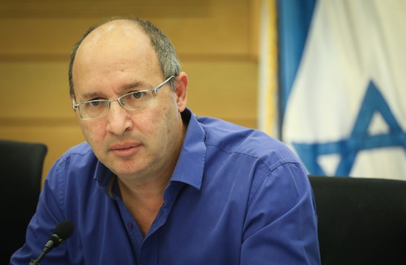
Avi Nissenkorn attends an emergency conference on disasters at construction sites in Israeli, at the Knesset, on May 27, 2019
(photo credit: NOAM REVKIN FENTON/FLASH90)
"I was Justice Minister at a critical point in time for Israeli democracy and fulfilled my role in the best way. To a large extent, I prevented the collapse of democracy. The previous government headed by Benjamin Netanyahu tried to take over the legal system and politicize the appointment of the Attorney General and state’s attorney and judges." Nissenkorn said in a recent interview with Maariv.
The former minister, who currently serves as chairman of the Israel Hotels Association, added: "There has been a trend to turn the justice system into a system on behalf of Netanyahu's government.” He also said that there was an attempt to weaken the Knesset by ruling via emergency orders without the Knesset's approval. He’s very proud of preventing this move.
Asked if he contributed to Netanyahu not being in power today, he said that Netanyahu was not the main issue. “When you try to take over the legal system and prevent the transfer of a state budget, that is the real problem. I prevented the collapse of the legal system.” He added that when you nod yes or shake your head no to Bibi, this reduces the tension of the circumstances. Nissenkorn added that Bibi started dangerous processes that he himself prevented, and that he prevented serious damage to democratic processes and the economy.
When asked if he regretted leaving Blue and White in favor of forming a new party, he replied: "I’m not sorry. It’s true that I left Blue and White and then I didn’t succeed because I chose the wrong political framework, and the result speaks for itself."
Referring to the crisis in the hotel industry, Nissenkorn added that for almost two years, tens of thousands of hotel workers have been in a state of shock and hover between hope and despair. He added that it’s illegitimate to sacrifice the tourism industry and the livelihoods of tens of thousands of workers on the altar of fighting COVID.
"For decades, billions of shekels were invested in infrastructure and training for [the tourism] industry. This is an economic sector that encompasses a national infrastructure and has a lot of working hands. The government must act immediately to find solutions for the industry and its employees."
He adds: "Inbound tourism must be encouraged, and with all due respect to COVID-19, the country must not be closed. Hotels can also be sustained with differential property taxes that take into account occupancy. Only in Israel is property tax uniform regardless of occupancy, in comparison to Europe, where property taxes are determined by actual occupancy." https://www.jpost.com/business-and-innovation/all-news/avi-nissenkorn-dont-sacrifice-the-tourism-industry-for-covid-19-689064

Bennett said planning to urge cabinet to expand no-fly list to most of the world
‘I expect all the ministers to understand the seriousness of the situation and not give in to pressure from the public or lobbyists,’ TV quotes PM as saying
By TOI staff Today, 9:34 pm
Prime Minister Naftali Bennett plans to ask the cabinet to broadly expand Israel’s “red” no-fly list to most of the world, including the US and Canada, in a bid to keep out the highly infectious Omicron variant, Channel 12 reported Friday. [Bennett is demonstrating just how stupid he is. Can he read the reports from South Africa? Can he understand that the fact that it is more transmissible doesn’t mean it is more dangerous? Can he understand that rarely are people hospitalized and die from this just like a flu? Can he understand that Hcq and Ivermectin are quite effective in treating this problem? Bennett is a multimillionaire and obviously must have ties with the Schwabs, Gates, and Soros’s of this world. Disgusting and stupid. – rdb]
However, Bennett is expected to face opposition from some of his ministers to such a drastic move, the report said, noting that Health Minister Nitzan Horowitz favored a more measured plan.
“Ministers that vote against the steps will be responsible for the outbreak. I expect all the ministers to understand the seriousness of the situation and not give in to pressure from the public or lobbyists,” the report quoted Bennett as telling a meeting of advisers on Friday. [Stop threatening people. You aren’t a physician or an epidemiologist or a microbiologist and you are either operating out of fear or out of evil motives.- rdb]
Israel added nine countries this week to the “red” list: the UK, Denmark, France, Spain, the United Arab Emirates, Ireland, Norway, Finland and Sweden.
Those wanting to travel to “red” list countries need to first obtain special permission from a government committee.
Israelis who do return from red countries are forced to enter quarantine in state-run hotels until their first COVID test comes back negative, after which they can leave, but must remain in home quarantine for seven days, even if they are fully vaccinated.
The cabinet on Thursday voted to extend the current travel restrictions, including the ban on foreigners entering the country and a requirement for all Israelis to quarantine for three days upon entry. The limitations will now last until December 29 at least.
However, Channel 12 noted that if the widespread ban was in place it would only last so long as Israel managed to stop the local spread of Omicron.
The latest Health Ministry coronavirus figures released Friday showed 838 new COVID-19 cases diagnosed the previous day, the highest daily figure in some two months.
The number represented an increase of 181 from the previous day, as the pandemic appeared to be on an upward trajectory in Israel once more.
The ministry said 45 of the new cases had been confirmed to be of the Omicron variant, bringing the total number of Omicron cases in Israel to 134. Most of the cases were found in people returning from overseas. There were an additional 207 likely cases waiting to be confirmed.
The ministry said 45 of the new cases had been confirmed to be of the Omicron variant, bringing the total number of Omicron cases in Israel to 134. Most of the cases were found in people returning from overseas. There were an additional 207 likely cases waiting to be confirmed.
The latest numbers also showed Israel’s basic virus reproduction rate had risen to 1.07. Also known as the “R-number,” the figure represents the number of people each confirmed patient infects, on average. Any number over 1 signifies that case numbers are rising.
Though the strain first identified in South Africa is believed to be the most infectious yet, it is not yet clear that it is more dangerous. In fact, some data has indicated the disease it causes may be milder than previous variants.
Also Friday, the government announced that it had finalized the plan to reimpose some restrictions on entry to malls.
The government had briefly announced the implementation of the Green Pass system at malls starting Friday (requiring proof of immunity or a negative test to access non-essential shops). But a public outcry from business owners and threats of rebellion led the plan to be shelved for now.
Instead, in a meeting between Bennett, Horowitz and Economics Minister Orna Barbivai, it was decided to place capacity limits on malls and stores of one person per 15 meters. Mall opening hours would also be expanded to reduce crowding.
In addition, extra people would be deployed to ensure masks were being worn in indoor venues.
As of Friday morning there were 6,542 active COVID-19 cases; 79 of those were severely ill, hospitalized COVID-19 patients, down from 93 a week earlier. There are 42 coronavirus patients on respirators.
According to Health Ministry data, 6,438,561 people in Israel have received at least one shot of the COVID-19 vaccine, 5,815,500 have received two shots, and 4,147,339 have received the booster shot. https://www.timesofisrael.com/bennett-said-planning-to-urge-cabinet-to-expand-no-fly-list-to-most-of-the-world/

Netanyahu, 130 others enter quarantine after 4 Knesset staff infected with COVID-19
Opposition leader was working out at the parliament’s gym with a personal trainer who was later found to be carrying virus, his party says
By TOI staff Today, 11:00 pm
Opposition leader Benjamin Netanyahu and some 130 others at the Knesset entered quarantine on Friday evening, after four parliamentary personnel were confirmed to be carriers of coronavirus, officials said.
According to Hebrew-language media reports, at least one is suspected to be a carrier of the Omicron variant of COVID-19.
Yesh Atid MK Simon Davidson also entered self-isolation due to the outbreak.
The chief Knesset officer informed Netanyahu that a personal trainer at the Israeli parliament’s gym, who was coaching him on Wednesday, was confirmed to be infected with COVID-19, his Likud party said in a statement.
“The former prime minister is acting in accordance with the guidelines and is waiting for the results of the tests,” Likud said.
Netanyahu has been forced into quarantine several times since the start of the pandemic over exposure to sick staff members.
On Thursday, a Knesset security guard tested positive for the Omicron variant of COVID-19. The guard has not been at work since Sunday, according to the Knesset spokesperson, but 21 other security and parliamentary personnel, as well as United Torah Judaism MK Meir Porush, have been instructed to enter quarantine.
According to new regulations, people who have come in direct contact with an Omicron carrier must isolate for three days, even if they are fully vaccinated.
On Wednesday, Defense Minister Benny Gantz announced that he had entered self-imposed quarantine after discovering that an aide who flew with him to the US this week had tested positive for coronavirus, later reported to be the Omicron variant.
A day earlier, Prime Minister Naftali Bennett tested negative for COVID-19 after a passenger on his flight back to Israel from the United Arab Emirates earlier this week tested positive for the coronavirus a day earlier.
The latest Health Ministry coronavirus figures released Friday showed 854 new COVID-19 cases diagnosed the previous day, the highest daily figure in some two months. MORE - https://www.timesofisrael.com/netanyahu-130-others-enter-quarantine-after-4-knesset-staff-infected-with-covid-19/

European powers warn Iran nuclear talks ‘reaching end of road’
Britain, France and Germany call latest request from Tehran to pause talks ‘disappointing;’ UN nuclear chief casts ‘doubt’ on missing Iran data from cameras
By Anne BEADE Today, 7:19 pm
VIENNA, Austria (AFP) — European diplomats in talks to save the Iran nuclear deal said Friday that “some technical progress” had been made but warned they were “rapidly reaching the end of the road.”
“There has been some technical progress in the last 24 hours, but this only takes us back nearer to where the talks stood in June,” Britain, France and Germany said in a statement after the latest talks ended in Vienna.
“We are rapidly reaching the end of the road for this negotiation,” they added, calling the latest pause requested by Tehran as “disappointing.”
The talks — aimed at bringing the US back into the agreement, which it left in 2018, and Iran to roll back its stepped-up nuclear activities — started in April this year, but then stopped for several months as the Islamic republic elected a new hardline government.
The talks finally resumed in late November.
“We have made good progress this week,” Tehran’s chief negotiator Ali Bagheri Kani said on Twitter on Friday before the meeting to take stock and adjourn the talks, adding they would continue “after a break of a few days.”
EU and US diplomats had been more guarded in their comments with diplomats from Britain, France and Germany — all party to the deal — saying on Monday that “precious time” was being lost “dealing with new Iranian positions inconsistent” with the agreement.
Washington — which under then-president Donald Trump pulled out of the deal in 2018 and reinstated sanctions on Iran — is indirectly participating in the talks.
The negotiations also include China and Russia, both parties to the agreement, which was meant to offer Iran sanctions relief in exchange for curbs on its nuclear program.
Following the US pullout, Iran has taken successive steps to increase its nuclear activities.
Missing camera memory unit
Earlier this year, Tehran also began restricting some inspection activities by the UN nuclear watchdog, the International Atomic Energy Agency (IAEA).
Tehran and the Vienna-based IAEA announced on Wednesday that they had reached an agreement on replacing the cameras at the TESA nuclear complex in Karaj, west of Tehran, after they were damaged in a June attack Iran blames on Israel.
IAEA director-general Rafael Grossi said Friday he had “doubts” over a missing camera memory unit from the complex, adding no understanding had been reached with Iran over this issue.
Asked whether he thought it could have vanished in the June attack, Grossi replied: “We have doubts about that.”
“This is why we are asking them ‘Where is it?’ I’m hopeful that they are going to come up with an answer because it is very strange that it disappears,” Grossi said.
Grossi admitted there was “concern” about losing surveillance data at Karaj but added: “We have ways to try to reconcile the facts on the ground with what Iran is going to be telling us”.
“Don’t forget this is a facility we know very well, we know the kind of equipment there is,” he said.
The IAEA’s experts would use “analysis, projections, modelling” to try “to put the jigsaw puzzle together,” he added. https://www.timesofisrael.com/european-powers-warn-iran-nuclear-talks-reaching-end-of-road/

Refugees not vaccinated because drugmakers fear injury lawsuits
Migrants fall outside legal immunity granted by countries to Big Pharma
By Art Moore Published December 16, 2021 at 7:58pm
A global vaccine program is denying tens of millions of refugees and other country-less people COVID-19 shots because some major drug manufacturers are concerned about getting sued by people claiming to have suffered adverse effects.
The United Nations says COVID-19 vaccine manufacturers have required that countries relieve them of any legal liability. [You can be maimed for life or die and the JAB companies demand that they have no liability ?????? so if it is supposed to be so safe and so good – WHY!!!!! – rdb’
Reuters reviewed internal documents from the charity operating the global vaccine program, Gavi, showing that about 167 million people could be excluded from national vaccine programs.
Non-governmental organizations participating in the program run by Gavi – called COVID-19 Vaccines Global Access, or COVAX – say they can't bear the legal risks of administering the vaccines to migrants.
More than two-thirds of COVAX doses have come from vaccines produced by Pfizer and BioNTech, Moderna and AstraZeneca.
Reuters said Moderna officials declined to comment. Officials with AstraZeneca and Pfizer said they were in talks with Gavi but declined further comment. Johnson & Johnson has said it would waive a requirement for indemnity for delivery of its vaccine to migrants.
"We are proud to be part of this effort to protect the world's most vulnerable people," said Paul Stoffels, vice chairman of the executive committee and chief scientific officer.
The European Federation of Pharmaceutical Industries and Associations, which represents large pharmaceutical companies in Europe, argues it would be hard to monitor vaccines for safety in refugee camps.
They point out that people may blame vaccines for problems that are unrelated. [OR probably more likely they don’t want the potential of thousands of deaths showing up too soon. – rdb]
"This could then lead to an increased number of litigation cases ... during which the safety and efficacy of the vaccine would be publicly questioned," the federation said in a statement to Reuters.
The spokesman said that might lead to increased "vaccine hesitancy" and a slower recovery from the pandemic.
But the EFPIA, Reuters reported, said the vaccine makers' primary legal concern is based on the unprecedented speed with which the COVID-19 shots were developed.
Reuters explained: "In normal circumstances, drugmakers buy insurance to cover liability for vaccines' potential adverse effects. But COVID forced them to develop drugs so quickly that some side effects – for instance, a rare blood-clotting condition in some of those who took the AstraZeneca vaccine – are emerging as shots go into people's arms." The vaccine(AKA JAB) structure was prepared before the disease was actually recognized so this is poppycock. – rdb]
John T. Monahan, a professor at Georgetown University, said vaccine manufacturers "try to minimize legal risks in almost every setting."
"The gold standard is full immunity from lawsuits," he said. "If they accept carve-outs, it may become more difficult to reach that goal." [That is total garbage and should Never Ever have happened in the first place. – rdb]
On Thursday, due to concerns about blood clots, an advisory panel to the Centers for Disease Control and Prevention unanimously voted to recommend the two-dose Pfizer and Moderna mRNA vaccines over the one-shot Johnson & Johnson vaccine.
A study published in the journal Nature Medicine on Tuesday from Oxford University showing the COVID-19 vaccines can cause myocarditis, an inflammation of the heart, in young people at a rate higher than the incidence of COVID-19.
A new peer-reviewed study of data in Hong Kong found a significant rise in myocarditis and pericarditis in young male adolescents after taking a second dose of the Pfizer/BioNTech COVID-19 vaccine.
In October, citing concerns about myocarditis, the Food and Drug Administration delayed its decision on administration of the Moderna vaccine to young people.
At the time, Sweden, Finland and Norway halted the Moderna COVID-19 vaccine for younger people, and Iceland stopped administering the shot to everyone.
Also, France's health authority< advised against using the Moderna vaccine because of the myocarditis risk.
The CDC's Vaccine Adverse Events Reporting System, or VAERS, reports 19,886 deaths, 102,857 hospitalizations and a total of 946,461 adverse events due to COVID-19 vaccines through Dec. 3.
However, many physicians and scientists believe the true figures are much higher. Physicians who sued the FDA for documents related to clinical trials for Pfizer's COVID-19 vaccine estimate the true numbers are five times higher. A recent study led by a researcher at Columbia University estimated the actual figures are higher by a factor of 20.

20,000+ Deaths Reported to VAERS Following COVID Vaccines
VAERS data released today by the Centers for Disease Control and Prevention included a total of 965,843 reports of adverse events from all age groups following COVID vaccines, including 20,244 deaths and 155,506 serious injuries between Dec. 14, 2020, and Dec. 10, 2021.
By Megan Redshaw 12/17/21
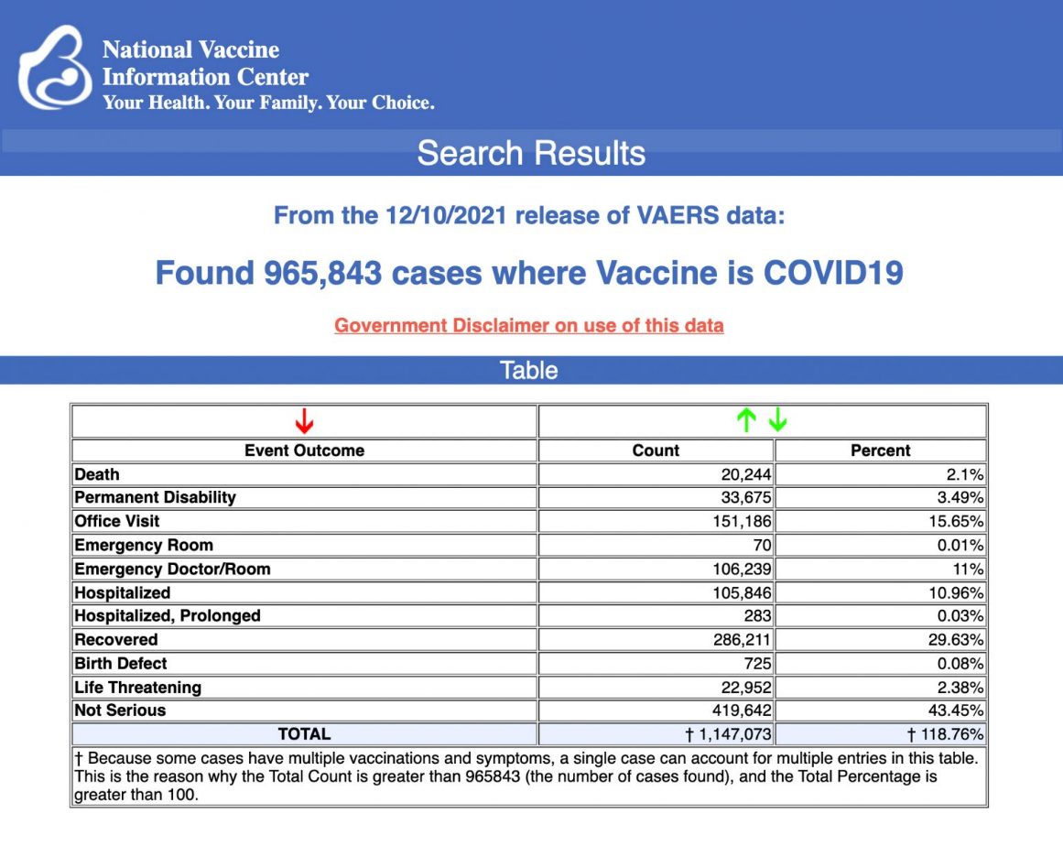
The Centers for Disease Control and Prevention today released new data showing a total of 965,843 reports of adverse events following COVID vaccines were submitted between Dec. 14, 2020, and Dec. 10, 2021, to the Vaccine Adverse Event Reporting System (VAERS). VAERS is the primary government-funded system for reporting adverse vaccine reactions in the U.S.
The data included a total of 20,244 reports of deaths — an increase of 358 over the previous week — and 155,506 reports of serious injuries, including deaths, during the same time period — up 4,560 compared with the previous week.
Excluding “foreign reports” to VAERS, 691,884 adverse events, including 9,295 deaths and 59,767 serious injuries, were reported in the U.S. between Dec. 14, 2020, and Dec. 10, 2021.
BUY TODAY: Robert F. Kennedy, Jr.'s New Book — 'The Real Anthony Fauci'
Foreign reports are reports received by U.S. manufacturers from their foreign subsidiaries. Under U.S. Food and Drug Administration (FDA) regulations, if a manufacturer is notified of a foreign case report that describes an event that is both serious and does not appear on the product’s labeling, the manufacturer is required to submit the report to VAERS.
Of the 9,295 U.S. deaths reported as of Dec. 10, 21% occurred within 24 hours of vaccination, 26% occurred within 48 hours of vaccination and 61% occurred in people who experienced an onset of symptoms within 48 hours of being vaccinated.
In the U.S., 480 million COVID vaccine doses had been administered as of Dec. 10. This includes 279 million doses of Pfizer, 184 million doses of Moderna and 17 million doses of Johnson & Johnson (J&J).
Every Friday, VAERS publishes vaccine injury reports received as of a specified date. Reports submitted to VAERS require further investigation before a causal relationship can be confirmed. Historically, VAERS has been shown to report only 1% of actual vaccine adverse events.
U.S. VAERS data from Dec. 14, 2020, to Dec. 10, 2021, for 5- to 11-year-olds show:
- 4,181 adverse events, including 80 rated as serious and 2 reported deaths. One death occurred in an 11-year-old girl from Georgia vaccinated Sept. 14, prior to the authorization of Pfizer’s COVID vaccine in the 5 to 11 age group.
The second death (VAERS I.D. 1890705) occurred in a 5-year-old girl who died four days after her first Pfizer shot. MORE - https://childrenshealthdefense.org/defender/vaers-cdc-covid-vaccine-pfizer-moderna-johnson/?utm_source=salsa&eType=EmailBlastContent&eId=4a817a99-1016-471c-97bd-79aba49bdc3d

Biden Administration Offers Bonuses to Doctors Who Implement ‘Anti-Racism Plans’
New Medicare rules also reward 'trauma-informed care'
The Biden administration will offer bonuses to doctors who "create and implement an anti-racism plan" under new rules from the Department of Health and Human Services, a move meant to update Medicare payments to "reflect changes in medical practice."
Effective Jan. 1, Medicare doctors can boost their reimbursement rates by conducting "a clinic-wide review" of their practice's "commitment to anti-racism." The plan should cover "value statements" and "clinical practice guidelines," according to HHS, and define race as "a political and social construct, not a physiological one"—a dichotomy many doctors say will discourage genetic testing and worsen racial health disparities.
Emergency Room nurses tend to patients in a hallway at the Houston Methodist The Woodlands Hospital on August 18, 2021 in Houston, Texas. / Getty Images Aaron Sibarium • December 16, 2021 1:45 pm
The "rationale" for the bonus, the new rules read, is that "it is important to acknowledge systemic racism as a root cause for differences in health outcomes between socially-defined racial groups." [The trash in DC pushing their CRTheory everywhere. May they all fall into the great pit.- rdb]
Such premises have found a receptive ear in the Oval Office, which has taken steps to institutionalize them throughout the federal bureaucracy. Hours after his inauguration, President Joe Biden signed an executive order launching a "whole-of-government equity agenda," one plank of which was the "equitable delivery of government benefits."
The new bonus scheme, HHS stresses, is "consistent with" this order. It follows a series of steps by the Biden administration to integrate "anti-racism" into government policy: in November, for example, the Department of Homeland Security listed "diversity, equity, and inclusion" as one of its top two priorities, ahead of "cybersecurity."
HHS did not immediately respond to a request for comment.
The new rules update Medicare's Merit-Based Incentive Payment System, a scoring rubric that determines eligible doctors' reimbursement rates. Congress set up that system in 2015 to reward clinicians for high-quality, cost-effective medical care—and to penalize them for providing unnecessary, costly services.
Doctors had been billing Medicare for services "regardless of how necessary they were," said Chris Pope, a scholar at the Manhattan Institute who worked on the legislation as a Hill fellow. Sold as a way of controlling costs, the payment reform passed with broad bipartisan support.
"Republicans who voted for [the scoring system] weren't voting for this," Pope explained. "The idea that this would be used as a tool of racial policy never came up."
But the scoring system did reward "improvement activities" that advance "health equity," creating a mechanism for HHS to inject ideology into medical compensation. The new rules add "anti-racism" plans to the list of such activities, which are broken up into "medium" and "high-weighted" categories. "Anti-racism" plans will fall into the second weighting, giving doctors extra incentive to implement them. Under the complicated scoring system, the highest possible bonus is 1.79 percent of a doctor's Medicare reimbursements.
Medicare is one of the most expensive social programs in the United States and has been growing more so over time. In 2020 alone, it cost nearly a trillion dollars. Efforts to lower the price tag, such as the 2015 payment reform, have produced administrative headaches and bureaucratic bloat. The Medicare Payment Advisory Commission, an independent federal agency that advises Congress on Medicare policy, has called for the merit-based payment system to be repealed, arguing that its complicated rules have little relation to medical outcomes and saddle doctors with unnecessary paperwork.
"No one went into medicine to check all these boxes," Rita Redberg, a cardiologist on the commission, said at a public meeting in 2017.
The new improvement activities could exacerbate this regulatory burden, especially on small clinics. According to HHS, one public comment on the rules stated that "anti-racism" plans "would be easier for larger, more established practices than smaller or solo practices to adopt." The agency said it "disagree[d]" that the bonus would have a disparate impact because a "small or new practice could tailor the activity to their context."
Clinics can also boost their reimbursements by implementing "a Trauma-Informed Care Approach to Clinical Practice," which seeks to "avoid re-traumatizing or triggering past trauma." That includes "multi-generational trauma, whereby experiences that traumatized earlier generations, such as the genocide of Native American tribes, are passed down" to subsequent generations. In 2018, the New York Times science section called the evidence for multi-generational trauma "circumstantial at best," saying it "falls well short of demonstrating that past human cruelties affect our physiology today."
Medicare has always straddled the line between medical and social policy, Pope noted. By conditioning payments on compliance with civil rights law, the program played a key role in desegregating Southern hospitals in the 1960s. In that sense, Pope said, the new payment scheme is "in tradition of how Medicare has operated since the outset."
But, he added, "the world in 1965 is very different from the world of 2021." https://freebeacon.com/biden-administration/biden-administration-offers-bonus-to-doctors-who-implement-anti-racism-plans/ [Much of this is NOT HEALTHCARE but is social restructuring and propaganda. – rdb]

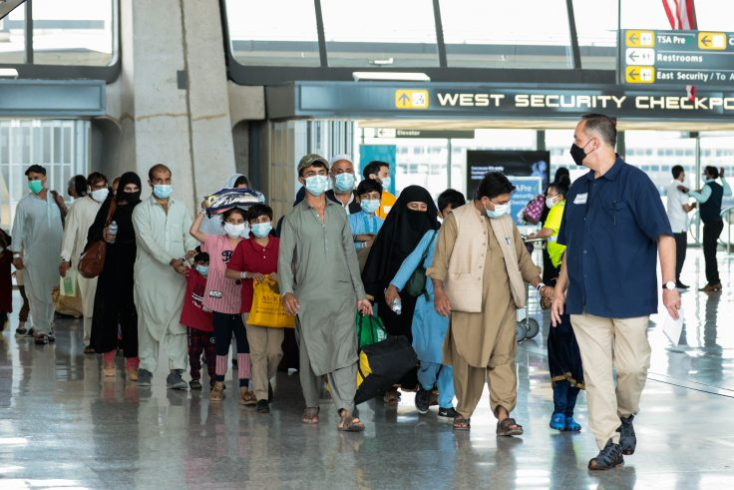
Four Months After Withdrawal, Biden Admin Doesn’t Know Identities of Afghan Refugees Resettled in US
GOP lawmakers want full accounting of failed vetting efforts
Refugees walk through the departure terminal to a bus at Dulles International Airport after being evacuated from Kabul following the Taliban takeover of Afghanistan on Aug. 31, 2021, in Dulles, Va. / Getty Images Adam Kredo
December 17, 2021 3:00 pm
More than four months after the Biden administration airlifted nearly 75,000 Afghans out of the war-torn country, it still does not know the identity or backgrounds of many who have since been resettled in the United States, according to three senators who received classified briefings on the situation.
"During a nonpublic briefing before the Senate Homeland Security and Governmental Affairs Committee, it was made clear that not all security and vetting measures have been taken to ensure the safety of our homeland," Sens. Ron Johnson (R., Wis.), Josh Hawley (R., Mo.), and Rick Scott (R., Fla.) disclosed in a letter sent Thursday to the Department of Homeland Security. The lawmakers are ordering the Biden administration to account for its failed vetting efforts and to "address the lack of transparency regarding this evacuation and resettlement operation." Congress, the lawmakers disclose, still does not have basic information about who the refugees are or if they were qualified to be brought into the country.
"It is beyond unacceptable that several months after President Biden's disastrous and deadly withdrawal we still do not have a full account of all the Americans who are still trapped in Afghanistan or a full account of the Afghans who were evacuated to the U.S.," the lawmakers write, according to a copy of the letter obtained exclusively by the Washington Free Beacon.
In the months since the Biden administration airlifted Afghans out of the country, it has obstructed congressional investigations into the bungled evacuation effort. Secretary of State Antony Blinken admitted to Congress in September that most refugees were not vetted prior to arriving stateside. Internal emails show that those helming the evacuation effort were ordered to fill flights to "excess" with unvetted Afghans. More than 12,000 Afghan refugees, and potentially more, arrived without a visa or basic identification, the Free Beacon first reported in October.
With the administration hoping to turn the page on its chaotic exit from Afghanistan, Johnson—ranking member of the Senate Permanent Subcommittee on Investigations—and his colleagues say that they will not back down from their oversight efforts.
"We are still concerned about your agencies' ability to fully vet these individuals if they do not have any identification documents and cannot prove who they claim to be," the letter to DHS states.
The lawmakers also expressed concern that the hasty evacuation of these Afghans was undertaken as hundreds of Americans were trapped in the country with no way to get back home. The Biden administration announced in October around 300 Americans were still stuck in the country but has not made any updates since.
Before the end of the year, the lawmakers demand the Biden administration disclose to lawmakers how many Afghan refugees cannot be identified and the steps being taken to ensure these individuals are not violent criminals or affiliated with terrorist organizations. They also want to know if the Biden administration created new identity documents for those who arrived without any paperwork.
The lawmakers also call on the administration to disclose if any of the Afghan refugees have been connected to terrorism or other crimes, as well as if they were interviewed in person by U.S. personnel prior to being resettled. Reports indicate that some of those airlifted to America were complicit in child trafficking and sex crimes.
In light of these reports, the senators want to know how many refugees have been arrested by U.S. law enforcement and are slated to be deported from the country. This includes details about whether Immigration and Customs Enforcement detained any of these Afghans over national security concerns.
DHS must also "provide the number of these Afghan nationals and other foreign nationals that have been resettled in each state so far," according to the senators' information request. https://freebeacon.com/biden-administration/four-months-after-withdrawal-biden-admin-doesnt-know-identities-of-afghan-refugees-resettled-in-us/ [This is absolutely THE MOST incompetent and despicable group in the Whitehouse that has ever darkened its doors. – rdb]

Investigation reveals U.S. taxes paying for illegals to break border barrier
Being handed out to immigrants on bank cards, sometimes as folding cash in envelopes
By Bob Unruh Published December 16, 2021 at 7:25pm
Under President Trump, lots of American taxes were being spent at southern border. There was the wall project, which was shown to slow the rate of illegal immigration. Then there were the agents and officers assigned to keep Americans secure.
Joe Biden canceled the wall work and with COVID-19 shot mandates appears to be trying to cut back on agents, too. But American tax money still is being spent at the border under his administration, with a new report published in the Federalist exposing that it is being handed out to those who are breaking and entering, so to speak.
On debit cards, sometimes even in cash.
The report is from Todd Bensman, a Texas-based senior national security fellow for the Center for Immigration Studies and a writing fellow for the Middle East Forum.
He visited the border, observed, made notes and took photographs.
He is now reporting that it is the United Nations, to which the United States pays megabucks on a regular basis, that is spending American money "in contravention of American immigration law and national interest."
"All of this sounds like they're using U.S. tax dollars to encourage this invasion into the nation, and it seems strange to me that we would support an organization that encourages and funds this," Rep. Lance Gooden, R-Texas, told him. "It's totally crazy. I am baffled that there's not more outrage but I think the lack of outrage is due to the lack of knowledge."
He was one of a dozen House Republicans who sponsored the "No Tax Dollars for the United Nations Immigration Invasion Act" when word of the handouts surfaced. It would prohibit the $3.8 billion in contributions currently proposed in the White House 2022 budget to the International Organization for Migration and other U.N.-supported organizations from being handed out at the border.
"It's unclear just how much the United States gives IOM to sustain intending border crossers until they succeed, or how many got some during 2021. But the cash giveaways have been on a steep skyward trajectory since 2019 and only show signs of continuing upward," Bensman's report said.
"The public reporting as to how much the United States, through the State Department, gives IOM and how many got it is opaque at best. President Joe Biden’s 2022 budget calls for $10 billion in humanitarian assistance 'to support vulnerable people abroad.' But there’s no detailed breakout," he wrote.
But he confirmed, "State Department-funneled money helped IOM provide 29,000 people in the Western Hemisphere with cash and voucher assistance and supported 75 shelter waystations, the State Department report states on page 42, much like the one I visited in Reynosa. Along the northern border of Mexico in July 2019, at the height of a 'caravan' crisis, the IOM provided 600 beds and essential items to the Mexican government and helped it expand existing shelters and build new ones to accommodate the 'asylum seekers.'"
He said the IOM expanded after President Biden took office and ended Trump's "Remain in Mexico" policy, a policy which courts have now ordered to be restored.
"Ambiguously, the IOM’s annual 2020 report on the program showed only that it gave cash to somewhere between 10,000 and 100,000 people in Mexico that year. Whatever the recipient numbers since 2019, the IOM clearly intends an upward trajectory for the cash giveaways. The IOM’s Emergency Manual stated several times it would do so in alignment with a fairly recent pact among an international consortium of organizations known as The Grand Bargain, of which the IOM is a signatory."
Bensman noted many parents are given about $800 a month while they are awaiting what they consider the best time to enter the U.S. illegally.
He said the handouts are through money cards as well as "hard cash in envelopes." But the IOM manual also notes there are bank transfers, mobile transfers and e-vouchers. Many are described as "unconditional; unrestricted cash transfers" for "multi-purpose" use.
He explained, "To border hawks, all of this looks, feels, and acts like an agency providing the means for illegal border crossings. The IOM’s own stated purpose for cash-based interventions would only reinforce the perception: the money is intended to 'restore feelings of choice and empowerment for beneficiaries.' Migrant advocates defend cash support to aspiring illegal border crossers as a means to prevent death and suffering among populations they believe have no choice but to migrate and would whether or not any U.N. agency helps out. But the legitimate flip side of that claim is that cash in envelopes or in e-wallets—filled in part by U.S. taxpayer money—can also be said to enable, sustain, or even entice many driven not by urgent dangers but by a desire for better jobs amid reports that Americans would let them in."
He noted the money is thought to create "financial breathing room they need to prepare for more opportune crossing moments. The money enables that highly desired payoff, rather than a forced trip home for lack of funds after, say, an expensive smuggling journey that ended with U.S. expulsion. Those ones arrive in villages with a deterring don’t-try-this message to friends and neighbors."
He explained the problem is that "with the greater choice and empowerment that IOM money can buy, aspiring migrants are able to remain within striking distance of the southern border to choose the time of their inevitable illegal border crossings." https://www.wnd.com/2021/12/investigation-reveals-u-s-taxes-paying-illegals-break-border-barrier/ [Are you mad yet????? You should be furious. – rdb ]

Commentary:
What More Can Anyone Say?
By Lex Greene|December 17th, 2021
Literally thousands of awake patriots have researched, written, and published literally millions of essays and articles desperately trying to reach millions of Americans and mobilize them in an effort to stop the total destruction of the USA on our watch. Thousands of little patriot groups have announced hundreds of “action plans” that never resulted in any real action being taken.
The truth is…millions of American patriots already know enough to be able to see what’s happening to our country and become properly motivated to action. This group knows enough and should already be on the move, but they aren’t yet, mostly because they are being drawn into a variety of worthless do-nothing measures that are going nowhere.
2024? Based on 2020?
Amend a constitution no longer in force or effect?
Secede from the very constitutional concepts you claim to want to protect?
Wait for who to do something?
Follow the Fauci way to freedom?
File more suits that the corrupt courts refuse to hear?
Have most Americans lost their ever loving minds?
The rest of America that really needs the critical facts, don’t want those facts. Many prefer to act like everything is fine and will be fine, or they are completely clueless of reality and on the wrong side of this battle. There is literally nothing anyone can say to change this group, until they are eaten alive by the same people who misled them into this disastrous place.
Either way, there isn’t really much more anyone can say about the current plight of our nation, freedom, and liberty, that hasn’t already been said a million times. Those on the wrong side of history will remain on the wrong side, until they are eaten by their own. Those who are on the right side will remain divided by a laundry list of bad ideas, waiting for someone else to “do something” or hoping against hope for solutions that will never work.
Americans will never get their country or freedom back, unless and until they take it back, by whatever means necessary, preferably peacefully. Regardless, the global (and U.S.) left isn’t going to stop their path of death and destruction, until someone stops them. Throughout history, tyrants have never stopped their evil endeavors on their own. The swamp has never drained itself, ever.
Most of us who have been at this for a long time, thought the American people would have put a stop to this a long time ago. I never imagined that the American people would ever allow the global left to get this far in the USA.
But over the many years of my involvement, I have come to realize that our nation’s Founders were dead right about pretty much everything, including this passage from our Declaration of Independence – “all experience hath shewn, that mankind are more disposed to suffer, while evils are sufferable, than to right themselves by abolishing [or altering]the forms to which they are accustomed.”
Marxist concepts of socialism and communism should have never been allowed to take root within the United States, much less become the daily diet of propaganda in every public education institution across the USA. British Common Law [precedence and procedure] should have never been allowed to infest our Constitutional courts for the purpose of undermining our Constitution and Natural Rights either. But that happened before the ink was dry on the Constitution, as Jefferson pointed out at the turn of the 19th century!
We should have never allowed our country to be systematically divided over economics, race, religion, gender, or anything else. We should have defended and enforced One Nation Under God, E Pluribus Unum… instead of allowing our countrymen to be ripped to shreds by corrupt politicians who can only gain power by dividing everyone else.
Americans should have never allowed the federal government to take over education, banking, business, industry, social spending, medicine, or the laundry list of things the government controls “unconstitutionally” today. But we did, we allowed all of it, for two centuries now.
The American Revolution was fought to eliminate all of these evils from our shores. The Civil War turned out to be a last gasp for State Sovereignty, States Rights, and Individual Liberties. That war wasn’t over slavery, it was over Federal tyranny, theft, and taxation without representation, by Washington D.C. against the southern states.
After two centuries of death by a thousand cuts, what the hell are we supposed to do now?
Today, every American, every State and every private enterprise lives under Federal tyranny. It’s no longer even “our body, our choice,” except as it pertains to the federal government’s authorized mass murder of over 60-million American children in the womb.
It’s almost insane to even think that at this late date, the American people are going to ever rise up against anything and fight back in any real way. Most Americans can’t even feel the pot they are boiling in. Many who can, are only concerned with trying to save themselves in a fallen nation that will soon live the life of every other 3rd world toilet on earth.
We will soon be One World, all equally destitute, enslaved and dying before our natural time. And it will be for one reason and one reason only…
Americans are now too stupid, too lazy, too immoral, too disengaged, too cowardly, and too self-indulgent to ever stand up together against evil. And what can anyone say today that can change this trajectory, or better said, this fall into the pits of hell?
I’ve been around a while. I remember what America once was, what it was once like to be a proud American. I look around today and I see nothing to be proud of, nothing at all!
If you are like me, let me know. Write me…maybe there are still a few real Americans left, looking for others and willing to do something that may actually matter. But don’t bother if you are waiting for anyone else to do something. There is no one else!
This isn’t rocket science. You don’t need to be a scholar of any kind to know we are in very serious trouble here. You only have to be smart enough and courageous enough to know that if YOU aren’t going to fix it, then no one will…
https://newswithviews.com/what-more-can-anyone-say/

Sheriff Has the Power and is Your Last Best Defense
By Andrew Wallace|December 17th, 2021
The following letter was mailed to my Sheriff to advise him of my concerns and to elicit the extent of his commitment to protect me from unconstitutional actions by rogue federal government actors. You may want to modify this letter for your own use. Not all Sheriffs have the same powers.
Dear Sheriff Chronister,
Every citizen in the United States is in real fear for their lives and freedoms from a lawless unconstitutional federal government; it has usurped powers of the states to the extent that a MAJORITY of “federal laws” are unconstitutional. Powers of the Federal Government are Enumerated in the Constitution, and apply ONLY to Immigration, Foreign Relations, Commerce, Currency, Post Office, and Defense. After the overthrow of Government by the Election Insurrection on November 6, 2020, it has no constitutional authority at all, and equal justice under the law no longer exists with the faux federal establishment!
The Supreme Court of the United States, being compromised, refused to even hear election cases involving clear violations of the Constitution. If we have a civil war, the blood will be on the hands of the Supreme Court…and those who refuse to honor their sacred Oath to protect and defend the Constitution
I assure you that every word in this letter is as factual as I could make it. I have been a writer with Newswithviews. com for 15 years. Enclosed are several of my articles that will further substantiate my words. .
The Democrat Communists and the FBI on January 5, 2021, manufactured a False Flag Insurrection for political purposes. The FBI then proceeded to arrest people for all manner of questionable crimes and to incarcerate them in solitary confinement, in terrible conditions, without medical care, bail or a speedy trial with proper council. This is not our Constitutional System of Justice and it scares the hell out of me and every person I know. The fact that it took 9 months for a handful of elected officials to visit the political prisoners is disheartening.
But, all of this was no surprise after the FBI, Democrat Governors, Mayors, and Prosecutors allowed BLM and Antifa to burn down their cities for political advantage, and to eliminate small business competitors of large corporations who financed the destruction. These arsonists are not in jail; some were even bailed out by Kamala Harris and Democrats!
I must congratulate you and your officers for stopping the arson of our small business last year. Under our Florida Constitution the people could have prevented arson by exercising their rights to protect life and property; but they were constrained by actions of compromised prosecutors who have charged people for harming the criminals! The most heinous example of lawless prosecutorial misconduct is the attempted framing of Kyle Rittenhouse. The evidence is clear that he acted in self-defense to defend himself against criminals who the police ignored and allowed to burn down the city.
Sheriff Chronister, you are an elected constitutional official of the State of Florida, and Chief Executive officer and Conservator of the Peace, and the highest-ranking law enforcement officer in the county. As such, your lawful authority is greater than any other law enforcement officer, including State and Federal officers. You took an oath to support, protect and defend the Constitution. I am asking you to give me your assurance that you can do, so even in the face of opposition from big-money donors who support the Democrat Communists.
The Parasitic Super Rich Ruling Class (PSRRC) control everything and their objective is to destroy our country, impoverish the people and install a New World Order Dictatorship.
As I have demonstrated, the PSRRC and their Communist minions in government and corporations have ignored the Enumerated Powers in the Constitution. They have then usurped powers reserved by the states to the extent that a MAJORITY of all federal laws are unconstitutional.
I am aware that I am making powerful allegations, but they are all based upon Constitutional facts that anyone can read and understand.
The unconstitutional laws passed by Congress, usurping powers of the states, are proof positive that all of our elected officials are corrupt or cowardly. This Concentration of power in hands of federal government is dangerous and unlawful. This usurpation of state powers is just the tip of the iceberg; there are countless other unconstitutional federal efforts at centralization and control, such as Private Federal Reserve Bank, Unconstitutional Money, OSHA, CDC, etc.
People who are not ignorant, apathetic, or Lenin’s “useful idiots” know that we are no longer protected by the Constitution of the United States and are, in fact, in grave danger from the traitors who insurrected our federal structure. Communists rule with brutality, fear and the barrel of a gun. But, by the Grace of God, we remain citizens of a more powerful Sovereign State, which the so-called Federal government is not.
Centralization of police power is the next most important goal of the PSRRC and their Communist minions in government. You surely noticed how the Democrat mayors tried to destroy their police forces while at the same time crying for help to justify a federal police force. Our Constitution stipulates that the Militia of the Several States will enforce laws of the Union (not state laws). In 1903 the Militia was made part of the National Guard by the Unconstitutional Dick Act. The FBI was formed as the Bureau of Investigation in 1908.THERE IS NOTHING IN THE CONSTITUTION THAT GIVES FEDERAL GOVERNMENT POLICE POWERS IN THE STATES. Congress keeps passing UNCONSTITUTIONAL laws giving FBI jurisdiction for specific crimes in the states, and they are getting their foot in the door by also offering their manpower to help local law enforcement. States should kick out unconstitutional federal agencies.
Now to my personal concerns, and that of millions of other patriotic citizens.
The Communists running our faux government take serious exception to letters like this one, or any of my writings exposing their criminal unconstitutional acts. I exercise my freedom of speech by speaking the truth. I don’t advocate violence or unlawful conduct. I don’t want the FBI coming to my house before dawn with a swat team, as they have been doing to others who are also speaking the truth.
Based upon my research the FBI has absolutely no authority to arrest me because they don’t appreciate the truth in my writing, if they even know the truth. Based on everything I know, the FBI is the most corrupt and incompetent so-called police force in the world.
What I must know for peace of mind is that if I call you to protect me from unlawful arrest that you will do so, even if it means you must arrest FBI agents for exercising authority they don’t posses. Even if the FBI has a warrant from a questionable judge, they don’t have authority to serve it. IS THIS NOT TRUE?
I served in the Armed Forces during the Korean Conflict and was a State Trooper in Kentucky for three years, so I have the utmost respect for the law. But, the FBI is a disgrace to the country and to all of law enforcement. The FBI should be disbanded.
I have great respect for you and your department. Unlike many of the dispirited police officers in Communist cities, your officers are always polite, neat, helpful and professional. I mean no disrespect by this letter. If you take exception to anything in the letter please tell me. I have researched these matters for decades, and know them to be true. I ask merely that you assure me that you also know them to be true, and that you intend to honor your Sacred Oath and protect the Unalienable Rights of myself and all other citizens of our county by not allowing ANY federal agency to perform unconstitutional “law enforcement” functions in your county.
If you want a professional in depth dissertation of the subject I refer you to “What Criminal Laws are Congress Authorized to Make” written by Publius Huldah a most distinguished Constitutional Scholar. You will find it on the Publius Huldah Blog.
God Bless America https://newswithviews.com/sheriff-has-the-power-and-is-your-last-best-defense/
Against the Religion of 'Woke Anti-Racism'
Michael Barone Posted: Dec 17, 2021 12:01 AM
"If you pull the camera back and think about 1965, and think about last week, there's been massive improvement. The question is why so many people pretend that that's not true."
That bracing dose of wisdom comes from John McWhorter, Columbia University linguistics professor and author of several books on other subjects, going back to his 2000 book, "Losing the Race: Self-Sabotage in Black America."
He's also a critic of what he calls, in the title of his latest book, "Woke Racism." Despite that, he has been hired as a commentator for the New York Times.
McWhorter, who was born in 1965, correctly identifies the anti-racism of that era as aimed at "slavery and legalized segregation" and "consistent with, indeed compelled by, the nation's founding principles." In contrast, he argues the current wave of anti-racism attacks those founding principles and condemns American society as irremediably racist.
As someone who became eligible to vote in 1965, I would add to his depiction of successive historical cycles the thesis that each great advance in equal rights is followed by the plaint that things are just as bad as ever.
The passage of civil rights acts in 1964 and 1965 ended legalized racial segregation in the South and vastly reduced exclusion of Black people from jobs and public accommodations nationwide. But the late 1960s saw dozens of riots in northern cities with lasting damage to Black neighborhoods, cheered on by local militants "mau-mauing" (novelist Tom Wolfe's term) sympathetic liberals.
Their listeners had to admit they were right in saying that northern cities did not turn out to be the "promised land" that postwar Black migrants from the South expected. But white liberals were typically too intimidated to point out that the "militants" were wrong in saying that nothing had changed.
The current wave of anti-racism comes after the election and reelection, both times with popular vote majorities, of a Black president -- something considered unthinkable back in 1965.
Once again, the response is to insist that things are as bad as ever. This wave of anti-racism, writes McWhorter, "becoming mainstream in the 2010s, teaches that because racism is baked into the structure of society, white peoples' 'complicity' in living within it constitutes racism itself, while for black people, grappling with the racism surrounding them is the totality of experience and must condition exquisite sensitivity toward them, including a suspension of standards of achievement and conduct."
For a set of beliefs so contrary to fact to thrive, it requires that it be taken as a religious faith. And that's exactly what McWhorter thinks "woke racism" is: "a new religion (that) has betrayed black America," as his subtitle puts it.
It's not hard to see in this religion a doctrine of original sin (see the NYT's 1619 Project), persecution of heretics (McWhorter gives myriad possible examples) and ritual prayers for forgiveness (from those who "cringe hopelessly at the prospect of being outed as a bigot.")
The policy responses to post-1965 mau-mau were lax policing, lavish welfare for single mothers, racial quotas and preferences. The results were sky-high crime, broken families and overmatched students on campuses.
Policies advanced in the latest wave include defunding or discouraging policing, lavish welfare for single mothers (in President Joe Biden's Build Back Better bill) and racial quotas -- plus career destruction and banishment for those who make the slightest misstep against the latest speech code.
McWhorter commits useful heresy by pointing out the predictable, actually precedented, consequences are bad for Black people -- and for Americans generally. The Black Lives Matter movement's success has had about 2,000 more Black people killed than would have under previous murder rates.
He also notes that propagators of the woke catechism tend to be affluent white liberals, from the corporate chiefs empowering their human resources and "Diversity, Equity and Inclusion" priesthoods to the urban white voters who support the political equivalents of yesteryear's grand inquisitors.
I would add, as one with adult memories of both cycles, that the post-1965 rioters, including those who died, were almost all residents of low-income Black neighborhoods. The more recent wave of "mostly peaceful" (as most media called them) riots seem to have been more multiracial, including white and often drug-addled or mentally ill "antifa" protesters.
Today's woke anti-racists, like the post-1965 mau-mauers, were wrong that Black people were no better off than before despite great political advances. Their success in cowing the larger society, however, owed something to the sense that things had not improved as much as people hoped. Unfortunately, as McWhorter argues, they made things worse for everybody in both cases.
Let's hope ordinary Americans of all ancestries once again manage to make things better. https://townhall.com/columnists/michaelbarone/2021/12/17/against-the-religion-of-woke-antiracism-n2600694
THE SHORASHIM BIBLICAL GIFT CATALOG 005
http://mad.ly/7f9f64?pact=20013931524&fe=1
Support Shorashim!

ARUTZ SHEVA
US official: Iran's breakout time to nuclear weapon is 'really short'
Biden administration official says Iran's breakout time to producing enough enriched uranium for one nuclear weapon is "really short" and alarming.
Elad Benari, Canada י"ג בטבת תשפ"ב 20:19 17.12.21
The United States believes Iran's breakout time to producing enough highly enriched uranium for one nuclear weapon is now "really short" and alarming, a senior Biden administration official told reporters on Friday, according to Reuters.
The official, who was speaking on condition of anonymity, did not have a precise time for the breakout, which has been estimated to be a matter of months.
"But it's really short. It is unacceptably short," the official said, calling it "alarming".
The official’s comments came as the remaining parties to the 2015 Iran nuclear met in Vienna to adjourn the talks on salvaging the deal.
The talks in Vienna resumed last week after a five-month pause following the election of Iranian President Ebrahim Raisi.
Iran has gradually scaled back its compliance with the 2015 nuclear deal it signed with world powers in response to former US President Donald Trump’s withdrawal from the agreement in May of 2018.
The Islamic Republic has repeatedly demanded that the US lift sanctions imposed on Iran and also reassure Iran it will not abandon the deal again as a precondition for its returning to compliance with the deal.
On Monday, diplomats from the western European countries negotiating with Tehran said that Iran's positions in the talks are "inconsistent" with the terms of the deal.
US officials have said that while they prefer the diplomatic route to reach an agreement with Iran, there are other options on the table should that fail.
White House Press Secretary Jen Psaki recently told reporters that the United States is preparing "additional measures" against Iran should the nuclear talks not succeed. https://www.israelnationalnews.com/news/318821 [And when you see these things lookup for you know your redemption is neigh. – rdb]
To be removed from this News list, Please click here and put "Unsubscribe" in the subject line.

Dear Friend, Supporter and Prospective Ambassador,
At the end of every fiscal year, I usually send an End of the Year Letter to inform everyone how and what Lev U’Neshama was doing to help our families in Tzfat. I’m writing this letter instead of an End of the Year Report because LUN is in a difficult situation. I’ll explain . . .
Lev U’Neshama began in December 2001. Our programs evolved according to community needs. We work to efficiently use supporters donations.
Lev U’Neshama is a registered Israeli Amutah (non-profit charity organization). We have no overhead, no rent, no salaries, no perks. All donations go to those in need. We are the machine, fueled our donors that we may provide for: Food Fund, Holiday Food Fund, Education Fund and Slush Fund (emergencies). We currently help 82 families regardless of their religious affiliation.
This fall I asked Felicia, my “right hand”, to take our annual census and to update family information. I schmooshed the Education Fund and the Slush fund into one, temporarily, and called it the Winter Fund.
After contacting the first 22 families on our list, we had received requests for 64 pairs of shoes, 22 pairs of eyeglasses and we gave one new, warm blanket per family (limited because of resources). We are unable to provide children's winter jackets as we had intended to do.
With additional donations we were able to fill the requests for 15 additional families; 53 pairs of shoes, 10 pairs of eyeglasses (and one blanket). As of the first week in December, nine families had their requests filled; 52 pairs of shoes, 10 eyeglasses (and one blanket).
Donations could not keep pace with the demands and I have 1,000 NIS remaining and 44 additional families who need to be evaluated for their requirements.
Our ability to continue helping requires additional donations. Any amount is a tremendous help.
We serve families having a disabled parent, some with disabled children, single parent families, widows, parents working part time with delayed or insufficient salaries to cover their basic family needs.
Some of our families have a meter in their homes into which they insert coins to buy a period of electricity since they are unable to pay a regular electric bill. Homes here generally do not have centrally heating so space electric space heaters are placed around the home; no electricity - no heat, no lights, no refrigerator, etc.
Some can only afford phone service allowing incoming calls but they can’t call out. One mother, awareFelicia had called two times, thought it must been important so her husband watched the children and she walked a considerable distance at night to knock on Felicia’s door. After a tearful 1 ½ hour conversation, we learned more about the family’s plight. The mother lost her job because the store where she worked was closed and the husband lost his work because that business also closed. There are many heartbreaking stories . . .
Two local merchants and a local optician provide Lev U'Neshama generous discounts which you can see by the these low prices: 1 pair of shoes: $33 1 eye exam and eyeglasses: $66 1 blanket: $33
The average cost for the requests of one family: 7 pairs of shoes, 2 pairs of eyeglasses and one blanket total $406. For each block of 9 families it would total about: $2,715
For the sake of the children in the remaining 44 families, please -
1) make a donation by selecting one or more of the above items to fund.
2) share a copy of this letter with family, friends, colleagues, synagogue friends, church group, etc.
3. Send this letter prefaced with your personal comments, to others via email.
We critically need more donors to join in the effort to complete the Winter Project. Additionally, more donors will help maintain our other programs and enable us to help more families. We have some on a waiting list for food assistance.
Donations may be made by PayPal using the recipient email address of: mortsmo@aol.com
US checks (Canadian checks in US funds) may be sent to my daughter in Denver and made payable to her:
Terri Smolensky
Send to: Terri Smolensky, 177 S Syracuse St. Denver CO 80230 USA
If someone else needs a US tax receipt, that can be arranged, please contact me.
We are very eager to hear from you. Your help is sorely needed. Become an Ambassador for Israel and Lev U’Neshama. Please spread the word to others to join our effort to help Tzfat’s struggling families!
Yaffa Smolensky, Volunteer Program Manager
Lev U’Neshama, Tzfat Israel
email: mortsmo@aol.com
Web site: www.levuneshama.com (donations can be made on this web site on the “How You Can Help” page.)

