LETTER FROM THE PASTOR REGARDING MARCH 29, 2020 WORSHIP

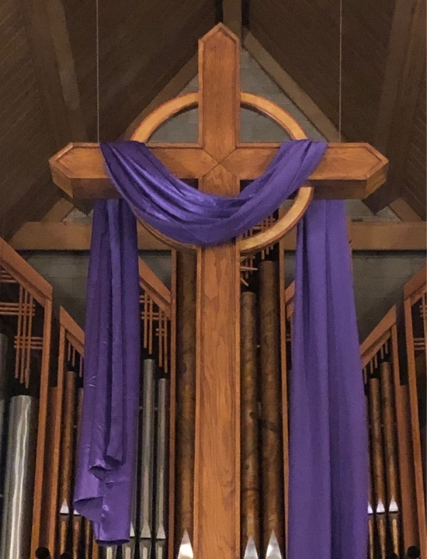

This Sunday, March 29, 2020, we will continue worshiping physically apart while being spiritually together. I once again urge all of us to keep our Sunday morning sacred, intentional, and focused by participating in worship from home at 10:30 AM. I invite you to make use of the pdf packet which includes a worship bulletin, a hymn, a copy of the sermon manuscript, and materials for our young disciples (no age limit required!). A recorded service will be accessible at https://fpchighland.org/sermons, which will follow the provided bulletin. I encourage you to view this recording and participate along with it if at all possible. I also invite you to follow this link to get an idea of how the hymn goes: https://www.youtube.com/watch?v=HMart4wXsI0.
It was a blessing to know that we were all worshiping together last Sunday. In these times, it is vital to maintain connection however we can. Continuing the living ritual of worship with the same words at the same time is a great way for us to connect to each other and God.

Thank you for your continued grace as we keep navigating these unknown waters!
Remember the words of our God through the prophet Isaiah: “Do not fear, for I am with you, do not be afraid, for I am your God; I will strengthen you, I will help you, I will uphold you” (Isaiah 41:10).
In Jesus Christ, the Resurrection and Life,
Rev. Tyler Orem

