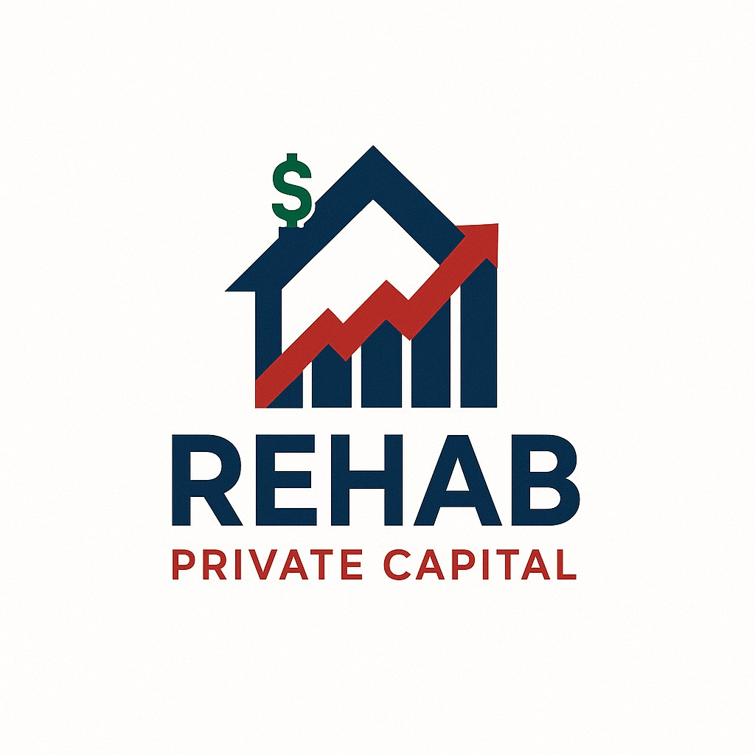

TIER A PROGRAM | TIER B PROGRAM | TIER C PROGRAM | PREMIUM JV PROGRAM
90% Purchase Price | 90% Purchase Price | 90% Purchase Price | 100% Purchase Price
100% Rehab Cost | 100% Rehab Cost | 90% Rehab Cost | 100% Rehab Cost
75% ARV | 70% ARV | 65% ARV | 70% ARV
720+ Credit Score | 660–719 Credit | Any Credit Qualifies | Any Credit Qualifies
2 Deals in Past 2 Years | 2 Deals in Past 2 Years | No Experience Necessary | No Experience Necessary (But Preferred)
No Tax Returns Required | No Tax Returns Required | Tax Returns Required | 100% of Closing Costs
Loan Amounts $30K–$2M | Loan Amounts $30K–$2M | Loan Amounts $30K–$2M | Loan Amounts $30K–$2M
 |  |  | Up to 4 Deals at a Time
 |  |  | Profit Split After Completion (75/25) 75 to Investor

