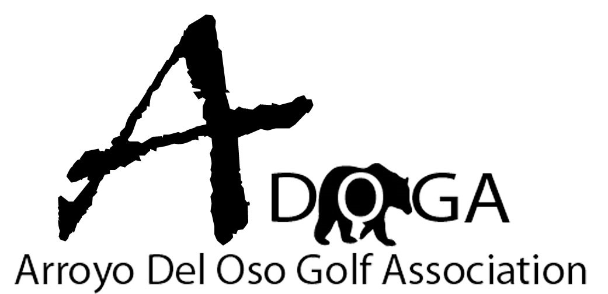

**Tournament Policies**

# General Rules

USGA Rules of Golf shall govern all tournament play.

In order to be eligible to use a USGA handicap in ADOGA tournaments, participants must have an active GHIN and a minimum of 5 scores posted within the past 12 months.

For two-man tournaments, no more than 10 strokes between partners, over 10 strokes, the higher handicap will be adjusted to lower handicap plus 10 strokes.

The Board of Directors is responsible for the set-up of the golf course prior to tournament play. The Tournament Chairman or his designee is responsible for the set-up of the tournament including printing rules sheets and scorecards.

The Deadline for entry into ADOGA tournaments will be 4:00 pm on the Friday the prior week before the event. The deadline for withdrawal from an event to receive a refund will be 5:00 pm the Wednesday before the event.

The ADOGA Rules Committee has the final decision on all rules questions and infractions that occur during tournament play.

The ADOGA Rules Committee has the power, prior to the next scheduled tournament, to rescind any prize money awarded to a participant(s) who knowingly violated a rule or unknowingly violated a rule and did not inquire with the rules committee for a correct ruling. All score discrepancies must be finalized prior to signature of all players on the card. If card is signed by all parties, then the score is final.

All prize money will be awarded in the form of gift certificates to Golf Mart. Gift cards do not expire.

In the event of a player’s disqualification or withdrawal during a tournament, they immediately become ineligible to receive any prizes including closest to the pin awards and skins.

# Local Rules

The Board of Directors has the power to enact local rules to govern tournament play if by a majority vote of the Board, if it is deemed necessary for the betterment of the competition.

**Slow Play Policy**

The Board has determined the need for a policy. 5 + hour rounds must stop! We are losing members due to the length of tournaments.

Please remember the lost ball rules. 3 minutes max. Do not return to tee box. E5 rule is in effect.

We need everyone to focus on this.

***Golf Course Marshalls will assist in enforcing pace of play for our tournaments. Should an altercation occur with a Marshall, said player will be disqualified from the tournament and could be band from future tournaments depending on the severity of the altercation.***

The new rule is:

Turn in your scorecard no later than 20 minutes behind the group in front of you.

Example: players on hole 18 turn in scorecard at 1:02 PM. Group on 17 must turn in scorecards by 1:21 PM. No penalty. Players on hole 16 turn in scorecards at 1:42. Penalty.

Penalties are as follows: 21-25 minutes behind, 1 stroke added to score.

26-31 minutes behind, 2 strokes added to score

32-37 minutes behind, 3 strokes added to score

38+ minutes behind, DQ

If it is a team tournament same rules, penalty added to team score. Should circumstances arise that are out of a player’s control a penalty may be waived. It is up to the players in the group to share their reason with board members upon turning in their card. If you don’t then the penalty will stand

# Payouts

The Association shall pay out at least 30% of the field’s participants.

Except for the Member-Guest tournament, 100% of all tournament entry fees shall be paid out as gift certificates to the winning participants.

The ADOGA will offer one gross winner and enough Net prizes to ensure this.

***For individual tournaments, all flights will have a Gross winner and a Net winner, along with subsequent prizes to ensure 30% of each flight is paid.***

For an example, 10 players are in a flight. $30 dollar entry fee from 10 players = $ 300 dollars.

A gross winner in the flight will be declared. The person who wins this is only eligible for this prize.

A net winner in the flight will be declared. The person who wins this is only eligible for this prize.

A 2nd net winner will be declared.

A 3rd net winner will be declared.

Prize payouts would be as follows. 32% of total goes to Gross and Net winner. $ 96.00

22% of total goes to 2nd net. $66.00

14% of total goes to 3rd net. $52.00

Once the flight grows to 13 entrants a 4th low net position will be added.

Payouts will be low gross and low net at 29%, 2nd low net at 18%, 3rd low net 14%, 4th low net at 10%.

***For partner tournaments, there will be no low gross component. Payouts would be:***

8-11 teams in a flight, 3 positions paid. Winning team 50% of purse, 2nd 30% of purse, 3rd 20% of purse.

12-13 teams in a flight. 4 positions paid. Winning team 40%, 2nd 30%, 3rd 20%, 4th 10%

14-16 teams in a flight. 5 positions will be paid. 35%, 25%, 18%, 14% and 8%.

# Exceptional Score Policy

All net scores will be posted; scores will not be adjusted. Rule 5.9 from the rules of handicapping will be used. This is done through the system. No input from the association.

* A reduction can be applied based on a single *exceptional score.*
* Reductions for multiple *exceptional scores* are applied cumulatively.
* A reduction is automatically applied within the calculation of a player’s updated *Handicap Index* following the submission of an *exceptional score.*
* A reduction for an *exceptional score* is applied by adjusting each of the most recent 20 *Score differentials* recorded in the player’s *scoring record*, which includes the *exceptional score*. As a result, the impact of the reduction will remain after the next score is submitted but will dilute over time as new scores are submitted.

Where there are fewer than 20 *Score differentials* in a player’s *scoring record* at the time an *exceptional score* is submitted, the reduction is applied by adjusting all of the *Score Differentials* recorded in the player's *scoring record*, which includes the *exceptional score*.

* Additional *handicap review* notifications will be generated for the *Handicap Committee’s* consideration, when:
  + Multiple *exceptional score*reductions are applied to a player’s *Handicap Index.*
  + A *Score Differential* is 10.0 strokes or more below a player’s *Handicap Index* in effect when that round was played and an *exceptional score*reduction of  
    -2.0 is triggered.
* The *Handicap Committee*is permitted to override any adjustment for an *exceptional score* if it considers that the adjustment would result in a player’s *Handicap Index* not being a fair reflection of their demonstrated ability (see Rule [7.1a Conducting a Handicap Review and Adjusting a Handicap Index](https://www.usga.org/content/usga/home-page/handicapping/roh/Content/rules/7%201%20Handicap%20Committee.htm#7.1a)).

You can look online for a complete explanation of the rule.

# Tie Breaking

To break all ties, a comparison of scores starting with the hardest handicap hole and working the way down, hole #3, hole #14, hole #2, hole #17, hole #5, hole #13 hole #8, hole #18, hole #1, hole #15, hole #9, hole #11, hole #4, hole #12, hole #7, hole #10, hole #6 and hole #16. Net scores used on net flights/gross scores used on gross winner in a flight.

The tie break winner will be the first player to win a hole outright.

# ADOGA Major Championships

ADOGA will have 11 annual Tournaments of which one (1) will be the Member/Guest and two (2) will be two-day “Major Championships”.

The two major championships will be the Club Championship (Gross and Net) and the Best Ball Championship.

The Club Championship will crown both a gross and a net champion. The Gross Champion will be the player with the lowest gross score over two days of competition.

The annual Net Champion will be determined during the President’s Cup Two-Day Individual Tournament.

In the event there are not enough participants to fill a “gross only” flight in a Gross Championship

(Club Championship), the Champion Flight will play Net.

The Player/Team with the lowest gross total will still be crowned Gross Champion and the Tournament Committee will ensure their payout is equal to the Net Champion in that flight.

The Gross Champion can only receive one payout, either the Gross Champion or regular flight net payout, not both.