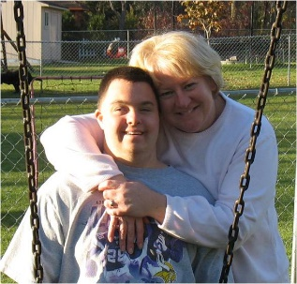MY CONTACT INFO
Name: Nancy Wagner
Street, City, State, Zip:
Phone/Email:

ABOUT ME
My son Matt was born with Down Syndrome in 1985. At his birth I was told that I had a mongoloid baby. The nurse suggested we find a place to send him to avoid the heart-ache of raising him. After an extended stay at Minneapolis Children’s Hospital we brought Matt home. He is the joy of our life! He would not be the remarkable young man he is today without the support we received from the talented teachers, therapist, respite care workers and direct support professionals. Matt now lives in an apartment in Eden Prairie with support staff available 24/7. This gives Matt the freedom to live, work, and participate in the activities of the community.

ISSUE
When Matt was 6 weeks old he started school at Fraser. We always knew that our role as parents was to provide the education and support he would need to find a job, live on his own and be a contributing member of society. One thing we learned along the way is how important it is to have consistent, capable staff. Today Matt’s basic safety and wellbeing is in jeopardy due to the lack of Direct Support Professionals (DSP). Our Service Providers are unable to hire and retain qualified DSP’s. Therefore, Matt does not have the supervision, support or transportation to live his life in a meaningful way.

IMPACT
Every time there is staff turnover whether it’s at Matt’s day program at Opportunity Partners or his independent living staff from Hammer Residence, Matt’s behavior and overall health and well-being is negatively impacted. He will cry, become depressed and gain weight. He will push his boundaries with the new staff. Matt can become violent and difficult to work with. His productivity at work goes down. When you rely on someone for all your basic needs and that person is constantly leaving it causes stress, anxiety and constant worry. That is not the kind of daily life I want for my child.

ASK
I am asking you to support the Best Life Alliance. This is a career choice and Direct Support Professionals should be paid a salary accordingly. The work DSP’s do is vital to Matt’s safety, health and welfare.

Thank you for your support of the Best Life Alliance
-Nancy, Bill and Matt Wagner

