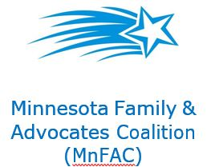 Advocacy – It Works!

You are an expert when it comes to your loved one.
- You don’t need to be an expert in the topic
- The legislators work for YOU
- Legislators WANT to hear from you
It is important to continually be educating yourself and the community, but you don’t need to know everything to advocate.
- It’s common to feel afraid or apprehensive
- It’s not unusual to feel overwhelmed by the material
- It’s “ok” to not know everything and all the details
- Working in pairs or a small group is fine
- See MNFAC “Ways to Get Connected” handout
- Refer to MNFAC Facebook page for the latest information
Advocating
Effective Means of Communication
- Email
- Letter
- Phone call to the Assistant
- Meeting
Basic considerations & understanding
- Non-adversarial – the tone should be educating
- Use an engaging picture of your loved one to personalize your story
- Your story should be short (1page), personal, and include an action for the legislative person
  - 7 Things Your Letter Should Include:
    - A picture
    - Your name and complete address with zip code
    - A little bit about who you and your child are
    - What the issue or problem is
    - Why it’s a problem. What happens
    - The ask. What do you want them to do
    - Thank them
Follow-up
- Always send a personal thank you by email or preferably a handwritten message. Include your address with zip code and email on all correspondence.

