*Christopher Counts The Constellations*:

A Synthesis of Stories & Stars:

An Arts-Infused, Multi-Disciplinary Unit

Grade 3

During the summer of 2020, a time of masks and social distancing, I directed the six-week summer reading program for soon-to-be third and fourth grade students, at Erie’s MLK Memorial Center. Every Tuesday and Thursday morning, we gathered on the stage, a haven for distractions. Stacked behind the rear black curtain (its own temptation) were partially opened storage cabinets and patched gymnastic mats. Lining the wall opposite of the back stage door was a floor-to-ceiling length mirror, protected by a two-barred railing. Noise filtered up from the gymnasium floor and through the heavy vinyl curtains that never quite fully shut.

Looming larger than the challenge of “catching students up” from a two-and-a-half month academic pandemic hiatus was my accepting the *nature* of the environment and figuring out how to *nurture* it into something other than an echo chamber of negative directives. That, alone, challenged me to attend to something bigger than reading and more immediate — *the art of focusing,* “a vital force bringing out the best in ourselves and others” (Christina Bengtsson. TedxGöteborg: February 9,2017). Ironically, little time is spent on teaching this vital force, a skill essential to learning. Games like “Memory” or “I Spy” are reserved for birthday parties or road trips; rarely are they played during science class, where focusing on details and making observations are key. Without being able to concentrate, children cannot focus; without being able to focus, they cannot distinguish between distractions and what’s “at stake,” that is, the hand slipping between the heavy vinyl curtain or the story book being held in someone’s hand.

That is why I began each lesson, outlined below, with Anne Green Gilbert’s Brain Dance®. Brain Dance® is a sequential exercise that mimics the eight movement patterns babies develop during their first year. These movement patterns “wire the central nervous system laying a foundation for appropriate behavior and attention, eye convergence necessary for reading, sensory-motor development and more” (Gilbert, Anne Green. *Brain-Compatible Dance Education*. Champaign, Illinois: Human Kinetics, Inc., 2019.) “Exercise,” according to Harvard psychiatrist and author Dr. John Ratey, “provides an unparalleled stimulus, creating an environment in which the brain is ready, willing, and able to learn” (*SPARK: The Revolutionary Science of Exercise and the Brain*). And, “the best exercise,” Ratey told Andrew Merle in June 2019, “is dance” (<https://qz.com/quartzy/1646275/the-best-types-of-exercise-for-brain-health>).

Finally, because each session ran for two hours, the fourteen multi-disciplinary lessons comprising “*Christopher Counts The Constellations*: A Synthesis of Stories & Stars” could easily become twenty-one, thus lasting for one school quarter. Not only was the time atypical of a classroom schedule, but, so too, the space. The stage gave us plenty of room to move without having to rearrange desks, something I was constantly doing while teaching in schools.

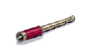**LESSON 1**

**Goals:**

1. Students will gain an awareness of the rhythmic nature of words.

2. Students will develop their listening skills.

3. Students will gain a deeper understanding of the elements involved in story making.

4. Students will develop an appreciation for their names and the names of others.

**Objectives:**

1. Students will be able to identify the number of syllables in spoken words.

2. Students will be able to repeat rhythmic phrases they hear.

3. Students will be able to classify stories as fiction.

4. Students will be able to differentiate between the author and illustrator.

5. Students will be able to predict events in a story by describing the illustrations. 6. Students will be able to interpret meaning through story illustrations.

7. Students will be able to discuss the significance of names.

8. Students will be able to construct an original “name” design.

**Common CORE Standards (<https://www.pdesas.org4>)**

* *1.1 Foundational Skills*

Students gain a working knowledge of concepts of print, alphabetic principle, and other basic conventions.

* CC.1.1.3.D

Know and apply grade-level phonics and word analysis skills in decoding words.

* CC.1.1.3.E

Read with accuracy and fluency to support comprehension.

* *1.3 Reading Literature*

Students read and respond to works of literature—with emphasis on comprehension, vocabulary acquisition, and making connections among ideas and between texts with focus on textual evidence.

* CC.1.3.3.B

Ask and answer questions about the text and make inferences from text, referring to text to support responses.

* CC.1.3.3.D

Explain the point of view of the author.

* CC.1.3.3.E

Refer to parts of texts when writing or speaking about a text using such terms as chapter, scene, and stanza and describe how each successive part builds upon earlier sections.

* CC.1.3.3.G

Explain how specific aspects of a text’s illustrations contribute to what is conveyed by the words in a story (e.g., create mood, emphasize aspects of a character or setting).

* CC.1.3.3.I

Determine or clarify the meaning of unknown and multiple-meaning words and phrases based on grade-level reading and content, choosing flexibly from a range of strategies and tools.

* CC.1.3.3.J

Acquire and use accurately grade-appropriate conversational, general academic, and domain-specific words and phrases, including those that signal spatial and temporal relationships.

* CC.1.3.3.K

Read and comprehend literary fiction on grade level, reading independently and proficiently.

* *1.4 Writing*

Students write for different purposes and audiences. Students write clear and focused text to convey a well-defined perspective and appropriate content.

* CC.1.4.3.A

Write informative/explanatory texts to examine a topic and convey ideas and information clearly.

* CC.1.4.3.E

Choose words and phrases for effect.

* CC.1.4.3.L

Demonstrate a grade-appropriate command of the conventions of standard English grammar, usage, capitalization, punctuation, and spelling.

* CC.1.4.3.W

Recall information from experiences or gather information from print and digital sources; take brief notes on sources and sort evidence into provided categories.

* *1.5 Speaking & Listening*

Students present appropriately in formal speaking situations, listen critically, and respond intelligently as individuals or in group discussions.

* CC.1.5.3.A

Engage effectively in a range of collaborative discussions on grade-level topics and texts, building on others’ ideas and expressing their own clearly.

* CC.1.5.3.C

Ask and answer questions about information from a speaker, offering appropriate detail.

* CC.1.5.3.E

Speak in complete sentences when appropriate to task and situation in order to provide requested detail or clarification.

* CC.1.5.3.G

Demonstrate command of the conventions of standard English when speaking, based on Grade 3 level and content.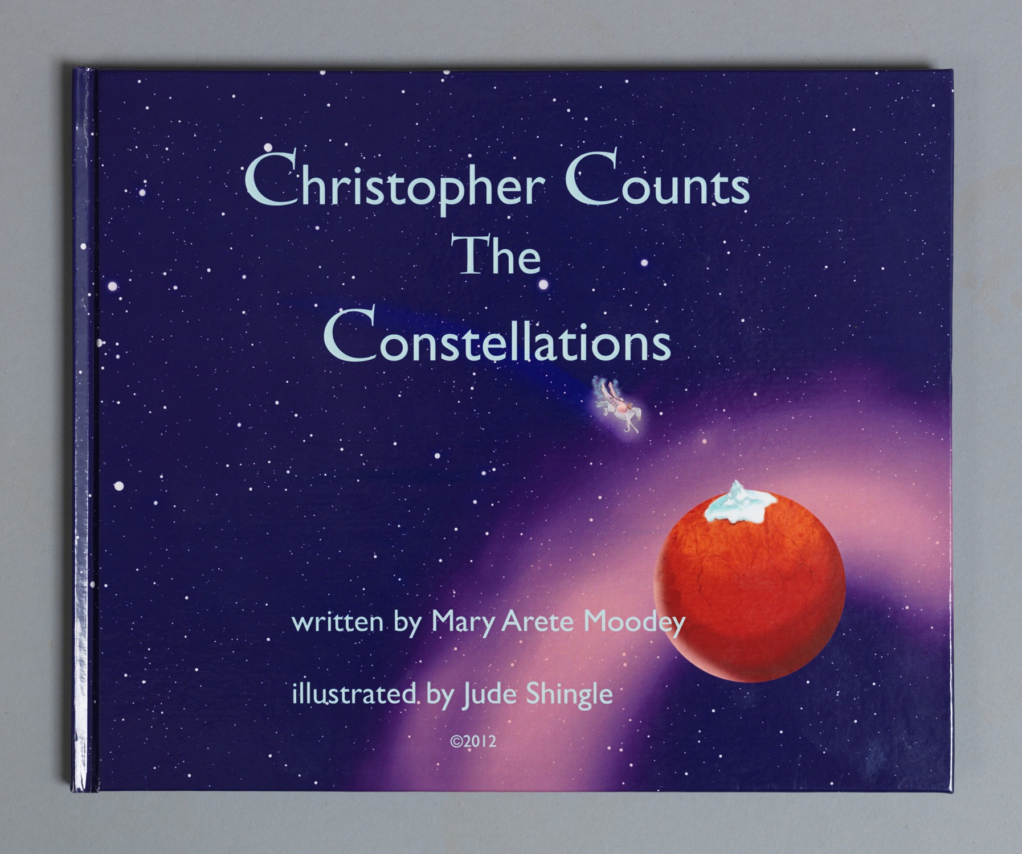

**Materials:**

ample space to move

*Christopher Counts The Constellations*

journals and/or lined paper

pencils/pens

blank white paper

construction paper

scissors

glue

colored pencils, crayons, and/or markers

Author’s Chair

**Measurement Assessments** (Formative):

Students clapping the correct number of syllables

Students participating in discussions

Students basing responses on evidence, both from the story and classmates’ work

Students completing name-art project

**Lesson 1 (cont.)**

**Procedure**

I. Opening Circle: Students gather in a circle, each students being an arm’s length apart.

A. Introduction

1. Have the students say and repeat their names.

2. Define/review syllable

3. Identify number of syllables in each students’ name

4. Clap the syllables in each name

*As this exercise involves the students’ repeating the pattern that has come before, it involves listening, paying attention to detail, and building upon a sequential structure*.

II. Language Arts/Reading

A. Introduce *Christopher Counts The Constellations*

1. Show book cover

2. Define author & show the author’s name

3. Define illustrator & show the illustrator’s name

4. Distinguish between fiction (story) and non-fiction

5. Explain that, in fiction, the narrator is the “character” telling the story can either be inside the story (1st person point-of-view) or outside (third-person).

B. Read aloud story

C. Recall story

1. Discuss the illustrations

Ask the students to reflect on which illustration is their favorite and why.

2. Compare the first illustration to the last

3. Explain how the first illustration “points to events” in the story

D. Define plot: Explain that the events in the story make up the plot.

E. Identify the rider and his name.

F. Make observations about his name and the beginning of each page.

G. Define acrostic*

IV. Language Arts/Writing/Art

A. In a journal, describe what makes your name special to you

1. What do you like about it (sound, letters, meaning)?

2. Is there anyone in your family who has the same name? If so, who?

3. Do you know others with the same name? If so, who?

B. Explain that they are the narrators of their own writing, which, in this can, will be in the first-person point-of-view.

C. Read aloud written responses

D. Design “name creatures”

1. Fold blank white paper in half lengthwise (hotdog bun style)

2. Draw the letters in your name in a chunky style, making sure the top of each letter touches the fold in the paper.

3. Make sure all the letters are connected.

4. Cut out the letters, making sure not to slice the tops at the folds.

5. Open up the paper when complete.

6. Mount on construction paper.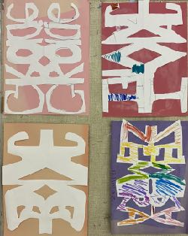

*Acrostics, as an early poetic art form, will be developed later in the unit. Acrostics written by Lewis Carroll and Edgar Allan Poe are included in the Appendix.

**LESSON 2**

**Goals:**

1. Students will become more aware of their personal space and the physical space around them.

2. Students will work cooperatively.

3. Students will appreciate ancient culture.

3. Students will gain confidence in reading aloud.

4. Students will think creatively.

**Objectives:**

1. Students will be able to identify the stressed syllables in spoken words.

2. Students will be able to repeat rhythmic phrases they hear.

3. Students will be able to name the three different space levels.

4. Students will be able to recite sections of the story aloud.

5. Students will be able to define myth and identify characteristics of the genre.

6. Students will be able to compare iconic representations of mythical figures to details in *CCTC* illustrations.

7. Students will be able to reconstruct and embellish an event in their life through writing.

8. Students will be able to speak clearly when presenting their original work.

9. Students will respond to their peers’ writing by referencing details from the work.

**Common CORE Standards**

* *1.1 Foundational Skills*
* CC.1.1.3.E

Read with accuracy and fluency to support comprehension.

* *1.3 Reading Literature*
* CC.1.3.3.A

Determine the central message, lesson, or moral in literary text; explain how it is conveyed in text.

* CC.1.3.3.C

Describe characters in a story and explain how their actions contribute to the sequence of events.

* CC.1.3.3.E

Refer to parts of texts when writing or speaking about a text using such terms as chapter, scene, and stanza and describe how each successive part builds upon earlier sections.

* CC.1.3.3.J

Acquire and use accurately grade-appropriate conversational, general academic, and domain-specific words and phrases, including those that signal spatial and temporal relationships.

* CC.1.3.3.K

Read and comprehend literary fiction on grade level, reading independently and proficiently.

* *1.4 Writing*
* CC.1.4.3.M

Write narratives to develop real or imagined experiences or events.

* CC.1.4.3.N

Establish a situation and introduce a narrator and/or characters.

* CC.1.4.3.P

Organize an event sequence that unfolds naturally, using temporal words and phrases to signal event order; provide a sense of closure.

* CC.1.4.3.Q

Choose words and phrases for effect.

* CC.1.4.3.R

Demonstrate a grade-appropriate command of the conventions of standard English grammar, usage, capitalization, punctuation, and spelling.

* CC.1.4.3.W

Recall information from experiences or gather information from print and digital sources; take brief notes on sources and sort evidence into provided categories.

* CC.1.4.3.X

Write routinely over extended time frames (time for research, reflection, and revision) and shorter time frames (a single sitting or a day or two) for a range of discipline-specific tasks, purposes, and audiences.

* *1.5 Speaking and Listening*
* CC.1.5.3.C

Ask and answer questions about information from a speaker, offering appropriate detail.

* CC.1.5.3.D

Report on a topic or text, tell a story, or recount an experience with appropriate facts and relevant, descriptive details; speak clearly with adequate volume, appropriate pacing, and clear pronunciation.

* *7.1 Basic Geography Literacy*
* Standard - 7.1.3.A

Identify how basic geographic tools are used to organize and interpret information about people, places and environment.

* Standard - 7.1.3.B

Identify and locate places and regions as defined by physical and human features.

**Materials:**

ample space to move

*Christopher Counts The Constellations*

*The Treasury of Greek Mythology* (Napoli, Donna Jo. Washington D.C.: National Geographic) or *D’Aulaires’ Book of Greek Myths* (D’Aulaire, Ingri and Edgar Parin)

journals and/or lined paper

pencils/pens

markers, crayons, and/or colored pencils

Author’s Chair

**Measurement Assessment** (Formative):

Students clapping correct number of syllables

Students demonstrating the difference between stressed and unstressed syllables

Students creating movement phrases that show different space levels and correct number of syllables

Students reading story aloud

Students drafting a story/anecdote

Students responding to classmates’ work by referring to specifics from the texts

**Lesson 2 (cont.)**

**Procedure**

I. Opening Circle

A. Recall syllable

B. Clap (and repeat) the syllables in everyone’s name.

C. Introduce stressed syllables

D. Clap the syllables in *Christopher counts*

E. Identify the stressed syllables

Have students stomp their feet on the stressed syllables.

II. Stand, but remain in Opening Circle

A. Introduce space levels:

High, Medium, Low

B. Have students change their space level with each syllable clap of *Christopher counts;* then, *Christopher counts the constellations*.

C. Have students work with a partner to create a movement phrase that: 1) uses all three space levels, and 2) combines both partners’ names, e.g., *Mary Marissa, James Keith, Zemira X’zeria.*

III. Language Arts/Reading/Social Studies

A. Recall *Christopher Counts The Constellations*

1.When does Christopher travel?

2. Where does Christopher go?

3. How does he travel and who is his traveling companion?

B. Ask for student volunteers to read/recite the story aloud with you.

(*Because the story is built upon repetition, anyone can join in as the story is being read*.)

C. Describe Christopher’s traveling companion

1. Does he look familiar or remind you of another story? Explain

2. From the illustrations, describe his special features.

D. Show a map of Ancient Greece

1. Introduce Pegasus from Greek mythology

2. Define myth as a type of story (fiction) that involves “superheroes”/gods and/or characters with supernatural powers and do not have a known author. Myths tell about a culture, the beliefs a group of people share, and were often told to explain how things came to be. The Greeks, for example, believed the world was run by different gods and the different gods looked over certain regions and/or had specific responsibilities.

3. Explain how Pegasus “came to life”: when Perseus beheaded Medusa to save Andromeda, the princess, Pegasus sprung from her (Medusa’s) blood.

4. Show the illustrations which have Perseus and ask what he is holding.

5. Explain that Perseus is holding Medusa’s head and her “hair” is a tangle of snakes.

IV. Language Arts/Writing

Write about a time you traveled* somewhere. Where did you go? When? How did you get there? With whom did you travel? What was the place like? (What did you see? How was it like/different from where you live? What did you do?) Be as descriptive as you can be.

V. Group Share on the Author’s Chair

Have students read aloud their writing.

Ask students to respond to their peers’s writing.

* Traveling somewhere could be anywhere: a friend or relative’s house, neighborhood park, school field trip.

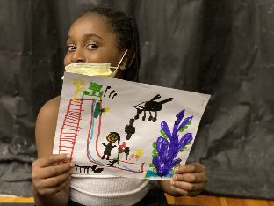

(Picture Caption: Before writing his story, James drew about the time he went to Waldameer, an amusement park.)

**LESSON 3**

**Goals:**

1. Students will learn dance vocabulary and qualities of movement.

2. Students will appreciate the commonalities between movement and language.

3. Students will learn about an early poetic form.

4. Students will discover the importance of dictionaries.

5. Students will play with language.

**Objectives:**

1. Students will demonstrate the qualities of movement when moving across the space.

2. Students will compare the qualities of movement to the rhythm of words and word phrases.

3. Students will identify the letters that compose the *Christopher* acrostic and “Acrostic” by Lewis Carroll.

4. Students will define the acrostic poetic form.

5. Students will recite passages from *Christopher Counts The Constellations* fluently.

6. Students will identify the words in the different acrostics.

7. Students will generate a list of new vocabulary words that begin with the letters in their names.

8. Students will incorporate new vocabulary words into their writing.

9. Students will respond to their peers’ writing by referencing details from the work.

**Common CORE Standards**

* *Arts and Humanities*
* Standard - 9.1.3.B

Recognize, know, use and demonstrate a variety of appropriate arts elements and principles to produce, review and revise original works in the arts.

* Standard - 9.1.3.C

Recognize and use fundamental vocabulary within each of the arts forms.

* *1.1 Foundational Skills*
* CC.1.1.3.D

Know and apply grade-level phonics and word analysis skills in decoding words.

* CC.1.1.3.E

Read with accuracy and fluency to support comprehension.

* CC.1.3.3.F

Determine the meaning of words and phrases as they are used in grade-level text, distinguishing literal from nonliteral meaning as well as shades of meaning among related words

* *1.3 Reading Literature*
* CC.1.3.3.A

Determine the central message, lesson, or moral in literary text; explain how it is conveyed in text.

* CC.1.3.3.B

Ask and answer questions about the text and make inferences from text, referring to text to support responses.

* CC.1.3.3.C

Describe characters in a story and explain how their actions contribute to the sequence of events

* CC.1.3.3.I

Determine or clarify the meaning of unknown and multiple-meaning words and phrases based on grade-level reading and content, choosing flexibly from a range of strategies and tools.

* CC.1.3.3.J

Acquire and use accurately grade-appropriate conversational, general academic, and domain-specific words and phrases, including those that signal spatial and temporal relationships.

* *Language* (<https://www.education.com/common-core/third-grade>)
* L.3.4.D

Use glossaries or beginning dictionaries, both print and digital, to determine or clarify the precise meaning of key words and phrases.

* L.3.5.A

Distinguish the literal and nonliteral meanings of words and phrases in context (e.g., take steps).

**Materials:**

ample space to move

*Christopher Counts The Constellations*

copies of acrostics by Lewis Carroll and Edgar Allan Poe (see Appendix)

children’s dictionaries

journals and/or lined paper

pens and/or pencils

Author’s Chair

**Measurement Assessment** (Formative):

Students moving in rhythm to the words spoken

Students reading story aloud

Students participating in discussions

Students classifying words according to “energies” or “qualities of movement”

Students demonstrating how to use a dictionary

Students writing sentences with newly discovered words

**Lesson 3 (cont.)**

**Procedure**

I. Opening Circle

A. Warm-up with Syllable-Clap Name Game

B. Demonstrate the three space levels

C. Introduce Word/Movement Energies (qualities of movement):

1. *Bouncing & Swinging*: the up and down movement that comes from galloping, skipping, leaping

Words/Word Phrases: *Christopher*, *constellations*, *Christopher counts the constellations*.

2. *Sustained*: an even, continuous flow seen in running, flying, lunging

Words/Word Phrases: *sky* (the long vowel sound lengthens the sound of the word); *winging among*, *wielding a sword*

3. *Vibrating*: a continuously fast movement like chattering teeth

Words: *chilling*, *sparkling*, *twittering*

4. *Percussive*: one short, sharp sudden movement

Words: *counts*, *spark*, *stomp* (many onomatopoetic words)

5. *Active Stillness*: still but ready to move (like a rest between notes)

D. While you speak and clap the rhythm of word phrases from the story, have students move across the room in the different space levels .

II. Language Arts/Reading

A. Read/recite *Christopher Counts The Constellations*

B. Recall acrostic (1st lesson)

C. Ask students if they have ever heard of (or seen) *Alice in Wonderland*

D. Explain that Lewis Carroll, the author, wrote many poems, several of which were acrostics.

E. Read aloud the acrostics by Lewis Carroll and Edgar Allan Poe F. Identify the first letters of each line

III. Language Arts/Writing

A. Explain what a dictionary is and how to use it.

B. Have students generate a list of words that begin with the first letter of their name. C. Compose a sentence where each word begins with the same letter (the sillier, the better).

D. Identify the overall word/movement energy in the sentence.

*Zany Zemira zigzags with zebras*. (Bouncing and Swinging)

*Jolly James juggles jellybeans*. (Bouncing and Swinging)

*Kind Keith kept Kayla’s keys*. (Sustained)

*X’zeria exclaims, “X marks the spot!”* (Percussive)

*Vivian’s very vibrant vest glitters in the shimmering sunlight*. (Vibrating)

E. Include other descriptive words, using the letters in your name, e.g.: energetic, magical, interesting, rambunctious, agile

III. Group Share from the Author’s Chair:

Have students read aloud their sentences while others move to them.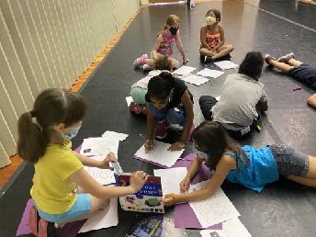

*Using a chart, like the one below, helps students listen to the sound of words and classify them according to energy (or rhythm).*

| Bouncing & Swinging | Sustained | Percussive | Vibrating |
| --- | --- | --- | --- |
| chilling the rider sitting | I | sit/stand | chilling |
| constellations | winging | caps |  |
| winging among the constellations | among | atop |  |
|  | sky |  |  |

**LESSON 4**

**Goals:**

1. Students will learn the four basic movement elements.

2. Students will listen to and feel the movement energy conveyed through music.

3. Students will deepen their understanding of how character traits are developed. 4. Students will learn grammar from reading literature.

5. Students will take risks in creating word-movement phrases.

**Objectives:**

1. Students will apply dance vocabulary to their movement patterns.

2. Students will repeat the eight developmental movements in the Brain Dance® sequence.

3. Students will define plot and summarize the events in *Christopher Counts The Constellations*.

4. Students will describe the characters Christopher and his traveling companion, using the story’s illustrations as a point of reference.

5. Students will define and identify parts of speech.

6. Students will classify elements within the story’s illustrations according to parts of speech.

7. Students will illustrate the “shape” of different nouns through movement.

8. Students will define verbs as being the main part of the predicate.

9. Students will distinguish between the subject and predicate in sentences.

10. Students will analyze their own sentences from previous writing activities.

**Common CORE Standards**

* *Arts and Humanities*
* Standard - 9.1.3.B

Recognize, know, use and demonstrate a variety of appropriate arts elements and principles to produce, review and revise original works in the arts.

* Standard - 9.1.3.C

Recognize and use fundamental vocabulary within each of the arts forms.

* *1.1 Foundational Skills*
* CC.1.1.3.D

Know and apply grade-level phonics and word analysis skills in decoding words.

* CC.1.1.3.E

Read with accuracy and fluency to support comprehension.

* *1.3 Reading Literature*
* CC.1.3.3.C

Describe characters in a story and explain how their actions contribute to the sequence of events.

* CC.1.3.3.G

Explain how specific aspects of a text’s illustrations contribute to what is conveyed by the words in a story (e.g., create mood, emphasize aspects of a character or setting).

* CC.1.3.3.E

Refer to parts of texts when writing or speaking about a text using such terms as chapter, scene, and stanza and describe how each successive part builds upon earlier sections.

* CC.1.3.PK.G (Grade 5)

Describe pictures in books using details.

* *1.4 Writing*
* CC.1.4.3.E

Choose words and phrases for effect.

* CC.1.4.3.T

With guidance and support from peers and adults, develop and strengthen writing as needed by planning, revising, and editing.

* CC.1.4.3.X

Write routinely over extended time frames (time for research, reflection, and revision) and shorter time frames (a single sitting or a day or two) for a range of discipline-specific tasks, purposes, and audiences.

* *1.5 Speaking and Listening*
* CC.1.5.3.A

Engage effectively in a range of collaborative discussions on grade-level topics and texts, building on others’ ideas and expressing their own clearly.

* CC.1.5.3.C

Ask and answer questions about information from a speaker, offering appropriate detail.

* CC.1.5.3.E

Speak in complete sentences when appropriate to task and situation in order to provide requested detail or clarification.

* *Language* (<https://www.education.com/common-core/third-grade>)
* L.3.1.A

Demonstrate command of the conventions of standard English grammar and usage when writing or speaking.

* L.3.1.E

Form and use the simple (e.g., I walked; I walk; I will walk) verb tenses.

* L.3.5.A

Distinguish the literal and nonliteral meanings of words and phrases in context (e.g., take steps).

* L.3.5.C

Identify real-life connections between words and their use (e.g., describe people who are friendly or helpful).

**Materials:**

ample space to move

Gustav Holst’s *The Planets*

CD player (or device for playing music)

*Christopher Counts The Constellations*

journals and/or lined paper

pens and/or pencils

Author’s Chair

**Measurement Assessment** (Formative):

Students participating in the Brain Dance® sequence

Students demonstrating the different space levels

Students reading story aloud

Students correctly identifying nouns from story

Students correctly identifying the subject and predicate in their own sentences

Students reading their work aloud

**Lesson 4 (cont.)**

**Procedure**

I. Opening Circle

A. Recall and demonstrate space levels and word/movement energies.

B. Introduce four basic movement elements: *space*, *time*, *force*, and *flow*.*

*Space* can be as vast as the galaxy, as big as Christopher’s bedroom, or as personal as one’s self.

*Time* includes the speed (or tempo) in which we move through the space (Pegasus’s flying speed v. airplane v. car v. bicycle v. walking. And, *pulse* is how we move through the space (think of the different energies). Accents in the movements we create are like “stressed syllables.”

*Force* describes the energy we expend while moving: strong, bold steps v. even strides v. light tiptoes. The movement/word energies describe the *quality* of force.

*Flow* conveys the freedom or restraint we use when moving. Free: continuous (sustained) and fluid; restraint/bound: controlled and balanced.

C. Demonstrate the Brain Dance® sequence:

Breath

Tactile-Touch

Core-Distal

Head-Tail

Upper-Lower

Body Sides

Eye Tracking

Cross-Lateral

Vestibular

Breath

D. Lead the Brain Dance sequence to Gustav Holst’s “Mars,” 1st movement, *The Planets*. (This will not take the full seven minutes of the movement.)

II. Language Arts/Movement

A. Recall plot as one element of story

B. Read aloud/recite *Christopher Counts The Constellations*

C. Introduce character, the person in the story, as another story element

1. Describe Christopher: Use context clues from the illustrations to explain your answer.

2. Recall PegasusDescribe Christopher’s traveling companion, using the illustrations as a point of reference.

D. Review/Introduce parts of speech

1. Define noun as a person, place, thing, and/or idea.

2. Make observations about the first illustration in the story (“Every night before drifting . . .”).

3. Generate a list of the nouns found in the picture.

E. Return to the Opening Circle

1. Read aloud the nouns and have students create shapes in the different space levels for each one.

2. Read aloud the nouns again and, this time, have the students move as the noun, e.g.: The mother’s *shadow blocks* the light; *blocks fall* down; the *window opens*; *stars dot* the sky; the *telescope stretches* across the window ledge.

F. Return to seats

1. Define verb as the word that *describes an action* (the noun that moved)*,* *a state of being,* or *appearance* in the sentence. The verb forms the main part of the *predicate* in a sentence.

2. Recall the nouns from the above movement exercise. Refer to theses nouns as the *subject* in the sentence.

3. Explain that a sentence is divided into two parts: the subject and predicate.

4. Review the students’ sentences from Lesson 3.

5. Identify the subject and predicate (the main noun and verb) in each sentence.

III. Group Share from the Author’s Chair

Students reread their sentences and indicate which word refers to the subject and which word, the predicate.

**LESSON 5**

**Goals:**

1. Students will discover the rhythm embedded in language.

2. Students will appreciate the commonalities between movement, dance, and music.

3. Students will learn the nuances of language.

4. Students will learn a new poetic form.

5. Students will support each other in their work.

**Objectives:**

1. Students will name the four elements of movement.

2. Students will apply the qualities of movement to their own movements.

3. Students will demonstrate the eight developmental movements in the Brain Dance® sequence.

4. Students will analyze sentence construction in *Christopher Counts The Constellations*.

5. Students will differentiate between the root word and a suffix.

6. Students will identify words in the story that have multiple meanings.

7. Students will context clues from the story to define the words with multiple meanings.

8. Students will generate a list of character traits to be used for the diamanté poem.

9. Students will write a draft of an original diamanté poem.

10. Students will respond to the work of their peers by making observations about the original text.

**Common CORE Standards**

* *Arts and Humanities*
* Standard - 9.1.3.A

Know and use the elements and principles of each art form to create works in the arts and humanities.

* Standard - 9.1.3.C

Recognize and use fundamental vocabulary within each of the arts forms.

* *1.1 Reading, Foundational Skills*
* CC.1.1.3.E

Read with accuracy and fluency to support comprehension.

* *1.3 Reading Literature*
* CC.1.3.3.E

Refer to parts of texts when writing or speaking about a text using such terms as chapter, scene, and stanza and describe how each successive part builds upon earlier sections.

* CC.1.3.3.F

Determine the meaning of words and phrases as they are used in grade-level text, distinguishing literal from nonliteral meaning as well as shades of meaning among related words

* CC.1.3.3.I

Determine or clarify the meaning of unknown and multiple-meaning words and phrases based on grade-level reading and content, choosing flexibly from a range of strategies and tools.

* *Creative Writing, Strand: Writing* ([dese.ade.arkansas.gov](http://dese.ade.arkansas.gov))

*Content Standard 2: Students, using a range of styles, shall write poetry, personal narratives, and short fiction for a variety of purposes and audiences.*

* W.2.CW.1

Produce original poetry, personal narratives, and short fiction that demonstrate understanding of genres appropriate to audience, purpose, and context

(e.g., organization, style, voice, usage, tone, word choice, poetic devices, mechanics)

**Materials:**

ample space to move

Gustav Holst’s *The Planets*

CD player (or device for playing music)

*Christopher Counts The Constellations*

Diamante worksheet (see Appendix)

journals and/or lined paper

pens and/or pencils

Author’s Chair

**Measurement Assessment** (Formative):

Students repeating the Brain Dance® sequence in correct order

Students creating a chart that shows: the root word, the participial suffix, and definition

Students drafting an original diamanté poem

**Lesson 5 (cont.)**

**Procedure**

I. Opening Circle

A. Recall the four elements of movement and word/movement energies (qualities of movement).

B. Warm up with the Brain Dance sequence to Gustav Holst’s “Mars,” 1st movement, *The Planets*.

C. Recall verb

D. While reading verbs aloud, have the students create movements that show the verb’s action, e.g.: drift, sit, stomp, fly, spy, sleep.

E. Compare the “word energy” (or quality of movement) of the verb to the same verb with an “ing” ending: drifting, sitting, stomping, flying, spying, sleeping.

F. Have students move across the space while you read aloud verbs ending in “ing.”

G. Discuss the change in the movements they made and how the change felt.

II. Language Arts/Reading

A. Identify the subject (the “acting” noun in the sentence) and predicate (the main verb) in “Christopher counts the constellations.”

B. Locate the subject in “C stands for the constellations dusting the darkening sky” and “H stands for the horse winging among the constellations dusting the darkening sky.”

C. Distinguish between “stand,” as in rising to your feet and holding an upright position; “stand,” as in a viewpoint or position (takes a stand); and “stands for,” as in representing or referring to a thing: “C stands for constellations”; “H stands for horse.”

E. With a partner, choose a page from the story:

1. list the “ing” words;

2. identify the main verb;

3. determine the meaning of the main verb from the context of the other words; 4. give alternate definitions of the same word, e.g.: dust, wing, spot.

| Word | Main Verb (Root) | Word + “ing” (Participle) | Meanings |
| --- | --- | --- | --- |
| Dusting | Dust | Dust + ing | covered with sprinkles, to polish/wipe a surface |
| Winging | Wing | Wing + ing | flying, wing => an extension on a bird (like an arm) or plane |
| Spotting | Spot | Spot + ing | spying (looking at), spot => a blemish or stain or mark |

III. Language Arts/Writing

A. Review the list of words

B. Introduce the diamanté poem and hand out diamanté masters. (See Appendix)

C. On the board, generate a list of words that describe what Christopher and the horse (Pegasus) are like and what they do.

C. As a group, compose a diamanté, comparing Christopher (boy/rider) to Pegasus (horse/what is being ridden).

Christopher

curious brave

looking counting riding

boy explorer horse wings

snorting flapping flying

fast white

Pegasus

— Summer Reading Students 2020, Erie Martin Luther King Center

D. Begin composing an original diamanté about self

IV. Group Share from the Author’s Chair

Students take turns reading aloud their diamanté poems *in process*.

Allow time for classmates to offer feedback.

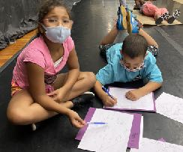

**LESSON 6**

**Goals:**

1. Students will appreciate the different elements of music within the same composition.

2. Students will discover commonalities between music, movement, and language.

3. Students will appreciate the benefits of working collaboratively.

4. Students will gain a deeper awareness about themselves.

5. Students will discover connections between themselves and fictional characters.

**Objectives:**

1. Students will compare different movements within the same musical composition.

2. Students will demonstrate the different qualities of movement.

3. Students will use domain-specific vocabulary when discussing the musical composition.

4. Students will read aloud fluently.

5. Students will reconstruct the story through movement phrases.

6. Students will define and identify nouns, adjectives, and verbs.

7. Students will generate a list of adjectives describing themselves.

8. Students will use a Venn Diagram as a comparative tool.

9. Students will respond to classmates’ work by giving textual evidence.

**Common CORE Standards**

* *Arts and Humanities*
* Standard - 9.1.3.C

Recognize and use fundamental vocabulary within each of the arts forms.

* Standard - 9.1.3.D

Use knowledge of varied styles within each art form through a performance or exhibition of unique work.

* Standard - 9.1.3.E

Demonstrate the ability to define objects, express emotions, illustrate an action or relate an experience through creation of works in the arts.

* *1.1 Reading, Foundational Skills*
* CC.1.1.3.E

Read with accuracy and fluency to support comprehension.

* *1.3 Reading Literature*
* CC.1.3.3.G

Explain how specific aspects of a text’s illustrations contribute to what is conveyed by the words in a story (e.g., create mood, emphasize aspects of a character or setting).

* CC.1.3.4.G (Grade 4)

Make connections between the text of a story or drama and a visual or oral presentation of the text, identifying where each version reflects specific descriptions and directions in the text.

* CC.1.3.5.G (Grade 5)

Analyze how visual and multimedia elements contribute to the meaning, tone, or beauty of a text (e.g., graphic novel, multimedia presentation of fiction, folktale, myth, poem).

**Materials:**

ample space to move

Gustav Holst’s *The Planets*

CD player (or device for playing music)

*Christopher Counts The Constellations*

journals and/or lined paper

pens and/or pencils

Venn Diagram worksheets

Author’s Chair

**Measurement Assessment** (Formative):

Students repeating the Brain Dance® sequence in correct order

Students using domain specific vocabulary in discussions

Students completing a Venn Diagram

**Measurement Assessment (Summative):**

Students retelling Christopher Counts The Constellations through a sequence of choreographed movements

**Lesson 6 (cont.):**

**Procedure:**

I. Opening Circle

A. Warm up with the Brain Dance sequence to Gustav Holst’s “Mars,” 1st movement, *The Planets*.

B. Using the vocabulary describing the four elements of movement and word/movement energies (qualities of movement), have students describe what they heard and felt while to “Mars.”

C. Explain that the music they had been listening to while warming-up with Brain Dance® was composed by Gustav Holst and that it, “Mars,” is the first movement of a larger work called *The Planets*. The other movements are: Venus, Mercury, Jupiter, Saturn, Uranus, and Neptune. (For more information, visit: <https://en.wikipedia.org/wiki/Gustav_Holst>)

II. Language Arts/Reading

A. Read aloud/recite *Christopher Counts The Constellations*

B. Divide students into small groups and assign each group a page(s) from the story.

Have each group retell that page through movement. At the end of the movement, the students will hold that group position until the next page. The stopping and holding action (active stillness) creates a “freeze frame” and the turning of the page signals the next group’s entry.

III. Language Arts/Writing

A. Review yesterday’s diamanté poem

B. Name the words they used on lines 2 and 6.

C. Define adjective as a word that describes/modifies a noun and answers one of the following questions: which one, how many, what kind of, or whose.

D. Review the list of adjectives that described Christopher e.g.: adventurous, curious, sneaky, brave, watchful.

E. Think of adjectives that describe you, e.g.: chatty, quiet, daring, timid.

F. Compare yourself to Christopher: likes and not-so-much-alike.

G. Introduce the Venn Diagram and explain how it is used.

1. Hand out Venn Diagram sheets.

2. With a partner, choose adjectives and character traits that show how Christopher and you are similar and different. Refer to Lesson 5 “Christopher/Pegasus” list.

III. Group Share from the Chair

Have students show and respond to each other’s Venn Diagram work-in-progress.

**LESSON 7**

**Goals:**

1. Students will encourage one another in their work.

2. Students will learn the myths behind the constellations.

3. Students will discover connections between the social sciences and astronomy.

4. Students will take risks while creating original work.

**Objectives:**

1. Students will repeat the Brain Dance® sequence in the correct order.

2. Students will identify the various settings in *Christopher Counts The Constellations*.

3. Students will define and identify different parts of speech.

4. Students will apply their knowledge of parts of speech to movement exercises.

5. Students will compare the story illustrations to scientific depictions of constellations.

6. Students will locate the story constellations on a sky chart.

8. Students will distinguish between stories and myths.

9. Students will incorporate mythological elements to their original stories (Lesson 2).

10. Students will design an original constellation.

**Common CORE Standards**

* *Arts and Humanities*
* Standard - 9.1.3.C

Recognize and use fundamental vocabulary within each of the arts forms.

* Standard - 9.1.3.E

Demonstrate the ability to define objects, express emotions, illustrate an action or relate an experience through creation of works in the arts.

* *1.1 Reading, Foundational Skills*
* CC.1.1.3.E

Read with accuracy and fluency to support comprehension.

* *1.3 Reading Literature*
* CC.1.3.3.B

Ask and answer questions about the text and make inferences from text, referring to text to support responses.

* CC.1.3.3.C

Describe characters in a story and explain how their actions contribute to the sequence of events.

* CC.1.3.3.E

Refer to parts of texts when writing or speaking about a text using such terms as chapter, scene, and stanza and describe how each successive part builds upon earlier sections.

* CC.1.3.3.G

Explain how specific aspects of a text’s illustrations contribute to what is conveyed by the words in the story (e.g., create mood, emphasize a character or setting).

* CC.1.3.3.J

Acquire and use accurately grade- appropriate conversational, general academic, and domain-specific words and phrases, including those that signal spatial and temporal relationships.

* *Creative Writing, Strand: Writing* ([dese.ade.arkansas.gov](http://dese.ade.arkansas.gov))

Content Standard 2: Students, using a range of styles, shall write poetry, personal narratives, and short fiction for a variety of purposes and audiences.

* R.1.CW.4

Analyze all authorial choices and the effects of authorial choices on the reader from example texts, including poetry, personal narratives, and fiction.

* *Earth Science: Earth in the Universe* (<http://colaborativelearning.pbworks.com>)
* 3.E.1.1

Recognize the major components and patterns observed in the earth, moon, sun system; recognize that the earth is part of a system called the solar system that includes the sun (a star), planets, and many moons and the earth is the third planet from the sun in our solar system.

**Materials:**

ample space to move

Gustav Holst’s *The Planets &* CD player (or device for playing music)

*Christopher Counts The Constellations*

journals and/or lined paper

pens and/or pencils

interactive sky chart

*The Treasury of Greek Mythology* or *D’Aulaires’ Book of Greek Myths* (D’Aulaire, Ingri and Edgar Parin)

Author’s Chair

**Measurement Assessment** (Formative):

Students repeating the Brain Dance® sequence in correct order

Students demonstrating the function of a noun and adjective through movement

Students incorporating mythological elements in their story drafts

Students identifying the constellations in *Christopher Counts The Constellations* on a sky chart and/or sky globe.

Students designing an original constellation

**Measurement Assessment** (Summative):

Students’ final copy of a diamanté poem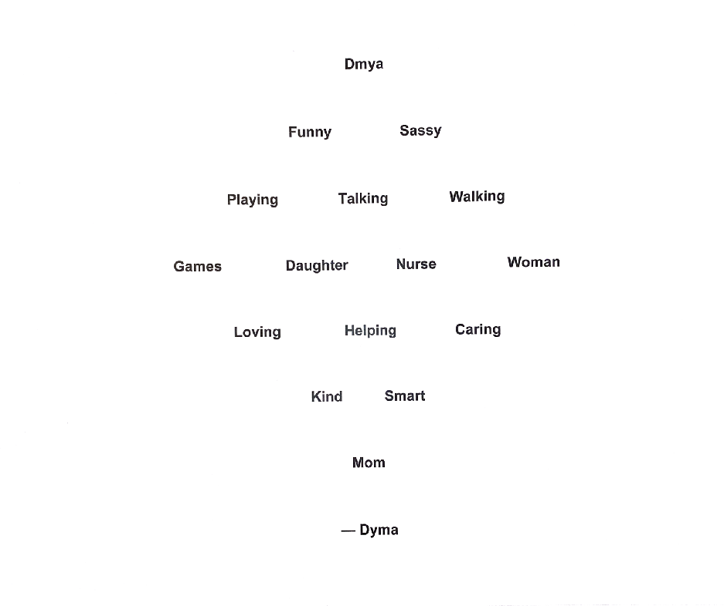

— Dyma, a 2020 Summer Reading Student @mlkcentererie.org

**Lesson 7 (cont.)**

**Procedure**

I. Opening Circle

A. Warm up with Brain Dance® sequence to Gustav Holst’s “Mercury”

B. Ask students to describe the different qualities of movement they heard/felt while listening and dancing to “Mercury,” as compared to “Mars.”

C. Recall parts of speech.

D. With a partner, choose a noun and adjective from either a classmate’s diamanté poem or story and create a movement sequence that shows the noun-adjective pair.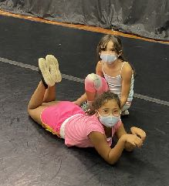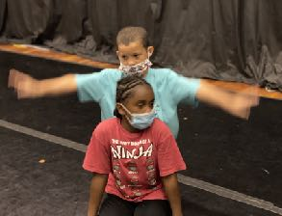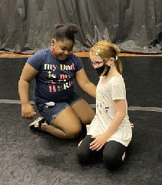

X’zeria and Roniaya: curled snake Keith and James: flying horse Dmya and Madolynn: helpful mom

II. Language Arts/Social Studies/Science

A. Recall the story elements, plot and character

B. Introduce setting

C. Identify the settings in *Christopher Counts The Constellations*

1. bedroom

2. sky (above houses)

3. space

4. Mars

D. Recall Pegasus and Perseus from Greek mythology

E. Study Jude Shingle’s spreadsheet illustration of the constellations: Perseus, Orion, Serpens, Pegasus, and Telescopium (telescope).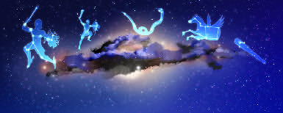

F. Show the students a night sky map and/or night sky globe and define constellation as a group of stars and “nearby” celestial objects” (nebulae, star clusters, planets, galaxies) that form a recognizable pattern and represent an animal, object, or person (mythological).

G. Explain how astronomers, when naming the constellations, considered the relationship between the mythological characters/creatures and the proximity of the objects.

1. Read aloud/recite “P stands for Perseus” page and revisit the illustrations with Perseus and Medusa’s head.

2. After Perseus saved Andromeda from the sea monster, Cassiopeia and Cepheus, Andromeda’s mom and dad, gave Perseus permission to marry their daughter, making Andromeda “Mrs. Perseus,” so to speak.

3. Andromeda, “Mrs. Perseus,” and Pegasus are connected by a star located in Pegasus’s wing, or “The Great Square.” (The Great Square is an asterism*.)

H. On the night sky map and/or night sky globe, point out the constellations: Cassiopeia, Cepheus, Andromeda, Pegasus, and Perseus.

III. Language Arts/Writing

A. Review the story drafts from Lesson 2.

B. Work with a partner and generate a list of ways the story setting and/or traveling companion could take on mythological proportions (something that is “larger than life”).

C. Design a constellation that recreates either the story’s main character (you as a “super hero”) or the traveling companion.

IV. Group Share from the Author’s Chair

Read aloud the list of generated ideas and show the constellation design.

* An asterism is a pattern of stars within a constellation, e.g.: The Big Dipper, the Great Square of Pegasus, Orion’s belt, the teapot in Sagittarius.

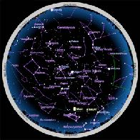

(<http://skyandtelescope.org/interactive-sky-chart>)

**LESSON 8**

**Goals:**

1. Students will appreciate the different emotional qualities of music within the same work.

2. Students will discover the vastness of our universe and the night sky.

4. Students will gain confidence in creating and expanding upon original work.

**Objectives:**

1. Students will use domain specific vocabulary from dance and music when describing their movements and the emotions they felt while moving.

2. Students will recite sections of *Christopher Counts The Constellations* fluently and from memory.

3. Students will distinguish between the Orion and Perseus constellations.

4. Students will describe the similarities and differences between the mythological figures, Orion and Perseus.

5. Students will identify the equator, North Pole, South Pole, and Northern and Southern Hemispheres on a globe.

6. Students will locate specific constellations on a sky map and/or sky globe.

7. Students will design a series of constellations within a “nearby” vicinity.

8. Students will devise and explain the relationships between their original constellation design and their subsequent ones.

**Common Core Standards:**

* *Arts and Humanities*
* Standard - 9.1.3.C

Recognize and use fundamental vocabulary within each of the arts forms.

* *Reading, 1.1 Foundational Skills*
* CC.1.1.3.E

Read with accuracy and fluency to support comprehension.

* *1.3 Reading Literature*
* CC.1.3.3.J

Acquire and use accurately grade- appropriate conversational, general academic, and domain-specific words and phrases, including those that signal spatial and temporal relationships.

* *1.4 Writing*
* CC.1.4.3.M

Write narratives to develop real or imagined experiences or events.

* CC.1.4.3.N

Establish a situation and introduce a narrator and/or characters.

* CC.1.4.3.P

Organize an event sequence that unfolds naturally, using temporal words and phrases to signal event order; provide a sense of closure.

* CC.1.4.3.Q

Choose words and phrases for effect.

* CC.1.4.3.R

Demonstrate a grade-appropriate command of the conventions of standard English grammar, usage, capitalization, punctuation, and spelling.

* CC.1.4.3.X

Write routinely over extended time frames (time for research, reflection, and revision) and shorter time frames (a single sitting or a day or two) for a range of discipline-specific tasks, purposes, and audiences.

* L.3.4.D

Use glossaries or beginning dictionaries, both print and digital, to determine or clarify the precise meaning of key words and phrases.

* *1.5 Speaking and Listening*
* CC.1.5.3.C

Ask and answer questions about information from a speaker, offering appropriate detail.

* CC.1.5.3.D

Report on a topic or text, tell a story, or recount an experience with appropriate facts and relevant, descriptive details; speak clearly with adequate volume, appropriate pacing, and clear pronunciation.

* *7.1 Basic Geography Literacy*
* Standard - 7.1.3.A

Identify how basic geographic tools are used to organize and interpret information about people, places and environment.

* Standard - 7.1.3.B

Identify and locate places and regions as defined by physical and human features.

* *Earth Science: Earth in the Universe* (collaborative *[learning.pbworks.com](http://learning.pbworks.com)*)
* Standard - 3.E.11

Recognize the major components and patterns observed in the earth, moon, sun system; recognize that the earth is part of a system called the solar system that includes the sun (a star), planets, and many moons and the earth is the third planet from the sun in our solar system.

**Materials:**

ample space to move

Gustav Holst’s *The Planets* & CD player (or device for playing music)

*Christopher Counts The Constellations*

journals and/or lined paper

pens and/or pencils

white chalk, oil pastels, and/or star stickers

unlined paper

black, dark blue, or purple construction paper

globe

interactive sky chart and/or celestial globe

*The Treasury of Greek Mythology* or *D’Aulaires’ Book of Greek Myths* (D’Aulaire, Ingri and Edgar Parin)

high intensity desk lamp needed for additional science activity

Author’s Chair

**Measurement Assessment** (Formative):

Students using dance and music vocabulary when describing their movements

Students generating a list (or Venn Diagram) of comparisons between mythological characters

Students locating the equator, the North and South Poles, and Hemispheres

Students naming the constellations along the Zodiac Belt

Students explaining the relationship between their original constellation and subsequent ones

**Measurement Assessment** (Summative):

Students’ final designs of constellations with a written explanation of relationships

**Lesson 8 (cont.)**

**Procedure**

I. Opening Circle

A. Warm up with the Brain Dance® sequence to “Jupiter.”

B. Using the vocabulary describing the four elements of movement and word/movement energies (qualities of movement), ask students to describe what they heard and felt while moving to “Jupiter,” as compared to their moving to “Mercury” and “Mars.”

II. Language Arts/Social Studies/Science

A. Read/recite the O stands for Orion page from *Christopher Counts The Constellations*.

B. Read aloud a version of the Orion myth.

C. Compare Orion to Perseus (Using the Venn Diagram for the exercise gives students the opportunity to become more familiar with this comparative tool.)

D. Study the illustrations of Orion in *Christopher Counts The Constellations*, then locate Orion on the night sky map.

E. Explain that because Orion the Hunter, according to one version of the myth, was killed by Scorpius, “his constellation” is not seen in the sky at the same time as Scorpius; and because Orion was so tall, the constellation is a prominent one in the night sky and can be seen throughout the world.

F. Show the students the globe and point out the equator, the axis, and the North and South Poles. Explain how the equator divides the earth in half and is like the planet’s belt or waistline and is equidistant from both Poles. Each half is called a hemisphere. The Northern Hemisphere is like the upper body, running *up* from the equator/waistline to the North Pole (top of the head); the Southern Hemisphere is like the lower body, running down from the equator/waistline to the South Pole (bottom of the feet).

G. Alongside the globe, place the night sky map or globe and define the ecliptic line as being the invisible line that passes through the equator two times a year (spring/vernal equinox and fall /autumnal equinox).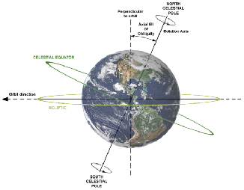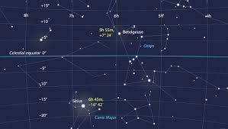

(Left: <https://en.wikipedia.org/wiki/File:AxialTiltObliquity.png>)

(Right: [skyandtelescope.org](http://skyandtelescope.org))

H. Identify Orion and show how the celestial equator passes through his belt (an asterism).

I. Name the constellations along the ecliptic line and describe Ophiuchus as being a great healer who, in the constellation, is seen holding a serpent (Serpens).

J. Read/recite “S stands for the serpent coiled above the ice caps.” Explain that Serpens is the only constellation in the Milky Way is split in two: Serpens Caput (head) and Serpens Cauda (tail). At certain times in the year (the fall in the Northern Hemisphere), it is located above Mars.

K. Show Telescopium, the only constellation in the story located completely in the Southern Hemisphere.

III. Language Arts/Writing

A. Review individual constellation designs

B. Plan a “neighborhood” of new constellations that are, in some way, connected to your first design. Write stories and/or explanations describing their relationship.

IV. Group Share from the Author’s Chair

Show the new constellations and read aloud story drafts/explanations.

*Additional Science Activity to help students recognize that the earth’s axis: is tilted; rotates on its axis every 24 hours; orbits the sun once a year; and daily, monthly, and seasonal time changes are the result of the earth’s movements.*

Have the students stand in one spot. Define their feet as being the bottom of the axis and their head as the top. Ask them to spin around once. Explain that one spin equals one rotation. Now, have them spin around slowly while moving around an object (say, a desk). Describe the trip around the object as a revolution, so that they, like the earth, were both rotating and revolving.

After the students are seated, spin the globe slowly and explain that: the earth *rotates* on its axis; it takes twenty-four hours (one day) for the earth to rotate on its axis; the earth is tilted while it rotates and revolves; and the earth’s “turning around” in front of the sun causes daytime and nighttime.

Using a desk lamp with a flexible arm, shine the light onto the globe and demonstrate how light from sun (the lamp) illuminates one half of the earth at a time. The shadowed portion of the globe is night.

**LESSON 9**

**Goals:**

1. Students will recognize that the moon has provided inspiration to artists in the different art genres.

2. Students will appreciate literature from an ancient culture.

3. Students will find beauty in art inspired by the night sky.

3. Students will learn about the moon and its phases.

4. Students will engage in imaginative thinking.

5. Students will value working with peers.

**Objectives:**

1. Students will match their dance movements to the rhythm of the music.

2. Students will use domain specific vocabulary when discussing their choice in movements.

3. Students will make observations about illustrations by referring to the text.

4. Students will compare and describe works of art inspired by the night sky.

5. Students will identify the phases of the moon.

6. Students will classify literary depictions of the moon according to specific phases.

7. Students will discuss their ideas based on evidence found in the text.

8. Students will demonstrate the phases of the moon during the class activity.

9. Students will interpret the phases of the moon by analyzing figurative language.

10. Students will compose a new list of moon imagery.

**Common CORE Standards**

* *Arts and Humanities*
* Standard - 9.1.3.C

Recognize and use fundamental vocabulary within each of the arts forms.

* Standard - 9.1.3.E

Demonstrate the ability to define objects, express emotions, illustrate an action or relate an experience through creation of works in the arts.

* *1.3 Reading Literature*
* CC.1.3.3.B

Ask and answer questions about the text and make inferences from text, referring to text to support responses.

* CC.1.3.3.E

Refer to parts of texts when writing or speaking about a text using such terms as chapter, scene, and stanza and describe how each successive part builds upon earlier sections.

* *1.4 Writing*
* CC.1.4.3.E

Choose words and phrases for effect

* *1.5 Speaking & Listening*
* CC.1.5.3.A

Engage effectively in a range of collaborative discussions on grade-level topics and texts, building on others’ ideas and expressing their own clearly.

* CC.1.5.3.C

Ask and answer questions about information from a speaker, offering appropriate detail.

* CC.1.5.3.E

Speak in complete sentences when appropriate to task and situation in order to provide requested detail or clarification.

* CC.1.5.3.G

Demonstrate command of the conventions of standard English when speaking, based on Grade 3 level and content.

* *Earth Science: Earth in the Universe* (collaborative *[learning.pbworks.com](http://learning.pbworks.com)*)
* Standard - 3.E.11

Recognize the major components and patterns observed in the earth, moon, sun system; recognize that the earth is part of a system called the solar system that includes the sun (a star), planets, and many moons and the earth is the third planet from the sun in our solar system.

**Materials:**

ample space to move

Tchaikovsky’s “Lake in the Moonlight” from *Swan Lake*

CD player (or device for playing music)

*Christopher Counts The Constellations*

journals and/or lined paper

pens and/or pencils

globe

interactive sky chart and/or celestial globe

*The Treasury of Greek Mythology* or *D’Aulaires’ Book of Greek Myths* (D’Aulaire, Ingri and Edgar Parin)

high intensity desk lamp needed for additional science activity

styrofoam balls

pencils (for science activity)

prints/slides/or computer viewing of art inspired by the night sky (<https://www.darksky.org/7-pieces-of-art-inspired-by-the-night-sky/>)

Author’s Chair

**Measurement Assessment** (Formative):

Students using dance and music vocabulary when describing their movements

Students identifying each phase of the moon

Students defining domain specific vocabulary, e.g.,: waning, waxing, gibbous

Students completing a list of imagery

**Lesson 9 (cont.)**

**Procedure**

I. Opening Circle

A. Explain Gustav Holst is just one of many composers who has used our galaxy as inspiration for music.

B. Introduce Luna, the Roman goddess personifying the moon; define “lunar” (an adjective) as “relating to the moon.”

C. Warm up with the Brain Dance® sequence to Tchaikovsky’s “Lake in the Moonlight.”

D. Using the vocabulary describing the four elements of movement and word/movement energies (qualities of movement), have students describe what they heard and felt while moving to music that was intended for ballet.

II. Language Arts/Science

A. Ask students to describe the moon:

1. As Christopher looking out his bedroom window (2nd page), and

2. As themselves, as they have seen it.

B. Show and discuss works of art inspired by the night sky (<https://www.darksky.org/7-pieces-of-art-inspired-by-the-night-sky/>)

C. Read aloud the myth of Selene, the Greek goddess of the moon.

D. Compare their descriptions of the moon to the ones they heard in the myth.

E. Introduce the phases of the moon

1. Locate the illustrations in *Christopher Counts The Constellations* that show the moon and describe its shape.

2. Compare the moon on the second page to the one on “I stands for ice caps.”

3. Discuss reasons why the moon is flipped. (Important to this type of discussion is having the students: observe details, formulate hypotheses, imagine different perspectives, engage in dialogue, and defend their ideas.

4. Conduct the moon phase activity found at: https://www.jpl.nasa.gov/edu/teach/activity/moon-phases

F. Compare Selene’s movements in the story to the phases of the moon.

III. Language Arts/Writing

A. With a partner, review the different descriptions of the moon written by their classmates.

B. Discuss the moon phase activity and the Selene myth; then, generate a list of new images of the moon in its various phases.

III. Group Share from the Chair

Partners take turns sharing their moon imagery.

**LESSON 10**

**Goals:**

1. Students will listen to contemporary music (late 60s).

2. Students will appreciate how mood and feelings can inform an artistic work.

3. Students will value their own imaginations.

**Objectives:**

1. Students will use domain specific vocabulary when describing how they patterned their movements to fit the music.

2. Students will recall imagery they heard in Langston Hughes’s poems.

3. Students will define mood and explain how imagery contributes to the overall mood of a work.

4. Students will compare images from Hughes’s poems to ones found in the “Goddess of the Moon” myth.

5. Students will express their interpretations of specific poems through movement.

6. Students will support their interpretations using textual evidence.

7. Students will develop their list of moon imagery from the previous lesson.

8. Students will describe the connections between an image and its “expansion.”

9. Students will provide feedback of their classmates’ work, based on textual evidence.

**Common Core Standards:**

* *Arts and Humanities*
* Standard - 9.1.3.C

Recognize and use fundamental vocabulary within each of the arts forms.

* *1.3 Reading Literature*
* CC.1.3.3.A

Determine the central message, lesson, or moral in literary text; explain how it is conveyed in text.

* CC.1.3.3.B

Ask and answer questions about the text and make inferences from text, referring to text to support responses.

* CC.1.3.3.E

Refer to parts of texts when writing or speaking about a text using such terms as chapter, scene, and stanza and describe how each successive part builds upon earlier sections.

* CC.1.3.3.I

Determine or clarify the meaning of unknown and multiple-meaning words and phrases based on grade-level reading and content, choosing from a range of strategies and tools.

* *1.5 Speaking & Listening*

Students present appropriately in formal speaking situations, listen critically, and respond intelligently as individuals or in group discussions.

* CC.1.5.3.A

Engage effectively in a range of collaborative discussions on grade-level topics and texts, building on others’ ideas and expressing their own clearly.

* CC.1.5.3.C

Ask and answer questions about information from a speaker, offering appropriate detail.

* CC.1.5.3.E

Speak in complete sentences when appropriate to task and situation in order to provide requested detail or clarification.

Write poems using a range of poetic devices and forms.

* *Language* (<https://www.education.com/common-core/third-grade>)
* L.3.4.D

Use glossaries or beginning dictionaries, both print and digital, to determine or clarify the precise meaning of key words and phrases.

* L.3.5.A

Distinguish the literal and nonliteral meanings of words and phrases in context (e.g., take steps).

**Materials:**

ample space to move David Bowie’s “Space Oddity” & CD player (or device for playing music)

*Christopher Counts The Constellations*

journals and/or lined paper

pens and/or pencils

copies of Langston Hughes’s poetry (see Appendix)

Author’s Chair

**Measurement Assessment** (Formative):

Students using dance and music vocabulary when describing their movements

Students producing a list of expanded imagery (Using a chart below like the one below is one way students can keep track of and develop images. This also can be used for introducing a lesson about metaphors and extended metaphors. Mind mapping or trees would be other ways.)

|  |  |  |  |
| --- | --- | --- | --- |
| Thing Describe | Characteristics of Thing | Image | Expanded Image |
| Moon | waxes | puffed up cheeks | when I blow up a balloon |
|  | wanes | shrinks, sunken cheeks | when a balloon pops |
|  | crescent | smile | closed lips, keeping something to myself |
|  | full | soccer ball | bounces, gets kicked around, flies in the air, caught in the net |

(The ideas in the above chart were generated by the 2020 Summer Reading Students, Martin Luther King Memorial Center, Erie, PA.)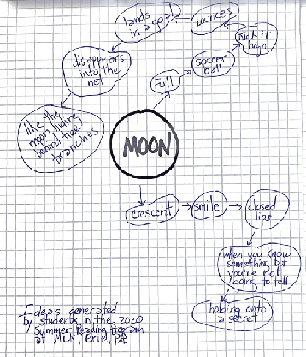

**Lesson 10 (cont.)**

**Procedure**

I. Opening Circle

A. Warm up with the Brain Dance® sequence to David Bowie’s “Space Oddity”

B. Using the vocabulary describing the four elements of movement and word/movement energies (qualities of movement), have students describe what they heard and felt while moving to a song with words compared to moving to music without words.

II. Language Arts/Reading

A. Introduce the American poet, Langston Hughes (<https://www.poetryfoundation.org/poets/langston-hughes> or <https://poets.org/poet/langston-hughes>)

B. Read aloud “New Moon” and “March Moon” (see Appendix) and compare them to descriptions of Selene, the moon goddess.

C. Discuss how the moon and stars comes to life.

D. Define mood (the “atmosphere” of the work, the feeling the work conveys)

E. Explain how imagery, the pictures words create, helps to create mood.

III. Language Arts/Movement

A. Return to Opening Circle

B. Read aloud a selection of moon/star poems and have students create movements that convey each poem’s mood.

C. Discuss how the mood affected their feelings and how they tried to convey those feelings through movement.

1. How did they incorporate the elements of movement into their work?

2. What qualities of movement/word energies did they hear, feel, express?

III. Language Arts/Writing

A. Review the list of moon imagery generated from Lesson 9.

B. Put stars by the images you particularly like. (Be prepared to explain why you like them.)

C. Expand on ways to develop each starred image, e.g.:

If the moon looks like a *banana*, does the night *peel* it until it’s gone? If the moon is shaped like a *ball*, does the wind *kick* it out of the sky come morning? If the moon looks like a *bowl*, what’s *inside*?

IV. Group Share from the Chair

1. Read aloud the original and expanded imagery.

2. Discuss the connection between the image and its “expansion.”

**LESSON 11**

**Goals:**

1. Students will listen to feelings expressed in music from the 1970s.

2. Students will appreciate how writers create a sensory world.

3. Students will deepen their appreciation for poets and the night sky.

4. Students will imagine the world from different perspectives.

**Objectives:**

1. Students will match their dance movements to the rhythm of the music.

2. Students will use domain specific vocabulary when discussing their choice in movements.

3. Students will recall the definitions, imagery and mood.

4. Students will define figures of speech.

5. Students will give examples of different types of figures of speech.

6. Students will identify the subject and predicate in sample poems.

7. Students will interpret meanings from textual evidence (i.e., the poetic devices the poet has used).

8. Students will describe how something looks from another perspective.

9. Students will create original writing.

10. Students will respond to classmates’ writing by referring to details within the work.

**Common Core Standards:**

* *Arts and Humanities*
* Standard - 9.1.3.C

Recognize and use fundamental vocabulary within each of the arts forms.

* *1.3 Reading Literature*
* CC.1.3.3.A

Determine the central message, lesson, or moral in literary text; explain how it is conveyed in text.

* CC.1.3.3.B

Ask and answer questions about the text and make inferences from text, referring to text to support responses.

* CC.1.3.3.E

Refer to parts of texts when writing or speaking about a text using such terms as chapter, scene, and stanza and describe how each successive part builds upon earlier sections.

* CC.1.3.3.I

Determine or clarify the meaning of unknown and multiple-meaning words and phrases based on grade-level reading and content, choosing from a range of strategies and tools.

* *1.5 Speaking & Listening*

Students present appropriately in formal speaking situations, listen critically, and respond intelligently as individuals or in group discussions.

* CC.1.5.3.A

Engage effectively in a range of collaborative discussions on grade-level topics and texts, building on others’ ideas and expressing their own clearly.

* CC.1.5.3.C

Ask and answer questions about information from a speaker, offering appropriate detail.

* CC.1.5.3.E

Speak in complete sentences when appropriate to task and situation in order to provide requested detail or clarification.

Write poems using a range of poetic devices and forms.

* *Language* (<https://www.education.com/common-core/third-grade>)
* L.3.4.D

Use glossaries or beginning dictionaries, both print and digital, to determine or clarify the precise meaning of key words and phrases.

* L.3.5.A

Distinguish the literal and nonliteral meanings of words and phrases in context (e.g., take steps).

* CC.1.3.3.E

Refer to parts of texts when writing or speaking about a text using such terms as chapter, scene, and stanza and describe how each successive part builds upon earlier sections.

* CC.1.3.3.I

Determine or clarify the meaning of unknown and multiple-meaning words and phrases based on grade-level reading and content, choosing from a range of strategies and tools.

* *1.5 Speaking & Listening*
* CC.1.5.3.A

Engage effectively in a range of collaborative discussions on grade-level topics and texts, building on others’ ideas and expressing their own clearly.

* CC.1.5.3.C

Ask and answer questions about information from a speaker, offering appropriate detail.

* CC.1.5.3.E

Speak in complete sentences when appropriate to task and situation in order to provide requested detail or clarification.

* *Creative Writing* ([dese.ade.arkansas.gov/public](http://dese.ade.arkansas.gov/public))
* R.1.CW.1

Analyze the function and effect of poetic devices and forms in poetry from a writer’s point of view.

* R.1.CW. 4

Analyze all authorial choices and the effects of authorial choices on the read from example texts, including poetry, personal narratives, and short fiction.

* R.1.CW.5

Evaluate poetry, [personal narratives, and short fiction] from a variety of cultures and perspectives to inform and inspire student writing.

**Materials:**

ample space to move

“Cat Stevens’s “Moonshadow” & CD player (or device for playing music)

copies of “Space Oddity” and “Moonshadow”

*Christopher Counts The Constellations*

journals and/or lined paper

pens and/or pencils

index cards

copies of Langston Hughes’s poetry (see Appendix)

copies of Figures of Speech (see Appendix)

Author’s Chair

**Measurement Assessment** (Formative):

Students using dance and music vocabulary when describing their movements

Students discussing poetry using domain specific vocabulary

Students defending their interpretations of poetry by referring back to the text

**Lesson 11 (cont.)**

**Procedure**

I. Opening Circle

A. Warm up with the Brain Dance® sequence to “Moonshadow” by Cat Stevens

B. Using the vocabulary describing the four elements of movement and word/movement energies (qualities of movement), have students describe what they heard and felt while moving to “Moonshadow.”

II. Language Arts/Reading/Movement Activity

A. Recall mood, the feeling the work conveys, and imagery

Compare the mood of “Space Oddity” to that of “Moonshadow.”

B. Recall imagery and explain how it contributes to mood.

C. Introduce Carl Sandburg (<https://poets.org/poet/carl-sandburg>) and explain that Langston Hughes found inspiration in Sandburg’s work.

D. Read aloud “Fulfilment, ”“Moonlight Night: Camel, ” and “Night Song” by Langston Hughes and “Baby Face Moon” by Sandburg.

E. Ask the students to list the images they remember and describe them (or explain why they remember them).

F. Introduce figurative language, name the various types, and hand out copies of Figures of Speech chants.

alliteration

hyperbole

idiom

imagery/sensory imagery,

metaphor

onomatopoeia

personification

simile

G. Explain that writers use figures of speech to “bring the world to life.” *(For older or more advanced students,* distinguish *between a poetic device, like rhyme or repetition, and figures of speech.)*

H. Identify the figures of speech in “Fulfillment,” “Moonlight Night: Camel,” “Night Song,” and “Baby Face Moon” e.g.:

Alliteration: bright ball

silver shanks

Imagery: silver water (sight)

Touched the river (touch)

yellow curtain (sight, touch)

velvet screen (sight, touch)

Metaphor: Day became a bright ball of light.

Night became a velvet screen.

Simile: Moon blessed us like an old grandmother.

Personification: Moon “took us both in laughing.”

the waves march/cutting the darkness

beating the land’s/Edge

Little short/Dusk/Was singing/A song

A lady named/Day/Fainted away

III. Language Arts/Writing/Movement

A. Hand out sets (two) of index cards with an unlike thing written on each card, e.g.: telescope// legs; stars//eyes; moon//egg; night//blanket.

1. Have students work in pairs and list ways two unlike things are alike.

2. From their list, have them compose sentences, e.g., My legs stretch out like a telescope; her eyes are as bright as stars.

3. Once they have written their sentences, have them choose one set and create a movement piece (still life, freeze frame) that shows how these unlike things are similar.

| Noun | Verb | Like | Noun |
| --- | --- | --- | --- |
| Telescope | extends | like | Legs |
|  | stretches |  |  |
|  | collapses |  |  |

| Noun | As | Adjective | As | Noun |
| --- | --- | --- | --- | --- |
| Stars | as | sparkly | as | Eyes |
|  | as | bright | as |  |
|  |  | sharp |  |  |

IV. Group Share from the Chair will involve the students demonstrating their similes.

**LESSON 12**

**Goals:**

1. Students will enjoy expressing themselves through movement.

2. Students will support the work of their peers.

3. Students will value their original creations.

**Objectives:**

1. Students will match their movements to the rhythm in the poetry.

2. Students will recall subjects and predicates.

3. Students will interpret the meaning of poems by analyzing English grammar.

4. Students will define figures of speech.

5. Students will identify imagery, metaphor, onomatopoeia, personification, and similes in select poems.

6. Students will refer back to the texts when explaining their interpretations of poems.

7. Students will write in their journals for a set amount of time.

8. Students will respond to their classmates’ work by referring back to their ideas expressed in speech and/or writing.

**Common Core Standards:**

* *Arts and Humanities*
* Standard - 9.1.3.C

Recognize and use fundamental vocabulary within each of the arts forms.

* *1.3 Reading Literature*
* CC.1.3.3.B

Ask and answer questions about the text and make inferences from text, referring to text to support responses.

* CC.1.3.3.C

Describe characters in a story and explain how their actions contribute to the sequence of events, chapter, scene and stanza and describe how each successive part builds upon earlier sections.

* Standard - CC.1.3.3.F

Determine the meaning of words and phrases as they are used in grade-level text, distinguishing literal from non-literal meaning as well as shades of meaning among related words.

* CC.1.3.3.I

Determine or clarify the meaning of unknown and multiple-meaning words and phrases based on grade-level reading and content, choosing flexibly from a range of strategies and tools.

* CC.1.3.3.J

Acquire and use accurately grade-appropriate conversational, general academic, and domain-specific words and phrases, including those that signal spatial and temporal relationships.

* *1.4 Writing*
* CC.1.4.3.E

Choose words and phrases for effect.

* CC.1.4.3.T

With guidance and support from peers and adults, develop and strengthen writing as needed by planning, revising, and editing.

* CC.1.4.3.X

Write routinely over extended time frames (time for research, reflection, and revision) and shorter time frames (a single sitting or a day or two) for a range of discipline-specific tasks, purposes, and audiences.

* *1.5 Speaking and Listening*
* CC.1.5.3.A

Engage effectively in a range of collaborative discussions on grade-level topics and texts, building on others’ ideas and expressing their own clearly.

* CC.1.5.3.C

Ask and answer questions about information from a speaker, offering appropriate detail.

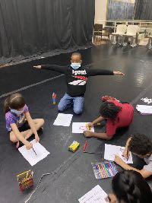

**Materials:**

ample space to move

Paul Simon’s “Song About the Moon” & CD player (or device for playing music)

*Christopher Counts The Constellations*

journals and/or lined paper

pens and/or pencils

copies of Langston Hughes’s poetry (see Appendix)

copies of Carl Sandburg’s “Fog” (see Appendix)

copies of Basho and Issa haiku (see Appendix)

copies of Figures of Speech (see Appendix)

Author’s Chair

**Measurement Assessment** (Formative)

Students using dance and music vocabulary when describing their movements

Students explaining how different figures of speech are used in select the poems

Students defending their interpretations of poetry by referring back to the text

Students using textual evidence when describing the world through a character’s p.o.v.

Students staying on task while writing

Students submitting drafts of their written work

Students reading aloud with expression

**Lesson 12 (cont.)**

**Procedure**

I. Opening Circle

A. Warm up with the Brain Dance® sequence to “Song About the Moon” by Paul Simon

B. Have students move through the space while you read aloud lines from a different selection of moon/star poems (see Appendix).

II. Language Arts/Reading/Art

A. Read aloud Langston Hughes’s poems “Change,” “Winter Moon,” “Gypsy Melodies,” and “Dreams,” and Carl Sandburg’s “Fog.”.

B. Identify the figures of speech and explain how each makes the subject more visible.

C. Introduce haiku

1. Japanese poem that typically has three lines, with a 5-7-5 syllable count (varies with translations)

2. Must include a reference to one of the five seasons (Fall, Winter, Spring, Summer, or New Year)

3. Focuses on something in nature

4. Brings the “universal” into the everyday, offering a spiritual insight

5. Many convey humor

D. Read aloud moon/star haiku by Bashō and Issa

E. Describe what elements seem “universal” (i.e., the big world outside ourselves) and which ones seem everyday.

F. Explain that Langston Hughes was influenced, not only by Carl Sandburg, but also by the haiku form.

G. Read aloud his poem “Dreams.”

1. *Why is this poem, with too many syllables, often classified as a haiku?*

2. Describe elements in s Hughes and Sandburg’s poems that seem haiku-like.

III. Language Arts/Writing

A. Review the moon imagery and the “expansions” from Lesson 10 and haiku

B. With a partner, develop the imagery even more, thinking about: metaphor (how the comparison moves, looks, feels, etc.); onomatopoeia (e.g., if the moon is a balloon and deflates, what sound does it make?); personification (recall “Change” and think about a type of person and how s/he moves); and word energies/qualities of movement.

C. Have students work independently on drafting a moon poem.

IV. Group Share from the Chair:

Read aloud drafts of moon poems

**LESSON 13**

**Goals:**

1. Students will enjoy listening to and moving to music from the 70s.

2. Students will love to learn new and unfamiliar words.

3. Students will deepen their understanding of meaning through drawing

4. Students will take pride in their own work.

**Objectives:**

1. Students will match their movements to the rhythms of the music.

3. Students will generate a list of unfamiliar words from their readings.

4. Students will use a dictionary as a resource for learning the meanings of words.

5. Students will define figures of speech.

6. Students will identify imagery, metaphor, onomatopoeia, personification, and similes in select poems.

7. Students will refer back to the texts when explaining their interpretations of poems.

8. Students will write in their journals for a set amount of time.

9. Students will submit a draft of an original poem.

9. Students will respond to their classmates’ work by referring back to their ideas expressed in speech and/or writing.

**Common Core Standards:**

* *Arts and Humanities*
* Standard - 9.1.3.C

Recognize and use fundamental vocabulary within each of the arts forms.

* *1.3 Reading Literature*
* CC.1.3.3.B

Ask and answer questions about the text and make inferences from text, referring to text to support responses.

* CC.1.3.3.C

Describe characters in a story and explain how their actions contribute to the sequence of events, chapter, scene and stanza and describe how each successive part builds upon earlier sections.

* Standard - CC.1.3.3.F

Determine the meaning of words and phrases as they are used in grade-level text, distinguishing literal from non-literal meaning as well as shades of meaning among related words.

* CC.1.3.3.I

Determine or clarify the meaning of unknown and multiple-meaning words and phrases based on grade-level reading and content, choosing flexibly from a range of strategies and tools.

* CC.1.3.3.J

Acquire and use accurately grade-appropriate conversational, general academic, and domain-specific words and phrases, including those that signal spatial and temporal relationships.

* *1.4 Writing*
* CC.1.4.3.E

Choose words and phrases for effect.

* CC.1.4.3.X

Write routinely over extended time frames (time for research, reflection, and revision) and shorter time frames (a single sitting or a day or two) for a range of discipline-specific tasks, purposes, and audiences.

* *1.5 Speaking and Listening*
* CC.1.5.3.A

Engage effectively in a range of collaborative discussions on grade-level topics and texts, building on others’ ideas and expressing their own clearly.

* CC.1.5.3.C

Ask and answer questions about information from a speaker, offering appropriate detail.

**Materials:**

ample space to move

“Walking on the Moon” by The Police & CD player (or device for playing music)

dictionaries

journals and/or lined paper

pens and/or pencils; colored pencils, markers, and/or crayons

drawing paper

copies of Dickinson’s “The Moon was but a chin of gold” (see Appendix)

copies of McGough’s “Mrs. Moon” (see Appendix)

copies of Robert Louis Stevenson’s “The Moon” (see Appendix)

copies of Figures of Speech (see Appendix)

“Who Am I” worksheets (see Appendix)

Author’s Chair

**Measurement Assessment:** (Formative)

Students matching their movements to the rhythm of the music

Students using dance and music vocabulary when describing their movements

Students explaining how different figures of speech are used in select poems

Students generating a list of unfamiliar words

Students demonstrating the correct use of a dictionary

Students defining unfamiliar words found in select poems

Students illustrating imagery found in select poems

Students staying on task while working

Students submitting drafts of their written work

Students reading aloud with expression

**Lesson 13 (cont.)**

**Procedure:**

I. Opening Circle

A. Warm up with the Brain Dance® sequence to “Walking on the Moon” by The Police.

B. Using vocabulary from dance and music, students will describe the movement choices they made.

II. Language Arts/Reading

A. Recite Figures of Speech chants and focus on “Metaphor”

B. Read aloud Roger McGough’s “Mrs. Moon,” Robert Louis Stevenson’s “The Moon,” and Emily Dickinson’s “The Moon was but a chin of gold”

C. Describe what the moon is doing in each of the poems.

D. List unfamiliar words found in the poems and, using a dictionary, define them.

E. Choose one poem and illustrate it — an aspect of one of them, e.g.: the moon’s gold chin, dewy eyes, sealed lips, tall bonnet, sparkling belt; an old lady sitting in a rocking chair, an old lady knitting, knitting needles, a ball of light, the night sky, moon’s face like a clock

F. Have the students describe their drawings to one another.

G. Ask how the drawings help them to interpret and convey meaning.

III. Language Arts/Writing/Movement

A. Imagine being Christopher looking at the moon or the moon looking at Christopher (refer to the second illustration in the story)

1. If Christopher, think about how he might act outside the story: how he spends his time during the day; what his favorite toy is (of the ones scattered across his floor) and why.

2. If the moon, how does the world look from your height? How does it feel to be shaped like a banana? Do you know any of the stars surrounding you?

B. List the ideas on the board (chart paper, Elmo, etc.).

C. Hand out the “Who Am I” worksheets.

D. Recall participles (verb + ing)

E. As a class, begin generating ideas for each category.

F. Recall the simile-movement/metaphor movement exercises from Lesson 11.

In pairs, have students choreograph movements for each line of the Christopher “Who Am I” poem.

IV. Group Share from the Chair

Students take turns reading lines from class “Who Am I” and sharing their movement phrases.

Who Am I

I am a boy soaring free.

I am black, the color of night.

I am an *Oh* amazed by all I see.

I am a star sparkling bright.

I am curiosity with eyes to see.

I am the earth, home to you and me.

I am Christopher counting the stars I see.

— Summer Reading Students 2020, Erie Martin Luther King Center

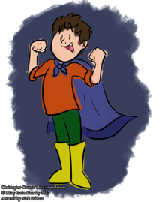

(Christopher in cape by Nick Kalmar)

**LESSON 14**

**Goals:**

1. Students will appreciate music from different eras.

2. Students will understand the commonalities between the arts and humanities.

3. Students will take pride in their work.

4. Students will appreciate collaborative work.

**Objectives:**

1. Students will much their movements to the rhythm of the music.

2. Students will use domain specific vocabulary when reflecting on the music they have listened throughout the unit.

3. Students will read aloud fluently and with expression.

4. Students will stay on task while writing.

5. Students will incorporate figures of speech in their own writing.

6. Students will design an original body puppet that resembles a character/image from their writing.

7. Students will work cooperatively while composing a group poem.

8. Students will discuss ideas based on text.

9. Students will choreograph a movement piece that conveys the meaning of the written word.

**Common Core Standards:**

* *Arts and Humanities*
* Standard - 9.1.3.B

Recognize, know, use and demonstrate a variety of appropriate arts elements and principles to produce, review and revise original works in the arts.

* Standard - 9.1.3.C

Recognize and use fundamental vocabulary within each of the arts forms.

* *1.3 Reading Literature*
* CC.1.3.3.J

Acquire and use accurately grade-appropriate conversational, general academic, and domain-specific words and phrases, including those that signal spatial and temporal relationships.

relationships.

* *1.4 Writing*
* CC.1.4.3.E

Choose words and phrases for effect.

* CC.1.4.3.X

Write routinely over extended time frames (time for research, reflection, and revision) and shorter time frames (a single sitting or a day or two) for a range of discipline-specific tasks, purposes, and audiences.

* *Creative Writing* ([dese.ade.arkansas.gov/public](http://dese.ade.arkansas.gov/public))
* W.2.CW.1

Produce original poetry, personal narratives, and short fiction that demonstrate understanding of genres appropriate to audience, purpose, and context

(e.g., organization, style, voice, usage, tone, word choice, poetic devices, mechanics)

* *1.5 Speaking and Listening*
* CC.1.5.3.A

Engage effectively in a range of collaborative discussions on grade-level topics and texts, building on others’ ideas and expressing their own clearly.

**Materials:**

ample space to move

Gustav Holst’s “Mars” by & CD player (or device for playing music)

journals and/or lined paper

pens and/or pencils; colored pencils, markers, and/or crayons

“Who Am I” worksheets (see Appendix)

mural paper

chalk pastels

scissors

**Lesson 14 (cont.)**

**Procedure**

I. Opening Circle

A. Warm up with the Brain Dance® sequence to “Mars” by Gustav Holst.

B. Discuss the different types of music listened to throughout the unit.

Select one that best fits *Christopher Counts The Constellations* and explain why

II. Language Arts/Writing/Movement/Art

A. Read aloud the Christopher “Who Am I” class poem

B. Review original writing and designs from this unit: names, travel story/traveling companion, silly sentences (and acrostic drafts), constellation creations, moon imagery and moon poem drafts.

C. Compose an original “Who Am I” poem, using imagery and ideas from earlier writings.

D. From the individual “Who Am I” poem, decide on a shape that exemplifies a characteristic of that animal/image.

E. Have students create a body mural in their chosen shapes

1. Each student positions her/himself on mural paper while someone else traces the shape.

2. Cut out the bodies and design them (chalk pastels, collage, paint)

3. The “Who Am I” poem can either be written directly onto the body or printed on a separate sheet and hung next to it (or glued onto it).

III. Group Share from the Author’s Chair

Read aloud “Who Am I” poems

IV. Finale

A. As a class, select lines/images from everyone’s work and create a composite piece.

B. Select music (or compose found sound) and choreograph a movement piece that incorporates the body puppets and poetry.

C. Perform the original work in front of an audience.

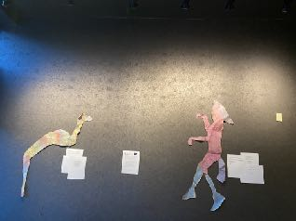

**APPENDIX**

1. **Acrostic Poems**

**Acrostic**

by Lewis Carroll, 1861

for Lorani, Alice, and Edith

Little maidens, when you look

On this little story-book,

Reading with attentive eye

Its enticing history,

Never think that hours of play

Are your only HOLIDAY,

And that in a HOUSE of joy

Lessons serve but to annoy:

If in any HOUSE you find

Children of a gentle mind,

Each the others pleasing ever—

Each the others vexing never—

Daily work and pastime daily

In their order taking gaily—

Then be very sure that they

Have a life of HOLIDAY.

**An Acrostic**

by Edgar Allan Poe

Elizabeth it is in vain you say

"Love not" - thou sayest it in so sweet a way:

In vain those words from thee or L. E. L.

Zantippe's talents had enforced so well:

Ah! if that language from thy heart arise,

Breathe it less gently forth - and veil thine eyes.

Endymion, recollect, when Luna tried

To cure his love - was cured of all beside -

His folly - pride - and passion - for he died.

**II. Diamanté Poem Worksheet**

Name: ___________________________________________________

Date: ____________________________________________________

Noun (Subject)

Adjective Adjective

Verb + ing Verb +ing Verb + ing

Noun Noun Noun Noun

Verb + ing Verb + ing Verb + ing

Adjective Adjective

Noun (Opposite of or different from Subject)

**III. Venn Diagram Sample**

by James, a 2nd grade student in the MLK Summer Reading Program, 2020

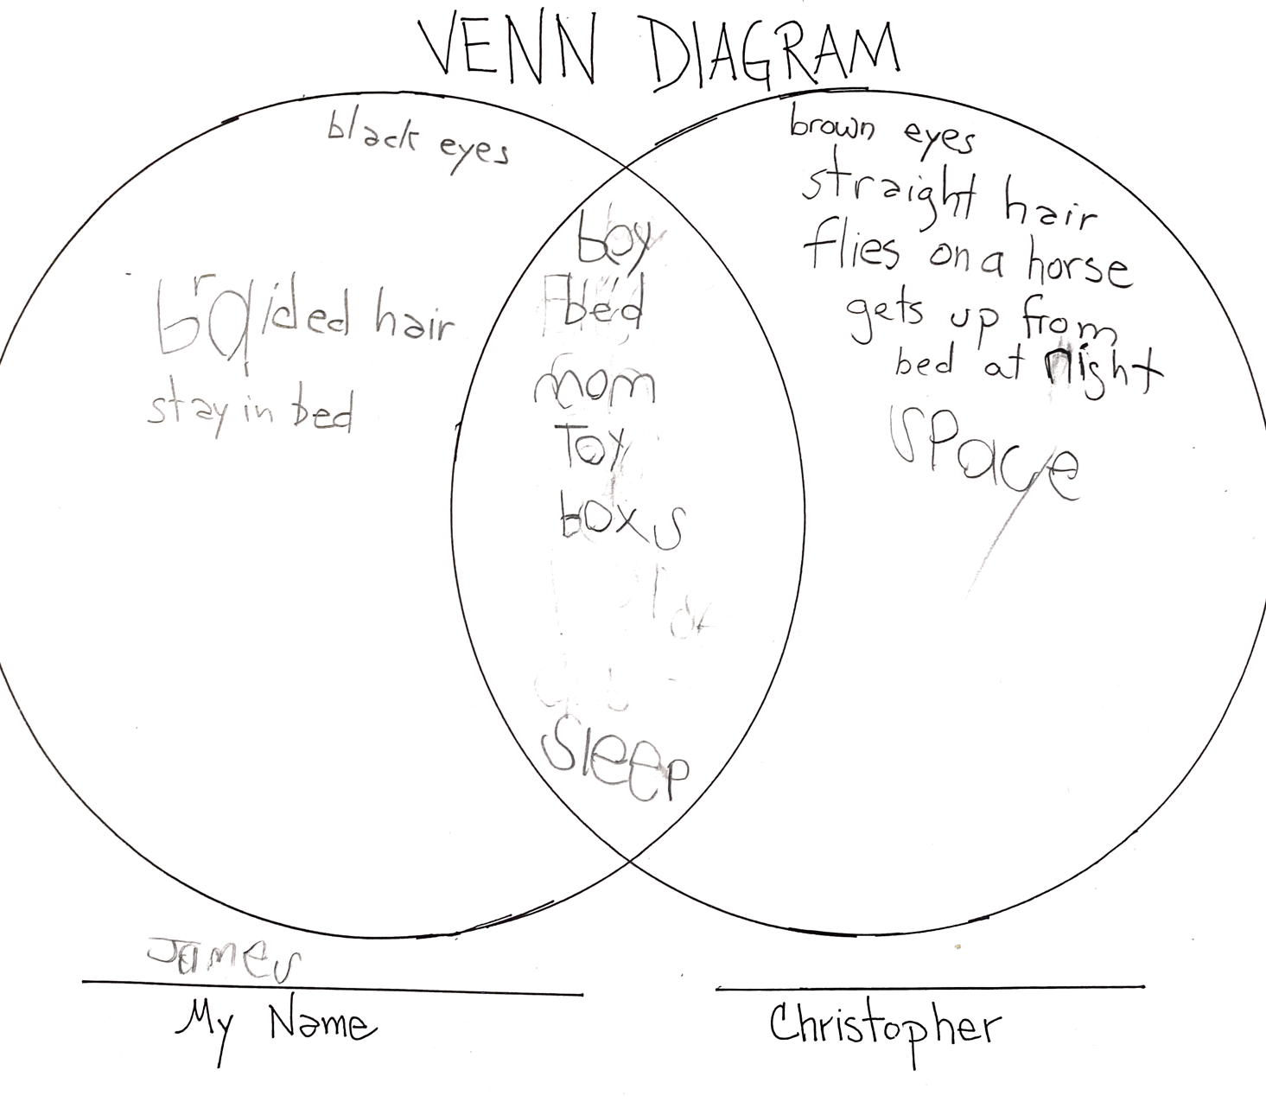

**IV. Space Oddity**

by David Bowie (1969)

Ground control to Major Tom,

Ground control to Major Tom,

Take your protein pills

and put your helmet on.

Ground control to Major Tom,

commencing countdown,

engines on.

Check ignition, and may

God’s love be with you.

The is Ground Control to Major Tom.

You’ve really made the grade.

And the papers want to know

whose shirt you wear.

Now it’s time to leave the capsule

if you dare.

The is Ground Control to Major Tom.

I’m stepping through the door

and I’m floating in a most peculiar way

And the stars look very different today

For here am I sitting

in a tin can

Far above the world

Planet Earth is blue

and there is nothing I can do.

Though I’m past one

hundred thousand miles

I’m feeling very still,

and I think my spaceship

knows which way to go.

Tell my wife I love her very much

She knows

Ground Control to Major Tom,

your circuits dead.

Can you hear me, Major Tom?

Can you hear me, Major Tom?

Can you hear me, Major Tom?

Here I am

floating in my tin can

far above the moon

Planet Earth is blue

and there’s nothing I can do.

**V. Moonshadow**

by Cat Stevens (1970)

Yes, I’m being followed by a moonshadow

Moonshadow, moon shadow

Leaping and hopping on a moon shadow

Moonshadow, moonshadow

And if I ever lose my hands

Lose my plough, lose my land

Oh, if I ever lose my hands

Oh well, I won’t have to work no more

And if I ever lose my eyes

If my colors all run dry

Yes, if I ever lose my eyes

Oh well, I won’t have to cry no more

Yes, I’m being followed by a moonshadow

Moonshadow, moon shadow

Leaping and hopping on a moon shadow

Moonshadow, moonshadow

And if I ever lose my legs

I won’t moan and I won’t beg

Oh, if I ever lose my legs

Oh well, I won’t have to walk no more

And if I ever lose my mouth

All my teeth north and south

Yes, if I ever lose my mouth

Oh well, I won’t have to talk . . .

Did it take long to find me

I ask the faithful light

Oh did it take long to find me

And are you going to stay the night

Yes, I’m being followed by a moonshadow

Moonshadow, moon shadow

Leaping and hopping on a moon shadow

Moonshadow, moonshadow

**VI. Poems by Langston Hughes (1902 - 1967)**

**New Moon**

There's a new young moon

Riding the hills tonight.

There's a sprightly young moon

Exploring the clouds.

There's a half-shy young moon

Veiling her face like a virgin

Waiting for a lover.

**March Moon**

The moon is naked.

The wind has undressed the moon.

The wind has blown all the cloud-garments

Off the body of the moon

And now she's naked,

Stark naked.

But why don't you blush,

O shameless moon?

Don't you know

It isn't nice to be naked?

**Fulfilment**

The earth-meaning

Like the sky-meaning

was fulfilled.

We got up

And went to the river,

Touched silver water,

Laughed and bathed

In the sunshine.

Day

Became a bright ball of light

For us to play with,

Sunset,

A yellow curtain,

Night,

A velvet screen.

The moon,

Like an old grandmother,

Blessed us with a kiss

And sleep

Took us both in

Laughing.

**Moonlight Night: Camel**

Tonight the waves march

In long ranks

Cutting the darkness

With their silver shanks,

Cutting the darkness

And kissing the moon

And beating the land’s

Edge into a swoon.

**Night Song**

In the dark

Before the tall

Moon came

Little short

Dusk

Was singing

A song.

In the dark

Before the tall

Moon came

A lady named

Day

Fainted away

In the

Dark.

**Change**

The moon is fat and old tonight,

Yellow and gross with pain.

The moon is fat and old tonight,

But she’ll be young again.

Whereas my love, who’s fair and sweet,

My love, who’s sweet and fair,

Will wither like the autumn rose

In winter air.

**Winter Moon**

How thin and sharp is the moon tonight!

How thin and sharp and ghostly white

Is the slim curved crook of the moon tonight!

**Gypsy Melodies**

Songs that break

And scatter

Out of the moon:

Rockets of joy

Dimmed too soon.

**Dreams**

Hold fast to dreams

For if dreams die

Life is a broken-winged bird

That cannot fly.

Hold fast to dreams

For when dreams go

Life is a barren field

Frozen with snow.

**VI. Poems by Carl Sandburg (1868 - 1967)**

**Baby Face Moon**

White moon comes in on a baby face.

The shafts across her bed are flimmering.

Out on the land White Moon shines,

Shines and glimmers against gnarled shadows,

All silver to slow twisted shadows

Falling across the long road that runs from the house.

Keep a little of your beauty

And some of your flimmering silver

For her by the window to-night

Where you come in, White Moon.

**Fog**

The fog comes

on little cat feet.

It sits looking

over harbor and city

on silent haunches

and then moves on.

**VII. Haiku**

**Moon haiku by Matsuo Bashō** (1644 - 1694)

**Autumn moonlight**

Autumn moonlight--

a worm digs silently

into the chestnut.

**Moonlight slanting**

Moonlight slanting

through the bamboo grove;

a cuckoo crying

**The moon glows the same** (published 1687)

The moon glows the same:

 it is the drifting cloud forms

make it seem to change.

**Clouds come**

Clouds come from time to time -

and bring to men a chance to rest

from looking at the moon.

**Moon/Star haiku by Kobayashi Issa** (1763 - 1827)

Under the evening moon

the snail

      is stripped to the waist.

Moon, plum blossoms,

this, that,

and the day goes.

Full moon:

my ramshackle hut

is what it is.

Crescent moon--

bent to the shape

of the cold.

Summer night--

even the stars

are whispering to each other.

**VIII. Walking on the Moon**

by The Police (1979)

Giant steps are what you take

Walking on the moon

I hope my legs don't break

Walking on the moon

We could walk forever

Walking on the moon

We could live together

Walking on, walking on the moon

Walking back from your house

Walking on the moon

Walking back from your house

Walking on the moon

Feet they hardly touch the ground

Walking on the moon

My feet don't hardly make no sound

Walking on, walking on the moon

Some may say

I'm wishing my days away

No way

And if it's the price I pay

Some say

Tomorrow's another day

You stay

I may as well play

Giant steps are what you take

Walking on the moon

I hope my legs don't break

Walking on the moon

We could walk forever

Walking on the moon

We could be together

Walking on, walking on the moon

Some may say

I'm wishing my days away

No way

And if it's the price I pay

Some say

Tomorrow's another day

You stay

I may as well play

Keep it up, keep it up

**IX. Poem by Robert McGlough (1937 - )**

**Mrs Moon**

by Roger McGough

Mrs Moon

sitting up in the sky

little old lady

rock-a-bye

with a ball of fading light

and silvery needles

knitting the night

**X. Poem by Emily Dickinson (1830 - 1886)**

**The Moon was but a chin of gold**

The Moon was but a Chin of Gold

A Night or two ago –

And now she turns Her perfect Face

Upon the World below –

Her Forehead is of Amplest Blonde –

Her Cheek – a Beryl hewn –

Her Eye unto the Summer Dew

The likest I have known –

Her Lips of Amber never part –

But what must be the smile

Upon Her Friend she could confer

Were such Her Silver Will –

And what a privilege to be

But the remotest Star –

For Certainty She take Her Way

Beside Your Palace Door –

Her Bonnet is the Firmament –

The Universe – Her Shoe –

The Stars – the Trinkets at Her Belt –

Her Dimities – of Blue.

**XI. Who Am I Worksheet**

DIRECTIONS: Choose a noun from *Christopher Counts The Constellations* (rider, telescope, horse, stars, etc.) for the first I AM sentence. For the following I AM sentences, say something about this noun by describing what it does, where it might be found, why it is important, and how you feel.

WHO AM I

I AM_______________________________________________________________________________.

(noun from *Christopher Counts The Constellations*)

I AM ______________________________________________________________________________.

(color — does not have to be limited to the exact color of the first noun)

I AM ______________________________________________________________________________.

(a sound — could be an instrument, a pitch, tone)

I AM ______________________________________________________________________________.

(place/land — some place found in the story: sky, house, room, planet, etc.)

I AM ______________________________________________________________________________.

(feeling — happiness, excitement, sadness, nervousness, joy)

I AM ______________________________________________________________________________.

(something in nature — wind, trees, stars, etc.)

I AM ______________________________________________________________________________.

(my name)

SAMPLE

I am the night blanketing the earth in darkness.

I am purple like a plum juicy and ready to eat.

I am the clattering of a crow begging for food.

I am a tree reaching towards the sky.

I am joy dancing with my friends.

I am Mary counting the stars before I go to sleep.

**RESOURCES**

1. Moodey, Mary. Christopher Counts The Constellations. Erie, PA: MarMooWorks, 2012.

II. Gilbert, Anne Green. *Teaching the Three R’s Through Movement Experiences*. Bethesda, Maryland: National Dance Education Organization, 2002.

III. Napoli, Donna Jo. *Treasury of Greek Mythology: Classic Stories of Gods, Goddesses, Heroes, & Monsters.* Washington, D.C.: National Geographic.

Or, D’Aulaires, Ingri and Parin, Edgar. *Book of Greek Myths*

IV. Hughes, Langston. *Selected Poems*. New York: Vintage Classics, 1996.

V. Websites

* <https://static.pdesas.org>
* <https://www.education.com/common-core/third-grade>
* [dese.ade.arkansas.gov](http://dese.ade.arkansas.gov)
* <http://colaborativelearning.pbworks.com>
* <https://www.creativedance.org>
* <http://skyandtelescope.org/interactive-sky-chart>
* <https://en.wikipedia.org/wiki/File:AxialTiltObliquity.png>
* <https://www.jpl.nasa.gov/edu/teach/activity/moon-phases>
* <https://www.darksky.org/7-pieces-of-art-inspired-by-the-night-sky/>
* [www.poetryfoundation.org](http://www.poetryfoundation.org)