Craft Sourcing Form_____________________________________
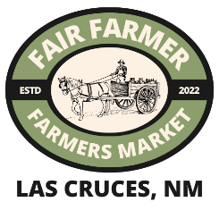
Vendor Name:_________________________________________ Date:_______________________
Business Name:________________________________________ Product Type:________________

Instructions:
- List every craft items/products in each numbered box. Include all variations offered and indicate if seasonal/rotating in numbered box. Example: Ceramic mug/New Mexico Clay, Laguna Glaze/ Ingredient List/ New Mexico Clay.
- Record all materials including separate color additions. Check the right-hand box if specific ingredient is sourced directly from a farm (not including distributors).
- List ALL farms/producers you directly purchase from and their contact for sourcing verification.
*if you need help finding farms, reach out the FFM before you turn in your ingredient sourcing form
- Attach recipets for ALL the materials purchased for each item.

Product | List all Product Ingredients  Check box if farm direct |  | List all Product Ingredients  Check box if farm direct |  | Farm Source(s) for raw ingredients
1.
2.
3.
4.
Notes

