Ingredient Sourcing Form_________________________________
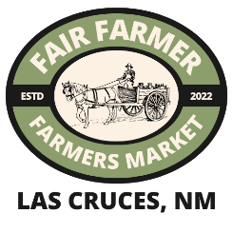
Vendor Name:_________________________________________ Date:_______________________
Store Name:__________________________________________ Product Type:_________________

Instructions:
- List different menu items/products in each numbered box. Include all flavors offered and indicate if seasonal/rotating in numbered box. Example: Chocolate Chip Muffin/Chocolate,flour,salt,water,Bs,Bp/Harvested from (insert farmers name) Farms/farm#
- Record all ingredients including separate flavor additions. Check the right-hand box if specific ingredient is sourced directly from a farm (not including distributors).
- List all farms you directly purchase from and their contact for sourcing verification.
*if you need help finding farms, reach out the FFM before you turn in your ingredient sourcing form
- %15 of EVERY item you wish to sell must come from NM Farms. Water does not count towards the %15

Menu Item or Product | List all Product Ingredients  Check box if farm direct |  | List all Product Ingredients  Check box if farm direct |  | Farm Source(s) for raw ingredients
1.
2.
3.
4.
Notes

